




Appl. Phys. A (2016) 122:576 DOI 10.1007/s00339-016-0052-5
Evaluating the impact of different exogenous factors on silk
textiles deterioration with use of size exclusion chromatography
DominikaPawcenis¹•MariuszSmolen´1•MonikaA.Aksamit-Koperska¹•
Tomasz Łojewski^{1,2}•Joanna Łojewska¹
Received: 21 July 2015 / Accepted: 15 April 2016 / Published online: 9 May 2016
©The Author(s) 2016. This article is published with open access at Springerlink.com
Abstract Size exclusion chromatography (SEC), espe- cially coupled with multiple angle laser light scattering detector (MALLS) is a powerful tool in diagnostics of deterioration of historic and art objects to evaluate their condition. In this paper, SEC–UV–MALLS–DRI technique was applied to study degradation of silk fibroin samples (Bombyx mori) artificially aged under various conditions: in the presence of oxygen, in different amount of water vapour and in volatile organic products (VOCs), all at temperature of 90°C. Conditions were chosen in such a way that it mimicked real conditions of textiles’ storing during exhibitions and in show cases. The influenceof temperature, moisture and VOCs content on the state of silk textiles was examined with the use of size exclusion chromatography. Pseudo-zero-order Ekenstamequationwas applied to study degradation rates of fibroin with use oftheapproximatedvaluesofDPoffibroin.
List of symbols
A₂
ckkK
M_{n}M_{w}
Second virial coefficient in Rayleigh equation Concentration of a solution (mg/cm³) Wavelength of incidental beam (in vacuum, nm) Reaction’s rateconstant
Optical constant in Rayleigh’s equation Number average molar mass (g/mol) Weight average molar mass, derived from Rayleigh equation (g/mol)
Refractive index of a solvent Avogadro constant Refractive indexincrement
Form factor in Rayleigh equation
Excess Rayleigh ratio, the difference between Rayleigh ratio for a solution and a pure solvent
n₀N_{A}
dn/dcP(h)
R(h)
1 Introduction
Abbreviations
Silk fibres have been used since 3500 B.C. in the textile industry, thanks to their unique properties like strength, moisture absorption and lustre. For this reason, many objects of historic importance are made of silk fibres.Thus, many museums have silk garments, carpets, tapestries and banners in their collections [1]. Exhibition of textiles allows the wide audience to enjoy history, beauty and craftsmanship of these silks. Regrettably, silk included in historical objects undergoes natural degradation inducedby light, temperature, humidity and other factors; it turns yellow and loses the mechanical strength [1]. Since in today’s societies there is a high demand for preservation of the historical objects of cultural heritage importance, the question arises how to preserve and conserve them for future generations. Active conservation treatments canalter their appearance which will affect theirartistic
DPDRI
MALLSMWD
Degree of polymerisation Differential refractive indexdetector
Multiple angle laser light scattering detector Molecular weight distribution

&
Joanna Łojewskalojewska@chemia.uj.edu.pl
1
Chemistry Faculty, Jagiellonian University, Ingardena 3,30-060Krako´w,Poland
Faculty of Materials Science and Ceramics, AGH University of Science and Technology, Mickiewicza 30, B8/3.36,
30-059Krako´w,Poland
2
13

576 Page 2 of 10
D. Pawcenis et al.
performance. Alternatively, passive conservation methods are applied to extend the lifetime of silk objects by developing methods for their safe exposition, preservation and storage.
Characteristicpropertiesofsilkresultfromthemolec-ulararchitectureoffibroin,ofwhichsilkfibreismostlyconsisted.Theprimarystructureiscreatedbyasequenceof amino acids, mainly by glycine (45 %), alanine(29%),serine (12 %) and tyrosine (5 %). Leucine,proline,valine,phenylalanine, histidine, lysine, threonine, argininearethelessabundantaminoacidsinfibroin[1–3].Thesecondarystructure is determined by theparticular aminoacids,whichcreaterigidcrystallineregions,arrangedinthestructure of b-harmonica, located in theheavy chain.Thissecondary structure is a result of the dominanceofthehydrophobicaminoacidssuchasglycineandalanine,arranged in parts of 59-mer-a repeatingsequenceofGAGAGSGAAG[SGAGAG]₈Y [4,5].Orderedcrystallineregionsmakingupabout60%ofthefibroinmass[6]areinterspersed with amorphous regions located in theareaofthelightchain[7].Theseregionsarericherinthehydro-philicaminoacidssuchasserine,threonine,arginineandlysine,whicharemoresusceptibletodegradation[8–12].Different storage and exhibition conditionshaveseri-ouslyaffectedthecurrentconditionofsilkobjects.Light,temperature and humidity have a detrimental impactontherateofthedegradation,manifestedby,forexample,glasstransition [13], recrystallisation [14,15],oxidative[16–19]andphotooxidative[20,21]changes,andphotoinduced–S–S– bond breakdown [22,23]. Additionally,thematerialduring natural ageing emits volatileorganiccompounds(VOCs),whichresultsinmassloss[24].VOCslikeaceticacid may also contribute to acidic hydrolysis[24].TheoxidationreactionswereexaminedbroadlybyShaoetal.[25], who presented results of investigations onchangesinthe crystallinity of fibroin as a function ofthecompactnessof tyrosine, studied through ATR-FTIRandFT-Ramanspectroscopies.Artificialageingofsilkfibresinducedbythefactorsmentionedaboveishopedtomimicthenaturalprocesses to better understand thedegradationphenomena.What is known about thermal ageing of silk, usedin thisstudy, is that its effects can be classified intotwogroups:purelyphysical(structural)changeswithinafibroinfibre,and chemical changes. High temperatureinducesthechangesinitsaminoacidscompositionoffibroin[16,19,26]andtothescissionsofitschains,whichinturnresultsinthechangesinmolarmassdistribution.Italsoenhancesthe formation of oxygen free radicals [27,28],whichattackthe most reactive amino acids: tryptophan,tyrosineandphenylalanineinamorphousregions[23,29].Thiseven-tuallygivesrisetothelossofsilkbrightness[19,24,30].Oxidativechangesinfunctionalgroupsoffibroinchainslead to their spatial rearrangement withinamorphous
regions [14,18], which together with water vapour, VOCs, oxygen or other agents facilitate chain scission. Addition- ally, upon thermal treatment a decrease in basic amino acids content and increase of the amount of acidic amino acids is observed [31].
By determining degradation mechanism and then kinetic parameters that rule the observed degradation changes, many important questions concerning the collection preservation could be answered. One of them is the iden- tification of silk object and their dating, and another is risk assessment. The knowledge of the degradation mechanism in principle allows to inhibit degradation pathways by designing the storage atmosphere so that it prevents their occurrence or by the chemical treatment of the textiles. A simple way of altering the storage conditions is for example lowering the temperature. According to Michalski et al. [32], a 5°C decrease in temperature will significantly prolong the lifetime of temperature-sensitive materials, analogously to the estimation that chemical reaction rates are reduced by a half for each 10°C fall. The interaction with relative humidity (RH) for other natural polymer– cellulosic materials was also described [32,33], and it was demonstratedthatapowerlawfitsthedatabest.
Accordingly to the expected changes in the silk fibres’ structure and composition, different analytical methods can be applied. In the literature, the degradation was evaluated by the changes of silk mechanical properties [34], colour [30], crystalline structure by X-ray diffraction [14,18,35], viscosity [36,37], molecular weight of silk component by sodium dodecyl sulphate-polyacrylamide gel electrophore- sis (SDS-PAGE) [38] and molecular weight distribution by SEC [19,30,36,39–41]. As the macroscopic properties (likemechanicalendurance)ofsilktextilesmaybereflected by the distribution of fibroin chain length, condition of the historical silk textiles can be evaluated from measurements of the molecular weight distribution of the silk [ref]. Thus, silksamplesarequitecommonlyanalysedbysizeexclusion chromatography (SEC) coupled with differentdetectors: ultraviolet spectrophotometric (UV), MALLS and differ- ential refractive index (DRI)detectors.
Indeed, molecular weights (which sometimes can be expressed as the degree of polymerisation) of aged cellu- losic and silk materials can be used in the study of degradation kinetics. Whereas kinetics of cellulose degra- dation has been widely studied [33,42–48], there is still a gap in knowledge about silk fibroin’s kinetics of degrada- tion [40,49,50]. Literature data are limited to kinetics and activation energies derived from tensile testing [40,51]and thermal analysis [52]. However, the latter one maynot reflect silk degradation occurring on open display at room temperature, which creates the necessity of investigation of the influence of temperature and RH on silk textiles deterioration.
13

Evaluating the impact of different exogenous factors on silk textiles deterioration with use…
Page 3 of 10 576
Assuming that depolymerisation is a pseudo-zero-order reaction, a kinetics of degradation of linear polymers can be described by Ekenstamequation:
degradation products attempt to determine
in the ageing atmosphere). An kinetic parameter in first-order
kinetics approximation (k) values has been undertaken based on the results of molecular masses determined by SEC of the samples aged at different conditions.
(
\ (
\
1
1
ln 1-DP -ln1-DP ¼kt
ð1Þ
0
t
wherekis a reaction rate constant,tis time of ageing, DP_{t}and DP₀are degrees of polymerisation of aged and unaged polymer, respectively. According to Luxford, number average molecular weight might be used instead of DP in case of silk fibroin [40]; however, in the same work Lux- ford reports on the basis of HPSEC and tensile strength results thatM_{n}may be not equivalent to DP, like in cel- lulose. As a matter of fact, in the case of polypeptides it is almost impossible to accurately compute DP due to dif- ferent molar masses of amino acids building up a polypeptide chain. Unlike DP, molar mass of any polymer will not directly reflect the number of chemical bonds between mers in polymer chain which could be used to define the degradation rate. For this reason, it seems that the use of any average molar mass in kinetic studies of silk fibroin is inadequate.
In this work, special attention is paid to the silk degra- dation via depolymerisation process, facilitated by a number of factors that occur naturally in the museums’ environment. To spot possible degradation pathways, a thermal ageing in 90°C in oxygen atmosphere was applied, coupled with different humidity levels and in presence of VOCs. These factors are known to affect art materials at a different rate [18,30,33,40,49,51,53–55]. The deterioration of silk fibres causes brittleness of the textile, resulting in loss of mechanical endurance. It is known that elevated relative humidity favours hydrolytic [18,40] and microbial [56–59] and oxidative [18] degra- dation of silk textiles. On other hand, accelerated ageing experiments on silk textiles indicated that dry-air atmo- sphere causes effects similar to damages detected in his- toric samples [19,60].
To evaluate the influence of relative humidity, presence of oxygen and volatile products of material degradation on silk textiles, it seems reasonable to compare material aged at the same elevated temperature at different RH, and in open and closed reactors (the latter to study the impact of
2 Experimental
2.1 Samples of silk fibroin and artificial ageing
Standard degummed and bleached silk fabric fromBom-byx mori(Habotai 35 g/m²Fei-Long, Warsaw, Poland) was used in allexperiments.
Prior to accelerated ageing, the samples were cut into pieces (c.a. 0.07 g) and dried for 15 min at 110°C in order to desorb water, and so not to distort the calculated relative humidity with in the ageing chamber and vials.
The accelerated ageing experiments were performed in three types of reactors providing number of conditions, presented in Table1.
During artificial ageing tests, samples were hanged in the thermal ageing chamber (open reactor) or in closed vials and heated up to 90°C. By changing the reactor type and gaseous conditions, the influence of several environ- ments could be traced down. Artificial ageing lasted 1, 3,5, 7, 14, 21, 28 and 35 days, allowing monitoring long time changes. Samples aged in closed vessels in 0 and 30 % RH were aged only for14 days.
Moisture content in ageing vessels was adjusted to obtain variety of conditions: from dry, semi-humid to humid, with RH values equal, correspondingly, to 0, 30and 70%RHascalculatedfor293Kand1013hPa.
Volatile organic compounds’ influence on silk degra- dation was imitated by ageing in hybridisation vials, acting as closed air-tight reactors [61]. Samples of c.a. 0.07 g of textile were put in c.a. 150 cm³volume hybridisation glass vials and were tight locked. The amount of silk was cal- culated so that the amount of oxygen in the vials was sufficient to assure a total oxidation of all N, C and Satoms in the fibroin molecule. Detailed description of ageing conditions and their supposed influence is depicted in Table1.
Table 1 Ageing conditions and agents affecting aged material
Reactor
Type
Conditions
Impact

Dryer
Open (air circulation)
Oxygen
T=90°C
Oxygen 70 % RHT=90°C
Oxygen
T?O₂
Climatic chamber
Open
T?O₂?H₂O
Closed vial
Closed
T?O₂?H₂O?VOC
13

576 Page 4 of 10
D. Pawcenis et al.
2.2 Size exclusion chromatography
K
X
c
1
¼
þ2A c
ð2Þ
2
R_{h} M_{w}PðhÞ
2.2.1 Sample preparation
whereKis a combined constant including the refractive index increment dn/dc:
Sample preparation procedure was described in details in previous work [39]. In the current work, dissolution of silk samples in 9.3 M LiBr (at 60°C for 3 h) was followed by dialysisinacellulosemembranetube(molecularweightcut- off3.5kDa,ZelluTrans/RothT1)againstpurewater(specific resistivity18.2MX,Simplicity185MerckMillipore)for4 h in microdialysis capsules a’1 cm³QuixSep (Roth). The dialysis solution was exchanged every 30 min in order to removeLiBr.ThefinalsolutionsforSECanalysiswerepre- paredbymixingonevolumeof0.4MNaClsolutionwithone volumeofeachsampleinordertoobtainsilkfibroinin0.2M NaCl. Prior to SEC analyses, samples werecentrifuged.
Transparent silk fibroin solutions without visible sus- pended particles were subjected to further analysis withoutfiltration.

!
!
( \
2
2
dn
1þcosa
2 2
K¼ 2pn
ð3Þ
0
N_{A}k⁴
dc
0
In order to apply Rayleigh equation, number of parameters must be known: fibroin concentrationc, its specific refractive index increment dn/dcand second virial coeffi- cientA₂.A₂is usually neglected due to small concentra- tions applied.
Concentration values came from differential refractive index detector (concentration sensitive). Specific refractive index value was obtained from three batch measurements offivedifferentconcentrationoffibroininwater,ranging
to 1.0mg/cm³
from
0.01
and
was
equal
to
0.1999±0.007cm³/g.
Weight average molar mass from Rayleigh equationwas calculated with the use of Debye’s model, which is rec- ommended for large molecules [63,64]. A plot ofR_{h}/K9cversus sin²(h/2) was constructed. The plot was fitted by a linear regression to obtain the intercept at zero angle aswellastheslopeatzeroangle.
Calibration of MALLS detector requires determination of detector constant which is a proportionality factor between the detector signal and the Rayleigh coefficientR(h) for one photodiode (11th, on 90°). The detector con- stant determination was performed with toluene (HPLCpurity)andwasfoundtobe1.5151910⁻⁴1/V9cm.Further procedure includes normalisation of other 17 photodiodes, which was done using a bovine serum albu- min (BSA) standard (66 kDa, Roth). Interdetector delay for UV–MALLS and MALLS–DRI was determined with the value of 0.0157 and 0.8709 cm³, respectively, also with theuse of BSA.
2.2.2 Analyses
The SEC system consisted of the following items: Waters 1515 isocratic pump, Waters 717? auto sampler, a column oven, a UV–Vis detector (Waters 2487 DualkAbsorbance, set at the wavelength 280 nm), a multiple angle laser light scattering detector Dawn Heleos (Wyatt Technology) and a differential refractive index detector Optilab T-rEX (Wyatt Technology), acting as a concentration-sensitive detector. Both MALLS and RI worked at the same wavelength (658 nm). In the literature, such SEC configuration for protein analyses is well described[62].
Chromatographic separationwasperformedonsilica-basedcolumnYarraSECS-4000fromPhenomenex(packed3lm,30097.8mm),maintainedat30°C(thesametemperatureasinDRIdetector),adownstream guard columnwasused(Phenomenex,30094.6mm).0.2MNaCl(aqueoussolu-tion,waterfromSimplicity185system,MerckMillipore)wasusedasamobilephase,withaflowrateof0.30cm³/min.Silkfibroinsampleswereinjectedinvolumesrangingfrom30to75ll. Eachsamplewasanalysed3times.ThespecificrefractiveindexincrementoffibroinwasdeterminedinbatchmodeusingdifferentialrefractiveindexdetectorOptilabT-rEXandcalculatedinAstra6.0.2software(WyattTechnology).
3.2 Kinetics of degradation
To obtainkvalue from kinetic curves, a reciprocal ofM_{n}orM_{w}versus ageing time may be plotted. However, as we mentioned in Sect.1,M_{n}andM_{w}may not be suitable to reflect the total number of peptide bonds. For this reason,we decided to use approximate degree of polymerisation of fibroin. Basing on the percentage and molar masses ofparticular amino acids in fibroin, a weighted average molarmass of a ‘‘monomer’’ was calculated and was equal to
93.46 g/mol, designated further asM_{m}(Eq.4). Details regarding calculations ofM_{m}are presented in Table2.
3 Data processing/calculations
3.1 Chromatographic results
P
The determination of absolute values of molecular weights using size exclusion chromatography with MALLS detec- tion is based on Rayleigh equation:
m w
i i
M_{m}¼
Pwi
ð4Þ
13

Evaluating the impact of different exogenous factors on silk textiles deterioration with use…
Page 5 of 10 576
average percentage of particular amino acids in silk fibroin chains, though amino acid composition in amorphous regionsdiffersfromcrystallineones.Thisalsoresultsinthe generalisation used in our the kinetics approach, as in the silk protein the most abundant amino acids are glycine and alanine, which are relatively light molecules and built mostly of crystalline phase [4,65,66]. Taking into account that silk fibroin is constructed of about 60–70 % of crys- talline regions [66], the first assumption gives overestima- tion of rate constant value,k, while the second simplificationexertsanoppositeeffectonthekvalue.
In fact, in order to create a real picture of the kinetics of silk fibroin degradation, the reactions running in the amorphous and crystalline regions should be considered separately, due to different mass transport rates and sus- ceptibility of amino acids to the degradation agents in these two domains. However, in real samples of silk fibroin used in this study it was impossible to isolate crystalline regions from amorphous ones, thus we could only make approxi- mations to describe the rate of depolymerisation process in fibroin chains.
Table 2 Abundance of amino acids in fibroin and calculation of weight averaged molar mass of a ‘‘monomer’’ amino acid
Aminoacid
Molar mass, g/mol (m_{i})
Contribution(w_{i})
m_{i}9w_{i}, g/mol
GAS YVDR E I L F T
75.07
89.09
105.09
181.19
117.15
133.1
156.19
147.13
131.17
131.17
165.19
119.12
0.45
0.29
0.12
0.05
0.02
0.01
0.01
0.01
0.01
0.01
0.01
0.01
Rw_{i}=1.00
33.78
25.84
12.61
9.06
2.34
1.33
1.56
1.47
1.31
1.31
1.65
1.19
Rm_{i}9w_{i}
= 93.46g/mol
M_{m}=93.46g/mol
By dividing a weight average molar mass (Eq.5) of fibroin samples obtained from SEC–MALLS, we obtained approx-imated DP value (Eq.6).
4 Results
Weight average equation:
molar
mass
was
calculated
from
4.1 Molecular weight distribution of silk fibroin
P
2
i
N
M
Molecular weight distribution (MWD) curves of aged samples compared with unaged one (Figs.1,2) distinctly shift towards lower values of molar mass regardless of the ageing conditions used, and initially they have rather monomodal distribution. However, after longer ageing time a shoulder peak appears indicating the appearance ofa new fibroin fraction of a lower molecular weight, espe- cially for the samples aged at elevated humidity in a cli- matic chamber and in closed vials. In Fig.1a–c, the results are arranged in a sequence of growing number of degra- dation agents: from O₂through O₂and H₂O (70 % RH) to finally O₂, H₂O (70 % RH) and VOC. For samples aged in dry air, the changes in MWD are the least, the range of MMD curves is between 31.5 and 1000 kDa. It is not surprising that oxidation is a dominating reaction during ageing in dry air which has been observed in the literature for both silk and cellulose [18,53,67,68], which explains why depolymerisation of the polypeptide is not aprevailing reaction here. This oxidation can, however, bring about the chain breakage and in this way contribute to the drop in its molecular weight. The addition of water vapour to the degradation atmosphere causes more significant changes in distribution of fibroin chains length (Fig.1b), manifested by more significant decrease of molecular mass (from 3.15 to 1000 kDa) especially in the final period of ageing (last 7 days). It is interesting to note that VOC, anothergas
i
P
M¼
ð5Þ

ð6Þ
are presented in
w
N M
i i
M_{w}
DP¼M
m
Details regarding Table2.
calculations of
M_{m}
Reciprocal of DP values for each condition sets (dry air ageing, wet air ageing in climatic chamber and ageing in closed vials) against ageing time were fitted to obtainlinear dependence, expressed in Eq.1. From slopes of kinetic curveskvalues werederived.
It has to be emphasized that the approach presented here is a kind of generalisation, which is based on two simplifications:
- Polymer chain scission runs with the same rate in the crystalline and amorphousregions;
- Amino acid composition is the same in the crystalline and amorphousregion.
Regarding the first assumption, it is known that amorphous regions are easily degraded due to better accessibility of degradationagentssuchasVOCs,watervapour,oxygen[9–11,50], unlike tightly packed crystalline regions. The sec- ond assumption has its consequences in the calculation of DP.Themethodofcalculationproposedherebasesonthe
13

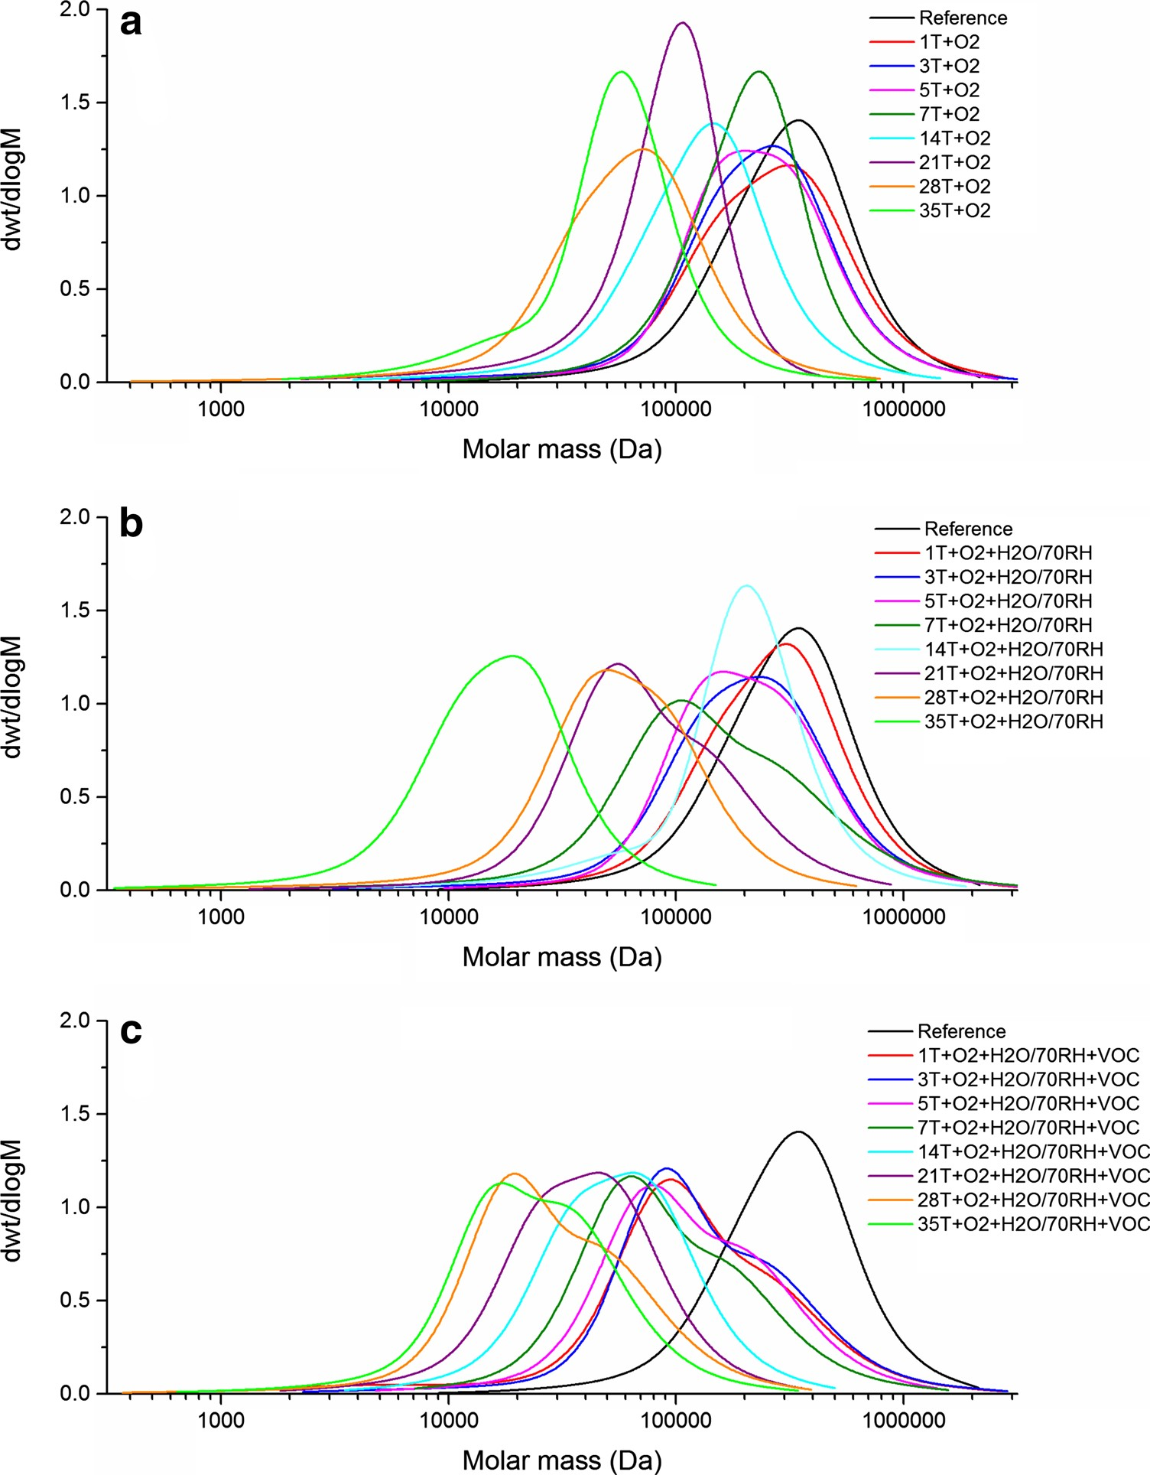
576 Page 6 of 10
D. Pawcenis et al.
phase agents that appears during ageing in a closed reactor, gives rise to slightly lesser degradation effect than the water vapour alone although the degradation dynamics is higherattheinitialstageofageing.
The influence of VOC on the degradation progress is presented in Fig.2a–c. In this experimental series, the shorter ageing was applied than in the previous series and the experiments differ in the growing concentration of water vapour starting from 0 through 125 g/m³(30 % RH) to 293 g/m³(70 % RH). The greatest drop in molecular mass is observed for the samples aged at relative humidity of 70 %, where overall deterioration is powered by high water concentration. In fact, acidic VOCs like acetic acid clearly contribute to acid hydrolysis of polypeptide chain
[24]. However, regardless of the level of relative humidity, the final degradation stage of fibroin seems to be similar which may indicate that during ageing the recrystallisation also takes place which inhibits further degradation [18,19]. The negative influence of moisture on silk fibres was noted in the literature [18,39,40]. Depending on the humidity level, the degradation dynamic is different, in VOC the most significant changes appear in the final ageing stage, while with increasing water vapour concentration degra- dation accelerates in the beginning of degradation. It seems the role of water in degradation mechanism is at least twofold where it acts as hydrolysis substrate on the one handandasapolymerplasticizerfacilitatingthe
polypeptide
access
to
degradation
agents,
on
the
other.
Fig. 1 Molecular weight distribution shifts of silk fibroin samples aged in: a ventilated oven, b climatic chamber with controlled RH level at 70 %,
c sealed vial containing water vapour corresponding to 70 % RH
13

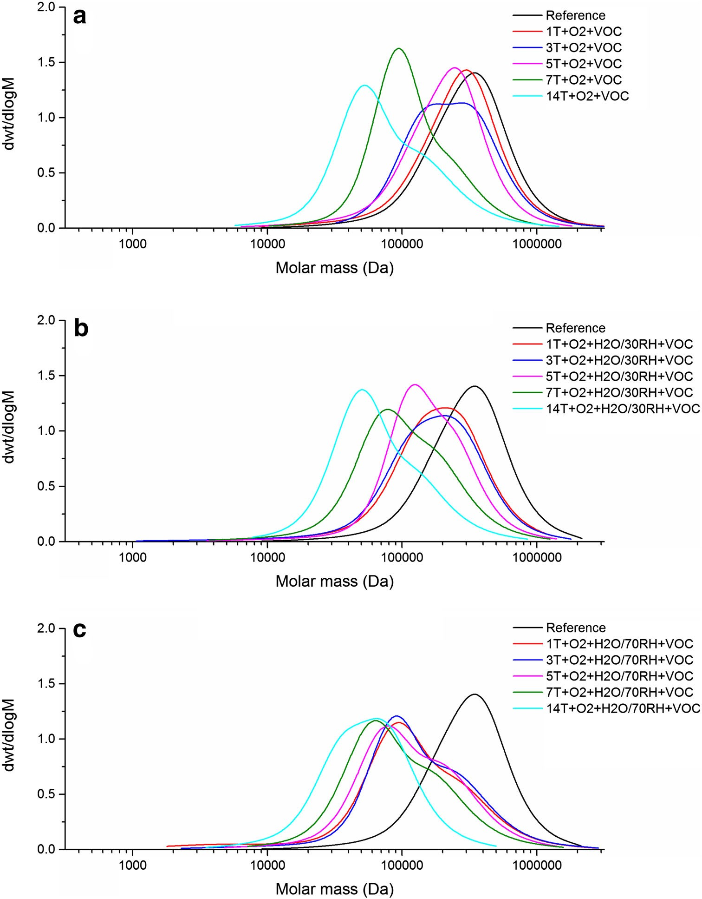
Evaluating the impact of different exogenous factors on silk textiles deterioration with use…
Page 7 of 10 576
Fig. 2 Molecular weight distribution curves of silk fibroin samples aged in sealed vials at different relative humidity levels: a 0 % RH,
b 30 % RH, c 70 % RH
Additionally, water may act as a transport media for both protons in acidic hydrolysis (H₃O?) and radicals in oxi- dation (e.g. OH*). The polimodal distribution of molar masses of aged samples may suggest that there are more and less stable fractions of fibroin that undergodegradation with higher and lower rates. These two fractions can be combined with the presence of amorphous and crystallinephases of fibroin which indeed degrade with differentrates.
Assuming the pseudo-zero-order
approximation of first-
order kinetic equation (Eq.1), rate constant values,k,can be derived from Eq.7:
1
1
kt¼DP
-DP
ð7Þ
t
0
According to Eq.7, 1/DP₀-1/DP_{t}is a measure of the number of broken bonds [69,70]. In cellulose for low values of DP, a downward or upward curvature of the 1/DP vs time was observed [71–73], which may suggest that kinetic equation is applicable only at early stages of depolymerisation. From the Fig.3, it can be deducted that for silk fibroin similar situation takes place. The k values are consistent within two groups of conditions: without
4.2 Ageing conditions vs degradation progress
To evaluate the impact of relative humidity and presenceof VOCs on degradation more quantitatively, the degradation progresswasexpressedasDPdependenceonageingtime.
13

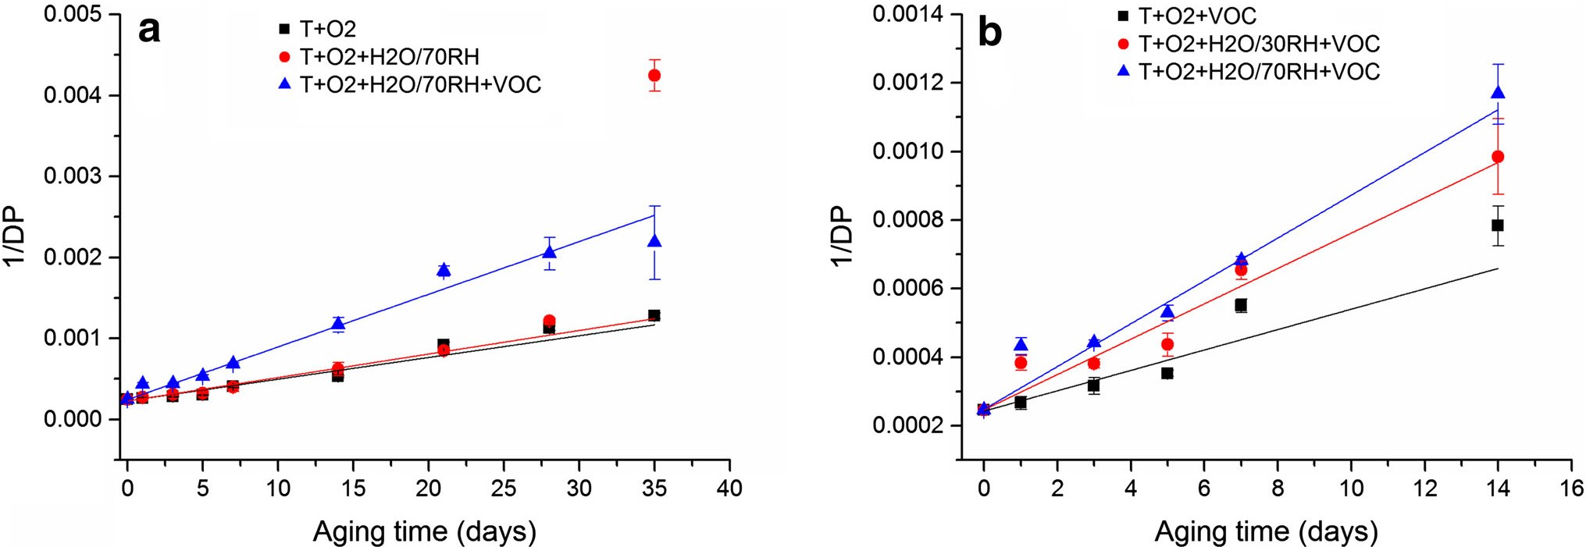
576 Page 8 of 10
D. Pawcenis et al.
Fig. 3 Relation between reciprocal of DP versus ageing time: a ventilated oven, climatic chamber with controlled RH level at 70 %, and sealed vial containing water vapour corresponding to 70 % RH, b sealed vials with 0, 30, 70 % RH
5 Conclusions
Table 3kvalues derived from DP of samples aged at dry and ele- vated humidity levels and VOCs atmosphere
The aim of this work was to approximate the kinetics of fibroin degradation at various conditions. The influence of temperature, moisture and VOCs content on the state of silk textiles was surveyed with the use of size exclusion chromatography. Based on the results of molecular mass, distributions of the approximated values of DP were cal- culated. They served as kinetic variables to study degra- dation rates of fibroin approximated by pseudo-zero-order Ekenstam equation. Destructive influence of water vapour on silk fibres was confirmed by the values of rate constantswhichvalidates the kinetic equation applied.
k(day⁻¹) Error
R2
Ageing conditions

T?O₂
T?O₂?H₂O/70RH
T?O₂?H₂O/70RH?VOC T?O₂?VOC
T?O₂?H₂O/30RH?VOC T?O₂?H₂O/70RH?VOC
2.7E-5
2.9E-5
6.5E-5
3.0E-5ª
5.2E-5ª
6.3E-5ª
2.7E-6
5.9E-6
3.4E-6
5.5E-6
6.6E-6
4.1E-6
0.923
0.746
0.978
0.848
0.923
0.980
a
Ageing interval limited to 14 days
watervapourindependentlyofconditionsappliedkdropstotherangefrom2.7910⁻⁵to3.0910⁻⁵1/day.Watervapour seems to considerably enhance degradation pro- gressandchangedegradationmechanismwhichisreflec- ted by much higher k values falling into the range from5.2910⁻⁵to6.5910⁻⁵1/day(Table3).Thus,notwithstandingthephysicalmeaningofk,itcanbeused asagaugetoassessdegradationprogress.Thetrendinkis consistent with the literature data concerningrecommen- dations for textilesstorage.
An influence of water vapour on the degradation mechanism can only be speculated here. Water indubitably accelerates the hydrolysis being a necessary substrate for its occurrence [74]. In such a case, kinetic equation should comprise water vapour concentration in another approachto the degradation kinetics. Secondly, water is a known polypeptide plasticizer [75–78] which rearranges hydrogenbond network [79,80] providing new diffusional paths for both hydrolysis and oxidation reactions. When radical mechanism of oxidation is assumed which can also be accompanied by the peptide bond scission, water can playa roleofatransporterorproviderofradicals.
Acknowledgments Financial support from the National Science Centre (Decision No. 2014/13/N/ST4/04089) and European Union (‘‘Doctus’’ scholarship to D.P.) is kindly acknowledged. The size exclusion chromatography system was equipped with a differential refractive index detector, which was purchased thanks to the financial support of the European Regional Development Fund in the frame- work of the Polish Innovation Economy Operational Programme (Contract No. POIG.02.01.00-12-023/08).
Open Access This article is distributed under the terms of the Creative Commons Attribution 4.0 International License (http://creativecommons.org/licenses/by/4.0/), which permits unrestricted use, distribution, and reproduction in any medium, provided you give appropriate credit to the original author(s) and the source, provide a link to the Creative Commons license, and indicate if changes were made.
References
- A. Timar-Balazsy, D. Eastop (eds.),Chemical Principles ofTextile Conservation(Butterworth-Heinemann, Oxford,1988)
- S. Landi (ed.),Textile Conservator’s Manual, 2nd edn. (Butter- worth-Heinemann, Oxford,1998)
13

Evaluating the impact of different exogenous factors on silk textiles deterioration with use…
Page 9 of 10 576
- X.Zhang,S.Yuan,Chin.J.Chem.28,656(2010)
- H.Yamada,H.Nakao,Y.Takasu,K.Tsubouchi,Mater.Sci.Eng. C 14, 41(2001)
- D.Pawcenis, M.A. Koperska, J.M. Milczarek, T. Łojewski, J. Łojewska,Appl.Phys.A114,301(2013)
- N. Luxford, Reducing the Risk of Open Display: Optimising thePreventive Conservation of Historic Silks, Doctoral Thesis,UniversityofSouthampton,WinchesterSchoolofArt(2009)
- K. Hallet, D. Howell, inSize Exclusion Chromatography as aTool for Monitoring Silk Degradation in Historic Tapestries, ed.by R. Janaway, P. Wyeth (Archetype Publications, London,2005), pp.143–150
- P. Calvini, Cellulose 21, 1127(2014)
- A.M.Emsley,G.C.Stevens,Cellulose1,26(1994)
- A.Emsley,R.Heywood,M.Ali,C.Eley,Cellulose4,1(1997)
- M.Kes,B.E.Christensen,Cellulose20,2003(2013)
- Step Project CT 90-0100, The Effects of Air Pollutants on theAccelerated Ageing of Cellulose Containing Materials—Paper(Delft,1994)
- A.Quye, D. Littlejohn, R.A. Pethrick, R.A. Stewart, Polym.Degrad. Stab. 96, 1934(2011)
- H.Z.Ding,Z.D.Wang,Cellulose14,171(2007)
- N.Luxford,D.Thickett,J.Inst.Conserv.34,115(2011)
- Q.Lu, B. Zhang, M. Li, B. Zuo, D.L. Kaplan, Y. Huang, H. Zhu, Biomacromolecules 12, 1080(2011)
- N. Luxford, D. Thickett, P. Wyeth, inPreserving Silk:Reassessing Deterioration Factors for Historic Silk Artefacts, ed.by C.A. Wilson, R.M. Laing (The Textile Institute (NZ), Dune-din, 2009), pp.151–157
- M.N.Bora, G.C. Baruah, C.L. Talukdar, Thermochim. Acta 218,425(1993)
- T.Łojewski,K.Zie˛ba,A.Knapik,J.Bagniuk,A.Luban´ska,J.
Łojewska, Appl. Phys. A 100, 809 (2010)
- M.-Y.Li, Y. Zhao, T. Tong, X.-H. Hou, B.-S. Fang, S.-Q. Wu,X.-Y.Shen,H.Tong,Polym.Degrad.Stab.98,727(2013)
- N. Luxford, D. Thickett, P. Wyeth, inMultidisciplinary Con-servation: a Holistic View for Historic Interiors(Rome, 2010),pp.1–12
- A. Deshmukh, S. Deshmukh, V. Zade, V. Thakare, Int. J. Theor.Appl. Sci. 5, 50(2013)
- O.Abdel-Kareem, E-PreservationSci. 7, 40 (2010)
- J.Szostak-Kotowa,Int.Biodeterior.Biodegrad.53,165(2004)
- K.Kavkler, N. Gunde-Cimerman, P. Zalar, A.Demsˇar,Int. Biodeterior. Biodegrad 97, 51(2015)
- J.Nilsson,F.Vilaplana,S.Karlsson,J.Bjurman,T.Iversen,Stud.Conserv. 55, 55(2010)
- T.Sawoszczuk,A.Baran´ski,M.Łagan,T.Łojewski,K.Zie˛ba,J.
Cult. Herit. 9, 401 (2008)
- J.Wen,T.Arakawa,J.S.Philo,Anal.Biochem.240,155(1996)
- S.Podzimek,Light Scattering, Size Exclusion Chromatographyand Asymmetric Flow Field Flow Fractionation(Wiley, Hobo-ken,2011)
- P.Kratochvil,Light Scattering from Polymer Solutions(Aca- demic, New York,1972)
- E.S.Sashina, A.M. Bochek, N.P. Novoselov, D.A. Kirichenko,Russ.J.Appl.Chem.79,869(2006)
- K.Trabbic,P.Yager,Macromolecules31,462(1998)
- T.Łojewski,P.Mis´kowiec,M.Missori,A.Luban´ska,J.Łojewska, Carbohydr. Polym. 82, 370(2010)
- J.Łojewska,A.Luban´ska,P.Mis´kowiec,T.Łojewski,L.M.Proniewicz,Appl.Phys.A83,597(2006)
- P.Calvini, Cellulose 19, 313(2012)
- P.Calvini,A.Gorassini,A.L.Merlani,Cellulose15,193(2008)
- R.J. Heywood, G.C. Stevens, C. Ferguson, A.M. Emsley, Ther- mochim. Acta 332, 189(1999)
- M.Marx-Figini,DieMakromol.Chem.187,679(1986)
- R.B.D. Fraser, T.P. MacRae,in Conformation of Fibrous Pro-teins and Related Synthetic Polypeptides(Academic Press, New York, 1973), pp.293–343
- C.Z. Zhou, F. Confalonieri, M. Jacquet, R. Perasso, Z.G. Li, J. Janin, Proteins 44, 119(2001)
- D. Kaplan, W.W. Adams, B. Farmer, C. Viney, inSilk: Biology,Structure, Properties, and Genetics, ed. by D. Kaplan, W.W. Adams, B. Farmer, C. Viney (American Chemical Society, Washington, 1994), pp.2–16
6. K. Urich,Comparative Animal
York, 1994), pp. 394–397
Biochemistry(Springer, New
- M. Lewin,Handbook of Fiber Chemistry, 2nd edn. (CRC Press, Boca Raton,2006)
- Y. Hu, Q. Zhang, R. You, L. Wang, M. Li, Adv. Mater. Sci.Eng.
2012, 185905 (2012). doi:10.1155/2012/185905
9. Y. Cao, B. Wang, Int. J. Mol. Sci. 10, 1514 (2009)
- C.Vepari,D.L.Kaplan,Prog.Polym.Sci.32,991(2007)
- S. Inoue, K. Tanaka, F. Arisaka, S. Kimura, K. Ohtomo, Sh. Mizuno, J. Biol. Chem.275(51), 40517–40528 (2000)
- Y. Yanagi, Y. Kondo, K. Hirabayashi, Text. Res. J. 70,871 (2000)
- N. Agarwal, D.A. Hoagland, R.J. Farris, J. Appl. Polym. Sci. 63, 401(1996)
- P.Garside,P.Wyeth,Appl.Phys.A89,871(2007)
- P. Garside, S. Lahlil, P. Wyeth, Appl. Spectrosc. 59, 1242(2005)
- I.Vanden,Berghe.J.Archaeol.Sci.39,1349(2012)
- M.Koperska,T.Łojewski,J.Łojewska,Spectrochim.Acta.
  - Mol. Biomol. Spectrosc. 135, 576(2015)
- M.A.Koperska,D.Pawcenis,J.Bagniuk,M.M.Zaitz,M.Missori,
T. Łojewski, J. Łojewska, Polym. Degrad. Stab. 105, 185 (2014)
- F. Vilaplana, J. Nilsson, D.V.P. Sommer, S. Karlsson, Anal. Bioanal. Chem. 407, 1433(2015)
- C. Solazzo, J.M. Dyer, S. Deb-Choudhury, S. Clerens, P. Wyeth, Photochem. Photobiol. 88, 1217(2012)
- Z. Wang, W. Chen, Z. Cui, K. He, W. Yu, J. Text. Inst. 107(4), 413–419 (2015).doi:10.1080/00405000.2015.1034933
- A. Sionkowska, A. Planecka, Polym. Degrad. Stab. 96, 523 (2011)
- S.Baltova,V.Vassileva,Polym.Degrad.Stab.60,53(1998)
- M.A. Koperska, D. Pawcenis, J.M. Milczarek, A. Blachecki, T. Łojewski, J. Łojewska, Polym. Degrad. Stab. 120, 357(2015)
- J.Shao,J.Zheng,J.Liu,C.M.Carr,J.Appl.Polym.Sci.96,1999 (2005)
- I. Vanden Berghe, J. Wouters, inIdentification and ConditionEvaluation of Deteriorated Protein Fibres at the Sub-Microgram Level by Calibrated Amino Acid Analysis, ed. by R. Janaway, P. Wyeth(ArchetypePublications,London,2005),pp.151–158
- P. Garside, P. Wyeth, inConservation Science: Heritage Mate-rials, ed. by E. May, M. Jones (Royal Society of Chemistry, Cambridge, 2006), pp.56–91
- D.Gong,H.Yang,Polym.Degrad.Stab.98,1780(2013)
- X.Zhang,I.VandenBerghe,P.Wyeth,J.Cult.Herit.12,408(2011)
- J.Kim,P.Wyeth,E-Preservation6,60(2009)
- H.E.Ahmed,S.S.Darwish,J.Polym.Environ.20,596(2012)
- S. Michalski, inICOM Comm. Conserv. 10th Trienn. Meet.Washington, DC, 22–27 August 1993 Prepr.(1993), pp.624–629
- D.Erhardt,M.F.Mecklenburg,inMat.Res.Soc.Symp.Proc.
(1995), pp. 247–270
- P. Wyeth, inSignatures of Ageing: Correlations with Behaviour, ed. by R. Janaway, P. Wyeth (Archetype Publications, London, 2005), pp.137–142
- A.C. Hermes, R.J. Davies, S. Greiff, H. Kutzke, S. Lahlil, P. Wyeth,C.Rieke,Biomacromolecules7,777(2006)
- S. Tse, A. Dupont, inHist. Text. Pap. Polym. Museums, editedby
J. M. Cardamone and M. T. Baker (ACS Symposium Series, American Chemical Society, Washington, DC, 2001), pp. 98–114
13

576 Page 10 of 10
D. Pawcenis et al.
- S.Zervos,A.Moropoulou,Cellulose12,485(2005)
- M.Strlicˇ,J.Kolar,S.Scholten,inAgeingStabilisationPaper,ed.byM.Strlicˇ,J.Kolar(NationalandUniversityLibrary,Ljubl-jana, 2005), pp.3–8
- M. Coppola, M. Djabourov, M. Ferrand, Macromol. Symp. 273, 56(2008)
- M.C. Lai, M.J. Hageman, R.L. Schowen, R.T. Borchardt, E.M. Topp,J.Pharm.Sci.88,1073(1999)
- Y.I. Matveev, V.Y. Grinberg, V.B. Tolstoguzov, FoodHydrocoll.
14, 425 (2000)
- Y.I. Matveev, V.Y. Grinberg, I.V. Sochava, V.B. Tolstoguzov, Food Hydrocoll. 11, 125(1997)
- H.Batzer,U.T.Kreibich,Polym.Bull.5,585(1981)
- T. Hashimoto, Y. Taniguchi, T. Kameda, Y. Tamada, H. Kurosu, Polym. Degrad. Stab. 112, 20(2015)
13

