
Annals of Botany 109: 47-64, 2012
doi:10.1093/aob/mcr249, available online at www.aob.oxfordjournals.org
REVIEW

Quite a few reasons for calling carnivores ‘the most wonderful plants
in the world’
Elżbieta Król1’*^, Bartosz J. Płachno2^, Lubomir Adamec3, Maria Stolarz1, Halina Dziubińska1,
and Kazimierz Trębacz1
1 Department of Biophysics, Institute of Biology, Maria Curie-Skłodowska University, Akademicka 19, 20-033 Lublin, Poland,
2Department of Plant Cytology and Embryology, Jagiellonian University, Grodzka 52, 31-044 Cracow, Poland and
3Institute of Botany AS CR, Dukelska 135, 37982 Trebon, Czech Republic
fThese authors contributed equally to this work.
*For correspondence. E-mail elkamaciekkrol@yahoo.de
Received: 30 May 2011 Returned for revision: 28 June 2011 Accepted: 8 August 2011 Published electronically: 21 September 2011
- Background A plant is considered carnivorous if it receives any noticeable benefit from catching small animals.
The morphological and physiological adaptations to carnivorous existence is most complex in plants, thanks to
which carnivorous plants have been cited by Darwin as ‘the most wonderful plants in the world’. When considering
the range of these adaptations, one realizes that the carnivory is a result of a multitude of different features.
- Scope This review discusses a selection of relevant articles, culled from a wide array of research topics on plant
carnivory, and focuses in particular on physiological processes associated with active trapping and digestion of
prey. Carnivory offers the plants special advantages in habitats where nutrient supply is scarce. Counterbalancing
costs are the investments in synthesis and the maintenance of trapping organs and hydrolysing enzymes. With the
progress in genetic, molecular and microscopic techniques, we are well on the way to a full appreciation of
various aspects of plant carnivory.
- Conclusions Sufficiently complex to be of scientific interest and finite enough to allow conclusive appraisal,
carnivorous plants can be viewed as unique models for the examination of rapid organ movements, plant excit-
ability, enzyme secretion, nutrient absorption, food-web relationships, phylogenetic and intergeneric relation-
ships or structural and mineral investment in carnivory.
Key words: Carnivorous plants, model plants, traps, rapid organ movements, gland functioning, nutrient
absorption, action potentials, plant excitability, plant indicators.
INTRODUCTION
We are accustomed to thinking of plants as being immobile and
harmless, and this may be a reason for our fascination with car-
nivorous plants and especially about those that move while trap-
ping. Such interest began in Victorian England and spread with
the popularization of Insectivorous Plants by Darwin (1875)
(Chase et al., 2009). Leading to the emergence of the so-called
carnivorous syndrome, a carnivorous lifestyle has resulted in sig-
nificant adaptive and functional implications (Laakkonen et al.,
2006). The most obvious manifestation of the syndrome is the
emergence of traps. They originate from leaves that have
become specialized in trapping, prey digestion and nutrient
absorption, thereby decreasing their photosynthetic rates (to
zero in case of the colourless traps of Genlisea and terrestrial
Utricularia, Adamec, 2006). The compact anatomy of traps
(reminiscent of roots), which is to restrict apoplastic conduc-
tivity (Pavlovic et al., 2007), serves the selective symplastic
transport of nutrients gained from carnivory. Investments in
the following cause considerable maintenance costs: attractants
such as nectars and odours (Juniper et al., 1989; Moran, 1996;
Bohn and Federle, 2004; Bennett and Ellison, 2009; Bhattarai
and Horner, 2009; Jurgens et al., 2009); edible trichomes
(Merbach et al., 2002); colourful projections (Schaefer and
Ruxton, 2008) and UV patterns (Moran et al., 1999); resinous
droplets (Voigt and Gorb, 2010) or slime that in Drosophyllum
has a scent of honey, which may mimic nectar (Jurgens et al.,
- ; glands excreting mucilage (Drosera, Pinguicula,
Byblis) or a hydrophobic resin (Roridula) to catch prey
(Juniper et al., 1989); glands excreting digestive enzymes -
these digestive glands, with their attendant mechanisms for sim-
ultaneous enzyme secretion and nutrient absorption are an ana-
tomical birthmark of the carnivorous syndrome (Luttge, 1971;
Benzing et al., 1976); exudation of organic compounds to
support the microbial community associated with the traps
(Sirova et al., 2009, 2010); and nutrient uptake machinery (An
et al., 2001) required for functioning of each single trap
(Knight, 1992; Adamec, 2006, 2010a; Pavlovic et al., 2007;
Hajek and Adamec, 2010). Therefore, it is not surprising that
the dual use of leaves for photosynthesis and nutrient uptake
has deeply reduced the net photosynthetic rate of terrestrial car-
nivorous plants, leading ultimately to reduction of the relative
growth rate (Ellison, 2006; Farnsworth and Ellison, 2008);
giant carnivorous species are the exception rather than the
rule: Triphyophyllum peltatum, Nepenthes rajah, N. edwardsi
ana, N. ampullaria, N. rafflesiana and N. rafflesiana var. gigan-
tea, N. palawanensis, N. attenboroughii (newly discovered by
Robinson et al., 2009), Sarracenia leucophylla, Drosera
© The Author 2011. Published by Oxford University Press on behalf of the Annals of Botany Company. All rights reserved.
For Permissions, please email: journals.permissions@oup.com
Downloaded from https://academic.oup.eom/aob/article-abstract/109/1/47/152100 by Uniwersytet Jagielloński user on 04 June 2020
48 Krol et al. — Carnivorous plants: a review
gigantea and D. regia. For the reasons given above (i.e. high
maintenance costs), some carnivorous plants are only carnivor-
ous when favoured by environmental conditions, e.g. Pinguicula
and pygmy Drosera spp. (Rice, 2007), or during periods of
extended growth, when extra nutrient supply is needed
(Triphyophyllum peltatum) (Bringmann et al., 2002). To
assess the expenditures and gains of carnivory, an ecological
cost-benefit model was created (Givnish et al., 1984). The
model assumes that the cost of capturing animals is offset by
the nutrient uptake in nutrient-poor environments. This is the
case when the most photosynthetically productive leaves are
supplied with macroelements gained from carnivory, otherwise
being unable to conduct photosynthesis efficiently (Ellison,
2006; Farnsworth and Ellison, 2008; Ellison and Gotelli,
- . Accordingly, as evaluated for non-carnivorous plants,
the positive correlation between CO2 fixation and
N-availability (foliar tissue N content) has long been known
(Field and Mooney, 1986). Recently, the mineral cost of
carnivory (i.e. the proportion of minerals contained in traps)
has been defined and quantified in aquatic carnivorous species
(Adamec, 2010b).
Because carnivory is largely a substitute for environmen-
tally limited macroelements, carnivorous plants are able to
cope with extreme habitats such as oligotrophic waters, dys-
trophic pools, peat bogs, fens, swamps, marshes, heaths,
mountain slopes, dripping rocks, clayish sands, fire-
impoverished soils and heavily leached areas (Juniper et al.,
1989). The distribution pattern points, however, to the predo-
minant co-occurrence of carnivorous plants with both sunny
and wet habitats (Table 1), where neither light nor water are
limiting factors (Givnish et al., 1984; Brewer et al., 2011).
Under such conditions, these plants use their prey mostly as
an alternative source of nitrogen, phosphorus and sulphur
(Juniper et al., 1989; Butler and Ellison, 2007), but also as a
source of ions, which though not necessarily
environment-limited are easily taken up from prey bodies,
e.g. potassium (Green et al., 1979; Karlsson, 1988; Plachno
et al., 2009; Adamec et al., 2010a), magnesium (Adamec,
2002, 2010a; Plachno et al., 2009), manganese (Steinhauser
et al., 2007) and even carbon (Fabian-Galan and Salageanu,
1968; Luttge, 1983; Adamec, 1997; Rischer et al., 2002).
The direct uptake of prey-derived organic carbon was shown
to be of crucial importance when CO2 and light were limited
(Adamec, 1997). There are over 700 carnivorous plant
species recognized today (Table 2) and these species are con-
stantly growing in number (Fleischmann et al., 2007, 2008;
Cheek and Jebb, 2009; Fleischmann and Rivadavia, 2009;
Lee et al., 2009; Robinson et al., 2009; Zamudio and
Olvera, 2009; Suksathan and Parnell, 2010; Souza and Bove,
2011). On the other hand, the conservation status of some
Table 1. Division of traps and distribution of habitats of carnivorous plants
Trap | Genus/species | Common name | Natural habitat | Region
Pitfall | Sarracenia | pitcher plants | fens, swamps, coastal plains, grassy  plains | north, east and south of North America
 | Darlingtonia | cobra lily | boggy areas and near streams in | Sierra Nevada mountains in south Oregon and north
 | californica |  | mountain | California (elevation up to 2500 m)
 | Heliamphora | sun pitchers | highland meadows | endemic to Guiana highlands
 | Nepenthes | tropical pitcher | ‘Lowlanders’ - humid lowland | subtropical regions of Asia (China, Singapore, India,
 |  | plants | forests; ‘Highlanders’ - tropical  montane forests | Thailand, Vietnam, Cambodia, Philippines, Malay  Peninsula), Australia, Seychelles and Madagascar
 | Cephalotus | Albany pitcher, | coastal plains | endemic to south-west Australia
 | follicularis | fly-catcher, moccasin  plant
 | Brocchinia | bromeliads | B. tatei and B. micrantha - sunny,  open areas with sandstone; others -  epiphyte of unshaded trees | endemic to Guyana, Venezuela and Columbia  (elevation 500-2900 m)
 | Catopsis berteroniana |  | epiphyte of unshaded trees | southern USA, Latin America, Brazil
Eel-trap | Genlisea | corkscrew plants | wetlands up to 2500 m | endemic to Guiana highlands, Angola, Zambia,  Tanzania, Madagascar
 | Sarracenia psittacina | parrot pitcher plant | wetter parts of boggy areas | south-eastern USA (Georgia, Florida)
Fly-paper | Drosera | sundews | marshes, fens, wet stands, boggy  shorelines | all continents but Antarctica
 | Drosophyllum | Portuguese dewy | slightly basic soils of narrow coastal | endemic to Portugal, southern Spain and northern
 | lusitanicum | pine | or maritime regions | Morocco
 | Triphyophyllum | West African liana | tropical rain forests | Sierra Leone, Liberia, Ivory Coast
 | peltatum
 | Pinguicula | butterworts | highly humid, wet areas and montane  regions (elevation up to 1900 m) | Europe, North America, northern Asia, West Africa,  west coast of South America
 | Byblis | rainbow plants | acid sands and desert areas | native to Australia and New Guinea
 | Roridula gorgonias, | flycatcher bushes or | fynbos area, costal mountain and | endemic to south Africa
 | Roridula dentata | bug plants | slopes at elevation 900-1200 m
Snap-trap | Dionaea muscipula | Venus flytrap | bogs, swamps, wet savannahs | North and South Carolina (USA)
 | Aldrovanda  vesiculosa | waterwheel plant | shallow and warm standing waters | central Europe, east Asia, Africa, Australia
Suction-trap | Utricularia | bladderworts | all kinds of still waters and water  films, wet soils, sands, rocks | all continents but Antarctica
Downloaded from https://academic.oup.eom/aob/article-abstract/109/1/47/152100 by Uniwersytet Jagielloński user on 04 June 2020

Król et al. — Carnivorous plants: a review
49
Table 2. Phylogenetic position of carnivorous plants
Division | Class | Order | Family | Genus/species | No. of species
Anthophyta (angiosperms) | Monocotyledones | Poales | Bromeliaceae | Brocchinia | 2
 |  |  |  | Catopsis berteroniana | 1
 | Dicotyledones | Caryophyllales | Dioncophyllaceae | Triphyophyllum peltatum | 1
 |  |  | Droseraceae | Aldrovanda vesiculosa | 1
 |  |  |  | Dionaea muscipula | 1
 |  |  |  | Drosera | >184
 |  |  | Drosophyllaceae | Drosophyllum lusitanicum | 1
 |  |  | Nepenthaceae | Nepenthes | >110
 |  | Oxalidales | Cephalotaceae | Cephalotus follicularis | 1
 |  | Ericales | Roridulaceae | Roridula | 2
 |  |  | Sarraceniaceae | Heliamphora | 18
 |  |  |  | Sarracenia | 9
 |  |  |  | Darlingtonia californica | 1
 |  | Lamiales | Lentibulariaceae | Pinguicula | >96
 |  |  |  | Genlisea | >22
 |  |  |  | Utricularia | >250
 |  |  | Byblidaceae | Byblis | >7
endemic carnivores growing in areas with intense human
activity (e.g. Drosophyllum lusitanicum) present an alarming
picture of ongoing declines (Goncalves and Romano, 2005).
In vitro propagation, especially in combination with conven-
tional practices (seed banks or habitat conservation) could be
a remedy for endangered species, providing an alternative to
replenish wild stocks (Jang et al., 2003; Goncalves and
Romano, 2007; Grevenstuk et al., 2010)
PASSIVE TRAPS
In passive traps there is no motion while trapping and enzyme
secretion is constitutive, i.e. independent of the presence of a
prey (Heslop-Harrison, 1975; Plachno et al., 2005a, b,
2006). In the presence of prey, however, the basal level of
secretion increases (Gallie and Chang, 1997; McNally et al.,
1988; Eilenberg et al., 2006). Moreover, the amount of
enzymes released seems be correlated to the size of the prey
(Darwin, 1875; Heslop-Harrison, 1975; Owen et al., 1999;
An et al., 2002). In other words, the expression/secretion of
digestive enzymes is regulated by a signal transduction mech-
anism. This lets the plant respond to the availability of food
resources and thus adjust the cost-benefit ratio efficiently
(Gallie and Chang, 1997). Nevertheless, passive traps can be
viewed as the containers of digestive fluid: pitfalls
(Sarracenia, Darlingtonia, Heliamphora, Cephalotus,
Nepenthes), tanks (Brocchinia, Catopsis), vesicles (eel-traps
of Genlisea) and fly-papers (Drosophyllum, Triphyophyllum,
Byblis, Roridula, majority of Pinguicula spp.).
The pitfalls of dicots have the shape of pitchers (Fig. 1A, C,
D, E), in which at least three distinctive zones can be recog-
nized (Juniper et al., 1989). A rim of slick surface covered
with nectaries and trichomes both lures and deceives; when
wet, the rim is especially slippery (Bohn and Federle, 2004;
Gorb and Gorb, 2006; Bennett and Ellison, 2009); moreover
Sarracenia flava nectar contains coniine (an alkaloid anaes-
thetic to insects) to increase prey-capture efficiency. The
waxy zone directly beneath the rim prevents escape; for this,
its walls may be covered with waxy scales (Nepenthes), pro-
truding aldehyde crystals (Sarracenia, Darlingtonia), cuticular
folds (Nepenthes, Cephalotus, Heliamphora), downward-
pointing hairs (Heliamphora, Sarracenia, Darlingtonia) or
guard-cell-originating lunate cells (Nepenthes) (Juniper
et al., 1989; Jaffe et al., 1992; Owen and Lennon, 1999;
McPherson, 2009; Poppinga et al., 2010; Moran and Clarke,
- . In Nepenthes, alkaloid fumes promote successful
capture (Ratsirarson and Silander, 1996), while fluid viscosity
increases its retentive properties (Giusto et al., 2008; Moran
and Clarke, 2010; Bonhomme et al., 2011b). The lowest part
of the pitcher, the digestive zone, harbours numerous digestive
glands (Fig. 2A-D) or a glandular epithelium (Sarracenia).
Nepenthes, Sarracenia and Cephalotus follicularis protect
their enzymes ( proteases, peptidases, phosphatases, esterases,
chitinases, nucleases) from rainfall dilution by covering the
pitchers with lids. As most Heliamphora species do not
produce enzymes (Jaffe et al., 1992), its lid has reduced in
size to become a small ‘nectar spoon’ while excess rainwater
is drained off through a slit. Deprived of its own enzymes,
too, Darlingtonia californica is unique in that it regulates the
pitcher water level by pumping it up through its roots. As
low pH promotes the action of proteolytic enzymes
(Amagase, 1972; Heslop-Harrison, 1976) and the uptake of
organic substances (Heslop-Harrison, 1976; Schulze et al.,
1999), the pitcher fluid is highly acidic (An et al., 2001).
Additionally, oxygen free radicals produced by the pitcher
plants aid in the digestion of prey bodies (Chia et al., 2004).
Although among Bromeliaceae (monocots), only
Brocchinia reducta (Fig. 1B) has been shown to secrete phos-
phatase (Plachno and Jankun, 2005; this needs be confirmed
with other methods) and neither B. hechtioides nor Catopsis
berteroniana produces proteases, these three species are estab-
lished plant carnivores. Depending on a food-web to acquire
nutrients, these plants provide habitats for frogs, insects (e.g.
ants), other carnivorous plants (e.g. Utricularia humboldtii)
and bacteria (including nitrogen-fixing bacteria), themselves
exploiting whatever is left over: faeces, animal or vegetable
debris. Absorption of N-compounds is carried out by special-
ized trichomes (Benzing et al., 1976).
Small soil-borne organisms (bacteria, algae, nematodes,
rotifers, annelids, crustaceans and mites) are found in the
Downloaded from https://academic.oup.eom/aob/article-abstract/109/1/47/152100 by Uniwersytet Jagielloński user on 04 June 2020
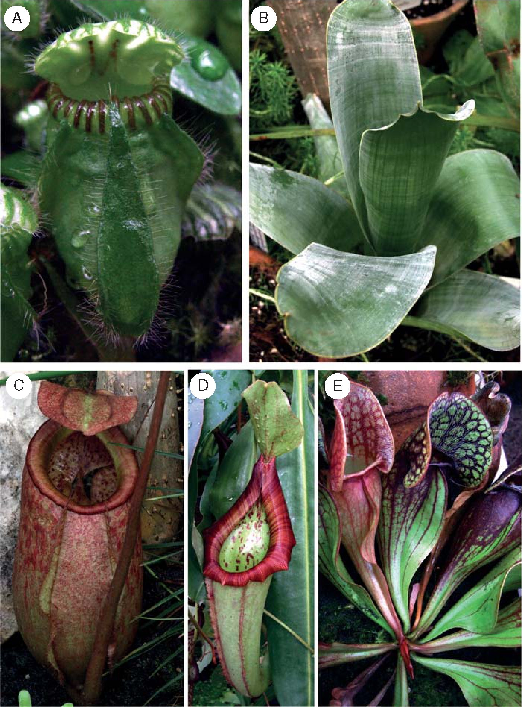
50
Król et al. — Carnivorous plants: a review
Fig. 1. Diversity of pitfalls: (A) pitcher of an Albany pitcher plant Cephalotus follicularis; (B) Brocchinia reducta as an example of carnivorous bromeliads; (C)
Nepenthes merrilliana; (D) Nepenthes hybrid ‘Miranda’; (E) North American pitcher plant Sarracenia purpurea.
subterranean eel-traps of rootless Genlisea (Plachno et al.,
2005a) (Fig. 3A, B). The Y-shaped eel-traps consist of two
arms joined to a long (3-15 cm) thin (0-5-0.8 mm) neck,
whose other end forms a digestive chamber known as a
vesicle. Arranged along the arms and the long neck, the
vesicle-pointing hairs prevent escape of prey. Digestion takes
place in the vesicle, where there are numerous digestive
glands, which in some species (Genlisea margaretae) are con-
centrated along vascular bundles (Plachno et al., 2007).
Juniper et al. (1989) found that Genlisea's digestive glands
morphologically resemble the sessile digestive glands of
Pinguicula, which seems to be well corroborated by the
common origin of both genera (Ellison and Gotelli, 2009).
Although some organisms are chemotactically attracted in
order to be digested by Genlisea (Barthlott et al., 1998),
others grow inside the traps as symbionts or commensals,
arguing for the prevalence of trophic microsystems in all
genera equipped with passive traps (Studnicka, 1996).
In general, trophic plant-commensal relationships are
multi-level and complex, with the microbial component
being of crucial importance (Barrera et al., 1989;
Steinhauser et al., 2007; Butler et al., 2008; Peterson et al.,
2008; Koopman et al., 2010; Adlassnig et al., 2011). The
strategy of taking advantage of commensal organisms is
especially critical for carnivores deprived of digestive
enzymes such as bromeliads (Frank and O'Meara, 1984),
Darlingtonia californica (Ellison and Farnsworth, 2005),
the majority of Heliamphora spp. except H. tatei (Barrera
Downloaded from https://academic.oup.com/aob/article-abstract/109/1/47/152100 by Uniwersytet Jagielloński user on 04 June 2020
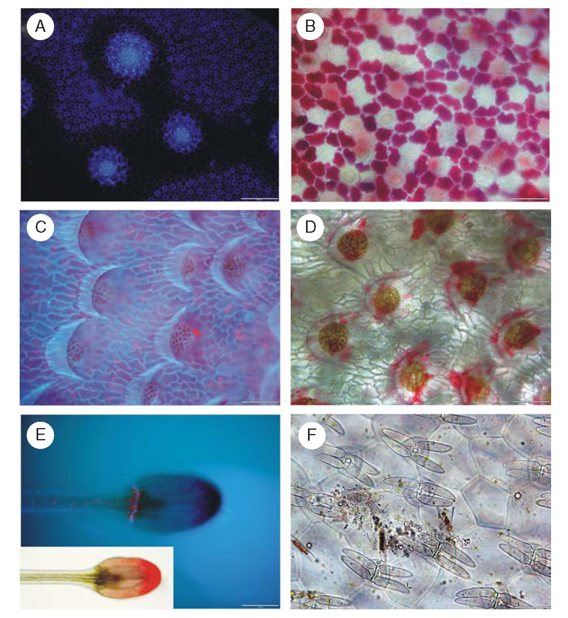
Fig. 2. Digestive glands of carnivorous plants. (A) Three large and numerous small digestive glands of the pitfall type of the trap - note
strong auto-fluorescence of the apical part of the large glands under UV light; scale bar = 200 mm. (B) Numerous small glands from the pitcher of Cephalotus
follicularis - note red anthocyanine in the epidermal cells, which surround glands; scale bar = 50 mm. (C,D) Digestive glands from the pitcher of Nepenthes
ampullaria; scale bar = 100 mm. (E) Emergence of Drosera filiformis - note auto-fluorescence under UV light: blue - cutinized walls of barrier cells and
red - chlorophyll; scale bar = 100 mm. Inset: the same emergence under light microscopy. (F) Quadrifid hairs from the trap of Utricularia volubilis; scale
bar = 50 mm.
et al., 1989; Jaffe et al., 1992; Adlassnig et al., 2011),
Nepenthes ampullaria (Moran et al., 2003) and N. lowii
(Clarke et al., 2009). Nepenthes lowii has a mutualistic
relationship with treeshrews Tupaia montana and its pitchers
act as faeces repositories for these small mammals native to
tropical forests (Clarke et al., 2009, 2010). The small woolly
bat Kerivoula hardwickii uses a different type of pitcher in
Borneo, Nepenthes rafflesiana elongata, as a lavatory and
home as well (Grafe et al., 2011). Nepenthes rajah utilizes
faeces of both the diurnal Tupaia montana and the nocturnal
rat Rattus baluensis (Greenwood et al., 2011; Wells et al.,
2011). Additionally, Nepenthes rajah hosts mosquito larvae
(Culex rajah, Toxorhynchites rajah), while N. bicalcarata
shelters ants (Camponotus schmitzi). Although both latter
named species secrete digestive enzymes, they benefit from
their commensals in such a way that the crushing of ‘prey’
by larvae or ants speeds up the digestive breakdown of
prey, which more than compensates for the partial loss of
prey supply (Bonhomme et al., 2011a). Sarracenia purpurea,
which is capable of producing some hydrolytic enzymes, also
prefers mutual commensalism with bacteria, protozoa, algae
and dipteran larvae (Atwater et al., 2006; Gebuhr et al.,
2006; Gray et al., 2006; Płachno et al., 2006; Peterson
et al., 2008; Płachno and Wołowski, 2008; Buckley et al.,
- . Among ‘fly-papers’, Pinguicula vulgaris and
P. lusitanica, which utilize nutrients from pollen-, seed- or
canopy-leaching, need assistant microorganisms which
support them by disposing of detritus (Darwin, 1875;
Lavarack, 1979; Juniper et al., 1989; Moran et al., 2003).
Byblis and Roridula both benefit from commensalism with
Capsid bugs: Setocornis, Cyrtopeltis, Pameridea roridulae
and Pameridea marlothii (Ellis and Midgley, 1996;
Hartmeyer, 1998; Midgley and Stock, 1998; Anderson and
Midgley, 2002, 2003, 2007). Thus, our understanding of car-
nivory may be broadened today by recognition of the fact
that carnivorous plants are able to lure and capture a prey
and then utilize (absorb) prey-derived compounds, regardless
of whether these compounds are provided directly or by
Downloaded from https://academic.oup.eom/aob/article-abstract/109/1/47/152100 by Uniwersytet Jagielloński user on 04 June 2020
Kroi et al. — Carnivorous plants: a review 51
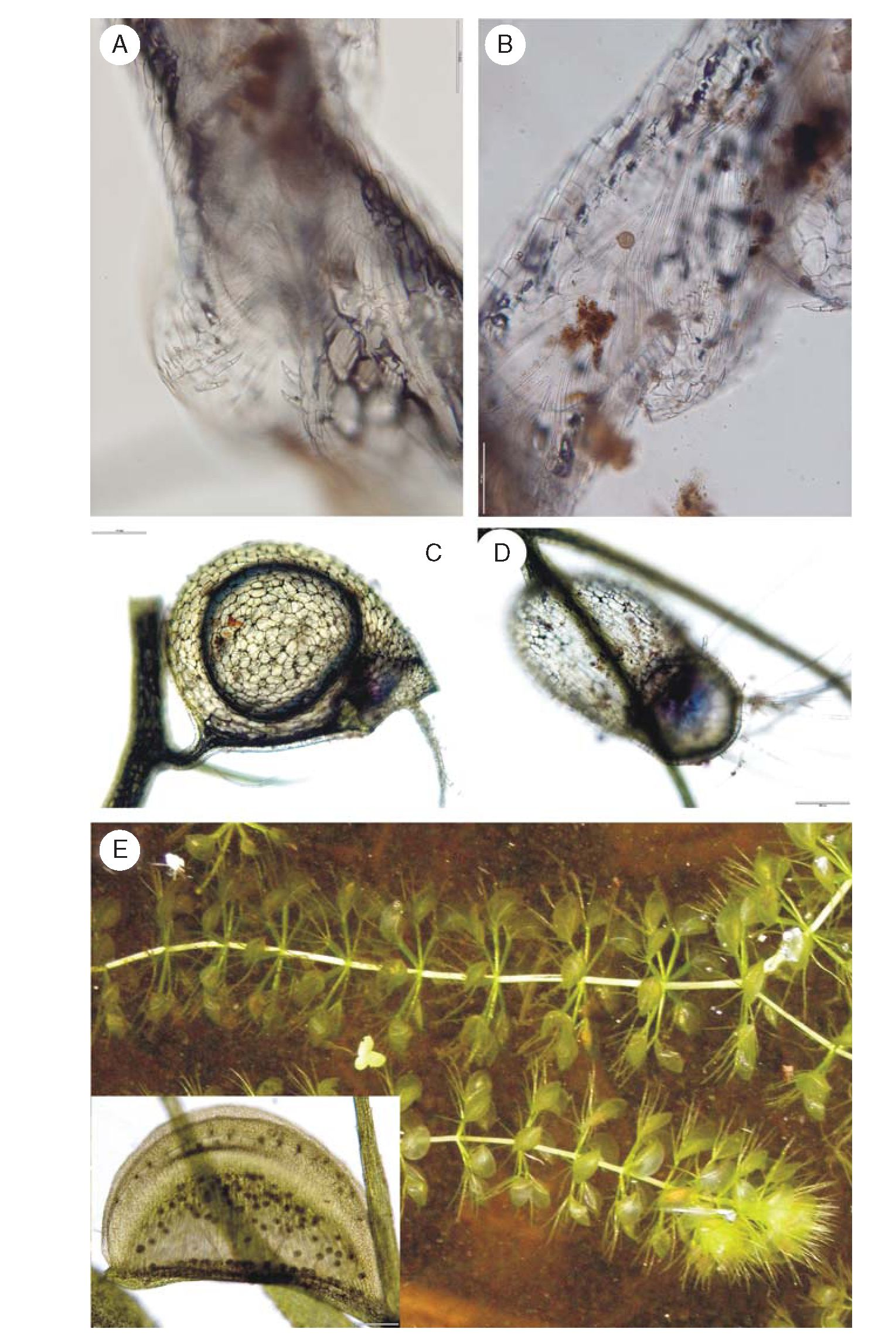
52
Król et al. — Carnivorous plants: a review
Fig. 3. Subterranean and aquatic traps. (A,B) Part of the eel trap of Genlisea margaretae: (A) external view opening in the arm of the trap; (B) the same but
from internal view; scale bars = 100 mm. (C,D) Bladders of Utricularia gibba; scale bars = 200 mm. (E) The waterwheel plant Aldrovanda vesiculosa in the
Velky Londyn sand-pit near Treboii (South Bohemia, Czech Republic); inset: magnification of the tropical clone Aldrovanda trap - dark points depict digestive
glands; scale bar = 200 mm.
commensal or symbiotic organisms. In other words, the
ability to efficiently absorb nutrients has become the real
clincher of carnivory (Jolivet, 1998; Bringmann et al.,
2001; Darnowski et al., 2007; Plachno et al., 2009), while
the presence of commensal or symbiotic associations may
be viewed as additional evidence (Hess et al., 2005). It can
be argued that the production of enzymes by the plant
itself, when commensals are already doing it, would be an
unnecessary cost for the plant that is still able to absorb
nutrients (Hartmeyer, 1998).
Downloaded from https://academic.oup.eom/aob/article-abstract/109/1/47/152100 by Uniwersytet Jagielloński user on 04 June 2020
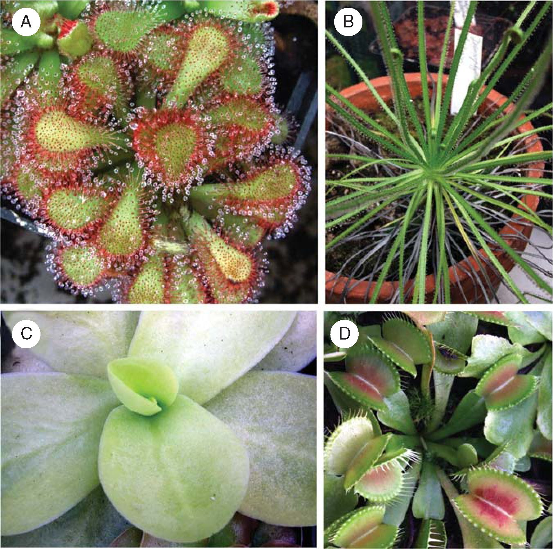
Król et al. — Carnivorous plants: a review
53
ACTIVE TRAPS
Active traps move while trapping. To synchronize their move-
ments action potentials (APs) are generated (see below).
Adhesive fly-papers, and snap- and suction-traps may be
counted as active traps. Adhesive traps (either active,
Fig. 4A, C; or passive, Fig. 4B) are evenly covered with
mucilage-producing glands which, when stalk-shaped, are
designated tentacles (Fig. 2E). In active adhesive traps, the ten-
tacles bend when stimulated. Drosera burmannii and
D. glanduligera bend their tentacles quickly, i.e. in seconds
(5-15 s) or even less (0.15 s), respectively (Gibson and
Waller, 2009); it is to the latter we owe the term ‘snap-
tentacle’ (Hartmeyer and Hartmeyer, 2005). Apart from tenta-
cle bending, in most Drosera and some Pinguicula spp., the
‘stimulated’ leaf curves around the prey to maximize contact
with it and extend the area of digestion/absorption around it
(Legendre, 2002b). Although leaf movement takes on
average a couple of hours, re-furling the unravelled position
takes a whole day. An exception is D. capensis, which
enwraps a prey in 30 min (http://en.wikipedia.org/wiki/
Drosera_capensis).
The tentacles of Drosera have direct connections with the
vascular system, due to the increased water consumption
during mucilage production (Williams and Pickard, 1974).
On prey capture, mucilage production is intensified. First,
formic acid initiates the digestive process of the insect body,
and the excretion of digestive enzymes (proteases, phospha-
tases, peroxidases, nucleases, carbohydrases and amylases)
then facilitates the break-down process (Heslop-Harrison and
Knox, 1971; Marburger, 1979; Juniper et al., 1989). The
chitin skeleton usually remains undigested, although chitinase
activity may be present in the digestive exudation of Drosera
(Matusikova et al., 2005). Chitinous remnants may also be
disposed of by associated mites (Antor and Garcia, 1995).
Dionaea muscipula with snap-traps (Fig. 4D) is the most
splendid example of the prey capture among land plants
(Darwin, 1875), while its closest descendent Aldrovanda vesi-
culosa (Fig. 3E), which displays a similar catching-technique,
has adapted an aquatic lifestyle in dystrophic waters (Arber,
1920). Both species snap their bi-lobe-traps whenever the mul-
ticellular trigger hairs (20 in Aldrovanda, three in Dionaea) of
epidermal origin are touched (Hodick and Sievers, 1986). In
Aldrovanda, ten trigger hairs stand along the hinge (midrib),
eight along the trap border line and two somewhere in the
middle. In Dionaea, there are three in the centre. Around the
rims of each trap there are four-armed glands in Aldrovanda
and star-like sessile glands in Dionaea, which secrete sweet
mucilage to attract prey and to seal the lobes hermetically
during digestion (Juniper et al., 1989). The central zone of
the lobes is richly covered with numerous sessile digestive
Fig. 4. Diversity of fly paper traps and numerous snap traps of the Venus flytrap Dionaea muscipula (D). (A) An example of the sundew Drosera - an active fly
sticky trap type; note numerous emergences with mucilage droplets, which both attract and catch prey. (B) Portuguese sundew Drosophyllum lusitanicum - a
passive fly sticky trap type. (C) Pinguicula gigantea from Mexico - an active fly sticky trap.
Downloaded from https://academic.oup.eom/aob/article-abstract/109/1/47/152100 by Uniwersytet Jagielloński user on 04 June 2020
54 Krol et al. — Carnivorous plants: a review
glands both in Aldrovanda and in Dionaea. The two genera
share a similar morphology of the digestive glands which, scat-
tered over the inner epidermis, are without vascular connection
(Hodick and Sievers, 1986). Digestion may take from one to
several days, depending on the size of the prey. The secreted
H+ ions speed up amino acid uptake (Rea and Whatley,
1983). When the trap eventually re-opens: (1) it is usually
not capable of further functioning and starts to decay
(Aldrovanda) - to prevent loss of valuable mineral nutrients,
highly efficient re-utilization takes place in Aldrovanda;
(2) it is ready to capture another insect (Dionaea), but the
process may be less effective if the trigger hairs are partially
damaged - the average trap of Dionaea is able to digest
2-4 prey items in its life span, reducing prey bodies to a
husk of chitin (Darwin, 1875).
Suction-traps (bladders) are ranked among the most
complex leaf structures ever to have been examined in plants
(Juniper et al., 1989). They are found exclusively in
Utricularia - all members of the genus are rootless, having
bladders instead of roots (Fig. 3C, D). Charles Darwin
thought that Utricularia traps were passive and it was Mary
Treat who first called them active (Treat, 1876; Sanders,
2009/2010). The walls of the bladder are thin, consisting of
two layers of cells. Various types of hairs cover the inside
and outside of the bladder (Thurston and Seabury, 1975).
The so-called trigger hairs (surrounding the entrance and the
door of the bladder), button-like glands (absorbing or excreting
salt depending on the developmental stage) and stalked tri-
chomes (with mucilage-secretory functions) are found on the
outer side (Liittge, 1983). The quadrifids (four-armed tri-
chomes; Fig. 2F) and the bifids (two-armed trichomes) -
both names coined by Darwin (1875) - appear on the internal
wall (Liittge, 1983; Plachno and Jankun, 2004). Quadrifid tri-
chomes play a substantial role in enzyme secretion/nutrient
absorption as glands of this type are of a large surface, and
thus provide an important means of increasing secretion/
absorption area without extending the size of the trap
(Fineran and Lee, 1975). Esterases, glucosidases, chitinase,
aminopeptidases ( proteases) and acid phosphatases have
been identified in the trap fluid (Juniper et al., 1989; Sirova
et al., 2003, 2009; Adamec et al., 2010b). The latter
enzymes have also been found in the bifid hairs (Plachno
et al., 2006). For most Utricularia species, phosphatases
exhibit the highest activity, while the activities of other
enzymes are usually lower by one or two orders of magnitude;
very low or even zero activity was found for aminopeptidase
(Sirova et al., 2003; Plachno et al., 2006; Adamec et al.,
2010b). All studies show that phosphatase secretion is consti-
tutive, independent of prey capture or N or P addition to the
ambient culture water, but dependent on trap age. The fluid
pH is usually 4.8-5.1 (but between 5.7 and 7.3 in
U. foliosa) and seems to be regulated by the traps (Sirova
et al., 2003).
The bifid hairs are indispensable for water removal (Sasago
and Sibaoka, 1985a). Water moves from the bladder interior,
crossing the bifid trichomes, bladder-wall cells and threshold
cells (an additional layer of cells located directly below the
entrance of a bladder) to reach the outer environment
(Sasago and Sibaoka, 1985b). For this, the bifid arms inside
as well as the button-like glands on the external side of the
bladder are covered with an ‘open structure’ cuticle (cuticular
gaps) (Liittge, 1983; Plachno and Jankun, 2004). Along with
the threshold cells, the bifid arms are presumed to function
like a salt-excreting gland facilitating water extrusion
(Sasago and Sibaoka, 1985a). More precisely, water moves
passively after chlorides, while the energy-dependent transport
of Cl_ ions against an electrochemical gradient needs a con-
tinuous supply of ATP (Sydenham and Findlay, 1975). It
was experimentally shown that the water outflow sufficient
for the next trap firing lasts 20-30 min and requires energy
from respiration only (Lloyd, 1929; Sasago and Sibaoka,
1985b). It was also hypothesized that Utricularia is able to
reset the traps so quickly thanks to the irreversible mutation
in cytochrome c oxidase in the respiratory chain (Jobson
et al., 2004), which causes a 20 % reduction in the overall
energy efficiency of the respiratory chain (Laakkonen et al.,
2006). However, as the intact trap lumen is permanently
anoxic, it is not clear which respiratory mechanism is used
by the Utricularia trap to obtain the ATP energy for their
exacting functions (Adamec, 2007).
Finally, when negative pressure is generated, elastic energy
is stored (Skotheim and Mahadevan, 2005; Marmottant et al.,
- . Thereafter, the negative pressure equilibrium seems to
‘lean on' the trigger hairs. Each trigger hair acts as a lever,
breaking the seal and releasing the energy whenever some-
thing (living creature or strong current) disturbs it
(Sydenham and Findlay, 1973). However, the existence of
trigger hairs is not indispensable to bladder suction (Lloyd,
1942). This, in turn, is consistent with the recent finding
that, after an extended lag period, the traps suck in water spon-
taneously without hair triggering (Marmottant et al., 2009;
Adamec, 2011a; Vincent et al., 2011). During firing, the
pressure difference between the inside and outside of the
bladder decreases from -17kPa to 0 (Sydenham and
Findlay, 1973; Sasago and Sibaoka, 1985a, b).
Terrestrial bladderworts have tiny traps that mostly feed on
protozoa and rotifers, while aquatic species can hold more sub-
stantial prey, such as crustacean zooplankton (e.g. water fleas),
nematodes, mosquito larvae, insects, tadpoles and even small
fish (Darwin, 1875). Still, for Utricularia living in nutrient-
poor waters, algae constitute up to 80 % of their diet
(Peroutka et al., 2008). Moreover, inside the traps, the living
algae and microbial commensals make up trophic communities
(food-webs) rather than submitting to predator-prey
interaction, delivering hydrolytic enzymes in return for food
supply (Richards, 2001; Sirova et al., 2003, 2009, 2010). To
support those microbial commensal communities, aquatic
Utricularia species secrete great amounts of organic
substances into the trap fluid (Sirova et al., 2009, 2010).
The shunting of carbon into bladders results on the one hand
in the decline of phototrophic organs in Utricularia macro-
rhiza (Knight, 1992). On the other hand, the same
Utricularia is also in a position to decrease the number of
traps when the macroelements are superfluous (Knight and
Frost, 1991; Friday, 1992; Bern, 1997; Guisande et al.,
2004; Kibriya and Jones, 2007; Adamec, 2008). The decrease
in the number or biomass of trapping organs under nutrient
excess resembles the behaviours of Drosera rotundifolia
(Thoren et al., 2003), D. binata (Stewart and Nilsen, 1993),
Triphyophyllum peltatum (Bringmann et al., 2002),
Downloaded from https://academic.oup.eom/aob/article-abstract/109/1/47/152100 by Uniwersytet Jagielloński user on 04 June 2020
Król et al. — Carnivorous plants: a review
55
Nepenthes talangensis (Pavlovic et al., 2010b) or Sarracenia
(Ellison and Gotelli, 2002; Farnsworth and Ellison, 2008),
while the decrease in the number of phototrophic leaves
seems to resemble a dwelling strategy of Aldrovanda vesicu-
losa (Fabian-Galan and Salageanu, 1968). Thus, the adaptive
capacity of aquatic Utricularia spp. in particular and of the
majority of carnivorous plants in general is truly outstanding
(Laakkonen et al., 2006).
ECOLOGICAL IMPLICATIONS
It appears that a significant majority of carnivorous plant
species can survive without prey availability, especially
under favourable conditions, e.g. if they are deprived of
plant competitors and/or grow on fertilized soils (Bruzzese
et al., 2010). Under such circumstances, the development of
carnivory might even be partly blocked (Knight and Frost,
1991; Adamec, 1997; Ellison, 2006; Farnsworth and Ellison,
2008). In extreme cases, all metabolic investments in carniv-
ory become invalid; for example, no pitchers are produced
(Ellison and Gotelli, 2002) or no glandular leaves appear
(Bringmann et al., 2002). However, under conditions of nutri-
ent abundance, although they should benefit from a metabolic
boost (Adamec, 1997, 2002; Hanslin and Karlsson, 1996), the
majority of carnivores cannot compete with non-carnivorous
plants in their natural habitats (Juniper et al., 1989; Schulze
et al., 2001; Gaertner et al., 2010). Sacrificing photosynthesis
and growth rate for the sake of the carnivorous syndrome, they
cannot gain mass as quickly as non-carnivores. Their goal of
survival, therefore, is to thrive in extreme habitats, where
carnivory is the lesser of two evils (Chase et al., 2009).
The carnivorous habit may also be abandoned under con-
ditions of low light, as is the case with Heliamphora (Jaffe
et al., 1992), Pinguicula (Zamora et al., 1998), Utricularia
(Bern, 1997) and Nepenthes (Pavlovic et al., 2007). This
argues that investments in carnivory are not feasible under
such circumstances. Alternatively, additional nutrient supply
is indispensible only during increased demands such as fast
growth (Jaffe et al., 1992), maturation (Bringmann et al.,
2002) or reproduction (Darnowski et al., 2006). Irrespective
of the reasons, the reported adaptations enable the plants to
optimize the carnivory trade-off. The strategy of Cephalotus
follicularis, Genlisea, Triphyophyllum peltatum, Utricularia
and some Pinguicula of segregating into the photosynthetic
and insectivorous leaves/organs serves the same function
(Pavlovic et al., 2007). It can be concluded that such a
variety of adaptive plasticity among carnivores is one of
reasons for regarding them as ‘the real wonders' like Darwin
(1875) did. However, for Charles Darwin and his good
friend Sir John Scott Burdon-Sanderson, fast movement
while trapping and the attendant electrical responses were
the biggest delight to discover (Burdon-Sanderson, 1873).
ELECTRICAL SIGNALLING IN CARNIVORES
The APs in the snap-traps of Dionaea muscipula and
Aldrovanda vesiculosa are the fastest self-propagating electri-
cal signals reported in plants to date (Trebacz et al., 2006;
Fromm and Lautner, 2007). In Aldrovanda, they were shown
to propagate at 80 mm s_1 (Iijima and Sibaoka, 1982), while
average rates of AP transmission in non-carnivorous plants
range from few up to 30 mm s_1 (Trebacz et al., 2006;
Fromm and Lautner, 2007). In Dionaea, APs reach up to
250 mm s_1 in midrib-forward direction, and ‘only’
60-170 mm s_1 when running towards the trap margins.
Also, AP durations of 1 s in A. vesiculosa (Iijima and
Sibaoka, 1981) and of 2 s in D. muscipula (Hodick and
Sievers, 1988) are unique among plants. By comparison,
APs in the closely related Drosera have an average duration
of 10-20 s (Williams and Spanswick, 1976), whereas in
lower plants a single AP can even last dozens of minutes
(Koselski et al., 2008).
One AP for Aldrovanda vesiculosa and at least two for
Dionaea muscipula are necessary to cause a trap to shut
(Brown, 1916). Like a tightened spring, elastic energy, accu-
mulated through an active process which is still imperfectly
understood, is passively released within 100 ms to bring
about a change in lobe position (Forterre et al., 2005).
However, the trap is not yet completely closed and will
reopen relatively quickly (within several hours), if not stimu-
lated repeatedly (Luttge, 1983). Incomplete closure produces
gaps between interlocking tines, which gives a sufficiently
small prey a chance to escape. This could be an adaptive
trait of energy saving, because a small prey does not provide
sufficient amounts of nutrients to benefit the plant (Pavlovic
et al., 2010a). If the prey is too large to break out, it begins
to scramble, touching the hairs repeatedly. The series of APs
thus generated triggers a complete closure. Within 0.5-2 h
the two lobes of the trap become tightly pressed to each
other (Affolter and Olivo, 1975; Lichtner and Williams,
1977). This second closure step relies on a loss of turgor of
the upper epidermis and adjacent mesophyll cells (Sibaoka,
1991) and simultaneous extension of the lower epidermis
(Hodick and Sievers, 1989). The loss of turgor is associated
with passive K+ release. The K+-channels that might be
involved have already been identified in Dionaea (Iijima and
Hagiwara, 1987). Accordingly, midrib-located K+ uptake is
responsible for active trap re-opening in Aldrovanda (Iijima
and Sibaoka, 1983). An entrapped animal stimulates digestive
glands to produce enzymes either by triggering of successive
APs or through urea excretion, or both (Luttge, 1971, 1983;
Robins and Juniper, 1980d). Needless to say, there are many
more chemical substances other than urea which can stimulate
gland exudation (e.g. amino acids, ammonium, methyl jasmo-
nate, coronatin; Robins, 1976; Slesak, 2002) and many of them
also act as AP elicitors (Luttge, 1983; Ueda et al., 2010). Once
evoked, the AP spreads, without a fall of amplitude, through
numerous plasmodesmata from one cell to another throughout
the entire traps of Aldrovanda (Iijima and Sibaoka, 1982) and
Dionaea (Hodick and Sievers, 1988). As almost all cells of the
trap are electrically coupled, they exhibit comparable resting
membrane potentials (from -80 to -160mV, depending on
experimental conditions), are equally excitable and their APs
display similar amplitudes (about 130 mV, when the concen-
tration of Ca2+ in the bath is around 1 mM) (Sibaoka, 1966;
Iijima and Sibaoka, 1981; Hodick and Sievers, 1986, 1988).
The AP amplitudes depend heavily on Ca2+-influx, which
has been elegantly shown by observing the corresponding
growth of their values with an increase in [Ca2+]ext (Iijima
and Sibaoka, 1985; Hodick and Sievers, 1986, 1988;
Downloaded from https://academic.oup.eom/aob/article-abstract/109/1/47/152100 by Uniwersytet Jagielloński user on 04 June 2020
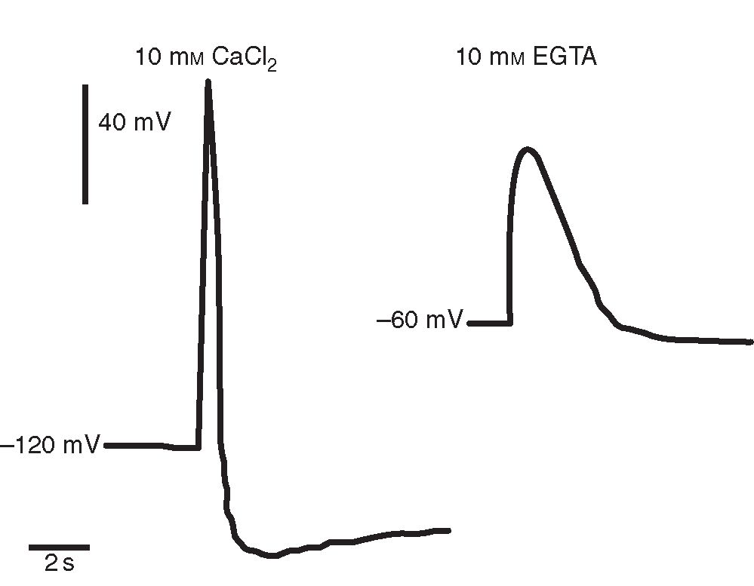
56
Krol et al. — Carnivorous plants: a review
Sibaoka, 1991). The peak AP value increased by 26-28 mV
with a tenfold increase in [Ca2+]ext. Inversely, Ca-ionophores
or chemicals disturbing Ca-homeostasis hamper AP ampli-
tudes, prolong repolarization (Fig. 5; Trebacz et al., 1996;
Krol et al., 2006) and slow down trap closure (Volkov et al.,
2008). Apart from Ca2+, Cl_ ions may also be considered
part of the depolarization phase, which was indirectly revealed
by the use of a Cl_-channel blocker (A9C) (Krol et al., 2006).
In Drosera, APs are generated in the head of tentacles in
response to chemical (Na+, chitin or prey defecation) or mech-
anical (touch) stimulation (Williams and Pickard, 1974). As
little weight as that of a human hair (0.822 mg) is sufficient
to initiate the response; among various chemicals, NaCl,
NH4Cl, urea, amino acids and phosphate are capable of trig-
gering APs in this genus (Luttge, 1983). The APs move
down the stalk of the tentacle at 5 mm s_1, while upward
propagation is twice as fast (Williams and Pickard, 1972a, b;
Williams and Spanswick, 1976). The inner stalk cells (reminis-
cent of the phloem parenchyma) and the outer cells (epider-
mis), both electrically coupled by numerous plasmodesmata,
are responsible for the rapid transmission of APs (Williams
and Pickard, 1974; Williams and Spanswick, 1976). Two suc-
ceeding APs within 1 min are necessary for tentacle movement
and just 1 min later the tentacle has completely curled
(Williams and Pickard, 1972b).
It seems that the first AP facilitates the spread of another
(Sibaoka, 1966; Fromm and Lautner, 2007). The requirement
for two successive APs serves to protect the trap against any
accidental and undesirable stimulation [e.g. by rain, tempera-
ture drops (Krol et al., 2006) or light (Trebacz and Sievers,
- ], and points to the interesting proposition that the
plants (here, Dionaea and Drosera) may possess a kind of
memory which allows them to take action only in response
to the second AP ( plant memory; Trewavas, 2005a, b;
Baluska and Mancuso, 2007; Volkov et al., 2009a). As the
membrane potential returns to its resting value directly after
the passage of the AP, the resting potential cannot act as an
Fig. 5. Action potentials recorded in terminal gland cells after touching a
trigger hair and in the presence of 10 mM CaCl2 (left) or of a calcium chelator
[10 mM EGTA (right)] in the external solution. Note that in the absence of free
calcium ions, not only is the amplitude of the action potential but also the
membrane resting potential are drastically affected.
‘accumulator’ in the memory process. There is also no indi-
cation that the memory is associated in any way with a recep-
tor potential (RP - membrane potential change that precedes
AP but is too small to evoke it) (Jacobson, 1965). Instead,
by analogy to animal nerve systems, a stepwise accumulation
of bioactive substances during successive stimulations of the
trap was suggested (Ueda and Nakamura, 2006; Ueda et al.,
2010).
There is no consensus that APs are involved in movement of
Utricularia bladders (Juniper et al., 1989). Although
Diannelidis and Umrath (1953) reported that electrical stimu-
lation causes the trap to ‘fire', other researchers have been
unable to repeat their results; even though single AP-like
changes were noted, the traps did not fire (Sydenham and
Findlay, 1973, 1975). Although recent findings indirectly
support the mechanical concept of trap triggering (Joyeux
et al., 2011; Vincent et al., 2011), it is tempting to speculate
that APs must be evoked repeatedly - by analogy to snapping
species (Brown, 1916) - to trigger trap movement.
A quite different role is played by APs in the
protocarnivorous Stylidium (Darnowski et al., 2006, 2007),
in that they are a part of its pollination strategy (Findlay,
1978; Findlay and Findlay, 1975, 1981, 1984; Findlay and
Pallaghy, 1978). As they have little to do with its carnivorous
lifestyle, we need not discuss them further at this point.
SECRETION AND ABSORPTION
Darwin (1875) was the first to show that carnivorous plants
secrete their digestive fluid in response to nitrogenous sub-
stances. Among these substances, uric acid (the principal con-
stituent of insect faeces) and glutamine (the major amino acid
of insect haemolymph) turned out to be the most effective eli-
citors of secretion (Robins, 1976). In Dionaea, repetitive elec-
trical or mechanical stimulation evokes enzyme secretion, too
(K. Trebacz and E. Krol, unpubl. res.). Thus, APs can also be
considered as elicitors of secretion. Once stimulated, the gland
cells undergo a cycle of ultrastructural changes generally
divided into two phases, the secretory and the resorptive
(Heslop-Harrison and Heslop-Harrison, 1981). During the
secretory phase, cell wall erodes, plasmalemma becomes less
invaginated and vacuoles shrink ( pointing to their involvement
in enzyme storage and release), but de novo protein synthesis
also takes place (Robins and Juniper, 1980b; McNally et al.,
- . In general, mucilage-secreting cells discharge the
Golgi-originated bodies [Drosera (Outenreath and
Dauwalder, 1982a)], while the exocytosis of digestive
enzymes involves a membrane fusion with storage vesicles
of endoplasmic reticulum (ER) origin [Pinguicula (Vassilyev
and Muravnik, 1988a, b), Genlisea (Plachno et al., 2007),
Drosera (Heslop-Harrison, 1976), Dionaea (Robins and
Juniper, 1980c)]. A split between mucilage- and enzyme-
secreting glands has been reported for Lamiales (Pinguicula,
Utricularia, Byblis) and for some Droseraceae sensu lato
[Drosophyllum (Heslop-Harrison and Knox, 1971; Juniper
et al., 1989; Legendre, 2002a, Plachno et al., 2006)]. On the
other hand, there are reports of glands secreting polysacchar-
ides and proteolytic enzymes at the same time, for example
Pinguicula (Luttge, 1971) and Dionaea (Robins and Juniper,
1980c). Although Pinguicula’s sessile glands were presumed
Downloaded from https://academic.oup.com/aob/article-abstract/109/1/47/152100 by Uniwersytet Jagielloński user on 04 June 2020
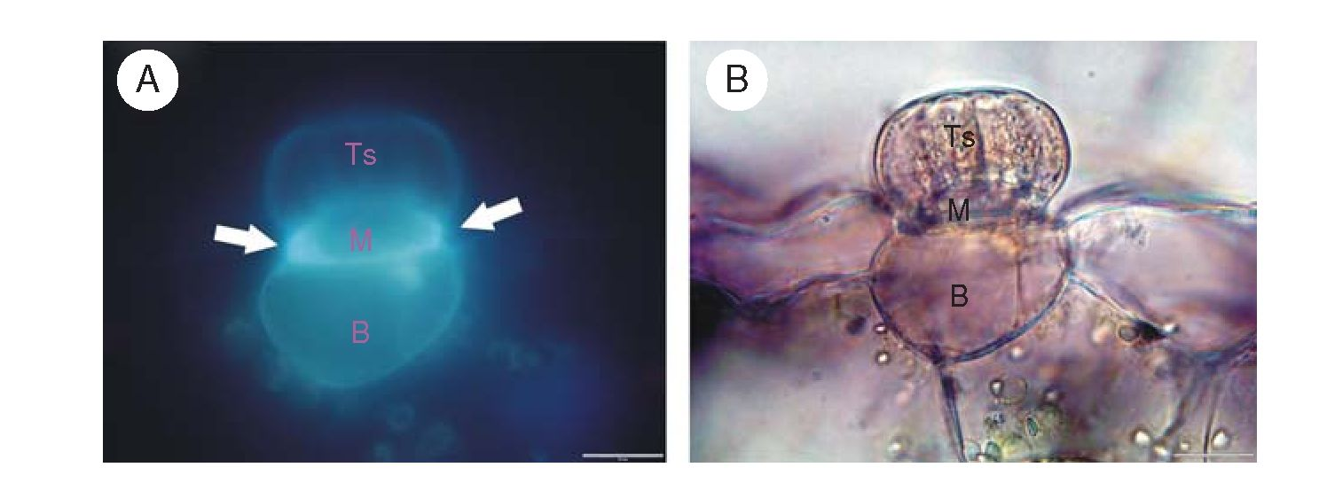
Król et al. — Carnivorous plants: a review
57
to undergo holocrine secretion (Heslop-Harrison, 1975, 1976;
Heslop-Harrison and Heslop-Harrison, 1980, 1981), other
reports clearly showed that these cells display a granulocyte
mode of secretion (Vassilyev and Muravnik, 1988a, b), as in
the case of the other carnivores. By analogy to enzyme
secretion, absorption of nutrients is either constitutive or
needs to be triggered (Rea and Whatley, 1983). Absorption
of nutrients is executed by all gland types (Outenreath and
Dauwalder, 1982b) as well as through any available apertures
in the protecting cuticle (Juniper et al., 1989; Anderson, 2005).
Within any one gland, these two processes may be temporally
(Heslop-Harrison and Heslop-Harrison, 1981) or developmen-
tally (Owen et al., 1999) separated. In Dionaea, secretion pre-
cedes absorption only slightly, and during several-day-long
digestion, both processes happen at the same time (Robins
and Juniper, 1980e). In Nepenthes, too, both processes
coincide after the first successful capture, and a bi-directional
transport of various compounds takes place (Owen et al.,
- . Because for Pinguicula each sessile gland is used
only once, the absorption starts only when the secretion
ends. The absorbed substances migrate through the apoplast
and symplast of the terminal cells (Owen et al., 1999). In
the endodermal layer, they must enter the symplast, which is
an active and selective process. The previously secreted H+
ions now play a direct role in the symport uptake of nitrogen-
ous compounds (Rea and Whatley, 1983). Among these
(ammonium, amino acids, peptides, uric acid) ammonium is
preferred, and ammonium transporters have long been shown
to be highly expressed in the glands (Schulze et al., 1999).
The absorbed material is stored in the small vacuoles, which
persist in an increased number through the whole absorption
phase (Robins and Juniper, 1980e). At the end of the phase,
the cell walls are rebuilt and the glands return to their state
prior to stimulation.
GLAND MORPHOLOGY
The secretory (slime and digestive) glands may be described as
stalk- [Drosera (Fig. 2E), Drosophyllum, Triphyophyllum,
Pinguicula, Byblis, Roridula, Utricularia (Fig. 2F)], sessile-
[Cephalotus (Fig. 2A, B), Drosophyllum, Drosera, Dionaea,
Aldrovanda, Pinguicula, Genlisea and Utricularia] or
sunken-glands [Nepenthes (Fig. 2C, D), Brochinia, Catopsis),
(Juniper et al., 1989). The main role of digestive glands is to
secrete digestive fluids and to absorb nutrients. The special
pitcher epithelium has developed as an alternative in
Sarracenia to perform both these functions (Hepburn et al.,
1920; Joel and Heide-J0rgensen, 1985; Gallie and Chang,
1997). Nevertheless, in Sarracenia purpurea only a small
amount of the fluid is produced by the epithelium and most of
the enzymes come from the pitcher inhabitants (Hepburn and
St. John, 1927; Hepburn et al., 1927; Plummer and Jackson,
1963); in another member of this family, Darlingtonia, the
fluid is rarely secreted (Treat, 1875) or is produced in very
small amounts (Adlassnig et al., 2011; our pers. obs.).
The stalk glands may resemble tentacles, trichomes, arms,
emergences, projections, papillae, bristles or hairs. As for
the sessile or sunken glands, their anatomical structures are
less distinctive as they look like pinheads more or less
embedded into the epidermis (Owen and Lennon, 1999). In
all the types, however, at least three functional compartments
are always present: terminal (secretory), middle (endodermal)
and basal (reservoir) cells (Fig. 6). The terminals of secretory
cells make up the outermost layer of cells, forming a visible
swelling. Within a gland, the number of secretory layers as
well the number of secretory cells in each layer varies: one
(rarely) to four (typically) and up to eight secretory cells
forming one-layered heads in Utricularia and Genlisea,
respectively; two layers of secretory cells in Dionaea and
Aldrovanda; and more than two layers in the large glands of
Nepenthes. The cuticular coat covering the outermost cells is
extremely thin and discontinuous, enabling secretion as well
as absorption (Williams and Pickard, 1974; Joel et al.,
1983). The presence of cuticular material is, nevertheless,
indispensable for the protection of the inside of the traps
from self-digestion and microbial infection. A markedly pro-
truding plasmalemma is a distinct feature of terminal cells.
Thanks to numerous cell-wall ingrowths, the plasma mem-
brane of terminal cells is deeply invaginated. A labyrinthine
structure of the plasmalemma considerably extends the
surface which faces the outer environment. Some secretory
cells are further characterized by abundant pit-fields with
numerous plasmodesmata [Nepenthes (Owen et al., 1999)],
which facilitate fast symplastic connection between terminal
and middle cells [Genlisea (Plachno et al., 2007)]. The plas-
modesmata as well as the labyrinthine ingrowths are laid
down non-randomly, indicating that their distribution and
orientation are precisely controlled (Robins and Juniper,
1980a). The plasmalemma is assisted by many mitochondria,
extended ER and Golgi vesicles, all of which are reminiscent
Fig. 6. Digestive gland anatomy. (A,B) Section through the Pinguicula digestive gland: TS, terminal (secretory) cells; M, middle (stalk) cell with Casparian-like
lateral wall (arrows), auto-fluorescence under UV light; B, basal cell; scale bars = 20 mm.
Downloaded from https://academic.oup.com/aob/article-abstract/109/1/47/152100 by Uniwersytet Jagielloński user on 04 June 2020
58
Krol et al. — Carnivorous plants: a review
of transfer cells (Offler et al., 2003). The large vacuole of
terminal cells (Plachno et al., 2007) usually houses storage
substances which may be used as energy supplies during inten-
sive secretion (Robins and Juniper, 1980b). It may also serve
as a reservoir for digestive enzymes (Schwab et al., 1969)
and osmotically active salts (Heslop-Harrison and
Heslop-Harrison, 1981). Like plasmalemma morphology, the
dynamic status of the vacuoles during secretion/absorption
cycles is carefully monitored (Robins and Juniper, 1980a;
Robins and Juniper, 1980e).
In Utricularia, bifids and quadrifids (Fig. 2F) are unique
examples of terminal cells, in which a highly specialized
regional separation of function occurs (Fineran and Lee, 1975;
Plachno and Jankun, 2004). The arms execute absorption and
secretion in the upper section, while the bottom regions
(stalks) discharge supportive and conductive functions typical
of the middle cells (Fineran and Lee, 1975). In the glandular
organs of the other carnivores, the secretory cells lie over the
highly specialized endodermal middle cells. In these endoder-
mal cells, heavily suberinized cell walls create a barrier for apo-
plastic transport (and also for external solutions) in such a way
that the hydrophobic suberin-like endodermal deposits form a
continuity with epidermal cuticle (Robins and Juniper, 1980a;
Owen and Lennon, 1999). The middle cells are simply ‘a bottle-
neck’ for apoplastic-symplastic exchange. They play a pivotal
role in nutrient uptake as they prevent uncontrolled leakage
between the apoplast and symplast (Fineran and Lee, 1975).
Numerous plasmodesmata between the middle and basal cells
are of vital importance. Their distribution within the gland is not
random, but shows a strong polarity, increasing toward the
inside [Dionaea (Robins and Juniper, 1980a)]. Storing K+ and
Cl_ in their central vacuole, the basal cells are sometimes
called reservoir cells [Pinguicula (Heslop-Harrison and
Heslop-Harrison, 1980)]. The high K+ content in basal cells
points to their osmoregulatory functions linked to the transfer
of different solutes into and out of the traps [Nepenthes
(Osunkoya et al., 2007)]. Beside the large vacuole, the other
cytoplasmic features reflecting the activities of basal cells
include abundant ribosomes, rudimentary plastids and numer-
ous electron-dense vesicles in close proximity to the nucleus
and plasmalemma. The basal layer is either in direct contact
with the conductive vessels (Nepenthes, Pinguicula, Drosera)
or separated from plant vasculature by 2-3 layers of mesophyll
or parenchymal cells (Dionaea, Aldrovanda, Genlisea).
The activity of digestive glands varies depending on trap
type and conditions. In pitfalls, eel-traps, suction-traps and fly-
papers of Pinguicula, Drosophyllum and Drosera they are
characterized by a low constitutive expression of hydrolysing
enzymes, intensified after prey capture (McNally et al.,
- . The terrestrial Dionaea and aquatic Aldrovanda are
two ‘extreme' examples, where secretion of digestive
enzymes commences only after induction (Juniper et al.,
- .
CONCLUSIONS
Despite being of little economic importance, carnivorous
plants have long held a fascination, being among the most
popular plants in cultivation. They still draw the attention of
many scientists as convenient model plants for such topics
as: fast movements (Joyeux et al., 2011), excitability (Krol
et al., 2006; Volkov et al., 2009a, b, 2011), negative excit-
ability-photosynthesis coupling (Pavlovic et al., 2011),
enzyme secretion (Vassilyev, 2005; Rottloff et al., 2009),
nutrient absorption (Plachno et al., 2009), heavy metal phyto-
toxicity (Moody and Green, 2010), food-web relationships
(Butler et al., 2008; Mouquet et al., 2008; Sirova et al.,
2009, 2010, 2011; Gotelli et al., 2011), plasticity and genetic
radiation (Greilhuber et al., 2006; Albert et al., 2010), phylo-
genetic and intergeneric relationships (Rogers et al., 2010;
Rahman, 2010), trade-off assessments (Pavlovic et al.,
2010a), and structural and mineral investment in carnivory
(Guisande et al., 2004, 2007; Adamec, 2008, 2009, 2010b).
Carnivorous species (namely Utricularia) can nowadays be
used as plant indicators for qualifying the degree of surface
water eutrophication (Jennings and Rohr, 2011); such an
approach meets the requirements of the Water Framework
Directive of the European Commission 2000 (Kopec et al.,
2008). Sarracenia spp. are suggested to be the best indicators
of threats from agriculture, over-collection and invasive
species, while Drosera spp. are particularly sensitive to agri-
culture (Jennings and Rohr, 2011). The biological appliance
of carnivore secondary metabolites has also gained in popular-
ity (Goncalves et al., 2008; Krolicka et al., 2008; Eilenberg
et al., 2010; Putalun et al., 2010; Mithofer, 2011). The more
that is learnt about the different taxa, the clearer it becomes
that carnivory is far more common than previously thought.
Because morphological and physiological adaptations to carni-
vorous lifestyles are quite complex (the concurrence of such
abilities as prey attraction and capture, digestion, absorption,
enzyme secretion and nutrient re-utilization), there are a con-
siderable number of plants carrying on ‘subtle’ forms of car-
nivory (Chase et al., 2009; Shaw and Shackleton, 2011).
Thus, plant carnivory still requires a great deal of study, in
terms of both its basic features and its co-evolution with non-
carnivorous traits.
With the use of state-of-the-art approaches such as
large-scale analysis of genes (genomic) and their products
(transcriptomic, proteomic, metabolomic) we have just begun
the journey to a full appreciation of the carnivorous syndrome.
For example, by the means of forward genetics based on a
recognizable phenotypic characteristic, one can search for
genes involved in a trap movement. With the use of reverse
genetics it may be possible to unmask channels involved in
excitation-triggered trapping or AP spread; one can think of
creating a plant line with altered activity of an ion channel
by transgenic methods (over-expressor, knock-out, antisense
or RNA interference). Additionally, certain expression
systems afford one the opportunity of working out the
channel functions in detail (Geiger et al., 2009). Another
approach would be to focus on nutrient transporters, following
their gene expression patterns which vary under distinct nutri-
tive stresses. One could also utilize proteome profiling or
metabolic fingerprinting to trace cellular processes under nutri-
ent limits. The very recent study by Gotelli et al. (2011)
suggests the use of proteomic signatures of Sarracenia pur-
purea inhabitants for monitoring pitcher ecosystem biomass,
health and state. As an entire aquatic food web is harboured
within the traps of this carnivorous plant, the S. purpurea
pitcher ecosystem can be used to model macro ecosystems
Downloaded from https://academic.oup.com/aob/article-abstract/109/1/47/152100 by Uniwersytet Jagielloński user on 04 June 2020
Król et al. — Carnivorous plants: a review
59
such as lakes or dystrophic waters (Gotelli and Ellison, 2006;
Gotelli et al., 2011). The biggest challenge, however, is to
combine all of these approaches to obtain a more complete
picture of carnivorous plants. Finally, any substantial progress
made in our understanding of carnivores must surely lead to
better apprehension of plant biology as a whole.

Note added in proof
The authors encourage the reader to refer to the last chapter
of the recently published book All Flesh is Grass. Plant-
Animal Interrelationships (Adamec, 2011b; Rice, 2011).
ACKNOWLEDGEMENTS
We cordially thank the referees, whose helpful and valuable
comments have greatly improved the manuscript, the director
of the Botanic Garden of the Jagiellonian University Prof.
Bogdan Zemanek for permission to use plants from the
Garden collections, and the gardener Lucyna Kurleto.
Financial support by the Polish Ministry of Education to
K.T. (grant no. N301 464534) and to B.J.P. (grant nos. N304
002536 and N304 220135) is gratefully acknowledged. B.J.P.
acknowledges the support of an award from the Foundation
for Polish Sciences (Start Programme). L.A. was partially sup-
ported by the Research Programme of the Academy of
Sciences of the Czech Republic, AV0Z60050516.
LITERATURE CITED
Adamec L. 1997. Mineral nutrition of carnivorous plants: a review. Botanical
Review 63: 273-299.
Adamec L. 2002. Leaf absorption of mineral nutrients in carnivorous plants
stimulates root nutrient uptake. New Phytologist 155: 89-100.
Adamec L. 2006. Respiration and photosynthesis of bladders and leaves of
aquatic Utricularia species. Plant Biology 8: 765-769.
Adamec L. 2007. Oxygen concentrations inside the traps of the carnivorous
plants Utricularia and Genlisea (Lentibulariaceae). Annals of Botany
100: 849-856.
Adamec L. 2008. Mineral nutrient relations in the aquatic carnivorous plant
Utricularia australis and its involvement in carnivory. Fundamentals in
Applied Limnology 171: 175-183.
Adamec L. 2009. Photosynthetic CO2 affinity of the aquatic carnivorous plant
Utricularia australis (Lentibulariaceae) and its investment in carnivory.
Ecological Research 24: 327-333.
Adamec L. 2010a. Dark respiration of leaves and traps of terrestrial carnivor-
ous plants: are there greater energetic costs in traps? Central European
Journal of Biology 5: 121-124.
Adamec L. 2010b. Mineral cost of carnivory in aquatic carnivorous plants.
Flora 205: 618-621.
Adamec L. 2011a. The comparison of mechanically stimulated and spon-
taneous firings in traps of aquatic carnivorous Utricularia species.
Aquatic Botany 94: 44-49.
Adamec L. 2011b. Part 7: Carnivorous plants: ecophysiological look at plant
carnivory. Why are plants carnivorous? In: Seckbach J, Dubinski Z. eds.
All flesh is grass. Plant-animal interrelationships. Cellular origin, life in
extreme habitats and astrobiology. Dordrecht: Springer Science +
Business Media B. V, 457-492.
Adamec L, Sirova D, Vrba J. 2010a. Contrasting growth effects of prey
capture in two aquatic carnivorous plant species. Fundamentals in
Applied Limnology 176: 153-160.
Adamec L, Sirova D, Vrba J, Rejmankova E. 2010b. Enzyme production in
the traps of aquatic Utricularia spiecies. Biologia 65: 273-278.
Adlassnig W, Peroutka M, Lendl T.2011. Traps of carnivorous pitcher plants
as a habitat: composition of the fluid, biodiversity and mutualistic activi-
ties. Annals of Botany 107: 181-194.
Affolter JM, Olivo RF. 1975. Action potentials in Venus’s-flytraps: long term
observations following the capture of prey. American Midland Naturalist
93: 443-445.
Albert VA, Jobson RW, Michael TP, Taylor DJ. 2010. The carnivorous
bladderwort (Utricularia, Lentibulariaceae): a system inflates. Journal
of Experimental Botany 61: 5-9.
Amagase S. 1972. Digestive enzymes in insectivorous plants. III. Acid pro-
teases in the genus Nepenthes and Drosera peltata. Journal of
Biochemistry 72: 73-81.
An CI, Fukusaki E, Kobayashi A. 2001. Plasma-membrane H+-ATPases are
expressed in pitchers of the carnivorous plant Nepenthes alata Blanco.
Planta 212: 547-555.
An CI, Fukusaki E, Kobayashi A. 2002. Aspartic proteinases are expressed in
pitchers of the carnivorous plant Nepenthes alata Blanco. Planta 214:
661-667.
Anderson B. 2005. Adaptations to foliar absorption of faeces: a pathway in
plant carnivory. Annals of Botany 95: 757-761.
Anderson B, Midgley JJ. 2002. It takes two to tango but three is a tangle:
mutualists and cheaters on the carnivorous plant Roridula. Oecologia
132: 369-373.
Anderson B, Midgley JJ. 2003. Digestive mutualism, an alternate pathway in
plant carnivory. Oikos 102: 221-224.
Anderson B, Midgley JJ. 2007. Density-dependent outcomes in a digestive
mutualism between carnivorous Roridula plants and their associated
hemipterans. Oecologia 152: 115-120.
Antor RJ, Garcia MB. 1995. A new mite-plant association: mites living
amidst the adhesive traps of a carnivorous plant. Oecologia 101: 51-54.
Arber A. 1920. Water plants: a study of aquatic angiosperms. Cambridge:
Cambridge University Press.
Atwater DZ, Butler JL, Ellison AM. 2006. Spatial distribution and impacts
of moth herbivory on Northern pitcher plants. Northeast Naturalist 13:
43-56.
Baluska F, Mancuso S. 2007. Plant neurobiology as a paradigm shift not only
in the plant sciences. Plant Signaling & Behavior 2: 205-207.
Barrera R, Fish D, Machado-Allison CE. 1989. Ecological patterns of
aquatic insects communities in two Heliamphora pitcher-plant species
of the Venezuelan highlands. Ecotropicos 2: 31 -44.
Barthlott W, Porembski S, Fischer E, Gemmel B. 1998. First protozoa-
trapping plant found. Nature 392: 447.
Bennett KF, Ellison AM. 2009. Nectar, not colour, may lure insects to their
death. Biology Letters 5: 469-472.
Benzing DH, Henderson K, Kessel B, Sulak J. 1976. The absorptive
capacities of bromeliad trichomes. American Journal of Botany 63:
1009-1014.
Bern AL. 1997. Studies on nitrogen and phosphorus uptake by the carnivor-
ous bladderwort Utricularia foliosa L. in South Florida wetlands. MSc
thesis, Florida International University, Miami.
Bhattarai GP, Horner JD. 2009. The importance of pitcher size in prey
capture in the carnivorous plant, Sarracenia alata Wood
(Sarraceniaceae). American Midland Naturalist 161: 264-272.
Bohn HF, Federle W. 2004. Insect aquaplaning: Nepenthes pitcher plants
capture prey with the peristome, a fully wettable water-lubricated aniso-
tropic surface. Proceedings of the National Academy of Sciences USA
101: 14138-14143.
Bonhomme V, Gounand I, Alaux C, Jousselin E, Barthelemy D, Gaume L.
2011a. The plant-ant Camponotus schmitzi helps its carnivorous
host-plant Nepenthes bicalcarata to catch its prey. Journal of Tropical
Ecology 27: 15 -24.
Bonhomme V, Pelloux-Prayer H, Jousselin E, Forterre Y, Labat JJ,
Gaume L. 2011b. Slippery or sticky? Functional diversity in the trapping
strategy of Nepenthes carnivorous plants. New Phytologist 191: 545-554.
Brewer JS, Baker DJ, Nero AS, Patterson AL, Roberts RS, Turner LM.
2011. Carnivory in plants as a beneficial trait in wetlands. Aquatic
Botany 94: 62-70.
Bringmann GM, Wenzel M, Bringmann HP, Schlauer J. 2001. Uptake of
the amino acid alanine by digestive leaves: proof of carnivory in the tro-
pical liana Triphyophyllum pelatatum (Dioncophyllaceae). Carnivorous
Plant Newsletter 30: 15 -21.
Bringmann G, Rischer H, Schlauer J, et al. 2002. The tropical liana
Triphyophyllum pelatatum (Dioncophyllaceae): formation of carnivorous
organs is only a facultative prerequisite for shoot elongation. Carnivorous
Plant Newsletter 31: 44-52.
Downloaded from https://academic.oup.eom/aob/article-abstract/109/1/47/152100 by Uniwersytet Jagielloński user on 04 June 2020
60
Król et al. — Carnivorous plants: a review
Brown WH. 1916. The mechanism of movement and the duration of the effect
of stimulation in the leaves of Dionaea. American Journal of Botany 3:
68-90.
Bruzzese B, Bowler R, Massicotte H, Fredeen A. 2010. Photosynthetic light
response in three carnivorous plant species: Drosera rotundifolia,
- capensis and Sarracenia leucophylla. 48: 103-109.
Buckley HL, Miller TE, Ellison AM, Gotelli NJ. 2010. Local- to
continental-scale variation in the richness and composition of an
aquatic food web. Global Ecology and Biogeography 19: 711-723.
Burdon-Sanderson J. 1873. Note on the electrical phenomena which accom-
pany irritation of the leaf of Dionaea muscipula (Venus flytrap).
Proceedings of the Royal Society of London 21: 495-496.
Butler JL, Ellison AM. 2007. Nitrogen cycling dynamics in the carnivorous
northern pitcher plant, Sarracenia purpurea. Functional Ecology 21:
835-843.
Butler JL, Gotelli NJ, Ellison AM. 2008. Linking the brown and green: nutri-
ent transformation and fate in the Sarracenia microsystem. Ecology 89:
898-904.
Chase MW, Christenhusz MJM, Sanders D, Fay MF. 2009. Murderous
plants: Victorian Gothic, Darwin and modern insights into vegetable car-
nivory. Botanical Journal of the Linnean Society 161: 329-356.
Cheek M, Jebb M. 2009. Nepenthes group montanae (Nepenthaceae) in
Indo-China, with N. thai and N. bokor described as new. Kew Bulletin
64: 319-325.
Chia TF, Aung HH, Osipov A, N., Goh NK, Chia LS. 2004. Carnivorous
pitcher plant uses free radicals in the digestion of prey. Redox Report
9: 255-261.
Clarke CM, Bauer U, Lee CiC, Tuen AA, Rembold K, Moran JA. 2009.
Tree shrew lavatories: a novel nitrogen sequestration strategy in a tropical
pitcher plant. Biology Letters 5: 632-635.
Clarke C, Moran JA, Chin L. 2010. Mutualism between tree shrews and
pitcher plants: perspectives and avenues for future research. Plant
Signaling & Behavior 5: 1187-1189.
Darnowski DW, Carroll DM, Ptachno B, Kabanoff E, Cinnamon E. 2006.
Evidence of protocarnivory in triggerplants (Stylidium spp.; Stylidiaceae).
Plant Biology 8: 805-12.
Darnowski DW, Moberly S, Ptachno B. 2007. Triggerplants (Stylidium spp.;
Stylidiaceae): a previously unrecognized genus of carnivorous plants.
Proceedings of the Botany and Plant Biology Joint Congress. Botanical
Society of America. Available at http://www.2007.botanyconference.
org/engine/search/index.php?func=detail & aid=18.
Darwin C. 1875. Insectivorous plants. London: Murray.
Diannelidis T, Umrath K. 1953. Aktionsstrome der Blasen von Utricularia
vulgaris. Protoplasma 42: 58-62.
Eilenberg H, Pnini-Cohen S, Schuster S, Movtchan A, Zilberstein A. 2006.
Isolation and characterization of chitinase genes from pitchers of the car-
nivorous plant Nepenthes khasiana. Journal of Experimental Botany 57:
2775-2784.
Eilenberg H, Pnini-Cohen S, Rahamim Y et al. 2010. Induced production of
antifungal naphthoquinones in the pitchers of the carnivorous plant
Nepenthes khasiana. Journal of Experimental Botany 61: 911-922.
Ellis AG, Midgley JJ. 1996. A new plant-animal mutualism involving a plant
with sticky leaves and a resident hemipteran insect. Oecologia 106:
478-481.
Ellison AM. 2006. Nutrient limitation and stoichiometry of carnivorous plants.
Plant Biology 8: 740-747.
Ellison AM, Farnsworth EJ. 2005. The cost of carnivory for Darlingtonia
californica (Sarraceniaceae): evidence from relationships among leaf
traits. American Journal of Botany 92: 1085-1093.
Ellison AM, Gotelli NJ. 2002. Nitrogen availability alters the expression of
carnivory in the northern pitcher plant, Sarracenia purpurea.
Proceedings of the National Academy of Sciences USA 99: 4409-4412.
Ellison AM, Gotelli NJ. 2009. Energetics, the evolution of carnivorous plants
- Darwin’s ‘most wonderful plants in the world’. Journal of
Experimental Botany 60: 19 -42.
Fabian-Galan G, Salageanu N. 1968. Consideration on the nutrition of
certain carnivorous plants (Drosera capensis and Aldrovanda vesiculosa).
Review Roumain de Biologie, Serie de Botanica 13: 275-280.
Farnsworth EJ, Ellison AM. 2008. Prey availability directly affects physi-
ology, growth, nutrient allocation and scaling relationships among leaf
traits in 10 carnivorous plant species. Journal of Ecology 96: 213-221.
Field C, Mooney H. 1986. The photosynthesis - nitrogen relationship in wild
plants. In: Givnish TJ. ed. On the economy of plant form and function.
Cambridge: Cambridge University Press, 25-55.
Findlay GP. 1978. Movement of the column of Stylidium crassifolium as a
function of temperature. Functional Plant Biology 5: 477 -484.
Findlay GP, Findlay N. 1975. Anatomy and movement of the column in
Stylidium. Functional Plant Biology 2: 597-621.
Findlay GP, Findlay N. 1981. Respiration-dependent movements of the
column of Stylidium graminifolium. Functional Plant Biology 8: 45 -56.
Findlay GP, Pallaghy CK. 1978. Potassium chloride in the motor tissue of
Stylidium. Functional Plant Biology 5: 219 -229.
Findlay N, Findlay GP. 1984. Movement of potassium ions in the motor
tissue of Stylidium. Functional Plant Biology 11: 451-457.
Fineran BA, Lee MSL. 1975. Organization of quadrifid and bifid hairs in the
trap of Utricularia monanthos. Protoplasma 84: 43-70.
Fleischmann A, Wistuba A, McPherson S. 2007. Drosera solaris
(Droseraceae), a new sundew from the Guayana Highlands.
Willdenowia 37: 551-555.
Fleischmann A, Gibson R, Rivadavia F. 2008. Drosera ericgreenii
(Droseraceae), a new species from the fynbos of South Africa. Bothalia
38: 141-159.
Fleischmann A, Rivadavia F. 2009. Utricularia rostrata (Lentibulariaceae), a
new species from the Chapada Diamantina, Brazil. Kew Bulletin 64:
155-159.
Forterre Y, Skotheim JM, Dumais J, Mahadevan L. 2005. How the Venus
flytrap snaps. Nature 433: 421-425.
Frank JH, O’Meara GF. 1984. The bromeliad Catopsis berteroniana traps
terrestrial arthropods but harbours Wyeomyia larvae. Florida
Entomologist 67: 418-424.
Friday LE. 1992. Measuring investment in carnivory: Seasonal and individual
variation in trap number and biomass in Utricularia vulgaris L. New
Phytologist 121: 439-445.
Fromm J, Lautner S. 2007. Electrical signals and their physiological signifi-
cance in plants. Plant Cell Environment 30: 249 -257.
Gaertner M, Konold W, Richardson DM. 2010. Successional changes on a
former tank range in eastern Germany: Does increase of the native grass
species Molinia caerulea cause decline of less competitive Drosera
species? Journal of Nature Conservation 18: 63 -74.
Gallie DR, Chang SC. 1997. Signal transduction in the carnivorous plant
Sarracenia purpurea. Regulation of secretory hydrolase expression
during development and in response to resources. Plant Physiology
115: 1461-1471.
Gebuhr C, Pohlon E, Schmidt AR, Kiisel K. 2006. Development of micro-
algae communities in the phytotelmata of allochthonous populations of
Sarrcenia purpurea (Sarraceniaceae). Plant Biology 8: 849-860.
Geiger D, Scherzer S, Mumm P et al. 2009. Activity of guard cell anion
channel SLAC1 is controlled by drought-stress signaling kinase-
phosphatase pair. Proceedings of the National Academy of Sciences
USA 106: 21425-21430.
Gibson TC, Waller DM. 2009. Evolving Darwin’s ‘most wonderful’ plant:
ecological steps to a snap-trap. New Phytologist 183: 575-587.
Giusto BD, Grosbois V, Fargeas E, Marshall DJ, Gaume L. 2008.
Contribution of pitcher fragrance and fluid viscosity to high prey diversity
in a Nepenthes carnivorous plant from Borneo. Journal ofBioscience 33:
121-136.
Givnish TJ, Burkhardt EL, Happel RE, Weintraub JD. 1984. Carnivory in
the bromeliad Brocchinia reducta, with a cost/benefit model for the
general restriction of carnivorous plants to sunny, moist, nutrient-poor
habitats. American Naturalist 124: 479 -497.
Goncalves S, Romano A. 2005. Micropropagation of Drosophyllum lusitani-
cum (Dewy pine), an endangered West Mediterranean endemic insecti-
vorous plant. Biodiversity Conservation 14: 1071-1081.
Goncalves S, Romano A. 2007. In vitro minimum growth for conservation of
Drosophyllum lusitanicum. Biol Plant 51: 795 -798.
Goncalves S, Goncalves MA, Ameixa O, Nogueira JMF, Romano A. 2008.
Insecticidal activity of leaf extracts from Drosophyllum lusitanicum
against Liriomyza trifolii (Burgess) (Diptera: Agromyzidae). Journal of
Horticultural Science Biotechnology 83: 653-657.
Gorb EV, Gorb SN. 2006. Physicochemical properties of functional surfaces
in pitchers of the carnivorous plant Nepenthes alata Blanco
(Nepenthaceae). Plant Biology 8: 841-848.
Downloaded from https://academic.oup.com/aob/article-abstract/109/1/47/152100 by Uniwersytet Jagielloński user on 04 June 2020
Król et al. — Carnivorous plants: a review
61
Gotelli NJ, Ellison AM. 2006. Food-web models predict species abundances
in response to habitat change. PLoS Biology 4: e324. http://dx.doi.org/10.
1371/journal.pbio.0040324.
Gotelli NJ, Smith AM, Ellison AM, Ballif BA. 2011. Proteomic characteriz-
ation of the major arthropod associates of the carnivorous pitcher plant
Sarracenia purpurea. Proteomics 11: 2354-2358.
Grafe TU, Schöner CR, Kerth G, Junaidi A, Schöner MG. 2011. A novel
resource-service mutualism between bats and pitcher plants. Biology
Letters 7: 436-439.
Gray S, Miller T, Mouquet N, Daufresne T. 2006. Nutrient limitation in
detritus-based microcosms in Sarracenia purpurea. Hydrobiologia 573:
173-181.
Green S, Green TL, Heslop-Harrison Y. 1979. Seasonal heterotrophylly and
leaf gland features in Triphyophyllum (Dioncophyllaceae), a new carni-
vorous plant genus. Botanical Journal of the Linnean Society 78: 99-116.
Greenwood M, Clarke C, Lee CC, Gunsalam A, Clarke RH. 2011. A
unique resource mutualism between the giant Bornean pitcher plant,
Nepenthes rajah, and members of a small mammal community. PLoS
One 6: e21114. http://dx.doi.org/10.1371/journal.pone.0021114.
Greilhuber J, Borsch T, Muller K, Worberg A, Porembski S, Barthlott W.
2006. Smallest angiosperm genomes found in lentibulariaceae, with
chromosomes of bacterial size. Plant Biology 8: 770-777.
Grevenstuk T, Coelho N, Goncalves S, Romano A. 2010. In vitro propa-
gation of Drosera intermedia in a single step. Biol Plant 54: 391-394.
Guisande C, Aranguren N, Andrade-Sossa C et al. 2004. Relative balance of
the cost and benefit associated with carnivory in the tropical Utricularia
foliosa. Aquatic Botany 80: 271-282.
Guisande C, Granado-Lorencio C, Andrade-Sossa C, Duque SR. 2007.
Bladderworts. Functional Plant Science Biotechnology 1: 58-66.
Hajek T, Adamec L. 2010. Photosynthesis and dark respiration of leaves of
terrestrial carnivorous plants. Biologia 65: 69-74.
Hanslin HM, Karlsson PS. 1996. Nitrogen uptake from prey and substrate as
affected by prey capture level and plant reproductive status in four carni-
vorous plant species. Oecologia 106: 370-375.
Hartmeyer I, Hartmeyer S. 2005. Drosera glanduligera: Der Sonnentau mit
‘Schnapp-Tentakeln’. Taublatt 2: 34-38.
Hartmeyer S. 1998. Carnivory in Byblis revised II: The phenomenon of sym-
biosis on insect trapping plants. Carnivorous Plant Newsletter 27:
110-113.
Hepburn JSSt., John EQ. 1927. A bacteriological study of the pitcher liquor
of the Sarraceniaceae. Transactions of the Wagner Free Institute of
Sciences Philadelphia 11: 75-83.
Hepburn JS, Jones FMSt., John E. 1920. The absorption of nutrients and
allied phenomena in the pitchers of the Sarraceniaceae. Journal of the
Franklin Institute 189: 147-184.
Hepburn JSSt., John EQ, Jones FM. 1927. The biochemistry of the
American pitcher plants. Transactions of the Wagner Free Institute of
Sciences Philadelphia 11: 1 -74.
Heslop-Harrison Y. 1975. Enzyme release in carnivorous plants. Frontiers in
Biology 43: 525-578.
Heslop-Harrison Y. 1976. Enzyme secretion and digest uptake in carnivorous
plants. In: Sunderland N. ed. Perspectives in experimantal biology 2:
Botany. Oxford: Pergamon Press, 463-476.
Heslop-Harrison Y, Heslop-Harrison J. 1980. Chloride ion movement and
enzyme secretion from the digestive glands of Pinguicula. Annals of
Botany 45: 729-731.
Heslop-Harrison Y, Heslop-Harrison J. 1981. The digestive glands of
Pinguicula: structure and cytochemistry. Annals of Botany 47: 293-319.
Heslop-Harrison Y, Knox RB. 1971. A cytochemical study of the leaf-gland
enzymes of insectivorous plants of the genus Pinguicula. Planta 96:
183-211.
Hess S, Frahm JP, Theisen I. 2005. Evidence of zoophagy in a second liver-
wort species, Pleurozia purpurea. Bryologist 108: 212-218.
Hodick D, Sievers A. 1986. The influence of Ca2+ on the action potential in
mesophyll cells of Dionaea muscipula Ellis. Protoplasma 133: 83-84.
Hodick D, Sievers A. 1988. The action potential of Dionaea muscipula Ellis.
Planta 174: 8-18.
Hodick D, Sievers A. 1989. On the mechanism of trap closure of Venus
flytrap (Dionaea muscipula Ellis). Planta 179: 32-42.
Iijima T, Hagiwara S. 1987. Voltage-dependent K channels in protoplasts of
trap-lobe cells of Dionaea muscipula. Journal of Membrane Biology 100:
73-81.
Iijima T, Sibaoka T. 1981. Action potentials in the trap-lobes of Aldrovanda
vesiculosa. Plant Cell Physiology 22: 1595-1601.
Iijima T, Sibaoka T. 1982. Propagation of action potentials over the trap-lobes
of Aldrovanda vesiculosa. Plant Cell Physiology 23: 679-688.
Iijima T, Sibaoka T. 1983. Movements of K+ during shutting and opening of
the trap-lobes in Aldrovanda vesiculosa. Plant Cell Physiology 24:
51 -60.
Iijima T, Sibaoka T. 1985. Membrane potentials in excitable cells of
Aldrovanda vesiculosa trap-lobes. Plant Cell Physiology 26: 1-13.
Jacobson SL. 1965. Receptor response in Venus’s fly-trap. Journal of General
Physiology 49: 117-129.
Jaffe K, MicheIangeli F, Gonzalez JM, Miras B, Ruiz MC. 1992. Carnivory
in pitcher plants of the genus Heliamphora (Sarraceniaceae). New
Phytologist 122: 733-744.
Jang G-W, Kim K-S, Park R-D. 2003. Micropropagation of Venus fly trap by
shoot culture. Plant Cell Tissue Organ Culture 72: 95-98.
Jennings DE, Rohr JR. 2011. A review of the conservation threats to carni-
vorous plants. Biological Conservation 144: 1356-1363.
Jobson RW, Nielsen R, Laakkonen L, Wikstrom M, Albert VA. 2004.
Adaptive evolution of cytochrome c oxidase: infrastructure for a carnivor-
ous plant radiation. Proceedings of the National Academy of Sciences
USA 101: 18064-18068.
Joel DM, Heide-Jprgensen HS. 1985. Ultrastructure and development of the
pitcher epithelium of Sarracenia. Israel Journal of Botany 34: 331-349.
Joel DM, Rea PA, Juniper BE. 1983. The cuticle of Dionaea muscipula Ellis
(Venus’s Flytrap) in relation to stimulation, secretion and absorption.
Protoplasma 114: 44-51.
Jolivet P. 1998. Interrelationship between insects and plants. London: CRC
Press.
Joyeux M, Vincent O, Marmottant P. 2011. Mechanical model of the ultra-
fast underwater trap of Utricularia. Physics Review E 83: 021911. http://
dx.doi.org/10.1103/PhysRevE.83.021911.
Juniper BE, Robins RJ, Joel DM. 1989. The carnivorous plants. London:
Academic Press.
JUrgens A, El-Sayed AM, Suckling DM. 2009. Do carnivorous plants use
volatiles for attracting prey insects? Functional Ecology 23: 875-887.
Karlsson PS. 1988. Seasonal patterns of nitrogen, phosphorus and potassium
utilization by three Pinguicula species. Functional Ecology 2: 203-209.
Kibriya S, Jones JI. 2007. Nutrient availability and the carnivorous habit in
Utricularia vulgaris. Freshwater Biology 52: 500-509.
Knight SE. 1992. Costs of carnivory in the common bladderwort, Utricularia
macrorhiza. Oecologia 89: 348-355.
Knight SE, Frost TM. 1991. Bladder control in Utricularia macrorhiza: lake-
specific variation in plant investments in carnivory. Ecology 72:
728-734.
Koopman MM, Fuselier DM, Hird S, Carstens BC. 2010. The carnivorous
pale pitcher plant harbors diverse, distinct, and time-dependent bacterial
communities. Applied Environmental Microbiology 76: 1851-1860.
Kopec D, Dałkowski R, Urbaniak P. 2008. Using macrophytes as trophic
state indicators in upland river waters: a case study of the Czarna
Maleniecka River. International Journal of Oceanography and
Hydrobiology 39: 1-8.
Koselski M, Trebacz K, Dziubińska H, Krol E. 2008. Light- and
dark-induced action potentials in Physcomitrella patens. Plant Signal
Behaviour 3: 13 -18.
Krolicka A, Szpitter A, Gilgenast E, Romanik G, Kaminski M, Lojkowska
- 2008. Stimulation of antibacterial naphthoquinones and flavonoids
accumulation in carnivorous plants grown in vitro by addition of elicitors.
Enzyme and Microbial Technology 42: 216 -221.
Krol E, Dziubmska H, Stolarz M, Trebacz K. 2006. Effects of ion channel
inhibitors on cold- and electrically-induced action potentials in Dionaea
muscipula. Biologia Plantarum 50: 411-416.
Laakkonen L, Jobson RW, Albert VA. 2006. A new model for the evolution
of carnivory in the bladderwort plant (Utricularia): Adaptive changes in
cytochrome c oxidase (COX) provide respiratory power. Plant Biology 8:
758-764.
Lavarack PS. 1979. Rainforest Drosera of north Queensland. Carnivorous
Plant Newsletter 8: 61 -62.
Lee CC, McPherson S, Bourke G, Mansur M. 2009. Nepenthes pitopangii
(Nepenthaceae), a new specie from central Sulawesi, Indonesia. Gardens'
Bulletin Singapore 61: 95-100.
Legendre L. 2002a. The genus Pinguicula L (Lentibulariaceae): an overview.
Acta Botanica Gallica 141: 77-95.
Downloaded from https://academic.oup.eom/aob/article-abstract/109/1/47/152100 by Uniwersytet Jagielloński user on 04 June 2020
62
Krol et al. — Carnivorous plants: a review
Legendre L. 2002b. The genus Pinguicula L. (Lentibulariaceae): an overview.
Acta Botanica Gallica 141: 77 -95.
Lichtner FT, Williams SE. 1977. Prey capture and factors controlling trap
narrowing in Dionaea (Droseraceae). American Journal of Botany 64:
881-886.
Lloyd FE. 1929. The mechanism of the water tight door of the Utricularia
trap. Plant Physiology 4: 87-102.
Lloyd FE. 1942. The carnivorous plants. New York: The Ronald Press
Company.
Luttge U. 1971. Structure and function of plant glands. Annual Review of
Plant Physiology 22: 23-44.
Luttge U. 1983. Ecophysiology of carnivorous plants. In: Lange OL, Nobel
PS, Osmond CB, Ziegler H. eds. Encyclopedia of Plant Physiology: III
physiological plant ecology responses to the chemical and biological
environment. Berlin: Springer, 489-517.
Marburger JE. 1979. Glandular leaf structure of Triphyophyllum peltatum
(Dioncophyllaceae): a ‘fly-paper’ insect trapper. American Journal of
(BDoitoanncyo6p6h:yl4l0ac4e-a4e1):1.a ‘fly-paper’ insect trapper. American Journal of
Marmottant P, Vincent O, Quilliet C. 2009. Study of the ultrafast trap of an
aquatic carnivorous plant. In: Thibant B. ed. Proceedings of the Plant
Biomechanics Conference 16-20 Nov. 2009. Cayenne, French Guiana,
Book of Abstracts. French Guyana: UMR EcoFoG, 170-175.
Matusikova I, Salaj J, Moravcikova J, Mlynarova L, Nap J-P, Libantova J.
2005. Tentacles of in vitro-grown round-leaf sundew (Drosera rotundifo-
lia L.) show induction of chitinase activity upon mimicking the presence
of prey. Planta 222: 1020-1027.
McNally SF, Steward A, Wilson UE. 1988. The stimulation of acid phospha-
tase activity in the stalk gland of Drosera rotundifolia. Annals of Botany
61: 289-292.
McPherson S. 2009. Pitcher plants of the Old World. Poole: Redfern Natural
History Productions Ltd.
Merbach MA, Merbach DJ, Maschwitz U, Booth WE, Fiala B, Zizka G.
2002. Carnivorous plants: mass march of termites into the deadly trap.
Nature 415: 36-37.
Midgley JJ, Stock WD. 1998. Natural abundance of 815N confirms insectivor-
ous habit of Roridula gorgonias, despite it having no proteolytic enzymes.
Annals of Botany 82: 387-388.
Mithofer A. 2011. Carnivorous pitcher plants: insights in an old topic.
Phytochemistry 72: 1678-1682.
Moody C, Green ID. 2010. Assimilation of Cd and Cu by the carnivorous
plant Sarracenia leucophylla Raf. fed contaminated prey.
Environmental Science and Technology 44: 1610 -1616.
Moran JA. 1996. Pitcher dimorphism, prey composition and the mechanisms
of prey attraction in the pitcher plant Nepenthes rafflesiana in Borneo.
Journal of Ecology 84: 515 -525.
Moran JA, Clarke CM. 2010. The carnivorous syndrome in Nepenthes
pitcher plants: current state of knowledge and potential future directions.
Plant Signaling & Behavior 5: 644-648.
Moran JA, Booth WE, Charles JK. 1999. Aspects of pitcher morphology
and spectral characteristics of six Bornean Nepenthes pitcher plant
species: implications for prey capture. Annals of Botany 83: 521-528.
Moran JA, Clarke CM, Hawkins BJ. 2003. From carnivore to detritivore?
Isotopic evidence for leaf litter utilization by the tropical pitcher plant
Nepenthes ampullaria. Internataional Journal of Plant Science 164:
635-639.
Mouquet N, Daufresne T, Gray SM, Miller TE. 2008. Modelling the
relationship between a pitcher plant (Sarracenia purpurea) and its phyto-
telma community: mutualism or parasitism? Functional Ecology 22:
728 -737.
Offler CE, McCurdy DW, Patrick JW, Talbot MJ. 2003. Transfer cells:
cells specialized for a special purpose. Annual Review of Plant Biology
54: 431-454.
Osunkoya OO, Daud SD, Di-Giusto B, Wimmer FL, Holige TM. 2007.
Construction costs and physico-chemical properties of the assimilatory
organs of Nepenthes species in Northern Borneo. Annals of Botany 99:
895-906.
Outenreath R, Dauwalder M. 1982a. Ultrastructural and radioautographic
studies of the digestive gland cells of Drosera capensis:
I. Development and mucilage secretion. J Ultra Mol Str Res 80: 71 -88.
Outenreath R, Dauwalder M. 1982b. Ultrastructural and radioautographic
studies of the digestive gland cells of Drosera capensis: II. Changes
induced by stimulation. Journal of Ultrastructure and Molecular
Structure Research 80: 164-174.
Owen TPJr, Lennon KA. 1999. Structure and development of the pitchers
from the carnivorous plant Nepenthes alata (Nepenthaceae). American
Journal of Botany 86: 1382-1390.
Owen TPJr, Lennon KA, Santo MJ, Anderson AN. 1999. Pathways for
nutrient transport in the pitchers of the carnivorous plant Nepenthes
alata. Annals of Botany 84: 459 -466.
Pavlovic A, Masarovicova E, Hudak J. 2007. Carnivorous syndrome in
Asian pitcher plants of genus Nepenthes. Annals ofBotany 100: 527 -536.
Pavlovic A, Demko V, Hudak J. 2010a. Trap closure and prey retention in
Venus flytrap (Dionaea muscipula) temporarily reduces photosynthesis
and stimulates respiration. Annals of Botany 105: 37-44.
Pavlovic A, Singerova L, Demko V, Santrucek J, Hudak J. 2010b. Root
nutrient uptake enhances photosynthetic assimilation in prey-deprived
carnivorous pitcher plant Nepenthes talangensis. Photosynthetica 48:
227-233.
Pavlovic A, Slovakova L, Pandolfi C, Mancuso S. 2011. On the mechanism
underlying photosynthetic limitation upon trigger hair irritation in the car-
nivorous plant Venus flytrap (Dionaea muscipula Ellis). Journal of
Experimental Botany 62: 1991-2000.
Peroutka M, Adlassnig W, Volgger M, Lendl T, Url W, Lichtscheidl I.
2008. Utricularia : a vegetarian carnivorous plant? Plant Ecology 199:
153-162.
Peterson CN, Day S, Wolfe BE, Ellison AM, Kolter R, Pringle A. 2008. A
keystone predator controls bacterial diversity in the pitcher-plant
(Sarracenia purpurea) microecosystem. Environmental Microbiology
10: 2257-2266.
Płachno BJ, Jankun A. 2004. Transfer cell wall architecture in secretory hairs
of Utricularia intermedia. Acta Biologica Crecoviensia Series Botanica
46: 193-200.
Płachno B, Jankun A. 2005. Phosphatase activity in glandular structures of
carnivorous plant traps. International Botanical Congress. Vienna,
Austria, P1716. Abstracts p. 510, http://fyziologia.sav.sk/geophyte-
colchicum/fran/papers/IBC2005.pdf.
Płachno BJ, Wołowski K. 2008. Algae commensals community in Genlisea
traps. Acta Societatis Botanicorum Poloniae 1: 77-86.
Płachno BJ, Adamus K, Faber J, Kozłowski J. 2005a. Feeding behaviour of
carnivorous Genlisea plants in the laboratory. Acta Botanica Gallica 152:
159 - 164.
Płachno BJ, Faber J, Jankun A. 2005b. Cuticular discontinuities in glandular
hairs of Genlisea St.-Hil. in relation to their functions. Acta Botanica
Gallica 152: 125-130.
Płachno BJ, Adamec L, Lichtscheidl IK, Peroutka M, Adlassnig W, Vrba
J. 2006. Fluorescence labelling of phosphatase activity in digestive glands
of carnivorous plants. Plant Biology 8: 813 -820.
Płachno BJ, Adamec L, Huet H. 2009. Mineral nutrient uptake from prey and
glandular phosphatase activity as a dual test of carnivory in semi-desert
plants with glandular leaves suspected of carnivory. Annals of Botany
104: 649-54.
Płachno BJ, Kozieradzka-Kiszkurno M, Swiątek P. 2007. Functional utras-
tructure of Genlisea (Lentibulariaceae) digestive hairs. Annals of Botany
t1r0u0c:tu1r9e5o-f2G0e3n. lisea (Lentibulariaceae) digestive hairs. Annals of Botany
Plummer GL, Jackson TH. 1963. Bacterial activities within the sarcophagus
of the insectivorous plant Sarracenia flava. American Midland Naturalist
69: 462-469.
Poppinga S, Koch K, Bohn HF, Barthlott W. 2010. Comparative and func-
tional morphology of hierarchically structured anti-adhesive surfaces in
carnivorous plants and kettle trap flowers. Functional Plant Biology 37:
952-961.
Putalun W, Udomsin O, Yusakul G, Juengwatanatrakul T, Sakamoto S,
Tanaka H. 2010. Enhanced plumbagin production from in vitro cultures
of Drosera burmanii using elicitation. Biotechnology Letters 32:
721-724.
Rahman MO. 2010. Use of Random PCR (RAPD) technology to analyze sys-
tematic relationships in terrestrial bladderworts (Utricularia L.).
Bangladesh Journal of Botany 39: 97-102.
Ratsirarson J, Silander JA. 1996. Structure and dynamics in Nepenthes
madagascariensis pitcher plant micro-communities. Biotropica 28:
218-227.
Rea PA, Whatley FR. 1983. The influence of secretion elicitors and external
pH on the kinetics of D-alanine uptake by the trap lobes of Dionaea mus-
cipula Ellis (Venus’s Flytrap). Planta 158: 312-319.
Rice BA. 2007. The Carnivorous Plant FAQ v. 11.5. http://www.sarracenia.
com/faq/faq5250.html.
Downloaded from https://academic.oup.com/aob/article-abstract/109/1/47/152100 by Uniwersytet Jagielloński user on 04 June 2020
Król et al. — Carnivorous plants: a review
63
Rice BA. 2011. Part 7: Carnivorous plants: reversing the roles of predator and
prey. A review of carnivory in the botanical world. In: Seckbach J,
Dubinski Z. eds. All flesh is grass. Plant-animal interrelationships.
Cellular origin, life in extreme habitats and astrobiology. Dordrecht:
Springer Science + Business Media B. V., 493-518.
Richards J. 2001. Bladder function in Utricularia purpurea
(Lentibulariaceae): is carnivory important? American Journal of Botany
88: 170-176.
Rischer H, Hamm A, Bringmann G. 2002. Nepenthes insignis uses a
C2-portion of the carbon skeleton of L-alanine acquired via its carnivor-
ous organs, to build up the allelochemical plumbagin. Phytochemistry 59:
603-609.
Robins RJ. 1976. The nature of the stimuli causing digestive juice secretion in
Dionaea muscipula Ellis (Venus’s flytrap). Planta 128: 263-265.
Robins RJ, Juniper BE. 1980a. The secretory cycle of Dionaea muscipula
Ellis. I. The fine structure and the effects of stimulation on the fine struc-
ture of the digestive gland cells. New Phytologist 86: 279-296.
Robins RJ, Juniper BE. 1980b. The secretory cycle of Dionaea muscipula
Ellis. II. Storage and the synthesis of the secretory proteins. New
Phytologist 86: 297 -311.
Robins RJ, Juniper BE. 1980c. The secretory cycle of Dionaea muscipula
Ellis. III. The mechanism of the release of digestive secretion. New
Phytologist 86: 313-327.
Robins RJ, Juniper BE. 1980d. The secretory cycle of Dionaea muscipula
Ellis. IV. The enzymology of the secretion. New Phytologist 86:
401-412.
Robins RJ, Juniper BE. 1980e. The secretory cycle of Dionaea muscipula
Ellis. V. The absorption of nutrients. New Phytologist 86: 413-422.
Robinson AS, Fleischmann AS, McPherson SR, Heinrich VB, Gironella
EP, Nefia CQ. 2009. A spectacular new species of Nepenthes
L. (Nepenthaceae) pitcher plant from central Palawan, Philippines.
Botanical Journal of the Linnean Society 159: 195-202.
Rogers W, Cruse-Sanders J, Determann R, Malmberg R. 2010.
Development and characterization of microsatellite markers in
Sarracenia L. (pitcher plant) species. Conservation Genetics Resource
2: 75-79.
Rottloff S, Müller U, Kilper R, Mithofer A. 2009. Micropreparation of
single secretory glands from the carnivorous plant Nepenthes. Annals of
Biochemistry 394: 135-137.
Sanders D. 2009/2010. Behind the curtain: Treat and Austin’s contributions to
Darwin’s work on insectivorous plants and subsequent botanical studies.
Jahrbuch Europaische Wissenschaftskultur 5: 285-298.
Sasago A, Sibaoka T. 1985a. Water extrusion in the trap bladders of
Utricularia vulgaris. I. A possible pathway of water across bladder
wall. Journal of Plant Research 98: 55 -66.
Sasago A, Sibaoka T. 1985b. Water extrustion in the trap bladders of
Utricularia vulgaris. II. A possible mechanism of water outfow.
Journal of Plant Research 98: 113 -124.
Schaefer HM, Ruxton GD. 2008. Fatal attraction: carnivorous plants roll out
the red carpet to lure insects. Biology Letters 4: 153 -155.
Schulze W, Frommer WB, Ward JM. 1999. Transporters for ammonium,
amino acids and peptides are expressed in pitchers of the carnivorous
plant Nepenthes. Plant Journal 17: 637-646.
Schulze W, Schulze ED, Schulze I, Oren R. 2001. Quantification of insect
nitrogen utilization by the venus fly trap Dionaea muscipula catching
prey with highly variable isotope signatures. Journal of Experimental
Botany 52: 1041-1049.
Schwab DW, Simmons E, Scala J. 1969. Fine structure changes during func-
tion of the digestive glands of Venus’s flytrap. American Journal of
Botany 56: 88-100.
Shaw PJ, Shackleton K. 2011. Carnivory in the teasel Dipsacus fullonum -
the effect of experimental feeding on growth and seed set. PLoS One 6:
e17935. http://dx.doi.org/10.1371/journal.pone.0017935
Sibaoka T. 1966. Action potentials in plant organs. Symposia of the Society of
Experimental Biology 20: 49-74.
Sibaoka T. 1991. Rapid plant movements triggered by action potentials.
Journal of Plant Research 104: 73 -95.
Sirova D, Adamec L, Vrba J. 2003. Enzymatic activities in traps of four
aquatic species of the carnivorous genus Utricularia. New Phytologist
159: 669-675.
Sirova D, Borovec J, Cerna B, Rejmankova E, Adamec L, Vrba J. 2009.
Microbial community development in the traps of aquatic Utricularia
species. Aquatic Botany 90: 129-136.
Sirova D, Borovec J, Santruckova H, Santrucek J, Vrba J, Adamec L.
2010. Utricularia carnivory revisited: plants supply photosynthetic
carbon to traps. Journal of Experimental Botany 61: 99-103.
Sirova D, Borovec J, Picek T, Adamec L, Nedbalova L, Vrba J. 2011.
Ecological implications of organic carbon dynamics in the traps of
aquatic carnivorous Utricularia plants. Functional Plant Biology 38:
583-593.
Skotheim JM, Mahadevan L. 2005. Physical limits and design principles for
plant and fungal movements. Science 308: 1308-1310.
Souza PCB, Bove CP. 2011. A new species of Utricularia (Lentibulariaceae)
from Chapada dos Veadeiros (Central Brazil). Systematic Botany 36:
465-469.
Steinhauser G, Adlassnig W, Peroutka M et al. 2007. Application of radio-
tracers in an exotic field of botany: how to feed carnivorous plants.
Journal of Radioanal and Nuclear Chemistry 274: 403 -409.
Stewart CNJr, Nilsen ET. 1993. Responses of Drosera capensis and
D. binata var. multifida (Droseraceae) to manipulations of insect avail-
ability and soil nutrient levels. New Zealand Journal of Botany 31:
385-390.
Studnicska M. 1996. Several ecophysiological observations in Genlisea.
Carnivorous Plant Newsletter 25: 14-16.
Suksathan P, Parnell JAN. 2010. Three new species and two new records of
Utricularia L. (Lentibulariaceae) from Northern Thailand. Thailand
Forestry Bulletin 38: 23-32.
Sydenham PH, Findlay GP. 1973. The rapid movement of the bladder of
Utricularia spp. Australian Journal of Biological Science 26:
1115-1126.
Sydenham PH, Findlay GP. 1975. Transport of solutes and water by resetting
bladders of Utricularia. Australian Journal of Plant Physiology 2:
335-351.
Slesak E. 2002. The effects of jasmonic acid on nastic movements in Dionaea
muscipula and Drosera capensis. Cell Molecular Biology Letters 7: 334.
Thoren LM, Tuomi J, Kamarainen T, Laine K. 2003. Resource availability
affects investment in carnivory in Drosera rotundifolia. New Phytologist
a1f5f9e:ct5s0i7n-ve5s1t1m.ent in carnivory in Drosera rotundifolia. New Phytologist
Thurston EL, Seabury F. 1975. A scanning electron microscopic study of the
utricle trichomes in Utricularia biflora Lam. Botanical Gazette 136:
87-93.
Treat M. 1875. Plants that eat animals. American Naturalist 9: 658 -662.
Treat M. 1876. Is the valve of Utricularia sensitive? Harpers New Monthly
Magazine 52: 382-387.
Trewavas A. 2005a. Green plants as intelligent organisms. Trends in Plant
Science 10: 413-419.
Trewavas A. 2005b. Plant intelligence. Naturwissenschaften 92: 401 -413.
Trebacz K, Sievers A. 1998. Action potentials evoked by light in traps of
Dionaea muscipula Ellis. Plant Cell Physiology 39: 369-372.
Trebacz K, Busch MB, Hejnowicz Z, Sievers A. 1996. Cyclopiazonic acid
disturbs the regulation of cytosolic calcium when repetitive action poten-
tials are evoked in Dionaea traps. Planta 198: 623 -626.
Trebacz K, Dziubinska H, Krol E. 2006. Eletrical signals in long-distance
communication in plants. In: Baluska F, Mancuso S, Volkmann D. eds.
Communication in plants. Berlin: Springer-Verlag, 277 -290.
Ueda M, Nakamura Y. 2006. Metabolites involved in plant movement and
‘memory’: nyctinasty of legumes and trap movement in the Venus
flytrap. Nat Prod Rep 23: 548-557.
Ueda M, Tokunaga T, Okada M et al. 2010. Trap-closing chemical factors of
the Venus Flytrap (Dionaea muscipulla Ellis). ChemBioChem 11:
2378-2383.
Vassilyev AE. 2005. Dynamics of ultrastructural characters of Drosophyllum
lusitanicum (Droseraceae) link digestive glands during maturation and
after stimulation. Taiwania 50: 167-182.
Vassilyev AE, Muravnik LE. 1988a. The ultrastructure of the digestive
glands in Pinguicula vulgaris L. (Lentibulariaceae) relative to their
function. I. The changes during maturation. Annals of Botany 62:
329-341.
Vassilyev AE, Muravnik LE. 1988b. The ultrastructure of the digestive
glands in Pinguicula vulgaris L. (Lentibulariaceae) relative to their func-
tion. II. The changes on stimulation. Annals of Botany 62: 343 -351.
Vincent O, Roditchev I, Marmottant P. 2011. Spontaneous firings of carni-
vorous aquatic Utricularia traps: temporal patterns and mechanical oscil-
lations. PLoS One 6: e20205. http://dx.doi.org/10.1371/journal.pone
.0020205.
Downloaded from https://academic.oup.com/aob/article-abstract/109/1/47/152100 by Uniwersytet Jagielloński user on 04 June 2020
64
Król et al. — Carnivorous plants: a review
Voigt D, Gorb S. 2010. Desiccation resistance of adhesive secretion in the
protocarnivorous plant Roridula gorgonias as an adaptation to period-
ically dry environment. Planta 232: 1511 -1515.
Volkov AG, Adesina T, Markin VS, Jovanov E. 2008. Kinetics and mechan-
ism of Dionaea muscipula trap closing. Plant Physiology 146: 694-702.
Volkov AG, Carrell H, Baldwin A, Markin VS. 2009a. Electrical memory in
Venus flytrap. Bioelectrochemistry 75: 142-147.
Volkov AG, Carrell H, Markin VS. 2009b. Molecular electronics of the
Dionaea muscipula trap. Plant Signaling & Behavior 4: 353-354.
Volkov AG, Pinnock MR, Lowe DC, Gay MS, Markin VS. 2011. Complete
hunting cycle of Dionaea muscipula: consecutive steps and their electri-
cal properties. Journal of Plant Physiology 168: 109-120.
Wells K, Lakim MB, Schulz S, Ayasse M. 2011. Pitchers of Nepenthes rajah
collect faecal droppings from both diurnal and nocturnal small mammals
and emit fruity odour. Journal of Tropical Ecology 27: 347-353.
Williams SE, Pickard BG. 1972a. Properties of action potentials in Drosera
tentacles. Planta 103: 222-240.
Williams SE, Pickard BG. 1972b. Receptor potentials and action potentials in
Drosera tentacles. Planta 103: 193-221.
Williams SE, Pickard BG. 1974. Connections and barriers between cells
of Drosera tentacles in relation to their electrophysiology. Planta 116:
1 -16.
Williams S, Spanswick R. 1976. Propagation of the neuroid action potential
of the carnivorous plant Drosera. Journal of Comparative Physiology
108: 211-223.
Zamora R, Gomez JM, Hodar JA. 1998. Fitness responses of a carnivorous
plant in contrasting ecological scenarios. Ecology 79: 1630-1644.
Zamudio S, Olvera M. 2009. A new species of Utricularia (Lentibulariaceae)
from Guerrero, Mexico. Brittonia 61: 119-125.
Downloaded from https://academic.oup.com/aob/article-abstract/109/1/47/152100 by Uniwersytet Jagielloński user on 04 June 2020

