
Signature:©PolJRadiol,2011;76(1):63-67
ORIGINALARTICLE
Uppergastrointestinaltractscintigraphyand
Received:2010.05.26
Accepted:2010.09.29
ultrasonographyindiagnosisofgastroesophagealrefluxinchildren
BogumiłaElbl1,BożenaBirkenfeld1,AnnaWalecka2,JadwigaSzymanowicz3,MariaListewnik1,AleksandraGwardyś1,TomaszUrasiński3
1DepartmentofNuclearMedicine,PomeranianMedicalUniversityinSzczecin,Szczecin,Poland
2DepartmentofDiagnosticImagingandInterventionalRadiology,PomeranianMedicalUniversityinSzczecin,Szczecin,
Poland
3DepartmentofPediatrics,HematologyandOncology,PomeranianMedicalUniversityinSzczecin,Szczecin,Poland

Author’saddress:BogumiłaElbl,DepartmentofNuclearMedicine,PomeranianMedicalUniversityinSzczecin,UniiLubelskiej1Str.,71-252Szczecin,Poland,e-mail:bmselbl@wp.pl
Summary
Gastroesophagealreflux(GER)isoneofthemostcommongastrointestinaltractdisordersbothinadultsandchildren.Thestudywasundertakentoassesstheusefulnessofgastrointestinaluppertract(GUT)scintigraphyandGUTultrasonographyindetectionofGERinchildren.
Theinvestigatedgroupcomprisedof76children,aged1-204months(mean74months)withclinicalsignsandsymptomsofGER.AllofthemunderwentGUTscintigraphy,and42childrenhadalsoGUTultrasonography.
GUTscintigraphyconfirmedrefluxin60/76children(78.9%),GUTultrasonography-in17/42children(40.5%).Airwaystractaspirationwasdetectedinonechild.
ScintigraphywasfoundtobeaveryusefulmethodindetectionofGER,asitconfirmedthepresenceofGERinmostofthechildrenwithsignsandsymptomssuggestiveofGER.Italsoallowsfor the detection ofairways tract aspiration. GUTultrasonography showed a lowersensitivity.Bothinvestigationsaresimple,noninvasive,notchangingthephysiologyofthegastrointestinaltractandcanbeperformedinout-patientconditions.
Background:
Material/Methods:
Results:
Conclusions:
Keywords:
gastroesophagealreflux•gastrointestinaltractscintigraphy•gastrointestinaltractultrasonography•children
PDFfile:
http://www.polradiol.com/fulltxt.php?ICID=881411
Background
Diagnosticsofthegastrointestinalrefluxisnotalwaysrequired.Veryoften,thediagnosiscanbebasedontypicalclinicalsymptoms.Onlyafterintroducingapropertreat-ment,ifthereisnotherapeuticeffect,thepatientshouldbereferredfordiagnostictests.Diagnosticsisrequiredincaseswithsymptomssuggestiveofesophagealinflam-mation,childrenwithimpairedphysicaldevelopment,patients suspectedof atypicalrefluxdisease, andespeciallythosewithsymptomsreferabletotherespiratorytract,e.g.recurrentinfectionsofthelowerrespiratorytract,refrac-toryasthma,apnea[1,3–6].
Gastroesopageal reflux is one of the mostcommon diseasesofthegastrointestinaltractinthewholegeneralpopula-tionand one of themost common pediatric problemsat thesametime[1–3].Ahighrateofnewbornsexperiencespit-tingorvomitingthatdonotinhibitnormaldevelopmentofthebaby,andthatsubsidespontaneouslybeforetheendofthefirstyear(socalledphysiologicalreflux).However,sometimes,refluxsymptomsdonotsubsidebutincrease,leadingtopossiblecomplicationsconnectedwitheffectsoftheacidcontentofthestomachontheesophagealmucus.
63

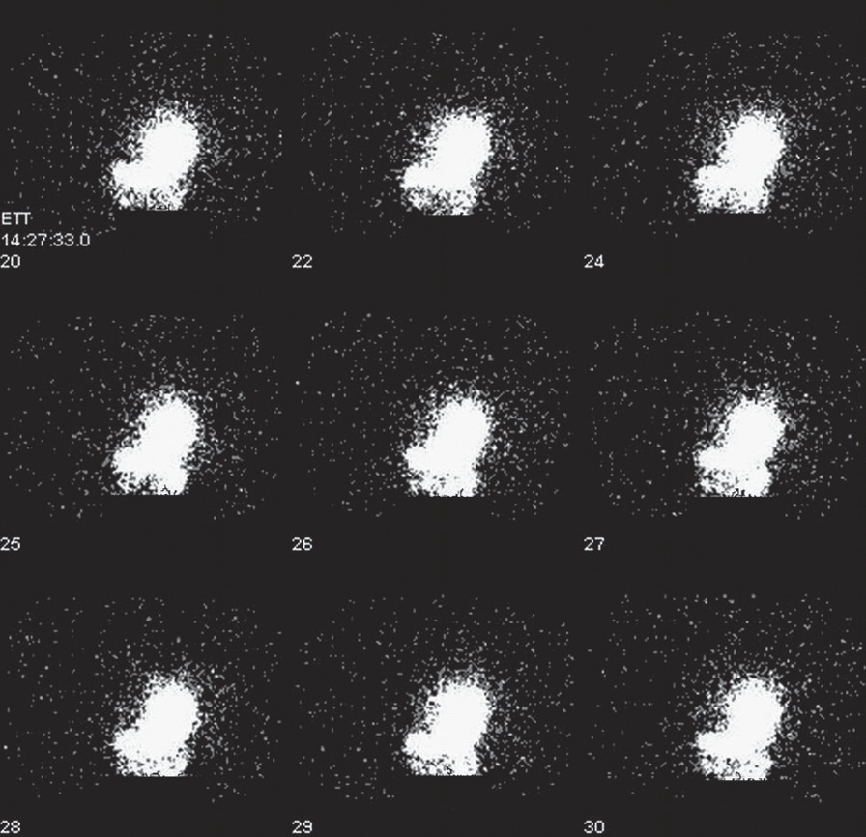
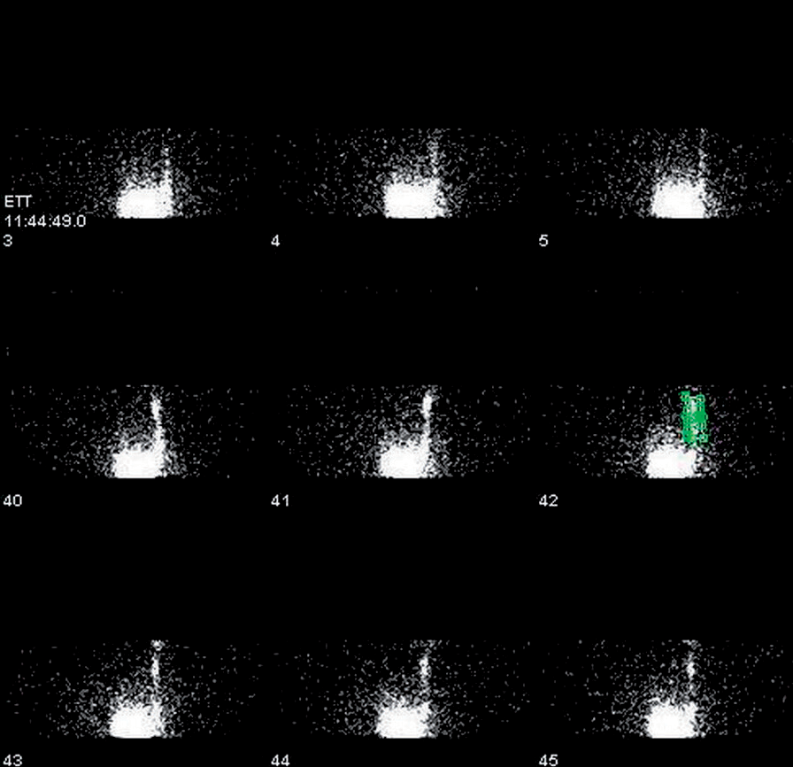
OriginalArticle
©PolJRadiol,2011;76(1):63-67
Methodsusedinthediagnosticsofthegastrointestinalrefluxinclude:24-hourpHtest,esophagealmotilitystudy,endoscopyofthegastrointestinaluppertract(GUT)withhistopathologicalexaminationofthesampledmaterial(visualizingnottherefluxitself,butitsconsequencescon-nectedwiththeeffectsoftheacidgastriccontentontheesophagealmucousmembrane),scintigraphy,ultrasonogra-phy.Thepreviouslyusedbarium-enhancedX-rayexamina-tionsbelongtothepast.
ScintigraphyandultrasonographyoftheGUTarenonin-vasivediagnosticmethods,andassuch,areespeciallyuse-fulinthediagnosticsofchildren.Authorsofthisreportaimedtoevaluatetheusefulnessofboththesenoninvasiveoptionsindiagnosinggastroesopagealrefluxinchildren.
Aimofthework
- Toinvestigatetheusefulnessofscintigraphyandultra-sonographyoftheGUTinthediagnosticsofthegas-troesopagealrefluxinchildren
- Toinvestigatetheusefulnessofradioisotopicexamina-tionsinthedetectionofthegastriccontentaspiratedtotheairwaytract.
Figure1.Normalresultsofthestudy.Radioactivecontentinthestomach.
MaterialandMethods
Thestudygroupincluded76children,38boysand38girls,aged1–204months(meanageof74months).ThechildrenwerereferredfromtheDepartmentofPediatrics,HematologyandOncologyofthePomeranianMedicalUniversityinSzczecinandfromtheGastrologicalOutpatientClinic.
Allthechildrenrevealedclinicalsymptomsofpathologi-calgastroesopagealreflux.Innewbornchildren,theseincludedspitting,anxiety,intensecrying;inolderchil-dren:heartburn,chestpain,stomachpainanddistention.Irrespectiveofage,therewereregurgitations,vomitingofdifferentintensity,sometimeswithbloodintheregurgitat-edgastriccontent,lackofappetite,chokingduringeating,insufficientweightgainorlossofweight.In14patients,therewereepisodesofapnea.
Figure2.Gastroesophagealreflux.Radioactivecontentovertheesophagealregion.
ScintigraphicexaminationsoftheGUTwereperformedintheDepartmentofNuclearMedicineofthePomeranianMedicalUniversityinSzczecin.GUTscintigraphywiththeuseofgammacamerawascarriedoutinall76children.Radiopharmaceutical,Tc-99m-antimonysulphidecolloidinthedoseof40MBqwasadministeredorally.Rightafteritsadministration,thepatientdrank100–330mlofafluid(milk,gruel,thickfruitjuice).Dynamicregisteringinsupinepositionwascarriedoutfor40minutesinAPprojectionor,incaseofananxiouschild,inPA.Nosedativeswereusedinchildren.Nomassageorpressingoftheabdomenwasintroduced.
- Latephase:twoacquisitionsofthechest:APandPA,inlyingposition, with anaimtovisualizeapossibleaspirationofthegastriccontenttotherespiratoryair-ways,carriedoutrightafterthegastricphase,andthenafter2hours.Timeofeveryacquisitionamountedto10minutes.
Intheexaminedmaterial,weevaluatedthepresenceofgastroesophagealrefluxandaspirationofthegas-triccontenttotheairwaysinall76children,esophagealmotilityin74children,andgastricemptyingin73chil-dren.Thegastroesophagealrefluxwasevaluatedqualita-tivelyonsubsequentdynamicimagesofthesecondphase(Figures1,2)andonthebasisoftime-activitycurvefromtheregionovertheesophagus(Figure3).Increaseinactiv-ityinthisregionbyatleast5%perimage,ascomparedtothebackground,wasinterpretedasthepresenceofreflux.
GUTscintigraphyincludedthefollowingphases:
- Esophageal phase: registereddynamically,one imagepersecond,foroneminute,passageoftheradiopharmaceuti-calfromtheoralcavity,throughtheesophagus,totheabdomen.
- Gastricphase:dynamicregisteringwascontinued,i.e.oneimageper30seconds,for40minutes.
64

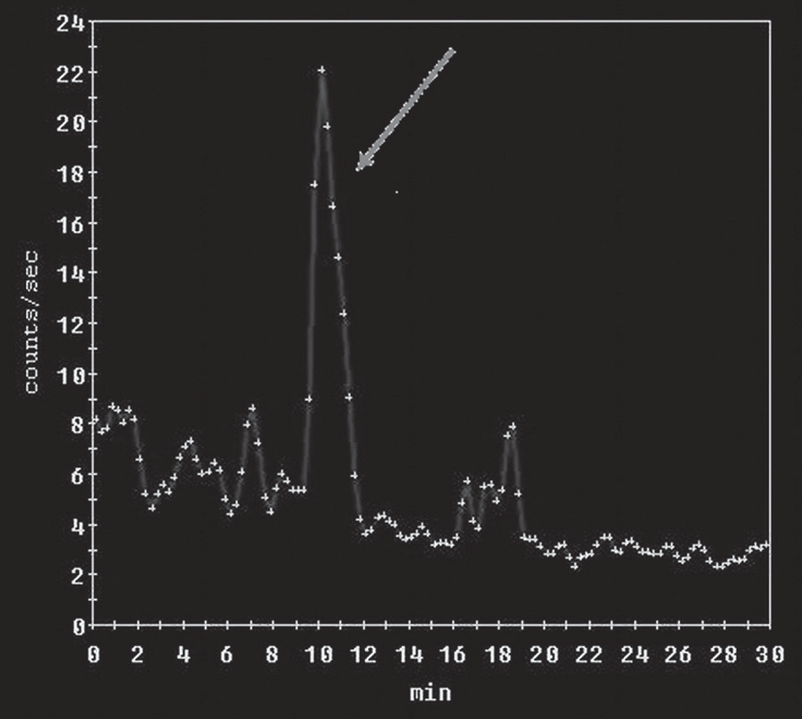
©PolJRadiol,2011;76(1):63-67
ElblBetal–Uppergastrointestinaltractscintigraphyandultrasonography…
result wasnon-diagnosticdueto child’smovementsduringacquisition.
Ultrasonographyforgastroesophagealrefluxwasper-formedin42children.Gastroesophagealrefluxwascon-firmedin17ofthem,whichaccountsfor40.5%ofstudypopulation.Theresultseemstobetoolowifwetakeintoaccountthefactthatthestudygroupincludedchildrenwithobviousclinicalsymptomsofgastroesophagealreflux.
Discussion
Gastroesophagealrefluxisnotalwaysaclinicalproblem.Inmostoftheinfants,thereisspittingorregurgitationnotinfluencingthegeneralhealthstateorpsychophysicaldevelopmentofthechild.Thesymptomssubsidespontane-ouslywithageanddonotneedtobediagnosed.Theprob-lemisthepathologicalgastroesophagealreflux,manifest-ingitselfwithrecurrentvomiting,disturbedweightgain,lossofappetite,anxiety,abdominalpainandchestpain.Itmaycauseapneathatmaybecomelife-threateninginextremecases[3,5–10].Someauthorsbelievethatintypicalclinicalsymptoms,analternativeforthediagnosticprocessistheintroductionoftreatment,‘justforatry’,andevalu-ationclinicalimprovement[6,11,12].However,accordingtomostoftheauthors,suspicionofthepathologicalgas-troesophagealrefluxrequiresdiagnostictestsinordertoconfirmthediagnosis,revealcomplications,andexcludeanatomicalmalformationsofthegastrointestinaltract.Atypicalformsofthegastroesophagealreflux(e.g.givingonlyrespiratorysymptoms)requirediagnosticsaswell[4,13,14].
Figure3.Time-activitycurvefromtheesophagealregion–GERismarkedbyanarrow.
Esophagealmotilitywasconsiderednormalifwithin10secondaftercontrastadministration,radioactivityoftheesophagusdecreasedbelow90%ofthebaselinevalue.Gastricemptyingwasevaluatedwiththenumberofcountsintheregionoverthestomach,atthebeginningandattheendofthegastricphase.Lossofactivitybelow65%ofthebaselinevaluewithin40minuteswasconsideredanor-malgastricemptying.Normalrangesforthepassageoftheradiotracerthroughtheesophagusareclearlydefinedintheliteratureandcommonlyused.Definitionofsuchrang-esforgastricemptyingismorecomplicatedanddependsonthetypeandvolumeoftheingestedfood,patient’sage,andexaminationposition.Accordingtotheliteraturedataforfluid meals, theappropriate value of theresidual gastriccontentrangesfrom36to70%after1hour[7].Weacceptedamedialvalueasanormalone,afterconsideringashorterexaminationtime.Wegavethepatientsfluidorsemi-fluidmeals,butnotstandardizedones.
Inthe diagnostics ofthegastroesophagealreflux[4,6],24-hourpHtestsbelongtosocalledgoldenstandard.Itssensitivityindiagnosingthisailmentisassessedfor87–96%,whileitsspecificityfor93–97%[4,9,13,15–17].SensitivityofpHtestsmaybereducedbyalkalizationofthegastriccontent,e.g.ininfantsduethefactthatthedietisbasedonmilk[9].AlsomedicinesfromthegroupofH2-blokersandprotonpumpinhibitorsincreasepHofthegastriccontent.DisadvantageofpHtestsistheirinvasive-nessandunphysiologicalcharacter[18].
Abdominalultrasonographywithevaluationofthegastro-esophagealrefluxwasperformedin42childrenatUSGlaboratoryoftheDepartmentofDiagnosticImagingandInterventionalRadiology,PomeranianMedicalUniversity.Twoscannerswereused:ATLUltrasoundmodelHDI3500andLogiq500MD.Theresultswereconsideredtobeposi-tiveifwithin10minutesofexamination,therewereatleast7episodesofgastroesophagealreflux.
ScintigraphyoftheGUTisnoninvasive,doesnotdis-turbphysiologyofthegastrictract,andiswelltoleratedbymostofthechildren.Theriskfromradiationexposureisminimalandthismethoddoesnotrequirehospitaliza-tion[7,17,19–26].SomeauthorsdefinethescintigraphicexaminationoftheGUTasinsufficientlysensitiveoruse-fulindiagnosinggastroesophagealreflux[1,4,5,27].Othersrecommenditasafirst-linemethodinrefluxdiagnostics[9,18,21,28].Authors’ownexperiencesshowthatthismethodhasmanyadvantagesanddeservesawideraccep-tance.Apartfromdetectinggastroesophagealreflux,itallowsforevaluationofesophagealmotilityandstomachemptying,andsometimes alsovisualization ofaspirationofthegastriccontenttotherespiratorytract.
Results
Scintigraphicfeaturesofthegastroesophagealrefluxwerefoundin60outof76children(78.9%).Featuresofaspira-tionofthegastriccontenttoairwayswerefoundin1case.Esophagealmotilitywasnormalin60outof74children(81.1%).Disturbancesofradiotracerpassagethroughtheesophaguswerefoundin9outof74children(12.2%).In5childrenoutof74(6.7%),theresultoftheexaminationwasnon-diagnostic,duetoincompleteswallowingofthetracerorchildmovingduringacquisition.Stomachemp-tyingwasevaluatedin73patients.In45casesoutof73(61.6%),gastricemptyingwasnormal,whilein17outof73(23.3%),slower.In11childrenoutof73(15.1%),the
Stomachemptyingmaybeassessedwithregistrationofthenumberofimpulsesintheregionofinterestabovethestomach,atthebeginningandattheendofthegas-tricphase.Therearenoestablished,commonlyapplying
65

OriginalArticle
©PolJRadiol,2011;76(1):63-67
normalvaluesofstomachemptying,asitdependsonthetypeandvolumeofingestedfood.Moreover,differentauthorsusedifferentfood(ofdifferentcompositionandconsistency)[7,23,29].Centersusingscintigraphyinevalu-ationofgastricemptyingtendtodefinetheirownnormalranges.
performed1217scintigraphiesandfoundaspirationin48casesonly[18].Inourmaterial,onlyonechildhadfea-turesofaspiration.Itseemsthatthevolumeofradioactivegastriccontentwhichcouldenterbronchiistoolowtobedetectedwithgammacamera[31,37].Animportantrolecanbeplayedbyrapidclearingofthebronchiwiththehelpofciliaryepithelium[18].Scintigraphymaynotrevealsmallvolumesoftheaspiratedgastriccontent.However,thereisnoalternativemethod.Thereexistsamethodofanalysisoflipidcontentinalveolarmacrophages.However,thisexam-inationisnottoospecificandrelativelyinconvenient[7,38].
Inordertorevealaspirationofradioactivegastriccontenttotherespiratoryairways,staticacquisitionsofthechestareperformedin supineposition, in AP andPAprojections.Theacquisitionscanberepeated,atdifferenttimeinter-vals,butwithinupto24hoursaftertheadministrationofradiopharmaceutical.
Ultrasonographytendstobedescribedasastudyoflowsensitivity(of35%),althoughsomeauthorsreportasensi-tivityofover90%.Suchadivergenceofresultsmayfollowfromasubjectiveassessmentoftheoperatorandnoclearultrasonographiccriteriaforrefluxdiagnosis[3,18,39].Inthepresentedmaterial,ultrasoundfeaturesofgastroesoph-agealrefluxwerefoundinaslittleas40%ofthepatients,inspiteofthefactthatallthosechildrenhadshownclearclinicalsymptomsofreflux.Shortexaminationtimehasanegativeinfluenceonultrasoundsensitivity.Advantageofultrasonographyisnoexposuretoradiation,noninvasive-ness,andwideavailability.
Interpretationofthestudyresultsdoesnotdependonsub-jectiveassessmentoftheoperator.Caglaretal.studiedthedifferencesintheevaluationofscintigraphyandrevealedahighrepeatabilityofresultsofthesamestudyobtainedbythesameobserveratdifferenttimeintervals,andbydif-ferentobservers,withadifferentdegreeofexperience[30].Oneofthelimitationsofthismethodistheexaminationtime,normallyamountingto30–60minutes,dependingonthecenter[18,20,21,24,30,31,32].Episodesofgastroesopha-gealrefluxmayappearlaterthan1houraftermeal,andthusremainundetectedduringscintigraphy.Inourcenter,registrationofthegastricphasewasconductedfor40min-utes,whichallowedforthedetectionofthegastroesopha-gealrefluxin79%ofourpatients.Ourresultsdonotdif-ferfromtheresultsobtainedinothercenters.Accordingtotheliterature,thesensitivityofthisexaminationmethodindetectinggastroesophagealrefluxamountsto69–89%[20–22,24,30,33–35].
Conclusions
- Scintigraphyoftheuppergastrointestinaltractisasen-sitivemethodusedinpreliminarydiagnosticsofgastro-esophagealreflux,especiallyrecommendedinchildren(itisnoninvasive,doesnotdisturbthephysiologyofthegastrointestinaltract,andisnotconnectedwithahighriskfromradiationexposure;itdoesnotrequirehospi-talizationeither).
- Atfurtherstagesofclinicaldiagnostics,scintigraphyoftheGUTisveryusefulinmonitoringofthediseasecourseandtreatmentresults.
- AnadditionaladvantageofGUTscintigraphyisthepos-sibilityofevaluationoftheesophagealmotility,gastricemptyingandvisualizationofgastriccontentaspirationtoairways.
- Ultrasonographyislesssensitiveindiagnosinggastro-esophagealrefluxthanscintigraphy.
MostoftheauthorsrecommendscintigraphyoftheGUTinAPprojection[7,18,23,36]duetoasmallerdistancebetweentheexaminedstructuresandthecollimator.Thispositionofthecamerawasusedinourcenteraswell.PAprojectionwascarriedoutonlyinexceptionalcases,whenthecolli-matorlocatedabovethechildcausedasevereanxiety.
Literaturedataonscintigraphicdetectionofthegastriccontentaspiratedtoairwaysrevealalowincidence.ThiscanbeconfirmedwithareportbyWynchanketal.who
References:
- BarełaAD,ChazanR:Wpływrefluksużołądkowo-przełykowegonaastmę.WiadLek,2002;55:575–83[inPolish]
- HymanPE,DiLorenzoC:PediatricGastrointestinalMotilityDisorders.AcademyProfessionalInformationServices,Inc.
- OralewskaB:Refluksżołądkowo-przełykowyudzieci.PrzewLek,1999;5:41–43[inPolish]
- MarekT,NowakA,RymarczykG:Chorobarefluksowaprzełyku–wybraneproblemy.Przewodniklekarza,1999;5:44–48[inPolish]
- OralewskaB,Celińska-CedroD,SochaP:Refluksżołądkowo-przełykowy.StandardyMed,1999;2:14–18[inPolish]
- RudolphCD,Mazur LJ,Liptak GSet al:Guidelinesfor evaluationandtreatmentofgastroesophagealrefluxininfantsandchildren:recommendationsoftheNorthAmericanSocietyforPediatricGastroenterologyandNutrition.JPediatrGastroenterolNutr,2001;32(suppl.2):1–31
- HeymanS:Assessmentofgastro-esophagealdysfunctioninchildren.
Q.J.Nucl.Med.officialpublicationoftheItalianAssociationofNuclearMedicine(AIMN)[and]theInternationalAssociationofRadiopharmacology(IAR).1997;41:269–80
- HeymanS,EicherPS,AlaviA:RadionuclidestudiesoftheuppergastrointestinaltractinchildrenwithfeedingdisordersJNuclMed:officialpublication,SocietyofNuclearMedicine,1995;36:351–54
- IAEA:LecturenotesforRegionalTrainingCourseonPediatricNuclearMedicine.Lemesos,Cyprus,2001;51–53,60–63
- OrensteinSR,ShalabyTM,PutnamPE:Thickenedfeedingsasacauseofincreasedcoughingwhenusedastherapyforgastroesophagealrefluxininfants.JPediatr,1992;6:913–15
- GalmicheJP,ScarpignatoC:Moderndiagnosisofgastroesophagealrefluxdisease(GERD).Hepatogastroenterology,1998;45:1308–15
- LindT,HavelundT,LundelLetal:Ondemandtherapywithomeprazoleforthelong-termmanagementofpatientswithheartburnwithoutoesophagitis–aplacebo-controlledrandomizedtrial.AilmentPharmacolTher,1999;13:907–14
- ButsJP,BarudiC,MoulinDetal:Prevalenceandtreatmentofsilentgastro-esophagealrefluxinchildrenwithreccurentrespiratorydisorders.EurJPediatr,1986;145:396–400
- EidNS,ShepherdRW,ThompsonMA:Persistentwheezingandgastroesophagealrefluxininfants.PediatrPulmonol,1994;18:39–44
66

©PolJRadiol,2011;76(1):63-67
ElblBetal–Uppergastrointestinaltractscintigraphyandultrasonography…
- AndzeGO,BrandtML,DickensStViletal:Diagnosisandtreatmentofgastroesophagealrefluxin500childrenwithrespiratorysymptoms:ThevalueofpHmonitoring.JPediatrSurger,1991;26:295–300
- Pei-HuaiC,Mei-HweiC,Shun-ChienH:Gastroesophagealrefluxinchildrenwithchronicrecurrentbronchopulmonaryinfection.JPediatrGastroenterolNutr,1991;1:16–22
- KaramanO,UzunerN,DeğirmenciBetal:Resultsofthegastroesophagealrefluxassessmentinwheezychildren.IndianJPediatr,1999;66:351–55
- WynchankS,MannMD,GuilletJ:Gastro-oesophagealrefluxinchildrenandnuclearmedicine.PresseMed,1995;24:1595–97
- BergerD,Bischof-DelaloyeA,ReinbergOetal:Esophagealandpulmonaryscintiscanningingastroesophagealrefluxinchildren.ProgPediatrSurg,1985;18:68-77
- DaviesRP,MorrisLL,SavageJPetal:Gastro-oesophagealreflux:theroleofimagingindiagnosisandmanagement.AustralasRadiol,1987;31:157–63
- KashyapR,SharmaR,MadanNetal:Evaluationofradionuclidegastroesophagographyasasuitablescreeningtestfordetectionofgastroesophagealreflux.IndianPediatr,1993;30:625–28
- LaudiziL,ZaniolP,VenutaAetal:Gastroesophagealrefluxinchildren.Acombinedradiologicandscintigraphicstudy.RadiolMed(Torino),1990;79:381–83
- MillerJH:Uppergastrointestinaltractevaluationwithradionuclidesininfants.Radiology,1991;178:326–27
- SeibertJJ,ByrneWJ,EulerARetal:Gastroesophagealreflux-theacidtest:scintigraphyorthepHprobe?AmerJRoentgenol,1983;140:1087–90
- SonnevilleA,Ait-TaharH,BaulieuFetal:Valueofesophagealscintigraphyinexplorationofagastro-esophagealrefluxinarespiratorypatient.AllergImmunol(Paris),2000;32:207–8
- ThomasEJ,KumarR,DasanJBetal:Radionuclidescintigraphyindetectionofgastroesophagealrefluxinsurvivorsofcongenitaldiaphragmatichernia.WorldJNuclMed,2003;3:191–93
- BalsonBM,KravitzEKS,McGeadySJ:Diagnosisandtreatmentofgastroesophagealrefluxinchildrenandadolescentswithsevereasthma.AnnAllergyAsthmaImmunol,1998;2:159–64
- CsendesA,GonzálezP,OleaEetal:Diagnosisofgastroesophagealrefluxbyradioisotopictechniques.RevMedChil,1989;117:1374–80
- JohnsonDG,ReidBS,MeyersRLetal:Arescintiscansaccuratein
theselectionofrefluxpatientsforpyloroplasty?JPediatrSurg,1998;33(4):573–79
- CaglarM,VolkanB,AlparR:Reliabilityofradionuclidegastroesophagealrefluxstudiesusingvisualandtime-activitycurveanalysis:inter-observerandintra-observervariationanddescriptionofminimumdetectablereflux.NuclMedCommun,2003;24:421–28
- MalfrootA,VandenplasY,VerlindenMetal:Gastroesophagealrefluxandunexplainedchronicrespiratorydiseaseininfantsandchildren.PediatrPulmonol,1987;3: 208–13
- PintelonH,JonckheerMH,PiepszA:Paediatricnuclearmedicineprocedures:routinesedationormanagementofanxiety?Nucl.Med.Commun,1994;15:664–66
- EbelKD:Nuclearmedicinediagnosisinpediatrics.Monatsschr.Kinderheilkd.1986;134:352
- ElMouzanMI,AbdullahAM:Thediagnosisofgastroesophagealrefluxdiseaseinchildren.SaudiMedJ,2002;23:164–67
- LatiniG,DelVecchioA,DeMitriBetal:Scintigraphicevaluationofgastroesophagealrefluxinnewborns.PediatrMedChir,1999;21:115–17
- GonzálezFernándezF,ArgûellesMartinF,RodriguezdeQuesadaBetal:Gastroesophagealscintigraphy:ausefulscreeningtestforGEreflux.JPediatrGastroenterolNutr,1987;6:217–19
- MalfrootA,DabI:Pathophysiologyandmechanismsofgastroesophagealrefluxinchildhoodasthma.PediatPulmonol,1995(Supp.11):55–56
- Wąsowska-KrólikowskaK,Toporowska-KowalskaE,KrogulskaA:Asthmaandgastroesophagealrefluxinchildren.MedSciMonit,2002;8(3):RA64–71
- KwiecieńJ,HalkiewiczF,MachuraEetal:Ocenawiarygodnościdiagnostycznejultrasonograficznychcechniewydolnościpołączeniażołądkowo-przełykowego.PediatWspółcz,2005;7(3):185–89[inPolish]
67

