


International Journal of
Molecular Sciences
Article

Life in the Current: Anatomy and Morphology of

Utricularia neottioides
Bartosz J. Płachno х'* , Lubomír Adamec 2, Piotr Świątek 3 , Małgorzata Kapusta 4 and
Vitor F. O. Miranda 5©
- Department of Plant Cytology and Embryology, Institute of Botany, Faculty of Biology,
Jagiellonian University in Kraków, 9 Gronostajowa St., 30-387 Cracow, Poland
- Institute of Botany CAS, Department of Experimental and Functional Morphology, Dukelská 135,
CZ-379 01 Třeboň, Czech Republic; lubomir.adamec@ibot.cas.cz
- Institute of Biology, Biotechnology and Environmental Protection, Faculty of Natural Sciences, University of
Silesia in Katowice, 9 Bankowa St., 40-007 Katowice, Poland; piotr.swiatek@us.edu.pl
- Department of Plant Cytology and Embryology, University of Gdansk, ul. Wita Stwosza 59, 80-308 Gdańsk,
Poland; malgorzata.kapusta@ug.edu.pl
- Departamento de Biologia Aplicada à Agropecuária, Universidade Estadual Paulista (Unesp), Faculdade de
Ciências Agrárias e Veterinárias, Jaboticabal, SP CEP 14884-900, Brazil; vitor.miranda@unesp.br
* Correspondence: bartosz.plachno@uj.edu.pl; Tel.: +48-12-422-1790
Received: 28 May 2020; Accepted: 22 June 2020; Published: 23 June 2020
Abstract: Rheophytism is extremely rare in the Utricularia genus (there are four strictly rheophytic
species out of a total of about 260). Utricularia neottioides is an aquatic rheophytic species exclusively
growing attached to bedrocks in the South American streams. Utricularia neottioides was considered
to be trap-free by some authors, suggesting that it had given up carnivory due to its specific habitat.
Our aim was to compare the anatomy of rheophytic U. neottioides with an aquatic Utricularia species
with a typical linear monomorphic shoot from the section Utricularia, U. reflexa, which grows in standing
or very slowly streaming African waters. Additionally, we compared the immunodetection of cell wall
components of both species. Light microscopy, histochemistry, scanning, and transmission electron
microscopy were used to address our aims. In U. neottioides, two organ systems can be distinguished:
organs (stolons, inflorescence stalk) which possess sclerenchyma and are thus resistant to water
currents, and organs without sclerenchyma (leaf-like shoots), which are submissive to the water
streaming/movement. Due to life in the turbulent habitat, U. neottioides evolved specific characters
including an anchor system with stolons, which have asymmetric structures, sclerenchyma and they
form adhesive trichomes on the ventral side. This anchor stolon system performs additional multiple
functions including photosynthesis, nutrient storage, vegetative reproduction. In contrast with typical
aquatic Utricularia species from the section Utricularia growing in standing waters, U. neottioides stems
have a well-developed sclerenchyma system lacking large gas spaces. Plants produce numerous
traps, so they should still be treated as a fully carnivorous plant.
Keywords: aquatic plants; carnivorous plants; Cerrado; Lentibulariaceae; plant anatomy; rheophytes;
cell-wall components
1. Introduction
The small generic section Avesicaria of the genus Utricularia L. (bladderwort) contains only two South
American aquatic or partly amphibious, rheophytic species: Utricularia neottioides A.St.-Hil. & Girard and
U. oliveriana Steyerm [1-3]. These exclusively grow attached to rocks in shallow streaming or seeping
waters While the latter species closely resembles the typical, smaller terrestrial Utricularia species with
spatulate leaves, U. neottioides, is morphologically one of the most modified and remarkable Utricularia
Int. J. Mol. Sci. 2020, 21, 4474; doi:10.3390/ijms21124474
www.mdpi.com/joumal/ijms
Int. J. Mol. Sci. 2020, 21, 4474
2 of 19
species. It is specialized for growth in fast-flowing waters by forming two types of shoots (stolons; [1,4,5]
and the literature therein); attached anchor stolons (claw-like, radiate 'rhizoids'), which fix the plant
to the rocky substrate by adhesive rhizoids, and long (dozens of cm) running stolons flowing freely in
the streams and bearing 1-4 cm long filamentous "leaves" (in fact they are modified leaf-like shoots;
see e.g., [6]). The "leaves" are only ca. 60 gm thick, densely covered by colorless hydrophobic trichomes
(hairs) and they are reminiscent of filamentous algae [4]. The inflorescence scape growing from anchor
stolons may be up to 30 cm long and bears several whitish and sweet-scented flowers. The pollinators of
U. neottioides remain a mystery, but it is possible that small insects are attracted by the soft and sweet
fragrance of the opened flowers (this subject is under study by our research group). Long discussions
have been conducted on the abundance of traps in this species as only a few traps (if any) have been
collected from the field sites and found in herbaria (see [1,4]). Moreover, no single trap was produced
either in the aseptic in vitro culture or in terrestrially grown plants on brown peat [4]. Rheophytes are
plants usually confined and adapted to streambeds and/or below the level of flooding and the plants
can be subject to temporary overflowing [7]. Rheophytism is rare in Utricularia and is represented by
a few species from different sections, including sect. Avesicaria. Following the phylogenetic evidence,
the rheophytism appeared at least twice in the evolutionary history of Utricularia [5,8,9] as it results from
the homoplastic processes of parallel evolution with terrestrial species as an ancestral form.
In contrast with the rheophytic U. neottioides, typical aquatic Utricularia species from the section
Utricularia grow in standing or very slowly streaming waters (e.g., U. australis, U.foliosa, U. reflexa) and
possess a quite different habit [10]. They have a linear, modular shoot structure which consists of leaf
nodes with finely pinnate, filamentous leaves and narrow tubular mtemodes [1,11,12]. The majority
of species with linear shoots have monomorphic (homogeneous, non-differentiated) green shoots
bearing traps. However, several species have dimorphic shoots differentiated into pale carnivorous
ones with all or the majority of traps and green photosynthetic ones without traps or with only few
traps. All aquatic Utricularia species with linear shoots form regular branches which allows rapid
propagation. Moreover, adult individuals typically show very rapid apical shoot growth of 1-4.2 new
leaf nodes per day but their basal shoot segments die at about the same rate. Very rapid apical shoot
growth with frequent shoot branching underlie the total, very high relative growth rate [11,12].
After the terrestrial life form, the aquatic is the most common of all Utricularia species [13].
The aquatic species can be classified in different subtypes, as suspended (freely) or affixed forms,
occurring in several sections, but most species are from sect. Utricularia [1,9]. Based on phylogenetic
hypotheses, the aquatic lineages are derived from the terrestrial ones through different events within
the genus Utricularia [5,9].
Aquatic Utricularia species usually grow in shallow standing or slowly streaming humic,
oligo-mesotrophic waters and a partly decomposed, nutrient-poor organic sediment (sedge or reed
litter, peat, or fen substrate) usually accumulates on the bottom in these waters [11,12]. The waters
are usually poor in minerals such as N, P, and sometimes also K, but enriched in free CO2 mostly
within 0.1-1 mM which supports rapid plant growth. The species can usually tolerate higher total
concentration of humic acids and tannins up to 60 mg/L. The waters are usually not saturated by
oxygen. Most aquatic Utricularia species grow in soft to moderately hard, acid, or neutral waters
(usually pH 5.7-7.0) but some temperate species can also occur in hard and alkaline waters [11,12].
Utricularia neottioides is distributed across a relatively large territory of tropical South America—in
Colombia, Venezuela, Bolivia, and mainly in Brazil [1,3]. The plants can form large stands in suitable
habitats with only inflorescences emerging above the water surface, but the stands are usually
monospecific, without other co-occurring higher species [4]. In permanent shallow streams or in
separated pools after a water-level decline, the plant can grow as a perennial, while in dried-out
streams during the dry season, as an annual, usually setting seeds for the next season. The plant can
also survive in temporary pools with standing water. As specified by Rivadavia [14] typical habitats are
shallow, swiftly flowing, cool, acidic, humic (brownish) streams of highland areas from ca. 300-1800 m
a.s.l. and the plants usually grow under bright sunshine.
Int. J. Mol. Sci. 2020, 21, 4474
3of 19
The plant grows very vigorously and rapidly in a sterile in vitro culture in a half-strength Gamborg
B5 medium with 2.5% sucrose [4]. The plant formed very thin stolons with finely filamentous leaves
2-5 cm long. However, any growth ex vitro as submerged in humic waters in aquaria was impossible
for unknown reasons. The plant could, however, rapidly grow in a terrestrial form with 8-18 mm long
filamentous leaves (diam. ca. 100-120 gm) which survived on the brown peat for 5-6 months but did
not propagate further [4].
The main aim of the present paper is to characterize in detail the shoot morphology and anatomy
of rheophytic U. neottiodes. Additionally, we compare it with those of a typical member of the section
Utricularia, namely aquatic U. reflexa Oliv., a species with linear monomorphic shoots adapted to
growing in standing waters in Africa. We also performed immunodetection of cell-wall components to
determine if there were any differences between U. neottiodes and U. reflexa.

2. Results
  - Utricularia neottioides
The plant body consists of (Figure 1A-E): anchor stolons (fixing plants to rock, Figures 1E and
2A-D), running stolons, which produce new rosettes (Figure 2B), stolons bearing leaf-like shoots and
forming an inflorescence. Traps occur both on anchor stolons and leaf-like shoots.
    - Anchor Stolons (Claw-Like 'Rhizoids') Fixing Plant
The organ has an asymmetric structure and is flattened ventrally (lower side, Figure 2D,E),
with the parenchyma being better developed on the dorsal and lateral sides than on the ventral side.
Epidermal adhesive trichomes (produce substances which glue the stolon to rocks) occur along the
ventral side (Figure 2D,E) and the epidermal cells vary in size depending on their location. Cells on
the ventral side are much smaller than those on the dorsal side (Figures 2E and 3A,B). Cuticle has folds
and these folds are not only composed of a cuticle but represent an irregular cell-wall contour covered
by a cuticle (Figure 3C). The cell walls of some epidermal cells are lignified, especially on the organ's
ventral side. Epidermal cells have chloroplasts (Supplementary Materials Figure S1A) and contain
mucilage-like material in vacuoles. This material positively stained with MB/AII (Figures 2E and 3C)
does not stain positively with ruthenium red (Supplementary Materials Figure S2A). Starch grains
occur (Supplementary Materials Figure S2C). Adhesive trichomes occur only along the ventral side
(Figure 3A,B,D), each consisting of one bottle-shaped basal cell, one short, pedestal cell and a head cell
(Figure 3E). The lateral wall of the pedestal cell is impregnated by cutin and the head cell is strongly
elongated. They produce a secretion (Figure 3F), which is not PAS positive but stains positively with
MB/AII (Figure 3D) and the head cells stain positively with ruthenium red. Beneath the epidermis,
there is a hypodermis containing sclerotic cells. The sclerenchyma forms a sheath, which surrounds a
ground tissue and a cortex The stolon hypodermis has up to three layers (Figures 2E and 3A,B), with the
number positively dependent on stolon size. Sclerenchyma cells are the most well-developed on the
dorsal and lateral sides. The cells retain their protoplasts, contain chloroplasts, and mucilage-like
material (Figure 4A,F; Supplementary Materials Figure S1B,C). Cell walls of the sclerenchyma cells
are thick with highly visible layers and are lignified (Figure 4A,D-F). They stain yellow with zinc
iodine chloride solution (Figure 4B) and they reflect polarized light (Figure 4C). Pits occur and some of
these are branched (Figure 4A). The cytoplasm strand of the pits can include mitochondria (Figure 4D).
Parenchyma cells contain strongly-staining cytoplasm and are mostly filled with a PAS-positive material
(probably mucilage) (Figure 5A,B). This material stains slightly with Lugol (Supplementary Materials
Figure S2). However, this material does not stain positively with ruthenium red (Supplementary
Materials Figure S2A). Starch grains occur (Supplementary Materials Figure S2B,C). There are small
intercellular spaces between the parenchyma cells (Figure 5B,C), sometimes filled with a material,
which stains pink with MB/AII (Figure 5C). The vascular bundle is small and is situated closer to the
ventral side and it consists of both xylem and phloem; the xylem occurs on the upper part of the bundle
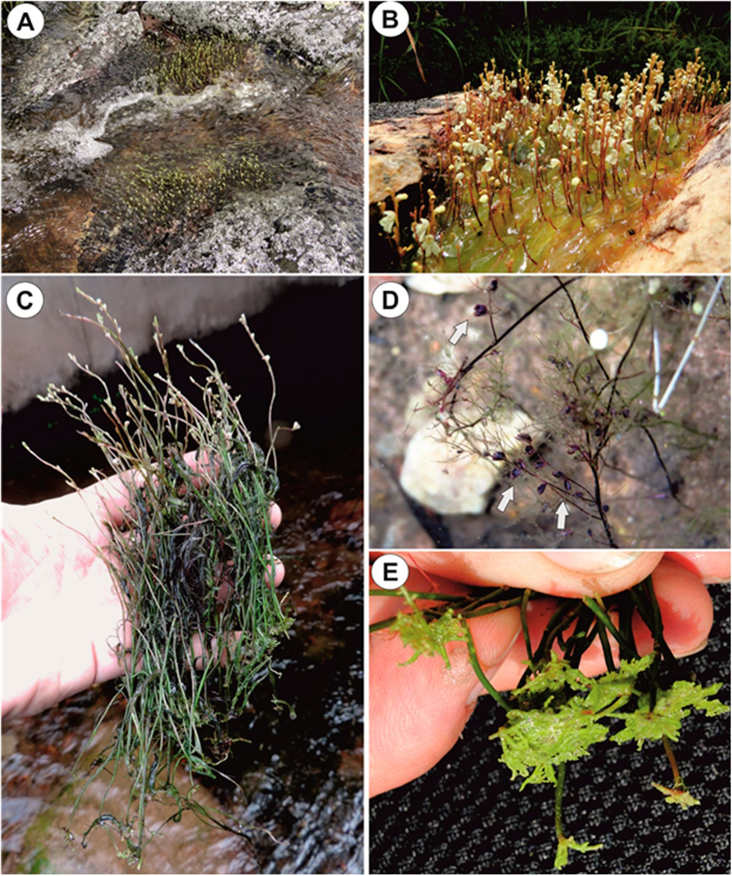
Int. J. Mol. Sci. 2020, 21, 4474
4 of 19
(Figure 5B). One or two tracheary elements occur. Vessels have reticulate pits (Figure 5D) and the
vessel diameter varies from 7.5-9 gm. The phloem is better developed than the xylem and sieve tubes
are well visible (Figure 5D). Formation of new stolons (branching) is observed on the ventral-lateral
side or the ventral side (Figure 5E ,F).
Figure 1. Habitat and general morphology of U. neottioides. (A,B) Utricularia neottioidei in a natural
habitat, (he Serra da Canastrs, southern Minas Gerais State (southeastern Brazil). (CE) Exposed plants.
(D) Leaf-like shoots with traps (white arrows). (E) Anchor systems of plants removed from rocks.
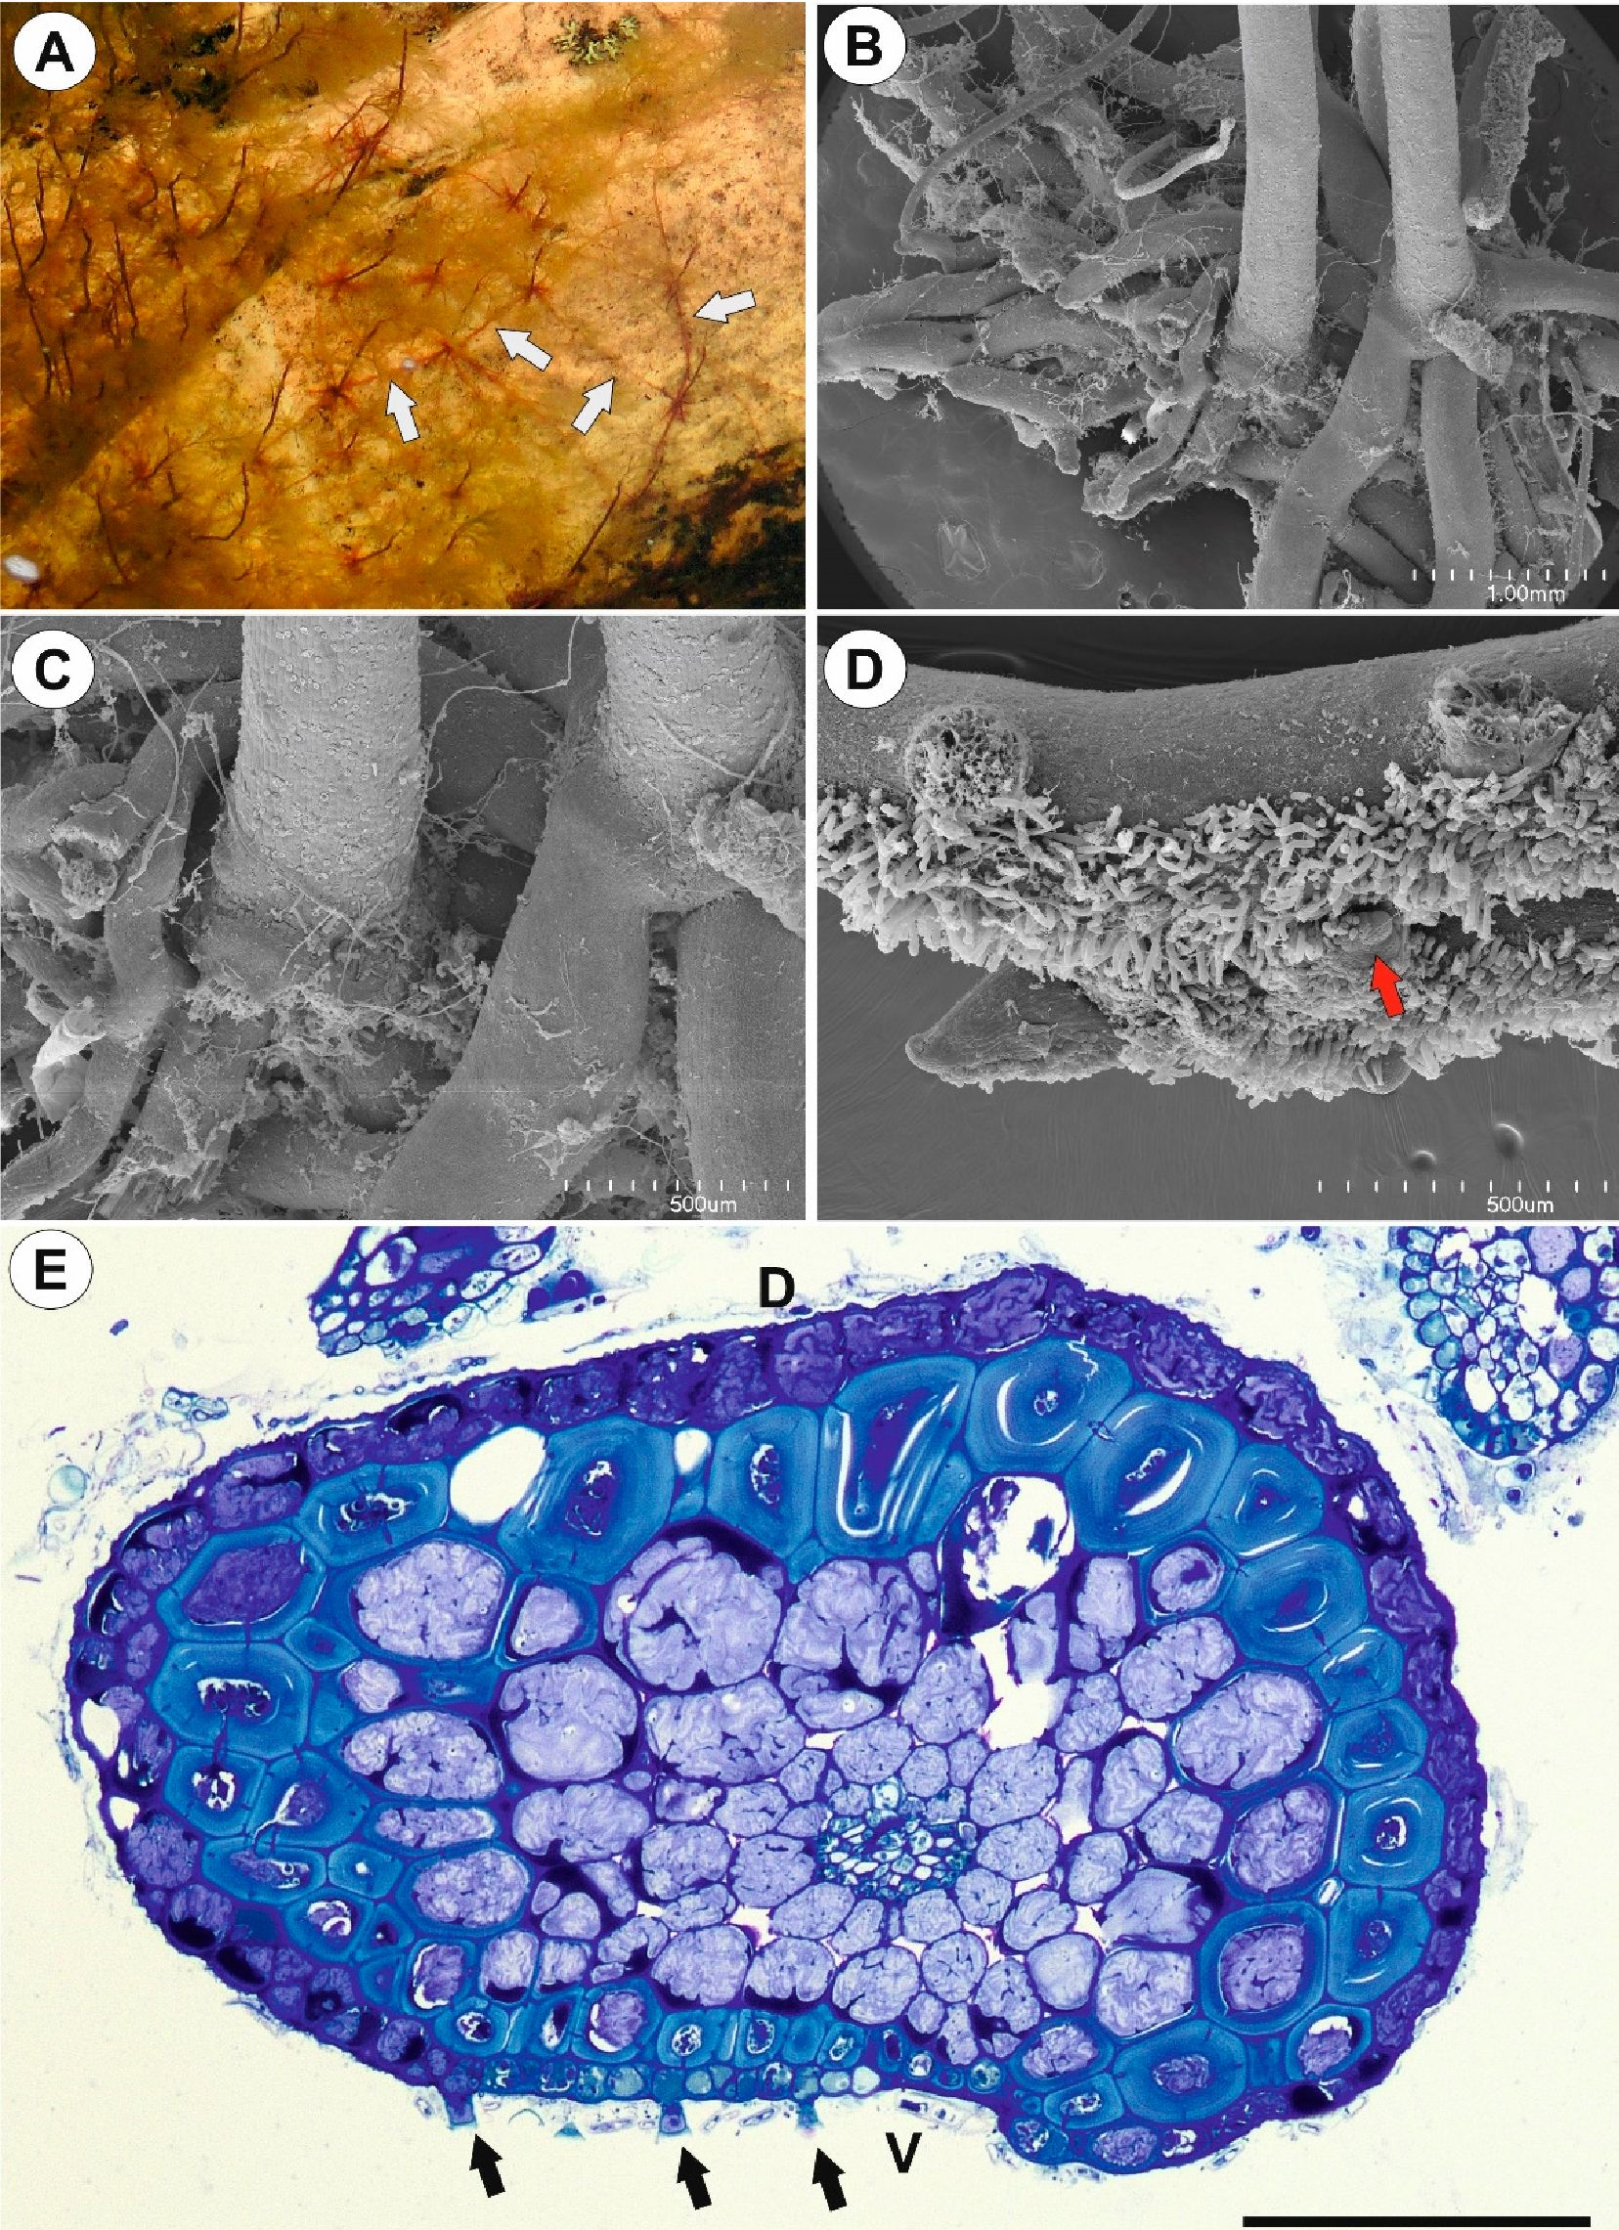
Int. J. Mol. Sci. 2020, 21, 4474
5 of 19
Figure 2. Anchor system structure of U. neottioides. (A) U. neottioides growing at rock; surface;
note funning stolons (white arrows), which are used for vegetative reproduction of this species.
(B,C) Basal portion of inflorescence stalle with claw-like anchor stolons, bar 1 mm (B) and 500 gm ((ľ).
(ID) Anchor s tolons; note adhesive hairs cn the ventral side of the stolons and formation of new ctolons
(reci arrow) on the ventral-lateral side of the stolon, bar 500 gm. (E) Transversal anchof stolon sisction,
note adhesive trichomes (black arrows), D-dorsal side- V-ventral side, bar 100 gm.
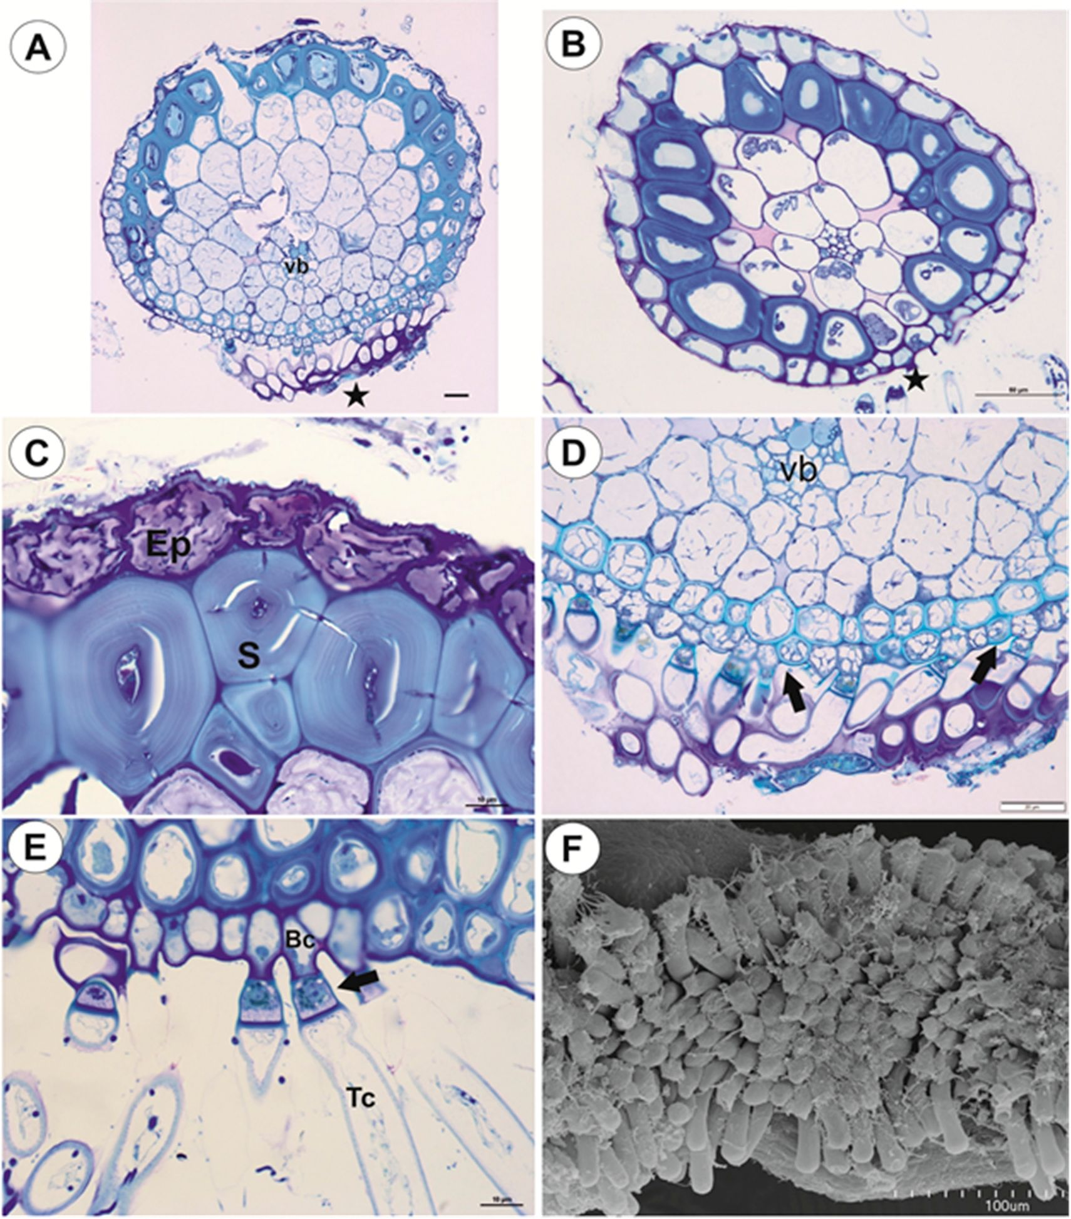
Int. J. Mol. Soi. 2020, 21, 4474
6 of 19
Figure 3. Structure of anchor stolons of U. neottioides. (A,B) Transversal anchor stolon section,
note adhesive trichomes (stars), vascular bundle (vb), bar 20 gm (A) and 50 gm (B). (C) Dorsal
part of anchor stolon; note epidermal cells contain mucilage in vacuoles (Ep) and sclerenchyma (S),
bar 10 gm. (D) Ventral part of anchor stolon; note lignification of cell walls of some epidermal cells
(arrows), vascular bundle (vb). Secretion produced by trichomes stain positively with MB/AII; note also
microorganisms attached to secretion, bar 20 gm. (E) Structure of adhesive trichomes: basal cell
(Bc), pedestal cell (arrow), and a head cell (Tc), bar 10 gm. (F) Morphology of adhesive trichomes;
note remains of secretion, bar 100 gm.
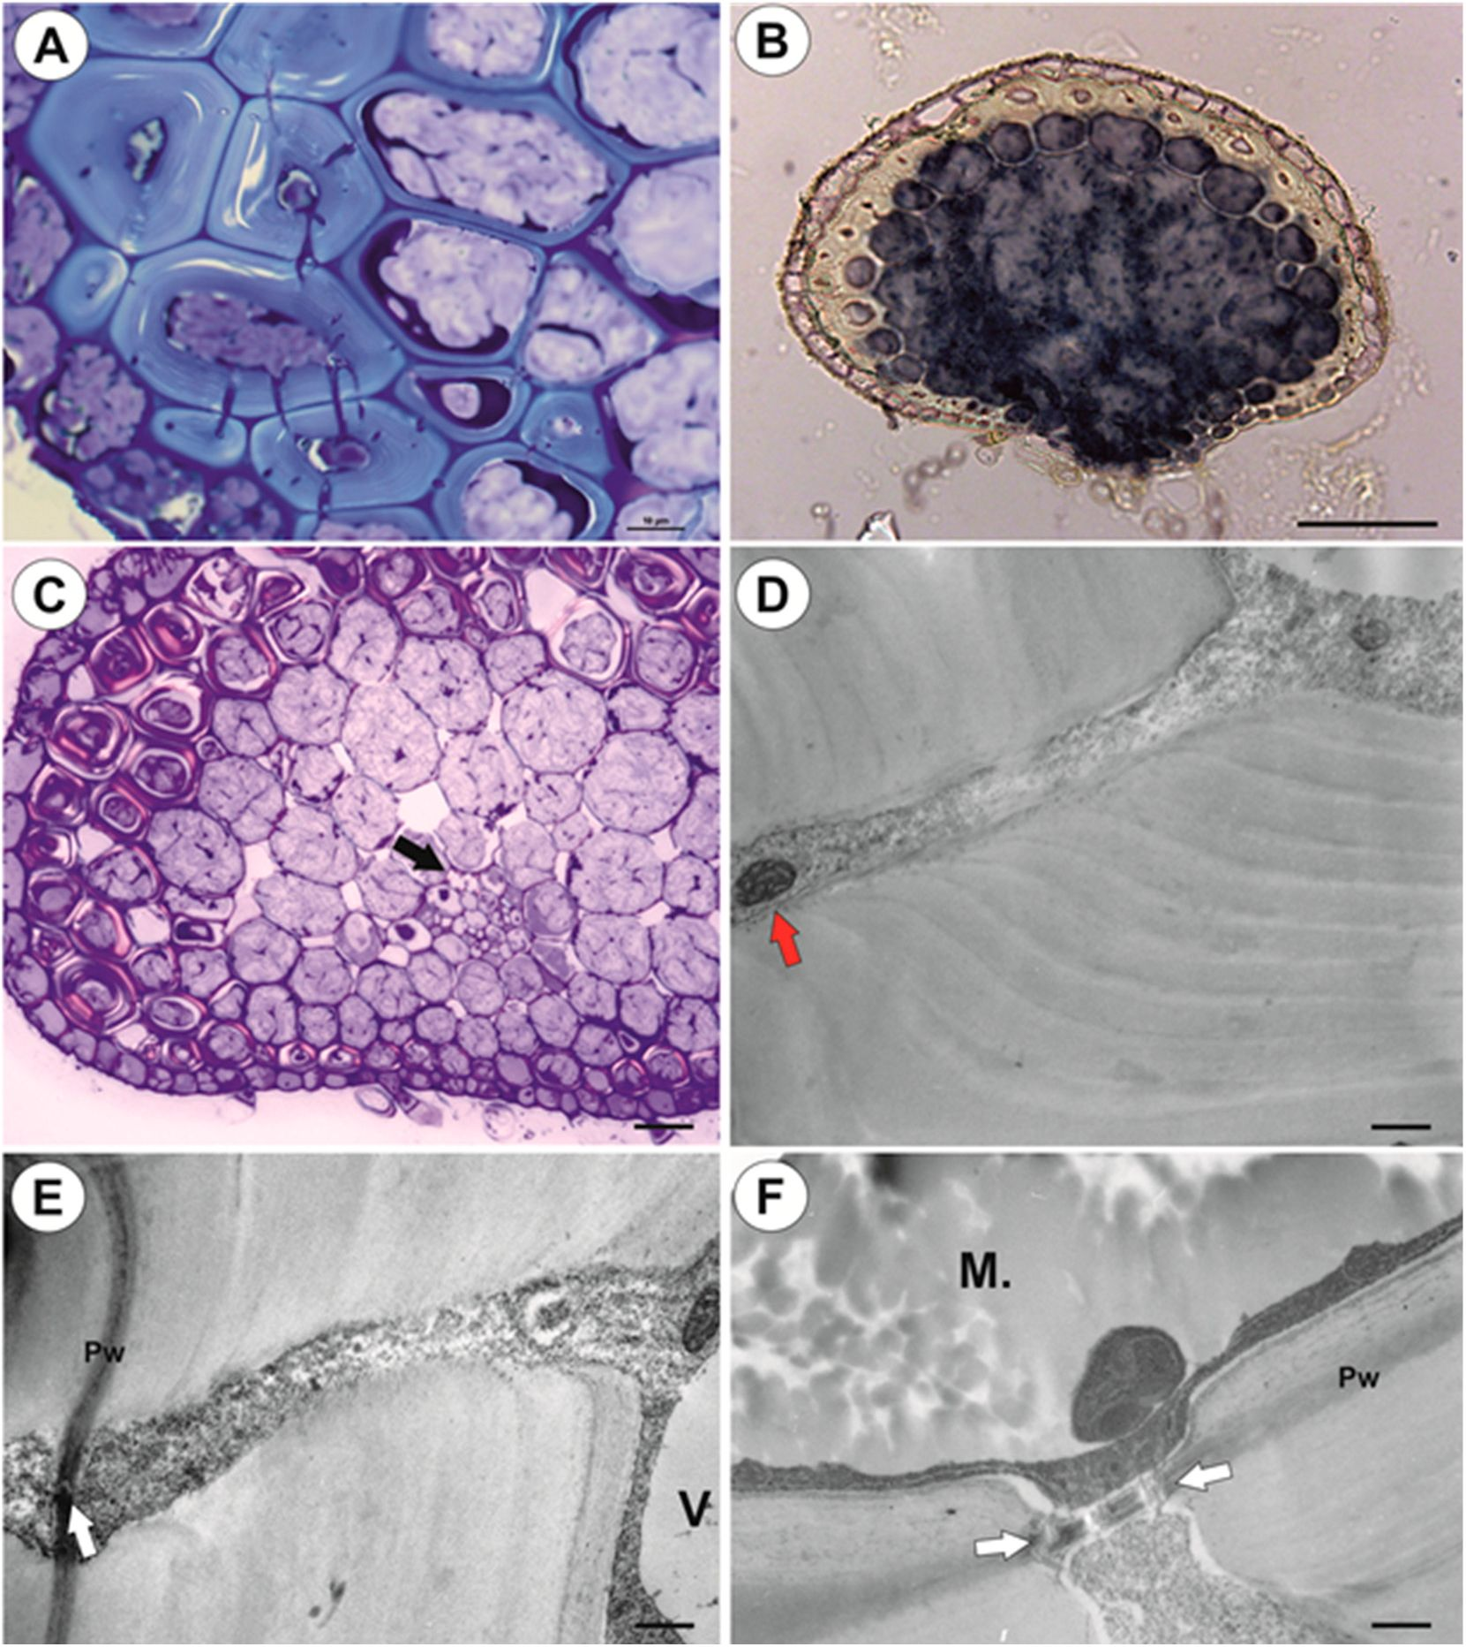
Int. J. Mol. Sci. 2020, 21, 4474
7 of 19
Figure 4. Anatomy of anchor stolons of U. neottioides. (A) Pits in cell walls of sclerenchyma cells,
bar 10 gm. (B) Transversal section of anchor stolon treated with zinc iodine chloride solution,
bar 100 gm. (C) Lignificated cell walls of sclerenchyma sells and "vessels (black arrow) reflect polarized
light, bar 27 gm. (D-F) Ultrastructure ol pits of sclerenchyma cells: mitochondrion in cytoplasmic
canal (red arrow), primary "wall (Pw), plasmodesmata (while arrow), vacuole (V), mucilage in vacuole
(M), bar 0.5 gm (D), 0.4 gm (E), and 0.6 gun (F).
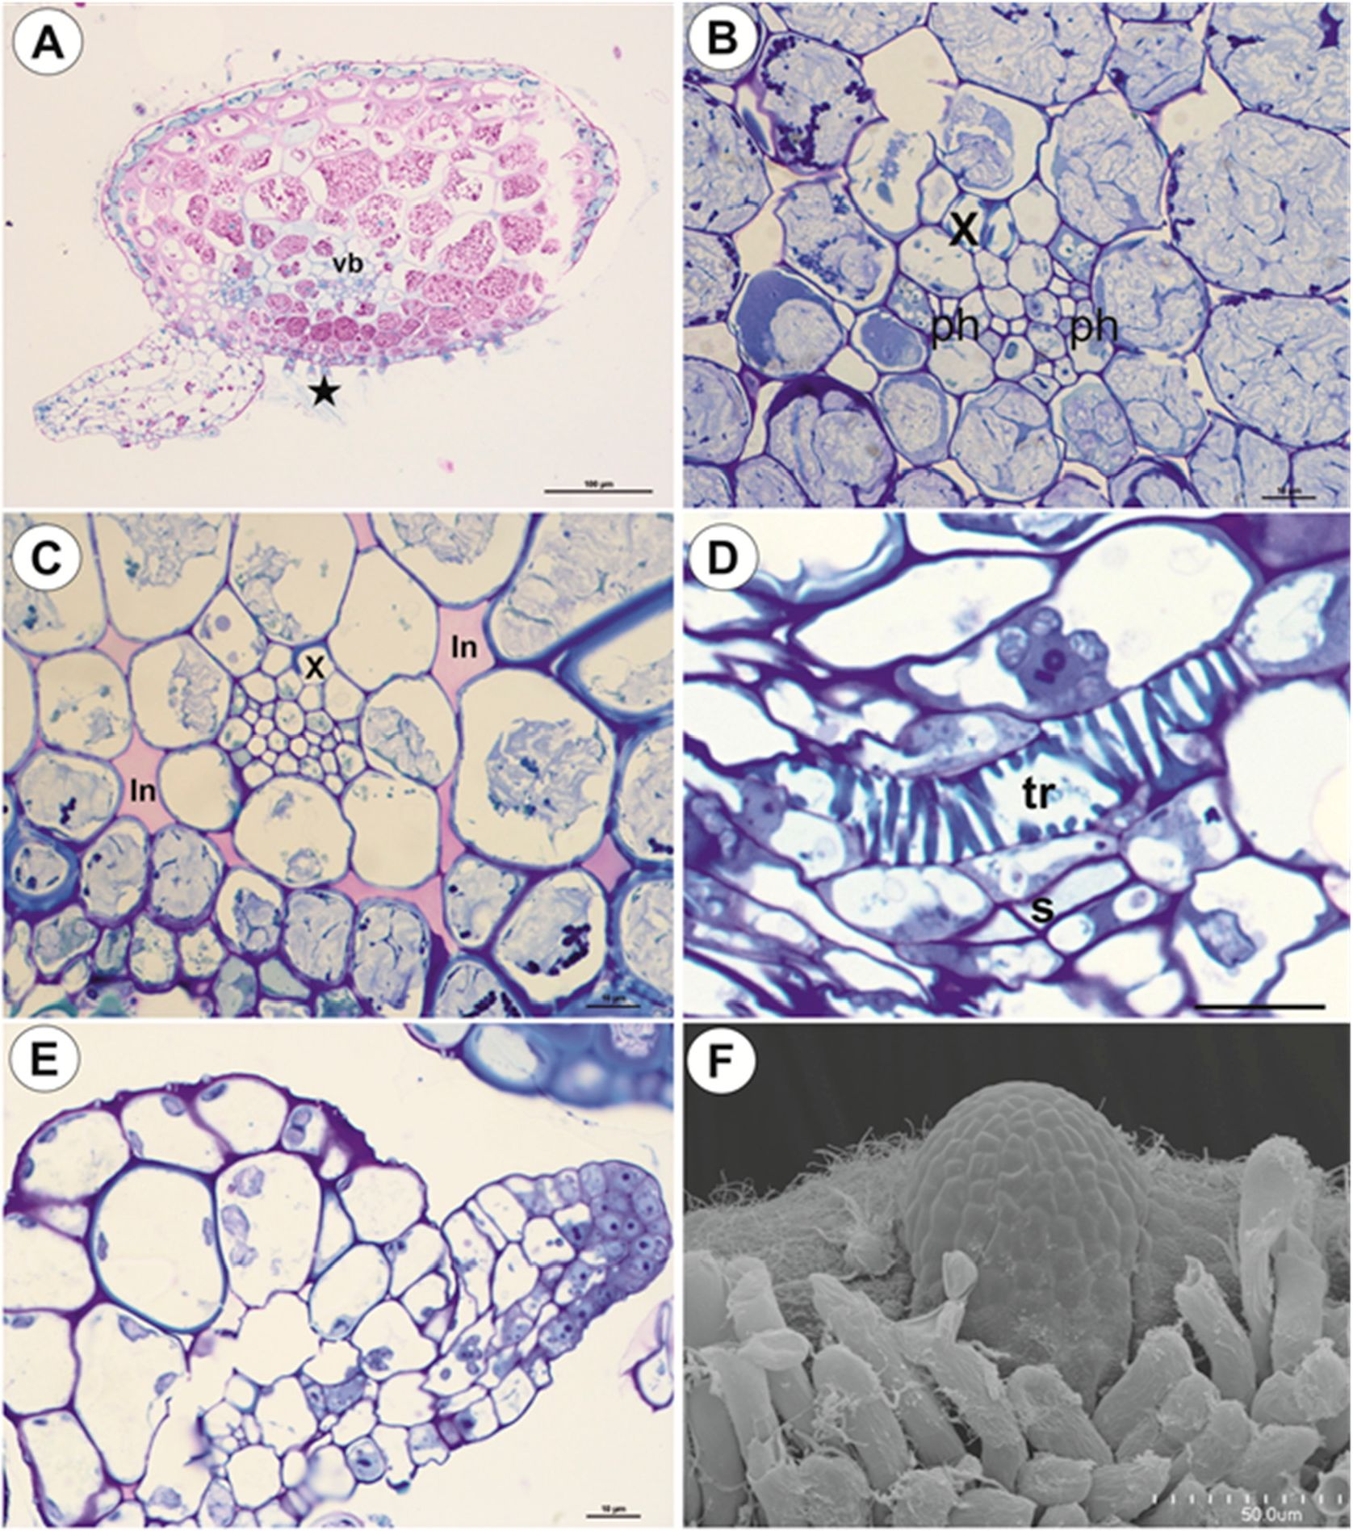
Int. J. Mol. Sci. 2020, 21, 4474
8 of 19
Figure 5. Anatomy of anchor stolons of U. neottioides. (A) Transversal section of anchor stolon,
PAS reaction, vascular bundle (vb), adhesive trichomes (star), bar 100 gm. (B-D) vascular bundle
structure: xylem (x), phloem (ph), interc ellular spaces (in), tracheary element-vessel (tr), sieve tube (S) ,
all bars 10 gm. (E,F) Formation of new stolon on the vsntrai-lateral side of the stolon, bar 10 gm (E)
and 50 gm (F).
    - Running Stolons
Running stolons have a similar structure to anchor stolons (Figure 6A-C). However, the difference
occurs in the sclerenchyma development. There are on°y a few sclerenehyma eells on the dorsal side;
(Figure 6Al or only on the ventral side (Figure 613). Epidermal adhesive trichomes occur along; the
ventral side (gigure 6A,B). In thkker stolons, xylem is better developed than in thincer ones, and up to
seven vessels may oacur (Figure 6C).
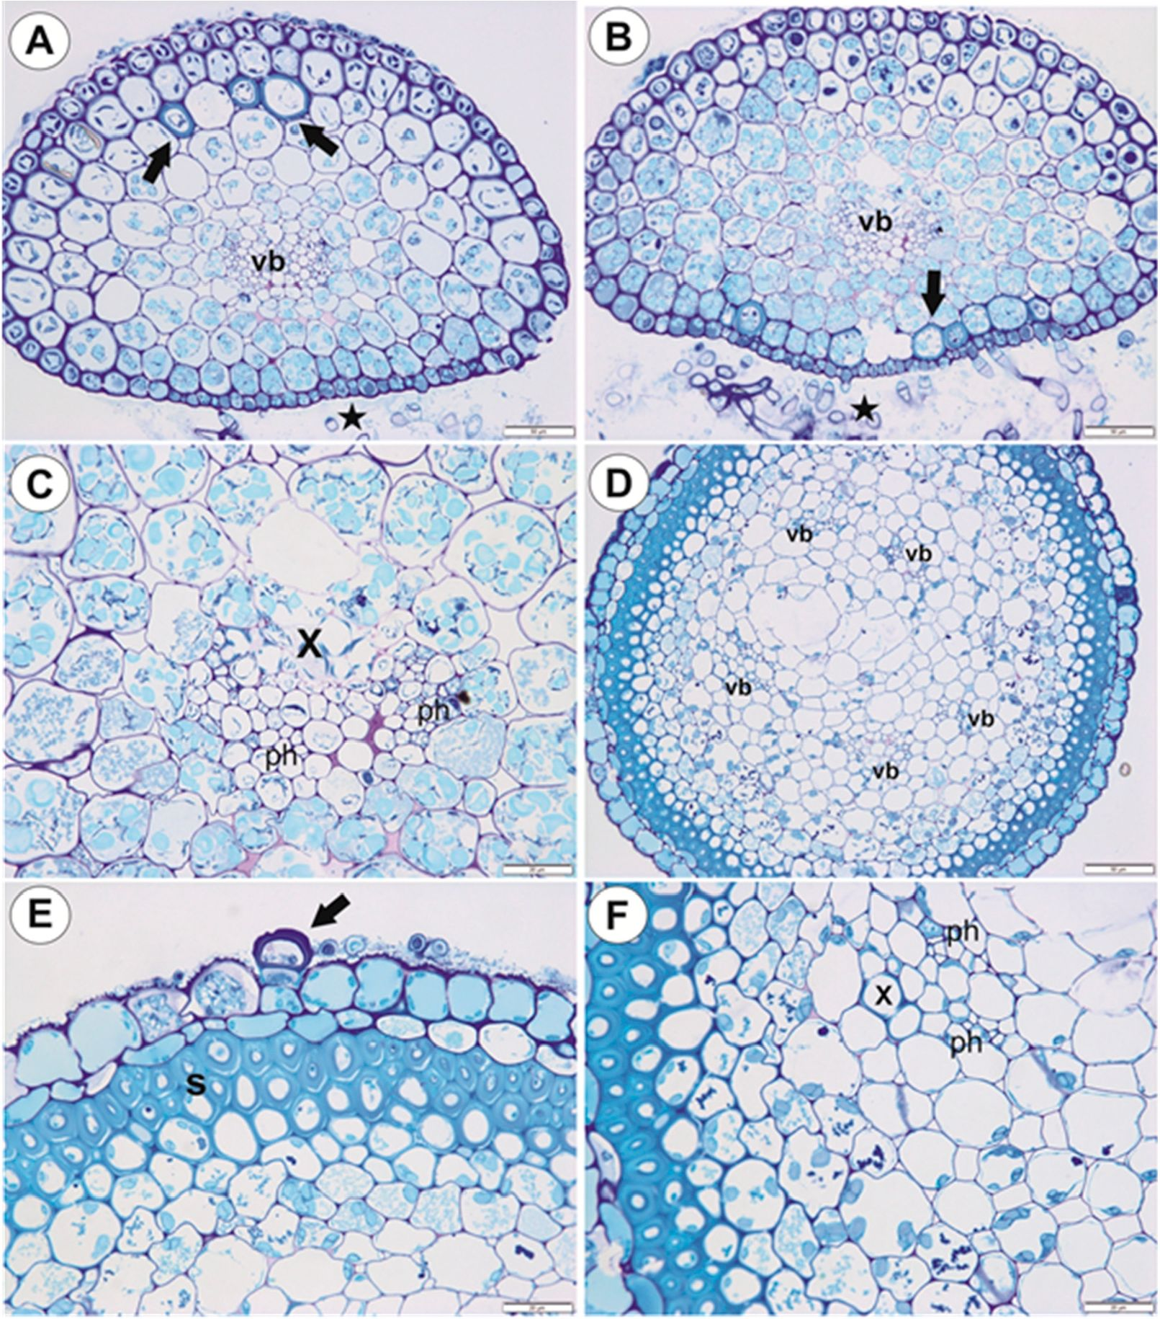
Int. J. Mol. Sa. 2020, 21, 4474
9 of 19
Figure 6. Anatomy of running; stolons and inflorescence stalk of U. neottioides. (A,B) Transversal
running stolon section; note s dhesive Srichomes (stars), vascular bundle Svb), sclerenchyma cells
(arrows), bars 50 gm. (C) Vascular bundle in the running stolon: xylem (x), phloem (ph); note starch
grains in parenchyma sells, bar 20 gm. (D-F) Transversal section of inflorescence stalk: vascular
bundle (vb), sc lerenchyma (S) , epidermal trichome (arrows), phloem (ph) , xylem (x), bar 50 gm (D) and
20 gm (E,F).
    - Basal Portion of Inflorescence Stalk-Stolon Bearing Leaf-Like Shoots and Forming Inflorescence
As shown in the transverse sections, the organ is round (Figure 6D) and there is no clear border
between the cortex and tire pith. Beneath the epidermis, there is a one-layered porenchyma and then
the sclerenchyma, which forms a continuous lignified fiberbelt (Figure 6D,E) with about five smal.
vascular bundle. (Figure 6D). Thee xylem and (he phloem are readily visible. In the vascolar bundle,
the xylem occurs more lo the outside ehan the phloems OFigure 6F). The cuticle o° epidermal cells has
folds. Tha epidermal cells have chloroplasts (Figure 6E) and there ase epidermal erichomes: each
trichome consisds of basal cell, barrier cell, and terminal cell (Figure 6E). Parenchyma cells contain
starch grains (Figure 6F).
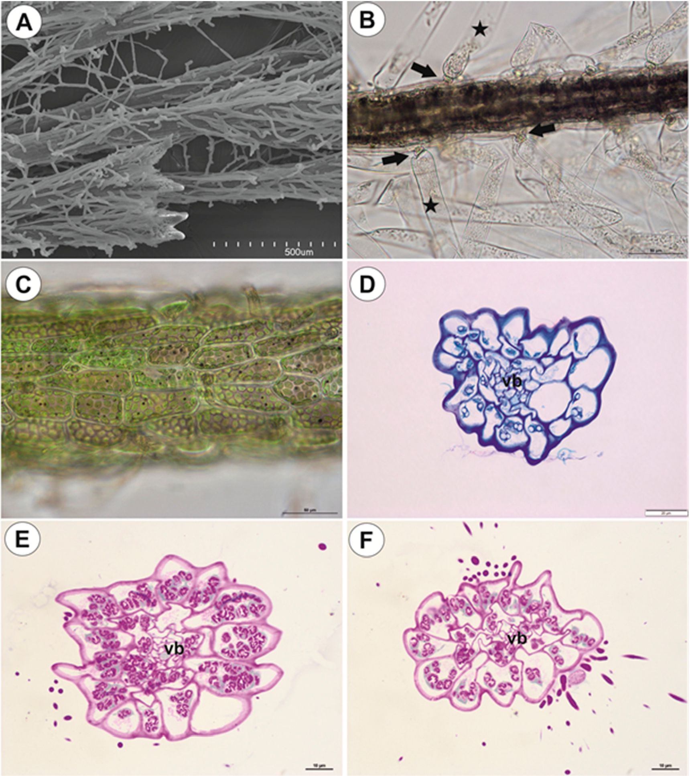
Int. J. Mol. Sci. 2020, 21, 4474
10 of 19
    - Filamentous Leaf-Like Shoots
Leaf-like shoots branch dichotomously, exhibit apical growth (Figure 7A), and they bear traps
(Figure ID). Howevei, traps may also occur on the anchor stolons. The surface of the shoots is covered
by numerous trichomes (Figure 7A,B): each trichome consists of a basal cell, a barrier cell, and an
elongate terminal cell (Figure 7B). Epidermal cells have chloroplasts and amyloplasts (Figure 7C-F).
Filamentous leaf-like shoois havo vety simple structure; there is an epidermis, one or two layers of
parenchyma and a centrally located vascular bundle (Figure 7D-F). In smaller shoots, the phloem
occurs but vessels are not observed in the vascular bundle.
Figure 7. Structuce of loaf-like shoots of U. neottioides. (A) Morphology of shoots; note that they Eire
densely coverrd It)? epidermal trichomes, bsr 500 gm. (B) Struciure of epidermal trichomes: pedestal
cell (arrow) and a head cell (star), bar 50 gm. (C) Chloaoplosts in epidermal cells of shoot; note dark
starch gaains (after Lugoľs stainéng), gar 50 gm. (D) Transverral shoot section: vascular bundle (vb),
bar 20 gun. (E,F) Transverral shoot section: after PAS reaction; note rnemorous starch grains: vasculau
bundle (vb)r both bars 10 gun.
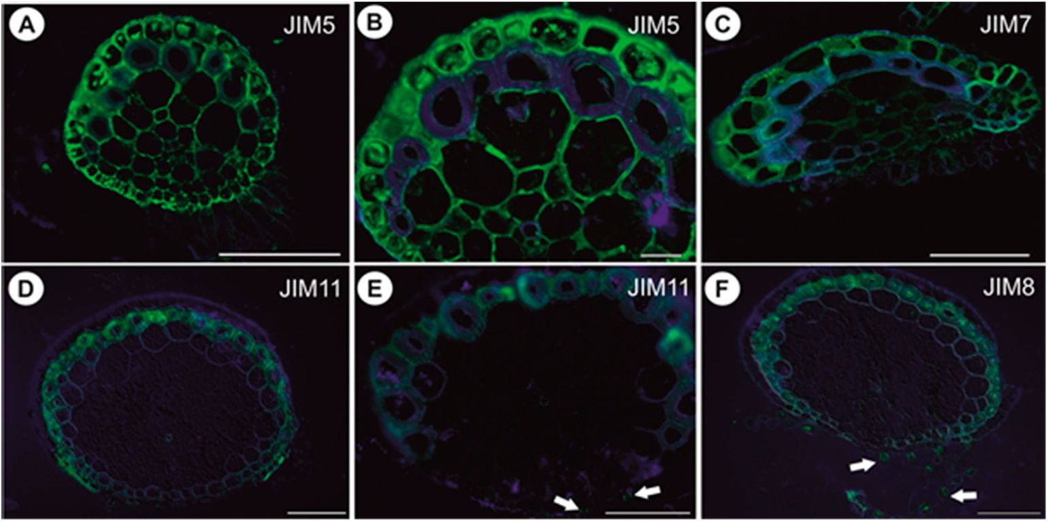
Int. J. Mot. Sci. 2020, 21,4474
11 of 19
    - Immunodetection of Cell Wall Components
In anchor stolons, the pectic epitope recognized by the JIM5 and JIM7 antibodies are abundant
in rrimary cell walls of various cell types: epidermis, parenchyma, phloem (Figure 8A-C). They are
present in the intercellular matrices (primary cell walls) between sclerenchyma fibers and absent
from the fiber secondary cell walls (Finure OB). The JIM5 epitope is detected in the interior of fiber
cells (Figure 8B). Both JIM5 and JIM7 epitopes also occur in vacuclar material in epidermal celle
(Figure 8A-C). Extensin epitope (JIM11) is in the? intercellular matrices (primary cell walls) between
sclerenehyma fibers and the fiber seronbery eell walls and Os also detected in cell walls of vesaels
(Figure 8D,E). It occurs in cell walls of barrier cells of trichomes (Figure 8E). AGPs recognized by
JIM8 are detected inside sclerenchyma fiber cells and inside trichome cells (Figure 8F). In the basal
portion of inflorescence stalks, the occurrence of pectic epitopes recognized by the JIM5 (Figure 9A)
end JIM7 antibodies (Figure 9B), the extensin epitope (JIM11) (Rgure 9C) and the arabinogalaetan
protem (AGIP JIM8) (Figure 9D) is similar to that in anchor stolons. filamentous leaf-Hke shoots,
pectic epitopes recognized by the JOM7 and JIM5 antibodies are abundant in the primary cell walls of
various cell types (Figure? 9E,I). The extensin epitope (JIM11) is abundantly present in intercellular
spaces of parenchyma cells, which surrounb tha vascular bundle, end also in cells of the vascular
bundle (Figure 9G,H). The AGPs recognizeF by tiie J9M8 are detected in barrier cells of trichomes and
in algae which grow on the organ surface (Figure 9I).
Figure 8. Pectin (JIM5, JIM7), extensin (JIM11) and arabinogalactan protein (JIM8) detection in anchor
stolons of U. neottioides. (A,B) Presence of the JIM5, bar 100 gm (A) and 20 gm (B). (C) Presence of
tire JIM7, bar 100 gm. (D,E) Presenre o° the extensin; note positive signal in cell walls of barrier cells
of trichomes (arrows), both bars 100 gm. (F) Presence o° ths 4IM8; note positive signal in trichomes
(arross), bar 100 gm.
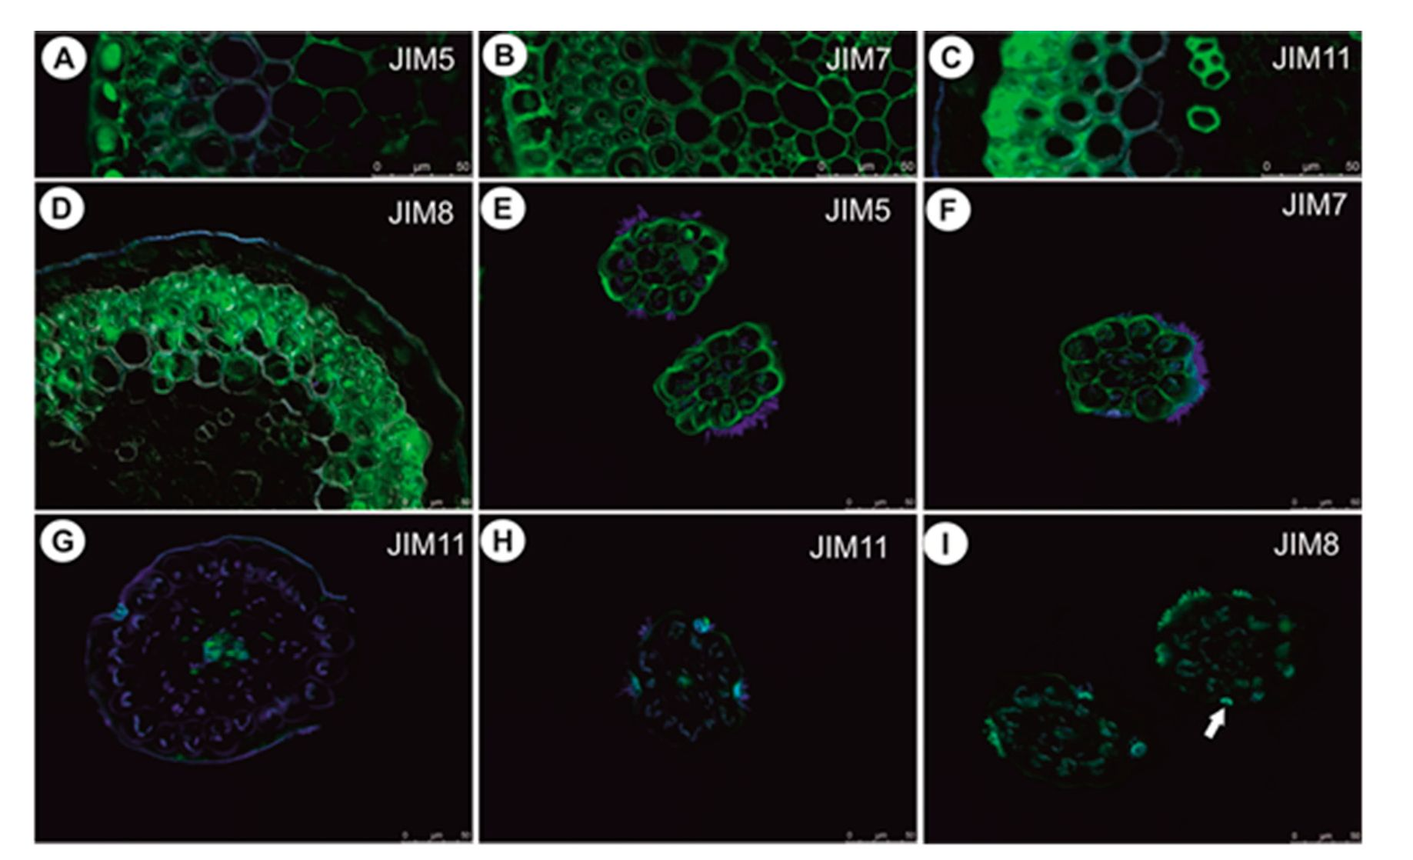
Int. J. Mol. Sci. 2020, 21, 4474
12 of 19
Figure 9. Pectin (JIM5, JIM7), extensin (JIM11) and arabinogalactan protein (JIM8) detection in
inflorescence stalk and leaf-like shoots of U. neottioides. (A) Presence of the JIM5 in inflorescence stalk,
bar 50 rtm. ( В) Presence o0 the JIM7 in inflo rescence stalk, bar 50 pm. (C) Presence of the JIM11 in
inflorescence stalls, bar 50 цт. (D) Presence of the JIM8 in inflo roscence stalk, bat 50 pm. ( E) Presence
of the JIM5 in leaf-like shoot, bar 50 em. (F) Presence of the JIM7 in leaf-like shoot, bar 50 цге. (G) and
(H) Presence of the CIM11 (n leaf-like shoot, bar 50 |em. (I) Presence of the JIM8 in leaf-like shoot; note a
positive signal in trichomes (arrows), bar 50 gm.

2.2. Utricularia reflexa
- Shoots
The small pith is surrounded by a large aerenchymatic cortex and an epidermis (Figure 10A);
the pith (cylinderi is ectophloic. The vessel is located almost eentrally and is surrounded by large
parenchyma cells with thick cell walls (Figure 1013). The pectic epitope recognized by che JIM5 antibody
is abundantly present in the walls of various cell types (Figure 10C-E) and the occurrence of pectic
epitope recognized by the JIM7 antibody is s-milar to that by the JIM5. A closer inspection of the
pith revealed that e larger amount of this epitope was found in thick; cell walls of parenchyma cello
(Figure 10G) in comparison to the JIM5 (Figure 10E). The extensin epitope (JIM11) is abundantly present
in intercellular spacec of parenchyma cells anF in ph1oem cells (Figure 10H).
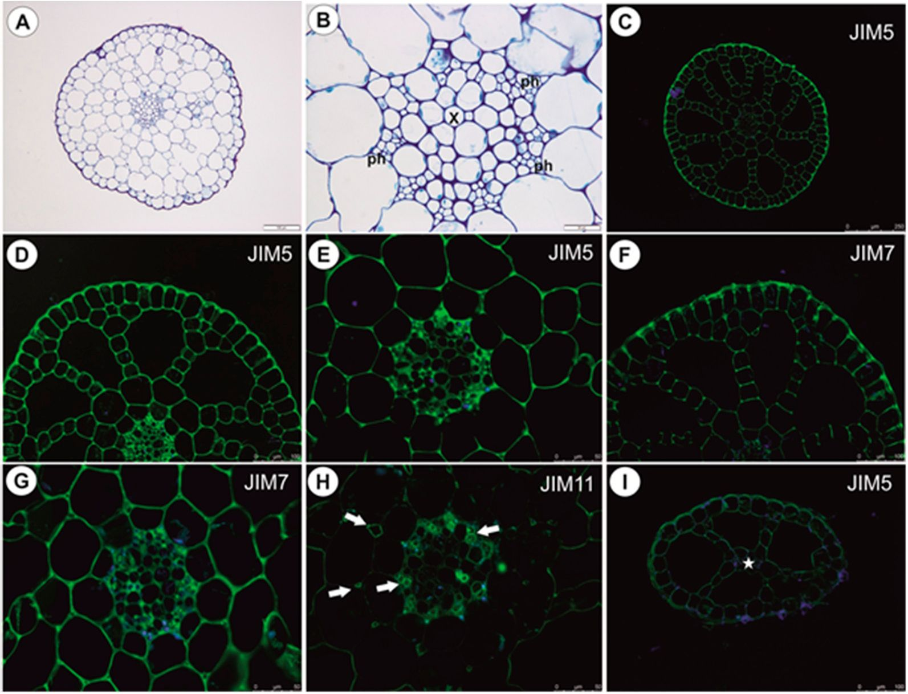
Int. J. Mol. Sa. 2020, 21, 4474
13 of 1 9
Figure 10. Anatomy and immimochemistry of shoots and leaf-like shoots of U. reflexa. (A) Transversal
shoot section, baf 100 цт. (B) Shoot pith anafomy; xylem veasel (x), phloem (ph), baf 20 цт. ( C-E)
Presence of the JIM5, bar 250 51m (C), 10 0 цт (D) and 50 ціп (E). (F,G) Presence of the J11V17, bar 100 цт
(F) anci 50 ціп (G). (H) Presence of the JIM11 (arrows), bar 50цгп. (I) Presence of the JIM5 in leaf-like
shoot, bar 100 gm.
    - Leaf-Like Shoots
These have a very simple structure. The single vascular bundle is surrounded by a one-layered
aerenchyma and an epidermis (Figure 10I). The occurrence of pectic epitopes recognized by the JIM5
and JIM7 antibodes (Figure 10I) is similar to that in the main shoot.

3. Discussion
In U. neottioides, two shoot systems can be distinguished: organs (stolons, inflorescence stalk),
which possess sclerenchyma and so are resiftant to water current, and organs without sclerenehyma
(leaf-like shoots), which are submissive to ihe movement erf waPer. In contrast with typical aquatic
Utricularia species from the sectioo Utricu(aria, which glow in standing or very slowly streaming waters,
the morphology and anatomy of U. neottioides are highly specialized. In U. reflexa (our results), U. vulgaris
L. [15], U. slygia Thor [16,17], U. bremii Heer, U. in term edia Hayne, U. minor L., U. ochroleuca Hartm., [16]
and U. breviscapa Wright ex Griseb. [17], submerged ehoots have very well-developed aerenchyma,
however, there is a lack of sclerenchyma. These organs also have a symmetric structure. Utricularia
neottioides stolons (anchor and running) are asymmetric (dorsiventral asymmetry, but also show
anymmetry in cell size), have only small mtercelluïar spaces, but have sderenchyma. Luetaelburg [18]
abo observed sclerenchyma ("Steinzellen") in the stolons ("rhizomastes"; his Figure 34) of U. neottioides,
however, our results show anoiher dirOribution of the sclerenchyma cefls and variations in their
occurrence. Sclerenchyma in anchor stolons may have a protective function against mechanical injury
by the water current and by material transported by water bui may olso protect these organs agamst
grazing by animals. Generally, sclerenchyma enables plant ocgans to withstand various mechanicar
strains, which may result from ftretching, bending, we(ght and pressure [19]. We showed that
Int. J. Mol. Sci. 2020, 21, 4474
14 of 19
sclerenchyma cells in U. neottioides organs retained their protoplasts up to maturity, so their cell walls
may continue to be modified in response to external stress factors.
In Podostemaceae, which occur in similar habitats to U. neottioides, silica bodies are present in
long-lived parts such as roots and stems. These may perform a similar function to the sclerenchyma in
U. neottioides stolons [20,21]. According to these authors, silica bodies may also prevent the plant from
collapsing during short periods of drought. Anchor stolons in U. neottioides have a thick cuticle in
the epidermal cells and the cell walls of some epidermal cells show lignification: both characteristics
strengthen the structure of these organs. Lloyd [22] found similarities between U. rigida, U. neottioides
and Podostemaceae. Van Steenis [7] classified rheophytic Utricularia and Podostemaceae, which both
grow in turbulent waters, to the same group-lepidorhephytes. Rutishauser [23] compared anchor
stolons of rheophytic Utricularia to the holdfasts in Podostemaceae, Hydrostachyaceae and seagrasses
(see section on Saxicolella amicorum root, Figure 4 in Ameka et al. [24], which resembles the anatomy of
the anchor stolon of U. neottioides). Adhesive trichomes along the lower (ventral) side of anchoring
organs occur both in rheophytic Utricularia and Podostemaceae as a functional convergence.
Adhesive trichomes were described in Podostemaceae [23]; these trichomes are reported to secrete
superglue-like substance, which affixes plants to the rock surface. However, some authors noted that
sticky extracellular polymeric substances produced by cyanobacteria are essential for anchoring of these
plants [25]. We noted that secretion produced by adhesive trichomes of U. neottioides stain positively
with MB/AII. Additionally, microorganisms are attached to this secretion. The role of cyanobacteria
biofilms for U. neottioides anchoring requires further testing, as does the composition of the adhesive
trichome secretions. The adhesive plant secretion may have lipid or pectic character. For example,
in parasitic plants, an adhesive epithelium occurs and secretes a lipidic glue (Viscum) or pectin-rich
polysaccharides (Cuscuta, Cassytha) to hold the parasite and host together [26].
The shape of the U. neottioides anchor stolon system could be compared with anchoring holdfasts
of some crinoids (see e.g., [27-29]). However, this is only analogy with the anchoring system between
a specialized carnivorous plant and specialized animals. We found that U. neottioides anchor stolons
store nutrients (starch) and mucilage. Stolon cells possess chloroplasts, so these organs perform
photosynthesis and can support the leaf-like shoots in this respect. Running stolons produce new
rosettes, which can give rise to new plants (vegetative reproduction); it should then be considered that
plants growing on one rock may be one clone. Thus, in addition to anchoring, the stolon system of
U. neottioides can perform multiple other functions.
Stänescu and Toma [15] could not distinguish the phloem elements from the xylem ones in the
submerged shoots of U. vulgaris. They noted that the central cylinder consisted of a homogeneous mass
of polygonal cells with cellulose cell walls. This contrasted with Schweingruber et al. [16], who noted
that in submerged shoots of aquatic Utricularia, the xylem and phloem within the central cylinder
were difficult to distinguish. These authors observed a circularly arranged, solitary unlignified vessel
in U. vulgaris. In other species, there were few to one (U. intermedia) isolated unlignified vessels.
In contrast, we did not have any problem distinguishing the xylem and phloem in the stolons of both
U. reflexa and U. neottioides. Their vessels have lignified cell walls. In U. neottioides, vessel diameters are
smaller than those observed in aquatic species from the section Utricularia [16].
The basal portion of the inflorescence stalk ([1] used the term peduncle for this organ) of
U. neottioides has a lignified fiber ring; a similar sclerenchyma ring was observed in the flower stalks of
various Utricularia species, e.g., [16,30]. Schweingruber et al. [16] noted that in the flower stalks of
aquatic Utricularia, there was a cortex with well-developed aerenchymatic intercellulars. This is in
contrast with U. neottioides, where the aerenchyma is lacking in the cortex. This trait possibly provides
a more compact and rigid structure for the stalk, which experiences rapid water currents.
The leaf-like shoots of U. neottioides have a very simple anatomy, similar to that of U. reflexa
(our results), U. aurea [31], U. gibba [32] and U. stygia [17], but without forming aerenchyma. These organs
of aquatic Utricularia species are anatomically simpler when compared to both the large "leaves" of
giant-leaved Utricularia species such as U. humboldtii with bifacial blade and palisade parenchyma [33],
Int. J. Mol. Sci. 2020, 21, 4474
15 of 19
and also the small-leaved terrestrial species such as U. dichotoma [34], U. uniflora, and U. paulineae [17].
We observe some differences in the immunodetection of cell wall components between U. reflexa and
U. neottioides. In both species, the pectic epitopes recognized by the JIM5 and JIM7 antibodies are
abundant in primary cell walls of various cell types. However, in U. reflexa, accumulation of these
epitopes occurs in the pith; this is associated with the occurrence of thick-walled parenchyma cells,
which are missing in pith of U. neottioides. Some differences found are associated with the occurrence
of sclerenchyma in the stolons of U. neottioides. Epitopes recognized by the JIM5 and JIM7 are absent
from the sclerenchyma secondary cell walls. In both species, extensin epitope (JIM11) is connected
with pith and vascular tissues, however, besides in U. neottioides this epitope occurs also in cell walls of
sclerenchyma cells.
The shoots of aquatic Utricularia from the sect. Utricularia are covered by small epidermal
trichomes, which also occur on short, modified shoots in turions [35]. Trichomes of U. neottioides shoots
have a similar architecture but their terminal cell is strongly elongated. These trichomes, which were
noted incorrectly as unicellular [4], could significantly increase gas exchange surfaces. In line with the
adaptation for living in strong currents and with the high density of elongated trichomes found in
U. neottioides, remarkable ecophysiological characteristics were estimated in this species [4]. The high
CO2 compensation point of photosynthesis of leaf-like shoots (17.1 gM CO2) indicates invariably a
ca. 2.5-5 times lower CO2 affinity than is usual in other aquatic Utricularia species. On the contrary,
the aerobic dark respiration rate was extremely high, around 8-12 times higher than is usual in other
aquatic Utricularia species. Such a high respiration rate might cause plant sensitivity to oxygen shortage
in the ambient water and, moreover, it must be counterbalanced by a very high net photosynthetic
rate, which requires a very high CO2 concentration in the water. Alternatively, the plant may be partly
dependent on the uptake of organic substances from the water (by the trichomes) or on the extensive
uptake of organic substances from carnivory (by traps). Further research should specify the relative
importance of elongated trichomes and carnivory for nutrient uptake.
Although some authors [4,36] had doubts regarding the trap occurrence in U. neottioides, traps were
recorded by several researchers in the past: Luetzelburg (as U. Herzogii, his figures: 37-39 [18]) and [1,22].
We have observed them in plants from populations from Minas Gerais as well. Traps were also recorded
in populations in Sao Paulo, Goias, and Rio de Janeiro States (S. Silva, V. Miranda, unpublished data).

4. Materials and Methods
  - Plant Material
Material of Utricularia neottioides was collected from small streams near Delfinópolis, Serra da
Canastra region, Minas Gerais State, Southeastern Brazil (Figure 1A-C). The pH of the streams inhabited
by U. neottioides ranged from 5.0 to 6.4 (pH meter Tri-Meter EC-983; see Table 1). Material of U. reflexa
(from Okavango Swamp, Botswana) was taken from the collection at the Institute of Botany CAS
at Trebon, Czech Republic. The plants were grown in 3 L miniaquaria and sedge litter was used as
substrate to create a dystrophic environment. The poorly branched plants were 20-30 cm long.
Table 1. pH and water temperature from Utricularia neottioides habitat in Delfmópolis-MG.
pH Range (n = 3) | Temp (°C) | Date-Time
4.99-5.02 | 29.8 | 07 February 2019-15:15
6.22-6.36 | 27.1 | 07 February 2019-17:52
5.66-5.75 | 26.8 | 09 February 2019-14:44
Int. J. Mol. Sci. 2020, 21, 4474
16 of 19

4.2. Morphological and Anatomical Studies
Material of both Utricularia species was fixed and later processed as in Lustofin et al. [37]: materials
were fixed in a mixture of 2.5% or 5% glutaraldehyde with 2.5% formaldehyde in a 0.05-M cacodylate
buffer (Sigma-Aldrich, Sigma-Aldrich Sp. z o.o. Poznan, Poland; pH 7.2) for several days, washed three
times in a 0.1-M sodium cacodylate buffer and post-fixed in a 1% osmium tetroxide solution at
room temperature for 1.5 h. Dehydration using a graded ethanol series, infiltration and embedding
using an epoxy embedding medium kit (Honeywell Fluka™, Honeywell Specialty Chemicals Seelze,
Seelze Germany) followed. After polymerization at 60 °C, sections for the TEM were cut at 70 nm
using a Leica Ultracut UCT ultramicrotome, stained with uranyl acetate and lead citrate. The stolon
ultrastructure was analyzed using a Hitachi H500 transmission electron microscope (Hitachi, Tokyo,
Japan), at an accelerating voltage of 75 kV and Hitachi UHR FE-SEM SU 8010 at 25 kV, which are
housed at the University of Silesia in Katowice. The semi-thin sections (0.9-1.0 gm thick) prepared for
the LM were stained with aqueous methylene blue/azure II (MB/AII) for 1-2 min and examined using
Olympus BX60 and Nikon Eclipse E400 light microscopes. For the SEM, material was fixed (as above),
later dehydrated and dried using supercritical CO2. They were then sputter-coated with gold and
examined at an accelerating voltage of 20 kV using a Hitachi В-4700 scanning electron microscope,
which is housed at the Institute of Geological Sciences, Jagiellonian University in Kraków, Poland.
About ten replications of material samples (each organ) were studied.
Histochemical procedures with fixed material using PAS reaction (the periodic acid-Schiff
reaction), ruthenium red, and Lugol's solution were performed to detect the polysaccharides, mucilage,
starch grains, and proteins [38]. Sections through U. neottioides and U. reflexa stolons and shoots
were analyzed using a polarized light microscope (Carl Zeiss Axio Lab.A1) in the Department of
Environmental Analysis, Geological Mapping and Economic Geology; AGH University of Science and
Technology. Parts of U. neottioides anchor stolons were stained with zinc iodine chloride solution to
visualize lignified cell walls of the sclerenchyma according to [39].

4.3. Immunodetection of Cell Wall Components
Stolons and shoots were fixed overnight at 4 °C in 8% (w/v) paraformaldehyde (PFA) with 0.25%
(v/v) glutaraldehyde (GA) in a PIPES buffer [38]. Plant material was then embedded in Steedman's
wax and sectioned. Rehydrated sections were blocked with a 1% BSA in PBS buffer and incubated
with primary antibodies against pectins (JIM5 and JM7), arabinogalactan (JIM8), and extensin n
(JIM11) overnight at 4 °C (see [40,41] and literature cited therein; rat monoclonal antibody JIM5, JIM7,
JIM8, JIM11, and JIM13 was obtained from Plant Probes, UK) and secondary antibody goat anti-rat
conjugated with FITC (Abcam: Abcam plc, registered in England and Wales with Company Number
03509322, Discovery Drive, Cambridge Biomedical Campus, Cambridge, CB2 0AX, UK). Chromatin
in the nuclei was stained with 7 gg/mL DAPI and samples cover-slipped using Mowiol medium.
They were viewed with Leica DM6000 B using FITC and DAPI filter combined with DIC (Nomarski
contrast). At least 2 different replications were performed for each organ and about 10-20 sections
were analyzed from each organ for each antibody used. Negative controls were performed by omitting
the primary antibody step, obtaining no fluorescence signal in each control frame for all slides stained
(Supplementary Materials Figures S3-S5).

5. Conclusions
Due to life in a turbulent habitat, U. neottioides evolved specific characteristics including an anchor
system with stolons, which have an asymmetric structure, sclerenchyma, and adhesive trichomes on
the ventral side. This anchor stolon system performs multiple functions including photosynthesis,
nutrient storage, and vegetative reproduction as well as anchorage. In contrast with typical aquatic
Utricularia species from the section Utricularia, U. reflexa, which grows freely in standing or very slowly
streaming waters and forms monomorphic shoots, U. neottioides has a well-developed sclerenchyma
Int. J. Mol. Sci. 2020, 21, 4474
17 of 19
system but lacks large aerenchyma. The plants produce traps and U. neottioides should be thus treated
as carnivorous plant.
Supplementary Materials: Supplementary materials can be found at http://www.mdpi.com/1422-0067/21/12/4474/s1.
Author Contributions: B.J.P. designed project; B.J.P., V.F.O.M. collected plants and L.A. cultivated the plants;
B.J.P., P.S., M.K. performed analysis and data visualization; B.J.P., L.A., V.F.O.M. prepared the original manuscript
draft; P.S., L.A., M.K., V.F.O.M. were involved in the experimental ideas and critically revised the manuscript.
All authors have read and agreed to the published version of the manuscript.
Funding: This research was partially supported financially to BJP by the Ministry of Science and Higher
Education of Poland as part of the statutory activities of the Department of Plant Cytology and Embryology,
Institute of Botany, Faculty of Biology, Jagiellonian University in Kraków (N18/DBS/000002), the Department of
Plant Cytology and Embryology, Faculty of Biology, University of Gdansk (531-D031-D243-200) and Institute
of Biology, Biotechnology and Environmental Protection, Faculty of Natural Sciences, University of Silesia in
Katowice. The scientific stay of BJP in Brazil was financed by the Jagiellonian University within the project
Integrate JU-Comprehensive Development Programme of the Jagiellonian University as part of the Knowledge
Education Development 2014-2020 Operational Programme co-financed by the European Social Fund of the
European Union (POWR.03.05.00-00Z309/17-00). We thank Conselho Nacional de Desenvolvimento Científico e
Tecnológico (CNPq) for the fellowship of VFOM (Bolsa de Produtividade - Proc. # 312908/2018-0). This study
was partly supported to LA by the long-term research development project of the Czech Academy of Sciences
No. RVO 67985939.
Acknowledgments: We would like to thank Saura Rodrigues Silva, Felipe Martins, Ramon Guedes, Samanta
Carvalho, Hugo Dolsan, Fernanda Rodrigues, Leonardo Veloso, and Guilherme Seber for kind help and participation
in the expedition to Minas Gerais. Additionally, thanks are due to S. Rodrigues Silva for the photo of U. neottioides'
traps (Figure 1D). The authors express their sincere thanks to Agata Jurkowska for the opportunity to use the
polarized light microscope. Special thanks are due to Brian G. McMillan (Glasgow, Scotland, U.K.) for English
correction. We cordially thank both reviewers for comments, which have helped to improve the manuscript.
Conflicts of Interest: The authors declare no conflict of interest.

References
- Taylor, P. The Genus Utricularia: A Taxonomic Monograph; Kew Botanic Gardens: London, UK, 1989.
- Miranda, V.F.O.; Menezes, C.G.; Silva, S.R.; Díaz, Y.C.A.; Rivadavia, F. Lentibulariaceae in Lista de Espécies
da Flora do Brasil; Jardim Botânico do Rio de Janeiro: Rio de Janeiro, Brasil, 2015. Available online:
http://floradobrasil.jbrj.gov.br/jabot/floradobrasil/FB30235 (accessed on 5 April 2020).
- Flora do Brasil 2020 under Construction. Jardim Botânico do Rio de Janeiro. Available online: http://floradobrasil.
jbrj.gov.br/ (accessed on 30 April 2020).
- Adamec, L.; Fleischmann, A.; Pásek, K. Biology of the trapless rheophytic Utricularia neottioides: Is it possible
to grow this specialized species in cultivation? Carniv. Plant Newslett. (Fullerton) 2015, 44,104-114.
- Jobson, R.W.; Baleeiro, P.C.; Guisande, C. Carnivorous Plants: Physiology, Ecology, and Evolution; Ellison, A.M.,
Adamec, L., Eds.; Oxford University Press: Oxford, UK, 2018; pp. 89-104.
- Rutishauser, R.; Isler, B. Developmental genetics and morphological evolution of flowering plants, especially
bladderworts (Utricularia): Fuzzy Arberian morphology complements classical morphology. Ann. Bot. 2001,
88,1173-1202. [CrossRef]
- Van Steenis, C.G.G.J. Rheophytes of the World. An Account of the Flood-Resistant Flowering Plants and Ferns and
the Theory of Autonomous Evolution; with 23 Photographs, 44 Figs.; Sijthoff & Noordhoff: Alphen aan den Rijn,
The Netherlands; Rockville, MA, USA, 1981; 408p.
- Müller, K.; Borsch, T. Phylogenetics of Utricularia (Lentibulariaceae) and molecular evolution of the trnK
intron in a lineage with high substitutional rates. Plant Syst. Evol. 2005, 250, 39-67. [CrossRef]
- Silva, S.R.; Gibson, R.; Adamec, L.; Dominguez, Y.; Miranda, V.F.O. Molecular phylogeny of bladderworts:
A wide approach of Utricularia (Lentibulariaceae) species relationships based on six plastidial and nuclear
DNA sequences. Mol. Phylogenet. Evol. 2018,118, 244-264. [CrossRef] [PubMed]
- Satter, R.; Rutishauser, R. Structural and dynamic descriptions of the development of Utricularia foliosa and
U. australis. Can. J. Bot. 1990, 68,1989-2003. [CrossRef]
- Adamec, L. Ecophysiology of aquatic carnivorous plants. In Carnivorous Plants: Physiology, Ecology, and
Evolution; Ellison, A.M., Adamec, L., Eds.; Oxford University Press: Oxford, UK, 2018; pp. 256-269.
- Adamec, L. Biological flora of Central Europe: Utricularia intermedia Hayne, U. ochroleuca R.W. Hartm.,
U. stygia Thor and U. bremii Heer ex Kolliker. Perspect. Plant Ecol. Evol. Syst. 2020, 44, e125520. [CrossRef]
Int. J. Mol. Sci. 2020, 21, 4474
18 of 19
- Guisande, C.; Granado-Lorencio, C.; Andrade-Sossa, C.; Duque, S.R. Bladderworts. Funct. Plant Sci. Biotechnol.
2007,1, 58-68.
- Rivadavia, F. Utricularia neottioides. Carniv. Plant Newslett. 1996, 25,46-47.
- Irina, S.; Constantin, T. Morpho-structural adaptations of some aquatic carnivorous plant species
(Aldrovanda vesiculosa L. and Utricularia vulgaris L.). Buletinul Gradinii Botanice Iasi. 2007,14, 7-12.
- Schweingruber, F.; Kučerová, A.; Adamec, L.; Doležal, J. Anatomic Atlas of Aquatic and Wetland Plant Stems;
Springer: Cham, Switzerland, 2020. [CrossRef]
- Reut, M.S.; Swiątek, P.; Miranda, V.F.O.; Płachno, B.J. Living between land and water—Structural and
functional adaptations in vegetative organs of bladderworts. 2020; submitted.
- Von Luetzelburg, P. Beiträge zur Kenntnis der Utricularien. Flora 1910,100,145-212. [CrossRef]
- Evert, R.F.; Eichhorn, S.E. Esau's Plant Anatomy: Meristems, Cells, and Tissues of the Plant Body: Their Structure,
Function, and Development, 3rd ed.; John Wiley &Sons: Hoboken, NJ, USA, 2006; 601p.
- Cook, C.D.K.; Rutishauser, R. Podostemaceae. In The Families and Genera of Vascular Plants; Kubitzki, K., Ed.;
Springer: Berlin, Germany, 2007; Volume 9, pp. 304-344.
- Grob, V.; Pfeifer, E.; Rutishauser, R. Morphology, development and regeneration of Thelethylax minutiflora,
a Madagascan river-weed (Podostemaceae). Phyton (Horn, Austria) 2007, 47, 205-229.
- Lloyd, F.E. The Carnivorous Plants; Chronica Botanica Company: Waltham, MA, USA, 1942.
- Rutishauser, R. Evolution of unusual morphologies in Lentibulariaceae (bladderworts and allies) and
Podostemaceae (river-weeds): A pictorial report at the interface of developmental biology and morphological
diversification. Ann. Bot. 2016,117, 811-832. [CrossRef] [PubMed]
- Ameka, K.G.; Pfeifer, E.; Rutishauser, R. Developmental morphology of Saxicolella amicorum and S. submersa
(Podostemaceae: Podostemoideae) from Ghana. Bot. J. Linn. Soc. 2002,139, 255-273. [CrossRef]
- Jâger-Zürn, I.; Grubert, M. Podostemaceae depend on sticky biofilms with respect to attachment to rocks in
waterfalls. Int. J. Plant Sci. 2000,161,599-607. [CrossRef]
- Heide-Jurgensen, H. Parasitic Flowering Plants; Koninklijke Brill NV: Leiden, The Netherlands, 2008.
- Seilacher, A.; MacClintock, C. Crinoid anchoring strategies for soft-bottom dwelling. Palaios 2005,20, 224-240.
[CrossRef]
- Plotnick, R.E.; Ebey, C.M.; Zinga, A. A radicle solution: Morphology and biomechanics of the Eucalyptocrinites
"root" system. Lethaia 2016, 49,130-144. [CrossRef]
- Ferretti, A.; Ausich, W.; Corradini, C.; Corriga, M.; Schonlaub, H. Stars in the Silurian sky: Echinoderm
holdfasts from the Carnic Alps, Austria. Geol. Acta 2016,14, 335-347.
- Slinger, J. The morphology and anatomy of Utricularia transrugosa Stapf. Bothalia 1954, 6, 385-406. [CrossRef]
- Rutishauser, R. The developmental plasticity of Utricularia aurea (Lentibulariaceae) and its floats. Aquat. Bot.
1993, 45,119-143. [CrossRef]
- Chormanski, T.A. Morphology and anatomy of three common Everglade Utricularia species; U. gibba,
U. cornuta, and U. subulata. Master's Thesis, Florida International University, Miami, FL, USA, 2007.
- Brugger, J.; Rutishauser, R. Bau und Entwicklung landbewohnender Utricularia-Arten. Bot. Helv. 1989, 99,
91-146.
- Reut, M.S.; Płachno, B.J. Unusual developmental morphology and anatomy of vegetative organs in Utricularia
dichotoma—leaf, shoot and root dynamics. Protoplasma 2020,257, 371-390. [CrossRef] [PubMed]
- Płachno, B.J.; Adamec, L.; Kozieradzka-Kiszkurno, M.; Swiatek, P.; Kammska, I. Cytochemical and
ultrastructural aspects of aquatic carnivorous plant turions. Protoplasma 2014, 251,1449-1454. [CrossRef]
[PubMed]
- Fleischmann, A. Do we have any evidence that any plants have given up carnivory? Carniv. Plant Newslett.
2011, 40, 37.
- Lustofin, K.; Swiatek, P.; Miranda, V.F.O.; Płachno, B.J. Flower nectar trichome structure of carnivorous plants
from the genus butterworts Pinguicula L. (Lentibulariaceae). Protoplasma 2020, 257, 245-259. [CrossRef]
[PubMed]
- Johansen, D.A. Plant Microtechnique; McGraw-Hill Book Co.: New York, NY, USA, 1940.
- Braune, W.; Leman, A.; Taubert, H. Praktikum Anatomii Roslin; Paristwowe Wydawnictwo Naukowe:
Warszawa, Polska, 1975; p. 295.

Int. J. Mol. Sci. 2020, 21, 4474
19 of 19
- Slazak, B.; Kapusta, M.; Malik SBohdanowicz, J.; Kuta, E.; Malec, P.; Goransson, U. Immunolocalization of
cyclotides in plant cells, tissues and organ supports their role in host defense. Planta 2016, 244,1029-1040.
[CrossRef]
- Gawecki, R.; Sala, K.; Kurczynska EU Swiatek, P.; Płachno, B.J. Immunodetection of some pectic,
arabinogalactan proteins and hemicellulose epitopes in the micropylar transmitting tissue of apomictic
dandelions (Taraxacum, Asteraceae, Lactuceae). Protoplasma 2017, 254, 657-668. [CrossRef]
© 2020 by the authors. Licensee MDPI, Basel, Switzerland. This article is an open access
article distributed under the terms and conditions of the Creative Commons Attribution
(CC BY) license (http://creativecommons.org/licenses/by/4.0/).

