© Med Sci Monit, 2009; 15(7): BR194-201
PMID: 19564819
www.MedSciMonit.com
Basic Research
Received: 2008.04.04  Accepted: 2008.08.19  Published: 2009.07.01  Authors' Contribution:  |a| Study Design  |b| Data Collection  |c| Statistical Analysis  |d| Data Interpretation  |p Manuscript Preparation  m Literature Search  |g| Funds Collection | Asthmatic bronchial fibroblasts demonstrate enhanced  potential to differentiate into myofibroblasts in culture  Marta Michalik1033™, Małgorzata Pierzchalska2™™, Agnieszka Legutko103,  Marcin Ura^, Anna Ostaszewska3B, Jerzy Soja3B, Marek Sanak303  - Department of Cell Biology, Faculty of Biochemistry, Biophysics, and Biotechnology, Jagiellonian University,  Cracow, Poland  - Department of Food Biotechnology, Faculty of Food Technology, Agricultural University, Cracow, Poland  - Department of Medicine, Jagiellonian University Medical School, Cracow, Poland  Source of support: Part of the described experiments was financially supported by grants from the Polish Ministry  of Science and Higher Education (2P04C 125 29; N N302 130834 and N N301 0502236)
 | Summary
Background: | Chronic inflammation and remodeling of the bronchial wall are basic hallmarks of asthma. It is  known that mesenchymal cells in the lamina reticularis underlying the basement membrane of  the thickened airway wall of asthmatics predominantly display the phenotype of myofibroblasts  and express a-smooth muscle actin (a-SMA). Human bronchial fibroblasts (HBFs) transform in  vitro into myofibroblasts under the influence of transforming growth factor (TGF-b). Differences  in the reactivity of fibroblasts to TGF-b in cultures derived from healthy and asthmatic donors are  elucidated here.
Material/Methods: | Primary human bronchial fibroblasts (HBFs) were cultured from bronchial biopsies from non-asth-  matic (n=7) and asthmatic (n=7) donors and treated with TGF-b1 or TGF-b2 to induce myofibroblast  differentiation. Expression of a-smooth muscle actin (a-SMA) was assessed by immunocytochem-  istry and Western blotting. The cell size and shape parameters were measured by computer-aided  methods.
Results: | Regardless of whether TGF-b1 or TGF-b2 was used, asthmatic cells showed enhanced expression of  the myofibroblast marker as confirmed by immunocytochemistry and immunoblotting. Analysis  of the shape parameters of cells incubated in the presence of TGF-b1 revealed that HBFs of asth-  matics differ from those of non-asthmatics.
Conclusions: | It is concluded that asthmatic HBFs cultured in vitro display some inherent features which facili-  tate their differentiation into myofibroblasts. These data indicate that increased reactivity of asth-  matic fibroblasts to TGF-b may play a crucial role in asthma.
key words: | human bronchial fibroblasts • myofibroblasts • transforming growth factor beta • asthma
Full-text PDF: | http://www.medscimonit.com/abstract/index/idArt/869704
Word count: | 3184
Tables: | 1
Figures: | 7
References: | 28
Author's address: | Marta Michalik, Department of Cell Biology, Faculty of Biochemistry, Biophysics, and Biotechnology, Jagiellonian  University, Gronostajowa 7, 30-387 Cracow, Poland, e-mail: marta.michalik@uj.edu.pl
BR194
Current Contents/Clinical Medicine • IF(2007)=1.607 • Index Medicus/MEDLINE • EMBASE/Excerpta Medica • Chemical Abstracts

Med Sci Monit, 2009; 15(7): BR194-201
Michalik M et al - Asthmatic bronchial fibroblasts demonstrate enhanced.
Background
Recent studies on bronchial asthma indicate that the chron-
ic inflammation of the airways does not fully explain the
pathophysiology of the disease. The structural changes
in the bronchial wall are now considered to be the sec-
ond fundamental factor in the development of asthma
[1]. Airway remodeling is intensively studied in many lab-
oratories as it seems to be resistant to currently available
pharmacological treatment. This process is defined as a
sequence of chronic structural changes leading to thick-
ening of the airway wall, epithelial damage, subepitheli-
al fibrosis, and increased deposition of extracellular ma-
trix proteins [2,3].
It is generally accepted that fibroblasts in the asthmatic
airways are stimulated not only to proliferate and produce
collagens, but also to differentiate into myofibroblasts, the
more contractile subset of fibroblasts which are involved in
wound contraction and the development of fibrotic changes
[4]. The process of myofibroblast differentiation has been
studied in both animal and human models and was shown
to be effectively induced by prolonged cell incubation with
transforming growth factor-b (TGF-b) [5]. Damage to the
epithelium, a characteristic feature of asthma, leads to in-
creased release of TGF-b1 and TGF-b 2 [6,7], the levels of
which are also elevated in the bronchoalveolar lavage of
asthmatics [8]. The aim of the present study was to evalu-
ate whether TGF-b-stimulated fibroblasts in culture show
an increased tendency to differentiate into myofibroblasts
when derived from asthmatics.
Material and Methods
Isolation, culture, and characterization of human
bronchial fibroblasts (HBFs)
Bronchial biopsies were obtained from the segmental bron-
chi during bronchoscopy using a fiberoptic bronchoscope
(Olympus, Japan). Primary HBFs were isolated as described
previously [9]. The cells were cultured in DMEM with 10%
FCS at 37°C in a humidified atmosphere with 5% CO2 and
used between 5-8 passages. For some experiments, cells
were incubated in serum-free DMEM supplemented with
0.1% bovine serum albumin (Sigma St. Louis, MO, USA)
with or without human recombinant TGF-b1 (source: CHO
cells) or TGF-b2 (source: BTI-Tn-5B1-4 (High-5) Insect Cells,
PeproTech EC, London, UK).
Patient characteristics
Committee (KBET/362/B/2003) and all the patients pro-
vided informed consent to participate.
Measurements of cell size and shape
A computer-based image analysis system was used to mea-
sure the size and shape of the bronchial fibroblasts from
the asthmatics and healthy donors. The cells were rinsed
with PBS, fixed with 3.7% formaldehyde, and stained with
Coomasie brilliant blue R-250 (Merck, Darmstadt, Germany).
Cell image analysis was performed using a basic system con-
sisting of an inverted Olympus IMT-2 microscope equipped
with a Hitachi KP-161 CCD camera, a personal computer,
Photo Delux image grabber, and software for image analy-
sis written by Mr. R. Tokarski [10,11]. The signal from the
video camera was digitized. Each image of fibroblasts was
subtracted from a background image to compensate for
any unevenness in the illumination and camera response.
The resulting image was then converted to a binary (black
and white) image by selecting a threshold gray level above
which all pixels were set to white and all others to black.
This selection was performed under manual control to en-
sure the best correspondence between the original cells
and the white areas of the binary image. The image was
then compared with the original optical image and any se-
lections not corresponding to single isolated cells were re-
moved (Figure 1A,B).
To characterize the cell morphology quantitatively, the sur-
face area of the cell projections (in pm2) and the cell exten-
sion, dispersion, and elongation were measured (Figure 1C).
The shape parameters were defined and calculated as de-
scribed by Dunn and Brown (1986) [12]. The parameters
were determined for at least 100 cells in each case. The mean
and standard error for each parameter were calculated.
Staining of a-SMA
Cells growing on glass coverslips were washed with PBS, fixed
in 3.7% paraformaldehyde for 5 min, and permeabilized in
0.1% Triton X-100 for 1 min. After 1 h in 0.3% H2O2, the
coverslips were incubated for 24 hours at 4°C with a mono-
clonal antibody against human a-SMA (clone 1A4, Sigma,
1:400). For staining, the Strept ABC Complex/HRP Duet
kit (Dako, Glostrup, Denmark) and the AEC Chromogen
Kit (Sigma) were used according to the manufacturers’ in-
structions. The level of myofibroblastic differentiation was
measured by counting at least 200 cells.
Immunofluorescence
The study was performed in two groups of subjects with a
total of 14 individuals. The first group consisted of 7 non-
asthmatics in whom diagnostic bronchoscopy ruled out any
serious airway pathology, including asthma, fibrotic lung
disease, sarcoidosis, and cancer (group NA: 2 males and 5
females; average age: 46 years; mean FEV1: 112% predict-
ed, range: 97-138%). The second group consisted of 7 pa-
tients diagnosed with moderate asthma (group AS: 2 males,
5 females; average age: 41 years; mean duration of asthma:
7 years; mean FEV1: 89.7% of predicted, range: 72-118%).
All patients were treated in the Department of Medicine
of Jagiellonian University and were in stable clinical con-
dition. The study was approved by the University’s Ethics
For the immunostaining of vimentin or a-SMA, cells grow-
ing on glass coverslips were washed with PBS, fixed in 3.7%
paraformaldehyde for 15 min, and permeabilized in 0.1%
Triton X-100 for 10 min at room temperature. Following
fixation the slides were blocked with 3% bovine serum albu-
min for 10 min. Then the slides were incubated with mouse
monoclonal antibody against vinculin (Sigma, 1:500) or
mouse monoclonal antibody against human a-SMA (clone
1A4, Sigma, 1:400) for 1 hour at room temperature. The
cells were washed five times with PBS and incubated with
Alexa Fluor 488 gout anti-mouse IgG (clone, Sigma, 1:200)
for 45 min at room temperature. Fluorescent images were
taken with a Leitz Orthoplan microscope.
BR195

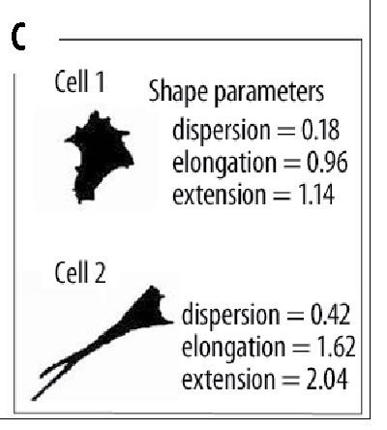
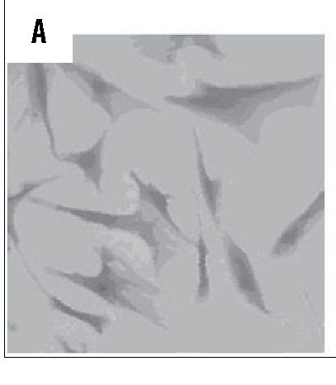
Basic Research Med Sci Monit, 2009; 15(7): BR194-201
Figure 1. Representative digitized video image of
HBFs (A) and an enhanced binary image
of A after residual noise (B). In panel
B, cells in contact and cells not fully
in the frame have been removed. Two
exemplary cells differing in shape and in
dispersion, elongation, and extension are
shown in panel C.
Preparation of cell extracts and immunoblotting
Cells were cultured in 6-cm-diameter Petri dishes until con-
fluency. The cells were stimulated with TGF-b (10 ng/ ml) for
48 hours. Fibroblasts were lysed with a lysis buffer (0.1 mol/l
Tris-HCl, 15% glycerol, 2 mmol/l EDTA, 2% SDS, 10 mmol/l
phenylmethytsulfonyl fluoride, and 10 pg/ml aprotinin, pH
7.4) and 10 pg of the total cellular protein was subjected to
SDS-PAGE in 12% acrylamide gels under reducing condi-
tions and transferred to a polyvinylidene difluoride mem-
brane (Hybond-P, Amersham Pharmacia Biotech). After
blocking in PBS-T (0.1% Tween 80 in PBS) containing 5%
skimmed milk overnight at 4°C, the membrane was incu-
bated for 1 hour with mouse monoclonal anti-a SMA actin
(SIGMA) antibody (1:1000 in 5% skimmed milk in PBS-T)
at 37°C. After washing three times, the membrane was incu-
bated for 1.5 hours with anti-mouse IgG horseradish perox-
idase-conjugated antibody (1:1000 in PBS-T containing 5%
skimmed milk; Santa Cruz Biotechnology). The extensively
washed membranes were incubated with chemiluminescent
reagent (ECL-Western blotting analysis system, Amersham)
for 60 seconds and exposed to Kodak X-Omat film. For quan-
titative measurements the films were digitalized and ana-
lyzed with an imaging system (ImageMaster VDS software,
GeneTool, Syngene). The membranes were stained with
Coomassie Brilliant Blue to check the uniformity of protein
loading. The lowest value obtained for a band representing
an NA patient was considered as 100%. The amount of pro-
tein was expressed relative to this lowest value. In some cas-
es, a-SMA protein was not detected in the control samples
and these wells were excluded from analysis.
Statistical analysis
The significance of differences in the proportion of cells
expressing a-SMA between the cell groups (AS, NA) were
determined by applying the nonparametric Mann-Whitney
U test or the Wilcoxon matched-pairs rank test. Two meth-
ods were used to assess the statistical significance of chang-
es in the cell projection parameters. In the case of shape
parameters, the data sets were examined by one-way analy-
sis of variance (ANOVA) with the Scheffe post hoc test. The
GLM (general linear model) module of Statistica 6.0 was
used for statistical calculations. The Kruskal-Wallis nonpara-
metric variant of ANOVA was applied for comparisons of
area and perimeter. The a correction according to Dunn-
Sidak was applied in multiple comparisons.
RESULTS
After isolation, the cells were assessed microscopically to
have fibroblast-like morphology. The levels of expression of
a-smooth muscle actin (a-SMA), vimentin, and F-actin were
also checked by means of the cytoimmunofluorescence stain-
ing or staining with TRITC-phalloidin. In all the primary cul-
tures kept under normal conditions (DMEM+10%FCS), less
than 0.5% of cells were very weakly stained for a-SMA and all
cells expressed vimentin. In sparse culture they developed rath-
er thin stress fibers and small focal adhesions. These results
were considered proof that the isolated cells were not smooth
muscle cells, but fibroblasts. This was the case in all the cell
cultures we used. It is now believed that in cell culture on a
rigid substrate, fibroblasts express a stable phenotype which
can be called the proto-myofibroblastic phenotype [13].
Although the generation of myofibroblasts in pathologi-
cal states (fibrosis, wound healing) in vivo is complex, the
main inducers of this phenotype seems to be transforming
growth factors b and the process can be reproduced in vitro
by incubating the cell cultures in medium containing the
active forms of TGF-b1 or -b2 for 1-3 days [14,15]. We cul-
tured the HBFs in serum-free medium supplemented with
the active form of human recombinant TGF-b1 or TGF-b2
at concentrations of 1, 5, 10, and 20 ng/ml for 48 hours.
The in vitro differentiation of the HBFs to myofibroblasts
was evaluated by an analysis of a-SMA protein expression
and the incorporation into stress fibers using immunocyto-
chemical methods. In contrast to control cultures incubat-
ed in DMEM with or without serum, the myofibroblasts in
medium containing TGF-b were easily distinguishable be-
cause they displayed well-developed, thick, and a-SMA-pos-
itive stress fibers. The percentage of the TGF-b-induced.
a-SMA-positive cells was 2-25% and varied from culture to
culture. In individual cultures the effect was dose depen-
dent up to 10 ng/ml, because of which a concentration of
10 ng/ml was chosen for further experiments. Our micro-
scopic observations indicated that the incubation of HBFs
in the medium containing TGF-b imposes an evident effect
not only on a-SMA expression, but also on the cell size and
shape (Figure 2). We did not observe significant differenc-
es between TGF-b1- and b2-treated HBF cultures.
To confirm these observations we measured the projected
cell areas and cell shape parameters (extension, elonga-
tion, and dispersion) of fibroblasts (a-SMA-negative cells)
and myofibroblasts (a-SMA-positive cells) from the same
TGF-b1-treated HBF culture. The parameters characteriz-
ing one representative cell culture are given in Figure 3.
According to Dunn and Brown [12], extension is a mea-
sure of how much the shape differs from a circle. It has
a value of zero if it is circular and increases without lim-
it as it becomes less compact and is the sum of the elonga-
tion and dispersion. Elongation is a measure of how much
the shape must be compressed along its long axis to min-
BR196
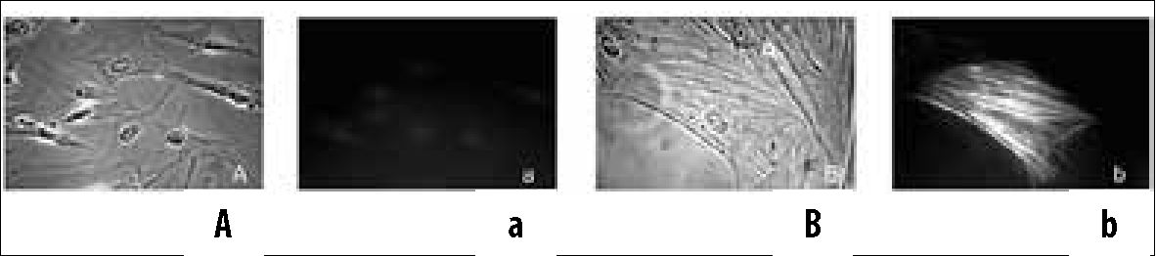
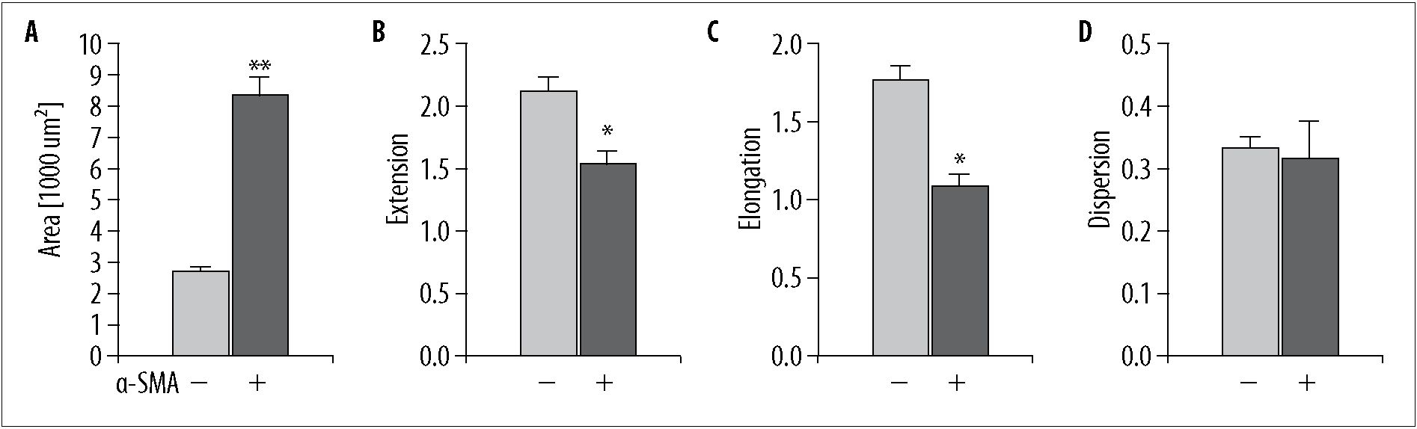
Med Sci Monit, 2009; 15(7): BR194-201
Michalik M et al - Asthmatic bronchial fibroblasts demonstrate enhanced.
imize its extension. It changes from 0 for a circular shape
and increases as the cell elongates. Elongation can never
be less than 0 or greater than the extension. Dispersion is
the minimum extension that can be attained by compress-
ing the shape uniformly. The minimum dispersion of zero
is achieved only if the shape is an ellipse and it can never
have a value greater than that of the extension.
In all the cultures tested, the myofibroblasts population was
characterized by a larger mean area (Figure 3A) and a small-
er extension of the cell projection. The reduced extension
value obtained for myofibroblasts is mainly due to the re-
duced elongation of the cell projections (Figure 3B-D).
The microscopic observations indicate that the incubation
of HBFs in medium containing TGF-^ imposes an evident
effect on the cell size and shape regardless of whether they
are fully differentiated myofibroblasts (Figure 4). We sought
to investigate whether this is more pronounced in the cell
cultures derived from asthmatics. To answer this question
the same quantitative analysis of the cell size and shape pa-
rameters was used. To get a statistically significant result we
repeated the experiments (48-h incubation of cells without
or with 10 ng/ml of TGF-^) using five cultures derived from
healthy donors and five from asthmatics (Table 1, Figure 5).
The cell cultures derived from various subjects differed sig-
nificantly in their cell projection area (the range of the
mean area was from 1915-5044 pm2 in the NA group and
1704-5236 pm2 in the AS group, Table 1A). However, the
statistical analysis revealed that there was no difference in
the areas of the cell projections of the HBFs from groups NA
and AS, regardless of the cell culture conditions [serum-free
medium with or without TGF-b1 (Table 1) or DMEM with
10% FCS (data not shown)]. However, TGF-b1 treatment
caused a significant increase in the projected cell area in
Figure 2. TG F-p1-induced changes in the
morphology of HBFs. HBFs (derived from
asthmatics) were cultured in DMEM
with 10% FCS for 24 hours, then with
the same medium (A,a) or with DMEM
supplemented with 0.1% BSA with
10 ng/ml TGF-P1 (B,b) for 48 hours.
The cells were fixed and stained for a-
SMA. The cells were photographed
with a Leitz Orthoplan microscope with
phase contrast optics (A,B) and with
epifluorescence mode (a,b). Bar = 20 pm
both groups of cultures (Table 1B, Figure 5A). Noteworthy
results were obtained when the effect of TGF-b1 on the exten-
sion of the HBF projections was studied. As shown in Table
1 and Figure 5B, the extension of the HBF projections was
significantly reduced upon TGF-b1 treatment in cell cultures
derived from the subjects of both groups. In the case of this
parameter there were significant differences between the NA
and AS groups for both culture conditions (serum-free me-
dium with and without TGF-b1). Surprisingly, the extension
seemed to be lower in the NA group (Table 1A).
To assess whether the potential of differentiation into myo-
fibroblasts depends on the subject group (NA or AS), the
percentage of cells expressing a-SMA was evaluated. In all
the cultures tested in the serum-free condition, only a small
proportion of cells (below 1%) showed a diffuse staining pat-
tern of a-SMA that was not incorporated into stress fibers.
In contrast, in the TGF-b1-treated HBFs the myofibroblasts
were easily distinguishable because they displayed well-devel-
oped, thick, and a-SMA-positive stress fibers. The percent-
age of a-SMA-positive cells was significantly higher in the
AS group than in the NA (Figure 6A). The same result was
obtained for cultures incubated for 48 hours in 10 ng/ml
of TGF-b2 (Figure 6B). The difference between the influ-
ence of TGF-b1 and TGF-b2 was not statistically significant
(Wilcoxon signed-ranks test, p>0.05).
Although cytoimmunofluorescence identified a very low
number of typical myofibroblasts in the TGF-b-untreated
Figure 3. Comparison of a-SMA-negative fibroblasts and a-SMA-positive myofibroblasts. The cells were cultured in DMEM with 10% FCS for 24
hours and then with DMEM supplemented with 0.1% BSA with 10 ng/ml TGF-P1 for 48 hours. The cells were fixed and stained for a-SMA.
The area (A), extension (B), elongation (C), and dispersion (D) of the cell projections for a-SMA-negative and -positive cells derived from
the NA and AS groups were determined. The presented values are the means ±SE. The parameters for at least 50 cells in each group were
calculated. Significantly different populations in the same culture are indicated by *p<0.05 and **p<0.01. One representative result of
four independent experiments is shown.
BR197

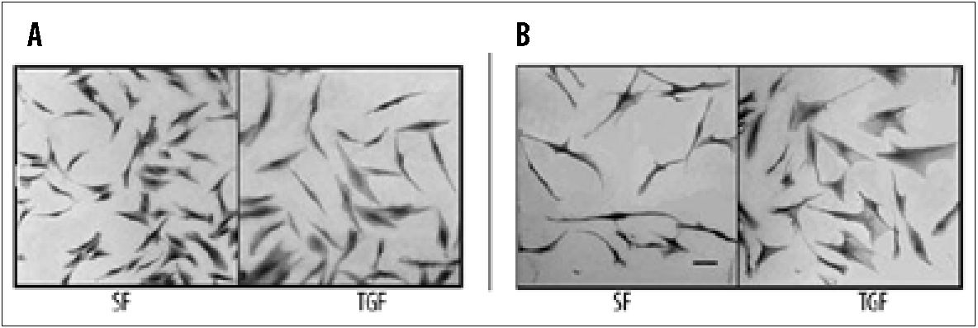
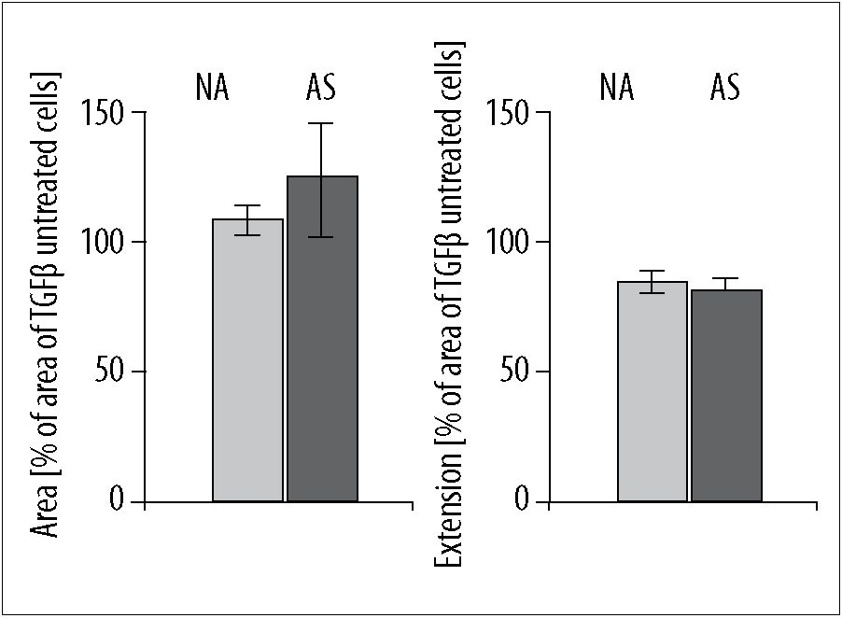
Basic Research
Med Sci Monit, 2009; 15(7): BR194-201
Figure 5. Size and shape of the HBF projections of the NA and AS
groups. The cells were cultured in DMEM with 10% fetal
calf serum for 24 hours and then with DMEM supplemented
with 0.1% BSA with (TGF) or without (SF) 10 ng/ml
TGF-P1 for 48 hours. The area (A) and extension (B) of the
cell projections for each experimental condition were
determined and calculated as the percentage of the control
value (SF). The results are the means of five separate
experiments from both groups presented separately with
the results of the statistical analysis in Table 1.
HBFs, a-SMA protein was detectable in whole-cell extracts
of unstimulated cells by immunoblotting, predominantly
in asthmatic cultures. In all the cultures tested, incubation
in TGF-bj resulted in a pronounced increase in the expres-
sion of the marker protein (representative blots are shown
in Figure 7A). When the amount of a-SMA protein was com-
pared between the groups, a higher expression of the myo-
fibroblast marker was evident in the HBFs from the asth-
matics (Figure 7B,C).

DiSCUSSiON
It is well known that transforming growth factor-b is one of
the most important pro-fibrotic cytokines in vivo [15-17]
and that it upregulates a-SMA expression in fibroblasts de-
rived from different tissues and induces the differentiation
of myofibroblasts in vitro [18,19]. Results using primary
cells from human airways also support this view [6,20,21].
However, it is worth noting that in our experiments not all,
but only a relatively small fraction of cells adopted a myo-
fibroblastic phenotype upon TGF-b1 or TGF-b2 treatment
(Figure 6). This observation suggests that HBFs represent
heterogenic cell populations with subtypes characterized by
slightly different features in which only some are somehow
primed to differentiate. The heterogenicity of fibroblasts
from asthmatics was confirmed by studies of Larsen et al.
Figure 4. TGF-p1-induced changes in the
morphology of HBFs. The cells derived
from the nA (A) and AS (B) groups
were cultured in DMEM with 10% FCS
for 24 hours and then with DMEM
supplemented with 0.1% BSA with (TGF)
or without (SF) 10 ng/ml TGF-P1 for 48
hours. Cells were stained with Coomassie
BB and photographed with an Olympus
IMT inverted microscope. Bar = 20 pm.
[21,22]. These authors compared primary cells derived from
bronchoalveolar lavage fluid (BALF) and from bronchial
biopsies and demonstrated that the first are more elongat-
ed, migrate faster, produce more a-SMA protein, and are
characterized by a different profile of extracellular matrix
protein production.
Our results indicate that the number of cells “primed” to
differentiate into myofibroblasts was significantly higher in
the populations of HBFs originating from asthmatic airways.
To our knowledge this is the first report showing such dif-
ferences between asthmatic and non-asthmatic fibroblasts.
However, congruent results were obtained by Wicks et. al.,
who showed that several smooth muscle-related proteins and
transcripts (calponin, heavy myosin chain, and desmin) are
upregulated to a greater extent by TGF-b2 in asthmatic HBFs
than in healthy controls [23]. In contrast to our comparison
of sparse, sub-confluent HBF cultures from asthmatics and
non-asthmatics (Figures 6,7), they failed to show a difference
in a-SMA expression. However, in very confluent cultures
which Wicks et al. evidently used, the expression of a-SMA
protein is generally very low (our results: data not shown)
and the differentiation of myofibroblasts in vitro is strongly
and inversely correlated with cell density [24].
It is believed that fibroblasts cultured in vitro are mechani-
cally activated by contact with the rigid substrate and have
a phenotype of proto-myofibroblasts, which represents an
intermediate step between fibroblasts and myofibroblasts in
vivo [13]. Our results indicate that the TGF-b-induced tran-
sition of bronchial fibroblasts into myofibroblasts is accom-
panied by striking cell shape changes (Figure 3) and this
phenomenon was equally evident in both groups of HBF
cultures. It was shown previously that TGF-b1-treated fibro-
blasts with a-SMA-containing stress fibers are characterized
by enhanced contractility and generate a higher traction
force [25,26]. Moreover, Dugina et al. [27] showed that
during myofibroblast differentiation a significant enlarge-
ment of focal adhesion (focal adhesion “supermaturation”)
takes place. These authors suggested that the process of fi-
broblast differentiation can affect cell adhesion and spread.
Furthermore, our quantitative measurements of the size and
shape parameters of fibroblasts derived from asthmatics and
non-asthmatics revealed some statistically significant differ-
ences. In the HBF cultures examined in our experiments,
TGF-b1 treatment increased the area of the cell projections,
possibly due to enhanced spreading of cells, regardless of
whether the cells expressed a-SMA protein. The diminished
extension of the cell projections was probably connected
with the retraction of cell protrusions caused by enhanced
cell traction force. Comparison of the HBF cultures of the
NA and AS groups (Table 1) revealed that, statistically, the
BR198

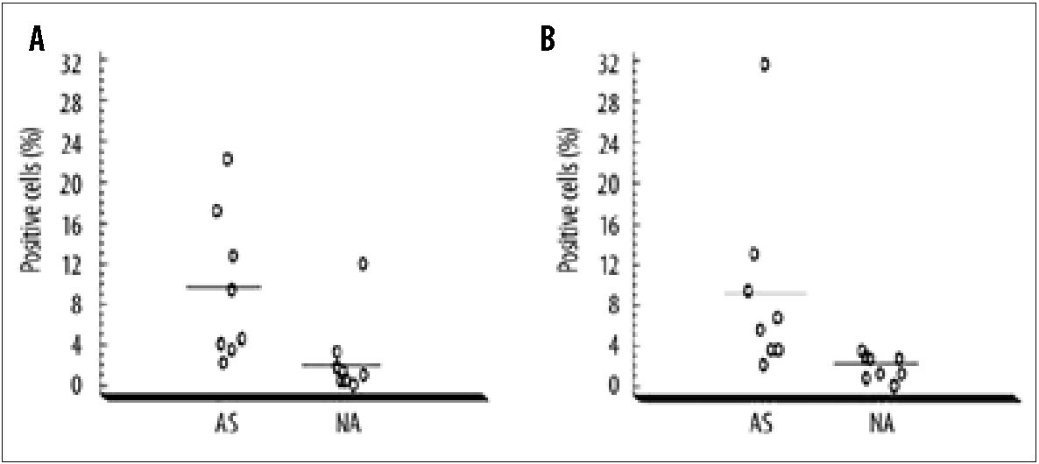
Med Sci Monit, 2009; 15(7): BR194-201
Michalik M et al - Asthmatic bronchial fibroblasts demonstrate enhanced.
Table 1. Size and shape of HBF projections of the NA and AS groups. (A) The cells were cultured in DMEM with 10% FCS for 24 hours and then with
DMEM supplemented with 0.1% BSA with (TGF) or without (SF) 10 ng/ml TGF-P1 for 48 hours. The area and extension of the cell projections
for each experimental condition were determined. At least 100 cells were analyzed. Values are given as the mean ±SE. (B) In the case of the
area of the cell projections, the statistical significance was determined by the nonparametric Kruskal-Wallis test. As multiple comparisons
were performed, the confidence level was lowered according to the Dunn-Sidak correction to a=0.013. In the case of the extension
parameter the statistical significance was determined by the Scheffe test. Significant p values are marked by (*).
A | Area [pm2] ± SE |  |  | Extension ± SE
Patients number | SF | TGF | SF |  | TGF
NA 1 | 2202±121 | 2583±103 | 3.39±0.9 |  | 2.79±0.8
NA 2 | 1915± 84 | 1927±102 | 2.76±0.7 |  | 2.36±0.7
NA 3 | 5044±243 | 5252±283 | 2.81 ±1.1 |  | 2.20±0.8
NA 4 | 4761 ±225 | 5332±281 | 3.09±1.0 |  | 2.85±1.0
NA 5 | 2720±144 | 3273±173 | 1.51 ±0.9 |  | 1.25±0.8
AS 1 | 1704± 99 | 2502±131 | 3.80±1.2 |  | 3.02±1.1
AS 2 | 1687±105 | 2306±132 | 3.88±0.9 |  | 3.04±0.9
AS 3 | 5236±269 | 5393±324 | 2.99±0.9 |  | 2.69±1.1
AS 4 | 5029±321 | 5141 ±322 | 3.27±1.1 |  | 2.57±0.9
AS 5 | 2637±233 | 5060±445 | 2.09±1.2 |  | 1.50±0.5
B | NA vs. AS |  |  | SF vs. TGF
 | SF | TGF | NA |  | AS
Area | 0.0226 | 0.8445 | 0.0017* |  | 0.0033*
Extension 5,1x10-8* 0,002* 3,3x10-9* 0,0001*
area was enhanced and the extension of the cell projections
was reduced in the asthmatic fibroblasts.
Although the role of TGF-b in airway remodeling in asth-
ma has been investigated in many laboratories, the mech-
anisms involved in the differentiation of phenotypic fibro-
blasts into myofibroblasts are only partially understood. It
is now widely accepted that the expressions of both TGF-b1
and TGF-b2 increase in the asthmatic airways and that in
vitro these cytokines induce the proliferation of fibroblasts
and their differentiation into myofibroblasts and extracel-
lular matrix protein synthesis [4,5,17]. Recently, Malavia et
al. reported that in co-culture of human bronchial epitheli-
al cells with normal human lung fibroblasts, prolonged cy-
tokine exposure (e.g. to IL-13) and mechanical perturba-
Figure 6. TGF-0-induced fibroblast to
myofibroblast differentiation in the NA
and AS groups. The HBFs were seeded
on glass coverslips at a density of 7500
cells/cm2 in DMEM with 10% FCS. After
24 hours the medium was changed
to DMEM supplemented with 0.1%
BSA with TGF-P1 (A) or TGF-P2 (B) at a
concentration of 10 ng/ml for 48 hours.
The cells were stained for a-SMA and the
numbers of positive cells were counted.
Each point represents the result obtained
from a single culture. Bars represent
the mean values. In the AS group
the percentage of positive cells was
significantly higher than in the NA group
in both treatments (Mann-Whitney U
test, p<0.01).
tions to the epithelium can cause the continuous release
of TGF-b2, which stimulates collagen production and se-
cretion from fibroblasts [28]. Taken together, these ob-
servations suggest that further experiments are needed to
explain whether the enhanced TGF-b-stimulated differ-
entiation of asthmatic HBFs into myofibroblasts, accompa-
nied by prominent cell shape changes, may be connected
with increased secretion of some extracellular matrix pro-
teins (e.g. collagen).
BR199

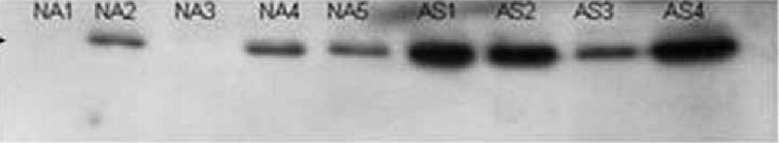
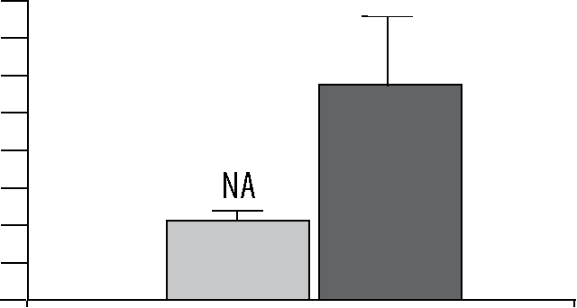
Basic Research
Med Sci Monit, 2009; 15(7): BR194-201
— | + | +  1  +  1 | _ | +
NA, | NA, | N A,, NA,, AS, AS, | AS,, | AS„
 | — | y*
Nft|„ | NA,,, | NA,V AS,,, AS,i. | AS,V | > I
}iA& HAJ KAS HA3 NA10 AS5 AS6 AS7 AS8 AS9
Figure 7. The expression of a-SMA in TGF-P1-
treated HBFs of the NA and AS groups.
Protein extracts were subjected to
SDS-PAGE electrophoresis and a-SMA
protein was detected by immunoblotting.
In immunoblot A, 10 pg of protein was
used to visualize the small amount of
a-SMA present in the TGF-P1-untreated
HBFs. In immunoblot B, 5 pg of protein
extract per well was applied and the
films were digitalized and analyzed by
an imaging system (Genetools Syngen)
to obtain semiquantitative data (C).
The lowest value on each film obtained
for a band representing an NA patient
was considered as 100%. The amount
of protein in other wells was expressed
relative to this lowest value.

CONOLUSiONS
AS
This study demonstrated that HBFs derived from asthmat-
ics display some inherent features in culture which facilitate
their differentiation into myofibroblasts. The exact molecu-
lar mechanism of the phenomenon reported here requires
further studies and may be of considerable importance in
explaining the bronchial remodeling in asthma.
Acknowledgements
We wish to express our gratitude to Prof. Włodzimierz Korohoda
for his intellectual inspiration continuously influencing our
research. We also thank Prof. Andrzej Szczeklik for his valu-
able support in conducting this project, Prof. Ewa Mogilnicka-
Niżankowska for her crucial help in the recruitment of patients,
and Zbigniew Madeja Ph.D. for fruitful discussions.

References:
- Baldwin L, Roche WR: Does remodelling of the airway wall precede
asthma? Paediatr Respir Rev, 2002; 3: 315-20
- Sullivan P, Stephens D, Ansari T et al: Variation in the measurements of
basement membrane thickness and inflammatory cell number in bron-
chial biopsies. Eur Respir J, 1998; 4: 811-15
- Benayoun L, Druilhe A, Dombret MC et al: Airway structural alterations
selectively associated with severe asthma. Am J Respir Crit Care Med,
2003; 167: 1360-68
- McAnulty RJ: Fibroblasts and myofibroblasts: their source, function and
role in disease. Int J Biochem Cell Biol, 2007; 39: 666-71
- Makinde T, Murphy RF, Agrawal DK: The regulatory role of TGF-
beta in airway remodeling in asthma. Immunol Cell Biol, 2007; 85(5):
348-56
- Zhang S, Smart H, Holgate ST, Roche WR: Growth factors secreted by
bronchial epithelial cells control myofibroblast proliferation: an in vitro
co-culture model of airway remodeling in asthma. Lab Invest, 1999; 79:
395-405
- Morishima Y, Nomura A, Uchida Y et al: Triggering the induction of
myofibroblast and fibrogenesis by airway epithelial shedding. Am J
Respir Cell Mol Biol, 2001; 24: 1-11
- Redington AE, Madden J, Frew AJ et al: Transforming growth factor-
betaL in asthma. Measurement in bronchoalveolar lavage fluid. Am J
Respir Crit Care Med, 1997; 156: 642-47
- Pierzchalska M, Szabo Z, Sanak M et al: Deficient prostaglandin E2 pro-
duction by bronchial fibroblasts of asthmatic patients, with special ref-
erence to aspirin-induced asthma. J Allergy Clin Immunol, 2003; 111:
1041-48
- Korohoda W, Madeja Z: Contact of sarcoma cells with aligned fibro-
blasts accelerates their displacement: computer-assisted analysis of tu-
mour cell locomotion in co-culture. Biochem Cell Biol, 1997; 75(3):
263-76
- Pierzchalska M, Michalik M, Stępień E, Korohoda W: Changes in mor-
phology of human skin fibroblasts induced by local anaesthetics: role
of actomyosin contraction. Eur J Pharmacol, 1998; 358: 235-44
- Dunn GA, Brown AF: Alignment of fibroblasts on grooved surfaces
described by a simple geometric transformation. J Cell Sci, 1986; 83:
313-40
- Hinz B, Phan SH, Thannickal VJ et al: The myofibroblast: one function,
multiple origins. Am J Pathol, 2007; 170(6): 1807-16
- Evans RA, Tian YC, Steadman R, Phillips AO: TGF-p ^mediated fibro-
blast-myofibroblast terminal differentiation-the role of Smad proteins.
Exp Cell Res, 2003; 282(2): 90-100
- Howell JE, McAnulty RJ: TGF-p: its role in asthma and therapeutic po-
tential. Curr Drug Targets, 2006; 7(5): 547-65
- Rahimi RA, Leof EB: TGF-p signaling: tale of two responses. J Cell
Biochem, 2007; 102: 593-608
- Wynn TA: Cellular and molecular mechanisms of fibrosis. J Pathol,
2008; 214(2): 199-210
- Desmouliere A, Darby IA, Gabbiani G: Normal and pathologic soft tis-
sue remodeling: role of the myofibroblast, with special emphasis on liv-
er and kidney fibrosis. Lab Invest, 2003; 83: 1689-707
- Malmstrom J, Larsen K, Malmstrom L et al: Transforming Growth
Factor-^ specifically induce proteins involved in the myofibroblast con-
tractile apparatus. J Proteome Res, 2004; 3: 525-37
- Barta V, Musani AI, Hastie AT et al: Bronchoalveolar lavage fluid con-
centrations of transforming growth factor (TGF)-p1, TGF-p2, interleu-
kin (IL)-4 and IL-13 after segmental allergen challenge and their effects
on alpha-smooth muscle actin and collagen III synthesis by primary hu-
man lung fibroblasts. Clin Exp Allergy, 2004; 34(3): 437-44
- Larsen K, Malmstrom J, Wildt M et al: Functional and phenotypical com-
parison of myofibroblasts derived from biopsies and bronchoalveolar
lavage in mild asthma and scleroderma. Respir Res, 2006; 7: 1-10
BR200
C 4OO
350
,ÍH 300
jç'i 250
200
IS 150
fe, 100
50
0
A IQf-ß
a-SMA
a-sm
B c,.
ff-SMA h
ff-SMA H

Med Sci Monit, 2009; 15(7): BR194-201
Michalik M et al - Asthmatic bronchial fibroblasts demonstrate enhanced...
- Larsen K, Tufvesson E, Malmstrom J et al: Presence of activated mobile
fibroblasts in bronchoalveolar lavage from patients with mild asthma.
Am J Respir Crit Care Med, 2004; 170(10): 1049-56
- Wicks J, Haitchi HM, Holgate ST et al: Enhanced upregulation of smooth
muscle related transcripts by TGF p2 in asthmatic (myo)fibroblasts.
Thorax, 2006; 61: 313-19
- Petridou S, Maltseva O, Spanakis S, Masur SK: TGF-beta receptor ex-
pression and smad2 localization are cell density dependent in fibro-
blasts. Invest Ophthalmol Vis Sci, 2000; 41(1): 89-95
- Hinz B, Celetta G, Tomasek JJ et al: Alpha-smooth muscle actin expres-
sion upregulates fibroblast contractile activity. Mol Biol Cell, 2001; 12:
2730-41
- Chen J, Li H, SundarRaj N, Wang JH: Alpha-smooth muscle actin ex-
pression enhances cell traction force. Cell. Motil Cytoskeleton, 2007;
64: 248-57
- Dugina V, Fontao L, Chaponnier C et al: Focal adhesion features dur-
ing myofibroblastic differentiation are controlled by intracellular and
extracellular factors. J Cell Sci, 2001; 114: 3285-96
- Malavia NK, Mih JD, Raub CB et al: IL-13 induces a bronchial epitheli-
al phenotype that is profibrotic. Respir Res, 2008; 9: 27-39
BR201

