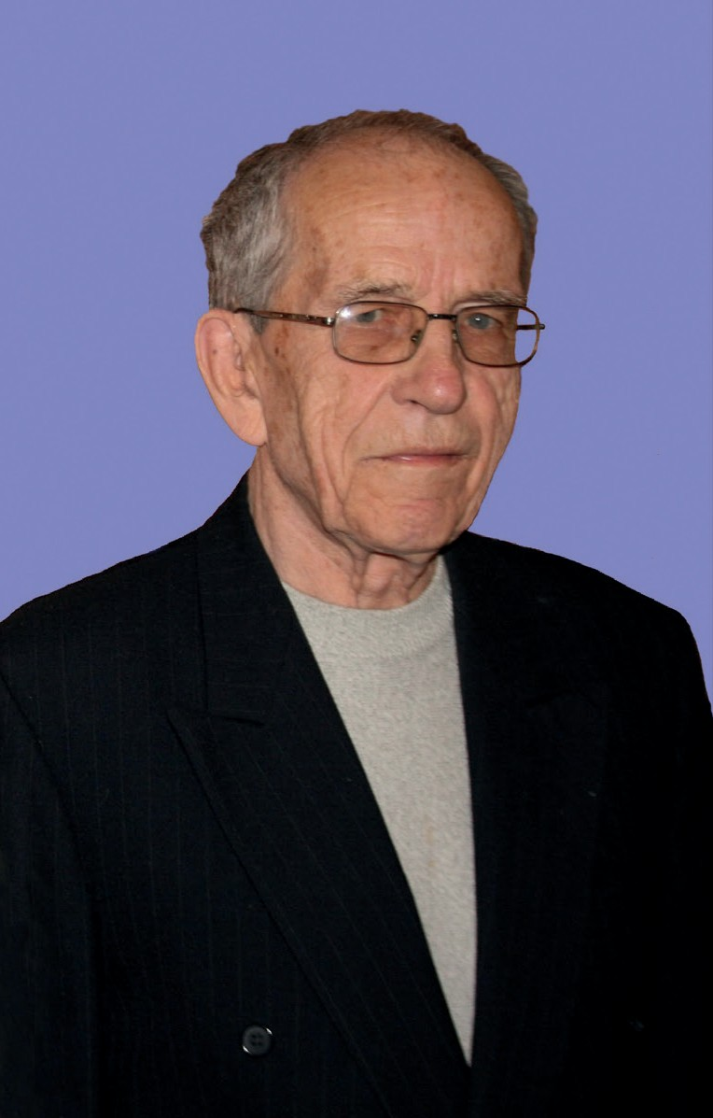

Prof. Zenon Woźniak



Acta Archaeologica Carpathica 56 (2021): 9–12
PL ISSN 0001-5229, e-ISSN 2719-4841
DOI 10.4467/00015229AAC.21.001.15342

Professor Zenon Woźniak. Editor of twenty-five volumes of Acta Archaeologica Carpathica

It is our great pleasure to present to the Readers the next, LVIth volume of our magazine. The year 2021 is the time of the 90th birthday jubilee of the long-time editor-in-chief of Acta Archaeologica Carpathica, Professor Zenon Woźniak. On behalf of the Editorial Board and my own, I am honored to ded- icate volume LVI to Professor, who is an outstanding specialist in the culture of the Celts and the La Téne period, and a deeply devoted editor of twenty-five volumes of AAC.
Professor Zenon Woźniak was born on November 29, 1931 in Starachowi- ce. He obtained his high school diploma in 1950 in Trzebnica. In 1950-1953 he studied History of Material Culture at the Jagiellonian University. He contin- ued his studies at the Poznań University, where in 1955 he obtained master’s degree specializing in the archaeology of Poland. His dissertation: Archaeo- logical materials for the earliest history of the Rawicz district was written under the supervision of Professor Witold Hensel. In 1955 he started working at the Archaeological Museum in Kraków as an assistant and then assistant profes- sor at the museum. Five years later, he took the position of the head of the De- partment of Archeology of the La Téne and Roman Periods. During this time, he conducted extensive excavation works at sites such as Kraków-Mogiła, Kraków-Tyniec (Abbey), Stradów, as well as at sites related to the archeolo- gy of the Carpathians: Wietrzno-Bóbrka, Łężkowice, Targowisko, Przemyśl, and Podegrodzie. This activity will be continued in later years on sites such as Sandomierz, Zofipole and Podłęże. At the end of 1964, Professor Zenon Woźniak finished his work at the Archaeological Museum in Kraków and


This is an open access article distributed under the terms of the Creative Commons license (CC BY-NC-ND 3.0 PL)
10 Paweł Valde-Nowak

began work at the Institute of the History of Material Culture of the Polish Academy of Sciences in Krakow as a senior assistant. Under the supervision of Prof. Stefan Nosek he prepared his doctoral dissertation Celtic settlement in southern Poland, which he defended on February 3, 1967. A few months later, Zenon Woźniak took the position of an assistant professor. Based on his dissertation Wschodnie pogranicze kultury lateńskiej, on April 9, 1973, he was awarded a postdoctoral degree by the Scientific Council of the Institute of the History of Material Culture of the Polish Academy of Sciences. At the request of the same council, on November 21, 1989, he was awarded the title of associ- ate professor and in the same year took the position of associate professor at the Polish Academy of Sciences. In the years 1983-1990, he was the head of the Archaeological Laboratory in Igołomia, near Krakow.
In the scientific field, Professor Zenon Woźniak’s research focuses on the chronology and character of Celtic settlement in Central Europe, with par- ticular emphasis on southern Poland. This is related to a number of the Pro- fessor’s works on the mixed Celto-Przeworsk group of Tyniec, characterized by the production of painted ceramics. Great merit in the field of the scien- tific organization was the establishment by Professor Zenon Woźniak of re- search teams whose task was to prepare for publication the results of research on large cemeteries from the pre-Roman and Roman periods. Professor was a member of various foreign organizations, such as German Archaeological Institute, L'Association Française pour l'Étude de l'Âge du Fer, Arbeitsgruppe Frühe Eisenzeit, as well as national ones, such as the Polish Academy of Arts and Sciences, Committee of Pre- and Protohistoric Sciences, scientific council of the Institute of Archeology and Ethnology Polish Academy of Sciences, Sci- entific Association of Polish Archaeologists (chairman of the Kraków branch). His didactic activity should also be mentioned. In the 1980s, he conducted lectures for students of archaeology at the Jagiellonian University, as well as nationwide doctoral seminars. Moreover, he worked as an appraiser of the Ministry of Culture and Art. At the end of the '90s, he was awarded the title of full professor. Professor Zenon Woźniak took over the editorial staff of Acta Archaeologica Carpathica in 1975, starting with volume XV (in previous years he was the deputy of professor Andrzej Żaki, editor and founder of AAC) and held this position until 2015, when the fiftieth volume of our journal was published. We can therefore speak of a double jubilee of the Professor – forty years on the editorial board and a ninetieth birthday.
Excellent scientific works of Professor Zenon Woźniak include a publica- tion that is of great value for every mountain lover and reader of our magazine.

Acta Archaeologica Carpathica 56 (2021)
Professor Zenon Woźniak. Editor of twenty-five volumes of AAC 11
On November 9-10 1974, in Kraków, he participated in the symposium “Mountains in the Polish culture” (Fig. 1). During this event, he was the only archaeologist to deliver a paper, which he entitled “Changes in the understanding of the role of the Car- pathians in the prehistory of Poland as archaeological research progress- es.” Materials from the symposium were published by the Mountain Tourism Commission of the Main Board of the Polish Tourist and Sightseeing Society (Marta Bronio- wska [ed.], Symposium “Mountains in the Polish Culture”, Krakow 1975). Over two hundred people attended the symposium, including repre- sentatives of such disciplines as lin- guistics, ethnography and history of art. The most important tourist activists and mountaineers of the time, “mountain people” with vari- ous backgrounds and interests, were present. Professor Zenon Woźniak’s

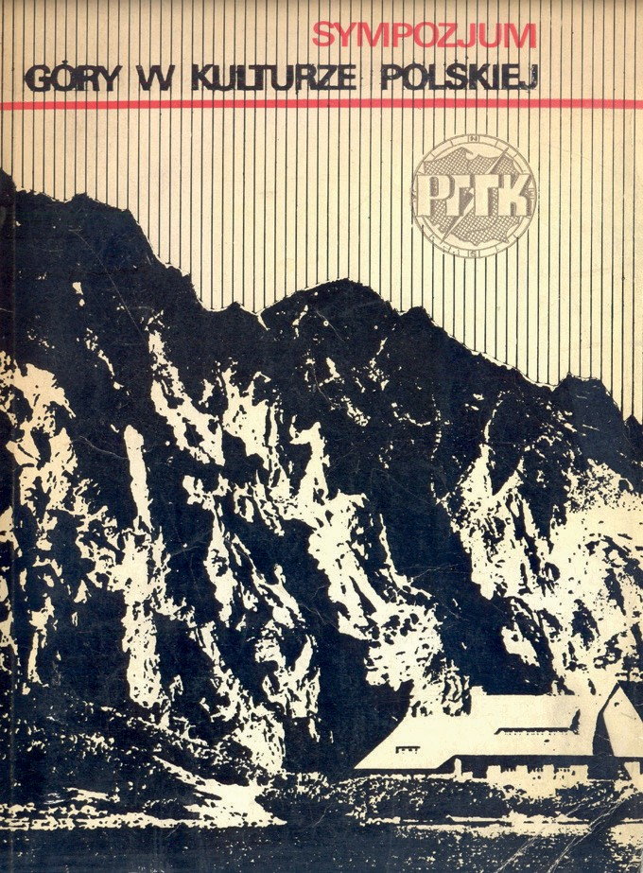
FIG. 1. The cover of the book materials from the conference in 1974 “Mountains in the Polish culture” with a chapter by Professor Zenon Woźniak “Changes in the perception of the role of the Carpathians in the prehistory of Poland as archaeolog- ical research progresses” (cover design by Maria Wisłocka)
statement, perfectly prepared and set in the realities of the history of archaeo-
logical research in the Polish Carpathians, can be treated as a preparation for the archaeological exploration that was to begin in a few years. They showed the great potential of these areas for the study of prehistoric settlements, in-
cluding the Old Stone Age. Professor Zenon Woźniak’s paper summarizes
over a hundred years of interest in the archaeological past of the Polish Car- pathians, for decades focused on monumental defensive works, both for the Lusatian culture strongholds, as well as medieval fortifications and castles.
Let us note that the time of this symposium coincides with the Professor’s
assumption of the function of editor in Chief Acta Archaeologica Carpathica. All the easier it will be for the Professor to shape the profile of subsequent volumes of the journal, treating works on all periods of prehistory and the Middle Ages equally.

Acta Archaeologica Carpathica 56 (2021)
12 Paweł Valde-Nowak

An attentive reader will notice that the subsequent volumes edited by Pro- fessor Zenon Woźniak are maintained at a very high scientific and editorial level, although the times were not conducive to the development of publishing techniques, and the editorial cycle, independent of the editorial board, was very extended. And yet the professor managed to keep the regularity of the publication of subsequent volumes, which disappeared from the bookshelves immediately. Nowadays, the position of the journal in the ministerial ranking is high, and the volumes of AAC are present in all of the main foreign archae- ological libraries. It is undoubtedly thanks to Professor Zenon Woźniak work that the journal is a part of the group of highest-rated Polish archaeological journals.
On behalf of the editorial board of Acta Archaeologica Carpathica, today a journal published by the Commission of the Prehistory of the Carpathians of the Polish Academy of Arts and Sciences (not by the Archaeological Com- mission of the Polish Academy of Sciences Branch in Krakow, as formerly), we thank the Professor for his great dedication to this journal and his contri- bution to each of the volumes. Thanks to him, their content encouraged the development of archaeological research in various fields and fueled interest in mountain archaeology. We dedicate the present, fifty-sixth volume of Acta Archaeologica Carpathica to Professor Zenon Woźniak, with best wishes for further satisfaction in scientific work and many years in good health.

Paweł Valde-Nowak

Acta Archaeologica Carpathica 56 (2021)

