Neuroendocrinology Letters Volume 38 No. 6 2017 ISSN: 0172-780X; ISSN-L: 0172-780X; Electronic/Online ISSN: 2354-4716
Web of Knowledge / Web of Science: Neuroendocrinol Lett
Pub Med / Medline: Neuro Endocrinol Lett

The effects of growth hormone therapy on the somatic development of a group of Polish children with Silver-Russell syndrome
O

Magdalena Sieńko 1, Elżbieta Petriczko 1, Stanisław Zajączek 2,
Agata Zygmunt-Górska 3, Jerzy Starzyk 3, Alicja Korpysz 4,

Jan Petriczko 5, Alicja Walczak 6, Mieczysław Walczak 1
R
- Department of Pediatrics, Endocrinology, Diabetology, Metabolic Diseases and Cardiology of Developmental Age, Pomeranian Medical University, Szczecin, Poland
I G
- Cytogenetics Unit, Department of Pathology, Pomeranian Medical University, Szczecin, Poland
- Department of Pediatric and Adolescent Endocrinology, Chair of Pediatrics, Polish-American Pediatric Institute, Jagiellonian University, Medical College, Cracow, Poland
- Department of Endocrinology and Diabetology The Children’s Memorial Health Institute, Warsaw, Poland
I
- Department of Plastic Endocrine and General Surgery, Pomeranian Medical University, Police, Poland
N A
- Department of Hygiene and Epidemiology, Pomeranian Medical University, Szczecin, Poland
Correspondence to: Magdalena Sieńko
Department of Pediatrics, Endocrinology, Diabetology, Metabolic Diseases and Cardiology of Developmental Age, Pomeranian Medical University
L
Szczecin, Poland.
e-mail: brzoskomag@poczta.onet.pl; elzbietapetriczko@gmail.com
Submitted: 2017-07-20 Accepted: 2017-08-15 Published online: 2017-12-10 Key words: Growth hormon treatment; Silver Russell syndrome
A
R T
Neuroendocrinol Lett 2017; 38(6):415–421 PMID: 29298282 NEL380617A02 © 2017 Neuroendocrinology Letters • www.nel.edu
Abstract OBJECTIVE: Silver-Russell Syndrome is both clinically and genetically a het- erogeneous syndrome. Among the most important dysmorphic features of this condition are: a triangular shaped face with a small mandible, a prominent frontal eminence, a thin vermilion border with downward-pointing lip corners, clino- and brachydactyly of the 5th fingers as well as body asymmetry. The most well-known genetic mutations in this syndrome are: the 11p15 epimutation (20–60% patients) and the maternal uniparental chromosome 7 disomy present in 7% to 15% of patients. Children with SRS have severely impaired physical growth – intrauterine and after birth. This, together with the aforementioned dysmorphic features, forms the main diagnostic criteria.
I C
L
E
MATERIAL AND METHODS: The study group consisted of 12 children treated with growth hormone, aged 2 to 17 (8.9±4.0 years), therein, all of whom met the phe- notype diagnostic criteria by Wollmann and Price. The effects of growth hormone therapy on somatic development of these children are also presented.
RESULTS: Height and weight improved as a result of growth hormone treatment, but the effects were significantly worse than in children with IUGR. Children from the study group presented also a smaller an improvement in growth velocity than children from the control group, but the difference was statistically insignificant. CONCLUSIONS: Growth hormone therapy accelerates the growth of children with SRS but to a smaller extent than the growth of children born with intrauterine growth retardation without dysmorphic features.

To cite this article: Neuroendocrinol Lett 2017; 38(6):415–421

INTRODUCTION
Silver-Russell Syndrome is both clinically and geneti- cally a heterogeneous syndrome. It presents a wide spectrum of clinical signs with a diverse manifestation of dysmorphic features, such as a triangular shaped face with a small mandible, a prominent frontal eminence, relative macrocephaly, ear lobe structure disorders, a thin vermilion zone with a long philtrum, downward- pointing lip corners and body asymmetry (Wollmann et al. 1995; Price et al. 1999). The most well-known genetic mutations in this syndrome are: the 11p15 epimutation found in 20% to 60% patients and the maternal unipa- rental chromosome 7 disomy (7–15%) (Netchine et al. 2007; Bruce et al. 2009; Bartholdi et al. 2009; Schönherr et al. 2006; Kotzot et al. 2008).
Silver-Russell Syndrome is related to an intrauter- ine growth retardation with a postnatal height deficit. Neonates with SRS are born on time and their birth weight is often below –2 SD. Later these children pres- ent with dwarfism and normal body proportions. Low, but consistent growth rate without catch-up growth constitutes to an intensification of growth retardation (Binder et al. 2011; Wakeling et al. 2011). Height deficit is amid the most serious impairments in children with SRS (Toumba et al. 2010). Such children do not reach their genetic growth potential and they are significantly shorter in adulthood (Cutfield et al. 2007). Contrary to most children born with IUGR, patients with SRS do not experience catch-up growth (Wollmann et al. 1995, Mascarenhas et al. 2012). Their growth rate is very low in postnatal and early childhood age (Cutfield et al. 2007). As children with SRS have a negative growth prog- nosis, Tanner and Ham (Tanner et al. 1969) proposed early growth hormone treatment of these children. According to commonly accepted guidelines, short chil- dren born with intrauterine growth retardation should begin growth hormone therapy after reaching the age of 4 (Wakeling et al. 2011). Growth hormone treatment introduced during puberty improves final height, but is less effective than when started in childhood. Growth hormone therapy, when introduced in childhood, led to a normalization of final height – height standard deviation within the normal range and higher by 2.1SD compared to the height of children, who began the treatment in puberty (Cutfield et al. 2007). Most authors underline the high importance of the dosage prescribed. A correlation was shown between the dose and the growth rate, especially in the first year of treat- ment (Ranke et al. 2003; Boguszewski et al. 1998; Sas et al. 1999). It was concluded that 85% short kids born with intrauterine growth retardation achieve height within the population norms after 7–8 years of high
dose growth hormone therapy (Cutfield et al. 2007).
The data regarding long-term growth hormone treatment of children with SRS are scarce. In a group of 33 children with SRS, a low dose of this medication led to an improvement in height by 1.8 SD (Cutfield
et al. 2007; Azcona et al. 1999). Growth rate improve- ment of children with SRS is at least comparable to the growth rate of other children with IUGR treated with GH (Cutfield et al. 2007). However, despite growth hormone treatment, patients with SRS do not achieve normal adult height, even though their final height is far greater than the height of people not receiving such therapy (Azcona et al. 1999; Azcona et al. 1998). Newest study conducted by Toumba et al. in 2010 with 26 children with SRS treated with growth hormone for a longer period of time (average 9.8 years) showed a substantial improvement of height with a final height within population norms (–1.3 SD). Higher increase in height was observed in patients with lower height at the beginning of therapy (Wakeling et al. 2011; Mascar- enhas et al. 2012).
Based on a number of studies, a high occurrence of growth hormone deficit (13–67%) was observed in short children with intrauterine growth retardation (De Zegher et al. 2000; De Zegher et al. 2005; Ong et al. 2005; De Zegher et al. 2002; Stanhope et al. 1989; Boguszewski et al. 1995). In children with SRS such a deficit is less frequent – 2%. It may point at a smaller biological activity of growth hormone in children with SRS or at a partial peripheral resistance to its effects (Lewandowska et al. 2002; Rakover et al. 1996).
Particularly underlined is the fact of beneficial effects of large doses of growth hormone on catch-up growth (De Zegher et al. 2000; Chatelain et al. 1993; Czernichow et al. 1997; Hokken-Koelega et al. 1999; De Zegher et al. 1999), as it is highly unlikely for children with SRS to achieve such a type of growth on their own (Toumba et al. 2010).
Earlier studies suggested that interrupting high dosage growth hormone therapy after two years in children with SRS in prepubertal age does not result in a deceleration of growth rate (Azcona et al. 1999; De Zegher et al. 1997). It may show that these children do not have to be treated until final height is reached, con- trary to other short children with intrauterine growth retardation (Binder et al. 2011). Although there is not enough data on final effects of growth hormone therapy in children with SRS, it appears to be sensible and safe (Stanhope et al. 1991).
Study goal
The effect of growth hormone therapy on somatic development of group of Polish children with Silver Russell Syndrome.

MATERIAL AND METHODS:
The study included 12 children at the age of 2 to 17 years (x – 8.9±4.0 years) diagnosed with Silver-Russell syndrome based on phenotype features. To the study qualified were children who fulfilled the diagnostic cri- teria of SRS by Wollmann et al. (1995) and by Prince et al. (1999).
All the children were under care of Department of Pediatrics, Endocrinology, Diabetology, Metabolic Dis- eases and Cardiology of Developmental Age, Pomera- nian Medical University in Szczecin or other centres in Poland (30 children from Szczecin, 3 from Warsaw and 5 from Cracow).
Children were treated with growth hormone due to somatotroph pituitary insufficiency or short stature as a result of intrauterine growth retardation.
Each child was height and weight measured. The results were input on percentile population nets of Polish children by I. Palczewska and Z. Niedźwiecka (2001), considering age and gender. Standard devia- tions (SD) of height and weight were also calculated.
The control group consisted of 16 children treated with growth hormone in a standard dose, at the age of 2 to 17 years (x – 9.6±3.9 years), chosen randomly to match age and gender of children from the study group. These children were born with intrauterine growth retardation, that is a birth weight ≤–2 SD in relation to their gender and gestational age and without any dys- morphic features. They also have an afterbirth growth impairment, i.e. height ≤–2SD for their age and gender. An analysis of somatic development was performed in the control group, the same as in the study group. The control group was a comparison reference point to the study group in terms of somatic development.

RESULTS
In a studied group 12 children with Silver-Russell syndrome diagnosed using phenotype criteria, were treated with growth hormone. Three children began their therapy at the age of 6, four at the age of 7, one at the age of 8, one at the age of 10, two at the age of 11 and one at the age of 15. One child had begun the therapy
at advanced bone age, therefore, the treatment period was shorter than one year. In one child the therapy was maintained for one year, in 2 children – 2,3 and 4 years and in one child – 5, 8, 9 and 10 years. Out of 12 chil- dren, 8 were treated for over 2 years.
In the control group 16 children received growth hormone. The therapy was introduced to 3 children at the age of 6, to 2 children at the age of 7, to one child at the age of 8, to three children and the age of 9, to two children at the age of 10, to one at the age of 11, 12 and
13. In the control group one child was treated for less than a year. In one the therapy was sustained for one year, two children were treated for 2 years, 2 children for 7 years, 3 children for 3 years, 3 children for 6 years and 4 children for 5 years. Out of 16 children treated with growth hormone, 12 were treated for over 2 years. Figure 1 shows the effect of growth hormone treat-
ment on the height of these children.
At the beginning of growth hormone therapy chil- dren from the study group had a larger height deficit expressed in SD compared to these children, who did not receive such treatment. During therapy a significant (p<0.05) improvement in height deficit (height SD) was seen from the age of 6 to 11. At the age of 17 only one patient from the study group continued growth hor- mone therapy. Therefore, despite seeing a significant difference of height expressed in standard deviation of 1.3SD between the treated child and the untreated children, the statistical significance of this difference was not calculated on account of the small number of children with this age.
Children from the control group treated with growth hormone at ages 6 to 8 and 11 to 17 were significantly (p<0.05) higher (height expressed in SD) than these, who did not receive such therapy, however, at ages 9 and 10 these differences were not significant.
Height SD

0
p=0.05
-1
p=0.05
p<0.05
-2

-3

-4

-5
Treatment no yes

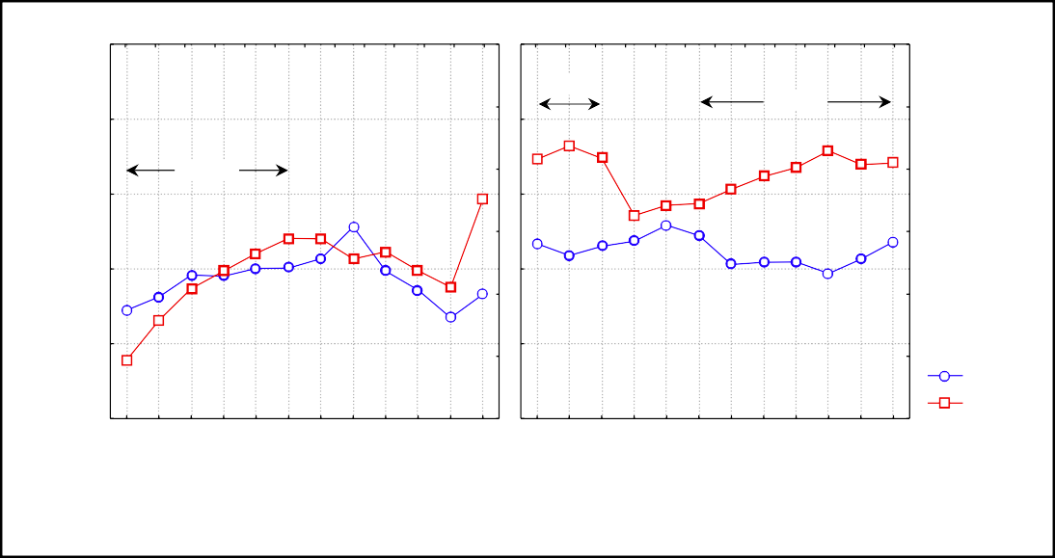
Fig. 1. Height SD of children treated with growth hormone from the study and the control groups (mean values).
6 7 8 9 10 11 12 13 14 15 16 17 6 7 8 9 10 11 12 13 14 15 16 17
Study group Control group
Age [years]
At the end of observation period, no significant differences were observed between children from the study and control groups in reference to age and time of therapy. Mean therapy time (assuming only the chil- dren treated over 2 years) was, both in the study and the control group, slightly over 5 years.
Figure 2 compared the height SD of children from the study and the control group before introducing growth hormone treatment, after one and two years of therapy at the last year of observation.
Significantly larger growth deficit in height SD was spotted in subsequent years of GH therapy in children from the study group, compared to the control group. It is important to note, however, that the children from the study group began the therapy with significantly (p<0.003) smaller height than children from the con- trol group. Growth hormone treatment significantly improved the height SD of children from the study group during the first and second years of therapy. In the following years no such improvement was seen.
Figure 3 compares the growth rate before beginning growth hormone therapy, one and two years after intro- ducing such therapy and at the last year of observation. As seen on Figure 3. children from both the control and the study group had similar height gains before
p=0.003
p=0.003
p=0.015
beginning and during growth hormone therapy. How- ever, during all years of therapy the growth rate of chil- dren from the study group was slightly slower than in the control group.
Figure 4 shows growth rate SD before introducing growth hormone treatment, one year and two years after introducing such treatment and at the last year of observation.
As seen on Figure 4 no significant difference was seen in growth rate SD between children from the study and the control group treated with growth hormone, both before, as during the first and second year of intro- ducing such therapy, although a statistically significant (p=0.015) lower growth rate SD was seen in children from the study group above 2 years from beginning growth hormone therapy.
Figure 5 compares weight SD of children from the study and the control groups before beginning growth hormone treatment, one and two years after introduc- ing such therapy and at the last year of observation.
Children from the study group began the treatment with significantly lower weight compared to the control group. However, under growth hormone therapy, the weight SD improved mainly in the study group, there- fore at the last year of observation the weight SD differ-

-0.5

-1.0

-1.5

-2.0

-2.5

-3.0

-3.5

-4.0

-4.5

-5.0
Group type: study control
8

6

4

2

0

-2

-4

-6

-8
Group type
study control

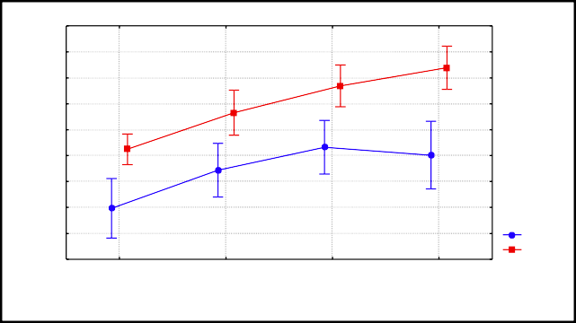
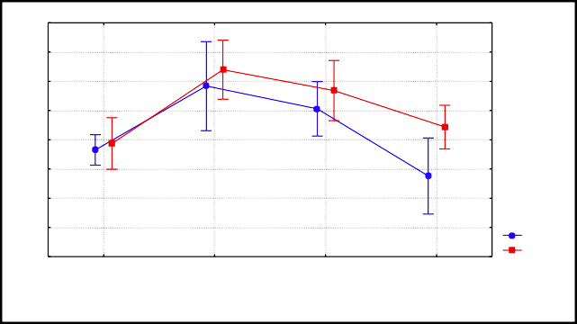
Fig. 2. Height SD of children from the study and the control group in subsequent years of growth hormone therapy (mean values with 95% confidence intervals).
0 1 2 >2
Treatment duration [years]
0 1 2 >2
Treatment duration [years]
p=0.001
p=0.001
Growth rate SD
Height SD

Fig. 4. Growth rate SD of children from the study and the control group in subsequent years of growth hormone therapy (mean values with 95% confidence intervals).

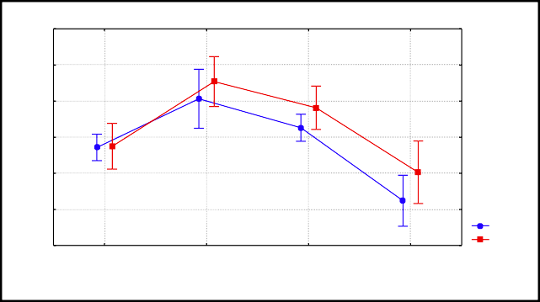
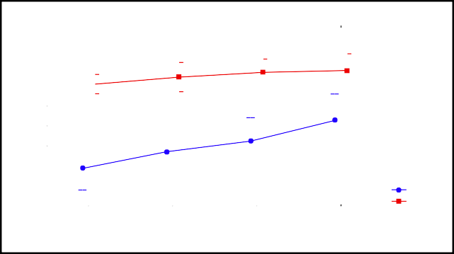
0.0
12

10

8

6

4

2

0

-0.5

-1.0
Treatment duration [years]

-1.5
Weight SD

-2.0

-2.5

-3.0

-3.5
Group type:
study control

-4.0

-4.5
0 1 2 >2
Growth rate [cm/year]

0 1 2 >2
.001
=0.003
Treatment duration [years]

Group type
=0.001
study control
01
p=0.0
p
p
p=0

Fig. 3. Growth rate of children from the study and the control group in subsequent years of growth hormone therapy (mean values with 95% confidence intervals).
Fig. 5. Weight SD of children from the study and the control group in subsequent years of growth hormone therapy (mean values with 95% confidence intervals).
ence between children from the study and the control group decreased.
2 children with the genetic change (1 child with maternal uniparental disomy of chromosome 7 and 11p15 epimutation and 1 child with epimutation 11p15) were treated with recombinant human growth hormone. The boy with maternal uniparental disomy of chro- mosome 7 began growth hormone therapy at the age of
10. After introducing recombinant human growth hor- mone treatment his growth rate improved noticeably, especially during the first year of therapy. His height SD before beginning therapy was only –3.75 and after two years of observation –2.02.
The girl with the 11p15 epimutation began treat- ment at the age of 8.
After one year of recombinant human growth hor- mone therapy her growth rate slightly improved. Before beginning therapy this child’s height SD was –3.84 and after one year of treatment –3.46.
A comparison of growth parameters of two children with a genetic change (maternal uniparental disomy of chromosome 7 and 11p15 epimutation) after one year of growth hormone therapy showed that the boy with mUPD7 had a notably better response to treatment. His growth rate after one year of rhGH therapy improved from 5.9 cm/year to 13.5 cm/year, while the girl with 11p15 epimutation improved her growth rate from
  - cm/year to only 6.3 cm/year.

DISCUSSION
Growth hormone therapy has a positive effect on chil- dren with intrauterine growth retardation, including children with SRS (Rakover et al. 1996; Chatelain et al. 1993; Christofordis et al. 2005; Ranke et al. 1996; Chernausek et al. 1996; Stanhope et al. 1991). Several studies confirm beneficial effects of treating children with SRS (Lewandowska et al. 2002; Rakover et al. 1996; Christofordis et al. 2005; Ranke et al. 1996; Chernausek et al. 1996). It appears that early introduction of growth hormone therapy should positively affect growth and improve the quality of life of these patients. Introducing growth hormone therapy in later age also results in an improvement of height, although not as high, as if the treatment was begun in the prepubertal period (Cut- field et al. 2007; Mascarenhas et al. 2012).
Since 2015 growth hormone therapy for SRS patients in Poland is financed by the National Health Fund (NFZ), as part of short stature treatment for SGA children. Our observation is, however, a first descrip- tion of treatment effects in 12 patients from before the treatment was refunded. Therefore, out of 38 children with phenotype features of SRS, only 12 were treated with growth hormone on the basis of somatotroph pituitary insufficiency or intrauterine growth retarda- tion. Therapy introduction was also largely limited by the advanced age of patients at diagnosis. Thus, the age of patients at the beginning of therapy differed.
Two youngest children were 6 years old and the oldest one – 15 years old. Numerous children did not receive growth hormone because of their age at the time of diagnosis. The observation of the effects of therapy was too short, since most patients did not complete their therapy. Growth hormone did not only increase height
– from –4.02 SD to –2.99 SD, i.e. 1 SD, during the last year of observation, but also weight – from –3.56 SD to –2.36 SD. Height and weight gains were significantly bigger in a group of children with SRS, compared to the group with intrauterine growth retardation. Although at the end of the observation period higher weight and height was achieved by children with IUGR. It is, how- ever, important to note, that children with SRS began the treatment with a substantially larger higher and weight deficit, much like the group observed by Ranke et al. in 2010. In our study, as in the study by Ranke et al. (2010), this difference was approximately 1 SD. The growth rate during the first two years of treatment was comparable between children with SRS and chil- dren with UIGR, albeit in the last year of observation, a significantly faster growth rate was seen in children with IUGR. It means, that children with SRS grow best during the first two years of therapy, unlike children with IUGR, who achieve good height gains also in later years of treatment. This result confirms the observation of other researchers (Cutfield et al. 2007).
Growth hormone therapy has a lot of positive effects on children with SRS. It leads not only to faster vertical growth, but is also beneficial for muscle mass growth, bone mineralization, and improves the quality of life and perception skills of these children (Cutfield et al. 2007). Despite the possible side effects, the advantages of growth hormone therapy outweigh the harmful effects. During an approximately ten-year observation, Toumba et al. (2010) analysed the growth of 26 children with Silver-Russell Syndrome treated with growth hor- mone. The cited author reached similar conclusions, pointing at a positive effect of growth hormone therapy in that study. Median height at the beginning of ther- apy was –2.7 SD and it increased to –1.3 SD during the therapy. The control group consisting of children with IUGR reached a final height of approximately –1.0. Despite a noticeable final height improvement, no child reached the desired final height. In the group examined by this author the biggest height gains were observed at
the beginning of puberty (Toumba et al. 2010).
It was commonly believed that pubertal growth spurt in children with SRS occurs a lot earlier than in normal population (Tanner et al. 1975). Toumba et al. (2010) observed, that growth hormone therapy may lead to a large growth rate acceleration, if introduced before puberty. This author states, however, that this data is not entirely reliable due to a small number of treated patients and a varied age of children at therapy intro- duction. Similar results were described earlier, although then, the observation period was shorter (Rakover et al. 1996; Chatelain etal. 1993; Ranke etal. 1996). Ranke et al.
(1996) suggests that despite discontinuing growth hor- mone therapy, children with SRS sustain good growth rate and perhaps, contrary to children with IUGR, a continuation of treatment until achieving final height would be, in case of children with SRS, unnecessary. The views on growth hormone dosage vary. In the above studies, children were treated with 0.16–
REFERENCES
    - Albanese A, Stanhope R (1997). Persistent short stature in chil- dren with intrauterine growth retardation : use of growth hor- mone treatment. Horm. Res. 48(1): 63–66.
    - Azcona C, Albanese A, Bareille P, Stanhope R (1998). Growth hormone treatment in growth hormone – sufficient and – insuf- ficient children with intrauterine growth retardation/ Russell-
0.43 mg/kg/week. (average 0.25 mg/kg/week.).
It is commonly approved, that it is crucial to intro-
Silver syndrome. Horm. Res. 50: 22–27.
    - Azcona C, Stanhope R (1999). Absence of catch-down growth in Russell-Silver syndrome after short-term growth hormone treat-
duce treatment in an early period of life, to “maximize” the growth promoting effect. Some authors believe that
ment. Horm. Res. 51: 47–49.
    - Bartholdi D, Krajewska-Walasek
M, Ounap K, Gasper H, Chrza-
to achieve the desired effect a much larger dose should be used than in the treatment of somatotroph pituitary
nowska K. H, Ilyana H, et al. (2009). Epigenetic mutations of the
imprinted IGF2-H19 domain in Silver-Russell syndrome (SRS): results from a large cohort of patients with SRS and SRS-like phe-
insufficiency (Chatelain et al. 1993; Albanese et al. 1997;
Chatelain et al. 1994). Other studies suggest, however,
notypes. J. Med. Genet. 46: 192–197.
    - Binder G, Begemann M, Eggermann
T, Kannenberg K (2011).
that despite applying different doses to all treated children, a significant growth rate acceleration was achieved (De Zegher et al. 2000; Chatelain et al. 1993; De Zegher et al. 1999).
The effectiveness of treating children with SRS with growth hormone is confirmed by data from the Australian OZGROW programme. In that study after
Silver-Russell syndrome. Best Pract. Res. Clin. Endocrinol. Metab.
25: 153–160.
    - Binder G, Liebl M, Woelfle J, Eggermann T, Blumenstock G, Sch- weizer R (2013). Adult height and epigenotype in children with Silver-Russell syndrome treated with GH. Horm. Res. Paediatr. 80: 193–200.
    - Boguszewski MCS, Rosberg S, Albertson-Wikland K (1995). Spontaneous 24-hour growth hormone profiles in prepubertal small for gestational age children. J. Clin. Endocrinol. Metab. 80:
5 years of treatment the height deficit of children with SRS decreased from –3.2 SD to –2.0 SD. Increasing the dose did not further improve the growth rate of those
2599–2606.
    - Boguszewski M, Albertsson – Wikland K, Aronsson S, Gustafsson J, Hagenas L, Westgren U, et al. (1998). Growth hormone treat- ment of short children born small – for – gestational – age: The
patients, although a better growth response was seen in younger and shorter patients (Lewandowska et al. 2002;
Nordic Multicentre Trial. Acta Paediatr. 87: 257–263.
    - Bruce S, Hannula-Jouppi K, Peltonen J, Kere J, Lipsanen-N
yman
Rakover et al. 1996; Mascarenhas et al. 2012).
Similar data was presented by Ranke et al. in a study
M (2009). Clinically distinct epigenetic subgroups in Silver-Rus-
sell syndrome: the degree of H19 hypomethylation associates with SRS phenotype severity and genital skeletal anomalies. J.
from 2010, where he describes the effects of growth
Clin. Endocrinol. Metab. 94: 579–587. 10 Chatelain P. G, International Board
of the Kabi Pharmacia
hormone therapy on 161 children with IUGR, includ-
ing 55 with SRS. Despite using a much higher growth hormone dose in patients with SRS, this author did not achieve significant differences in height gains during the first and subsequent years of therapy between chil- dren with SRS and IUGR.
In the study of Binder et al. (2013) the genotype was
International Growth Study (1993). Auxology and response to growth hormone treatment of patients with intrauterine growth retardation or Silver-Russell syndrome: analisys of data from the Kabi Pharmacia International Growth Study. Acta Paediatr. 82(Suppl.391): 79–81.
11 Chatelain P G, Job JC, Blanchard J, Ducret JP, Oliver M, Sagnard L (1994). Dose dependent catch-up growth after 2 years of growth hormone treatment in intrauterine growth retarded children. J.
not a significant predictor of height gain in population
Clin. Endocr. Metab. 78: 1454–1460. 12 Chernausek SD, Breen TJ, Frank GR
(1996). Linear growth in
children with SRS. There was however a trend toward a
batter outcome in children with mUPD7 (Binder et al. 2013), but in our study, a comparison of growth param- eters of two children with a genetic change (maternal uniparental disomy of chromosome 7 and 11p15 epi- mutation) after one year of growth hormone therapy showed clearly, that the boy with mUPD7 had a nota- bly better response to treatment. His growth rate after one year of rhGH therapy improved from 5.9 cm/year
response to growth hormone treatment in children with short stature associated with intrauterine growth retardation: The National Cooperative Growth Study experience. J. Pediatr. 128: 522–527.
- Christofordis A, Maniadaki I, Stanhope R (2005). Managing children with Russell-Silver syndrome: more than just growth hormone treatment? J. Pediatr. Endocrinol. Metab. 18: 651–652.
- Cutfield WS, Reiter EO on behalf of the KIGS International Board (2007). Growth and growth hormone treatment in children born small for gestational age and with Silver-Russell syndrome. In: Ranke M. B, Price D. A, Reiter E. O.: Growth hormone therapy in
to 13.5 cm/year, while the girl with 11p15 epimutation
improved her growth rate from 5.2 cm/year to only
pediatrics – 20 Years of KIGS. Karger, Basel: 389–399.
- Czernichow P (1997). Growth hormone treatment of
short chil-
6.3 cm/year. However this observation needs to be con- firmed in larger cohorts (Binder et al. 2013).

CONCLUSIONS
Recombinant human growth hormone therapy pro- motes somatic growth in children with Silver-Russell Syndrome, although to a smaller degree than in chil- dren with intrauterine growth retardation.
dren born small for gestational age. Acta Paediatr. 424: 213–215. 16 De Zegher F, Butenandt O, Chatelain P. G, Albertsson-Wikland K,
Jonsson B, Löfström A, et al. (1997). Growth hormone treatment of short children born small for gestational age: Reappraisal of the rate of bone maturation over 2 years and meta-analysis of height gain over 4 years. Acta Paediatr. 423: 207–212.
17 De Zegher F, Du Caju MV, Heinrichs C, Maes M, De Schepper J, Craen M, et al. (1999). Early, discontinuous, high dose growth hormone treatment to normalize height and weight of short children born small for gestational age: results over 6 years. J. Clin. Endocr. Metab. 84: 1558–1561.
- De Zegher F, Albertsson-Wikland K, Wollmann HA, Chatelain P, Chaussain JL, Löfström A, et al. (2000). Growth hormone treat- ment of short children born small for gestational age: growth responses with continuous and discontinuous regimens over 6 years. J. Clin. Endocrinol. Metab. 85: 2816–2821.
- De Zegher F, Ong K, van Helvoirt M, Mohn A, Woods K, Dunger D (2002). High-dose growth hormone (GH) treatment in non-GH- deficient children born small for gestational age induces growth responses related to pretreatment GH secretion and associated with a reversible decrease in insulin sensitivity. J. Clin. Endocri- nol. Metab. 87: 148–151.
- De Zegher F, Hokken-Koelega A (2005). Growth hormone therapy for children born small for gestational age: height gain is less dose dependent over the long term than over the short term. Pediatrics. 115: e458–e462.
- Hokken-Koelega A (1999). What is the role of GH therapy in chil- dren born small for gestational age? In: Monson J. P.: Chalenges in growth hormone therapy. Oxford: Blackwell Science: 78–98.
- Kotzot D (2008). Maternal uniparental disomy 7 and Silver- Russell syndrome — clinical update and comparison with other subgroups. Eur. J. Med. Genet. 51: 444–451.
- Lewandowska K, Rymkiewicz-Kluczyńska B (2002). Obraz klin- iczny i efekty leczenia hormonem wzrostu dzieci z zespołem Silvera-Russella. Pediatr. Pol. 7: 599–602.
- Mascarenhas JV, Vageesh SA (2012). Russell Silver syndrome: a perspective on growth and the influence of growth hormone therapy. Indian J. Endocrinol. Metab. 16: 840–842.
- Netchine I, Rossignol S, Dufourg M, Azzi S, Rousseau A, Perin L, et al. (2007). 11p15 imprinting center region 1 loss of meth- ylation is a common and specific cause of typical Russell-Silver syndrome: clinical scoring system and epigenetic — phenotypic correlations. J. Clin. Endocrinol. Metab. 92: 3148–3154.
- Ong K, Beardsall K, de Zegher F (2005). Growth hormone therapy in short children born small for gestational age. Early Hum. Dev. 81: 973–980.
- Palczewska I, Niedźwiecka Z (2001). Wskaźniki rozwoju soma- tycznego dzieci i młodzieży warszawskiej. Med. Wieku Rozw. 5(Suppl.1 do nr 2): 17–118.
- Price S. M, Stanhope R, Garrett C, Preece M. A, Trembath R. C (1999). The spectrum of Silver-Russell syndrome: a clinical and molecular genetic study and new diagnostic criteria. J. Med. Genet. 36: 837–842.
- Rakover Y, Dietsch S, Ambler GR, Chock C, Thomsett M, Cowell CT (1996). Growth hormone therapy in Silver-Russell syndrome: 5 years’ experience of Australian and New Zealand growth data- base (OZGROW). Eur. J. Pediatr. 155: 851–857.
- Ranke MB, Lindberg A (1996). Growth hormone treatment of short children born small for gestational age or with Silver- Russell syndrome: result from KIGS (Kabi International Growth Study), including the first report on final height. Acta Paediatr. 417: 18–26.
- Ranke MB, Lindberg A, Cowell CT, Wikland KA, Reiter EO, Wilton P, et al. (2003). KIGS International Board: Prediction of response to growth hormone treatment in short children born small for ges- tational age: analysis of data from KIGS (Pharmacia International Growth Database). J. Clin. Endocrinol. Metab. 88: 125–131.
- Ranke MB, Lindberg A (2010). Height at start, first – year growth response and cause of shortness at birth are major determina- tions of adult height outcomes of short children born small for gestational age and Silver-Russell syndrome treated with growth hormone: analysis of data from KIGS. Horm. Res. Paedi- atr. 74: 259–266.
- Sas T, de Waal W, Mulder P, Houdijk M, Jansen M, Reeser M, et al. (1999). Growth hormone treatment in children with short stat- ure born small for gestational age: 5-year results of a random- ized, double – blind, dose – response trial. J. Clin. Endocrinol. Metab. 84: 3064–3070.
- Schönherr N, Meyer E, Eggermann K, Ranke MB, Wollmann HA, Eggermann T (2006). (Epi)mutation in 11p15 significantly contribute to Silver-Russell syndrome: but are they generally involved in growth retardation? Eur. J. Med. Genet. 49: 414–418.
- Stanhope R, Ackland F, Hamill G, Clayton J, Jones J, Preece M. A (1989). Physiological growth hormone secretion and response to growth hormone treatment in children with short stature and intrauterine growth retardation. Acta Paediatr. Scand. 349: 47–52.
- Stanhope R, Preece MA, Hamill G (1991). Does growth hormone treatment improve final height attainment of children with intrauterine growth retardation? Arch. Dis. Child. 66: 1180–1183.
- Tanner JM, Ham TJ (1969). Low brithweight dwarfism with asym- metry (Silver’s syndrome): treatment with human growth hor- mone. Arch. Dis. Child. 44: 231–243.
- Tanner JM, Lejarraga H, Cameron N (1975). The natural history of Silver-Russell syndrome: a longitudinal study of thirty nine cases. Pediatr. Res. 9: 611–623.
- Toumba M, Albanese A, Azcona C, Stanhope R (2010). Effect of long – term growth hormone treatment on final height of children with Russell-Silver syndrome. Horm. Res. Paediatr. 74: 212–217.
- Wakeling EL (2011). Silver-Russell syndrome. Arch. Dis. Child. 96: 1156–1161.
- Wollmann HA, Kirchner T, Enders H, Preece MA, Ranke MB (1995). Growth and symptoms in Silver-Russell syndrome: review on the basis of 386 patients. Eur. J. Pediatr. 154: 958–968.

