
Journal of Solid State Electrochemistry (2019) 23:1463–1472 https://doi.org/10.1007/s10008-019-04236-2
Study on self-assembled monolayer of functionalized thiol
on gold electrode forming capacitive sensor for chromium(VI) determination
Jolanta Kochana¹ & Karolina Starzec¹ & Marcin Wieczorek¹ & Paweł Knihnicki¹ & Maciej Góra¹ & Anna Rokicińska¹ &
Paweł Kościelniak¹ & Piotr Kuśtrowski¹
Received: 6 November 2018 / Revised: 9 February 2019 / Accepted: 10 February 2019 / Published online: 23 March 2019
# The Author(s) 2019
Abstract
A capacitive sensor based on S-{12-[1-(pyridin-4-ylmethyl)-1H-1,2,3-triazol-4-yl]dodecyl} ethanethioate (FT), a compound with a functional group exhibiting selective affinity towards Cr(VI) ions, was developed. FT was mixed with shorter-chain thiol-decanethiol (DT), to obtain an Au electrode surface well covered by a thiol monolayer. The composition and high quality of self-assembled monolayers (SAMs) were crucial factors influencing the performance of the capacitive sensor. In this work, SAMs formed from FT and DT mixtures with different compositions were studied. For physicochemical characterization of SAMs X-ray photoelectron spectroscopy (XPS), contact angle measurements as well as atomic force microscopy (AFM) were used. Cyclic voltammetry was employed to estimate an electrode surface coverage. Based on the obtained results, the composition of thiol layer providing the best parameters for capacitive sensing of chromium(VI) was chosen. Moreover, the analytical performance of sensor was verified.
Keywords Capacitive sensor . Self-assembled monolayer . Cr(VI) determination
Introduction
quantitative detection of medicament-diclofenac with the use of aptasensor based on bimetallic AgPt nanoparticle– decorated carbon nanotubes [3] or to sensitive impedimetric determination of melamine with molecularly imprinted polymer-based electrode [4].
Among electrochemical sensors, capacitive sensors can be distinguished. They are commonly known in two configura- tions: parallel-plate or interdigitated electrode (IDE) with various sensing layers [5]. They can be used in different areas of analysis. Zeinali et al. [5] and Homayoonia et al. [6] reported capacitive sensors designated for gas analysis. In both cases MOF was used as a component of capacitive sensor and volatile organic compounds (VOCs) were the analytes. A miniaturized sensor based on an interdigital capacitor (as the transducer) and a dual-imprinted titania-polyaniline composite film (as the receptor) for instant monitoring of ethanol in gasohol fuel blends were proposed by Irshad et al. [7]. For detection of 4-nitrophenol, manganese dioxide/ reduced graphene oxide nanocomposite paper was fabricated for supercapacitor preparation [8]. Using the interdigitated electrode capacitors, glucose, based on solvatochromic- dye-containing sensing membrane [9], and foodborne pathogenic Escherichia coli [10] were detected. A supercapacitor-based biosensor for low lipoprotein detection was also proposed [11]. For this purpose, graphene oxide was
The ability of sensitive detection is of crucial importance in many areas of human life. Sensors of new generation seem to be ideal analytical tools for that purpose not only because of their highly sensitivity, but also due to their simplicity and minimal requirements for a sample pretreatment. Ultrasensitive sensors designated for medical diagnosis, food analysis, environmental analysis, and monitoring of air quality have been reported. In the trend of ultrasensitive detection, electrochemical methods are often used. The indicator-free DNA hybridization sensor based on graphene nanocomposite as the enhanced sensing platform for detection breakpoint cluster region gene and the cellular abl (BCR/ABL) [1] and non-enzymatic glassy carbon sensor modified with gold nano- particles (GNPs) onto conductive polyaniline (PANI) for de- tection of glucose [ 2] can be given as examples. Electrochemical methods can be also adopted for the
* Jolanta Kochana jolanta.kochana@uj.edu.pl
1
Faculty of Chemistry, Jagiellonian University, Gronostajowa 2, 30-387 Kraków, Poland
ORIGINAL PAPER

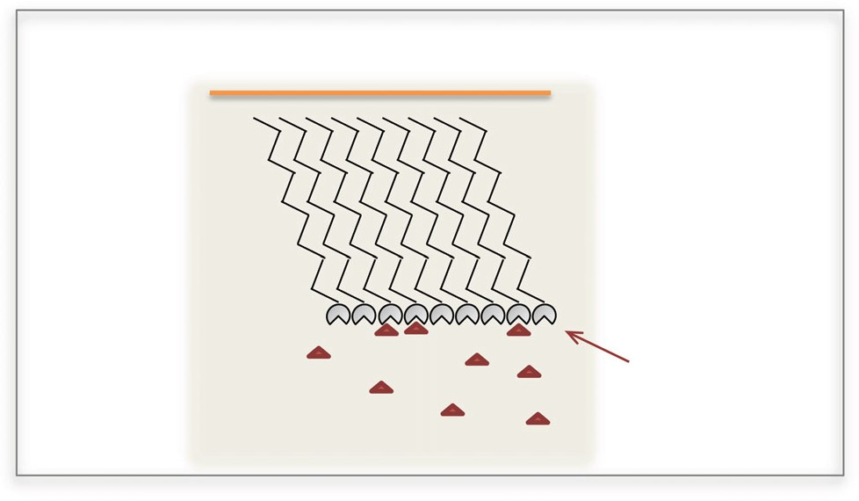
1464
J Solid State Electrochem (2019) 23:1463–1472
functionalized with hyperbranched polyethylenimine and in- corporated into chitosan to obtain a nanocomposite film on a Pt disk electrode.
Capacitive sensors are a different group of electrochemical sensors whose operation is based on the electrostriction phe- nomenon. The electrostriction, described in the literature in 1960s [12], consists in a change of dimensions of materials, influenced by electrical field, and is specific for dielectrics. This phenomenon is especially noticeable in nanomembranes, e.g., self-assembled monolayers (SAM) [13]. Applying to these membrane potential lower than 1 V causes an appear-
ance of strong electrical field of 10⁵–10⁶ V cm⁻¹ in intensity. Electrostatic forces change the dimensions of the dielectric. In
this case, the membrane’s compression, manifested by a de- crease in its thickness, occurs. As a result, an increase in the membrane capacitance is observed.
The electrostriction phenomenon is often found in layers formed by long-chain organic compounds organized on a sur- face of solid electrode being in contact with an electrolyte solution [13, 14]. A gold electrode covered with a self- assembled monolayer of long-chain thiols can be considered as a capacitor whose covers are the electrode surface from one side and the electrolyte (analyte) solution from the other side (Fig. 1). Functional groups of thiols exposed to the solution participate in different interactions with an analyte based on adsorption, association, formation of hydrogen or coordina- tion bonds, redox reactions, or antigen-antibody interactions. The presence of analyte initiates phenomena on the membrane/solution phase boundary influencing the electrostriction of the double layer and affects the capacitance-potential characteristics. The measurement of ca- pacitance changes can be used to determine different types of analytes.
The crucial factors influencing the behavior of capacitive sensor are composition and quality of thiol SAM. To achieve the best analytical parameters of developed sensors, the self- assembled monolayer of thiols should expose the biggest number of functional groups to the analyte solution
simultaneously providing the favorable wetting properties. Furthermore, the well-ordered thiol film enables the repeat- able occurrence of electrostriction phenomenon beneficially influencing the sensor functioning.
Self-organizing layers have found applications in many areas of nanotechnology, molecular electronics, and (bio)sensors because of the possibility of changing the sur- face. Recently, modification of electrodes by self-assembled monolayers has become very attractive due to simplicity and quickness of this approach [15]. Well-defined self-assembled monolayer of thiols is formed as a result of strong chemisorp- tion between metal surface (usually gold) and sulfur atoms of thiols [16]. SAMs of alkanethiols on the gold surface, Au(111), are the most commonly studied because of their well-packed structure, stability, and especially flexibility in design of the chain length [17]. For this reason, electrochem- ical and surface studies of different SAMs [18], blocking be- havior [19], potential dependence of the kinetics of thiol self- assembling on gold [20] or impact of 1-decanethiol formation and removal cycles on the surface properties of polycrystalline Au and SAM quality [21] were reported. Moreover, these structures have found many applications in electrochemistry as sensors [22, 23] and biosensor platforms [24], in catalysis
[25] and surface science [26]. The main advantage of using SAM is the possibility of fabricating and modifying the func- tional, active groups of thiols according to their purposes.
The present work deals with a capacitive sensor for Cr(VI) determination [27]. Chromium is believed to be one of the most common pollutants at hazardous waste sites. Chromium exists in the environment in the form of trivalent Cr(III) and hexavalent Cr(VI). The first one is considered to be essential for the maintenance of glucose, protein, and lipid human metabolism. The second form, Cr(VI), has an undesir- able effect on the lungs, liver, and kidneys. The examples of electrochemical chromium(VI) determination include the use of a glassy carbon electrode modified with silicomolybdate doped polypyrrole film [28], the preparation of hybrid and electroactive thin films containing microcrystalline cellulose (MC), or MC modified with a phosphate group (PC) in con- junction with polyaniline (PANI) and poly(vinyl sulfonic acid) (PVS) by the layer-by-layer technique [29] or determination in estuarine waters by catalytic cathodic stripping voltammetry using a vibrating silver amalgam microwire electrode [30]. The determination of Cr(VI) employing the screen-printed carbon electrode (SPCE) modified with the use of organic compound (PANI) and graphene quantum dot [31] or inorgan- ic nanoparticles like AuNPs [32] have been reported.
The presented capacitive sensor was formed by S-{ 12-[1-(pyridin- 4-ylmethyl)-1H-1,2,3- triazol-4- yl]dodecyl} ethanethiol, with the terminal groups exhibiting
Gold electrode surface
S S S S S S S S S
Self-assembled monolayer of functionalized
thiols
Electrostriction phenomenon
Interaction with analyte molecules
Analyte molecules
Electrolyte solution
the affinity towards CrO ²⁻ and Cr O ²⁻ anions, assembled on
4
2 7
a gold electrode surface [33]. Because of steric hindrance, attributed to the relatively large functional groups, to obtain
Fig. 1 Scheme of membrane-covered electrode in contact with an electrolyte solution

J Solid State Electrochem (2019) 23:1463–1472
1465
the well-ordered thiol monolayer, which in turn minimizes non-specific adsorption of analyte, shorter-chain thiol- decanethiol (DT) was used as an additional component of thiolating solution [34, 35]. The main goal of the study was the characterization of thiol layers of various compositions supported on the gold surface. X-ray photoelectron spectros- copy (XPS) and contact angle measurements as well as atomic force microscopy (AFM) techniques were employed. An elec- trode surface coverage with the layer of thiols was calculated using cyclic voltammetric measurements. The research under- taken also dealt with optimization of measuring procedure and its influence on analytical performance of the sensor.
of cleaning. The efficiency of the processes was evaluated based on peak potential separation, ΔE_{p} [36]. The smaller was the ΔE_{p} value and the closer to theoretical one (for one-electron process 0.058 V), the cleaner was the gold electrode surface. In our experiments, the value of ΔE_{p} in the range of 0.07–0.08 V was accepted.
Self-assembled monolayers of thiols were spontane- ously formed on a gold electrode surface by immersing the electrode in a thiol solution at 30 °C for 30 min, and subsequently at ambient temperature (ca. 20 °C) for
90 min. Then, the electrode was rinsed with a large amount of EtOH/H₂O (1:1, v/v) solution. The prepared sensors were stored in the EtOH/H₂O (1:1, v/v) solution and carefully rinsed with the EtOH/H₂O (1:1, v/v) solu- tion before capacitive measurements. Because of steric hindrance, attributed to relatively large functional groups, to obtain a high structural quality of the thiol membrane, FT was mixed with shorter-chain DT. In the thiolation process, the mixtures obtained by mixing of
0.2 mmol L⁻¹ solutions of both thiols at various FT/(FT
+ DT) volume ratios (0.00, 0.05, 0.15, 0.25, 0.33, 0.50,
0.67, and 1.00) were examined.
Experimental
Chemicals
All chemicals, unless mentioned otherwise, were analytical- grade reagents. Potassium dichromate(VI), K₂Cr₂O₇ (> 99.5%), ethanol (EtOH), nitric acid, potassium chloride, sodi- um nitrate, and potassium hexacyanoferrate(III) were pur- chased from Avantor (Poland). 1-Decanethiol from Alfa Aesar (USA), sulfuric acid (95–97%) from Merck (Germany), acetone from Chempur (Poland), potassium hy- droxide from Centro-chem (Poland), and 0.3 μm alumina powder, used for polishing working electrodes surface from Buehler Micropolish (USA), were supplied. Water solutions were prepared using ultrapure water (conductivity <
0.5 μS cm⁻¹) from an HLP 5 system (Hydrolab, Poland), and EtOH/H₂O mixture (1:1, v/v) was used for preparation of 0.2 mmol L⁻¹ both decanethiol (DT) and functionalized thiol (FT) solutions.
1-Decanethiol 99% (DT) was purchased from Aldrich (USA), while S-{12-[1-(pyridin-4-ylmethyl)-1H-1,2,3- triazol-4-yl]dodecyl} ethane-thiol (FT) was synthesized ac- cording to the procedure described in Supporting information. The structure of FT was confirmed by NMR and ATR-IR spectroscopy as well as elemental analysis.
Surface characterization
For surface investigation, gold layers with thickness of ca. 150 nm were evaporated onto crystal silicon wafers (ITME, Warsaw) consolidated with a 5-nm chromium adhesion layer. Evaporations were carried out in an oxygen-free glovebox (MBRAUN, Germany). SAMs of thiols were formed by im- mersing the freshly prepared wafers in the thiol mixture of different composition at ambient temperature for 24 h. Before measurements, the wafers were brought out from the thiol solution and carefully rinsed with EtOH/H₂O (1:1, v/v). Before the AFM experiments, they were additionally dried using nitrogen.
Contact angle measurements were carried out at room tem- perature using a Standard Contact Angle Goniometer ramé- Hart Model 2000 (ramé-hart instrument co., USA). They were performed to study hydrophobicity of SAMs supported onto an evaporated gold layer. One microliter of deionized water was put on a gold surface covered by SAMs and a needle tip was in contact with a drop. For each SAM, the measurements were repeated five times.
X-ray photoelectron spectroscopy measurements were per- formed with a Prevac system equipped with a hemispherical analyzer VG SCIENTA R3000 (Scienta Omicron, Sweden). The spectra were taken using a monochromatized aluminum source AlKα (E_{b} = 1486.6 eV). The base pressure in the ana-
lytical chamber was about 5 × 10⁻⁹ mbar. The binding energy scale was calibrated using the Au 4f_{7/2} line of a cleaned gold
sample at 84.0 eV. The surface composition was analyzed taking into account the areas and binding energies of Au 4f,
Sensor preparation
Prior to formation of thiol monolayers, a gold electrode was cleaned by mechanical polishing with alumina slurry followed by cyclic voltammetry in 0.5 mol L⁻¹ KOH and
0.5 mol H₂SO₄ solutions, in potential between of
− 0.2 to 1.1 V and − 0.3 to 1.5 V vs. Ag/AgCl reference electrode, respectively. The measurements were carried out until repeatable cyclic voltammograms were obtained.
Solution of K₃[Fe(CN)₆] (5 mmol L⁻¹ with 20 mmol L⁻¹ NaNO₃) was used for verifying cleanliness of an electrode
surface. A pair of well-defined redox peaks correlated to Fe(III) + e⁻ ↔ Fe(II) reaction manifested a desired result
L−1

1466
J Solid State Electrochem (2019) 23:1463–1472
the voltage U₊ to U₋ lasts the same as in opposite direction, from U₋ to U₊ and can be expressed by the equation:
C 1s, N 1s, S 2p, and O 1s. The spectra were fitted using the Casa XPS software.
Atomic force microscopy images were obtained with a Dimension Icon+ atomic force microscope (Bruker, Germany) working in air in PeakForce Tapping mode. Silicon nitride cantilevers (Bruker, Germany) with nominal
normal spring constant of 0.58 N m⁻¹ were used for all the measurements.
ΔU
i
T _{þ} ¼ T ₋ ¼ C
ð2Þ
Since the total period of the resulting signal, T, is given as
T = T + T , it is equal to
+ −
ΔU
i
T ¼ 2C
ð3Þ
Electrochemical measurements
As a consequence, the capacitance can be described as follows
All electrochemical experiments were carried out at room temperature in a three-electrode arrangement consisting of a working gold electrode covered by SAM, a platinum
i
C ¼ T
ð4Þ
2ΔU
L−1)
counter electrode, and a Ag/AgCl (3 mol
reference
electrode. The gold electrodes were made from a 1.00- mm-diameter rod of pure gold (99.99%, Mint of Poland) placed into a Teflon holder. Both, measurement KSP-2 module, composed of a galvanostat, capacitance meter CMTR-243 and A/C-C/A converters, and the software used to control measurements, acquisition, and analysis of the capacitance-potential characteristics, were de- signed and produced by KSP Elektronika Laboratoryjna (Poland).
Capacitance measurements were performed using the capacitance-to-frequency conversion method [13, 37, 38]. In this approach, the investigated capacitor, an electrode covered with SAM of functionalized thiols, being in con- tact with analyte solution, is periodically charged and discharged by a current in a defined range of potential, ΔU, and the current is constant in its absolute value, but with alternating sign. The voltage change over the time is triangular as is presented in Fig. 2.
While the capacitor is charged from the voltage U₊ to U₋, the voltage changing rate, V, is influenced by the current, i, and
the capacitance, C, according to the equation:
The method employed for measurement enabled recording of capacitive characteristics in the form of capacitance- potential curves. The measurements were carried out in the
potential range from − 200 to 800 mV with scan rate of 50 mV s⁻¹ and potential step of 2 mV. Every day, before capacitance experiments, the measurement device was cali-
brated using a 10.00 nF capacitor. For each sensor, the capac- itance measurements in solution of supporting electrolyte (0.1 mol L⁻¹ NaNO₃) were performed. After addition of a proper volume of the sample solution (or analyte standard
solution), the mixture was stirred for 1 min using a magnetic stirrer MS 11HS (Wigo, Poland) and then measuring cycles were done registering capacitance-potential curves.
Results and Discussion
Electrochemical characterization of SAMs
Assuming that redox reactions can take place only on parts of electrode surface uncovered by thiols and that diffusion to bare surface spots is planar, characterization of SAMs can be done using fractional coverage of the monolayer on a gold surface,
U _{þ}−U ₋ i
V ¼ ¼
ð1Þ
T _{þ} C
Θi
estimated from cyclic voltammetry measurements [39]:
CV
Owing to the fact, that the current value is the same in both directions of voltage change, charging of the capacitor from
U
iSAM
p
Θi
−
¼ 1
ð5Þ
CV
ibare
p
U₊
where ibare is a peak current recorded on the bare gold electrode
p
in a K₃[Fe(CN)₆] solution, and iSAM is a respective peak current
p
recorded on the electrode covered by thiol at the same measuring conditions. Based on the CV measurements, carried out using the gold electrodes covered with thiol monolayers of varying composition, the Θ^{i}_{CV} values were calculated (see Table 1). It can be found that the best elec- trode surface coverage was achieved at the FT/(FT + DT) ratio of 0.67 (FT:DT ratio 2:1, v/v).
ΔU
0
t
U₋
T
Fig. 2 Cyclic changes of the capacitor voltage during measurements

A
J Solid State Electrochem (2019) 23:1463–1472
1467
Table 1 Characterization of SAMs: electrode surface
Θi
Composition of thiol mixture FT/(FT + DT)
Contact angle [°]
FT/(FT + DT) ratio at Au surface
Atomic ratio at Au surface
CV
coverage Θ^{i} , contact angle and
CV
S/Au
N/Au
C/Au
surface composition of studied thiol monolayers assembled on Au electrode
0.00 (100% DT)
0.05
0.15
0.25
0.33
0.50
0.67
1.00 (100% FT)
0.641
0.664
0.743
0.780
0.817
0.866
0.886
0.849
112.8
90.2
69.0
61.4
51.9
48.4
42.9
40.9
0.000
0.335
0.652
0.757
0.879
0.920
0.979
1.000
0.05
0.05
0.06
0.06
0.05
0.06
0.06
0.05
0.00
0.02
0.07
0.08
0.09
0.12
0.16
0.21
0.53
0.77
0.81
0.92
1.02
1.28
1.17
1.08
Physicochemical characterization of SAMs
values of static contact angle (Table 1) clearly decrease with raising the FT content due to its higher hydrophilicity com- pared to DT. It should be kept in mind that both thiols differ in the length of hydrocarbon chain and the layer is formed main- ly by the functional groups of FT. It is not therefore surprising that this surface becomes hydrophilic even at the low contents of FT in the formed membrane.
The coating of Au electrode with the thiol monolayer was also controlled by atomic force microscopy. In Fig. 5, an ex- ample of AFM image taken for the bare gold and gold covered with mixture of FT/(FT + DT) at molar ratio of 0.67 is shown. The obtained layer is continuous, remarkably smooth, and densely uniform (compared with bare Au surface), without any clear faults. For other compositions of thiol films, similar AFM pictures were collected.
X-ray photoelectron spectroscopy was used to follow the composition of the thiol monolayer formed on the Au elec- trode. Apart from the Au 4f photoemission observed as a doublet at 84.0 eV (Au 4f_{7/2}) and 87.7 eV (Au 4f_{5/2}) with spin-orbit splitting of 3.7 eV, the peaks related to C 1s, N 1s, S 2p, and O 1s are found in the recorded survey XPS spectra. The presence of oxygen impurities can be attributed to partial- ly oxidized electrode surface and other contaminants (such as unremoved solvents) existing in the thiol layer. The remaining elements correspond mainly to thiols (FT and DT) introduced onto the Au surface. The determined amounts of the compo- nents of SAMs are listed in Table 1. Obviously, the packing density of the thiol layer on the Au electrode is very similar regardless to the composition of the thiolating mixture, and the S/Au atomic ratio of 0.05–0.06 was determined for all the studied membranes.
The S 2p spectra have a doublet structure due to the pres- ence of the S 2p_{3/2} and S 2p_{1/2} peaks. Their positions at 162.0
± 0.1 eV and 163.3 ± 0.2 eV suggest that sulfur exists exclu- sively in the thiol groups chemically bonded to the Au surface, and no significant amounts of free or oxidized thiols are iden- tified [40]. Furthermore, the N and S contents were used to calculate the composition of the thiol layers formed at the various thiolating mixtures. In Fig. 3, % at. of FT in SAMs determined as
Verification of sensor functioning
Based on the results of electrochemical and physicochemical studies performed, for further experiments, the mixture of FT/ (FT + DT) at molar ratio of 0.67 was chosen for the sensor construction. For a series of prepared electrodes, similar in shape capacitance-potential curves usually with hysteresis
100
80
1 % at:N
% at:FT ¼ 4 ∙ % at:S ∙100%
ð6Þ
60
is shown. As can be found, at lower FT/(FT + DT) ratios in the thiolating mixture, FT is predominantly attached to the metal electrode. An increase in the FT content during the thiolating process results in obtaining the monolayer characterized by the chemical compositions very close to the intended ones.
The wetting behavior of the Au surface after modification with the thiol monolayer was studied by contact angle mea- surements. Examples of images captured for the thiol mixtures of different composition are shown in Fig. 4. The determined
40
20
0
0.0
0.2
0.4
0.6
0.8
1.0
FT/(FT/DT)
Fig. 3 Composition of thiol monolayer determined by XPS
% FT in thiol monolayer bonded to Au electrode

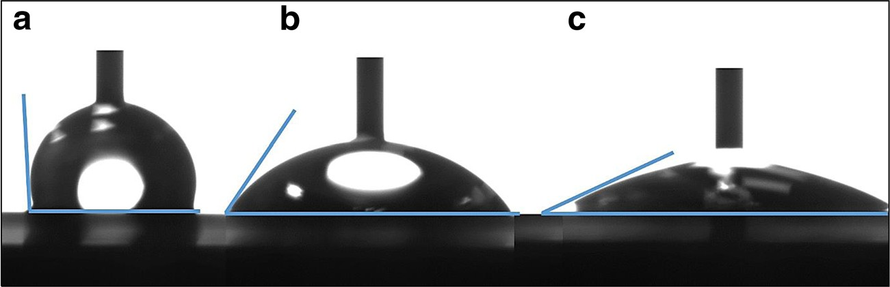
1468
J Solid State Electrochem (2019) 23:1463–1472
Fig. 4 Examples of contact angle images of DT monolayer (a), DT:FT monolayer at volume ratio
0.50 (b) and FT monolayer (c)
measuring cycles. Simultaneously, it was revealed that the sensor sensitivity decreased along with the increase in the number of measurements carried out in solution of supporting electrolyte It is likely that the thiol mono- layer, after being exposed many times to variable elec- tromagnetic field, was less flexible and, as results, electrostriction of SAMs was weaker. For that reason, it was decided that five measuring cycles in supporting
electrolyte (0.1 mol L⁻¹ NaNO₃) for each sensor will be carried out, assuming that the further changes in the
course of capacitance-potential curves could be neglected. After an introduction of each volume of stan- dard Cr(VI) solution and mixture stirring, five consecu- tive capacitance-potential characteristics were recorded. Since, starting from the third measuring cycle, the curves overlapped; therefore, the fourth cycle was used for analytical purposes.
In order to verify if the modified procedure of capacitance measurements enables the determination of chromium(VI) at lower concentrations, the measurements were performed in three different Cr(VI) concentration ranges: up to 10, 50,
and 500 nmol L⁻¹. The following linear relationships of the capacity versus concentration (C–c) were obtained, as mean
values for three sensors for each concentration range:
were recorded, in both, supporting electrolyte and analyte solutions (see Fig. 6). The fluctuation of capacitive char- acteristic pattern and the level of measured capacitance were random, which could be clarified by unrepeatable assembling of thiols on the gold electrode surface being an effect of non-ideal smoothness of gold surface after the electrode preparing process.
The important issue of proposed approach was the
way of the analytical signal readout. From Fig. 6,
it
is
seen that, with increasing concentration of Cr(VI), up to
L−1,
500 nmol
capacitance characteristics moved along
the capacitance axis. It was noticed that in nearly all cases, the most significant signal changes were revealed at potentials of 0.70 V, accordingly that potential was selected for the analytical signal readout.
To improve the analytical parameters of proposed sensor, consideration about experiments performed in the solution of supporting electrolyte was taken. The most often employed procedure of electrochemical mea- surements includes recording signal in supporting elec- trolyte until its constant value is reached. During capac- itive experiments it was observed that the biggest dif- ference in capacitance-potential curves registered for supporting electrolyte occurred during the first three
up to 10 nmol L⁻¹ C nF⋅cm⁻² ¼ 119:4ð 7:3Þ n F⋅cm⁻²⋅nmol⁻¹⋅L ⋅c nmol⋅L⁻¹ þ 10558ð 44Þ n F⋅cm⁻² ;
up to 50 nmol L⁻¹ C n F⋅cm⁻² ¼ 13:0ð 1:0Þ n F⋅cm⁻²⋅nmol⁻¹⋅L ⋅c nmol⋅L⁻¹ þ 5448ð 29Þ n F⋅cm⁻² ;
up to 500 nmol L⁻¹ C n F⋅cm⁻² ¼ 7:0ð 0:8Þ nF⋅cm⁻²⋅nmol⁻¹⋅L ⋅c nmol⋅L⁻¹ þ 13503ð 224Þ n F⋅cm⁻² ;
L−1)
(standard deviations were calculated based on the law of propagation of uncertainty). Comparing the calibration re- lationships obtained for different concentration ranges, it was realized that the highest sensor sensitivity was re- ceived for the lowest analyte concentration, up to
Cr(VI) concentration range (up to 500 nmol
in-
c r e a s e d b y m o r e t h a n 5 0 % , f r o m 4 . 6 t o
c m − 2
n m o l ⁻ ¹
L 1
7 . 0 n F
( 0 . 0 3 6 a n d
0.0557 nF nmol⁻¹ L¹, respectively).
Due to fluctuations of the capacitive characteristics observed for various sensors, analytical signals for a sample and standard solutions should be measured uti- lizing the same sensor and in the same solution of a supporting electrolyte. Furthermore, measurements for growing analyte concentrations were necessary. Considering the above, the adequate calibration ap- proach was applied—the modified standard addition
L−1,
cm−2
nmol⁻¹ L¹,
10 nmol
119.4
nF
whereas 13.0
and 7.0 nF·cm⁻²·nmol⁻¹·L for the Cr(VI) concentrations
up to 50 and 500 nmol L⁻¹, respectively. In comparison to the results reported previously [27], it was noticed that
reducing the number of measuring cycles recorded in supporting electrolyte allowed to increase the sensor sen- sitivity, its value corresponding to the highest studied

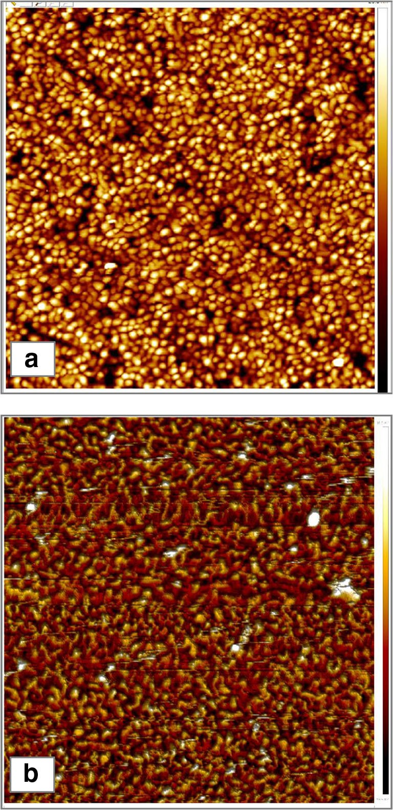
-0,2 -0,1 0,0 0,1 0,2 0,3 0,4 0,5 0,6 0,7 0,8
J Solid State Electrochem (2019) 23:1463–1472
1469
method, called signal increment extrapolative calibration method [27, 41]. Calibration procedure was consisted into few steps. At the beginning, the one addition of the standard analyte was introduced into supporting electrolyte and the analytical signal was measured (R1) (see Fig. 7a). In the next step, the known volume of the sample solution with unknown concentration of the an- alyte was added and new analytical signal was recorded (R2). Afterwards, analytical signals (R3 ÷ R5) were measured for subsequent three standard additions of known volume and concentration. As a result, based on signals (R2 ÷ R5), the calibration graph could be created, and the concentration of the unknown sample could be calculated by extrapolation of the calibration plot to the signal of the first standard solution (R1).
The developed methodology was verified in a synthetic solution containing different amounts of Cr(VI) within the lowest examined concentration range. The analyses of syn- thetic solutions were performed at four different concentra- tions. The results of determinations are presented in Table 2.
Exemplary calibration graphs obtained for 2 nmol·L⁻¹
chromium(VI) solutions according to the calibration method
used are shown in Fig. 7b. The data in Table 2 reveal that relative errors are lower than 7%, even at very low chromium(VI) concentrations (1 and 2 nmol·L⁻¹); therefore,
the accuracy of the sensor can be regarded as satisfactory. The
RSD values do not exceed 6%, indicating acceptable precision of the method.
Based on described-above calibration approach, the limit of detection was estimated. For this purpose, the formula LOD = t_{α,} _{f} ∙ s was employed, where t_{α,} _{f} was the critical
Student’s t value read for the significant level α = 0.1 and f
degrees of freedom for n measurements (f = n − 1), and s was the standard deviation of the obtained results [42]. The calcu- lation performed based on ten analyses carried out for 1 nmol·
Fig. 5 AFM images of uncovered Au surface (a) and of thiol monolayer formed on Au electrode in solution containing FT/(FT + DT) molar ratio of 0.67 (b)
Fig. 6 Example of capacitance- potential curves recorded for developed sensors in supporting electrolyte (dotted line) and Cr(VI) solutions of increasing concentrations from 1 to
10 nmol·L⁻¹, scan rate 20 mV·s⁻¹
Capacitance (nF cm-2)

c

7000
-0.2 -0.1 0.0 0.1 0.2 0.3 0.4 0.5 0.6 0.7 0.8
E vs. Ag/AgCl (V)
12500

12000

11500

11000

10500

10000

9500

9000

8500

8000

7500

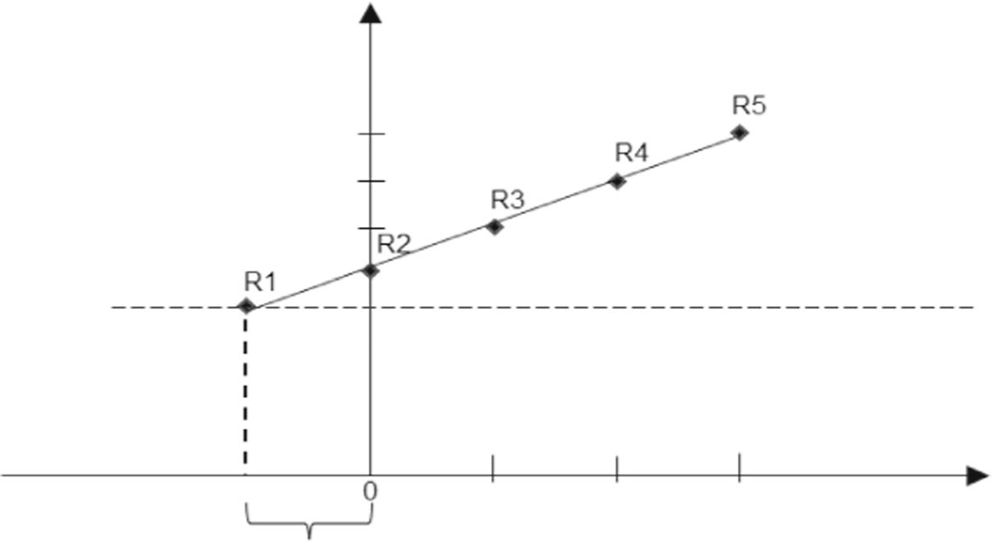
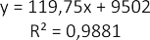
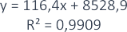
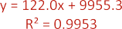
1470
J Solid State Electrochem (2019) 23:1463–1472
Fig. 7 The signal increment extrapolative calibration–general approach (a); exemplary calibration graphs received for three 2 nmol L⁻¹ Cr(VI) synthetic
solutions (b)
L−1
Cr(VI) standard solutions gave the LOD value of
0.31 nmol·L⁻¹. Reproducibility of sensor operation was esti-
Table 2 Results of determinations of Cr(VI) in synthetic samples
mated as 3.5% (RSD%) for the three independently prepared sensors employing for Cr(VI) determination in solution with
concentration of 5 nmol·L⁻¹. Repeatability obtained for three analyses carried out with the use of one sensor gave an RSD
value of 9.1%.
Comparing the presented sensor to other electrochemical sensors designated for Cr(VI) determination (see Table 3), it can be noticed that in this case, linear response range was better than obtained for the sensors based on hybrid films of phosphate cellulose and electroactive polymer [29], polyaniline/graphene quantum dot–modified screen-printed carbon electrode [31] and screen-printed carbon electrode modified with gold nanoparticles [32]. The developed sensor exhibited lower limit of detection in comparison with all re- ported sensors except for vibrating silver amalgam microwire electrode demonstrating similar LOD values [30].
Concentration of Cr(VI) solution [nmol L⁻¹]
Expected
Found
Mean
RE [%]
RSD [%]
1.00
1.07
0.98
1.02
1.96
1.89
2.17
4.96
5.32
5.17
10.72
11.08
1.02
2.2
3.7
2.00
2.01
0.3
5.9
5.00
5.15
3.0
3.5
10.00
10.65
6.5
3.6
10.15

J Solid State Electrochem (2019) 23:1463–1472
1471
Table 3 Comparison of analytical parameters for different electrochemical sensors designated for Cr(VI) determination
Linear range [mol L⁻¹]
LOD [mol L⁻¹]
Electrochemical technique
Reference
1 × 10⁻⁹–1× 10⁻⁸
1× 10⁻⁸–5× 10⁻⁸
1× 10⁻⁷–5× 10⁻⁷
1.46 × 10⁻⁵–6× 10⁻⁵
to 2 × 10⁻⁸ (buffer)
to 6 × 10⁻⁸ (seawater)
1.92 × 10⁻⁶–1.92 × 10⁻⁴
3.85 × 10⁻⁷–3.85 × 10⁻⁶
3.85 × 10⁻⁶–5.8 × 10⁻³
3.1 × 10⁻¹⁰
Capacitive measurement
This work
4.83 × 10⁻⁶
2× 10⁻¹⁰ (buffer)
3× 10⁻¹⁰ (seawater)
1.87 × 10⁻⁶
1.04 × 10⁻⁷
9.62 × 10⁻⁷
Square wave voltammetry
[29]
[30]
Linear sweep cathodic voltammetry
Linear sweep voltammetry Amperometry
[31]
[32]
[43]
Conclusion
of the European Regional Development Fund in the framework of the Polish Innovation Economy Operational Program (contract no. POIG.02.01.00-12-023/08).
The electrochemical sensor of new generation for Cr(VI) de- tection, based on the electrostriction phenomenon of a thiol monolayer covalently bound on a gold electrode, was present- ed. To characterize the surface of thiol layers embedded on gold surface, electrochemical (CV) and physicochemical methods (XPS, AFM, and contact angle measurements) were employed. Based on the CV measurements, it was found that the best surface coverage of the gold electrode was obtained using the mixture of thiols at the FT/(FT + DT) ratio of 0.67. The contact angle measurements confirmed that hydrophilic- ity of the monolayer clearly increases due to the growth of FT content in comparison to DT. It can be noticed that even in the case of using two thiols with different lengths of hydrocarbon chain at different proportions (FT and DT), the external sur- face of SAMs is mainly formed by the terminal functional groups of FT. Therefore, the electrode surface becomes hydro- philic even at the low content of FT in the formed monolayer. According to the XPS measurements, the packing density of the thiol monolayer on the Au electrode is very similar regard- less of the composition of the thiolating mixture, and the S/Au atomic ratio of 0.05–0.06 was determined for all the studied thiol films. An increase in the FT content during the thiolating process results in obtaining the membranes characterized by the chemical compositions very close to the intended ones.
Our results show that the modification of measuring proce- dure beneficially influenced the sensor performance. The exper- iments carried out demonstrated that reducing the number of measuring cycles recorded in supporting electrolyte allowed to increase the sensor sensitivity and made possible determination of Cr(VI) at lower concentration levels, in nanomolar range, in comparison with those reported formerly [27].
Compliance with ethical standards
Conflict of interest The authors declare that they have no conflict of interest.
Open Access This article is distributed under the terms of the Creative Commons Attribution 4 .0 International License (http:// creativecommons.org/licenses/by/4.0/), which permits unrestricted use, distribution, and reproduction in any medium, provided you give appro- priate credit to the original author(s) and the source, provide a link to the Creative Commons license, and indicate if changes were made.
References
1.
Yang J, Zhang W (2014) Indicator-free impedimetric detection of BCR/ABL fusion gene based on ordered FePt nanoparticle- decorated electrochemically reduced graphene oxide. J Solid State Electrochem 18(10):2863–2868
Ahammad AJS, Mamun AA, Akter T, Mamun MA, Faraezi S, Monira FZ (2016) Enzyme-free impedimetric glucose sensor based on gold nanoparticles/polyaniline composite film. J Solid State Electrochem 20(7):1933–1939
Shiravand T, Azadbakht A (2017) Impedimetric biosensor based on bimetallic AgPt nanoparticle-decorated carbon nano- tubes as highly conductive film surface. J Solid State Electrochem 21(6):1699–1711
Shamsipur M, Moradi N, Pashabadi A (2018) Coupled electrochemical-chemical procedure used in construction of molec- ularly imprinted polymer-based electrode: a highly sensitive impedimetric melamine sensor. J Solid State Electrochem 22(1): 169–180
Zeinali S, Homayoonnia S, Homayoonnia G (2019) Comparative investigation of interdigitated and parallel-plate capacitive gas sen- sors based on Cu-BTC nanoparticles for selective detection of polar and apolar VOCs indoors. Sensor Actuat B-Chem 278:153–164 Homayoonia S, Zeinali S (2016) Design and fabrication of capac- itor nanosensor based on MOF nanoparticles as sensing for VOCs detection. Sensor Actuat B-Chem 237:776–786
Irshad M, Mujahid A, Afzal A, Bajwa SZ, Hussain T, Zaman W, Latife U, Makshoof Athar M (2018) A miniaturized electronic sen- sor for instant monitoring of ethanol in gasohol fuel blends. RSC Adv 8(41):22952–22962
2.
3.
4.
5.
Acknowledgements Szczepan Zapotoczny and Sylwia Dąbrowska are kindly acknowledged for taking AFM pictures and helping with the ex- perimental part work, respectively.
6.
7.
Funding information The study was supported by the National Science Centre, Poland, Project 2013/11/B/ST4/00864. The research was partially carried out with the equipment purchased thanks to the financial support

1472
J Solid State Electrochem (2019) 23:1463–1472
phenomenon and its application to determination of Cr(VI) by the flow injection technique. Talanta 166:383–390
Balamurugan A, Chen SM (2007) Silicomolybdate doped polypyr- role film modified glassy carbon electrode for electrocatalytic re- duction of Cr(VI). J Solid State Electrochem 11(12):1679–1687 Teixeira PRS, do Nascimento Marreiro AS, Farias EAO, Dionisio NA, Filho ECS, Eiras C (2015) Layer-by-layer hybrid films of phosphate cellulose and electroactive polymer as chromium(VI) sensors. J Solid State Electrochem 19(7):2129–2139
Espada-Bellido E, Bi Z, van den Berg CMG (2013) Determination of chromium in estuarine waters by catalytic cathodic stripping voltammetry using a vibrating silver amalgam microwire electrode. Talanta 105:287–291
Punrat E, Maksuk C, Chuanuwatanakula S, Wonsawat W, Chailapakul O (2016) Polyaniline/graphene quantum dot- modified screen-printed carbon electrode for the rapid determina- tion of Cr(VI) using stopped-flow analysis coupled with voltammetric technique. Talanta 150:198–205
Tu J, Gan Y, Liang T, Wan H, Wang P (2018) A miniaturized electrochemical system for high sensitive determination of chromium(VI) by screen-printed carbon electrode with gold nano- particles modification. Sensors Actuators B Chem 272:582–588 Turyan I, Mandler D (1997) Selective determination of Cr(VI) by a self-assembled monolayer-based electrode. Anal Chem 69(5):894–897
Huang L, Reekmans G, Saerens D, Friedt JM, Frederix F, Francis L, Muyldermans S, Campitelli A, Van Hoof C (2005) Prostate-specific antigen immunosensing based on mixed self-assembled mono- layers, camel antibodies and colloidal gold enhanced sandwich as- says. Biosens Bioelectron 21(3):483–490
Jambrec D, Gebala M, Mantia FL, Schuhmann W (2015) Potential- assisted DNA immobilization as a prerequisite for fast and con- trolled formation of DNA monolayers. Angew Chem Int Ed 54(50):15064–15068
Fischer LM, Tenje M, Heiskanen AR, Masuda N, Castillo JL, Bentien A, Emneus J, Jakobsen MH, Boisen A (2009) Gold cleaning methods for electrochemical detection applications. Microelectron Eng 86(4-6):1282–1285
Kalinowski S, Three-electrode system for measuring the electrical capacitance of the membrane deposited on the electrode (2014), Polish Patent No. PL218407B1
Kalinowski S, Figaszewski Z (1995) A four-electrode system for measurement of bilayer liquid membrane capacitance. Meas Sci Technol 6:1043–1049
Campuzano S, Pedrero M, Montemayor C, Fatás E, Pingarrón JM (2006) Characterization of alkanethiol-self-assembled monolayers- modified gold electrodes by electrochemical impedance spectros- copy. J Electroanal Chem 586(1):112–121
Castner DG, Hinds K, Grainger DW (1996) X-ray photoelectron spectroscopy sulfur 2p study of organic thiol and disulfide binding interactions with gold surfaces. Langmuir 12(21):5083–5086 Kościelniak P, Wieczorek M (2016) Univariate analytical cali- bration methods and procedures. A review. Anal Chim Acta 944:14–28
Geiß S, Einax JW (2001) Comparison of detection limits in envi- ronmental analysis – is it possible? An approach on quality assur- ance in the lower working range by verification. Fresenius J Anal Chem 370(6):673–678
Miscoria SA, Jacq C, Maeder T, Martín Negri R (2014) Screen- printed electrodes for electroanalytical sensing, of chromium VI in strong acid media. Sensor Actuat B-Chem 195:94–302
8.
Haldorai Y, Giribabu K, Hwang SK, Kwak CH, Huh YS, Han YK (2016) Facile synthesis of α-MnO₂ nanorod/graphene nanocomposite paper electrodes using a 3D precursor for supercapacitors and sensing platform to detect 4-nitrophenol. Electrochim Acta 222:717–727 Khan MR, Khalilian A, Kang SW (2016) Fast, highly-sensitive, and wide-dynamic-range interdigitated capacitor glucose biosensor using solvatochromic dye-containing sensing membrane. Sensor 16(2):265–278
Pandey A, Gurbuz Y, Ozguz V, Niazi JH, Qureshi A (2017) Graphene-interfaced electrical biosensor for label-free and sensitive detection of foodborne pathogenic E. coli O157:H7. Biosens Bioelectron 91:225–231
Rodriguez-Silva AA, Movil-Cabrera O, Oliveira dos Anjos CT, Staser JA (2016) Supercapacitor-Based biosensor for low density lipoprotein detection. J Electrochem Soc 163:256–263
Babakov AV, Ermishkin LN, Lieberman EA (1966) Influence of electric field on the capacity of phospholipid membranes. Nature 210(5039):953–955
Kalinowski S (2005) Electrochemical methods and their applica- tion. Adv Planar Lipid Bilayers Liposomes 2(C):1–47
Kilian J, Kalinowski S, Kochana J, Knihnicki P (2012) A new capac- itive sensor based on electrostriction phenomenon. Application for de- termination of ionic surfactants. Procedia Eng 47:1338–1341 Schneider S, Partes C, Wiesner A, Terfort A (2018) Potential- induc e d p hase transition o f b enzoxazole-2-thiol , naphthaleneoxazole-2-thiol and anthraceneoxazole-2-thiol mono- layers on gold electrodes. Electrochim Acta 283:167–173 Shamsipur M, Kazemi SH, Mehdinia A, Mousavi MF, Sharghi H (2008) Electron transfer behavior through densely packed self- assembled monolayers of a novel heteroaromatic thiol derivative onto the gold surface. Electroanal 20(5):513–519
Mandler D, Kraus-Ophir S (2011) Self-assembled monolayers (SAMs) for electrochemical sensing. J Solid State Electrochem 15(7-8):1535–1558
Scharf J, Strehblow HH, Zeysing B, Terfort A (2001) Electrochemical and surface analytical studies of self-assembled monolayers of three aromatic thiols on old electrodes. J Solid State Electrochem 5(6):396–401
Shen H, Mark JE, Seliskar CJ, Mark HB Jr, Heineman WR (1997) Blocking behavior of self-assembled monolayers on gold elec- trodes. J Solid State Electrochem 1(2):148–154
Rohwerder M, de Weldige K, Stratmann M (1998) Potential depen- dence of the kinetics of thiol self-organization on Au(111). J Solid State Electrochem 2(2):88–93
Thal D, Kahlert H, Chinnaya J, Ahrens P, Hasse U (2018) Impact of gold-1-decanethiol-SAM formation and removal cycles on the sur- face properties of polycrystalline gold and SAM quality. J Solid State Electrochem 22(4):1149–1154
Dey RS, Gupta S, Paira R, Chen SM, Raj CR (2012) Flow injection amperometric sensing of uric acid and ascorbic acid using the self- assembly of heterocyclic thiol on Au electrode. J Solid State Electrochem 16(1):173–178
Kang J, Zhuo L, Lu X, Wang X (2005) Electrochemical behavior of dopamine at a quercetin-SAM-modified gold electrode and analyt- ical application. J Solid State Electrochem 9(2):114–120
Foubert A, Beloglazova NV, Hedström M, Saeger SDE (2019) Antibody immobilization strategy for the development of a capac- itive immunosensor detecting zearalenone. Talanta 191:202–208 Hao P, Pylypenko S, Schwartz DK, Medlin JW (2016) Application of thiolate self-assembled monolayers in selective alcohol oxidation for suppression of Pd catalyst deactivation. J Catal 344:722–728 Venäläinen A, Meinander K, Räisänen M, Tuboltsev V, Räisänen J (2018) Metallization of self-assembled organic monolayer surfaces by Pd nanocluster deposition. Surf Sci 677:68–77
Wieczorek M, Kochana J, Knihnicki P, Wapiennik K, Kościelniak P (2017) Novel electroanalytical method based on the electrostriction
28.
9.
29.
10.
30.
11.
31.
12.
13.
32.
14.
33.
15.
34.
16.
35.
17.
18.
36.
19.
37.
20.
38.
21.
39.
22.
40.
23.
41.
24.
42.
25.
43.
26.
Publisher’s note Springer Nature remains neutral with regard to jurisdic- tional claims in published maps and institutional affiliations.
27.

