
Signature:©PolJRadiol,2009;74(4):55-63
originalarTiClE
Post-mortemCTexamination– ownexperiences
Received:2009.11.04
Accepted:2009.11.04
AndrzejUrbanik1,RobertChrzan1,KrzysztofWoźniak2,ArturMoskała2
1RadiologyDepartment,CollegiumMedicum,JagiellonianUniversity,Cracow,Poland
2InstituteofForensicMedicine,CollegiumMedicum,JagiellonianUniversity,Cracow,Poland

Author’saddress:AndrzejUrbanik,RadiologyDepartment,CollegiumMedicum,JagiellonianUniversity,Kopernika19Str.,Cracow,Poland,e-mail:aurbanik@mp.pl
Summary
Theaimoftheworkwastopresentthepossibilitiesandusefulnessofthepost–mortemCTexaminationintheevaluationofhumancorpsesforthepurposesoftheforensicmedicine.
Theexaminationswereperformedwiththeuseofthemultidetector-rowCTSomatom16(Siemens)unit,andinvolved32humancorpsesofpeoplewhodiedofunnaturalcauses(variouscauses,mostlyinjuries).CTexaminationmadeitpossibletohighlightthechangesintheosseoussystem(skeletalsystem),parenchymatousorgans(parenchymalorgans,solidorgans)andinthesofttissues,ineverycase.
TheCTimageswereusefulindirectingtheperformanceofthetraditionalautopsy.Whencomparingtheresultsofthevirtualandthetraditionalautopsy,ahighcorrelationoftheresultswasaffirmed.
Keywords:
CT•forensicmedicine•virtualautopsy
PDFfile:
http://www.polradiol.com/fulltxt.php?ICID=900381
Background
procedures,itwasdecidednottooperateandthewoundedwomanshortlydied[2].Theresearchersrealisedthenthatx-rayexaminationsmaybeusefulincivilcasesaswell.Consequently,asearlyasbetween7and29ofNovember1896,inDenver(USA),somemancalledJ.Smithwassub-jectedtoaseriesofx-rayswithinthehipregion(Figure3).Onthebasisofthoseimages,itwasprovedthatdoctorW.W.Grant(oneofthefoundersoftheAmericanCollegeofSurgeons,andthefirstsurgeontoperformappendectomy)committedaprofessionalerror.Itwasfoundthathehadnot diagnosedthe fracture of thefemur,had not introducedthepropertreatment,whichledtotheshorteningofthepatient’sleg,asthebonechipswereleftunoperated[3].
Radiologyplaysanimportantroleinforensicmedicine.Forensicradiologyhasevenformedaseparatesub-domainofthediagnosticimaging.Itmayseemunbelievablethatforensicradiologywasintroducedrightafterthediscoveryofx-raysandwasoneofthefirstfieldsinwhichRoentgenappliedhisdiscovery.Thefirstradiologicalexaminationcarriedoutfortheneedsofforensicphysiciansdatedasearlyas7February1896(justtoremind:thefirstinforma-tionaboutthediscoveryappearedon5January1896).ItsauthorwasJohnCox,theprofessorofphysicsatMcGillUniversityinMontreal,andthepatient–TelsonCunning,amanwithagunshotleg.Thesurgicalproceduredidnotsucceedinfindingthebulletandthusinprovingthemurderattempt.Onlywiththehelpofx-rayexamina-tion(Figure1,expositionof45minutes)itwaspossibletovisualisethebullet,stuckbetweenthefibularandthetibialbone.Onthatbasis,someonecalledGeorgeHolderwassentencedto14yearsofimprisonment[1].ThenextexampleisthemurderofElisabethHartleyfromNelsoninLancashire(GreatBritain).Shewasshotintheheadbyherhusbandbutshemanagedtosurvive.X-rayexami-nationoftheheadperformedtwice(29Apriland2May1896)revealed4bullets(Figure2).Afterthediagnostic
Accordingtothereports,theearlyexperienceswithradiol-ogyusedinforensicmedicineturnedouttobeveryposi-tive.Theywerecontinuedwhilereconsideringfurtherapplicationsofradiology.In1896,Angerersuggestedtouseradiographicimagesofthewristtoidentifytheageoftheexaminedperson[4].WhenKoeningperformedthefirstintraoral x-ray in1896, themethod wasimmediately intro-ducedforidentificationpurposes[5].Thenewapplicationtookplacein1897forthefirsttime–duringidentificationofthevictimsofagreatfireofParis.Thismethodwasalsousedin1945,toidentifythecharredbodyofAdolfHitler
55

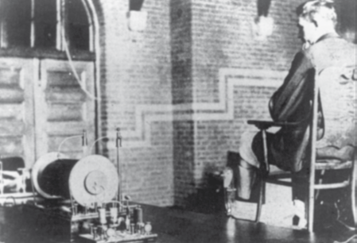
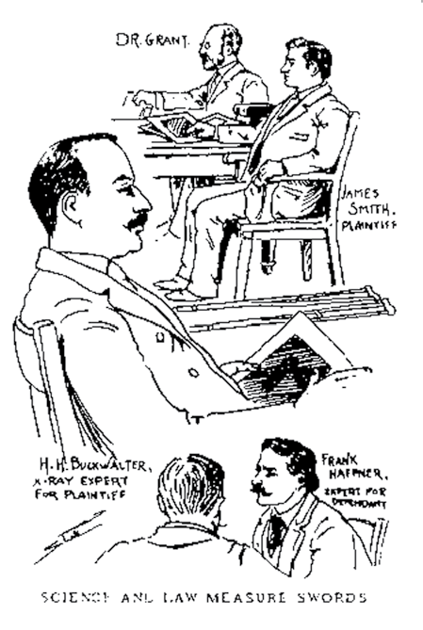
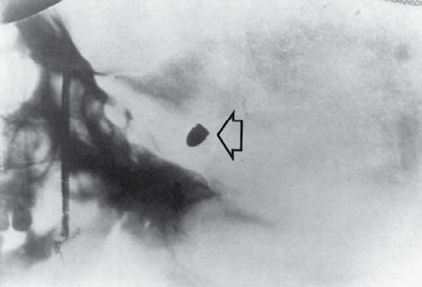
OriginalArticle
©PolJRadiol,2009;74(4):55-63
Figure1.Photographyofthefirst(7February1896)x-rayexaminationforthepurposesofforensicmedicine.
Figure2.X-rayexamination–showingoneof4bulletsinsidetheskullofElizabethHartley.
Figure3.LawsuitfiledbyJ.SmithagainstdoctorW.W.Grant.
[6],bycomparingtheremainswithanx-rayofhisskull,takenon19September1944(Figure4).
andforensicmedicine.ThefirstCTexaminationforforen-sicpurposeswasconductedin1977andaimedatevalu-ationofagunshotwoundtohead[12].Thenewmethodproveditsusefulness,whichbecameevenmoreobviousafter the introduction of the spiral techniqueand 3D recon-structions[13].
In1899,Levinsohn,fromGermany,presentedanidentifica-tionsystemofthemeasurementsbetweenchosenpoints,markedonx-rayimages.Thiswasaradiologicalvariantofthesystemdevelopedin1879byFrenchanthropologistAlphonseBertillonfortheneedsofthepolice(anthropo-logicalsystemofidentificationonthebasisof12measure-mentsbetweentheestablishedpointsonthebody)[7,8].
Furthertechniquesusedinforensicmedicineinvolved:MRIin1990[14,15],andUSGin2002[16].
WemaysaythatsincetheintroductionofCT,in1977,forensicradiologyhaschangeditsfacecompletely.Itsbaseswere settled in multiplestudies by Riepert,published since1989[17,18].Inmid-90’s,Steinetal.,fromtheInstituteofForensicMedicineinHeidelberg,startedtopublishveryimportantworksonthatissue[19,20].Atthesametime,RichardDirnhofer,fromtheInstituteofForensicMedicineattheUniversityofBern,gotintocontactwiththeRadiologyLaboratoryandwiththepoliceofthatcity.Aclosecooperationbetweenforensicphysiciansandradi-ologistsconsistedinperformingCTexaminationsofthecorpses,carryingoutautopsiesandconfrontingtheresults.CTexaminationsandautopsiesweresupplementedwithafullphotographicaldocumentationand,lateron,withMRIresults.In2003,theobtainedresultswerediscussedandusedfortheelaborationofaprojectwhichreceiveddiffer-entnames:‘scalpelfreeautopsy’,‘digitalautopsy’,‘image-guidedminimal invasiveautopsy’,and, finally,Virtopsy(thenameprotectedbypatent)forvirtualautopsy[21].
Itwasalsoattemptedtousex-radiationindactyloscopy.In1897,Walsh[9],andin1918,HenriBeclere[10]describedasimilartechnique,whichconsistedincoveringfingertipswithbismuthnitrateandleadIVoxide,andthentakingimageswithsoftx-rays(Figure5).
Aswemaysee,radiologyfounditsapplicationinforen-sicmedicinerightfromthebeginning,andbecameaveryvaluabletool,allowingforinvestigationsorresolvinglaw-suits.Mostofthetimeitwasusedtoevaluatethepathol-ogies(especiallytheinjuries)ofthebones,tofindforeignbodieswithinthecorpsesofthevictims,andtoidentifythebody.Radiologywasshownbeparticularlyimportantinforensicballistics.Aclassicstudyonthisissue,byLorenz,appearedin 1948[11].
Introductionofcomputedtomographytothediagnosticpractice,in1972,broughtaboutarevolutiontoradiology
56

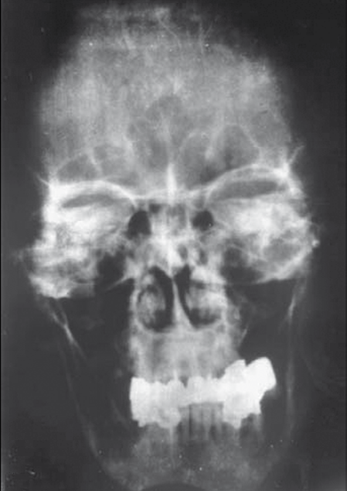
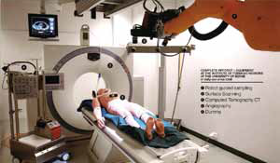
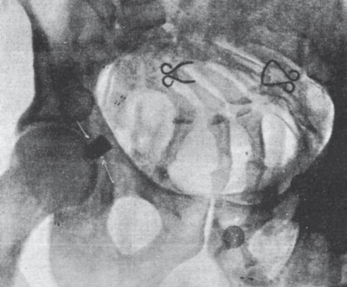
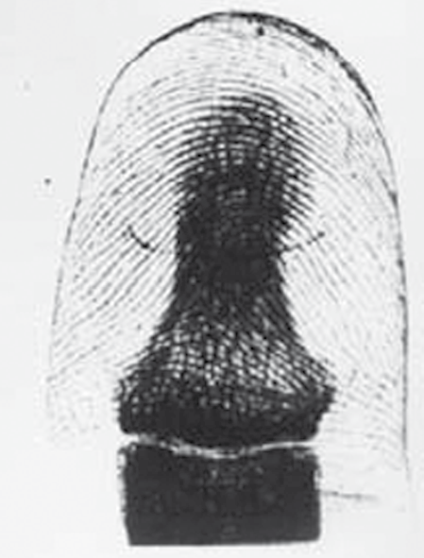
©PolJRadiol,2009;74(4):55-63
UrbanikAetal–Post-mortemCTexamination–ownexperiences
Figure6.LaboratoryofvirtualautopsyinBern.
Figure4.Plainx-rayoftheskullofAdolfHitler,whichwasusedforidentificationofhisremains.
Figure7.Plainx-rayofthepelvis–thefirstPolishx-rayperformedforthepurposesofforensicmedicine.
(Figure6).Individualelementsareused,dependingontheindications.Asfarastheimagingstudiesareconcerned,CTisthemostoftenusedexaminationmethod.Atpresent,theInstituteofForensicMedicineinBernpossessesitsownmultidetector-rowCTscannerandsoeveryautopsyispre-cededbythe processofimagingwiththeuseofthatscanner.
ThenumberofsuchlaboratoriesintheInstitutesofForensicMedicineofdifferentcountriesisincreasing.In2003,inJapan,aseparateAssociationofAutopsyImagingwasgrounded.
InPoland,thefirstpublicationdescribingtheapplicationofx-raysinforensicmedicineappearedin1930.Itsauthor,StefanGryglicki,providedadescriptionofanx-rayexamina-tiondetectingabulletindisintegratingcorpses(Figure7)[22].
In2008,TheLaboratoryofDiagnosticImagingattheClinicalHospitalinCracowcameintoclosecooperationwiththeLaboratoryofForensic MedicineatCollegiumMedicum,JagiellonianUniversity.TherewasaneedtocarryoutacomprehensivestudyoftheremainsofWładysławSikorski.Thecooperationturnedouttobeveryefficientandfruitful,sotheresearchersdecidedtofulfillaprojectaimingatanintroductionofCTexaminationsbeforethemainautopsies(inselectedforensiccases).
Figure5.X-rayimageofafinger,forthepurposesofdactyloscopy.
Currently,thisprojectinvolvesopticalscanningofthecorpses,photogrammetry,CT,MRIandangiography
Thetargetofthisworkistopresentownexperiencesinthatrespect.
57

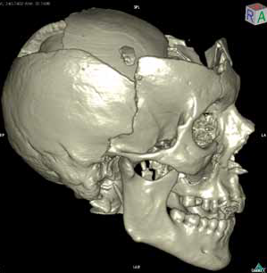
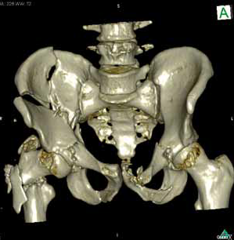
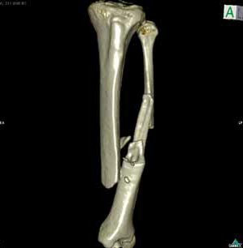
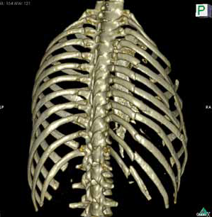
OriginalArticle
©PolJRadiol,2009;74(4):55-63
Figure8.CTexamination–comminutedfractureoftheskull.
Figure10.CTexamination–comminutedfractureofthepelvis.
Figure9.CTexamination–multilevelfracturesoftheribs.
MaterialandMethods
Figure11.CTexamination-comminutedfractureofthelowerleg.
epidemiologicalsafetyduringprojectpreparation,asamplematerialwascollectedfromeverybody,formicrobiologi-calexaminations.Noresultssuggestiveofmicrobiologicalthreatswerefound.Post-mortemimagingstudieswerecar-riedout with the use of CT Somatom 16 scanner (Siemens),inthefollowingprotocols:
Thirty-twobodiesweresubjectedtoCTexamination.Theircauseofdeathincluded:
- Roadtrafficaccidents(17cases),
- Fallsfromheight(4cases)
- Gunshotwounds(4cases)
- Injuriesfromrandomincidents,otherthanroadtraf-ficaccidents,e.g.crushbyamechanicalcoalminer(3cases),
- Explosion(2cases),
- Assaultandbattery(1person),
- Drowning(1person).
Headexamination:
Acquisition: 120kV,100mAs,16×0.75 mm,pitchof0.55
Reconstructions:
- slicethicknessandreconstructioninterval3mm,kernelH30s,brainwindowW80HU,C35HU,
- slicethicknessandreconstructioninterval1.5mm,ker-nelH30s,brainwindowW80HU,C35HU,
- slicethicknessandreconstructioninterval0.7mm,ker-nelH60s,brainwindowW1500HU,C450HU.
Timebetweendeathandexamination
amountedto
maximum24hours.Thecorpsesweredeliveredintwo(oneinsideanother)tightlysealedbags.Tocheckfor
58

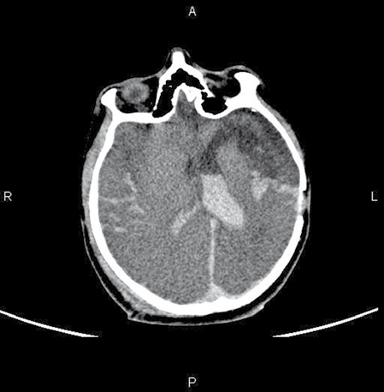
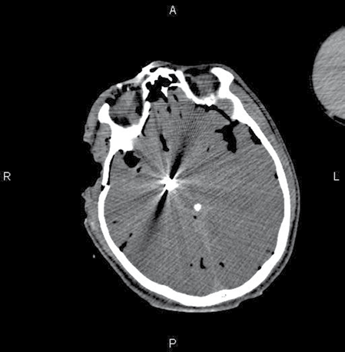
©PolJRadiol,2009;74(4):55-63
UrbanikAetal–Post-mortemCTexamination–ownexperiences
Figure12.CTexamination–Brainhaematomas,bloodintheventricles,tornbraintissue.
Figure13.CTexamination–bulletinthebrain.
In gunshotwounds and explosionswith shrapnels,theadvantageofCTissignificant.Owingtothisexamination,itispossibletofindandpreciselylocatein3dimensionsthebullets,theirtinypartsorshrapnels.Similarresultscanbeobtainedinautopsyonlywithanextensiveprepara-tion;thesearchforforeignbodiesbaseshereonintuitionmostly,withoutanyguaranteeoffullsuccess.Therewasevenonecaseinwhichthelocationofshrapnelsdeter-minedinCTwasnottraced downinautopsy,andthesearchhadtobesupportedbyfluoroscopy.
Trunkexamination:
Acquisition:120kV,140mAs,16×0.75mm,pitchof1.0
Reconstructions:
- slicethicknessandreconstructioninterval5mm,kernelB31f,abdominalorganswindowW 300HU,C40HU,
- slicethicknessandreconstructioninterval1.5mm,ker-nelB31f,abdominalorganswindowW300HU, C40HU,
- slicethicknessandreconstructioninterval1.5mm,ker-nelB60f,bone windowW 1500HU, C450 HU.
CTexaminationenabledapreciseevaluationofthesofttissuelesions.Ascomparedtothestandardautopsy–notprecededbyanyimaging–thisstudywasshowntobesig-nificantlymoreeffective.Inautopsy,reachingtheinjuredlocationswithinagivenorganortissue,wasconnectedwiththenecessityofpreparations,andthuswithfurtherinjuries.CTexaminationwascompletelynon-invasive,i.e.didnotresultinanyirreversibletissuedamage.
Imagingdataweresecondarilyprocessedwiththeuseofadedicatedcomputerprogram(multiplanarand3Dreconstructions).Next,rightaftertheexamination,astandardautopsywasperformed.ThisprocedurewasguidedbyCTimages(CTimages,shownonthecomputermonitor,werelookedatduringautopsy).Afterthepro-cedure,theresultsofbothstudies(concerningonecase)werecompared.
Theexaminedmaterialrevealedthefollowingpathologicallesionsoforgansandsofttissues:
- brainhaematomas,bloodinventricles,torncerebraltis-sue(Figure12),
- thebulletsandtheirfragments(iftheygotfragmented)(Figure13),
- tornaortaandotherbloodvessels(Figure14),
- injuryoftheheartwalls,airinheartchambers(Figures15,16),
- pneumothorax,mediastinalemphysema,subcutaneousemphysema(Figure17),
- lungcontusion(Figure18),
- bloodinthepleuralcavity(Figure19),
- fractureoftheliver,spleen,andbloodintheperitonealcavity(Figure20),
- tornintestines(Figure21),
- pneumoperitoneum,subcutaneousemphysema(Figure22).
Results
Inallstudiedcases,theinjuriesoftheskeletalsystemwereevaluated.Apartfromthebaselineimagesintransversesections,thereconstructionsindifferentplanes(especial-lythe3Dreconstructions)alsoturnedouttobeveryuse-ful(Figures8–11).WeanalysedfirstofalltheCTimagesoftheosseoussystem,includingskulls.ItwaspointedoutthatCTexaminationsenabledvisualisationofsmallinju-ries,potentiallydifficulttoidentifyduringautopsy[23,24].Moreover,CTexaminationsfacilitatedapreciseevalua-tionofthecervicalspineinjuries,whichwasparticularlyimportantintheassessmentofthesequelaeofroadtrafficinjuries.WithCT,itwasalsoeasytoidentifytheinjuriesoftransverseprocesses,especiallyinthelumbarspine,whiletheautopsyrequiredanextensivepreparationofsofttis-sues insuchcases. Ontheother hand,theevaluationof dis-locatedribfractureswasmoredifficultinCT.
Allthesepathologieswereconfirmedwithautopsy.
59

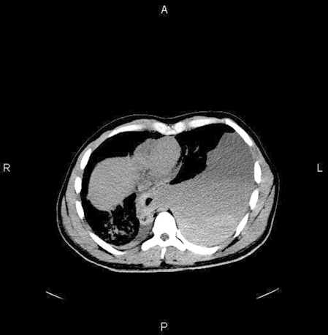
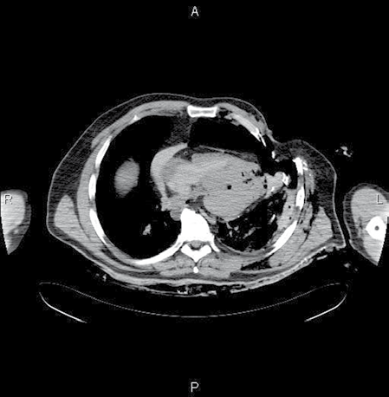
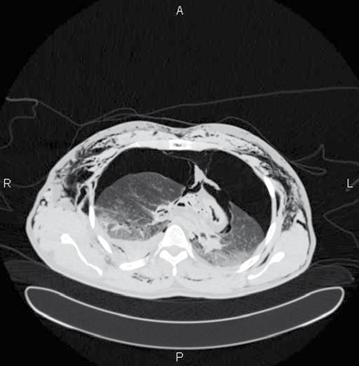
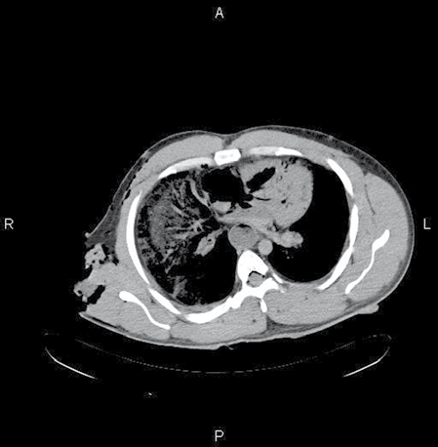
OriginalArticle
©PolJRadiol,2009;74(4):55-63
Figure14.CTexamination–Ruptureddescendingaorta,bloodinthepleuralcavity.
Figure16.CTexamination–Airintheheart.
Figure17.CTexamination–pneumothorax,mediastinalemphysema,subcutaneousemphysema.
Figure15.CTexamination–Tornheartmuscle.
Therewasonecaseofdrowning,wherewefound:pulmo-naryoedemaandfluidinparanasalsinuses(Figure23),whichpointedtothefactthatthevictimwasstillalivewhendrowning.
aboutthecorpses.Itinvolvesthedescriptionofthestatethatwasregisteredvisuallybythephysicianconductingtheobduction(whichtendstobesubjective).Topresenttherecognisedpathologiesobjectively,theresearchersstartedrecordingsubsequentstagesofobductionwithphotos.
Discussion
Theprimaryaimoftheforensic-medicalautopsiesistodefinethecauseorcausesofdeath.Ifthevictimhadsuf-feredinjuries,itisnecessarynotonlytodescribethembutalsotonamethetraumamechanisms.Insomecases,thesearchforforeignbodieswithinthecorpses(materialevi-dence)mayalsoprovenecessarytofindthetoolofcrimeandtoidentifythedeadperson.
Autopsyisabasicprocedureusedinforensicmedicine.In1306,physicianMondinodeLuzzistartedtocarryoutthefirstpublicautopsies(duringthefirstautopsy,heusedthebodyofaconvict).However,itwasnotuntilthe16thcenturythatthepost-mortemsectionsweremadepublic.Despitethenumberofyearsthatpassedfromthattime,theprocedureofobductionshasnotchangedmuch–onlythetechnique.Ageneraloutlineoftheprocedurehasnotchangedeither,andtheautopsyprotocolisstillabasicsourceofinformation
Identificationanddeterminationoftherangeandcharacteroftheinjuriesoftheosseoustissuearethemostcommon
60

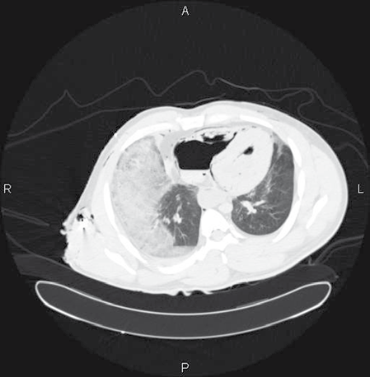
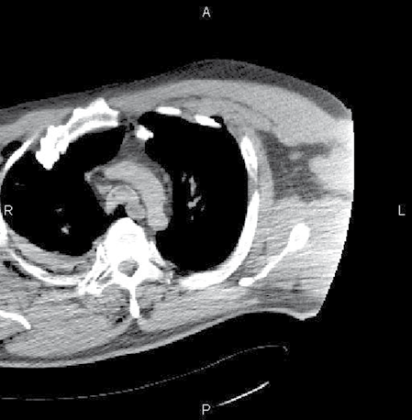
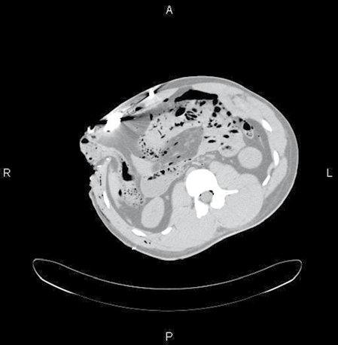
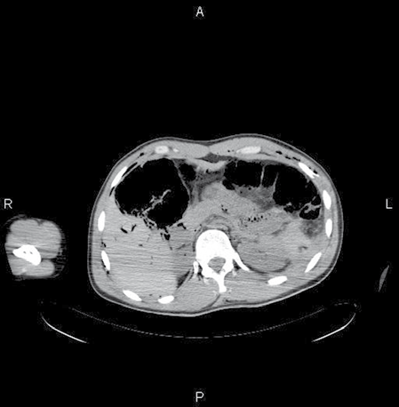
©PolJRadiol,2009;74(4):55-63
UrbanikAetal–Post-mortemCTexamination–ownexperiences
Figure18.CTexamination–Bruisedheart.
Figure20.CTexamination–Haematomabetweenthespleenandthekidney–rupturedspleen.
Figure19.CTexamination–Haematomainthepleuralcavity.
Figure21.CTexamination–Rupturedintestines;pneumoperitoneum.
reasonforradiologicalexaminationsperformedforthepur-posesofforensicmedicine.Thisistheresultofahighavail-abilityofstandardx-rayscannerstoforensicphysicians
–manyInstitutesofForensicMedicineareequippedwithsuchscannersorhaveanaccesstothem.X-rayexamina-tion,eventhestandardone,allowsfordeterminationofthemechanism,direction,andmeanofinflictingtheinjury,aswellasthetoolofcrime.Therearemanypositionsinthemedicalliteraturethatreviewautopsiesandx-rayexamina-tions,especiallyininjuriesfollowingfromroadtrafficacci-dents[22].WithCT,minororhardtoapproachinjuriesmaybevisualisedmoreeffectively.AutopsymayrevealthemonlyafterpreviousanalysisoftheCTimages.Moreover,imagingdataobtainedduringCTacquisitionandtheappli-cationofadditional,dedicatedcomputerprograms,allowfortheperformanceofprecisemultiplanarand3Drecon-structions.Thisleadstoamoreaccurateanalysisofthe
traumamechanismandtoabettervisualisation[23].Ownmaterialbroughtaboutsimilarresults:theanalysisoftheosseoussystemwasthemostfrequenttaskofradiologists.Applicationofsecondaryreconstructionsoftheimagingdataallowedforadifferentevaluationthanwiththeprevi-ouslyusedstandardx-rayimaging.WhenanalysingCTandautopsyresults,thefollowingobservationsweremade:
- CTexaminationsallowedforidentificationoffracturesthatwerenotdislocated,
- Theyfacilitatedvisualisationofinjurieswithinthecer-vicalspine,especiallythefracturesofthedensofaxis,whichwasparticularlyimportantintheevaluationofthecausesofdeathinroadtrafficaccidents.Manyauthorsreportdifficultiesintheevaluationofthatregionandtheimportanceofthisassessment[24],
61

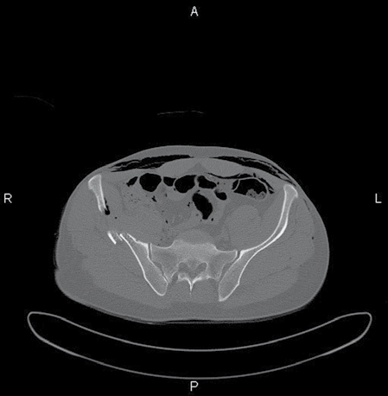
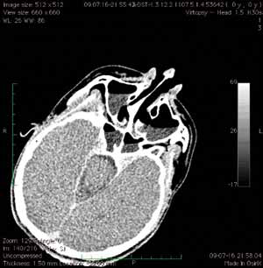
OriginalArticle
©PolJRadiol,2009;74(4):55-63
Figure22.CTexamination–Fracturesofthepelvis;subcutaneousemphysemaandpneumoperitoneum.
Figure23.CTexamination–Fluidwithinsinuses,afterdrowning.
Thisoptionradicallychangedforensicradiology.Itbecameamethodofcomprehensiveevaluationsofallbodyparts.Itseemsthatinsomecases,CTofthecorpsesmaybesuf-ficientforaforensic-medicalevaluation.TheadvantageofCTisthatduringvirtualautopsy,thecorpsesdonotgetinjuredandtheirimage(inadigitalform)isobjectiveandmay be evaluatedmore thanone time (alsoafter cremationordecomposition). CT plays anextremelyimportant role intheevaluationofthemechanismofdeathwhenthereisnoevidenceofinjuries.Thatisthecaseofdrowningaccidents
–CTisabletoestablishwhether,atthemomentofdrown-ing,thevictimwasstillalive,ornot[26].
- Theyallowedforidentificationofthosetransversepro-cessesthatgotbrokenofffromthelumbarvertebrae,whichisparticularlyimportantintheevaluationofthestateofavictim(aliveordead)duringtrauma.
HighusefulnessoftheCTexaminationwasshownincaseofgunshotwounds,asthebulletsarenotalwayseasytofindduringautopsy,especiallywhenfragmentedinsidethebody.ItturnedouttobeveryeasytoidentifyandlocatewithCTeventhetiniestsplintersofthebullets(particu-larlyincaseofshotgunwounds).Itwaspossibletofindtheminthecourseofautopsyafterprovidingadditionalsafetymeasurestotheforensicphysiciancarryingouttheobduction. TheroleofCT isevenmoreimportant inexami-nationsofthevictimsofexplosion(forthesamereasonsastheabovementioned).However,therangeofshrapnelscatteringismuchlargerinhere.Itshouldbepointedoutthatpreviouslyitwasx-rayimagingthatplayedanimpor-tantroleinsuchcases,buttherewereno3Dreconstruc-tions,whichsignificantlyhinderedthecorrectlocalization.ReconstructiveoptionsoftheCTsoftwareallowforthevisualisationofthetrajectoryofbulletoritsshrapnelsaswell.Owingtothat,itispossibletodeterminethecircum-stancesofthegunshot.Allobservationsmadebyauthorsofthis articleagreewithconclusionsofotherauthorsreview-ingthisproblem[25].
Conclusions
1.Post-mortem,preautopsyCTmakestheobductionamoredirectedandeasierprocedure,andtheforensicphysiciansmayfocusonmoredifficultelements,requir-ingspecialattention.
2.Incaseofgunshotwoundsandexplosions,CTshouldbeagoldenstandard,asitguidestheprocessofevaluation,tracingforeignbodies–avaluablematerialevidence.
3.Imagingdataobtainedduringvirtualautopsyallowforreconstructionsthatarehelpfulindeterminingthemechanismsofinjury,includingthereconstructionsofgunshotcanals.
Apartfromthepossibilitiesofosseoustissueevaluationandofforeignbodydetection,whichwaspartiallyfea-siblewithtraditionalradiology,CTexaminationsenabledvisualisationofsofttissuesandofparenchymatousorgans.
4.ThedigitalCTimageofcorpsesallowsforevaluationofthebodyatanymomentoftime,regardlessofthesubse-quentdecompositionorcremation.
References:
- CoxJ,KirkpatrickRC:TheNewphotographywithreportofcaseInchichabullewasphotographedIntheleg.MontrealMedJ,1896;24:661
- EckertWC:Thehistoryoftheforensicapplicationsinradiology.AmJForensicMedPathol,1984;5:53
- PearBL:1896–thefirstyearofx-raysinColorado.AmJRoentgenol,1995;165:1075
- GoodmannPC:Thenewlight:discoveryandintroductionofthex-ray.AmJRoentgenol,1995;165:1041
- DewingSB:Modernradiologyinhistoricalperspectives.ThomasCC(ed.),Springfield,1962
62

©PolJRadiol,2009;74(4):55-63
UrbanikAetal–Post-mortemCTexamination–ownexperiences
- SognnaesRF:DentalevidenceinpostmortemidentificationofAdolfHitler,EvaBraunandMartinBorman.LegalMedicineAnnual,1977;177
- LevinsohnB:Beitrazzurfeststellungdridentitaet.ArchKrim-AnthropLeipzing,1899;2:211
- KevlesBH:Nakedtothebone:medicalimaginginthetwentiethcentury.RutgersUniversityPress,NewYork,1998
- WalshD:Skinpictureswithx-rays.BrMedJ,1897;27:787
- BeclereH:Laradiographeantropometricdupouce(superpositiondesempreitesdigitales,dusequeletteetdel’ongle).CRAcadSci,1918;167:499
- LorenzR:DerSchusskanalimRoentgenbilde.DtschZGesgerichtMed,1948;39:435–48
- WullenweberR,SchneiderV,GrummeT:ComputertomographischeUntersuchungenbeiSchaedel-Schuss-Verletzungen.ZRechtsmed,1977;80:227–46
- OliverWR,ChancellorAS,SoltysMetal:Three-dimentionalreconstructionorabulletpath:validationbycomputedradiography.JForensicSci,1995;40:321–24
- AmbergR,FosterB:Fuermaier.IdentyficationbyMRI.ZRechtsmed,.1989;102:185–89
- RosPR,LiKG,VoPetal:Preatopsymagneticresonanceimaging:initialexperience.Magn.Reson.Imaging,1990;8:303–8
- FarinaJ,MillanaC,Fdez-AceneroMJetal:Ultrasonographicautopsy(echopsy):anewtechnique.VirchowsArch,2002;6:635–39
- RiepertT,RittnertC:Roentgenidentificationofunknowncadverswithadvancedpostmortemchanges.Z.Rechtsmed.,1989;102(2–3):207–16
- RiepertT,SchultesA,GrassH,atal:AutopsieandpostmortaleComputertomographie–einprospektiverVergleich.Rechtsmedizin,2001;11:160
- SteinK,BahnerL,MerkelJetal:DetectionofgunshotresiduesinroutineCTs.IntJLegalMed,2000;114(1–2):15–18
- SteinK:Computedtomographyinforensicpathology,whatisnormalfindingsincadaver.ForensicSciInt,2003;136:270
- Dirnhoffer R,JackowskiC,VockP etal:Virtopsy:minimallyinvasive,imaging-guidedvirtualautopsy.Radiographic,2006;26:1305–33
- RyglickiS:PrzyczynekdozastosowaniapromieniRoentgena
wmedycyniesądowej.Czasopismosądowo-lekarskie,1930;4:244–48
- TeresińskiG:Biomechanikapotrąceńpieszego.WydawnictwoAkademiiMedycznejwLublinie,2005
- BuckU,NaetherS,BraunMetal:Applicationof3Ddocumentationandgeometricreconstructionmethodsintrafficaccidentanalysis:withhighresolutionsurfacescanning,radiologicalMSCT/MRIscanningandrealdatabasedanimation.ForensicSciInt,2007;170(1):20–28
- WoźniakK,Rzepecka-WoźniakE:Rutynowebadanieodcinkaszyjnegordzeniakręgowegoikręgosłupapodczassekcjisądowo-
-lekarskich.ArchMedSądKrym,2003;53(2):91–107
- ThaliM,YenK,VockPetal:Image-guidedvirtualautopsyfindings
ofgunshotvictimsperformedwithmulti-slicecomputedtomographyandmagneticresonanceimagingandsubsequentcorrelation
betweenradiologyandautopsyfindings.ForensicSciInt,2003;138(1–3):8–13
- Levy AL,HarckeTH, GetzJetal:Virtualautopsy:Two-andThreedimentionalMultidetectorCTFindingsinDrowningwithAutopsyComparison.Radiology,2007;3:862–86
63

