

©PolJRadiol2018;83:e426-e436
DOI:https://doi.org/10.5114/pjr.2018.79617
Received:27.02.2018
Accepted:21.08.2018
Published:12.09.2018
http://www.polradiol.com
Evaluatingthemalignantpotentialofintraductalpapillarymucinous
neoplasmsofthepancreas:addedvalueofnon-enhancedendoscopicultrasoundtosupplementnon-enhancedmagneticresonanceimaging
TakaoIgarashiA,B,C,E,F,Hirokazu AshidaD, KazuhikoMorikawaD,KeitaroEnokiD, KazuyoshiOhkiE, GouKawakamiE,
HiroyaOjiriE
DepartmentofRadiology,TheJikeiUniversitySchoolofMedicine,Tokyo,Japan
Abstract
Purpose:Toevaluatethediagnosticperformanceofcombiningnon-enhancedmagneticresonanceimaging(MRI)andnon-enhancedendoscopicultrasonography(EUS)forassessingthemalignantpotentialoflesionsinpatientswithintraductalpapillarymucinousneoplasmsofthepancreas(IPMNs).
Materialandmethods:Datafrom38patientshistopathologicallydiagnosedwithIPMNadenomasorIPMNadenocar-cinomaswereretrospectivelyanalysed.Preliminaryunivariateandmultivariateanalyseswereconductedtoidentifystatisticallysignificantassociations.Threeblindedradiologistsevaluatedtheimagesetstoassessthediagnosticperformanceofcombineduseofnon-enhancedMRIandEUSasopposedtonon-enhancedMRIaloneindistin-guishingmalignantfrombenignlesions.Observerperformance andinterobservervariability weredeterminedusingreceiver-operating-characteristiccurveanalysisandweightedκstatistics.
Results:Multivariateanalysesidentifiedasignificantdifferencebetweentheabruptchangeinthemainpancreaticduct(MPD)calibrewithdistalpancreaticatrophyandthesignalintensityoflesion-to-spinalcordratioonMRI;asignificantdifferencewasobservedinMPDsizeonEUS.Diagnosticperformanceassessmentsoftheimagesetsdidnotdiffersignificantlybetweentheblindedradiologists.
Conclusions:Theclinicalutilityofnon-enhancedEUSmaybeattributiveinevaluatingIPMNthathasalreadybeenevaluatedbynon-enhancedMRI.
Keywords:magneticresonanceimaging,endoscopicultrasonography,intraductalpapillarymucinousneoplasmofthepancreas.
creasedoverthelastdecadealongsideasharpincreasein
incidencebecauseofincreaseddetectionofsuchlesions.Asymptomaticcysts,mostofwhichwerepresumablysmallIPMNs,wereidentifiedin2.8%of2832consecutiveCTscansperformedinoneyearatasingleinstitution[1].IPMNsaredefinedasgrosslyvisibleintraductalepithelialneoplasmswithpapillaryproliferationandcystformation[2].The2010WorldHealthOrganisation(WHO)classi-ficationsubcategorisestheIPMNsaccordingtotheirma-lignanttransformationasIPMNwithloworintermediatedysplasia,IPMNwithhigh-gradedysplasia(equivalentto
Introduction
Mostcysticlesionsofthepancreasareincidentallydetect-
edduringultrasonography,computedtomography(CT),ormagneticresonanceimaging(MRI)combinedwithMRcholangiopancreatography(MRCP)performedbe-causeofanunrelated indication. Intraductalpapillary mu-cinousneoplasmofthepancreas(IPMN)isafairlycom-moncysticlesionofthe pancreas,particularlyobservedintheelderly.IPMNwasfirstrecognisedinthe1980s;thevolumeofpublishedliteraturerelatedtoIPMN hasin-
Correspondenceaddress:
TakaoIgarashi,DepartmentofRadiology,TheJikeiUniversitySchoolofMedicine,3-25-8,Nishi-Shimbashi,Minato-ku,Tokyo105-8461,Japan,phone:+81-3-3433-1111,fax:+81-3-3431-1775,e-mail:igarashi-t@jikei.ac.jp
Authors’contribution:
AStudydesign∙BDatacollection∙CStatisticalanalysis∙DDatainterpretation∙EManuscriptpreparation∙FLiteraturesearch∙GFundscollection
e426
©PolJRadiol2018;83:e426-e436

Evaluatingthemalignantpotentialofintraductalpapillarymucinousneoplasmsofthepancreas:addedvalueofnon-enhancedendoscopicultrasoundtosupplementnon-enhancedmagneticresonanceimaging
theintraductalpapillarymucinouscarcinoma[IPMC],
non-invasive),andIPMNwithanassociatedinvasivecarcinoma(IPMC).Inadditiontopancreaticintraepi-thelialneoplasia(PanIN),themostcommonneoplasticprecursortoductalpancreaticcancerisIPMN[2,3].Itsrelativelyslowgrowthenablesearlydiagnosisandcurativesurgical treatment [4].IPMChasbeenattractingattentionas apotentiallycurablepancreaticcanceriftreatedpriortobecominginvasive.
Diffusion-weightedimaging(DWI)hasbeenshowntobeeffectiveinthediagnosisofmalignantIPMN[5-7].Ma-lignantpancreatictumoursgenerallyshowhighersignalin-tensitiesandlowerapparentdiffusioncoefficients(ADCs)thanbenigntumors[8].ThediagnosticperformanceofDWIwasshowntobecomparabletothatofcontrast-en-hancedMRIforevaluatingthemalignantpotentialofcysticpancreaticlesions[7,9].Furthermore,thecombineduseofDWIandMRCPwithnon-enhancedMRIwasshowntobeparticularlyeffectiveinthediagnosisofmalignantIPMNandpredictionofinvasiveIPMCrisk[5,7].
Endoscopicultrasonography(EUS)isthebestmodalityformonitoringpancreaticcysticneoplasmsandfor predict-ingthemalignantpotentialofbranch-typeIPMNthroughthedetectionandevaluationofmuralnodules[10,11].Thediameterandwidthofthemuralnodulesofpapillarypro-trusionsasassessedonpreoperativeEUSwereshowntore-liablydistinguishbetweenlow-andhigh-riskIPMNs[12].
InsituationsinwhichthereisanincreaseddetectionofIPMNsduetowidespreaduseofimagingexaminations,differentiatingbenignfrompotentiallymalignantonesusinganoninvasivetechniqueisofgreatvalue.Inthescreeningtest,theadministrationofcontrastmaterialisnotneces-sary.ForevaluatingthemalignantpotentialofIPMNus-ingnon-enhancedMRIcombinedwithMRCPandDWI,theadvantageofusingnon-enhancedEUStosupplement
non-enhancedMRIisnotclear.Theminimalinterobserv-
ervariabilityofassessingmuralnodulesorsolidtumourswouldbeinvaluablefortheadministrationofappropriatetreatmentinpatientswithsuspiciouslesions[5].Toourknowledge,theaddedvalueofnon-enhancedEUStothein-terpretationoffindingsfromnon-enhancedMRIcombinedwithMRCPandDWIhasnotbeeninvestigatedtodate.
Thepurposeofourstudywastoevaluatethediagnosticvalueofcombineduseofnon-enhanced MRI withMRCPandDWIandnon-enhancedEUS(hereafterreferredtoasMRIwithEUS),asopposedtonon-enhancedMRIwithMRCPandDWIalone(hereafterreferredtoasMRIalone).
Materialandmethods
Patients
Therequirementforwritten,informedconsentfrompa-tientswaswaivedbecauseoftheretrospectivenatureofthereviewofclinicalandimagingdata.PatientswhoweresuspectedtohaveIPMNwithmalignantpotentialuponpreoperativeMRIand/orEUSandwhounderwentcura-tivesurgeryforIPMNatourinstitutionbetweenJune01,2009andOctober 31, 2015wereretrospectivelyidenti-fiedbysearchingourimagingdatabase.PreoperativeEUSwithfineneedleaspirationhadneverbeenperformedinourinstitution.Thefollowingexclusioncriteriawereused:(a)patientswithpancreaticductaladenocarcinomaconcomitantwithIPMNs,characterisedbydistinctcyst-iclesionsonhistopathology;(b)patientswithmucinouscarcinomaonhistopathology;(c)patientswhodidnotundergoMRIorEUS;and(d)patientswhodidnotun-dergopreoperativeMRIandEUSwithintheimmediatesixmonthsbeforethedateofsurgery.AdetailedprocessofthepatientselectionissummarisedinFigure1.
Eligibleforcurrentstudy
n=38
Mixed-typeIPMN
n=12
IPMN–intraductalpapillarymucinousneoplasms,MRI–magneticresonanceimaging,EUS–endoscopicultrasonography,MPD–mainpancreaticduct
Figure1.Flowdiagramshowstheprocessforpatientselection
©PolJRadiol2018;83:e426-e436
e427
MPD-typeIPMN
n=7
Branch-typeIPMN
n=19

ocarcinomaconcomi-inctcysticlesionson

nhistopathologyEUS
–PatientswhodidnotundergopreoperativeMRIandEUSwithintheimmediate6monthsbeforethedateofsurgeryn=2
- PatientswhoweresuspectedofhavingIPMNwithmalignantpotentialuponpreoperativeMRIand/orEUS
- PatientswhounderwentcurativesurgeryforIPMNatourinstitutionbetweenJune01,2009andOctober31,2015
n=50

Exclusion
–PatientswithpancreaticductaladentantwithIPMNscharacterizedbydisthistopathology
n=4
- Patientswithmucinouscarcinomao
n=3
- PatientswhodidnotundergoMRIor
n=3

TakaoIgarashi,HirokazuAshida,KazuhikoMorikawaetal.
stitution.Thesameradiologist,whowasawareoftheclin-
icalinformation,evaluatedboththeinterpretedMRandEUSfindingsonapicturearchivingandcommunicationsystems(PACS)monitor.Accordingtothe2012interna-tionalconsensus/Fukuokaguidelines(Fukuokaguidelines[FG])forthemanagementofIPMNandmucinouscyst-icneoplasmsofthepancreas,whichfocusonhigh-riskstigmata(HRS)andworrisomeimagingfeatures(WFs)[10]thefollowingmorphologicalfindingswereassessedbythesameradiologist:mainpancreaticduct(MPD)size(>10mmor5-9mm);cystsize(>30mmornot);walland/orseptalthicknessofcyst(>3mmornot);muralnoduleheightand/orwidth(>10mm,5-9mmorless);abruptchangeintheMPDcalibrewithdistalpancreaticatrophy(presentorabsent);andlymphadenopathy(pres-entorabsent).InadditiontoperforminganassessmentaccordingtotheFGcriteria,thequantitativeassessmentofADCvaluebasedontheADCmap,andthecalculationoflesion-to-spinalcordratio(LSR)asarelativeADCval-uewereperformed.Optimalcut-offvaluesofADCandLSRwereidentifiedonreceiver-operating-characteristic(ROC)curveanalysis.Theseoptimalcut-off valuesofADCandLSRwereappliedforblindedevaluation.
AnelectroniccalliperincludedinthePACSprogramwasusedforthemeasurementofthelargestdiameteroflesionsinanyaxialorcoronalimage.Forcystsizeandwalland/orseptalthicknessofcyst,theparametersofevaluationwerebranch-typeandmixed-typeIPMN.Ifseveralcystswerepresent,thecyst withthelargestwalland/orseptalthicknesswas acceptedasalesion.Amuralnodule wasdefinedasanysolidnoduleintheMPDorbranchductofawell-circumscribedtissuelesionsurroundedbyaductwall.Forlymphadenopathy,adiameter>10mmintheshortaxiswasacceptedassignificantlymphadenopathy.
Magneticresonanceimagingtechnique
AllpatientshadundergoneMRIona1.5Teslaunit(MAGNETOMAvantoorSymphony,SiemensMedicalSolutions,Erlangen,Germany)usingaphased-arraybodycoil.Non-enhancedfat-suppressedin-phaseT1-weightedbreath-holdspoiledgradient-recalled-echo(GRE)imag-es,T2-weightedfast-spin-echo(T2W-FSE)images,DWimageswithlowandhighb-values(b=50,800s/mm2,respectively),and3D-fat-suppressedT1-weightedGREsequenceswithCartesiansampling,namedvolumetricinterpolatedbreath-holdexamination (VIBE),onSiemensHealthcareMRIsystemswereobtainedintheaxialplane.Half-Fourieracquisitionsingle-shotturbospin-echo(HASTE)sequencewasobtainedintheaxialandcoronalplanes.Arespiratory-triggered3D-T2-weightedMRCPsequencewasacquired,andcoronalmaximumintensityprojection(MIP)wasreconstructedbasedonadataset.WehaveincludedDWIasaroutineprotocolforMRCPconductedatourinstitution.Detailsofimagingparam-etersevaluatedinthisstudyaresummarisedinSupple-mentaryTable1.
Endoscopicultrasonographytechnique
Afterobtainingwritten,informedconsent,patientsweresedatedwithmidazolamusinganintravenousbolusdoseof4-5mgunderhaemodynamicandoximetricmonitor-ing.EUSwasperformedbyanendosonographerwith20yearsofexperienceatourinstitution.Anelectronicra-dial(GF-UE260,OlympusMedicalSystems,Tokyo,Japan)oracurvedlineararrayechoendoscope(GF-UCT260,OlympusMedicalSystems,Tokyo,Japan)withthePro-SoundAlpha-10processor(Hitachi-AlokaMedicalCo.,Ltd.,Tokyo,Japan)wasusedforendoscopicdiagnosis.TissueharmonicEUSscreeningofthepancreaticobiliarysystemwasperformedusingstandardisedimagingtech-niques[13,14];particularattentionwaspaidtoprimarypancreatic lesions.Harmonicimagingwasachievedwithatransmittingfrequencyof3.75MHzandreceivingfre-quencyof7.5MHz.TheacousticpowerofharmonicEUSwassetwithamechanicalindexof0.25-0.3,andasinglefo-cus point wassetatthemostdistant margin ofthe pancre-aticlesionsfromthetransducer.DuringEUSexamination,tumourlocationswererecorded(head,body,andtailordiffuse).Thecystsizesandthethicknessesofcystwalland/orseptumandmuralnodulesweremeasured.Theassoci-atedpresenceofmainpancreaticductdilatationand/oraninvasivecysticlesioncomponentwasrecorded,ifidentified.
Measurementofapparentdiffusioncoefficientandlesion-to-spinalcordratioondiffusion-weightedimages
ForthevisualassessmentofDWimages,theADCmeas-urementswereperformedonADCmapsincludedinthePACSprogram.Theregionofinterest(ROI)forobtainingtheADCvaluewasmanuallyselected.Inthecaseofasol-idcomponentsuchasamuralnodule,thickenedseptaand/orcystwall,orparenchymal mass,theROIwas se-lectedtocoverboththesolidandthecysticportionsasmuchaspossible.ForprecisemeasurementofADCval-ues,theROIwasplacedonthelesionoftheHASTEim-ageandwascopiedmanuallytotheDWimagetoexcludeapartialvolumephenomenon.ThemeanADCvaluecalculatedfromatleast threemeasurements wasused intheanalysis.T2W-FSEimageswerenotusedtodetermineaROIbecauseoftheirlowerspatialresolutioncomparedwiththatofHASTEimages.
LSRwasmeasuredontheDWimagewithadiffusiongradientofb=800s/mm2.FormeasurementofspinalcordsignalintensityonDWI,theROIwaslocatedon
Imageanalysis
Evaluationofimagingfindingsforpreliminaryanalyses
Oneradiologistwith15yearsofMRIexperienceretro-spectivelyreviewedthepatientmedicalrecordsatourin-
e428
©PolJRadiol2018;83:e426-e436

Evaluatingthemalignantpotentialofintraductalpapillarymucinousneoplasmsofthepancreas:addedvalueofnon-enhancedendoscopicultrasoundtosupplementnon-enhancedmagneticresonanceimaging
Table1.Imagingfindingsinpatientswithintraductalpapillarymucinouscarcinomas(IPMC)andintraductalpapillarymucinousadenomas(IPMAs)
A)MRI
B)EUS
©PolJRadiol2018;83:e426-e436
e429
IPMC IPMA
(n=20) (n=18)
Univariate
Multivariate
OR 95%CI pvalue
pvalue
MPDsize(mm)
–
–
<0.001
8.15
1.04-63.9
0.045

≥10
9
0
–
–
–
–
≥5
15
4
–
–
–
–
Cystsize(mm)
–
–
0.27
–
–
–

≥30
5
11
–
–
–
–
<30
8
6
–
–
–
–
Factor IPMC
(n=20)
IPMA Univariate Multivariate
(n=18) pvalue OR 95%CI
pvalue
Age,mean(SD)
73.9(8.3)
68.1(9.7)
0.6
–
–
–
Sex(male,female)
16,4
12,6
0.23
–
–
–
IPMNtype
–
–
<0.001
–
–
–

Branch
4
15
–
–
–
–
Mixed
9
3
–
–
–
–
MPD
7
0
–
–
–
–
Location
–
–
0.36
–
–
–

Head
14
10
–
–
–
–
Body
5
4
–
–
–
–
Tail
1
4
–
–
–
–
MPDsize(mm)
–
–
–
5.02
0.61-41.4
0.13

≥10
8
0
0.004
–
–
–
≥5
17
5
<0.001
–
–
–
Cystsize(mm)
–
–
0.45
–
–
–

≥30
7
13
–
–
–
–
<30
6
5
–
–
–
–
Walland/orseptalthicknessofcyst(mm)
–
–
0.1
–
–
–

≥3
6
3
–
–
–
–
<3
6
15
–
–
–
–
Muralnoduleheightand/orwidth(mm)

≥10
3
1
0.35
–
–
–
≥5
11
7
0.32
–
–
–
AbruptchangeinMPDcalibrewithdistalpancreaticatrophy
–
–
<0.001
34.5
1.85-644
0.018

Present
13
1
–
–
–
–
Absent
7
17
–
–
–
–
Lymphadenopathy
–
–
0.99
–
–
–

Present
1
0
–
–
–
–
Absent
19
18
–
–
–
–
ADCvalue(×10–3mm2/s)
1.79(±0.45)
2.43(±0.33)
<0.001
–
–
–

AreaofROIforADC(mm2)
734(±693)
798(±793)
0.62
–
–
–
LSR
0.26(±0.09)
0.17(±0.04)
<0.001
16.3
1.45-184
0.02

AreaofROIforLSR
91.8(±12.1)
84.5(±11.4)
0.08
–
–
–

TakaoIgarashi,HirokazuAshida,KazuhikoMorikawaetal.
Table1.cont.
MRI–magneticresonanceimaging,OR–oddsratio,CI–confidenceinterval,MPD–mainpancreaticduct,ADC–apparentdiffusioncoefficient,LSR–lesion-to-spineratio,EUS–endoscopicultrasonography,IPMN–intraductal papillarymucinousneoplasm, ROI–regionofinterest
Priortostatisticalanalysis,anf-testwasappliedtoage,ADCvalues,areaofROIforADC,LSRandtheareaofROIforLSRtotestforanormaldistribution.AllvariablesshowednosignificantdifferenceexceptforLSRatthe5%significancelevel.Therefore,theWilcoxonranksumtestwasusedforLSR.
asliceofthelumbarenlargementbecauseofitslargersig-
nalintensitycomparedwiththoseofotherregionsofthespine,whichfacilitatedlocationoftheROI.
LSRwascalculatedaccordingtothefollowingformula:LSR=meansignalintensityoflesiononDWI/maxi-
mumsignalintensityofspinalcordonDWI.
wasdetected;(ii)forquantitativeassessment,theoptimal
cut-offLSRvaluedeterminedonROCcurveanalysiswasusedtodeterminethepresenceorabsenceofrestricteddiffusion.ToevaluatethediagnosticvaluesofotherMRfindingssuggestiveofIPMCwithaninvasivecomponent,thepresenceofsignalalterationinthepancreaticparen-chymaorperipancreaticfattissuewasalsoevaluated.Thereaderswerefinallyaskedtoevaluatethepossibilityofmalignancyusingthefollowingpreviouslyreportedscoringcriteria[15,16]:score1,noWFsorHRS;score2,oneWF with no HRS;score3,morethan two WFs withnoHRS;score4,oneHRS;andscore5,morethantwoHRS.RadiologicalWFsincludedcystsize,walland/orseptalthicknessofcyst;muralnodulewithoutarestricteddiffusion,abruptchangeintheMPDcalibrewithdistalpancreaticatrophy,andlymphadenopathy.RadiologicalHRSsincludedcysticlesionofthepancreaticheadwithdilatationofthebiliarytract,muralnodulewithare-stricteddiffusion,andMPDdilatation>10mm.Amuralnodulewitharestricteddiffusionwasdefinedasequiva-lenttoanenhancedmuralnodule.IntheblindedreadingofMRIwithEUS,the writtenresultsofEUSwerepro-videdtoeachreaderafterthefirstreadingofMRIalone.TheEUSfindingsincludedfindingsassociatedwithinter-nationalconsensusguidelines2012forthemanagementofIPMNandMCNofthepancreas [10].Nobloodflowinformationofthelesionwasincluded.TheMRIfindingsthatchangedaccordingtotheresultsoftheEUSfindingswererecorded.Subsequently,eachreaderwasaskedtoreportafinal decisionbyusingthe EUSresults.Atthispoint,thereaderswereaskedtoprioritisetheEUSfind-ings,ifrequired.
Blindedevaluation
ForcomparisonofthediagnosticperformanceofMRIwithEUSandMRIaloneindistinguishingmalignantfrombenignIPMNs,threeradiologists(15,8,and7yearsofexperienceininterpretingMRimages,respectively)whowereblindedtoclinicalandhistopathologicalinformation,reviewedtheimagesets,i.e.preoperativeMRIaloneandMRIwithEUS.Eachimagesetwasreviewedinthesameorder(first,MRIonly;second,MRIwithEUS)bythreeblindedreaderstoassessthefollowing:MPDsize(>10mmor5-9mmornot);cystsize(>30mmornot);walland/orseptalthicknessofcyst(>3mmornot);muralnoduleheightand/orwidth(>10mmor5-9mmornot);abruptchangeintheMPDcalibrewithorwithoutdistalpancreat-icatrophy(presentorabsent);lymphadenopathy(presentorabsent);areasofrestricteddiffusion(presentorabsent);andsignalalterationofpancreaticparenchymaand/orperi-pancreaticfattissue(presentorabsent).
RestricteddiffusionwasdefinedbyDWIfindingsthatsatisfiedthefollowingtwoconditions:(i)forqual-itativeassessment,whenbothhigh-signalintensityre-gionscomparedwithnormalpancreasparenchymaonthehighbvalueDWIs(b-value=800s/mm2)andlowsignalintensityregionsontheADCmapwithhighLSR
e430
©PolJRadiol2018;83:e426-e436
IPMC IPMA Univariate Multivariate
(n=20) (n=18) pvalue OR 95%CI pvalue
Walland/orseptalthicknessofcyst(mm)
–
–
0.02
0.7
0.07-6.74
0.76

≥3
8
4
–
–
–
–
<3
3
14
–
–
–
–
Muralnoduleheightand/orwidth(mm)
–
–
0.02
15.7
0.58-428
0.102

≥10
8
1
–
–
–
–
≥5
13
7
–
–
–
–
AbruptchangeintheMPDcalibrewithdistalpancreaticatrophy
–
–
0.001
6.43
0.53-77.8
0.14

Present
11
1
–
–
–
–
Absent
9
17
–
–
–
–
Lymphadenopathy
–
–
0.99
–
–
–

Present
0
0
–
–
–
–
Absent
20
18
–
–
–
–

Evaluatingthemalignantpotentialofintraductalpapillarymucinousneoplasmsofthepancreas:addedvalueofnon-enhancedendoscopicultrasoundtosupplementnon-enhancedmagneticresonanceimaging
Histopathologicalanalysis
Inthepresentstudy,low-andintermediate-gradedyspla-siaweredefinedasIPMNadenomas(IPMAs),whereashigh-gradedysplasiaandIPMNwithcarcinomawerede-finedasIPMCs,aspreviouslydescribed[15].
Evaluationofimagingfindingsforpreliminaryanalyses
FindingsofpatientswithIPMCsandIPMAsareshowninTable1.On univariateanalysesofMRI findings,sta-tisticallysignificantfindingsforthediscriminationofmalignantlesionsfrombenignlesionswereMPDsize(≥5mm),abruptchangeintheMPDcalibrewithdistalpancreaticatrophy,ADCvalue,andLSR(allp<0.001).OnmultivariateanalysesofMRIfindings,bothabruptchangeintheMPDcalibrewithdistalpancreaticatro-phyandLSRdemonstratedastatisticallysignificantdif-ference(oddsratio[OR]:34.5;95%confidenceinterval[CI]:1.85-644;p=0.018;OR:16.3;95%CI:1.45-184;
p=0.02,respectively).
OnunivariateanalysesofEUSfindings,statisticallysignificantfindingsforthediscriminationofmalignantlesionsfrombenignlesionswereMPDsize(≥5mm),Walland/orseptalthicknessofcyst,Muralnoduleheightand/orwidth,andabruptchangeintheMPDcalibrewithdistalpancreaticatrophy(allp<0.05).OnmultivariateanalysesofEUSfindings,onlyMPDsize(≥5mm)exhib-itedastatisticallysignificantdifference(OR:8.15;95%CI:1.04-63.9;p=0.045).
Statisticalanalysis
AllstatisticalanalyseswereperformedusingEkuseru-Toukei2015(SSRI,Tokyo,Japan)andR(TheRProjectforStatisticalComputing,www.r-project.org,version3.3.0)software.
Forpreliminaryunivariateanalyses,atwo-tailedpairedt-test wasused tocomparethemeanage,ADC,theareaofROIforADC,andtheareaofROIforLSRbetweenthebenignandmalignantlesions.ForLSR,theWilcoxonranksumtestwasused.OtherfindingswereanalysedusingtheFisherexacttestintheunivariateanalyses.Apvalue
<0.05wasconsideredstatisticallysignificant.Multivari-atelogisticregressionanalyseswereconductedwithback-wardselectionusingvariablesthatshowedasignificantassociationonunivariateanalyses,andbyreferringtosignificantfindingsreportedelsewhere[10,17,18].
Basedontheblindedscores,anROCcurvewasfitto eachreader’sconfidencerating usingmaximum-like-lihoodestimationtodetermineobserverperformanceandcut-offvalues.Observerperformancewasindividu-allycalculatedbasedontheareaundertheROCcurve(AUC).Forassessment ofthediagnosticperformanceofMRIwithandwithoutEUSandthepredictionofinvasiveIPMCintheblindedevaluation,thesensitivity,specifici-ty,positive-predictivevalue,andnegative-predictivevaluewerealsodeterminedforeachreader.Theassessmentofeachreader’sfindingswithandwithoutinformationofEUSfindingswasperformedusingtheMcNemartest.Todeterminetheagreementrateofscoringamongthethreeblindedreaders,weightedκstatisticswasusedtomeasurethedegreeofagreementrespectively.Avalueof
≤0.20wasconsideredasslightagreement,0.21-0.40asfairagreement,0.41-0.60asmoderateagreement,0.61-
0.80assubstantialagreement,and≥0.81asalmostperfectagreement.
Measurementofapparentdiffusioncoefficientandlesion-to-spinalcordratiousingdiffusion-weightedimages
ADCvaluesandLSRinDWimagesareshowninFigure2.Thecut-offADCvalueforthediagnosisofIPMCwas
≤2.12×10−3mm2/s.Thecut-offLSRvalueforthediag-nosisofIPMCwas≥0.18.ThemeanADCforIPMCwassignificantlylowerthanthatforIPMA(p<0.001).Ontheotherhand,themeanLSRforIPMCwassignificantlyhigherthanthatforIPMA(p<0.001).
Blindedevaluation
ThediagnosticperformanceofMRIwithandwithoutEUSindistinguishingmalignantIPMNsfrombenignIPMNsusingblindedevaluationisshowninTable2.Thethreeblinded readersshowednosignificantdifferenceinAUCsforMRIaloneandMRIwithEUS(reader1:95%CI:−0.083-0.027;p=0.32;reader2:95%CI:−0.034-
0.012;p=0.34;reader3:95%CI:−0.121-0.025;p=0.2).
Nosignificantdifferencewasobservedinthesensitivity,specificity,andpositive-andnegative-predictivevaluesofMRIaloneandMRIwithEUS.Thereweredifferencesbe-tweenthethreereaderswithrespecttofindingsofmuralnodule,walland/orseptalthicknessofcyst,andMPDsize(Figure3).However,thedifferencewasnotstatisticallysignificant(muralnodule:p=0.25to>0.99;walland/
orseptalthicknessofcyst:p>0.99;MPDsize:p=0.25).
ThepredictionofinvasiveIPMCisshowninTable3.Thethreereadersgenerallyshowedlowersensitivityandhigherspecificityirrespectiveofthepresenceorab-
Ethicalapproval
ThisstudywasapprovedbytheinstitutionalreviewboardofTheJikeiUniversitySchoolofMedicine(approvalnum-ber28-160).
Results
Thestudyincluded38patientswith20histopathologically
confirmedIPMClesionsand18IPMAlesions.TheIPMClesionsincludedtwowithhigh-gradedysplasia,sixwithnon-invasivecarcinoma,and12withinvasive carcinoma.
©PolJRadiol2018;83:e426-e436
e431

TakaoIgarashi,HirokazuAshida,KazuhikoMorikawaetal.
A
3.5
B
0.5
<0.001
<0.001
0.45
3
0.4
2.5
0.35
0.3
2
0.25
1.5
0.2
0.15
1
0.1
0.5
0.05
0
0
IPMC
IPMA
IPMC
IPMA
DWI–diffusion-weightedimaging
Figure2.Apparentdiffusioncoefficient(ADC)andlesion-to-spinalcordratioondiffusion-weightedimaging.MeanADCforintraductalpapillarymucinousadenocarcinoma(IPMC)wassignificantlylowerthanthatforintraductalpapillarymucinousadenoma(IPMA).Themeanlesion-to-spinalcordratio(LSR)forIPMCwassignificantlyhigherthanthatforIPMA
Table2.Diagnosticperformanceofmagneticresonanceimaging(MRI)withandwithoutuseofendoscopicultrasonography(EUS),indistinguishingmalignantfrombenignintraductalpapillarymucinousneoplasmsonblindedevaluation
Sensitivity,specificity,PPV,andNPVvaluesare expressedaspercentages.Datainparenthesesare95%confidenceintervals.
PPV–positive-predictivevalue,NPV–negative-predictivevalue,AUC–areaundertheROCcurve
senceofEUSinformation.Theinterobserveragreement
betweenthethreeblindedreadersisshowninTable4.AmoderatetosubstantialagreementwasobservedforthepredictionofmalignantIPMNs(κ=0.57-0.79).MRIwithEUSgenerallydemonstratedhigherinterobserveragreementthanMRIaloneforthepredictionofmalig-nantIPMNs.ThesametendencywasnotobservedforthepredictionofinvasiveIPMCs(κ=0.43-0.68)(Figure4).
ablindedevaluation.Combineduseofnon-enhanced
MRIandEUSimprovedtheabilitytodiagnosemalignantIPMNs;however,thisimprovementwasnotstatisticallysignificant.TheeffectivenessofmeasuringADCvaluesandLSRforpredicting malignantpotentialhasbeen as-sessedinpreviousreports[5,8,9,19,20].OurfindingthattheADCvaluesofhigh-grade/invasiveIPMNlesionsweresignificantlylowerthanthoseoflow-gradeIPMNlesionsisconsistentwiththefindingsofearlierstudies[5,9].TheuseofLSRinthepresentstudyalsohelpeddis-tinguishmalignantfrombenignIPMNs;similarfindingshavebeenreportedelsewherein thecontextoflungcan-cerandgallbladder[19,20].ItisrelativelyconvenienttocalculateLSRonaPACSmonitorindependentoftheMRIdevice.However,furtherstudiesarerequiredtoclarifythe
Discussion
Inthepresentretrospectivestudy,wecomparedthediag-
nosticperformanceofnon-enhancedMRIwithnon-en-hancedEUStothatofnon-enhancedMRIaloneforpre-dictingthemalignant potentialofIPMNs,byperforming
e432
©PolJRadiol2018;83:e426-e436
AUC Sensitivity Specificity PPV NPV
MRIalone MRIwithEUS p-value MRI MRI
alone withEUS
MRI MRI MRI MRI
alone with alone with
EUS EUS
MRI MRI
alone withEUS
Reader1

0.75
(0.598-0.908)
0.78
(0.632-0.929)
0.32
(−0.083-0.027)
72.2

72.2

75.0

80.0

72.2

76.5

75.0

76.2

Reader2

0.71
(0.08-0.554)
0.72
(0.57-0.87)
0.34
(−0.034-0.012)
55.6

55.6

80.0

80.0

71.4

71.4

66.7

66.7

Reader3

0.63
(0.422-0.828)
0.67
(0.473-0.873)
0.2
(−0.121-0.025)
75

75

69.2

69.2

52.9

52.9

85.7

85.7

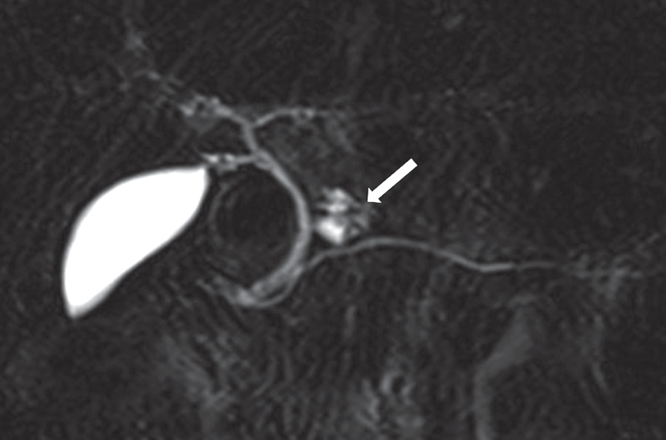
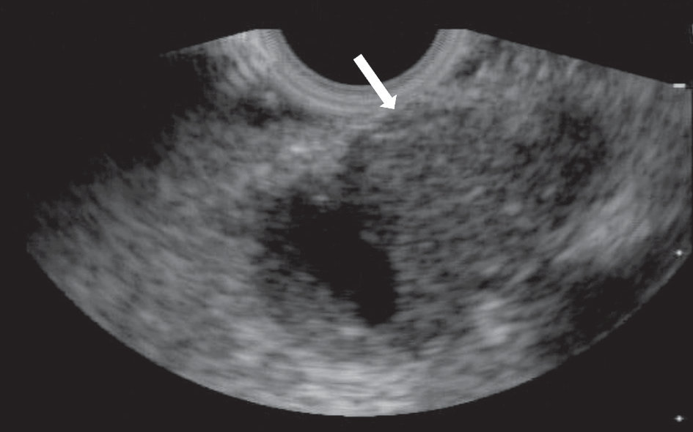
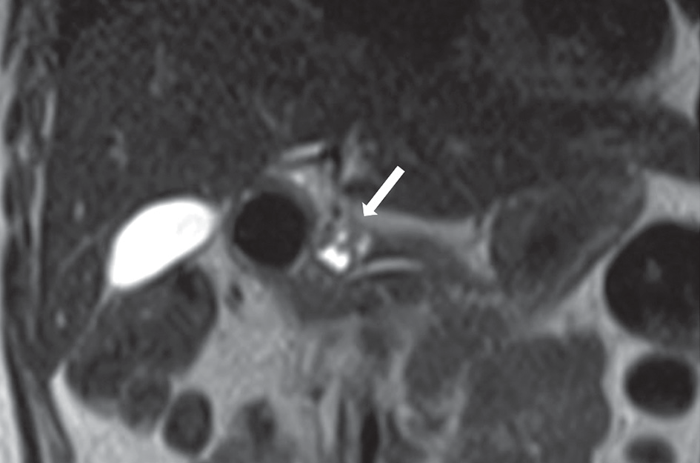
Evaluatingthemalignantpotentialofintraductalpapillarymucinousneoplasmsofthepancreas:addedvalueofnon-enhancedendoscopicultrasoundtosupplementnon-enhancedmagneticresonanceimaging
A
B
C
Figure3.A51-year-oldwomanwithintraductalpapillarymucinousade-nocarcinomawithinvasivelesioninthebodyofpancreas.Maximumin-tensityprojectionimageshowingcysticlesionwithmulti-septalstructures(arrow)(A).Half-Fourieracquisitionsingle-shotturbospinechocoronalimageshowingcysticlesionwithmulti-septalstructures(B).Invasivele-sioncouldnotbedetectedonnon-enhanced magneticresonanceimages;Non-enhancedendoscopicultrasonographyimageshowinga cysticlesionwithdetectionofbothmuralnoduleandinvasivelesion(arrow)(C)
Table3.Predictionofinvasiveintraductalpapillarymucinousadenocarcinoma
Allparametersexpressedaspercentages.
PPV–positive-predictivevalue,NPV–negative-predictivevalue,MRI–magneticresonanceimaging,EUS–endoscopicultrasonography
Table4.Weightedκ valuesofinterobserveragreementbetweenthethreeblindedreaders
κ-valueswith95%ConfidenceIntervalsarepresented.
IPMN –intraductalpapillarymucinousneoplasms,IPMC–intraductal papillarymucinousadenocarcinoma,MRI–magneticresonanceimaging,EUS–endoscopicultrasonography
utilityofLSRvis-à-visthatofADC.Ourstudysuggested
atendencyforlowersensitivityandhigherspecificityforpredictingmalignantpotentialofIPMNs andinvasiveIP-MCsonblindedevaluation.Thissuggeststhatevaluationofascoreof2and3thatincludesoneWFormorethantwoWFswithnoHRScouldimpactthesensitivity.Ithas
beenpreviouslyshownthatradiologicalWFsarenotcu-
mulativeinriskpredictionbecausethereisnostepwiseincreaseinratesofmalignantorinvasiveIPMNwithanincreaseinthenumberofWFs[21].
Intheblindedevaluation,theadditionofEUSfind-ingschangedtheinterpretationofmuralnodule,walland/
©PolJRadiol2018;83:e426-e436
e433
PredictionofmalignantIPMN
PredictionofinvasiveIPMC
MRIalone MRIwithEUS MRIalone MRIwithEUS
Reader1and2
0.67(0.498-0.842)
0.67(0.473-0.861)
0.68(0.395-0.971)
0.62(0.321-0.922)
Reader2and3
0.57(0.33-0.818)
0.65(0.433-0.866)
0.48(0.127-0.846)
0.43(0.09-0.776)
Reader1and3
0.72(0.565-0.877)
0.79(0.648-0.929)
0.49(0.127-0.846)
0.49(0.127–0.846)
Sensitivity Specificity PPV NPV
MRIalone MRIwithEUS MRIalone
MRIwithEUS MRIalone MRIwithEUS
MRIalone MRIwithEUS
Reader1
50.0
58.3
92.0
92.3
75.0
77.8
80.0
82.8
Reader2
58.3
66.7
96.2
96.2
87.5
88.9
83.3
86.2
Reader3
25.0
25.0
100
100
100
100
74.3
74.3

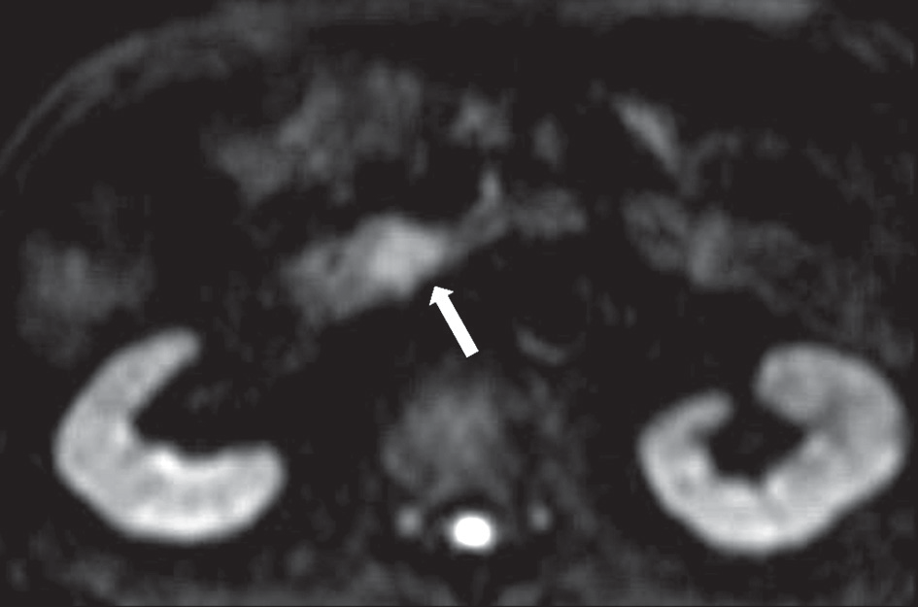
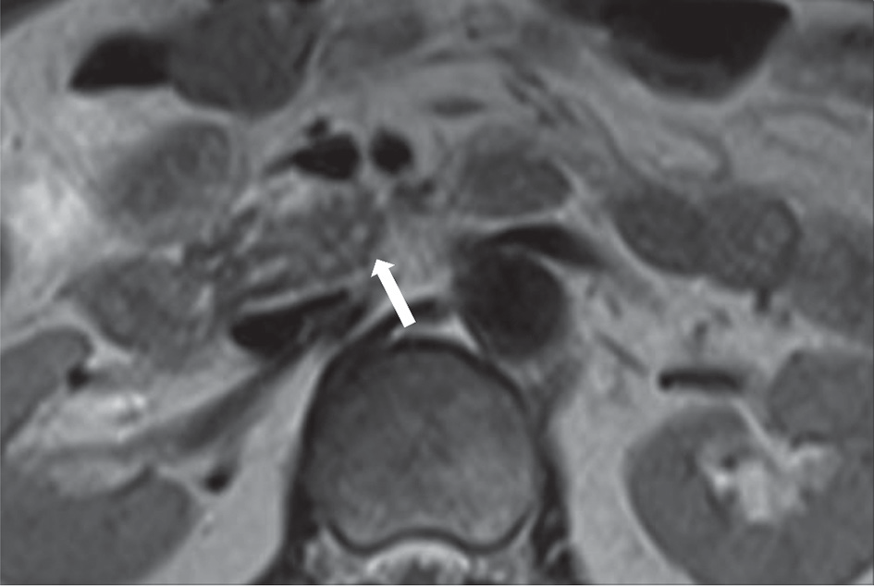
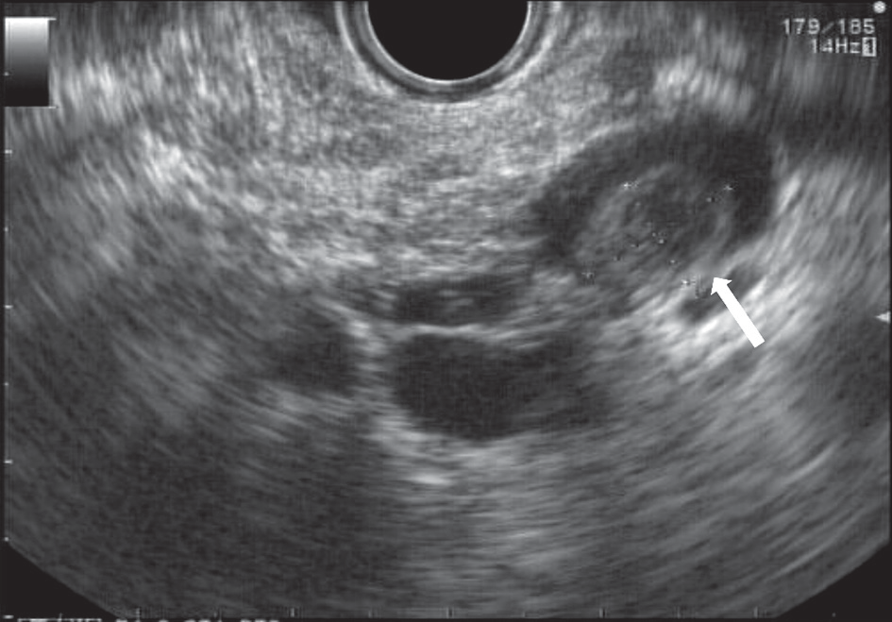
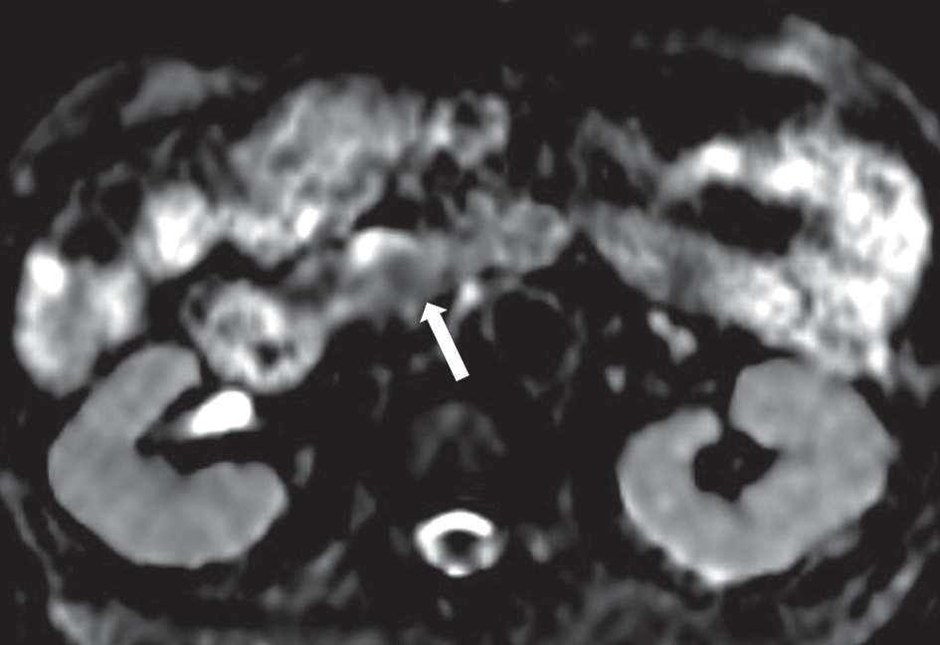
TakaoIgarashi,HirokazuAshida,KazuhikoMorikawaetal.
B
A
C
D
Figure4.An82-year-oldmanwithintraductalpapillarymucinousadenocarcinomawithinvasivelesionintheheadofpancreas.Multilocularcysticmasswithmuralnoduleswasdetectedonnon-enhancedmagneticresonanceimaging.Aninvasivelesionwithrestricteddiffusionwasdetectedondiffusion-weightedimage(arrow)(A).Restricteddiffusionwasidentifiedasalow-signallesiononapparentdiffusioncoefficientmap(arrow)(B).TheuncinateprocessofpancreasshowedlossofnormalmorphologyduetoinvasivelesionoftheintraductalpapillarymucinousadenocarcinomaonT2-weightedimage(arrow)(C).Amultilocularcysticmasswithmuralnodules(arrow)wasdetectedbyendoscopicultrasonography,whichfailedtoidentifytheinvasivelesion(D)
orseptalthicknessofcyst,andMPDsizeonMRIbythe
threereaders.However,thechangewasstatisticallyinsig-nificant.Non-enhancedMRIwithDWIhasonlyalimitedvaluefordiagnosisofhigh-gradedysplasiaandstageT1carcinoma[7].Thelowprevalenceofasolidproliferativeportioninbothnon-invasiveIPMCandbenignIPMNwasreported to underlie the significantoverlapofADCvaluesbetweenthesetwolesions[5].Furthermore,de-pendingontheviscosityofthecontentsofcysticlesionsand/ormucusplugs,theADCvaluesandLSRoflesionscanshowvariousvalues.Fromthisperspective,assess-mentofvascularityforsolidproliferativeportionmaybenecessary.Onthebasisofthe FG criteriathat accordweighttoanenhancingmuralnoduleforthepurposeofdeterminingmalignancy[10],ourfindingssuggestthatbloodflowinformation isnecessaryforthe interpretationofWFs,especiallyformuralnodulesandwalland/orsep-talthicknessofcyst.
DiagnosticaccuracystudydemonstratedthattheFGcriteria,whichwasselectedinourstudy,hashighersen-sitivityindetectinghigh-gradedysplasiaandcancercom-paredtothetwoguidelinescreatedbythe2015AmericanGastroenterologicalAssociationandtheAmericanCollegeofRadiology[22].
AsstatedintheFGcriteria,ifwewereabletoaddthe
EUSfindingswithbloodflowdataofthelesion,wheneval-uatingthenon-enhancedMRIfindings,thesensitivityofourresultscouldhavebeenimproved,especiallyincasesthatscored2or3onblindedevaluation.
Contrast-enhancedharmonicEUSwithtime-intensitycurveanalysiswasshowntobeusefulforquantitativeeval-uationofbloodflowintheIPMNmicrovasculature,andfordifferentiatingbetweenhigh-gradedysplasia/invasivecar-cinomaandlow-andintermediate-gradedysplasia[23].Inclinicalpractice,althoughanon-enhancedEUSasascreen-ingmodalitycandetectpancreaticintraepithelialneoplasialesionsandsmallinvasivecarcinomasassociatedwithIPMN[24,25]inthecaseoflesionsscoredas2or3,itisreasonabletorecommendenhancedEUSinadditiontonon-enhancedMRI.Presently,thereisnoconsensusontheuseofdynamiccontrastenhancedMRIfordistinguishingmalignantfrombenignIPMNs.FurtherstudiesarerequiredtoassesstherelativevalueofenhancedMRIandenhancedEUS.
Severallimitationsofthepresentstudyshouldbeacknowledged.Theretrospectivestudydesignandrela-tivelysmallsamplesizearekeylimitationsthatlimitthestatisticalpoweroftheanalysisandmayhaveintroducedanelementofselectionbias. Inparticular,changesinFG
e434
©PolJRadiol2018;83:e426-e436

Evaluatingthemalignantpotentialofintraductalpapillarymucinousneoplasmsofthepancreas:addedvalueofnon-enhancedendoscopicultrasoundtosupplementnon-enhancedmagneticresonanceimaging
(2012)mighthaveinfluencedthepatientinclusioncrite-
ria.Secondly,insomecasesitwasdifficulttodistinguishmuralnodulefrommucousplugornormalpancreaticparenchyma inthepreliminary analyses. ThismayhaveinfluencedtheinterpretationofMRIfindingsintheblind-edevaluation.Thirdly,theEUScriteriaforIPMNsweremainlytheMPDandinternalcharacteristicsofthecysticlesion;there wasinadequate emphasisonthepresence orabsenceoffindingssuggestiveofIPMCwithaninvasivecomponent.ThiscouldhavehadanimpactonthetworeaderswithlowerκvaluesforMRIwithEUSthanforMRIalone,inthepredictionofinvasiveIPMC.
Inconclusion,theclinicalutilityofnon-enhancedEUSmaybeattributiveinevaluating IPMNthathasal-
readybeenevaluatedbynon-enhancedMRI.Theresults
ofouranalysissuggestthattheadditionaluseofenhancedEUSforpatientswithoneWFormorethantwoWFsandnoHRSonnon-enhancedMRImaybeuseful.
Acknowledgements
Theauthorswouldlike tothank SoumeiNozu(Siemens
JapanK.K.,CustomerServiceDivision)forprovidingin-formationaboutdetailedMRparameters.
Conflictofinterest
Theauthorsdeclarethattheyhavenoconflictofinterest.
References
traductalpapillarymucinous neoplasmitself.Pancreas2012;41:
855-862.
Kobayashi N, Sugimori K,ShimamuraT,etal.Endoscopic ultra-sonographicfindingspredicttheriskofcarcinomainbranchductintraductalpapillarymucinousneoplasmsofthepancreas.Pancre-atology2012;12:141-145.
InuiK,KidaM,FujitaN,etal.Standardimagingtechniquesinthepancreatobiliaryregionusingradialscanningendoscopicultra-sonography.DigEndosc2004;16:S118-S133.
EUS-FNAStandardizationCommittee,YamaoK,IrisawaA,etal.Standardimagingtechniquesofendoscopicultrasound-guidedfine-needleaspirationusingcurvedlineararrayechoendoscope.DigEndosc2007;19:S180-S205.
KimSH,LeeJM,LeeES,etal.Intraductalpapillarymucinousneo-plasmsofthepancreas:evaluationofmalignantpotentialandsur-gicalresectabilitybyusingMRimagingwithMRcholangiography.Radiology2015;274:723-733.
KangHJ,LeeJM,JooI,etal.Assessmentofmalignantpotentialinintraductalpapillarymucinousneoplasmsofthe pancreas:Compar-isonbetweenmultidetectorCTandMRimagingwithMRcholan-giopancreatography.Radiology2016;279:128-139.
KawadaN,UeharaH,NagataS,etal.Muralnoduleof10mmorlargeraspredictorofmalignancyforintraductalpapillary mucinousneoplasmofthepancreas:Pathologicalandradiologicalevaluations.Pancreatology2016;16:441-448.
RidtitidW,DeWittJM,SchmidtCM,etal.Managementofbranch-ductintraductalpapillarymucinousneoplasms:alargesingle-centerstudytoassesspredictorsofmalignancyandlong-termoutcomes.GastrointestEndosc2016;84:436-445.
UtoT,TakeharaY,NakamuraY,etal.Highersensitivityandspeci-ficityfordiffusion-weightedimagingofmalignantlunglesionswith-outapparentdiffusioncoefficientquantification.Radiology2009;252:247-254.
KitazumeY,TauraS,NakaminatoS,etal.Diffusion-weightedmag-neticresonanceimagingtodifferentiatemalignantfrombenigngallbladderdisorders.EurJRadiol2016;85:864-873.
RochAM,CeppaEP,DeWittJM,etal.InternationalConsensus
Guidelinesparametersforthepredictionofmalignancyinintra-
1.
LaffanTA,HortonKM,KleinAP,etal.Prevalenceofunsuspected
pancreaticcystsonMDCT.AJRAmJRoentgenol2008;191:802-807.HrubanRH,TakaoriK, Klimstra DS, et al. Anillustrated consen-susontheclassificationofpancreaticintraepithelialneoplasiaandintraductalpapillarymucinousneoplasms. AmJSurgPathol2004;28:977-987.
MatthaeiH,SchulickRD,HrubanRH,MaitraA.Cysticprecursorstoinvasivepancreaticcancer.NatRevGastroenterolHepatol2011;8:141-150.
BassiC,SarrMG,LillemoeKD,ReberHA.Naturalhistoryofintra-ductalpapillarymucinousneoplasms(IPMN):Currentevidenceandimplicationsformanagement.JGastrointestSurg2008;12:645-650.KangKM,LeeJM,ShinCI,etal.Addedvalueofdiffusion-weightedimagingtoMRcholangiopancreatographywithunenhancedMRimagingforpredictingmalignancyorinvasivenessofintraductalpapillarymucinousneoplasmofthepancreas.JMagnResonImag-ing2013;38:555-563.
OgawaT,HoraguchiJ,FujitaN,etal.Diffusion-weightedmagneticresonanceimagingforevaluatingthehistologicaldegreeofmalig-nancyinpatientswithintraductalpapillarymucinousneoplasm.JHepatobiliaryPancreatSci2014;21:801-808.
JangKM,KimSH,MinJH,etal.Valueofdiffusion-weightedMRIfordifferentiatingmalignantfrombenignintraductalpapillarymu-cinousneoplasmsofthepancreas.AJRAmJRoentgenol2014;203:992-1000.
KartalisN,LindholmTL,AspelinP,etal.Diffusion-weightedmag-neticresonanceimagingofpancreastumours.EurRadiol2009;19:1981-1990.
SandrasegaranK,AkisikFM,PatelAA,etal.Diffusion-weightedimagingincharacterizationofcysticpancreaticlesions.ClinRadiol2011;66:808-814.
TanakaM, Fernández-delCastilloC,AdsayV,et al.Internationalconsensusguidelines2012forthemanagementofIPMNandMCNofthepancreas.Pancreatology2012;12:183-197.
OhnoE,ItohA,KawashimaH,etal.Malignanttransformationofbranchduct-typeintraductalpapillarymucinousneoplasmsofthepancreasbasedoncontrast-enhancedendoscopicultrasonography
morphologicalchanges:Focusonmalignanttransformationofin-
12.
2.
13.
3.
4.
14.
5.
15.
6.
16.
7.
17.
8.
18.
9.
19.
10.
20.
11.
21.
©PolJRadiol2018;83:e426-e436
e435

TakaoIgarashi,HirokazuAshida,KazuhikoMorikawaetal.
ductalpapillarymucinousneoplasmarenotproperlyweightedand
arenotcumulative.HPB(Oxford)2014;16:929-935.
- XuMM,YinS,SiddiquiAA,etal.Comparisonofthediagnosticac-curacyofthreecurrentguidelinesfortheevaluationofasymptomaticpancreaticcysticneoplasms.Medicine(Baltimore)2017;96:e7900.
- YamamotoN,KatoH,TomodaT,etal.Contrast-enhancedharmon-ic endoscopic ultrasonographywith time-intensitycurveanalysisforintraductalpapillarymucinousneoplasmsofthepancreas.En-
doscopy2016;48:26-34.
- MaireF,CouvelardA,PalazzoL,etal.Pancreaticintraepithelialne-
oplasiainpatientswithintraductalpapillarymucinousneoplasms:theinterestofendoscopicultrasonography.Pancreas2013;42:1262-
1266.
- KamataK,KitanoM,KudoM,etal.ValueofEUSinearlydetectionofpancreaticductaladenocarcinomasinpatientswithintraductalpapillarymucinousneoplasms.Endoscopy2014;46:22-29.
e436
©PolJRadiol2018;83:e426-e436

SupplementaryTable1.Pulsesequenceparametersfor1.5-TeslaMRimaging
FS–fatsuppressed;GRE-T1WI–gradient-echoT1-weightedimaging;T2WI–T2-weightedimaging;DWI–diffusion-weightedimaging;HASTE–half-Fourieracquisitionsingle-shotturbospinecho;MRCP–MRcholangiopancreatography;VIBE–volumetricinterpolatedbreath-holdexamination(T1-weightedGREsequenceswithcartesiansamplingwhichisreferredtoas“VIBE”onSiemensHealthcareMRIsystems);TR–repetitiontime;TE–echotime;FA–flipangle;FOV–fieldofview;ST–slicethickness;BW–bandwidth;AT–acquisitiontime;ETL–echotrainlength
FSGRE-T1WI T2WI
DWI RARE FS3DVIBE HASTE
3D-MRCP TrueFISP
TR(ms)
102-142
3000
1200-1500
4500
4.94-5.20
584-600
1050-1400
320-333.1
TE(ms)
4.76-5.04
90-91
67-86
758-759
1.86-1.93
180
601-614
1.41-1.52
FA(degrees)
70
150

180
15.0
110-160
140-150
77
bvalues

50/800

Matrix

187×256

208×320-256×
×320
77×128

307×384

199×384

141×256-176×
×256
314×320-323×
×320
205×256

FOV

308×380-308×
×384
308×380

262×350-277×
×370
300×300

300×400

275×400

320×320-340×
×340
400×400

ST(mm)
7.0
7.0
7.0
70
3.0
4.0
1.8
4.0
BW(Hz/pixel)
300
601
1346-2298
150
260
781
488
543-651
AT(s)
38
30
2:09-2:26
4.5
19-20
20
1:59-2:07
19-120
ETL

31

307

141-176
87-117

