

Geological Quarterly, 2012, 56 (4): 907-920
DOI: http://dx.doi.org/10.7306/gq.1067

Structure and Miocene evolution of the Gdów tectonic “embayment”
(Polish Carpathian Foredeep) - a new model based on reinterpreted seismic data
Piotr KRZYWIEC, Krzysztof BUKOWSKI, Nestor OSZCZYPKO and Aleksander GARLICKI

Krzywiec P., Bukowski K., Oszczypko N. and Garlicki A. (2012) - Structure and Miocene evolution of the Gdów tectonic “embayment”
(Polish Carpathian Foredeep) - a new model based on reinterpreted seismic data. Geol. Quart., 56 (4): 907-920, doi: 10.7306/gq.1067
Analysis of previously available stratigraphic data coupled with the re-interpretation of seismic profiles calibrated by boreholes has
allowed the construction of a new tectonic model of evolution of the Gdów “embayment” - a tectonic re-entrant located along the
Carpathian front east of Kraków (southern Poland). This model shows that the main phase of localized fault-controlled subsidence
took place in the Early Badenian and was associated with deposition of the locally overthickened Skawina Formation. Also, deposi-
tion of evaporites of the Wieliczka Formation seems to have been tectonically controlled by local basement faulting. Supra-evaporitic
siliciclastic deposits have developed as a result of overall north-directed sediment progradation from the eroded Carpathian belt to-
wards the Carpathian Foredeep. During the final stages of development of the Carpathian fold-and-thrust wedge the previously sub-
siding Gdów “embayment” area was uplifted and basement faults were reactivated either as reverse faults or as low angle thrust faults.
Along the leading edge of this inverted structure a triangle zone developed, with backthrusting along the evaporitic level. As a result,
overthickened evaporites, formed in local tectonically-controlled depressions within the area of the Gdów “embayment” area have
been strongly folded and internally deformed.
Piotr Krzywiec, Institute of Geological Sciences, Polish Academy of Sciences, Twarda 51/55, 00-818 Warszawa, Poland, e-mail:
piotr.krzywiec@twarda.pan.pl; Krzysztof Bukowski and Aleksander Garlicki, Faculty of Geology, Geophysics and Environmental Pro-
tection, AGH University of Science and Technology, Mickiewicza 30, 30-059 Kraków, Poland, e-mails: buk@agh.edu.pl,
kcyran@geolog.geol.agh.edu.pl; Nestor Oszczypko, Institute of Geological Sciences, Jagiellonian University, Oleandry 2A, 30-063
Kraków, Poland, e-mail: nestor_oszczypko@yahoo.com (received: June 28, 2012; accepted: December 12, 2012; first published online:
December 19, 2012).
Key words: Carpathian Foredeep Basin, Gdów “embayment”, Miocene, wedge tectonics.
INTRODUCTION
The trailing edge of the Carpathian fold-and-thrust belt be-
tween Kraków and Tarnów has been the subj ect of intense
studies because of its control over depostts of rock salt (e.g.,
Wieliczka and Bochnia salt mines) and hydrocarbon accumu-
lations. Frontal thrust sheets of the Outer (flysch) Carpathians
south of Kraków include the Silesian and Subsilesian nappes
(Fig. 1). Further to the north, a relatively narrow zone of the de-
formed Miocene Carpathian Foredeep deposits is located,
forming the Zgłobice thrust-sheet (Kotlarczyk, 1985; cf.
Oszczypko et al., 2006 for extensive review and numerous ref-
erences). Miocene foredeep deposits are also presentwithinthe
so-called Gdów “embayment”, analysed in this paper.
Transgression of the Early Miocene sea of the Carpathian
Foredeep Basin covered both the foreland platform and in part
the Outer Carpathian thrust sheets. During the development of
this sedimentary basin (Badenian-Sarmatian; Fig. 2), marine
sedimentation prevailed. Only the late Badenian salinity crisis
associated with deposition of evaporites (rock salt, gypsum)
marked significant shallowing of the basin.
In the Early Badenian the axial part of the basin reached up-
per bathyal depths, while the northern and southern parts of the
basin were within the neritic-littoral zone (cf. Oszczypko et al.,
2006). Gradual shallowing of the basin began in Serravalian
times (Andreyeva-Grigorovich et al., 2003). Results of recent
⁴⁰Ar/³⁹Ar dating indicate that deposition of the evaporites in the
Carpathian Foredeep Basin started shortly after 13.81 ±
0.076 Ma (de Leeuw et al., 2010) and thus directly after Mi3b, a
major step in the Middle Miocene global cooling, dated in the
Mediterranean region at 13.82 ± 0.03 Ma (Abels et al., 2005).
Isotopic data of Badenian foraminifera indicate a sharp de-
crease in seawater temperature just below the evaporites
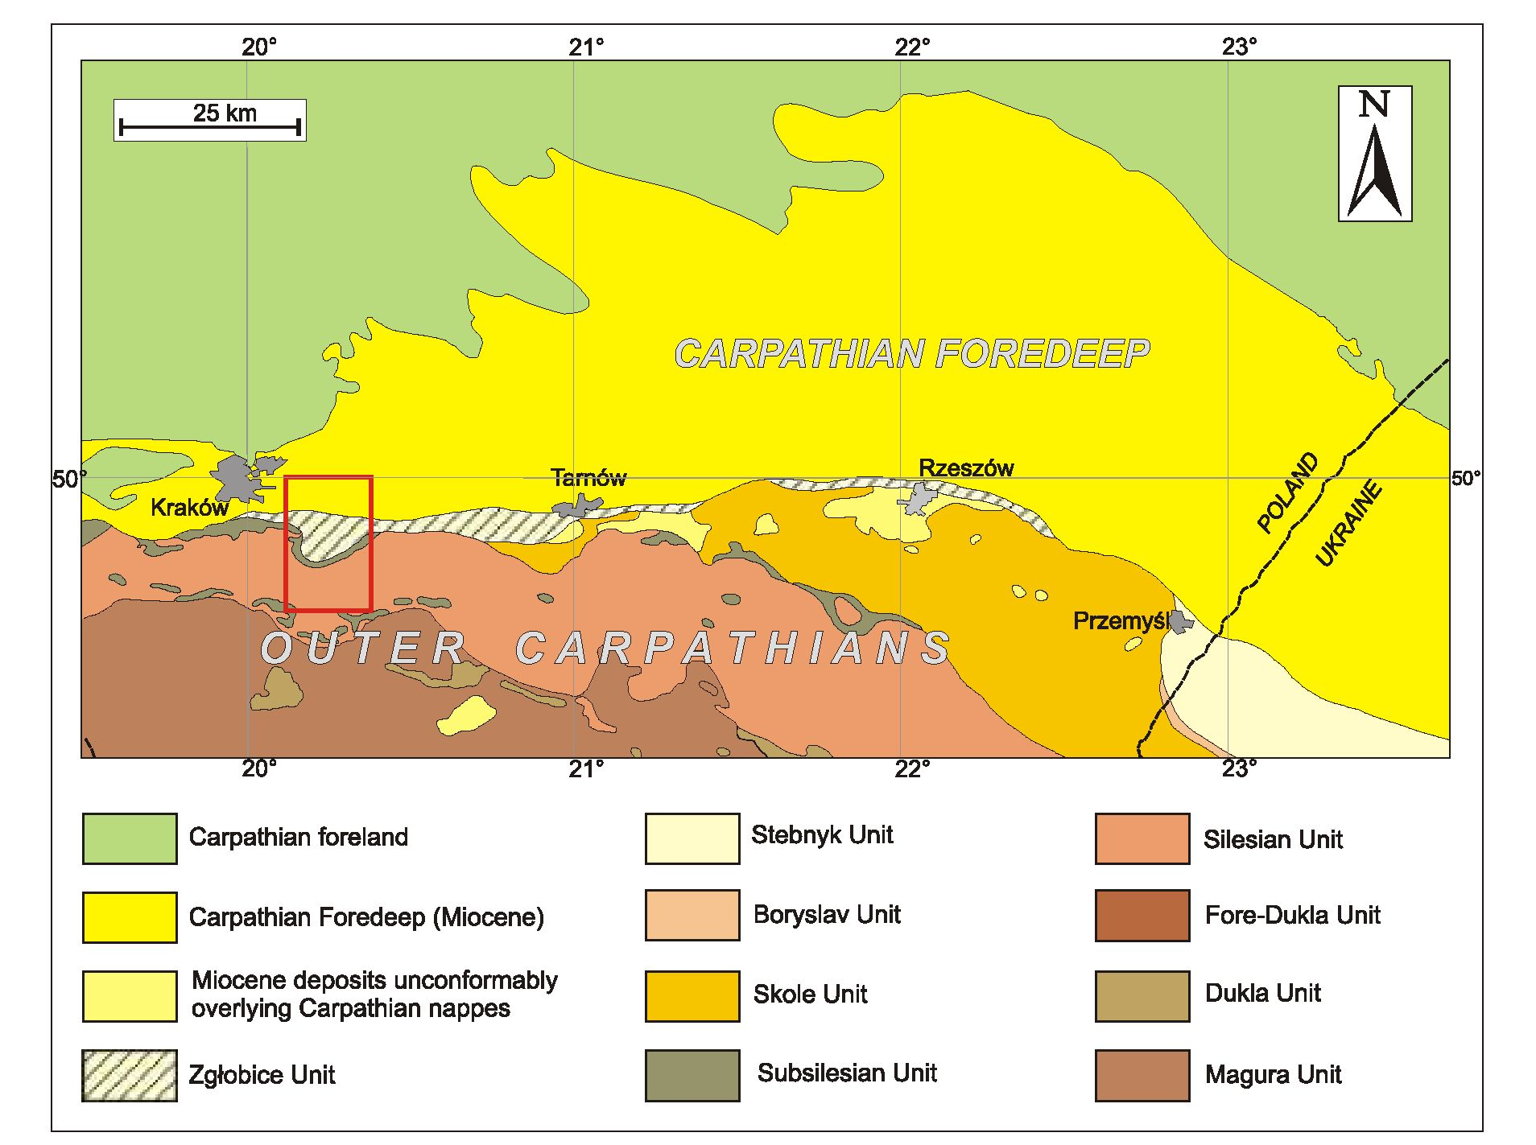
908
Piotr Krzywiec, Krzysztof Bukowski, Nestor Oszczypko and Aleksander Garlicki
Fig. 1. Simplified geological map of the Outer Carpathians and their foreland between Kraków and Przemyśl
Red rectangle - area shown on Figure 3
(Gonera et al., 2000; Bicchi et al., 2003; Peryt and Gedl, 2010;
Bukowski, 2011; Gonera and Bukowski, 2012), also in agree-
ment with the globally recognized Mi3b cooling event (de
Leeuw et al., 2010). The drop in global sea level at Mi3b
caused the final closure of the existing gateways between the
Central Paratethys and the Mediierranean part of the Tethys.
Sea level lowering likely restricted the deep outflow of dense
saiine waters from the Carpathian Foredeep, trapping the salt
within the Paratethys basins and consequently setting off the
Badenian salinity crisis (de Leeuw et al., 2010; Bukowski,
2011).
Shallow parts of the evaporite basin were dominated by sul-
phate and subordinary carbonate-littoral facies (e.g., Kasprzyk,
1993; Peryt et al., 1997; Bąbel, 2004; Jasionowski and Peryt,
2010). Deeper parts of baiin, located along the Carpathian
front, were occupied by chloride-sulphate facies - rock salts of
the Wieliczka Formation (Fig. 2; see Garlicki, 1979; Peryt,
2006). According to Bąbel (2004), the gypsum sub-basin was
very shallow, zero to several metres deep, whilst the depth of
the halite sub-basin was estimated at not less than 30-40 m.
After the Badenian salinity crisis, the edge of the
Carpathian thrust belt moved by a few kilometres to the north
(see Oszczypko, 1997, 1998; Kovac et al., 1998; Oszczypko
and Oszczypko-Clowes, 2012). At the front of the Carpathian
orogen this resulted in a deepening of the basin, which reached
depths chararteristic for the outer shelf, during the deposition
of the clayey sediments of the Chodenice Beds (Gonera, 1994;
Kovac et al., 1998; Oszczypko, 1999). At the same time the
high level of the sea caused exiensive marine transgresssion
onto the Outer Carpathian thrust sheets, including the Magura
Nappe. This is marked in the Nowy Sącz Basin by
transgressive neritic deposits (NN6/7 Zone) over the freshwa-
ter Biegonice Formation (Oszczypko et al., 1992;
Oszczypko-Clowes et al., 2009).
The zone of maximum subsidence within the Carpathian
Foredeep Basin migrated in Sarmatian times ca. 40-50 km to-
wards the NE, towards the Teisseyre-Tornquist Zone that was
reactivated due to foreland flexural extension (cf. Krzywiec,
2001; Oszczypko et al., 2006; Gągała et al., 2012).
The frontal thrust of the Outer (flysch) Carpathian orogenic
front in the area south-east of Kraków recedes to the south,
forming a “bay” or “embayment”, termed by Niedźwiedzki
(1883-1886) the Gdów embayment, after the town of Gdów
(Fig. 3). The surface and shallow subsurface geometry of this
area prompted Niedźwiedzki (1883-1886) to propose that in
Miocene times the frontal Carpathian thrust did indeed form a
bay filled by the Miocene sea. Subsequent studies (see below)
have clearly shown that this original concept was in error and
that this retreat of the frontal Carpathian thrust was due to com-
bination of tectonics, uplift and erosion. In order, however, to

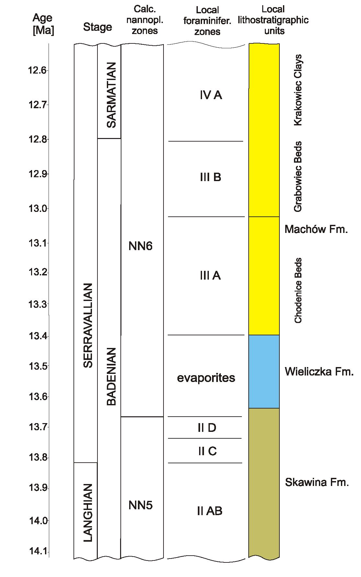
Structure and Miocene evolution of the Gdów tectonic “embayment” (Polish Carpathian Foredeep).
909
Fig. 2. The local Carpathian Foredeep Middle Miocene stratigraphy
in comparison with the standard global chronostratigraphy
(GSSP after Hilgen et al., 2009)
Calcareous nannoplankton NN zones after Peryt (1997) and Raffi et al.
(2006), local foraminiferal zones after Alexandrowicz (1963); position of
the Chodenice Beds after de Leeuw et al. (2010) and Śliwiński et al.
(2012); not ice that de Leeuw et al. (2010) put the base of evaporites at
13.81 ± 0.076 Ma; colours used to depict local lithostratigraphic units
match those used on Figures 4-6 and 8
maintain compatibility with the previous nomenclature, the
term “embayment” will be used through this paper, although it
should not be understood in its original strict meaning, coined
by Niedźwiedzki (1883-1886).
The Miocene deposits of the Gdów “embayment” consist
mostly of clays and shales, with subordinate sands. They are all
included in the Lower Badenian sub-evaporitic deposits (Połto-
wicz, 1962; Alexandrowicz, 1965; Moryc, 1970a, b). Alexan-
drowicz (1965) divided this succession into four foraminiferal
lev els IIA, IIB, IIC, IID, and proposed the name Skawina Beds
(Alexandrowicz, 1963). Later, the term “Skawina Beds” has
been extended and defined as the “Skawina Formation” (Ale-
xandrowicz et al., 1982). The beginning of Skawina Formation
deposition is dated to the Lower Badenian Orbulina suturalis
Zone (see Oszczypko et al., 2006). In the southern part of the
Gdów “embayment” the Skawina Fm. has been drilled beneath
the Outer Carpathians in borehole Łapanów 1 in the depth in-
terval 1.458-1.765.5 m. In the upper part of the Skawina For-
mation, late Badenian calcareous nannoplankton belonging to
the lower part of NN6 Zone have been determined (Peryt,
1997; Oszczypko and Oszczypko-Clowes, 2012). The same
NN6 nanoplankton assemblages have been described from the
sub-evaporitic Skawina Formation in the Bochnia and Kalush
Salt Mine (Andreyeva-Grigorovich et al., 2003; Fig. 2).
In the southern part of the Gdów “embayment” (i.e. Gdów 1
and Gdów 2 boreholes; Fig. 3) a significant increase in the
amount of sands and gravels is obterved. The same coarse
clastic depostts are also known from outcrops in the Sypka
Góra viltage, near Gdów, where gravels with flysch material
occur (cf. Jasionowski, 1997). Their thickness reaches at least
40 metres; they have been interpreted as havtng formed on
gravel deltas (Doktor, 1983). The Lower Badenian foramini-
feral assemblages IIA-IIC have been identified in these depos-
its (Alexandrowicz, 1965). Similar flysch gravels, occurring di-
rectly below the evaporites, were described from the marginal
zone of the Carpathian Foredeep, in Wrząsowice (Gonera et al.,
1990) and Bacharowice (Doktor, 1983), south of Kraków.
This paper consists of two main parts. The first is devoted to
critical analysis of main previously published tectonic models
of the Gdów “embayment” area in order to provide a historical
perspective for geotogtcal studtes of the frontal Outer Carpa-
thians east of Kraków, dating back at least to the XVIIIth cen-
tury. The second part describes a new tectono-stratigraphic
model of the evolution of the Gdów “embayment” based on re-
interpreted seismic data calibrated by boreholes.
PREVIOUS TECTONIC MODELS OF THE GDOW
“EMBAYMENT”
The earliest geological studies of the frontal Carpathian
orogenic wedge in Poland have focused on the area located im-
mediately east of Kraków, where rock salt has been mined for
centuries in Wieliczka and Bochnia salt mines (e.g., Schober;
1750; Townson, 1797; Pusch, 1824; Hrdina and Hrdina, 1842;
Niedźwiedzki, 1883-1886; Uhlig, 1903; cf. Poborski, 1965;
d’Obyrn and Przybyło, 2010). In the 20th century, exploration
for oil and gas greatly intensified and resulted in the acquisition
of a large amount of subsurface geophysical data that signifi-
cantly improved the understanding of the geological structure
of the frontal Carpathian fold-and-thrust belt in, among others,
Kraków-Tarnów area. Foliowing decades of irtense geoiogi-
cal and geophysical study, many structural models have been
proposed for the fronial Carpathians (see Oszczypko et al.,
2006 for detailed overview and further references).
The area of the Gdów “embayment” has been extensively
studied: in toial, several tens of deep boreholes have been
drilled, numerous geophysical studies (gravity, magnetic, seis-
mic) have been made, mostly during exploration for rock salt

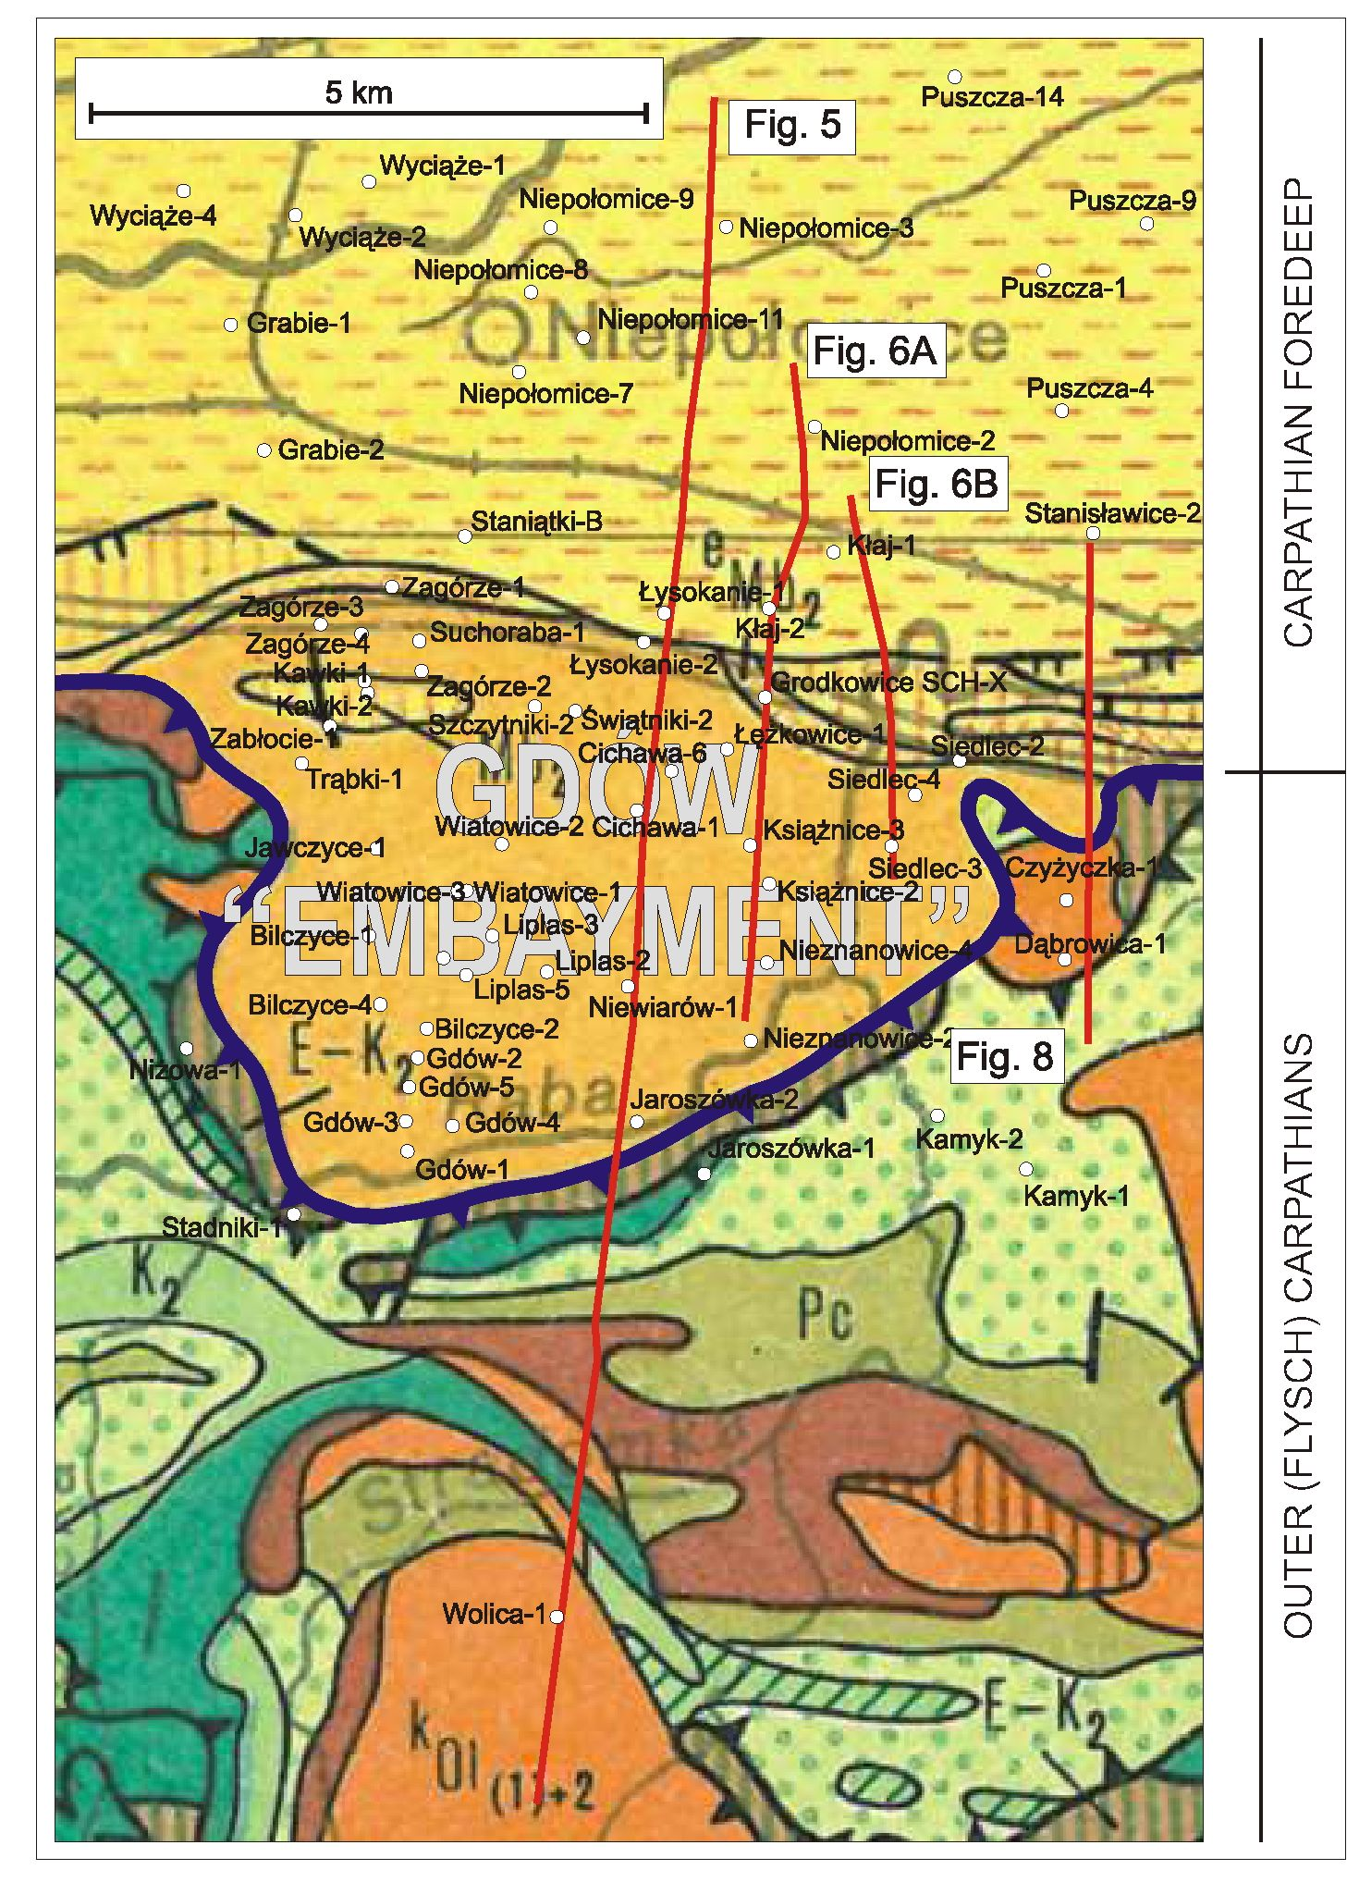
910
Piotr Krzywiec, Krzysztof Bukowski, Nestor Oszczypko and Aleksander Garlicki

Fig. 3. Location of the interpreted seismic profiles (Figs. 5 and 6), geological cross-section (Fig. 7)
and boreholes on a background of a simplified geological map of the Outer Carpathians
and their foreland without Quaternary formations (after Żytko et al., 1989)
For other explanations see Żytko et al. (1989)
and, in more recent years, for hydrocarbons. All the surface and
subsurface data have altowed many researchers to come up
with different models of the present-day structure and evotu-
tion of this part of the Carpathian front. Betow, a brief sum-
mary of these models is given, that will be consequently used as
a reference point for discussion of new results of seismic data
interpretation. Previous models of the Gdów “embayment” are
presented in chronological order, to illustrate the evolution of
the ideas triggered by the increased amount of stratigraphic and
tectonic evidence. Selected tectono-stratigraphic models of the
Gdów “embayment” that illustrate the evolution of concepts of
its geological structure are shown on Figure 4.
The first model that presented, in modern style, the struc-
ture of the Gdów “embayment” was published by Garlicki, fol-
lowing irtense exploration for rock salt in the Łężkowice -
Siedlec area (Garlicki, 1960 and his fig. 2). In this model, the
Gdów “embayment” is filled by the gently folded Chodenice
and Grabowiec beds (cf. Fig. 2) entraining also Miocene
evaporites (rock salt). The northern edge of the “embayment”
coincides with salt deposits that are deformed, upiifted to the
surface and over-thickened. In this model, there is no tectonic
deformation within the pre-Miocene basement although this
basement is shown by hatched lines indicating uncertain geom-
etry (Garlicki, 1960) - a result of the scarcity of reliable good
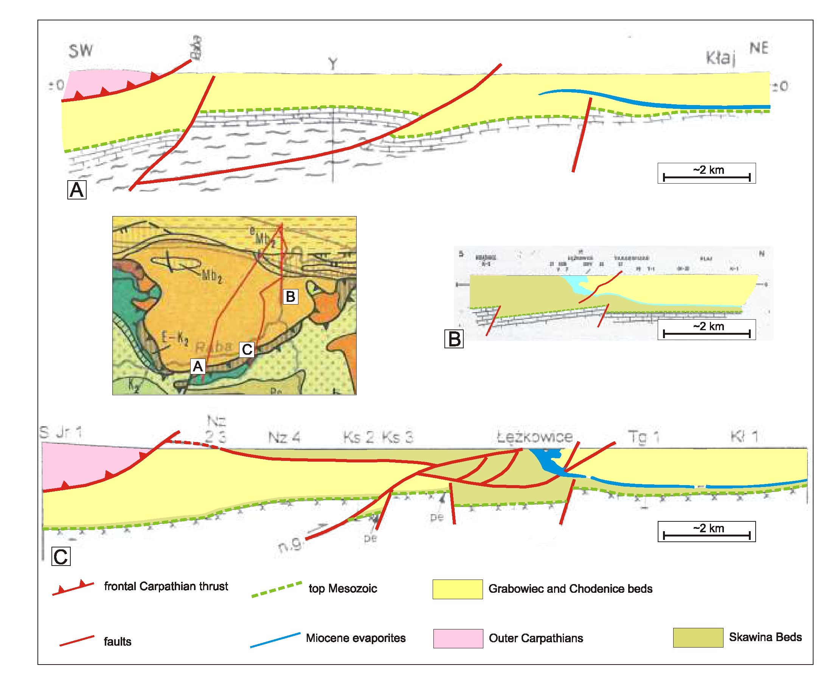
Structure and Miocene evolution of the Gdôw tectonic “embayment” (Polish Carpathian Foredeep)..
911
Fig. 4. Geological models of the Gdów “embayment"
A - according to Połtowicz (1962); B - according to Garlicki (1971); C - according to Połtowicz (2004); geological cross-sections are shown
at approximately the same scale and are vertically aligned along the approximate location of the Kłaj 1 borehole (cf. Fig. 3); all the key explanations
are shown on this figure; for explanations of other symbols see original papers of Połtowicz (1962), Garlicki (1971) and Połtowicz (2004)
quality subsurface data, as this model pre-dates the acquisition
of modern digital seismic reflection data.
In 1962, Połtowicz published the next model of the Gdów
“embayment”, using not only well and surface geological data
but also geophysical subsurface information: reflection seismic
and geoelectric data (Połtowicz, 1962 and his fig. 4). His model
is shown on Figure 4A. Połtowicz, having access to the sub-
surface geophysical data, first suggested the presence of low
angle reverse faults (thrusts) deiached within the Meiozoic
basement, cutting also the Miocene infill of the Gdów “embay-
ment”. Its Miocene sedimentary infill consists of the Chode-
nice Beds (coniaining also rock salt deposits), present within
the entire “embayment” and overlying the Mesozoic basement.
The Grabowiec Beds are present only to the north of the north-
ern edge of the “embayment”.
Significant improvement in the geological interpretation of
the Gdów “embayment” was fuelled by the deiailed biostra-
tigraphic studies of the Miocene foredeep succession in this
area. Alexandrowicz (1965; cf. also Doktor, 1983) distingui-
shed the sub-evaporitic succesiion present within the entire
“embayment” as the Skawina Beds (IIA-D foraminiferal zo-
nes), with the Chodenic and Grabowiec beds (IIIA, B foramini-
feral zones) located entirely above the evaporitic level (Fig. 2;
cf. also Łuczkowska, 1958; Olewicz, 1973a, b). This more pre-
cise tripartite stratigraphic zonation provided a new reference
point for the tectonic analyses of this area, with the evaporitic
level defined as a marker horizon located at the boundary be-
tween the Skawina Beds and Chodenice Beds. It is also worth
mentioning that Miocene foredeep evaporites form an excellent
marker in interpretation of the seismic data
In early 1970s Garlicki summarized a decade of geological
and geophysical studies of the Gdów “embayment” and pre-
sented his new refined tectono-stratigraphic model of the pres-
ent-day structure of this area and also of its Miocene evolution
(Garlicki, 1971; Fig. 4B). He adopted the tripartite stratigraphic
model of the Miocene infill established by Alexandrowicz

912
Piotr Krzywiec, Krzysztof Bukowski, Nestor Oszczypko and Aleksander Garlicki
(1965) compristng (1) the sub-evaporitic siliciclastic succest
sion (Skawina Beds), (2) evaporites (rock salt), and (3) the su-
pra-evaporitic siliciclastic succession (Chodenice and Grabo-
wiec Beds). In his model (Garlicki, 1971 and his fig. 2) pro-
posed a system of reverse faults rooted in the Meso-Paleozoic
basement of the Gdów “embayment”. In this model the sedt-
mentary infill, as in the model of Alexandrowicz (1965), con-
sists entirely of the folded sub-evaporitic Skawina Beds char-
acterized by significant thickness, up to several hundreds of
metres. Overthickened and strongly deformed (folded) salt de-
posits are located along the northern edge of the “embayment”,
where they had been recognized by numerous boreholes in the
Łężkowice area (Fig. 3). The supra-evaporitic succession
(Chodenice and Grabowiec beds), conformably deposited
above the evaporites, is present only to the north of the northern
edge of the “embayment”. In this area, the sub-evaporitic suc-
cession is rather thin, of the order of tens of metres, in contrast
to the thick infill of the Gdów “embayment” at the same strati-
graphic position. Ustng his structural model, Garlicki (1971)
proposed also a model for the tectono-stratigraphic develop-
ment of this area (Garlicki, 1971 and his fig. 3). He associated
increased thickness of the Skawina Beds with syn-depositional
activtty of basement faults and retated increased local subsi-
dence. Garlicki (1971) postulated also that salt deposits of the
Łężkowice area, thicker than in the northern part of the fore-
deep basin and presently strongly deformed, were depostted
during increased tectonically-controlled local subsidence wi-
thin the future Gdów “embayment” area. Deposition of evapo-
rites was followed by deposition of siliciclastic deposits of the
supra-evaporitic succession (Chodenice and Grabowiec beds).
According to Garlicki (1971), during later phases of the tec-
tonic evolution of this area, due to the increase orogenic push
retated to the final phase of development of the Carpathian
fold-and-thrust belt, basement normal faults were reactivated
as reverse faults, and the entire Miocene foredeep infill of the
Gdów “embayment” was folded and thrust towards the north.
Models of the Gdów “embayment” by Alexandrowicz
(1965) and Garlicki (1971) were subsequently challenged. Ac-
cording to Poborski and Jawor (1987), almost the entire infill of
the Gdów “embayment” consists of the supra-evaporitic Cho-
denice Beds, with only a thin and incomplete cover of the
sub-evaporitic Skawina Beds resting directly above the Meso-
zoic basement (see Poborski and Jawor, 1987 and their fig. 2).
Poborski and Jawor (1987) did not, howtver, prestnt any
stratigraphic evidence in support of their new model although
they suggested significant modifications of the previous strati-
graphic findtngs of Łuczkowska (1958) and Alexandrowicz
(1965).
In their next paper, Poborski and Jawor (1989) proposed an
even more generalized structure of the Gdów “embayment” as
they used only the general term “Miocene formation” to de-
scribe the entire Miocene infill of the “embayment”. Within
this formation, the evaporitic level was distnguished as a
marker horizon, but no information was given on the precise
stratigraphy of the sub- and supra-evaporitic successions.
According to newer models of the Gdów “embayment” by
Połtowicz (1991, 2004; Fig. 4C), only the uppermost part (up
to 200 m) of its sedimentary cover consists of the sub-evapo-
ritic Skawina Beds. These sediments form an allochthonous
thrust slice tectonically transported above a very flat (almost
horizonial) fault (detachment level) to the north. Beneath this
slice, the autochthonous cover consists of the thick Chodenice
and Grabowiec beds and thin Skawina Beds, resting above the
Mesozoic basement. This basement is dissected by several nor-
mal and reverse/thrust faults. Połtowicz (1991, 2004), similarly
to Poborski and Jawor (1987), did not, however, provide any
deiailed stratigraphic data that would support his structural
model. He only quoted archive unpubiished stratigraphic re i
sults of Z. Kirchner from unidentified industry wells, without
presenting any solid biostratigraphic data or even references to
the archive well reports. Taking this into account one can con-
clude that the structural models of Poborski and Jawor (1987)
and Połtowicz (1991, 2004), significantly different from the
previous models based on deiailed stratigraphic studies (Gar-
licki, 1971), are not supported by reliable and verifiable strati-
graphic data and have to be treated with the great caution.
The Carpathian front in the area located east of Kraków was
first de scribed as as sociated with a triangle zone by Jones
(1997). This model was, however, mentioned only in a confer-
ence abstract and was not supported by any more comprehen-
sive publication. Recently, a model of wedge tectonics and tri-
angle zones was used in order to explain the structore of the
Carpathian front imaged on seismic data from the Woj-
nicz-Tarnów area, located to the east of the Gdów “embay i
ment” (Krzywiec et al., 2004). Furthermore, it has been also
suggested that in the Wieliczka part of the Carpathian front
wedge, located to the west of the Gdów “embayment”, wedge
tectonics also played an important role, and that the entire
Wieliczka Salt Mine is located in the core of the triangle zone
formed during the last stages of compression within the Carpa-
thian orogenic wedge (Krzywiec and Verges, 2007). Finally,
Bukowski et al. (2010) presented a seismic profile from the
Gdów “embayment”, reinterpreted using verified stratigraphic
data from boreholes and outcrops (including new radiometric
dates of tuffites). This seismic profile (Bukowski et al., 2010
and their fig. 9) shows low-angle thrust faults and steep reverse
faults detached within the Meso-Paleozoic basement of the
Gdów “embayment”, and triangle zone and associated back-
thrusting along its northern edge, similarly to that reported from
the Wojnicz-Tarnów area by Krzywiec et al. (2004).
RESULTS OF SEISMIC DATA INTERPRETATION
FROM THE GDÓW “EMBAYMENT”
In order to construct a revised tectono-stratigraphic model
of evolution of the Gdów “embayment”, seismic data acquired
in 1992 by Geofizyka Kraków was used. This seismic data
comprised post-stack time migrated profiles, with the reference
level (0 sec TWT) equal to 170 m a.s.l. Approximately the first
200 milliseconds of seismic data has been muted due to very
low quality and could not have been used for interpretation.
Some of the boreholes drilled in the study area (cf. Fig. 3)
had sonic logs and check-shot data available, and this data was
used to construct time-depth tables, necessary for precise
well-to-seismic tie.
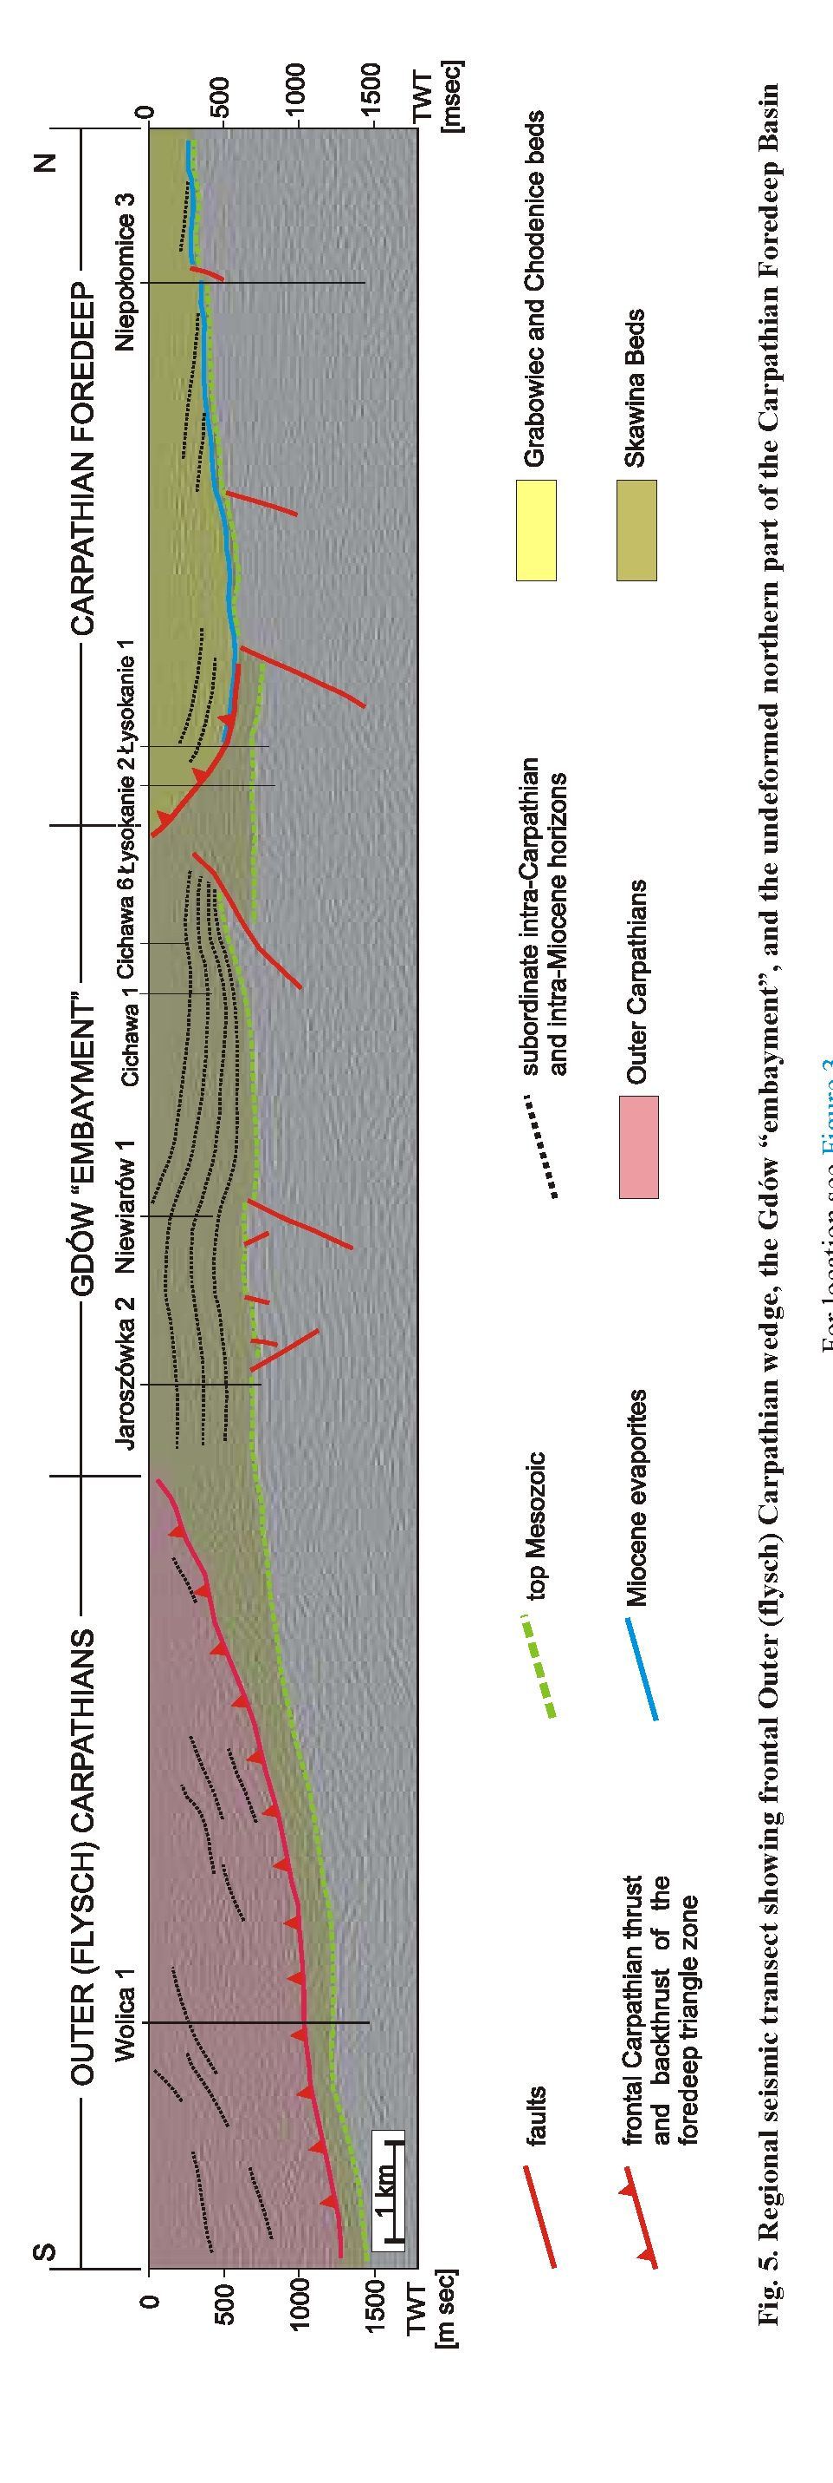
Structure and Miocene evolution of the Gdów tectonic “embayment” (Polish Carpathian Foredeep)... 913
The general structure of the study area is shown on a re-
gional seismic transect, constructed using several seismic pro-
files reprocessed by Geofizyka Kraków using original field
data (Fig. 5). It shows three main structural domains, important
for the analysis described in this paper:
- frontal part of the Outer (fysch) Carpathians,
- Gdów “embayment”,
- northern part of the Carpathian Foredeep.
The frontal Outer Carpathian thrust sheet is strongly inter-
nally deformed, but its structure and evolution has not been a
focus of this paper, and consequently, it was treated en bloc as a
tectonic block that was thrust to the north during the final stages
of the Carpathian collision. Within the Gdów “embayment”,
resotution of the seismic data is significantly higher and one
can observe there numerous fairly continuous seismic reflec-
tors that precisely depict the internal geometry of this part of
the Carpathian thrust belt. Stratigraphic information from nu-
merous boreholes as well as published results of earlier strati-
graphic studtes show that all the Miocene deposits that cover
the Meso-Paleozoic basement of the Gdów “embayment”
should be regarded as sub-evaporitic Skawina Beds (cf. Buko-
wski et al., 2010). Overall thickness changes in the sub-evapo-
ritic Miocene succession within the Gdów “embayment” show
a gradual thickness increase generally towards the south. There
are also clearly visible faults within the Meso-Paleozoic base-
ment (Fig. 5). One fault, located in the northern part of the
Gdów “embayment”, may be classified as a low-angle thrust
fault that carries Mesozoic (Jurassic) rocks towards the north,
above the Skawina Beds (Figs. 5 and 6). Along the trailtng
edge of the Gdów “embayment” (vicinity of the Łysokanie 1
and 2 boreholes) foredeep evaporites together with overtytng
Chodenice and Grabowiec beds are uptifted, and the overall
structure may be described as a triangle zone, filled by de -
formed Skawina Beds, with the backthrust developed along the
ductile evaporitic level. Farther to the north, sub-evaporitic de-
postts are rather thin and form only a thin veneer above the
Meso-Paleozoic basement. The supra-evaporitic Chodenice
and Grabowiec beds make up the bulk of the foredeep deposits
in this part of the foredeep basin. They have not undergone any
significant compressional deformation during the final Carpa-
thian thrusting movements. They are characterized by an ap-
proximately internal configuration parallel to the evaporites
and deeper basement, and, farther to the north, by an inclined
seismic pattern, with a clearly visible angular unconformity
above the evaporites. Such internal geometry could be inter-
preted as an effect of overall sedi ment progradation from the
south towards the north, simttarly to the depositional model
proposed for the part of the foredeep located more to the east, in
the Wojnicz-Tarnów area (Krzywiec, 2001; cf. Oszczypko et
al., 2006).
Two other seismic profiles have been selected to more pre-
cisely iltustrate the internal structure of the Gdów “embay t
ment” (Fig. 6). The first of them (Fig. 6A) is located in its more
central part and is calibrated by several boreholes (cf. Fig. 3).
The Książnice 2 borehole provides crucial stratigraphic infor-
mation on the precise location of the low-angle thrust fault de-

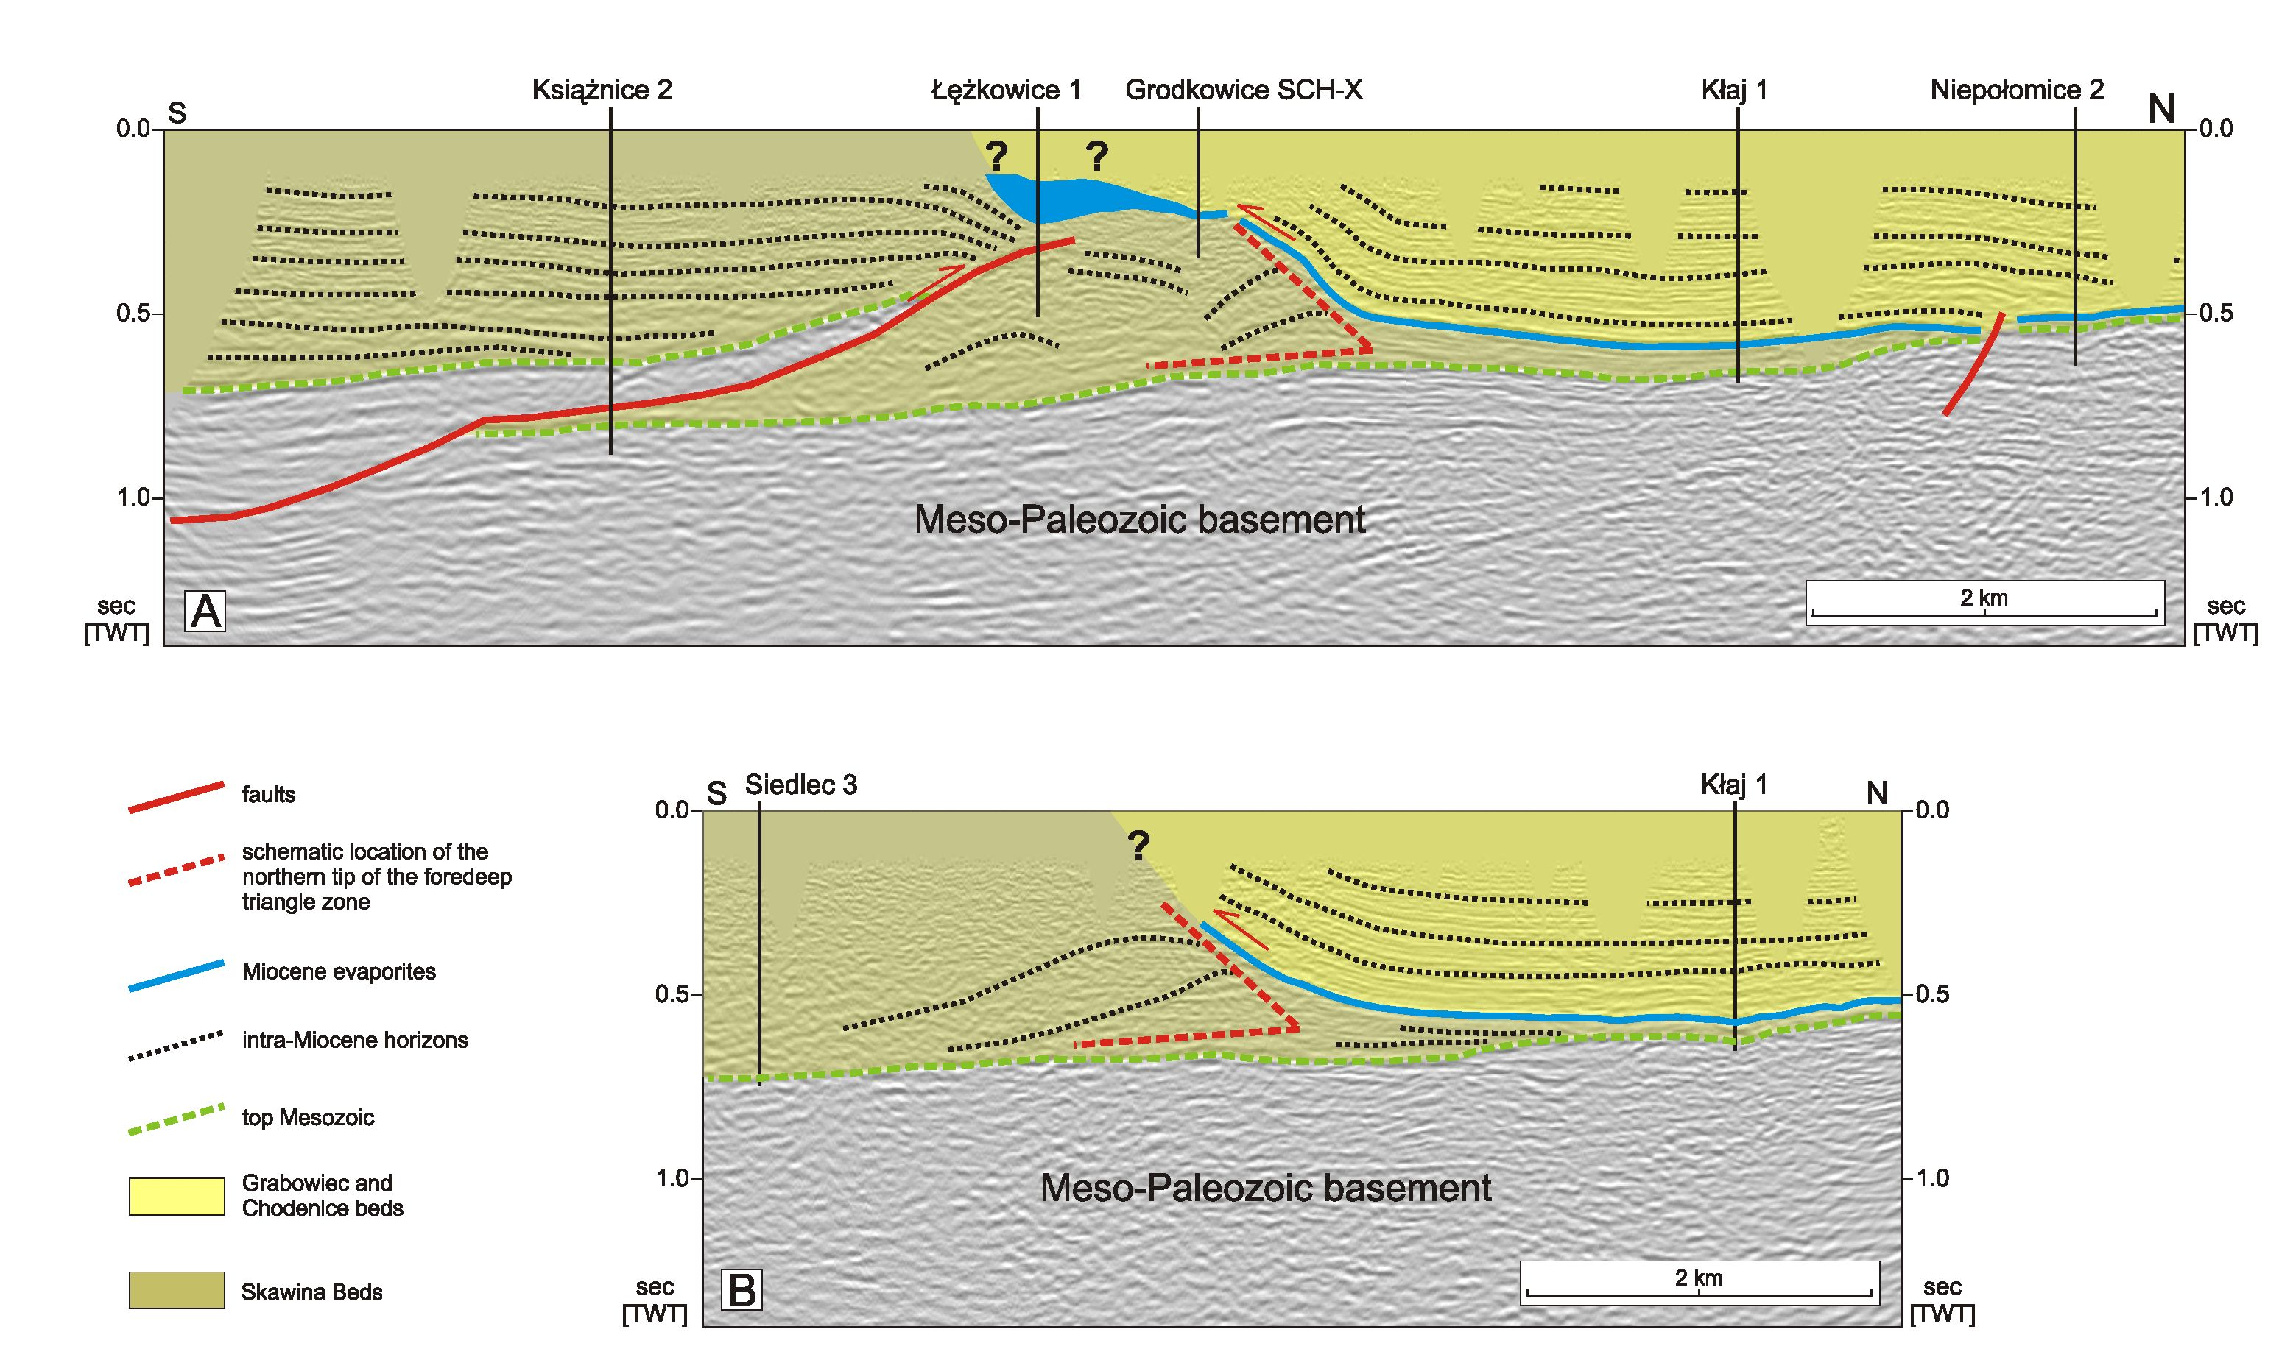
Fig. 6. Interpreted seismic profiles
A - central part of the Gdów “embayment”. Note that due to the low quality of seismic data at shallower levels, structural interpretation of the Łężkowice-Grodkowice area, recognized from numerous boreholes
drilled during exploration for rock salt, should be regarded as a first-order approximation only, partly based on published models (Garlicki, 1971); on this profile, as in the regional seismic transect shown on Fig-
ure 5, thick-skinned thrust faulting rooted in the Meso-Paleozoic basement can be observed. Such thrust faulting, confirmed also by several boreholes, has been already indicated by earlier studies (e.g., Połtowicz,
1962, 1991, 2004; Garlicki, 1971; Poborski and Jawor, 1987, 1989); B - eastern edge of the Gdów “embayment”; in this area, no thick-skinned thrust faulting has been observed within the Meso-Paleozoic base-
ment; for lo cation see Fig ure 3
914 Piotr Krzywiec, Krzysztof Bukowski, Nestor Oszczypko and Aleksander Garlicki

Structure and Miocene evolution of the Gdów tectonic “embayment” (Polish Carpathian Foredeep).
915
tached with the deeper (sub-Miocene) basement. Boreholes
from the Łężkowice-Grodkowice area provided information
on deformed thick evaporites located at shaltow depths (cf.
Garlicki, 1971). It should be stressed, however, that due to the
low quality of seismic data at shallower levels, the exact struc-
tural interpretation of the evaporites in the Łężkowice-Grod-
kowice area should be regarded as a first-order approximation
only, partly based on pubtished models (Garlicki, 1971). The
Skawina Beds within the Gdów “embayment” are generally
only gently deformed and preserve pre-deformational internal
depositional geometry. The only exception is the most northern
tip of the “embayment”, where all the Miocene depostts are
strongly deformed. Evaporites with their siliciclastic cover of
the Chodenice and Grabowiec beds are concordantly uplifted
along the trailing edge of the Gdów “embayment”, similarly to
what has been ob terved on the regional transect detcribed
above (Fig. 5). Farther to the north, evaporites are underlain
only by a thin veneer of the sub-evaporitic depostts. A very
similar structure of the Miocene foredeep deposits could be ob-
served on the second profile, located within the eastern part of
the Gdów “embayment” (Fig. 6B). On this profile one can also
observe thick Skawina Beds, stratigraphicaly documented by
the Siedlec 3 borehole (Łuczkowska, 1958), that along the
trailtng edge of the Gdów “embayment” are compressionally
deformed. Above this zone of relatvely strong deformation,
evaporites together with the supra-evaporitic Chodenice and
Grabowiec beds are locally uplifted. The main difference be-
tween these two profiles is the presence (Fig. 6A) or lack (Fig.
6B) of the thick-skinned thrust faults rooted within the Meso-
Paleozoic basement. The triangular geometry of the zone of the
deformed Skawina Beds beneath the uptifted evaporites and
supra-evaporitic siliciclastics may be interpreted, simttarly to
what has been described above for the regional seismic
transect, as a triangle zone related to the wedge tectonics active
during last stages of the Carpathian thrusting (cf. Krzywiec et
al., 2004, Krzywiec and Vergés, 2007). Supra-evaporitic
siliciclastic deposits are backthrust towards the south along the
detachment related to the foredeep evaporites. Seismic imaging
of the triangle zone itself is not very good, although one can ob-
serve traces of fold structures present in the northern corner of
the triangle zone.
MIOCENE EVOLUTION OF THE GDÓW
“EMBAYMENT” AREA - A MODEL
A general model for the Miocene evotuton of the Gdów
“embayment” was constructed using the interpreted seismic data
described above and is shown on Figure 7. Itwas constructedus-
ing the central part of the regional transect from Figure 5.
The model consists of three main stages, each associated
with development of the three main building blocks of the sedi-
mentary infill of this part of the Carpathian Foredeep: the
Skawina Beds, the evaporitic Wieliczka Formation and finally
the Chodenice and Grabowiec beds of the Machów Formation
(cf. Fig. 2).
The first stage of evolution of the Gdów “embayment” was
associated with deposition of the Skawina Beds (Fig. 7A).
These are mostly clayey-sandy deposits, but significant in
crease in coarser maierial could be observed in the southern
part of the “embayment” (Doktor, 1983). The thick (up to
1000 m) Lower Badenian Skawina Beds within the Gdów
“embayment” have their stratigraphic equivaient in the more
northern part of the Carpathian Foredeep Basin i.e. the
Baranów Beds (cf. Oszczypko et al., 2006). They are, however,
characterized by much smaller thickness, ca. 30-40 m or less
(Ney et al., 1974) and are schematically shown on Figure 7A as
a very thin veneer of siliciclastic deposits developed above the
Meso-Paleozoic basement. The reconstructed geometry of the
Gdów “embayment” during deposition of the Skawina Beds
(Fig. 7A) suggests that increased thickness of the sedimentary
infill was controlled by localized tectonic activity of this part of
the foredeep basin. Some sub-Miocene faults might have di-
rectly controlled deposition of the Skawina Beds; additionally,
flexural subsidence was responsible for a general thickness in-
crease towards the south, i.e. towards the Carpathians. The
presence of coarser material in the southern part of the Skawina
Beds within the Gdów “embayment” clearly indicates relai
tively short transport and proximity of the source area i.e.
emerged Carpathian thrust sheets (Alexandrowicz, 1965;
Doktor, 1983).
During the next stage of development of the Gdów
“embayment”, upper Badenian evaporites of the Wieliczka
Formation were deposited (Fig. 7B). Their inferred thickness is
smaller than the thickness of the underiying Lower Badenian
Skawina Beds; they are, however, also characterized by lateral
thickness variations, similarly to the Skawina Beds. Within the
Gdów “embayment” evaporites might have attained larger
thickness, while towards the north they form a generally thin
veneer. It is postulated that such local thickness increase of the
evaporitic cover within the Gdów “embayment” areas was also
reiated to tectonic activity of some basement faults (cf. Fig.
7B). Such model is fully compatible with the earlier model pro-
posed by Garlicki (1971) for the Łężkowice area.
The third stage of the proposed evolution of the area of the
present-day Gdów “embayment” shown on Figure 7C was as-
sociated with deposition of the Chodenice and Grabowiec beds
of the Machów Formation (cf. Fig. 2). These deposits have
been generally shed towards the Carpathian Foredeep Basin
from the emerged and eroded Carpathians (e.g., Oszczypko et
al., 2006). Within the present-day southern and central parts of
the basin they are characierized by an overall progradational
pattern directed towards the north (cf. Krzywiec, 2001;
Porębski et al., 2002; Porębski and Steel, 2003). Such general
depositional architecture of the supra-evaporitic siliciclastic
cover of the Carpathian Foredeep in front of the Carpathian
thrust belt is clearly visible on the regional transect in Figure 5.
Within the Gdów “embayment” area, due to the later uplift
and erosion (see below), only evaporites are locally preserved
at the surface (cf. Bukowski et al., 2010).
During the final stages of development of the Carpathian
fold-and-thrust wedge the previously subsiding Gdów
“embayment” area was uplifted and basement faults were reac-
tivated either as reverse or as low-angle thrust faults. As a result
of this upiift, the entire foredeep succession deposited above
the Skawina Beds (i.e., evaporites of the Wieliczka Formation
and siliciclastics of the Machów Formation) has been removed
by erosion. Only evaporites were locally preserved and may be
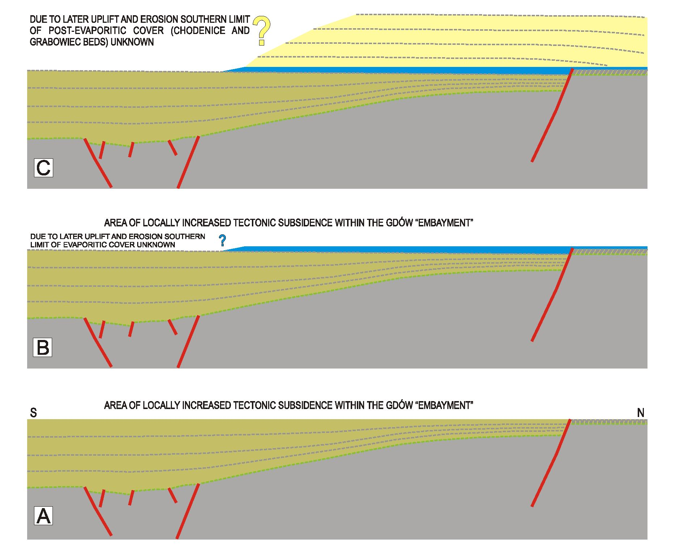
916
Piotr Krzywiec, Krzysztof Bukowski, Nestor Oszczypko and Aleksander Garlicki
Fig. 7. Quantitative model of the three main stages of the Miocene evolution of the Gdów “embayment”
A - deposition of the Skawina Beds. Note that the lateral northern equivalent of this relatively thick infill of the Gdów “embayment”
was also deposited but is characterized by relatively small thickness; B - deposition of evaporites of the Wieliczka Formation.
Within the Gdów “embayment” they might have been characterized by increased thickness that later led to development of the
Łężkowice rock salt deposit characterized by strong internal compressional deformation (Garlicki, 1960, 1971). Later uplift of the
axial part of the Gdów “embayment” and subsequent erosion removed the southern part of the evaporitic cover, its exact southern
edge not being known precisely (cf. Poltowicz, 1994); C - deposition of the Chodenice and Grabowiec beds, with inferred general
sediment supply from the south (cf. Krzywiec, 2001; Oszczypko et al., 2006)
found at the surface in parts of the Gdów “embayment” area
(see Bukowski et al., 2010 for more detailed description).
During final thrusting movements within the Carpathians, a
triangle zone developed along the leading edge of inverted
structure of the Gdów “embayment”. Its formation was most
probably influenced by the lateral thickness and facies changes
in the transition zone between the “embayment” area character-
ized by thicker evaporites and the area located to the north,
characterized by much thinner evaporitic cover. Such lateral
changes of detachment level very often trigger formation of tri-
angle zones (cf. Krzywiec and Aleksandrowski, 2004). Back-
thrust of the triangle zone present along the northern edge of
the Gdów “embayment” formed along the evaporitic level
(Figs. 5 and 6). Locally, during suchbackthrusting, over thick-
ened evaporites formed in tectoni cally-controlled depression
within the Gdów “embayment” area (Fig. 7B) have been
strongly folded and internally deformed. Such deformations
are documented by numerous boreholes from the Ciężko-
wice-Grodkowice area (Garlicki, 1971).
DISCUSSION AND CONCLUSIONS
The model of evotution of the Gdów “embayment” pre -
sented in this paper was constructed using relatively good qual-
ity seismic data calibrated by numerous boreholes and augt
mented by surface geotogical data. To a large degree, it sup-
ports one of the eartier models postulated by Garlicki (1971),
and that was later challenged (Poborski and Jawor, 1987, 1989;
Poltowicz, 1991, 2004). In this model, the sedimentary infill of
the Gdów “embayment” consists of the Skawina Beds, with
only locally preserved remnants of the evaporitic cover at the
surface. The formation of such thick Lower Badenian sili-
ciclastic deposits has been attributed to localized tectonically-
controlled subsidence, exerted either by local fault activity or
by flexure of the lower plate under the advancmg Carpathian
orogenic wedge. The next stage of the Miocene evotution of
this area includes a phase of deposition of the evaporitic cover
that was also characterized by larger thickness within the Gdów
“embayment” due to continuing locally increased and tectoni-

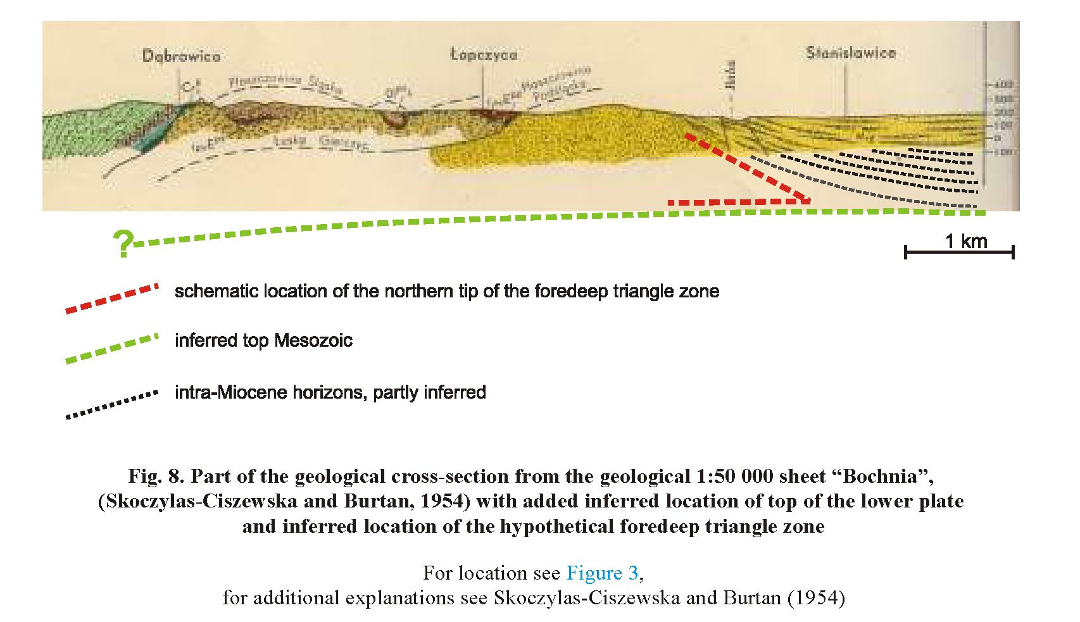
Structure and Miocene evolution of the Gdôw tectonic “embayment” (Polish Carpathian Foredeep).
917
cally-controlled subsidence. The evaporites were overlain by
siliciclastic deposits of the Machów Formation (Chodenice and
Grabowiec beds) during the third stage of development of the
study area. This siliciclastic cover was derived from the
emerged and eroded Carpathian orogenic wedge. It should be
however stressed that, due to late- and post-orogenic uplift and
erosion, the second and third stages should be regarded as more
conjectural than based on qualitative reconstructions.
The proposed model for development of the Gdów “emi
bayment” includes also formation of the triangle zone along its
northern edge during the last thrusting movements of the Carpa-
thian orogenic wedge. This part of the model, based on reinter-
preted seismic data and with reference points provided by mod-
els for the Wojnicz (Krzywiec et al., 2004) and Wieliczka
(Krzywiec and Verges, 2007) areas, is novel and different from
all previously published models. However, in this conlext it is
worth mentioning that the proposed structural interpretation of
the northern edge of the Gdów “embayment” based on seismic
data is in good agreement with the much earlier structural model
of this area proposed by Skoczylas-Ciszewska and Burtan
(1954; Fig. 8). On this cross-seclion one can obierve a su
pra-evaporitic Miocene cover conformably uplifted above the
older strongly deformed foredeep Miocene deposits. Due to the
lack then of deeper wells in this area, and the lack of reliable
subsurface geophysical (seismic) data Skoczylas-Ciszewska and
Burtan (1954) did not show the top of the sub-Miocene Meso-
Paleozoic basement - Figure 7 shows its conjectural configura-
tion. The key element of reinterpretation of this geological
cross-seclion, shown on Figure 7, is the presence of a triangle
zone along the leadlng (northern) edge of the Gdów “embay-
ment”, identical to the model proposed uslng seismic data and
described in this paper. It should be also stressed that geological
maps from the mid-XXth century were based on a large amount
of surface geological data that are presently mostly unavailable
due to increased surface anthropogenic infrastructure. Therefore,
the geometry of the supra-evaporitic succession, concordantly
uplifted towards the surface along the presumed backthrust de-
veloped within the frontal part of the Gdów “embayment”
shown by Skoczylas-Ciszewska and Burtan (1954; Fig. 7) on
their cross-section, should be regarded as generally reliable. This
shows, together with the recent findlngs of Bukowski et al.
(2010), that surface data support the model of the Gdów triangle
zone filled by deformed Skawina Beds proposed in this paper.
Acknowledgements. This work has been carried out
within the research proj ect No 6 T12 2005 C/06569 funded
jointly by PGNiG S.A. and the Ministry of Science and Higher
Education. PGNiG S.A.is thankedforproviding access to seis-
mic data. A. Wysocka (University of Warsaw, Warsaw) and
J. Verges (Institute of Earth Sciences “Jaume Almera”, Barce-
lona) are thanked for their thorough reviews that greatly helped
to finally shape this paper.
REFERENCES
ABELS H.A., HILGEN F.J., KRIJGSMAN W., KRUK R.W., RAFFI I.,
TURCO E. and ZACHARIASSE W.J. (2005) - Long-period orbital
control on middle Miocene global cooling. Integrated stratigraphy and
astronomical tuning of the Blue Clay Formation on Malta.
Paleoceanography, 20 (4): 1-17.
ALEXANDROWICZ S.W. (1963) - Zarys stratygrafii miocenu okolic
Krakowa. Spraw. Pos. Kom. Nauk. PAN, Oddz. w Krakowie, 17:
520-523.
ALEXANDROWICZ S.W. (1965) - La Molasse miocene aux environs de
Gdów. Bull. Acad. Pol. Sc., 13: 49-57.

91S
Piotr Krzywiec, Krzysztof Bukowski, Nestor Oszczypko and Aleksander Garlicki
ALEXANDROWICZ S.W., GARLICKI A. and RUTKOWSKI J. (19S2) -
Podstawowe jednostki litostratygraficzne miocenu zapadliska
przedkarpackiego. Kwart. Geol., 26 (2): 470-471.
ANDREYEVA-GRIGOROVICH A.S., OSZCZYPKO N., ŚLĄCZKA A.,
SAVITSKAYA N.A. and TROFIMOVICH N.A. (2003) - Correlation
of the Late Badenian salts of the Wieliczka, Bochnia and Kalush areas
(Polish and Ukrainian Carpathian Foredeep). Ann. Soc. Geol. Pol., 73:
67-S9.
BĄBEL M. (2004) - Badenian evaporite basin of the northern Carpathian
Foredeep as a drawdown salina basin. Acta Geol. Pol., 54: 313-337.
BICCHI E., FERRERO E. and GONERA M. (2003) - Paleoclimatic inter-
pretation based on Middle Miocene planktonic foraminifera: the
Silesian Basin (Paratethys) and Monferrato (Tethys) record.
Palaeogeogr. Palaeoclimatol. Palaeoecol., 196: 263-303.
BUKOWSKI K. (2011) - Badenian saline sedimentation between Rybnik
and Dębica based on geochemical, isotopic and radiometric research
(in Polish with English summary). Dissert. Monogr., 236: 1-1SS.
BUKOWSKI K., de LEEUW A., GONERA M., KUIPER K.F.,
KRZYWIEC P. and PERYT D. (2010) - Badenian tuffite levels within
the Carpathian orogenic front (Gdów-Bochnia area, Southern Poland):
radio-isotopic dating and stratigraphic position. Geol. Quart., 54 (4):
449-464.
DE LEEUW A., BUKOWSKI K., KRIJGSMAN W. and KUIPER K.F.
(2010) - Age of the Badenian salinity crisis; impact of Miocene cli-
mate variability on the circum-Mediterranean region. Geology, 38:
715-71S.
DOKTOR M. (19S3) - Sedimentation of Miocene gravel deposits in the
Carpathian Foredeep (in Polish with English summary). Studia Geol.
Pol., 68: 6-107.
D’OBYRN K. and PRZYBYŁO J. (2010) - Rozpoznanie geologiczne
złoża soli kamiennej „Wieliczka” do 1945 roku. Prz. Górn., (3-4):
110-121.
GARLICKI A. (1960) - Rock salt deposit Łężkowice-Siedlec in Gdów
“bay” (in Polish with English abstract). Prz. Geol., 8 (1): 43-45.
GARLICKI A. (1971) - Rock salt deposit at Łężkowice on Raba (in Polish
with English summary). Kwart. Geol., 15 (4): 930-946.
GARLICKI A. (1979) - Sedimentation of Miocene salts in Poland (in Pol-
ish with English summary). Pr. Geol., 119: 1-66.
GĄGAŁA Ł., VERGÉS J., SAURA E., MALATA T., RINGENBACH J-C.,
WERNER P. and KRZYWIEC P. (2012) - Architecture and orogenic
evol ut ion of the northeastern Outer Carpathians from cross-sect ion
balancing and forward modeling. Tectonophysics, 532-535: 223-241
GONERA M. (1994) - Palaeoecology of marine Middle Miocene (Bade-
nian) in the Polish Carpathians (Central Paratethys). Foraminifera re-
cord. Bull. Pol. Acad. Sc. Earth Sc., 42 (2): 107-125.
GONERA M. and BUKOWSKI K. (2012) - Isotopic events in the
Early/Middle Badenian (Miocene) of Silesia Balin (Cenlral Paral
tethys). Geol. Quart., 56 (3): 561-56S.
GONERA M., OSZCZYPKO N. and ZUCHIEWICZ W. (1990) - Profil
utworów badeńskich w rejonie Wrząsowic na SE od Krakowa.
Sprawozd. Pos. Kom. Nauk Geol. PAN Oddz. w Krakowie, 34 (1/2):
211-215.
GONERA M., PERYT T.M. and DURAKIEWICZ T. (2000) -
Bi o strati graphical and palaeoenvironmental implications of isotopic
stud ies ^{1S}O, ¹³C of middle Miocene Badenian foraminifers in the Cen-
tral Paratethys. Terra Nova, 12: 231-23S.
HILGEN F.J., ABELS H.A., IACCARINO S., KRIJGSMAN W., RAFFI
I., SPROVIERI R., TURCO E. and ZACHARIASSE W.J. (2009) -
The Global Stratotype Section and Point (GSSP) of the Serravallian
Stage (Middle Miocene). Episodes, 32: 152-166.
HRDINA J.N. and HRDINA L.E. (1S42) - Geschichte der Wieliczkaer Sa-
line. Wien. Carl Gerold: 274 pp.
JASIONOWSKI M. (1997) - Lithostratigraphy of the Miocene deposits in
the eastern part of the Carpathian Foredeep (in Polish with English ab-
stract). Biul. Państw. Inst. Geol., 375: 43-60.
JASIONOWSKI M. and PERYT T.M. (2010) - Isotopic composition of
do lo mite as so ci ated with Mid dle Mio cene Badenian anhydrites in the
Carpathian Foredeep Basin of SE Poland. Geol. Quart., 54 (4):
533-54S.
JONES P. (1997) - The Carpathians of the southern Poland: thrust tecton-
ics or wedge tecton i cs (abs.): 1997 AAPG International Conference
and Exhibition, Austria, Vienna, Abstract book: A27-A28.
KASPRZYK A. (1993) - Lithofacies and sedimentation of the Badenian
(middle Miocene) gyptum in the northern part of the Carpathian
Foredeep, southern Poland. Ann. Soc. Geol. Pol., 63: 33-84.
KOTLARCZYK J. (1985) - An outi ine of the stratigraphy of Marginal
Tectonic Units of the Carpathian Orogene in the Rzeszów-Przemyśl
area. In: Geotraverse Kraków-Baranów-Rzeszów-Przemyśl-
- Komańcz a-Dukla. Guide to excursion 4 (ed. J. Kotlarczyk): 21-32.
XIII Congr. Carpath.-Balkan Geol. Ass., Cracow, Poland.
KOVÂC M., NAGYMAROSY A., OSZCZYPKO N., ŚLĄCZKA A.,
CSONTOS L., MARUNTEANU M., MATENCO L. and MARTON E.
(1998) - Palinspastic re con struction of the Carpathian-Pannonian re-
gion during the Miocene. In: Geodynamic Development of the West-
ern Carpathians: Bratislava (ed. M. Rakus): 189-217. Slovak Geologi-
cal Survey.
KRZYWIEC P (2001) - Contrasting tectonic and sedimentary history of
the central and eastern parts of the Polish Carpathian Foredeep Basin -
results of seismic data interpretation. Mar. Petrol. Geol., 18 (1): 13-38.
KRZYWIEC P. and ALEKSANDROWSKI P (2004) - Wedge tectonics
and triangle zones - basic concepts (in Polish with English abstract).
Prz. Geol., 52 (10): 985-989.
KRZYWIEC P and VERGÉS J. (2007) - Role of the foredeep evaporites
in wedge tectonics and formation of triangle zones: Comparison of the
Carpathian and Pyrenean Thrust Fronts. In: Thrust Belts and Foreland
Basins - from Fold Kinematics to Petroleum Systems (eds. O.
Lacombe, J. Lavé, F. Roure and J. Vergés): 383-394. New Frontiers in
Earth Sciences, Springer Verlag.
KRZYWIEC P., ALEKSANDROWSKI P., FLOREK R. and SIUPIK J.
(2004) - The structure of the Outer Carpathian orogenic front: an ex-
ample of the Miocene Zgłobice unit between Brzesko and Wojnicz -
new data, new models, new questions (in Polish with English
summary). Prz. Geol., 52 (11): 1051-1059.
KUCZKOWSKA E. (1958) - The Miocene microfauna of the Carpathian
Foredeep (in Poli sh with Engl ish summary). Kwart. Geol., 2 (1):
105-126.
MORYC W. (1970a) - Katalog wierceń Górnictwa Naftowego w Polsce.
Przedgórze Karpat - część zachodnia, t. I, cz. 3. Wyd. Geol., War-
szawa.
MORYC W. (1970b) - Katalog wierceń Górnictwa Naftowego w Polsce.
Przedgórze Karpat - część zachodnia, t. I, cz. 4. Wyd. Geol., War-
szawa.
NEY R., BURZEWSKI W., BACHLEDA T., GÓRECKI W., JAKÓBi
CZAK K. and SŁUPCZYŃSKI K. (1974) - Outi ine of paleogeo-
graphy and evolution of lithology and facies of Miocene layers in the
Carpathian Foredeep (in Polish with English summary). Pr. Geol., 82:
1-65.
NIEDŹWIEDZKI J. (1883-1886) - Stosunki geologiczne formacyi
solonośnej Wieliczki i Bochni. Kosmos, 8 (1883): 137-159, 387-401,
483-492; 9 (1884): 565-580, 717-743; 11 (1886): 137-155.
OLEWICZ Z.R. (1973a) - Geology of the Fore-Carpathian region between
Wieliczka and Bochnia (in Poli sh with Engl ish summary). Pr. Inst.
Naft.
OLEWICZ Z.R. (1973b) - Tectonic structure of the Bochnia Unit and of
the marginal part of the Silesian Unit beiween the rivers Raba and
Uszwica (in Polish with English summary). Acta Geol. Pol., 23 (4):
701-761.
OSZCZYPKO N. (1997) - The Early-Middle Miocene Carpathian periph-
eral forei and bai in (Western Carpathians, Poi and). Prz. Geol., 45:
1054-1063.
OSZCZYPKO N. (1998) - The Western Carpathian foredeep-devel op ment
of the foreland basin in front of the accretionary wedge and its burial
history (Poland). Geol. Carpath., 49: 1-18.
OSZCZYPKO N. (1999) - The Miocene subsidence of the Polish
Carpathian Foredeep (in Polish with English summary). Pr. Państ. Inst.
Geol., 168: 209-230.
OSZCZYPKO N. and OSZCZYPKO-CLOWES M. ( 2012) - Stages of de-
velopment in the Poli sh Carpathian Foredeep Basin. Centr. Eur. J.
Geosc., 4 (1): 138-162.
Structure and Miocene evolution of the Gdów tectonic “embayment” (Polish Carpathian Foredeep).
919
OSZCZYPKO N., OLSZEWSKA B., ŚLĘZAK J. and STRZĘPKA J.
(1992) - Miocene marine and brackish deposits of the Nowy Sącz ba-
sin (Polish Western Carpathians) - new lithostratigraphic and biostra-
tigraphic standards. Bull. Pol. Acad. Sc., Earth Sc., 40: 83-96.
OSZCZYPKO N., KRZYWIEC P, POPADYUK I. and PERYT T. (2006) -
Carpathian Foredeep Basin (Pol and and Ukraine) - its sediment ary,
structural and geodynamic evolution. AAPG Mem., 84: 293-350.
OSZCZYPKO-CLOWES M. OSZCZYPKO N. and WÓJCIK A. (2009) -
New data on the late Badenian-Sarmatian deposits of the Nowy Sacz
Basin (Magura Nappe, Polish Outer Carpathians) and their palaeogeo-
graphical implications. Geol. Quart., 53 (3) 273-292.
PERYT D. (1997) - Calcareous nannoplankton stratigraphy of the Middle
Miocene in the Gliwice area (Upper Silesia, Poland). Bull. Pol. Acad.
Sc., Earth Sc., 45: 119-131.
PERYT D. and GEDL P. (2010) - Palaeoenvironmental changes preceding
the Middle Miocene Badenian sal inlty crisis in the northern Poll sh
Carpathian Foredeep Basin (Borków quarry) inferred from
foraminifers and dinoflagellate cysts. Geol. Quart., 54 (4): 487-508.
PERYT T.M. (2006) - The beginning, development and termination of the
Mid dle Mio cene Badenian salinity crisis in Central Paratethys. Sedim.
Geol., 188-189: 379-396.
PERYT T.M., HAŁAS S., KAROLI S. and PERYT D. (1997) - Isotopic re-
cord of environmental changes during deposition of Badenian (Middle
Miocene) gypsum at Koberice near Opava (Czech Republic) (in Polish
with English summary). Prz. Geol., 45 (8): 807-811.
POBORSKI J. (1965) - Historical development of views on the geological
structure of the salt beds of Wieliczka (in Polish with Engl ish sum-
mary). Studia i materiały do dziejów żup solnych w Polsce, 1: 37-54.
POBORSKI J. and JAWOR E. (1987) - Old basement of the Miocene
salt-bearing formation in the vicinities of Gdów (Podkarpacie Ret
gion). Bull. Acad. Pol. Sc., 35 (3): 215-219.
POBORSKI J. and JAWOR E. (1989) - Notes on the Cracow
sub-Carpathian tectonics (in Polish with English summary). Prz.
Geol., 37 (6): 308-311.
POŁTOWICZ S. (1962) - Outline of the tectonic structure of the Bay of
Gdów. Bull. Acad. Pol. Sc., Ser. Sc. Geol. Geogr., 10 (1): 53-60.
POŁTOWICZ S. (1991) - Miocene of the Carpathian Zone between
Wieliczka and Dębica (in Polish with English summary). Geologia, 17
(3): 19-57.
POŁTOWICZ S. (1994) - Znaczenie badeńskiej formacji solonośnej w
tektogenezie polskich Karpat brzeżnych. Geologia. Kwart. AGH, 20
(1): 59-76.
POŁTOWICZ S. (2004) - The Stebnik and Zgłobice Units in the Polish
Carpathians structure (in Polish with English summary). Geologia, 30
(1): 85-120.
PORĘBSKI S. and STEEL R.J. (2003) - Shelf-margin deltas: their strati-
graphic significance and relation to deepwater sands. Earth-Sc. Rev.,
62: 283-326.
PORĘBSKI S., PIETSCH K., HODIAK R. and STEEL R.J. (2002) - Ori-
gin and sequential development of Badenian-Sarmatian clinoforms in
the Carpathian forel and basin (SE Poland). Geol. Carpath., 54 (2):
119-136.
PUSCH G.G. (1824) - Geognostisch-bergmännische Reise durch einen
Theil der Karpathen, Ober- und Nieder-Ungarn ausgestellt im Jahre
1821. Johann Ambrosius Barth, Leipzig.
RAFFI I., BACKMAN J., FORNACIARI E., PALIKE H., RIO D.,
LOURENS L. and HILGEN F. (2006) - A review of calcareous
nannofossil astrobiochronology encompassing the past 25 million
years. Quatern. Sc. Rev., 25/23-24: 3113-3137.
SCHOBER C.G. (1750) - Physikalische Nachricht von den pohlnischen
Salzgruben Wieliczka und Bochnia. Hamburgisches Magazin, 16:
115-155. Hamburg.
SKOCZYLAS-CISZEWSKA K. and BURTAN J. (1954) - Szczegółowa
mapa geologiczna Polski w skali 1:50 000, ark. Bochnia (M34-77B).
Inst. Geol., Warszawa.
TOWNSON R. (1797) - Travels in Hungary with a short account of Vienna
in the year 1793. G.G. and J. Robinson, London, 506 pp.
ŚLIWIŃSKI M., BĄBEL M., NEJBERT K., OLSZEWSKA-NEJBERT D.,
GĄSIEWICZ A., SCHREIBER B.C., BENOWITZ J.A. and LAYER P
(2012) - Badenian-Sarmatian chronostratigraphy in the Polish Carpa-
thian Foredeep. Palaeogeogr. Palaeoclimatol. Palaeoecol., 326—328:
12-29.
UHLIG V. (1903) - Bau und Bild der Karpaten. V. Tempsky und G.
Freytag, Wien und Leipzig.
ŻYTKO K., GUCIK S., RYŁKO W., OSZCZYPKO N., ZAJĄC R.,
GARLICKA I., NEMCOK J., ELIAS M., MENCIK E., DVORAK J.,
STRANIK Z., RAKUS M. and MATEJOVSKA O. (1989) - Geologi-
cal map of the Western Outer Carpathians and their foreland without
Quaternary formations (1:500 000). In: Geological Atlas of the West-
ern Outer Carpathians and their Forel and (eds. D. Poprawa and J.
Nemcok). Państw. Inst. Geol., Warszawa.

