

ARTICLE
Received 5 Dec 2014 | Accepted 18 Feb 2015 | Published 26 Mar 2015^^^BDOI:10.1038/ncomms7673| OPEN

Molecular mechanisms of NET formation and
degradation revealed by intravital imaging in the
liver vasculature

Elzbieta Kolaczkowska1,2,3, Craig N. Jenne4, Bas G.J. Surewaard1, Ajitha Thanabalasuriar1, Woo-Yong Lee1,
Maria-Jesus Sanz1,5, Kerri Mowen6,7, Ghislain Opdenakker3 & Paul Kubes1
Neutrophil extracellular traps (NETs) composed of DNA decorated with histories and
proteases trap and kill bacteria but also injure host tissue. Here we show that during a
bloodstream infection with methicillin-resistant Staphylococcus aureus, the majority of bacteria
are sequestered immediately by hepatic Kupffer cells, resulting in transient increases in liver
enzymes, focal ischaemic areas and a robust neutrophil infiltration into the liver. The
neutrophils release NETs into the liver vasculature, which remain anchored to the vascular
wall via von Willebrand factor and reveal significant neutrophil elastase (NE) proteolytic
activity. Importantly, DNase although very effective at DNA removal, and somewhat effective
at inhibiting NE proteolytic activity, fails to remove the majority of histones from the vessel
wall and only partly reduces injury. By contrast, inhibition of NET production as modelled by
PAD4-deficiency, or prevention of NET formation and proteolytic activity as modelled in
NE“7“ mice prevent collateral host tissue damage.
1 Department of Physiology and Pharmacology, Calvin, Phoebe and Joan Snyder Institute for Chronic Diseases, University of Calgary, HRIC 3280 Hospital
Drive N.W., Calgary, Alberta, Canada T2N 4N1. 2 Department of Evolutionary Immunology, Institute of Zoology, Jagiellonian University, ul. Gronostajowa 9,
30-387 Krakow, Poland. 3 Laboratory of Immunobiology, Rega Institute for Medical Research, KU Leuven - University of Leuven, Minderbroedersstraat 10 blok
x - bus 1030, 3000 Leuven, Belgium. 4Department of Microbiology, Immunology and Infectious Diseases, Calvin, Phoebe and Joan Snyder Institute for
Chronic Diseases, University of Calgary, HRIC 3280 Hospital Drive N.W., Calgary, Alberta, Canada T2N 4N1. 5 Department of Pharmacology, Faculty of
Medicine, University of Valencia, Av. Blasco Ibanez 15, 46010 Valencia, Spain. 6Department of Chemical Physiology, Scripps Research Institute La Jolla,
10550 North Torrey Pines Road La Jolla, 92037 California, USA. 7 Department Immunology and Microbial Sciences, Scripps Research Institute La Jolla,
10550 North Torrey Pines Road La Jolla, 92037 California, USA. Correspondence and requests for materials should be addressed to P.K.
(email: pkubes@ucalgary.ca).
NATURE COMMUNICATIONS | 6:6673 | DOI: 10.1038/ncomms7673 | www.nature.com/naturecommunications
© 2015 Macmillan Publishers Limited. All rights reserved.
1
ARTICLE
NATURE COMMUNICATIONS | DOI: 10.1038/ncomms7673
Neutrophils are among the first non-resident, immune cell
responders of early infections1. These cells rapidly react
to infection and clear pathogens by various means
including phagocytosis, antimicrobial killing by factors released
during degranulation or through the formation of neutrophil
extracellular traps (NETs)2,3. These extracellular DNA structures
were discovered just a decade ago and their primary function has
been delineated to immobilize and kill pathogens4. Within the
bloodstream, the capture of the pathogens, for the most part,
remains a function of Kupffer cells within the liver vasculature.
These cells express a specialized pathogen receptor, the
Complement Receptor of the Immunoglobulin superfamily
(CRIg), which has evolved to catch circulating pathogens under
shear conditions5. By contrast, neutrophils are not capable of
directly catching circulating pathogens but by producing NETs,
they can increase the catching capacity of the liver6. In addition,
NETs may also have lasting effects by modulating tissue healing
and even shaping the late (adaptive) immune response1,7.
The enzymes, peptidyl arginine deiminase type IV (PAD4) and
neutrophil elastase (NE), have been implicated in the initial
decondensation of DNA and the proteolytic degradation of the
nuclear envelope8,9. The DNA is then released through lysis10,
vesicular transport and degranulation11 or by some as yet
unresolved catapulting mechanism3. Regardless, the negatively
charged DNA functions as the backbone of the NET and binds
the other NET components, potentially through positive
electrostatic charge4. These additional NET components include
nuclear proteins (histones), cytoskeletal proteins and granular
proteins, including proteases4. DNase has been shown to
completely dissolve NETs in vitro 4, and is consequently used
both in animal models12 and perhaps even clinically13,14 to
remove NETs.
Because of the cytotoxic mix of proteins and enzymes bound to
NETs, these structures have been described as a double-edged
sword, not only facilitating pathogen elimination, but also
eliciting damage to bystander cells6,15. Pathogenicity of NETs
has also been implicated in the promotion of thrombosis as
NETs serve as scaffolds for fibrin, von Willebrand factor (VWF)
and thrombus formation16. Although histones have a potent
antimicrobial action17, they can also damage and kill endothelial
and epithelial cells18,19. Another potentially harmful molecule is
the potent broad-spectrum protease NE4,20. A single drop of
plasma has an anti-proteolytic shield that can inactivate the
elastase released from millions of neutrophils, however, when
elastase was bound to DNA it preserved NE activity, as was
shown long before NETs were described21-24. This implies that
NETs might be reservoirs of active, inhibitor-insensitive NE, and
DNase could be unleashing a proteolytic storm into the
bloodstream, or could simply breakdown the NETs. However,
even this latter point, that is, are all NET components removed
with DNase, is really not known. These questions have significant
clinical relevance as DNase is given as a therapeutic agent, for
example, in cystic fibrosis patients25 and further clinical
applications may be forthcoming.
S. aureus bacteremia is one of the most common serious
bacterial infections worldwide. In the United Kingdom alone
around 12,500 cases each year are reported with an associated
30% mortality26. Of 6,697 bloodstream infections from 59
hospitals in the United States of America, S. aureus was the
most common bacterial isolate, accounting for 23% of all
episodes26. Although skin and soft tissue lesions are quite
common and still treatable, in many patients these infections lead
to bacteremia and all too often sepsis27,28. Furthermore, catheter
and heart valve colonization by S. aureus also leads to
bacteremia29 and methicillin-resistant S. aureus (MRSA) is
becoming a very significant problem in this regard. S. aureus
appears to be one of the most potent inducers of NETs11 both in
humans and mice but whether this contributes to improved
health or disease remains unclear. To study NET production,
persistence and biological importance in S. aureus bacteremia, we
used multi-laser spinning disk confocal microscopy. We detected
MRSA-induced NETs and their associated components (histones
and NE). We demonstrate that intravenous infection with MRSA,
as happens in catheter infections, vegetative growths on heart
valves or in serious skin infections, leads to rapid sequestration of
the pathogen to the liver and a neutrophil-dependent NET
formation within the liver sinusoids. This neutrophil recruitment
and subsequent NET release is associated with profound liver
injury. The development of a novel in vivo zymography assay
revealed that NE bound to DNA is protected from neutralization
by plasma. Inhibition of NE activity lining endothelium
significantly limited collateral damage. Removal of DNA with
DNase failed to remove all histones or proteases from the vascular
wall, and provided less protection than prevention of NET
formation (NE “1 ~ and PAD4 “1 ~ mice). This was because
NETs anchored to the vascular wall, in part via VWF. Our data
indicate that the effectiveness of DNase might be limited in terms
of removal of the most dangerous NET components and
advocates for inhibition of NET production.

Results
MRSA homes primarily to the liver leading to tissue damage.
Systemically injected MRSA was nearly completely cleared from
the circulation within the first 4 h and not detected by 8 h
(Fig. 1a). In investigated organs, including liver, kidney, lung and
spleen (Fig. 1b, black lines and Supplementary Fig. 1a-c) MRSA
colony-forming units (CFUs) could be detected mostly within the
first 12 h. However, at all times investigated, the liver had 25-450
times higher CFUs than any other tissue (Fig. 1b red line). This
significantly higher bacterial load was due to bacterial capture and
sequestration by liver intravascular macrophages (Kupffer
cells)30. Visualization of the liver for the first 30-60 s after MRSA
injection reveals the tremendous ability of Kupffer cells, localized
in the vasculature, to catch MRSA out of the blood stream in the
first pass (Supplementary Movie 1). This was not dependent upon
route of administration as injection via different vessels still
resulted in the majority of MRSA in the liver.
MRSA induced significant pathological changes in the liver
over the first 12-24 h post administration but rapidly resolved
thereafter. Macroscopically, white areas that appeared to lack
perfusion were noted on the surface of the liver (Fig. 1c,d), and
they correlated with increased levels of alanine transaminase
(ALT) indicative of hepatocyte necrosis (Fig. 1e). Further careful
histopathological examination revealed numerous focal loci of
necrotic hepatocytes, and infiltrating leukocytes (Supplementary
Fig. 2a). The appearance of the necrotic loci upon MRSA
treatment was observed in various strains of mice (C57Bl/6, Balb/
c and B6.129) and has previously been reported in pigs and in
humans31,32. Large liver abscesses are rare in humans33 and were
not seen in our mouse model. In intravital experiments using
FITC-albumin, these necrotic areas were found to be devoid of
any blood flow while surrounding areas were well perfused
(Supplementary Fig. 2b). In addition, MRSA infected mice
exhibited sickness behaviour (apathy, lower locomotor activity)
and loss of weight, and the latter did not fully recover even at
1 week post infection (Supplementary Fig. 3a). This dose of
MRSA (1-2 x 107) was sublethal but an increase of only 0.5-1
order of magnitude (5-10 x 107) led to 40-50% mortality over
the first 7 days (Supplementary Fig. 3b).
MRSA-induced neutrophil recruitment mediates liver damage.
Intravital microscopy of healthy uninfected livers reveals that
2
NATURE COMMUNICATIONS | 6:6673 | DOI: 10.1038/ncomms7673 | www.nature.com/naturecommunications
© 2015 Macmillan Publishers Limited. All rights reserved.
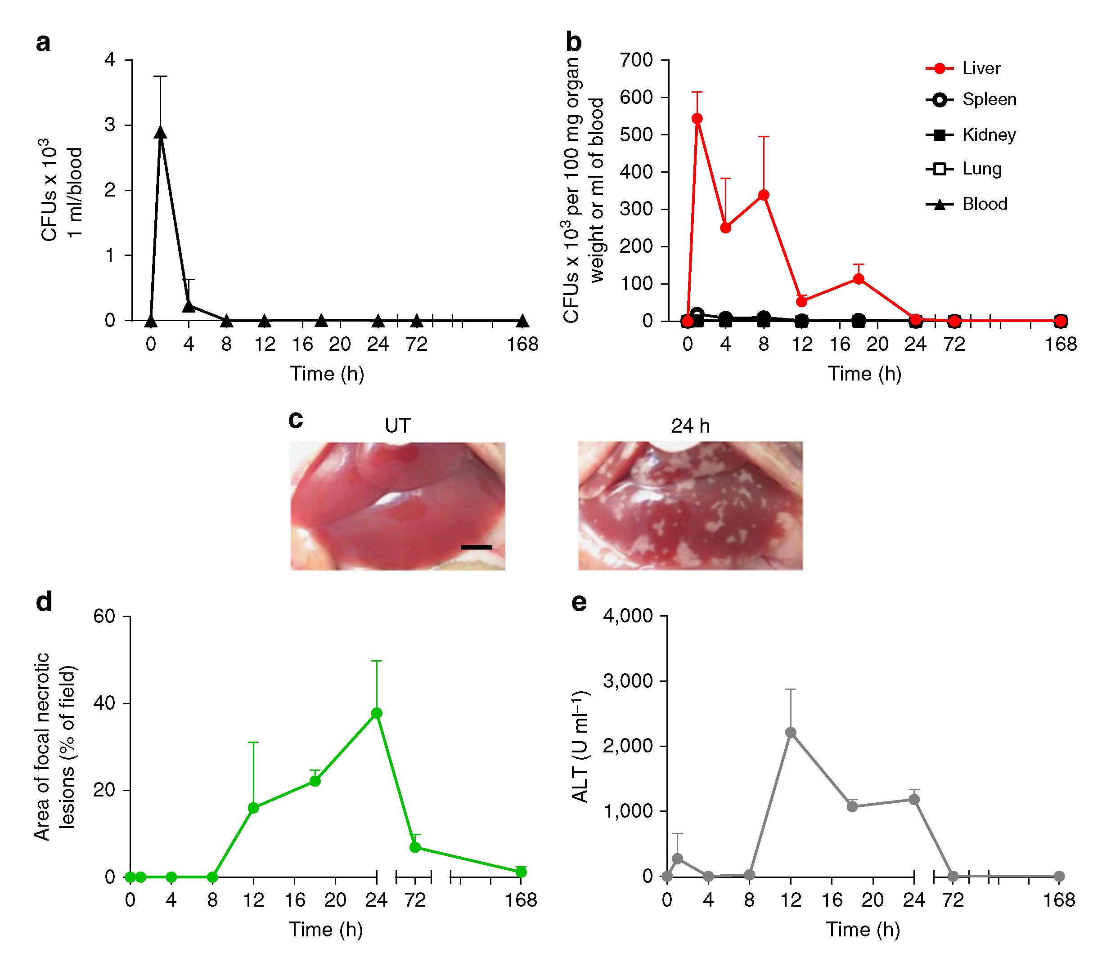
NATURE COMMUNICATIONS | DOI: 10.1038/ncomms7673
ARTICLE
Figure 1 | Systemic infection of mice with MRSA results in accumulation of bacteria in the liver and hepatic damage. Kinetic changes of the bacterial
load in the blood (a), and all tested organs (liver, spleen, kidney and lung) (b) of methicillin-resistant Staphylococcus aureus (MRSA)-infected mice
expressed as colony-forming units (CFUs). (c) Representative images of the healthy uninfected liver (untreated, UT), and liver collected from a
mouse infected 24 h earlier with MRSA. The scale bar indicates 5 mm. (d) Changes in liver morphology evaluated by ImageJ as the area covered with focal
necrotic loci, and (e) serum ALT levels were monitored in UT control (no infection) and septic mice over a period of 7 days. Data are shown as mean ± s.d.;
n>3 per group.
columns of hepatocytes (green autofluorescence) are perfused by
liver sinusoids (black spaces between hepatocytes) with very few
neutrophils (Ly6G+ ) present within the vessels (Supplementary
Movie 2, part I). Following MRSA infection (at 24 h), architecture
within this tissue was profoundly disrupted and numerous
neutrophils could be seen crawling within the sinusoids in the
vicinity of the necrotic lesions (Supplementary Movie 2, part II).
A significant recruitment of neutrophils into the infected liver
was observed as early as 1 h post infection and it continued over
the next 8h (Fig. 2a,b). Selective depletion of neutrophils before
MRSA inoculation, completely abrogated the liver damage
(Fig. 2c,d). A similar response was noted in CD44_ 1 ~ mice
(Fig. 2c,d), which have normal numbers of circulating neutrophils
that fail to be recruited to infected livers. This is because unlike in
other organs, where neutrophil recruitment is selectin- and
integrin-dependent, in the liver it relies on CD44 during systemic
infection34.
MRSA induces NET formation in the liver. To identify NETs
using intravital microscopy, and to delineate these structures
from free DNA released from damaged cells, we utilized a
combination staining approach to visualize the co-localization of
three cardinal NET components: extracellular DNA (extDNA),
histones (H2A.X) and NE (Fig. 3a). In addition, MMP-9 was
detected, and displayed the same staining pattern as NE
(Supplementary Fig. 4a). extDNA was detected with cell
impermeable Sytox green and could be seen lining the walls of the
liver sinusoids (Fig. 3a). Histones and NE were clearly lining
sinusoids suggesting NETs were anchored within the vasculature
along the sinusoidal walls. In fact, all three structures clearly
overlaid along the sinusoids. However, Fig. 3a (top row, green
channel for extDNA) also reveals that at 4h two Kupffer cells
(top) and a few hepatocytes (lower left corner) took up Sytox
green, which clearly did not overlap with antibodies for histones
and NE (see overlay in Fig. 3a for 4h) highlighting the impor-
tance of staining for all three structures to identify NETs. By 24 h,
there were fewer Sytox-positive cells. Interestingly, at no time
point did we see neutrophils take up Sytox green suggesting that
they were neither permeable nor lysing (Supplementary Movie 3,
magenta Ly6G+ neutrophils do not take up Sytox green). To
confirm the identity of Sytox-positive structures, we used i.v.
DNase to remove the bright green signal associated with DNA,
which was lining the vasculature (Supplementary Movie 3).
NET formation was most robust at 4 and 8 h and persisted
beyond 24 h post infection (Fig. 3a-c), a time when bacteria were
no longer detectable in the liver and circulation (Fig. 3a versus
Fig. 1a,b).
With a novel in vivo zymographic assay, we were able to
determine that NE was enzymatically active at 4 h and remained
active even 24 h post infection (Fig. 4a,b). In contrast, although
MMP-9 protein was found in NETs, the activity of MMPs was
very weak (Supplementary Fig. 4a versus b).
NATURE COMMUNICATIONS | 6:6673 | DOI: 10.1038/ncomms7673 | www.nature.com/naturecommunications
© 2015 Macmillan Publishers Limited. All rights reserved.
3
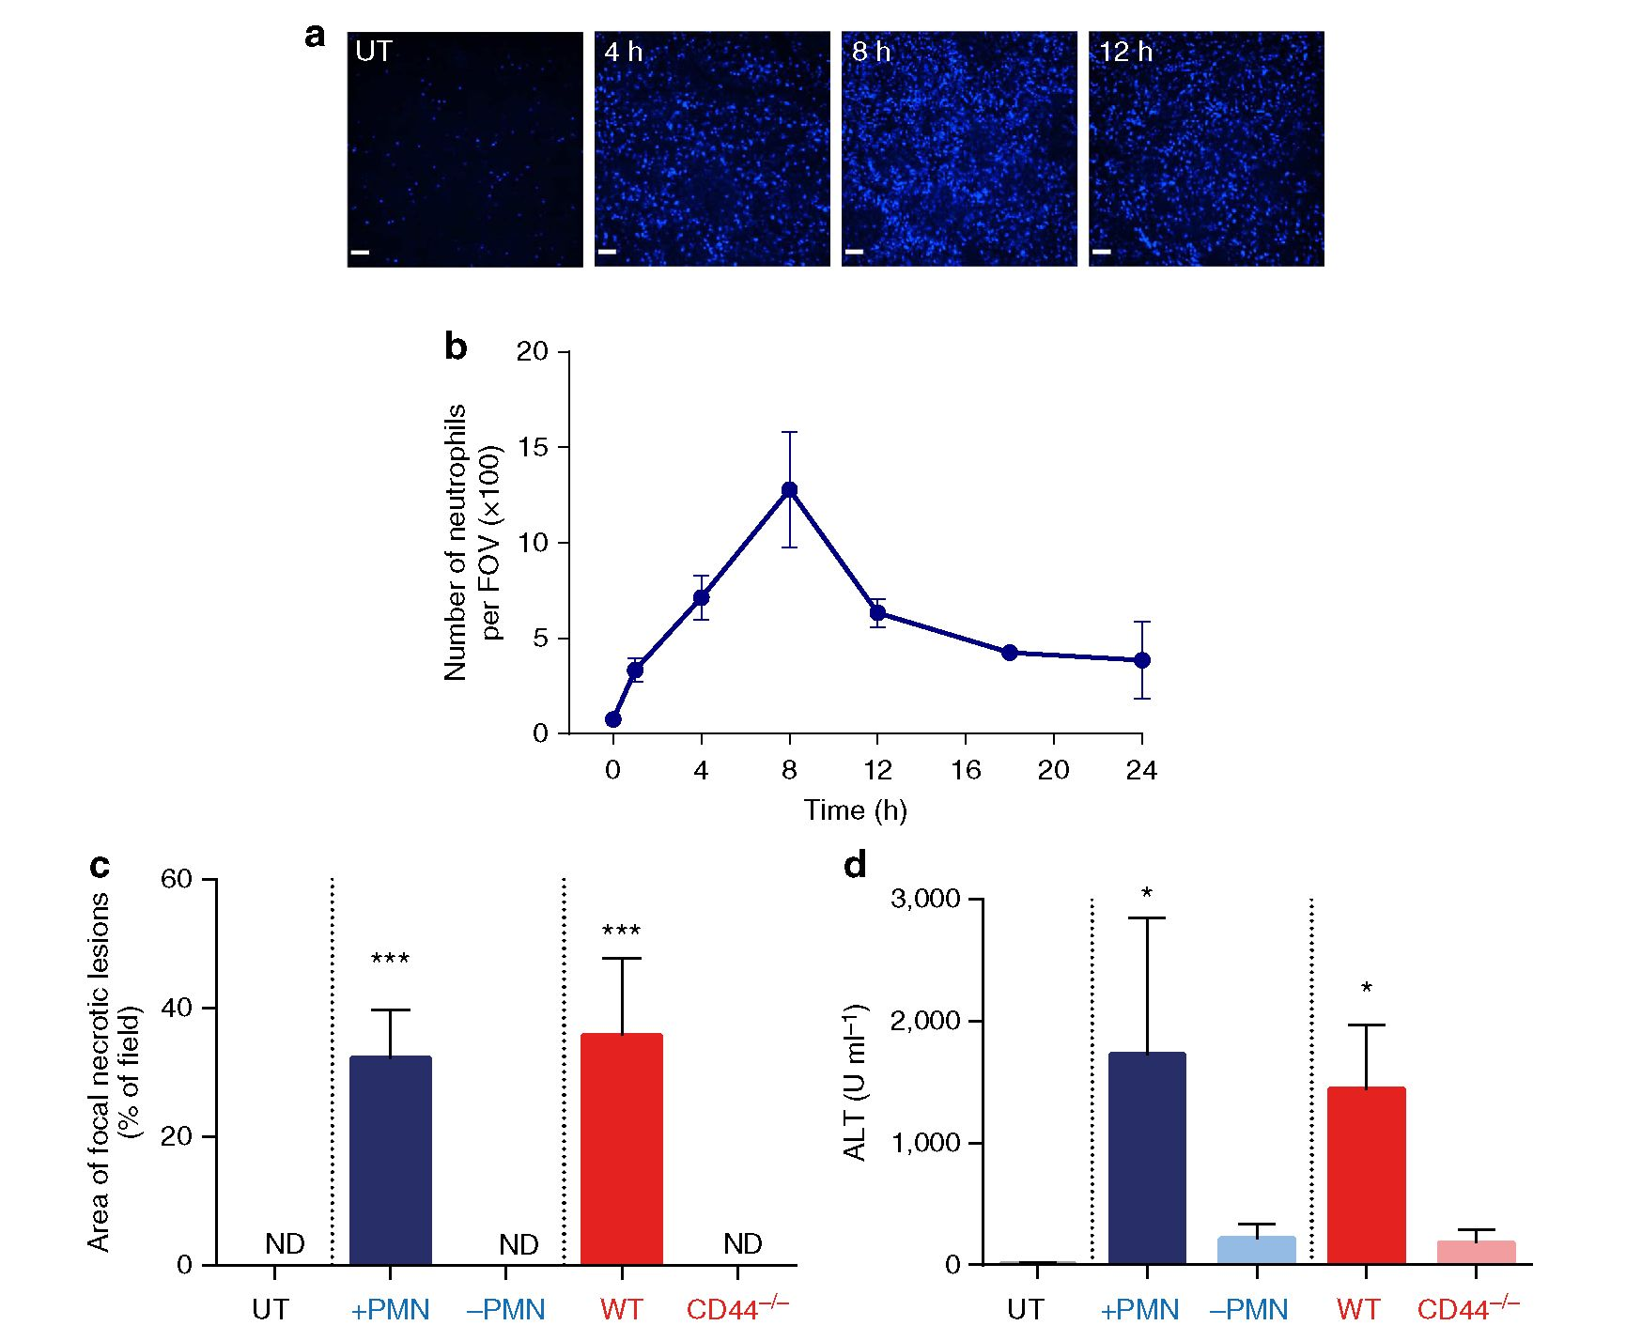
ARTICLE
NATURE COMMUNICATIONS | DOI: 10.1038/ncomms7673
Figure 2 | Neutrophils are indispensable for development of the damage to the liver. (a) Representative SD-IVM images of neutrophil infiltration into the
liver sinusoids of MRSA-infected mice (magnification 4x). Images were taken just before bacteria injection (0 h/UT), and every few hours post MRSA
inoculation. Neutrophils were stained with eFluor 660 anti-Gr-1 antibody (blue). Scale bar, 100 pm. (b) The numbers of infiltrating neutrophils as imaged in
a were quantified with ImageJ software and are expressed as number per field of view (FOV). (c,d) Depletion of neutrophils with a high dose of neutrophil-
depleting anti-Gr1 antibody (-PMN; blue bars) or lack of neutrophil recruitment in the liver of CD44_/_ mice (red bars; at 24 h of sepsis) unlike in their
controls ( + PMN) or wild-type controls (WT), respectively. (c) The area covered with altered hepatic tissue was evaluated with ImageJ, and (d) ALT levels
were measured in serum. ND, not detected. *0.01 <P<0.05, ***0.0001 <P< 0.001 (analysis of variance). Data are shown as mean ± s.d.; n>3 per group.
Intravital spinning disk microscopy revealed robust histones
and NE staining in areas adjacent to the focal necrosis
(Supplementary Fig. 5a). Interestingly, despite numerous
attempts and various staining approaches we were not able to
image within these necrotic areas. Therefore, an alternative
approach, the highly sensitive In-Vivo Xtreme imaging instru-
ment was used which measures the intensity of fluorescence
emitted from whole organ explants. Using this approach, at 12 h
post-infection, we identified clear patches of proteolytically active
NE, which appeared to precede the formation of focal necrotic
areas (Supplementary Fig. 5b). High levels of NE activity persisted
in/nearby the necrotic areas at 24 h with enzymatic activity
diminishing in areas located away from the lesions (Fig. 4c).

DNase removes extracellular DNA but no other NET components.
DNase was shown previously to breakdown NETs6,12, and
in vitro to dissolve the whole NET structure4. Real-time
observation, using spinning disk microscopy, revealed that the
DNase immediately dissolves extDNA (1-2 min) without
affecting histones and NE lining the walls of liver sinusoids
(Supplementary Movie 4). When DNase was injected
intravenously 4 h following infection with MRSA (after majority
of NETs are formed), and then the livers were imaged at 24 h,
again no extDNA was observed (Fig. 5a) but despite this,
significant amounts of histones (70%) and NE remained (50%)
attached to sinusoids (Fig. 5b,d). Furthermore, substantial NE
proteolytic activity persisted (~50%; Fig. 5c), and so did the liver
damage (Fig. 5e). The DNase treatment changed neither
neutrophil infiltration (Supplementary Fig. 10a) nor bacterial
clearance in this organ (Supplementary Fig. 11b). As an
alternative to DNase treatment, heparin has been previously
reported to mediate the in vitro dismantling of NET-associated
DNA16. Also upon repeated high-dose heparin treatment, a
significant amount of NE and histone signal persisted in liver
sinusoids (Supplementary Fig. 6a,b), and some hepatic damage
remained (Supplementary Fig. 6c,d).
NET components anchor to VWF in vasculature. Following the
unexpected observation that not all NET components detach
upon DNase treatment, we aimed to identify vasculature lining
molecule(s) to which the components bind. We have previously
shown that under both basal conditions and during systemic
MRSA infection, VWF lines the liver sinusoids and Kupffer
cells30. Furthermore, this molecule, normally associated with
hemostasis, has been shown to bind histones35 raising the
possibility that VWF mediates anchoring of NETs within the liver
vasculature. Pre-treatment of mice with VWF blocking antibody
did not affect neutrophil recruitment to the liver (Supplementary
4
NATURE COMMUNICATIONS | 6:6673 | DOI: 10.1038/ncomms7673 | www.nature.com/naturecommunications
© 2015 Macmillan Publishers Limited. All rights reserved.
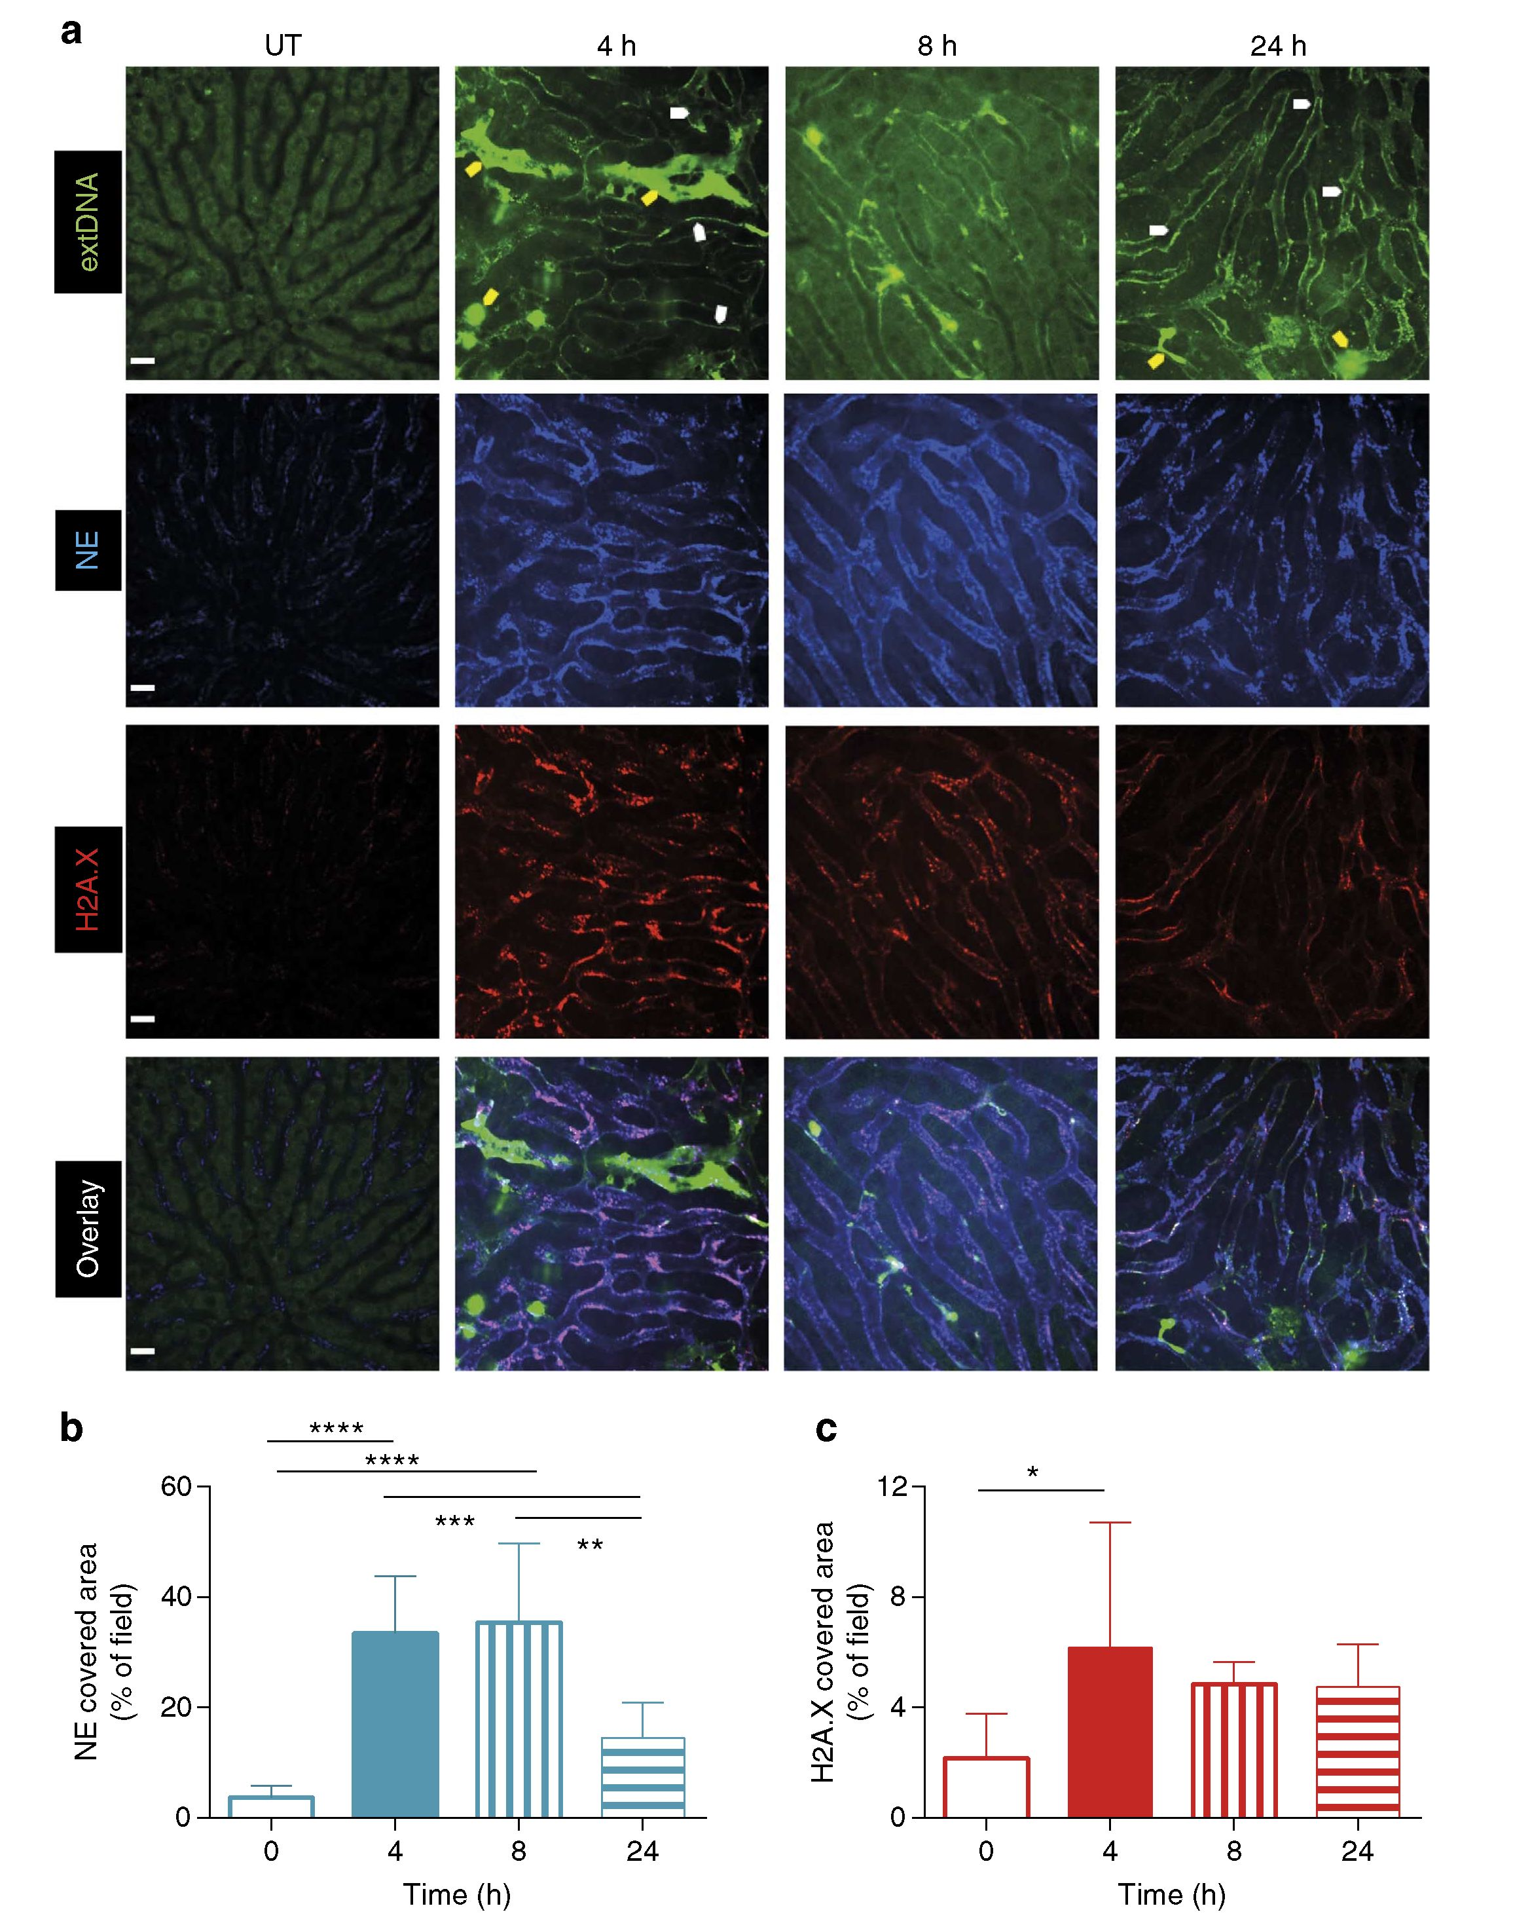
NATURE COMMUNICATIONS | DOI: 10.1038/ncomms7673
ARTICLE
Figure 3 | Neutrophils form NETs that persist for hours in liver vasculature during MRSA sepsis. (a) Representative images of NETs were acquired
with SD-IVM in untreated (UT) mice, and animals injected with MRSA, 4, 8 and 24h before imaging. Extracellular DNA (extDNA) was stained with
Sytox Green (greenbright), histones H2A.X with AF555-anti-H2A.X antibody (red) and neutrophil elastase (NE) with AF647-anti-NE antibody (blue).
To visualize co-localization of NET components, the images from each channel were overlaid. Yellow arrows indicate Sytox+ necrotic cells, whereas
white arrows denote (exemplary) DNA localization along sinusoid walls. The scale bar indicates 20 pm. Quantitative analysis of NETs within the livers
of mice systemically infected with MRSA: (b) area of NE and (c) of H2A.X staining. Data are representative of three experiments. *0.01 <P<0.05,
***0.0001 <P<0.001 (t-test). Data are shown as mean±s.d.; n = 3-10 per group.
Fig. 10f) but reduced the histone binding by 50% and reduced
liver damage by nearly 80% (Fig. 6b, c-d, respectively). In
addition, blocking VWF prevented the accumulation of DNA
(Supplementary Movie 5) within the liver vasculature and
significantly reduced (by half) the amount of the elastase within
the sinusoids (Fig. 6a and Supplementary Movie 5), suggesting
that VWF anchors the entire NET structure to the blood vessel
walls. To further verify these results, we i.v. administered
ADAMTS13, a protease that removes VWF from the vessel
wall. ADAMTS13 was applied at 8 h so it could not, and did not
(Supplementary Fig. 10e), affect neutrophil recruitment.
ADAMTS13 reduced VWF-dependent NET adherence to the
vascular wall (Fig. 6e,f), and resulted in diminished hepatic
damage (Fig. 6g,h).
Prevention of NET release eliminates liver damage. The specific
mechanisms leading to in vivo NET production remain con-
troversial. Oxidants have previously been purported to induce
NET formation in vitro in response to phorbol myristate acetate
(PMA)16. NET formation and liver injury following MRSA
infection of Ncf_ / _ mice (deficient for p47p in myeloid cells,
thus not generating reactive oxygen species (ROS) by these cells)
or of animals treated with apocynin (general nicotinamide
NATURE COMMUNICATIONS | 6:6673 | DOI: 10.1038/ncomms7673 | www.nature.com/naturecommunications
© 2015 Macmillan Publishers Limited. All rights reserved.
5
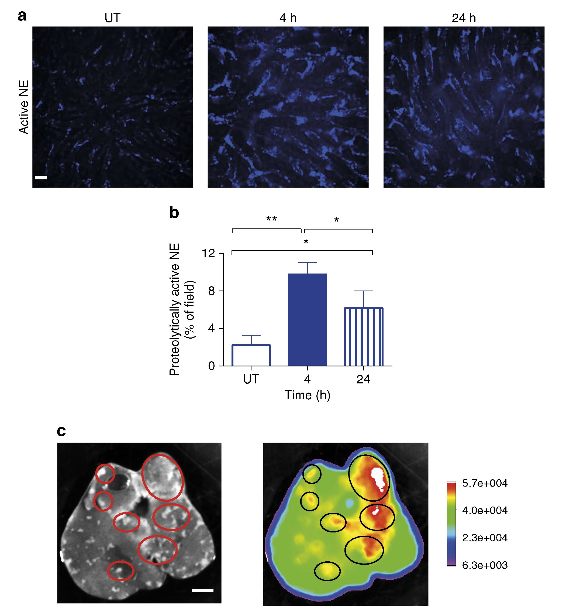
ARTICLE
NATURE COMMUNICATIONS | DOI: 10.1038/ncomms7673
Figure 4 | Neutrophil elastase attached to NETs is proteolytically active and co-localizes with necrotic areas. Activity of the enzyme was measured
by in vivo zymography in which otherwise silent substrate becomes fluorescent in the presence of the active enzyme. (a) Representative images
demonstrating the activation of the fluorescent substrate following successful processing by neutrophil elastase (NE), reflecting on its activity. The scale
bar indicates 20 pm. (b) Quantitative analysis by ImageJ of NE activity within the livers of untreated (UT) mice, and animals infected with MRSA, 4 and
24 h before imaging. (c) Representative images of a liver extracted from a mouse inoculated with MRSA 24 h before imaging and injected with NE activity
AF680-like probe. The black and white image reveals localization of necrotic areas on the liver surface, and the intensity rainbow image shows localization
of the substrate effectively processed by active NE. Circles denote exemplary areas of co-localization of necrotic areas and active NE (as indicated by its
processed substrate). The scale bar indicates 5 mm. *0.01 <P< 0.05, **0.001 <P< 0.01 (t-test). Data are shown as mean±s.d.; n = 3 per group.
adenine dinucleotide phosphate (NADPH) inhibitor) was similar
to that observed in wild-type mice (Supplementary Fig. 7a-d).
Thus, in vivo NET production in response to systemic MRSA
infection does not depend on NADPH oxidase-dependent
oxidants. Although oxidant production from other sources
cannot be excluded, the source was not NADPH oxidase.
Elastase has been previously shown to be critical for histone
degradation leading to DNA decondensation and NET forma-
tion9. MRSA infection of NE-deficient mice was by far the most
effective way of reducing NET production (Fig. 7a,b) and liver
damage (Fig. 7c,d). When an elastase inhibitor was administered
4h following MRSA infection, NETs still formed during the first
4h but the subsequent protease activity of NE was reduced
(Fig. 8a). This approach attenuated damage to the liver by
approximately 50% (Fig. 8b,c). NE could be released either
through degranulation or as a portion of NETs. In a final series of
experiments, we used an NE independent way of preventing NET
production, namely in PAD4-deficient mice8. PAD4 deficiency
dramatically reduced NET release following MRSA infection
(Fig. 7e,f). Moreover, PAD4-deficient mice demonstrated
significantly reduced liver damage (~80%; Fig. 7g,h) suggesting
that NET proteolytic activity (based on NE _ / _ data) accounts
for about 80% while the remaining 20% might be related to
elastase release via degranulation.
Deficiency in the other NET-associated protease studied here,
namely MMP-9, resulted in no inhibition of NET formation and
no inhibition of liver damage (Supplementary Fig. 8a-d). More-
over, the remaining hepatic injury in PAD4_ / _ mice was not
caused by ROS themselves (unrelated to NETs) as NADPH
inhibitor did not further limit the damage in PAD4-deficient mice
(Supplementary Fig. 9a,b). Finally, we addressed the very important
issue of whether the damage could be caused by S.aureus toxins.
There are more than ten toxins produced by S.aureus including
three bicomponent leukocidins, Luk AB/GH, Panton Valentine
Leukocidin, g-haemolysin, the pore-forming a-haemolysin, 5-toxin
and phenol-soluble modulins (PSM) a36,37. The agr operon
constitutes a global regulatory system (the master switch) that
controls cell density-dependent expression of majority of S. aureus
virulence factors38. We used a mutant MRSA that is lacking agr
operon that results in an S. aureus that expresses none of the
aforementioned toxins37. When we used this mutant we still saw
ample NET production and liver damage (Supplementary Fig. 12).
6
NATURE COMMUNICATIONS | 6:6673 | DOI: 10.1038/ncomms7673 | www.nature.com/naturecommunications
© 2015 Macmillan Publishers Limited. All rights reserved.
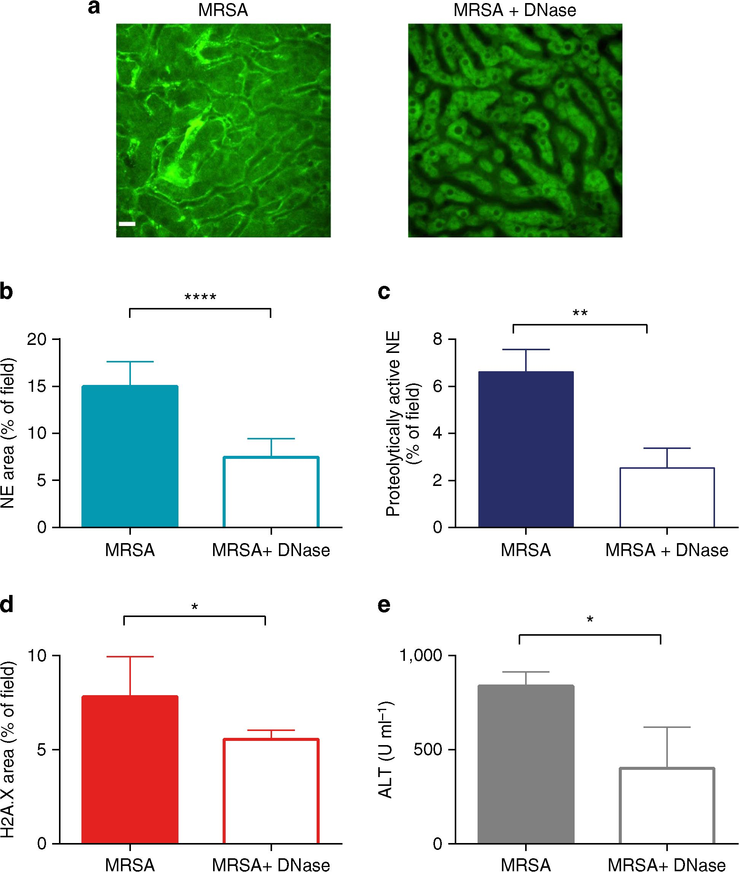
NATURE COMMUNICATIONS | DOI: 10.1038/ncomms7673
ARTICLE
Figure 5 | DNase efficiently removes extracellular DNA but only partially other NET components. DNase was applied intravenously 4 h after induction of
MRSA sepsis (MRSA + DNase), and at 24 h post infection its effect on liver damage was compared with saline-treated mice (MRSA). (a) DNase treatment
completely removed extracellular DNA (extDNA; representative images, scale 20 pm), but only partially removed other NET components: quantitative
analysis of the NET area covered by (b) NE and (d) H2A.X staining 24 h after MRSA. (c) Quantitative analysis of NE activity at 24 h of sepsis as estimated
by in vivo zymography detecting specifically NE processed fluorescent substrate (area covered by the substrate assessed with ImageJ). Changes in serum
ALT levels were measured at 24h (e). *0.01 <P<0.05, **0.001 <P<0.01, ****P<0.0001 (t-test). Data are shown as mean±s.d.; n = 3-7 per group.

Discussion
Methicillin-resistant S. aureus (MRSA) is one of the most
common blood isolates during sepsis27 and indwelling
intravenous catheters are among the most common reasons for
MRSA infection39. Community-associated (CA)-USA300 is the
dominant CA strain and represents the vast majority of S. aureus
infections in the North America40. Although most of the
superficial skin infections are still readily managed with
antibiotics, when bacteremia is associated with skin infections,
the results are far more devastating, resulting in up to 30%
mortality26,39. There is growing evidence that sepsis-associated
deaths are not due to the microorganism per se, but rather are due
to the persistent activation of innate immunity, resulting in
intractable inflammation and organ injury28,41. Our model of
MRSA bacteremia in mice in part corroborates this theory, but in
part provides novel information. We report herein that upon
entry of S.aureus into the vasculature, the reticuloendothelial
system and more specifically, the Kupffer cells of the liver, very
rapidly sequester the majority of the S.aureus. This leads to a
transient increase in liver enzymes, and some liver necrosis that
appears to be entirely the result of neutrophil recruitment,
activation and NET release and that this damage was eliminated
by 80% if neutrophil-mediated NET production (PAD4
deficiency) was blocked.
It is worth noting that the liver enzymes quickly returned back
towards control levels and the liver repaired rapidly in our mouse
model and overt abscesses were not noted. In humans, MRSA-
induced liver abscesses are also not commonly described33,
perhaps due to the profound and rapid healing power of the liver.
However, some liver necrosis is not unusual, and in humans if
microabscesses develop they are potentially life-threatening31,42,
and multiple liver abscesses lead to higher mortality than single
abscesses33. The elevated liver enzyme levels, and even the
observed liver lesions in our model, only lasted 24-72 h and
would likely have been missed in humans who are often infected
for prolonged time points before entering intensive care units.
Nevertheless, during MRSA bacteremia, hepatic damage
(increased ALT) is regularly reported43 and similar areas of
focal necrosis with neutrophil infiltration and vascular leakiness
were also reported in other model species such as pigs32.
Liver resident macrophages (Kupffer cells) provide the first
defence to many disseminating pathogens that enter the blood-
stream44. We have recently reported that immediately upon
bacterial capture by Kupffer cells, and well before any neutrophils
NATURE COMMUNICATIONS | 6:6673 | DOI: 10.1038/ncomms7673 | www.nature.com/naturecommunications
© 2015 Macmillan Publishers Limited. All rights reserved.
7
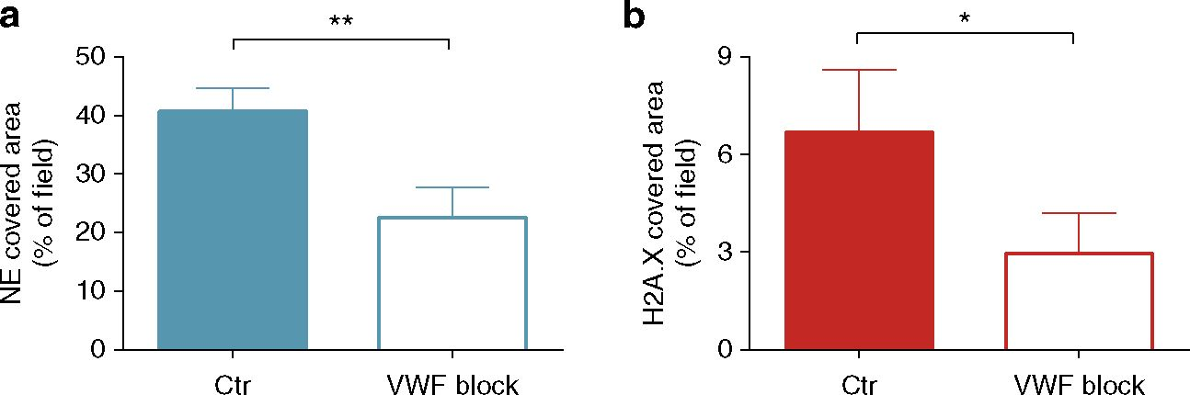
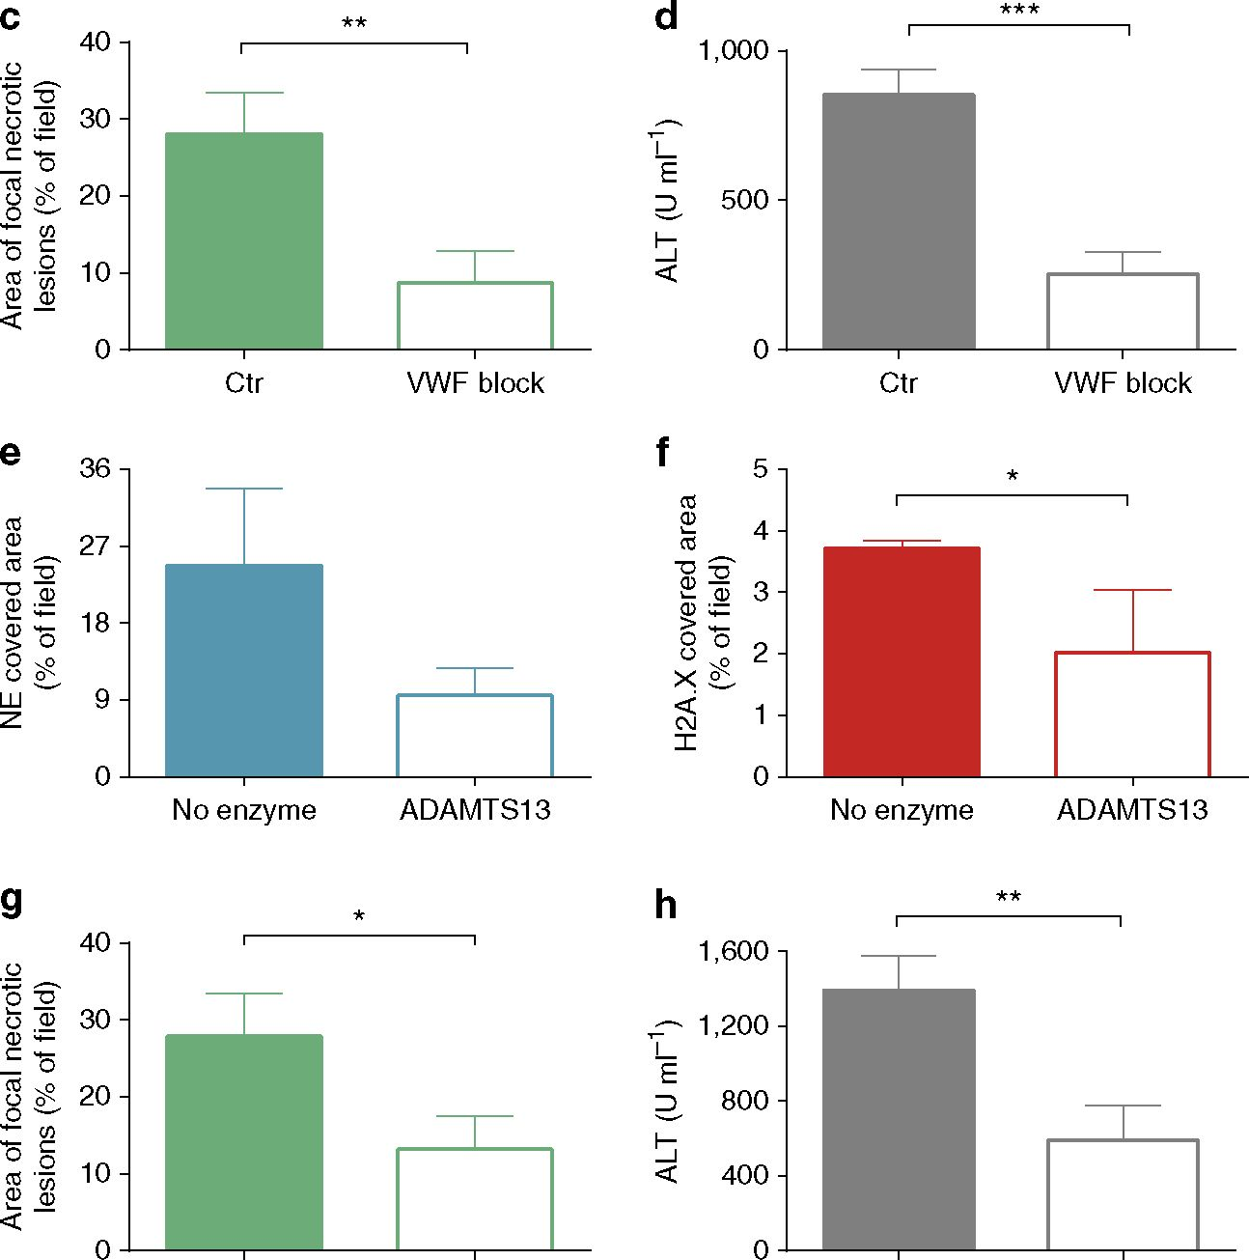
ARTICLE
NATURE COMMUNICATIONS | DOI: 10.1038/ncomms7673
No enzyme ADAMTS13 No enzyme ADAMTS13
Figure 6 | NET components attach extracellularly to von Willebrand factor. Von Willebrand factor (VWF) blocking antibody was applied i.v. 30 min
before MRSA inoculation (VWF block) while control mice received rabbit serum (Ctr). Quantitative analysis of NETs within the liver sinusoids was
performed at 4 h of sepsis: (a) area of NE and (b) H2A.X staining. At 24 h post MRSA inoculation, (c) area covered with necrotic tissue was assessed with
ImageJ, and (d) serum ALT levels were measured. Alternatively, VWF was shed by ADAMTS13. In this scenario, mice were inoculated with MRSA and 8 h
later they were injected intravenously with ADAMTS13. Sixteen hours later, their livers were imaged by SD-IVM to detect and quantify neutrophil elastase
(e) and histones H2A.X (f). Impact of ADAMTS13 on liver damage as estimated by area covered with necrotic tissue (g) and ALT levels (h).
*0.01 <P< 0.05, **0.001 <P<0.01, ***0.0001 <P< 0.001 (t-test). Data are shown as mean ± s.d.; n>3 per group.
arrive, platelets that appear to patrol the liver by a touch-and-go
interaction with Kupffer cells, swarm and encapsulate caught
S. aureus, helping to eradicate the infection30. Ironically, this
interaction is dependent upon VWF, the very same molecule that
localizes NETs to the vasculature at later time points and leads to
significant liver damage. We used lower concentrations of
S.aureus than in our previous study30 to ensure that mice
survived the early essential need for VWF. It is possible that at
this lower concentration the VWF and platelets are not needed to
help eradicate infection. This is another example of a molecule
(in this case VWF) that is essential to help the host survive the
early phase of an infection, but with time the molecule is no
longer of benefit and in this case causes some bystander injury via
NET anchoring to the vessel wall. The neutrophils are likely
summoned by the Kupffer cells, and upon arrival and activation
in the liver, start rapidly making NETs that anchor via VWF and
persist for at least 24 h.
Our in vivo data revealed that NET-associated NE is
proteolytically active within the vasculature. This result is
particularly interesting as it demonstrates that even in the
presence of a high concentration of endogenous protease
inhibitors (10% of plasma proteins)45,46, this critical protease
remains active. The possibility that DNA can protect active
proteases was previously reported in simple in vitro studies
utilizing co-incubation of elastase and DNA23,24, the observation
described well before NETs were discovered. Our findings with
MRSA-induced intravascular NETs place these previous results in
a new context and underscore the potential significance of that
8
NATURE COMMUNICATIONS | 6:6673 | DOI: 10.1038/ncomms7673 | www.nature.com/naturecommunications
© 2015 Macmillan Publishers Limited. All rights reserved.
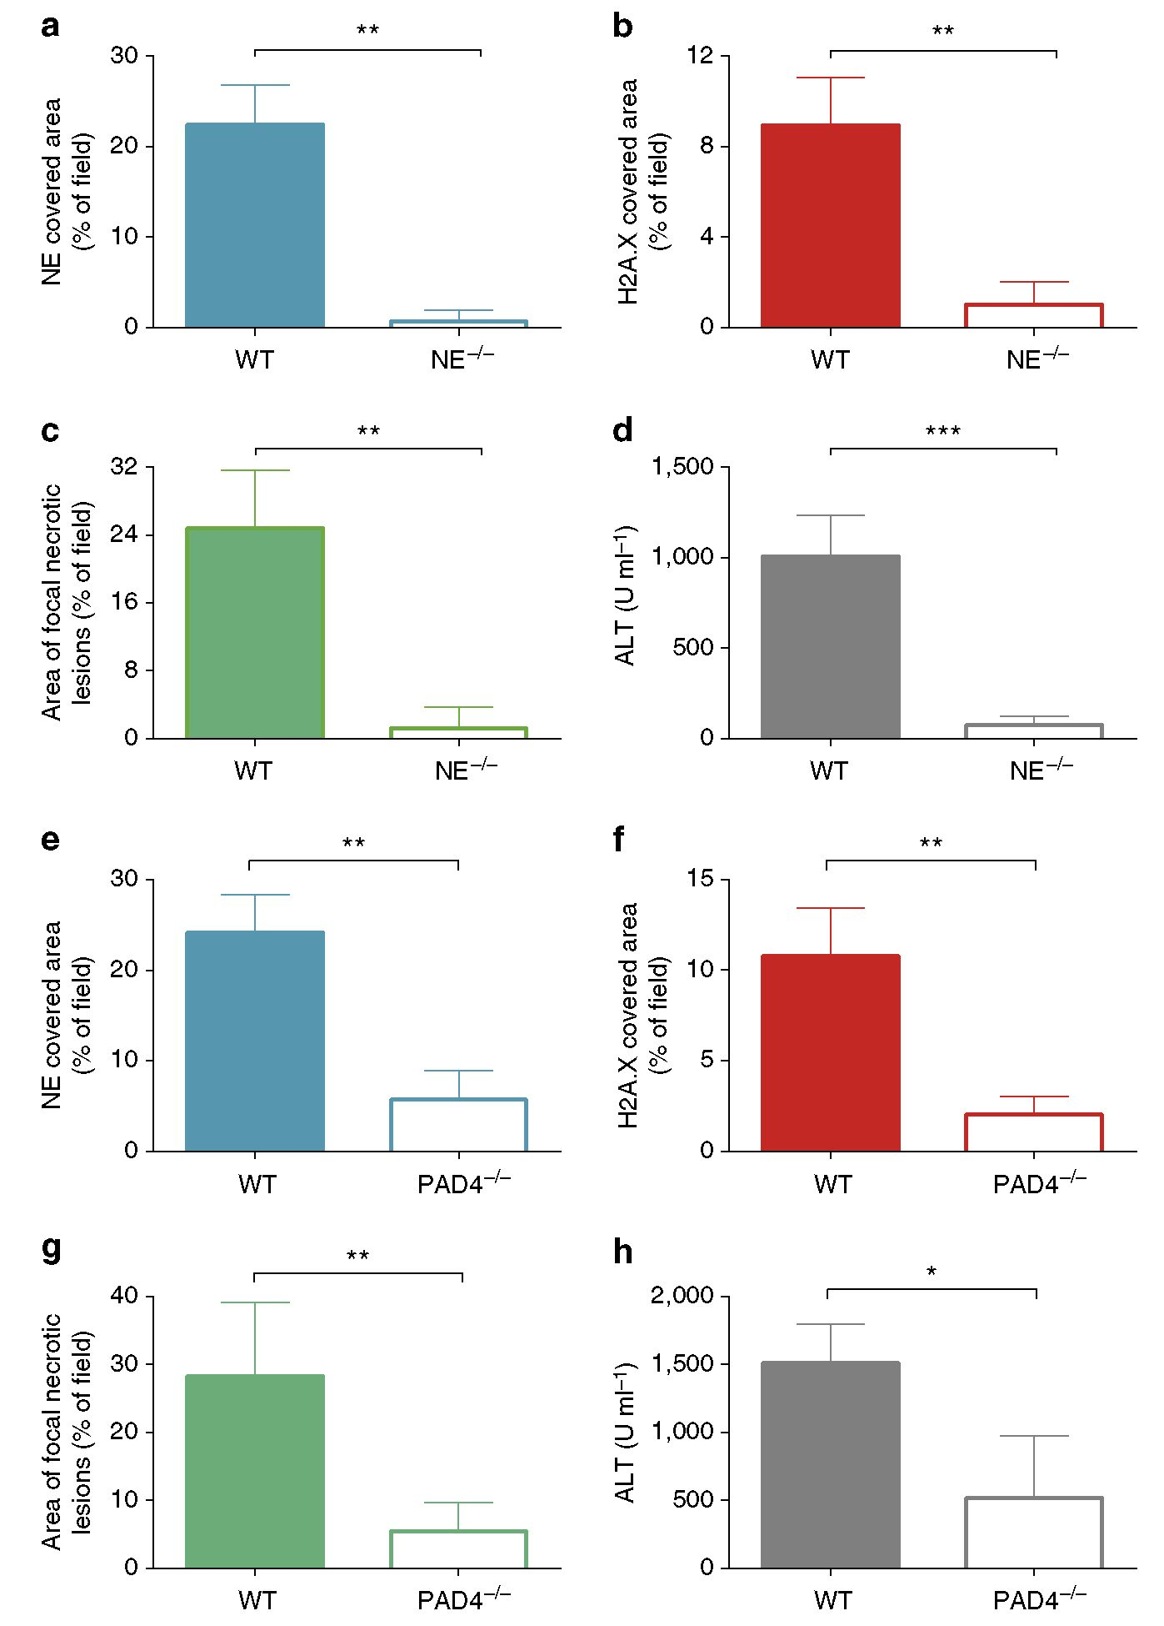
NATURE COMMUNICATIONS | DOI: 10.1038/ncomms7673
ARTICLE
Figure 7 | Impaired release of NETs by NE- and PAD4-deficient mice during MRSA sepsis. Quantitative analysis of NETs within the livers of neutrophil
elastase-deficient (NE_/_) mice and their wild-type controls (WT) systemically infected with MRSA for 4h: (a) area of NE and (b) H2A.X staining.
Hepatic damage was evaluated at 24 h post MRSA inoculation: (c) area covered with altered tissue was assessed in NE_/_ and WT mice with ImageJ, and
(d) ALT levels were measured in serum. Quantitative analysis of the NET area covered by NE (e) and (f) H2A.X staining at 4h after MRSA infection in
PAD4_/_ and WT mice. (g) Evaluation of the liver area with altered morphology and (h) serum levels of ALT in PAD4_/_ and WT mice at 24 h post
MRSA inoculation. *0.01 <P<0.05, **0.001 <P<0.01, ***0.0001 <P<0.001 (t-test). Data are shown as mean ± s.d.; n = 3-5 per group.
work23,24. However, it is important to note that not all NET-
bound proteases were observed to be active. The low MMP
activity associated with intravascular NETs, despite strong
deposition of MMP-9 protein, might be explained by the fact
that NE is stored in neutrophilic granules as the active protease,
whereas MMP-9 is released as zymogen requiring extracellular
activation47,48.
Blocking the production of NETs (NE “/ “ and PAD4 “/ “
phenotypes) almost completely protected the liver from MRSA-
induced damage, suggesting that it is the NET (and associated
components), and not the pathogen, that is entirely responsible
for the observed damage. The potential for NE to induce
significant bystander tissue destruction has been recognized for
decades49 and our data suggest that all of the liver injury is
attributable to NE and a large portion (at least 80%) of that
damage is attributable to NET production as PAD4 “/ “ mice,
which could not make NETs, but could release elastase through
degranulation, had an 80% reduction in liver injury. Consistent
with this conclusion is the slightly higher deposition of NE in the
liver vasculature of PAD4 “/ “ mice than in NE “/ “ animals and
this could presumably be through degranulation. Histones have
also been shown to induce direct injury to endothelium in
sepsis19, and although these molecules did not prove to be the
dominant cytotoxic molecule in our model, the role of histones as
NATURE COMMUNICATIONS | 6:6673 | DOI: 10.1038/ncomms7673 | www.nature.com/naturecommunications
© 2015 Macmillan Publishers Limited. All rights reserved.
9
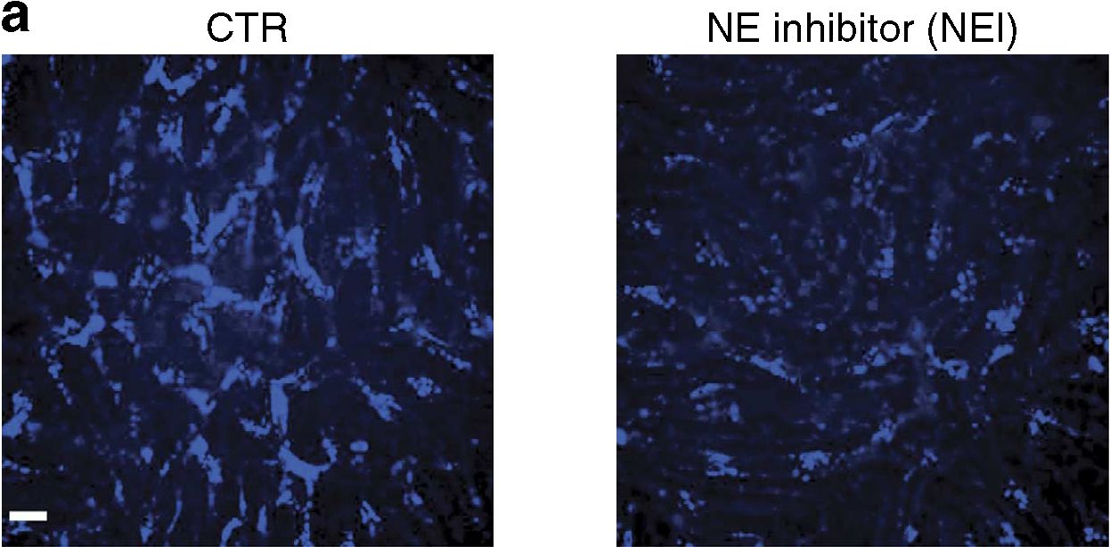
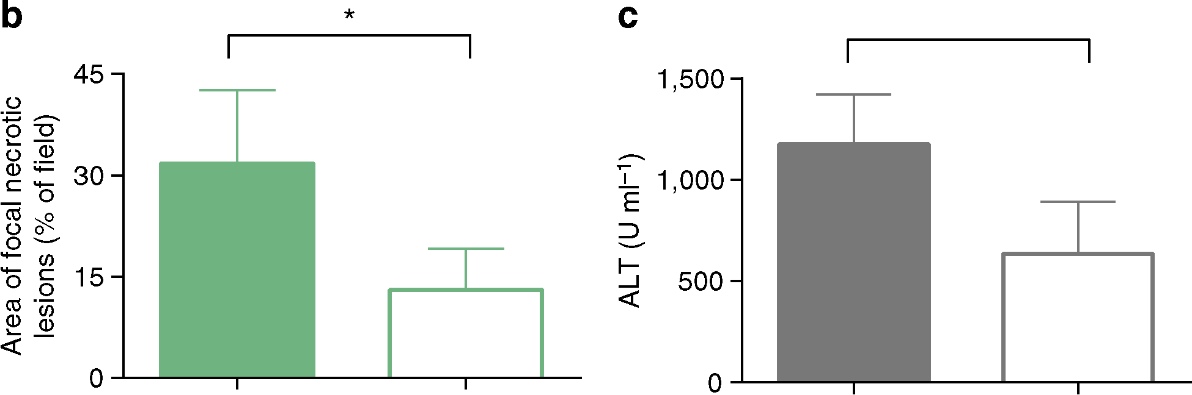
ARTICLE
NATURE COMMUNICATIONS | DOI: 10.1038/ncomms7673
CTR
NEI
P = 0.0569
CTR
NEI
Figure 8 | Inhibition of neutrophil elastase activity diminishes MRSA-triggered damage to the liver. Inhibitor of NE was applied after NETs were
formed and released to vasculature. (a) Representative images of liver sinusoids laid with substrate processed by NE (AF680-like probe) in MRSA-treated
mice (CTR) and animals treated with NE inhibitor sivelestat (NEI) at 4h of sepsis. The scale bar indicates 20 pm. (b) Changes in liver morphology
evaluated 24h post MRSA inoculation by ImageJ and (c) serum ALT levels estimated in mice treated with either NE inhibitor (NEI) or saline (CTR).
*0.01 <P<0.05 (t-test). Data are shown as mean ±s.d.; n>3 per group.
a potential anchor protein for the entire NET structure should
not be underestimated. Indeed, blocking VWF dislodged each of
NET components from the liver vasculature and reduced tissue
injury by 80%. It is also worth mentioning that the histones may
specifically target endothelium19, whereas we measured liver
enzymes that are more reflective of hepatocyte necrosis.
DNase efficiently degrades extracellular DNA and is success-
fully used to diminish symptoms of cystic fibrosis13. Although
this potential therapy may be tempting in sepsis, our data suggest
that DNase fails to clear all of the NET components, as histones
and elastase remain bound to the endothelium in sufficient
amounts to cause significant liver injury, even in the presence of
DNase.
Almost 20 years ago, Ward and colleagues identified an
interesting potent biochemical interaction between histones and
VWF of unknown physiological role35. And recently, VWF was
found to directly interact with DNA of NETs50 and co-localize
with them16. Here we have identified VWF as a critical anchor for
NETs within the liver vasculature, and that disruption of this
interaction not only reduced adherence of histones and elastase to
the sinusoidal endothelium but also reduced DNA binding to the
vessel wall, suggesting that the entire NET structure was
disrupted. What remains unclear is the specific nature of this
interaction. A prevailing view is that similar to NET binding to
bacteria, the interactions between histones and VWF, are based
on electrostatic forces, mediated by positively charged amino
acids within the protein binding to anionic DNA4,51. This would
also explain how the infusion of non-adhering heparin, carrying
the strongest negative charge of all biological polymers52, was able
to destabilized the NET structure in vivo. In fact, a recent in vitro
study showed that when incubated together, DNA, histones
and heparin formed complexes and that when the heparin
concentration increased, DNA was displaced, and the histone-
heparin dimers dominated53. Also NE was shown to be sensitive
to electrostatic interactions as it can be sequestered by negatively
charged gauze (used for wound healing) via its positively charged
side chain residues54.
In summary, this report highlights that NETs adhere to the
vessel wall, persist for at least 24 h, and, importantly, retain much
of their proteolytic activity. DNase, despite being highly efficient
at removing DNA, is much less effective at removing some of the
most toxic components of NETs. The persistence of NET-
associated proteases within the liver vasculature, even after the
dissolution of the NET structure, suggests that strategies that
either inhibit NET production or induce the shedding of anchor
molecules, such as VWF, might offer greatest efficacy in
preventing NE-associated tissue damage.

Methods
Mice. Animal experiments were carried out with male adult mice (7- to 10-week
old) and all experimental animal protocols were approved by the University of
Calgary Animal Care Committee and were in compliance with the Canadian
Council for Animal Care Guidelines. The C57Bl/6J mice, NE-deficient mice
(NE _ / _), B6(Cg)-Ncf1m1J/J mice (Ncf_ / _) were purchased from Jackson
Laboratories. MMP-9-deficient mice were generated at the Rega Institute for
Medical Research, University of Leuven (Belgium)47. Peptidylarginine deiminase
4-deficient mice (PAD4 _ / _), mice were a kind gift from Dr Kerri Mowen at
the Scripps Research Institute (La Jolla, CA, USA). All of the above mice were
generated on the C57Bl/6J background. In addition, CD44-deficient mice
(CD44 _ / _) and their respective WT strain (B6.129) were also purchased from
Jackson Laboratories. All animals were maintained in a specific pathogen-free
environment at the University of Calgary Animal Resource Centre. Mice were
housed under standardized conditions of temperature (21-22 °C) and illumination
(12 h light/12 h darkness) with free access to tap water and pelleted food. Changes
in animal weight were monitored at the same time daily (morning).
Materials and treatments. Purified goat anti-mouse histone H2A.X (M20) and
goat anti-mouse NE (M18) and goat anti-mouse MMP-9 (M17) antibodies were
purchased from Santa Cruz Biotechnology (catalogue no. sc-54607, sc-9521,
sc-6841, respectively). For intravital microscopy, NE and histone H2A.X antibodies
were conjugated to Alexa Fluor 647 or Alexa Fluor 555 with protein labelling kits as
per the manufacturer’s instructions (Invitrogen). Labelling of neutrophils was
performed using either Alexa Fluor 750-conjugated anti-Ly6G (1A8) from AbLab
(custom made) or eFluor 660-conjugated anti-Gr-1 (RB6-8C5) from eBioscience
(catalogue no. 50-5931). Kupffer cells were stained with PE-anti-F4/80 (BM8;
eBioscience; catalogue no. 12-4801). Sytox green DNA dye was purchased from
Invitrogen. For the degradation of intravascular DNA, 2,000 U of cell culture grade
DNase I (Roche) were administered i.v. at the time of bacterial injection or 4h post
10
NATURE COMMUNICATIONS | 6:6673 | DOI: 10.1038/ncomms7673 | www.nature.com/naturecommunications
© 2015 Macmillan Publishers Limited. All rights reserved.
NATURE COMMUNICATIONS | DOI: 10.1038/ncomms7673
ARTICLE
infection. In some experiments, the 2,000 U of DNase i.v. were used to remove
extDNA in real-time during imaging.
For detection of active proteases, FAST Fluorescent Imaging Agents
(PerkinElmer) were used: Neutrophil Elastase 680 and MMPSense 750. The
optically silent compounds become fluorescent following specific protease-
mediated activation. These assays were confirmed for selectivity using both
knockout mice and inhibitors.
Two NE inhibitors were used, elastase inhibitor IV (Calbiochem/EMD
Millipore) and sivelestat (Sigma-Aldrich). The elastase inhibitor IV was
administered i.p. at the dose of 50mgkg _ 1 and sivelestat was injected i.v. at the
dose of 10mgkg_ 1. Both inhibitors were administered at 4h and again at 12h
after MRSA injection55 and yield similar results; data for sivelestat are shown in
figures. NADPH inhibitor apocynin (acetovanillone; Sigma-Aldrich) was delivered
- v. at the dose of 10mgkg _ 1, 30min before MRSA injection56,57. Unfractionated
heparin (Sandoz, Boucherville, Canada) and low-molecular-weight heparin
Fragmin anti-factor Xa (Pfizer) were administered s.c. at 400Ukg_ 1. Heparins
were administrated at time 0 and again at 12 h after MRSA injection. Data for
unfractionated heparin are shown on figures.
Neutrophil depletion was performed by i.p. injection of 200 mg unconjugated
anti-Gr-1 antibody (1A8; BioXcell; catalogue no. BE0075-1) 48 and 24h before
bacterial injection. Control mice were injected with matching rat IgG2b antibodies
(BE0089).
Bacterial strain and bacterial treatments. Clinically isolated CA-MRSA
(US300-2406) carrying chloramphenicol resistance genes58 was used in the study.
In addition, USA300 LAC (unlabelled or GFP) and USA300 LACDAgr mutant
were studied. MRSA was grown in BHI (Difco Brain Heart Infusion, BD)
supplemented with chloramphenicol (20 pgml_ 1, Calbiochem) on an orbital
shaker at 37 0C overnight. Subsequently, bacteria were subcultured in fresh BHI
and incubated for 2h at 37 0C with shaking to obtain bacteria in mid-log phase
growth before injection. Bacteria were washed, suspended in saline and mice were
injected via the tail vein with 1-2 x 107 CFUs in a volume of 200 pl per mouse.
In some experiments, mice were injected with 5-10 x 107 of CFUs.
Evaluation of the size of damaged areas on liver surface. At specified time
points post MRSA injection, the livers of euthanized mice were removed and
immediately placed in ice-cold PBS. Images of the livers were captured with a
digital camera and the affected areas on the surface of each liver were quantified
with ImageJ (NIH).
Perfusion of the liver. To determine perfusion of the liver microvasculature,
FITC-labelled albumin (5mgml_ 1, 50 pl per mouse; Sigma-Aldrich) was i.v.
administered into an anaesthetized mouse undergoing intravital imaging. Videos
were recorded for 10 min to visualize appearance of FITC-albumin in the vascu-
lature. The perfused sinusoids turned green immediately and the unperfused
sinusoids remained unlabelled during the 10-min period.
Biochemical assessment of liver injury. Anaesthetized mice were washed with
70% ethanol under sterile conditions. Blood was collected by cardiac puncture in a
heparinized syringe. Samples were centrifuge at 400g for 10 min for the retrieval
of plasma. Plasma samples were analysed for ALT levels as per manufacturer’s
protocol (Biotron Diagnostics Inc.).
Liver histology. The left liver lobe was removed and placed in 10% neutral-
buffered formalin (Sigma-Aldrich). The formalin-fixed tissue was embedded in
paraffin, cut in 4-pm sections and stained with haematoxylin and eosin by Calgary
Laboratory Services.
Bacteriological analysis. Anaesthetized mice were washed with 70% ethanol
under sterile conditions. Blood was collected by cardiac puncture. Subsequently,
mice were euthanized and the lungs, liver, right kidney and spleen were removed
and homogenized. For determination of CFUs, 10 pl of tissue homogenate or blood
was serially diluted, plated onto BHI agar plates (Difco Brain Heart Infusion Agar,
BD) supplemented with chloramphenicol (20 pgml_ 1) and incubated at 37 0C for
24 h followed by colony enumeration.
Preparation of the mouse liver for intravital microscopy. Mice were
anaesthetized with a mixture of ketamine hydrochloride (200 mg kg _ 1, Bayer Inc.
Animal Health) and xylazine hydrochloride (10mgkg_ 1, Bimeda-MTC,
Cambridge, Canada). After anaesthesia, cannulation of the right jugular vein was
performed for maintenance of anaesthetic and for injection of antibodies or
other reagents. Preparation of the liver for intravital imaging was performed as
previously described59. Briefly, a midline incision followed by a lateral incision
along the costal margin to the midaxillary line was performed to expose the liver.
The mouse was placed in a right lateral position, and ligaments attaching the
liver to the diaphragm and the stomach were cut, thus allowing the liver to be
externalized onto a glass coverslip located on the inverted microscope heat-
controlled stage with all blood flow remaining intact. The liver was draped with a
saline-soaked KimWipes to avoid tissue dehydration and to help restrict movement
of the tissue on the slide.
Spinning disk confocal intravital microscopy. The exposed liver lobe was
visualized with an Olympus IX81 inverted microscope (Olympus) equipped with a
confocal light path (Wave-Fx; Quorum) based on a modified Yokogawa CSU-X1
head (Yokogawa Electric Corporation) with a UPLANSAPO 10 x /0.40 or
UPLANSAPO 20 x /0.70 air objective. Four laser excitation wavelengths (491, 561,
643 and 730 nm; Cobalt) were used in rapid succession and visualized with the
appropriate long-pass filters (Semrock and Chroma). Exposure times for excitation
wavelengths were 400 ms for all lasers. A back-thinned EMCCD 512 x 512 pixel
camera (C9100-13, Hamamatsu) was used for fluorescence detection. Volocity
acquisition software (PerkinElmer) was used to drive the microscope.
Analysis of spinning disk confocal microscope-acquired images. Fluorescence
imaging of NET components and neutrophil counts was performed with intravital
immunofluorescence analysis. Neutrophils were visualized by injection of
Alexa Fluor-conjugated 750 anti-mouse Ly6G (3 pg) or eFluor 660-conjugated
anti-Gr-1 (1.6 pg) antibodies. Extracellular DNA was labelled with Sytox Green
DNA dye (5 pM), histone H2A.X was labelled with Alexa Fluor 555-conjugated
anti-mouse H2A.X antibody (5 pg) and NE was labelled with either Alexa Fluor
647-conjugated or Alexa Fluor 555-conjugated anti-mouse NE antibody (0.6 pg).
Alexa Fluor 647-conjugated anti-mouse MMP-9 antibody (0.6 pg) was used for
detection of MMP-9. Kupffer cells were stained with PE-anti-F4/80 (2.5 pg).
All antibodies and dyes were injected i.v. 15 min before intravital imaging.
Neutrophils and NETs were quantified with SD-IVM using previously
published methodology59. In brief, images were acquired as z stacks of xy planes
(1 pm intervals) from the bottom to top of sinusoids in each field of view using a
x 20 objective lens, and saved as extended focus images in.tiff format. Images from
individual colour channels (for example, red for histone H2A.X, far red for
elastase) were exported and analysed in ImageJ (NIH). Neutrophils were counted
per 10x field of view (FOV), minimum 4 FOV from each mouse. Intensity of
histone and elastase staining, and of protease processed substrate, was analysed so
that differences in background fluorescence between experiments and antibody lots
could be accounted for and background autofluorescence could be eliminated,
contrast was adjusted to minimize autofluorescent background staining, and a
minimum brightness threshold was set to yield only positive staining. The same
contrast and threshold values were applied to all images from all treatment groups
within the experiment. Thresholded images were converted to binary (black and
white), and the area per field of view covered by positive fluorescence staining
(black) was calculated with ImageJ software. Data are expressed as the percentage
of area in each FOV covered by positive fluorescence staining.
NE activity in the whole liver. Optical and X-ray small animal imaging system (In-
Vivo Xtreme, Bruker) was used to quantify, and localize active elastase within the
liver. Live mid-log phase S. aureus were administered i.v. together with Neutrophil
Elastase 680 FAST Fluorescent Imaging Agents (PerkinElmer). At either 12 or 24 h
post infection, livers were removed and placed in the imaging chamber. Livers
collected from untreated (UT) mice were used as controls. Photons were measured
during a 2-s exposure. Total photon emissions from uniform area of each mouse liver
were quantified by using the Molecular Imaging (MI) software (Bruker).
Studies on NET component attachment to VWF. For inhibition of VWF, each
mouse was given intravenous injection of 50 pg polyclonal rabbit antibody to
human VWF with strong cross-reaction with mouse VWF (Dako; catalogue
no. A0082) 30 min before infection30. Normal rabbit serum (Sigma-Aldrich) was
used as a control. ADAMTS13 (3 pg per mouse; R&D) was also used in some
experiments. In pilot experiments, recombinant ADAMTS13 that starts at the
N-terminus of the pro-domain and ends in the spacer domain was tested against
the full-length molecule for its efficiency to shed VWF. No significant differences
were recorded and the shorter rhADAMTS13 was used in subsequent studies.
MRSA sepsis was induced and 8 h later ADAMTS13 was injected into the tail vein.
This time point was selected not to influence neutrophil recruitment that reaches
its maximum 8 h post MRSA. Liver sinusoids were imaged 16 h later (at 24 h) for
NET components, and damage to the organ was assessed as described above.
Statistics. All data are presented as mean values±s.d. Data were compared either
by unpaired two-tailed Student’s t-test or one-way analysis of variance with
Bonferroni multiple comparisons post hoc test. Statistical significance was set at
P<0.05. Sample size was determined on the basis of prior power calculations and
our experiments applying intravital microscopy58,59.

References
- Kolaczkowska, E. & Kubes, P. Neutrophil recruitment and function in health
and inflammation. Nat. Rev. Immunol. 13, 159-175 (2013).
- Yipp, B. G. & Kubes, P. NETosis: how vital is it? Blood 122, 2784-2794 (2013).
NATURE COMMUNICATIONS | 6:6673 | DOI: 10.1038/ncomms7673 | www.nature.com/naturecommunications
© 2015 Macmillan Publishers Limited. All rights reserved.
11
ARTICLE
NATURE COMMUNICATIONS | DOI: 10.1038/ncomms7673
- Phillipson, M. & Kubes, P. The neutrophil in vascular inflammation. Nature
Med. 17, 1381-1390 (2011).
- Brinkmann, V. et al. Neutrophil extracellular traps kill bacteria. Science 303,
1532-1535 (2004).
- Helmy, K. Y. et al. CRIg: a macrophage complement receptor required for
phagocytosis of circulating pathogens. Cell 124, 915-927 (2006).
- McDonald, B., Urrutia, R., Yipp, B. G., Jenne, C. N. & Kubes, P. Intravascular
neutrophil extracellular traps capture bacteria from the bloodstream during
sepsis. Cell Host Microbe 12, 324-333 (2012).
- Gunzer, M. Traps and hyper inflammation - new ways that neutrophils
promote or hinder survival. Br. J. Haematol. 164, 189-199 (2014).
- Li, P. et al. PAD4 is essential for antibacterial innate immunity mediated by
neutrophil extracellular traps. J. Exp. Med. 207, 1853-1862 (2010).
- Papayannopoulos, V., Metzler, K. D., Hakkim, A. & Zychlinsky, A. Neutrophil
elastase and myeloperoxidase regulate the formation of neutrophil extracellular
traps. J. Cell Biol. 191, 677-691 (2010).
- Fuchs, T. A. et al. Novel cell death program leads to neutrophil extracellular
traps. J. Cell Biol. 176, 231-241 (2007).
- Pilsczek, F. H. et al. A novel mechanism of rapid nuclear neutrophil
extracellular trap formation in response to Staphylococcus aureus. J. Immunol.
185, 7413-7425 (2010).
- Caudrillier, A. et al. Platelets induce neutrophil extracellular traps in
transfusion-related acute lung injury. J. Clin. Invest. 122, 2661-2671 (2012).
- Pressler, T. Review of recombinant human deoxyribonuclease (rhDNase) in the
management of patients with cystic fibrosis. Biologics 2, 611-617 (2008).
- Papayannopoulos, V., Staab, D. & Zychlinsky, A. Neutrophil elastase enhances
sputum solubilization in cystic fibrosis patients receiving DNase therapy. PLoS
One 6, e28526 (2011).
- Branzk, N. et al. Neutrophils sense microbe size and selectively release
neutrophil extracellular traps in response to large pathogens. Nat. Immunol. 15,
1017-1025 (2014).
- Fuchs, T. A. et al. Extracellular DNA traps promote thrombosis. Proc. Natl
Acad. Sci. USA 107, 15880-15885 (2010).
- Hirsch, J. G. Bactericidal action of histone. J. Exp. Med. 108, 925-944 (1958).
- Saffarzadeh, M. et al. Neutrophil extracellular traps directly induce epithelial
and endothelial cell death: a predominant role of histones. PLoS One 7, e32366
(2012).
- Xu, J. etal. Extracellular histones are major mediators of death in sepsis. Nature
Med. 15, 1318-1321 (2009).
- Urban, C. F. et al. Neutrophil extracellular traps contain calprotectin, a
cytosolic protein complex involved in host defense against Candida albicans.
PLoS Pathog. 5, e1000639 (2009).
- Duranton, J. et al. Effect of DNase on the activity of neutrophil elastase,
cathepsin G and proteinase 3 in the presence of DNA. FEBS Lett. 473, 154-156
(2000).
- Duranton, J., Boudier, C., Belorgey, D., Mellet, P. & Bieth, J. G. DNA strongly
impairs the inhibition of cathepsin G by alpha(1)-antichymotrypsin and
alpha(1)-proteinase inhibitor. J. Biol. Chem. 275, 3787-3792 (2000).
- Belorgey, D. & Bieth, J. G. DNA binds neutrophil elastase and mucus
proteinase inhibitor and impairs their functional activity. FEBS Lett. 361,
265-268 (1995).
- Belorgey, D. & Bieth, J. G. Effect of polynucleotides on the inhibition of
neutrophil elastase by mucus proteinase inhibitor and alpha 1-proteinase
inhibitor. Biochemistry 37, 16416-16422 (1998).
- Dubois, A. V. et al. Influence of DNA on the activities and inhibition of
neutrophil serine proteases in cystic fibrosis sputum. Am. J. Respir. Cell Mol.
Biol. 47, 80-86 (2012).
- Thwaites, G. E. et al. Clinical management of Staphylococcus aureus
bacteraemia. Lancet Infect. Dis. 11, 208-222 (2011).
- Pottinger, P. S. Methicillin-resistant Staphylococcus aureus infections. Med.
Clin. North Am. 97, 601-619 (2013).
- Hotchkiss, R. S., Monneret, G. & Payen, D. Sepsis-induced
immunosuppression: from cellular dysfunctions to immunotherapy. Nat. Rev.
Immunol. 13, 862-874 (2013).
- Saginur, R. & Suh, K. N. Staphylococcus aureus bacteraemia of unknown
primary source: where do we stand? Int. J. Antimicrob. Agents 32(Suppl 1)):
S21-S25 (2008).
- Wong, C. H., Jenne, C. N., Petri, B., Chrobok, N. L. & Kubes, P. Nucleation of
platelets with blood-borne pathogens on Kupffer cells precedes other innate
immunity and contributes to bacterial clearance. Nat. Immunol. 14, 785-792
(2013).
- Verbanck, J., Ponette, J., Verbanck, M., Vandewiele, I. & Segaert, M.
Sonographic detection of multiple Staphylococcus aureus hepatic
microabscesses mimicking Candida abscesses. J. Clin. Ultrasound 27, 478-481
(1999).
- Soerensen, K. E. et al. The use of sequential organ failure assessment
parameters in an awake porcine model of severe Staphylococcus aureus sepsis.
APMIS 120, 909-921 (2012).
- Alvarez, J. A. et al. Single and multiple pyogenic liver abscesses: etiology,
clinical course, and outcome. Dig. Surg. 18, 283-288 (2001).
- McDonald, B. et al. Interaction of CD44 and hyaluronan is the dominant
mechanism for neutrophil sequestration in inflamed liver sinusoids. J. Exp.
Med. 205, 915-927 (2008).
- Ward, C. M., Tetaz, T. J., Andrews, R. K. & Berndt, M. C. Binding of the von
Willebrand factor A1 domain to histone. Thromb. Res. 86, 469-477 (1997).
- Wang, R. et al. Identification of novel cytolytic peptides as key virulence
determinants for community-associated MRSA. Nature Med. 13, 1510-1514
(2007).
- Pang, Y. Y. et al. agr-Dependent interactions of Staphylococcus aureus USA300
with human polymorphonuclear neutrophils. J. Innate Immun. 2, 546-559
(2010).
- Cheung, G. Y., Wang, R., Khan, B. A., Sturdevant, D. E. & Otto, M. Role of the
accessory gene regulator agr in community-associated methicillin-resistant
Staphylococcus aureus pathogenesis. Infect. Immun. 79, 1927-1935 (2011).
- Kaasch, A. J. et al. Staphylococcus aureus bloodstream infection: a pooled
analysis of five prospective, observational studies. J. Infect. 68, 242-251 (2014).
- Nimmo, G. R. USA300 abroad: global spread of a virulent strain of community-
associated methicillin-resistant Staphylococcus aureus. Clin. Microbiol. Infect.
18, 725-734 (2012).
- Xiao, W. et al. A genomic storm in critically injured humans. J. Exp. Med. 208,
2581-2590 (2011).
- Khanna, N. & Inkster, T. Meticillin-resistant Staphylococcus aureus hepatic
abscess treated with tigecycline. J. Clin. Pathol. 61, 967-968 (2008).
- De Simone, N. et al. Therapeutic plasma exchange in the management of sepsis
and multiple organ dysfunction syndrome: a report of three cases. J. Clin.
Apher. 29, 127-131 (2014).
- Jenne, C. N. & Kubes, P. Immune surveillance by the liver. Nat. Immunol. 14,
996-1006 (2013).
- Jochum, M., Gippner-Steppert, C., Machleidt, W. & Fritz, H. The role of
phagocyte proteinases and proteinase inhibitors in multiple organ failure. Am.
J. Respir. Crit. Care Med. 150, S123-S130 (1994).
- Travis, J. & Salvesen, G. S. Human plasma proteinase inhibitors. Annu. Rev.
Biochem. 52, 655-709 (1983).
- Kolaczkowska, E. et al. Neutrophil elastase activity compensates for a genetic
lack of matrix metalloproteinase-9 (MMP-9) in leukocyte infiltration in a
model of experimental peritonitis. J. Leukoc. Biol. 85, 374-381 (2009).
- Vandooren, J., Van den Steen, P. E. & Opdenakker, G. Biochemistry and
molecular biology of gelatinase B or matrix metalloproteinase-9 (MMP-9): the
next decade. Crit. Rev. Biochem. Mol. Biol. 48, 222-272 (2013).
- Janoff, A. Elastase in tissue injury. Annu. Rev. Med. 36, 207-216 (1985).
- Grassle, S. et al. von Willebrand factor directly interacts with DNA from
neutrophil extracellular traps. Arterioscler. Thromb. Vasc. Biol. 34, 1382-1389
(2014).
- Parker, H., Albrett, A. M., Kettle, A. J. & Winterbourn, C. C. Myeloperoxidase
associated with neutrophil extracellular traps is active and mediates bacterial
killing in the presence of hydrogen peroxide. J. Leukoc. Biol. 91, 369-376
(2012).
- Caughey, G. H. Building a better heparin. Am. J. Respir. Cell Mol. Biol. 28,
129-132 (2003).
- Longstaff, C. et al. Mechanical stability and fibrinolytic resistance of clots
containing fibrin, DNA, and histones. J. Biol. Chem. 288, 6946-6956 (2013).
- Edwards, J. V. & Howley, P. S. Human neutrophil elastase and collagenase
sequestration with phosphorylated cotton wound dressings. J. Biomed. Mater.
Res. A. 83, 446-454 (2007).
- Ishii, T. et al. Neutrophil elastase contributes to acute lung injury induced by
bilateral nephrectomy. Am. J. Pathol. 177, 1665-1673 (2010).
- Sanchez, G. et al. Exercise and tachycardia increase NADPH oxidase and
ryanodine receptor-2 activity: possible role in cardioprotection. Cardiovasc. Res.
77, 380-386 (2008).
- Jun, J. et al. Intermittent hypoxia has organ-specific effects on oxidative stress.
Am. J. Physiol. Regul. Integr. Comp. Physiol. 295, R1274-R1281 (2008).
- Yipp, B. G. et al. Infection-induced NETosis is a dynamic process involving
neutrophil multitasking in vivo. Nature Med. 18, 1386-1393 (2012).
- Jenne, C. N. et al. Neutrophils recruited to sites of infection protect from
virus challenge by releasing neutrophil extracellular traps. Cell Host Microbe 13,
169-180 (2013).

Acknowledgements
We thank Dr Bjorn Petri for assistance with In-Vivo Xtreme imaging, and acknowledge
assistance oflate Carla Badick, and Trecia Nussbaumer with mice breeding. Supported by
Alberta Innovates Health Solutions, the Canadian Institutes of Health Research and the
Canada Research Chairs Program (P.K.). E.K. is supported by Marie Curie fellowship
FP7-PEOPLE-2010-IOF (grant No.273340) from EU. B.G.S. is partially funded by
FP7-PEOPLE-2013-IOF (grant No. 627575) and Alberta innovates Health Solutions
(AIHS).
12
NATURE COMMUNICATIONS | 6:6673 | DOI: 10.1038/ncomms7673 | www.nature.com/naturecommunications
© 2015 Macmillan Publishers Limited. All rights reserved.

NATURE COMMUNICATIONS | DOI: 10.1038/ncomms7673
ARTICLE

Author contributions
E.K. designed and performed the experiments, collected, analysed and discussed data and
wrote the manuscript. B.G.S. did the skin imaging. C.N.J., W.-Y.L., M.-J.S. performed
some experiments and discussed the data. A.T. assisted the lung imaging. K.M. provided
PAD4-deficient mice. G.O. provided MMP-9-deficient mice and discussed results. P.K.
co-designed experiments, supervised the study and co-wrote the manuscript.

Additional information
Supplementary Information accompanies this paper at http://www.nature.com/
naturecommunications
Competing financial interests: The authors declare no competing financial interests.
Reprints and permission information is available online at http://npg.nature.com/
reprintsandpermissions/
How to cite this article: Kolaczkowska, E. et al. Molecular mechanisms of NET
formation and degradation revealed by intravital imaging in the liver vasculature.
Nat. Commun. 6:6673 doi: 10.1038/ncomms7673 (2015).
This work is licensed under a Creative Commons Attribution 4.0
International License. The images or other third party material in this
article are included in the article’s Creative Commons license, unless indicated otherwise
in the credit line; if the material is not included under the Creative Commons license,
users will need to obtain permission from the license holder to reproduce the material.
To view a copy of this license, visit http://creativecommons.org/licenses/by/4.0/
NATURE COMMUNICATIONS | 6:6673 | DOI: 10.1038/ncomms7673 | www.nature.com/naturecommunications
© 2015 Macmillan Publishers Limited. All rights reserved.
13

