
Eur. Phys. J. C (2016) 76:194
DOI 10.1140/epjc/s10052-016-4031-y

The European
Physical journal C
CrossMark
Regular Article - Experimental Physics

QED radiative corrections and their impact on H → ττ searches
at the LHC
Mieczysław Witold Krasny1,a, Stanisław Jadach2, Wiesław Płaczek3
- Laboratoire de Physique Nucleaire et des Hautes Energies, Universite Pierre et Marie Curie-Paris 6, Universite Paris Diderot-Paris 7, CNRS-IN2P3,
4 pl. Jussieu, 75005 Paris, France
- Institute of Nuclear Physics, Polish Academy of Sciences, ul. Radzikowskiego 152, 31-342 Kraków, Poland
- Marian Smoluchowski Institute of Physics, Jagieilonian University, ul. Łojasiewicza 11, 30-348 Kraków, Poland
Received: 15 February 2016 / Accepted: 17 March 2016 / Published online: 9 April 2016
© The Author(s) 2016. This article is published with open access at Springerlink.com
Abstract In this paper we show that the excess of the tt
events with respect to the Standard Model background pre-
dictions, observed by the ATLAS and CMS collaborations
and interpreted as the evidence of the Higgs-boson decay
into a pair of t-leptons, may be accounted for by properly
taking into account QED radiative corrections in the mod-
elling of the Z/y* ^ tt background.
1 Introduction
The extraction of a H ^ tt signal from the measured mass
spectrum of tt pairs produced at the Large Hadron Collider
(LHC) requires very precise knowledge of the expected H ^
tt and Z/y* ^ tt mass spectra. If the mass of the tt
pairs is reconstructed with perfect resolution then analysis
is simple. However, in reality the analysis is complicated by
the missing energy carried by neutrinos from t-decays, the
resolution of the measurements of the energies of the various
particles in the final state, and, last but not the least, the
adequate modelling of the photon radiation processes.
In this paper we discuss the robustness of experimental
evidence of the H ^ tt decays extracted from data col-
lected at the LHC - reported by the ATLAS and CMS col-
laborations [1,2] and considered as the direct confirmation of
the Higgs-boson coupling to fermions. We focus our investi-
gation on the processes of radiation of photons by muons and
t-leptons. These processes become particularly important
for the Higgs-signal search strategy in which the dominant
The work is partly supported by the program of the French-Polish
co-operation between IN2P3 and COPIN No. 05-116, and by the
Polish National Centre of Science Grant No.
DEC-2012/04/M/ST2/00240.
ae-mail: krasny@lpnhe.in2p3.fr
Z/y* ^ tt background is modelled using Z/y* ^ MM
events. This modelling, customarily called the embedding
procedure, was used by both the ATLAS and CMS collabo-
rations in their respective analyses [1,2].
The embedding procedure exposes the analyses to the
necessity of taking into account and applying the QED radia-
tive corrections, which are specific to this procedure. The
study presented in this paper demonstrates that they are large
and could explain all the excess of events interpreted as the
H ^ tt signal.
This paper is organised as follows. The ATLAS and CMS
embedding procedure is summarised in Sect. 2. Section 3
starts with an introductory discussion of the radiative cor-
rections to the Z/y*-boson leptonic decays. This discussion
is followed by a presentation of the Monte Carlo tools used
in the analysis of the QED radiative processes associated
with the Z/y*-boson decays into t and m pairs. We anal-
yse the dependence of radiative corrections on the assumed
parton distributions, fragmentation model, handling of pro-
cesses involving multi-photon emissions, in order to asses
the theoretical precision of the results presented in subse-
quent sections of this paper. Finally, in Sect. 3 we discuss the
size of the radiative corrections for an analysis based on the
embedding procedure and its dependence on the experimen-
tal resolution of the reconstructed invariant mass of t +t -
pairs. In Sect. 4 we present our predictions for the excess
of events by properly taking into account radiative photons
in the modelling of the Z/y* ^ tt background. We com-
pare this excess with that of the predicted Higgs-boson sig-
nal. In our study we follow the published ATLAS and CMS
analyses [1,2]. In Sect. 5 we discuss why the radiative correc-
tions effects were not given sufficient attention in the ATLAS
and CMS analyses. In Sect. 6 we propose a list of tests that
can check experimentally the size of the radiative correction
effects and discriminate between signatures of Higgs-boson
1 Springer
194 Page 2 of 13
Eur. Phys. J. C (2016) 76:194
decays versus missing radiative corrections in the modelling
of the Z/y * ^ tt background. The conclusions of the paper
are presented in Sect. 7.
- Modelling of Z/y * ^ tt processes with t-embedded
Z/y * ^ ii events
The TT-decays of Z/y * -bosons produced by the Drell-
Yan process are the dominant source of background for
H ^ tt searches at the LHC. The background evalua-
tion method is common for both ATLAS and CMS analyses
- . The Z/y* ^ tt decays are modelled using embedded
event samples in loosely selected Z/y * ^ MM data. These
event samples are recorded for each data taking period. In
the embedding procedure muon tracks and their associated
energy depositions in the calorimeters are replaced by a sim-
ulated detector response to the final-state particles of the cor-
responding t-lepton decays.
In deriving the momentum vectors of the embedded t -
leptons, the momentum vectors of the corresponding muons
are used. These vectors are determined using the muon tracks
reconstructed from the central tracker and muon spectrom-
eter hits. The t-momentum vectors are calculated by taking
the energies of the corresponding muons and correcting the
M-momentum vectors for the effect of the muon and t-lepton
mass difference. The energy depositions in the calorimeter
which are identified as being associated with the outgoing
muons are removed. Next, the detector response to the t -
leptons is simulated. In the initial simulation step the radia-
tion of photons and the decays of t-leptons are generated. In
the final step the response of the tracker and of the calorime-
ters to the t-lepton decay products are simulated.
There are several advantages of the embedding technique:
the sensitivity to the Monte Carlo modelling aspects of the
hadronic system associated with the Z/y*-boson production
is minimised, the pile-up effects are automatically taken into
account in the background simulation, including theunderly-
ing event activity. However, as discussed in the next section,
there is a price to pay for such a simplification of the back-
ground estimation technique.
- Radiative corrections in Z/y * leptonic decays
  - Initial discussion
Leptons produced in Z/y*-boson decays radiate photons.
The probability of radiation depends on the lepton mass.
Electrons radiate photons more frequently than muons,
muons more frequently than t-leptons. The difference of
probabilities is proportional to the logarithm of the squares
of the leptons masses, (a/n) ln(m^/m2j).
i J
In order to describe the observed invariant mass distri-
butions of pairs of leptons produced in Z/y*-decays, the
processes of final-state photon radiation (FSR) have to be
modelled and the corresponding radiative corrections should
be taken into account.
The size of the radiative corrections depends not only on
the lepton type, but also on the lepton detection apparatus,
the experimental cuts and the reconstruction method of the
lepton momentum vector. Radiative corrections for the mea-
surements of the lepton momentum which include informa-
tion of radiated photons reconstructed in the calorimeter are
sizeably smaller than those based on its momentum vector
solely measured from the curvature of the lepton track.
In this paper we use the term bare leptons for those which
have their momentum vector reconstructed solely from the
track parameters and the term dressed leptons for an ide-
alised case in which all the radiative photons are assigned to
their lepton emitters and the photon measured momenta are
used in the reconstruction of the initial momentum vector of
the leptons.1 The radiative corrections for the bare-lepton-
based measurements are large, while the ones based on the
dressed leptons are small. In general, the size of the radia-
tive corrections may vary within the above boundaries. Their
numerical values are detector- and analysis-dependent, and
reflect the efficiency of algorithms, which assign the pho-
ton energy depositions in the calorimeters to the respective
outgoing leptons.
The photon radiation by t-leptons has an additional sub-
tlety with respect to photon radiation by stable electrons and
long-lived muons. Photons may originate both from the t-
lepton radiation and from the t decays. Since neutrinos pro-
duced in the t decays remain undetected, it is hardly possible
to experimentally identify the photon origin on an event-by-
event basis from the reconstructed t-mass.
At first sight the QED radiative effects should play a negli-
gible role in the determination of the strength of the H ^ tt
decay signal. This is perhaps why the necessity to evaluate
the radiative correction to the embedding procedure escaped
attention. As discussed in Sect. 3.3, these corrections, for a
realistic detector resolution and for the adapted measurement
strategy, are large and cannot be neglected.
In advance of a quantitative analysis of the radiative cor-
rections to the embedding procedure, we first present the
Monte Carlo tools used in our analysis and evaluate their
precision.
  - Theoretical control
The inclusive cross section for the H ^ tt decays is, in the
LHC energy range, three orders of magnitude lower than that
1 Such an association, to be exact, can only be made at the amplitude,
rather than cross-section level.
1 Springer
Eur. Phys. J. C (2016) 76:194
Page 3 of 13 194
for Z/y* ^ tt decays. This 10-3 ratio defines the preci-
sion yard-stick for the requisite theoretical and experimental
control of the Z/y* ^ tt background.
In the studies presented in this paper we use the Monte
Carlo event generator WINHAC [3-6]. This program simu-
lates the single W±/Z/y*-boson production with leptonic
decays in hadronic collisions, i.e. the charged-current (CC)
and neutral-current (NC) single Drell-Yan (DY) processes.
The parton-level hard processes are convoluted with parton
distribution functions (PDFs) supplied through the LHAPDF
library [7]. For the W-boson processes WINHAC features the
O (a) Yennie-Frautschi-Suura (YFS) exclusive exponentia-
tion for the electroweak corrections [4-6]. This is not the case
for the Z/y * processes, considered in this paper, which are
included only at the Born level and the QED radiative correc-
tions are provided through an interface to the PHOTOS gen-
erator [8-11]. PHOTOS generates multi-photon final-state
radiation (FSR) in Z/y* decays with the use of an iterative
algorithm in which resummation of leading QED radiative
effects is improved with a matrix-element (ME) correction
to account for sub-leading, mainly O(a), effects. It is shown
in Ref. [12] that PHOTOS reproduces very well the exact
O(a) FSR corrections. In this paper we refer to the gen-
erator based on the WINHAC and PHOTOS interface as
WINHAC+PHOTOS.
WINHAC includes only the leading-order (LO) QCD
matrix elements. However, in order to generate realistic
kinematical distributions of Z/y*, it is interfaced with the
PYTHIA 6.4 generator [13], which performs the initial-
state QCD (and QED) parton shower, the appropriate proton-
remnant treatment and the necessary hadronisation/decays.
This interface provides an improved generation of lepton
transverse momenta with respect to the original PYTHIA 6
program, which results in a good agreement with the NLO
QCD predictions; for details see Ref. [14].
In the studies presented in this paper we use as the base-
line the CTEQ6.1 parametrisation of PDFs [15]. Other
parametrisations, such as MSTW2008NNLO [16], are con-
sidered as a cross-check of the PDF-dependence of the Z/y *
kinematical distributions.
For our studies of the QED FSR effects we use PHOTOS
in its best set-up, i.e. with multi-photon radiation includ-
ing the ME correction. To see how important are the sub-
leading O(a) FSR corrections we also perform computa-
tions with the ME correction switched off. In order to cross-
check the WINHAC+PHOTOS results, we use the KKMC
Monte Carlo event generator [17]. It features the O(a2) YFS
exclusive exponentiation of QED radiative corrections in the
process of Z/y * production and decay. Its main advantages
with respect to PHOTOS are: inclusion of initial-final state
radiation interferences, the exact O(a2) FSR corrections and
a better overall normalisation (includes the radiative correc-
tions, which is not the case in PHOTOS). Initially KKMC
was developed for e+e- colliders, such as LEP, but recently
it has been adapted also for hadron colliders by adding quark
beams and a possibility of their convolution with PDFs. It
was already used to assess the size of the second-order QED
correction to the observable for the NC DY process at the
LHC [18].
Since we want to follow closely the analysis of the LHC
experiments, instead of using the QCD K-factors, we nor-
malise the Z/y *-boson and Higgs-boson cross sections to
the values used in the ATLAS analysis [1].
The analysis shown in the current and in the following
sections is made for the pp centre-of-mass collision energy
of 8 TeV and the event-acceptance cuts:
\rn \ <2.5, pt,i > 10 GeV, mn > 40 GeV, (1)
where ni, pT,l and mll are, respectively, the pseudo-rapidity,
the transverse momentum of each of the leptons (m± or t±)
and the invariant mass of the opposite-sign lepton pairs.
In Fig. 1 we present the results of the generator-level pre-
cision evaluation of the tools used in this analysis. In Fig. 1a
we show the Born-level invariant-mass distribution of the
t+t- pairs which originate from Z/y*-boson decays and
from Higgs-boson decays. At the event generator level the
Higgs-boson peak is clearly visible above the Z/y*-boson
background.
The QED FSR corrections (5 = d°FSR - 1) to the bare-
d °Born
dilepton invariant mass distribution mll, for the Z/y* decays,
are shown in Fig. 1b, separately for t-pair and for M-pair
final states. As expected, the radiative corrections for the t
case are significantly (~2 times) smaller than those for the
M case. The FSR corrections are positive below the Z-boson
mass peak and can be as large as ~100 % for muons and
~50 % for taus. At mll = MZ the corrections change sign
and become negative. In the Higgs-boson region (~ 125 GeV)
the corrections are about -10 % for muons and about -5 %
for taus.
In Fig. 1c we show that the sensitivity of a realistic
simulation of the Z/y*-boson four-momentum for M-pair
final states to PDF parametrisations and to PYTHIA parton-
shower and hadronisation effects is small. We use CTEQ6.1
PDFs with and without PYTHIA, and MSTW2008NNLO
PDFs with PYTHIA. As can be seen, all three curves are on
top of each other. Clearly, the results for the FSR corrections
do not depend, within a 1 %, on the QCD patron-shower and
hadronisation effects, or on the choice of the PDFs parametri-
sation.
Finally, in Fig. 1d, we present the study of effects of var-
ious approximations used in the calculations of the QED
radiative corrections. We compare two running modes of
PHOTOS: (1) its best set-up, i.e. multi-photon radiation
including the ME correction, denoted as PHOTOS-Best,
and (2) the multi-photon radiation without the ME correction,
denoted as PHOTOS-LL. The differences between these two
12n
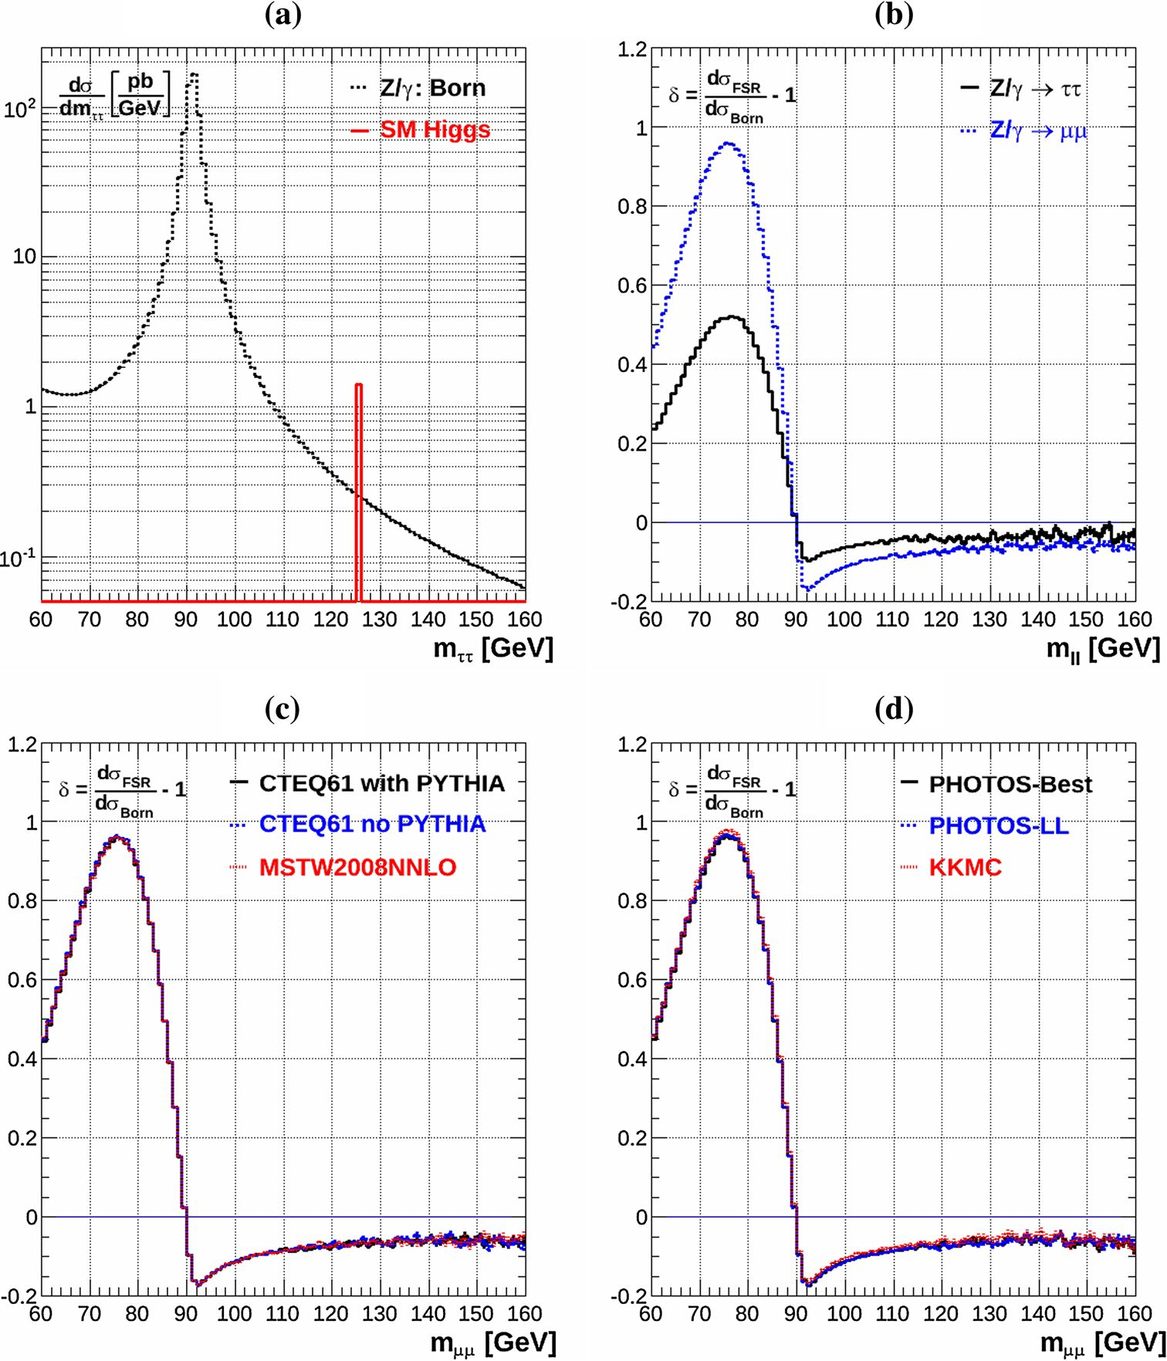
194 Page 4 of 13
Eur. Phys. J. C (2016) 76:194
Fig. 1 a The
WINHAC+PHOTOS inclusive
opposite sign tt mass
distribution and the expected
125 GeV Standard Model Higgs
signal (shown for a bin width of
1 GeV); b the QED radiative
corrections (5 = d°FSR — 1) for
v d°Born '
bare m and t pairs; c the PDF
and QCD-effects dependence of
the size of the QED radiative
corrections for the muon pairs
(see text for details); d the size
of the QED radiative corrections
for various calculation
approximations (see text for
details)
results are very small, below 1 %, and are not visible in the
plot. This shows that the ME correction in PHOTOS, which
accounts for the sub-leading O(a) QED effects, is not impor-
tant for the studies presented here. Nevertheless, our main
results are obtained using PHOTOS in its best set-up. In
Fig. 1d, we also compare the WINHAC+PHOTOS radia-
tive corrections with those of KKMC. Here the differences
are also barely visible in the plot: they reach up to 1.5 %
below the Z-boson mass peak and up to ~1 % above it.
These can be attributed to the differences between KKMC
and PHOTOS discussed earlier. We have checked that these
differences are almost identical for the t and m cases. There-
fore, as far as the difference of the radiative corrections for
muons and taus is concerned, they are negligible. The same
is true for the purely weak corrections. Therefore, we con-
clude that WINHAC+PHOTOS is adequate for our study of
the QED FSR influence on the background to the H ^ tt
signal in the LHC Run 1 data. In the future, with increased
statistical and systematic precision of the LHC data, using
more precise MC generators, such as KKMC, may be
necessary.
The above study demonstrates that at the generator level
the radiative corrections for the NC DY process are well con-
trolled. In the mass region relevant for the Higgs signal they
are small compared to the signal itself. One could thus expect
that they would have a negligible impact on the experimental
determination of the H ^ tt signal at the present statistical
precision. This is indeed the case for the classical analysis, in
which the radiative effects are implemented in all the back-
ground MC generators and the treatment of simulated and
data events is the same.
In the following subsection we demonstrate that this state-
ment no longer holds for the embedding-procedure-based
analysis which uses real rather than generated events.
12n
Eur. Phys. J. C (2016) 76:194
Page 5 of 13 194
  - FSR corrections to embedding procedure
As discussed earlier, we use the term bare leptons for those
which have their momentum vector reconstructed solely from
the track parameters and the term dressed leptons for an ide-
alised case in which all the radiative photons are assigned
to their lepton emitters and the photon measured momenta
are used in the reconstruction of the initial momentum vec-
tor of the leptons. Therefore the dressed lepton, as far as the
FSR is concerned, is equivalent to a Born lepton. If in the
extraction of the Higgs signal, data are compared to com-
plete Monte Carlo simulations of Z/y* ^ tt and H ^ tt
events, the analysis would be consistent. In the analyses of
- a fully simulated H ^ tt sample is used. However,
the Z/y* ^ tt sample is obtained by embedding t-leptons
in a sample of Z/y* ^ pp data. Had dressed t-leptons
been used to replace dressed muons in data, the analysis
would still be consistent. However, what is done instead,
is to replace bare muons in data with simulated dressed
t -leptons.
The necessity of taking into account the QED FSR cor-
rections to the embedding procedure has its origin in the
interplay of the following three effects:
- in the embedding procedure bare muons in data are
replaced by simulated dressed t-leptons,
- the measurement resolution of the invariant mass of two
opposite-charge t-leptons (t+t-) is comparable to the
mass difference between the Z-boson and the Higgs
boson,
- the inclusive cross section for Z/y *-bosons decaying
into leptons is three orders of magnitude larger than that
for the Higgs boson.
The interplay of the above three effects is illustrated in
Fig. 2. The upper left plot (a), shows the difference between
the WINHAC+PHOTOS differential cross section plotted
as a function of the invariant mass of the t+t - pair, m tt , for
the generated sample of the Z/y* ^ tt decays and for the
corresponding cross section for the case, where the t-lepton
momenta are determined using the embedded Z/y * ^ pp
sample. We call the differential cross-section difference:
^da dorgenerated daembedded (2)
dmTT dmTT dmTT
the radiative corrections to the embedding procedure. Note,
that these corrections are additive rather than multiplicative.
Such a representation is appropriate for the studies of radia-
tive corrections which are “non-local”, i.e. for the case when
their size in each mass bin is an integral over the Born cross
section for a wide mass interval.
The procedure of association of the radiative photons with
the parent t-leptons in the reconstruction is not discussed in
- . Therefore, we cannot provide in this paper a precise
estimate of the radiative corrections to the embedding proce-
dure. Instead, we estimate upper and lower boundaries of the
radiative corrections. Below we refer to these two boundaries
as (1) dressed corrections, and (2) bare corrections.
The two distributions shown in Fig. 2a reflect the follow-
ing two possible outcomes of the reconstruction of the outgo-
ing t-lepton momenta in generated Z/y* ^ tt decays: (1)
the momenta of the dressed t-leptons - represented by the
dashed line (dressed corrections) and (2) the momenta of the
bare t-leptons - represented by the dots (bare corrections).
These correspond to boundaries on the size of the radiative
corrections to the embedding procedure.
If, in the event-by-event experimental reconstruction pro-
cedure of the t-lepton momenta, all photons radiated by each
of the t-leptons were reconstructed from the electromag-
netic energy clusters in the calorimeters and if they were
unambiguously associated to one of the outgoing t -leptons,
contributing to its momentum reconstruction, the radiative
corrections would be those represented by the dashed line.
If, on the other hand, all the calorimetric energy depositions
of photons coming from the initial t-lepton radiation (before
its decay) were not associated to their parent t-leptons, the
radiative corrections to the embedding procedure would have
the values represented by the dots.
The solid line in Fig. 2a represents the cross section for
the H ^ tt decay signal for the case of perfect resolution.
It is significantly higher than the size of the radiative cor-
rections. Thus, are the radiative corrections irrelevant while
establishing the existence of the Higgs-boson signal? If the
invariant mass of the t -lepton pairs, m tt, could be recon-
structed with the precision comparable to that for the muon
pairs, the answer would be affirmative and the discussion in
this chapter could be considered as purely academic. In real-
ity, however, the mass of the t-lepton pairs is reconstructed
with finite resolution, insufficient to assign the t -lepton pairs
to either the Z/y * -boson or Higgs-boson source, on an event-
by-event basis.
In Fig. 2b-d we show the size of the radiative correction
to the embedding procedure for the following three values
of specifying the Gaussian smearing of the recon-
structed mrr: = 10, 20 and 30 GeV. Already for the
_ 10 GeV smearing, the values of the radiative cor-
rections in the mass region of 110-140 GeV are compara-
ble to the Higgs-boson signal. The size of the corrections
increases rapidly, in the Higgs signal mass region, with wors-
ening resolution (increasing a-mT31), outweighing the Higgs-
boson signal already for CT?smirear = 20 GeV. We recall that these
plots were made for the inclusive event sample specified by
the kinematical cuts defined in the previous section. It is evi-
dent that, for any realistic detector and, in particular, in the
presence of escaping neutrinos, these corrections must be
considered with great care.
1 Springer
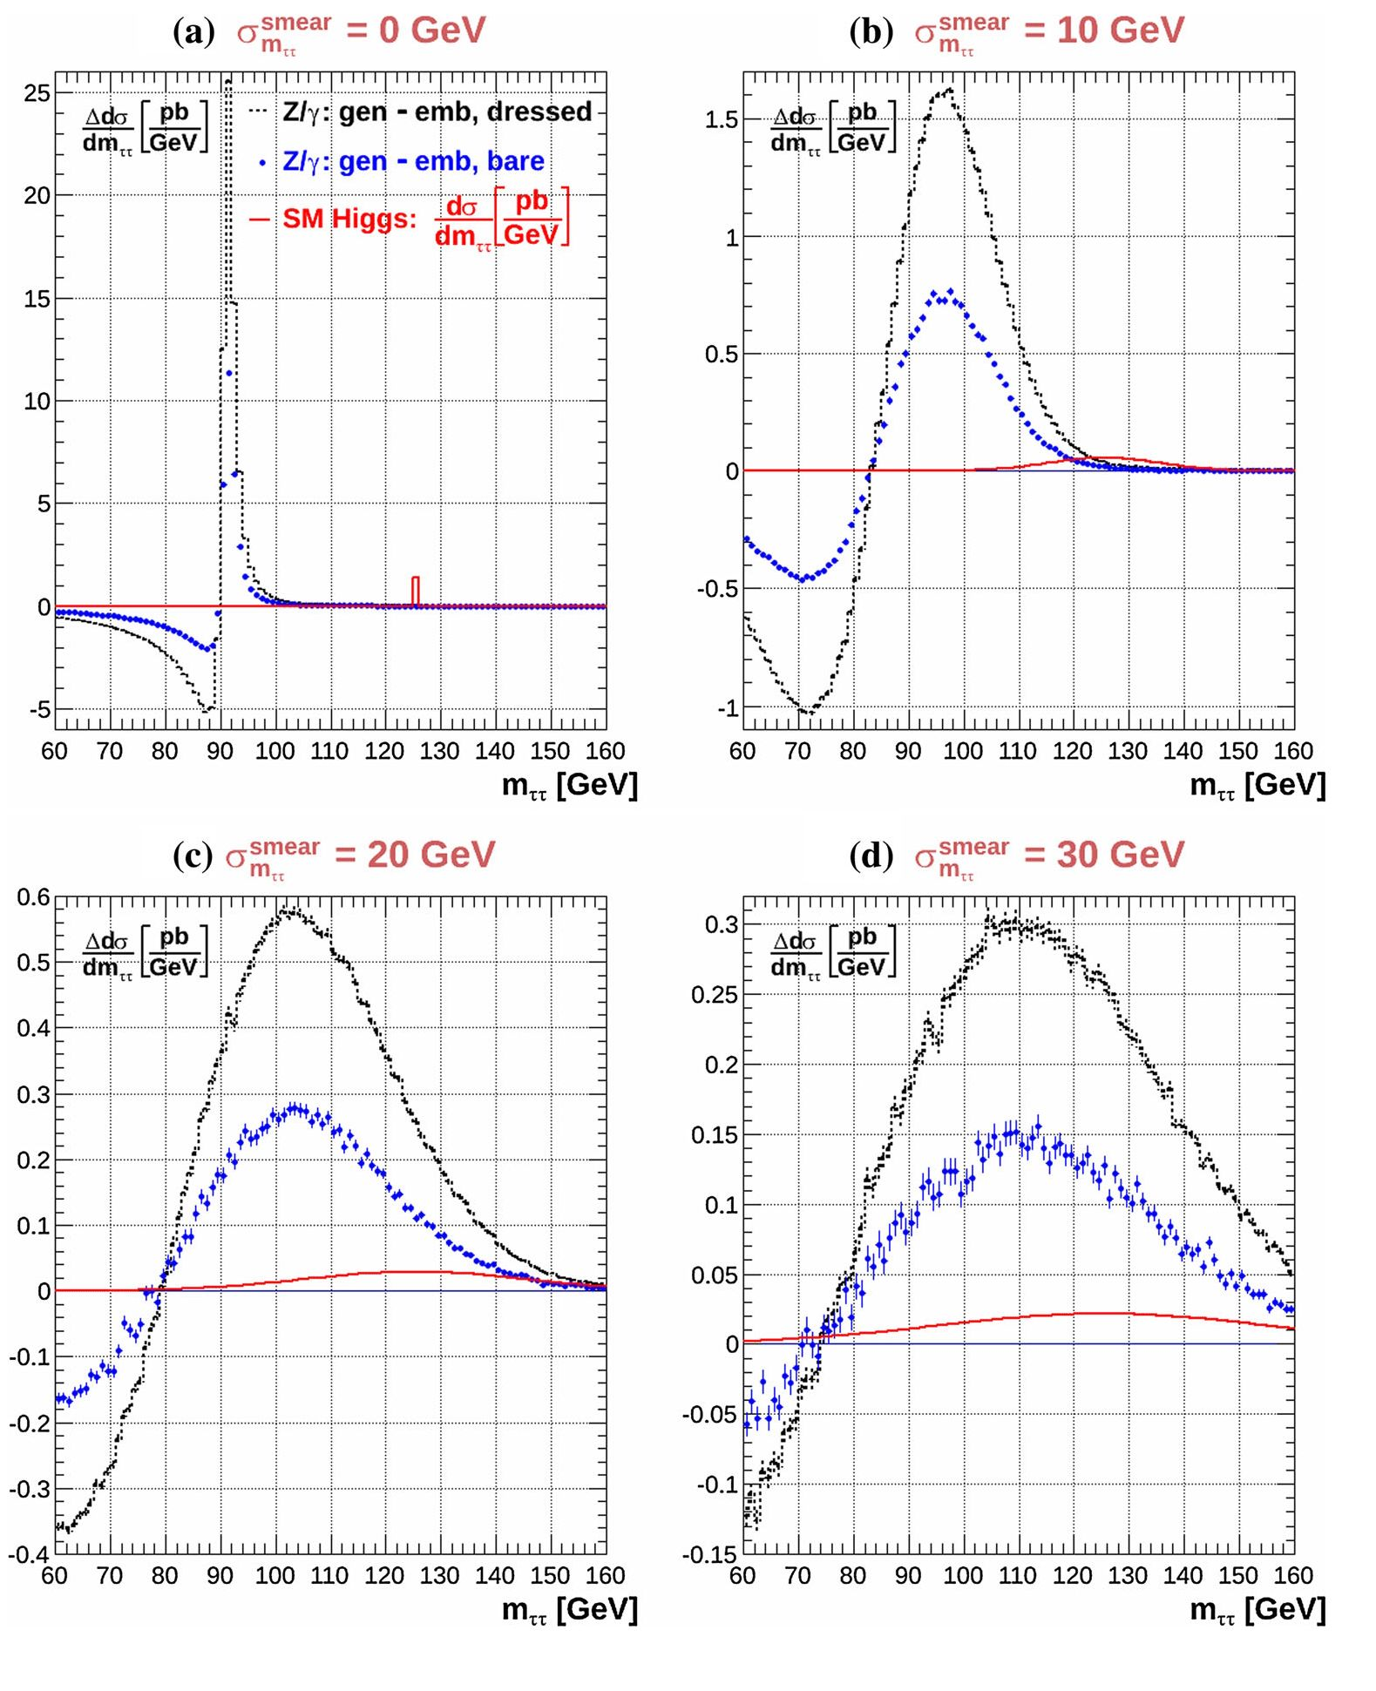
194 Page 6 of 13
Eur. Phys. J. C (2016) 76:194
Fig. 2 The dressed and bare
QED radiative corrections to the
embedding procedure,
Ada dagenerated dgęmhedrted
dmtt dmtt dmtt ’
for pp centre-of-mass collision
energy of 8 TeV and the
following event-acceptance
cuts: \ni| < 2.5, pt,i > 10 GeV
and mil > 40 GeV. Shown are
plots for the following four
values of ammTear specifying the
Gaussian smearing of the
measured invariant mass of the
1+T- pairs: a^^1^ = 0, 10, 20
and 30 GeV - shown in panels
a, b, c and d, respectively. The
corresponding smeared
distributions for the Standard
Model (SM) Higgs-boson
signal, dma~, are also shown for
comparison
It is also important to note that the radiative corrections
to the embedding procedure have a positive sign in the mass
region above the Z-boson mass peak and a negative sign
below it. If not taken into account, the Z/y * ^ 11 back-
ground to the Higgs searches, determined using the embed-
ding procedure, would be significantly (with respect to the
Higgs-boson signal strength) underestimated in the Higgs-
boson mass search region above Z-boson mass and overes-
timated for masses smaller than the Z-boson mass. It is thus
precisely in the region where H ^ 11 decay signals have
been reported [1,2] that the neglected radiative corrections to
the embedding procedure may potentially produce a spuri-
ous Higgs-boson signal by underestimating the background
level.
4 H ^ tt evidence
- Initial remarks
The ATLAS and CMS papers discussing the H ^ 11
decay evidence [1,2] do not present unfolded signal and
background distributions in which the detector and analy-
sis dependent corrections are accounted for. The results pre-
sented in such a form cannot, strictly speaking, be fully
checked by any external analysis. The goal of the analysis
presented in this section is only to provide the best possible
initial estimate of the size of the missing radiative correc-
tions in the modelling of the Z/y * ^ 11 background and
an initial assessment of their impact on the extraction of the
1 Springer
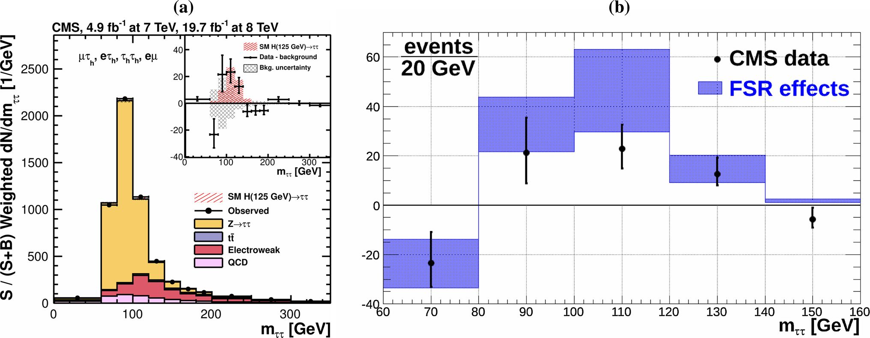
Eur. Phys. J. C (2016) 76:194
Page 7 of 13 194
Fig. 3 a The CMS Fig. 11 taken from [2]; b the comparison of the
observed excess of weighted events, interpreted in [2] as the Higgs sig-
nal, with our predictions for the for the excess of weighted background
events that originate from the missing FSR corrections to the embedding
procedure of modelling the Z/y * ^ tt background
H ^ tt decay signal. Since several simplifications have to
be made, we specify the details of these estimates, leaving to
the LHC collaborations the precise determination of the size
of the corrections for their respective analysis methods.
As discussed in the previous section, the effective size
of the missing radiative corrections in the modelling of the
Z/y* ^ tt background for the ATLAS and CMS analyses
are sensitive to the experimental resolution of the measure-
ment of mxx. The corrections also depend on the efficiencies
of the event-subsample selection cuts, which were optimised
in the ATLAS and CMS analyses [1,2] to enrich the H ^ tt
signal with respect to all background contributions.
The event-subsamples in the H ^ tt searches are clas-
sified in terms of event categories. These categories are char-
acterised by: (1) the type of the t-lepton decays: ie (iM)ihad,
leip, Thadihad, and (2) the event jet activity and the jet(s)
transverse momentum. CMS considers 38 event categories,
while ATLAS considers 6 categories (more information on
the event categories can be found in Refs. [1,2]). In each of
the event categories the mTT resolution and the ratio of the
signal to background are different.
- The CMS case
In Fig. 3a we reproduce Fig. 11 of the CMS paper [2]. Fig-
ure 3a shows the observed and predicted mTT distribution
integrated over all the CMS event categories. The normali-
sation of the predicted background distributions corresponds
to the result of a global fit. The Higgs-signal distribution is
normalised to the Standard Model (SM) prediction (m = 1).
The distributions in each category, i, are weighted by the
ratio between the expected signal and “signal+background”
yields, wi = Si/(Si + Bi). The insert shows the correspond-
ing difference between the data and their estimate of the back-
ground distributions. Also shown is the expected distribution
for a 125 GeV Standard Model Higgs boson.
We estimate the effect of the missing radiative corrections
to the embedding procedure in the modelling of the Z/y * ^
tt background in three steps.
In the first step we determine, from Fig. 3a, the total
number of weighted Z/y* ^ tt events in the mass inter-
val: 60-160 GeV to be Nf’ot = 3780 ± 190. In the sec-
ond step we determine the Gaussian smearing parameter
ammTear (CMS) of the mTT measurement as the average of the
38 RMS values, ai, for each of the CMS event categories:
ami31 (CMS) = (ai) = 18.4 GeV. The values for each of
the event categories are taken from Table 4 in Appendix B of
Ref. [2]. In the third step we calculate our predictions for the
QED radiative corrections to the Z/y* ^ tt background
contribution shown in Fig. 3a.
We first calculate the difference between the differen-
tial cross section for the generated sample of Z/y* ^ tt
decays and the corresponding cross section in which the
i -lepton momenta are determined by using the embedded
Z/y * ^ MM sample. We do it twice: for the bare and for the
dressed lepton corrections with the Gaussian mass smearing
of amT”(CMS) = 18.4 GeV. The cross sections are sub-
sequently multiplied by the “weighted” luminosity defined
such that the total number of the embedded Z/y* ^ tt
events in the mass internal 60-160 GeV is equal to the num-
ber of the weighed events in the CMS data, NfOt. This nor-
malisation allows us to replace the calculation of the radiative
corrections to the differential cross sections by the calcula-
tion of the number of weighted events which must be added to
1 Springer
194 Page 8 of 13
Eur. Phys. J. C (2016) 76:194
the Z/y* ^ tt background contribution, shown in Fig. 3a,
in order to take into account the missing radiative corrections
in the modelling of the Z/y* ^ tt background.
Such a procedure involves the following three simplifica-
tions:
- The mTT smearing is assumed to be Gaussian.
- The small effect of the radiative corrections to the cate-
gory dependent weights, wi, which requires their redef-
inition as wi = Si/(Si + Bi (1 + Si)), where Si are the
category-dependent radiative corrections, is neglected.
- Instead of calculating the radiative correction for each of
the event categories, with the category-dependent ai, we
use its average value ammrear(CMS). The latter simplifi-
cation assumes implicitly that:
38 38
J2 °i wlNi « ammrear (CMS) £ wi Ni, (3)
i = 1 i = 1
where i denotes the event category and Ni the category-
dependent number of Z/y* ^ tt background events
satisfying the CMS event-selection criteria. This condi-
tion is strictly fulfilled only in the limit of a negligible
dispersion of the ai values. In reality the dispersion of the
ai values is 3.1 GeV. This value is sufficiently small to jus-
tify such a simplification. In order to quantify such a state-
ment we repeated the calculations for ammrear = 15 GeV
and for ammrear = 20 GeV. The corresponding radiative
corrections are found to stay well within the uncertainty
range of the radiative corrections which spans the differ-
ence between the bare and dressed radiative corrections.
In Fig. 3b we compare our predicted excess of weighted
events that originate from the missing QED radiative correc-
tions in the modelling of the Z/y* ^ tt background with
the observed excess of weighted events, taken from the insert
of the plot Fig. 3a, and interpreted in Ref. [2] as the Higgs-
boson signal. Our predictions are plotted as the shadowed
regions, the upper limit corresponding to the dressed radia-
tive corrections and the lower limit corresponding to the bare
corrections. As can be deduced from this plot, the missing
radiative corrections in the modelling of the Z/y* ^ rr
background could fully account for the excess of events and
the Higgs-boson contribution may no longer be required. The
p-value qualifying the agreement of the predictions of the
excess of events due to the missing radiative corrections in
the modelling of the Z/y* ^ tt background with the data
is 0.55. It is calculated for the arithmetic mean of the pre-
dictions for the bare and for the dressed radiative corrections
with the prediction error taken as a half of the difference of
these predictions. The corresponding p-value for the hypoth-
esis in which the Higgs signal is added on top of the missing
radiative corrections in the modelling of the Z/y* ^ rr
background is 0.007. Such a hypothesis is clearly disfavoured
by the data.
As discussed in Sect. 3.3, a striking footprint of the
radiative-corrections-driven excess of events is that it changes
sign for mTt < MZ. This effect, although statistically weak
at the present collected luminosity, is indeed observed in the
data and well reproduced by the missing radiative correc-
tions in the modelling of the Z/y* ^ tt background, thus
supporting the hypothesis that the excess events may be fully
accounted for by the effects of the missing radiative correc-
tions.
- The ATLAS case
Our initial estimate of the effect of the missing radiative cor-
rection to the embedding procedure in the modelling of the
Z/y* ^ tt background for the ATLAS analysis presented
in Ref. [1] is made separately for the six event categories.
The ATLAS event classes reflect the decay channels of
the t-leptons: riepTiep, rhadTiep and rhadThad. For each of
the above three classes, two hadronic remnant configura-
tions, assuring an optimal rejection efficiency of background
events with respect to the Higgs-boson signal, are defined:
(1) the Vector-Boson-Fusion (VBF) configuration, in which
the production of the t-lepton pair is accompanied by the
emission of two jets having a large separation in rapidity, (2)
the Boosted configuration in which the t-lepton pair recoils
against a high transverse-momentum jet(s). The above three
decay channels and the two hadronic configurations define
six event categories. Additional details about the selection
criteria of events belonging to each of the above categories
can be found in Ref. [1].
In our initial estimate of the radiative correction effects
to the CMS analysis we assume Gaussian smearing of the
reconstructed mTT. For the ATLAS case we base our analysis
on the published resolution functions presented in Ref. [1]
for the VBF and Boosted categories. This allowed us to take
into account non-Gaussian resolution tails.
In Fig. 4a, b we compare the ATLAS mTT distributions
for Z/y* ^ tt decays, for the VBF and Boosted config-
urations, with the mTT distribution based on our model of
the measurement resolution. The published and our model
distributions are in very good agreement which validates our
modelling of the experimental resolutions. All the results
presented below are be based on this modelling of the exper-
imental resolution. The resolution functions are assumed to
be the same for the TlepTlep, ThadTlep and ThadThad decay
modes.
The ATLAS selection criteria for the Boosted and VBF
categories increase the ratio of the number of accepted
H ^ tt events sizeably with respect to the Z/y* ^ rr
background, as compared to the fully inclusive samples. The
1 Springer
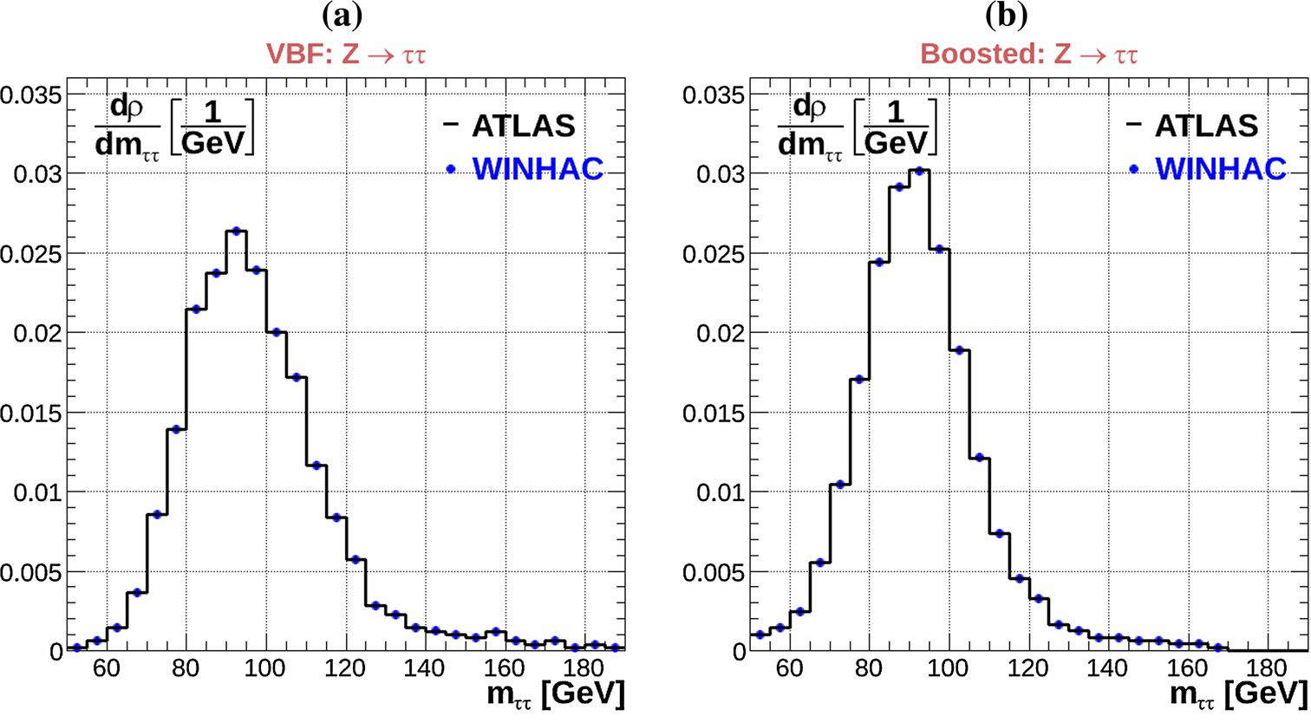
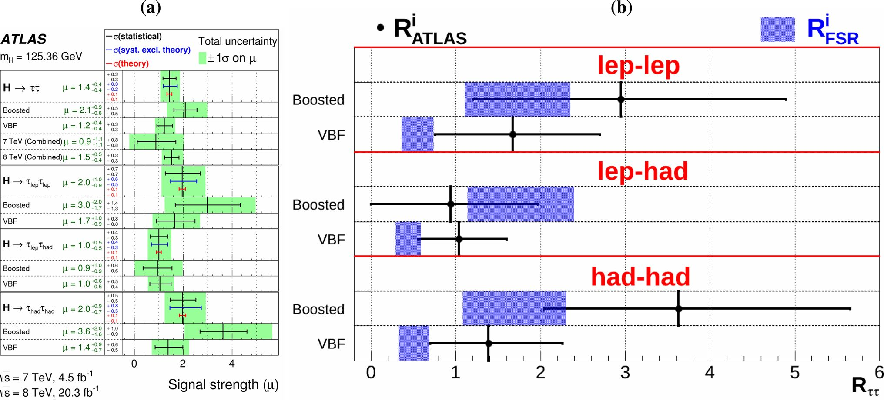
Eur. Phys. J. C (2016) 76:194
Page 9 of 13 194
Fig. 4 The reconstructed
invariant r+r- mass, mrr, in
the ATLAS experiment [1]
compared with the
WINHAC-based model used in
our studies: a for the VBF
selection of events, and b for the
Boosted selection of events
Fig. 5 a Reproduction of Fig. 10 taken from the ATLAS paper [1];
b a comparison of the RAtlas values taken from Fig. 10 of Ref. [1],
with the RFi SR values for each event category (here, the upper bound-
aries of the shadowed regions for the RFsr values correspond to dressed
corrections and the lower boundaries correspond to bare corrections)
ratios of the integrated number of the accepted H ^ rr
H i
events, Ntot’ , to the number of the accepted Z/y* ^ rr
events, Nt^, are determined in our analysis for each event
category using Fig. 2 of Ref. [1]. These ratios are used to
calculate the corresponding ratios of the event-selection effi-
ciencies in the ATLAS-analysis acceptance region [1]:
<H=NhL^ aZ x BR(Z ^ TT)
4 N-Zt i aH x BR(H ^ tt)
where superscript i denotes the event category. The values
of aZ x BR(Z ^ tt) and aH x BR(H ^ tt) taken from
[1] are 1303 and 1.4 pb, respectively. The ratios of the event
selection efficiencies are used in turn to calculate the corre-
sponding ratios of the number of excess events that originate
from the missing radiative corrections in the modelling of
the Z/y* ^ tt background, to the number of expected
excess events from 125 GeV SM Higgs-boson decays in
the ATLAS acceptance regions. These ratios, calculated for
the mxx region between 80 and 150 GeV, and denoted as
RFSR = NFsr/N1h, can be directly compared to the values
of the event-category-dependent a1 parameters, which are
the ratios of the observed to predicted Higgs-boson coupling
strength to t-leptons in each event category [1]. This com-
parison is shown in Fig. 5.
1 Springer
194 Page 10 of 13
Eur. Phys. J. C (2016) 76:194
In Fig. 5a we reproduce Fig. 10 taken from the pub-
lished ATLAS paper [1], which shows the a1 values for each
event category. These values can be interpreted as the event-
category-dependent ratios of the number of the observed
excess events, with respect to the SM background predic-
tions, Neixcess, to the respective number of events originat-
ing from the Higgs-boson decays: RAtlas = N1excess/NlH,
where, as before, i specifies the event category. If the excess
of the observed events is produced only by H ^ tt decays,
then RAtlas = a1 = 1. We refer to this case as the Higgs-
only hypothesis. If the observed excess of events is fully
accounted for by the missing radiative corrections in the
modelling of the Z/y* ^ tt background, N,ixcess = NFsr,
then RAtlas = RFSR. We refer to this case as the the FSR-
only hypothesis. Finally, if the observed excess of events
is accounted for by contributions from both mechanisms,
RATLAS = RFSR + 1. We refer to this case as the the
FSR+Higgs hypothesis.
In Fig. 5b we compare the values of RAi TLAS taken from
Fig. 5a with the RFi SR values, for each event category. The
upper boundaries of the shadowed regions for the RFi SR val-
ues correspond to dressed corrections and the lower bound-
aries correspond to bare corrections.
The first observation is that the FSR-only hypothesis pro-
vides a satisfactory description of the data - the discrepancy
with the data is always less than 1a and the p-value for this
hypothesis is 0.46. Again, as in the CMS case, RFsr is calcu-
lated for the arithmetic mean of the predictions for the bare
and dressed radiative corrections with the prediction error
taken as a half of the difference of these predictions. Con-
trary to the CMS case, for ATLAS the FSR+Higgs hypothesis
is the most probable. The p-value for this hypothesis is 0.77,
slightly better than for the FSR-only hypothesis. Therefore,
although the ATLAS data does not require a contribution
from Higgs-boson decays to explain the observed excess of
events, a contribution from Higgs-boson decay cannot be
ruled out given the level of current experimental uncertain-
ties.
It is intriguing that our prediction for the excess of events
originating from the missing radiative corrections in the mod-
elling of the Z/y* ^ tt background for the preselected
VBF samples is about a factor of 2 lower than the prediction
for the Boosted samples. A similar effect (at a level of 1a)
is observed in the ATLAS data. The value of RAi TLAS for the
VBF category is also about a factor of 2 lower than that for
the Boosted category. This effect calls for a further comment.
Our predictions of the radiative corrections to the embed-
ding procedure for the ATLAS case, in particular the ratio
of the size of the effect for the VBF and Boosted categories,
rely fully on the ATLAS-analysis-specific efficiencies for the
selection of Higgs-decay events in the Monte Carlo signal
sample and for the selection of Z/y*-boson-decay events in
the embedded data sample. In the ATLAS analysis the Monte
Carlo events for the VBF Higgs production category are gen-
erated with the POWHEG+PYTHIA8 generators [19-23].
As shown in an earlier ATLAS paper [24], devoted to the
VBF Z/y*-boson production process, both the POWHEG
and SHERPA [25] generators fail to describe the data in the
phase-space region [24] which is relevant for the analysis
presented here. Namely, the Monte Carlo predictions are too
high by a factor of ~2 in the region of large two-jet invariant
mass (see Fig. 11 in [24]) and should be corrected to obtain
the background templates used in extraction of the Z/y*-
boson VBF signal. Such corrections may also be important
for adequate modeling of the Higgs-boson VBF signal. Their
absence in the Higgs-boson signal analysis presented in Ref.
[1] may explain the apparent discrepancy of the RAi TLAS and
RFi SR values for the VBF and Boosted categories. If both
the Higgs-boson and the Z/y*-boson contributions were to
be taken from Monte Carlo the impact of these corrections
on the ratio of efficiencies for the selection of Higgs decay
events and Z/y*-boson decay events, would be significantly
smaller than in the case of the embedding procedure, and the
observed discrepancy may disappear.
- Final remarks
The results presented in this section represent the initial esti-
mation of the size of the radiative corrections to the embed-
ding procedure for the full acceptance regions of the ATLAS
and CMS analyses. No attempt is made to determine how
the effective corrections would change in more restrictive
kinematical regions or for the Boosted Decision Tree (BDT)
based analysis, in which all the kinematical properties of the
background and signal events are taken into account. Since
the BDT analyses of ATLAS and CMS [1,2] are based on
distributions which are not corrected for detector effects, we
are technically unable to provide the radiative corrections for
the BDT-type of analyses. Our analysis shows, however, that
the ATLAS and CMS BDT analyses should have taken into
account the modifications of the templates of the kinemati-
cal distributions for the Z/y* ^ tt samples caused by the
QED radiative corrections to the embedding procedure. This
statement holds for the present statistical accuracy of the
measurement. For a sizeably larger collected luminosity it
may, in principle, be possible to reduce the size of the radia-
tive correction effects by performing the analyses in more
severely restricted phase-space regions, in which the impact
of radiative corrections is diminished.
5 Embedding procedures and FSR effects
The mechanism in which the missing radiative corrections in
the modelling of the Z/y* ^ tt background could mimic
the Higgs-decay signal was communicated by one of the
12n
Eur. Phys. J. C (2016) 76:194
Page 11 of 13 194
authors of this paper (MWK) to the authors of [1,2] at the
time of preparing these papers for publications. The reply
was that the other sources contributing to the uncertainties of
the embedding procedure were dominant and the effects of
the missing QED radiative correction in the modelling of the
Z/y* ^ tt background are already covered by the corre-
sponding systematic errors. This was claimed to be confirmed
by the Monte Carlo studies in which the detector simulation
results for the embedded and generated Z/y* ^ tt samples
were compared.
In the subsequent CMS and ATLAS technical papers, fol-
lowing the H ^ tt evidence papers [1,2], more atten-
tion has been given, by the respective groups developing the
embedding procedures, to the importance of QED radiative
effects. In the outlook section of the CMS note devoted to
the embedding procedure [26], the importance of quantifying
the impact of the final state radiation for various embedding
methods was notified but the corresponding studies were left
for the future analyses. The ATLAS collaboration published
very recently the paper on the embedding procedure [27].
The QED radiative effects were discussed for the first time,
jointly with the resolution effects of the reconstructed muon
momenta. As a measure of their importance, the distributions
of the t decay lepton transverse momentum and of the invari-
ant mass of the visible tt decay products, mvrlT, for generator-
and detector-seeded t embedding were presented in Fig. 8a,b
of Ref. [27]. These plots demonstrated that the effects of the
uncorrected resolution and final-state radiation of the input
muons are negligible in the case of reconstructed tt final
states, for which the mass resolution is dominated by the
neutrinos produced in the t decay. This conclusion is indeed
correct,2 but only at a precision level of 5-10 %. However,
as our analysis has shown, the extrapolation of such a gen-
eral conclusion to the Higgs-boson searches, where higher
precision is required, cannot be justified.
6 The way forward
As indicated in the previous section, the excess of events
attributed to the Higgs signal may be a consequence of the
missing QED final-state radiative correction in the mod-
elling of the Z/y* ^ tt background. In order to discrim-
inate, beyond any doubt, between the three hypotheses for-
mulated in the previous section: FSR-only, Higgs-only and
2 Note, that Fig. 8a of Ref. [27] is largely irrelevant to the studies of the
radiative effects because hard-photon radiation affects predominantly
the transverse momentum distribution of the sub-leading rather than the
leading lepton. Moreover, the negative slope of the distribution of the
visible rr mass shown in Fig. 8b is clearly visible even at the 5-10 %
precision level of the studies presented in [27]. This negative slope may
be considered as a footprint of the importance of the FSR effects.
FSR+Higgs, the following experimental tests may provide
additional information:
- The mrr dependence test.
This test boils down to selecting the event categories for
which the experimental resolution of the reconstructed
mrr is the best, say in the 10 GeV < a^me™ < 15 GeV
range, and to performing the analysis in two subsamples
of events selected below and above m rr = 120 GeV. If
the excess of events is found to be confined to the lower
mass region, the FSR-only hypothesis is favoured. If it is
found to be concentrated in the higher mass region, the
Higgs-only hypothesis is more likely.
- The embedded t momentum definition test.
Here we exploit the fact that most of the large energy
photons radiated by the outgoing muons coming from
Z/y*-boson decays are collinear with the initial (vertex)
outgoing muon direction. The identification of FSR pho-
tons is easier thanks to the solenoidal magnetic field in
both the ATLAS and CMS experiments. The FSR pho-
ton energy clusters reconstructed in the electromagnetic
calorimeter can be differentiated (with a certain effi-
ciency) from the muon energy loss in the calorimeters
because of the bending of the muons in the magnetic
field. If the energy of the identified radiative photon clus-
ters is added to muon energy which is measured by its
track, the size of the radiative correction to the embed-
ding procedure is drastically reduced. Such a test can
be done in particular for the VBF subsample of events,
for which the transverse momentum spectrum of muons
is softer than for the Boosted sample. Here the larger
deflection in the magnetic field allows for larger separa-
tion of the radiative photon clusters and the muon energy
deposition from muon interactions in the material in the
electromagnetic calorimeter. By varying the association
criteria of electromagnetic clusters with the muon, one
can experimentally control the level of the radiative cor-
rections to the embedding procedure in the modelling of
the Z/y* ^ tt background.
For higher energy muons one could add all the energy
deposition in the electromagnetic calorimeter to the
energy of the muon measured by tracking, and perform
a statistical subtraction of the energy deposition com-
ponent that results from direct muon interactions in the
material of the electromagnetic calorimeter. The statisti-
cal subtraction can utilize a spectrum of energy deposi-
tion simulations for muons of different momenta.
- The bare-versus-dressed t-lepton test.
As shown in Fig. 2, the size of the radiative corrections
to the embedding procedure is different for these two
definitions of the outgoing t-lepton momentum. In the
majority of t-lepton decays the radiative photons cannot
be experimentally resolved and they are included in the
12n
194 Page 12 of 13
Eur. Phys. J. C (2016) 76:194
momentum reconstruction of the dressed t-lepton. How-
ever, as far as the embedding procedure is concerned,
the radiation and decays of t-leptons are generated by
Monte Carlo programs in which the source of each pho-
ton is clearly defined. The test would consist of repeat-
ing the embedding analysis twice, for the dressed and
for the bare t-lepton definitions. If the main source of
the excess of “Higgs-like” events are the radiative cor-
rections to the embedding procedure, this excess would
vary in a predictable way, and the FSR-only and Higgs-
only hypotheses could be discriminated with respect to
each other.
- The selection efficiency test.
The size of the radiative corrections to the embedding
procedure depends very strongly on the relative efficiency
of selecting the Higgs-like events with respect to the
remaining background, in optimal restricted phase-space
volumes. The embedding procedure, in which the main
background is determined directly from the data, while
the Higgs signal is simulated using the Monte Carlo gen-
erated events, is prone not only to the QED radiative
corrections, but also to the QCD radiative corrections,
which are treated differently for data and Monte Carlo
events. The test would consist of determining the ratio,
rather than absolute values, of the selection efficiencies in
a restricted kinematical region from a fixed Monte Carlo
generator, having the same QCD approximations for the
production of Z/y* and Higgs bosons. The large uncer-
tainties of the absolute predictions cancel in this ratio.
This test is of particular importance in view of the appar-
ent discrepancy of the RFsr and RAtlas values between
the VBF and Boosted samples of events. The R1fsr val-
ues are driven by the ratio of efficiencies, as illustrated
in Eq. (4), while the RAtlas values carry, in addition, an
imprint of the relative strength of the Higgs-boson cou-
plings to fermions and bosons. A single-Monte-Carlo-
based measurement could be decisive for an unambigu-
ous interpretation of the “VBF vs. Boosted” discrepancy.
7 Conclusions
In this paper we present an analysis of the effects of QED
final-state radiative corrections to the modelling of the
Z/y* ^ tt process, which is the dominant background
in the H ^ tt searches. We focus our attention on the
radiative corrections to the embedding procedure used by
ATLAS and CMS to model the Z/y* ^ tt background
in the extraction of the H ^ tt signal from experimental
data. We make an initial estimate of the size of these correc-
tions for the ATLAS and CMS analyses [1,2] and show that
the missing radiative corrections in the embedding procedure
may explain the excess of events which has been attributed to
a Higgs-boson signal. We propose several experimental tests
which can differentiate between an excess which originates
from missing QED radiative corrections in the modelling of
the Z/y* ^ tt background and an excess originating from
Higgs-boson decays.
The goal of this paper is to re-draw the attention of the
CMS and ATLAS collaborations to the importance of the
effect of the QED radiative corrections to the embedding
procedure for modelling the Z/y* ^ tt background. Our
earlier suggestions on this matter, addressed to the ATLAS
and CMS collaborations at the time of preparation of their
respective papers, are now quantified by an initial estimate of
the size of the effect. It is our hope that these estimates will
persuade both collaborations to take into account the QED
radiative corrections to their respective embedding proce-
dures used to model the Z/y* ^ tt background in the
extraction of the H ^ tt signal from current and future
experimental data.
Acknowledgments We would Like to thank T. Przedzinski and Z.
Wjs fortheirhelp in interfacing PHOTOS to WINHAC. Weacknowl-
edge the help of the Academic Computer Centre CYFRONET AGH in
Krakow, Poland, where our numerical simulations were performed with
the use of the computing cluster Zeus. We would like to thank Anne
Pfost and Patrick Czodrowski for their critical reading of the manuscript.
Open Access This article is distributed under the terms of the Creative
Commons Attribution 4.0 International License (http://creativecomm
ons.org/licenses/by/4.0/), which permits unrestricted use, distribution,
and reproduction in any medium, provided you give appropriate credit
to the original author(s) and the source, provide a link to the Creative
Commons license, and indicate if changes were made.
Funded by SCOAP3.
References
- G. Aad et al. (ATLAS Collaboration), JHEP 1504, 117 (2015).
arXiv:1501.04943 [hep-ex]
- S. Chatrchyan et al. (CMS Collaboration), JHEP 1405,104 (2014).
arXiv:1401.5041 [hep-ex]
- W. Płaczek, S. Jadach, WINHAC version 1.37: The Monte Carlo
event generator for single W -boson production with leptonic
decays in hadron collisions. http://cern.ch/placzek/winhac
- W. Płaczek, S. Jadach, Eur. Phys. J. C 29, 325 (2003).
arXiv:hep-ph/0302065
- W. Płaczek, PoS EPS-HEP2009, 340 (2009). arXiv:0911.0572
[hep-ph]
- W. Płaczek, S. Jadach, M.W. Krasny, Acta Phys. Pol. B 44, 2171
(2013). arXiv:1310.5994 [hep-ph]
- M.R. Whalley, D. Bourilkov, R.C. Group, The Les Houches accord
PDFs (LHAPDF) and LHAGLUE, in HERA and the LHC: a work-
shop on the implications of HERA for LHC physics. Proceed-
ings, Part B. European Organization for Nuclear Research (2005).
arXiv:hep-ph/0508110
- E. Barberio, Z. Was, Comput. Phys. Commun. 79, 291 (1994)
- P. Golonka, Z. Was, Eur. Phys. J. C 45, 97 (2006).
arXiv:hep-ph/0506026
- P. Golonka, Z. Was, Eur. Phys. J. C 50, 53 (2007)
12n
Eur. Phys. J. C (2016) 76:194
Page 13 of 13 194
- N. Davidson, T. Przedzinski, Z. Was, Comput. Phys. Commun.
199, 86 (2016). arXiv:1011.0937 [hep-ph]
- A.B. Arbuzov, R.R. Sadykov, Z. Was, Eur. Phys. J. C 73(11), 2625
(2013). arXiv:1212.6783 [hep-ph]
- T. Sjostrand, S. Mrenna, P. Skands, JHEP 05, 026 (2006).
arXiv:hep-ph/0603175
- M.W. Krasny, W. Płaczek, Acta Phys. Pol. B 43, 1981 (2012).
arXiv:1209.4733 [hep-ph]
- D. Stump, J. Huston, J. Pumplin, W.K. Tung, H.L.
Lai, S. Kuhlmann, J.F. Owens, JHEP 0310, 46 (2003).
arXiv:hep-ph/0303013
- A.D. Martin, W.J. Stirling, R.S. Thorne, G. Watt, Eur. Phys. J. C
63, 189 (2009). arXiv:0901.0002 [hep-ph]
- S. Jadach, Z. Was, B.F.L. Ward, Comput. Phys. Commun. 130, 260
(2000). Source code available from http://home.cern.ch/jadach/
- T.K.O. Doan, W. Płaczek, Z. Was, Phys. Lett. B 725, 92 (2013).
arXiv:1303.2220 [hep-ph]
- P. Nason, JHEP 0411, 40 (2004). arXiv:hep-ph/0409146
- S. Frixione, P. Nason, C. Oleari, JHEP 0711, 70 (2007).
arXiv:0709.2092 [hep-ph]
- S. Alioli, P. Nason, C. Oleari, E. Re, JHEP 1006, 43 (2010).
arXiv:1002.2581 [hep-ph]
- E. Bagnaschi, G. Degrassi, P. Slavich, A. Vicini, JHEP 1202, 88
(2012). arXiv:1111.2854 [hep-ph]
- T. Sjostrand, S. Mrenna, P. Skands, Comput. Phys. Commun. 178,
852 (2008). arXiv:0710.3820 [hep-ph]
- G. Aad et al. (ATLAS Collaboration), JHEP 1404, 31 (2014).
arXiv:1401.7610 [hep-ex]
- T. Gleisberg et al., JHEP 0902,7 (2009). arXiv:0811.4622 [hep-ph]
- B.Treiber, Abschazung des Untergrundes aus Z ^ rr Ereignissen
in Z ^ rr Analysen, Karlsruhe Institute of Technology preprint,
IEKP-KA/2015, 30 Juli 2015
- G. Aad et al. (ATLAS Collaboration), JINST 10(09), P09018
(2015). arXiv:1506.05623 [hep-ex]
1 Springer

