


Abstract: Phosphodiesterase (PDE) inhibitors are currently a widespread and extensively studied
group of anti-inflammatory and anti-fibrotic compounds which may find use in the treatment of
numerous lung diseases, including asthma and chronic obstructive pulmonary disease. Several PDE
inhibitors are currently in clinical development, and some of them, e.g., roflumilast, are already
recommended for clinical use. Due to numerous reports indicating that elevated intracellular cAMP
levels may contribute to the alleviation of inflammation and airway fibrosis, new and effective
PDE inhibitors are constantly being sought. Recently, a group of 7,8-disubstituted purine-2,6-dione
derivatives, representing a novel and prominent pan-PDE inhibitors has been synthesized. Some of
them were reported to modulate transient receptor potential ankyrin 1 (TRPA1) ion channels as well.
In this study, we investigated the effect of selected derivatives (832—a pan-PDE inhibitor, 869—a
TRPA1 modulator, and 145—a pan-PDE inhibitor and a weak TRPA1 modulator) on cellular responses
related to airway remodeling using MRC-5 human lung fibroblasts. Compound 145 exerted the most
considerable effect in limiting fibroblast to myofibroblasts transition (FMT) as well as proliferation,
migration, and contraction. The effect of this compound appeared to depend mainly on its strong PDE
inhibitory properties, and not on its effects on TRPA1 modulation. The strong anti-remodeling effects
of 145 required activation of the cAMP/protein kinase A (PKA)/cAMP response element-binding
protein (CREB) pathway leading to inhibition of transforming growth factor type ßi (TGF-ßx) and
Smad-dependent signaling in MRC-5 cells. These data suggest that the TGF-ß pathway is a major
target for PDE inhibitors leading to inhibitory effects on cell responses involved in airway remodeling.
These potent, pan-PDE inhibitors from the group of 7,8-disubstituted purine-2,6-dione derivatives,
thus represent promising anti-remodeling drug candidates for further research.
Int. J. Mol. Sci. 2020, 21, 4008; doi:10.3390/ijms21114008
www.mdpi.com/journal/ijms
Article
A Novel, Pan-PDE Inhibitor Exerts Anti-Fibrotic
Effects in Human Lung Fibroblasts via Inhibition of
TGF-ß Signaling and Activation of
cAMP/PKA Signaling
Katarzyna Wójcik-Pszczoła 1'* , Grażyna Chłon-Rzepa 2 , Agnieszka Jankowska 2 ,
Marietta Ślusarczyk 2, Paweł E Ferdek 3, Agnieszka A Kusiak 3, Artur Swierczek 4,
Krzysztof Pociecha 4, Paulina Koczurkiewicz-Adamczyk 1, Elzbieta Wyska 4, Elzbieta Pekala ЧЭ
and Reinoud Gosens 5
- Department of Pharmaceutical Biochemistry, Faculty of Pharmacy, Jagiellonian University Medical College,
Medyczna 9, 30-688 Kraków, Poland; paulina.koczurkiewicz@uj.edu.pl (P.K.-A.);
elzbieta.pekala@uj.edu.pl (E.P.)
- Department of Medicinal Chemistry, Faculty of Pharmacy, Jagiellonian University Medical College,
Medyczna 9, 30-688 Kraków, Poland; mfchlon@cyf-kr.edu.pl (G.C.-R.);
agmeszka.w.jankowska@doctoral.uj.edu.pl (A.J.); mari1106@o2.pl (M.S.)
- Department of Cell Biology, Faculty of Biochemistry, Biophysics and Biotechnology, Jagiellonian University,
Gronostajowa 7, 30-387 Kraków, Poland; pawel.ferdek@uj.edu.pl (P.E.F.);
a.kusiak@student.uj.edu.pl (A.A.K.)
- Department of Pharmacokinetics and Physical Pharmacy, Faculty of Pharmacy, Jagiellonian University
Medical College, Medyczna 9, 30-688 Kraków, Poland; swierczek.artur@gmail.com (A.S.);
k.pociecha@uj.edu.pl (K.P.); mfwyska@cyf-kr.edu.pl (E.W.)
- Department of Molecular Pharmacology, University of Groningen, Antonius Deusinglaan 1, 9713 AV
Groningen, The Netherlands; r.gosens@rug.nl
* Correspondence: katarzynaanna.wojcik@uj.edu.pl; Tel.: +48-12-620-55-77
Received: 11 May 2020; Accepted: 31 May 2020; Published: 3 June 2020
Int. J. Mol. Sci. 2020, 21, 4008
2 of 23
Keywords: asthma; COPD; myofibroblasts; airway remodeling; fibroblast-to-myofibroblast transition;
TGF-ß; phosphodiesterases; cAMP; TRPA1 channels; calcium influx

1. Introduction
Cyclic nucleotide phosphodiesterases (PDEs) are cellular enzymes responsible for the hydrolysis
of phosphodiester bonds in two second messengers'—adenosine 3',5'-cyclic monophosphate (cAMP)
or guanosine 3',5'-cyclic monophosphate (cGMP). PDEs are grouped into 11 subfamilies (PDE1-PDE11)
characterized by different substrate specificities: cAMP-specific (PDE4, PDE7, and PDE8), cGMP-specific
(PDE5, PDE6, and PDE9) and both, cAMP and cGMP-specific (PDE1, PDE2, PDE3, PDE10, and
PDE11) [1]. Therefore, the range of available inhibitors and their therapeutic potential is enormous [1].
Their potential therapeutic application covers disorders from heart failure and fertility, through
Parkinson's and Alzheimer's disease, as well as depression and schizophrenia, to a wide range of
inflammatory diseases [1]. Anti-inflammatory and anti-fibrotic properties of cAMP were demonstrated
in different cellular models [2]. The cAMP was reported to be involved in regulating the function of both
inflammatory cells as well as lung and bronchi structural cells in respiratory diseases, which inspired
a growing interest in the potential therapeutic applications of PDE inhibitors [3,4]. A substantial
body of evidence indicates that elevated cAMP levels promote airway smooth muscle cell (ASMC)
relaxation and decrease ASMC/lung fibroblast proliferation, migration, and the ability to synthesize
extracellular matrix (ECM) proteins, as well as reduce lung fibroblast to myofibroblast transition
(FMT) [2,3,5]. Also, cGMP inhibitors are currently receiving increasingly more interest [1,4,6], owing to
the facts that (1) cigarette smoking was associated with a decreased level of guanylyl cyclase [7] and (2)
that stimulation of this cGMP-producing enzyme can reduce oxidative stress in chronic obstructive
pulmonary disease (COPD) [8]. Additionally, it is known that smoking can induce PDE3 and PDE4
expression in the lungs [9], which not only indicates PDEs involvement in COPD but is also good
further evidence confirming the validity of using PDE inhibitors in the treatment of lung diseases.
The first non-selective PDE inhibitor used in asthma therapy was theophylline
(1,3-dimethylpurine-2,6-dione), a compound that belongs to the group of methylxanthines [10].
However, a number of side effects often limit its therapeutic application. Recently, this and other
naturally occurring methylxanthines were proposed as a potential treatments for pediatric respiratory
tract diseases [11]. Since PDE1, PDE3, PDE4, PDE5, and PDE7 are most closely associated with
the pathogenesis of asthma or COPD [1,3], there has been a need for more selective inhibitors suitable
for targeting isoforms of these PDE families. The aim of this approach is not only to achieve a more
precise blockade of these enzymes but also to reduce the side effects of non-selective PDE inhibitors.
Several inhibitors have undergone clinical trials, and some of them, such as roflumilast (a PDE4
inhibitor), are currently used in the clinic [12]. Another example is the inhaled PDE4 inhibitor, CHF6001
currently in phase II clinical trials, which also exhibits preferential anti-inflammatory properties
in COPD [13]. However, since the efficacy of PDE inhibitors has not been markedly improved by
the increased selectivity toward a specific PDE, the focus of the research was moved towards dual or
pan-PDE inhibitors. Pan-PDE inhibitors represent compounds that are able to inhibit various isoforms
within different PDE classes. Another reason why such inhibitors could be desirable is the cell-specific
expression and compartmentalized intracellular localization of individual PDEs in the cell, which
could account for the synergistic effects of targeting multiple subtypes simultaneously [14]. The reason
for testing PDE inhibitors with a broader spectrum of activity also lies in the fact that the expression of
individual PDEs may change in response to irritants to which patients are exposed, or those that cause
asthma or COPD, e.g., tobacco smoke [9]. Pan-PDE inhibitors may provide a more effective therapeutic
approach than selectively acting agents, mainly through their improved spectrum of pharmacological
activity [1,4]. Enhanced therapeutic potential of pan-PDE inhibitors is expected to result from their
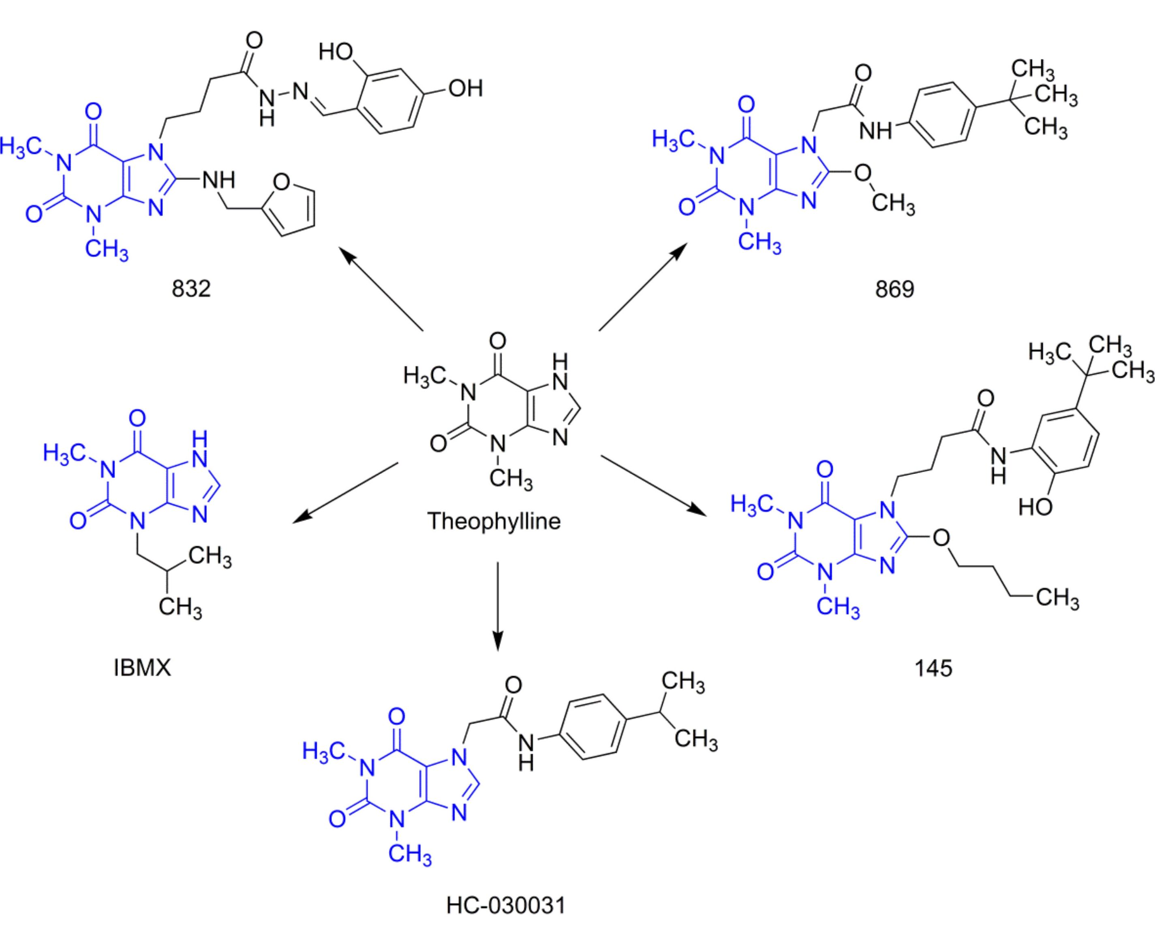
Int. J. Mol. Sci. 2020, 21,4008
3 of 23
effect on a number of signaling pathways involved in the development of asthma and other lung or
bronchial diseases [1,3].
Besides the above-mentioned PDEs, transient receptor potential ankyrin 1 (TRPA1) channels have
recently been proposed to contribute to the pathogenesis of asthma and COPD [15]. These non-selective
calcium-permeable channels have been implicated in allergic reactions, including the late allergic
response, airway hyperresponsiveness and bronchoconstriction, neurogenic inflammation, and cough;
these receptors were also suggested to function as toxicant sensors [16,17]. TRPA1 expression was
described in both immune and lung structural cells, including epithelial cells, smooth muscle cells,
and fibroblasts, as well as sensory neurons. They can be activated by many different irritants, e.g.,
allyl isothiocyanate, allicin, or acrolein as well as pro-inflammatory mediators, including histamine,
prostaglandins, or bradykinin [15-18]. Therefore, it is believed that TRPA1 antagonists may serve as
a promising therapeutic alternative for lung diseases [17,18].
Our earlier studies revealed that, compared to selective PDE4 inhibitors (roflumilast or cilomilast),
pan-PDE inhibitors might provide better inhibition of the transforming growth factor type ß1
(TGF-ß 1)-induced ASMC remodeling [19]. We have also reported that some of the recently synthesized
- disubstituted purine-2,6-dione derivatives, in addition to being pan-selective PDE inhibitors,
can interact with TRPA1 ion channels [20,21]. In this study, we selected three 7,8-disubstituted
purine-2,6-dione derivatives (Figure 1): 832 (a pan-PDE inhibitor), 869 (a TRPA1 modulator), and
145 (a pan-PDE inhibitor and a TRPA1 modulator) and evaluated their ability to limit profibrotic
responses of lung fibroblasts. For this purpose, we used TGF-ß 1 or fetal bovine serum (FBS)-activated
MRC-5 cells and investigated proliferation, migration, contraction, expression of profibrotic genes, and
phenotype transition into myofibroblasts under the influence of these 7,8-disubstituted purine-2,6-dione
derivatives. Our goal was also to verify the TRPA1 contribution in the potential anti-fibrotic effects of
- disubstituted purine-2,6-dione derivatives.
Figure 1. Chemical structures of 832, 869,145, and reference compounds, IBMX and HC-030031, as
theophylline derivatives.
Int. J. Mol. Sci. 2020, 21, 4008
4 of 23
- Results

2.1. Compounds 832 and 145 but not 869 are Prominent, Pan-PDE Inhibitors
Our previous studies revealed that both amide and hydrazide 7,8-disubstituted purine-2,6-dione
derivatives represent a group of strong and non-selective PDE inhibitors [19-22]. This and previous
experiments allowed us to determine the activity of the studied compounds against PDE1B, 3A, 4B,
4D, and 7A (Table 1). For most isoforms, the activity of 832 and 145 was much better than that of
a non-selective, reference inhibitor, IBMX. To better understand the activity profile of 832, 869, and 145,
we have expanded our research to include other isoforms of individual PDEs, particularly those involved
in the pathogenesis of bronchial asthma. Luminescence analysis with human recombinant PDEs
(recently a rapid mass spectrometric determination of AMP and cAMP level has been designed [23])
showed that 832 and 145 effectively inhibit also PDE1C, 3B, and 4A with IC50 values of 89.18 pM,
0.42 pM, 4.75 pM, and 48.52 pM, 2.05 pM, 1.59 pM, respectively (Table 1). Similar to IBMX, compound
832 was active against PDE1A. Interestingly, 145 was the only compound in the study group capable of
inhibiting PDE8A, with an IC50 value of 73.18 pM (Table 1). In contrast to 832 and 145, compound 869
did not show significant activity as a PDE inhibitor (Table 1).
Table 1. Compounds 832, 869, and 145 as PDE inhibitors.
Compound |  |  |  |  |  | PDE-IC50 [pM]
Compound | 1A | 1B | 1C | 3A | 3B | 4A | 4B | 4D | 5A | 7A | 8A
832 | 7.24 | 0.04 | 89.18 | 0.125 | 0.42 | 4.75 | 4.4 3 | n.a. | n.a. | 10.5 3 | n.a.
869 | n.a. | n.a. | 172.18 | n.a. | 156.70 | 58.05 | n.a. | n.a. | n.a. | n.a. | n.a.
145 | n.a. | 2.69 1 | 48.52 | 0.181 | 2.05 | 1.59 | 5.43 2 | 13.85 1 | 103.88 1 | 5.07 2 | 73.18
IBMX | 0.11 | 35.70 1 | 12.52 | 0.71 1 | 0.31 | 16.39 | 46.60 4 | 81.94 | 45.09 1 | 77.70 4 | n.a.
Values published previously: 1 [19]; 2 [20]; 3 [21];4 [22]; n.a.—not active

2.2. Compound 869 is a Representative Antagonist of the TRPA1 Channel
Our previous reports indicated that some of the 7,8-disubstituted purine-2,6-dione derivatives, in
addition to PDE inhibition may also modulate TRPA1 channel activity [20]. Therefore, we determined
the ability of 832, 869, and 145 to inhibit and activate the TRPA1 channel and compared the obtained
results with reference compounds; a known TRPA1 channel antagonist—HC-030031 and a known
TRPA1 channel agonist—ASP 7663. Out of all the studied compounds, only 869 showed strong TRPA1
channel antagonism, comparable to the reference HC-030031 (Table 2). It inhibited the TRPA1 channel
activity by 74.9% and 98.7% at 10 pM and 50 pM, respectively (Table 2). The two other investigated
compounds at best showed only a weak modulation of the TRPA1 channel (less than 25% of control)
(Table 2).
Table 2. Compounds 832, 869, and 145 as TRPA1 modulators.
Compound | TRPA1 Inhibition (% of control)  10 pM 50 pM |  | TRPA1 Activation (% of Control)  10 pM 50 pM
832 | 12.4 | 8.8 | 3.8 | 2.4
869 | 74.9 | 98.7 | 0.0 | 2.2
145 | 12.3 | 4.8 | 0.2 | 4.6
HC-030031 | 91.8 | 98.8 | - | -
ASP 7663 | - | - | 75.8 | 76.1
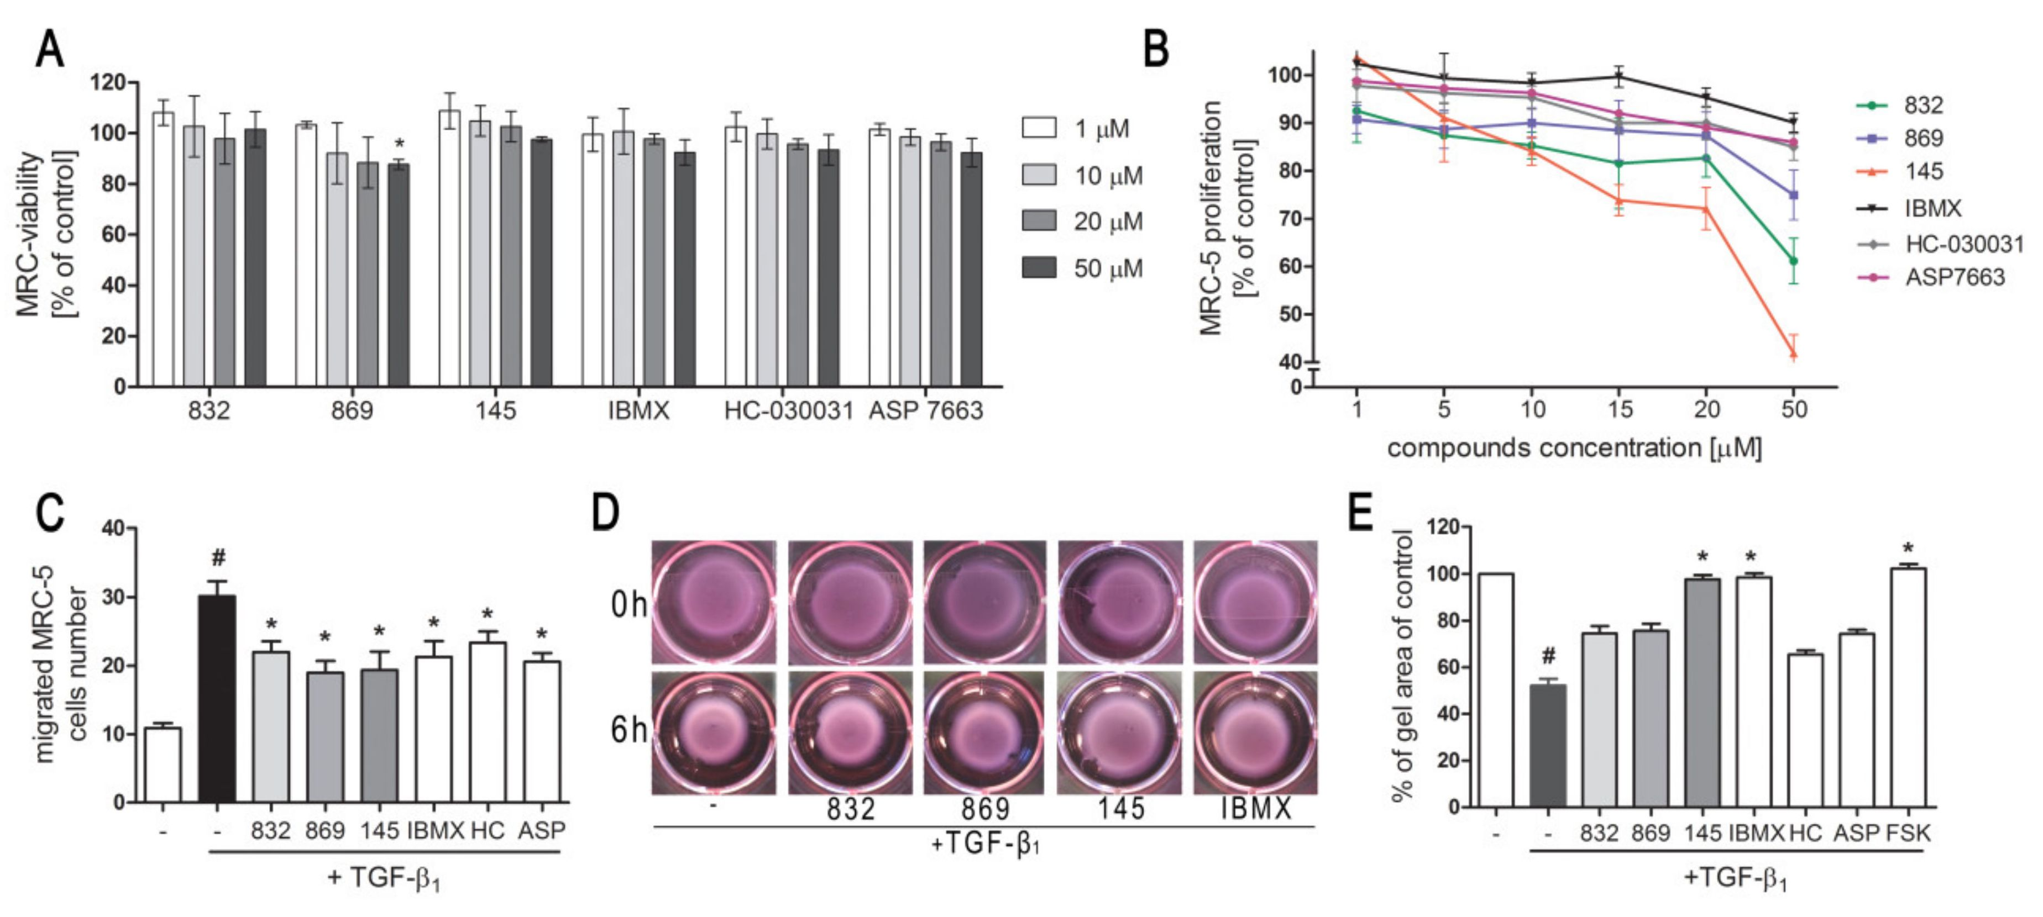
Int. J. Mol. Sci. 2020, 21, 4008
5 of 23
  - 7,8-Disubstituted Purine-2,6-dione Derivatives Selectively Affect Activated Lung Fibroblasts' Proliferation
and Migration
We first determined whether 832, 869, and 145 affect MRC-5 lung fibroblast viability. We exposed
the cells to increasing concentrations (1-50 pM) of the study compounds or to reference controls (IBMX,
HC-030031, and ASP 7663), and found that none of the tested compounds decreased the initial viability
of MRC-5 cells (Figure 2A). To investigate the ability of 832, 869, and 145 to limit the proliferative and
profibrotic responses of lung fibroblasts, we used two stimuli for the fibroblast activation: FBS (for
proliferation) or TGF-ß1 (for profibrotic responses). The selected 7,8-disubstituted purine-2,6-dione
derivatives had differential activity in inhibiting FBS-induced lung fibroblast proliferation. Compound
832, 869, and 145 reduced MRC-5 proliferation more effectively than the reference compounds used in
the study. At a lower concentration range (1-20 pM), 145 exerted the best anti-proliferative activity
against FBS-induced MRC-5 cells, whereas for 832 and 869, this effect was much less prominent
(Figure 2B, Table S1). Interestingly, virtually no change in the lung fibroblast proliferation rate
was observed at lower concentrations of the TRPA1 channel agonist/antagonist. At the highest
concentration applied (50 pM), FBS-induced MRC-5 proliferation rate was inhibited by 39%, 25%, and
58%, in the presence of 832, 869 and 145, respectively; while for IBMX, HC-030031, and ASP 7663 these
values were 10%, 15%, and 14%, respectively (Figure 2B). In further analyses, cells were treated with
compounds at 10 pM, because this concentration was both non-toxic and did not decrease the MRC-5
cell proliferation rate. As for TGF-ß 1-induced MRC-5 migration, all compounds, as well as the reference
compounds, showed similar activity and slightly but statistically significantly reduced the ability of
lung fibroblasts to move throughout the Transwell pores (Figure 2C). In turn, the differential effects of
- disubstituted purine-2,6-dione derivatives were observed in the collagen gel contraction assay. As
demonstrated in Figure 2D,E, the size of the collagen gel lattices after TGF-ß 1 and 832 or 869 increased
only slightly compared to TGF-ß 1 administered alone. Compound 145 and IBMX had a different effect
and restored the size of collagen gel lattices to that of the untreated control (Figure 2D). Forskolin,
a cAMP activator, showed similar properties as 145 or IBMX, suggesting that an increased cAMP
level may be responsible for the reversal of TGF-ß 1-induced collagen gel contraction (Figure 2E). At
the same time, no effect of the TRPA1 channel agonist/antagonist on TGF-ß 1-induced lung fibroblast
contraction was observed (Figure 2E).
Figure 2. Compounds 832, 869, and 145 disturb FBS or TGF-ß 1-induced MRC-5 cells remodeling
phenotype. (A) Lung fibroblasts were cultured in growing concentrations of 832, 869, 145, IBMX,
HC-030031, and ASP7663 (1-50 pM) for 48 h. A viability assay was performed with CYTO-Tox One
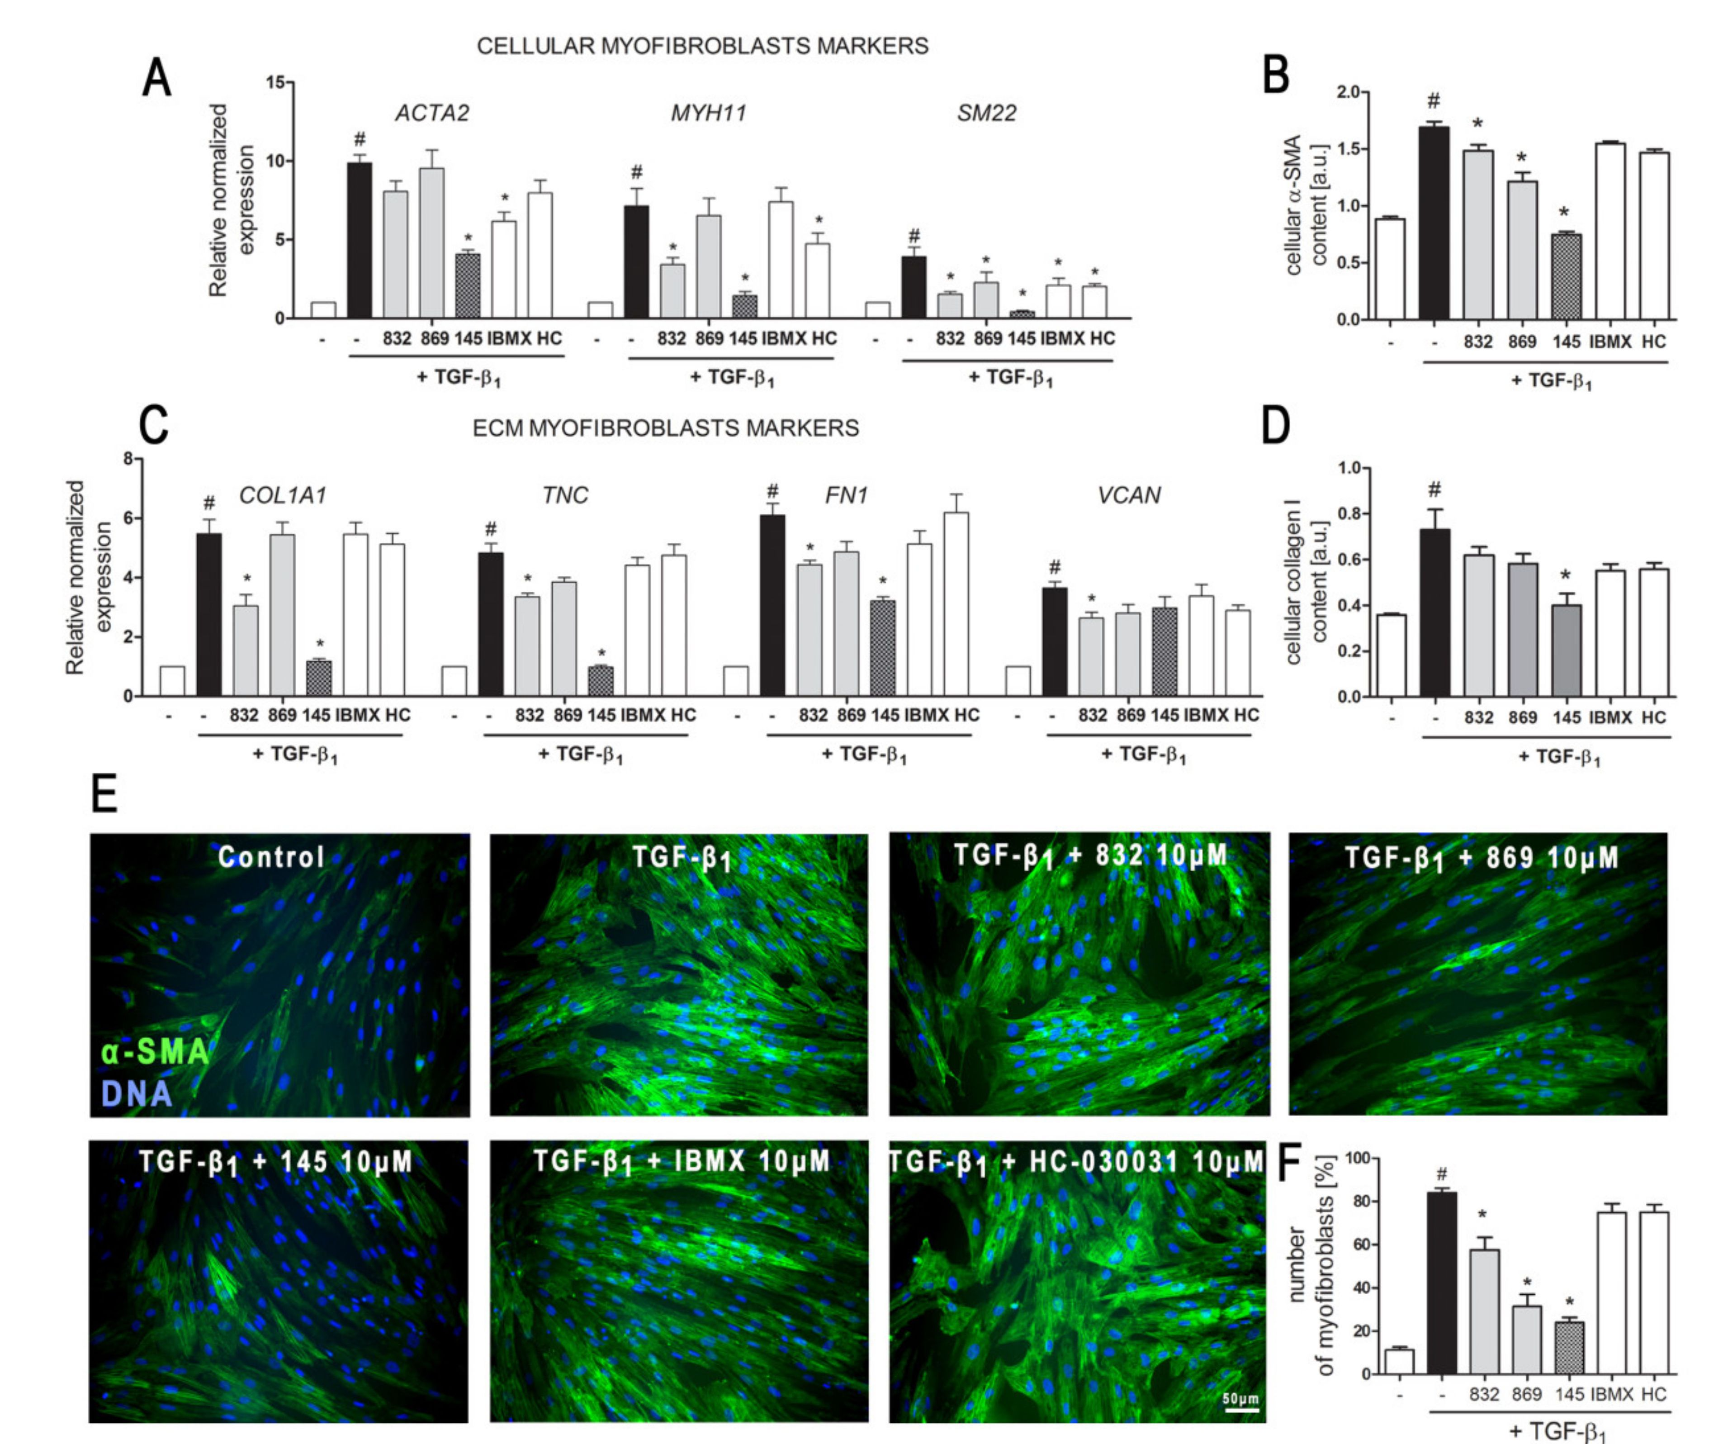
Int. J. Mol. Sci. 2020, 21, 4008
6 of 23
fluorescent kit according to the manufactures' protocol. Values represent viable cells (% mean ± S.E.M.)
in reference to controls; (B) Lung fibroblasts were cultured for 24 h and then serum-deprived for
72 h. MRC-5 proliferation in the growing concentrations of the studied compounds (1-50 pM) was
determined using the alamarBlue® assay after 48 h of incubation in the presence of FBS; n = 6. (C)
Lung fibroblasts migration in response to TGF-ß 1 (5 ng/mL) was assessed after 24 h incubation with
the studied compounds (10 pM). MRC-5 were stained with crystal violet, and any migrated cells were
counted in 10 randomly selected fields of view. (D, E) MRC-5 contraction was determined after 1 h
pre-incubation of collagen gel lattices in the presence of the studied compounds (0 h) and 6 h exposure
to TGF-ß1. (D) Representative pictures of collagen gel lattices. (E) Quantification of the collagen gel
area after a 6-h long incubation in the presence of the studied compounds and TGF-ß1. All values
represent the mean (± S.E.M.). The results were considered statistically significant at the p level of 0.05
against the control (#) and TGF-ß 1 (*).
- Compound 145 Significantly Limits TGF-ß 1-Induced Lung Fibroblast to Myofibroblast Transition
The demonstrated properties of 7,8-disubstituted purine-2,6-dione derivatives prompted us to
check whether 832, 869, and 145 may affect the TGF-ß 1-induced phenotype switch of lung fibroblasts
into myofibroblasts. Transcriptional analysis of myofibroblast markers in MRC-5 cells, cultured in
the presence of TGF-ß 1 and 832, 869, or 145, revealed that studied 7,8-disubstituted purine-2,6-dione
derivatives exert different effects on the expression of target genes (Figure 3A,C).
Figure 3. Compound 145 significantly reduced TGF-ß 1-induced MRC-5 transition into myofibroblasts.
MRC-5 were pre-incubated for 1 h with the studied compounds (10 pM) and then cultured for 24 h
(A, C) or 48 h (B, D-F) in TGF-ß1 (5 ng/mL). (A, C) qPCR was carried out to analyze ACTA2, MYH11,
SM22, COL1A1, TNC, FN1, and VCAN transcript levels. Samples were run three times in duplicates.
Int. J. Mol. Sci. 2020, 21, 4008
7 of 23
Cellular a-smooth muscle actin (a-SMA) (B) and collagen I (D) protein level was determined by in-cell
ELISA; n = 8. (E) To visualize a-SMA positive stress fibers, MRC-5 were fixed, permeabilized, blocked,
and labeled with anti-a-SMA antibody, followed by Alexa Fluor 488 conjugated antibody, nuclei
were stained with Hoechst 33342 dye. Microphotographs were taken using a Leica DMiL LED Fluo
microscope, 40x objective, bar = 50 pm. (F) Myofibroblasts (MRC-5 positive for a-SMA) were counted
in 20 randomly selected fields of view and expressed as a percentage of the entire MRC-5 population.
Each bar represents the mean value (± S.E.M.). The results were considered statistically significant at
the p level of 0.05, against control (#) and TGF-ß 1 (*).
The expression of all the analyzed myofibroblast markers: ACTA2, MYH11, SM22, COL1A1,
TNC, FN1, and VCAN was significantly increased after activation with TGF-ßx (Figure 3A,C).
In the 7,8-disubstituted purine-2,6-dione derivatives group, 145 showed the highest activity in
reducing TGF-ß 1-induced myofibroblast gene expression and caused a two-fold, five-fold, nine-fold,
four-fold, and five-fold decrease in the expression of ACTA2, MYH11, SM22, COL1A1, and TNC,
respectively (compared to TGF-ß! administration alone) (Figure 3A,C). Compounds 832 and 869
showed slightly weaker effects on TGF-ß1-induced expression of myofibroblast markers. The results
of the transcriptional analysis were also confirmed at the protein level (Figure 3B,D). 832,869, and 145
selectively reduced TGF-ß 1-induced cellular content of a-SMA and collagen I in lung fibroblasts. Also,
in this case, compound 145 exhibited the most prominent properties and significantly reduced the levels
of both proteins in TGF-ßx-treated cells (Figure 3B,D). Transcriptional and protein analysis showed
that our PDE inhibitors more efficiently diminished the TGF-ßx-induced myofibroblast phenotype in
MRC-5 cells than the non-selective, reference inhibitor, IBMX (Figure 3A-F). Since the expression and
synthesis of a-SMA actin, as well as its incorporation into stress fibers is one of the main markers of
fibroblast to myofibroblast transition, we also performed immunocytochemical staining of fibroblasts
cultured in the presence of TGF-ßx and 832, 869, or 145 (Figure 3E). The number of myofibroblasts
(MRC-5 with a-SMA-positive stress fibers) in cultures decreased in the presence of 832, 869, or 145,
and the most significant decrease occurred with compound 145 (Figure 3F). Interestingly, the analyses
did not show any significant effect for the TRPA1 channel antagonist, HC-030031, on TGF-ßx-induced
lung fibroblast to myofibroblast transition (Figure 3A-F).
  - Both Inhibition and Activation ofTRPA1 Channels Affect Ca2+ Signals in MRC-5
TRPA1 is an ion channel within the plasma membrane, permeable for Ca2+. Since the tested
compounds had very different effects on TRPA1 channel inhibition or activation, we decided to
check whether they also affect the intracellular Ca2+ homeostasis. Analysis of spontaneous Ca2+
signals in MRC-5 revealed that out of the studied compounds, only 869 exhibited similar properties
to the reference antagonist—HC-030031—and inhibited Ca2+ influx in lung fibroblasts (Figure 4).
The other compounds triggered Ca2+ responses in MRC-5, although to a lesser extent than the reference
agonist used in the analysis—ASP 7663. Compounds 832 and 145 caused a two-fold and four-fold
increase in the average response area, respectively, while responses induced by ASP 7663 triggered, on
average, a 10-fold elevation of intracellular Ca2+ over the baseline levels (Figure 4). The activation of
TRPA1 by compound 145 at the concentration of 10 pM was much less prominent than that by ASP
7663. As opposed to ASP 7663, which caused sustained and prolonged increases in intracellular Ca2+,
compound 145 triggered less pronounced oscillatory type Ca2+ signals.
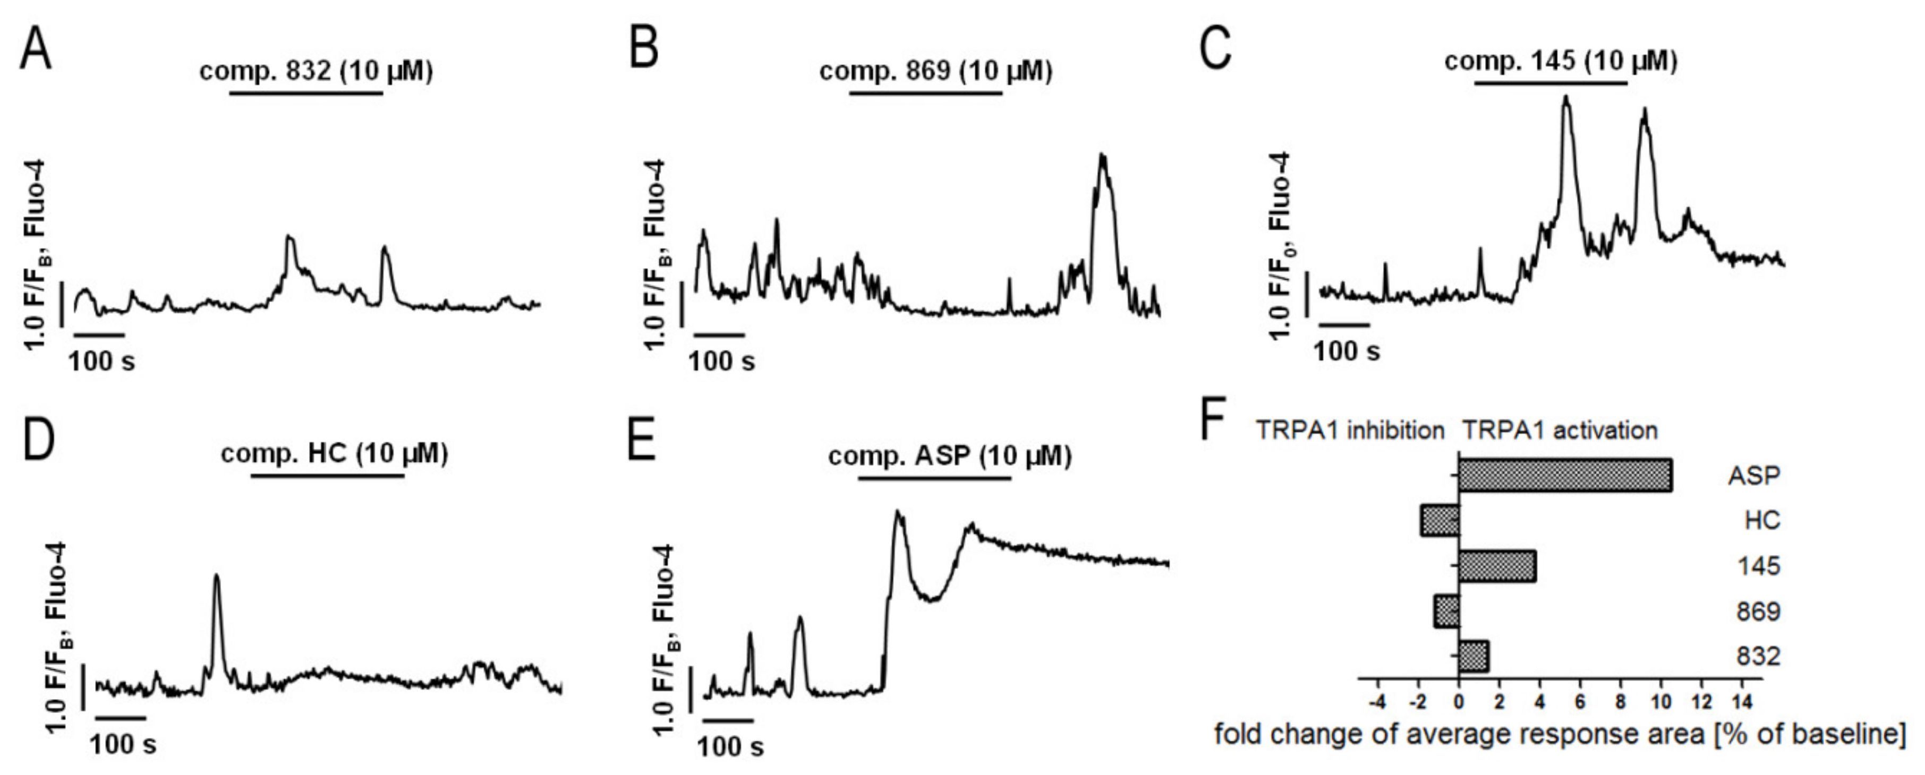
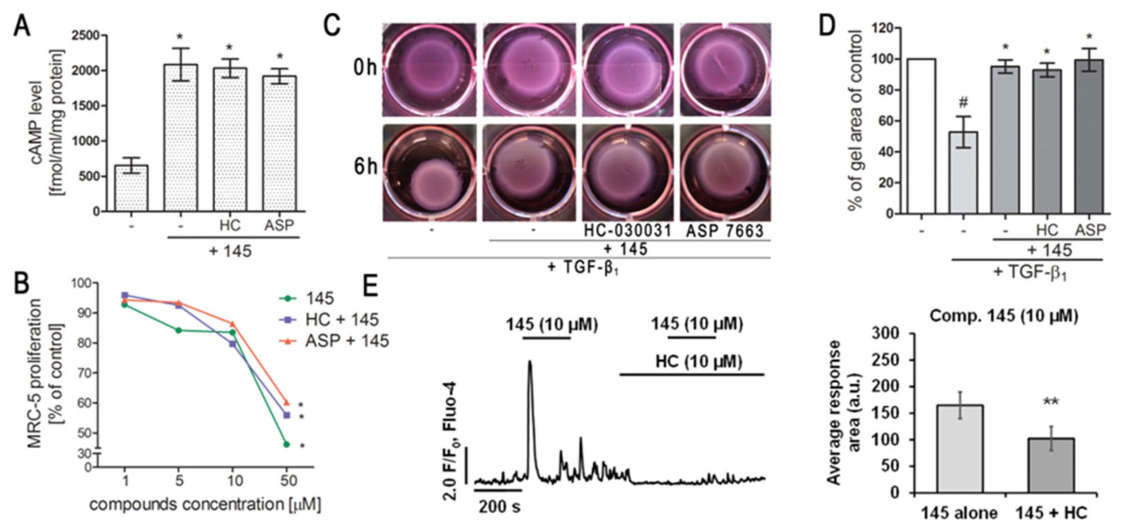
Int. J. Mol. Sci. 2020, 21, 4008
8 of 23
Figure 4. Both inhibition and activation of TRPA1 channels affect Ca2+ signals in MRC-5 cells. Traces
show representative Ca2+ responses recorded in MRC-5, before and after acute application of one of
the investigated compounds: (A) 832 (10 pM), n = 22; (B) 869 (10 pM), n = 23; (C) 145 (10 pM), n = 28;
(D) HC-030031 (10 pM), n = 25; (E) ASP7663 (10 pM), n = 23. (F) Fold change of TRPA1 inhibition or
activation after an acute application of investigated compounds.
  - Modulation ofTRPA1 Ion Channel Does Not Affect Compound 145 Anti-Fibrotic Properties
Since compound 145 showed the most promising anti-fibrotic properties without triggering an
excessive Ca2+ influx in MRC-5, we decided to assess the overall TRPA1 component in the observed
effect. To achieve this, we either blocked or activated TRPA1 in MRC-5 by preincubation with
HC-030031 or ASP 7663, respectively, and then exposed the cells to 145. Neither the TRPA1 agonist
nor the antagonist caused any significant changes in cAMP levels in lung fibroblasts obtained after
incubation with compound 145 (Figure 5A). Moreover, compared to compound 145 alone, neither
of the aforementioned TRPA1 modulators affected the FBS-induced lung fibroblast proliferation rate
(Figure 5B, Table S2). Given that our experiments revealed that 145 is very efficient at restoring
the TGF-ß 1-induced collagen gel contraction (Figure 2D,E), we decided to check whether this feature is
dependent on TRPA1. Preincubation of MRC-5 with HC-030031 or ASP 7663, followed by the application
of 145, did not result in the appearance of significant differences in the size of the collagen gel lattices
compared to the treatment with 145 alone (Figure 5C,D). At the same time, compound 145 failed to
induce Ca2+ responses under TRPA1 inhibition by HC-030031 in lung fibroblasts (Figure 5E).
Figure 5. Modulation of TRPA1 channel activity does not affect the anti-fibrotic properties of compound
145 in MRC-5 cells. (A) Lung fibroblasts were cultured for 24 h and then serum-deprived for 2 h.
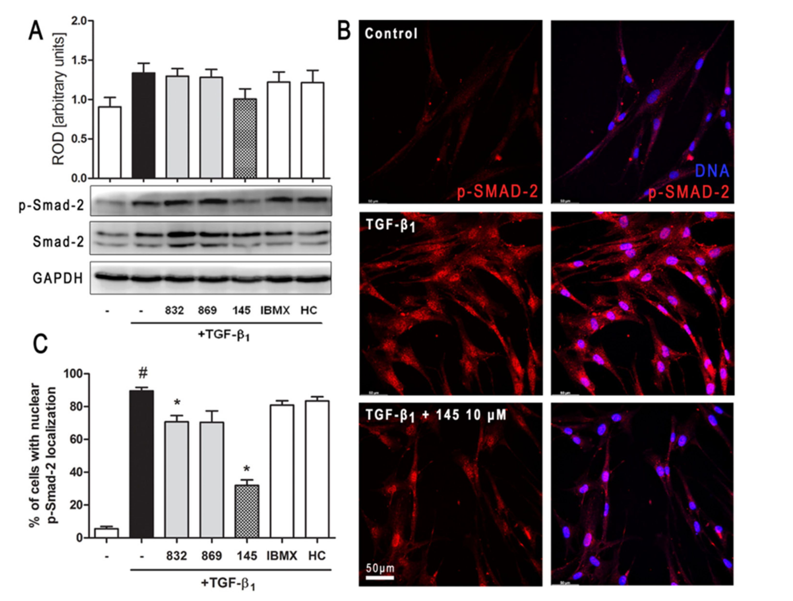
Int. J. Mol. Sci. 2020, 21,4008
9 of 23
The cAMP concentration (fmol/mL/mg of protein; n = 4) was measured after 30 min of pre-incubation
with HC-030031 (10 pM) or ASP7663 (10 pM) followed by 30 min of incubation with 145. (B) Lung
fibroblasts were cultured for 24 h and then serum-deprived for 72 h. MRC-5 proliferation in the growing
concentrations of the studied compounds (1-50 pM) was determined using alamarBlue® assay after
48 h of incubation in the presence of FBS; n = 6. (C, D) MRC-5 contraction was determined after 30
min of pre-incubation with HC-030031 (10 pM) or ASP7663 (10 pM) followed by 30 min of incubation
with 145 and 6 h exposure to TGF-ß 1. (C) Representative pictures of collagen gel lattices taken at
the beginning of the experiment (0 h) and after 6 h incubation. (D) Quantification of collagen gel area
after a 6 h incubation in the presence of study compounds and TGF-ß 1. Each bar represents the mean
(± S.E.M.) (E) MRC-5 cells were treated for 200 s with 145 (10 pM) and then again with 145 (10 pM)
in the presence of HC-030031 (10 pM); representative trace (left); bar charts showing average Ca2+
increase above the baseline recorded for 200 s during the first and the second application of 145 (n = 30,
right). The results were considered statistically significant at the p level of 0.05 (*) or 0.01 (**).
- Compound 145 Attenuates Smad-2 Phosphorylation in TGF-ß 1-Induced Lung Fibroblasts
Intracellular Smad proteins are one of the main effectors of TGF-ß 1 and constitute an essential
part of its canonical signaling pathway. To investigate the contribution of Smad-2 to the effect of 145 in
TGF-ß 1-induced lung fibroblasts, we checked the level of phosho-Smad-2. Immunoblotting revealed
that Smad-2 phosphorylation induced by TGF-ß 1 was reduced by 145 (Figure 6A). Simultaneously,
no differences in the TGF-ß 1-induced Smad-2 phosphorylation were present after incubation with
832, 869, IBMX, and HC-030031 (Figure 6A). The fraction of fibroblasts with nuclear localization of
p-Smad-2 was significantly elevated in TGF-ß 1-induced MRC-5 (Figure 6B,C). While a slight decrease
in nuclear localization of p-Smad-2 occurred in the cells treated with 832, compound 145 caused a very
marked decrease of TGF-ß 1-induced nuclear localization of p-Smad-2 (a 57% decrease compared to
TGF-ß 1 alone) (Figure 6C).
Figure 6. Compound 145 limits TGF-ß 1-induced Smad-2 phosphorylation and nuclear translocation in
MRC-5 cells. Lung fibroblasts were pre-incubated with the studied compounds (10 pM) for 1 h, and
then TGF-ß 1 (5 ng/mL) was added for 1 h. (A) Representative immunoblot and densitometry analysis
Int. J. Mol. Sci. 2020, 21, 4008
10 of 23
of p-Smad-2 in MRC-5 (n = 4). The relative optical density (ROD) signal was normalized to the GAPDH
control level. Each bar represents the mean value (± S.E.M.). (B) Immunofluorescence staining for
p-Smad-2 protein: MRC-5 were fixed, permeabilized, blocked, and incubated with anti-p-Smad-2
antibody followed by Alexa Fluor 546 conjugated antibody, nuclei were stained with the Hoechst 33342
dye. Microphotographs were taken using Leica DMi8 microscope with Thunder Imaging System,
40x objective, bar = 50 pm. (C) Cells exhibiting strong nuclear p-Smad-2 signals were counted in 20
randomly selected fields of view and expressed as a percentage fraction in the entire MRC-5 population.
The results were considered statistically significant at the p level of 0.05, against the control (#) and
TGF-ß 1 (*) conditions.
  - Compound 145 Activates cAMP/PKA/CREB Dependent Signaling in TGF-ß1-Induced Lung Fibroblasts
In order to clarify further molecular mechanisms underlying the anti-fibrotic action of 145
on TGF-ßx-induced human lung fibroblasts, we analyzed the cAMP/PKA/CREB pathway, which
represents the main signaling pathway for compounds characterized as PDE inhibitors. Firstly, we
determined the level of cAMP in MRC-5 cells exposed to selected 7,8-disubstituted purine-2,6-dione
derivatives. Compound 145 showed the best activity and increased cAMP levels in lung fibroblasts
from 508.87 fmol/mL/mg of protein in the control to 2262.07 fmol/mL/mg of protein (Figure 7A).
The effects of other studied compounds were somewhat weaker, but still significant. For 832 and IBMX,
a 2.16-fold and 2.53-fold increase in cAMP level, respectively, was observed (Figure 7A). The level
of cAMP achieved in 145-treated fibroblasts (4.5-fold increase when compared to the control) was
similar to that obtained for the known cAMP activator—forskolin (5.7-fold increase when compared to
the control). The presence of TGF-ßx did not influence the cAMP levels in MRC-5 cells (Figure 7A).
Protein kinase A activity in TGF-ß 1-induced fibroblasts correlated with the recorded cAMP levels and
was the highest in forskolin treated cells and slightly lower in 145, IBMX, and 832-treated MRC-5
cells (Figure 7B). There was no significant change in the activity of this kinase in TGF-ßx-induced
cells incubated in the presence of HC-030031 or 869. The CREB phosphorylation data were in line
with the presented above. CREB phosphorylation occurs as a result of elevated cAMP levels and
increased PKA activity (Figure 7C). An increased CREB phosphorylation was found in TGF-ß 1-induced
MRC-5 cultured in the presence of 145 or forskolin, whereas the other compounds had no effect on this
process (Figure 7C). Also, phosphorylated CREB translocation to the nucleus was significantly more
prominent in TGF-ß1-induced MRC-5 cultures exposed to 145 and forskolin (Figure 7D). The fraction
of MRC-5 cells with nuclear p-CREB localization was elevated by 70% and 76% in the presence of
145 and forskolin, respectively (Figure 7E). Compound 832, 869, IBMX, and HC-030031 caused only
a slight increase in the percentage of fibroblasts exhibiting the nuclear localization of phosphorylated
CREB (Figure 7D,E).
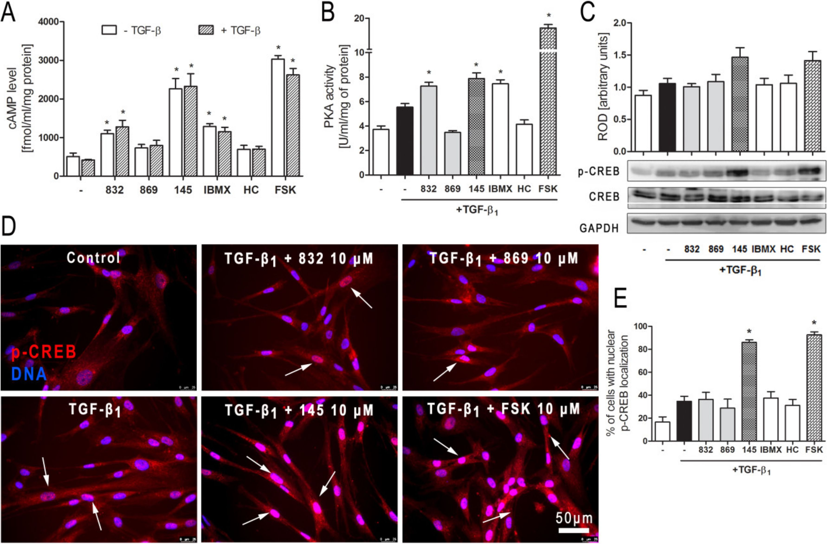
Int. J. Mol. Sci. 2020, 21, 4008
11 of 23
Figure 7. Compound 145 activates cAMP/PKA/CREB dependent pathway in TGF-ß 1-induced MRC-5
cells. (A) Lung fibroblasts were cultured for 24 h and then serum-deprived for 2 h. The cAMP level
was measured after 30 min of incubation with the studied compounds (10 pM) and TGF-ß 1 (5 ng/mL).
Each bar represents the mean (± S.E.M.) The cAMP concentration (fmol/mL/mg of protein; n = 4).
(B) Protein kinase A activity in MRC-5 was determined after 30 min of incubation with the studied
compounds (10 pM), and 30 min of incubation with TGF-ß 1 (n = 4). (C) Representative immunoblot
and densitometry analysis of p-CREB in MRC-5 (n = 4). The ROD signal was normalized to the GAPDH
control level. Each bar represents the mean value (± S.E.M.). (D) Immunofluorescence staining for
p-CREB protein: MRC-5 were fixed, permeabilized, blocked, and incubated with anti-p-CREB antibody
followed by an Alexa Fluor 546 conjugated antibody, nuclei were stained with Hoechst 33342 dye.
Microphotographs were taken using a Leica DMi8 microscope, 40x objective, bar = 50 pm. (E) Cells
exhibiting co-localization of p-CREB and nuclear signal were counted in 20 randomly selected fields
of view and expressed as a percentage fraction in the entire MRC-5 population. The results were
considered statistically significant at the p level of 0.05, against control (*).

3. Discussion
Tissue remodeling is a widespread pathological process in which a number of structural changes
occur in a tissue or organ that impairs its normal physiological functions [24-26]. In the lungs or
bronchi, remodeling in asthma, COPD and lung fibrosis is often associated with the imbalance in ECM
protein turnover, disturbances that occur in the structure and functions of the epithelial layer, smooth
muscle cell hyperplasia and hypertrophy, and increased levels of tissue myofibroblasts, predominantly
as a result of fibroblast to myofibroblast transition [27,28]. Therefore, in the search for new anti-fibrotic
drugs, particular attention should be paid to pleiotropic compounds that affect various cellular
processes associated with remodeling. We have recently shown novel PDE inhibitors from the group of
- disubstituted purine-2,6-dione derivatives as potent modulators of ASMC remodeling [19]. Here
we demonstrated for the first time that a strong pan-PDE inhibitor from this group, compound 145 can
also exert anti-fibrotic effects in TGF-ß ^induced human lung fibroblasts via limiting FMT.
A number of studies have earlier demonstrated FMT-limiting properties of cAMP elevating agents,
such as PDE inhibitors or activators of soluble adenylyl cyclase [29-31]. The potential benefits of
using theophylline as an anti-inflammatory drug in the treatment of asthma have long been known,
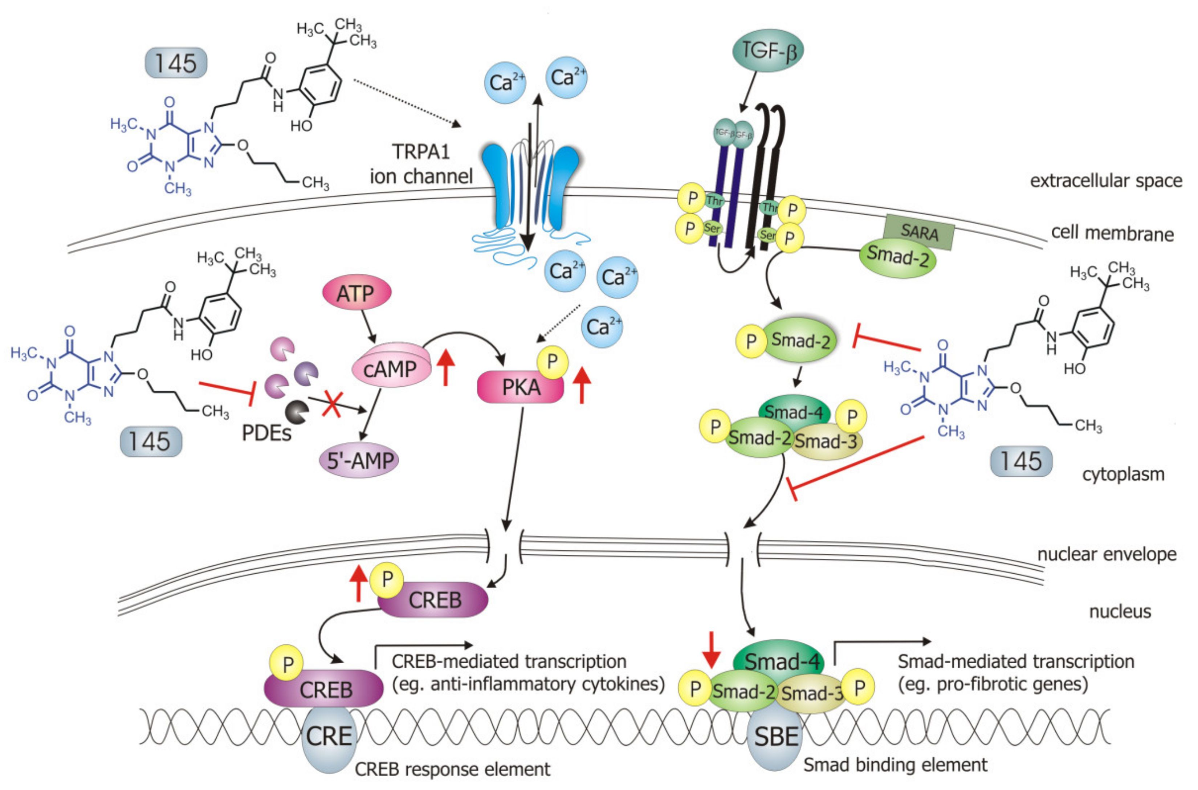
Int. J. Mol. Sci. 2020, 21,4008
12 of 23
but it was only a few years ago when Yano et al. reported the anti-FMT effects of this substance in
the lung [32]. In turn, we demonstrated that other methylxanthines, i.e., pentoxifylline or lisofylline,
can also reduce FMT in bronchial fibroblasts isolated from asthmatics [33]. Other studies revealed
that selective inhibitors, particularly those inhibiting PDE4, such as rolipram or roflumilast, also show
anti-FMT effects [31,34,35].
Our recently designed and synthesized 7,8-disubstituted purine-2,6-dione derivatives fill very
well the gap between inhibitors highly selective for a single isoenzyme, and non-selective and weak
non-specific inhibitors. Both our previous [19] and current research show that 7,8-disubstituted
purine-2,6-dione derivatives represent a group of pan-PDE inhibitors with high inhibitory potency
against individual PDE isoenzymes. They can effectively and strongly inhibit many different PDEs,
including those relevant to the pathogenesis of respiratory diseases [1,3]. Recently, we confirmed 145
favorable binding modes in the active site of PDE4B and PDE7A as well as to the TRPA1 model [20].
Moreover, molecular docking studies of close analogs of compounds 832 and 869, which recognized
crucial interactions in PDE4B/PDE7A and TRPA1 sites, respectively, were previously described [20,21].
Here, it was demonstrated for the first time that these potent, pan-PDE inhibitors exert a strong
limiting effect on TGF-ß 1-induced FMT in lung fibroblasts. Selected 7,8-disubstituted purine-2,6-dione
derivatives, especially 145 inhibited the expression of genes and proteins characteristic for both
myofibroblasts and extracellular matrix proteins secreted by these cells. We showed that some
compounds belonging to 7,8-disubstituted purine-2,6-dione derivatives can also reduce proliferation,
migration, and contraction of pulmonary fibroblasts. We also displayed that the observed anti-fibrotic
effects of pan-PDE inhibitor, 145, are the result of its impact on the canonical TGF-ß signaling pathway.
This compound, decreased Smad-2 phosphorylation and subsequent translocation to the nucleus,
thereby reducing TGF-ß 1-induced and Smad-mediated transcription of profibrotic genes in lung
fibroblasts (Figure 8).
Figure 8. Compound 145 interaction with TGF-ß 1-induced MRC-5 cells and possible targets related
to its anti-fibrotic effects. Abbreviations: ATP—adenosine triphosphate; 5'-AMP—5'-adenosine
monophosphate; CRE—CREB response element; SBE—Smad binding element, SARA—Smad anchor
for receptor activation
Int. J. Mol. Sci. 2020, 21, 4008
13 of 23
The Smad-dependent TGF-ß signaling pathway has already been identified as a potential
therapeutic target for preventing fibrosis in the lung and other organs [36,37]. This has been confirmed by
our current and previous data, in which we have also shown that in asthmatic fibroblasts, pentoxifylline
and lisofylline can limit TGF-ß signaling [33]. Further evidence is provided by Fehrholz et al. who
demonstrated in lung epithelial cells that caffeine and rolipram might also affect Smad-dependent
TGF-ß signaling [38]. Similar effects have been described for the new drugs used in idiopathic
pulmonary fibrosis (IPF) therapy, pirfenidone, and nintedanib [39]. Although the exact mechanism of
action of these anti-inflammatory, antioxidant and anti-remodeling drugs is yet unknown, it is has
been found that they can affect, among others, TGF-ß/Smad-dependent signaling [39,40].
Some studies revealed that increased intracellular cAMP levels could directly affect the canonical
TGF-ß and Smad-dependent signaling pathway [41-45]. After an increased CREB phosphorylation
(e.g., in response to the elevated intracellular cAMP levels), a CREB-binding protein (CBP) effectively
binds p-CREB resulting in enhancement of its transcriptional activity [46]. On the other hand, it
is known that CBP can directly interact with the Smad protein complex and operate as a Smad
transcriptional co-activator [47]. As such, competition between cAMP-dependent CREB/CBP binding
and TGF-ß-dependent Smad/CBP binding for the common co-activator CBP [43,45] is proposed as
the mechanistic explanation for the functional inhibition of Smad-dependent signaling. Compound
145, as a strong PDE inhibitor, elevated cAMP levels in lung fibroblasts, activated PKA and, as
a consequence, led to increased CREB phosphorylation, which in turn inhibited Smad signaling
(Figure 8). The presence of 145 caused the most prominent activation of the cAMP/PKA/CREB pathway
in TGF-ßx-induced MRC-5 cells. At the same time, this compound had the best inhibitory effect on
TGF-ß1/Smad-2 signaling. While a strong activation of cAMP-dependent CREB phosphorylation is not
surprising given that 145 elevates intracellular cAMP, its inhibitory effect on Smad-2 phosphorylation
indicates new and desirable properties of this compound (Figure 8). Since other Smad proteins can also
regulate TGF-ß signaling, the effect of 145 on Smad-3/4 or Smad-1 should also be tested in future studies.
The increased efficacy of compound 145 may be the result of the interaction with two independent
signaling pathways, both of which promote anti-fibrotic effects. It is known that the reduction of
TGF-ß-induced and Smad-mediated transcription of profibrotic genes is one of the main goals of
anti-fibrotic therapy [36,37] and out of the studied compounds, 145 best meets this requirement.
Of note, is that there are also other reports that associate CREB phosphorylation and activation
of CREB-mediated transcription with anti-inflammatory properties, e.g., increased IL-10 synthesis,
inhibition of NF-kB signaling, Th17 cell differentiation, and survival of Treg cells [48,49]. Therefore, it
is likely that the high CREB phosphorylation induced by 145, compared to other tested compounds,
may explain the prominent anti-fibrotic effects of this compound in TGF-ßx-induced MRC-5.
We have characterized compounds 832 and 145 as strong, pan-PDE inhibitors. However, despite
the similar affinity of both compounds to, e.g., PDE1, PDE3, or PDE4, only 145 was able to inhibit, e.g.,
PDE4D, PDE5A, or PDE8A. Compound 145 ability to inhibit PDE8A is an important feature because
even the currently known non-selective inhibitors, such as IBMX (also used in this study), are unable
to inhibit PDE8, probably due to lack of the interaction in the binding site, i.e., hydrogen bond with
Tyr748 [50]. The literature data showed that PDE8 significantly differs from other PDE isoenzymes [50].
Recent reports indicate that this isoform may be of particular importance for the development of
effective PDE inhibitors [4,51]. Both the elevated cAMP levels in MRC-5 treated with 145, as well as
the increased anti-fibrotic properties of this compound, may result from its interaction with PDE8.
Another reason for enhanced 145 activity may be its ability to inhibit cGMP-specific, PDE5A. This
also suggests a possible involvement of cGMP in 145 anti-fibrotic effects in MRC-5 cells. In turn, 145
PDE4D and PDE3 inhibition may result in inducing nausea and ionotropic effects, respectively. On
the other hand, the potential side-effects caused by pan-PDE inhibitors can be mitigated by reducing
their potential therapeutic dose, while maintaining a similar impact to selective PDE inhibitors.
Previous studies [20] made us aware that 145 may also interact with TRPA1 channels. In
light of the reports indicating that TRPA1 channels may be a potential molecular target for lung
Int. J. Mol. Sci. 2020, 21, 4008
14 of 23
diseases [18,52,53], and since caffeine can suppress TRPA1 activity [54], we examined whether 832,869,
and 145 affect the function of this channel. Our results do not support a very strong agonistic/antagonistic
activity of 145 towards TRPA1, but functional analysis revealed that this compound can modify calcium
influx in pulmonary fibroblasts in a way a weak agonist would. To assess the involvement of
TRPA1 in the observed activity of compound 145, we performed a series of experiments in which we
pharmacologically blocked or activated this ion channel and then compared the effects in the presence
and absence of 145. The presence of 145 neither affected MRC-5 proliferation or cAMP levels, which
indicates that the TRPA1 component may not play an important role in 145-mediated anti-fibrotic
effects. We cannot exclude that 145 exerts such a strong inhibitory effect on PDE that the maximum
anti-fibrotic potential is already achieved, and thus, any further modulation of TRPA1 activity may be
negligible for the final outcome. The slight but noticeable effect of the TRPA1 antagonists—HC-030031
and 869, on some tested TGF-ß ^induced MRC-5 myofibroblast features associated with remodeling
may support this notion. This is also in line with several clinical trials in which TRPA1 antagonists
are tested to treat respiratory diseases [53]. On the other hand, Kurahara et al. demonstrated that
pirfenidone might exert anti-inflammatory and anti-fibrotic effects upon TRPA1 activation [55]. We
have not seen similar effects in our study; in fact, TRPA1 activation via ASP 7663 did not result in
significant changes in the phenotype of TGF-ßi-induced MRC-5 cells. Considering the above reports,
and since large and sustained intracellular Ca2+ elevations are often noxious for cells and may trigger
cell death [56], the fact that compound 145 does not excessively activate Ca2+ influx via TRPA1 might be
desirable from the therapeutic perspective. Collectively, it could be argued that anti-fibrotic properties
of compound 145 are accomplished by a strong PDE inhibitor activity, while the TRPA1 channel
modulation is minor and may only slightly contribute to 145 activity.
One of the further mechanisms of methylxanthine interaction with its cellular targets is that these
compounds may function as adenosine receptor antagonists. Our earlier studies carried out on airway
smooth muscle cells did not support the concept of adenosine A1 or A2A receptor antagonism as
a potent modulator of TGF-ß-induced airway remodeling [19]. In turn, Roberts et al. showed that
selected agonists of the Gs-coupled receptors, including, e.g., adenosine A2B or prostacyclin receptors,
can inhibit lung fibroblast differentiation into myofibroblasts [57]. The effect of these compounds was
comparable to that achieved after administration of the adenylate cyclase activator, forskolin, but it
was not consistently associated with the level of cAMP [57]. Here, we demonstrate a link between PDE
inhibition, increased cAMP levels, activation of the PKA/CREB pathway, and anti-fibrotic properties
for both, compound 145 and forskolin. Considering the results of SAR studies indicating which
chemical substituents predispose a compound to possess adenosine receptor antagonist activity [58],
and our earlier data indicating a lack of effect of adenosine antagonists on TGF-ß 1-induced remodeling
in ASMC, we believe that adenosine antagonistic effects do not contribute to the observed effects
of the 7,8-disubstituted purine-2,6-dione derivatives in our study. Calcium signals have also been
implicated in the mechanism of action of methylxanthine compounds [59,60]. Disturbances in calcium
homeostasis may also lead to the synthesis of the extracellular matrix and other profibrotic proteins in
pulmonary fibroblasts [56]. 7,8-disubstituted purine-2,6-dione derivatives turned out to have poor
activity towards calcium-dependent TRPA1 channels.
Our previous research demonstrated that compounds from the group of 7,8-disubstituted
purine-2,6-dione derivatives are able to limit ASMC remodeling response, and here we confirm
145 preferential activity in reducing lung fibroblast features associated with remodeling. Although
both the previous and current studies provide solid evidence of the anti-fibrotic effect of compound
145, the studies so far have been performed in vitro in the presence of one growth factor. Therefore,
the activity of 145, a new pan-PDE inhibitor, should be verified in vivo in a model of chronic lung
diseases and compared with known anti-inflammatory drugs or PDE inhibitors already used clinically.
In the in vivo model, it would be possible to know the 145 pleiotropic effects. Given the complexity
of bronchial and lung remodeling, the search for compounds with a wide spectrum of activity is
extremely valuable. Considering the data obtained with ASMCs and presented here lung fibroblasts, it
Int. J. Mol. Sci. 2020, 21, 4008
15 of 23
can be concluded that the group of 7,8-disubstituted purine-2,6-dione derivatives offers promising
drug candidates targeting chronic lung disease therapy.

4. Materials and Methods
  - Tested Compounds
N'-(2,4-dihydroxybenzylidene)-4-(8-((furan-2-ylmethyl)amino)-1,3-dimethyl-2,6-dioxo-1,2,3,6-
tetrahydro-7H-purin-7-yl)butanehydrazide (working name 832, described in [21]), N-(4-(tert-butyl)
phenyl)-2-(8-methoxy-1,3-dimethyl-2,6-dioxo-1,2,3,6-tetrahydro-7H-purin-7-yl)acetamide (working
name 869, described in [20]), and 4-(8-butoxy-1,3-dimethyl-2,6-dioxo-1,2,3,6-tetrahydro
-7H-purin-7-yl)-N-(5-(tert-butyl)-2-hydroxyphenyl)butanamide (working name 145, described
in [20]) were used in this study. These compounds were synthesized according
to a multistep procedure, as described previously [20,21]. Briefly, to obtain 832,
8-bromo-1,3-dimethyl-3,7-dihydro-1H-purine-2,6-dione was treated with furan-2-ylmethanamine
in refluxing 2-methoxyethan-1-ol. Next, the 8-[(furan-2-yl)methyl]amine derivative was
alkylated at position 7 using ethyl 4-bromobutanoate in the presence of K2CO3 and
a catalytic amount of N-benzyl-N,N-diethylethanaminium chloride (TEBA) in refluxing
acetone. Treatment of the obtained ester with hydrazine hydrate in anhydrous ethanol
gave the corresponding hydrazide. In the final step, the hydrazide was condensed with
2,4-dihydroxybenzaldehyde in methanol in the presence of a catalytic amount of HCl. To obtain
869, 8-bromo-1,3-dimethyl-3,7-dihydro-1H-purine-2,6-dione was alkylated at position 7 with ethyl
- chloroacetate in the presence of K2CO3 and a catalytic amount of TEBA in refluxing acetone.
The synthesized ethyl 2-(8-bromo-1,3-dimethyl-2,6-dioxo-1,2,3,6-tetrahydro-7H-purin-7-yl)acetate
was treated with sodium methanolate in methanol, then hydrolyzed using potassium hydroxide in
a water-acetone mixture and acidified with concentrated HCl to obtain the corresponding acid. In
the final step, the obtained acid was condensed with 4-tert-butylaniline in N,N-dimethylformamide
in the presence of di(1H-imidazol-1-yl)methanone. 145 was obtained in a similar manner,
but ethyl 4-bromobutanoate was used for the alkylation, the transesterification reaction was
carried out using sodium butanolate in butanol, and in the final stage, the resulting acid was
condensed with 2-amino-4-(tert-butyl)phenol [20]. Reference substances used in the studies were:
- isobutyl-1-methyl-3,7-dihydro-1H-purine-2,6-dione (IBMX, Sigma Aldrich, St. Louis, MO, USA),
2-(1,3-dimethyl-2,6-dioxo-1,2,3,6-tetrahydro-7H-purin-7-yl)-N-(4-isopropylphenyl)acetamide
(HC-030031, Sigma Aldrich, St. Louis, MO, USA) and
(E)-2-(7-fluoro-1-isobutyl-2-oxoindolin-3-ylidene)acetic acid (ASP 7663, Sigma Aldrich, St. Louis, MO,
USA). In some experiments, the adenylyl cyclase activator, forskolin (Sigma Aldrich, St. Louis, MO,
USA) was used. All evaluated compounds were dissolved in dimethylsulfoxide (DMSO, PAN-Biotech,
Germany) and diluted in culture medium (the final DMSO concentration did not exceed 0.5% and was
not harmful to the cells).
  - PDE Subtype Selectivity
Inhibitory activities of the investigated compounds against various subtypes of human recombinant
(hr)PDEs, namely PDE1A, PDE1B, PDE1C, PDE3A, PDE3B, PDE4A, PDE4B, PDE4D, PDE7A, and
PDE8A were assessed using a PDE-GloTM Assay Kit (Promega, Madison, WI, USA) according to
the protocol provided by the manufacturer. Briefly, appropriate amounts of each enzyme (SignalChem,
Richmond, B.C., Canada), diluted with PDE-Glo reaction buffer, were distributed on a 384-well plate
(Thermo Scientific, Waltham, MA, USA). The investigated compounds were dissolved in DMSO, diluted
with the same vehicle, and mixed with the reaction buffer at a v/v ratio of 1:5. Thereafter, 1 gL of these
mixtures and 2.5 gL of the cAMP solution as a substrate were added. The final cAMP concentration
was 0.05 gM. The samples were incubated for 10 min at 30 °C. Then, 2.5 gL of termination buffer and
2.5 gL of PDE-Glo detection solution were added to each well and incubated for 20 min. Finally, 10 gL
Int. J. Mol. Sci. 2020, 21, 4008
16 of 23
of PDE-Glo kinase reagent was added, and luminescence was measured using the POLARstar Omega
plate reader (BMG LABTECH, Ortenberg, Germany). Each sample was prepared in quadruplicate.
The relative activities (A, %) of all samples were calculated from the following equation: A = [(LUsample
- LUblank)/(LUcontrol - LUblank)]100%; where LUcontrol is the luminescence of a control sample in
the absence of a PDE inhibitor, LUsample is a luminescence of an investigated sample in the presence of
an inhibitor, and LUblank is a luminescence of a sample in the absence of enzyme (activity = 0). IC50
values were estimated using non-linear regression.
  - TRPA1 Assay
The TRPA1 agonist and antagonist fluorescent imaging plate reader (FLIPR) Assay (functional,
HEK293 cell-based) was performed at Eurofins Panlabs, Inc. (St. Charles, MO, USA). The compounds
were prepared in assay buffer to the final dilutions 10 and 50 gM. In each experiment, the respective
reference compounds were tested: allyl isothiocyanate (the agonist assay) and ruthenium red (the
antagonist assay). The electrophysiological assays were conducted on a FLIPRTETRA instrument
where the test compounds, vehicle controls, and reference agonists or antagonists were added to
the assay plate after a fluorescence baseline was established. The agonist or antagonist incubation
during the assay was for a total of 180 s and was used to assess each compound's ability to activate
or inactivate TRPA1. All plates were subjected to appropriate baseline corrections. Once baseline
corrections were processed, maximum fluorescence values were exported, and data was manipulated
to calculate percentage activation or percentage inhibition. Results showing activity greater than 25%
were considered to represent significant effects of test compounds. Experiments were run three times,
and at least 20 individual cells were recorded in each experiment.
  - In Vitro Lung Fibroblast Culture
The normal human lung fibroblast cell line—MRC-5 (ATCC® CCL-171™, Manassas, VA,
USA)—was used in the study. Cells were cultured in Eagle's Minimum Essential Medium (EMEM,
ATCC® 30-2003™, Manassas, VA, USA) supplemented with 10% (v/v) fetal bovine serum (FBS; Gibco,
Thermo Fisher Scientific, Waltham, MA, USA) and antibiotics mixture (penicillin, streptomycin,
amphotericin B; Gibco, Thermo Fisher Scientific, Waltham, MA, USA) (standard culture medium)
in standard culture conditions (5% CO2, 37 °C, 95% humidity). Unless otherwise specified, for
the experiments, cells were seeded at a final density (5 X 103/cm2) in standard culture medium for
24 h and then cultured in EMEM at reduced serum content (0.5%; v/v) for additional 24 h. TGF-ß 1 (BD
Biosciences, San Jose, CA, USA) was administered at 5 ng/mL concentration in all experiments.
  - Viability and Proliferation Assays
MRC-5 cell viability was evaluated using CytoTox-ONE™ Homogeneous Membrane Integrity
Assay (Promega Corporation, Madison, WI, USA) according to the manufacturer's protocol. The average
fluorescence intensity with an excitation wavelength of 560 nm and an emission wavelength of 590 nm
was measured using a microplate reader (SpectraMax® iD3, Molecular Devices, San Jose, CA,
USA). Experiments were run three times in duplicates. MRC-5 proliferation was determined using
the alamarBlue® assay. Cells were seeded for 24 h in standard culture medium, then serum-starved for
an additional three days. Evaluated compounds (1-50 gM) were added 1 h prior FBS (10%, v/v) for an
additional 48 h. After incubation, the alamarBlue® reagent (Invitrogen, Life Technologies, Carlsbad,
CA, USA), dissolved in Hank's Balanced Salt Solution (10% v/v; Gibco, Thermo Fisher Scientific,
Waltham, MA, USA), was added for 30 min. After the observed color change, the supernatant was
transferred to 96-well plates, and the absorbance was measured at 570 and 600 nm. The percent
difference in reduction between treated and control cells was calculated according to the manufacturer's
protocol. The experiments were run three times in duplicates.
Int. J. Mol. Sci. 2020, 21, 4008
17 of 23
  - Transwell Migration Assay
MRC-5 migration was evaluated using 6.5 mm Transwell culture plates with an 8.0 gm pore
polycarbonate membrane (Corning Incorporated, NY, USA). Cells were serum-deprived for 24 h,
trypsinized and seeded in the upper chamber in serum-free culture medium supplemented with or
without study compounds (10 gM). The lower compartment was filled with the same culture medium,
and after 1 h TGF-ß1 was added to the wells. After 24 h of incubation cells were fixed with 4%
formaldehyde solution (Sigma Aldrich, St. Louis, MO, USA) and stained with 0.5% crystal violet
solution (Sigma Aldrich, St. Louis, MO, USA). The non-migrated cells were removed from the upper
face of the membranes using a cotton swab. The number of migrated cells was counted under an
inverted microscope (Nikon Eclipse TS 100,10X objective) using 10 randomly selected fields of view.
Experiments were run twice, in a blind-folded manner.
  - Cell Contraction Assay
A collagen cell contraction assay was performed according to manufactures' instructions (Cell
Biolabs, INC., San Diego, CA, USA). Briefly, MRC-5 was harvested and mixed with a collagen solution.
After polymerization, collagen gel lattices were cultured for two days, during which mechanical tension
develops. Before releasing the stressed matrix, MRC-5 cells were pre-treated with study compounds
(10 gM) for 1 h. Then collagen gels were gently released from the sides of the culture dishes and
contraction in the presence of study compounds, and TGF-ß 1 was initiated. The collagen gel size was
monitored at various time points and quantified with the Fiji ImageJ Software (National Institutes of
Health, Bethesda, MD, USA, version 1.52q). The experiments were run three times.
  - Intracellular Calcium Measurements
MRC-5 cells were briefly washed with NaHEPES buffer (NaHEPES buffer was prepared as follows:
NaCl 140 mM, KCl 4.7 mM, HEPES 10 mM, MgCl2 1 mM, glucose 10 mM; pH 7.3) and then loaded
with 1 gM Fluo-4 AM (Thermo Fisher Scientific, Waltham, MA, USA) for 1 h, 37 °C in NaHEPES. After
the incubation, the cells were washed again with fresh NaHEPES and used for experiments in a flow
chamber perfused with NaHEPES-based extracellular solution supplemented with 1 mM CaCl2. All
experiments were carried out at room temperature using Zeiss LSM 880 confocal microscope (40X
oil objective), excitation was set to 488 nm, and the emission was between 500 and 600 nm. Each
series of images was recorded at 256 X 256-pixel resolution, two consecutive frames were averaged,
and the interval between the averaged images was set at 2 s. Fluorescence signals were plotted
as F/F0, where F0 was baseline fluorescence defined as the averaged signal from ten consecutive
baseline images.
  - cAMP ELISA
MRC-5 cells were seeded in standard culture medium for 24 h and then serum-starved for 2 h
in HBSS. The study compounds (10 gM) were added to the MRC-5 cultures and after 30 min of
incubation, the intracellular cAMP level in cell lysates was measured using a colorimetric cAMP ELISA
Kit according to the manufacturer's protocol (Cell Biolabs, INC., San Diego, CA, USA). Obtained
results were normalized to total protein content in each sample. The experiments were run two times
in duplicates.
  - In-Cell ELISA
The relative a-SMA and collagen I level in MRC-5 cells were measured using an in-cell ELISA
assay. Study compounds (10 gM) were added 1 h before TGF-ß1 treatment, and the content of
both proteins in fibroblasts was determined after 48 h of incubation. Briefly, MRC-5 were fixed
in methanol, permeabilized and blocked in 1% bovine serum albumin (BSA) with 0.1% Tween®
20 and then immunostained with primary mouse, monoclonal anti-a-SMA or anti-collagen type I
Int. J. Mol. Sci. 2020, 21, 4008
18 of 23
antibodies (#A2547 or #SAB4200678, respectively, Sigma Aldrich, St. Louis, MO, USA), followed
by secondary, anti-mouse, peroxidase-conjugated antibody (#A9044, Sigma Aldrich, St. Louis, MO,
USA). The colorimetric reaction resulting from the addition of peroxidase substrate was stopped, and
the absorbance was measured at 450 nm. The relative protein amount was normalized to the total cell
number in each sample (Janus Green staining). The experiments were run four times in duplicates.

4.11. Immunofluorescence Labelling
For immunocytochemical labeling, MRC-5 cells were seeded on glass coverslips. Study compounds
(10 gM) were added 1 h before TGF-ß1 treatment, and analysis was performed after 1 h (p-Smad-2
and p-CREB detection) or 48 h (a-SMA detection) of incubation. Cells were fixed in methanol
or 4% formaldehyde solution, permeabilized in 0.2% or 0.1% Triton X-100 solution (for p-Smad-2
and p-CREB or a-SMA, respectively). After incubation in blocking solution the following primary
antibodies: rabbit polyclonal, anti-phospho-Smad-2 (Ser465, Ser467) antibody (#44-244G, Thermo Fisher
Scientific, Waltham, MA, USA); rabbit polyclonal, anti-phospho-CREB1 (Ser133) antibody (#orb213775,
Biorbyt, Cambridge, United Kingdom); mouse monoclonal, anti-a-SMA antibody (#MA5-11547,
Thermo Fisher Scientific, Waltham, MA, USA) and secondary antibodies: goat anti-rabbit Alexa Fluor
546 conjugated antibody and goat anti-mouse Alexa Fluor 488 conjugated antibody (#A-11010 and
#A-11001, respectively, Invitrogen, Carlsbad, CA, USA) were used. Nuclei were counterstained with
Hoechst 33342 dye (Thermo Fisher Scientific, Waltham, MA, USA). Slides were mounted in ProLong™
Glass Antifade Mountant (Invitrogen, Carlsbad, CA, USA) and analyzed using Leica DMiL LED
Fluo microscope (for a-SMA and p-CREB visualization, 40X objective) or Leica DMi8 with Thunder
Imaging System (for p-Smad-2 visualization, 40X objective), all equipped with LAS-X Software (Leica
Microsystems GmbH, Wetzlar, Germany). Experiments were run four times using five randomly
selected fields of view, at the same fluorescent time exposure and in a blind-folded manner.

4.12. Quantitative PCR
Quantitative polymerase chain reaction (qPCR) was performed to assess the expression level of
selected human genes: ACTA2, MYH11, SM22, COL1A1, TNC, FN1, and VCAN. MRC-5 cells were
preincubated with study compounds (10 gM) for 1 h, followed by 24 h incubation with TGF-ß1,
and then total RNA was extracted using Total RNA Mini Kit (A&A Biotechnology, Gdynia, Poland)
according to the manufacturer's protocol. RNA concentration was measured with a BioSpectrometer®
basic (Eppendorf), and equal amounts of total RNA (about 1 gg) were reverse-transcribed using
the iScript™ cDNA Synthesis Kit (BioRad, Hercules, CA, USA). qPCR assays were performed using
the CFX96 Touch Real-Time PCR Detection System (BioRad, Hercules, CA, USA) and SsoAdvanced™
Universal SYBR® Green Supermix (BioRad, Hercules, CA, USA). qPCR cycling was performed with
denaturation at 94 °C for 30 s, annealing at 59 °C for 30 s and an extension at 72 °C for 30 s. Specific
primers used to quantify the transcripts are listed in Table 3. The relative abundance of specific mRNA
transcripts was estimated based on cycle threshold (Ct) value and recalculated against the endogenous
reference 18S ribosomal RNA gene (18S rRNA) using the ACt method. The experiments were run three
times in duplicates.
Int. J. Mol. Sci. 2020, 21, 4008
19 of 23
Table 3. Sequences of primers used.
Gene | Forward Sequence (5'^3') | Reverse Sequence (5'^3')
ACTA2 | CCGGGAGAAAATGACTCAAA | GAAGGAATAGCCACGCTCAG
MYH11 | CAGATGCTGGACCTTGAAGA | TCCATGACCAGGATCTCATC
SM22 | CGCGAAGTGCAGTCCAAAATCG | GGGCTGGTTCTTCTTCAATGGGC
COL1A1 | AGCCAGCAGATCGAGAACAT | TCTTGTCCTTGGGGTTCTTG
TNC | CCAGCGACCATCAACGCAGC | GGGGCTTGTTCAGTGGATGCCT
FN1 | TCGAGGAGGAAATTCCAATG | ACACACGTCCACCTCATCAT
VCAN | GGGAACCTGGTGAAGAAACA | CTTCCACAGTGGGTGGTCTT
18S rRNA | CGCCGCTAGAGGTGAAATTC | TTGGCAAATGCTTTCGCTC
Abbreviations: ACTA2—actin alpha 2, MYH11—myosin-heavy chain 11, SM22—transgelin, COL1A1—collagen type
I alpha 1 chain, TNC—tenascin C, FN1—fibronectin 1, VCAN—versican.
  - Western Blotting
Western Blot analysis was performed according to a standard protocol. Briefly, MRC-5 cells
were pre-incubated with the study compounds (10 gM) for 1 h, followed by 48 h incubation with
TGF-ß 1 and then lysed in RIPA buffer (RIPA Lysis and Extraction Buffer, Thermo Fisher Scientific,
Waltham, MA, USA) and supplemented with protease inhibitor cocktail and phosphatase inhibitor
cocktail (both from Sigma Aldrich, St. Louis, MO, USA). Equal amounts of protein (30 gg) were
separated using 10% SDS-polyacrylamide gels and transferred onto polyvinylidene difluoride (PVDF)
membranes (Thermo Fisher Scientific, Waltham, MA, USA). Then membranes were washed with Tris
Buffered Saline with Tween 20 (TBST) buffer (150 mM NaCl, 50 mM Tris, 0.05% Tween 20), blocked
with 5% skim milk in TBST and incubated overnight with the appropriate primary antibody: rabbit,
polyclonal anti-SMAD2 antibody, dilution 1:250, #51-1300 and rabbit, polyclonal anti-phospho-SMAD2
(Ser465, Ser467) antibody, dilution 1:500, #44-244G (both from Thermo Fisher Scientific, Waltham,
MA, USA); rabbit, polyclonal anti-CREB1 antibody, dilution 1:500, #orb213777 and rabbit, polyclonal
anti-phospho-CREB1 (Ser133) antibody, dilution 1:500, #orb213775 (both from Biorbyt LLC, San
Francisco, CA, USA); mouse monoclonal anti-GAPDH antibody, dilution 1:5000, #G8795 (Sigma
Aldrich, St. Louis, MO, USA). The next day, after gentle rising, membranes were exposed to secondary,
rabbit anti-mouse IgG (whole molecule) peroxidase antibody (#A9044, dilution 1:3000, Sigma Aldrich,
St. Louis, MO, USA) and goat anti-rabbit IgG (H+L) peroxidase-conjugated antibody (#32460, dilution
1:3000, Thermo Fisher Scientific, Waltham, MA, USA). Blots were visualized using a chemiluminescence
method (Clarity Max™ Western ECL Substrate—Peroxide Solution, BioRad, Hercules, CA, USA) with
a C-DiGit® Blot Scanner (LI-COR Biosciences, Lincoln, NE, USA). ROD was measured according to
the NTH guidelines with Fiji ImageJ Software. The experiments were run four times.
  - Protein Kinase A Activity
Protein Kinase A (PKA) activity in MRC-5 cells was determined using a PKA Colorimetric
Activity Kit (Invitrogen, Carlsbad, CA, USA) according to the manufacturer's protocol. MRC-5 cells
were seeded in standard culture medium, and after 48 h they were serum-starved for 2 h in HBSS,
followed by the addition of study compounds (10 gM) and incubation for 30 min. Finally, TGF-ß1
was administered, and the samples were incubated for an additional 30 min. Whole cell lysates were
used in the assay. The amount of PKA was normalized to the total protein content in each sample.
The experiments were run two times in duplicates.
  - Statistical Analysis
Statistical analysis was performed with GraphPad Prism (GraphPad Software, Inc., San Diego,
CA, USA, version 5.01). The comparisons between experimental conditions were performed using
a non-parametric Wilcoxon test for paired data and a non-parametric Mann-Whitney U test (for qPCR
Int. J. Mol. Sci. 2020, 21, 4008
20 of 23
data). Values presented in the graphs correspond to the mean ± standard error of the mean (S.E.M.). P
< 0.05 was considered statistically significant.
Supplementary Materials: The following are available online at http://www.mdpi.com/1422-0067/21/11/4008/s1,
Table S1: MRC-5 proliferation in the growing concentrations of studied compounds. Values represent data
presented on Figure 2B and Table S2: MRC-5 proliferation in the growing concentrations of studied compounds.
Values represent data presented on Figure 5B.
Author Contributions: Conceptualization, K.W.-P., G.C.-R. and R.G.; methodology, K.W.-P., P.E.F., A.J., M.S., K.P.,
A.S., and P.K.-A.; software, K.W.-P., E.W., and P.E.F.; validation, K.W.-P.; formal analysis, K.W.-P., E.W., A.J., M.S.,
and P.E.F.; investigation, K.W.-P., A.A.K., P.E.F., K.P., A.S., P.K.-A., A.J., M.S.; resources, K.W.-P., E.P., G.C.-R., E.W.,
P.E.F.; data curation, K.W.-P.; writing—original draft preparation, K.W.-P.; writing—review and editing, R.G.,
P.E.F., E.W., E.P., G.C.-R., and K.W.-P.; visualization, K.W.-P.; supervision, K.W.-P. and R.G.; project administration,
K.W.-P.; funding acquisition, K.W.-P. and G.C.-R.. All authors have read and agreed to the published version of
the manuscript.
Funding: This research was funded by the National Science Centre, Poland, grant number 2017/27/B/NZ7/01633 and
in a part grant number 2018/29/B/NZ7/00285, and 2017/01/X/NZ3/01184. The APC was funded by National Science
Center, Poland, grant number 2017/27/B/NZ7/01633. P.E.F. and A.A.K. were supported by the HOMING/2017-4/31
project grant, carried out within the HOMING program of the Foundation for Polish Science (Fundacja na rzecz
Nauki Polskiej, FNP), co-financed by the European Union under the European Regional Development Fund.
Acknowledgments: We would like to thank the KAWA.SKA Sp. z o.o. company for providing a Leica DMi8 with
Thunder Imaging System microscope for immunocytochemical analyzes. The confocal microscopy experiments
were performed using the equipment purchased thanks to the financial support from the European Regional
Development Fund in the framework of the Polish Innovation Economy Operational Program (contract no.
POIG.02.01.00-12-167/08, project Małopolska Centre of Biotechnology).
Conflicts of Interest: The authors declare no conflict of interest. The funders had no role in the design of the study;
in the collection, analyses, or interpretation of data; in the writing of the manuscript, or in the decision to publish
the results.

References
- Maurice, D.H.; Ke, H.; Ahmad, F.; Wang, Y.; Chung, J.; Manganiello, V.C. Advances in targeting cyclic
nucleotide phosphodiesterases. Nat. Rev. Drug Discov. 2014,13, 290-314. [CrossRef] [PubMed]
- Insel, P.A.; Murray, F.; Yokoyama, U.; Romano, S.; Yun, H.; Brown, L.; Snead, A.; Lu, D.; Aroonsakool, N.
cAMP and Epac in the regulation of tissue fibrosis. Br. J. Pharmacol. 2012,166,447-456. [CrossRef] [PubMed]
- Page, C.P. Phosphodiesterase Inhibitors for the Treatment of Asthma and Chronic Obstructive Pulmonary
Disease. Int. Arch. Allergy Immunol. 2014,165,152-164. [CrossRef] [PubMed]
- Zuo, H.; Cattani-Cavalieri, I.; Musheshe, N.; Nikolaev, V.O.; Schmidt, M. Phosphodiesterases as therapeutic
targets for respiratory diseases. Pharmacol. Ther. 2019,197,225-242. [CrossRef]
- Billington, C.K.; Ojo, O.O.; Penn, R.B.; Ito, S.; Pharmacol, P.; Author, T. cAMP Regulation of Airway Smooth
Muscle Function. Pulm. Pharmacol. Ther. 2013, 26,112-120. [CrossRef]
- Ntontsi, P.; Detta, A.; Bakakos, P.; Loukides, S.; Hillas, G. Experimental and investigational phosphodiesterase
inhibitors in development for asthma. Expert Opin. Investig. Drugs 2019,28, 261-266. [CrossRef]
- Glynos, C.; Dupont, L.L.; Vassilakopoulos, T.; Papapetropoulos, A.; Brouckaert, P.; Giannis, A.; Joos, G.F.;
Bracke, K.R.; Brusselle, G.G. The Role of Soluble Guanylyl Cyclase in Chronic Obstructive Pulmonary
Disease. Am. J. Respir. Crit. Care Med. 2013,188, 789-799. [CrossRef]
- Paul, T.; Salazar-Degracia, A.; Peinado, V.I.; Tura-Ceide, O.; Blanco, I.; Barreiro, E.; Barbera, J.A. Soluble
guanylate cyclase stimulation reduces oxidative stress in experimental Chronic Obstructive Pulmonary
Disease. PLoS ONE 2018,13, e0190628. [CrossRef]
- Zuo, H.; Faiz, A.; van den Berge, M.; Mudiyanselage, S.N.H.R.; Borghuis, T.; Timens, W.; Nikolaev, V.O.;
Burgess, J.K.; Schmidt, M. Cigarette smoke exposure alters phosphodiesterases in human structural lung
cells. Am. J. Physiol. Cell. Mol. Physiol. 2019, 318, L59-L64. [CrossRef]
- Barnes, PJ. Theophylline. Am. J. Respir. Crit. Care Med. 2013,188, 901-906. [CrossRef]
- Oñatibia-Astibia, A.; Martínez-Pinilla, E.; Franco, R. The potential of methylxanthine-based therapies in
pediatric respiratory tract diseases. Respir. Med. 2016,112,1-9. [CrossRef] [PubMed]
- Phillips, J.E. Inhaled Phosphodiesterase 4 (PDE4) Inhibitors for Inflammatory Respiratory Diseases. Front.
Pharmacol. 2020,11, 259. [CrossRef] [PubMed]
Int. J. Mol. Sci. 2020, 21, 4008
21 of 23
- Singh, D.; Beeh, K.M.; Colgan, B.; Kornmann, O.; Leaker, B.; Watz, H.; Lucci, G.; Geraci, S.; Emirova, A.;
Govoni, M.; et al. Effect of the inhaled PDE4 inhibitor CHF6001 on biomarkers of inflammation in COPD.
Respir. Res. 2019,20,180. [CrossRef] [PubMed]
- Oldenburger, A.; Maarsingh, H.; Schmidt, M. Multiple facets of cAMP signalling and physiological impact:
cAMP compartmentalization in the lung. Pharmaceuticals 2012, 5,1291-1331. [CrossRef]
- Grace, M.S.; Baxter, M.; Dubuis, E.; Birrell, M.A.; Belvisi, M.G. Transient receptor potential (TRP) channels in
the airway: Role in airway disease. Br. J. Pharmacol. 2014,171, 2593-2607. [CrossRef]
- Yang, H.; Li, S. Transient Receptor Potential Ankyrin 1 (TRPA1) Channel and Neurogenic Inflammation in
Pathogenesis of Asthma. Med. Sci. Monit. 2016,22,2917-2923. [CrossRef]
- Belvisi, M.G.; Birrell, M.A. The emerging role of transient receptor potential channels in chronic lung disease.
Eur. Respir. J. 2017, 50,1601357. [CrossRef]
- Dietrich, A. Modulators of Transient Receptor Potential (TRP) Channels as Therapeutic Options in Lung
Disease. Pharmaceuticals 2019,12, 23. [CrossRef]
- Wójcik-Pszczoła, K.; Chłoń-Rzepa, G.; Jankowska, A.; Ellen, E.; Swierczek, A.; Pociecha, K.; Koczurkiewicz, P.;
Piska, K.; Gawedzka, A.; Wyska, E.; et al. Novel phosphodiesterases inhibitors from the group of
purine-2,6-dione derivatives as potent modulators of airway smooth muscle cell remodelling. Eur. J.
Pharmacol. 2019, 865,172779. [CrossRef]
- Chłon-Rzepa, G.; Slusarczyk, M.; Jankowska, A.; Gawalska, A.; Bucki, A.; Kołaczkowski, M.;
Swierczek, A.; Pociecha, K.; Wyska, E.; Zygmunt, M.; et al. Novel amide derivatives of
1,3-dimethyl-2,6-dioxopurin-7-yl-alkylcarboxylic acids as multifunctional TRPA1 antagonists and PDE4/7
inhibitors: A new approach for the treatment of pain. Eur. J.Med. Chem. 2018,158,517-533. [CrossRef]
- Chłon-Rzepa, G.; Jankowska, A.; Slusarczyk, M.; Swierczek, A.; Pociecha, K.; Wyska, E.; Bucki, A.;
Gawalska, A.; Kołaczkowski, M.; Pawłowski, M. Novel butanehydrazide derivatives of purine-2,6-dione as
dual PDE4/7 inhibitors with potential anti-inflammatory activity: Design, synthesis and biological evaluation.
Eur. J. Med. Chem. 2018,146, 381-394. [CrossRef] [PubMed]
- Swierczek, A.; Wyska, E.; Bas, S.; Woyciechowska, M.; Mlynarski, J. PK/PD studies on non-selective PDE
inhibitors in rats using cAMP as a marker of pharmacological response. Naunyn. Schmiedebergs. Arch.
Pharmacol. 2017, 390,1047-1059. [CrossRef] [PubMed]
- Cicalini, I.; De Filippis, B.; Gambacorta, N.; Di Michele, A.; Valentinuzzi, S.; Ammazzalorso, A.; Della
Valle, A.; Amoroso, R.; Nicolotti, O.; Del Boccio, P.; et al. Development of a Rapid Mass Spectrometric
Determination of AMP and Cyclic AMP for PDE3 Activity Study: Application and Computational Analysis
for Evaluating the Effect of a Novel 2-oxo-1,2-dihydropyridine-3-carbonitrile Derivative as PDE-3 Inhibitor.
Molecules 2020,25,1817. [CrossRef] [PubMed]
- Wynn, T.A. Cellular and molecular mechanisms of fibrosis. J. Pathol. 2008,214,199-210. [CrossRef] [PubMed]
- Jun, J.-I.; Lau, L.F. Resolution of organ fibrosis. J. Clin. Investig. 2018,128, 97-107. [CrossRef] [PubMed]
- Weiskirchen, R.; Weiskirchen, S.; Tacke, F. Organ and tissue fibrosis: Molecular signals, cellular mechanisms
and translational implications. Mol. Asp. Med. 2019, 65, 2-15. [CrossRef]
- Wilson, M.S.; Wynn, T.A. Pulmonary fibrosis: Pathogenesis, etiology and regulation. Mucosal Immunol. 2009,
2,103-121. [CrossRef]
- Michalik, M.; Wojcik-Pszczola, K.; Paw, M.; Wnuk, D.; Koczurkiewicz, P.; Sanak, M.; Pekala, E.; Madeja, Z.
Fibroblast-to-myofibroblast transition in bronchial asthma. Cell. Mol. Life Sci. 2018, 75, 3943-3961. [CrossRef]
- Lambers, C.; Boehm, P.M.; Karabacak, Y.; Samaha, E.; Benazzo, A.; Jaksch, P.; Roth, M. Combined Activation
of Guanylate Cyclase and Cyclic AMP in Lung Fibroblasts as a Novel Therapeutic Concept for Lung Fibrosis.
BiomedRes. Int. 2019, 2019,1345402. [CrossRef]
- Dunkern, T.R.; Feurstein, D.; Rossi, G.A.; Sabatini, F.; Hatzelmann, A. Inhibition of TGF-ß induced lung
fibroblast to myofibroblast conversion by phosphodiesterase inhibiting drugs and activators of soluble
guanylyl cyclase. Eur. J. Pharmacol. 2007, 572,12-22. [CrossRef]
- Sabatini, F.; Petecchia, L.; Boero, S.; Silvestri, M.; Klar, J.; Tenor, H.; Beume, R.; Hatzelmann, A.; Rossi, G.A.
A phosphodiesterase 4 inhibitor, roflumilast N-oxide, inhibits human lung fibroblast functions in vitro. Pulm.
Pharmacol. Ther. 2010, 23,283-291. [CrossRef] [PubMed]
- Yano, Y.; Yoshida, M.; Hoshino, S.; Inoue, K.; Kida, H.; Yanagita, M.; Takimoto, T.; Hirata, H.; Kijima, T.;
Kumagai, T.; et al. Anti-fibrotic effects of theophylline on lung fibroblasts. Biochem. Biophys. Res. Commun.
2006, 341, 684-690. [CrossRef] [PubMed]
Int. J. Mol. Sci. 2020, 21, 4008
22 of 23
- Wójcik-Pszczoła, K.; Hincza, K.; Wnuk, D.; Kądziołka, D.; Koczurkiewicz, P.; Sanak, M.; Madeja, Z.;
Pekala, E.; Michalik, M. Pentoxifylline and its active metabolite lisofylline attenuate transforming growth
factor ß1-induced asthmatic bronchial fibroblast-to-myofibroblast transition. Acta Biochim. Pol. 2016, 63,
437-442. [CrossRef] [PubMed]
- Selige, J.; Hatzelmann, A.; Dunkern, T. The differential impact of PDE4 subtypes in human lung fibroblasts
on cytokine-induced proliferation and myofibroblast conversion. J. Cell. Physiol. 2011, 226, 1970-1980.
[CrossRef] [PubMed]
- Togo, S.; Liu, X.; Wang, X.; Sugiura, H.; Kamio, K.; Kawasaki, S.; Kobayashi, T.; Ertl, R.F.; Ahn, Y.; Holz, O.;
et al. PDE4 inhibitors roflumilast and rolipram augment PGE2 inhibition of TGF-ß1-stimulated fibroblasts.
Am. J. Physiol. Cell. Mol. Physiol. 2009,296, L959-L969. [CrossRef] [PubMed]
- Wei, Y.; Kim, T.J.; Peng, D.H.; Duan, D.; Gibbons, D.L.; Yamauchi, M.; Jackson, J.R.; Le Saux, C.J.; Calhoun, C.;
Peters, J.; et al. Fibroblast-specific inhibition of TGF-ß1 signaling attenuates lung and tumor fibrosis. J. Clin.
Investig. 2017,127, 3675-3688. [CrossRef]
- Walton, K.L.; Johnson, K.E.; Harrison, C.A. Targeting TGF-ß Mediated SMAD Signaling for the Prevention
of Fibrosis. Front. Pharmacol. 2017, 8,461. [CrossRef]
- Fehrholz, M.; Speer, C.P.; Kunzmann, S. Caffeine and rolipram affect Smad signalling and TGF-ß1 stimulated
CTGF and transgelin expression in lung epithelial cells. PLoS ONE 2014, 9, e97357. [CrossRef]
- Gan, W.; Huang, K.; Lv, Z.; Gao, S.; Su, C.; Li, X.; Zhou, H. Comparison of in-vitro anti-fibrotic effects of
pirfenidone and nintedanib. Eur. Respir. J. 2019, 54, PA1282.
- Rangarajan, S.; Kurundkar, A.; Kurundkar, D.; Bernard, K.; Sanders, Y.Y.; Ding, Q.; Antony, V.B.; Zhang, J.;
Zmijewski, J.; Thannickal, V.J. Novel Mechanisms for the Antifibrotic Action of Nintedanib. Am. J. Respir.
Cell Mol. Biol. 2016, 54, 51-59. [CrossRef]
- Yang, H.; Li, G.; Wu, J.-J.; Wang, L.; Uhler, M.; Simeone, D. Protein Kinase A Modulates Transforming Growth
Factor-ß Signaling through a Direct Interaction with Smad4 Protein. J. Biol. Chem. 2013, 288, 8737-8749.
[CrossRef] [PubMed]
- Weng, L.; Wang, W.; Su, X.; Huang, Y.; Su, L.; Liu, M.; Sun, Y.; Yang, B.; Zhou, H. The Effect of cAMP-PKA
Activation on TGF-ß1-Induced Profibrotic Signaling. Cell. Physiol. Biochem. 2015, 36,1911-1927. [CrossRef]
[PubMed]
- Liu, X.; Sun, S.Q.; Hassid, A.; Ostrom, R.S. cAMP Inhibits Transforming Growth Factor-ß-Stimulated
Collagen Synthesis via Inhibition of Extracellular Signal-Regulated Kinase 1/2 and Smad Signaling in Cardiac
Fibroblasts. Mol. Pharmacol. 2006, 70, 1992-2003. [CrossRef] [PubMed]
- Liu, Y.; Xu, H.; Geng, Y.; Xu, D.; Zhang, L.; Yang, Y.; Wei, Z.; Zhang, B.; Li, S.; Gao, X.; et al. Dibutyryl-cAMP
attenuates pulmonary fibrosis by blocking myofibroblast differentiation via PKA/CREB/CBP signaling in rats
with silicosis. Respir. Res. 2017,18, 38. [CrossRef]
- Schiller, M.; Dennler, S.; Anderegg, U.; Kokot, A.; Simon, J.C.; Luger, T.A.; Mauviel, A.; Böhm, M. Increased
cAMP levels modulate transforming growth factor-beta/Smad-induced expression of extracellular matrix
components and other key fibroblast effector functions. J. Biol. Chem. 2010,285, 409-421. [CrossRef]
- Cardinaux, J.R.; Notis, J.C.; Zhang, Q.; Vo, N.; Craig, J.C.; Fass, D.M.; Brennan, R.G.; Goodman, R.H.
Recruitment of CREB binding protein is sufficient for CREB-mediated gene activation. Mol. Cell. Biol. 2000,
20,1546-1552. [CrossRef]
- Chen, W.; Lam, S.S.; Srinath, H.; Schiffer, C.A.; Royer, W.E.; Lin, K. Competition between Ski and CREB-bmdmg
Protein for Binding to Smad Proteins in Transforming Growth Factor-ß Signaling. J. Biol. Chem. 2007, 282,
11365-11376. [CrossRef]
- Wen, A.Y.; Sakamoto, K.M.; Miller, L.S. The role of the transcription factor CREB in immune function. J.
Immunol. 2010,185, 6413-6419. [CrossRef]
- Wang, X.; Ni, L.; Chang, D.; Lu, H.; Jiang, Y.; Kim, B.-S.; Wang, A.; Liu, X.; Zhong, B.; Yang, X.; et al. Cyclic
AMP-Responsive Element-Binding Protein (CREB) is Critical in Autoimmunity by Promoting Th17 but
Inhibiting Treg Cell Differentiation. EBioMedicine 2017, 25,165-174. [CrossRef]
- Wang, H.; Yan, Z.; Yang, S.; Cai, J.; Robinson, H.; Ke, H. Kinetic and structural studies of phosphodiesterase-8A
and implication on the inhibitor selectivity. Biochemistry 2008, 47,12760-12768. [CrossRef]
- Vang, A.G.; Basole, C.; Dong, H.; Nguyen, R.K.; Housley, W.; Guernsey, L.; Adami, A.J.; Thrall, R.S.;
Clark, R.B.; Epstein, P.M.; et al. Differential Expression and Function of PDE8 and PDE4 in Effector T cells:
Implications for PDE8 as a Drug Target in Inflammation. Front. Pharmacol. 2016, 7, 259. [CrossRef] [PubMed]

Int. J. Mol. Sci. 2020, 21, 4008
23 of 23
- Dietrich, A.; Steinritz, D.; Gudermann, T. Transient receptor potential (TRP) channels as molecular targets in
lung toxicology and associated diseases. Cell Calcium 2017, 67,123-137. [CrossRef]
- Mukhopadhyay, I.; Kulkarni, A.; Khairatkar-Joshi, N. Blocking TRPA1 in Respiratory Disorders: Does It
Hold a Promise? Pharmaceuticals 2016, 9, 70. [CrossRef]
- Nagatomo, K.; Kubo, Y. Caffeine activates mouse TRPA1 channels but suppresses human TRPA1 channels.
Proc. Natl. Acad. Sci. USA 2008,105,17373-17378. [CrossRef] [PubMed]
- Kurahara, L.H.; Hiraishi, K.; Hu, Y.; Koga, K.; Onitsuka, M.; Doi, M.; Aoyagi, K.; Takedatsu, H.; Kojima, D.;
Fujihara, Y.; et al. Activation of Myofibroblast TRPA1 by Steroids and Pirfenidone Ameliorates Fibrosis in
Experimental Crohn's Disease. Cell. Mol. Gastroenterol. Hepatol. 2018, 5, 299-318. [CrossRef] [PubMed]
- Janssen, L.J.; Mukherjee, S.; Ask, K. Calcium Homeostasis and Ionic Mechanisms in Pulmonary Fibroblasts.
Am. J. Respir. Cell Mol. Biol. 2015, 53,135-148. [CrossRef] [PubMed]
- Roberts, M.J.; Broome, R.E.; Kent, T.C.; Charlton, S.J.; Rosethorne, E.M. The inhibition of human lung
fibroblast proliferation and differentiation by Gs-coupled receptors is not predicted by the magnitude of
cAMP response. Respir. Res. 2018,19, 56. [CrossRef]
- Müller, C.E.; Jacobson, K.A. Xanthines as adenosine receptor antagonists. Handb. Exp. Pharmacol. 2011,
151-199.
- Frredholm, B.B. On the Mechanism of Action of Theophylline and Caffeine. Acta Med. Scand. 1985, 217,
149-153. [CrossRef]
- Monteiro, J.P.; Alves, M.G.; Oliveira, P.F.; Silva, B.M. Structure-Bioactivity Relationships of Methylxanthines:
Trying to Make Sense of All the Promises and the Drawbacks. Molecules 2016, 21, 974. [CrossRef]
© 2020 by the authors. Licensee MDPI, Basel, Switzerland. This article is an open access
article distributed under the terms and conditions of the Creative Commons Attribution
(CC BY) license (http://creativecommons.org/licenses/by/4.0/).

