Vol. 126 (2014)
ACTA PHYSIC A POLONICA .4
No. 4A
Proceedings of the XVI National Conference on Superconductivity and Strongly Correlated Systems, Zakopane 2013

Anderson-Kondo Lattice Hamiltonian
from the Anderson-Lattice Model:
A Modified Schrieffer-Wolff Transformation
and the Effective Exchange Interactions
E. Kądzielawa-Major* and J. Spałek
Marian Sriiolndiowski Institute of Physics, Jagiollonian University, W.S. Reymonta 4, 30-059 Kraków, Poland
We derive the Anderson Kondo lattice model by applying canonical perturbation expansion for the Anderson-
lattice model in direct space. The transformation is carried out. up to the fourth order by a modified Schrieffer Wolff
transformation: we separate the part. of hybridization term responsible for the high-energy processes (involving
the largest, in-t.he-syst.em int.raat.omic Coulomb interaction between / electrons) and replace it. wit.li the virtual
processes in higher orders. The liiglier-order processes lead to three separate exchange interactions. The obtained
Hamiltonian contains both the Kondo (/ c) and the superexchange (f /) interactions, as well as a residual hy-
bridization responsible for the lieavy-quasiparticle formation. This effective Hamiltonian can be used to analyze
the magnetic or the paired states, as well their coexistence in heavy-fermion systems. The magnitudes of both the
Kondo exchange and the superexchange integrals are estimated as a function of bare hybridization magnitude.
DOI: 10.12693/APliysPolA.126.A-100
PACS: 71.10.Fd, 71.20.Eh, 71.27.-a, 71.70.Gm

1. Introduction
In this paper we present our main results concerning
the canonical perturbation expansion for the Anderson-
lattice model in direct, space, by transforming out only a
part, of the / c hybridization term and replacing it. with
the virtual processes in higher orders, which in turn yield
the effective / c, / /, and c c interactions. The calcula-
tions are carried out up to the fourth order, taking into
account, both two- and three-site processes. These results
elaborate and correct, the earlier results [1|. We also es-
timate the magnitude of the derived exchange integrals.
The present, results provide an effective model for subse-
quent. consideration of magnetism and real-space pairing
in heavy-fermion systems [2, 3]. The results represent, an
application of the modified Schrieffer Wolff transforma-
tion, that leads, among others, to the itineracy of origi-
nally localized / electrons.

2. Model
The basic feature of Anderson-lattice model is the
hybridization term Vim representing the quantum-
mechanical mixing between the two types of electrons:
the atomic (/) and the conduction (c) states. We as-
sume that |Vim| C U, where U is the magnitude of
the /-/ Coulomb interaction in the same atomic /-state.
Other Coulomb interactions (in the conduction band and
between bands) are disregarded. Additionally, we put
* corresponding author; e-mail: ewa. kadzie lawaSuj .edu.pl
f ~ Vim, which means that the atomic level is located
below, but not. too far from the Fermi surface. Therefore,
one can calculate nontrivial corrections in small param-
eter Vim/U to the electronic / and c states if the strong
Coulomb interaction ~ U and the hybridization ~ Vim
are included.
The starting Anderson-lattice Hamiltonian in the site
(real-space) language reads
H 'y ' (tmn — ) clnj Cnj + ef ^ ' Nij
mnj ia
m=n
TU^AA + E ^im fj Cmj + V44j /ij) , (O
i imj
where cmj are creation and annihilation operators
of electrons in c-state in real-space representation (m is
the site number and a the spin), /j, / ij are creation and
annihilation operators of /-electrons on i-th site with spin
a, Nij = /ij fij is the number of /-electrons on site i, tmn
is hopping integral for c-electrons, tf is the bare energy of
the originally localized 4/ electrons, Vim is hybridization
U
(the high-energy scale in the system).
The starting point, in the derivation of the effec-
tive Hamiltonian via a canonical perturbation expansion
(introduced for Anderson-lattice model in f 1|) is a divi-
sion of the hybridization term into two parts. Namely,
we divide the term into two, reflecting the low- and the
high-energy processes, i.e., those which do not and do
U
in Fig. 1. In formal language, it. amounts to separating
the hybridization term in the following manner:
(A-100)
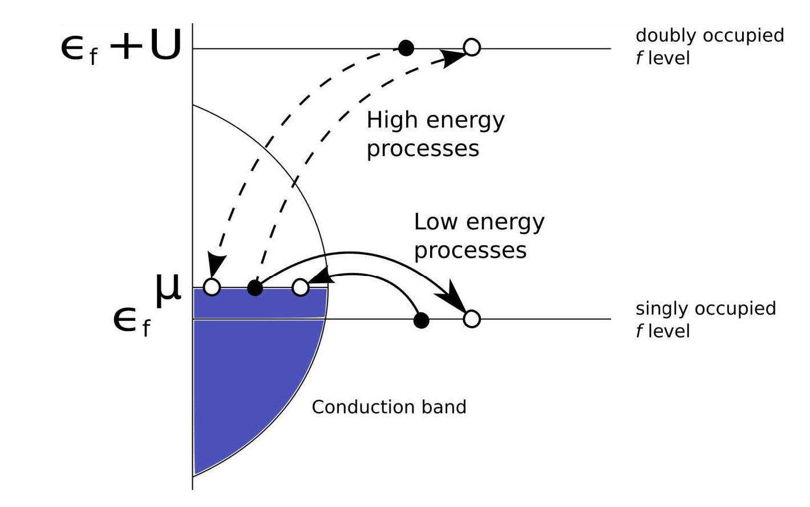
Anderson-Kondo Lattice Hamiltonian from the Anderson-Lattice Model.
A-101
Fig. 1. Low- and high-energy interband hopping pro-
cesses in direct space induced by the hybridization be-
tween / and c states. Only the high-energy f-c mixing
processes (involving energy U) are transformed out and
replaced by exchange processes in the second and the
fourth orders. Low-energy processes remain unchanged
in effective Hamiltonian as residual hybridization. In
effect, such transformation differs from the standard
Schrieffer-Wolff transformation, where both terms are
transformed out.
It should be noted that in the present approach the
number of f electrons J2i N is not conserved, neither
before nor after the transformation. Instead, only the
total number of electrons in the system, n(e) = Ni + ni
is fixed, where ni = a drcia- This last circumstance
allows for an itineracy of strongly correlated / electrons;
it allows to represent one of the principal differences with
the Schrieffer-Wolff approach.

3. Canonical perturbation expansion:
a brief summary
To develop the canonical perturbation expansion
(CPE) we proceed as follows [1]. Due to the fact that
important are the double occupancies of / electrons on
the same site, we project them out from Hamiltonian
with the help of operators Pi:

fldma = (l - N^) ftcro* + NflCm. (2)
Next, by treating as a perturbation only the part con-
nected with high-energy processes, i.e., ~ (NiafCiacma +
H.c.), we calculate explicitly the effective Hamiltonian
using the canonical perturbation expansion up to the
fourth order. The low-energy part remains unchanged
and represents a residual hybridization, which will intro-
duce, among others, the itineracy of the starting (bare)
localized / states. In general, the canonical perturbation
expansion method allows for differentiation between the
two terms in (1), which are of the same order (~ Vim).
The differentiation constitutes the main difference be-
tween the present transformation and that introduced
originally by Schrieffer and Wolff [4]. It will lead to far
reaching consequences, e.g., the itineracy of originally
atomic (/) electrons.
Y Pi = 1 Mid Pi Pi = su, Pi. (3)
i
Operators Pi project the states onto subspace with (/ — 1)
double occupancies in the system of / sites. We redefine
initial Anderson-lattice model using projection operators
Pi
Ho = Pi HPi + P2 HP2, (4)
Hi = Pi HP2 + P2 HPi. (5)
Hi
ing by one number of double occupancies
P2HPi = (PiHP2)1 = Y VimNis flCma. (6)
ima
In reality, only the effective Hamiltonian projected onto
Pi
subspaces will show up through virtual processes only.
Now, we introduce the canonical transformation of (1)
using the transformation generator S of the form
H(e) = e-1 (Ho + £Hi )e+i eS, (7)
where £ is a parameter, which groups the terms of the
same order of expansion in Vim (at the end we put £ =1).
Expanding the exponential functions into a Taylor series
and eliminating the linear term ~ £ by setting the phys-
ical condition
Hi = i[S, Ho ], (8)
we obtain up to the fourth order
H(£) = Ho — 2£2[S, Hi] — 1 £3 [S, [S, Hi]]
+8£4[S, [S, [S,Hi]]]+ O(£5). (9)
With the use of the definition of projection opera-
tors we can find form of PiSPi+i from condition (8), by
putting PiS(0) Pi+i = 0 and iterating the solution [1], Fi-
nally, we obtain
Pi Pi+i =
— i (Pi HiPi+i) (Pi+i Ho Pi+i — Pi Ho Pi)- . (10)
Let us note that PiSPi ~ Pi, thus we can always choose
S in such a way that PiSPi = 0, because if we project
(8) with operator Pi on both sides we obtain that PiSPi
Ho
In the atomic limit, the difference Pi+iHoPi+i —
PiHoPi can be replaced by mean value of energy dif-
ference between subspaces with / mid (l — 1) double oc-
cupancies. By making this approximation, we neglect
renormalization of the low-energy hybridization processes
by the higher order contributions (i.e., neglect the terms
~ Vim in the denominator of (10)). In effect, we have
Pi+i Ho Pi+i — Pi Ho Pi«(Pi+i Ho Pi+i) — (Pi Ho Pi > =
U + e/ — p, = U + e/. (11)
Finally, by projecting out the expansion introduced by
expression (9) on the subspace without double occupan-
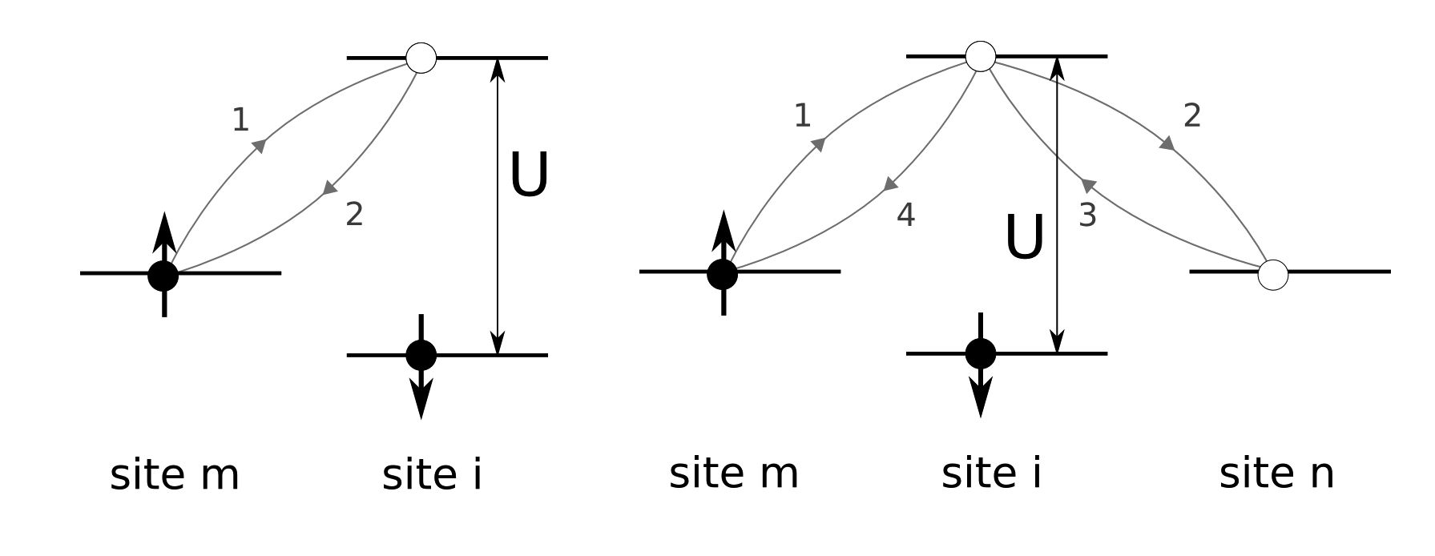
A-102
E. Kądzielawa-Major, J. Spałek
cies, the effective Hamiltonian can be obtained in the
form

Pi H Pi « Pi Ho Pi -ttĘ- Pi Hi P2 Hi Pi
U + ef

+ - 1 (Pi Hi P2 Hi Pi Hi P2 Hi Pi
(U + ef) V

- 2 Pi Hi P2 Hi P3 Hi P2 Hi Pi), (12)
where we have put £ =1. Let us note that the third-
-order term is always zero, because we have chosen that
Pi S Pi = 0.
The term PiHiP2HiPi describes virtual process in the
second order in which in intermediate state a single dou-
ble occupancy occurs. In the fourth order two different
types of processes appear: those with passing through
the subspace (Pi) without double occupancies and those
with passing through that subspace with up to two dou-
P3
In what follows we restrict ourselves to the most in-
teresting part, that is to the Hamiltonian projected onto
the subspace without double occupancies (12). This part
will be discussed in detail, because it is helpful in de-
termining the ground state for different magnetic and
superconducting phases of heavy fermions with nominal
4fi starting configuration (Ce3+ ions).
- Results: Kondo (f-c) and superexchange
(/-/) integrals
An explicit form of the effective Hamiltonian can be
found, if we carry out a careful analysis of all possi-
ble processes, which can show up in the second and
the fourth orders of the expansion. After collecting the
all possible diagrams containing two- and three-site pro-
cesses (examples are shown in Fig. 2), we evaluate them
Fig. 2. Examples of processes in the second (left) and
the fourth (right) orders of the CPE expansion.
using definitions (4)-(6). In effect, the complete effective
Hamiltonian (12) with projected out double occupancies
(Heff — PiHPi) has the following form:
Heff — ^2 (t mn ) cJna Cna + €f lfia
m=n,a i,a

+ E (Vm (l - N*) flCm* +H.O.)
i,m,a

+ E S • Sm - »)
i,m

+ E (Si • S - Cj)
i=j,a
+2i E J(H) (1 + —) Sm • (Sj X Si) , (13)
(mi)(mj) ' Hc
where th) projected partide-number operators are via =
(l - Nia^j Nia, and v% = ^ Si and Sm are the lo-
cal spin operators in the fermion representation for / and
c electrons, respectively; nc = (nm) and nf = (v%) are
average occupancies. The first three terms represent the
projected starting Hamiltonian with residual (projected)
hybridization only. The next three represent, respec-
tively: the Kondo interaction, the superexchange part
and the interaction of Dzialoshinskii-Moriya-type, the
last appearing only if the c-electrons are present. The
noncollinearity of the magnetic ordering of c electrons
(~ »S'i • (Sn x Sm)), as well as the superexchange interac-
tion between them, were neglected in effective Hamilto-
nian (13) since the c bandwidth Wc = 2z\t(mn) | is by far
the largest energy in the c-electron subsystem.
The corresponding exchange integrals have the follow-
ing forms:
j(K) _ 2 |Vim I2 4 |Vim I4
im U + ef (U + f )3

_4 IVim|2 \Vm 1 (( _ nc)
no; (U + ef)3 V 2)
-2 E \Vim |2 |Vin;|2 nc - 2 E IVim |2 IVjm\ nf, (14)
n(i) (U + ef) j (m) (U + ef)
J(H) = E ]Vjm|2|Vim3|2 nc. (15)
ij id) (U + ef )3
The first of them represents the effective Kondo ex-
change integral calculated here to the fourth order; the
second, the exchange integral for both the Heisenberg
part and the novel three-spin interactions. Note that in
order to estimate the corresponding exchange integrals,
nc nf
the actual occupancies. Obviously, ne = nc + nf. Now,
we can estimate numerically the values of (14) and (15),
as discussed next.
- Estimates of exchange integrals
The numerical estimates of the exchange integrals ap-
pearing in (14) and (15) are shown in Figs. 3 and 4 for the
two values of Coulomb interaction U: ef + U = 3eV and
ef + U = 5 eV, respectively. We have also assumed that
hybridization has nonzero value only for nearest neigh-
bours V^im) = V, where the number of nearest neighbors
z = 4 and the hybridization magnitude | V| = 0.3^0.5 eV.
Typically for Ce systems the number of electrons per site
is nc = 1 and nf = 1 Let us note that to estimate jj
we assume that sites i and j are next nearest neighbors,
such that summation in (15) allows only those m, which
ij
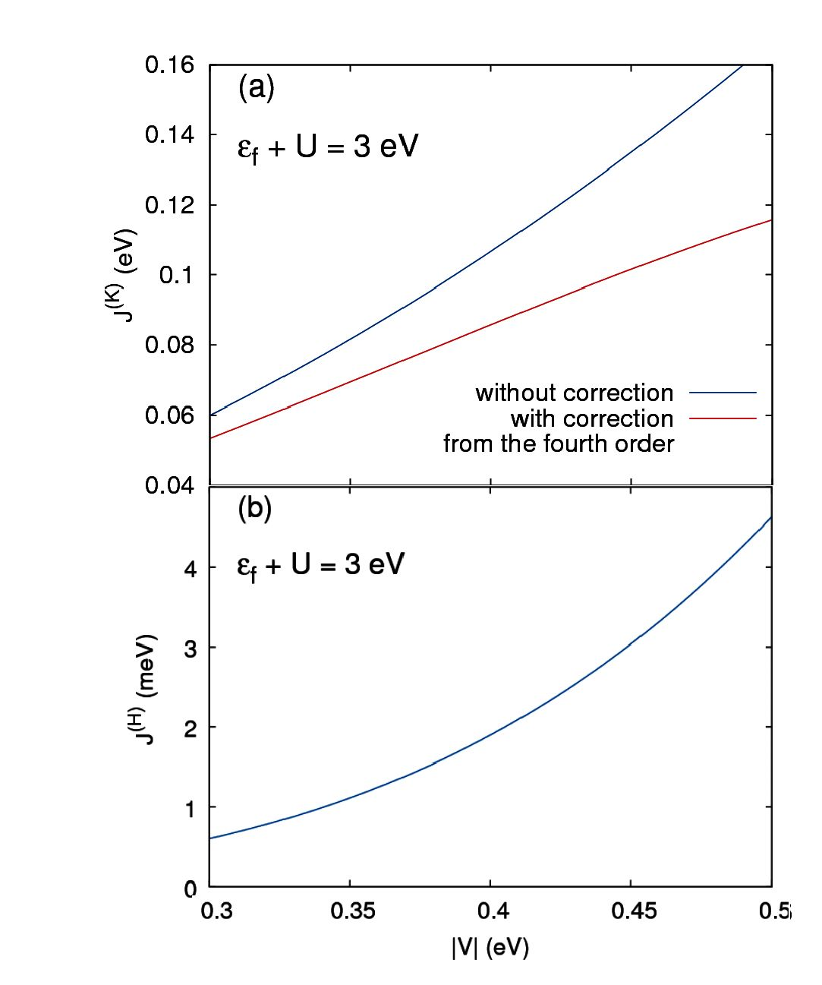
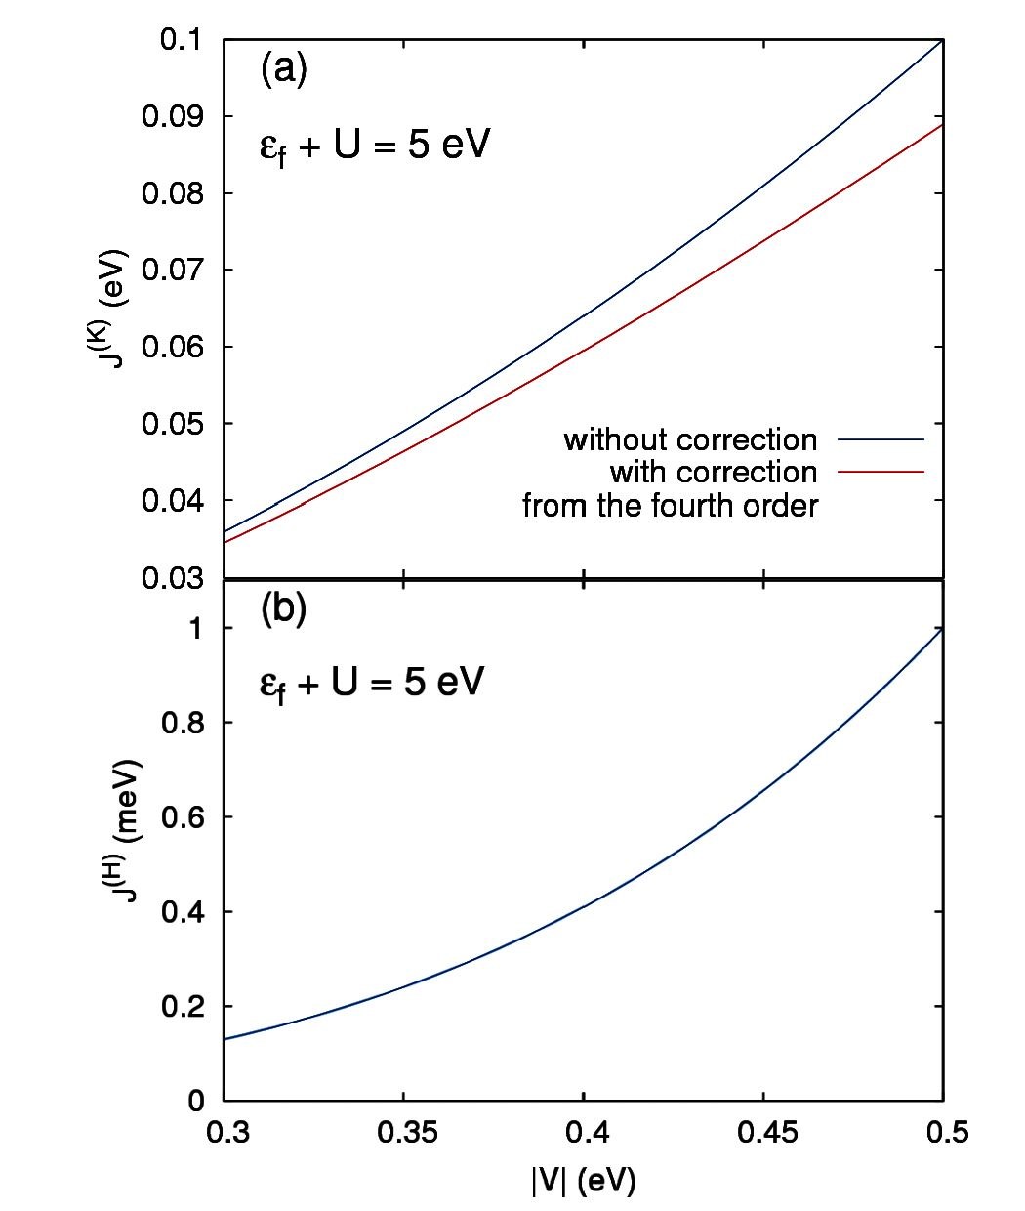
Anderson-Kondo Lattice Hamiltonian fromi the Anderson-Lattice Model.
A-103
Fig. 3. Exemplary values of the Kondo exchange inte-
gral Jwith and without correction from the fourth
order (a) and that for the superexchange integral J
(b); both as a function of bare hybridization magnitude
\V\, for e/ + U = 3 eV.
Let us note that J(K) in Fig. 3a is always antiferromag-
netic; the fourth order effects reduce the second-order
value by ^ 30% for the smaller U-value. Likewise, the
f-f exchange J(H) is also always antiferromagnetic and
more than an order of magnitude smaller, as it should be,
since it contains solely the fourth-order processes. For the
larger value of U the integral J(H) and the correction from
the fourth order in J(K) are smaller. Let us note also that
the present approach contains short range interaction be-
tween asymptotically itinerant fermions (Vim = 0).

6. Concluding remarks
The value of the Kondo exchange and the superex-
change integrals have been evaluated as a function of
hybridization magnitude. In the metallic state there ap-
pears a 3-spin interaction (the last term in (13)), which
may introduce a noncollinearity of the spins in the mag-
netic heavy-fermion state. A detailed analysis of the re-
sults will be published separately.

Acknowledgments
The work was supported in part by the project TEAM
awarded to our group by the Foundation for Polish
Science (FNP) for the years 2011-2014, as well as by
the grant, MAESTRO from the National Science Centre
(NCN), No. DEC-2012/04/A/ST3/00342.

References
- -J. Spalek, P. Gopalan, J. Phys. (France) 50, 2869
(1989).
- O. Howczak, .J. Spalek, J. Phys. Condens. Matter
24, 205602 (2012).
- O. Howczak, .J. Kaczmarczyk, .J. Spalek, Phys. Sta-
tus Solidi B 250, 609 (2013).'
- J.R. Sclirieffer, P.A. Wolff, Phys. Rev. 149, 491
(1966).
Fig. 4. Values of the Kondo exchange J(K) with and
without correction coming from the fourth order (a) and
of superexchange J(H) integral (b); both integrals as a
\V\
e/ + U = 5 eV.

