ORIGINAL RESEARCH
23
Medicina Sportiva Practica, Tom 17, Nr 2: 23-28, 2016 Copyright © 2016 Medicina Sportiva
THE ASSOCIATION BETWEEN STUDY FACULTY, STUDENTS HABITS AND LIFESTYLE FACTORS, PARTICULARLY PHYSICAL ACTIVITY IN A POPULATION OF STUDENTS IN A BIG CITY
Agnieszka Skrzypek, Marta Szeliga, Bogumiła Kowalska, Agata Stalmach-Przygoda, Michał Nowakowski
Department of Medical Education, Jagiellonian University Faculty of Medicine, Kraków
Abstract
Background: The aim of the study was to assess the association between study faculty, students habits and lifestyle factors, particularly physical activity in a population of students in a big city.
Methods: The study evaluated 1131 students, who filled out questionnaire, an average aged of 21,79 ± 2,26 years, 50,6% men. Students represented 6 different universities in Krakow: 38% of respondents were students of the Jagiellonian University (UJ), including 20,8% students of the Faculty of Medicine (UJ CM). 24,7% subjects were students of the University of Science and Technology (AGH), 12,8% of the Academy of Physical Education (AWF), 5,5% of the Academy of Fine Arts (ASP), 8,7% University of Agriculture (UR) and 10,3% of the University of Economics (UEK).
Results: Physical activity was more frequent among students of the Academy of Physical Education (AWF): almost 80%. 68,4% of students claimed, that they follow the rules of health lifestyle. 29,9% of them perform various kind of sport minimum 3 times a week but 18,3% were no physical active even once a week. There was statistically significant (p<0.001) dependence between subjective declaration of students that they obey the rules of a healthy lifestyle. Analysis demonstrates significant positive correlation between physical activity and consumption of vegetables and fruits. Alcohol drink 43,2% of students in small quantities, no more than once a week. 28,4% admit that sometimes loses control over drinking. Students who more often smoke cigarettes significantly more often drink coffee, alcohol and use drugs.
Conclusions: Educational program of universities and academic environment influence on young adults habits. Physical activity is connected with occurrence other healthy habits.
Keywords: students habits, young adults lifestyle, physical activity, risk factors of atherosclerosis in Polish students
Introduction
The benefits of healthy lifestyle, as proven so far, are extreme great. A balanced diet rich in fresh fruits, vegetables and see food, with high amounts and proper proportion of omega 3 and 6 acids, elimination of risk factors of atherosclerosis such as smoking, overweight or obesity, alcohol use and physical inactivity plays important role in maintenance of the health [1]. Athe- rosclerosis leads to development of coronary artery di- sease, occurrence of stroke and any other diseases that lead to death. Atherosclerosis is responsible for high mortality and morbidity. Physical activity influences positively health and fitness and reduces risk of several diseases, particularly connected with the atherosc- lerosis, promotes well-being and mental health and reduces stress [2-7]. Lack of physical activity is related to social problems and poor development of health [2, 8,9]. As proven by Koivusilta L., Stalsberg R., Currie
C. and other scientists practicing physical activity by young people and their educational achievements are influenced by their living conditions [2,10-12]. So far it’s generally known, that regular physical activity with healthy habits reduce morbidity and mortality of
cardiovascular diseases and prolong life expectancy in good condition. Many national scientific societies, e.g. the American Heart Association (AHA) and Canadian Cardiovascular Society emphasize improvement of diet and physical activity as one of their primary aims [13,14]. People develop healthy habits in youth. The aim of the study was to investigate the association between Polish students healthy habits and their study faculty. The second aim was to assess impact of sport on other habits and lifestyle.
Methods
The association between study faculty, students habits and lifestyle factors, particularly physical ac- tivity, was investigated in a population of students in big city (in Krakow). The study evaluated 1131 Polish students, who filled out questionnaire, aged 18 - 35 years, an average of 21,79 ± 2,26 years, 559
(49,4%) women and 572 (50,6%) men. Students represented 6 different universities in Krakow: 430 (38%) of respondents were students of the Jagiellonian University (UJ): Faculty of Medicine, Health Sciences, Law and Computer Science. Due to the kind of study,
THE ASSOCIATION BETWEEN STUDY FACULTY, STUDENTS HABITS AND LIFESTYLE FACTORS…
24
students of the Jagiellonian University Medical College (Faculty of Medicine and Faculty of Health Sciences) were analyzed separately. Accordingly there were 195 (17,2%) Jagiellonian University students and 235 (20,8%) students of the Medical College (UJ CM). 279 (24,7%) subjects were students of the AGH University of Science and Technology (AGH), 145 (12,8%) of the Academy of Physical Education (AWF), 62 (5,5%) of the Academy of Fine Arts (ASP), 98 (8,7%) University of Agriculture (UR) and 117 (10,3%) of the University of Economics (UEK). People, who study in Krakow, come from various parts of Poland as well as from abroad. The data were obtained during October 2014 - April 2015. In order to assess students habits and lifestyle, we used method of diagnostic survey using the survey technique. The questionnaire was prepared by authors of the study. BMI was calcula- ted from anthropometric measurements. The Ethics Committee of the Jagiellonian University accepted the study protocol (nr 122.6120.56.2015). The program R
2.15.1 was used in statistical analysis and p<0,05 was considered significant.
Results
Our analysis shows that physical activity was more frequent among students of the Academy of Physical Education (AWF): almost 80% of them regularly un-
dertake physical activity (at least 3 times a week), for comparison at the Medical College (UJ CM) such ac- tivity takes only about 20% of the students (p<0,0001). It’s connected with the educational program of the faculty. The frequency of physical activity of students of different universities are presented in Table 1.
The number of students who claimed following the rules of healthy lifestyle is: 757 (68,4%). Healthy life- style means: no smoking, systematic physical activity, fresh vegetables and fruits everyday, no much sweet and coffee. Only 337 (29,9%) of them (25,7% female and 34,0 % male) perform various kind of sports mi- nimum 3 times a week but 206 (18,3%): 120 (21,5 %) female and 86 (15,1%) male were no physical active even once a week. There was statistically significant (p<0.0001) dependence between subjective declaration of students that they obey the rules of a healthy lifesty- le, and the regularity of their physical activity (Fig. 1). Analysis of diet habit shows that only 8% (n=90) students eat sea fish at least 2 times a week. Most fish eat the UJ (14% at least twice a week) and CM UJ (10,2% at least twice a week) students. We can not say that students who are more physically active more likely consume sea fish despite the statistically significant (p=0,0007) positive Spearman rank cor-
relation because this correlation is too low (rsp=0,1). The majority of respondents (69,8%; n=789) eat fresh
Table 1. The frequency of physical activity among students of different universities

Min. 3 times a week
2 times a week
1 time a week
None
n
%
n
%
N
%
n
%

UJ CM

Total
48
20,4
49
20,9
55
23,4
83
35,3
Female
33
18
34
18,1
44
24
72
39
Male
15
28,8
15
28,8
11
21,2
11
21,2

UJ

Total
46
23,6
54
27,7
63
32,3
32
16,4
Female
12
18,7
22
34,4
20
31,2
10
15,6
Male
34
25,9
32
24,4
43
32,8
22
16,8

AGH

Total
59
21,2
54
19,4
121
43,5
44
15,8
Female
4
10,8
9
24,3
16
43,2
8
21,6
Male
55
22,8
45
18,7
105
43,6
36
14,9

AWF

Total
111
76,6
26
17,9
7
4,8
1
0,7
Female
41
63,1
17
26,1
6
9,2
1
1,5
Male
70
87,5
9
11,2
1
1,2
0
0

ASP

Total
10
16,1
10
16,1
22
35,5
20
32,3
Female
6
14,6
8
19,5
14
34,1
13
31,7
Male
4
19
2
9,5
8
38,1
7
33,3

UR

Total
32
33,3
17
17,7
32
33,3
15
15,6
Female
27
33,7
13
16,2
30
37,5
10
12,5
Male
5
31,2
4
25
2
12,5
5
31,2

UEK

Total
31
26,7
30
25,9
44
37,9
11
9,5
Female
20
23
23
26,4
38
43,7
6
6,9
Male
11
37,9
7
24,1
6
20,7
5
17,2
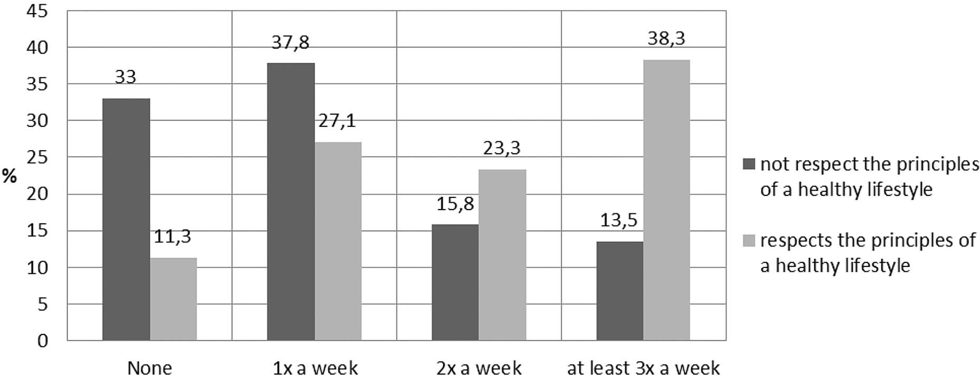
THE ASSOCIATION BETWEEN STUDY FACULTY, STUDENTS HABITS AND LIFESTYLE FACTORS…
25
Frequency of physical activity
Fig. 1. The relationship between subjective assessment of going by the principles of a healthy lifestyle and the physical activity of students
vegetables at least several times a week or every day. similar number of students (67,9%; n=766) eat fresh fruit at the same frequency. Analysis demonstrates positive correlation between physical activity and consumption of fresh vegetables (rsp=0,2; p<0,0001) and fruits (rsp=0,2; p<0,0001) but this is not a strong relationship.
18,2% (n=206) of students consume sweets every day and 36,6% (n=413) several times a week. We noti- ced a weak tendency of consuming sweets by students who are not physically active than the students who practice sport minimum 3 times a week. There was observed a negative correlation between the activity and the consumption of sweets (rsp= -0,1; p<0,0015).
The number of students, who drink coffee minimum
twice a day is 29,6% (n =334) students drink coffee minimum twice a day but 43,7% (n=494) do not drink at all. 13,1% (n=148) of students did not drink alcohol and 43,2% (n=486) drink alcohol in small quantities, no more than once a week. However, as many as 28,4% (n=320) of respondents admit that sometimes loses control over drinking, and sometimes they get drunk. AGH students consume significantly more alcohol than students of other universities in Krakow. This can not be simply explained only by the fact that at the AGH was a predominated by men who more likely drink alcohol than women. Considering all the surveyed students, men really consume significantly (p<0,0001) more alcohol than women but for comparison, the proportion of men and women at UJ were similar to those at AGH, however, the consumption of alcohol at this university was signifi- cantly lower. At the AGH nearly one-quarter of students regularly gets drunk – several times a week (21,9% male and 24,3% female), while at other universities does not do this any woman and no more than one man. We found no relationship between the frequency of physical activity and the amount of drinking coffee or alcohol.
Only 10,8% (n=122) of surveyed students smoke cigarettes every day (regardless of the number of ci- garettes). Students of ASP (38,7% smoke every day) more often smoke cigarettes than the other students (p<0,0001). There is no significant correlation betwe- en physical activity of students and smoking cigarettes by them (p=0,0875). Statistically significant positive correlations indicate that students who more often smoke cigarettes, significantly more often drink coffee (rsp= 0,31; p<0,0001), alcohol (rsp= 0,15; p<0,0001) and
use drugs (rsp= 0,33; p<0,0001). Number of smokers
significantly increased during study (p <0,0001) com- pared to the period before they start studying. There is also a very strong positive correlation between smo- king before and during studies (rsp= 0,64; p<0,0001).
Alcohol consumption among the surveyed students
did not increased much, but statistically significant (p<0,0001) during the study, comparing to the time before they start. As in the case of cigarettes, those who drank more alcohol before study in the cycle of studies still are drinking more (rsp= 0,59; p<0,0001).
Using drugs by young adults is one of the main
problem nowadays. Our findings proved that it is also important issue among Polish students of whom 40% (n=450) declare that they had tried illegal drugs, this is especially a problem of ASP students (72,6% had tried drugs) which significantly more likely consume drugs (p<0,0001) than other students. Using drugs has no statistically significant effect on the physical activity of students (p=0,5413).
Obesity is not a big problem among students. Obe- sity occurred in 1,7% (n=18). Overweight occurred in 13,4% (n=146). Comparing students with overweight with those who have BMI<25kg/m2 it was found that higher percentage of subjects with overweight eat si- gnificantly less fresh fruits (p<0,0001) and vegetables (p<0,0001).
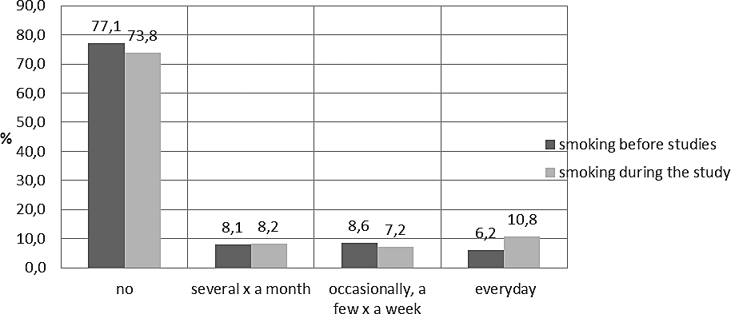
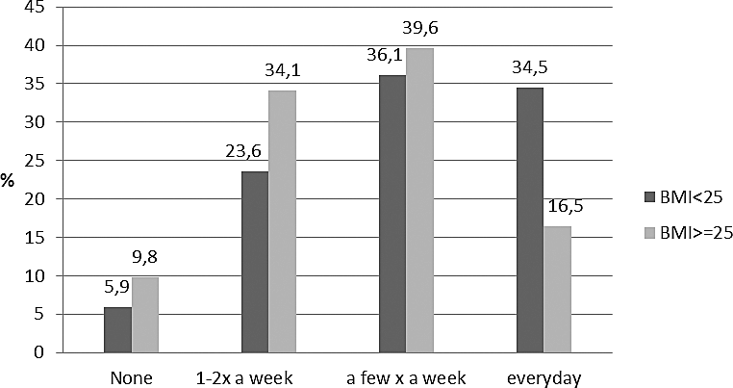
THE ASSOCIATION BETWEEN STUDY FACULTY, STUDENTS HABITS AND LIFESTYLE FACTORS…
26
Frequency of smoking
Fig. 2. The relationship between smoking before and during the study
Frequency of consumption of fresh fruit
Fig. 3. The relationship between the consumption of fresh fruit and BMI
There were no significant differences between students with a BMI≥25 and students with a BMI<25 in the frequency of physical activity, consumption of sea fish, sweets, coffee, alcohol, cigarettes and drugs. 39,8% (n=446) of students never measured their blood pressure. Among those, who measured, the blood pres- sure is usually correct, only 7,5% (n=58) was abnormal.
BMI was the highest in students of the Academy of Physical Education and it is connected with the suspected larger mass of muscles in comparable with students who represented others study faculty. In opinion of the study’s authors more suitable parameter to determine whether the body is fat or fit is the level of the fat tissue in the body but we didn’t measure it.
Discussion
As proved so far, an unhealthy lifestyle among young adults is a serious problem [13]. In Euro- pe, diseases of the cardiovascular system are the
cause of 55 % of all deaths in women and 43 % of deaths in men [15]. There are non-modifiable and modifiable risk factors for atherosclerosis [16,17]. Non-modifiable risk factors include age, male gen- der and genetic factors. Modifiable risk factors for atherosclerosis include: sedentary lifestyle, limi- tation of physical activity, smoking, hypertension, overweight, obesity, disorders of carbohydrate and lipid metabolism, improper eating habits and stress. There are many modifiable risk factors in students habits, as our findings shows in this and previous study [18]. In particular, the use of improper diet, poverty of vegetables and fruits, sedentary lifestyles observed among students of most universities, with the exception of the Academy of Physical Education [18]. Some authors of the other researches have found that young women have more healthy habits and lifestyle than young men but our study doesn’t confirm this [13,19,20]. Young adults often observe
THE ASSOCIATION BETWEEN STUDY FACULTY, STUDENTS HABITS AND LIFESTYLE FACTORS…
27
and learn new habits through the process of social comparison that helps them adjust to peer norms and behaviours [21,22]. High school and universities have own program of education. These programs have impact on young adults, indirectly on their lifestyle. Promotion of healthy behavioral patterns among students, has significant meaning in the scale of whole country. It will decrease occurrence of cardiovascular diseases, mortality and morbidity connected with them. Social comparison tendencies may play an important role in adolescents habits. Adolescents and young adults tend to use peers as a basis of comparison rather than the general popu- lation [21,23]. On the basis of the study results we claim that social comparison tendencies may play an important role also in development of others habits. Lifestyle and pattern of healthy or unhealthy habits create various kinds of students cultures. As Bettina
F. Piko highlights the importance of complex models in health education programs on adolescent smok- ing. We proved in our study, that education programs have significant meaning also on other habits. Our findings indicated that the students lifestyle and habits depend on university. Results of our study proved that students who are physically active, have healthy habits e.g. usually don’t use tobacco or drink alcohol. A physically active lifestyle, good nutrition, absence of tobacco and alcohol may delay or prevent the onset of cardiovascular disease [13].
In the European Union (EU) two thirds of the adult population (aged 15 years and over) did not reach re- commended levels of activity in 2002 [24]. One in five people takes little or no physical activity, with higher levels of inactivity in the eastern part of the Region, according the World Health Organization, European Region as a whole [25]. In according to the data, Polish student are rather active (especially from the Academy of Physical Education).
According to Oyhenart et al., economic and edu- cational factors can cause the differences in nutritional habits among adolescents [26]. Amarashinghe et al. claimed that socioeconomic conditions and the surro- unding economic environment influence on people’s health and quality of life [27]. To summarize, young people make numerous mistakes in their diet and have unhealthy habits under the influence of environmental pressure and educational factors, as claimed Breat et al [28]. Authors of the study noticed that students of Faculty of Medicine unfortunately don’t have proper habits and provided sedentary lifestyle but this fact is connected with the educational programs: no man- datory physical education course and not enough free time for this activity. We agree with J. Suliburska et al., that mass media (especially the Internet) and deve- lopment of communication can lead to improvement of habits in young people[13]. We emphasize the role
of cultivation of sport by mass media and enrich in lectures about healthy lifestyle’s rules in educational program at each university.
Conclusions
Our findings point to the importance of both educational programs of universities and academic environment that influences young adults habits. Sport is the strongest factor of healthy lifestyle. Physical activity is connected with occurrence of other healthy habits. Students who are physically active have more healthy habits and lifestyle (don’t like smoking, prefer healthy diet).
Key-points
This study explores interrelationships among young adults physical activity and other habits.
There are many modifiable risk factors of atherosc- lerosis in students, e.g. smoking, inappropriate nutri- tional behaviours, overweight and sedentary lifestyle. Educational program of the university and acade- mic environment have significant impact on physical
activity of students.
Results of the study emphasize the significance of complex models in health education programs on young adults habits and promotion of sport and phy- sical activity – one of the most important healthy habit connected with occurrence of other proper habits.
Conflicts of interest
None declared.
References
1.
Molarius A, Berglund K, Eriksson C, Lambe M, Nordström E, Eriksson H, Feldman I. Socioeconomic conditions, lifestyle factors, and self-rated health among men and women in Sweden. Eur J Public Health 2006; 17 (2): 125-133.
Koivusilta LK, Nupponen H, Rimpelä AH. Adolescent physical activity predicts high education and socio-economic position in adulthood. Eur J Public Health 2011; 22 (2): 203-209.
Haskell WL, Lee IM, Pate RR, et al. Physical activity and public health: updated recommendation for adults from the American College of Sports Medicine and the American Heart Association. Med Sci Sports Exerc 2007;39:1423-34.
Kohl HW III. Physical activity and cardiovascular disease: evi- dence for a dose response. Med Sci Sports Exerc 2001;33:S472- 83, S493–4.
Mikkelsson L, Kaprio J, Kautiainen H, et al. Endurance run- ning ability at adolescence as a predictor of blood pressure levels and hypertension in men: a 25-year follow-up study. Int J Sports Med 2005;26:448-52.
Biddle SJH, Fox KR, Boutcher SH, Faulkner GE. The way forward for physical activity and the promotion of psycho- logical well-being. In: Biddle SJH, Fox KR, Boutcher SH, editors. Physical Activity and Psychological Well-being. Lon- don: Routledge; 2000. p. 154-68.
Fontaine KR. Physical activity improves mental health. Phys Spotsmed 2000; 28; 10: 83–84.
Hallal PC, Victora CG, Azevedo MR, Wells JC. Adolescent physical activity and health: a systematic review. Sports Med 2006;36:1019-30.
Kantomaa MT, Tammelin TH, Ebeling HE, Taanila AM. Emo- tional and behavioral problems in relation to physical activity in youth. Med Sci Sports Exerc 2008;40:1749-56.
2.
3.
4.
5.
6.
7.
8.
9.
THE ASSOCIATION BETWEEN STUDY FACULTY, STUDENTS HABITS AND LIFESTYLE FACTORS…
28
10.
Stalsberg R, Pedersen AV. Effects of socioeconomic status on the physical activity in adolescents: a systematic review of the evidence. Scand J Med Sci Sports 2010;20:368-83.
Currie C, Molcho M, Boyce W et al. Researching health inequalities in adolescents: the development of the Health Behaviour in School-Aged Children (HBSC) family affluence scale. Soc Sci Med 2008;66:1429-36.
Koivusilta L, Rimpelä A, Vikat A. Health behaviours and health in adolescence as predictors of educational level in adulthood: a follow-up study from Finland. Soc Sci Med 2003;57:577-93.
Suliburska J, Bogdański P, Pupek-Musialik D, Głód- Nawrocka M, Krauss H, Piątek J. Analysis of lifestyle of young adults in the rural and urban areas. Ann Agric Environ Med 2012; 19 (1): 135-139.
Lichtenstein AH, Appel LJ, Brands M, Carnethon M, Daniels S, Franch HA, Franklin B, Kris-Etherton P, Harris WS, Ho- ward B, Karanja N, Lefevre M, Rudel L, Sacks F, van Horn L, Winston M, WylieRosett J. Summary of American Heart Association Diet and Lifestyle Recommendations revision 2006. Arterioscler Thromb Vasc Biol. 2006; 26(10): 2186-2191. Petersen S, Peto V, Rayner M. et al. European Cardiovascular Disease Statistics: 2005 edition. British Heart Foundation; London 2005.
Hayman LL, Meininger JC, Daniels SR, McCrindle BW, Hel- den L. et al. Primary prevention of cardiovascular disease in nursing practise: focus on children and youth. Circulation 2007; 116: 344-57.
Narodowy Program Zdrowia na lata 2007 - 2015. http:// www.mz.gov.pl/wwwfiles/ma_struktura/docs/zal_urm_ npz_90_15052007p.pdf
Skrzypek A, Szeliga M, Stalmach-Przygoda A, Kowalska B, Jabłoński K, Nowakowski M. Analysis of lifestyle and risk factors of atherosclerosis in students of selected universities in Krakow. Przegl Lek. 2016; 73, 5: 316-19.
Łagowska K, Woźniewicz M, Jeszka J. Comparison of eating habits among students with admitted sex and level of physical activity. Rocz Panstw Zakl Hig. 2011; 62(3): 335-42.
Szponar B, Krzyszycha R. Ocena sposobu odżywiania studen- tów Uniwersytetu Medycznego w Lublinie w roku akademic- kim 2007–2008. Bromat Chem Toksykol. 2009; 2: 111-16.
21.
Piko BF, Luszczynska A, Gibbons FX, Tekozel M. A culture-
-based study of personal and social influences of adolescent smoking. Eur J Public Health. 2005; 15 (4): 393-98.
Gibbons FX, Buunk BP. Individual differences in social comparison: Development of a scale of social comparison orientation. J Pers Soc Psychol 1999; 76:129-42.
Aspinwall LG, Future-oriented aspects of social comparisons. In: Buunk BP, Gibbons FX, Editors. Health, coping, and well-
-being: Perspectives from social comparison theory. Mahwah, NJ: Erlbaum, 1997:125-166.
Sjöström M et al. Health-enhancing physical activity across European Union countries: the Eurobarometer study. J Public Health, 2006, 14(1):1–10.
The world health report 2002: reducing risk, promoting he- althy life. Geneva, World Health Organization, 2002 (http:// www.who.int/whr/2002/en, accessed 28 July 2006) Oyhenart EE, Castro LE, Forte LM, Sicre ML, Quintero FA, Luis MA, Torres MF, Luna ME, Cesani MF, Orden AB. Socio- environmental conditions and nutritional status in urban and rural schoolchildren. Am J Hum Biol. 2008; 20(4): 399-405. Amarasinghe A, D’Souza G, Brown Ch, Oh H, Borisova T. The Influence of Socioeconomic and Environmental Deter- minants on Health and Obesity: A West Virginia Case Study. Int J Environ Res Public Health. 2009; 6: 2271-87.
Breat C ,Van Strien T. Assessment of emotional, externally induced and restrained eating behaviour in nine to twelve-
-year-old obese and not obese children. Behav Res Ther. 1997; 35: 863-73.
11.
22.
23.
12.
24.
13.
25.
14.
26.
27.
15.
16.
28.
17.
Address for correspondence: Agnieszka Skrzypek
Department of Medical Education Jagiellonian University School of Medicine ul. Św. Łazarza 16
31-530 Krakow Poland
tel. +48 609 731 609
e-mail: agnieszka.skrzypek@gmail.com
18.
19.
20.

