GEOLOGICA CARPATHICA, OCTOBER 2012, 63, 5, 407— 421 doi: 10.2478/v10096-012-0032-4

Reworked nannofossils from the Lower Miocene deposits in the Magura Nappe (Outer Western Carpathians, Poland)

MARTA OSZCZYPKO-CLOWES

Institute of Geological Sciences, Jagiellonian University, Oleandry 2a, 30-063 Kraków, Poland; m.oszczypko-clowes@uj.edu.pl

(Manuscript received October 3, 2011; accepted in revised form June 13, 2012)

Abstract: Studies, based on calcareous nannofossils, proved that the level of reworked microfossils had so far been underestimated. More recently detailed quantitative studies of calcareous nannoplankton of the Magura, Malcov, Zawada and Kremna formations from the Magura Nappe in Poland documented a degree of nannofossil recycling among those formations. In the Late Eocene—Early Oligocene pelagic Leluchów Marl Member of the Malcov Formation the level of redeposition is very low (0—3.80 %), however, in the flysch deposits of the Malcov Formation reworking increased to
31.4 %. Late Oligocene through Early Miocene “molasse” type deposits of the Zawada and Kremna formations contain 43.7—69.0 % of reworked nannofossils. Quantitative analyses of the reworked assemblages confirmed the domination of Paleogene nannofossil species over Cretaceous ones. The most abundant, reworked assemblages belong to the Early— Middle Eocene age.

Key words: stratigraphy, calcareous nannoplankton, reworked specimens, Paleogene—Lower Neogene, Outer Western Carpathians, Magura Succession.

Introduction

The Polish Outer Carpathians are composed of Upper Juras- sic—Lower Miocene flysch deposits: deep-water siliciclastic turbidites, deposited by submarine gravity flows – mainly turbidity currents. The exception is the Late Cretaceous— Eocene Sub-Silesian succession, which is represented by variegated marls deposited in pelagic environments. The Carpathian flysch is composed of an alternation of conglomer- ates, sandstones, mudstones, claystones and, less frequently, by marls and cherts. In the Cretaceous—Paleogene flysch for- mations these components are mixed in different proportions. The first stratigraphic studies of the Magura Nappe succes- sion are more than 100 years old. The earliest biostratigraphic data, dating the youngest deposits of the Magura Nappe to the Eocene, were based upon large foraminifera. A significant qualitative change in biostratigraphic studies took place after the application on calcareous nannoplankton (Radomski 1967; Birkenmajer & Oszczypko 1989; Oszczypko et al. 1990). This research resulted in the introduction of formal lithostratigraphic schemes in the Krynica and Bystrica facies zones (for references see Oszczypko-Clowes 2001). Contem- porary research on calcareous nannoplankton from the Krynica and Bystrica zones suggested the presence of mainly Early- Eocene age formations, while the younger data were found in the outer zones, mainly in the Siary Zone. Such a biostrati- graphical framework strongly affected the contemporary pa- leogeographic and paleotectonic reconstructions – not only for the Magura Nappe, but also for the entire Outer Western Carpathians. Further studies, based on calcareous nannofos- sils, proved that the level of reworked microfossil associations had been underestimated (e.g. Birkenmajer & Oszczypko 1989; Oszczypko et al. 1990). The significance of these, de- tailed quantitative studies of calcareous nannoplankton from

the Magura, Malcov, Zawada and Kremna formations of the Magura Nappe, is documented by the degree of nannofossils re- cycling and its impact on the age determination.
The concept of the turbidity current, as a mechanism re- sponsible for the deposition of sandy/silty and muddy turbidi- tes, was developed by Kuenen & Migliorini (1950). Over time turbiditic deposits were divided into several classes (see Ein- sele 2002): coarse-grained turbidites, sandy medium-grained turbidites (siliciclastic and carbonate), carbonate turbidites (calciturbidites or allodapic limestones) and mud turbidites. The hypothesis of medium-grained siliciclastic turbidites was popularized in literature by Bouma (1962). The Bouma (1962) concept of Ta division has been extended by Lowe (1982), who distinguished sub-divisions S1, S2, S3, which result from grain flows. The first two sub-divisions: (S1 and S2), with an inverse gradation, are represented by coarse-grained sandy turbidites, deposited by a bottom traction. A massive S3 di- vision, resulting from grain-flow “freezing”, displays water- escape structures (e.g. “dish”) and levels of intraclasts, derived from the erosion of a bottom muddy-clay layer. A later modification of the Bouma Ta division was introduced by Shanmungan (2000) as gravelly traction intervals, R2 and R3. In terms of the formation of gravitational flow deposits Einsele (2002) highlights the importance of: marine delta, prodelta slopes, submarine canyon heads, shelf break ero- sion, subduction-related depositional environments and de-
posits of the forearc basins.
The presence of allochthonous, shallow-marine faunas in sediment suspension currents have been known since the late 50’s (Kuenen & Migliorini 1950). This was particularly re- lated to turbidites derived from carbonate skeleton material and reef detritus from carbonate shelves and platforms (see Einsele 2002). At the end of the nineteenth century, and dur- ing the first half of the twentieth century, allochthonous fau-

www.geologicacarpathica.sk

nas (e.g. ammonites, inoceramids, corals and larger foramin- ifera) were often the only basis for biostratigraphy of the flysch strata in the Outer Carpathians, the Apennines, Dinar- ides and other orogens. A revision of these views, based on small foraminifera and calcareous nannoplankton, sometimes provoked long controversy. Examples of such exchanges in- clude discussions concerning the age of “black flysch” in the Pieniny Klippen Belt, in Poland (Sikora 1962; Birkenmajer & Pazdro 1968; Oszczypko et al. 2004; Birkenmajer & Gedl 2004; Birkenmajer et al. 2008; Oszczypko et al. 2008a,b), “Crete Nero” and the Cilento Flysch in the Southern Apen- nines (see Cieszkowski et al. 1994, 1995 and references therein). The most recent example of these scientific exchanges focuses on the principal age revision of the Outer Dinarides, flysch deposits in Slovenia, Croatia, Bosnia-Herzegovina and Montenegro (Mikes et al. 2008). The issue of reworked mi- crofossils from the Western Carpathian flysch was also raised by Švábenická & Bubík (1992) and Švábenická et al. (2007).

Previous works

Polish Outer Carpathian flysch deposits, with massive re- worked microfossil assemblages, were first recognized in the Paleogene Magura Succession deposits of the Nowy Sącz and Orava-Nowy Targ depressions (Fig. 1B).
In 1973 Oszczypko documented the presence of Upper Eocene/Oligocene deposits in the southern margin of the Nowy Sącz Basin (borehole Nowy Sacz I), occurring at the top of the Upper Eocene Magura Sandstone, which was re- garded as the youngest beds of the Magura Succession. At the same time, in the Biegonice and Zawada sections (Bystrica Subunit), among the yellow-grey, massive marls of the Łącko, Blaicher (cf. Oszczypko 1973) recognized three different age, foraminifera assemblages (benthic and planktonic) which were mixed with each other and contained Early/Mid- dle Eocene; Late Eocene/Oligocene and Oligocene species.
The youngest Oligocene foraminifera were considered au- tochthonous, while the two remaining assemblages were re- garded as reworked. These sections (Fig. 1B) were once more revised by Oszczypko et al. (1999) and Oszczypko & Oszczypko-Clowes (2002) and were included in the Zawada Formation. These new studies documented the presence of Early Miocene foraminifera (N5) and calcareous nanno- plankton (NN1—2) as well as large quantities of reworked Late Cretaceous to Middle Eocene foraminifera and calcare- ous nannoplankton in the Zawada Formation.
The history of biostratigraphical research of the Magura- type sandstones in the proximity of Nowy Targ (Krynica Sub- unit) was more or less similar. These thick-bedded sandstones with intercalations of grey marly claystones were regarded as the Inoceramian beds (Cenomanian—Turonian – Halicki 1959 or Turonian—Maastrichtian—Danian – Watycha 1963).
New data on the age of these deposits have been published by Cieszkowski & Olszewska (1986), who established these beds as the Malcov Formation (Late Eocene/Oligocene). Later Cieszkowski (1992) described the Lower/?Middle Mio- cene deposits of the Magura Succession in the Stare Bystre and Rogoźnik sections of the Podhale region (Fig. 1B).
These strata revealed multiple layers of reworked foramin- ifera and calcareous nannoplankton of a Cretaceous and Pa- leogene age. The contemporaneous, Lower Miocene flysch of the Magura Succession was also drilled in the Nowy Targ 1 borehole (Paul & Poprawa 1992), at the northern boundary of the Pieniny Klippen Belt.
A similar approach was conducted via biostratigraphic studies in the Poprad valley, near Stará Cubovňa (Cubovnianska Vrchovina, East Slovakia). In this area (Fig. 1B), within the contact zone of the Magura Nappe and the Pieniny Klippen Belt, Matějka (1959) described the Kremna facies. Previously, those strata were included in the “Nordliche Granz Flysch Zone” (Uhlig 1890) or “Peri-Klippen Flysch” or “Inter Klip- pen Flysch” (Horwitz 1935). Stráník & Hanzlíková (1968) described the “Kremna facies” as a sandy-conglomeratic cal- careous flysch, with intercalations of grey-greenish claystones and siltstones. On the basis of the foraminiferal studies, these strata were determined as Paleocene/Eocene to Late Eocene intermediate lithofacies between the PKB and Magura Paleo- gene. More recently, Oszczypko et al. (2005) defined these de- posits as the development of the Kremna Formation, being the youngest (Oligocene—Early Miocene) member of the Magura Succession in the Peri-PKB zone. The calcareous nanno- plankon studies of this formation showed a predominance (60 %) of reworked species, mainly Middle—Late Eocene, while the youngest species that were identified belonged to the Early Miocene (NN1 and NN2, see Oszczypko et al. 2005). The Kremna Formation is regarded as the equivalent of the Zawada and Stare Bystre formations in the Nowy Sącz and Podhale areas. Over recent years the Kremna Formation was recognized in the Krynica facies zone in the Muszyna and Jaworki areas (Oszczypko & Oszczypko-Clowes 2010; Oszczypko-Clowes 2010) as well as in the “Magura Autoch- thonous Paleogene” in the tectonic windows of the PKB (Oszczypko & Oszczypko-Clowes 2010; Oszczypko et al. 2010). Likewise, Lower Miocene strata were also found in the Krynica Zone within the vicinity of Humenné.

Regional settings and studied sections

The following selected profiles were examined in this re- search: Zawada, Leluchów and Ujak as well as the Kremna sections of the Magura Nappe and Pieniny Klippen Belt. Figure 2 shows the synthetic lithostratigraphic profiles of the Paleogene-to-Lower Miocene deposits across the Magura Nappe. These profiles are representative of the eastern sector of the Magura Nappe in Poland (Fig. 1B). The top of the var- iegated shales with Reticulophragmium amplectens (Mid- dle—Late Eocene) or the Sub-Menilite Globigerina Marls (SMGM) were adopted as the correlation level.

The Krynica Zone

The Krynica facies’ Zone (Figs. 1B, 2) provides an impor- tant insight for our understanding of the terminal history of the Magura Basin. This zone contains facies linked with the post-nappe: Late Eocene—Oligocene of the Central Carpathian Paleogene Basin and Pieniny Klippen Belt suture zone (Újak

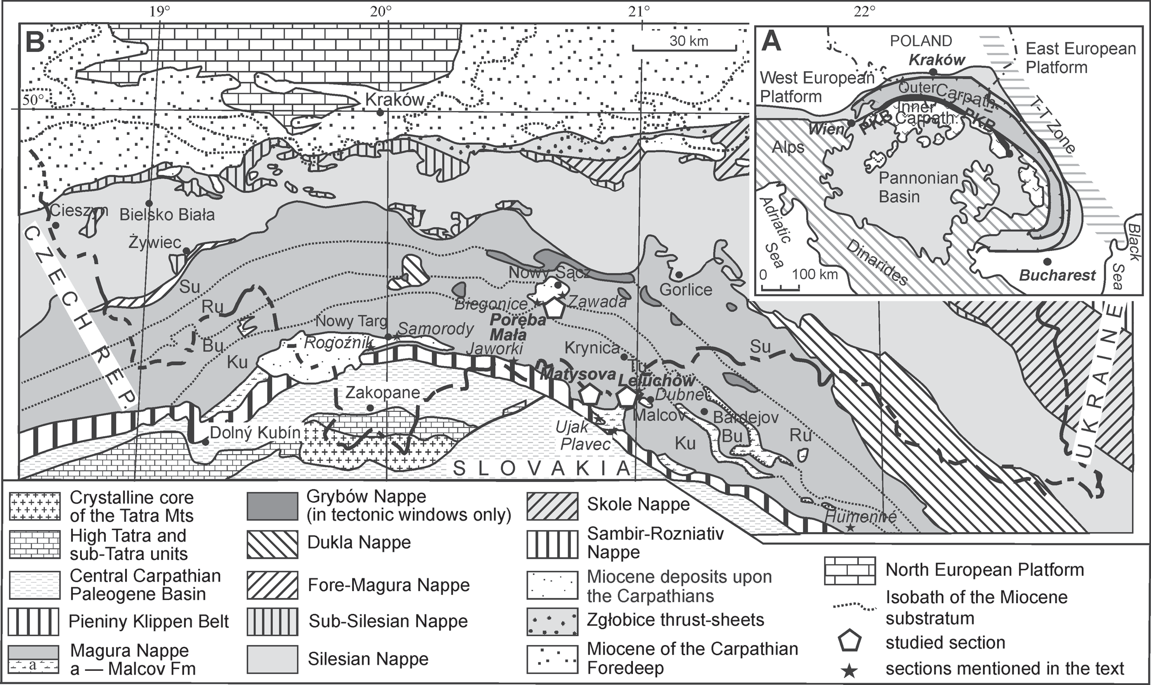

Fig. 1. A – Simplified tectonic scheme of the Alpine-Carpathian orogens (based on Picha 1996). B – Geological map of the Polish Car- pathians (Żytko et al. 1989, modified), with location of studied areas. Abbreviations: Su – Siary, Ru – Rača, Bu – Bystrica, Ku – Krynica, Tu – Tylicz facies zones of the Magura Nappe.

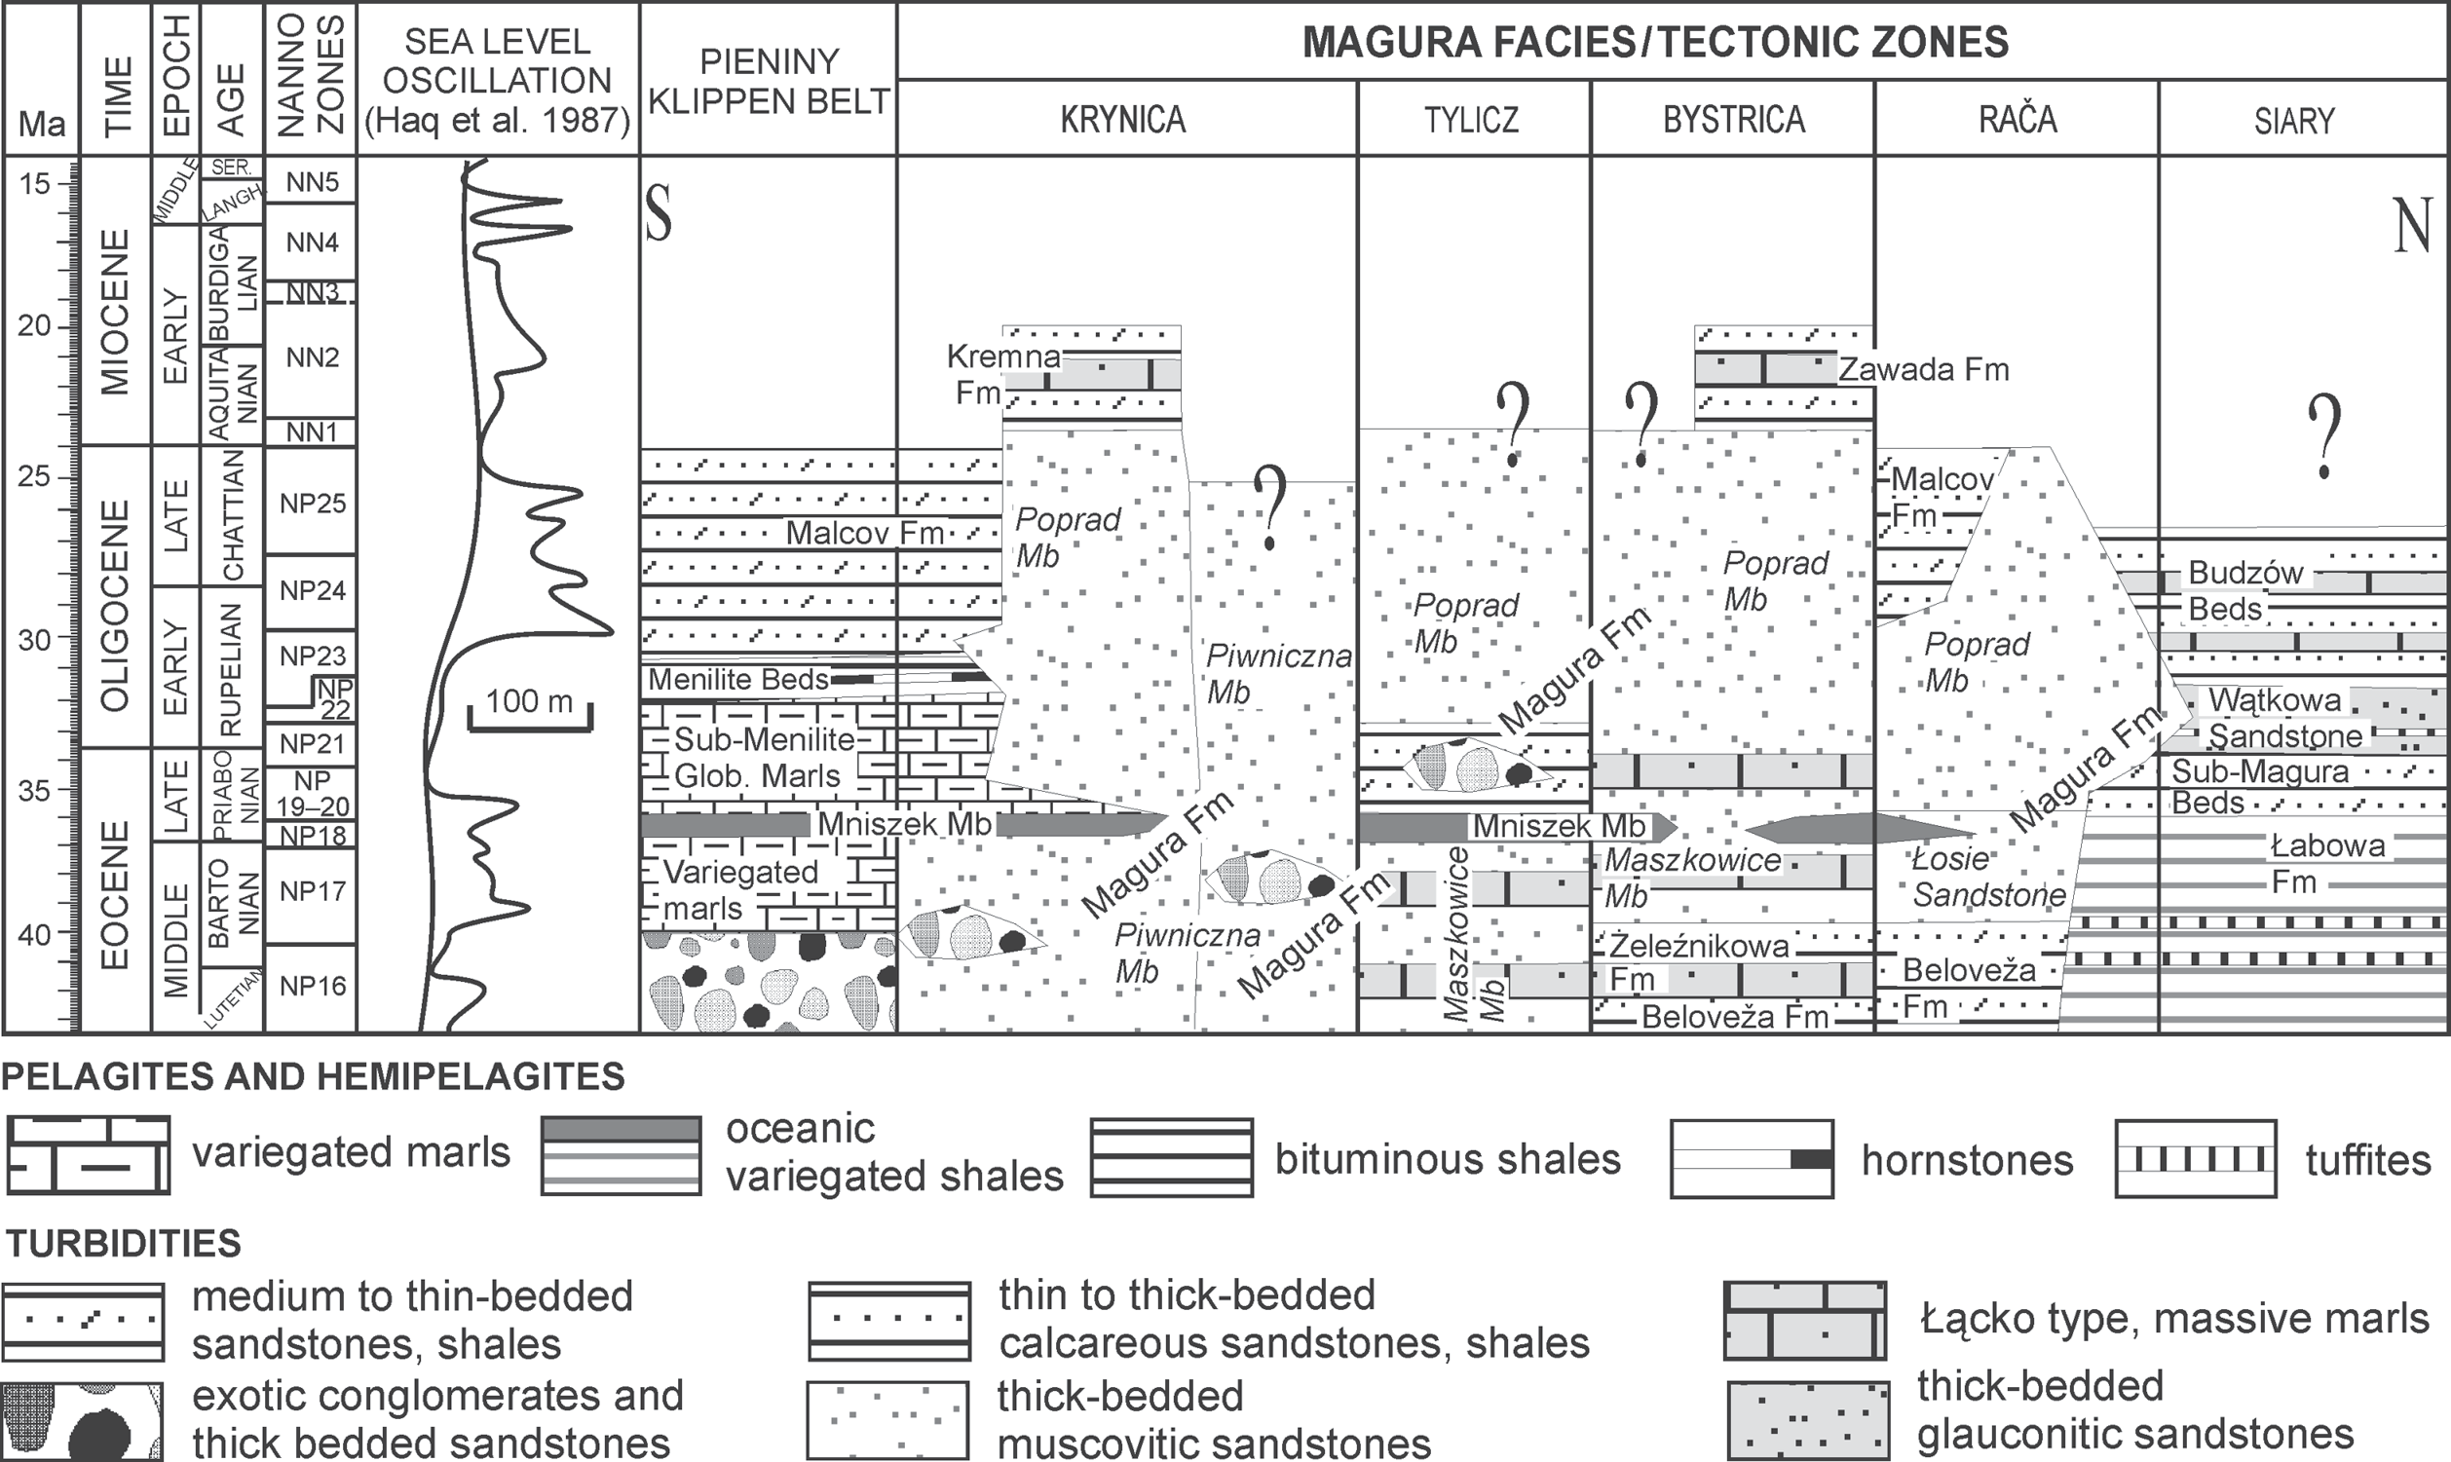
Fig. 2. Lithostratigraphic table of the Paleogene/Early Miocene deposits of the Magura Nappe and Pieniny Klippen Belt (Oszczypko & Oszczypko-Clowes 2009).

section, Fig. 1B). In the southern part of the Krynica Zone the youngest deposits belong to the Malcov and Kremna forma- tions (Figs. 2, 3, 4). Until this point, the only outcrops of the Malcov Formation in Poland were located in the Leluchów section (for reference see Oszczypko-Clowes 2001; Oszczypko & Oszczypko-Clowes 2010). In the Leluchów profile (Fig. 3) the Malcov Formation is composed of the following, Upper Eocene—Oligocene lithostratigraphic units: the Leluchów Marl Member, the Smereczek Shale Member and the Malcov For- mation s.s. The Leluchów Marl Member (see SMGM) consists of green and grey, marly shales covered by red, greyish-green, greenish and olive marls. The Smereczek Shale Member (Fig. 3) contains a marly development with a few tuffite inter- calations in the lower portion whereas the upper portion con- sists of black non-calcareous, bituminous shales with a few
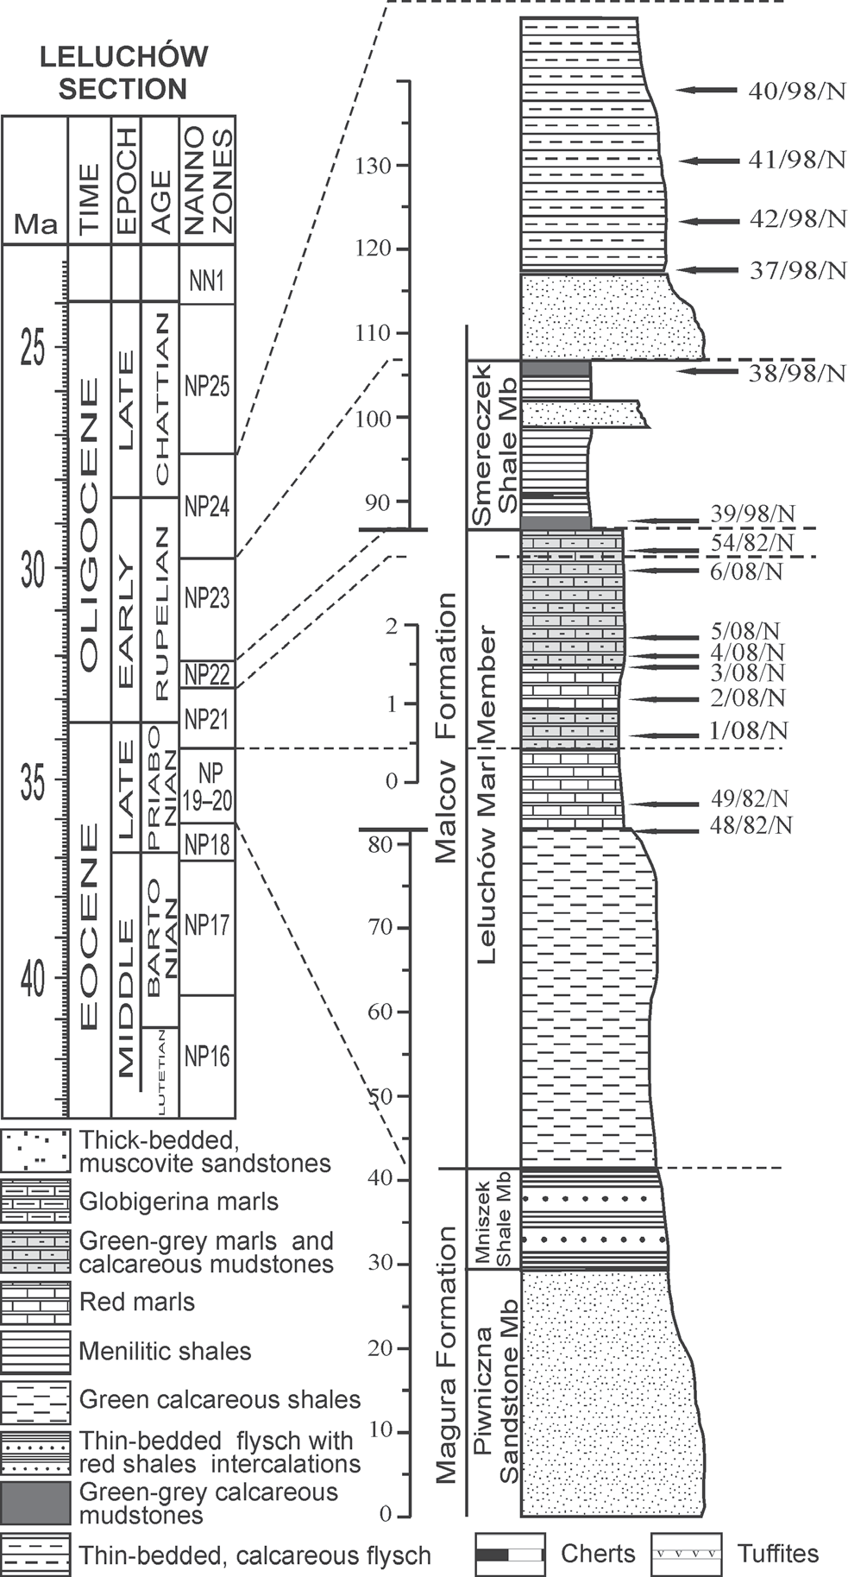

Fig. 3. Lithostratigraphic profile and sample intervals – Leluchów Succession, Krynica Zone of the Magura Nappe (Oszczypko-Clowes 2001; Oszczypko et al. 2005; Oszczypko-Clowes & Żydek 2012).
layers of coarse-grained, thick-bedded sandstone. Thin-bed- ded turbidites, dark-grey marly shales occur in the uppermost part of the Leluchów section. These flat-lying, south dipping strata belong to the Malcov Formation s.s.
A similar type of the Malcov Formation, is also known from exposures in the Újak village near Stará Cubovňa and Plaveč (Fig. 1B).
The sedimentary transition from the Poprad Sandstone Member to the Kremna facies is well exposed in the Matysova section (Fig. 4). A continuation of the Magura Formation from the Krynica-Muszyna-Leluchów area is visible in the northern part of the Cubovnianska Vrchovina Range, SW of the Poprad River. In the Cubovnianska Vrchovina Range the Poprad Sandstone Member (Strihov beds) fill the Hraničné-Kremna- Matysova, a 4—6 km wide synclinal zone (see Nemčok 1990; Oszczypko et al. 2005). The Poprad Sandstone Member, up to 1000 m thick, is underlain by the Mniszek Shale Member and covered by the Kremna Formation (Oszczypko et al. 2005). In the Matysova section, the lower part of formation (Fig. 4) is represented by coarse- to very coarse-grained, thick-bedded (0.40 to 2 m) sandstones, with sporadic intercalations of dark- grey, marly mudstones. A characteristic feature of these de- posits is the occurrence of Magura type sandstones as well as 1.5—2.0 m thick intercalations of dark-grey-to-greenish cal- careous Łącko type marly mudstones.
The thickness of the Kremna Formation varies from 200— 300 m in the Matysova and Dubne section and ranges up to 500—600 m in the Kremna and Jaworki-Kosarzyska section (Figs. 1B, 4).

The Bystrica Zone

The youngest deposits of this zone belong to the Zawada Formation (Figs. 2, 5) which was documented on the southern periphery of the Nowy Sącz Basin (Fig. 1B). This formation was found in the Nowy Sącz 4 borehole as well as in Zawada Biegonice (Oszczypko et al. 1999; Oszczypko-Clowes 2001) and also the Poręba Mała sections (Oszczypko & Oszczypko- Clowes 2002). The Zawada Formation is represented by me- dium- to thick-bedded, sometimes glauconitic, sandstones with intercalations of thick-bedded marls and marly clay- stones. The thickness of the formation is at least 550 m (Figs. 2, 4).
According to Oszczypko et al. (1999), this formation occurs in the southern part of the Rača Subunit and at the front of the Bystrica Subunit of the Magura Nappe. Due to the lack of ex- posure, the relationship between the Malcov Formation of the Rača Subunit and the Zawada Formation is not yet clear.

Materials and methods

The current research utilizes samples previously used in the following papers: Oszczypko-Clowes 2001; Oszczypko & Oszczypko-Clowes 2002; Oszczypko et al. 2005; Oszczypko & Oszczypko-Clowes 2010.
All samples were analysed with a Nikon-Eclipse E 600 POL, at a 1000 ξ magnification using both parallel and crossed nicols. The applied taxonomic framework is based

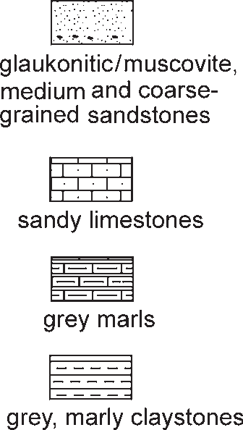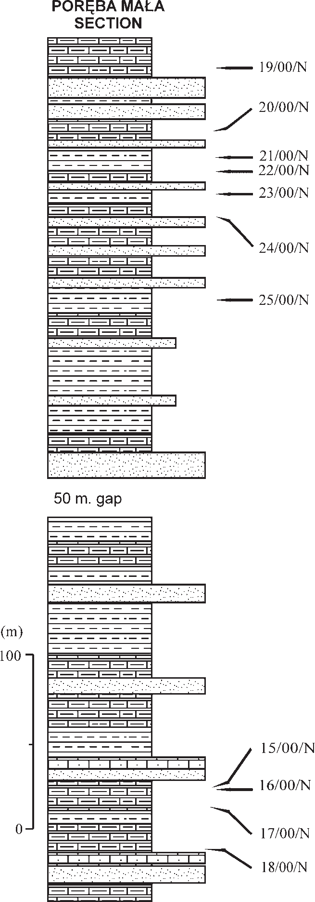
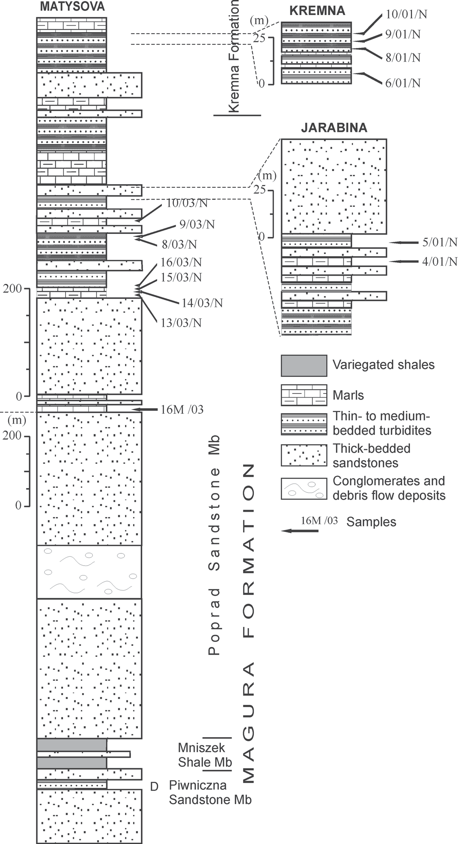
Fig. 5. Lithostratigraphic profile and sample intervals – Poręba Mała Succession, Bystrica Zone of the Magura Nappe (Oszczypko & Oszczypko-Clowes 2002).

Fig. 4. Lithostratigraphic profile and sample inter- vals – Matysova, Jarabina and Kremna successions, Krynica Zone of the Magura Nappe (Oszczypko et al. 2005).

upon Aubry (1984, 1988, 1989, 1990, 1999), Perch-Nielsen (1985), and Bown (1998 and references therein).
Quantitative analyses were performed using counts of 300 specimens per slide. The authors accepted a 5 % margin of error in analysis and calculation of percentage abundance of autochthonous and allochthonous assemblages. The nominal values as well as the percentage abundance, are presented in Tables 1, 2 and 3. Specimens photographed using the LM are illustrated in Figs. 6—7.
To distinguish reworked from in-place nannofossils the full stratigraphic ranges of species, were used. Individual species older than the youngest assemblage were identified as re- worked taxa. Issues arise concerning long-ranging Cenozoic taxa, which also form a part of the Early Neogene assem- blages. In such assemblages, autochthonous or allochthonous,
both types occur together in the sample and cannot be distin- guished from each other. In this study long-ranging taxa such Braarudosphaera bigelowii, Cyclicargolithus floridanus, Coccolithus pelagicus and Sphenolithus moriformis were counted as autochthonous species. In such a situation the cal- culated percent value of reworking should be interpreted as the minimum level of reworking.

Results

Calcareous nannofossil preservation and abundance

State of preservation is one of the methods used in identi- fying reworked fossils via the presence of very intensive

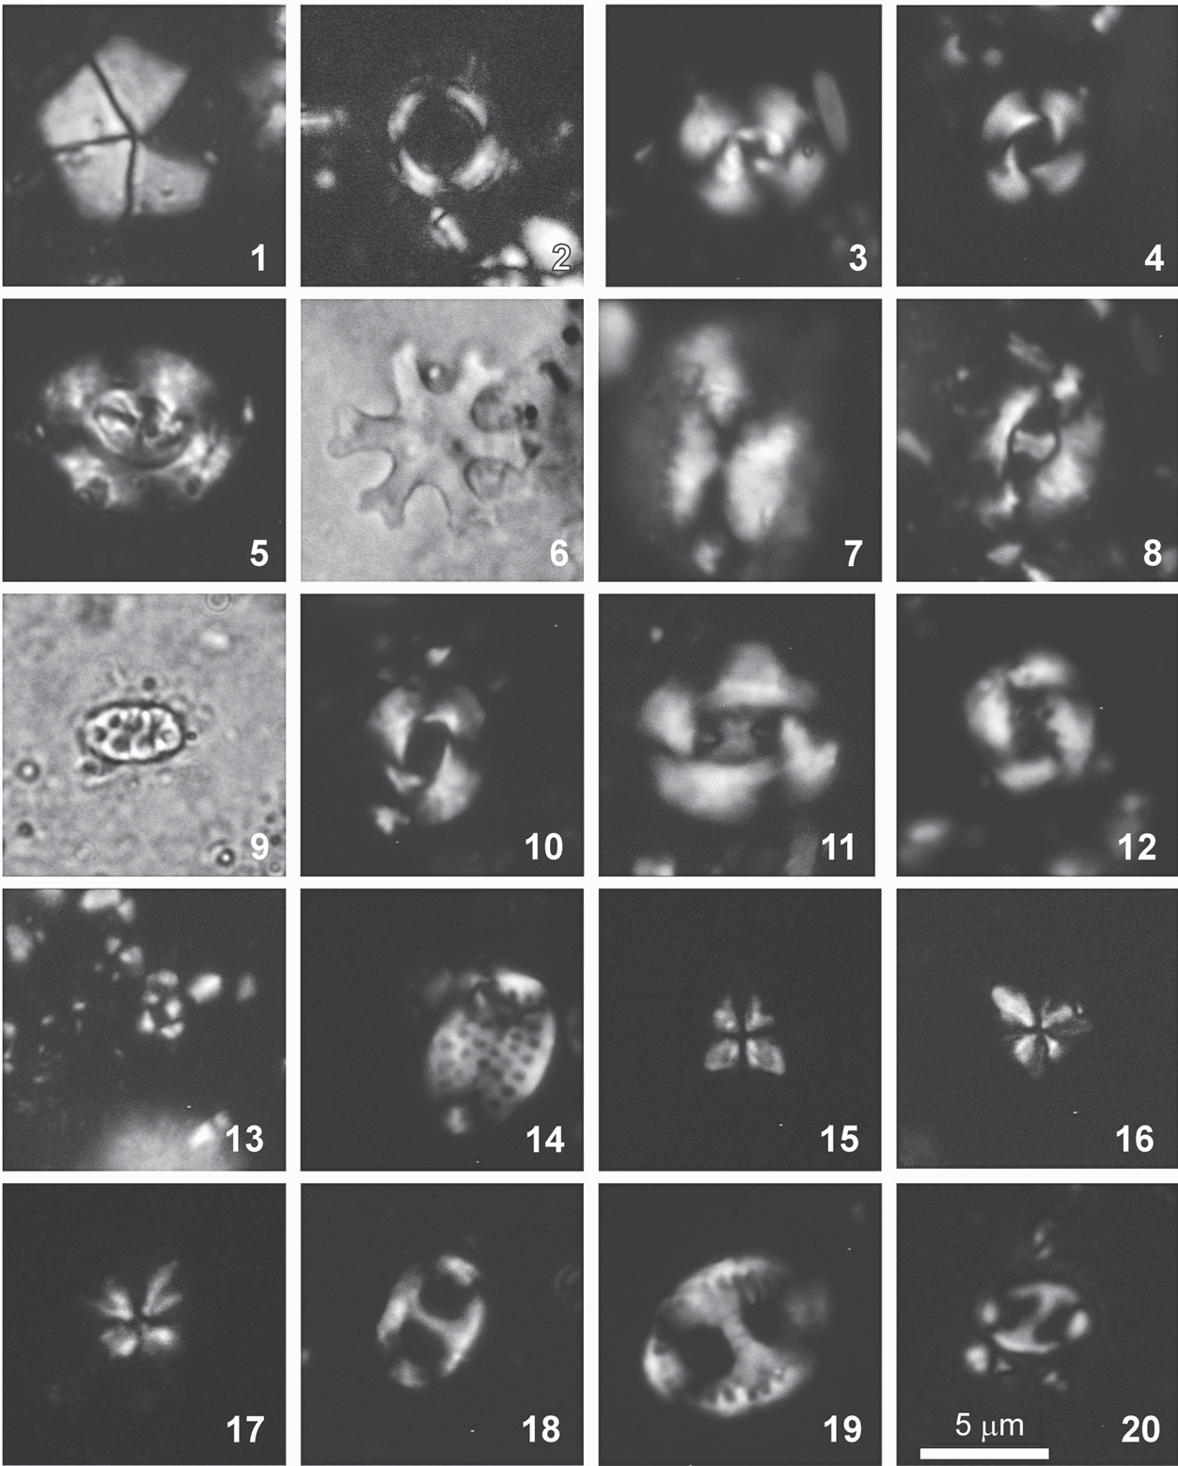

Fig. 6. Autochthonous species in LM (scale bar is the same for all photographs). 1 – Braarudosphaera bigelowii (Leluchów section, Smereczek Shale Mb, sample 38/98/N); 2 – Coronocyclus nitescens (Matysova section, Magura Fm, sample 9/03/N); 3 – Cyclicar- golithus abisectus (Leluchów section, Malcov lithofacies, sample 41/98/N); 4 – Cyclicargolithus floridanus (Poręba section, Zawada Fm, sample 16/00/N); 5 – Dictyococcites bisectus (Leluchów section, Leluchów Marl Mb, sample 49/82/N); 6 – Discoaster deflandrei (Le- luchów section, Malcov lithofacies, sample 40/98/N); 7 – Helicosphaera compacta (Leluchów section, Malcov lithofacies, sample 41/98/N); 8 – Helicosphaera intermedia (Poręba section, Zawada Fm, sample 17/00/N); 9 – Holodiscolithus macroporus (Jarabina section, Magura Fm, sample 5/01/N); 10 – Reticulofenestra dictyoda (Leluchów section, Leluchów Marl Mb, sample 48/82/N); 11 – Reticulofenestra lockerii (Leluchów section, Smereczek Shale Mb, 39/98/N); 12 – Reticulofenestra ornata (Leluchów section, Smereczek Shale Mb, 39/98/N); 13 – Reticulofenestra sp. small (Poręba section, Zawada Fm, sample 18/00/N); 14 – Ponthosphaera multipora (Kremna section, Kremna Fm, sample 8/01/N); 15, 16 – Sphenolithus conicus (Matysova section, Magura Fm, sample 9/03/N); 17 – Sphenolithus dissimilis; 18 – Transver- sopontis fibula (Leluchów section, Smereczek Shale Mb, 39/98/N); 19 – Transversopontis pulcher (Jarabina section, Magura Fm, sample 5/01/N); 20 – Transversopontis pulcheroides (Leluchów section, Leluchów Marl Mb, sample 54/82/N).

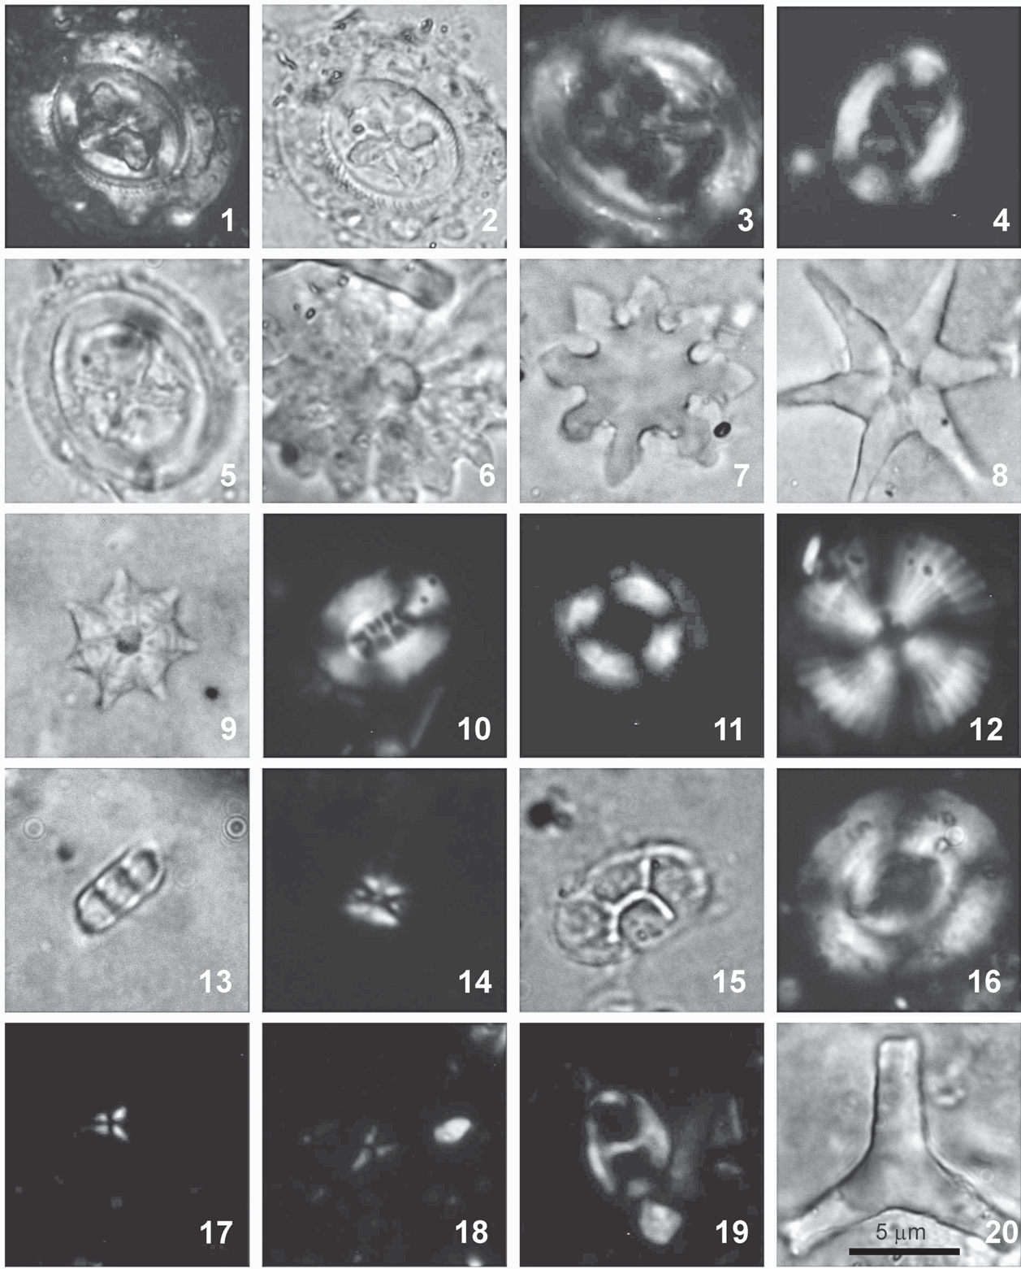

Fig. 7. Allochthonous species in LM (scale bar is the same for all photographs). 1, 2 – Chiasmolithus gigas (Matysova section, Magura Fm, sample 9/03/N); 3 – Chiasmolithus grandis (Matysova section, Magura Fm, sample 9/03/N); 4 – Chiasmolithus solitus (Matysova section, Magura Fm, sample 9/03/N); 5 – Chiasmolithus oamaruensis (Poręba section, Zawada Fm, sample 25/00/N); 6 – Discoaster barbadiensis (Poręba section, Zawada Fm, sample 16/00/N); 7 – Discoaster binodosus (Poręba section, Zawada Fm, sample 25/00/N); 8 – Discoaster lodoensis (Jarabina section, Magura Fm, sample 4/01/N); 9 – Discoaster saipanensis (Poręba section, Zawada Fm, sample 23/00/N); 10 – Ellipsolithus macellus (Matysova section, Magura Fm, sample 9/03/N); 11 – Ericsonia formosa (Jarabina section, Magura Fm, sample 4/01/N); 12 – Heliolithus kleinpelli (Matysova section, Magura Fm, sample 10/03/N); 13 – Isthmolithus recurvus (Jarabina section, Magura Fm, sample 5/01/N); 14 – Lanternithus minutus (Poręba section, Zawada Fm, sample 24/00/N); 15 – Neococcolithes dubius (Jarabina section, Magura Fm, sample 5/01/N); 16 – Reticulofenestra hillae (Poręba section, Zawada Fm, sample 16/00/N); 17, 18 – Spheno- lithus calyculus (Poręba section, Zawada Fm, sample 24/00/N); 19 – Transversopontis fibula (Poręba section, Zawada Fm, sample 22/00/N); 20 – Tribrachiatus orthostylus (Matysova section, Magura Fm, sample 8/03/N).

mechanical damage as well as signs of etching, severe dissolu- tion and overgrowth. When considering all investigated as- semblages the preservation of calcareous nannofossils is moderate (m) or predominantly moderate-to-good (m-g) in all investigated samples (Tables 1, 2, 3 – published in the elec- tronic version at the www.geologicacarpathica.sk). Nannofos- sils show minor etching and minor-to-moderate over growth. A good to moderate preservation of nannofossils indicates that little carbonate dissolution has occurred in these sediments.
Estimates of the nannofossil abundance for individual sam- ples (Tables 1, 2, 3) was established using the following crite- ria: VH – very high (> 20 specimens per 1 field of view), H – high (10—20 specimens per 1 field of view), M – mode- rate (5—10 specimens per 1 field of view), L – low (1—5 specimens per 1 field of view), VL – very low (< 5 speci- mens per 5 fields of view).

Calcareous nannofossils biostratigraphy

Biostratigraphic analyses, using the standard Martini zona- tion (1971), confirmed results obtained through earlier re- search (Oszczypko et al. 1999, 2005; Oszczypko-Clowes 2001; Oszczypko & Oszczypko-Clowes 2002, 2010).
For reference purposes, the biostratigraphic framework can be summarized as follows:
Malcov Formation: Leluchów Marl Member – Zones NP19—20—NP22 (Late Eocene—Early Oligocene), Smereczek Shale Member – Zone NP23 (Early Oligocene) and the Mal- cov Formation s.s. – Zone NP24 (Early Late Oligocene);
Poprad Sandstone Member of Magura Formation: Zones NP25—NN1 (latest Oligocene—earliest Miocene);
Kremna Formation: NN2 (Early Miocene); Zawada Formation: NN1—NN2 (Early Miocene).
The zone assignment of NP25 is based on the first occur- rence (FO) of Sphenolithus capricornutus and S. conicus. Slightly less abundant are Cyclicargolithus abisectus, Reticu- lofenestra lockeri, S. dissimilis and R. dictyoda. Dictyococ- cites bisectus is present, though rare. The FO of Sphenolithus conicus has been frequently used as the base of the NN1 Zone, however, Bizon & Műller (1979), Biolzi et al. (1981) and Melinte (1995) observe the FO of this species as low as the upper part of the NP25 Zone.
The zone assignment of NN1 is based on a continuous range of S. conicus and S. dissimillis following the disap- pearance of D. bisectus. Traditionally the last occurrence (LO) of Helicosphaera recta was used to define the base of NN1 (Martini & Worsley 1970). It is now well-known that this species also appeared in the Early Miocene. As a result, Perch-Nielsen (1985), Berggren et al. (1995), Fornaciari & Rio (1996) and Young (in Bown 1998) suggested redefining the base of NN1 as the LO of D. bisectus. The biostrati- graphic range of S. delphix is also problematic. According to Young (Young in Bown 1998), this species is only charac- teristic for the upper part of NN1, however this taxon was re- ported by Aubry (1985) from NP25 and NN1.
The NN2 assignment is based on the co-occurrence of the following species: Sphenolithus conicus, Sphenolithus dis- belemnos, Reticulofenestra pseudoumbilica and Triquetror- habdulus carinatus. At the same time Dictyococcites bisectus,
Cyclicargolithus abisectus and Zygrhablithus bijugatus are absent from this association assemblage. According to Young (1998), the FO of S. disbelemnos and/or Umbilicosphaera rotula are reliable biostratigraphical events, characteristic for the lower limit of the NN2 Zone.
Additionally, the nannofossil association from the Zawada Formation contains Discoaster druggi and Helicosphaera ampliaperta. The presence of D. druggi was observed in
2: 50 % of investigated samples, whereas the occurrence of Helicosphaera ampliaperta is extremely rare. The presence of H. ampliaperta can suggest the upper part of Zone NN2 (see Holcová 2002, 2005).

Species diversity – reworked assemblages

The Malcov Formation

Forty four species were identified during quantitative analy- ses of calcareous nannoplankton. Samples from the Leluchów Marl Member are characterized by a very low level of rework- ing, which does not exceed 3.80 % (sample 3/08/N). The great- est number of reworked specimens (13.3 %—31.35 %; Fig. 8; Table 1) were observed in samples taken from thin marly in- tercalations in the Smereczek Shale Member (39/98/N and 38/98/N) as well as the Malcov lithofacies (37/98/N, 42/98/N, 41/98/N and 40/98/N). The reworked assemblage is domi- nated by Paleogene taxa. They constitute between 11—30 % (samples 39/98/N 40/98/N, respectively) of all identified speci- mens. Cretaceous species are a minor component with less than 3 %. The main components of the Paleogene assemblage (Ta- ble 1) are Discoaster spp., Reticulofenestra spp. and Ericsonia spp., Discoaster spp. varies from 0.32 (sample 39/98/N) through 4.4 (sample 37/98/N) up to 14.2 %, (sample 40/98/N), whereas the abundance of Reticulofenestra spp. ranges from 3.5 (sample 39/98/N) up to 11.7 % (sample 41/98/N). The abun- dance of Ericsonia spp. does not exceed 8 % (sample 39/98/N).

The Poprad Sandstone Member of the Magura Formation

The quantitative analyses show a substantial quantity of reworked nannofossils (Fig. 8; Table 2). The greatest re- working is observed in sample 4/01/N (60.8 %), whereas the lowest amounts occur in sample 13/03/N (21.9 %). The re- maining samples range from 37%—53 %.
Cretaceous species make up ~11 % (samples 16/03/N, 13/03/N, 14/03/N, 15/03/N), whereas the remaining samples contain between 2.9 % and 7.6 %. Cretaceous species (Fig. 9) are con- sistently less abundant compared with Paleogene species, with the exception of sample 15/03/N (Paleogene taxa – 16.5 %, Cretaceous taxa – 21 %). The Paleogene assemblage (Ta- ble 2) is composed mainly of Discoaster spp., Sphenolithus spp. and a heterogeneous group “other”. The group labelled as “other” is composed of Ellipsolithus macellus, Ericsonia fenestrata, E. formosa, Helicosphaera heezenii, Isthmolithus recurvus, Neococcolithes dubius, Pontosphaera lateliptica, P. plana, Reticulofenestra reticulata, Rhabdosphaera clavigera, Toweius rotundus, Tribrachiatus orthostylus. The most com- mon taxon is T. orthostylus, reaching a value of 18.05 % in sample 4/01/N. The content of Discoaster spp. is greatest in

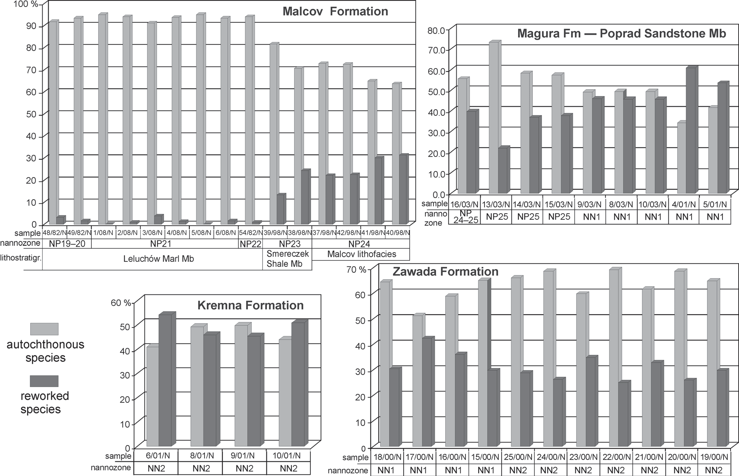

Fig. 8. Percentage abundance of autochthonous and allochthonous species in samples (Leluchów section after Oszczypko-Clowes & Żydek,
2012).

samples 16/03/N, 8/03/N and 4/03/N, reaching values of 19 %, 18 % and 16 %, respectively. The abundance of Sphe- nolithus spp. varies from 0 % (samples 16/03/N, 13/03/N, 15/ 03/N) through to 1.3 % and up to almost 15 % (5/03/N).

The Kremna Formation

The level of reworking is also high (Fig. 8; Table 2), rang- ing from 46.2 % (sample 9/01/N) up to 54.2 % (6/01/N). Per- centages of Cretaceous species are very low and range from
4.1 % to a maximum of 13.3 % in sample 10/01/N (Fig. 9). Paleogene species account for 37.6 % to 50.03 % of the total assemblage. The most abundant is the group of species labeled as “other” which include: Ellipsolithus macellus, E. fenestrata,
E. formosa, Toweius spp., Transversopontis fibula and Tri- brachiatus orthostylus. This group forms nearly 23 % (sample 6/01/N) of all specimens, which decrease to a value not higher than 16.5 % (sample 10/01/N). The most common species is
T. orthostylus reaching a value of 12 % in samples 6/01/N and 10/01/N. The genus Discoaster averages about 12 %, whereas Sphenolithus spp. is lower varying from 4.4 %—6.3 %.

The Zawada Formation

All investigated samples are characterized by the presence of reworked specimens (Fig. 8; Table 3). The level of re- working is highest in samples 17/00/N (maximum 42.4 %),
16/00/N, 23/00/N where reworked taxa represent more than 34 % of all identified species. This value decreases in sam- ples 15/00/N, 18/00/N, 19/00/N, 21/00/N and 25/00/N with maximum values :Σ 29—32 %. The remaining samples con- tain less than 26 % of the reworked species.
The percent abundance of Cretaceous species varies from
1.5 %—9 % (Fig. 9; Table 3), with an average content less than 5 %. Paleogene species are much more abundant, and consti- tute 20 %—39 % of the total assemblage. The assemblage is dominated by specimens of genera Chiasmolithus and Dis- coaster. Chiasmolithus spp. range from 2 % up to nearly 10 % of all determined species, with an average content of ~ 4 %. Discoaster spp. average ~ 3 %. The highest abundance (10, 13 %) was observed in sample 16/00/N. Helicosphaera spp. are less abundant, with an average content of approximately 3 % reaching a maximum of 6.9 % in sample 21/00/N.
The group labeled as “other” is represented by the following species: Holodiscolithus macroporus, Lanternithus minutus, Neococcolithes dubius, Pontosphaera lateliptica, Rhabdo- sphaera clavigera, R. inflata, Transversopontis fibula and Tri- brachiatus orthostylus. These taxa are generally very rare in the assemblage and, in sum, do not constitute more than 6 % of all determined species. In fact, the increased abundance of this group in samples 17/00/N, 24/00/N, 23/00/N and 21/00/N is linked to the increased abundance of Neococcolithes dubius. The most common species of this assemblage is Ericsonia formosa, with a value ranging from 3 %—8 % of all determined species.

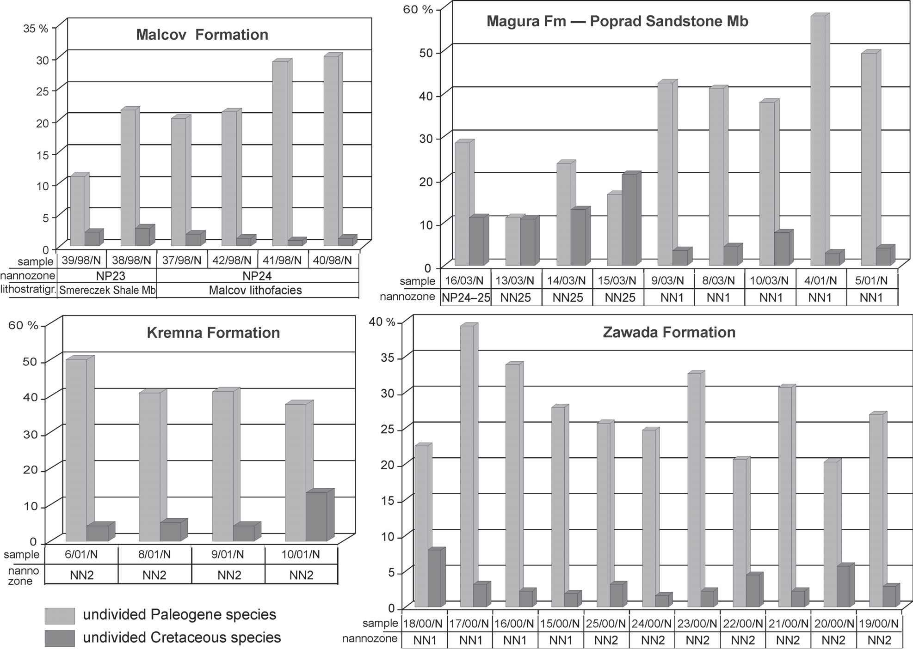

Fig. 9. Percent abundance of allochthonous species – Cretaceous versus Paleogene taxa.

Age determination of reworked assemblages

Cretaceous species commonly occur together with Ceno- zoic taxa. The precise age determination of Paleogene as- semblages is not easy, especially as an overlap pattern of several index species is visible.

The Malcov Formation

The Lower Eocene assemblage is represented by Discoaster multiradiatus (range: NP9—11) and Discoaster lodoensis (NP12—14). The long-lasting species include Discoaster bar- badiensis (NP10—20), D. nodifer (NP15—22), D. saipanensis (NP15—20), D. tanii (NP16—22), Isthmolithus recurvus (NP19/20—22), Lanternithus minutus (NP16—22), Reticulo- fenestra hillae (NP16—22) and R. umbilica (NP16—22). The presence of Isthmolithus recurvus suggests that the entire as- semblage may be not older than Zone NP19/20 and not younger than NP22 (as R. umbilica is the index species for the upper limit of Zone NP22).

The Poprad Sandstone Member of the Magura Formation and the Kremna Formation

A number of characteristic taxa of the Early/Middle Paleo- gene are present such as Chiasmolithus gigas (NP15),
Ch. grandis (NP11—17), Ch. solitus (NP10—16), Discoaster barbadiensis (NP10—20), D. binodosus (Lower to Middle Eocene), D. multiradiatus (NP9—11), D. salisburgensis (NP9—12), Ericsonia formosa, Toweius spp., Tribrachiatus orthostylus (NP11—12). On the basis of the stratigraphic range of the above given species it is possible to interpret two independent assemblages: Early Eocene – not older than NP9 and not younger than NP12 and Middle Eocene spanning from NP15 to NP16 or even NP17. As for the Late Eocene or rather Early Oligocene, specimens of Isthmolithus recurvus (NP19/20—22), Pontosphaera lateliptica, Transver- sopontis fibula NP23 (only observed in the Kremna Forma- tion) occurred across the entire studied material.

The Zawada Formation

In this formation the assemblages are even more mixed with overlapping species much more prominent. The Early Eocene is represented by Discoaster multiradiatus (NP9—11),
- distinctus (NP12—14), D. lodoensis (NP12—14).
Longer ranging species, spanning from the Middle Eocene to Early Oligocene, include Chiasmolithus gigas (NP15), Discoaster tanii (NP16—22), Helicosphaera bramlettei (NP14—23), Lanternithus minutus (NP16—22), Reticulofenestra umbilica (NP16—22). These taxa may constitute either Mid- dle Eocene, Late Eocene or even Early Oligoceene assem-

blages. The presence of the Middle Eocene could be dated by the Chiasmolithus gigas zonal marker, whereas the presence of Chiasmolithus oamaruensis (NP18—22) may suggest Late Eocene or Early Oligocene.
Concurrently, there is a biostratigraphic overlap with typi- cal Oligocene species, such as Pontosphaera lateliptica, Transversopontis fibula and, very rarely, Sphenolithus capri- cornutus and S. calyculus. The two latter species are typical of the latest Oligocene period.

Discussion

The Oligocene—Early Miocene closing of the northern sec- tor of the Outer Carpathian sedimentary area is manifested by the deposition of the Krosno synorogenic lithofacies, which occupied the Grybów-Dukla-Silesian/Sub-Silesian/ Skole and Boryslav-Pokuttya basin system. These lithofacies represent fining and thinning upward sequences. Towards the top, these sedimentary sequences are dominated by marly pelites. The beginning and termination of these deposits was diachronic and migrated across the basins towards the north (Garecka 2008).
The Malcov lithofacies, an equivalent of the Krosno types, are typical for the Pieniny Klippen Belt/Magura Basin. In the PKB and Krynica Zone of the Magura Basin, the deposition of the Malcov lithofacies was initiated during the NP24 and per- sisted until the NP25 Zone. In Rača Zone Malcov lithofacies belong to NP24 and NP25 zones (Oszczypko-Clowes 2001). In the northern part of the Magura Basin (Siary Zone) the youngest deposits (so-called Supra-Magura beds) belong to the NP24 Zone (Oszczypko-Clowes 2001). In the Grybów-Dukla units, the Krosno shaly facies belong to NP25 (Oszczypko- Clowes 2008; Oszczypko-Clowes & Oszczypko 2011).
During the Late Oligocene (NP25/NN1), the frontal part of the Magura Nappe thrust northwards onto the terminal Krosno flysch basin (Oszczypko & Oszczypko-Clowes 2009). The
northward thrusting of the Magura Nappe was accompanied by the formation of the piggy-back basin on the Magura Nappe and was filled with synorogenic turbidites from the Zawada and Kremna formations (NN1 and NN2 zones).
Reworked microfossils can be used to determine the source of sediments in order to provide information on the processes of source rock erosion, transportation, sedimenta- tion and preservation.
A majority of the allochthonous nannoflora consists of Middle Eocene taxa, together with less abundant Cretaceous, Early Eocene and Oligocene nannofossils. Various age dis- tributions provide an insight into the Cretaceous to Cenozoic sediment reworking history in the remnant flysch basin. Cre- taceous species, as well as Early Eocene taxa, are reworked into Middle Eocene sediments. These sediments, most likely formed low, consolidated basin slopes periodically incorpo- rated into gravity flows. These flows provided a significant proportion of older, many times redeposited forms in the studied material. The presence of reworked Oligocene nan- nofossil shows a more or less continuous erosion of newly deposited sediments on the sea floor during the Early Mio- cene. The scarcity of Paleocene nannofloral elements is probably due to the unavailability of Paleocene sediments for reworking processes. The diversity of Paleocene index species and their resistance to degradation would permit them to be abundant in Cenozoic flysch sediments. The same reworking pattern was observed throughout the entire flysch belt of the Outer Dinaride nappe front by Mikes et al. (2008). In the studied material, Paleogene derived nannofossils show preservation as good as, or even better, than that of the original rock. This may be due to transportation in a coated muddy suspension. In addition, all reworked species are re- sistant to dissolution. In such situations the original assem-
blages had to be much more diversified.
It is very difficult to show precisely the lithological forma- tions which formed the source rocks for the reworked material. This is connected with a 23° clockwise rotation of the eastern

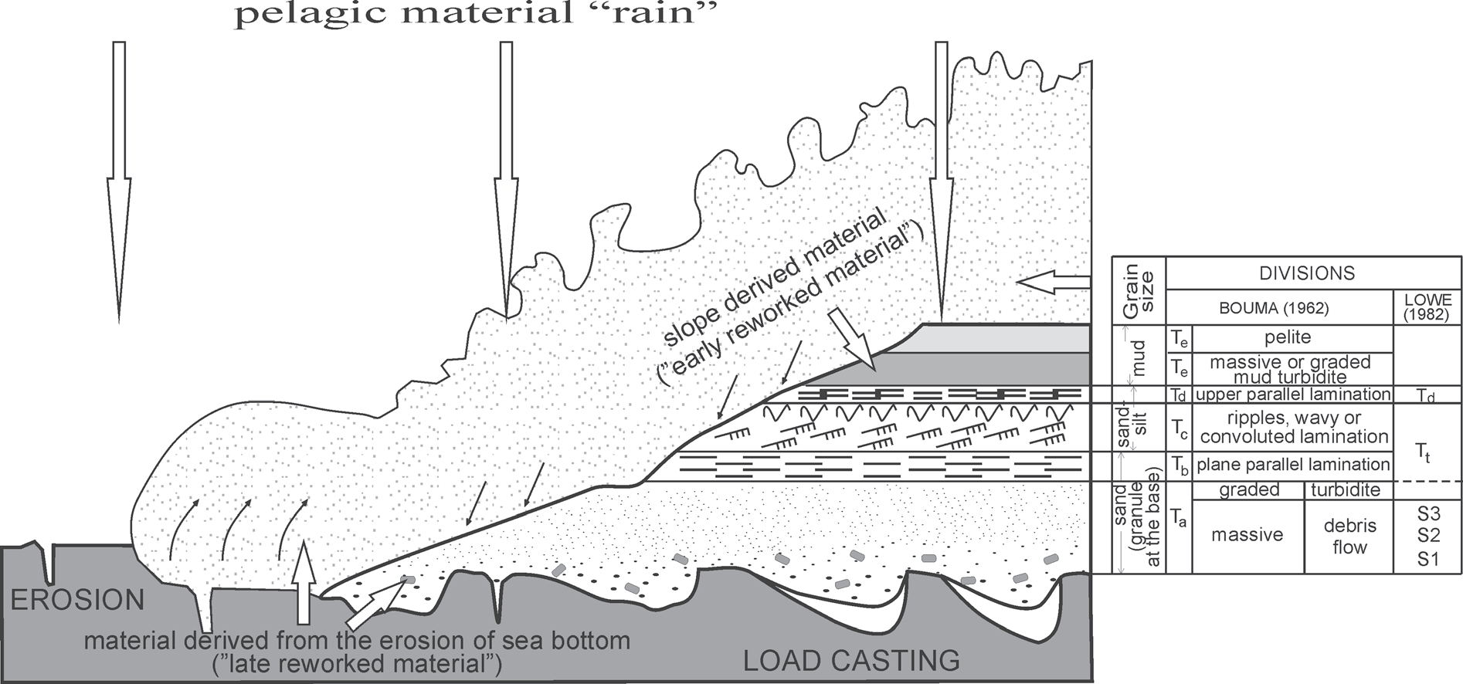

Fig. 10. Model of gravity flow deposition versus coccoliths settling (Bouma 1962; Lowe 1982; Einsele 2002, supplemented).

part of the Alpine-Carpathian-Pannonian region which took place in the Early Miocene, 20 Ma BP (Ustaszewski et al. 2008). According to this reconstruction the maximal width of the Magura Basin at that time ranged up to 200 km.
The percentage of reworked species is clearly associated with lithology (Fig. 8). This is very clearly visible in the Malcov Formation. The lowest number (0 %—3.8 %) of re- worked species was recorded in samples from marly, pelagic facies from the Leluchów Marl Member. Turbidite facies, from the Malcov lithofacies, are characterized by an in- creased reworking, reaching 31.4 %. The values are even higher for the Poprad Sandstone Member and Kremna Forma- tion, where the samples were collected from massive marly claystones (Te), originating from the finest cloud suspension.
The quantitative analyses proved that the level of rework- ing is high and very high for flysch deposits, which led to age misinterpretations in the past. Age determination based on the youngest assemblage can be approximated, and al- ways should be phrased as not older than. The most reliable indicator for the determination of age can be observed via muddy-clay intraclasts (S3), which were eroded by the gravi- tational front directly from the sea floor (Fig. 10), as well as from pelagic “rain”. That is why nannofossils remain the most important tool for biostratigraphic interpretations in flysch.

Conclusion

  - The youngest deposits of the Magura Basin belong to the Zawada/Kremna formations of the Early Miocene age (NN1, NN2).
  - These synorogenic turbidite facies are characterized by a high level of reworked nannofossils.
  - A quantitative analysis of the reworked assemblages confirmed the domination of Paleogene nannofosssil species over Cretaceous ones.
  - The most abundant, reworked assemblages belong to the Early-Middle Eocene age.
  - The reworked assemblages are also much better pre- served than the autochthonous ones which has led to misin- terpretations concerning their age in the past.

Acknowledgments: The author wishes to thank Anonymous reviewers for their constructive criticism and detailed review of the manuscript. Miroslav Bubík and Lilian Švábenická are also gratefully acknowledged for their valuable comments on the manuscript.

Reference

Aubry M.-P. 1984: Handbook of Cenozoic calcareous nannoplankton. Book 1: Ortholithae (Discoasters). Micropaleontology Press, Amer. Mus. Natur. Hist., New York, 1—265.
Aubry M.P. 1985: Northwestern European Palaeogene magneto- stratigraphy: calcareous nannofossil evidence. Geology 13, 3, 198—202.
Aubry M.-P. 1988: Handbook of Cenozoic calcareous nannoplank- ton. Book 2: Ortholithae (Holochoccoliths, Ceratoliths and others). Micropaleontology Press, Amer. Mus. Natur. Hist.,
New York, 1—279.
Aubry M.-P. 1989: Handbook of Cenozoic calcareous nannoplankton. Book 3: Ortholithae (Pentaliths, and others) Heliolithae (Fasci- culiths, Sphenoliths and others). Micropaleontology Press, Amer. Mus. Natur. Hist., New York, 1—279.
Aubry M.-P. 1990: Handbook of Cenozoic calcareous nannoplankton. Book 4: Heliolithae (Helicoliths, Cribriliths, Lopadoliths and others). Micropaleontology Press, Amer. Mus. Natur. Hist., New York, 1—381.
Aubry M.-P. 1999: Handbook of Cenozoic calcareous nannoplankton. Book 5: Heliolithae (Zygolithus and Rhabdolithus). Micropale- ontology Press, Amer. Mus. Natur. Hist., New York, 1—367.
Bąk K. & Oszczypko N. 2000: Late Albian and Cenomanian rede- posited foraminifera from Late Cretaceous—Paleocene deposits of the Rača Subunit (Magura Nappe, Polish Western Car- pathians) and their paleogeographical significance. Geol. Car- pathica 51, 6, 371—382.
Berggren W.A., Kent D.V., Swisher C.C. & Aubry M.P. 1995: A revised Cenozoic geochronology and chronostratigraphy. SEPM, Spec. Publ. 54, 129—212.
Biolzi M., Műller C. & Palmieri G. 1981: Calcareous nannoplankton. In: Gelati R. & Steininger F. (Eds.): In search of the Paleo- gene-Neogene boundary stratotype. Part II. Rev. Ital. Paleont. Stratigr. 89, 4, 460—471.
Bizon G. & Műller C. 1979: Remarks on the Oligocene/Miocene boundary based on the results obtained from the Pacific and the Indian Ocean. Ann. Géol. Pays Hellén. 1, 101—111.
Birkenmajer K. & Gedl P. 2004: Dinocyst ages of some Jurassic strata, Grajcarek Unit at Sztolnia Creek, Pieniny Klippen Belt, Poland. Stud. Geol. Pol. 123, 245—277.
Birkenmajer K., Gedl P., Myczyński R. & Tyszka J. 2008: “Creta- ceous black flysch” in the Pieniny Klippen Belt, West Car- pathians: a case of geological misinterpretation. Cretaceous Research 29, 535—549.
Birkenmajer K. & Oszczypko N. 1989: Cretaceous and Palaeogene lithostratigraphic units of the Magura Nappe, Krynica Subunit, Carpathians. Ann. Soc. Geol. Pol. 59, 145—181.
Bouma A.H. 1962: Sedimentology of some flysch deposits: a graphic approach to facies interpretation. Elsevier, Amsterdam, 1—168. Bown P.R. (Ed.) 1998: Calcareous nannofossil biostratigraphy. British Micropalaeontological Society Series. Kluwer Academic
Publishers, Cambridge, 1—315.
Cieszkowski M. 1992: Marine Miocene deposits near Nowy Targ, Magura Nappe, Flysch Carpathians (South Poland). Geol. Car- pathica 46, 339—346.
Cieszkowski M. & Olszewska B. 1986: Malcov Beds in Magura Nappe near Nowy Targ, Outer Carpathians, Poland. Ann. Soc. Geol. Pol. 56, 53—71.
Cieszkowski M., Oszczypko N., Pescatore T., Senatore M.R., Ślączka
    - & Valente A. 1995: Carbonate megaturbidites in the flysch successions of the South Appenines (Cilento, Italy) and the Outer Carpathians (Poland). [Megatorbiditi calcareo-marnose nelle succesioni flyscioidi dell’Appennino Meridionale (Cilento, Italia) e dei Carpazi Settentrionali (Polonia).] Boll. Soc. Geol. Ital. 114, 18, 67—88.
Cieszkowski M., Oszczypko N., Pescatore T., Senatore M.R., Ślączka A. & Valente A. 1994: Deep-sea clastic sediments and associated megaturbidites and olistostromes (Cenozoic, Cilento, Southern Italy). 15th IAS Regional Meeting, Ischia, 1994, Pre Meeting Fieldtrip Guidebook, Excursio A9, 191—220.
Dżułyński S., Książkiewicz M. & Kuenen P.H. 1964: Turbidites in flysch of the Polish Carpathians. Geol. Soc. Amer. Bull. 70, 1089—1118.
Einsele G. 2002: Sedimentary basins-evolution, facies and sediment budget. Second edition, Springer Verlag, Berlin—Haidelberg— New York, 1—792.

Fornaciari E. & Rio D. 1996: Latest Oligocene to Early Middle Miocene quantitative calcareous nannofossil biostratigraphy in the Mediterranean region. Micropaleontology 42, 1—37.
Garecka M. 2008: Oligocene/Miocene boundary in the Polish Outer Carpathians based on calcareous nannoplanton. Biul. Państw. Inst. Geol. 432, 1—45 (in Polish, English summary).
Halicki B. 1959: Notes on the Podhale and Magura flysch in the Podhale region. Acta Geol. Pol. 11, 477—491 (in Polish, English summary).
Haq B.U., Hardenbol J. & Vail P.R. 1987: Chronology of fluctuating sea levels since the Triassic. Science 235, 1156—1167.
Holcová K. 2002: Calcareous nannoplankton from the Eggenburgian stratotype and faciostratotypes (Lower Miocene, Central Para- tethys). Geol. Carpathica 53, 6, 381—390.
Holcová K. 2005: Quantitative calcareous nannoplankton bio- stratigraphy of the Oligocene/Miocene boundary interval in the northern part of the Buda Basin (Central Paratethys). Geol. Quart. 49, 3, 263—274.
Horwitz L. 1935: New schematic cross-section through the Pieniny Klippen Belt in Poland. Spraw. Państw. Inst. Geol. 8, 3, 79—105 (in Polish).
Kuenen P.H. & Migliorini C.I. 1950: Turbidity currents as a cause of graded bedding. J. Geol. 58, 91—127.
Lowe D.R. 1982: Sediment gravity flows. II. Depositional models with special reference to the deposits of high-density turbidity currents. J. Sed. Petrology 52, 279—297.
Martini E. 1971: Standard Tertiary and Quaternary calcareous nanno- plankton zonation. II. Proc. II Planktonic Conf. Roma 1970, Edizioni Tecnoscienza, Rome, 729—785.
Martini E. & Worsley T. 1970: Standard Neogene calcareous nan- noplankton zonation. Nature 225, 289—290.
Mafašovský M. & Andreyeva-Grigorovich A.S. 2002: The Lower Miocene deposits of the Krynica Subunit of the Magura Nappe near Humenne (eastern Slovakia). Paleogeographical, Paleo- ecological and Paleoclimatic Development of Central Europe, Abstract Book, Bratislava, 63—64.
Matějka A. 1959: Sector de Šariš de la zone des Klippes internes entre le Poprad et le Sekčovský potok. Zprávy o Geol. Výzk. v
r. 1957, Praha.
Melinte M. 1995: Changes in nannofossil assemblages during the Oligocene—Lower Miocene interval in the Eastern Carpathians and Transylvania. Abstracts 10th RCMNS, Bucharest 1995, Ro- manian J. Stratigr. 76, suppl., 7, 171—172.
Middletown G.V. 1993: Sediment deposition from turbidity cur- rents. Ann. Rev. Earth and Planet. Sci. 21, 89—114.
Mikes T., Báldi-Beke M., Kazmer M., Dunkl I. & von Eynatten H. 2008: Calcareous nannofossil age constraints on Miocene flysch sedimentation in the Outer Dinarides (Slovenia, Croatia, Bosnia- Herzegovina and Montenegro). In: Siegesmund S., Fugenschuh
    - & Froitzheim N. (Eds.): Tectonic aspects of the Alpine-Di- naride-Carpathian System. Geol. Soc. London, Spec. Publ. 298, 335—363.
Nemčok J. 1990: Geological map of the Pieniny, Cubovnianska and Ondavská vrchovina Mts. Geologický Ústav D. Štúra, Bratislava.
Olszewska B. & Oszczypko N. 2010: The geological position, sedi- mentary record and composition of the Tylicz Conglomerate (Late Eocene—Oligocene): stratigraphical and paleogeographical implications (Magura Nappe, Polish Outer Carpathians). Geol. Carpathica 61, 39—54.
Oszczypko N. 1973: The geology of the Nowy Sącz Basin (The Middle Carpathians). Biul. Inst. Geol. 271, 101—197 (in Polish, English summary).
Oszczypko N., Dudziak J. & Malata E. 1990: Stratigraphy of the Cretaceous through Palaeogene deposits of the Magura Nappe in the Beskid Sądecki Range, Polish Outer Carpathians. Stud. Geol. Pol. 97, 109—181 (in Polish).
Oszczypko N., Andreyeva-Grigorovich A.S., Malata E. & Oszczypko- Clowes M. 1999: The Lower Miocene deposits of the Rača Subunit near Nowy Sącz (Magura Nappe, Polish Outer Car- pathians). Geol. Carpathica 50, 6, 419—433.
Oszczypko N. & Oszczypko-Clowes M. 2002: Newly discovered Early Miocene deposits in the Nowy Sącz area (Magura Nappe, Polish Outer Carpathians). Geol. Quart. 46, 2, 117—133.
Oszczypko N. & Oszczypko-Clowes M. 2009: Stages in the Magura Basin: a case study of the Polish sector (Western Carpathians). Geodinamica Acta 22, 1—3, 83—100.
Oszczypko N. & Oszczypko-Clowes M. 2010: The Paleogene and Early Neogene stratigraphy of the Beskid Sądecki Range and Cubovnianska Vrchovina (Magura Nappe, Western Car- pathians). Acta Geol. Pol. 60, 317—348.
Oszczypko N., Dudziak J. & Malata E. 1990: Stratigraphy of the Cretaceous through Palaeogene deposits of the Magura Nappe in the Beskid Sądecki Range, Polish Outer Carpathians. Stud. Geol. Pol. 97, 109—181 (in Polish, English sumary).
Oszczypko N., Golonka J. & Malata E. 2008a: The age of so-called black flysch of the Pieniny Klippen Belt in Poland. Reply for re- ply. [Wiek tzw. czarnego fliszu pienińskiego pasa skałkowego w Polsce – odpowiedź na odpowiedź.] Przegl. Geol. 56, 459—460 (in Polish).
Oszczypko N., Golonka J. & Malata E. 2008b: Response to “The voice in the discussion of the biostratigraphy so-called black flysch of Pieniny Klippen Belt in Poland”. [Odpowiedź na “Głos w dys- kusji nad biostratygrafią tzw. czarnego fliszu pienińskiego pasa skałkowego w Polsce.”] Przegl. Geol. 56, 221—224 (in Polish).
Oszczypko N., Plašienka D. & Jurewicz E. 2010: Tectonics of the Klippen Belt and Magura Nappe in the Eastern Part of the Pie- niny Mts. (Western Carpathians, Poland and Slovakia) – new approches and results. Proceedingss XIX Congress of the Car- pathian-Balkan Geological Association, Thessaloniki, Greece, 23—26 September 2010. Scientific Annales of the School of Ge- ology, Aristotle University of Thessaloniki, Faculty of Sciences, Special Volume 100, 1—2, 221—230.
Oszczypko N., Oszczypko-Clowes M., Golonka J. & Marko F. 2005: Oligocene—Lower Miocene sequences of the Magura Nappe and Pieniny Klippen Belt and adjacent Magura Nappe between Jarabina and the Poprad River (East Slovakia and South Poland) – their tectonic position and paleogeographic implications. Geol. Quart. 49, 379—402.
Oszczypko N., Malata E., Švábenická L., Golonka J. & Marko F. 2004: Jurassic Cretaceous controversies in the Western Car- pathian Flysch: “black flysch” case study. Creteceous Research 25, 89—113.
Oszczypko-Clowes M. 2001: The nannofossil biostratigraphy of the youngest deposits of the Magura Nappe (East of the Skawa river, Polish Flysch Carpathians) and their palaeoenvironmental con- ditions. Ann. Soc. Geol. Pol. 71, 139—188.
Oszczypko-Clowes M. 2008: The stratigraphy of the Oligocene de- posits from the Ropa tectonic window (Grybów Nappe, Western Carpathians, Poland). Geol. Quart. 52, 2, 127—142.
Oszczypko-Clowes M. 2010: Calcareous nannoplankton biostratigra- phy of the terminal sediments of the Magura Basin – a case study of the Polish sector (Outer Western Carpathians). Pro- ceedings XIX Congress of the Carpathian-Balkan Geological Association, Thessaloniki, Greece, 23—26 September 2010, Sci- entific Annales of the School of Geology, Aristotle University of Thessaloniki, Faculty of Sciences, Special Volume 100, 1—2, 221—230.
Oszczypko-Clowes M. & Oszczypko N. 2011: Stratigraphy and tec- tonics of a tectonic window in the Magura Nappe (Świątkowa Wielka, Polish Outer Carpathians). Geol. Carpathica 62, 2, 139—154.
Oszczypko-Clowes M. & Żydek B. 2012: Paleoecology of the Upper

Eocene Lower Oligocene Malcov Basin based on the calcare- ous nannofossils: a case study of the Leluchów section (Krynica Zone, Magura Nappe, Polish Outer Carpathians). Geol. Car- pathica 63, 2, 149—164.
Paul Z. & Poprawa D. 1992: Geology of the Magura Napppe in the Peri-Pieniny Zone in light of the Nowy Targ PIG 1 borehole. Przegl. Geol. 40, 7, 404—409 (in Polish, English summary).
Perch-Nielsen K. 1985: Cenozoic calcareous nannofossils. In: Bolli H., Saunders J.S. & Perch-Nielsen K. (Eds.): Plankton stratig- raphy. Cambridge University Press, 11, 427—554.
Picha F. 1996: Exploring for hydrocarbons under thrust belts – A challenging new frontier in the Carpathians and elsewhere. AAPG Bull. 80, 10, 1547—1564.
Radomski A. 1967: Some stratigraphic units based on nannoplankton in the Polish Outer Carpathians. Inst. Geol. Biul. 211, 385—393.
Shanmugam G. 2000: 50 years of the turbidite paradigm (1950s— 1990s): deep-water processes and facies models – a critical perspective. Mar. Petrol. Geol. 17, 285—342.
Sikora W. 1962: New data on the geology of the Pieniny K1ippen Belt. Bull. Pol. Acad. Sci., Earth Sci. 10, 203—211.
Stráník Z. & Hanzlíková E. 1968: Stratigraphy of the Magura Group of nappes. In: Mahel M. & Buday T. (Eds.): Regional geology of Czechoslovakia. Part II. The West Carpathians. 446—480.
Švábenická L. & Bubík M. 1992: The fossil record (calcareous nan- nofossils and foraminifers) in single intervals of the Upper Cretaceous flysch sequence of the West Carpathians, Czecho-
slovakia. Cretaceous Research 13, 583—590.
Švábenická L., Bubík M. & Stráník Z. 2007: Biostratigraphy and paleoenvironmental changes on the transition from the Menilite to Krosno lithofacies (Western Carpathians, Czech Republic). Geol. Carpathica 58, 3, 237—262.
Tefák F. 2008: Paleogene depositional systems and paleogeography of the submarine fans in western part of the Magura Basin (Ja- vorníky Mountains, Slovakia). Geol. Carpathica 59, 4, 333—344. Uhlig V. 1890: Geologische Spezialkarte der Ősterreichisch-Un- garischen Monarchie. k.k. Geol. R.A., Zone 8, XXIII, Alt Lu-
blau (Stará Cubowna) und Szczawnica, Wien.
Ustaszewski K., Schmid S., Fügenschuh B., Tischler M., Kissling
E. & Spakman W. 2008: A map-view restoration of the Al- pine-Carpathian-Dinaridic system for the Early Miocene. Swiss J. Geosci., 101/supplementary issue, 273—294.
Watycha L. 1963: Magura flysch of the southern part of Gorce Mts.
Przegl. Geol. 8, 371—378 (in Polish, English summary).
Young J. 1998: Miocene. In: Bown P. (Ed.): Calcareous nannofos- sil biostratigraphy. Kluwer Academic Publishers, Dordrecht, 225—265.
Żytko K., Gucik S., Ryłko W., Oszczypko N., Zając R., Garlicka I., Nemčok J., Eliás M., Menčík E. & Stráník Z. 1989: Map of the Tectonic Elements of the Western Outer Carpathians and their Foreland. In: Poprawa D. & Nemčok J. (Eds.): Geological Atlas of the Western Outer Carpathians and their Foreland. PIG, Warszawa, GÚDŠ, Bratislava, ÚÚG, Praha.

Appendix

Nannofossil taxa in text, in alphabetic of genera epihets

Blackites creber (Deflandre, 1954) Roth, 1970
Braarudosphaera bigelowii (Gran & Braarud, 1935) De- flandre, 1947
Calcidiscus leptoporus (Murray & Blackman, 1898) Loe- blich & Tappan, 1978
Chiasmolithus altus Bukry & Percival, 1971
Chiasmolithus bidens (Bramlette & Sullivan, 1961) Hay & Mohler, 1967
Chiasmolithus expansus (Bramlette & Sullivan, 1961) Gartner, 1970
Chiasmolithus gigas (Bramlette & Sullivan, 1961) Ra- domski, 1968
Chiasmolithus grandis (Bramlette & Riedel, 1954) Ra- domski, 1968
Chiasmolithus medius Perch-Nielsen, 1971
Chiasmolithus modestus Perch-Nielsen, 1971
Chiasmolithus oamaruensis (Deflandre, 1954) Hay, Mohler & Wade, 1966
Chiasmolithus solitus (Bramlette & Sullivan, 1961) Locker, 1968
Coccolithus pelagicus (Wallich, 1871) Schiller, 1930
Coronocyclus nitescens (Kamptner, 1963) Bramlette & Wilcoxon, 1967
Cyclicargolithus abisectus (Müller, 1970) Wise, 1973
Cyclicargolithus floridanus (Roth & Hay in Hay et al., 1967) Bukry, 1971
Cyclicargolithus luminis (Sullivan, 1965) Bukry, 1971
Dictyococcites bisectus (Hay, Mohler & Wade, 1966) Bukry & Percival, 1971
Discoaster barbadiensis Tan, 1927
Discoaster binodosus Martini, 1958
Discoaster deflandrei Bramlette & Riedel, 1954
Discoaster distinctus Martini, 1958
Discoaster druggi Bramlette &Wilcoxon, 1967
Discoaster kuepperi Stradner, 1959
Discoaster lodoensis Bramlette & Riedel, 1954 Discoaster multiradiatus Bramlette & Reidel, 1954 Discoaster saipanensis Bramlette & Riedel, 1954 Discoaster salisburgensis Stradner, 1961
Discoaster sublodoensis Bramlette & Sullivan, 1961
Discoaster tanii Bramlette & Riedel, 1954
Discoaster tanii nodifer (Bramlette & Riedel, 1954) Bukry, 1973
Ellipsolithus macellus (Bramlette & Sullivan, 1961) Sulli- van, 1964
Ericsonia fenestrata (Deflandre & Fert, 1954) Stradner in
Stradner & Edwards (1968)
Ericsonia formosa (Kamptner, 1963) Haq, 1971
Ericsonia subdisticha (Roth & Hay in Hay et al., 1967) Roth in Baumann & Roth, 1969
Helicosphaera ampliaperta Bramlette & Wilcoxon, 1967
Helicosphaera bramlettei Müller, 1970
Helicosphaera carteri (Wallich, 1877) Kamptner, 1954 Helicosphaera compacta Bramlette & Wilcoxon, 1967 Helicosphaera euphratis Haq, 1966
Helicosphaera heezenii (Bukry, 1971) Jafar & Martini, 1975
Helicosphaera intermedia Martini, 1965 Helicosphaera lophota Bramlette & Sullivan, 1961 Heliolithus kleinpelli Sullivan, 1964
Isthmolithus recurvus (Deflandre in Deflandre & Fert, 1954)
Lanternithus minutus Stradner, 1962
Neococcolithes dubius (Deflandre in Deflandre & Fert, 1954) Black, 1967
Neococcolithes minutus (Perch-Nielsen, 1967) Perch- Nielsen, 1971
Pontosphaera discopora Schiller, 1925
Pontosphaera lateliptica (Báldi-Beke & Baldi, 1974) Perch-Nielsen, 1984
Pontosphaera multipora (Kamptner, 1948) Roth, 1970
Pontosphaera plana (Bramlette & Sullivan, 1961) Perch- Nielsen, 1971
Reticulofenestra callida (Perch-Nielsen, 1971) Bybell, 1975 Reticulofenestra daviessi (Haq, 1968) Haq, 1971 Reticulofenestra dictyoda (Deflandre in Deflandre & Fert,
1954) Stradner in Stradner & Edwards, 1968 Reticulofenestra hillae Bukry & Percival, 1971 Reticulofenestra ornata Müller, 1970
Reticulofenestra pseudoumbilica (Gartner, 1967) Gartner, 1969
Reticulofenestra reticulata (Gartner & Smith, 1967) Roth & Thierstein, 1972
Reticulofenestra umbilica (Levin, 1965) Martini & Ritz- kowski, 1968
Sphenolithus calyculus (Bukry, 1985)
Sphenolithus capricornutus Bukry & Percival, 1971
Sphenolithus conicus Bukry, 1971
Sphenolithus delphix Bukry, 1973
Sphenolithus disbelemnos Fornaciari & Rio, 1996 Sphenolithus dissimilis Bukry & Percival, 1971 Sphenolithus editus Perch-Nielsen in Perch-Nielsen et al.,
1978
Sphenolithus moriformis (Brönnimann & Stradner, 1960) Bramlette & Wilcoxon, 1967
Sphenolithus radians Deflandre in Deflandre & Fert, 1954
Sphenolithus spiniger Bukry, 1971
Transversopontis fibula Gheta, 1975
Transversopontis pulcher (Deflandre in Deflandre & Fert, 1954) Hay, Mohler & Wade, 1966
Transversopontis pulcheroides (Sullivan, 1964) Báldi- Beke, 1971
Tribrachiatus orthostylus Shamrai, 1963 Triquetrorhabdulus carinatus Martini, 1965 Triquetrorhabdulus milowii Bukry, 1971 Umbilicosphaera rotula (Kamptner, 1956) Varol, 1982 Zygrhablithus bijugatus (Deflandre in Deflandre & Fert,
1954) Deflandre, 1959
Electronic Edition of Tables 1– 3 — OSZCZYPKO-CLOWES: REWORKED NANNOFOSSILS FROM THE LOWER MIOCENE I

Tbe1NomIl n aIa s aC o L aI a a sIa b i I s a o I

 | Leluchów Marl Mb |  |  |  |  |  |  |  |  |  |  |  |  |  |  |  |  |  | Smereczek Shale Mb |  |  |  | Malcov lithofacies
Calc. nannofossil Zone (Martini 1971) | NP19–20 |  |  |  | NP21 |  |  |  |  |  |  |  |  |  |  |  | NP22 |  | NP23 |  |  |  | NP24
Sample | 48/82/N |  | 49/82/N |  | 1/08/N |  | 2/08/N |  | 3/08/N |  | 4/08/N |  | 5/08/N |  | 6/08N |  | 54/82/N |  | 39/98/N |  | 38/98/N |  | 37/98/N |  | 42/98/N |  | 41/98/N |  | 40/98/N
Sample abundance | H |  | H |  | VH |  | VH |  | VH |  | VH |  | VH |  | VH |  | H |  | M |  | M |  | M |  | H |  | H |  | H
Nannofossil preservation | M |  | M |  | G |  | G |  | G |  | G |  | G |  | G |  | G |  | M |  | M |  | M |  | M |  | M |  | M
Chiasmolithus grandis |  |  |  |  |  |  |  |  |  |  |  |  |  |  |  |  |  |  |  |  |  |  | 1 | 0.3 |  |  | 1 | 0.3
Chiasmolithus medius |  |  |  |  |  |  |  |  | X |  | X |  | X |  | X |  |  |  |  |  | X |  | X |  | X |  | X |  | 1 | 0.3
Chiasmolithus oamaruensis | 1 | 0.3 |  |  |  |  |  |  |  |  |  |  |  |  |  |  |  |  |  |  |  |  |  |  | 1 | 0.3
Chiasmolithus sp. | 2 | 0.6 |  |  |  |  |  |  | X |  | 2 | 0.6 |  |  |  |  |  |  |  |  |  |  |  |  | X |  | 2 | 0.6
Discoaster barbadiensis |  |  |  |  |  |  |  |  | X |  |  |  |  |  |  |  |  |  |  |  | 6 | 1.9 | 1 | 0.3 | 2 | 0.6 | 6 | 1.9 | 11 | 3.5
Discoaster lodoensis |  |  |  |  |  |  |  |  |  |  |  |  |  |  |  |  |  |  |  |  | 2 | 0.6 | X |  | 3 | 1.0 | X |  | 1 | 0.3
Discoaster multiradiatus | 3 | 1.0 | 2 | 0.6 |  |  |  |  |  |  |  |  |  |  |  |  |  |  |  |  |  |  | 3 | 1.0 | X |  | 4 | 1.3 | 2 | 0.6
Discoaster saipanensis |  |  |  |  |  |  | X |  | X |  |  |  |  |  |  |  |  |  |  |  | 2 | 0.6 | X |  | 3 | 1.0 | X |  | 2 | 0.6
Discoaster sp. |  |  |  |  |  |  |  |  |  |  |  |  |  |  |  |  |  |  | 1 | 0.3 | 9 | 2.9 | 6 | 1.9 | 3 | 1.0 | 15 | 4.8 | 14 | 4.4
Discoaster tanii |  |  |  |  |  |  |  |  |  |  |  |  |  |  |  |  |  |  |  |  | 1 | 0.3 | 2 | 0.6 | 4 | 1.3 | 3 | 1.0 | 9 | 2.9
Discoaster tanii nodifer |  |  |  |  |  |  |  |  |  |  |  |  |  |  |  |  |  |  |  |  | 3 | 1.0 | 2 | 0.6 | 1 | 0.3 | 5 | 1.6 | 6 | 1.9
Ericsonia fenestrata |  |  |  |  |  |  |  |  |  |  |  |  |  |  |  |  |  |  |  |  |  |  | X |  | X
Ericsonia formosa |  |  |  |  |  |  |  |  |  |  |  |  |  |  |  |  |  |  | 13 | 4.1 | 25 | 7.9 | 18 | 5.7 | 17 | 5.4 | 16 | 5.1 | 21 | 6.7
Ericsonia subdisticha |  |  |  |  |  |  |  |  |  |  |  |  |  |  |  |  |  |  |  |  |  |  |  |  | X
Isthmolithus recurvus |  |  |  |  |  |  |  |  |  |  |  |  |  |  |  |  |  |  | 10 | 3.2 |  |  | 2 | 0.6 | 5 | 1.6 | 3 | 1.0 | 3 | 1.0
Lanternithus minutus |  |  |  |  |  |  |  |  |  |  |  |  |  |  |  |  |  |  |  |  |  |  | X |  | X
Neococcolithes dubius |  |  |  |  |  |  |  |  |  |  |  |  |  |  |  |  |  |  |  |  | 1 | 0.3 |  | 0.0 | 2 | 0.6
Reticulofenestra dictyoda |  |  |  |  |  |  |  |  |  |  |  |  |  |  |  |  |  |  | 6 | 1.9 |  |  | 4 | 1.3 |  |  | 11 | 3.5 | 5 | 1.6
Reticulofenestra hillae |  |  |  |  |  |  |  |  |  |  |  |  |  |  |  |  |  |  |  |  | 12 | 3.8 | 3 | 1.0 | 4 | 1.3 | 5 | 1.6 | 7 | 2.2
Reticulofenestra reticulata |  |  |  |  |  |  |  |  |  |  |  |  |  |  |  |  |  |  | 5 | 1.6 | 2 | 0.6 | 3 | 1.0 | 4 | 1.3 | 1 | 0.3 | X
Reticulofenestra umbilica |  |  |  |  |  |  |  |  |  |  |  |  |  |  |  |  |  |  |  |  | 4 | 1.3 | 19 | 6.0 | 15 | 4.8 | 20 | 6.3 | 13 | 4.1
Sphenolithus predistentus |  |  |  |  | X
Sphenolithus radians |  |  |  |  |  |  |  |  |  |  |  |  |  |  |  |  |  |  |  |  | 1 | 0.3 |  |  | 2 | 0.6
Sphenolithus spiniger |  |  | 2 | 0.6 | X |  | X |  | 3 | 1.0 | 2 | 0.6
Tribrachiatus orthostylus |  |  | X |  |  |  |  |  |  |  |  |  |  |  |  |  |  |  |  |  |  |  |  |  | 1 | 0.3 |  |  |  | 0.0
undivided Cretaceous species | 5 | 1.6 | 1 | 0.3 |  |  | 3 | 1.0 | 9 | 2.9 |  |  |  |  | 5 | 1.6 | 3 | 1.0 | 7 | 2.2 | 9 | 2.9 | 6 | 1.9 | 4 | 1.3 | 3 | 1.0 | 4 | 1.3
REWORKED SPECIES | 11 | 3 % | 5 | 2 % |  |  | 3 | 1 % | 12 | 4 % | 4 | 1.3 % |  |  | 5 | 2 % | 3 | 1 % | 42 | 13 % | 77 | 24 % | 70 | 22 % | 71 | 22 % | 95 | 30 % | 99 | 31 %
Braarudosphaera bigelowii |  |  | X |  |  |  |  |  |  |  | 1 | 0.3 |  |  |  |  |  |  |  |  | 2 | 0.6 | 3 | 1.0 | X
Chiasmolithus oamaruensis | 1 | 0.3
Coccolithus pelagicus | 53 | 17 | 82 | 26 | 79 | 25 | 75 | 24 | 66 | 21 | 122 | 39 |  | 25 | 34 | 11 | 44 | 14 | 56 | 18 | 51 | 16 | 65 | 21 | 72 | 23 | 34 | 11 | 65 | 21
Coronocyclus nitescens | 8 | 2.5 | 3 | 1.0 | 2 | 0.6 | X |  | 2 | 0.6 |  |  |  |  | 1 | 0.3 | 2 | 0.6 | X |  |  |  |  |  | 2 | 0.6 | 3 | 1.0
Cyclicargolithus abisectus |  |  |  |  |  |  |  |  |  |  |  |  |  |  |  |  |  |  |  |  |  |  | 5 | 1.6 | 10 | 3.2 | 11 | 3.5 | 6 | 1.9
Cyclicargolithus floridanus | 4 | 1.3 | 31 | 9.8 | 61 | 19 | 91 | 29 | 110 | 35 | 47 | 15 | 70 | 22 | 89 | 28 | 81 | 26 | 41 | 13 | 50 | 16 | 46 | 15 | 56 | 18 | 68 | 22 | 44 | 14
Dictyococcites bisectus | 83 | 26 | 73 | 23 | 64 | 20 | 47 | 15 | 42 | 13 | 66 | 21 | 87 | 28 | 27 | 8.6 | 77 | 24 | 99 | 31 | 76 | 24 | 77 | 24 | 45 | 14 | 44 | 14 | 57 | 18
Dictyococcites sp. | X |  | 2 | 0.6 | 6 | 1.9 | 2 | 0.6 | 4 | 1.3 | 11 | 3.5 | 9 | 2.9 | 7 | 2.2 | 4 | 1.3 |  |  | 7 | 2.2 | 4 | 1.3 | 12 | 3.8 | 22 | 7.0 | 14 | 4.4
Discoaster barbadiensis | 5 | 1.6 | 2 | 0.6
Discoaster deflandrei | X |  | X |  | X |  |  |  | 1 | 0.3 |  |  |  |  |  |  |  |  |  |  | X |  | X |  | 1 | 0.3 | X |  | 2 | 0.6
Discoaster saipanensis | X |  | 1 | 0.3
Discoaster sp. | 4 | 1.3 | 6 | 1.9 | X |  | 1 | 0.3 |  |  | X
Discoaster tanii | 1 | 0.3 | 1 | 0.3 | 3 | 1.0 |  |  |  |  |  |  |  |  | 2 | 0.6
Discoaster tanii nodifer |  |  | X |  |  |  |  |  | X |  | 1 | 0.3
Ericsonia fenestrata |  |  |  |  | X |  | 1 | 0.3 |  |  | X |  | X |  | 3 | 1.0 | X |  | X
Ericsonia formosa | 4 | 1.3 | 7 | 2.2 | 11 | 3.5 | 5 | 1.6 | 1 | 0.3 | 2 | 0.6 | X |  | X
Ericsonia subdisticha |  |  |  |  | 11 | 3.5 | 12 | 3.8 | 9 | 2.9 | 14 | 4.4 | 16 | 5.1 | 2 | 0.6 |  |  | X |  | X
Helicosphaera bramlettei |  |  |  |  |  |  |  |  |  |  |  |  | 1 | 0.3 |  |  |  |  |  |  | 1 | 0.3 |  |  | X |  | X |  | 1 | 0.3
Helicosphaera compacta |  |  | X |  |  |  |  |  |  |  |  |  | X |  | 1 | 0.3 |  |  | 2 | 0.6 |  |  |  |  | X |  | 3 | 1.0 | 2 | 0.6
Isthmolithus recurvus | X |  | X |  | 9 | 2.9 | 5 | 1.6 | 3 | 1.0 | 1 | 0.3 |  |  | 2 | 0.6 | 7 | 2.2
Lanternithus minutus |  |  |  |  | X |  | 2 | 0.6 |  |  | X |  | X |  | 91 | 29 | 47 | 15 | 3 | 1.0 | X
Pontosphaera multipora |  |  |  |  |  |  |  |  |  |  |  |  |  |  | 1 | 0.3 |  |  | 2 | 0.6 |  |  |  |  | X
Reticulofenestra callida |  |  |  |  |  |  |  |  | 4 | 1.3 | 3 | 1.0 | 1 | 0.3
Reticulofenestra dictyoda | 15 | 4.8 | 10 | 3.2 | 4 | 1.3 | 3 | 1.0 | 2 | 0.6 |  |  | 3 | 1.0
Reticulofenestra hillae | 26 | 8.2 | 4 | 1.3 | X |  | 2 | 0.6 | 4 | 1.3 |  |  | 1 | 0.3 | 4 | 1.3 | X
Reticulofenestra lockerii |  |  |  |  |  |  |  |  |  |  |  |  |  |  |  |  |  |  | 19 | 6.0 | 15 | 4.8 | 11 | 3.5 | 3 | 1.0 | 2 | 0.6
Reticulofenestra ornata |  |  |  |  |  |  |  |  |  |  |  |  |  |  |  |  |  |  | 22 | 7.0 | 11 | 3.5 | 7 | 2.2 | 11 | 3.5 | 10 | 3.2 | X
Reticulofenestra reticulata | 2 | 0.6 | X |  |  |  |  |  |  |  | X |  | 2 | 0.6 | 3 | 1.0 | 2 | 0.6
Reticulofenestra umbilica | 84 | 27 | 67 | 21 | 36 | 11 | 36 | 11 | 29 | 9.2 | 1 | 0.3 | 3 | 1.0 | X |  | 3 | 1.0
Sphenolithus dissimilis |  |  |  |  |  |  |  |  |  |  |  |  |  |  |  |  |  |  |  |  |  |  | 3 | 1.0 | 5 | 1.6 | 2 | 0.6 | 4 | 1.3
Sphenolithus moriformis | X |  | 5 | 1.6 | 14 | 4.4 | 14 | 4.4 | 11 | 3.5 | 15 | 4.8 | 22 | 7.0 | 3 | 1.0 | 15 | 4.8 | 4 | 1.3 | 8 | 2.5 | 8 | 2.5 | 11 | 3.5 | 4 | 1.3 | 5 | 1.6
Sphenolithus predistentus |  |  |  |  | X
Transversopontis fibula |  |  |  |  |  |  |  |  |  |  |  |  |  |  |  |  |  |  | 1 | 0.3
Transversopontis pulcher |  |  |  |  |  |  |  |  |  |  |  |  | X |  | 6 | 1.9 | X |  | 2 | 0.6 |  |  | 1 | 0.3 | 1 | 0.3
Transversopontis pulcheroides |  |  |  |  |  |  |  |  |  |  |  |  |  |  |  |  | 3 | 1.0 |  |  |  |  |  |  | X |  | 1 | 0.3 | 1 | 0.3
Zygrhablithus bijugatus |  |  | 1 | 0.3 | X |  | 1 | 0.3 | X |  | 12 | 3.8 | 7 | 2.2 | 19 | 6.0 | 12 | 3.8 | 7 | 2.2 | 2 | 0.6 | X |  | X |  | 1 | 0.3
AUTOCHTONOUS SPECIES | 290 | 92 % | 295 | 93 % | 300 | 95 % | 297 | 94 % | 288 | 91 % | 296 | 94 % | 300 | 95 % | 295 | 93 % | 297 | 94 % | 258 | 82 % | 223 | 71 % | 230 | 73 % | 229 | 73 % | 205 | 65 % | 201 | 64

Electronic Edition of Tables 1–3 — OSZCZYPKO-CLOWES: REWORKED NANNOFOSSILS FROM THE LOWER MIOCENE II
Tbe1N mIl n aIa s aC o L aI a a sIa b sa T au a ao aa n a s a o I

 | Matysova |  |  |  |  |  |  |  |  |  |  |  |  |  | Jarabina |  |  |  | Kremna
Lithostratigraphy | Magura Fm |  |  |  |  |  |  |  |  |  |  |  |  |  |  |  |  |  | Kremna Fm
Age | OLIGOCENE |  |  |  |  |  |  |  |  |  |  |  |  |  |  |  | O/M |  | MIOCENE
Calcareous nannofossil Zones Martini (1971) | NP24/25 |  | NP25 |  | NP25 |  | NP25 |  | NN1 |  | NN1 |  | NN1 |  | NN1 |  | NN1 |  | NN2 |  | NN2 |  | NN2 |  | NN2
Sample Nos. | 16/03/N |  | 13/03/N |  | 14/03/N |  | 15/03/N |  | 9/03/N |  | 8/03/N |  | 10/03/N |  | 4/01/N |  | 5/01/N |  | 6/01/N |  | 8/01/N |  | 9/01/N |  | 10/01/N
Sample abundance | H |  | M |  | M |  | M |  | M |  | M |  | M |  | M |  | M |  | H |  | H |  | M |  | L
Nannofossil preservation | M |  | M |  | M |  | M |  | P |  | P |  | P |  | M |  | P |  | M |  | M |  | M |  | P
Chiasmolithus bidens | 1 | 0.3 |  | 0 |  | 0 |  | 0 |  | 0 |  | 0 |  | 0 |  | 0 |  | 0 | 5 | 1.6 | 1 | 0.3 | 1 | 0.3 |  | 0
Chiasmolithus gigas | X |  | 1 | 0.3 | 2 | 0.6 |  | 0 | 5 | 1.6 | 1 | 0.3 | 1 | 0.3 |  | 0 | 1 | 0.3 |  | 0 |  | 0 |  | 0 |  | 0
Chiasmolithus grandis |  | 0 |  | 0 |  | 0 |  | 0 | 1 | 0.3 | 1 | 0.3 |  | 0 |  | 0 |  | 0 | 11 | 3.5 | 5 | 1.6 | 5 | 1.6 | 1 | 0.3
Chiasmolithus medius |  | 0 |  | 0 |  | 0 |  | 0 |  | 0 |  | 0 |  | 0 |  | 0 | 2 | 0.6 |  | 0 |  | 0 | 1 | 0.3 |  | 0
Chiasmolithus solitus | 5 | 1.6 |  | 0 | 1 | 0.3 | 3 | 1.0 | 11 | 3.5 | 4 | 1.3 |  | 0 | 6 | 1.9 |  | 0 | 6 | 1.9 | 8 | 2.5 | 12 | 3.8 | 6 | 1.9
Discoaster barbadiensis | 45 | 14.3 | 14 | 4.4 | 20 | 6.3 | 7 | 2.2 | 17 | 5.4 | 13 | 4.1 | 16 | 5.1 | 7 | 2.2 | 8 | 2.5 | 14 | 4.4 | 15 | 4.8 | 21 | 6.7 | 31 | 9.8
Discoaster binodosus | 10 | 3.2 | 3 | 1.0 | 14 | 4.4 | 13 | 4.1 | 15 | 4.8 | 22 | 7.0 | 7 | 2.2 | 29 | 9.2 | 10 | 3.2 | 18 | 5.7 | 8 | 2.5 | 7 | 2.2 | 7 | 2.2
Discoaster kuepperi | 0 |  | 0 |  | 0 |  | 0 |  | 0 |  | 0 |  | 0 |  | 5 | 1.6 | 3 | 1.0 |  | 0 |  | 0 |  | 0 |  | 0
Discoaster lodoensis | 0 |  | 0 |  | 0 |  | 0 |  | 1 | 0.3 | 2 | 0.6 | 0 |  | 8 | 2.5 | 6 | 1.9 | 6 | 1.9 | X |  |  | 0 |  | 0
Discoaster multiradiatus | 6 | 1.9 | 0 |  | 0 |  | 1 | 0.3 | 8 | 2.5 | 11 | 3.5 | 13 | 4.1 | 0 | 0 | 1 | 0.3 | 4 | 1.3 | 4 | 1.3 | 4 | 1.3 | 2 | 0.6
Discoaster saipanensis | 0 |  | 0 |  | 0 |  | 0 |  | 0 | 0 |  | 0 | 0 |  | 0 | 0 |  | 0 |  | 0 | 3 | 1.0 | 3 | 1.0 |  | 0
Discoaster salisburgensis |  | 0 | X |  |  | 0 |  | 0 |  | 0 | 9 | 2.9 | 5 | 1.6 | 1 | 0.3 |  | 0 | 2 | 0.6 |  | 0 |  | 0 |  | 0
Discoaster sp. | 0 | 0 | 6 | 1.9 | 4 | 1.3 | 4 | 1.3 |  | 0 |  | 0 | 1 | 0.3 |  | 0 |  | 0 | 3 | 1.0 | 3 | 1.0 | 1 | 0.3 | X | 0
Discoaster tanii | 0 |  | 0 |  | 0 |  | 0 |  | 0 |  | 0 |  | 0 |  | 0 | 0 | 1 | 0.3 |  | 0 | 9 | 2.9 |  | 0 |  | 0
Discoaster tanii nodifer | 0 |  | 0 |  | 0 |  | 0 |  | 0 |  | 0 |  | 0 |  | 0 | 0 | 1 | 0.3 |  | 0 |  | 0 |  | 0 | 2 | 0.6
Ellipsolithus macellus | 0 |  | 0 |  | 6 | 1.9 | 0 |  | 9 | 2.9 | 1 | 0.3 | 6 | 1.9 | 2 | 0.6 |  | 0 | 9 | 2.9 | 9 | 2.9 | 12 | 3.8 |  | 0
Helicosphaera papilata |  |  |  |  |  |  |  |  |  |  |  |  |  |  |  |  | X
Ericsonia fenestrata | 0 | 0 | 0 | 0 | 0 | 0 | 0 | 0 | 0 | 0 | 1 | 0.3 | 1 | 0.3 | 0 | 0 | 5 | 2 | 1 | 0.3 | 0 | 0 | 0 | 0 | 0 | 0
Ericsonia formosa |  | 0 |  | 0 |  | 0 |  | 0 | 4 | 1.3 | 8 | 2.5 | 8 | 2.5 | 16 | 5.1 | 11 | 3 | 6 | 1.9 | 7 | 2.2 | 3 | 1.0 | 7 | 2.2
Heliolithus kleinpelli |  |  |  |  | 3 | 1.0 | 2 | 0.6 |  |  |  |  | 2 | 0.6 |  | 0 |  | 0 |  | 0 | 1 | 0.3 | 3 | 1.0 |  | 0
Helicosphaera heezenii |  |  |  |  |  |  |  |  |  |  |  |  |  |  |  |  | X
Isthmolithus recurvus |  |  |  |  |  |  |  |  | X |  | X |  | X |  |  |  | 1 | 0.3 |  |  | X
Neococcolithes dubius |  |  |  |  |  |  | 1 | 0.3 |  |  |  |  |  |  |  | 0 | 6 | 1.9 |  | 0 | 1 | 0.3 |  | 0 |  | 0
Pontosphaera lateliptica | 1 | 0.3 | 2 | 0.6 |  |  | 1 | 0.3 | 1 | 0.3 |  |  |  |  |  |  |  |  |  |  |  |  | 1 | 0.3
Pontosphaera plana |  |  |  |  |  |  |  |  | 4 | 1.3 | 1 | 0.3 |  |  |  |  |  |  |  |  | 7 | 2.2
Reticulofenestra reticulata |  |  |  |  | 1 | 0.3
Rhabdosphaera clavigera |  |  |  |  |  |  |  |  |  |  |  |  |  |  |  |  | 22 | 7.0
Sphenolithus editus |  |  |  |  |  |  |  |  | 8 | 2.5 | 1 | 0.3 |  |  | 34 | 10.8 | 29 | 9.2 |  | 0 |  | 0 |  | 0 |  | 0
Sphenolithus radians |  |  |  |  | 1 | 0.3 |  |  | 20 | 6.3 | 3 | 1.0 | 26 | 8.2 | 10 | 3.2 | 18 | 5.7 | 18 | 5.7 | 19 | 6.0 | 14 | 4.4 | 18 | 5.7
Sphenolithus spiniger |  |  |  |  |  |  |  |  |  |  |  |  |  |  | 1 | 0.3 |  | 0.0 |  | 0 | 1 | 0.3 |  | 0 |  | 0
Toweius rotundus | 14 | 4.4 | 4 | 1.3 | 5 | 1.6 | 9 | 2.9 | 7 | 2.2 | 10 | 3.2 | 13 | 4.1 | 7 | 2.2 | 1 | 0.3 | 12 | 3.8 | 5 | 1.6 | 8 | 2.5 | 8 | 2.5
Transversopontis fibula |  |  |  |  |  |  |  |  |  |  |  |  |  |  |  |  |  |  | 5 | 1.6 | 3 | 1.0 | 2 | 0.6 |  | 0
Tribrachiatus orthostylus | 8 | 2.5 | 5 | 1.6 | 21 | 6.7 | 13 | 4.1 | 23 | 7.3 | 42 | 13.3 | 23 | 7.3 | 57 | 18.1 | 30 | 9.5 | 38 | 12.0 | 21 | 6.7 | 35 | 11.1 | 37 | 11.7
undivided Cretaceous species | 35 | 11.1 | 34 | 10.8 | 41 | 13.0 | 67 | 21.2 | 11 | 3.5 | 14 | 4.4 | 24 | 7.6 | 9 | 2.9 | 13 | 4.1 | 13 | 4.1 | 16 | 5.1 | 13 | 4.1 | 42 | 13.3
REWORKED SPECIES | 125 | 39.6 % | 69 | 21.9 % | 119 | 37.7 % | 121 | 38.3 % | 145 | 45.9 % | 144 | 45.6 % | 146 | 46.2 % | 192 | 60.8 % | 169 | 53.5 % | 171 | 54.2 % | 146 | 46.2 % | 146 | 46.2 % | 161 | 51.0 %
Braarudosphaera bigelowii | 27 | 8.6 | 11 | 3.5 | 4 | 1.3 | 32 | 10.1 | 1 | 0.3 | 1 | 0.3 | 15 | 4.8 |  | 0 | 1 | 0.3 | 1 | 0.3 | 2 | 0.6 | 1 | 0.3 | 10 | 3.2
Chiasmolithus oamaruensis |  | 0 |  | 0 | 1 | 0.3 |  | 0 | 1 | 0.3 |  | 0.0 |  | 0 |  | 0 |  | 0 |  | 0 |  | 0 |  | 0 |  | 0
Coccolithus pelagicus | 28 | 8.9 | 54 | 17.1 | 51 | 16.2 | 49 | 15.5 | 36 | 11.4 | 53 | 16.8 | 50 | 15.8 | 50 | 15.8 | 48 | 15.2 | 41 | 13.0 | 34 | 10.8 | 40 | 12.7 | 77 | 24.4
Coronocyclus nitescens | 2 | 0.6 |  | 0 | 2 | 0.63 | 2 | 0.63 | 7 | 2.22 | 5 | 0 |  | 0 | 4 | 1.3 | 6 | 1.9 |  | 0 |  | 0 |  | 0 | 3 | 0.95
Cyclicargolithus abisectus | 4 | 1.3 | 1 | 0.3 | 3 | 1.0 | 7 | 2.2 | 4 | 1.3 |  | 0 |  | 0 |  | 0 |  | 0 |  | 0 | 2 | 0.6 |  | 0 | 2 | 0.6
Cyclicargolithus floridanus | 0 | 0 | 0 | 0 | 0 | 0 | 0 | 0 | 0 | 0 | 0 | 0 | 0 | 0 | 2 | 0.6 | 6 | 1.9 | 0 | 0 | 0 | 0 | 0 | 0 | 0 | 0
Cyclicargolithus luminis | 0 | 0 | 0 | 0 | 0 | 0 | 0 | 0 | 10 | 3.2 | 0 | 0 | 0 | 0 | 0 | 0 | 0 | 0 | 2 | 0.6 | 15 | 4.8 | 18 | 5.7 | 0 | 0
Dictyococcites bisectus | 5 | 1.6 | 6 | 1.9 | 1 | 0.3 | 2 | 0.6 |  | 0 |  | 0 |  | 0 |  | 0 |  | 0 | X |  | X |  |  | 0 | X
Discoaster deflandrei | 1 | 0.3 | X | 0 | 0 | 0 | 0 | 0 | 1 | 0.3 | 0 | 0 | X | 0 | 1 | 0.3 | 1 | 0.3 | 0 | 0 | 0 | 0 | 0 | 0 | X | 0
Helicosphaera carterii | 0 |  | 0 |  | 0 | 0 | 0 |  | 0 | 0 | 0 | 0 | X |  | 0 | 0 | 0 |  | 0 |  | 0 |  | 0 |  | 0
Helicosphaera compacta |  |  |  |  |  |  |  |  |  |  |  |  |  |  | X |  |  |  | X |  | X |  | X
Helicosphaera euphratis |  |  |  |  |  |  |  |  |  |  |  |  |  |  |  |  |  |  |  |  | X |  | X
Holodiscolithus macroporus |  |  |  |  |  |  |  |  |  |  |  |  |  |  |  | 0 | 2 | 0.6 |  | 0 |  | 0 |  | 0 |  | 0
Pontosphaera discopora |  |  |  |  | 1 | 0.3 |  |  |  |  |  |  |  |  | 0 | 0 | 0 | 0 | 3 | 1.0 | 8 | 2.5 | 2 | 0.6 | 2 | 0.6
Pontosphaera multipora |  |  | 1 | 0.3 |  |  |  |  |  |  |  |  | X |  |  |  |  |  |  |  | 4 | 1.3
Reticulofenestra daviessi |  |  |  |  |  |  |  |  | 1 | 0.3 | 2 | 0.6
Reticulofenestra dictyoda |  |  |  |  |  |  |  |  | 5 | 1.6 | 1 | 0.3
Reticulofenestra sp. small | 0 |  | 0 |  | 0 |  | 0 |  | 7 | 2.2 | 0 | 0.0 |  |  | 0 | 0 | 6 | 1.9 | 5 | 1.6 | 16 | 5.1 | 0 | 0 | 0 | 0
Reticulofenestra ornata | 1 | 0.3
Sphenolithus conicus |  |  | 5 | 1.6 | 8 | 2.5 |  |  | 10 | 3.2 | 15 | 4.8 | 8 | 2.5 | 9 | 2.9 | 5 | 1.6 | 8 | 2.5 | 4 | 1.3 | 4 | 1.3 | 9 | 2.9
Sphenolithus delphix |  |  |  |  |  |  |  |  |  |  |  |  |  |  | 1 | 0.3 | 3 | 1.0
Sphenolithus disbelemnos |  |  |  |  |  |  |  |  |  |  |  |  | 4 | 1.3 | 0 | 0 | 0 | 0 | 0 | 0 | X | 0 | 1 | 0.3 | X | 0
Sphenolithus dissimilis | 3 | 0.3 | 5 | 1.6 | 4 | 0.6 | 4 | 0.6 | 5 | 0.6 | 5 | 1.3 | 2 | 0.6 | 0 | 0 | 1 | 0.3 | 1 | 0.3 | 13 | 1.3 | 0 | 0 | 5 | 0.3
Sphenolithus moriformis | 72 | 22.8 | 79 | 25.0 | 62 | 19.6 | 67 | 21.2 | 35 | 11.1 | 65 | 20.6 | 53 | 16.8 | 24 | 7.6 | 20 | 6.3 | 43 | 13.6 | 30 | 9.5 | 40 | 12.7 | 20 | 6.3
Transversopontis pulcher |  |  |  |  |  |  |  |  |  |  |  |  | 1 | 0.3 | 0 | 0 | 9 | 2.9 | 6 | 1.9 | 7 | 2.2 | 2 | 0.6 | 0 | 0
Transversopontis pulcheroides | 1 | 0.3 |  |  |  |  |  |  |  |  |  |  |  |  | 0 | 0 | 0 | 0 | 4 | 1.3 | 3 | 1.0 | 15 | 4.8 | 4 | 1.3
Triquetrorhabdulus carinatus |  |  |  |  |  |  |  |  |  |  |  |  |  |  | 0 | 0 | 0 | 0 | 0 | 0 | 2 | 0.6 | 0 | 0 | X | 0
Zygrhablithus bijugatus | 31 | 9.8 | 69 | 21.9 | 44 | 13.9 | 16 | 5.1 | 32 | 10.1 | 9 | 2.9 | 21 | 6.7 | 17 | 5.4 | 23 | 7.3 | 14 | 4.4 | 14 | 4.4 | 31 | 9.8 | 3 | 1.0
AUTOCHTONOUS SPECIES | 175 | 55.4 % | 231 | 73.2 % | 184 | 58.3 % | 181 | 57.3 % | 155 | 49.1 % | 156 | 49.4 % | 156 | 49.4 % | 108 | 34.2 % | 131 | 41.5 % | 128 | 40.9 % | 155 | 49.1 % | 157 | 49.7 % | 139 | 44.0 %

Electronic Edition of Tables 1–3 — OSZCZYPKO-CLOWES: REWORKED NANNOFOSSILS FROM THE LOWER MIOCENE III
Tbe3 111 1 t 1 C 1 o o 1 t e d 1Co t 1 1 o

Lithostratigraphy | Zawada Formation
Age | MIOCENE
Calcareous nannofossil Zones Martini (1971) | NN1 |  | NN1 |  | NN1 |  | NN1 |  | NN2 |  | NN2 |  | NN2 |  | NN2 |  | NN2 |  | NN2 |  | NN2
Sample Nos. | 18/00/N |  | 17/00/N |  | 16/00/N |  | 15/00/N |  | 25/00/N |  | 24/00/N |  | 23/00/N |  | 22/00/N |  | 21/00/N |  | 20/00/N |  | 19/00/N
Sample abundance | H |  | M |  | H |  | M |  | H |  | M |  | M |  | H |  | M |  | H |  | H
Nannofossil preservation | M |  | P |  | M |  | M |  | M |  | P |  | P |  | M |  | P |  | M |  | M
Chiasmolithus altus | 4 | 1.3 |  | 0 | 14 | 4.4 |  | 0 |  | 0 |  | 0 |  | 0 |  | 0 |  | 0 | 4 | 1.3 | 7 | 2.2
Chiasmolithus bidens |  | 0 |  | 0 |  | 0 |  | 0 | 6 | 1.9 | 2 | 0.63 | 2 | 0.6 |  | 0 |  | 0 |  | 0 |  | 0
Chiasmolithus expansus |  | 0 | 5 | 1.6 |  | 0 |  | 0 |  | 0 | 1 | 0.3 |  | 0 |  | 0 |  | 0 |  | 0 |  | 0
Chiasmolithus gigas |  | 0 | 2 | 0.6 |  | 0 |  | 0 |  | 0 |  | 0 |  | 0 |  | 0 | 3 | 1.0 |  | 0 |  | 0
Chiasmolithus grandis |  | 0 | 11 | 3.5 | X |  | 1 | 0.3 | 1 | 0.3 | 1 | 0.3 | 2 | 0.6 | 4 | 1.3 | 2 | 0.6 | 2 | 0.6 | 4 | 1.3
Chiasmolithus medius |  | 0 |  | 0 |  | 0 | 2 | 0.6 |  | 0 |  | 0 |  | 0 |  | 0 |  | 0 |  | 0 |  | 0
Chiasmolithus oamaruensis |  | 0 | 2 | 0.6 |  | 0 | 6 | 1.9 | 2 | 0.6 | 2 | 0.6 |  | 0 |  | 0 |  | 0 | 1 | 0.3 |  | 0
Chiasmolithus solitus | 2 | 0.6 | 11 | 3.5 | 11 | 3.5 | 9 | 2.9 | 4 | 1.3 | 4 | 1.3 | 13 | 4.1 | 9 | 2.9 | 9 | 2.9 | 11 | 3.5 | 10 | 3.2
Discoaster adamanteus |  | 0 |  | 0 |  | 0 |  | 0 | 3 | 1.0 | 1 | 0.3 | 1 | 0.3 |  | 0 |  | 0 |  | 0 | 1 | 0.3
Discoaster barbadiensis | 1 | 0.3 | 11 | 3.5 | 20 | 6.3 | 3 | 1.0 | 5 | 1.6 | 11 | 3.5 | 5 | 1.6 |  | 0 | 9 | 2.9 | 2 | 0.6 | 10 | 3.2
Discoaster binodosus | 1 | 0.3 | 1 | 0.3 | 1 | 0.3 |  | 0 | 2 | 0.6 |  | 0 | 2 | 0.6 |  | 0 |  | 0 |  | 0 |  | 0
Discoaster distinctus | 1 | 0.3 | 2 | 0.6 |  | 0 |  | 0 | 2 | 0.6 |  | 0 | 2 | 0.6 | 1 | 0.3 |  | 0 | 1 | 0.3 | 4 | 1.3
Discoaster kuepperi |  | 0 | 2 | 0.6 |  | 0 |  | 0 |  | 0 |  | 0 |  | 0 |  | 0 |  | 0 |  | 0 |  | 0
Discoaster lodoensis |  | 0 | 3 | 1.0 | 1 | 0.3 |  | 0 | 1 | 0.3 |  | 0 | 3 | 1.0 |  | 0 |  | 0 | 2 | 0.6 | 4 | 1.3
Discoaster mediosus |  | 0 |  | 0 |  | 0 |  | 0 |  | 0 |  | 0 |  | 0 | X |  |  | 0 |  | 0 |  | 0
Discoaster multiradiatus |  | 0 | X |  |  | 0 |  | 0 |  | 0 |  | 0 | 1 | 0.3 |  | 0 |  | 0 |  | 0 |  | 0
Discoaster saipanensis |  | 0 | 5 | 1.6 | 3 | 1.0 |  | 0 | 4 | 1.3 |  | 0 | 6 | 1.9 |  | 0 |  | 0 |  | 0 |  | 0
Discoaster sp. | X |  | X |  |  | 0 |  | 0 |  | 0 |  | 0 |  | 0 |  | 0 |  | 0 |  | 0 |  | 0
Discoaster tanii | 3 | 1.0 | 2 | 0.6 | 7 | 2.2 | 3 | 1.0 | 3 | 1.0 | 3 | 1.0 | 5 | 1.6 | 1 | 0.3 |  | 0 | 1 | 0.3 | 1 | 0.3
Discoaster tanii nodifer |  | 0 | 2 | 0.6 | X |  |  | 0 | 1 | 0.3 |  | 0 |  | 0 |  | 0 |  | 0 |  | 0 |  | 0
Ericsonia fenestrata | 4 | 1.3 |  | 0 | X |  |  | 0 | 1 | 0.3 |  | 0 | 4 | 1.3 |  | 0 | X |  | 1 | 0.3 |  | 0
Ericsonia formosa | 28 | 8.9 | 16 | 5.1 | 15 | 4.8 | 22 | 7.0 | 20 | 6.3 | 16 | 5.07 | 9 | 2.9 | 19 | 6.0 | 16 | 5.1 | 11 | 3.5 | 15 | 4.8
Ericsonia subdisticha | 5 | 1.6 | 1 | 0.3 |  | 0 |  | 0 |  | 0 |  | 0 |  | 0 |  | 0 |  | 0 |  | 0 |  | 0
Helicosphaera bramlettei | 9 | 2.9 | 14 | 4.4 | 6 | 1.9 |  | 0 |  | 0 | 6 | 1.9 | 11 | 3.5 | 9 | 2.9 | 14 | 4.4 | 13 | 4.1 | 3 | 1.0
Helicosphaera elongata |  | 0 |  | 0 | 1 | 0.3 |  | 0 |  | 0 |  | 0 |  | 0 |  | 0 |  | 0 |  | 0 |  | 0
Helicosphaera lophota |  | 0 |  | 0 |  | 0 |  | 0 |  | 0 | 2 | 0.6 | 1 | 0.3 | 2 | 0.6 | 8 | 2.5 |  | 0 |  | 0
Holodiscolithus macroporus |  | 0 | 1 | 0.3 |  | 0 |  | 0 |  | 0 |  | 0 |  | 0 |  | 0 |  | 0 |  | 0 |  | 0
Lanternithus minutus |  | 0 |  | 0 |  | 0 |  | 0 |  | 0 | 3 | 1.0 | 1 | 0.3 | 2 | 0.6 | 1 | 0.3 |  | 0 |  | 0
Neococcolithes dubius |  | 0 | 10 | 3.2 | 5 | 1.6 | 1 | 0.3 |  | 0 | 4 | 1.3 | 5 | 1.6 | 3 | 1.0 | 9 | 2.9 | 1 | 0.3 | 3 | 1.0
Pontosphaera lateliptica | 4 | 1.3 |  | 0 | 2 | 0.6 | 5 | 1.6 | 1 | 0.3 |  | 0 |  | 0 |  | 0 |  | 0 |  | 0 |  | 0
Reticulofenestra dictyoda | 5 | 1.6 | 10 | 3.2 | 11 | 3.5 | 26 | 8.2 | 11 | 3.5 | 6 | 1.9 | 10 | 3.2 | 12 | 3.8 | 10 | 3.2 | 8 | 2.5 | 16 | 5.1
Reticulofenestra hillae | 2 | 0.6 | 3 | 1.0 | 7 | 2.2 | 7 | 2.2 |  | 0 | 3 | 1.0 | 1 | 0.3 |  | 0 | 4 | 1.3 |  | 0 | 1 | 0.3
Reticulofenestra umbilica |  | 0 | 1 | 0.3 |  | 0 |  | 0 |  | 0 |  | 0 |  | 0 |  | 0 |  | 0 |  | 0 |  | 0
Rhabdosphaera clavigera |  | 0 | 2 | 0.6 |  | 0 |  | 0 |  | 0 | 1 | 0.3 | 4 | 1.3 |  | 0 | 3 | 1.0 | 1 | 0.3 |  | 0
Rhabdosphaera inflata |  | 0 |  | 0 |  | 0 |  | 0 | 8 | 2.5 |  | 0 |  | 0 |  | 0 |  | 0 |  | 0 |  | 0
Semihololithus kerabyi |  | 0 |  | 0 |  | 0 |  | 0 | 1 | 0.3 | 6 | 1.9 | 6 | 1.9 |  | 0 | 4 | 1.3 | 1 | 0.3 | 2 | 0.6
Sphenolithus calyculus |  | 0 |  | 0 |  | 0 |  | 0 | 1 | 0.3 | 1 | 0.3 |  | 0 |  | 0 |  | 0 |  | 0 | X
Sphenolithus capricornutus |  | 0 |  | 0 |  | 0 |  | 0 |  | 0 | 1 | 0.3 | 1 | 0.3 |  | 0 |  | 0 |  | 0 |  | 0
Sphenolithus delphix |  | 0 | 1 | 0.3 |  | 0 |  | 0 |  | 0 |  | 0 | 1 | 0.3 |  | 0 |  | 0 |  | 0 |  | 0
Sphenolithus editus |  | 0 |  | 0 |  | 0 | 2 | 0.6 | X |  | 1 | 0.3 | 2 | 0.6 |  | 0 |  | 0 | 1 | 0.3 | 1 | 0.3
Sphenolithus radians |  | 0 | 1 | 0.3 | 2 | 0.6 |  | 0 | 4 | 1.3 | 2 | 0.6 | 2 | 0.6 |  | 0 | 2 | 0.6 |  | 0 | 2 | 0.6
Sphenolithus spiniger |  | 0 | 2 | 0.6 | 1 | 0.3 |  | 0 |  | 0 | 1 | 0.3 |  | 0 | 1 | 0.3 | 2 | 0.6 |  | 0 |  | 0
Transersopontis fibula | 2 | 0.6 | 3 | 1.0 |  | 0 |  | 0 |  | 0 |  | 0 | 3 | 1.0 | 2 | 0.6 | 1 | 0.3 | 3 | 1.0 | 1 | 0.3
Tribrachiatus orthostylus |  | 0 |  | 0 |  | 0 | 1 | 0.3 |  | 0 |  | 0 |  | 0 |  | 0 |  | 0 |  | 0 |  | 0
undivided Cretaceous species | 25 | 7.9 | 10 | 3.2 | 7 | 2.2 | 6 | 1.9 | 10 | 3.2 | 5 | 1.6 | 7 | 2.2 | 14 | 4.4 | 7 | 2.2 | 18 | 5.7 | 9 | 2.9
REWORKED SPECIES | 96 | 30.4 % | 134 | 42.4 % | 114 | 36.1 % | 94 | 29.8 % | 91 | 28.8 % | 83 | 26.3 % | 110 | 34.8 % | 79 | 25.0 % | 104 | 32.9 % | 82 | 26.0 % | 94 | 29.8 %
Braarudosphaera bigelowii |  | 0 |  | 0 | 5 | 1.6 |  | 0 |  | 0 |  | 0 |  | 0 |  | 0 |  | 0 |  | 0 |  | 0
Calcidiscus leptoporus |  | 0 |  | 0 |  | 0 |  | 0 |  | 0 |  | 0 | 2 | 0.6 | 2 | 0.6 | 5 | 1.6 |  | 0 |  | 0
Coccolithus pelagicus | 79 | 25.0 | 34 | 10.8 | 26 | 8.2 | 50 | 15.8 | 44 | 13.9 | 44 | 13.9 | 35 | 11.1 | 55 | 17.4 | 38 | 12.0 | 52 | 16.47 | 47 | 14.88
Coronocyclus nitescens | 5 | 1.6 | 3 | 1.0 | 2 | 0.6 |  | 0 | 7 | 2.2 | 3 | 1.0 | 4 | 1.3 | 5 | 1.6 | 1 | 0.3 |  | 0 | 22 | 7.0
Cyclicargolithus abisectus | 3 | 1.0 | 7 | 2.2 | 5 | 1.6 | 5 | 1.6 | 23 | 7.3 | 9 | 2.9 | 5 | 1.6 | 14 | 4.4 | 9 | 2.9 | 6 | 1.9 | 1 | 0.3
Cyclicargolithus floridanus | 66 | 20.9 | 19 | 6.0 | 36 | 11.4 | 56 | 17.7 | 58 | 18.4 | 42 | 13.3 | 33 | 10.5 | 80 | 25.3 | 39 | 12.4 | 57 | 18.1 | 51 | 16.2
Cyclicargolithus luminis |  | 0 | 1 | 0.3 | 4 | 1.3 | 1 | 0.3 | 1 | 0.3 | 4 | 1.3 | 4 | 1.3 | 14 | 4.4 | 3 | 1.0 | 2 | 0.6 | 3 | 1.0
Discoaster deflandrei | 4 | 1.3 | 16 | 5.1 | 20 | 6.3 | 10 | 3.2 | 4 | 1.3 | 7 | 2.2 | 12 | 3.8 | 2 | 0.6 | 5 | 1.6 | 7 | 2.2 | 12 | 3.8
Discoaster druggi |  | 0 |  | 0 |  | 0 |  | 0 | 1 | 0.3 | 6 | 1.9 | 3 | 1.0 |  | 0 | 2 | 0.6 | 3 | 1.0 | 3 | 1.0
Helicosphaera ampliaperta |  | 0 |  | 0 |  | 0 |  | 0 |  | 0 |  | 0 | X |  |  | 0 |  | 0 |  | 0 |  | 0
Helicosphaera euphratis | 2 | 0.6 | 2 | 0.6 |  | 0 | X | 0 | 3 | 1.0 | X |  | 1 | 0.3 | 1 | 0.3 | 1 | 0.3 | 3 | 1.0 | 1 | 0.3
Helicosphaera intermedia |  | 0 | 1 | 0.3 |  | 0 |  | 0 |  | 0 |  | 0 |  | 0 |  | 0 |  | 0 |  | 0 |  | 0
Reticulofenestra sp. small | 17 | 5.4 | 9 | 2.9 | 11 | 3.5 | 14 | 4.4 | 24 | 7.6 | 15 | 4.8 | 18 | 5.7 | 13 | 4.1 | 21 | 6.7 |  | 0 | 12 | 3.8
Neococcolithes minutus |  | 0 |  | 0 |  | 0 |  | 0 |  | 0 | 1 | 0.3 |  | 0 |  | 0 |  | 0 |  | 0 |  | 0
Pontosphaera discopora | 1 | 0.3 | 2 | 0.6 |  | 0 |  | 0 |  | 0 |  | 0 | 1 | 0.3 | 1 | 0.3 | 1 | 0.3 | 2 | 0.6 |  | 0
Pontosphaera multipora |  | 0 | 2 | 0.6 |  | 0 |  | 0 |  | 0 |  | 0 | 5 | 1.6 |  | 0 | 4 | 1.3 | 9 | 2.9 | 1 | 0.3
Pontosphaera plana | 1 | 0.3 | 4 | 1.3 | 1 | 0.3 |  | 0 | 2 | 0.6 | 3 | 1.0 | 3 | 1.0 | 1 | 0.3 | 2 | 0.6 | 4 | 1.3 | 3 | 1.0
Pontosphaera rothi |  | 0 | X | 0 |  | 0 |  | 0 |  | 0 |  | 0 |  | 0 |  | 0 |  | 0 |  | 0 |  | 0
Reticulofenestra daviesii |  | 0 |  | 0 |  | 0 |  | 0 | 4 | 1.3 |  | 0 | 4 | 1.3 |  | 0 |  | 0 | X | 0 |  | 0
Reticulofenestra pseudoumbilica |  | 0 |  | 0 | 0 | 0 |  | 0 | X | 0 |  | 0 |  | 0 |  | 0 |  | 0 |  | 0 |  | 0
Sphenolithus conicus | 3 | 1.0 | 4 | 1.3 | 13 | 4.1 | 2 | 0.6 | 4 | 1.3 | 17 | 5.4 | 10 | 3.2 | 4 | 1.3 | 12 | 3.8 | 8 | 2.5 | 14 | 4.4
Sphenolithus disbelemnos |  | 0 |  | 0 |  | 0 |  | 0 |  | 0 | 4 | 1.3 |  | 0 |  | 0 | X | 0 | X | 0 |  | 0
Sphenolithus dissimilis |  | 0 | 1 | 0.3 | 1 | 0.3 |  | 0 | 1 | 0.3 | 3 | 1.0 | 1 | 0.3 |  | 0 | 1 | 0.3 | X | 0 | X | 0
Sphenolithus moriformis | 6 | 1.9 | 20 | 6.3 | 22 | 7.0 | 21 | 6.7 | 23 | 7.3 | 25 | 7.9 | 19 | 6.0 | 9 | 2.9 | 24 | 7.6 | 9 | 2.9 | 21 | 6.7
Transversopontis obliquipons |  | 0 | 2 | 0.6 |  | 0 |  | 0 |  | 0 |  | 0 |  | 0 |  | 0 |  | 0 |  | 0 |  | 0
Transversopontis pulcher | 12 | 3.8 | 7 | 2.2 | 3 | 1.0 | 4 | 1.3 | 1 | 0.3 | 2 | 0.6 | 13 | 4.1 | 13 | 4.1 | 11 | 3.5 | 24 | 7.6 | 1 | 0.3
Transversopontis pulcheroides | 1 | 0.3 | 11 | 3.5 | 7 | 2.2 | 4 | 1.3 | 1 | 0.3 | 12 | 3.8 | 6 | 1.9 | 2 | 0.6 | 8 | 2.5 | 15 | 4.8 | 5 | 1.6
Triquetrorhabdulus carinatus |  | 0 | 2 | 0.6 | X | 0 |  | 0 | 2 | 0.6 | 2 | 0.6 | 3 | 1.0 |  | 0 | 3 | 1.0 | 4 | 1.3 |  | 0
Triquetrorhabdulus milowii |  | 0 |  | 0 |  | 0 |  | 0 |  | 0 |  | 0 |  | 0 |  | 0 | X |  |  | 0 |  | 0
Umbilicosphaera rotula |  | 0 |  | 0 |  | 0 |  | 0 | 2 | 0.6 | 1 | 0.3 | 3 | 1.0 |  | 0 |  | 0 |  | 0 |  | 0
Zygrhablithus bijugatus | 4 | 1.3 | 15 | 4.8 | 30 | 9.5 | 39 | 12.4 | 4 | 1.3 | 17 | 5.4 | 4 | 1.3 | 3 | 1.0 | 5 | 1.6 | 12 | 3.8 | 8 | 2.5
AUTOCHTONOUS SPECIES | 204 | 64.6 % | 162 | 51.3 % | 186 | 58.9 % | 206 | 65.2 % | 209 | 66.2 % | 217 | 68.7 % | 189 | 59.9 % | 219 | 69.4 % | 195 | 61.8 % | 217 | 68.7 % | 205 | 64.9 %

