

International Journal of Occupational Medicine and Environmental Health 2019;32(4):475-488
https://doi.org/10.13075/ijomeh.1896.01352
DIFFICULT ENTRY AND RETURN
TO THE LABOR MARKET:
ON THE PROFESSIONAL (RE)INTEGRATION
OF PEOPLE WITH DISABILITIES
AND CHRONIC HEALTH CONDITIONS IN POLAND
(THE PATHWAYS RESEARCH PROJECT)
ALEKSANDRA PIŁAT1, BARBARA WOŹNIAK1, BEATA TOBIASZ-ADAMCZYK1, MONIKA BRZYSKA1,
MATILDE LEONARDI2, SABRINA FERRAINA3, and ASEL KADYRBAEVA3
- Jagiellonian University Medical College, Kraków, Poland
Department of Medical Sociology, Chair of Epidemiology and Preventive Medicine
- Foundation IRCCS Neurological Institute Carlo Besta, Milan, Italy
- European Association of Service Providers for Persons with Disabilities (EASPD), Brussels, Belgium
Abstract
Objectives: The objective of this study is to present the barriers existing in Poland to professional integration and reintegration of people with chronic
diseases, including mental health conditions, and discuss them on the basis of expert opinions and in comparison with the situation in other European
countries. Material and Methods: The research methodology was based on a mixed-methods approach, including literature review, in-depth expert
interviews, and a survey (based on a structured questionnaire) performed with experts. Results: The mapping of policies, systems and services facilitat-
ing the integration and reintegration of people with chronic diseases in Poland, as well as expert opinions, made it possible to identify many barriers
regarding access to support, such as an obligation to have a certificate of disability, and a system of certification by 2 institutions. There are also bar-
riers regarding the support itself, including problems with subsidies and with professional (re)integration services. Conclusions: Poland has a multi-
level and multi-sector system of public institutions, which should provide support for people with disabilities and chronic diseases. Nevertheless, the
research conducted in Poland indicates an insufficient implementation of the existing solutions. Int J Occup Med Environ Health. 2019;32(4):475—88
Key words:
disability, Poland, vocational rehabilitation, employability, labor market, chronic conditions
Funding: this study was supported by the European Union’s Health Programme (2014-2020) (project No. 663474, entitled “Participation to healthy workplaces and
inclusive strategies in the work sector, PATHWAYS,” project manager: Matilde Leonardi, Ph.D.) and by the Ministry of Science and Higher Education (grant No. 3649/
HP3/16/2017/2, grant manager: Prof. Beata Tobiasz-Adamczyk).
Received: April 20, 2018. Accepted: March 14, 2019.
Corresponding author: Aleksandra Pilat, Jagiellonian University Medical College, Department of Medical Sociology, Chair of Epidemiology and Preventive Medicine,
Kopernika 7a, 31-034 Kraków, Poland (e-mail: aleksandra.pilat@uj.edu.pl).
475
ORIGINAL PAPER
A. PIŁAT ET AL.
INTRODUCTION
“PArticipation To Healthy Workplaces And Inclusive
Strategies in the Work Sector” (PATHWAYS) is an in-
ternational project, co-funded by the Health Programme
of the European Union, coordinated by the Neurological
Institute Carlo Besta in Milan, Italy. The project gathers
together health scientists representing various professions
(physicians, psychologists, medical sociologists, etc.) from
10 European countries (Austria, Belgium, Czech Repub-
lic, Germany, Greece, Italy, Norway, Poland, Slovenia,
Spain). The PATHWAYS project aims to contribute to the
development of innovative approaches to promote pro-
fessional (re)integration of people with chronic diseases
(PwCDs) that are rarely studied in the context of their in-
fluence on work ability and employability of the patients,
namely depression, headaches (migraine), diabetes, mus-
culoskeletal disorders, chronic obstructive pulmonary dis-
ease (COPD), and cardiovascular diseases.
Work ability [1] is a complex issue that results from a com-
bination of different factors, including individual-level fac-
tors (such as education, skills, motivation, etc.) and work-
place-related factors (e.g., physical and mental work de-
mands, management or physical work environment). The
project aims to increase occupational activity of PwCDs
on the labor market, inter alia, through improving their
work ability.
On the one hand, a poor health condition could be associat-
ed with a higher risk of unemployment and treated as a pos-
sible source of adverse consequences for self-rated health,
as well as physical and psychological well-being. Neverthe-
less, not all people of working age have the same opportu-
nities to enter (preoccupation health selection) and remain
on the labor market. A specific group is formed by people
with disabilities (PwDs), PwCDs and people with mental
disorders, considering the issue of social selection and em-
ployers preferences towards more effective workers.
On the other hand, in the course of performing occupa-
tional activity, the occurrence of specific diseases, espe-
cially chronic conditions, could significantly change the
work course and position of active workers, cause limita-
tions in their ability to perform previous work or even the
necessity to leave work, and change their occupational sta-
tus from an active worker to a passive pensioner.
The prevalence of chronic conditions in the current epide-
miological structure of diseases poses challenges for medi-
cal practitioners, associated with controlling the disease
process, and offering such treatments which give a chance
to minimize the biological and psychosocial consequences
of the disease, and the limitations caused by the actual
heath status, as well as make it possible to return to or con-
tinue previous social roles, especially the occupational one.
In the strategies of coping with chronic conditions and
disabilities, special attention in several concepts has been
paid to occupational activity, because most people spend
a major part of their lives in the working environment,
with employment constituting an important dimension of
an adult’s life. It not only provides material resources (in-
come) but also significantly influences the general social
status in relation to the level of education, professional
skills, as well as the sense of engagement, social identifica-
tion, participation in social networks consisting of differ-
ent groups of co-workers, and physical as well as mental
stimulation [2,3]. Occupational activity can contribute
to mental well-being, as well as increase the sense of be-
longing and social integration. People who are employed
declare higher self-esteem which depends on the value of
work-life satisfaction and self-realization. In the case
of re-employment, a return to paid employment improves
one’s self-rated health in a short time [4].
Changes in the health status, especially associated with
long-term chronic conditions and disability, along with
long-lasting sickness absence, can trigger the necessity to
give up work. However, in terms of the “response shift
theory” [5], many of the existing chronic conditions, af-
ter systematic treatment and health assessment, give
individuals an opportunity to adopt to new health con-
476
IJOMEH 2019;32(4)
BARRIERS TO PROFESSIONAL (RE)INTEGRATION
ORIGINAL PAPER
ditions by learning new patterns of functioning in new
health-related circumstances.
The issues of controlling the course of chronic conditions
by modern medicine, developing a new social circumstance,
are associated with the general position of chronically-ill
people on the labor market. It also appears advisable to
perceive that problem from a long-term perspective and
inquire about the extent to which the position of people
with chronic conditions, living in different countries (also in
Poland), depends on the socio-economic circumstances and
whether they have the same chance to continue or return to
the previous occupational activity, or be involved in another
forms of such activity. The question should, therefore, be
asked of whether the existing patterns on the labor market
provide opportunities for chronically-ill people, and what
should be done within the social policy framework to im-
prove their participation in occupational activity.
Barriers in the assessment of the existing situation -
the question of the definition
Disability can be defined in a number of ways, although
a more standardized definition of disability has been es-
tablished by the World Health Organization (WHO),
which covers impairments, activity limitations and partici-
pation restrictions [6]. The definition and measurement of
PwDs play a key role in elaborating on the employment
issue [7]. Depending on the definition and measurement
of the population of PwDs, there is a different number of
the disabled, especially in the context of employment. This
can be clearly observed on the example of Poland, where
at least 2 definitions of the disabled are currently in use.
The first definition arises from legal regulations, and the
second is a broader definition covering people with the
subjective feeling of limitations in everyday activities. The
second comes from self-assessment of the health status,
so it covers not only people with a certificate of disabil-
ity but also those with self-reported limitations in some
activities.
The International Classification of Functioning, Disabil-
ity and Health (ICF) has marked an attempt to establish
a common language used to describe health and health-
related conditions, including disabilities [8-10]. The ICF
is based on a modern definition of disability, and refers to
both medical [10] and social models of disability [11]. Ac-
cording to the ICF, disability is a complex phenomenon that
is both a problem at the level of a person’s body, and a com-
plex and primarily social phenomenon [12]. It consists of
interactions between the health condition and contextual
factors, such as environmental and personal determinants.
The ICF model identifies 3 levels of human functioning,
- e., the level of the body or body parts, the whole person,
and the whole person in the social context [13]. The use-
fulness of this tool is particularly important from the social
policy perspective, because it allows planning interventions,
strategies and programs in the area of disability, including
people with disabilities on the labor market.
Assessing the number of people with disabilities (PwDs)
and people with chronic diseases (PwCDs)
According to the Central Statistical Office in Poland, there
are 7.7 million people with self-reported disabilities, including
3.8 million Poles with a legal certificate of disability [13]. This
means that every 10th Pole has a legally confirmed disability.
The certification of disability levels (severe, moderate or
mild) regulates such issues as the amount of compensa-
tion for employees, funding for the salaries of people with
disabilities, and many others. Despite the fact that some
solutions have been in place, the number of people with
disabilities on the labor market is still low.
According to the most recent data available from the La-
bor Force Survey in Poland, the activity rate for people
with disabilities (16+) equals 16.3%, compared to 56% for
people without disabilities (15+) [14]. The employment
rate, defined as a measure of the extent to which the avail-
able labor resources are being used, indicates that only
15.2% of people with disabilities are currently working (in
IJOMEH 2019;32(4 ) 477
ORIGINAL PAPER
A. PIŁAT ET AL.
comparison to 53.7% of people without disabilities). The
outcome of this situation is a higher unemployment rate
among people with disabilities (6.6%) than among able-
bodied people (4.2%) [14]. Moreover, disabilities and dis-
eases constitute the third most common reason for being
professionally passive, preceded only by retirement and
the acquisition of knowledge, skills/qualifications [15].
The most frequently declared chronic diseases for both
women and men include back and neck pain, migraine and
diabetes [16]. In Poland, > 8 million people suffer from
back pain and 3.5 million have diabetes, whereas migraine
is a chronic disease affecting 2.5 million Poles. Other fre-
quently occurring chronic diseases are COPD which is rec-
ognized among 2.5 million Poles, coronary artery disease
(CAD) diagnosed among 2.9 million, and depression with
the number of cases oscillating around 1.2—1.5 million. Be-
ing professionally passive contributes to a financial burden
for the country. An average number of people receiving
a disability pension in 2015 was about 1 million, and the
average number of people receiving a family pension was
1 million 265 thousands [17].
Currently, 52% of Poles report a long-standing illness
which has lasted for at least 6 months, and it is worth to
mention that 80% of the causes of disability are related to
chronic diseases [15].
Aim of the paper
This paper is focused solely on the results regarding poli-
cies, systems and services existing in Poland. The most im-
portant and influential solutions (in terms of their impact
on the situation of people with limited capability for work)
were selected to be presented and discussed here.
The presented paper is based on the findings from the first
stage of the PATHWAYS project. The objective of this study
is to present the barriers existing in Poland to professional
integration and reintegration of persons with chronic dis-
eases, including mental health conditions, and discuss them
on the basis of expert opinions and in comparison with the
situation in other European countries. The existing Polish
solutions were critically analyzed with respect to effective-
ness of the (re)integration of the people with specific dis-
abilities and chronic conditions to the labor market.
MATERIAL AND METHODS
The first stage of the PATHWAYS research project was
aimed at the identification of solutions existing in the
partner countries, related to professional (re)integration
of people with chronic health problems. The analytical
concept of the study is illustrated in Figure 1. Three types
of strategies were studied, including policies (i.e., legis-
lations, policies), systems (i.e., programs, schemes) and
services (e.g., activities to assist job seekers), addressed to
people with health problems, regarding their participation
in, and (re)integration to, the labor market. As in most
regulations PwCDs are considered as PwDs, this group, as
the largest, was also taken into account in the study.
The research methodology was based on a mixed-methods
approach, including document analysis, in-depth expert
interviews, and a survey (based on a structured question-
naire) performed with experts.
The document analysis was focused mainly on the analysis
of the policy documents and other publications concern-
ing policies, systems and services in Poland. Each partner
made a list of the legal and political solutions existing at
the moment of conducting the research at the national or
local level, and regulating the situation of PwCDs/PwDs
on the labor market. The documents were searched for
on the Internet. Any document concerning the issue un-
der examination was included in the analysis (but the pre-
sented paper is focused only on the most important regu-
lations). The documents were categorized into 3 types,
namely policies, systems and services (Figure 1).
The second step focused on the distribution of the devel-
oped questionnaire to national experts (e.g., policymak-
ers, service providers, physicians having expertise in the
diseases under examination, etc.) (Table 1), representing
478
IJOMEH 2019;32(4)
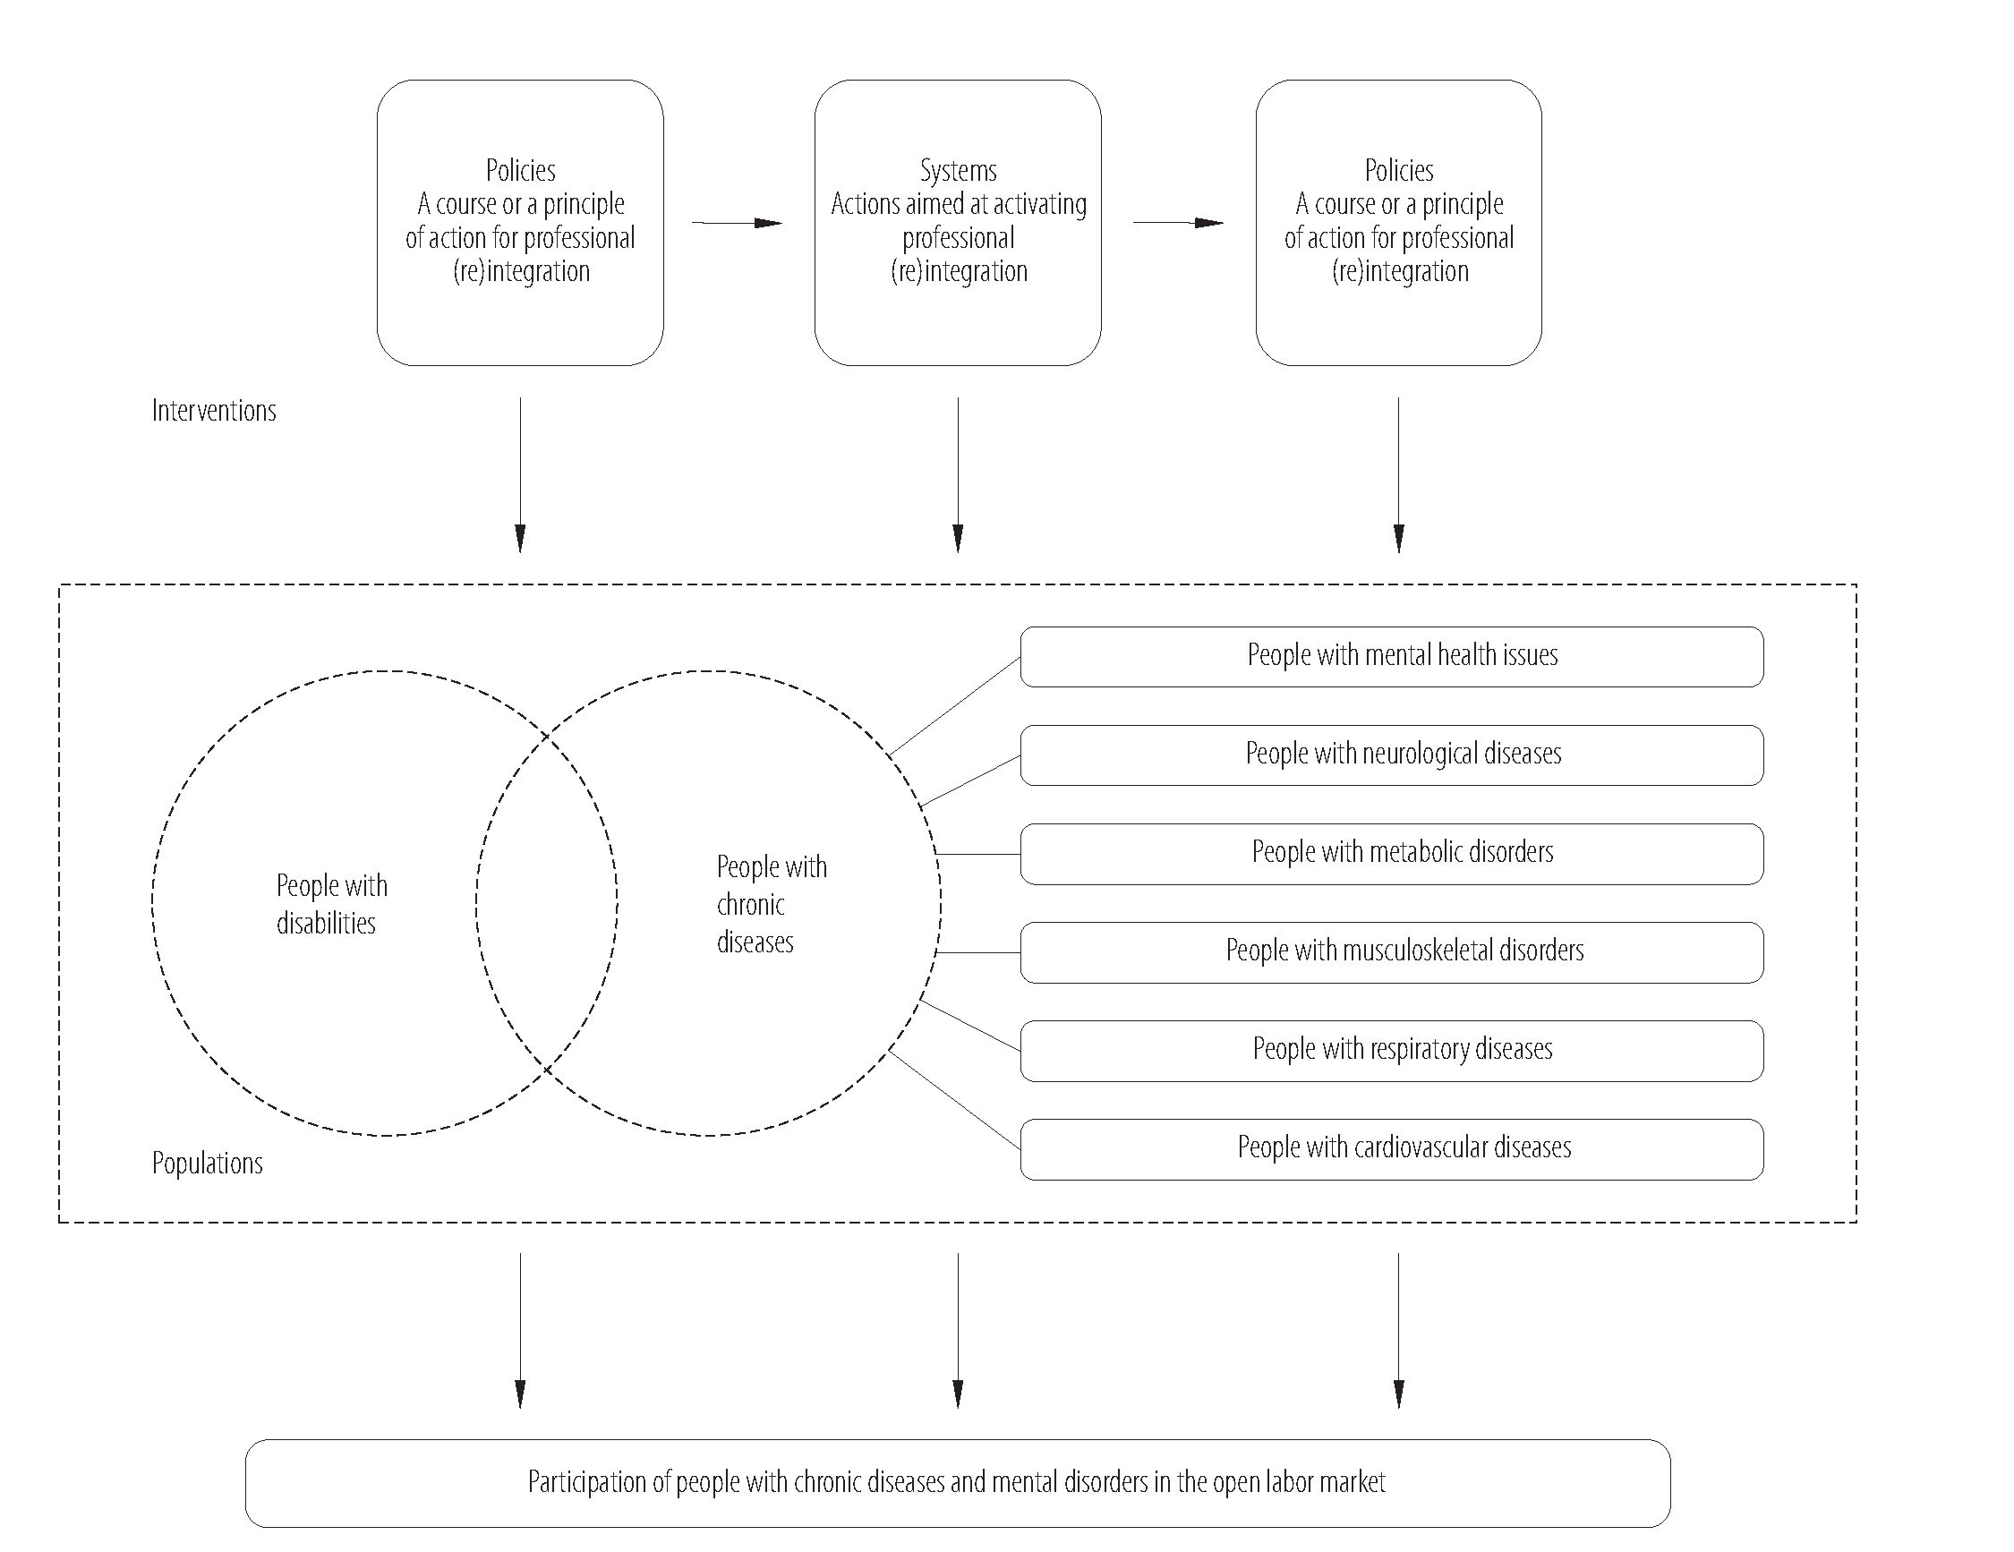
BARRIERS TO PROFESSIONAL (RE)INTEGRATION
ORIGINAL PAPER
Source: D4.1. A report on the comparison of the available strategies based on 5 categories of social welfare models in Europe, an internal report
in the PATHWAYS project developed by EASPD [17].
Figure 1. The analytical scheme followed in the first stage of the PATHWAYS research project
organizations working in the field of professional (reinte-
gration of people with the diseases under examination in
the PATHWAYS project (N = 10). The questionnaire was
divided into 3 parts:
- General information about the respondent (e.g., organ-
ization details, provided services in the field of employ-
ability of PwCDs),
- Information on national-level legislations regulating
the employment of PwCDs/PwDs (e.g., what kind of
support is provided in the country for both PwCDs/
PwDs and employers, legal solutions and provisions,
existing gaps in the legislation),
- Information on the disease/disability-specific legisla-
tion, schemes and services.
To eliminate all the possible gaps appearing in the ques-
tionnaire in the third step, expert interviews (semi-struc-
tured) (N = 3/country) were conducted among represen-
tatives of public, private and non-governmental organiza-
IJOMEH 2019;32(4 ) 479
ORIGINAL PAPER
A. PIŁAT ET AL.
tions (NGOs) providing professional (re)integration sup-
port to people with limited capability for work. There were
3 versions of the interview scenario: for the authorities,
service providers and self-advocates. The tool covered the
following sections:
- general information about the respondent,
- information about the existing strategies,
- opinions about them.
Information about the study participants is available in
Table 1.
Each of the research techniques employed in the project
was aimed at eliciting information about the policies, sys-
tems and services existing in each partner country. The
gathered information made it possible to create a model
of barriers identified in the Polish system of professional
(re)integration (Figure 2). Finally, the SWOT (strengths,
weaknesses, opportunities and threats) analysis (Figure 3)
was performed in order to summarize the results based
on reviews and expert opinions. The SWOT analysis
highlighted the most important results, presenting the
strengths and opportunities, as well as threats and weak-
nesses, of the solutions existing in Poland and regulating
the situation of people with disabilities and chronic condi-
tions on the labor market.
Table 1. Polish participants (N = 13) in the PATHWAYS research project conducted in 10 European countries (Austria, Belgium,
Czech Republic, Germany, Greece, Italy, Norway, Poland, Spain and Slovenia) in 2015-2018
Expert | Organization | Position | Study type
Expert 1 | NGOs “Defeat cancer” | representative,  chemist | e-mail survey
Expert 2 | university office for PwDs | leader | e-mail survey
Expert 3 | Association for Development  of Community Psychiatry and Care | psychiatrist | e-mail survey
Expert 4 | university hospital | physician | e-mail survey
Expert 5 | department of metabolic diseases,  university hospital | physician | e-mail survey
Expert 6 | chair of General Surgery and  Department of General Surgery,  Oncology and Gastroenterology | physician | e-mail survey
Expert 7 | National Union of the vocational  rehabilitation facilities and public  enterprise | manager | e-mail survey
Expert 8 | MATIO Foundation for Families  and Patients with Cystic Fibrosis | physiotherapist | e-mail survey
Expert 9 | Jagiellonian University  Medical College | physician | e-mail survey
Expert 10 | municipal labor office - department  of stimulation of disabled people | career advisor | e-mail survey
Expert 11 | Marshall office | policy maker | expert semi-structured interviews
Expert 12 | foundation | service provider | expert semi-structured interviews
Expert 13 | Polish Association of Disabled People | self-advocate | expert semi-structured interviews
NGOs - non-governmental organization(s); PwDs - people with disabilities.
480 IJOMEH 2019;32(4)
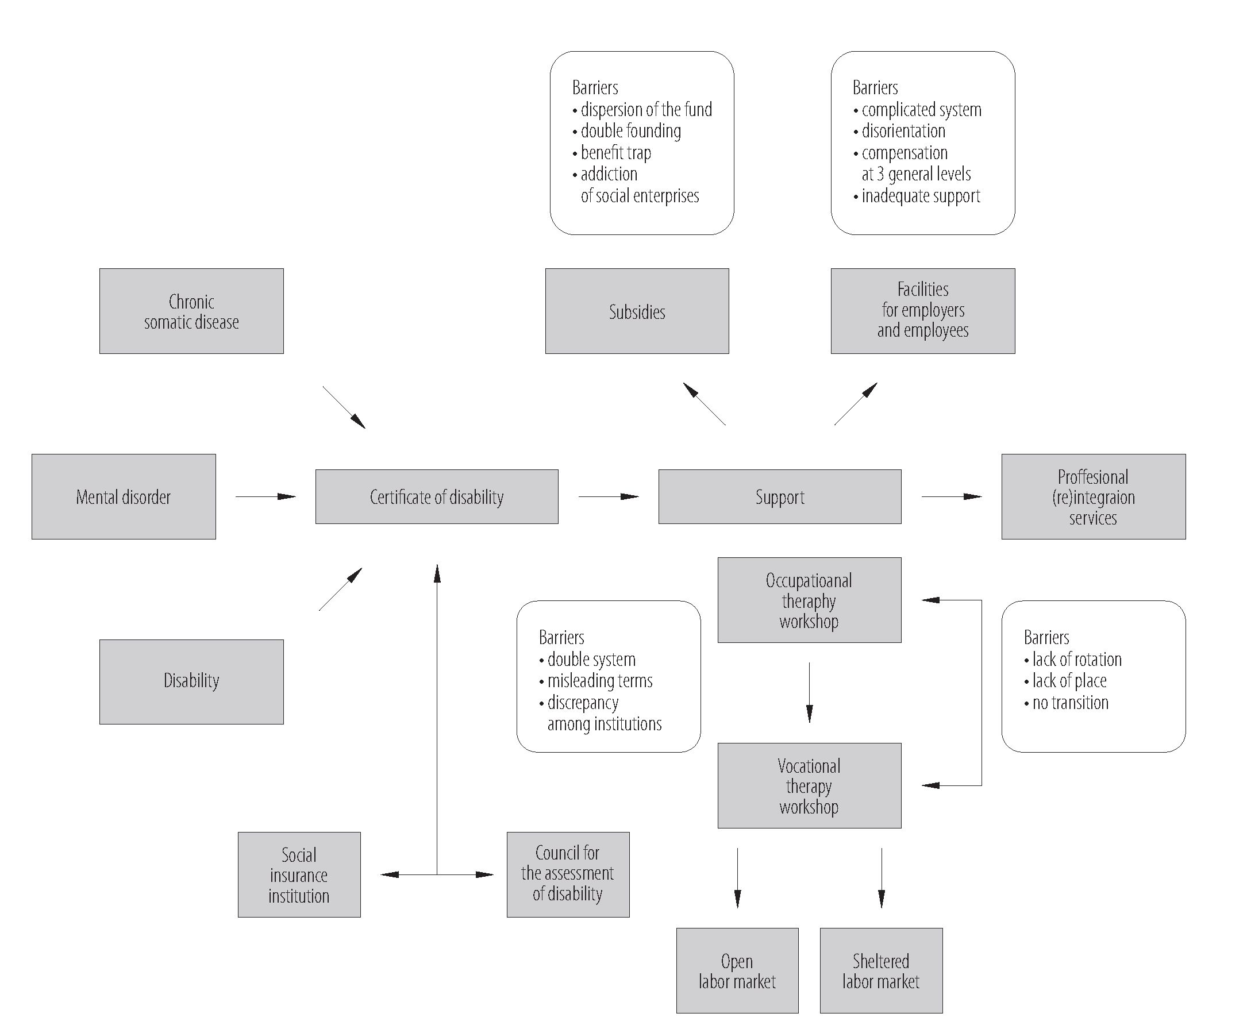

ORIGINAL PAPER
A model developed by the authors on the basis of the PATHWAYS research.
Figure 2. A system of professional (re)integration and barriers identified by experts
Ethical approval
All procedures performed in the studies involving human
subjects were in accordance with the ethical standards of
the institutional and/or national research committee, and
with the 1964 Helsinki Declaration and its subsequent
amendments, or comparable ethical standards.
The Bioethical Commission approval number is
122.6120.222.2016; the document was issued on June 27,
2016.
RESULTS
Barriers to professional (re)integration
identified in Poland
The analysis based on a mixed-methods approach made
it possible to develop a model (Figure 2) to visualize the
Polish system of support for PwCDs/PwDs, and the main
barriers existing within it, limiting access to this support,
such as an obligation to have a certificate of disability,
and a system of certification by 2 institutions. Obtaining
IJOMEH 2019;32(4) 481
ORIGINAL PAPER
A. PIŁAT ET AL.
Strengths | Weaknesses
- the existing variety of legal solutions focused on the (re)integration of people with certified  disabilities  - a growing number of occupational therapy workshops and vocational therapy workshops  - the existing systemic mechanism of financing the (re)integration of people with disabilities | - the lack of solutions targeted at people suffering from chronic conditions  but not having the certificate of disability  - the lack of specificity in terms of causes of disability  - solutions targeted at already active individuals  - the lack of an empowerment approach and a person-centered approach  - the inconsistency of existing solutions (e.g., the benefit trap)  - the lack of an integrated services approach  - the lack of an evidence-based approach (evaluation)
Opportunities | Threats
- increased financing through the EU and targeted projects aimed at (re)integration  (e.g., training programs targeted at the development of skills)  - the developing sector of NGOs in Poland  - the growing sector of patients advocacy groups focused on (re)integration  - the development of disability studies in Poland and scientific research in this field  - the rising awareness of work-related problems among people with disabilities  and chronic conditions and the "new identity of disabled people"  - the growing number of well-educated young people with disabilities | - the stigma surrounding work ability and productivity of people with disabilities  and chronic conditions  - the low level of education among disabled people  - the lack of motivation to work on the part of people with disabilities
Figure 3. A SWOT analysis of the solutions existing in Poland, identified in the paper
the certificate entitles one to receive support in the main
3 aspects:
- subsidies,
- facilities for both employers and employee,
- services for professional (re)integration, such as oc-
cupational therapy workshop (OTW) and vocational
therapy workshop (VTW).
The main barriers to this support, as identified by profes-
sionals, are briefly described below.
Policies
According to the experts, in Poland there are no legal
frameworks specifically addressing the needs of people
with chronic somatic diseases. People with non-commu-
nicable chronic diseases (NCDs) are considered a group
with special needs only if they have a disability certifi-
cate. The certificate also constitutes a prerequisite for
any supporting programs, “These must be people who
have a disability certificate. This is the basis. They must
have a certificate from the Social Insurance Institution
or the Council for the Assessment of People with Dis-
abilities. They must be legally recognized as disabled”
(Expert 12).
People with mental health conditions, whose situation has
been partially regulated by the National Mental Health
Protection Programme [18], but not in the context of em-
ployment, constitute no exception. According to a mental
health expert, all kinds of support on the labor market de-
pend on having a certificate of disability, “Persons from
the selected group [mental disorder] are not singled out,
but they are covered by a broader legislation applicable to
persons with disabilities” (Expert 3).
Other barriers identified during the review, as confirmed
by the experts, are problems with the double disability
certification system. In Poland, there are 2 systems with
different nomenclatures. In the Act on Old-Age and Dis-
ability Pensions from the Social Insurance Fund, and the
Act on the Social Insurance System [19], the following
terms appear: “inability to work” and “inability to live
independently/need for long-term care” [19]. Such terms
are misleading as “employers often think that people clas-
sified to these categories cannot work at all” (Expert 2).
A crucial issue is the difficulty with obtaining a certificate
of disability due to discrepancies among institutions or
even regions, “It should be emphasized that an expert
opinion is crucial and the same type of disability may be
482 IJOMEH 2019;32(4)
BARRIERS TO PROFESSIONAL (REINTEGRATION
ORIGINAL PAPER
qualified at different levels in different parts of the coun-
try” (Expert 1).
People who already have a certificate of disability can
get legal support. The legislative frameworks on disabil-
ity and employment are mainly described in the Act on
Vocational and Social Rehabilitation and Employment
of Persons with Disabilities (of 27 August 1997) [20]. The
Act governs the anti-discrimination policy and motivation
for employers to hire PwDs, as well as regulates the rights
and responsibilities of both employers and their employ-
ees (PwDs). One of the main incentives for employers who
hire persons with limited capability for work is receiving
compensation for the potential loss in productivity, “but it
is very problematic to receive a compensation. Many effec-
tive employers resign from the compensation” (Expert 3).
Another legal act which regulates the issues of disabil-
ity and employment is the Labor Code [21]. The Code is
mostly focused on anti-discrimination issues and equal
treatment of all employees (including PwDs), and the
solutions it envisages should also indirectly improve the
situation of PwDs. Nevertheless, the reference regulations
do not take into account the diversity of needs expressed
by people with different types of disabilities and diverse
chronic diseases, “No (legal) interpretation regarding the
possibility of professional integration of people with hypo-
glycemia” (Expert 5).
Systems
The crucial support for professional integration with re-
spect to subsidies is the State Fund for Rehabilitation of
Disabled Persons (PFRON). The Fund operates under
the Act on Vocational and Social Rehabilitation and Em-
ployment of Persons with Disabilities [20]. The aim of the
Fund is to support the vocational and social rehabilitation
and/or employment of disabled persons.
The PFRON funds are allocated, inter alia, to compen-
sations for employers (on both the sheltered and open
labor market), intended to cover the additional costs of
employing disabled people (subsidies for salaries); re-
imbursement of the costs of workplace adaptation and
equipment for employees with disabilities; financing of
the establishing and operation of occupational therapy
workshops and vocational rehabilitation facilities; out-
sourcing of non-governmental organizations and foun-
dations’ tasks in the field of professional and social re-
habilitation of persons with disabilities; co-financing of
system projects implemented from the EU funds; and
providing support for individuals with disabilities. These
tasks are usually divided between different institutions
and regions, which leads to dispersion and difficulties
with understanding who is responsible for what, “I know
that NGOs find it problematic to reach the most appro-
priate entity to find the funding source to solve a specific
problem” (Expert 11). The reimbursement of costs, both
of workplace adaptation and equipment, and salaries for
certified PwDs, takes into account the level of disabil-
ity (severe, moderate or mild). However, these 3 general
levels of disability cannot consider individual needs and
barriers in the workplace of people with non-communi-
cable diseases (NCDs) [22].
According to the experts, a disability or chronic disease is
not always a problem for the labor force, owing to modern
technologies, “Workplace adaptation and home offices
could constitute effective solutions for people with NCDs”
(Expert 13). In this case, the funds intended for salary re-
imbursement or regulations have not worked out. In the
experts’ opinion, this money should be better targeted and
spent, for example, on training and further education.
One of the experts also indicated the problem with double
funding, which constitutes a huge problem, inter alia, for
NGOs. For instance, the funds intended for the same pur-
pose, such as the adaptation of infrastructure to the needs
of the disabled, can be obtained from 2 different sources.
“Our statutory aim is to finance construction works, such
as building and adaptation of rehabilitation facilities, and
there is another institution (PFRON) that has a goal to
IJOMEH 2019;32(4) 483
ORIGINAL PAPER
A. PIŁAT ET AL.
reduce the architectural barriers and potential beneficia-
ries” (Expert 11).
In consequence, institutions do not actually know where
they should apply for money. The respondents also pointed
to the complexity of the funding system. The experts claimed
that employers sometimes resign from reimbursement or
workplace adaptation due to disorientation, “It happens
that employers even resign from this fund!” (Expert 13).
The analyzed documents, as well as expert opinions, show
that the financial support in Poland is concentrated around
government subsidies, rather than social investments [15].
According to one of the experts, social enterprises are
“addicted” to subsidies and benefits, “They (vocational
rehabilitation facilities) are less motivated than other
companies to sell the goods and services they produce at
favorable prices. In other words, they are not interested in
maximizing their profits” (Expert 11).
Their income could not be invested in the growth of the
company or used in any other way. The whole profit earned
from their work is intended for the Fund (PFRON). The
significance of subsidies as a barrier was articulated both
in the reviewed documents and during the interviews.
The interviewed experts referred to the “benefit trap” as
a barrier to professional (re)integration of PwDs. They
described it as a situation in which a person receiving ben-
efits does not undertake professional activity for fear of
losing these benefits.
Services
The most important support tools of the professional
(re)integration of people with limited capability for work
to the labor market include occupational therapy work-
shops, vocational rehabilitation facilities and sheltered
workshops. The purpose of rehabilitation carried out by
means of occupational therapy workshops is the overall
development and improvement of the efficiency of par-
ticipants, necessary to lead an active and independent life.
The purpose of the workshop is to gradually gain indepen-
dence - from learning independently, through performing
daily activities and social independence, to taking up em-
ployment. PwDs completing the workshop (and reaching
a good level of social rehabilitation) should be transferred
and employed in a vocational rehabilitation facility.
The assumption is that the OTWs are the first step in the
professional rehabilitation and integration process, where
social rehabilitation and self-efficacy building are combined
with activities aimed at professional activation. The subse-
quent stage involves activities at the vocational rehabilitation
facilities (VRFs), where social and professional rehabilita-
tion are still carried out together, but from that moment the
disabled person is professionally active and works for a given
enterprise. Vocational rehabilitation facilities offer individual
development and activation programs tailored to the needs
of the disabled, and there are special commissions evaluat-
ing their development. When a PwD reaches the next level
of professional development, he/she should be transferred
to the open labor market or - if unable to go there - start
working in a sheltered workshop. The reviewed documents
show that VRFs and OTWs do not constitute a coherent
system. One of the experts said, “It is still Utopian to think
that they would go further, beyond the VRFs” (Expert 11).
The reviews as well as expert opinions indicate the lack of
rotation between OTWs, VTWs and the labor market. In
consequence, those institutions are overfilled, and there are
no free places for new PwDs.
Sheltered workshops, in turn, are not focused on transi-
tion to the open labor market, as they are designed for
those people with disabilities who are unable to work be-
yond the sheltered work sector. The status of a sheltered
work unit is given by the province governor by way of an
administrative decision.
Based on the results of the documents analysis, as well
as the in-depth interviews and the survey performed with
experts, the authors were able to present the existing solu-
tions as the SWOT (strengths, weaknesses, opportunities
and threats) analysis.
484 IJOMEH 2019;32(4)
BARRIERS TO PROFESSIONAL (REINTEGRATION
ORIGINAL PAPER
DISCUSSION
The objective of this study was to identify the existing bar-
riers to professional (re)integration of PwCDs in Poland.
The mapping of policies, systems and services facilitating
the integration and reintegration of PwCDs in Poland has
revealed that Poland has a multi-level and multi-sector sys-
tem of public institutions, which should provide support for
people with disabilities. The institutions should guarantee
effective services adjusted to the needs of people with all
kinds of disabilities or chronic diseases, and ensure their
full functioning in the society. Nevertheless, the research
conducted in Poland indicates an insufficient implementa-
tion of the existing solutions. Moreover, there are persistent
symptoms sustained by institutional arrangements, which
have repeatedly confirmed that they are inefficient and loss-
making, as well as constitute a barrier rather than support.
The obligation to hold a certificate of disability is the first
barrier to professional (re)integration. The certificate
constitutes a prerequisite for systemic support. It means
that, in terms of any support, PwCDs are considered part
of a group of persons with disabilities. This barrier is es-
calated by terminological discrepancy, the 3 general levels
of disability, and the way disability is defined. This issue
has also been identified in other European countries [22].
Recent research has indicated that the occupational needs
of chronically-ill people differ from those of PwDs. This
diversity mainly concerns the presence of pain, fatigue,
problems with motor control or cognitive functioning [23].
To be more precise, the existing studies have proven that
depression has the largest impact on every work area, mi-
graine and diabetes impact on cognitive work demands,
and musculoskeletal pain mainly affects physical work
demands [24]. The results suggest that every chronic dis-
ease has some specific demands regarding the workplace,
which should be recognized in order to provide the most
effective environment for PwCDs.
Voojis et al. [25] point out the necessity to strike an in-
tervention balance between focusing on personal abilities
and job demands. This paper shows the ineffectiveness of
intervention due to a generalized approach and inappli-
cable regulations. The PFRON system, on the one hand,
adjusts the working environment to the needs of people
with disabilities but, on the other hand, these solutions are
generalized, as they are not focused on a specific disease,
but on the 3 general levels of disability. The same require-
ments and duties have to be fulfilled by employers who
hire people with various diseases, regardless of the reason
behind issuing a certificate of disability. Hence, the sys-
temic solution and services are aimed at adjusting people
with chronic diseases to the employers’ expectations, in-
stead of adapting the workplace, employment and em-
ployment practices to the needs of disabled or chronically-
ill staff. Due to the lack of solutions for specific somatic
and mental chronic diseases, the 3 general levels of dis-
ability fail to promote a holistic approach focusing on both
personal attitude and job demands. In consequence, the
Polish support system has been identified as deficient. The
adequacy of the solutions aimed also at individual needs
has been confirmed in the review, which shows that effec-
tive return-to-work and vocational rehabilitation interven-
tions depend, inter alia, on the support’s being tailored to
individual needs [26].
Two disturbing mechanisms with regard to subsidies sup-
port have been identified. Both of them make PwDs more
dependent on the financial support and discourage them
from entering the labor market [22]. First, people with
a certificate of disability are afraid of losing the status of
a person unable to work, as this would lead to falling into
the “benefit trap” [27]. Research conducted in Poland has
indicated that more than a half of the studied population
is more or less convinced that being employed results in
losing the disability pension [28]. The benefit trap as a bar-
rier in return to work has also been shown in randomized
research conducted on people with mental disorder [29].
Addiction to subsidies has also been noted as regards so-
cial enterprises. The research has suggested that the lack
IJOMEH 2019;32(4)
485
ORIGINAL PAPER
A. PIŁAT ET AL.
of motivation is a consequence of the need to transfer the
whole profit to the Fund (PFRON). Motivation-oriented
solutions exist, for example, in the Netherlands where the
policy focus is on the idea that labor participation contrib-
utes to the well-being of both individuals and the society.
It means that disability benefits have been tightened for
people as a stimulation for their return to work [30]. In an-
other study, also conducted in the Netherlands, research-
ers have explored solutions that facilitate participation in
the labor market. These solutions are focused either on
the people themselves, such as accepting and coping with
the disease, or gaining an insight into what they are cur-
rently capable of, or on their job and workplace, e.g., mak-
ing adaptations to the workplace [31].
Consequently, most of the people with chronic diseases
and/or disabilities are not employed at all. This is reflect-
ed by the low employment rate among PwDs. This may
lead to social exclusion and economic dependence. Policy
strategies, systemic solutions and services play the most
important role in supporting the employment of people
with chronic diseases. Protection against social risks, such
as unemployment, should be one of the priorities of so-
cial welfare. It is important both from the economic point
of view and for individuals, as continuing activities dur-
ing a chronic disease is more effective in reducing pain
than traditional medical treatment [27]. A good example
is set by people with low back pain, who are able to con-
tinue working or to return to work within a few days or
weeks, even with residual or recurrent symptoms [28]. All
the more, the need to implement strategies helping people
with specific chronic diseases to pursue their professional
reintegration is urgent in the whole European Union.
It was reflected in the Europe 2020 Strategy which high-
lights the necessity for the participation of all working-
age people in the labor market [32], given especially that
people with long-standing health problems experience
a higher economic unemployment rate and only 19.7% of
them are employed [33].
Limitations
The presented research tackles an important issue that is
rarely studied in the European context. This article will
contribute to the discussion on the situation of PwCDs/
PwDs on the labor market. However, there are some
limitations of this study that should be mentioned. First
of all, the survey sample is not representative. Moreover,
the study is focused exclusively on the experts’ perspective
(the PwCDs/PwDs’ perspective will be analyzed in a sepa-
rate paper). The issue under examination requires further
investigation on larger samples. It is also worth mention-
ing that although this paper presents only the situation in
Poland, the comparative data for Europe, based on the
PATHWAYS project results, are available [22].
CONCLUSIONS
The actual health condition is not the only reason why
PwCDs withdraw from the labor market and do not decide
to return after treatment and adaptation to their new sta-
tus. The most important factors are the lack of adequate
support, systemic barriers, and ineffective services not tai-
lored to individual needs.
The problems with the support for people with disabilities,
as identified in the PATHWAYS project and proven by the
results of other studies, have shown that policies, systems
and services should develop in the direction of an active
policy. They should be aimed at promoting the employ-
ment of people with chronic diseases, and at encouraging
both employers and potential employees to cooperate.
Overcomplicated systems do not encourage employers to
hire people with disabilities. The support system should,
therefore, be simplified and, at the same time, its promo-
tion is necessary. The most important thing is that the
employer should know that hiring a person with disability
is profitable. Another crucial recommendation concerns
more flexible subsidies and higher motivation for social
enterprises. If there is a real support on the labor mar-
ket for people with chronic diseases, people with mental
486
IJOMEH 2019;32(4)
BARRIERS TO PROFESSIONAL (RE)INTEGRATION
ORIGINAL PAPER
health problems and people with disabilities, employ-
ers will manage to respond to the need for employment
among these groups. According to the interviewed experts
and other research [30], those who should create solutions
are mainly people with chronic diseases, as they are ca-
pable of identifying their own needs.
REFERENCES
- Ilmarinen J. Work ability - a comprehensive concept for oc-
cupational health research and prevention. Scand J Work En-
viron Health. 2009;35(1):1-5, https://doi.org/10.5271/sjweh.
1304.
- Jin-Won N, Jinseok K, Jumin P, Hyun-Jung K, Young Dae K.
Gender Difference in Relationship between Health-Related
Quality of Life and Work Status. Ginsberg SD, editors. PLoS
One. 2015;10(12):e0143579, https://doi.org/10.1371/journal.
pone.0143579.
- Waddell G, Burton K. Is work good for your health and well-
being? London: The Stationery Office; 2006 [cited 2018 Jun 5].
Available from: https://www.gov.uk/government/uploads/sys
tem/uploads/attachment_data/file/214326/hwwb-is-work-
good-for-you.pdf.
- Schuring M, Mackenbach J, Voorham T, Burdorf A. The
effect of re-employment on perceived health. J Epidemiol
Community Heal. 2011;65(7):639-44, https://doi.org/10.1136/
jech.2009.103838.
- Schwartz CE, Andresen EM, Nosek MA, Krahn GL. Re-
sponse Shift Theory: Important Implications for Measur-
ing Quality of Life in People With Disability. Arch Phys
Med Rehabil. 2007;88(4):529-36, https://doi.org/10.1016/
j.apmr.2006.12.032.
- Altman B. Factors in Studying Employment for Persons with
Disability: How the picture can change. London: Emerald
Publishing; 2017. p. 7-14.
- World Health Organization [Internet]. Geneva: The Organi-
zation; 2001 [cited 2018 Jun 8]. International Classification
of Functioning, Disability and Health (ICF). Available from:
http://www.who.int/classifications/icf/en/.
- Oliver M, Sapey B. Social Work with Disabled People.
2nd ed. London: Macmillan; 1999.
- Priestley M. Disability Politics and Community Care. Lon-
don: Jessica Kingsley Publisher; 1999.
- French S. Disabled People and Employment, First. New
York: Ashgate Publishing; 2001.
- Shakespeare T, Watson N. Defending the Social Model Dis-
abil. Soc. 1997;12(2):293-300, https://doi.org/10.1080/096875
99727380.
- World Health Organization. Towards a Common Language
for Functioning, Disability and Health ICF Towards a Com-
mon Language for Functioning, Disability and Health: ICF
The International Classification of Functioning, Disabil-
ity and Health [Internet]. Geneva: The Organization; 2002
[cited 2018 Apr 20]. Available from: http://www.who.int/clas-
sifications/icf/icfbeginnersguide.pdf.
- Central Statistical Office. [Internet]. Warsaw: The Office;
2015 [cited 2018 Apr 4]. [Social Surveys and Living Condi-
tions Department. Health Status of Population in Poland
in 2014]. Available from: http://stat.gov.pl/obszary-tema-
tyczne/zdrowie/zdrowie/stan-zdrowia-ludnosci-polski-w-
2014-r-,6,6.html. Polish.
- Central Statistical Office [Internet]. Warsaw: The Office;
2018 [cited 2019 Mar 23]. [Labour force survey in Poland
in I quarter 2018]. Avaliable from: https://stat.gov.pl/obsza
ry-tematyczne/rynek-pracy/pracujacy-bezrobotni-bierni-za-
wodowo-wg-bael/aktywnosc-ekonomiczna-ludnosci-polski-i-
kwartal-2018-roku,4,29.html.Polish.
- Central Statistical Office [Internet]. Warsaw: The Office;
2017 [cited 2019 Mar 23]. [Health and Health Care]. Avali-
able from: https://stat.gov.pl/obszary-tematyczne/zdrowie/
zdrowie/zdrowie-i-ochrona-zdrowia-w-2017-r-,1,8.html.
Polish.
- Social Insurance Institution [Internet]. Warsaw: The In-
stitution; 2015 [cited 2018 Apr 4]. [Expenditures on So-
cial Security Benefits Related to Incapacity for Work].
Avaliable from: http://www.zus.pl/baza-wiedzy/statystyka/
opracowania-tematyczne/wydatki-na-swiadczenia-z-ubez
IJOMEH 2019;32(4) 487
ORIGINAL PAPER
A. PIŁAT ET AL.
pieczen-spolecznych-zwiazane-z-niezdolnoscia-do-pracy.
Polish.
- European Commission [Internet]. Brussels: The Commis-
sion; 2014 [cited 2018 Mar 28]. The European Semester.
Available from: http://ec.europa.eu/europe2020/europe-
2020-in-a-nutshell/priorities/inclusive-growth/index_en.htm.
- National Programme for Protection of the Mental Health
[Internet]. Warsaw: Ministry of Health; 2017 [cited 2019
Mar 24]. Available from: https://www.gov.pl/web/zdrowie/
narodowy-program-ochrony-zdrowia-psychicznego1.
- [Act No. 887 of 13 October 1998 on the Social Insurance
System. J Laws 1998-11-10, No. 137, pp.4850—80]. Polish.
- [Act of 27 August 1997 on Vocational and Social Rehabilita-
tion and Employment of Persons with Disabilities. J Laws
1997, item 123]. Polish.
- [Labour Code of 26 June 1974. J Laws 1974, No. 24, item
141). Polish.
- Scaratti C, Leonardi M, Silvaggi F, Avila C, Munoz-Muril-
lo A, Stavroussi P, et al. Mapping European Welfare Mod-
els: State of the Art of Strategies for Professional Integra-
tion and Reintegration of Persons with Chronic Diseases.
Int J Environ Res Public Health. 2018;15(4):781, https://doi.
org/10.3390/ijerph15040781.
- Baanders AN, Mieke Rijken P, Peters L. Labour partici-
pation of the chronically ill: a profile sketch. Eur J Public
Health. 2002;12(2):124—30, https://doi.org/10.1093/eurpub/
12.2.124.
- Munir F, Jones D, Leka S, Griffiths A. Work limitations
and employer adjustments for employees with chronic ill-
ness. Int J Rehabil Res. 2005;28(2):111-7, https://doi.
org/10.1097/00004356-200506000-00003.
- Vooijs M, Leensen MCJ, Hoving JL, Wind H, Frings-Dresen
MHW. Interventions to enhance work participation of work-
ers with a chronic disease: a systematic review of reviews.
Occup Environ Med. 2015;72(11):820-6, https://doi.org/
10.1136/oemed-2015-103062.
- Waddell G, Burton AK, Kendell N. Vocational Rehabilita-
tion. What Works for Whom? London: University of Hud-
dersfield Repository Waddell; 2005.
- Grover C, Piggott L. Disabled People, Work and Welfare: Is
Employment Really the Answer? Bristol: Policy Press; 2015.
- Fundacja Instytut Rozwoju Regionalnego. [Benefit trap and
work activity of people with disability] [Internet]. Kraków:
Fundacja; 2011 [cited 2018 Jun 5]. Avaliable from: http://
www.firr.org.pl/uploads/PUB/Pulapka_swiadczeniowa.pdf.
Polish.
- Burns T, Catty J, Becker T, Drake RE, Fiortti A, Knapp M,
et al. The effectiveness of supported employment for people
with severe mental illness: a randomised controlled trial. Lan-
cet. 2007;370(9593):1146—52, https://doi.org/10.1016/S0140-
6736(07)61516-5.
- Van Hal LBE, Meershoek A, de Rijk A, Nijhuis F. Going be-
yond vocational rehabilitation as a training of skills: return-
to-work as an identity issue. Disabil Soc. 2012;27(1):81-93,
https://doi.org/10.1080/09687599.2012.631799.
- Vooijs M, Leensen MCJ, Hoving JL, Wind H, Frings-Dre-
sen MHW. Perspectives of People with a Chronic Disease
on Participating in Work: A Focus Group Study. J Occup
Rehabil. 2017;27(4):593-600, https://doi.org/10.1007/s10926-
016-9694-6.
- Foreman P, Murphy G, Swerissen H. Facilitators and Bar-
riers to Return to Work: A Literature Review. Melbourne:
Australian Institute for Primary Care, La Trobe University;
2006.
- Hyde M. From Welfare to Work? Social Policy for Dis-
abled People of Working Age in the United Kingdom in the
1990s. Disabil Soc. 2000;15(2):327-41, https://doi.org/10.
1080/09687590025702.
- Sprangers MA., Schwartz CE. Integrating response shift into
health-related quality of life research: a theoretical model.
Soc Sci Med. 1999;48(11):1507-15, https://doi.org/10.1016/
S0277-9536(99)00045-3.
This work is available in Open Access model and licensed under a Creative Commons Attribution-NonCommercial 3.0 Poland License - http://creativecommons.org/
licenses/by-nc/3.0/pl/deed.en.
488 IJOMEH 2019;32(4)

