
Eur. J. Immunol. 2014. 44: 3403-3412
DOI: 10.1002/eji.201444869
Molecular immunology 3403
European Journal of
Immunology

Carbamylation of immunoglobulin abrogates activation
of the classical complement pathway
Catalin Koro1, Ewa Bielecka2, Anders Dahl-Knudsen3, Jan J. Enghild3,
Carsten Scavenius3, Johan G. Brun4, Veronika Binder1, Annelie Hellvard1,
Brith Bergum1, Roland Jonsson1, Jan Potempa2,5, Anna M. Blom6
and Piotr Mydel1
- Broegelmann Research Laboratory, Department of Clinical Science, University of Bergen,
Bergen, Norway
- Department of Microbiology, Faculty of Biochemistry, Biophysics and Biotechnology,
Jagiellonian University, Krakow, Poland
- Interdisciplinary Nanoscience Center at the Department of Molecular Biology and Genetics,
Aarhus University, Aarhus, Denmark
- Department of Rheumatology, Haukeland University Hospital and Department of Clinical
Science, University of Bergen, Bergen, Norway
- Centre for Oral Health and Systemic Diseases, University of Louisville School of Dentistry,
Louisville, KY, USA
- Department of Laboratory Medicine Malmo, Lund University, Malmo, Sweden
Post-translational modifications of proteins significantly affect their structure and
function. The carbamylation of positively charged lysine residues to form neutral
homoitrulline occurs primarily under inflammatory conditions through
myeloperoxidase-dependent cyanate (CNO-) formation. We analyzed the pattern of
human IgG1 carbamylation under inflammatory conditions and the effects that this
modification has on the ability of antibodies to trigger complement activation via the
classical pathway. We found that the lysine residues of IgG1 are rapidly modified after
brief exposure to CNO-. Interestingly, modifications were not random, but instead
limited to only few lysines within the hinge area and the N-terminal fragment of the CH2
domain. A complement activation assay combined with mass spectrometry analysis
revealed a highly significant inverse correlation between carbamylation of several key
lysine residues within the hinge region and N-terminus of the CH2 domain and the proper
binding of C1q to human IgG1 followed by subsequent complement activation. This
severely hindered complement-dependent cytotoxicity of therapeutic IgG1. The reaction
can apparently occur in vivo, as we found carbamylated antibodies in synovial fluid from
rheumatoid arthritis patients. Taken together, our data suggest that carbamylation has a
profound impact on the complement-activating ability of IgG1 and reveals a pivotal role
for previously uncharacterized lysine residues in this process.
Keywords: Carbamylation • IgG1 • Complement • Inflammation • Rheumatoid arthritis
I I Additional supporting information may be found in the online version of this article at the
publisher’s web-site

Introduction
Correspondence: Dr. Piotr Mydel Nearly all newly translated proteins undergo post-translational
e-mail: piotr.mydel@k2.uib.no modifications that affect a range of their functions [1, 2]. Recently,
© 2014 The Authors. European Journal of Immunology published by WILEY-VCH Verlag GmbH & Co. www.eji-journal.eu
KGaA, Weinheim
This is an open access article under the terms of the Creative Commons Attribution-NonCommercial-
NoDerivs License, which permits use and distribution in any medium, provided the original work is
properly cited, the use is non-commercial and no modifications or adaptations are made.
3404 Catalm Koro et al.
Eur. J. Immunol. 2014. 44: 3403-3412
the chemical conversion of lysine into uncharged homocitrulline
(i.e., carbamylation) within the polypeptide chain has raised con-
siderable interest in the context of inflammatory and autoimmune
diseases [3, 4]. In vivo carbamylation is mainly dependent on
the activity of myeloperoxidase (MPO), an enzyme located in the
azurophilic granules of neutrophils in the context of H2O2/SCN-
generated by activated neutrophils. Thus, the amount of carbamy-
lated residues is relatively high in the inflammatory milieu. Loss of
charge due to carbamylation may induce conformational changes
and subsequently result in the loss of protein function [5]. In
fact, carbamylation has been reported to abrogate the activity of
matrix metalloproteinase 2, tissue inhibitor of metalloproteinase
2, and insulin [6-8]. Moreover, homocitrulline residues may act as
neoepitopes leading to production of autoantibodies, which have
predictive value in the pathogenesis of rheumatoid arthritis (RA)
[9] and juvenile idiopathic arthritis [10].
Complement is a pivotal component of the innate immune
system and plays a key role in antibody-dependent and
-independent immunity [11]. In addition, activated complement
factors modulate function of adaptive immunity [12]. Over 30 sol-
uble proteins form the complement system and provide a defence
against bacteria, viruses, and tumor cells and are essential for the
clearance of antigens and immune complexes [13]. The biological
activity of complement factors is triggered via three independent
pathways: classical, alternative, and lectin, which converge at the
level of C3 cleavage. The classical pathway is initiated by the bind-
ing of C1q, the first component of the classical complement path-
way, to antigen-bound IgG (or IgM), which subsequently triggers
complement dependent cytotoxicity (CDC) [14]. Moreover, this
event induces recruitment of effector cells, which in turn mediates
antibody-dependent cellular cytotoxicity (ADCC) [15]. In addition
to IgG and IgM, C1q can also recognize a wide array of host and
pathogen proteins (e.g. LPS, bacterial porins, apoptotic cells, and
cartilage molecules) [14, 16, 17]. The binding of C1q to human
IgG1 is relatively well characterized, and most of the binding sites
have been mapped to the C-terminal portion of the constant heavy
chain (CH2) domains of the Fc fragment of the molecule. Although
the affinity of soluble IgG for C1q is very weak, upon immune
complex formation the strength of binging increases over
1 000-fold [18].
Molecular modeling studies based on the crystal structure of
a globular portion of C1q [16, 19] and mutationval analysis of
human IgGi [20] suggested that the Lys322, Pro329, and Pro331
residues in the hinge region of the Fc fragment are important
for interaction between IgG1 and C1q, which then results in
complement activation. Further studies revealed that Glu333 and
Lys326 also play pivotal roles in the activity of IgG1 molecules [21].
Nevertheless, there is no doubt that the main C1q binding site is
located in close proximity to Lys322, Pro329, and Pro331 [22] in
agreement with the results of crystal structure studies, suggesting
a critical role for the hinge region of human IgG1 in C1q binding
[16]. Interestingly, to date more than 25 therapeutic antibodies
available in the market belong to the IgG class and the clinical
efficacy of nearly all of them relies either on the complement-
dependent cytotoxicity (CDC) or Ab-dependent cellular
© 2014 The Authors. European Journal of Immunology published by
WILEY-VCH Verlag GmbH & Co. KGaA, Weinheim
cytotoxicity ADCC mechanism [23]. In addition to supress-
ing effector functions any carbamylation located on the effector
Fc portion of the therapeutic antibody might have profound
impact on pharmacokinetics and pharmacodynamics.
We report here the inhibitory effect of lysine carbamylation
of human IgGi on complement activation. Although the trans-
formation of lysine into homocitrulline is a chemical process,
these modifications occurred in a very specific pattern depen-
dent on the availability of the polar residues to cyanate ions;
only 5 of 26 lysine residues in the heavy chain of human IgG1
underwent substantial carbamylation. This modification hindered
the ability of IgG1 to bind Ciq and initiate complement acti-
vation, thus providing insight into the IgG1-C1q interaction.
Furthermore, we showed that carbamylation selectively inhibited
complement-dependent cytotoxicity in rituximab (RTX) without
affecting antibody-dependent cellular cytotoxicity of RTX. Finally,
we detected modified immunoglobulins in the synovial fluid of RA
patients, a finding that suggests that IgG carbamylation occurs in
vivo and may hinder complement activation.

Results

Lysine residues in human IgG1 heavy chain undergo
rapid carbamylation
The unique domain architecture at the hinge and within the
Fc fragment is crucial for activation of the classical comple-
ment pathway and interaction with the Fc receptor on immune
cells. Immunoglobulins present in the inflammatory environment
are exposed to thiocyanate and MPO released by activated neu-
trophils. Therefore, we evaluated the process of carbamylation of
human IgG1 and the potential downstream effects of this modifica-
tion on immunoglobulin function. To this end, IgG1 was incubated
with 0.1M potassium cyanate (KCNO) for up to 24 h at 37°C
and the carbamylation of Lys residues was assessed by western
blotting using antibodies designed to detect homocitrulline
residues. The amount of homocitrulline increased significantly
within the first 3 h. Prolonged incubation (6 and 12 h) resulted in
only a moderate increase in band density (Fig. 1A). Using a colori-
metric method we estimated the total amount of formed homoc-
itrulline residues on IgG1 treated with 0.1M KCNO. The number
of modifications increased rapidly within first 3 h of incubation
reaching 80 nmol/mg of protein. Further time points showed only
moderate increase of the amount of the homocitrulline within the
molecule reaching 95-130 nmol/mg after 24 h incubation. That
indicates that the majority of lysines susceptible to carbamylation
are modified very rapidly in presence of KCNO (Fig. 1B).
Gingipain K (Kgp) of Porphyromonas gingivalis, a Lys-Xaa pep-
tide bond-specific protease, specifically cleaves the Lys222 - Thr223
peptide bond in the IgG1 hinge region, generating Fc and Fab
fragments [24]. Since the conversion of lysine to homocitrulline
prevents this cleavage, we utilized Kgp to examine carbamylation
at K222 in IgG1. Significant cleavage of control IgG1 was observed
as early as 5 min after incubation with Kgp, whereas modified
www.eji-journal.eu

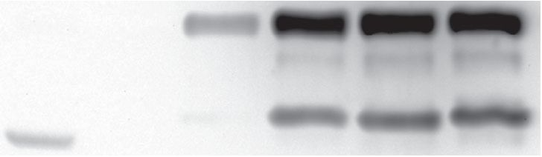
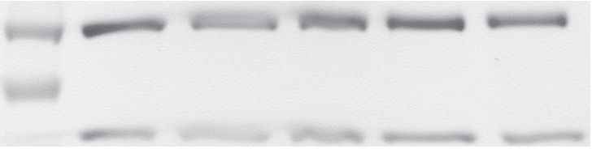
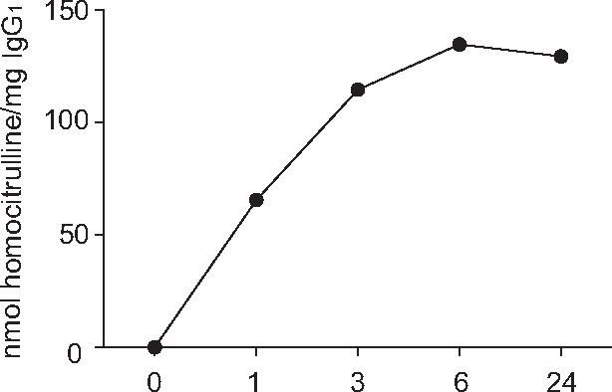
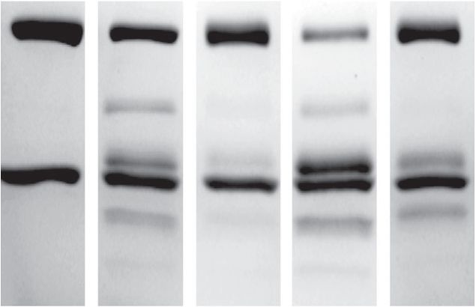
Eur. J. Immunol. 2014. 44: 3403-3412 Molecular immunology

A
50 kDa -
25 kDa -
carbamylation time (h)
Std
0 h 1 h
3 h
6 h
12 h
50 kDa
37 kDa -

B
carbamylation time (h)
carbamylation time (h)

C
50 kDa
igG.
0 h
12 h
0 h
12 h
25 kDa
5 min
20 min
Figure 1. Human IgG1 undergoes rapid carbamylation, which protects
it from Kgp cleavage. (A) Western blot analysis of 2 pg of IgG1 carbamy-
lated with KCNO in a time-dependent manner. The level of carbamyla-
tion was detected with homocitrulline-specific antibodies (upper panel)
together with loading controls (Coomassie staining; lower panel). Data
are representative of three independent experiments. (B) The time-
dependent effect of KCNO incubation on carbamylation of IgG1. Car-
bamylated IgG1 was degraded with proteinase K and samples were
incubated with urea nitrogen reagent and 3% w/v 2,3-butanedione
monoxime. The amount of homocitrulline/mg IgG1 was quantified by
measurement of the absorbance at 530 nm. Each point represents the
mean of duplicate samples and data are from a single experiment
representative of four independent experiments using IgG1 and RTX.
(C) 2.25 pg of carbamylated and control IgG1 were incubated for the
indicated times with 10 nM Kgp and SDS-PAGE was performed to assess
the cleavage of IgG. All samples were separated on 4-15% gradient
gels under reducing conditions. Data shown are representative of three
independent experiments.
forms of IgG1 were not susceptible to the cleavage. After 20 min
of incubation with 10 nM Kgp, the majority of the heavy chain
of control IgG1 was cleaved, in contrast to carbamylated IgG1,
which remained mostly intact (Fig. 1C). These findings indicate
that the heavy chain of human IgG1 is rapidly carbamylated in the
presence of cyanate and suggest that K222 in the hinge region is
an important target for modification.

Analysis of the in vitro and in vivo IgG1 carbamylation
by mass spectrometry
To determine the pattern and extent of IgG1 carbamylation,
we employed mass spectrometry. As expected, we detected a
time-dependent increase in the amount of carbamylation [25, 26].
Intriguingly, the modifications were not random and only a few
of the 26 available lysines within the IgG1 heavy chain underwent
modification (Fig. 2). After 1 h of incubation with KCNO, we
observed only two lysine residues that were efficiently modified
with spectral counts above 10 (Fig. 2B and C). These residues
were identified as K326 and K334, located at the N-terminus of
the polypeptide chain folding into the CH2 domain (Fig. 2B).
Consequently, the degree of modification of these two residues
increased with time of incubation, suggesting that they are
exposed and easily accessible for modification. After 6- and 12-h
incubations, in addition to increased modification of K326 and
K334 (Fig. 2A), our analysis revealed a significant amount of
carbamylation of K322 on the CH2 domain and K222 and K246
within the hinge region and in its proximity, respectively. This
fully corroborates our findings from the Kgp cleavage experiment.
Increasing the time of exposure of IgG1 to cyanate up to 24 h did
not change the overall pattern of modification. Carbamylation of
K322, K326, and K334 remained comparable to that observed at
the 6- and 12-h time points. By contrast, carbamylation of hinge
region lysine K222 and neighboring K246 progressed to very high
levels after 24 h.
Carbamylation is fuelled by inflammatory conditions that
engage excessive numbers of activated neutrophils, a condition,
which occurs in the synovial fluid of RA patients. Therefore, we
examined synovial fluid samples for the presence of modified
IgGs. Total IgG was purified from synovial fluid samples from two
patients and subjected to mass spectrometry. In both samples, car-
bamylation of K246 and K334 on IgG1 was detected (Supporting
Information Table 1). This is consistent with our in vitro findings,
which show that these lysines are susceptible to carbamylation.
Collectively, these results provide strong evidence that
although carbamylation is a nonenzymatic reaction, it has a sig-
nificant level of specificity and affects only a small number of
lysine residues within the IgG1 chain, regardless of exposure time.
Furthermore, the presence of carbamylated proteins in synovial
fluid confirms that this process occurs in vivo.

IgG1 carbamylation inhibits complement activation
Efficient binding of C1q to the Fc portion of IgG1 is a pivotal step
in complement activation. This prompted us to investigate the
3405
© 2014 The Authors. European Journal of Immunology published by
WILEY-VCH Verlag GmbH & Co. KGaA, Weinheim
www.eji-journal.eu
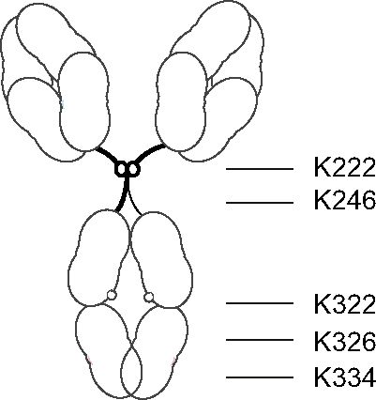
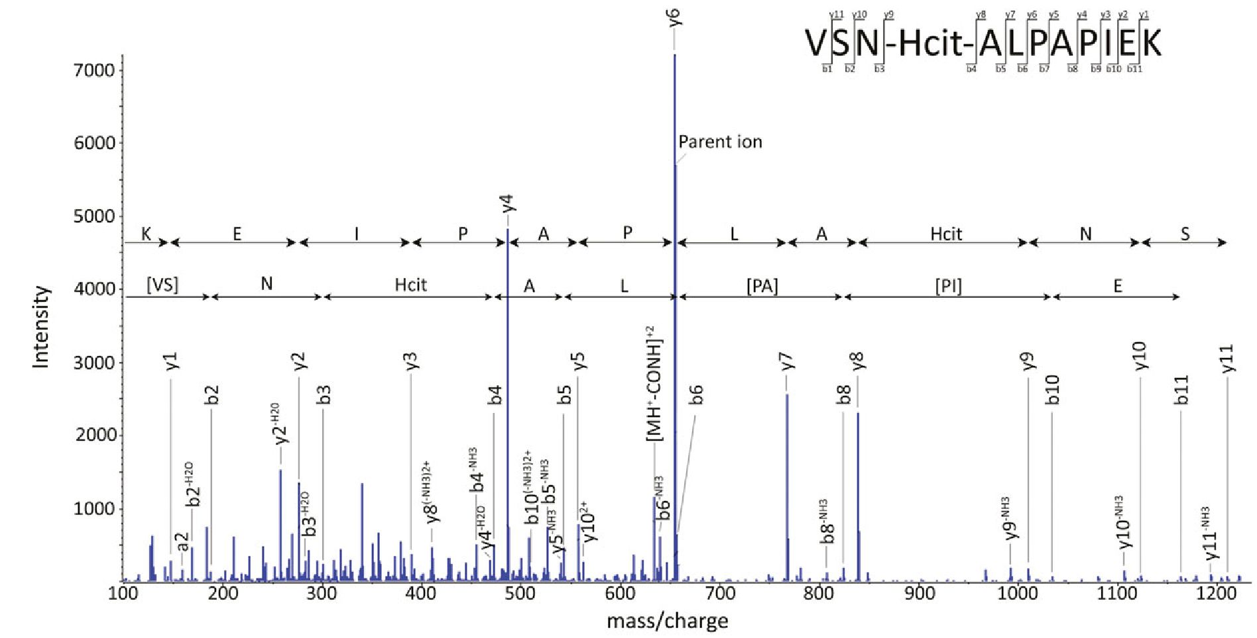
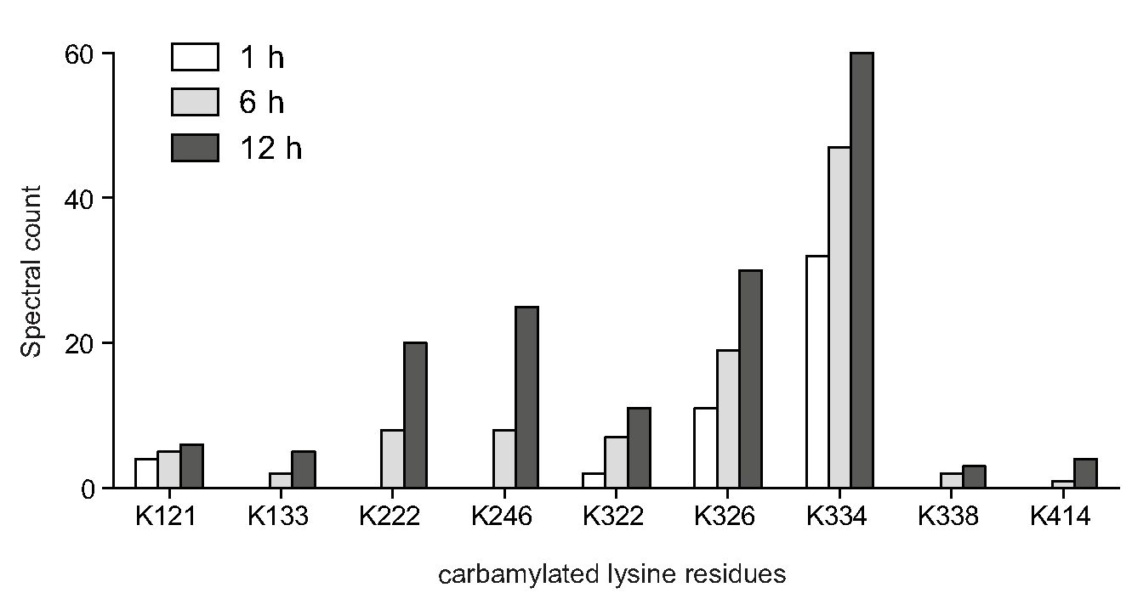
3406
Catalin Koro et al.
Eur. J. Immunol. 2014. 44: 3403-3412

A
C
Hinge PKSCDKTHTC
VFLFPPKPKD
C(H)2 VSNKALPAPIEKTI

B
Figure 2. Carbamylation of CH2 and the hinge region sites of IgG1. (A) Schematic representation of the IgGi sites observed to be preferentially
carbamylated in our experiments. The positions of the highly modified lysine residues are indicated in red. (B) An example of the tandem mass
spectrometry assignment of carbamylation of the CH2 site K326. The MS/MS spectrum displays the VSN-Hcit-ALPAPIEK peptide fully sequenced
from the C-terminus (y-ions) and nearly fully sequenced from the N-terminus (b-ions). In the spectrum, additional evidence of ions formed
by collision-induced neutral loss of water, ammonia, and isocyanic acid ([MH+-CONH]+2) are marked; the latter is a characteristic feature of
carbamylation. Results shown are representative of 50 MS/MS spectra assigned to the VSN-Hcit-ALPAPIEK modification. (C) Mass spectrometric
evaluation of the time-dependent carbamylation of detected putative carbamylation sites in IgGi performed using spectral counting at the
indicated time points. Each bar represents the spectral count of a single carbamylation experiment and is representative of two independent
experiments.
capacity of carbamylated IgG1 to trigger this event. Our results
revealed that carbamylation has a profound impact on the abil-
ity of C1q to bind IgGi (Fig. 3A-C). After 3 h incubation, we
detected a nearly 60% decrease in the deposition of Ciq on mod-
ified immunoglobulins (Fig. 3A, p < 0.05). Longer carbamylation
times (6, 9 or 12 h) resulted in complete abrogation of the abil-
ity of IgG1 to bind C1q. For these time points, C1q deposition
was approximately equal to that of the negative control (Fig. 3A).
In addition, we observed decreased deposition of the C4b frag-
ment, a component of C3 convertase in the classical pathway of
complement activation (Fig. 3B). Carbamylated IgG1 (6 h) trig-
gered significantly less formation of C4b in response to 1% normal
human serum (NHS) than intact IgG1. Subsequently, deposition
of opsonin C3b was also significantly abrogated (9 h and 12 h
© 2014 The Authors. European Journal of Immunology published by
WILEY-VCH Verlag GmbH & Co. KGaA, Weinheim
www.eji-journal.eu
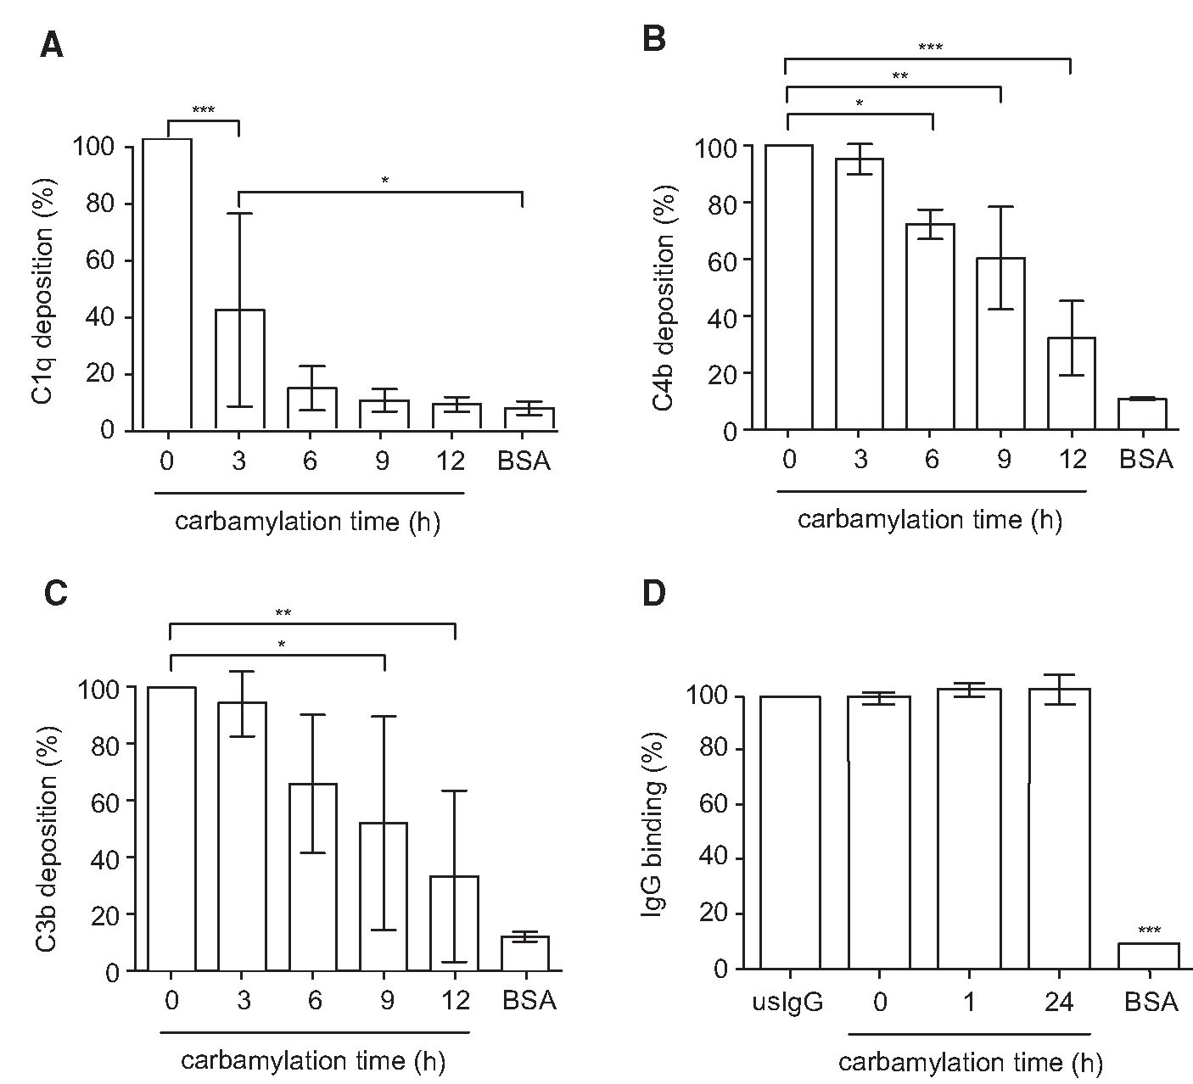
Eur. J. Immunol. 2014. 44: 3403-3412
Molecular immunology
Figure 3. Carbamylation of IgG1 inhibits
binding of C1q and subsequent deposition
of C4b and C3b. (A-C) The deposition of
(A) C1q, (B) C4b, and (C) C3b on carbamy-
lated IgG1. Plates were coated with native
and carbamylated heat-aggregated human
myeloma IgG1 and incubated with 1% NHS
in GVB++. Deposited complement proteins
were detected with specific antibodies by
using an ELISA-based method. The data are
shown as the means ± SD of duplicates
pooled from at least three independent exper-
iments, where deposition of complement
products induced by native IgG1 was con-
sidered to be 100%. (D) Detection of heat-
aggregated native and carbamylated human
myeloma IgG1. Plates were coated with the
immunoglobulins at a concentration of 10
pg/mL. The immunoglobulins were detected
by using rabbit anti-human IgGs in an ELISA-
based assay. Native IgG1 worked as a posi-
tive control to ensure proper binding to the
plate and was considered to show 100% bind-
ing. The data shown are derived from dupli-
cated samples pooled from four independent
experiments, where the plates were coated
with 1.25-20 pg/mL of each IgG. Data are
expressed as means ± SD. The statistical sig-
nificance was evaluated by one-way ANOVA
followed by Tukey's multiple comparisons
post-test: *p < 0.05; **p < 0.01; ***p < 0.001.
p < 0.05 and p < 0.01, respectively, Fig. 3C). This significant dif-
ference was clearly not a result of impaired plate-binding capacity
of IgG1 after carbamylation since there was no difference in coat-
ing with carbamylated IgG and control IgG (Fig. 3D).

IgG1 carbamylation abolishes CDC but does not affect
ADCC
To further confirm our findings we investigated the capacity of
carbamylated RTX, a CD20 specific chimeric mAb with a human
Fc fragment of the IgG1 subtype, to bind C1q and subsequently
exert CDC on Raji cells. The ability of carbamylated RTX to lyse
cells was decreased by 25% already after 30 min carbamylation
and completely abolished after 3 h incubation with 0.1M KCNO
(Fig. 4A).
In contrast to CDC, carbamylation did not affect the ability of
RTX to induce ADCC, which depends on an antigen binding by Fab
and interaction of Fc fragment of IgG with CD16a (FCyRIIIa) on
natural killer (NK) cells. Even after 3 h carbamylation, when nearly
all available lysines were carbamylated, there was no significant
difference in ADCC induced cell death caused by carbamylated
and control untreated antibodies (Fig. 4B). Taken together these
results confirm that carbamylation of IgG specifically targets the
region of Fc, which is responsible for C1q binding and complement
activation but has no impact on antibodies ability to recognize
antigens and interact with CD16a.

Discussion
IgG is the most abundant circulating immunoglobulin isotype
and represents close to 75% of the total serum immunoglobulin
content. It plays a key role in the inflammatory environment by
recognizing invading pathogens via its Fab fragment, and once
in complex with the antigen, it triggers complement activation
via its Fc domain. Downstream products of complement cascade
activation function as chemoattractants, opsonins, and proinflam-
matory mediators and cause direct cell lysis through formation of
the membrane attack complex [27]. Antigen-bound IgG does also
mediate cytotoxic effects through interaction with FcyR present on
effector cells, such as macrophages, neutrophils or NK cells [28].
Any modifications of the Fc fragment can have a profound effect
on the ability of immunoglobulin to execute its effector functions.
It was shown previously that some post-translational modifica-
tions of IgG, such as glycosylation [29, 30] and oxidation [31]
significantly influence the capacity of IgG to efficiently bind C1q.
Here, we analyzed the pattern of IgGj carbamylation occurring in
vitro and in vivo and studied the effect of this modification on the
ability of IgG1 to trigger the classical complement pathway and
induce CDC and ADCC.
Appreciation of the role of carbamylation in autoimmune and
inflammatory diseases was significantly increased by the discovery
of autoantibodies recognizing carbamylated peptides in patients
with both RA [9] and juvenile idiopathic arthritis [10]. Although
carbamylation has initially been studied in the context of uremia,
3407
© 2014 The Authors. European Journal of Immunology published by
WILEY-VCH Verlag GmbH & Co. KGaA, Weinheim
www.eji-journal.eu
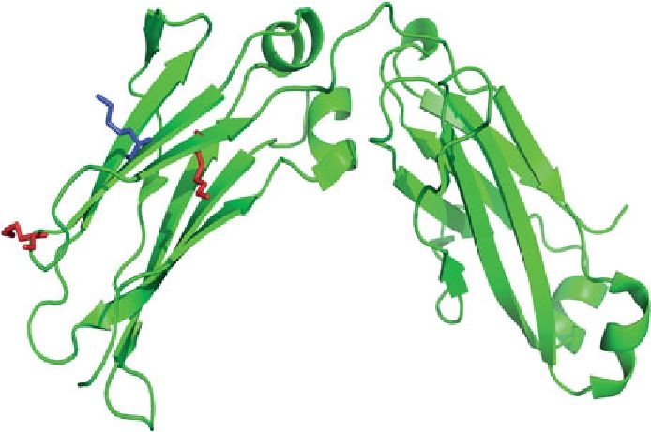
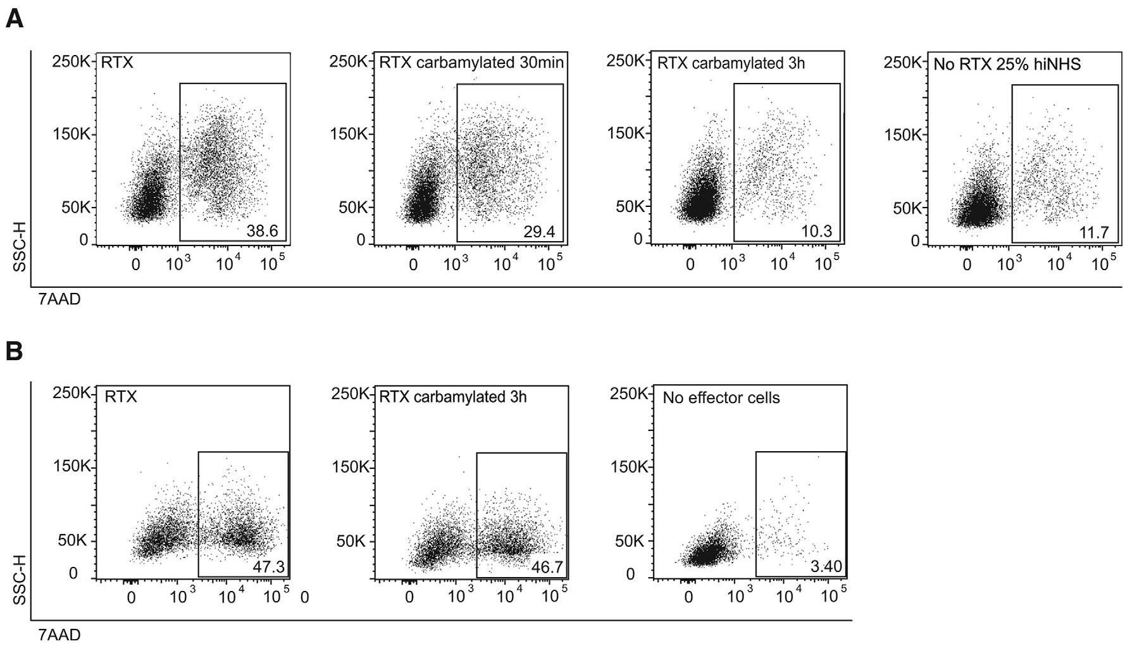
3408 Catalin Koro et al.
Eur. J. Immunol. 2014. 44: 3403-3412
Figure 4. Carbamylation of RTX affects CDC but not ADCC. (A) Flow cytometry was performed to assess 7AAD expression from two independent
CDC assays displaying Raji cells incubated with 25% NHS or hiNHS and 10 pg/mL native or modified RTX for the duration of 12 h. Plots are
representative of two independent assays. (B) Flow cytometry was used to assess 7AAD expression from ADCC assay with NK:Raji cell ratio of 11:1
and 10 pg/mL native or modified RTX following 15 h incubation. Results are representative of three separate assays with NK:Raji ratio ranging
from 6.5:1 to 11:1.
as urea exists in equilibrium with cyanate anions (OCN-) [6, 32],
it was recently shown to be effectively mediated by MPO produced
by activated neutrophils [3]. Therefore, protein carbamylation in
vivo may be mainly driven by inflammation. In chronic inflam-
matory diseases such as periodontitis, in which MPO levels are
significantly elevated, the amount of carbamylation might be sig-
nificantly higher, especially in smokers in whom high SCN- levels
are detected as well as in uremic patients with high level of urea
in the blood [33, 34].
In the current study, we found that selected lysine residues in
IgGi were rapidly modified after exposure to KCNO. Interestingly,
these modifications were specifically limited to Lys residues within
the hinge region and N-terminal fragment of the CH2 domain. For-
mation of neutral homocitrulline from positively charged lysine in
these two regions of the heavy chain had a profound impact on the
capacity of IgGi to bind Ciq [2i] thus demonstrating the impor-
tance of K322 (shown in blue in Fig. 5) in binding of Clq to IgG.
We observed a dramatic decrease in Clq binding and subsequently
CDC already after short time (30 min to 3 h) exposure to KCNO,
at which time only two Lys residues (K326 and K334; shown in
red in Fig. 5) other than the previously mentioned K322 were sig-
nificantly carbamylated. Therefore, we propose that in addition
to K322, K326 and K334 are crucial for effective binding of Clq,
and that modification of these residues abrogates the ability of
IgG1 to effectively activate the complement cascade effectively.
Previous crystallization studies also suggested the importance of
the hinge region in Clq binding [16] and antigen recognition, but
this was not verified by experimental data. In our study, however,
exposure to cyanate for more than 3 h rendered IgGl incapable
© 2014 The Authors. European Journal of Immunology published by
WILEY-VCH Verlag GmbH & Co. KGaA, Weinheim
Figure 5. Three-dimensional structural model of the Fc fragment of
IgG1. Lysine in position 322 is represented in blue. Carbamylated lysine
residues in position 326 and 334 are shown in red.
of complement activation, with the level of Clq deposition and
CDC activation equivalent or nearly equivalent, respectively, to
that of the negative control. These findings closely correlated with
the carbamylation of K222 and K246, emphasizing the impor-
tance of these hinge residues in Clq binding. Interestingly, a pre-
vious study showed a significant and unexplained decrease in Clq
binding to IgG after immunoglobulins were exposed to neu-
trophils, a finding that failed to be mimicked in vitro by oxida-
tive agents (HOCL and H2O2) [35]. We propose that this loss of
function by IgGl was due to carbamylation of immunoglobulin
molecules via the MPO/H2O2/SCN- system generated by acti-
vated neutrophils.
Downstream complement activation products such as C3b and
C4b play a major role in the clearance of immune complexes
from the circulation [36]. Binding of C3b and C4b to complement
www.eji-journal.eu

Eur. J. Immunol. 2014. 44: 3403-3412
Molecular immunology 3409
receptor 1 (CR1), which is present on multiple cell types (ery-
throcytes, phagocytes, neutrophils, mesangial cells, and lympho-
cytes) [37] facilitates the removal of the circulating immune
complexes [38]. Therefore, an increased level of immune com-
plexes may result from improper complement activation and
decreased C3b/C4b opsonisation. Decreased immune complex
clearance is implicated in the pathogenesis of various autoim-
mune diseases, such as systemic lupus erythematosus [39]. Impor-
tantly, using the synovial fluid of RA patients we found evi-
dence that carbamylation of IgG occurs in vivo that might affect
their ability to activate the complement pathway and remove
immune complexes from the synovial fluid. Interestingly, clear-
ance of immune complexes in dialyzed uremic patients is also
significantly decreased [40], which correlates closely with the
observation of increased levels of carbamylation in that patient
group. In keeping with this, we fully confirmed the presence
of carbamylated IgG in the sera of dialyzed patients (data not
shown) but did not analyze them for complement activation.
Nevertheless, there is a little doubt that impairment of antibac-
terial activity in people suffering from renal failure contributes
to increased susceptibility to infections. This contention is sup-
ported by multiple reports of high infection burden in patients
with end-stage renal disease, in which around 80% are unrelated
to the dialysis procedure (for review see [41]). The most frequent
bacterial isolates in these cases were S. aureus, P. aeruginosa,
E. coli, Klebsiella species, all sensitive to the bactericidal activity of
complement. Taking into consideration all the data, it is tempting
to speculate that carbamylation of IgG with the downstream inhi-
bition of complement could play a role in higher susceptibility to
infections in uremic patients.
Biologics are rapidly gaining the ground in the therapy of
cancers [42, 43] and autoimmune diseases [44-46]. Their thera-
peutic effect often relies on exerting CDC or ADCC [23]. NK cells
are primary mediators of ADCC activation by binding of the Fc part
of antigen-loaded antibodies to surface-expressed FCyRIIIa [15].
Previously, the binding site for FCyRIIIa was mapped to amino
acids present on the hinge proximal end of the CH2 domain and
the CH2-CH3 interface [47]. Site directed mutagenesis substitut-
ing K322 [48], K334 and K338 [47] to Ala was shown to affect
the FCyRIIIa binding and hindered ADCC activation. Neverthe-
less, our finding here using RTX clearly showed that carbamyla-
tion of K322 and K334 did not alter NK-cell mediated activation of
ADCC. In striking contrast, however, CDC of RTX was totally abol-
ished by carbamylation. This indicates that different regions of Fc
fragments of antibodies are involved in complement activation
and signalling via interaction with FCyRIIIa.
It is appreciated that the high level of cyanate in serum of ure-
mic patients can rapidly carbamylate therapeutic antibodies and
reduce their effectiveness. Here we showed the presence of car-
bamylated IgG1 in inflamed synovial fluid. This finding together
with susceptibility of RTX to carbamylation strongly argues that
inflammation-driven modification of antibodies may reduce effec-
tiveness of biologics used to treat inflammatory diseases.
Taken together, in this study we presented evidence that lysine
residues within the IgG1 chain undergo carbamylation at spe-
© 2014 The Authors. European Journal of Immunology published by
WILEY-VCH Verlag GmbH & Co. KGaA, Weinheim
cific positions in vitro and in vivo. We identified the involved
residues by mass spectrometry and demonstrated their essential
role in effective activation of the classical pathway of complement.
Since protein carbamylation is clearly associated with inflamma-
tory reactions it is important to understand the pathophysiological
effects of such a modification, not only relating to biological activ-
ities of IgG, but also to other proteins. Results of these studies may
shed a new light on the pathogenesis of chronic inflammatory and
autoimmune diseases and lead to novel diagnostic and therapeutic
approaches.

Materials and methods

Carbamylation of IgG1 and Rituximab
Human myeloma IgG1 (Calbiochem, Darmstadt, Germany) and
Rituximab (Mabthera, Roche) were carbamylated by incubation
with 0.1 M KCNO in 0.1 M Tris buffer (pH 7.4) at 37°C for 30 min-
24 h. KCNO was removed by ultrafiltration using Amicon Ultra-2
filters (50 k, Millipore, Darmstadt Germany).

Western blot
Carbamylated IgG1 samples were separated on 4-15% Tris-HCl
gels (Bio-Rad) and transferred to PVDF membranes (Bio-Rad).
Membranes were blocked with 5% w/v skim milk in TTBS (20 mM
Tris (pH 7.5), 150 mM NaCl, and 0.05% v/v Tween-20). Rabbit
anti-carbamyl-lysine polyclonal antibody (1/1 000, Cell Biolabs)
was used as the primary antibody with a HRP-conjugated goat
anti-rabbit HRP conjugated antibody (1/20 000, Jackson Labora-
tories) as the secondary.

Quantifications of homocitrulline on IgG1
Carbamylated and native IgG1 (0.45 mg/mL) were digested
for 2 h at 37°C with 4 ^g Proteinase K (Sigma-Aldrich, Oslo,
Norway) in a final volume of 30 ^L PBS containing 1% w/v SDS.
Thereafter, 105 ^L nitrogen reagent (0.83 M sulfuric acid, 1.13 M
orthophosphoric acid, 0.55 mM thiosemicarbazide, and 2.6 mM
cadmium sulfate) and 21 ^L 3% 2,3-butanedione monoxime
(Sigma-Aldrich) were added to the reaction mixture. The
samples were incubated at 97°C for 30 min on a dry heater block,
cooled for 5 min and centrifuged 10 000 x g for 10 min at room
temperature. The absorbance of the supernatant was measured at
530 nm. A standard curve ranging from 0 to 800 ^M was created
using homocitrulline (N6-carbamoyl-dl-lysine, Sigma-Aldrich).
www.eji-journal.eu
3410 Catalin Koro et al.
Eur. J. Immunol. 2014. 44: 3403-3412

Complement activation C1q, C4b, and C3b
Carbamylated and native IgGi were diluted with PBS and aggre-
gated by incubation at 65°C for 20 min. Duplicate wells of
MaxiSorp microtitre plates (Fisher Scientific) were coated
overnight at 4°C with aggregated human myeloma IgGs1 diluted
in 75 mM sodium carbonate (pH 9.6) to a final concentration
of 10 ^g/mL. Additional wells were coated with BSA as a nega-
tive control. After washing with 50 mM Tris (pH 8.0), 150 mM
NaCl, and 0.1% v/v Tween-20, wells were blocked with 1% v/v
BSA diluted in PBS and incubated for 2 h at room tempera-
ture. Complement activation was achieved by incubation with 50
^L NHS, pooled from healthy volunteers and diluted in GVB++
(5 mM veronal buffer (pH 7.3), 140 mM NaCl, 0.1% v/v gelatin,
1 mM MgCl2 and 0.15 mM CaCl2) to a final concentration of 0.5,
1, 2, 4, 6, 8 or 10%. After 45 min (C1q) or 20 min (C3b and
C4b), the wells were washed, and bound complement proteins
were detected after 1 h incubation with anti-C1q, anti-C4c (diluted
1/4 000), and anti-C3b (diluted 1/2 000) antibodies (Dako) fol-
lowed by a secondary horseradish peroxidase-conjugated swine
anti-rabbit antibody (Dako). After washing, the plates were devel-
oped with OPD tablets (Dako) and the absorbance was measured
at 490 nm using a plate reader (Varian). To ensure proper binding
of the immunoglobulins to the plate, Maxisorp plates were coated
overnight with serial dilution (1.25-20 ^g/mL) of each aggregated
IgG1 as above. Duplicate wells were coated with aggregated native
IgG1 as a positive control and BSA was used as a negative con-
trol. Bound IgG was detected with rabbit anti-human IgG (diluted
1/2 000) (Dako). After 1 h incubation at room temperature, the
plate was washed and incubated for another hour with swine
anti-rabbit IgGs conjugated to horseradish peroxidase (diluted
1/2 000) (Dako). The plate was developed with OPD tablets and
the absorbance was measured at 490 nm.

Cell cytotoxicity by CDC
Raji cells were cultured in complete RPMI medium containing
UltraGlutamine (Life technologies), 10%v/vFCS (PAA, Pasching,
Austria), 100 units/mL penicillin, and 100 ^g/mL streptomycin
(Sigma-Aldrich). For CDC assay 4 x 105 cells/mL were incubated
in complete RPMI, without FCS, containing 10 ^g/mL native or
modified RTX and 25% pooled NHS or Heat inactivated normal
human serum (hiNHS) at 37°C for 12 h. Following incubation
cells were stained with 7-amino-actinomycin D (7AAD) for dis-
crimination between live and dead cells. Cells were collected on a
BD LSRFortessa and analyzed using FlowJo ver. X.0.7 (Tree Star
Inc.).

Cell cytotoxicity by ADCC
NK cells were purified using the EasySep human NK cell enrich-
ment kit (Stemcell) according to the manufacturer’s instructions.
Isolated cells were analyzed for purity through staining with PE
© 2014 The Authors. European Journal of Immunology published by
WILEY-VCH Verlag GmbH & Co. KGaA, Weinheim
conjugated anti-CD56 (N901, Beckman Coulter) and flow cyto-
metric analysis displayed a purity of 89% (data not shown).
NK cells were cryopreserved in RPMI containing 25% v/v FCS
and 10% v/v DMSO and stored short for term in — 70°C until use.
Following defrosting cells were allowed to rest in complete RPMI
media for 24 h. ADCC assay was performed as follows: 2 x 105
Raji cells/mL were cultured in complete RPMI media together
with NK in ratios up to 11:1 (NK cells:Raji cells). Cultures were
incubated for 5, 12 or 15 h in 37°C and stained with 7AAD to
discriminate between viable and dead cells. Raji cells were dis-
criminated from NK cells by gating of FSC and SSC (Supporting
Information Fig. 1), which was confirmed through staining of Raji
cells with CFSE prior to coculture.

Preparation of IgG from synovial fluid
Immunoglobulins from synovial fluid were purified using HiTrap
Protein A HP columns (GE Healthcare). Briefly, samples of syn-
ovial fluid from two patients with rheumatic inflammatory joint
disease diluted 1:4 in PBS were loaded onto 1 mL columns.
Bound immunoglobulins were thereafter eluted with 0.1 M sodium
citrate (pH 3.0). The study was approved by the Committee of
Ethics at the University of Bergen (nr. 242.06). All patients gave
their informed consent.

Mass spectrometry
Immunoglobulin samples were brought to a final concentration of
- 1 M NH4HCO4 and disulfide bridges were reduced with 10 mM
DTT for 45 min at 56°C followed by cysteine alkylation with
55 mM iodoacetamide at room temperature for 30 min. Residual
iodoacetamide was quenched with 20 mM DTT before trypsin
digestion using 0.02 mass equivalents of Sequencing Grade Mod-
ified Trypsin (Promega) overnight at 37°C in 50 mM NH4HCO3.
The digested samples were acidified by the addition of formic acid
to 5% v/v and peptides were purified using Porous R2 (C8-C18)
50 ^m beads (PerSeptive Biosystems) packed as microcolumns in
20 ^L GELoader tips (Eppendorf). Eluted peptides were dried to a
volume of a few microliters using a vacuum evaporator and then
diluted in 5% formic acid prior to performing mass spectrome-
try. Tandem mass spectra were recorded with a TripleTOF 5600
(AB Sciex) quadrupole time-of-flight mass spectrometer equipped
with a Nanospray© III ion source (AB Sciex) and interfaced with
an Easy-nLC II HPLC system (Thermo Scientific). Up to 0.7 ^g
peptide sample per analysis was loaded onto a 13 cm in-house
packed fritted emitter fused silica column packed with 3 ^m
Reprosil-Pur C18-AQ (Dr. Maisch GmbH) reverse phase material
in a PicoFrit™ (New Objective) fritted fused silica emitter (75 ^m
- d., 10 ^m tip). Peptides were eluted using a 30 or 60 min gra-
dient from 5 to 35% organic phase (90% acetonitrile in 0.1%
formic acid in water) at a constant flow rate of 250 nL/min. MS
was performed using unattended data-dependent acquisition with
50 scans per 2.8 s duty cycle, a survey scan accumulation time of
www.eji-journal.eu
Eur. J. Immunol. 2014. 44: 3403-3412
Molecular immunology 3411
250 ms, MS/MS accumulation times of 100 ms and a peptide frag-
mentation threshold set to 150 arbitrary intensity units. Calibra-
tion was performed every fifth sample, ensuring mass accuracies
below 10 ppm. The generated raw data were converted into Mas-
cot generic format (mgf) peaklists and searched using the Mascot
search engine (v. 2.3.02, Matrix Science) against the Swiss-Prot
database (human, 20,248 sequences, downloaded February 2013)
with the following restrictions: peptide mass tolerance 30 ppm,
fragment mass tolerance 0.1 Da, two allowed missed cleavages
(semispecific trypsin) and a minimum MudPIT peptide score of
20. In addition, carbamidomethylation of cysteines, carbamyla-
tion of lysines, and oxidation of methionines were allowed as
variable modifications. Assigned immunoglobulin lysine carbamy-
lations were manually reviewed to rule out false assignments.

Limited proteolysis of IgG1 by Gingipain K
Carbamylated and native IgG1 at a final concentration of 15 pM
was incubated with 10 nM Gingipain K (Kgp) in 0.1 M Tris (pH 8),
1 mM EDTA and 2 mM L-cysteine. The samples were incubated
for 1 h at 37°C and cleavage of IgGi was analyzed by SDS-PAGE
using 4-15% gradient SDS-PAGE gels (Bio-Rad). Protein bands
were visualized by Coomassie bio-safe staining (Bio-Rad) staining.

Statistical analysis
Statistical differences were determined using one-way ANOVA
with Tukey’s post-test for multiple comparisons. All statistical anal-
yses were performed using GraphPad Prism, version 6.0b for Mac
(GraphPad), and a p value of <0.05 was considered statistically
significant.
Acknowledgments: This work was funded by grants
from the European Commission (FP7-HEALTH-2010-261460
“Gums&Joints,” FP1717-HEALTH-306029 “TRIGGER”) and Marie
Curie ITN (RAPID No. 290246). JP is supported by grants from
the National Institutes of Health (Grant DE 09761 and DE 022597
USA), National Science Center (2011/01/B/NZ6/00268, Krakow,
Poland) and Polish Ministry of Science and Higher Education:
projects 137/7.PR-EU/2011/2 and K/PMW/000095. AB is sup-
ported by Swedish Research Council (K2012-66X-14928-09-5),
foundations of Osterlund, Kock, King Gustav V s 80th Anniversary,
Swedish Rheumatism Association and grant for clinical research
(ALF). The Faculty of Biochemistry, Biophysics and Biotechnology
of the Jagiellonian University is a beneficiary of structural funds
from the European Union (P0IG.02.01.00-12-064/08).
Conflict of Interest: The authors declare no financial or commer-
cial conflict of interest
i© 2014 The Authors. European Journal of Immunology published by
WILEY-VCH Verlag GmbH & Co. KGaA, Weinheim

References
- Anderton, S. M., Post-translational modifications of self antigens: impli-
cations for autoimmunity. Curr. Opin. Immunol. 2004.16: 753-758.
- Mann, E., McDermott, M.J., Goldman,J., Chiesa, R. and Spector, A., Phos-
phorylation of alpha-crystallin B in Alexander's disease brain. FEBS Lett.
1991. 294: 133-136.
- Wang, Z., Nicholls, S.J., Rodriguez, E. R., Kummu, O., Horkko, S., Barnard,
J., Reynolds, W. F. et al., Protein carbamylation links inflammation,
smoking, uremia and atherogenesis. Nat. Med. 2007.13:1176-1184.
- Mydel, P., Wang, Z., Brisslert, M., Hellvard, A., Dahlberg, L. E., Hazen,
S. L. and Bokarewa, M., Carbamylation-dependent activation of T
cells: a novel mechanism in the pathogenesis of autoimmune arthritis.
J. Immunol. 2010. 184: 6882-6890.
- Kraus, L. M. and Kraus, A. P., Jr., The search for the uremic toxin: the case
for carbamoylation of amino acids and proteins. Wien Klin Wochenschr
1998. 110: 521-530.
- Kraus, L. M. and Kraus, A. P., Jr., Carbamoylation of amino acids and
proteins in uremia. Kidney Int. Suppl. 2001. 78: S102-S107.
- Higashi, S. and Miyazaki, K., Reactive site-modified tissue inhibitor of
metalloproteinases-2 inhibits the cell-mediated activation of progelati-
nase A. J. Biol. Chem. 1999. 274: 10497-10504.
- Oimomi, M., Hatanaka, H., Yoshimura, Y., Yokono, K., Baba, S. and Take-
tomi, Y., Carbamylation of insulin and its biological activity. Nephron
1987. 46: 63-66.
- Shi, J., Knevel, R., Suwannalai, P., van der Linden, M. P., Janssen, G.
M., van Veelen, P. A., Levarht, N. E. et al., Autoantibodies recognizing
carbamylated proteins are present in sera of patients with rheumatoid
arthritis and predict joint damage. Proc. Natl. Acad. Sci. USA 2011. 108:
17372-17377.
- Hissink Muller, P. C., Anink, J., Shi, J., Levarht, E. W., Reinards, T.
H., Otten, M. H., van Tol, M. J. et al., Anticarbamylated protein (anti-
CarP) antibodies are present in sera of juvenile idiopathic arthritis (JIA)
patients. Ann. Rheum. Dis. 2013. 72: 2053-2055.
- Daha, M. R., Role of complement in innate immunity and infections. Crit.
Reu. Immunol. 2010. 30: 47-52.
- Carroll, M. C. and Isenman, D. E., Regulation of humoral immunity by
complement. Immunity 2012. 37: 199-207.
- Ricklin, D., Hajishengallis, G., Yang, K. and Lambris, J. D., Complement:
a key system for immune surveillance and homeostasis. Nat. Immunol.
2010. 11: 785-797.
- Dumestre-Perard, C., Doerr, E., Colomb, M. G. and Loos, M., Involve-
ment of complement pathways in patients with bacterial septicemia.
Mol. Immunol. 2007. 44: 1631-1638.
- Seidel, U. J., Schlegel, P. and Lang, P., Natural killer cell mediated
antibody-dependent cellular cytotoxicity in tumor immunotherapy with
therapeutic antibodies. Front. Immunol. 2013. 4:1-8.
- Gaboriaud, C., Juanhuix,J., Gruez, A., Lacroix, M., Darnault, C., Pignol, D.,
Verger, D. et al., The crystal structure of the globular head of complement
protein C1q provides abasis forits versatilerecognition properties. J. Biol.
Chem. 2003. 278: 46974-46982.
- Sjoberg, A., Onnerfjord, P., Morgelin, M., Heinegard, D. and Blom, A. M.,
The extracellular matrix and inflammation: fibromodulin activates the
classical pathway of complement by directly binding C1q. J. Biol. Chem.
2005. 280: 32301-32308.
- Kishore, U., Kojouharova, M. S. and Reid, K. B., Recent progress in the
understanding of the structure-function relationships of the globular
head regions of C1q. Immunobiology 2002. 205: 355-364.
www.eji-journal.eu
■

3412
Catalin Koro et al.
Eur. J. Immunol. 2014. 44: 3403-3412
- Bally, I., Rossi, V., Lunardi, T., Thielens, N. M., Gaboriaud, C. and Arlaud,
G. J., Identification of the C1q-binding Sites of Human C1r and C1s: a
refined three-dimensional model of the C1 complex of complement. J.
Biol. Chem. 2009. 284: 19340-19348.
- McCall, M. N. and Easterbrook-Smith, S. B., Comparison of the role of
tyrosine residues in human IgG and rabbit IgG in binding of complement
subcomponent C1q. Biochem.J. 1989. 257: 845-851.
- Idusogie, E. E., Wong, P. Y., Presta, L. G., Gazzano-Santoro, H., Totpal, K.,
Ultsch, M. and Mulkerrin, M. G., Engineered antibodies with increased
activity to recruit complement. J Immunol 2001.166: 2571-2575.
- Idusogie, E. E., Presta, L. G., Gazzano-Santoro, H., Totpal, K., Wong, P.
Y., Ultsch, M., Meng, Y. G. et al., Mapping of the C1q binding site on
rituxan, a chimeric antibody with a human IgG1 Fc. J. Immunol. 2000.164:
4178-4184.
- Lee, J. I., Zhang, L., Men, A. Y., Kenna, L. A. and Huang, S. M., CYP-
mediated therapeutic protein-drug interactions: clinical findings, pro-
posed mechanisms and regulatory implications. Clin. Pharmacokinet. 2010.
49: 295-310.
- Vincents, B., Guentsch, A., Kostolowska, D., von Pawel-Rammingen, U.,
Eick, S., Potempa, J. and Abrahamson, M., Cleavage of IgG1 and IgG3
by gingipain K from Porphyromonas gingivalis may compromise host
defense in progressive periodontitis. FASEB J 2011. 25: 3741-3750.
- Jaisson, S., Lorimier, S., Ricard-Blum, S., Sockalingum, G. D., Delevallee-
Forte, C., Kegelaer, G., Manfait, M. et al., Impact of carbamylation on
type I collagen conformational structure and its ability to activate human
polymorphonuclear neutrophils. Chem. Biol. 2006.13:149-159.
- Jaisson, S., Delevallee-Forte, C., Toure, F., Rieu, P., Garnotel, R. and
Gillery, P., Carbamylated albumin is a potent inhibitor of polymorphonu-
clear neutrophil respiratory burst. FEBS Lett. 2007. 581:1509-1513.
- Dunkelberger, J. R. and Song, W. C., Complement and its role in innate
and adaptive immune responses. Cell Res. 2010. 20: 34-50.
- Fanger, M. W., Shen, L., Graziano, R. F. and Guyre, P. M., Cytotoxicity
mediated by human Fc receptors for IgG. Immunol. Today 1989.10: 92-99.
- Nose, M. and Wigzell, H., Biological significance of carbohydrate chains
on monoclonal antibodies. Proc. Natl. Acad. Sci. USA 1983. 80: 6632-6636.
- Vestrheim, A. C., Moen, A., Egge-Jacobsen, W., Bratlie, D. B. and
Michaelsen, T. E., Different glycosylation pattern of human IgG1 and
IgG3 antibodies isolated from transiently as well as permanently trans-
fected cell lines. Scand. J. Immunol. 2013. 77: 419-428.
- Uesugi, M., Yoshida, K. and Jasin, H. E., Inflammatory properties of IgG
modified by oxygen radicals and peroxynitrite. J. Immunol. 2000. 165:
6532-6537.
- Fluckiger, R., Harmon, W., Meier, W., Loo, S. and Gabbay, K. H.,
Hemoglobin carbamylation in uremia. N. Engl.J. Med. 1981. 304: 823-827.
- Churg, A., Marshall, C.V., Sin, D.D., Bolton, S., Zhou, S., Thain, K., Cado-
gan, E. B. et al., Late intervention with a myeloperoxidase inhibitor stops
progression of experimental chronic obstructive pulmonary disease. Am.
J. Respir. Crit. Care Med. 2012. 185: 34-43.
- Alfakry, H., Sinisalo, J., Paju, S., Nieminen, M. S., Valtonen, V., Terva-
hartiala, T., Pussinen, P. J. et al., The association of serum neutrophil
markers and acute coronary syndrome. Scand. J. Immunol. 2012. 76: 181-
187.
- Griffiths, H. R. and Lunec, J., The C1q binding activity of IgG is modified
in vitro by reactive oxygen species: implications for rheumatoid arthritis.
FEBS Lett. 1996. 388: 161-164.
- Birmingham, D. J. and Hebert, L. A., CR1 and CR1-like: the primate
immune adherence receptors. Immunol. Reu. 2001.180:100-111.
- Miyaike, J., Iwasaki, Y., Takahashi, A., Shimomura, H., Taniguchi, H.,
Koide, N., Matsuura, K. et al., Regulation of circulating immune com-
plexes by complement receptor type 1 on erythrocytes in chronic viral
liver diseases. Gut 2002. 51: 591-596.
- Krych-Goldberg, M. and Atkinson, J. P., Structure-function relationships
of complement receptor type 1. Immunol. Reu. 2001.180:112-122.
- Lachmann, P.J. andWalport, M.J., Deficiency of the effector mechanisms
of the immune response and autoimmunity. Ciba Found. Symp. 1987.129:
149-171.
- Perez, G. O., Glasson, P., Favre, H., Wauters, J. P., Benzonana, G., Jeannet,
M. and Lambert, P. H., Circulating immune complexes in regularly dia-
lyzed patients with chronic renal failure. Am.J. Nephrol. 1984. 4: 215-221.
- Berman, S.J., Johnson, E. W., Nakatsu, C., Alkan, M., Chen, R. and LeDuc,
J. Burden of infection in patients with end-stage renal disease requiring
long-term dialysis. Clin. Infect. Dis. 2004. 39:1747-1753.
- Elvington, M., Huang, Y., Morgan, B. P., Qiao, F., van Rooijen, N., Atkin-
son, C. and Tomlinson, S., A targeted complement-dependent strategy to
improve the outcome of mAb therapy, and characterization in a murine
model of metastatic cancer. Blood 2012.119: 6043-6051.
- Scott, A. M., Wolchok, J. D. and Old, L. J., Antibody therapy of cancer.
Nat. Reu. Cancer 2012. 12: 278-287.
- Edwards, J. C., Szczepanski, L., Szechinski, J., Filipowicz-Sosnowska, A.,
Emery, P., Close, D. R., Stevens, R. M. et al., Efficacy of B-cell-targeted
therapy with rituximab in patients with rheumatoid arthritis. N. Engl. J.
Med. 2004. 350: 2572-2581.
- Martin Mdel, P., Cravens, P. D., Winger, R., Kieseier, B. C., Cepok, S.,
Eagar, T. N., Zamvil, S.S.et al., Depletion of B lymphocytes from cerebral
perivascular spaces by rituximab. Arch. Neurol. 2009. 66:1016-1020.
- Postal, M., Costallat, L. T. and Appenzeller, S., Biological therapy in sys-
temic lupus erythematosus. Int.J. Rheumatol. 2012. 2012:1-9.
- Shields, R. L., Namenuk, A. K., Hong, K., Meng, Y. G., Rae, J., Briggs, J.,
Xie, D. et al., High resolution mapping of the binding site on human IgG1
for Fc gamma RI, Fc gamma RII, Fc gamma RIII, and FcRn and design of
IgG1 variants with improved binding to the Fc gamma R. J. Biol. Chem.
2001. 276: 6591-6604.
- Hezareh, M., Hessell, A. J., Jensen, R. C., van de Winkel, J. G. and Parren,
P. W., Effector function activities of a panel of mutants of a broadly
neutralizing antibody against human immunodeficiency virus type 1. J.
Virol. 2001. 75: 12161-12168.
Abbreviations: ADCC: antibody-dependent cellular cytotoxicity - CDC:
complement-dependent cytotoxicity - CH2: constant heavy chain 2 ■
KCNO: potassium cyanate - Kgp: Gingipain K - MPO: myeloperoxidase ■
NHS: normal human serum - RA: rheumatoid arthritis - RTX: rituximab
- 7AAD: 7-amino-actinomycin D
Full correspondence: Dr. Piotr Mydel, Broegelmann Research
Laboratory, Department of Clinical Science, University of Bergen,
The Laboratory Building, 5th floor, N-5021 Bergen, Norway
Fax: +47-55-97-58-17
e-mail: piotr.mydel@k2.uib.no
Received: 26/5/2014
Revised: 22/7/2014
Accepted: 12/8/2014
Accepted article online: 13/8/2014
©C 2014 The Authors. European Journal of Immunology published by
WILEY-VCH Verlag GmbH & Co. KGaA, Weinheim
www.eji-journal.eu

