

The effect of Galleria mellonella hemolymph polypeptides on
Legionella gormanii

Elżbieta Chmiel1, Marta Palusinska-Szysz1*, Agnieszka Zdybicka-Barabas2,
Małgorzata Cytryńska2 and Paweł Mak3
'Department of Genetics and Microbiology, Institute of Microbiology and Biotechnology, Maria Curie-Skłodowska University, Lublin, Poland;
2Department of Immunobiology, Institute of Biology and Biochemistry, Maria Curie-Skłodowska University, Lublin, Poland; 3Department of Ana-
lytical Biochemistry, Faculty of Biochemistry, Biophysics and Biotechnology, Jagiellonian University, Kraków, Poland
Among Legionella species, which are recognized to be
pathogenic for humans, L. gormanii is the second preva-
lent causative agent of community-acquired pneumonia
after L. pneumophila. Anti-L. gormanii activity of Gal-
leria mellonella hemolymph extract and apolipophorin
III (apoLp-III) was examined. The extract and apoLp-III
at the concentration 0.025 mg/ml caused 75% and 10%
decrease of the bacteria survival rate, respectively. The
apoLp-III-induced changes of the bacteria cell surface
were analyzed for the first time by atomic force micros-
copy. Our studies demonstrated the powerful anti-Legio-
nella effects of the insect defence polypeptides, which
could be exploited in drugs design against these patho-
gens.
Key words: Legionella gormanii, Galleria mellonella, apolipophorin III,
Atomic Force Microscopy
Received: 28 October, 2013; revised: 22 February, 2014; accepted:
25 February, 2014; available on-line: 20 March, 2014
INTRODUCTION
Currently, members of the family Legionellaceae com-
prise 58 described species that are highly successful in
colonizing natural aquatic environments (Euzeby, 2013).
A particular hallmark of these bacteria is their dual host
system allowing intracellular growth in protozoa (from
the genera Acanthamoeba, Naegleria, Hartmanella) and in
human alveolar macrophages during infection (Fields
et aL, 2002). The ability to survive and replicate inside
unicellular organisms contributed to the acquisition of
virulence factors that enable Legionella to overcome the
antimicrobial activities of human macrophages. The clini-
cal manifestations of Legionella infections are primarily re-
lated to the respiratory tract. The most common presen-
tation is acute pneumonia, which varies in severity from
mild illness to fatal multilobar pneumonia. Legionella is
widely recognised as an important source of communi-
ty- and hospital-acquired pneumonia. The second form
of a respiratory illness is called Pontiac fever, which is a
flu-like infection (Palusinska-Szysz & Cendrowska-Pinko-
sz, 2009). The first described Legionella species, L. pneu-
mophila, is unceasingly the dominating species among
clinical isolates, whereas L gormanii is the second preva-
lent causative agent of community-acquired pneumonia
(Lode, 1987). Legionella infections are difficult to treat be-
cause of their intracellular localization in phagocytic cells.
Moreover, bacteria released from A. castellanii are more
resistant to chemical disinfectants and antibiotics used to
treat pneumonia in comparison with those residing out-
side amoebae in the environment or laboratory cultured
on Legionella artificial medium. A combination of fluo-
roquinolones with macrolides is an effective method of
Legionnaires’ disease treatment. However, the mortality
rate among patients with hospital-acquired pneumonia
is 14%, and with community-acquired pneumonia rang-
es from 5 to 10% (Benin et al, 2002; Palusinska-Szysz,
2011). Therefore, the development of new antibacterial
agents for Legionella infections is urgently needed.
A rich source of natural defence peptides (antimicro-
bial peptides; AMPs) with different biochemical proper-
ties and antimicrobial activity is insect’s hemolymph (Bu-
let et aL, 2004; Bulet & Stocklin, 2005). Due to amino
acid composition, amphipathicity, cationic charge, and
molecular size, AMPs can interact with microbial cell
membranes forming toroidal or barrel-stave pores, or
micelles composed of peptides and the membrane phos-
pholipid molecules. Disturbing a proper structure of a
cell membrane leads to depolarization, increased per-
meabilization, and even membrane fragmentation, which
results in death of the invading microbes (Bulet et al,
2004). These properties and selective toxicity towards
some pathogens make them the patterns for designing
drugs alternative to antibiotics.
A great arsenal of defence peptides of different bio-
chemical and antimicrobial properties has been de-
scribed in Galleria mellonella immune hemolymph. In ad-
dition, lysozyme and apolipophorin III (apoLp-III) play
important role in the insect immune response against
bacteria and fungi (Hultmark, 1996; Weers & Ryan,
2006; Cytrynska et al., 2007; Brown et al., 2008; 2009;
Zdybicka-Barabas et al, 2013). ApoLp-III, an abun-
dant hemolymph protein, is involved in lipid transport
and immune reactions. Because of lipopolysaccharide
(LPS), lipoteichoic acid (LTA), and ^-1,3-glucan binding
ability, the protein is considered as an important pat-
tern recognition receptor (Halwani et al, 2000; Pratt &
Weers, 2004; Whitten et al., 2004; Zdybicka-Barabas &
Cytrynska, 2013). The defence proteins and peptides iso-
lated in our laboratory from immune hemolymph of G.
mellonella larvae exhibit antimicrobial activity against dif-
ferent fungi, Gram-positive and Gram-negative bacteria
e-mail: marta.szysz@poczta.umcs.lublin.pl
*Presented at 3rd Workshop on Microbiology in Health and Envi-
ronmental Protection - MIKROBIOT 2013, Łódź, Poland
Abbreviations: ACES, N-(2-acetamido)-2-aminoethanesulfonic acid;
AFM, atomic force microscopy; AMP, antimicrobial peptide; apoLp-
III, apolipophorin III; BCYE, buffered charcoal yeast extract; LPS,
lipopolysaccharide; LTA, lipoteichoic acid; RMS roughness, root-
mean-square roughness; tFa, trifluoric acid.
124
E. Chmiel and others
2014
(Cytrynska et al. 2007; Zdybicka-Barabas & Cytrynska,
2011; Zdybicka-Barabas et aL, 2012a; 2012b; 2013). Re-
cently, the greater wax moth G. mellonella has been suc-
cessfully used to study pathogenesis and infection by dif-
ferent human pathogenic bacteria and fungi, including L.
pneumophila (Harding et al, 2012; 2013a; 2013b). In our
previous study, anti-H. dumoffii activity of G. mellonella
defensin and apoLp-III has been documented indicating
promising potential of the insect defence factors in fight-
ing Legionella spp. (Palusinska-Szysz et al, 2012).
In order to test antimicrobial activity of G. mellonella
defence compounds against other species of Legionella,
the effects of hemolymph methanolic extracts and the
purified apoLp-III on L. gormanii cells were investigated.
In addition, the apoLp-III-induced changes of the bac-
teria cell surface topography and properties were imaged
and analyzed by atomic force microscopy (AFM). Our
study is an attempt at assessment of the potential of the
new agents in elimination of L. gormanii.
MATERIALS AND METHODS
Microorganisms and growth conditions. L. gormanii
strain NCTC 11401 (Health Protection Agency Culture
Collections, Salisbury, UK) was cultured on buffered
charcoal-N-(2-acetamido)-2-aminoethanesulfonic acid
(ACES) yeast extract agar plates (BCYE; pH 6.9) (Ox-
oid, Basingstoke, UK) for 72 h at 37°C in a humidified
incubator (5% CO() (Feeley et al, 1979). Micrococcus lute-
us ATCC 10240 and Escherichia coli D31 (Boman et al,
1974) were grown in 2.5% Luria-Bertani (LB) medium at
28oC and 37oC, respectively.
Insects immunization and preparation of hemo-
lymph methanolic extracts. The larvae of G. mellonella
(Lepidoptera: Pyralidae) were reared on honeybee nest
debris (a natural diet) at 30oC in the dark. The immune
challenge was performed by puncturing of the last instar
larvae with a needle dipped into a pellet containing live
E. coli D31 and M. luteus cells. The immune hemolymph
was collected 24 h after the challenge. The methanolic
extracts containing antimicrobial peptides and proteins
below 30 kDa were prepared from the hemocyte-free
hemolymph and deprived of lipids as described earlier
(Cytrynska et al, 2007). The protein concentration was
determined by a Bradford method (Bradford, 1976) us-
ing bovine serum albumin as a standard.
Purification of apolipophorin III. G. mellonella
apoLp-III was purified from the immune hemolymph
extract as described in our previous study (Zdybicka-
Barabas et al, 2013). Briefly, the freeze-dried hemolymph
extract dissolved in 0.1% trifluoroacetic acid (TFA) was
subjected to the HPLC chromatography using a Dis-
covery Bio Wide Pore C18 4.6 mm x 250 mm column
(Sigma-Aldrich, USA) and two buffer sets, A: 0.1% TFA
(v/v), B: 0.07% TFA, 80% acetonitrile (v/v). A linear
gradient from 30 to 70% of buffer B over 35 min and
1 ml/min flow rate was applied. The homogenous frac-
tion containing apoLp-III was freeze-dried, subjected
to weighting, redissolved in sterile deionized water, and
stored at —80oC until use. The homogeneity and identity
of apoLp-III was confirmed by SDS-PAGE electropho-
resis (Schagger & von Jagow, 1987) and by N-terminal
sequencing on an automatic protein sequencer (Procise
491, Applied Biosystems).
Antimicrobial assays. The activity of immune hemo-
lymph extract and apoLp-III against L. gormanii was car-
ried out using a colony counting assay as described pre-
viously (Palusinska-Szysz et al, 2012). Briefly, 10 gl of
a bacterial suspension (obtained by 2x10-4 dilution of
a suspension with OD620 = 0.1) was incubated without
(control) or with the extract (final protein concentrations
0.025-0.8 mg/ml) or apoLp-III (final protein concentra-
tions 0.025-0.2 mg/ml) at 37°C for 1 h. Then, the incu-
bation mixtures were spread onto BCYE medium plates,
incubated for 4 days at 37°C, and the number of the
colony-forming units (CFU) was determined. The mini-
mal inhibitory concentration (MIC) was defined at the
concentration which yielded 95% inhibition of bacterial
growth. The data were calculated from three independ-
ent experiments, each performed in triplicate.
Atomic force microscopy imaging of L. gormanii.
Forty gl of a water suspension (OD620=0.2) containing
the L. gormanii cells grown on BCYE medium were in-
cubated without (control) and in the presence of purified
G. mellonella apoLp-III (final concentration 0.2 mg/ml) at
37oC for 1 h. After centrifugation (8 000 x g, 10 min.,
4oC) the bacteria were suspended in 5 gl of pyrogen-free
water, applied on the surface of mica discs and allowed
to dry overnight at room temperature.
L. gormanii cell surface imaging was carried out using
NanoScope V AFM (Veeco, USA) in “PeakForce QNM”
operation mode with a NSG 30 silicon tip (spring con-
stant of 20N/m; NT-MDT, Russia) (Analytical Labora-
tory, Faculty of Chemistry, UMCS, Lublin, Poland). The
data were analyzed with Nanoscope Analysis ver. 1.40
software (Veeco, USA). Two fields on each mica disc
were imaged. The roughness values were measured over
the entire bacterial cell surface on 3 gmx3 gm areas.
The average surface root-mean-square (RMS) roughness
was calculated from forty fields (265 nmx265 nm).
Statistics. Statistical analysis was performed using the
Wilcoxon’s paired test. The data were presented as ±
standard deviation (SD) from three independent exper-
iments.
RESULTS AND DISCUSSION
The antibacterial activity of G. mellonella immune
hemolymph extract against L. gormanii was evaluated.
The results showed dose-dependent killing of L. gormanii
cells by the extract (Table 1). The incubation of L. gor-
manii in the presence of the extract at the concentration
- 025 mg/ml for 1 h caused more than 75% decrease
of the bacteria survival rate compared to the control,
Table 1. The growth inhibition of L. gormanii by G. mellonella im-
mune hemolymph extract.
Concentration of hemo-  lymph extract (mg/ml) | Survival rate (%)
0 | 100 (%)
0.025 | 23.8 (±1.5) (%)
0.05 | 15 (±0.6) (%)
0.1 | 11 (±0.6) (%)
0.2 | 7 (±0.6) (%)
0.4 | 6 (±0.6) (%)
0.8 | 5 (±0.6) (%)
L. gormanii was incubated with the G. mellonella immune hemolymph
extract at the concentrations of 0-0.8 mg/ml at 37°C for 1 h. The bac-
teria were then seeded on BCYE agar plates and the colonies were
counted after four days incubation at 37°C in a 5% CO2 atmosphere.
Data were expressed as means ± S.D. of three independent experi-
ments.
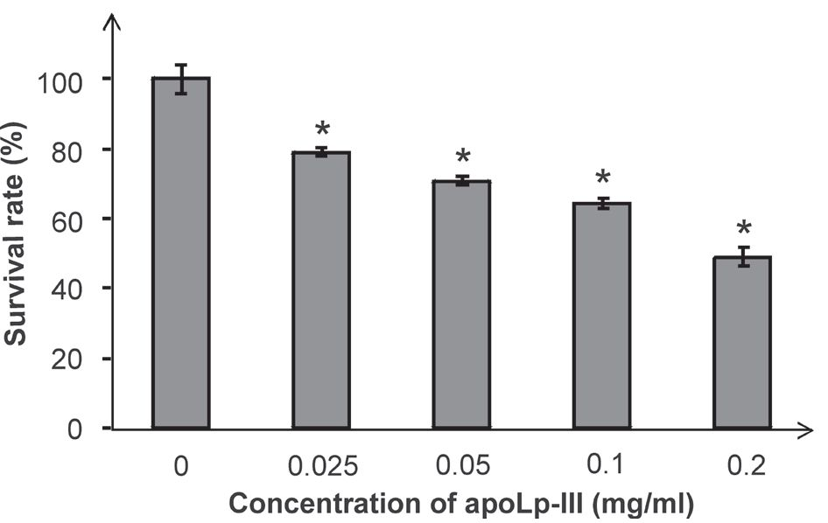
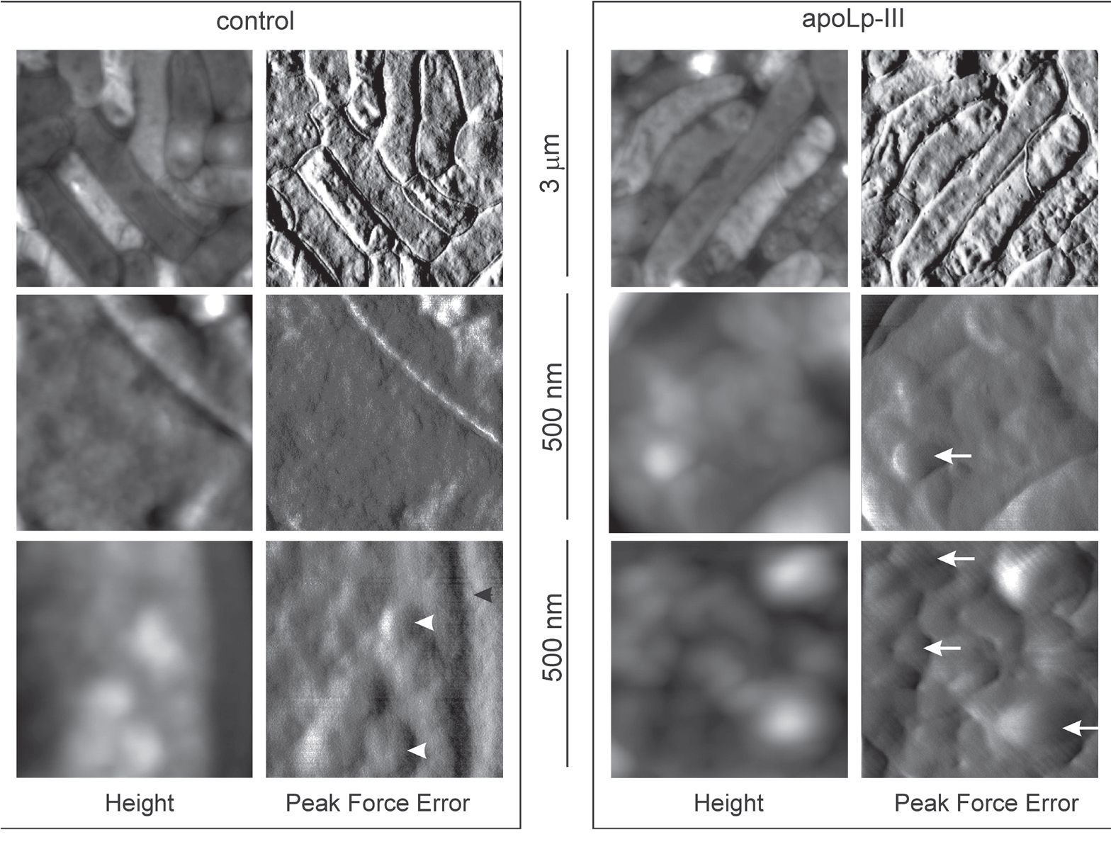
Vol. 61
Anti-L gormanii activity of G. mellonella proteins
125
Figure 1. The effect of G. mellonella apoLp-III on L. gormanii
survival rate.
The bacteria were incubated with the G. mellonella apoLp-III at
the concentrations of 0-0.2 mg/ml at 37°C for 1 h. Cells were then
plated on BCYE agar and the number of colonies was counted
after four days incubation at 37°C in a 5% CO2 atmosphere. Ex-
perimental results were mean ± S.D. of three independent experi-
ments. The Wilcoxon's paired test was used for comparisons with-
in groups. p values *p<0.001 were considered.
- e. non-treated bacteria. The MIC value defined as the
concentration yielding at least 95% inhibition of bacterial
growth for the extract was determined to be 0.8 mg/ml.
However, the extract used at the concentration 0.4 mg/
ml reduced the bacteria survival rate to almost the same
extent, i.e. by 94%. Recently, we have reported that an-
timicrobial proteins and peptides of the G. mellonella im-
mune hemolymph extract inhibited L. dumoffii growth.
When the extract was used at the concentration 0.4 mg/
ml, ca. 50% decrease of L. dumoffii survival rate was ob-
served (Palusinska-Szysz et aL, 2012).
A main protein component of G. mellonella hemo-
lymph extract is apoLp-III (Cytrynska et al, 2007).
Hence, the effect of apoLp-III on L. gormanii survival
rate was studied. A colony counting assay using apoLp-
III at the concentrations 0.025-0.2 mg/ml revealed that
L. gormanii cells were sensitive to apoLp-III. The protein
at the concentration 0.2 mg/ml caused ca. 50% decrease
of the bacteria survival rate (Fig. 1). Interestingly, when
apoLp-III was used at the concentration 0.025 mg/ml,
the survival rate of L. gormanii decreased only by 10%,
whereas the hemolymph extract at the same concen-
tration caused 75% reduction of bacterial survivability
(Fig. 1). The results indicated that although L. gormanii
was susceptible to apoLp-III action, other proteinaceous
(e.g. defence proteins and peptides) and non-protein-
aceous compounds present in G. mellonella hemolymph
extract were probably also involved in killing of the bac-
teria. Increasing of the hemolymph extract and apoLp-
III concentrations above 0.8 mg/ml and 0.2 mg/ml, re-
spectively, did not reduce further L. gormanii survival rate
(data not shown). However, the explanation of this fact
needs further investigations.
In our previous papers, usefulness of an atomic force
microscopy for analysis of an influence of G. mellonel-
la defence factors on bacterial and fungal cell surface
has been demonstrated (Zdybicka-Barabas et al, 2011;
2012a; 2012b; 2013). In this study, AFM was used for
examining of the G. mellonella apoLp-III effect on L. gor-
manii cell surface. AFM imaging revealed that the sur-
face of L. gormanii control cells was covered with small
uniform granules (Figs. 2, 3). On the surface of some
control cells few shallow depressions were also visible.
Figure 2. The effect of G. mellonella apoLp-III on L. gormanii cell surface topography.
The cells were incubated without (control) or in the presence of apoLp-III (0.2 mg/ml) at 37oC for 1 h and then imaged by AFM. The
height and "peak force error” images are presented. The white and black arrowheads indicate granules and furrows, respectively, on the
control cells surface. The white arrows mark bubble-like features appearing on apoLp-III-treated cells.
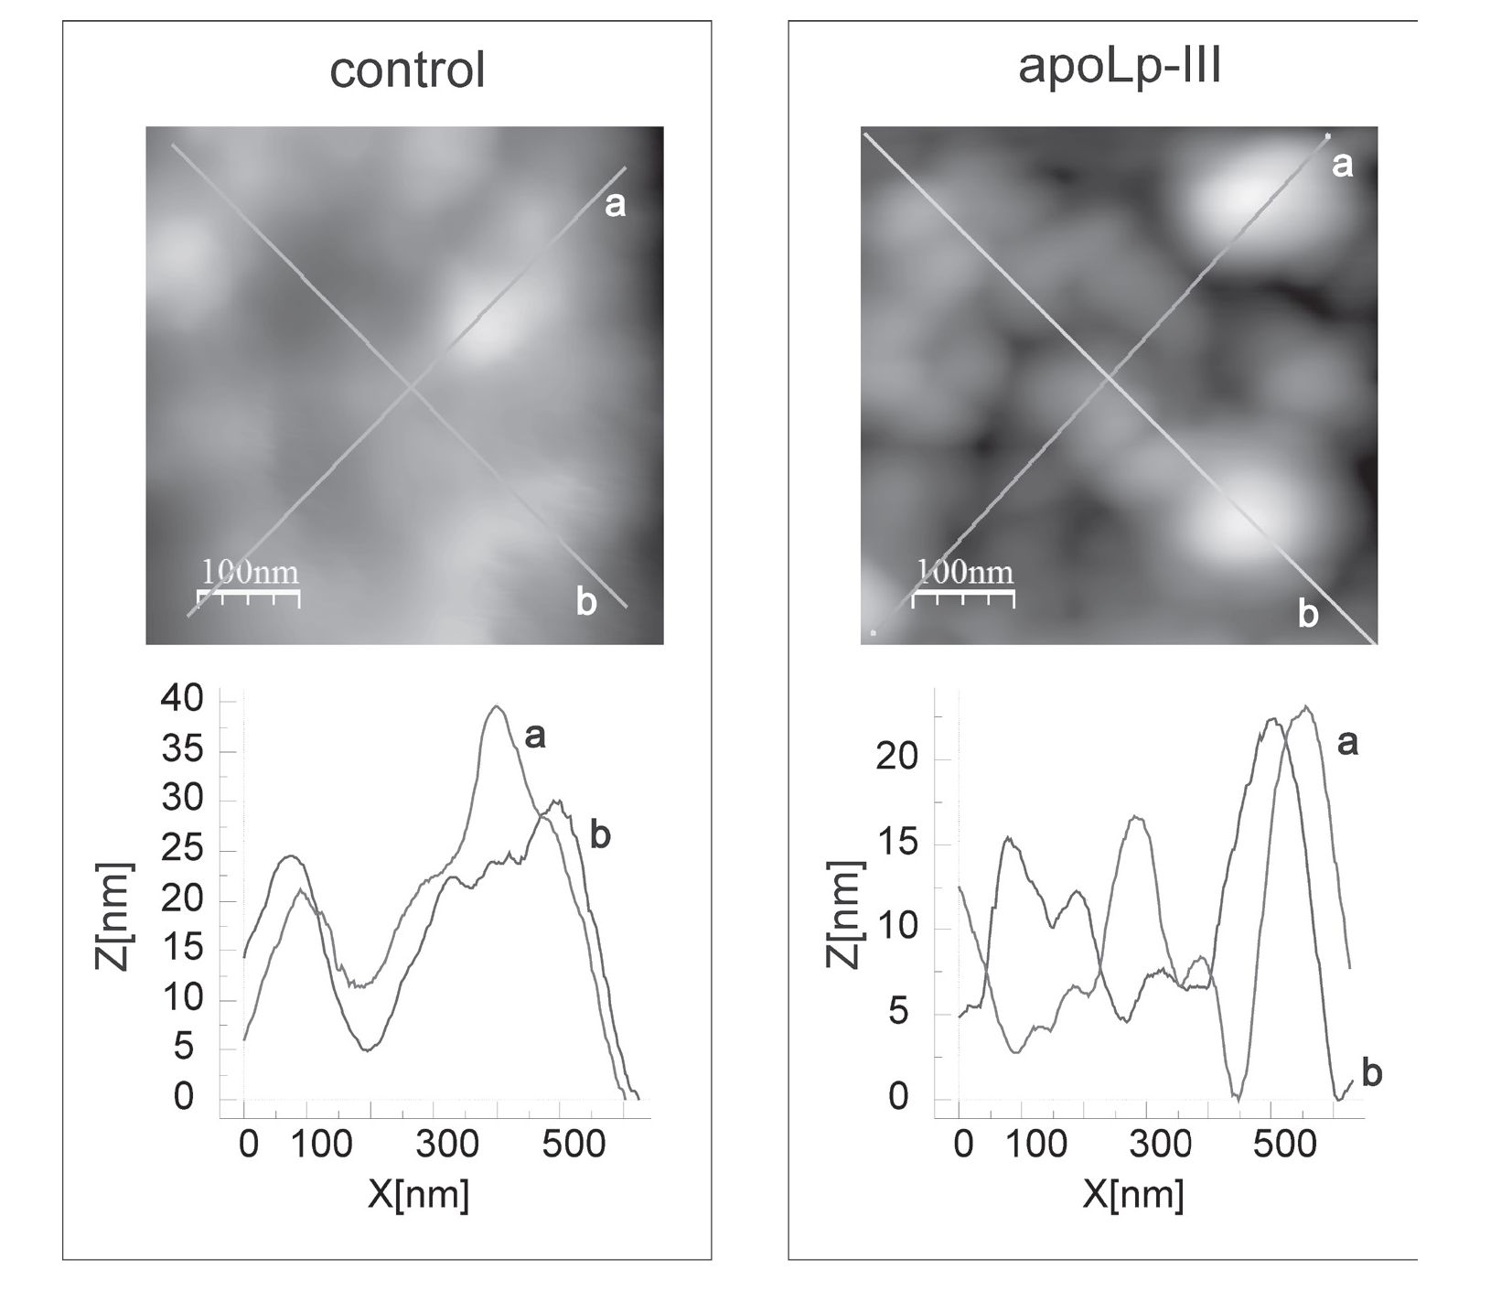
126
E. Chmiel and others
2014
Figure 3. Profile section analysis of L. gormanii cell surface.
The cells were incubated without (control) or in the presence of apoLp-III (0.2 mg/ml) at 37oC for 1 h and then imaged by AFM. The up-
per panels present the height images of the cell surface. The bottom panels demonstrate the section profiles corresponding to the lines
(a, b) shown in the height images.
In addition, the cells with uneven surface covered with
furrows, some of them 10—20 nm deep and even 200
nm wide, were detected in the control samples. In con-
trast, the most of the apoLp-III-exposed cells were dec-
orated with numerous rounded bubble-like features of
different size, 15—20 nm in height and 100—200 nm in
diameter (Figs. 2, 3). The alterations of the L. gormanii
cell surface caused by apoLp-III were also reflected by
1.44-fold increase in cell surface roughness, the param-
eter used to describe the structural heterogeneity of the
bacterial cell surface. The RMS roughness values for the
control and apoLp-III-treated cells were calculated as
2.935 nm (±1.016) and 4.2305 nm (±1.003; ¿>=0.00103),
respectively. One of the reasons of the increase of the
surface roughness could be rupturing of bacterial cell
following the apoLp-III binding to LPS and phospholip-
ids, which was reported by Pratt & Weers (2004).
Although both L. dumoffii and L. gormanii were sensi-
tive to G. mellomlla apoLp-III, the 8-fold lower concen-
tration of apoLp-III was sufficient to exert the same
bactericidal effect on L. gormanii in comparison to L.
dumoffii (Palusinska-Szysz et aL, 2012). The high sensi-
tivity of L. gormanii to apoLp-III in comparison with L.
dumoffii indicates that different Legionella species could
exhibit diverse susceptibility to the insect-derived antimi-
crobial factors, possibly reflecting differences in the cell
surface properties.
Searching for antimicrobials effective against L. gor-
manii is especially important since this species was iso-
lated from peadiatric cases. Moreover, antimicrobial ther-
apy commonly used in empirical pneumonia treatment
in young patients is not effective against Legionella spp.
(Ephros et al, 1989; Greenberg et aL, 2006).
Acknowledgements
The authors are grateful to Prof. Teresa Jakubowicz
(Department of Immunobiology, Maria Curie-Sklodows-
ka University, Lublin, Poland) and Prof. Teresa Urban-
ik-Sypniewska (Department of Genetics and Microbiol-
ogy, Maria Curie-Sklodowska University, Lublin, Poland)
for critical reading of the manuscript.
This work was supported by the grant from the Min-
istry of Science and Higher Education (Poland) No. N
N303 822640 and realized partially using equipment
purchased through European Union structural funds
(grants “Molecular Biotechnology for Health” No.
POIG.02.01.00-12-064/08 and “Małopolska Center of
Biotechnology” No. POIG.02.01.00-12-167/08).
REFERENCES
Benin AL, Benson RF, Arnold KE, Fiore AE, Cook PG, Williams LK,
Fields B, Besser RE (2002) An outbreak of travel-associated Le-
gionnaires’ disease and Pontiac fever: the need for enhanced surveil-
lance of travel-associated legionellosis in the United States. J Infect
Dis 185: 237-243.
Boman HG, Nilsson-Faye I, Paul K, Rasmuson TJr (1974) Insect im-
munity. 1. Characteristics of an inducible cell-free antibacterial reac-
tion in hemolymph of Samia cynthia pupae. Infect Immun 10: 136-145.
Vol. 61
Anti-L. gormanii activity of G. mellonella proteins
127
Bradford MM (1976) A rapid and sensitive method for the quantita-
tion of microgram quantities of protein utilizing the principle of
protein—dye binding. Anal Biochem 72: 248—254.
Brown SE, Howard A, Kasprzak AB, Gordon KH, East PD (2008)
The discovery and analysis of a diverged family of novel antifungal
moricin-like peptides in the wax moth Galleria mellonella. Insect Bio-
chem Mol Biol 38: 201—212.
Brown SE, Howard A, Kasprzak AB, Gordon KH, East PD (2009)
A peptidomic study reveals the impressive antimicrobial peptide ar-
senal of the wax moth Galleria mellonella. Insect Biochem Mol Biol 39:
792-800.
Bulet P, Stöcklin R (2005) Insect antimicrobial peptides: structures,
properties and gene regulation. Protein Pept Lett 12: 3-11.
Bulet P, Stöcklin R, Menin L (2004) Anti-microbial peptides: from in-
vertebrates to vertebrates. Immunol Rev 198: 169-184.
Cytrynska M, Mak P, Zdybicka-Barabas A, Suder P, Jakubowicz T
(2007) Purification and characterization of eight peptides from Gal-
leria mellonella immune hemolymph. Peptides 28: 533-546.
Ephros M, Engelhard D, Maayan S, Bercovier H, Avital A, Yatsiv I
(1989) L gormanii pneumonia in a child with chronic granulomatous
disease. Pediatr Infect Dis J 8: 726-727.
Euzeby J (2013) List of bacterial names with standing in nomenclature:
http://www.bacterio.cict.fr/
Feeley JC, Gibson RJ, Gorman GW, Langford NC, Rasheed JK, Mack-
el DC, Baine WB (1979) Charcoal-yeast extract agar: primary isola-
tion medium for Legionella pneumophila. J Clin Microbiol 10: 437-441.
Fields BS, Benson RF, Besser RE (2002) Legionella and Legionnaires’
disease: 25 years of investigation. Clin Microbiol Rev 15: 506-526.
Greenberg D, Chiou CC, Famigilleti R, Lee TC, Yu VL (2006) Prob-
lem pathogens: paediatric legionellosis — implications for improved
diagnosis. Lancet Infect Dis 6: 529-535.
Halwani AE, Niven DF, Dunphy GB (2000) Apolipophorin-III and
the interactions of lipoteichoic acids with the immediate immune
responses of Galleria mellonella. J Invertebr Pathol 76: 233-241.
Harding CR, Mattheis C, Mousnier A, Oates CV, Hartland EL, Fran-
kel G, Schroeder GN (2013a) LtpD is a novel Legionella pneumophila
effector that binds phosphatidylinositol 3-phosphate and inositol
monophosphatase IMPA1. Infect Immun 81: 4261-4270.
Harding CR, Schroeder GN, Reynolds S, Kosta A, Collins JW, Mous-
nier A, Frankel G (2012) Legionella pneumophila pathogenesis in the
Galleria mellonella infection model. Infect Immun 80: 2780-2790.
Harding CR, Stoneham CA, Schuelein R, Newton H, Oates CV, Hart-
land EL, Schroeder GN, Frankel G (2013b) The Dot/Icm effector
SdhA is necessary for virulence of Legionella pneumophila in Galleria
mellonella and A/J mice. Infect Immun 81: 2598-2605.
Hultmark D (1996) Insect lysozymes. In Lysozym es: Model enzymes in
biochemistry and biology. Jollés P, ed, pp 87—102. Birkhäuser Verlag,
Basel, Switzerland.
Lode H, Kemmerich B, Schäfer H, Grothe R, Hartmann R, Ehret W,
Ruckdeschel G (1987) Significance of non-pneumophila Legionella
species in adult community-acquired and nosocomial pneumonias.
Klin Wochenschr 65: 463—468.
Palusinska-Szysz M (2011) Legionnaires’ disease. In Manual of Childhood
Infections. The Blue Book. Sharland M, ed, Chapter 81, pp 912—924.
Oxford University Press, UK.
Palusinska-Szysz M, Cendrowska-Pinkosz M (2009) Pathogenicity of
the family Legionellaceae. Arch Immunol Ther Exp (Warsz) 57: 279-290.
Palusinska-Szysz M, Zdybicka-Barabas A, Pawlikowska-Pawl^ga B, Mak
P, Cytrynska M (2012) Anti-Legionella dumoffii activity of Galleria mel-
lonella defensin and apolipophorin III. Int J Mol Sci 13: 17048—17064.
Pratt CC, Weers PMM (2004) Lip op oly saccharide binding of an ex-
changeable apo lip op rote in, apolipophorin III, from Galleria mellonel-
la. Biol Chem 385: 1113-1119.
Schägger H, von Jagow G (1987) Tricine-sodium dodecyl sulfate-poly-
acrylamide gel electrophoresis for the separation of proteins in the
range from 1 to 100 kDa. Anal Biochem 166: 368-379.
Weers PMM, Ryan RO (2006) Apolipophorin III: Role model apolipo-
protein. Insect Biochem Mol Biol 36: 231-240.
Whitten MMA, Tew IF, Lee BL, Ratcliffe NA (2004) A novel role for
an insect apolipoprotein (apolipophorin III) in ß-1,3-glucan pat-
tern recognition and cellular encapsulation reactions. J Immunol 172:
2177-2185.
Zdybicka-Barabas A, Cytrynska M (2011) Involvement of apolipo-
phorin III in antibacterial defense of Galleria mellonella larvae. Comp
Biochem Physiol B Biochem Mol Biol 158: 90-98.
Zdybicka-Barabas A, Cytrynska M (2013) Apolipophorins and insect
immune response. Inv Surv J (ISJ) 10: 58-68.
Zdybicka-Barabas A, Januszanis B, Mak P, Cytrynska M (2011) An
atomic force microscopy study of Galleria mellonella apolipophorin
III effect on bacteria. Biochim Biophys Acta 1808: 1896-1906.
Zdybicka-Barabas A, Mak P, Klys A, Skrzypiec K, Mendyk E, Fiolka
MJ, Cytrynska M (2012a) Synergistic action of Galleria mellonella ani-
onic peptide 2 and lysozyme against Gram-negative bacteria. Biochim
Biophys Acta 1818: 2623-2635.
Zdybicka-Barabas A, St^czek S, Mak P, Piersiak T, Skrzypiec K,
Cytrynska M (2012b) The effect of Galleria mellonella apolipophorin
III on yeasts and filamentous fungi. J Insect Physiol 58: 164-177.
Zdybicka-Barabas A, St^czek S, Mak P, Skrzypiec K, Mendyk E,
Cytrynska M (2013) Synergistic action of Galleria mellonella apolipo-
phorin III and lysozyme against Gram-negative bacteria. Biochim Bio-
phys Acta 1828: 1449-1456.

