
Adv.Geosci.,45,259–265,2018
https://doi.org/10.5194/adgeo-45-259-2018
©Author(s)2018.ThisworkisdistributedundertheCreativeCommonsAttribution4.0License.


DistributionofminormetallicelementswithinwasteincinerationbottomashesdefinedbyWDX/EDXspectrometry

PiotrR.Kowalski,MonikaKasina,andMarekMichalik
InstituteofGeologicalSciences,JagiellonianUniversity,Gronostajowa3a,30-387Kraków,Poland

Correspondence:PiotrR.Kowalski(p.kowalski@doctoral.uj.edu.pl)

Received:31May2018–Revised:30July2018–Accepted:5August2018–Published:5September2018

Abstract.Anumberofmetallicelementsareinheritedfromwasteduringthermaltreatmentandconcentratedintheincin-erationresidues.Becausethemajorpartoftheincinerationresiduemassarebottomashes(BAs),theirstudyisofgreatimportancefromthepointofviewoftheirenvironmentalim-pactorresourcepotential.ThegeneralfocusofthisstudywasontheminormetallicelementspresentinBAs.Theyco-occurredwithmainphasesandoftendeterminedthein-heritedpotentialofthematerial.Theanalysedresidueswereproducedfrommunicipalandindustrialwaste.TheBAswerestudiedusingspectroscopicmethodsofchemicalmicroanal-ysis:energydispersiveX-rayspectrometry(EDX)andwave-lengthdispersiveX-rayspectrometry(WDX).Boththemainandminormetallicelementswereconcentratedinmetalliccomponents.Theyweretypicallypresentasseparategrainsandmetallicinclusions(commonlyintheglassmatrixofthegrains)ranginginsizefromseveraltohundredsofmicrome-tres.DespiteFe-,Al-andCu-richoccurrences,metallicel-ementsrarelyoccurredinfragmentscomposedofasingleelement.Theirmainformsofoccurrencewerealloygrains,admixturesinpolymetallicoccurrencesandmicro-inclusionsinglassymatrix.Thecontentofparticularelementsinthoseformswasinvestigatedanddescribedingreaterdetail.Eventhoughtwotypesofbottomashwereformedfromdiffer-enttypesofwasteanddifferencesinusedtechnologieswerepresent,theobtainedmaterialscontainedmetalliccompo-nentshavingsimilarattributes.ElevatedconcentrationsofnotonlyFeandAl,butalsoTi,CuandZn,allowustoconsiderbottomashasapromisingmaterialfromthepointofviewofmetallicelements’recovery(e.g.bythephysicalconcentrationofelementsthroughgravityormagneticmeth-ods).

Introduction

Wasteincinerationisoneofthemostcommontreatmentmethodsinwastemanagement.Itallowswastemassandvol-umereduction.Nevertheless,itcausesgrowthintheworld-wideproductionofwasteincinerationresidues.Duringther-maltreatment,wasteisdetoxifiedandtransformedintothreesolidmaterials:bottomash(BA),flyash(FA)andairpollu-tioncontrol(APC)residues.Asconcentratesofinflammablewastefraction,theyarecomposedofnewlyformedphasesandcomponentsinheritedfromwastesuchasmetallicfrag-ments,fragmentedglassorceramic(Chandleretal.,1997).Elementsinheritedfromwasteareentrappedinincinerationresiduesandexcludedfromtheirnaturalcycles;therefore,proceduresforthepost-treatmentmanagementorrecyclingofincinerationresiduesneedtobedeveloped.MostmetallicelementsconcentrateinBAsthus,theymightbeconsideredasasourceofvaluablecomponentsorwaste-basedrawma-terialinindustrialapplications(Funarietal.,2015;Lametal.,2010;Kowalskietal.,2016).
BAsareheterogeneousgrainymaterials.Theircomposi-tionismainlydependentonthelocalwastestreamcom-position,appliedwastemanagementsystemandtechnologyofincineration.Besidesamorphousandcrystallinecompo-nentsformedduringincineration,BAsarerichinresidualcomponentsinheritedfromwaste(oftenbarelyaffectedbyhightemperature).Also,metalliccomponentsarepresentintheBAs,eveniftherecyclingofmetalproductsisper-formedpriortothethermaltreatment(Chandleretal.,1997;Saffarzadehetal.,2009;Weietal.,2011).Afterthermalprocessing,thenextstageofrecyclingintheincinerationplantisusuallyperformedbyusingsinglemagnetsoreddy-currentseparators.Theprocessiseffectivefortheseparationoflargefragmentsofmetalproductsreleasedinthefurnacefromwaste.Nevertheless,itisnotpossibletorecoversingle

orsmallmetalfragmentswithoutfragmentationoftheBAgrains.
CommonmetallicelementssuchasFe,AlandMgarepresentintheBAsinthehighestamount,whileuptoafewwt%ofothermetallicelementsisalsooftenpresent
(e.g.Ti,Zn,Cu,Cr).Currently,itisconsideredthatthere-coveryofsingleelementsmightnotbeeconomicallyrea-sonablebecauseofthepresenceofeasyaccessiblenaturalorsecondaryresources.Nevertheless,incinerationresiduescouldbetreatedaseasilyaccessible,producedcontinuouslyinlargeamounts,andawaste-basedsourceofatleastafewmetallicelements(Kuoetal.,2007).Fromthispointofview,thevalueofelementsalsopresentinminoritymightbeen-couragingfordevelopingproceduresoftheirseparationandrecovery.FortheestimationofBAs’resourcepotential,thebasicstudiesofminormetallicelementsareofgreatim-portance.Basedonthispresumption,themainfocusofthisstudywasonBAs’minormetallicelements,especiallythosepresentassideelementsinalloysanddispersedwithinvar-iousBAphases.WealsofocusonthedistributionofminormetallicelementswithinthephasesintwotypesofBApro-ducedfromwastegeneratedinhouseholdsandindustry.

Materials&analyticalmethods

  - Bottomashessamplingandusedincinerationtechnologies

Toinvestigateminormetalliccomponentsinwasteincinera-tionBAs,285kgofthematerialintotalwascollectedfromtwooperatingplantslocatedinPolandduringseveralsam-plingcampaigns(intheyearsfrom2015to2018).
TwelvesamplesofBAwerecollectedfromamunicipalsolidwasteincineration(MSWI)plant(155kg).Eachsam-plerepresentedanaveragedportionoffreshmaterialandwascollectedfromadepthof30cmonanuncoveredheap.AccordingtotheEuropeanListofWaste(EPA,2002),thistypeofBA(wastecode:190112)iscategorisedas“bot-tomashandslagotherthanthosementionedin190111*(*bottomashandslagcontainingdangeroussubstances)”.Theplantisnowunderreconstruction(plannedefficiency
ofwasteincinerationwillbe300000tyr−1),butatthetime
whenthesampleswerecollecteditwasincineratingupto55000tofwasteeveryyear.Theplantwasequippedwithashaftfurnace,wherewaste(<8th−1)wasthermallytreatedfor30–120minattemperaturesrangingfrom950to1100◦C.HotBAwascooledwithwaterandstoredonanuncoveredheap.Throughatechnologicalprocess,productscomposedofferrousmetalswereseparatedfromtheBAmanuallyandbyusingmagneticseparators.FluegasesfromthefurnacewereledtoanAPCsystemwhereinafewstepstheashesandresidueswereseparated,heatwasrecoveredandgasesweretreatedtoneutraliseitstoxicandhazardouscomponents(NOx,SOx,HCl,HF,toxicmetallicelements,dioxins,furans
andorganicpollutants)(MalczewskiandNadulski,2010).InthisplantBA,APCandFAwereproducedinthepropor-tionsof91.5%,7%and1.5%,respectively(Kowalskietal.,2017).
ThesecondgroupofBAsampleswascollectedinanin-dustrialandhazardouswasteincineration(IHWI)plant.ThisBAiscategorisedas“bottomashandslagcontainingdan-geroussubstances”(wastecode:190111*).Becauseofstrictsafetyregulations,thesampleswerepreparedbyincinerationplantemployees.SevensamplesoffreshBAwerecollectedattheendofthetechnologicalline(130kg).TheBAwas
producedintheincinerationplant,where∼800categoriesof
waste(including379hazardoustypes)arethermallytreated.
Theplantisequippedwitharotaryfurnace,whichisabletoincinerateupto50000tofwasteperyear.Theincinerationtimewas25–60minandthetemperaturesrangedfrom900to1150◦C.AfterincinerationtheBAiscooledwithwater,andduringtransportationtostoringcontainers,fragmentsoffer-rousmetalproductsareseparatedusingmagneticseparators.Theinstallationisequippedwithanadvancedmulti-stageAPCsystemtorecoverenergyanddealwithelevatedcon-tentoftoxicandhazardouscomponentsoffluegases.Thisisacombinationofwashers,dryers,filtersandabsorbers,usedforeffectiveremovalofHg,HCl,SOx,NOx,HF,dioxins,fu-rans,PCBsandtoxicmetallicelements(Pikon´andGrabski,2006).Inthisplant,BAandAPCareproducedinweightat
theproportionof70:30.
AdditionallytotheBAsamples,foursamplesofFA(∼
40kg)andeightsamplesofAPCresidues(∼40kg)were
collectedandanalysedinparallel.

Samplepreparation

Priortoanalysis,BAsamplesfrombothincinerationplantsweredriedandaveragedusingRetschsamplesplitters.Aftertheremovaloffragmentsofmetalproductsthatcouldnotbecrushedormilled(<5wt%oftheMSWIBAand1–2wt%oftheIHWIBAsamples),theBAswerecrushedusingajawcrusher(tungstencarbidecrushingelements).Forchemicalanalysis,theBAsweremilledinaRetschplanetaryballmill
for20min(2×10min,250rpm,tungstencarbidegrindingel-
ements).ForquantitativeX-raydiffraction,thesampleswere
crushedto0.4mmandmilledinaMcCronemicronisingmill(inalcohol,10min,samplesanalysedasdisorientedspeci-men).

Analyticalmethods

InbothtypesofBA,thecontentofresidualcomponentswasdetermined.From1kgofeachsample,fragmentedmetalproductsandotherheat-resistantcomponentsweremanuallyseparatedandweighed.IntheMSWIBA,theywereprimar-ilyrepresentedbyfragmentedglassandceramicproducts.
TheBAs’chemicalcompositionwasdeterminedbyBu-reauVeritasUpstreamMinerals(formerlyAcmeLabsAn-

Table1.AveragedcontentofmajorelementsinBAsfromwasteincineration.

element(wt%) | Si | Ca | Fe | Na | Al | Mg | Ti | Ctot | Stot | LOI
MSWIBAa | 24.98 | 11.72 | 6.80 | 4.97 | 4.00 | 1.00 | 0.45 | 0.40 | 0.33 | 1.22
SD | 1.7 | 0.7 | 2.4 | 0.6 | 0.7 | 0.1 | 0.1 | 0.2 | 0.1 | 1.7
IHWIBAb | 14.51 | 8.37 | 6.73 | 6.22 | 5.32 | 1.06 | 3.01 | 10.42 | 1.73 | 14.7
SD | 1.6 | 2.1 | 2.2 | 1.2 | 0.9 | 0.2 | 1.1 | 4.9 | 0.3 | 6.6
aAveragedvaluesbasedonanalysisof9samples.bAveragedvaluesbasedonanalysisof7samples.SD–standarddeviation.

Table2.AveragedcontentofminorelementsinBAsfromwasteincineration.

element(wt%) | K | P | Cu | Zn | Mn | Cr | Pb | Zr | Sn | Ni | Co | YREE
MSWIBAa | 6656 | 3422 | 1290 | 1229c | 645 | 552 | 277d | 208 | 174 | 56 | 43 | 88
SD | 570 | 616 | 567 | 985 | 126 | 278 | 355 | 37 | 107 | 19 | 12 | 12
IHWIBAb | 5088 | 6072 | 3635 | 6433e | 1582 | 1534 | 486f | 696 | 561 | 806 | 240 | 262
SD | 947 | 2145 | 1561 | 4436 | 689 | 516 | 496 | 258 | 480 | 295 | 109 | 137
aAveragedvaluesbasedonanalysisof9samples.bAveragedvaluesbasedonanalysisof7samples.cIn1sample:0.39wt%Zn;din1sample:0.13wt%Pb;ein3samples:0.9–1.2wt%Zn;fin2samples:∼0.12wt%Pb.SD–standarddeviation.

alyticalLaboratoriesLtd.)inVancouver,Canada.Theele-ments’contentwasmeasuredbyinductivelycoupledplasmaopticalemissionandmassspectrometry(ICP-OESandICP-MS,respectively).ThetotalcontentofCandSwerealsomeasuredusingaLECOcombustionanalysisandlossonig-nition(LOI)wasestimatedbasedonthethermalmethod.
TheBAs’mineralcompositionwasdeterminedusingX-raypowderdiffraction.Measurementswereperformedin
theanglerangeof2–70◦28usingaPhilipsX’PertAPD
diffractometer(goniometerPW3020,curvedgraphitecrys-talmonochromator,CuKαradiation)withastepof0.02◦per5sforquantitativeanalyses.InterpretationsweremadebasedonthedatabaseoftheMineralogicalSocietyofAmerica(DownsandHall-Wallace,2003)andSEIFERTAutoQuansoftwarewasusedforthequantitativecalculations(basedontheRietveldrefinementmethodandtheadditionofinternalstandard:10wt%ofZnO.
AnalysesofBAsinpolishedthinsectionsandmicro-spotanalyseswereperformedusingaHitachiS-4700fieldemis-sionscanningelectronmicroscope(FE-SEM;operatingvolt-ageof20kV,timeforstandardlessmicroanalysis100s,spec-imencoatedwithcarbon)equippedwithaThermoNoranenergydispersiveX-rayspectrometry(EDX)analyser(sev-eralhundredEDXanalysesofmetalliccomponentsweremade)andaJEOLSuperprobeJXA-8230electronmicro-probeequippedwith5wavelengthdispersiveX-rayspec-trometry(WDX)detectors(calibrationwithstandards,beamsize10µm,acceleratingvoltage20kV,19elementsmea-suredincludingdirectmeasurementofO,specimencoatedwithcarbon).Sixsampleswereanalysedusingthemicro-
probe.Fromeachmaterial,∼300spotanalysesweremade
(mostofthemwerefocusedonmetalliccomponents).The
sizedistributionofmetalliccomponentswasdeterminedbymeasuringtheirsizesintwodimensionsusingSEMimages.

Resultsanddiscussion

TheBAswerematerialsrichinSi,Ca,Fe,NaandAl.Inloweramounts,Mg,Ti,CandSwerepresent(Table1).IncomparisontotheMSWIBA,theIHWIBAhadlessSiandCa,similarcontentofFe,Mgandusuallyslightlyhighercon-tentofothermainelements.InbothtypesofBAs,thecon-tentofparticularelementsvariedinsomerangewhencom-paringsinglesamplescollectedindifferentsamplingcam-paigns(standarddeviationvaluesfortheanalysedgroupofsamplesaregivenforeachvalueinTables1and2).TheIHWIBAchemicalcompositionwaslessuniform,whichcouldbeexpectedduetothefactthattheoutputwastemix-turewasmuchmorediversifiedthantheMSWIBA.Addi-tionally,Chandleretal.(1997)reportedthevariabilityofBAchemicalcompositionmostlyasaresultofchangesintheincineratedwastecomposition,butalsoasaresultoftheef-fectivenessofthewastemanagementsystemandtheusedtechniquesofwastepre-treatmentandBAvalorisationintheincinerationplant.Incontrasttothevariabilityofchemicalcomposition,BAfromtheindustrialwastewasmacroscop-icallymorehomogeneousandcontainedsmalleramountsofresidualcomponents(only0.5wt%–2.0wt%ofmetal-licfragments).TheMSWIBAcontained25wt%–35wt%offragmentedglass,2.5wt%–5.5wt%ofmetaland2.0wt%–
7.0wt%ofceramicproducts.
ThechemicalcompositionoftheBAswasreflectedintheirphasecomposition.BothtypesofBAcontainedahighamountofamorphousphase,mostlyrepresentedbysili-

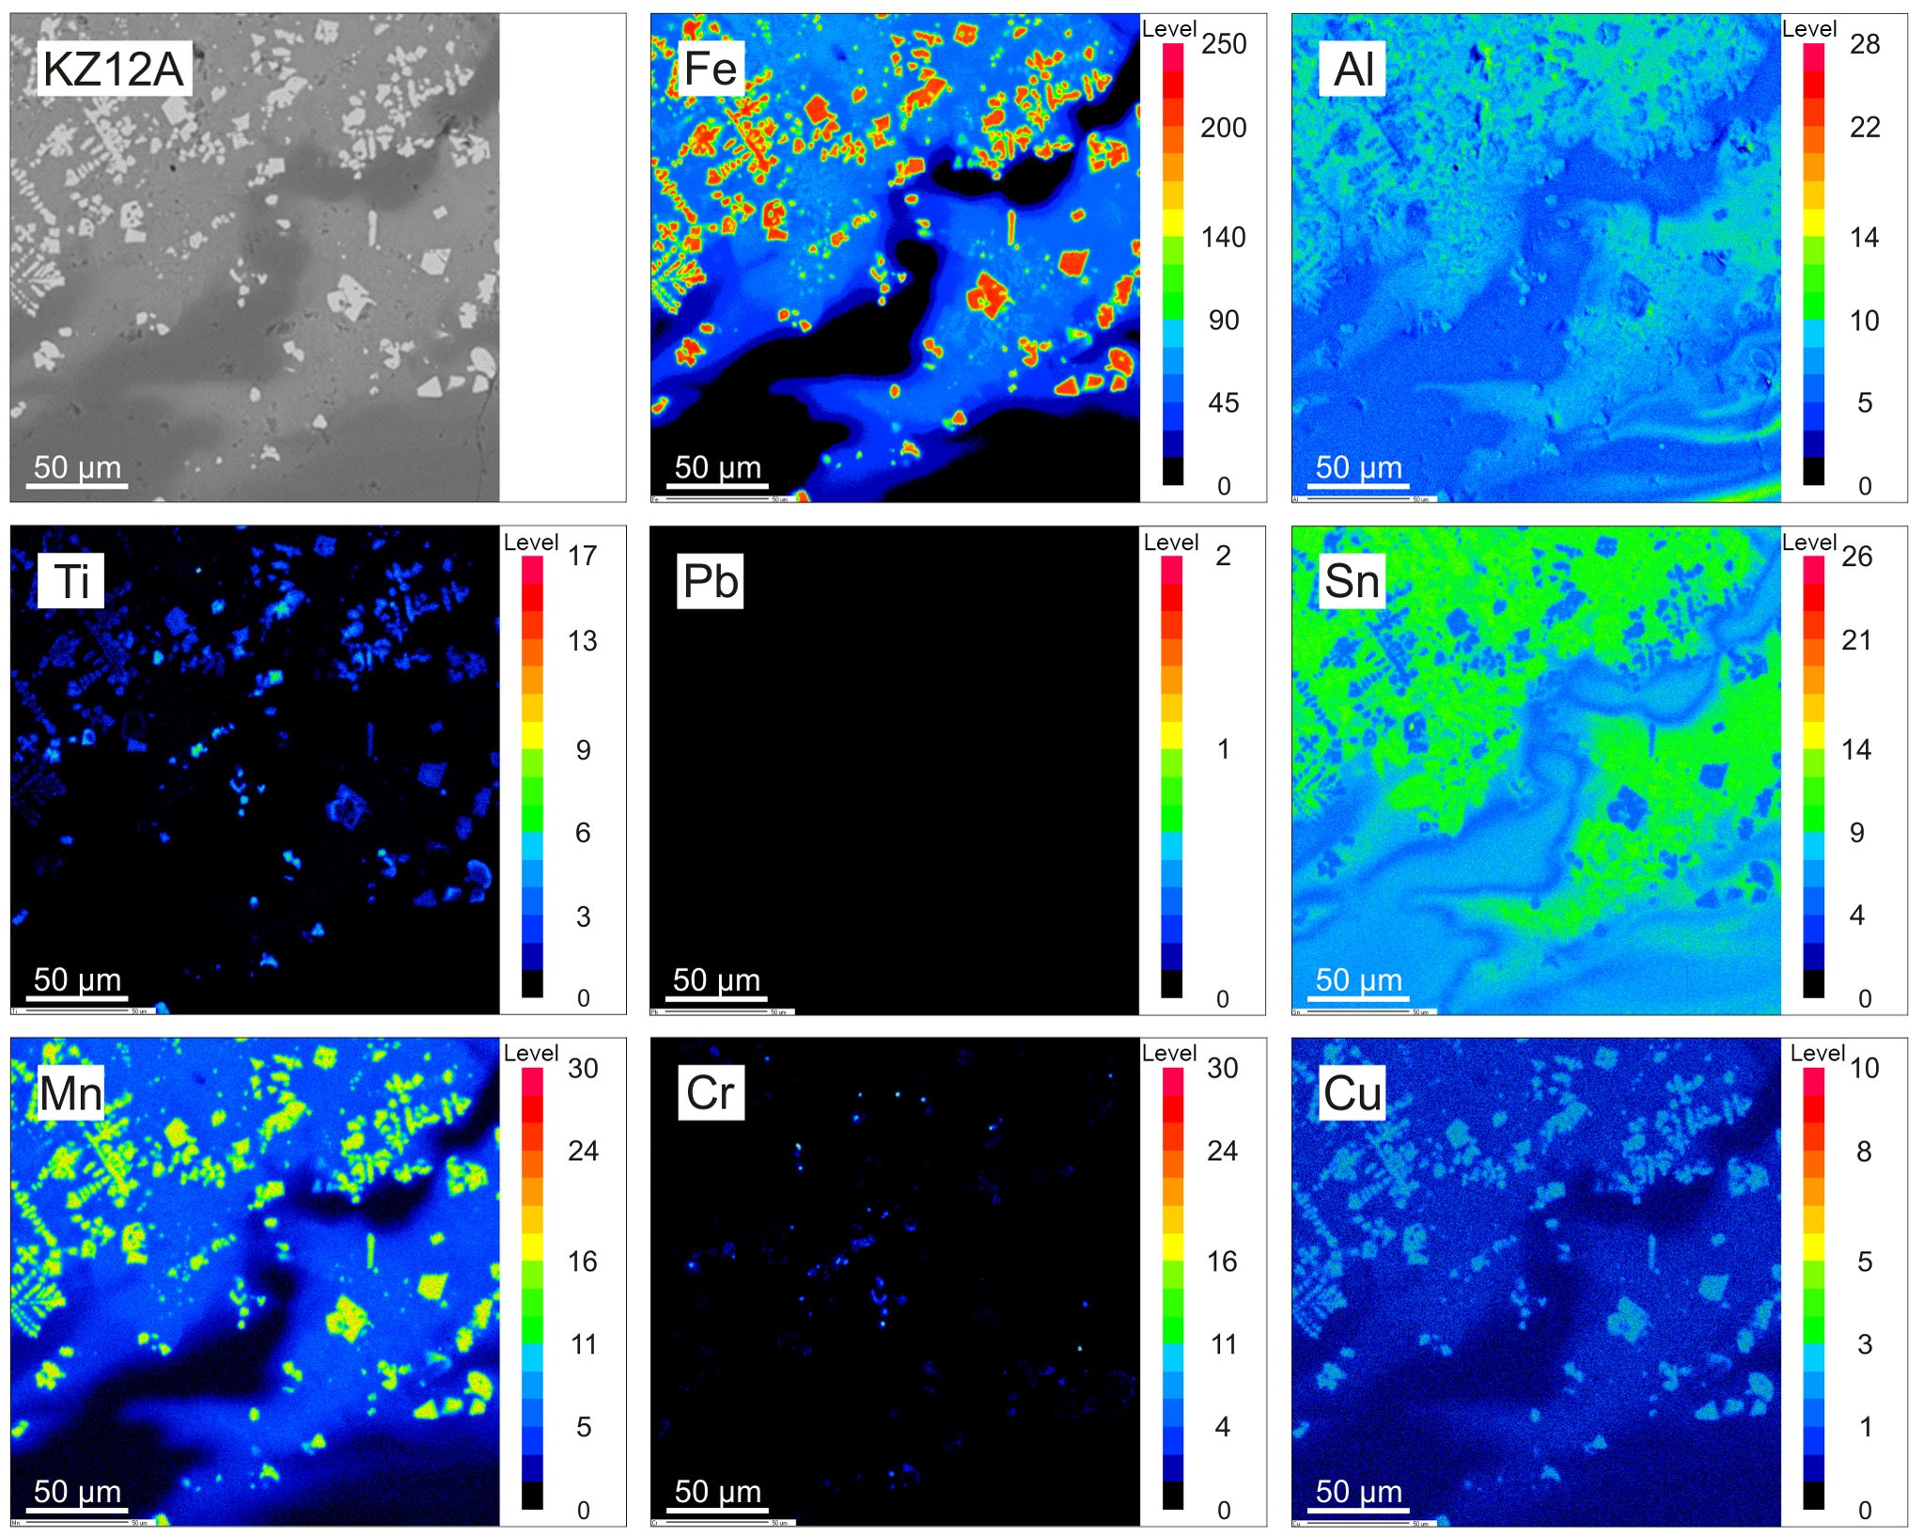

Figure1.MSWIBAWDXmaps.GlassymatrixoftheBAgrainrichinmetallicinclusions(mostlyFe-Mn-richinclusions).

categlass,althoughitscontentwashigherintheIHWIBA(55wt%–65wt%inMSWIBAvs.65wt%–80wt%inIHWIBA)(Kowalskietal.,2017).CrystallinephasewascomposedofseveralphasesinbothtypesofBA.Themainmineralsweresilicatesandaluminosilicatescon-tainingCaandalkalis,carbonatesandoxides.Insmalleramountsphosphates,sulphatesandchlorideswerepresent.TheMSWIBAcontainedmorequartz(SiO2),andmelilite
groupminerals(Ca2Mg[Si2O7]−Ca2Al[AlSiO7]),whereas
theIHWIBAwasrichinsulphateminerals(Ca[SO4]·
nH2O;Na2Ca[SO4]2;Na2[SO4]),calcite(Ca[CO3])andFe-
oxides(FexOy).
InbothtypesofBA,thegroupofminorelementswas
dominatedbymetallicelements.Ti,Cu,Zn,MnandCrwerethemostimportant(Table2).Kuoetal.(2007)concludedthatCu,Zn,CrandPbfromthegroupofminormetallicele-mentswereconcentratedmostlyintheBAandarepromisingfromthepointofviewoftheirrecovery.Similartothemajorelements,thecontentofminorcomponentswasdiversified,whichmadetheestimationofaveragedvaluesdifficult,andfortheaveragedatatobereliableitwasnecessarytoanalyseasignificantamountofthematerial.Ingeneral,theIHWIBA
hadremarkablyhighercontentofminormetallicelements,anddespitethelevelofvariabilitythismaterialseemstobemorepromisingfromthepointofviewofthemetallicel-ements’recovery.Alsointhismaterial,insomesamplesamuchhighercontentofparticularelementswasdetected(e.g.inIHWIBA>1wt%ofZn)(Table2).
Ifconsideringthetotalcontentofmetallicelements(Al,Fe,Mg,Ti,Mn,Cr,Ni,Mo,Cu,Pb,ZnandSn),theycon-stituted>12.7wt%(8.8wt%–17.1wt%)oftheMSWIBAand∼17.6wt%(11.5wt%–23.1wt%)oftheIHWIBA.Inbothmaterials,2/3–4/5ofthegivenamountswereFeandAl.MetallicelementsinbothBAtypesweremostlyconcen-
tratedintheformofmetallicfragments,mainlyasmetallicinclusions(inthesizeof1–15µm)andseparatedmetallicgrains(inthesizeof50–300µm).ThoseoccurrencesweredominatedbyFe-andAl-richfragments,whereasothers(Cu,Zn,NiandveryfewPb,Ti,Cr,Sn-richmetallicfrag-ments)werepresentlessfrequently.SimilarformsandtypesofmetallicoccurrencesweredescribedbyWeietal.(2011).AlsoFunarietal.(2015)concludedthatmetallicelementsaremostlyconcentratedinthefine-grainedfractionofBAsandconcentrationsofsomeofthem(e.g.Cu,Zn,Pb,Ni)are

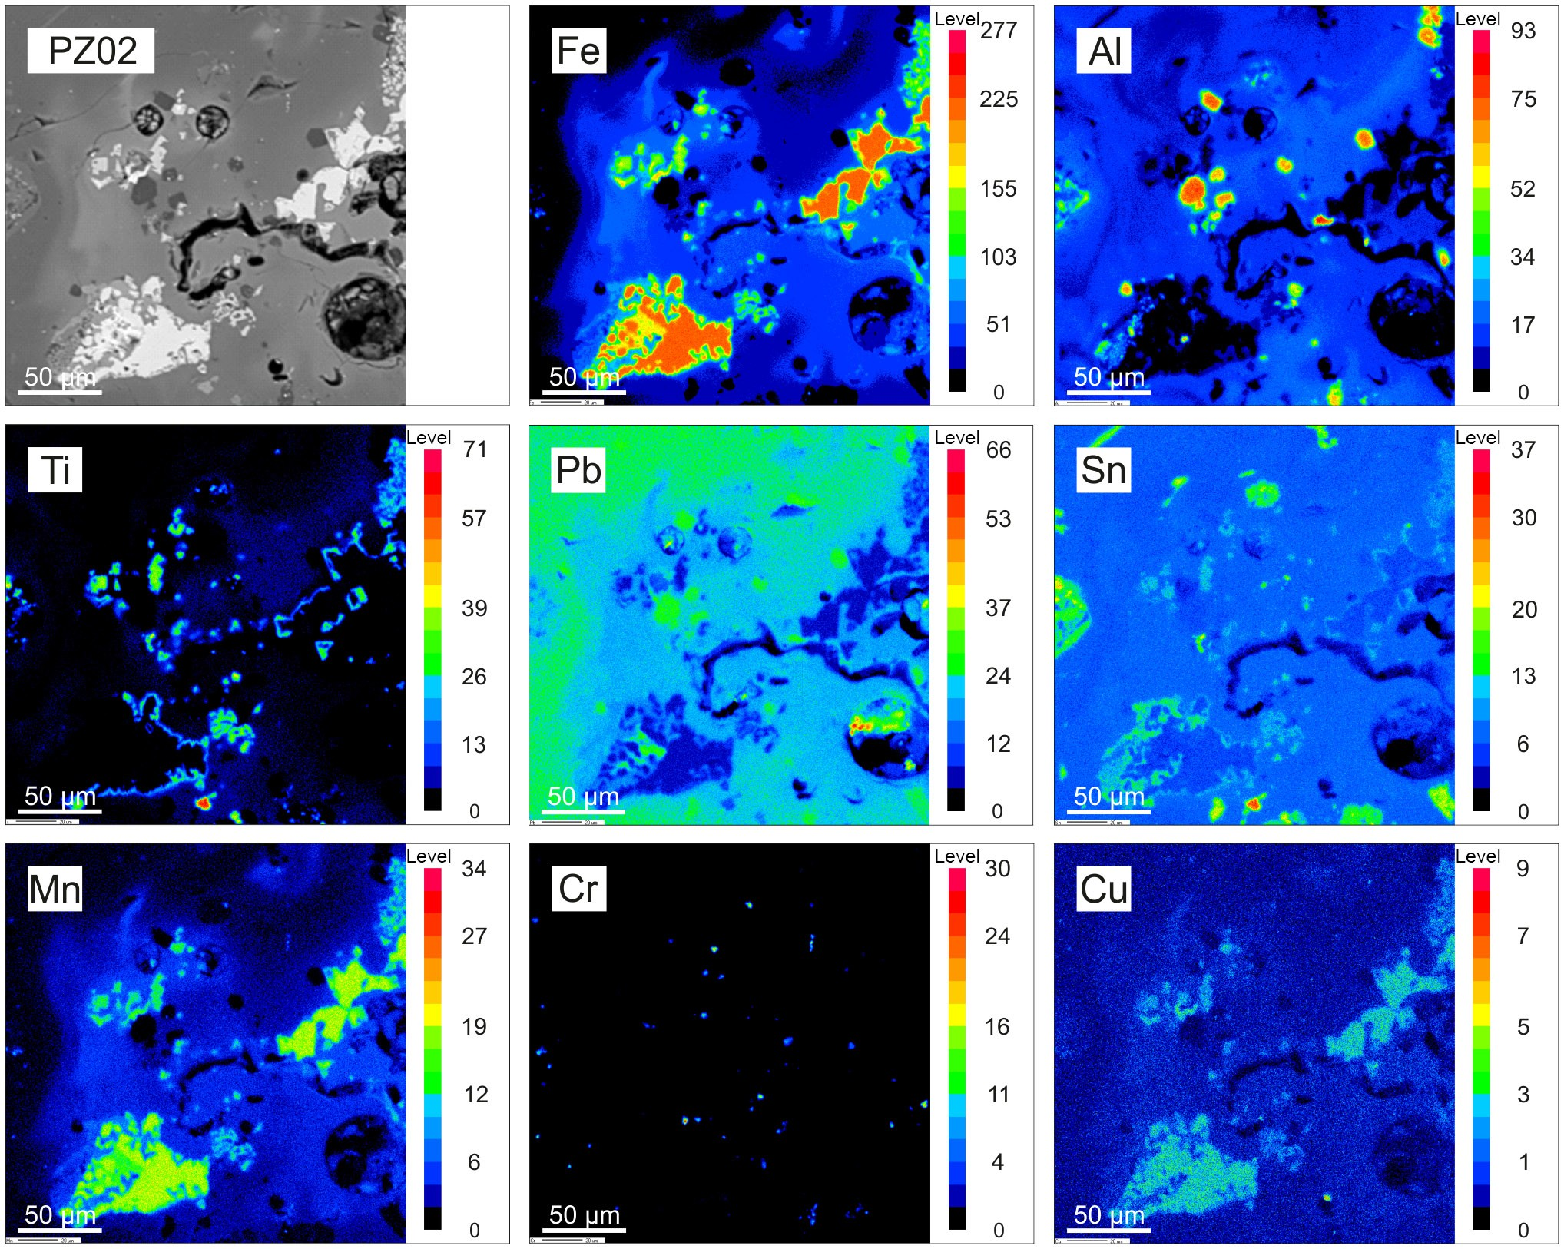

Figure2.IHWIBAWDXmaps.BAgrainrichinmetallicinclusions(Fe-Mn-Tidominated).

closetovaluesinlow-gradeores.MostoftheminormetallicelementsintheBAwereadmixturesinmulti-elementmetal-licoccurrencesandothernon-metallicphases.IntheMSWIBA(basedonWDXanalysis),theusualcontentofPbintheBAcomponentswas<0.15wt%.Pbusuallyco-occurredwithFe,SnorZnandwasrarelypresentintheglass.From25wt%to85wt%ofthePbcontainedPb-richoccurrencesandsulphides.Cuwasmostlypresentinaformofmetallicfragmentscontaining35wt%–85wt%oftheelement(alsoseveralwt%insulphides).Rarely,0.1wt%–0.5wt%ofCuwasmeasuredinthecompositionofFe-andAl-richgrains.From0.1to0.5wt%ofMn/CrwereusuallypresentinFe-richoccurrences.SeveralpercentofthemwerepresentinalloyswithAl,FeandCr(Mn)orFe,PbandMn(Cr).ZnwasusuallymeasuredinFe-richgrainsinlowamounts
(0.1wt%–0.3wt%),but30wt%–90wt%waspresentinZn-richoccurrencesandsulphides.
IntheIHWIBAcomponents(basedonWDXanaly-sis),Cu(0.2wt%–4.0wt%)waspresentmainlyinmulti-elementmetallicoccurrences.Highercontentwasdetectedinthecompositionofsulphides(20wt%–40wt%)andCu-dominatedfragments(50wt%–80wt%).Pb(0.1wt%–
0.3wt%)waspresentinFe-,Al-andSn-richmetallicfrag-ments.InPb-richoccurrences,itscontentreached50wt%–90wt%.Znusuallyoccuredinmulti-elementoccurrencesanditscontentwasinarangeof0.2wt%–2.0wt%.HighervaluesofZn(20wt%–50wt%)werepresentinsulphidesandoccurrencesdominatedbyFe.Cr(0.1wt%–1.0wt%)wasusuallymeasuredwithinFe-,Al-orTi-richfragments.Higheramountsoftheelement(15wt%–25wt%)werepresentinmulti-elementoccurrences.Mnwascommonlypresentinvariousmetallicfragmentsbutitscontentwasusu-allybelow0.5wt%.
AspresentedinFigs.1and2,microprobeWDXmapsweregeneratedinareasofglassymatrixcontaininggrainsrichinmetallicinclusions.TheresultsindicatedthatAlandFewereconcentratedmostlyindiscretegrainsandlargeinclusionsoftencontainingseveralotherelementsinlowamounts.MnandCuwerepresentasminorcomponentsofmetallicoccurrences.Tioccurredinmarginalzonesofmetal-licFe-richfragments,Crwasconcentratedintheformofmicro-inclusions,whileSnandPbweredispersedevenlywithlocalspotsofenrichment.Thistypeofpatternwascom-monamongtheglassymatrixoftheBAgrainswheremetal-

licinclusionswerepresent.Areasoflocalenrichmentinmetallicelementswereusuallysurroundinggroupsofmetal-licinclusions.AssuggestedbySaffarzadehetal.(2009),metalliccomponentscouldbefixedwithinthesilica-richma-trixasaresultofcomplexreactionsinthefurnace.Thisre-actionseemstoimmobilisemetalsandmaketheirrecoverydifficult,sincesilicaisknowntobeastabilisingagentforheavymetals(Rodellaetal.,2017).MinormetallicelementsoccurredinvarioustypesofBAs;theywerepresentinsim-ilarformsandoccurredasmulti-elementassociations.Alle-grinietal.(2014)estimatedtherecoveryefficiencyforFeandnonferrousmetalstobe85%and61%,respectively,whichenablesustoconsiderBAasaneasilyaccessibleandcheapwaste-basedsourceofimportantelements.Nevertheless,therecoveryprocessescouldbeimpededbecauseadvancedre-coverytechniquesneedtobeappliedfordispersedelementsorthoseentrappedwithinanumberofphases(oftenastracecomponents),whilethemultiplicityofmetallicfragments’chemicalcompositionmightbeproblematic,sinceanumberofthemcontainedahighamountofAlandFe.

Conclusions

Despitethedifferencesincompositionandtypeofwastetheyoriginatefrom,anumberofsimilaritiesoccurreddur-ingtheanalysisofbothtypesofBA.Theywerecomposedofsimilarmineralphases,typesofgrainsandhadremark-ablysimilarinternalstructures.Metallicelementsrepresent
8.8wt%–23.1wt%oftheBA(moremetallicelementswereconcentratedintheIHWIBA).BesideshighcontentofFeandAl(ca.10.8wt%–12.1wt%),theelevatedcontentofTi(∼3.0wt%intheIHWIBA),Cu(0.1wt%–0.4wt%)and
Zn(∼0.6wt%intheIHWIBA)wasmeasured.TheBAs’
chemicalcompositionwasdiversified,butthesevariations
didnotaffecttheformsofmetallicoccurrences.Metallicel-ementswereconcentratedinbothtypesofBAintheformofmetallicinclusions(inthesizeof1–15µm)andseparatemetallicgrains(inthesizeof50–300µm),mostlyintheformofafewelements’occurrences.MoremetallicgrainswerepresentintheIHWIBA,despitethematerialbeingmoredi-versified.
MinormetallicelementspresentintheBAsmightbein-terestingfromthepointofviewoftheirrecovery.Themostpromisingintermsoftheirrecoveryareoccurrencesdom-inatedbyaparticularelement,whereitscontentisusuallymuchhigherthan50wt%,andwhenthemetallicfragmentisintheformofaseparategrainoracomponentweaklybondedinthegrains’aggregate.

Dataavailability.JagiellonianUniversityistheownerofthedata,whichcanbereleasedbythecorrespondingauthoronareasonablerequest.
Authorcontributions.PRKcollectedsamples,performedanalysis,analysedthedataandwrotethepaper.MKhelpedPRKwithsam-pling,dataacquisitionandinterpretations.MMdesignedandsuper-visedthisworkandapprovedthemanuscript.

Competinginterests.Theauthorsdeclarethattheyhavenoconflictofinterest.

Specialissuestatement.Thisarticleispartofthespecialissue“Eu-ropeanGeosciencesUnionGeneralAssembly2018,EGUDivisionEnergy,Resources&Environment(ERE)”.ItisaresultoftheEGUGeneralAssembly2018,Vienna,Austria,8–13April2018.

Acknowledgements.ThisresearchwasfundedbythePol-ishNationalScienceCentre,scientificgrantno.UMO-2014/15/B/ST10/04171.Theauthorsappreciatethecooperationoftheincinerationplantexecutives(whopermittedthesitevisitsandsampling),assistanceofJurajMajzlanandtechnicalsupportofStefanKieferduringEDXdataacquisition(InstitutfürGeowis-senschaften,Friedrich-Schiller-Universität,Jena,Germany).

Editedby:ChristopherJuhlin
Reviewedby:ChristopherJuhlinandoneanonymousreferee

References

Allegrini,E.,Maresca,A.,Olsson,M.E.,Holtze,M.S.,Boldrin,A.,andAstrup,T.F.:Quantificationofthere-sourcerecoverypotentialofmunicipalsolidwastein-cinerationbottomashes,WasteManage.,34,1627–1636,https://doi.org/10.1016/j.wasman.2014.05.003,2014.
Chandler,A.J.,Eighmy,T.T,Hartlén,J.,Hjelmar,O.,Kosson,D.S.,Sawell,S.E.,vanderSloot,H.A.,andVehlow,J.:Municipalsolidwasteincinerationresidues,Stud.Environ.Sci.,67,174–202,339–418,734–740,1997.
Downs,R.T.andHall-Wallace,M.:TheAmericanMineralogistcrystalstructuredatabase,Am.Mineral.,88,247–250,2003.EnvironmentalProtectionAgency(EPA):EuropeanWasteCata-
logueandHazardousWasteList,Ireland,ISBN:1-84095-083-8,2002.
Funari,V.,Braga,R.,Bokhari,S.N.H.,Dinelli,E.,andMeisel,T.:SolidresiduesfromItalianmunicipalsolidwasteincinerators:Asourcefor“critical”rawmaterials,WasteManage.,45,206–216,https://doi.org/10.1016/j.wasman.2014.11.005,2015.
Kowalski,P.R.,Kasina,M.,andMichalik,M.:Metal-lic elementsfractionationinmunicipalsolidwasteincineration residues,EnergyProcedia,97,31–36,
https://doi.org/10.1016/j.egypro.2016.10.013,2016.
Kowalski,P.R.,Kasina,M.,andMichalik,M.:Metal-licelementsoccurrencesinthemunicipalwastein-cineration bottomash,EnergyProced.,125,56–62,https://doi.org/10.1016/j.egypro.2017.08.060,2017.
Kuo,N.W.,Ma,H.W.,Yang,Y.M.,Hsiao,T.Y.,andHuang,C.M.:Aninvestigationonthepotentialofmetalrecoveryfromthemu-

nicipalwasteincineratorInTaiwan,WasteManage.,27,1673–1679,https://doi.org/10.1016/j.wasman.2006.11.009,2007.
Lam,C.H.K.,Ip,A.W.M.,Barford,J.P.,andMcKay,G.:UseofIncinerationMSWAsh:AReview,Sustainability,2,1943–1968,https://doi.org/10.3390/su2071943,2010.
Malczewski,J.andNadulski,P.:ThermaltreatmentofwastesinZUSOK–operationalexperience,VIIConference:“DlaMiastaiS´rodowiska–ProblemyUnieszkodliwianiaOdpadów”,Confer-
encematerials,61–65,2010(inPolish).
Pikon´,K.andGrabski,T.:Incinerationofhazardouswaste–casestudy,ArchiwumGospodarkiOdpadamiiOchronyS´rodowiska,4,57–68,2006(inPolish).
Rodella,N.,Bosio,A.,Dalipi,R.,Zacco,A.,Borgese,L.,Depero,L.E.,andBontempi,E.:Wastesilicasourcesasheavymetalstabilizersformunicipalsolidwasteincinerationflyash,Arab.J.Chem.,10,3676–3681,https://doi.org/10.1016/j.arabjc.2014.04.006,2017.
Saffarzadeh,A.,Shimaoka,T.,Motomura,Y.,andWatan-abe,K.:Characterizationstudyofheavymetal-bearingphasesinMSWslag,J.Hazard.Mater.,164,829–834,https://doi.org/10.1016/j.jhazmat.2008.08.093,2009.
Wei,Y.,Shimaoka,T.,Saffarzadeh,A.andTakahashi,F.:Mineralogicalcharacterizationofmunicipalsolidwasteincinerationbottomashwithanemphasisonheavymetal-bearingphases,J.Hazard.Mater.,187,534–543,https://doi.org/10.1016/j.hazmat.2011.01.070,2011.

