
Signature:©PolJRadiol,2011;76(1):85-87
CASEREPORT
CTimagingofaorticintramuralhematoma:Reportof
Received:2010.09.27
Accepted:2011.01.07
twocases,andreviewofliterature
ZbigniewSerafin,KatarzynaLaskowska,MałgorzataMarzec,WładysławLasek
DepartmentofRadiologyandDiagnosticImaging,NicolausCopernicusUniversity,CollegiumMedicum,Bydgoszcz,Poland
Author’saddress:ZbigniewSerafin,DepartmentofRadiologyandDiagnosticImaging,NicolausCopernicusUniversity,CollegiumMedicum,Sklodowskiej-Curie9Str.,85-094Bydgoszcz,Poland,e-mail:serafin@cm.umk.pl
Summary
Aorticintramuralhematoma(IMH)isarelativelyrare,butpotentiallyfatalpathology,whichismostcommonlydiagnosedunderemergencyconditionswithcomputedtomographyangiography(CTA).WepresenttwocasesofIMHexaminedwithdifferentCTAprotocols,whichresultedindiversediagnoses.
Inthefirstpatient,contrast-enhancedCTArevealeddilatationofthoracicaortaandpolymorphicwallthickening.Itwasmisdiagnosedasbeingamuralthrombusandwascomplicatedbyacutedissection.Inthesecondpatient,non-enhancedCTrevealedhyperdenseaorticwallthickening.Thepatientwasdiagnosed ashavingtype BIMH buthedied duetoaortic rupture.
Inouropinion,CTexaminationoftheaortainemergencycasesshouldalwaysincludenon-enhancedscanning.AnydelayinproperdiagnosisandtreatmentofIMHmayresultinseriouscomplications.
Keywords:
computedtomographyangiography•thoracicaorta•aorticintramuralhematoma
PDFfile:
http://www.polradiol.com/fulltxt.php?ICID=881415
Background
Trans-esophagealechocardiographysuggestedanextensivemuralhematomaintheascendinganddescendingaorta.CTAwasperformedinaprotocolofanon-gatedhelicalacquisitionoftheentirethoracicaorta,withacollimationof64×0.6mm at120kVpandatubecurrentmodulation,using100mLof370mg-I/mLnon-ioniccontrastmediainjectedattherateof4mL/s.CTrevealedanextensivehypodensethickeningoftheaorticwall(Figure1A).Theascendingaortawasdilatedtoadiameterof45mm,andpresenteda6-mmconcentricwallthickening.Thedescendingaortahadadiameterof40–43mm,witha15-mmcrescent-shapedwallthickening.Thelesionextendedtothelevelofthedia-phragm.Therewasalsoseenaminorareaofatelectasisinthelungparenchyma adjacentto thedescendingaorta,andasmallamountoffluidintheleftpleuralcavity.
Intramuralhematoma(IMH)isarelativelyrarebutpoten-tiallyfatalpathology,andoneoftheentitiesincludedintoagroupof acuteaortic syndromes(AAS)[1]. IMHdevelops intheexternallayerofthemedia,duetoaspontaneousrup-tureofthevasavasorum[2].However,inrarecases,IMHmayalsobecausedbyapenetratingulceroranintimaltear [3].Asthe mostcommonsymptomof thehematomaisanacutechestpain,theconditionismostcommonlydiag-nosedunderemergencyconditionswithcomputedtomog-raphyangiography(CTA).
WepresenttwocasesofIMH,whichwereexaminedwithCTA.Theexaminationswereperformedusingdifferentprotocols,whichresultedindiverseradiologicaldiagnoses.
Due to itsconcentric shape, itsextent, theexistence ofaorticdilatation,andincorrectmeasurementsofCTden-sity,thelesionwasmisdiagnosedasbeingamuralthrom-bus.Thepatientwastreatedconservatively.Thetreat-mentledtoarapidreleaseofpain.However,after7days,thepatientexperiencedarelapseofsymptoms.ThesecondCTArevealedanaorticdissectionandaslightincreaseof
CaseReports
Case1
A52-year-oldfemalepatientwasreferredfromapri-maryhospitalfor diagnosticsof anatypicalchest pain.
85

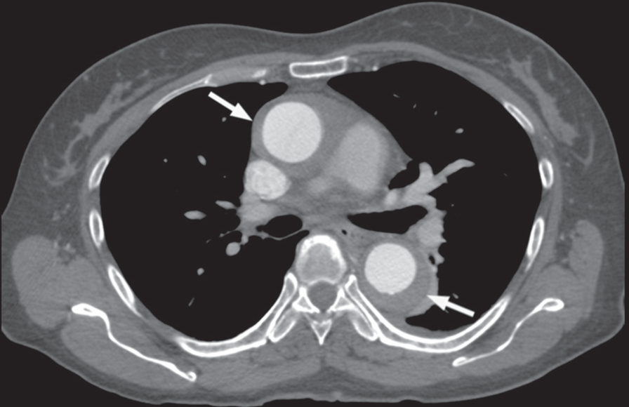
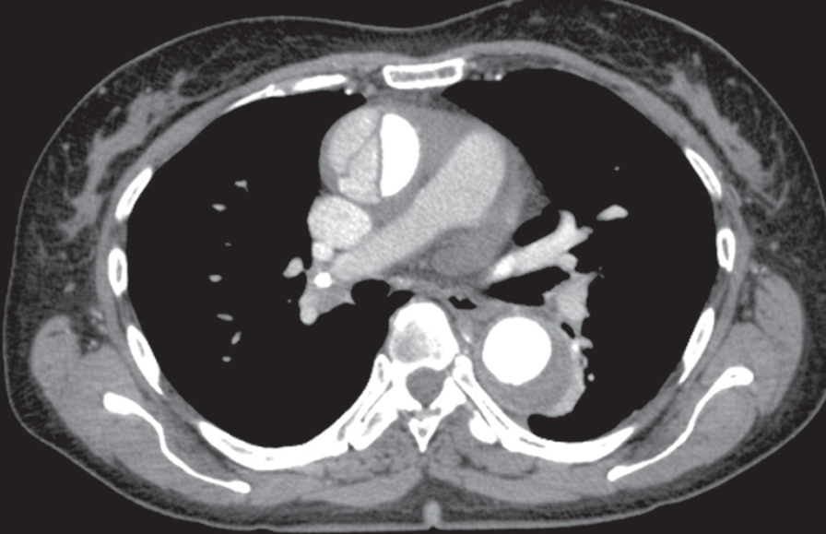
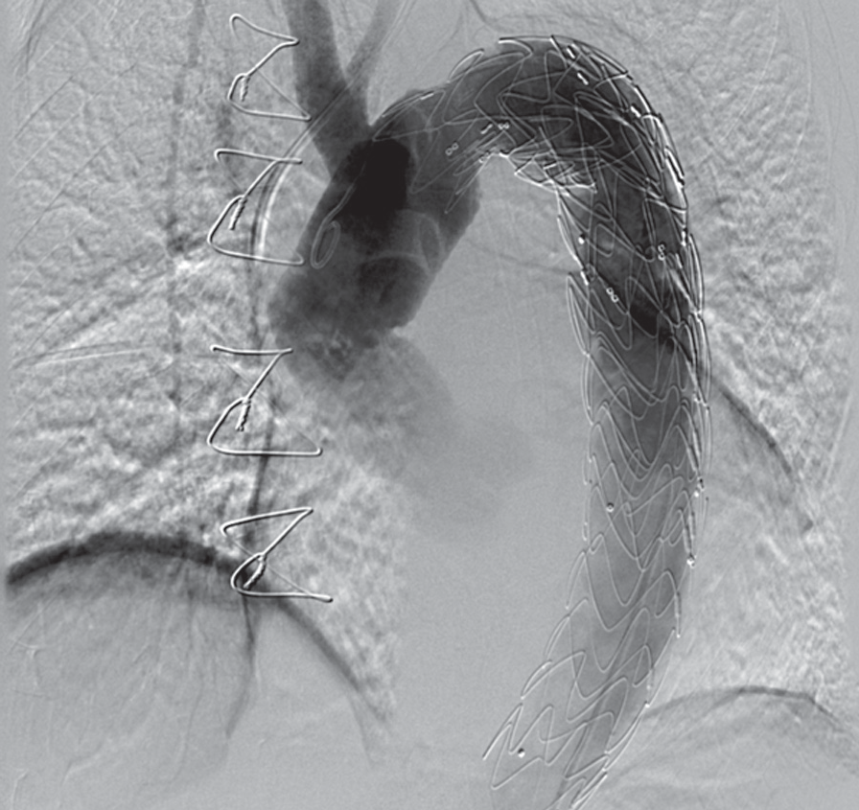
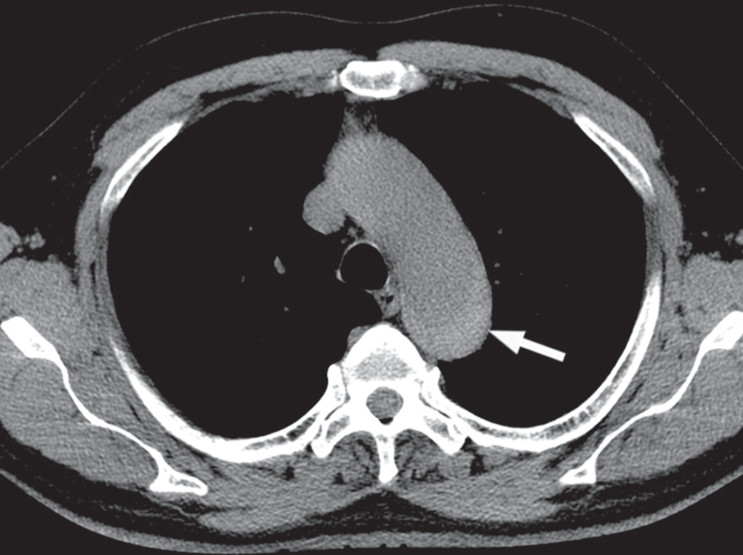
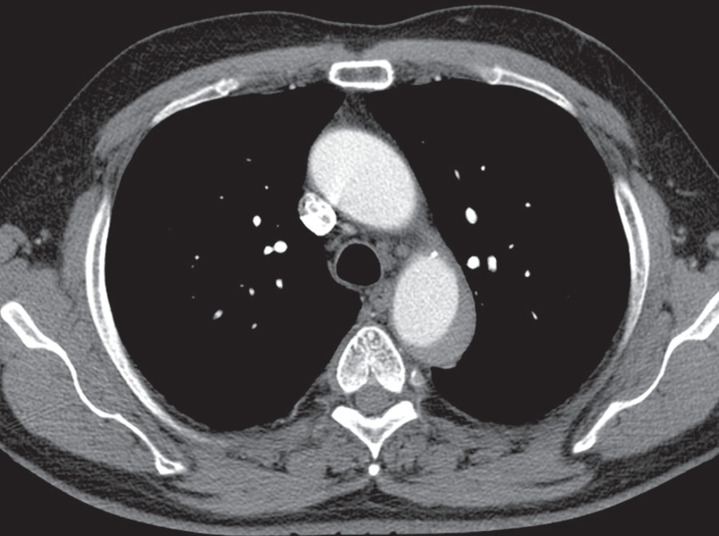
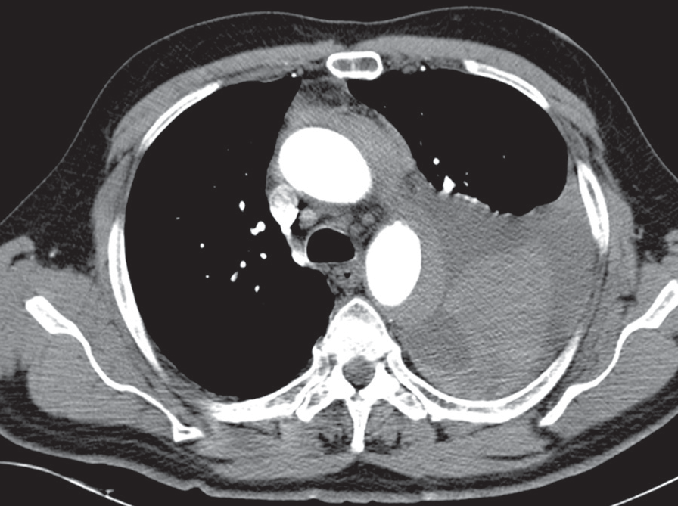
CaseReport
©PolJRadiol,2011;76(1):85-87
Figure1.Case1.(A)CTAatthetimeofadmission,presentingadilatationofthethoracicaortawithhypodense wallthickening (arrows).Notethe smallareaofatelectasisadjacenttothedescendingaorta,andthefluidintheleftpleuralcavity.(B)CTAperformedsevendayslater,revealinganacutedissection oftheascendingaorta.(C)Angiographyimagetakenafterthestent-graftimplantation.
Figure2.Case2.(A)Non-enhancedscanatthetimeofadmission,presentingahyperdenselesioninthelumenofthedescendingaorta(arrow).(B)Contrast-enhancedCTAconfirmswell-definedcrescentwallthickeningofthedescendingaorta.(C)CTAperformed6hourslatershowedahemorrhageintotheleftpleuralcavity.
examinationwasperformedinaprotocolofnon-enhancedandcontrast-enhancednon-gatedhelicalscanofthetho-racicaorta.Bothacquisitionswereobtainedwithacolli-mationof64×0.6mmat120kVpandatubecurrentmodu-lation.Contrastagentwasgivenatadoseof120mLwithinjectionrateof4mL/s.Contrast-enhancedscansrevealeda11-mmhypodense crescent-shapedwallthickeningofthedescendingaorta,whichwashyperdensebeforecontrastadministration(Figure2A,B).ThepatientwasdiagnosedashavingtypeBIMH,andsubjectedtoanemergentsur-gery.However,duringpreoperativeperiod,thehematoma
theprimarylesionsize,whichappearedtobeatypeAIMH(Figure1B).Thepatientwassuccessfullytreatedbyacom-binedsurgical-endovascularmethod:ascendingaortagraft-ingfollowedbyastent-graftimplantationintothedescend-ingaorta,whichgaveapositiveclinicaloutcome(Figure1C).
Case2
A63-year-oldmalepatientinagoodclinicalconditionwithamoderateatypicalchestpain,referredforCTA.The
86
A

B

C

A

B

C

©PolJRadiol,2011;76(1):85-87
SerafinZetal–CTimagingofaorticintramuralhematoma…
ruptured,resultinginafatalmassivehemorrhageintotheleftpleuralcavity(Figure2C).
thickening,withnormalandinvolvedsegmentswithintheaorta.Activeinflammationoftheaorticwallisassociatedwithcontrastenhancement,whilethetypicalperivascularfibrosisin chronic aortitiscan be betterdemonstrated withMRA.Similarly,lymphomacanbedifferentiatedfromIMHbycontrastenhancementandMRA,andpresentsasanirregularperiaorticmass,usuallyinvolvingotherorgans.
Discussion
IMHconsistsof13–29%ofAAScases[1],whichalsoincludestwo otherpathologies:acuteaortic dissection(AAD),andpenetratingaorticulcer(PAU).Allofthethreeentitieshaveasimilarclinicalpresentationbutadifferentnaturalhistory,andshouldbethereforedifferentiateddur-ingdiagnosticimaging.
Thefirstofourcaseswasmisdiagnosedduetotwomainreasons.Firstly,theexaminationdidnotincludenon-enhancedCTimages,andthereforethehyperdensityoftheaorticwallthickeningwasmissed.Moreover,ameasure-mentofCTattenuationofsuchsmallstructuresadjacenttothe contrast-filledaortalumen has alimited value owingtopartialvolumeaveraging.Secondly,thehematomahadnon-specificfeaturesinthispatient, i.e.circumferentialshape,involvementoftheentirethoracicaorta,andsimul-taneousaorticdilatation.Thedelayin thecorrectdiagnosisledtoaseriouscomplication–aorticdissection.OursecondcaserevealedtypicalfeaturesofIMHandwasdiagnosedproperly.However,thepatientdevelopedanaorticrupture,the most serious complication of IMH.
TherateofspontaneousregressionsofIMHisestimatedat34%[4].However,themortalityinIMHreaches21%,andresultsmostlyfromaorticwallrupture[5].Inunrupturedcases,themostcommoncomplicationsaretrueorfalseaneurysmsanddissections.InaseriesbyEvangelistaetal.[5],patientswithIMHdescribedamoresevereinitialpainthanpatientswithAAD,butwerelesslikelytohavelowerlimbischemia,pulsedeficits,oraorticvalveinsufficiency.Moreover,theyrequiredalongertimetodiagnosisandahighernumberofthediagnostictests.
DiagnosisofIMHisusuallymadewiththeuseoftrans-esophagealechosonography,CTA,ormagneticresonanceangiography(MRA),withinsignificantdifferencesinsensi-tivityandspecificitybetweenthetechniques[1].Ofthesemethods,CTAseemstobeofthegreatestimportanceduetoitsavailabilityandcomprehensivenessinemergencycondi-tions.Onnon-enhancedCTimages,IMHischaracterizedbyahyperdense(50–70HU)thickeningoftheaorticwall.Atyp-icalhematomahasasmoothsurface,crescentshape,thick-nessofatleast7mm,andlengthof3–20mm,andislocatedinthedescendingaorta[1].Thelesiondoesnotenhanceaftercontrastadministration,whichenablesitsdifferentiationfromAAD,PAUandotheraorticwallpathologies.
Unexpectedly,withcontemporarydevelopmentinCTtech-nology,thediagnosticwork-upofIMHseemstobeprob-lematicalinthesettingofemergencyradiology.Withanintroductionofthe64–320-rowmultisliceCTscanners,imagingofcoronaryarteriesinpatientssufferingfromacutechestpainbecamefeasibleandisofgreatinterest[6].Moreover,toincreasethecost-effectivenessofCT,triple-rule-outprotocolswereintroduced.Thisenabledimagingofcoronaries,pulmonaryarteries,andaorticlumeninsin-gleECG-gatedexaminations[7].Themostapparentadvan-tageofsuchprotocolsistheirhighnegativepredictivevalueinthediagnosticsofcoronaryarterystenosis,acutepulmonaryembolism,andAAD[8].However,beingtailoredtowardsthosethreepathologies,theydonotincludenon-enhancedscans[6–8]inordertospeedupthediagnosticprocessandtolimittheradiationdose,whichisessentialforIMHdemonstration.
DifferentialdiagnosisincasesofaorticwallthickeningshouldincludeAAD,atheroscleroticplaque,muralthrom-bus,aortitis,andlymphoma.AtypicalAADcaseiseasytodifferentiatefromIMHoncontrast-enhancedimages,becauseofanintimalflapseeninthevessellumen.Inrarecasesoffalselumenthrombosis,vizualizationofthesiteoftheintimalrearandspiralprogressionmayhelptocon-firmAAD.Atheroscleroticplaqueusuallyhasanirregularinternalshapeandincludescalcifications.Muralthrom-busischaracterizedbyhypodensity,circumferentialshape,andirregularluminalsurface.Itcommonlycoexistswithaneurysms.Aortitiscausesdiscontinuousconcentricwall
Conclusions
Inouropinion,omittingnon-enhancedCTexaminationsinpatientsadmittedforchestCTAduetoacutechestpainwillpossiblyleadtomisdiagnosesinasignificantnumberofnon-typicalIMHcases.Thepresentedcasessuggestthatanydelayinproperdiagnosisandtreatmentmayresultinfurtherseriouscomplications,includingfatalaorticrupture.
References:
- BuckleyO,RybickiFJ,GersonDS etal:Imagingfeaturesofintramuralhematomaoftheaorta.IntJCardiovascImaging,2010;26:65–76
- GoreI:Pathogenesisofdissectinganeurysmoftheaorta.AMAArchPathol,1952;53:142–53
- ParkKH, Lim C,Choi JH et al:Prevalenceof aortic intimaldefect insurgicallytreatedacutetypeAintramuralhematoma.AnnThoracSurg,2008;86:1494–500
- EvangelistaA,DominguezR,SebastiaCetal:Long-termfollow-upofaorticintramuralhematoma:predictorsofoutcome.Circulation,2003;108:583–89
- EvangelistaA,MukherjeeD,MehtaRHetal:Acuteintramuralhematomaoftheaorta:amysteryinevolution.Circulation,2005;111:1063–70
- HeinPA,RomanoVC,LembckeAetal:Initialexperiencewithachestpainprotocolusing320-slicevolumeMDCT.EurRadiol,2009;19:1148–55
- HalpernEJ:Triple-rule-outCTangiographyforevaluationofacutechestpainandpossibleacutecoronarysyndrome.Radiology,2009;252:332–45
- SchertlerT,FrauenfelderT,StolzmannPetal:Triplerule-outCTinpatientswithsuspicionofacutepulmonaryembolism:findingsandaccuracy.AcadRadiol,2009;16:708–17
87

