

© Pol J Radiol 2022; 87: e202-e206
DOI: https://doi.org/10.5114/pjr.2022.115706
Received: 13.03.2021
Accepted: 23.03.2021
Published: 01.04.2022
http://www.polradiol.com
Original paper
Optic nerve sheath diameter and its implications in the evaluation
of cerebral venous sinus thrombosis
Sudha Kiran DasA,B,C,D,E,F, Saurabh JindalB,C,D,E,F, Vikram PatilD,E,F, Sachin T.B,D,E,F
JSS Medical College, Jssaher, India
Abstract
Purpose: To ascertain the role of optic nerve sheath diameter (ONSD) in the evaluation of cerebral venous sinus throm- bosis (CVST).
Material and methods: A retrospective study with convenient sampling was done during the period November 2018 to January 2020. Forty-one patients across all age groups with magnetic resonance venography (MRV) diagnosis of CVST and 82 gender-matched controls were included in the study. ONSD was measured on axial T2-weighted magnetic resonance images. CVST was identified on axial TOF-MRV including the stage, degree, and location. Intraparenchymal infarction and haemorrhage were also noted with their stage and size. The distribution of values for ONSD was tested for equality of variances using independent samples t-test. A cut-off value for ONSD was derived using ROC analysis.
Results: The mean difference between ONSD of cases and controls was 0.84 mm (95% CI: 0.61-1.06) and was statistically significant at p < 0.001. Mean ONSD in cases was 5.33 ± 0.66, and in the control group it was 4.49 ± 0.31. The cut-off value for ONSD was taken as 4.57 mm, derived using the ROC analysis (AUC was 0.876 suggesting good diagnostic accuracy). ONSD showed a sensitivity of 87% and a negative predictive value of 89% in predicting CVST. However, we found no statistical significance between ONSD in patients with acute or chronic thrombosis or in those with neuropa- renchymal complications.
Conclusions: ONSD is a valid triage tool with high sensitivity and negative predictive value, and it can be used in the evaluation of CVST.
Key words: cerebral venous sinus thrombosis, optic nerve sheath diameter, MRI.
crease pressure within hours of symptom onset, including
emergent decompressive hemicraniectomy.
Direct intracranial pressure (ICP) monitoring with shunts is an invasive procedure and not without complica- tions. There is growing interest in the use of the optic nerve sheath diameter (ONSD) as a surrogate non-invasive marker of ICP [2]. The optic nerve sheath has a high spatial resolu- tion on magnetic resonance imaging (MRI). Measurement of the optic nerve sheath by MRI may be an ideal reference due to high spatial resolution. The aim of this study was to assess the diagnostic accuracy of ONSD in the evaluation
Introduction
Cerebral venous sinus thrombosis (CVST) is a chal-
lenging diagnosis for both clinicians and radiologists due to its highly variable clinical presentation, including headache and stroke-like symptoms. There is an average delay of 1 week from the onset of symptoms to the time of diagnosis, and it is associated with poor outcomes [1]. In the acute phase, patients are at risk of cerebral herniation and death due to elevated intracranial pressure. In addition to anticoagulation, patients may require measures to de-
Correspondence address:
Sudha Kiran Das, JSS Medical College, Jssaher, India, e-mail: sudha7492@gmail.com
Authors’ contribution:
A Study design ∙ B Data collection ∙ C Statistical analysis ∙ D Data interpretation ∙ E Manuscript preparation ∙ F Literature search ∙ G Funds collection
This is an Open Access journal, all articles are distributed under the terms of the Creative Commons Attribution-Noncommercial-No Derivatives 4.0
International (CC BY-NC-ND 4.0). License (https://creativecommons.org/licenses/by-nc-nd/4.0/).
e202

Optic nerve sheath diameter and its implications in the evaluation of cerebral venous sinus thrombosis
of CVST and determine its association with stage/degree
thrombosis and intracranial haemorrhage.
Statistical analysis
The data was analysed using International Business Machines-Statistical Package for Social Sciences (IBM SPSS) version 20.0 software for windows. The data fol- lowed a normal distribution. Based on distribution, the median was used to express the central tendency. A cut- off value for ONSD was derived using receiver operator characteristic (ROC) curve analysis. The area under the curve (AUC), sensitivity, specificity, and predictive values were calculated with standard formulae, to establish diag- nostic accuracy. The distribution of values was tested for equality of variances using Levene’s test. The distribution of values was tested for equality of means using indepen- dent samples t-test with a 95% confidence interval (CI). A p < 0.01 was considered statistically significant.
Material and methods
Study setting and patient characteristics
This was a cross-sectional analytical study conducted at the Department of Radiodiagnosis at a tertiary care hospi- tal. All patients with a plain magnetic resonance venogra- phy (MRV) diagnosis of CVST were retrospectively identi- fied from the departmental database between November 2018 and January 2020 (13 months). This was performed using a keyword search of imaging reports containing the terms “cerebral venous thrombosis” and “dural sinus thrombosis” in the diagnostic text line. A total of 41 cases across all age groups were identified. Among these were 23 males and 18 females. A control group comprising of 82 sex-matched individuals were also included. Pertinent sociodemographic data (age and sex) and clinical details (presentation and mode of onset) were noted. The study was conducted after obtaining approval from the Institu- tional Review Board.
Results
Patient characteristics
A total of 41 cases with CVST and 82 controls were analysed in the present study. The median age for the cases was 36 years with an interquartile range of 28, a minimum age of 18, and a maximum of 80 years. The median age for controls was 44.5 years with an interquartile range of 27, minimum age of 15, and a maximum age of 70 years. The cases and controls were sex-matched with 56.1% (23/41) males and 43.9% (18/41) females. The most com- mon clinical symptom was headache followed by altered consciousness. A right-sided CVST was noted in 15/41 (36%) cases, left-sided in 14/41 (34%), and bilateral in the remaining cases. There was simultaneous involvement of transverse sinus, sigmoid sinus, and internal jugular vein in 41% of cases at the time diagnosis. One-fifth (9/41) of the cases were diagnosed with a single sinus thrombosis. The most common sinus involved was the transverse sinus followed by the superior sagittal sinus and the sigmoid sinus. A small proportion (10%) had involvement of all the dural venous sinuses.
Imaging protocol
All subjects included in the study underwent imaging on a 3.0 T MRI scanner (Philips Ingenia, Netherlands) with a 32-channel phased-array receive-only head coil. The MRI protocol included axial T1-weighted images (WI) (repetition time/echo time [TR/TE], 450/10 ms), axial T2-WI (TR/TE, 3000/80 ms; slice thickness 5 mm; matrix – 400 × 255), diffusion-weighted imaging (TR/TE, 3539/114 ms; b-factor 1000), T2*-weighted gradient echo sequence (TR/TE, 843/16 ms), and time-of-flight – MRV (TR/TE, 16,3.5 ms; slice thickness 3 mm) images.
Image interpretation
The images were interpreted by an experienced radio- logist (author S.K.D.) who was blinded to the MRI find- ings. First, on axial T2W images, the retrobulbar area was magnified 5 times, and the ONSD was measured on either side separately, in an axis perpendicular to the optic nerve and 3 mm behind the globe. Combined ONSD was cal- culated by adding the ONSD values from either side and dividing the sum by a factor of 2. After measuring the ONSD, axial TOF-MRV was used to look for dural venous sinus thrombosis, including location, number of sinuses involved, degree (complete or partial), and stage (acute or chronic) of thrombosis. A non-visualization of the sinus was regarded as complete thrombosis. The presence of collaterals was noted for chronic thrombosis. Intraparen- chymal haemorrhage and infarction were also noted with their size, location, and stage.
Analysis of optic nerve sheath diameter between the case and the control groups
The mean ONSD ± SD for the right and the left eyes were 5.28 ± 0.71 mm and 5.38 ± 0.76 mm, respectively. The combined mean ONSD was 5.33 ± 0.66 mm in the cas- es and 4.49 ± 0.31 mm in the control group (p < 0.0001). The mean difference between the case and controls for the right and left eye were 0.84 mm (p < 0.0001; 95% CI: 0.61-1.07) and 0.87 mm (p < 0.0001; 95% CI: 0.58-1.08),
respectively. The combined difference for both sides was 0.84 mm (p < 0.0001; 95% CI: 0.61-1.06).
The cut-off value for ONSD derived from ROC analysis was 4.57 mm. At this value, the AUC was 0.876 (Figure 1). The sensitivity, specificity, positive predic-
© Pol J Radiol 2022; 87: e202-e206
e203

Sudha Kiran Das, Saurabh Jindal, Vikram Patil, Sachin T.
0.9
(p = 0.0.34). The p-values with mean and CI are shown in
Table 1. Representative cases of acute and chronic CVST are shown in Figures 2 and 3.
0.8
0.7
0.6
0.5
Association of optic nerve sheath diameter with neuro- parenchymal complications
Around half (49%) of all patients had a high signal on diffusion-weighted imaging, consistent with acute infarc- tion. Only 6 patients had chronic infarction. Of the total 41 cases, 17 (41%) were complicated by an intracranial haemorrhage, 11 had an acute bleed with an iso-hyperin- tense signal on T1-WI, and 6 had a hypointense signal on T1-WI suggesting a chronic bleed. The maximum volume of bleed noted among our cases was ~70-80 cc (6 cm × 6 cm × 4.5 cm) with the most common location being parieto-temporal lobes (43% of cases). Neither the presence nor the stage of haemorrhage were associated with ONSD. The p-value with mean and CI are shown in Table 1.
0.4
0.3
0.2
0.1
0
0.0
0.2
0.4
0.6
0.8
1.0
1-Specificity
Figure 1. ROC curve. Test result variable: averaged optic nerve sheath dia- meter (mm). AUC – 0.876
Table 1. Parametric associations with optic nerve sheath diameter
Discussion
CVST is an uncommon, potentially life-threatening
condition that affects young adults, typically females
< 40 years of age. The diagnosis can be challenging due to a wide range of clinical presentations that often mimic other neurological conditions. The clinical presentation depends on the onset, location, and size of the thrombus. Despite advances in diagnostic techniques, a misdiagnosis occurs in 1 out of 30 patients in the emergency setting [3]. The mortality rate in the acute phase is ~3-15%, and around 10% develop secondary complications like haem- orrhage, vision loss, and neurological deficits [1,4,5]. A quick and precise diagnosis is, therefore, essential to decrease this risk. An MRV is not usually obtained dur- ing the initial workup when this diagnosis is not clinically suspected. In these cases, the radiologist may be the first to suggest the diagnosis and plays a critical role in ensur- ing the patient receives prompt and appropriate care.
Around 50% of patients with CVST present with fea- tures of raised ICP and > 80% have an elevated cerebrospi- nal fluid opening pressure [6]. Direct monitoring of ICP through a shunt is invasive and associated with complica- tions. The subarachnoid space continues along the optic
tive value (PPV), and negative predictive value (NPV)
for this cut-off were 0.88, 0.53, 0.94, and 0.89, respec-
tively (Table 2).
Association of optic nerve sheath diameter with stage and degree of thrombosis
An acute thrombotic event was seen in approximately two-thirds (68%) of cases. Out of the 13 patients who had chronic thrombosis, most of them had development of collaterals (84%). There was no association between ONSD and the stage of thrombosis. Complete thrombosis was observed in 61% (25/41), while the remaining 16 had partial occlusion. The mean value of ONSD in cases with partial thrombosis was 5.24 ± 0.40 mm and in complete thrombosis was 5.39 ± 0.79 mm. ONSD values showed a significant association with degree of thrombosis
Table 2. Comparison of measures of diagnostic accuracy [15-17,19]
ONSD – optic nerve sheath diameter
e204
© Pol J Radiol 2022; 87: e202-e206
Sensitivity
Study Imaging modality ONSD threshold (mm)
Sensitivity (%) Specificity (%) AUC
Dong et al., 2016
MRI
5.0
64
97
0.85
David et al., 2016
MRI
6.0
77
83
0.84
David et al., 2016
USG
4.8
77
82
0.86
Moretti et al., 2009
USG
5.2
94
76
–
Maissan et al., 2015
USG
5.0
94
98
0.99
Present study, 2020
MRI
4.6
87
53
0.88
Parameter
p-value Mean difference CI
Stage of thrombosis
0.350
0.50
–0.10 to 1.11
Degree of thrombosis
0.034
–0.14
–0.58 to 0.28
Haemorrhage
0.100
0.14
–0.31 to 0.59

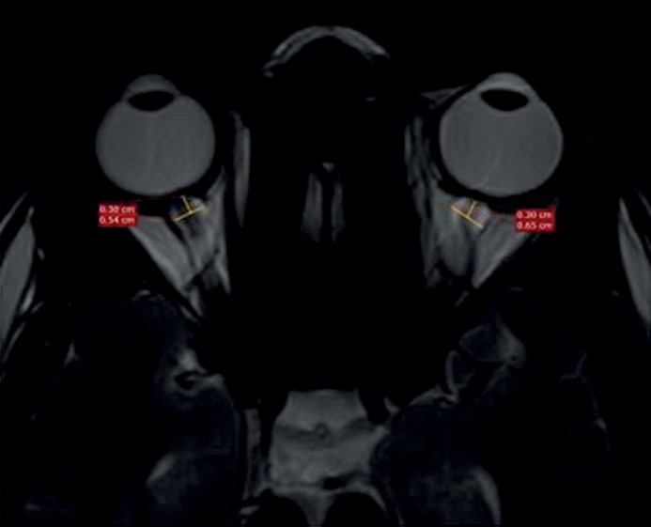
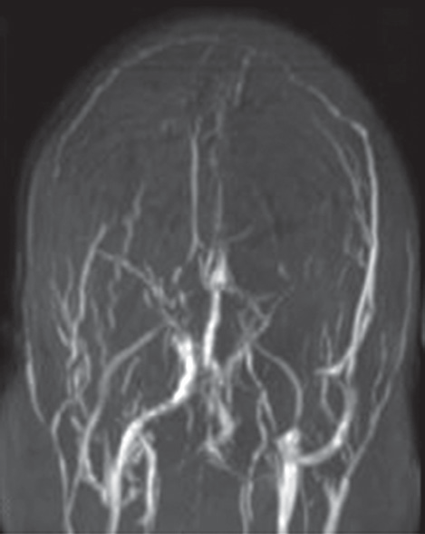
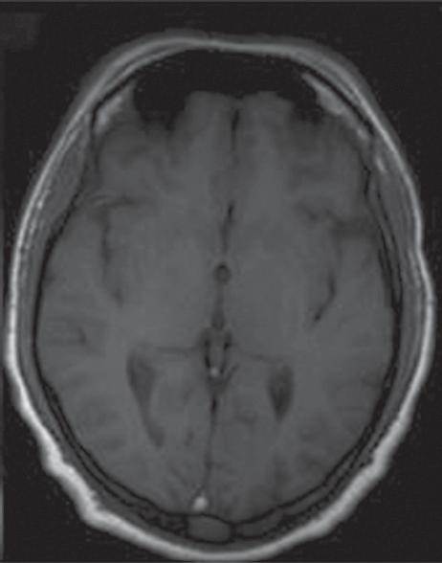
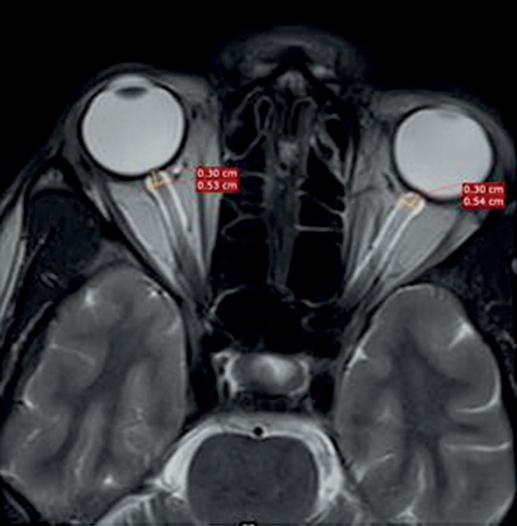
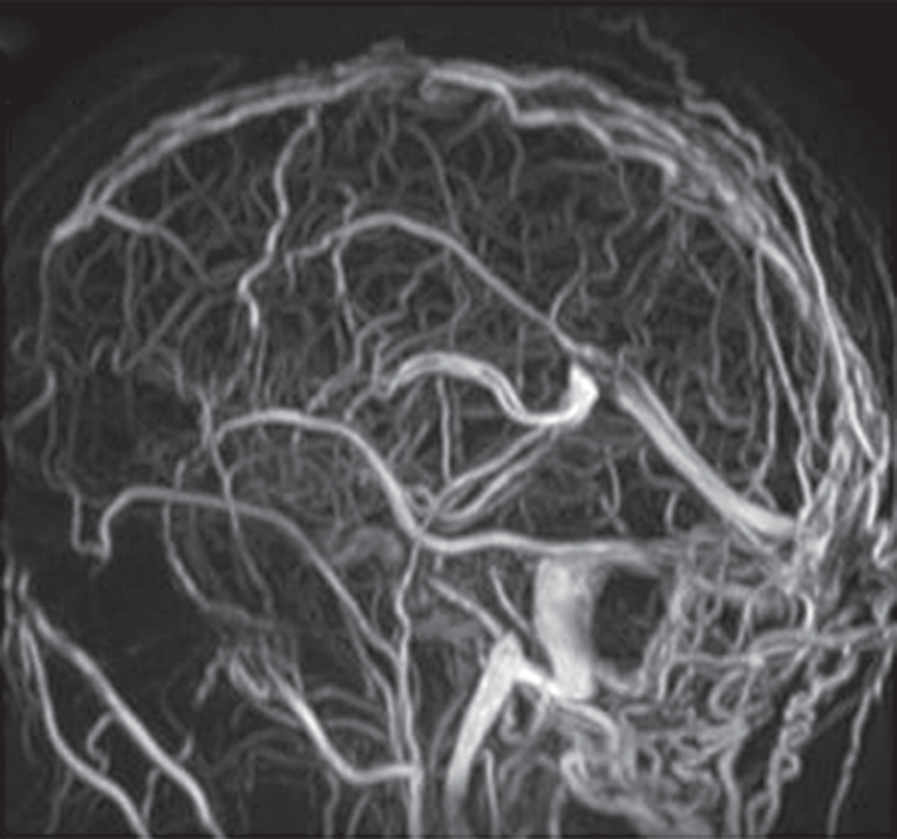
Optic nerve sheath diameter and its implications in the evaluation of cerebral venous sinus thrombosis
A
A
C
B
B
Figure 2. A patient with acute cerebral venous sinus thrombosis. A) Axial T2WI showing bilateral increased optic nerve sheath diameter. B) Coronal TOF-MRV image showing complete absence of flow related signal in su- perior sagittal sinus, bilateral transverse sinuses, and left sigmoid sinus, suggestive of acute thrombosis. C) Axial T1WI showing hyperintense signal in the region of superior sagittal sinus consistent with thrombosis
Figure 3. A patient with chronic cerebral venous sinus thrombosis. A) Axial T2WI showing bilateral increased optic nerve sheath diameter. B) Sagittal TOF-MRV image showing multiple tortuous collaterals and venous channels, consistent with chronic thrombosis
nerve within the optic nerve sheath, which is an extension
of the dura mater. Raised ICP is transmitted through the CSF within this sheath causing a measurable increase in the ONSD. There is growing interest in the use of ONSD as an indicator of elevated ICP, as shown in previous stud- ies in the literature. Elevations in ONSD (3.0-5.9 mm) have been reported in patients with traumatic brain injury and idiopathic intracranial hypertension. An elevated ICP seems to be the common mechanism underpinning these conditions [7-19]. To our knowledge, this is the first study to evaluate the role of ONSD in patients with CVST.
In our study, the mean ONSD of patients was signifi- cantly higher than the mean of the controls (5.33 ± 0.66 mm vs. 4.49 ± 0.30 mm) (p < 0.0001). We derived a cut-off value of 4.57 mm from our ROC curve, which gave us a sensitivity of 87.8% and a specificity of 53%. A similar study by Dong et al. obtained an ONSD cut-off of 5 mm in patients with acute CVST. They reported a sensitivity of 64.5% and specificity of 96% [1].
We also observed a significantly higher ONSD in patients with collaterals, which is because there is an in- crease in the venous load as the collateral channels open up and the ICP is persistently high [20]. This is important
because prolonged pressure on the optic nerves can re-
sult in permanent blindness; therefore, it is important to monitor the ONSD during the period of increased pres- sure periodically to guide the therapy.
ONSD can be measured by USG or MRI. The high res- olution of MRI makes it the investigation of choice. How- ever, limited availability, increased scan times, motion- and flow-related artifacts, and higher cost restrict its wider use as a follow-up tool. Ultrasonographic ONSD mea- surement has recently become a popular non-invasive ap- proach for the detection of elevated ICP [21]. Moreover, measuring ONSD via ultrasound is a repeatable and quick method because the orbital window is easily available and uncomplicated in most patients. According to David et al., absolute values of ONSD differed between USG and MRI, they provided almost identical sensitivities and specifici- ties [17]. Few other studies in the past have shown good reproducibility and a robust observer-agreement for both
© Pol J Radiol 2022; 87: e202-e206
e205

Sudha Kiran Das, Saurabh Jindal, Vikram Patil, Sachin T.
ultrasound and MRI for ONSD 3 mm behind the papilla
[22-24].
The main limitation of our study is its retrospective nature. Serial follow-up imaging might have given us bet- ter results. Another limitation was that the MRI examina- tions did not include isotropic high-resolution imaging of the orbits but rather whole-brain axial T2 images of lower resolution.
tion of CVST. Further studies with sequential ONSD are
needed to establish ONSD as a point-of-care ultrasound tool (POCUS) for elevated intracranial pressure in sus- pected CVST.
Conflict of interest
The authors report no conflict of interest.
Conclusions
ONSD is a valid triage tool with high sensitivity and
negative predictive value and can be used in the evalua-
References
- Ferro JM, Canhão P, Stam J, et al. Prognosis of cerebral vein and
dural sinus thrombosis: results of the International Study on Cer- ebral Vein and Dural Sinus Thrombosis (ISCVT). Stroke 2004; 35: 664-670.
- Geeraerts T, Newcombe VF, Coles JP, et al. Use of T2-weighted mag- netic resonance imaging of the optic nerve sheath to detect raised intracranial pressure. Crit Care 2008; 12: R114.
- Liberman AL, Gialdini G, Bakradze E, et al. Misdiagnosis of cer- ebral vein thrombosis in the emergency department. Stroke 2018; 49: 1504-1506.
- Canhão P, Ferro JM, Lindgren AG, et al. Causes and predictors of death in cerebral venous thrombosis. Stroke 2005; 36: 1720-1725.
- Coutinho JM, Zuurbier SM, Aramideh M, Stam J. The incidence of cerebral venous thrombosis: a cross-sectional study. Stroke 2012; 43: 3375-3377.
- Koban Y, Ozlece H, Karayol S, Huseyinoglu N. Decreased retinal nerve fiber layer thickness in patients with cerebral venous throm- bosis. BMC Ophthalmol 2019; 19: 57.
- Kimberly HH, Noble VE. Using MRI of the optic nerve sheath to detect elevated intracranial pressure. Crit Care 2008; 12: 181.
- Hirfanoglu T, Aydin K, Serdaroglu A, et al. Novel magnetic reso- nance imaging findings in children with intracranial hypertension. Pediatr Neurol 2015; 53: 151-156.
- Hansen HC, Helmke K. Validation of the optic nerve sheath response to changing cerebrospinal fluid pressure: ultrasound findings during intrathecal infusion tests. J Neurosurg 1997; 87: 34-40.
- Hassen GW, Al-Juboori M, Koppel B, et al. Real time optic nerve sheath diameter measurement during lumbar puncture. Am J Emerg Med 2018; 36: 736.e1-736.e3.
- Raffiz M, Abdullah JM. Optic nerve sheath diameter measurement: a means of detecting raised ICP in adult traumatic and non-trau- matic neurosurgical patients. Am J Emerg Med 2017; 35: 150-153.
- Major R, Girling S, Boyle A. Ultrasound measurement of optic nerve sheath diameter in patients with a clinical suspicion of raised intrac- ranial pressure. Emerg Med J 2011; 28: 679-681.
- Maralani PJ, Hassanlou M, Torres C, et al. Accuracy of brain imaging in the diagnosis of idiopathic intracranial hypertension. Clin Radiol
2012; 67: 656e63.
- Moretti R, Pizzi B, Cassini F, Vivaldi N. Reliability of optic nerve
ultrasound for the evaluation of patients with spontaneous intracra- nial hemorrhage. Neurocrit Care 2009; 11: 406-410.
- Maissan IM, Dirven PJ, Haitsma IK, et al. Ultrasonographic meas- ured optic nerve sheath diameter as an accurate and quick monitor for changes in intracranial pressure. J Neurosurg 2015; 123: 743-747.
- Patterson DF, Ho ML, Leavitt JA, et al. Comparison of ocular ultra- sonography and magnetic resonance imaging for detection of in- creased intracranial pressure. Front Neurol 2018; 9: 278.
- Rajajee V, Vanaman M, Fletcher JJ, Jacobs TL. Optic nerve ultra- sound for the detection of raised intracranial pressure. Neurocrit Care 2011; 15: 506.
- Dong C, Zheng YM, Li XL, et al. Morphometric MRI changes in intracranial hypertension due to cerebral venous thrombosis: a ret- rospective imaging study. Clin Radiol 2016; 71: 691-697.
- Aaron S, Arthur A, Prabakhar AT, et al. Spectrum of visual impair- ment in cerebral venous thrombosis: importance of tailoring thera- pies based on pathophysiology. Ann Indian Acad Neurol 2017; 20: 294-301.
- Robba C, Santori G, Czosnyka M, et al. Optic nerve sheath diameter measured sonographically as non-invasive estimator of intracranial pressure: a systematic review and meta-analysis. Intensive Care Med 2018; 44: 1284-1294.
- Wang LJ, Chen HX, Tong L, et al. Ultrasonographic optic nerve sheath diameter monitoring of elevated intracranial pressure: two case reports. Ann Transl Med 2020; 8: 20.
- Bäuerle J, Schuchardt F, Schroeder L, et al. Reproducibility and ac- curacy of optic nerve sheath diameter assessment using ultrasound compared to magnetic resonance imaging. BMC Neurol 2013; 13: 187.
- Steinborn M, Fiegler J, Ruedisser K, et al. Measurement of the optic nerve sheath diameter in children: comparison between transbulbar sonography and magnetic resonance imaging. Ultraschall Med 2012,
33: 569-573.
e206
© Pol J Radiol 2022; 87: e202-e206

