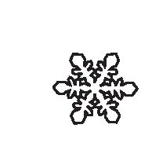

vol. 35, no. 4, pp. 627-646, 2014
doi: 10.2478/popore-2014-0029

Cold stress effects on organelle ultrastructure
in polar Caryophyllaceae species

Irena GIEŁWANOWSKA12*, Marta PASTORCZYK1 Maja LISOWSKA3,
Michał WĘGRZYN3 and Ryszard J. GÓRECKI1
1 Katedra Fizjologii, Genetyki i Biotechnologii Roślin, Wydział Biologii i Biotechnologii,
Uniwersytet Warmińsko-Mazurski w Olsztynie, ul. Oczapowskiego 1A, 10-719 Olsztyn, Poland
2 Instytut Biochemii i Biofizyki PAN, Zakład Biologii Antarktyki i Polska Stacja
Antarktyczna“H. Arctowski”, ul. Ustrzycka 10/12, 02-141 Warszawa, Poland
3 Zakład Badań i Dokumentacji Polarnej, Instytut Botaniki, Uniwersytet Jagielloński,
ul. Lubicz 46, 35-506 Kraków, Poland
* corresponding author <i.gielwanowska@uwm.edu.pl>
Abstract: This study investigated leaf mesophyll cells of Caryophyllaceae plants growing in
polar regions - Cerastium alpinum and Silene involucrata from the Hornsund region of
Spitsbergen island (Svalbard Archipelago, Arctic), and Colobanthus quitensis from the Ad-
miralty Bay region on King George Island (South Shetland Islands, West Antarctic). Ultra-
structural changes were analyzed in mesophyll protoplasts of plants growing in natural Arctic
and Antarctic habitats and plants grown in a greenhouse, including plants exposed to
short-term cold stress under semi-controlled conditions. Cell organelles of plants growing in
natural polar habitats and greenhouse-grown plants were characterized by significant mor-
phological plasticity. Chloroplasts of plants studied in this work formed variously shaped pro-
trusions and invaginations that visibly increased the contact area between adjacent cell com-
partments and reduced the distance between organelles. S. involucrata plants grown under
greenhouse conditions, tested by us in this work, were characterized by highly dynamic cell
nuclei with single or multiple invaginations of the nuclear membrane and the presence of
channels and cisternae filled with cytoplasm and organelles. Crystalline inclusion proteins
were observed in the cell nuclei of C. quitensis between nuclear membranes and in the direct
proximity of heterochromatin. Our study revealed significant conformational dynamics of
organelles, manifested by variations in the optical density of matrices, membranes and enve-
lopes, in particular in C. quitensis, which could suggest that the analyzed Caryophyllaceae
taxa are well adapted to severe climate and changing conditions in polar regions.
Key words: Arctic, West Antarctic, Cerastium alpinum, Colobanthus quitensis, Silene
involucrata, cold stress, organelles.

Introduction

Vascular plants inhabiting polar regions have developed specific adaptive
traits that enable them to respond to changes in environmental conditions, includ-

Pol. Polar Res. 35 (4): 627-646, 2014
628
Irena Gielwanowska et al.
ing changes that take place within a short period of time (Day et al. 1999; Lutz
2010; Parnikoza et al. 2011). Analyses of flowering plants growing in their natural
habitats revealed the stability of the photosynthetic apparatus during the day/night
cycle and throughout the growing season. Severe conditions in the Antarctic prob-
ably induced genetic changes that maximized the photosynthetic efficiency of the
studied plants (Bravo et al. 2007); therefore, low temperature is not a limiting fac-
tor. The optimal temperature for photosynthesis is 13°C in Deschampsia antarc-
tica E. Desv. and 19°C in Colobanthus quitensis (Kunth) Bartl., but the efficiency
of photosynthesis in both species can exceed 30% at a temperature of 0°C (Xiong
et al. 1999; Casanova-Katny et al. 2006). The above indicates that the analyzed
taxa are able to effectively assimilate carbon at low temperatures (Perez-Torres et
al. 2006) and have developed effective mechanisms to neutralize reactive oxygen
species (Perez-Torres et al. 2004).
One of the mechanisms by which polar plants protect themselves against low
temperature is the synthesis of various stabilizing proteins whose presence in plant
cells has been demonstrated by various studies (Reyes et al. 2003; Bravo and Grif-
fith 2005; Olave-Concha et al. 2005; John et al. 2009). The majority of those stud-
ies investigated C. quitensis and D. antarctica, native species of West Antarctic
(Parnikoza et al. 2011). The D. antarctica genome probably contains more than
ten genes encoding dehydrins, proteins that maintain the cell’s physiological in-
tegrity under stress. Dehydrins were observed mostly in tissues where the process
of ice crystal formation is initiated - the epidermis and bundle sheaths of D.
antarctica (Olave-Concha et al. 2005).
Anti-freeze proteins (AFPs) constitute a specific group of proteins that prevent
the formation of ice crystals in the tissues of D. antarctica (Bravo and Griffith
2005). AFPs inhibit the growth and modify the shape of ice crystals in the apoplast,
which slows down protoplast dehydration and increases the plant’s resistance to
frost (Doucet et al. 2000; Griffith and Yaish 2004). Bravo and Griffith (2005) ob-
served that AFP accumulation is a part of the mechanism of low-temperature toler-
ance in D. antarctica. Ice recrystallization inhibition proteins (IRIPs) play a simi-
lar role in the apoplast of the analyzed species (John et al. 2009). No such mecha-
nisms were observed in C. quitensis plants (Bravo and Griffith 2005) that avoid
freeze damage through tissue cooling (Bravo et al. 2001).
Heat shock proteins (HSPs) with molecular weight of 70 kDa were also identi-
fied in D. antarctica (Reyes et al. 2003). The main role of HSPs is to prevent pro-
tein aggregation.
Studies of cold-sensitive plants such as beans and cold-resistant plants, such as
peas revealed, that differences in the protein and lipid composition of thylakoid
membranes determine plants’ sensitivity to low temperatures (Garstka et al. 2007).
The subcooling of pea and bean plants at low night-time temperatures and optimal
day-time temperatures induced considerable changes in the chloroplast structures
of both cold-sensitive and cold-resistant plants, but the observed processes were
Cold stress effects on organelle ultrastructure
629
much slower in pea chloroplasts. Cold stress led to changes in the structure of pro-
tein-chlorophyll photosynthetic complexes, in particular in the proportions of an-
tenna protein isoforms in both peas and beans (Rumak et al. 2010). At low temper-
atures, the concentrations of hydrogen peroxide and nitric oxide were higher in the
cells of bean than pea plants. The observed changes clearly indicate that the struc-
ture of chloroplasts is closely linked to their function (Kolodziejek et al. 2007).
Cold stress is often accompanied by dehydration of plant cells due to water
freezing in tissues. Significant water loss is manifested by the degradation of inter-
nal chloroplast and mitochondrial membranes and the gradual breakdown of the
mitochondrial stroma and matrix (Lopez-Carbonell et al. 1994).
Physiological responses to environmental stressors are manifested in the
ultrastructure of cell organelles. Chloroplasts are the most damage-sensitive orga-
nelles (Kratsch and Wise 2000). The shape and content of chloroplasts and the
structure of their internal membranes are influenced by environmental stressors.
Studies involving microscopic analyses revealed significant plasticity of cell
organelles in several species of polar and alpine flowering plants (Lütz et al. 2012),
which was manifested by the examined taxa’s ability to produce various surface de-
formations. The evaluated plants contained chloroplasts with pockets filled with cy-
toplasm, vesicles and organelles, chloroplasts with differently sized protrusions con-
taining stroma and thylakoid systems (Gielwanowska 2003; Gielwanowska et al.
2005; Gielwanowska and Szczuka 2005), chloroplasts with vast areas that were free
of thylakoids and were filled only with stroma (Holzinger et al. 2007a, b) as well as
thin and long protrusions - stromules (Shaw and Gray 2011). Similar chloroplasts
with numerous invaginations filled with mitochondria were observed in the cells of
Antarctic lichen algae (Gielwanowska and Olech 2012).
Dense stroma, a well organized system of internal membranes and differences
in their conformational state are the characteristic features of mitochondria in the
mesophyll of flowering plants native to the Antarctic (Gielwanowska et al. 2005).
Very large peroxisomes with a dense matrix were noted in the direct proximity
of mitochondria and chloroplasts in mesophyll cells of polar plants and high-al-
pine vascular plants (Lütz and Engel 2007). In Poaceae plants of polar regions,
peroxisomes are accompanied by crystalline protein structures in the matrix
(Gielwanowska et al. 2005). Peroxisomes are usually spherical, but variously
shaped and elongated peroxisomes were also reported (Muench and Mullen 2003).
The existing research failed to demonstrate whether the noted protrusions are indi-
rect structures created during biogenesis or structures that participate in metabolite
exchange and increase the contact area between cell organelles, as is the case with
chloroplast deformations - stromules (Muench and Mullen 2003).
The nuclei of mesophyll cells in flowering plants are generally spherical, but
they can take on various shapes. Different visualization techniques have been used
to analyze atypical characteristics of cell nuclei, including their ability to create
grooves and invaginations (Singh et al. 1998; Collings et al. 2000; Meier 2001).
630
Irena Giełwanowska et al.
This study examined the ultrastructure of organelles in the mesophyll cells of
Caryophyllaceae plants: Cerastium alpinum L. and Silene involucrata (Cham. et
Schltdl.) growing in the Arctic and Colobanthus quitensis native to West Antarc-
tic. Leaf mesophyll cells from plants growing in natural habitats were chemically
preserved at harvest. This study also analyzed leaf mesophyll cells from the same
plant species grown in an experimental greenhouse, including plants exposed to
short-term cold stress.

Materials and methods
Plant material. — Colobanthus quitensis, Cerastium alpinum and Silene invo-
lucrata plants were harvested during polar expeditions organized in 2008-2010 in
the region of the Stanisław Siedlecki Polish Polar Station in Hornsund, Spitsbergen
(77°00’ N and 15°33’ E) and the Henryk Arctowski Polish Antarctic Station on King
George Island (62°09’ S and 58°28’ W, South Shetland Islands). The plants were
chemically preserved and embedded in epoxide resin at harvest.
Plant cultivation. — Seeds and live plants were secured and transported to
Olsztyn. Plant specimens were planted in pots with garden soil, and seeds were
sown in soil and grown at approximately 20°C in the experimental greenhouse of
the Wydział Biologii i Biotechnologii Uniwersytetu Warmińsko-Mazurskiego
w Olsztynie (Faculty of Biology and Biotechnology of the University of Warmia
and Mazury in Olsztyn). Plant tissue was sampled for analysis. In this study,
those plants are referred to as greenhouse plants grown at a temperature of 20°C.
Selected specimens were additionally grown in a climate test cabinet (Nuve Cli-
mate Test Cabinet, TK 252) at a temperature of 8/4°C (day/night) and 16h/8h
(day/night) photoperiod. Tissue samples were also collected from the above
plants for analysis. In this study, those plants are referred to as plants grown at a
temperature of 8/4°C.
Determining the location of insoluble polysaccharides. — Insoluble poly-
saccharides were determined by the Periodic acid-Schiff (PAS) reaction (Pearse
1985) in leaf blade segments fixed in Carnoy’s solution (96% ethanol and acetic
acid v/v, 3:1) at room temperature for 12 hours. The specimens were dehydrated in
a graded series of ethanol and were embedded in Poly Bed 812 epoxide resin.
Semi-thin sections (1.5 pm thick) were prepared in the microtome (Leica Ultracut
R) using diamond knives (Diatome). The specimens were placed on slides and
mounted with a drop of glycerin. They were analyzed under the Nikon Eclipse 80i
light microscope with compatible hardware and software (NIS ELEMENTS) for
digital image recording.
Analyses of leaf anatomy and ultrastructural analyses of mesophyll cells.
— Specimens for analysis under a light microscope (LM) and a transmission elec-
Cold stress effects on organelle ultrastructure
631
tron microscope (TEM) were fixed in 3.5% glutaraldehyde solution in phosphate
buffer for 24 hours at room temperature, followed by secondary fixation in 2.5%
osmium tetroxide solution. The specimens were rinsed and dehydrated in a graded
series of alcohols and acetone and were embedded in Poly Bed 812 epoxide resin
(Polyscience). Microtome sections were prepared in a microtome (Leica Ultracut
R) using diamond knives (Diatome). Semi-thin sections (1.5 pm thick) were
placed on slides and stained with toluidine blue and azure B. They were analyzed
according to the procedure applied to specimens subjected to the PAS reaction. Ul-
tra-thin sections (60-90 nm thick) were mounted on nickel grids with 300 mesh
squares. Directly before examination, saturated aqueous uranyl acetate solution
and lead citrate were added to impart contrast to the specimens. The specimens
were examined and electronograms were obtained simultaneously under two
transmission electron microscopes - JEOL JEM 100S and JEOL 1400. JEOL JEM
100S supports analog image recording, whereas JEOL 1400 is equipped with hard-
ware and ITEM software for recording data files.
Analysis of cell organelles responses to cold stress. — Plants grown in pots in
a greenhouse (one plant per pot, two replications) were transferred to the laboratory
and acclimatized. After 24 hours of incubation at room temperature (18-20°C), the
pots were placed in the Heraeus BK6160 incubator (Kendro Laboratory Products)
with constant temperature of 20°C and 20 h/4 h (day/night) photoperiod. After 24
hours, the plants were subjected to cold stress at 4°C for 48 hours. After 1,4 and 12
hours, 3-4 mm long leaf segments (central part of the leaf blade of the second or
third leaf) were removed and fixed. After 48 hours of exposure to cold stress, the
plants were allowed to equilibrate at 20°C, and the last tissue samples were collected
after 24 hours at 20°C. Tissue samples collected from unstressed plants at 20°C
served as the control.

Results
Leaf anatomy of Caryophyllaceae plants. —The mesophyll of bifacial leaves
of the analyzed species is composed of palisade and spongy cells (Figs 1a-b, g, 2a
and 4a). Mesophyll cells of C. alpinum harvested in the Arctic had a regular shape
(Fig. 1a, h). In greenhouse-grown plants, palisade parenchymal cells were mostly
elongated, whereas spongy parenchymal cells were mostly isodiametric (Fig. 1b, g).
Mesophyll cells of S. involucrata harvested from greenhouse conditions (Fig. 4a, c)
had a similar shape, but parenchymal cells of the bundle sheath and the adjacent
mesophyll cells near vascular bundles were irregular in shape (Fig. 1b). Large
intercellular spaces were observed between parenchymal cells in peripheral and cen-
tral segments of the leaf blade in all analyzed Caryophyllaceae plants (Figs 1a-b (is),
g (is), h (is), 2a (is) and 4a-c (is)).
632
Irena Giełwanowska et al.
Collateral vascular bundles in all analyzed plants were noted in the central part
of the leaf along the boundary between palisade and spongy parenchymal layers.
Subject to species, stage of leaf development and distance from the leaf base, four to
six vascular bundles were reported in Colobanthus quitensis (Fig. 2a), and up to 10
vascular bundles were observed in Cerastium alpinum (Fig. 1a) and Silene involu-
crata (Fig. 4a). Vascular bundles were surrounded by parenchymatic sheaths with
closely adhering cells. Those cells had regular (Fig. 1b,h) or irregular shape (Fig.
4b), and they did not contain starch. Varied amounts of starch granules were noted in
the chloroplasts of the remaining mesophyll cells of analyzed polar plants. Starch
granules were abundant in the leaf parenchyma of C. alpinum harvested in the Arctic
(Fig. 1h), which was confirmed by TEM images (Fig. 1c-f), in leaf mesophyll tissue
of C. quitensis plants harvested in the Antarctic (Fig. 2d, h) and in greenhouse-
grown S. involucrata plants (Fig. 4b). The remaining greenhouse-grown plants con-
tained far less starch (Figs 1j, m-o). Large amounts of insoluble, PAS-positive poly-
saccharides were determined in the cell walls of all leaf tissues, in particular in exter-
nal walls that come into contact with abaxial and adaxial epidermis and in vascular
bundles. Idioblasts with PAS-negative druse crystals were observed between vascu-
lar bundles (Figs 1a, arrowheads, h, arrows, 2a and 4c, arrows).
The presence and ultrastructure of cell organelles. — In leaf cells of
Caryophyllaceae plants growing in natural Arctic and Antarctic habitats, fixed im-
mediately after harvest, the organelles were very densely packed (Fig. 1c-f),
whereas much looser organelle arrangement was noted in tissue specimens col-
lected from plants grown in a greenhouse under varied conditions due to the four-,
fivefold larger size of their cells. In several cases, cell organelles from the leaf cells
of Cerastium alpinum grown in the Arctic region were tightly clustered, and their
surfaces were deformed. Chloroplasts with a regular surface (Fig. 1c-d) and
chloroplasts forming invaginations and protrusions (Fig. 1e-f) were observed in
mesophyll cells of C. alpinum plants harvested and fixed in the Arctic. In meso-
phyll cells of plants grown in a greenhouse under varied temperatures, chloroplasts
formed characteristic shorter or longer protrusions that had equal width or were
wider at the ends and were filled with stroma and thylakoids (Fig. 1i-j, arrow-
Fig. 1. Anatomical structure of leaf blades and cell organelles in the cytoplasm of mesophyll leaf cells
of Cerastium alpinum grown in the Arctic region (a, h, c-f). Ultrastructure of the cell organelles of
C. alpinum grown under greenhouse conditions (b, g, i-o). a. Section of the leaf blade with varied
adaxial (ad) and abaxial (ab) epidermis and numerous stomata (st). Numerous collateral vascular
bundles are visible along the boundary of palisade and spongy mesophyll layers. Idioblasts with crys-
tals (druse, arrowheads) between vascular bundles. Semi-thin sections were stained with toluidine
blue and azure B. b, g. A section of central (b) and lateral (g) region of the leaf blade. Regular, elon-
gate palisade cells and mostly isodiametric spongy mesophyll cells can be seen. Mesophyll cells are
separated by extensive intercellular spaces (is). h. Lateral vascular bundles surrounded by a paren-
chymatic bundle sheath. High concentrations of starch grains are visible in three chloroplasts in both
palisade and spongy mesophyll layers. Starch grains are not observed only in bundle sheath
chloroplasts. Cells containing crystal chambers are found in the proximity of bundle sheats (arrows). ^
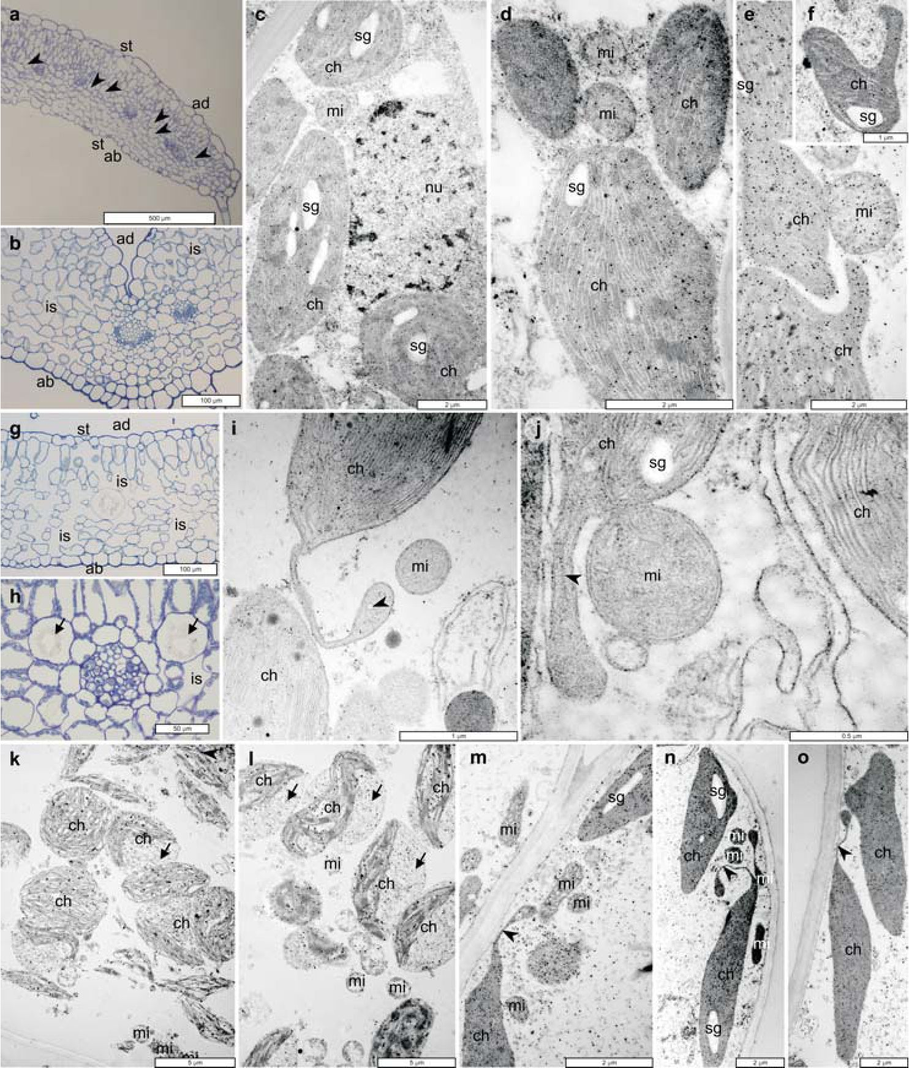
Cold stress effects on organelle ultrastructure
633
c-f. The cell nucleus (nu), mitochondria (mi) and chloroplasts (ch) are packed tightly together. De-
formed chloroplasts are shown in e and f. In c the cell nucleus is packed tightly together with the
chloroplasts. Nearly all chloroplasts contain starch grains. i, j. Atypically shaped chloroplasts and mi-
tochondria in leaf mesophyll cells of plants grown at a variable temperature of 8/40C. Chloroplasts
with starch (j, sg) form characteristic protrusions with thylakoid (arrowheads). Plastoglobules are
present in chloroplasts. k and l. Destructive changes in chloroplasts (ch) and mitochondria (mi) under
greenhouse conditions. Short and thick chloroplasts with visibly dilated thylakoid lumina and large
sections containing stromal parts without thylakoids (arrows). Mitochondria with disorganized inter-
nal membrane structures. m-o. Destructive changes in chloroplasts (ch) and mitochondria (mi) of
plant incubated at the temperature of 40C for 12 hours. Chloroplasts contain infrequent large starch
grains, dense osmiophilic stromal parts, and they form protrusions with thylakoids (m, arrowheads).
The lumina of internal membrane vesicles in the mitochondria (mi) are dilated.
634
Irena Giełwanowska et al.
heads). Plants subjected to short-term cold stress (40C for 12 hours) contained
chloroplasts with long protrusions that were wider at the ends and featured visible
thylakoid lumina (Fig. 1m-o, arrowheads). Stromules of varied length were
formed on the side of the cell wall and often closely adhered to it. The leaf cells of
greenhouse-grown plants contained normal mesophyll cells as well as cells with
degenerating chloroplasts and mitochondria (Fig. 1k-l).
Chloroplasts with deformed surfaces were noted in mesophyll cells of Colo-
banthus quitensis plants harvested from their natural habitat in the Antarctic and
grown in a greenhouse. Deformations had the shape of pocket invaginations that
closely surrounded single mitochondria (Fig. 2d), larger invaginations that en-
closed several mitochondria (Fig. 2e-f) or longer protrusions containing stroma
and thylakoids (Fig. 3k). Extensive thylakoid-free areas were visible in the chloro-
plasts of plants grown at both constant and varied temperature (Figs 2d, i-j and
4d-e). The chloroplasts of C. quitensis plants contained starch globules and lipid
plastoglobules, and lipid drops were particularly abundant in the material collected
in the Antarctic (Fig. 2d, h).
The mesophyll cells of the analyzed plants contained numerous mitochondria
in the proximity of chloroplasts. The mitochondria had a spherical shape in the
mesophyll cells of Cerastium alpinum plants incubated at the temperature of 40C
for 12 hours, and they were finger-shaped or elongated in the mesophyll cells of
this species plants subjected to cold stress (Fig. 1m (mi), n (mi)). In the remaining
cells, the mitochondria were of various shapes - from spherical, which were most
frequently observed in the mesophyll cells of C. quitensis plants harvested from
the Antarctic (Fig. 2c-d (mi), h (mi)), to elongated and finger-shaped, which were
noted mostly in plants grown under constant (200C) and varied (8/40C) tempera-
ture (Fig. 2g-k (mi)). In addition to normally arranged mitochondria, the cyto-
plasm of C. quitensis cells also contained mitochondria with evident signs of de-
generation, mostly lysis. Degenerating mitochondria were frequently reported in
plants collected in the Antarctic (Fig. 2d (mi)) and in the cells of plants exposed to
low temperatures (Fig. 3l-m (mi)).
Fig. 2. Anatomical leaf structure and differentiation of cell organelles in leaf mesophyll cells of
Colobanthus quitensis grown in the natural habitat of the Antarctic and under greenhouse conditions.
a. Anatomical structure of a leaf of plant growing in a greenhouse. Stomata (st) are visible in the
adaxial (ad) and abaxial (ab) epidermis. Mesophyll cells on the adaxial side of the blade are slightly
elongated and contain more chloroplasts, and those on the abaxial side are isodiametric and contain
fewer chloroplasts. The system of intercellular spaces (is) in the mesophyll is well-developed. Five
vascular bands with various amounts of conducting tissue are visible. Parenchymal bundle sheaths
(arrowheads) with a few chloroplasts are also visible. Semi-thin section stained with toluidine blue.
Scale = 100 pm. b, c. Ultrastructure of parts of mesophyll cells of plants grown in the natural habitat
of the Antarctic with nuclei located close to the cell wall (c, nu). The irregular surface of the cell
nucleus is shown. Protein crystals, individual or paired, in the cell nucleus inside the circular area
with lighter content and lipid droplets (b, nu, arrowhead). Circular areas with lighter or darker content
inside the cell nucleus surrounded by a membrane (c, arrows) are observed. d. Fragments of leaf ^
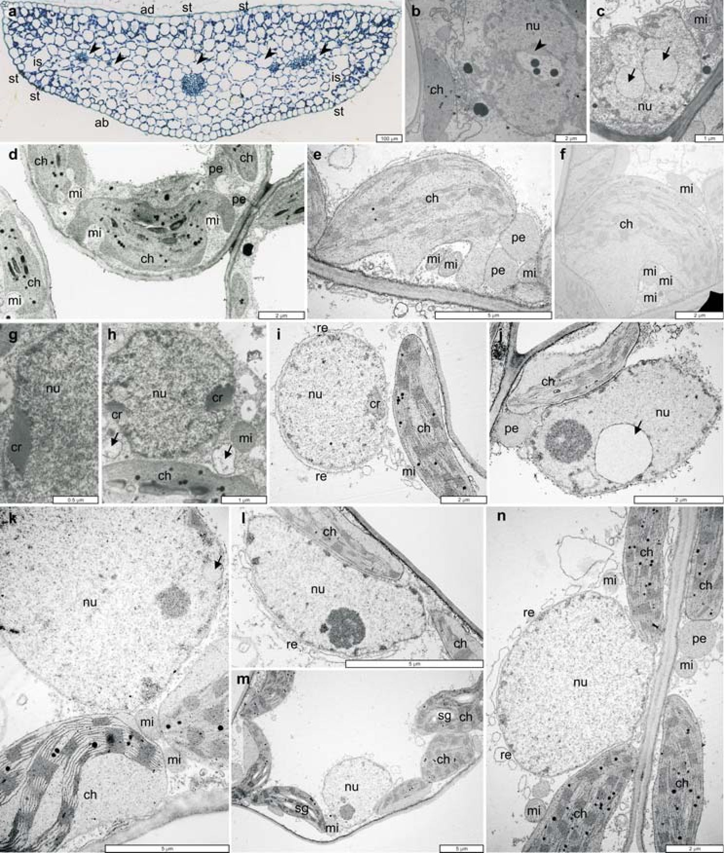
Cold stress effects on organelle ultrastructure
635
mesophyll cells of plant from Antarctic tundra. Chloroplasts (ch) with starch grains and plasto-
globules have numerous pocked-shaped indentations containing mitochondria (mi) with disorga-
nized internal membrane structures. e, f. Fragments of mesophyll leaf cells of plant grown at a vari-
able temperature of 8/40C. Chloroplasts (ch) with deformations in the form of swellings. Mitochon-
dria (mi) with well-organized inner membrane structures inside the invaginations and between the
large peroxisomes (pe). g, h. Fragments of cytoplasm with nuclei in leaf mesophyll cells of plants
from Antarctic tundra. i-n. Ultrastructure of mesophyll cells protoplasts of greenhouse plants grown
at a temperature of 200C. Parts of cytoplasm with nuclei located close to the cell wall and hetero-
chromatin in the area of the nuclear membrane. Longitudinally (i, re) and vertically (l, m, n, re) mem-
branes of the endoplasmic reticulum can be observed in the direct vicinity of cell nuclei. Chloroplasts
(ch) contain numerous osmiophilic plastoglobules and starch grains (m). Very large peroxisomes (pe,
j, n) are tightly packed together with chloroplasts and mitochondria.
636
Irena Giełwanowska et al.
The mitochondria of greenhouse-grown Silene involucrata plants were char-
acterized by varied conformational dynamics, different matrix density and varied
arrangement of the internal membrane system (Fig. 4d-h (mi)).
Regular, lens-shaped chloroplasts with a well-organized system of grana
thylakoids and stroma thylakoids were observed near the cell wall in mesophyll of
S. involucrata specimens grown at 200C and at varied temperature. Small osmo-
philic plastoglobules and infrequent starch grains were noted in the stroma be-
tween grana stacks (Fig. 4f-l). Osmophilic drops (Fig. 4j-k, arrows), whose den-
sity was similar to that of cytoplasmic material (Fig. 4l, arrow), were adjacent to
the outer membrane of the chloroplast envelope.
The peroxisomes of mesophyll cells of the analyzed Caryophyllaceae plants
were significantly larger than chloroplasts and mitochondria. They were densely
packed near the remaining organelles, mostly chloroplasts and mitochondria (Figs
2e, j (pe); 3a, g, i-k (pe) and 4k (pe)).
In strongly vacuolized cells of C. quitensis plants, spherical and oval cell nu-
clei were distributed mostly in the cytoplasm along the cell wall, similarly to other
organelles. The cell nuclei of the discussed species are characterized by low levels
of heterochromatin that is distributed mostly in peripheral regions near the internal
nuclear envelope (Fig. 2b-c, g-n (nu) and 3a-e (nu)). The membranes of channels
and endoplasmic reticulum cisternae stretched along the outer membrane of the
nuclear envelope on the side of the cytoplasm (Figs. 2i (re) and 3a (re), e (re)). Indi-
vidual (Fig. 2b, arrow; j, arrow; k, arrow) and multiple (Fig. 2c, arrows) spherical
areas with brighter or darker material, surrounded by a single-layer membrane,
were noted in the region of cell nuclei. Crystalline proteins were visible in the
intermembrane space of nuclear envelopes in mesophyll cells of plants harvested
from the Antarctic (Fig. 2b (nu), arrowhead, g (cr) and h (cr)) and greenhouse-
grown plants (Fig. 3a-f, arrowheads). Both individual and multiple crystalline
structures were observed. In some cases, optically bright areas were noted near
crystalline proteins in the direct proximity of heterochromatin (Fig. 3d (nu) arrow-
head). In S. involucrata, the cell nuclei distributed along the cell wall featured nu-
merous protrusions and invaginations filled with cytoplasm and vesicles, orga-
nelles and cell material (Fig. 4d-e (nu) and h-i (nu)).
Degenerative changes in organelles were observed in selected cells of Cerastium
alpinum and Colobanthus quitensis plants grown in a greenhouse and subjected to
short-term cold stress (40C). Mitochondria with dilated lumina of the internal mem-
brane system or completely disorganized systems of internal and external mem-
branes were reported (Figs 2d (mi), 3f, (mi) and 4l (mi)). Those cells also contained
chloroplasts with atypical features. Chloroplasts contained large, thylakoid-free ar-
Fig. 3. Ultrastructure of mesophyll cell protoplasts of Colobanthus quitensis grown under laboratory
conditions, at 200C and at variable temperature, 8/40C (i) and at 40C for 12 hours (l, m). a-f. Protein
crystals (arrowheads) in the nuclei (nu). Characteristic protein crystals, individual and paired, can be ^
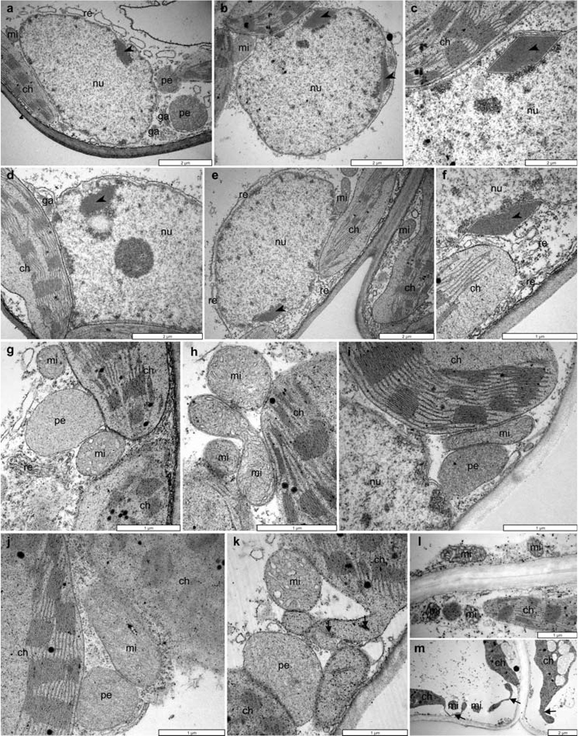
Cold stress effects on organelle ultrastructure
637
observed in the nuclear intermembrane space. The nucleus remains in close contact with organelles,
mostly chloroplasts (ch), mitochondria (mi), peroxisomes (pe), endoplasmic reticulum (re) and Golgi
apparatus (ga). g-j. Chloroplasts (ch), mitochondria (mi) and peroxisomes (pe) are tightly packed to-
gether. Peroxisomes are large in comparison with the mitochondria. k. Organelles in the cytoplasm of
leaf mesophyll cells of Colobanthus quitensis grown under variable temperature, 8/4°C. Chloroplast
with longer protrusion with parts of lamellar system (arrows). l, m. Mitochondria with dilated lumina
of inner membrane vesicles (l, mi) and disorganized chloroplasts with long protrusions (m, arrows) in
plant cell incubated for 12 hours at the temperature of 4°C.
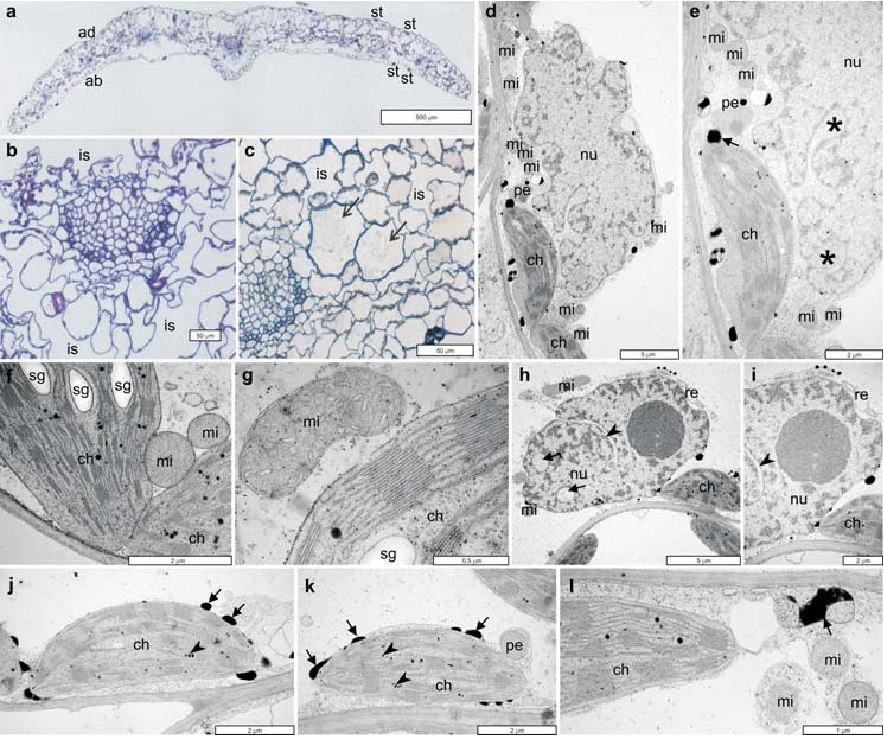
638
Irena Giełwanowska et al.
Fig. 4. Anatomical structure of the leaf blade (a-c), insoluble polysaccharides (a-b) and ultrastructure
of the organelles in Silene involucrata grown under greenhouse conditions. a. Cross-sections of the
leaf blade. Adaxial (ad) and abaxial (ab) epidermis with numerous stomata. Vascular bundles are visi-
ble along the boundary of palisade and spongy mesophyll layers. b. Insoluble carbohydrates in cell
walls of the mesophyll and vascular bundles and in chloroplasts. Large intercellular spaces (is) can be
observed in the mesophyll. c. Idioblasts with toluidine blue and PAS negative reactions (arrows) in
the mesophyll near the vascular bundles. Large intercellular spaces (is) can be observed in the meso-
phyll. d, e. Cell nucleus with numerous protrusions and invaginations filled with cytoplasm with ves-
icles, organelles and material (stars). Mitochondria with dense matrix (mi), large peroxisomes (pe)
and chloroplasts with drops of electron-dense material (arrow) are visible in the cytoplasm near the
cell nucleus. f, g. Cell fragments of Silene involucrata grown at a variable temperature of 8/40C.
Chloroplasts with well-organized grana thylakoids contain many large and bright-colored starch
grains (sg) and osmiophilic plastoglobules. The organelles are tightly packed together and with vari-
ously shaped mitochondria in different conformation states. h, i. A very large nucleolus and three cy-
toplasm areas are visible in the cell nucleus - two in cross-section (arrows) and one in longitudinal
section (arrowhead). j-l. Cell fragments of Silene involucrata grown at a variable temperature of
8/40C. Chloroplasts (ch) in the cytoplasm adjacent to the cell wall have a regular surface. They con-
tain regular grana and intergrana thylakoids, infrequent starch grains (sg) and osmiophilic plasto-
globules (arrowheads). Osmiophilic droplets are adjacent to the outer membrane of chloroplasts (j, k,
arrows) or are found in the cytoplasm (l, arrow).
eas that were filled only with stroma, and laterally distributed thylakoids had dilated
lumina (Fig. 1k-l (ch)). Strongly elongated chloroplasts with single, large starch
Cold stress effects on organelle ultrastructure
639
granules were observed in the cells of plants exposed to a temperature of 4°C for 12
hours. Narrow stromules were visible at the ends of their long axes (Fig. 1m-o (ch)
arrowheads). Those changes were characteristic of the degradation of cell organelles
and protoplasts.

Discussion
Anatomical responses of polar plants to environmental stressors. — Polar
plants adapt to unsupportive environmental conditions by growing in dense
patches that prevent heat loss and contribute to a positive energy balance in habi-
tats characterized by low temperatures (Aleksandrova 1983; Block et al. 2009).
Their adaptive responses are also visible in the structure of epidermal cells, leaf pa-
renchyma cells and vascular bundles. According to many authors, polar plants are
xerophytes (Jellings et al. 1983; Vieira and Montovani 1995; Romero et al. 1999;
Mantovani and Vieira 2000; Lewis-Smith 2003; Wielogarski and Karlsen 2007;
Lütz 2010; Parnikoza et al. 2011). Xerophytic adaptations take place in response
to periodic water loss resulting from low temperatures and drought (Alberdi et al.
2002).
Xerophytic leaves of Colobanthus quitensis are characterized by small size
and epidermis comprising thick-walled, densely packed cells and thick cuticle.
The plant’s specialized floral leaves (Gielwanowska et al. 2011) have a unique
structure. The epidermis effectively protects cells against mechanical damage, ex-
cessive sunlight, harmful ultraviolet radiation, low temperatures and pathogens. In
severe polar climates it also protects the shoot against excessive transpiration,
wind-borne sand grains and saline aerosol.
Polar plants have also developed various types of epidermal hairs that protect
them against chilling winds and excessive radiation (Wielogarski and Karlsen
2007). Cerastium alpinum leaves are covered with long mechanical hairs and
shorter secretory hairs. Numerous mechanical hairs are also found on the adaxial
surface of leaf blades in Silene involucrata. Cerastium uniflorum Thom. ex Rchb.,
an alpine species, has developed hairs that densely cover the leaf blade and control
light intensity (Lütz and Engel 2007). Epidermal hairs differ in color - from very
dark in Draba and selected Ranunculus species, to lightly colored and completely
permeable to sunlight. Willow inflorescences are covered with light-colored hairs
that are completely permeable to sunlight, prevent heat loss and maintain internal
temperature 15°C higher than ambient temperature (Krog 1955).
The assimilatory parenchyma of the analyzed Caryophyllaceae species is com-
posed of palisade and spongy cells. In Cerastium alpinum and Colobanthus
quitensis plants growing in natural habitats, the majority of leaf cells had regular
shape, and large starch grains were visible in chloroplasts. Starch granules in
chloroplasts play the role of osmotically neutral storage of assimilatory starch, and
640
Irena Giełwanowska et al.
starch hydrolysis preserves cell integrity under exposure to stressors because the
produced soluble carbohydrates protect the membranes of thylakoids and other
cell structures (Vecchia et al. 1998).
Large intercellular spaces were observed between mesophyll cells in the ana-
lyzed plants. They formed a continuous system of air channels that facilitate oxy-
gen transport and gas exchange. Intercellular spaces also support the elimination
of volatile compounds accumulated in roots, including CO2, ethylene, organic ac-
ids and CH4, by reverse diffusion (Neue et al. 1990). Mesophyll cells with irregu-
lar shape were observed near intercellular spaces in semi-thin sections of C.
quitensis plants. Cell wall invaginations and protrusions increase the area of
intercellular spaces and promote gas accumulation (Romero et al. 1999). The
above changes in the structure and function of mesophyll cells could be induced by
long-term stressors. Similar changes in spongy and palisade parenchyma cells and
intercellular spaces were described in tomato leaves in response to salinity stress
(Sam et al. 2003).
Leaf vascular tissue in the examined Caryophyllaceae plants was composed of
collateral vascular bundles with very narrow cell lumina. Research has demon-
strated that tracheal elements with a small diameter inhibit water freezing (Lütz
2010).
Ultrastructure of mesophyll cells. — Herbaceous plants growing at various
latitudes and in different habitats are characterized by significant ultrastructural
similarities. The organelles of polar and alpine plants differ only in their plasticity
and degree of cooperation, which probably enables those plants to rapidly modify
metabolic processes and develop under unsupportive environmental conditions
(Lütz et al. 2012). Metabolic disruptions induced by environmental factors are
manifested in the ultrastructure of cell organelles. Cellular components have var-
ied tolerance to low temperature, dehydration and excessive light exposure.
Chloroplasts are the most sensitive organelles, whereas cell nuclei, mitochondria
and peroxisomes are characterized by greatest stability (Kratsch and Wise 2000).
The ultrastructural organization of organelles determines the response of cells and
entire plants to abiotic stress.
Microscopic observations of Caryophyllaceae plants harvested from their natu-
ral habitats and grown in a greenhouse under varied conditions revealed tightly
packed cytoplasmic organelles. Dense arrangement of organelles is noted in all
plants, not only species native to the Arctic and the Antarctic. Chloroplasts, mito-
chondria and peroxisomes are distributed in close proximity during photorespiration
(Körner and Larcher 1988; Larcher et al. 1997) and photoinhibition (Holzinger et al.
2007a, b).
The most closely adhering chloroplasts and mitochondria were observed in
the mesophyll of C. quitensis plants growing in a coastal habitat in the Antarctic.
Numerous pocket indentations filled with mitochondria were noted in individual
chloroplasts (Fig. 2d). In addition to surface deformations, indentations and
Cold stress effects on organelle ultrastructure
641
invaginations filled with organelles, the chloroplasts of Cerastium alpinum, Colo-
banthus quitensis and Silene involucrata contained large, thylakoid-free areas. Simi-
lar spaces containing only stroma were described in several species of polar and al-
pine plants, including Geum montanum L., Geum reptans L., Oxyria digyna (L.)
Hill. and Ranunculus glacialis L. (Lütz 1987; Larcher et al. 1997; Holzinger et al.
2007a, b; Lütz and Engel 2007; Lütz et al. 2012). In the analyzed taxa, chloroplasts
formed characteristic shorter or longer protrusions that had equal width or were
wider at the ends (Fig. 1i-j arrowheads). In addition to typical stromules filled only
with stroma, C. alpinum and C. quitensis also featured long and narrow protrusions
containing membranes and thylakoids (Figs 1i-j, m-o and 3k, m). Stromules that in-
crease the surface area of chloroplasts and come into direct contact with the adjacent
cell compartments were previously reported in two species of flowering plants na-
tive to the Antarctic, C. quitensis and Deschampsia antarctica (Giełwanowska et al.
2005; Giełwanowska and Szczuka 2005). According to Köhler et al. (1997), chloro-
plast protrusions not only transport molecules, but they can also act as specific re-
ceptors that search for areas where the concentrations of ready-to-use molecules are
higher. Stromules increase the contact area between chloroplasts and other proto-
plast elements. The contact area between organelles is expanded or reduced to regu-
late the rate of macromolecule and micromolecule exchange with the cytoplasm,
other organelles and the environment, and this mechanism could play a key role in
severe polar climate. The above hypothesis seems to be validated by a recent study
by Busch et al. (2013) who demonstrated that in wheat and rice cells, the formation
of stromules and the distribution of chloroplasts along cell walls increases the con-
tact area between chloroplasts and intercellular spaces. The above facilitates re-
assimilation of CO2that is released into intercellular spaces during photorespiration
and normal respiration. Chloroplast stromules are formed on the side of the cell wall
and in the direct vicinity of the CO2 reservoir. Therefore, it can be assumed that the
formation of numerous pockets and the establishment of close contacts with mito-
chondria inside those pockets is driven by the carbon dioxide gradient surrounding
chloroplasts. Numerous mitochondria-filled pockets on chloroplast surfaces and
close contacts between those organelles have also been observed in the cells of Ant-
arctic lichen algae (Giełwanowska and Olech 2012). Mitochondria cluster around
the cell nucleus and trigger hypoxia to minimize damage caused by free radicals
(Bereiter-Hahn and Voth 1994; Logan and Leaver 2000).
In previous ultrastructural analyses of Deschampsia antarctica cells (Giełwa-
nowska et al. 2005), the highest number of pockets, invaginations and protrusions
was noted in chloroplasts of plants that grew in coastal areas and were swept by
waves during sea storms. In their mesophyll cells, individual chloroplasts simulta-
neously formed several types of deformations, including long stromules, pockets
and invaginations. The above structural arrangement increases the contact area be-
tween adjacent organelles and reduces the distance between cell compartments. It
aids metabolite flow and eliminates energy expenditure related to long-distance
642
Irena Giełwanowska et al.
transport. This energy-saving mechanism could play a vital role in plants growing
in extreme climates (Hanson and Sattarzadeh 2011).
Nuclei with highly irregular surfaces were observed in many Silene involucrata
cells. They formed numerous protrusions and invaginations that were filled with cy-
toplasm, vesicles and organelles. Spherical areas enclosed by single-layer mem-
brane were observed in the cell nuclei of C. quitensis and S. involucrata. They re-
sembled nuclear vacuoles of mitotic cells (Sheffield et al. 1979; Yi et al. 1994) and
endoplasmic reticulum elements trapped inside nuclei. It is believed that such struc-
tures are a part of the membrane system in the cytoplasm (Singh and Walles 1995;
Singh et al. 1998). Extended endoplasmic reticulum comprising transverse and lon-
gitudinal cisternae was observed in the direct proximity of cell nuclei in C. quitensis.
It can be assumed that various deformations can participate in the exchange of
mRNA and proteins between the nucleoplasm and the cytoplasm, as demonstrated
by the location of deformations near the nucleolus and the presence of active cyto-
plasm with small vesicles in those deformations (Collings et al. 2000). The dis-
cussed structures probably increase the contact area between the nucleus and the cy-
toplasm (Meier 2001).
Single and multiple symmetrically distributed crystalline inclusion proteins
were observed in the nuclei of mesophyll cells in C. quitensis plants growing in the
natural habitat and in a greenhouse. The proteins were visible in the intermembrane
space of the nuclear envelope, mainly in the proximity of heterochromatin or opti-
cally bright areas in the cell nucleus. Electron microscope observations do not sup-
port full identification of those structures or their functions. It remains unknown
whether those structures had originated in the cell nucleus or whether they were
transported to the nucleus from the cytoplasm. Chromatin-stabilizing proteins have
been described in numerous studies investigating the production of special cell pro-
teins in response to environmental stressors (Velazquez and Linquist 1984).
In addition to active cells with typical cytoplasmic organization, the mesophyll
of Caryophyllaceae plants harvested from natural habitats in the Arctic and the
Antarctic, grown in a semi-controlled environment and subjected to short-term
cold stress also contained cells with partially or completely damaged chloroplasts
and mitochondria (Figs 1k-o and 3l-m). Internal membranes with clearly dilated
lumina were observed in mitochondria undergoing various conformational
changes. In chloroplasts, the thylakoid system was completely relaxed, and exten-
sive thylakoid-free areas were also noted. Changes in the structure and function of
the photosynthetic apparatus inside the internal membrane system are the first
symptoms of mild stress; therefore, chloroplasts can be regarded as receptors of
environmental stimuli (Kratsch and Wise 2000) and the most sensitive cell orga-
nelles. Changes in the conformational state and ultrastructure of organelles in po-
lar Caryophyllaceae plants are most probably adaptive responses to variations in
environmental conditions and stimuli. Those mechanisms enable polar plants to
grow and survive in unsupportive and changing habitats.
Cold stress effects on organelle ultrastructure
643
Acknowledgements. — We are grateful to Mrs Teresa Jagielska for greenhouse work. Par-
ticular thanks are addressed to two anonymous referees for their comments on the manuscript.

References
Alberdi m., Bravo L.A., Gutierrez A., Gidekel M. and Corcuera L. 2002. Ecophysiology of
Antarctic vascular plants. Physiologia Plantarum 115: 479-486.
ALEKSANDROVA V.D. 1983. The Arctic and Antarctic: Their Division into Geobotanical Areas.
Cambridge University Press, Cambridge: 3-247.
BEREITER-HAHN J. and VÖTHM. 1994. Dynamics of mitochondria in living cells: shape changes, dislo-
cations, fusion, and fission of mitochondria. Microscopy Research and Technique 27: 198-219.
BLOCK w., Smith L.R.I. and KENNEDY A.D. 2009. Strategies of survival and resource exploitation
in the Antarctic fellfield ecosystem. Biological Reviews 84: 449-484.
BRAVO L.A. and Griffith M. 2005. Characterization of antifreeze activity in Antarctic plants. Jour-
nal of Experimental Botany 56: 1189-1196.
Bravo L.A., Saavedra-Mella F.A., Vera F., Guerra A., Cavieres L.A., Ivanov A.G.,
HUNER N.P.A. and CORCUERA L.J. 2007. Effect of cold acclimation on the photosynthesis per-
formance of two ecotypes of Colobanthus quitensis (Kunth.) Bartl. Journal of experimental Bot-
any 58: 3581-3590.
Bravo L.A.,UlloaN., Zuniga G.E., Casanova A., Corcuera L.J. and Alberdi M. 2001. Cold
resistance in Antarctic angiosperms. Physiologia Plantarum 111: 55-65.
BUSCH F.A., SaGET.L., Cousins A.B. and SAGE R.F. 2013. C3 plants enhance rates of photosynthe-
sis by reassimilating photorespired and respired CO2. Plant, Cell and Environment 36: 200-212.
Casanova-Catny M.A., Bravo L.A., Molina-Montenegro m., Corcuera L.J. and Lohen-
GRINA AC. 2006. Photosynthetic performance of Colobanthus quitensis (Kunth) Bartl. (Caryo-
phyllaceae) in a high-elevation site of the Andes of central Chile. Revista Chilena de Historia
Natural 79: 41-53.
COLLINGS D.A., CARTER C.N., RINK J.C., SCOTT A.C., WAYATT S.E. and STRÖMGREN-ALLEN N.
2000. Plant nuclei can contain extensive grooves and invagination. The Plant Cell 12: 2425-2439.
DAY T.A., RUHLAND C.T., GROBE C.W. and XIONG F. 1999. Growth and reproduction of Antarctic
vascular plants in response to warming and UV radiation reductions in the field. Oecologia 119:
24-35.
Doucet C.J., Byass L., Elias L., Orrall D., Smallwood m. and Bowles D.J. 2000. Distribu-
tion and characterization of recrystalization inhibitor activity in plant and lichen species from
UK and Maritime Antarctic. Cryobiology 40: 218-227.
GARSTKA M., VENEMA J.H., RUMAK I., GIECZEWSKA K., ROSIAK M., KOZIOŁ-LIPIŃSKA J., KIER-
DASZUK B., VREDENBERG WJ. and MOSTOWSKA A. 2007. Contrasting effect of dark-chilling on
chloroplast structure and arrangement of chlorophyll-protein complexes in pea and tomato - plants
with a different susceptibility to non-freezing temperature. Planta 226: 1165-1181.
GIEŁWANOWSKA I. 2003. Deschampsia antarctica responses to abiotic stress factors. Acta Physio-
logiae Plantarum 25: 61-62.
GIEŁWANOWSKA I. and OLECH M. 2012. New ultrastructural and physiological features of the
thallus in Antarctic lichens. Acta Biologica Cracoviensia Series Botanica 54: 1-13.
GIEŁWANOWSKA I. and SZCZUKA E. 2005. New ultrastructural features of organelle in leaf cells of
Deschampsia antarctica Desv. Polar Biology 28: 951-955.
Giełwanowska I., Szczuka E., Bednara J. and Górecki R.J. 2005. Anatomic features and
ultrastructure of Deschampsia antarctica (Poaceae) leaves from different growing habitats. An-
nals of Botany 96: 1109-1119.
644
Irena Giełwanowska et al.
Giełwanowska I., Bochenek A, Gojło F., Górecki R., Kellmann w., Pastorczyk M. and
SZCZUKA F. 2011. Biology of reproduction of Colobanthus quitensis (Kunth) Bartl. Polish Po-
lar Research 32: 139-155.
GRIFFITH M. and YaISH M.W. 2004. Antifreeze proteins in overwintering plants: a tale of two activi-
ties. Trends in Plant Science 9: 399-405.
HANSON M.R. and SATTARZADEH A. 2011. Stromules: recent insights into a long neglected feature
of plastid morphology and function. Plant Physiology 155: 1486-1492.
HOLZINGER A., WASTENEYS G.O. and LÜTZ C. 2007a. Investigating cytoskeletal function in chloro-
plast protrusion formation in the Arctic-Alpin plant Oxyria digina. Plant Biology 9: 400-410.
HOLZINGER A., BUCHNER O., Lütz C. and HANSON M.R. 2007b. Temperature-sensitive formation
of chloroplast protrusions and stromules in mesophyll cells of Arabidopsis thaliana. Proto-
plasma 230: 23-30.
JELLINGS I., USHER M.B. and LEECH R.M. 1983. Variations in the chloroplasts to cell index in
Deschampsia antarctica along 16o latitudinal gradient. British Antarctic Survey Bulletin 61:
13-23.
John U.P., Polotnianka R.M., Sivakumaran K.A., Chew O., Mackin L., Kuiper M.J.,
Talbot J.P., Nugent G.D., Mautord J., Schrauf G.F. and Spangenberg G.C. 2009. Ice
recrystallization inhibition proteins (IRIPs) and freeze tolerance in the cryophilic Antarctic hair
grass Deschampsia antarctica F. Desv. Plant, Cell and Environment 32: 336-348.
Kolodzifjek I., KOZIOŁ-LIPIŃSKA J., WAŁĘZA M. and MOSTOWSKA A. 2007. Aspects of pro-
grammed cell death during senescence of barley leaves - possible role of nitric oxide. Proto-
plasma 232: 97-108.
Köhler R.H., Warren J.C., Zipfel R., Webb W.W. and Hanson M.R. 1997. Exchange of protein
molecules through connections between higher plant plastids. Science 276: 2039-2042.
KÖRNER C. and LARCHER W. 1988. Plant life cold climates. In: S.P Long and F.Y. Woodward (eds)
Plants and temperature. Symposium Society Experimental Biology, Cambridge 42: 25-27.
KRATSCH H.A. and WISE R.R. 2000. The ultrastructure of chilling stress. Plant, Cell and Environ-
ment 23: 337-350.
KROG J. 1955. Notes on the temperature measurements indicative on special organization in arctic
and subarctic plants for utilization of radiate heat from the sun. Physiologia Plantarum 8:
836-839.
LARCHER W., Wagner J. and LÜTZ C. 1997. Effect of heat on photosynthesis, dark respiration and
cellular ultrastructure of Arctic-alpine psychrophyte Ranunculus glacialis, Photosynyhetica 34:
219-232.
LEWIS-SMITH R.I. 2003. The enigma of Colobanthus quitensis and Deschampsia antarctica in
Antarctica. In: A.H.I. Huiskes, W.W.C. Gieskes, R.L.M. Schorno, S.M. van der Viesand and
W.I. Volff (eds) Antarctic Biology in Global Context. Backham Publishers, Leiden: 234-239.
LOGAN D.C. and LEAVER C.J. 2000. Mitochondria-targeted GFP highlights the heterogeneity of mi-
tochondrial shape, size and movement within living plant cells. Journal of Experimental Botany
51: 865-871.
LOPEZ-CARBONELL M., ALEGRE L. and OnCKELEN H. 1994. Changes in cell ultrastructure and en-
dogenous abscisic acid and indole-3-actic acid concentrations in Fatsia japonica leaves under
polyethylene glycol-induced water stress Plant Growth Regulation 15: 165-174.
LÜTZ C. 1987. Cytology of high alpine plants II. Microbody activity in leaves of Ranunculus
glacialis L. Cytologia 52: 679-686.
LÜTZ C. 2010. Cell physiology of plants growing in cold environments. Protoplasma 244: 53-73.
LÜTZ C. and FNGEL L. 2007. Changes in chloroplast ultrastructure in some high-alpine plants: adap-
tation to metabolic demands and climate? Protoplasma 231: 183-192.
LÜTZ C., BERGWEILER P., DI PIAZZA L. and HOLZINGER A. 2012. Cell organelle structure and func-
tion in alpine and polar plants are influenced by growth conditions and climate. In: C. Lütz (ed.)
Cold stress effects on organelle ultrastructure
645
Plants in alpine regions. Cell physiology and adaptation and survival strategies. Springer-
Verlag, Wien: 43-60.
MANTOVANI A. and VIEIRA R.C. 2000. Leaf micromorphology of Antarctic pearlwort Colobanthus
quitensis (Kunth) Bartl. Polar Biology 23: 531-538.
MEIER I. 2001. The plant nuclear envelope. Cellular and Molecular Life Sciences 58: 1774-1780.
MUENCH D.G. and Mullen R.T. 2003. Peroxisome dynamics in plant cells: a role for cytoskeleton.
Plant Science 164: 307-315.
NEUE H.U., BECKER-HEIDMANN P. and SCHARPENSEEL H.W. 1990. Organic matter dynamics, soil
properties and cultural practices in rice lands and their relationship to methane production. In:
A.F. Bauwman (ed.) Soil and greenhouse effect. Wiley, New York: 466-475.
Olave-Concha N., Bravo L.A., Ruiz-Lara S. and Corcuera L.J. 2005. Differential accumula-
tion of dehydrin-like proteins by abiotic stresses in Deschampsia antarctica Desv. Polar Biology
28: 506-513.
PARNIKOZA I., KOZERETSKA I. and KUNAKH V. 2011. Vascular Plants of the Maritime Antarctic:
Orgin and Adaptation. American Journal of Plant Sciences 2: 381-395.
PEARSE A.G.E. 1985. Histochemistry 4th ed. Vol. 2: Analytical technology. Churchill-Livingstone,
Edinburgh, London: 98-106.
PENNELL R.I. and LAMB C. 1997. Programmed cell death. The Plant Cell 9: 1157-1168.
Perez-Torres E., Garcia A., Dinamarca J., Alberdi A., Gutierrez A., Gidekel M., Ivanov
A.G., HUNER N.P.A., CORCUERA L.J. and BRAVO L.A. 2004. The role of Photochemical
Quenching and antioxidants in photoprotection of Deschampsia antarctica Desv. Functional
Plant Biology 31: 731-741.
REYES M.A., CORCUERA L.J. and CARDEMIL L. 2003. Accumulation of HSP70 in Deschampsia
antarctica Desv. leaves under thermal stress. Antarctic Science 15: 345-352.
Romero M., Casanova A., Iturra G., Reyes A., Montenegro G. and Alberdi M. 1999. Leaf
anatomy of Deschampsia antarctica (Poaceae) from the Maritime Antarctic and its plastic re-
sponse to changes in the growth conditions. Revista Chilena de Historia Natural 72: 411-425.
RUMAK I., GIECZEWSKA K., KIERDASZUK B., GRUSZECKI W.I., MOSTOWSKA A., MAZUR R. and
GARSTKA M. 2010. 3-D modelling of chloroplast structure under (Mg2+) magnesium ion treat-
ment. Relationship between thylakoid membrane arrangement and stacking. Biochimica et
Biophysica Acta (Bioenergetics) 1797: 1736-1748.
Sam O., Ramirez C., Coronado M.J., Testillano P.S. and Risueno M.C. 2003. Changes in tomato
leaves induced by NaCl stress: leaf organization and cell ultrastructure. Biologia Plantarum 47:
361-366.
SHAW D.J. and GRAY J.C. 2011. Visualisation of stromules in transgenic wheat expressing a
plastid-targeted yellow fluorescent protein. Planta 233: 961-970.
Sheffield e., Cawood A.H., Bell P.R. and Dickinson H.G. 1979. The development of nuclear
vacuoles during meiosis in plants. Planta 146: 597-601.
SINGH S. and WALLES B. 1995. Ultrastructural differentiation of the ovarian transmitting tissue in
Lilium regale. Annals of Botany 75: 455-462.
SINGH S., LAZZARO M.D. and WALLES B. 1998. The nuclear reticulum in placental cells of Lilium
regale is a part of endomembrane system. Protoplasma 2003: 144-152.
VECCHIA F.D., ASMAR T., CALAMASSIR. and RASCIO C.V. 1998. Morphological and ultrastructural
aspects of dehydratation and rehydratation in leaves of Sporobolus stapfianus. Plant Growth
Regulation 24: 219-228.
VELAZQUEZ J.M. and LINQUIST S. 1984. HSP70 nuclear concentration during developmental stress
and cytoplasmic storage during recovery. Cell 36: 655-662.
VIEIRA R.C. and MANTOVANI A. 1995. Anatomia foliar de Deschampsia antarctica Desv. (Gra-
minaceae). Revista Brasileira de Botanica 18: 207-220.
646
Irena Giełwanowska et al.
WIELOGARSKI F.E. and KARLSEN S.R. 2007. Some views on plants in polar and alpine regions. Re-
views in Environmental Science and Biotechnology 6: 33-45.
XIONG F.S., RUHLAND C.T. and DAY T.A. 1999. Photosynthetic temperature response of the Antarc-
tic vascular plants Colobanthus quitensis and Deschampsia antarctica. Physiologia Plantarun
106: 276-286.
YIW., SHI-JIE Y., MING-YiL. andCHENG-HOU L. 1994. Nuclear invaginations and nuclear vacuole
formation in several plants. Acta Botanica Sinica 36: 963-966.
Received 30 March 2014
Accepted 30 October 2014

