
Arch Biol Sci. 2017;69(3):513-522 https://doi.org/10.2298/ABS160722127K

The effect of succession stage on seed rain and seedling recruitment in overgrown
Molinia caeruleae meadows
Kinga Kostrakiewicz-Gierałt
Department of Plant Ecology, Institute of Botany, Jagiellonian University, Lubicz 46, 31-512 Kraków, Poland
E-mail: kinga.kostrakiewicz@uj.edu.pl
Received: July 22, 2016; Revised: September 23, 2016; Accepted: October 12, 2016; Published online: November 9, 2016
Abstract: Investigations into the effect of succession stage on seed rain and seedling recruitment were conducted in Krakow-
Kostrze (southern Poland) in 2014 and 2015. Observations were carried out in Molinia caeruleae meadows representing
early (Patch I), temporary (Patch II) and advanced (Patch III) stage of secondary succession. Patch I was dominated by
meadow species creating delicate stems, Patch II abounded in large tussock grasses and tall-growing rhizomatous grasses and
Patch III was overgrown by willow shrubs and bordered by trees. The number of seeds and taxa in the seed rain decreased
gradually in the successive study sites. Species resident in the standing vegetation were the most abundantly represented in
the seed rain and their share augmented remarkably in Patch III, most likely due to its spatial isolation by the surrounding
shrubs and trees. The share of seedlings and taxa in artificially made gaps in the plant cover and litter decreases along the
successional gradient. The majority of taxa appearing in the seedling pool of all the patches occurred in the seed rain, while
the taxa in the soil seed-bank reserves were modestly represented only in Patches I and II. Combining the obtained results
and published data, it can be stated that, being abundant in the seed rain, the best colonizers show the greatest germination
capability. Although the best colonizers are meadow taxa, fast-growing weeds, trees as well as alien, invasive species also
appeared in the seedling pool.
Key words: secondary succession; seed dispersal; seedling pool; species composition

INTRODUCTION
At the beginning of 20th century the semi-natural rich-
in-species humid meadows (order Molinietalia) were
common across the whole of Europe [1]. During the
1970s, the traditional agricultural management was
either heavily intensified or abandoned for socio-
economic reasons. The lack of land-use contributing
to secondary succession promoted the development
of swamps and brushwoods, which finally brought
about the disappearance of numerous plant species
and a decrease in biodiversity. The encroachment of
tall-growing native and alien perennials, as well as
shrubs and trees, leading to habitat fragmentation
and diminishing of the aforementioned communities’
area, was also noted across the whole of Europe during
this period [2-7]. Consequently, the most endangered
types of humid meadows were listed among other pro-
tected habitats in the Annex I Habitat Directive and
are included in the net NATURA 2000 [8].
© 2017 by the Serbian Biological Society
Although the creation of gaps in the continuous
plant cover and litter seems to be a very effective way
of active conservation of humid meadows, studies of
natural colonization of openings are rather scarce.
So far, the studies of natural seedling recruitment of
artificially made gaps during meadow overgrowing
were conducted in relation to gap size [9], shape [10],
the mode of gap creation [11-17] and time of origi-
nation [18]. Moreover, Fibich et al. [19] investigated
the establishment of seedlings and vegetative sprouts
in openings.
Considering the insufficient state of knowledge,
the present studies were undertaken. Their main aim
was to assess the relations between the plant cano-
py, seed rain and seedling pool in Molinia caeruleae
patches with different habitat conditions. Specific
goals focused on answering the following questions:
- What is the number of taxa and seeds in the seed
rain? ii) How abundantly are the taxa present in the
How to cite this article: Kostrakiewicz-Gieralt K. The effect of succession stage 513
on seed rain and seedling recruitment in overgrown Molinia caeruleae meadows.
Arch Biol Sci. 2017;69(3):513-22.
514
Arch Biol Sci. 2017;69(3):513-522
Table 1. Site conditions in observed patches of Molinietum caeruleae in the year 2014. Names of Patches: Patch I - dominated by small
meadow species, Patch II - dominated by large tussocks grasses and macroforbs), Patch III - overgrown by willow shrubs and bordered
by trees.
Patch | I | II | III
Patch area (m2) | 1700 | 1900 | 1600
Successional stage | Initial | Temporary | Advanced
Number of species in patch | 56 | 47 | 39
Dominants  (species, with cover >20%) | Lathyrus pratensis Lotus  corniculatus | Molinia caerulea, Deschampsia  caespitosa, Lysimachia vulgaris, | Salix repens ssp. rosmarinifolia,  S. caprea, S. cinerea
Subdominants  (species, with cover 5-20%) | Lychnis flos-cuculi, Succisa  pratensis | Serratula tinctoria, Polygonum  bistorta | Betula pendula, Populus  tremula
The value of statistical significance of differences (Kruskal-Wallis H test, df=2) among patches in vascular plant height achieved
39.39 (p<0.001)
established vegetation represented in the seed rain?
iii) Which species occur in the seed rain? iv) What
is the number of taxa and seedlings in the seedling
pool? v) How abundantly are taxa present in the seed
rain represented in the seedling pool? and vi) Which
species occur in the seedling pool?
MATERIALS AND METHODS
Study area
The investigations were carried out in the Kostrze dis-
trict on the western border of Krakow, south of the
Vistula River (southern Poland). The research area
is situated at ca. 210 m a.s.l, on the low flood terrace
of the Vistula. Peaty or clay- and silt-laden soils with
fluctuating water tables are covered by Molinietum
caeruleae patches [20]. The abandonment of mowing
for at least the past dozen years has favored the en-
croachment of vegetation from the alliances Phragmi-
tion and Magnocaricion, leading to the fragmentation
of meadows [21,22]. The meadows are surrounded
by diverse vegetation types, including deciduous for-
ests covering the slopes of the Vistula valley, calcare-
ous grasslands occurring on the limestone and chalk
hill slopes, and ruderal communities appearing near
buildings and along the edges of roads.
The studies were carried out in an area compris-
ing three adjacent abandoned patches of Molinietum
caeruleae sensu Matuszkiewicz [23], characterized by
the presence of the following taxa: Betonica officinalis,
Dianthus superbus, Gentiana pneumonanthe, Gladi-
olus imbricatus, Iris sibirica, Molinia caerulea, Poten-
tilla erecta, Sanguisorba officinalis, Selinum carvifolia,
and Succisa pratensis. The studied patches differed as
to successional stage and dominant species. Patch I
(50° 01' 55.7" N; 19° 52' 03.1" E), abandoned for ca.
20 years, was dominated by meadow species creating
delicate erect (up to 30 cm) or procumbent stems (i.e.
Lathyruspratensis Lotus corniculatus); Patch II (50°
01' 55.2" N; 19° 52' 05.5" E), not used for ca. 35 years,
by large tussock grasses and tall-growing rhizoma-
tous grasses (e.g. Molinia caerulea, Phragmites aus-
tralis); and Patch III (50° 01' 55.6" N; 19° 52' 04.4" E),
unmanaged for at least 45 years, was overgrown by wil-
low shrubs and bordered by trees (i.e. S. caprea, S. cin-
erea). The floristic similarity among the study sites was
checked by the Jacquard index. In July 2014, an evalu-
ation of the plant height from soil surface to the top
flower (n=30, randomly chosen stems) was performed
using a folding tape measure. The habitat conditions
in the experimental patches are described in Table 1.
The characteristic of seed traps and seed
identification
Twenty traps for the seed rain were placed in each
study site in both study seasons during the first week
of April. The traps were separated from each other by
belts of untouched vegetation at least 3 m wide and
were located ca. 2 m from the borders of the patches.
The plastic-made traps consisted of a transparent, cy-
lindrical container half-buried in the soil. The contain-
ers were covered on top by a fine mesh (pore size 0.4
cm) to reduce insect capture. The volume of contain-
ers was 2260.8 cm3 (the height of the containers was
20 cm, while their radius was 6 cm). The traps were
emptied twice a month in the laboratory. Each time
the containers and mesh were washed and then reused.
Seeds deposited in the traps were identified directly
Arch Biol Sci. 2017;69(3):513-522
515
under a binocular microscope (at 10-60x magnifica-
tion) or a dissecting microscope using the author’s
comparative collection, as well as the keys and manu-
als for seed determination [24-26] and monographs
[27-29]. Altogether, in the seed rain of the successive
patches, 145 seeds - most likely from the Poaceae and
Cyperaceae families, indeterminable at the species-lev-
el - were excluded from the analyses. Then, for each
patch the following parameters were counted: i) the
cumulative number of species/seeds in all the traps; ii)
the average number of species/seeds per trap; iii) the
percentage of seeds representing the species present
and absent in the plant cover; iv) the Jacquard index
between the species composition of the plant canopy
and the seed rain. At each study site the number of
diaspores representing particular species appearing in
the seed rain were counted, and the five most abun-
dantly represented in the traps were identified.

Gap creation and seedling determination
Next to each trap a gap with an area 20 cm x 20 cm
was artificially made. The gaps were created by clip-
ping all the aboveground parts of the plants at soil
level and removing them along with the litter layer.
The underground organs of the plants were not dug
up. This treatment is considered optimal for seedling
recruitment in wet meadows according to Kotorova
and Leps [30], as well as Kostrakiewicz [9]. The ramets
of the adjacent plants encroaching on the gap area
during the growing season were not removed.
Habitat conditions in the openings were moni-
tored in a central part of each gap once a week from
April until November, between 10:00 and 12:00 in the
years 2014 and 2015. Altogether, measurements were
taken during 30 weeks each year. The light intensity
at the soil level was examined in full sunshine with a
Voltcraft MS-1300 digital light meter (accuracy ±5%
; measuring range 0.01-50 000 lx). The humidity at
ground level was measured using an OMEGA HSM50
handheld digital soil moisture sensor (accuracy ±5%;
measuring range 0-50% moisture content of soil). Soil
temperature at a depth of 5 cm was measured using
a Hanna electronic temperature sensor (accuracy
±0.1°C; measuring range -10-60°C). The weekly av-
erage values of the abovementioned parameters were
calculated for each Patch separately and are presented
together with the dates of measurements in Suppl. Ta-
ble S1.
The process of gap colonization by generative off-
spring was monitored once a week from April until
November in the studied years. All the recruits were
removed and examined according to the guides for
seedling determination [31,32] with the support of
the author’s own comparative collection. The genets
of rare and protected plants were identified in situ
without digging them up and marked with plastic
rings and sticks. The nomenclature of the taxa fol-
lows Mirek et al. [33]. Altogether in the seedling pool
of successive patches, 87 seedlings (most likely from
Poaceae family, indeterminable at the species level)
were excluded from the analyses. Then, for each
patch the following parameters were counted: i) the
average light availability, soil moisture and soil tem-
perature within gaps; ii) the cumulative number of
species/seedlings found in all the gaps; iii) the aver-
age number of species/seedlings per gap; iv) the per-
centage of seedlings representing the species present
in the plant cover and the seed rain, present only in
the plant cover, present exclusively in the seed rain,
as well as absent in the plant canopy and seed rain of
the particular patches.
In each study site the number of seedlings of each
taxa appearing in the seedling pool was counted and
the five most abundantly represented species in the
gaps were distinguished.

Statistical analyses
The normal distribution of the untransformed data
(number of taxa/seeds in the traps) was tested using
the Kolmogorov-Smirnov one-sample test at the sig-
nificance level of p<0.05. Subsequently, the variance
homogeneity was tested using the Brown-Forsythe
test at the significance level of p<0.05. As the distribu-
tion of characteristics in some groups of data was not
consistent with the normal distribution and the vari-
ance was not homogeneous, the statistical analysis was
based on the nonparametric Kruskal-Wallis H test. It
was applied to examine if there were significant dif-
ferences in: i) light availability, soil moisture and soil
temperature within gaps between particular patches;
- the number of taxa/seeds in the seed rain between
516
Arch Biol Sci. 2017;69(3):513-522
particular patches. After a significant value of the test
was achieved, post-hoc comparisons were made.
Chi-square statistics were used to check whether
there were significant differences among the study
sites in i) species composition of the seed rain regard-
ing the share of species present/absent in the estab-
lished vegetation and ii) the species composition of
the seedling pool regarding the presence/absence of
species in the plant canopy and seed rain.

RESULTS
Habitat conditions
The floristic composition of plant canopy did not dif-
fer substantially between study sites. The Jacquard
index values, reaching 0.40 between Patches I and
II, 0.33 between Patches I and III and 0.36 between
Patches II and III, indicate the greatest floristic simi-
larity between Patches I and II. The average height
of standing vegetation rose in consecutive sites and
reached from 44.9 cm in Patch I, via 88.6 cm in Patch
II, to 114.2 cm in Patch III. Performed observations
showed considerable differences in site conditions
within gaps in subsequent study sites. The statistical
analysis showed that within openings made in succes-
sive patches, light availability decreased, soil humidity
increased, whereas the soil temperature did not differ
significantly in the openings made in the consecutive
patches (Table 2).

Seed rain
The total number of species recorded in the seed rain in
the consecutive patches was 46, 34 and 33, respectively.
The average number of all taxa per trap diminished.
The total number of seeds in the seed rain in the con-
secutive patches amounted to 1868, 1185 and 442, re-
spectively. Similarly, the mean number of seeds per trap
decreased remarkably in successive patches (Fig. 1).
Species present and absent in the plant canopy
were observed in the seed rain of all the patches; how-
ever their contribution was different. In Patches I and
II, the share of seeds representing species occurring
and not occurring in the standing vegetation was
rather similar, whereas the share of seeds represent-
ing species present in the plant cover dominated in
Patch III (Fig. 3). The Jacquard index values between
species composition in the seed rain and plant canopy
in particular patches came to 0.35, 0.34 and 0.47, re-
spectively. The full list of names of the species with
their occurrence in the plant canopy and seed rain is
given in Suppl. Table S2.
Different species dominated in the seed rain in
particular study sites. These were: Betonica officinalis,
Cirsium arvense, Filipendula ulmaria, Sanguisorba of-
ficinalis and Solidago canadensis in Patch I, Betula pen-
dula, Inula salicina, Iris sibirica, Sanguisorba officinalis,
and Succisa pratensis in Patch II, and Betula pendula,
Filipendula ulmaria , Selinum carvifolia, Iris sibirica, and
Sanguisorba officinalis in Patch III (Suppl. Table S3).
Table 2. The average (±SD) light availability (Lx), soil humidity (% of water content) and soil temperature (°C) in artificially created gaps
in the years 2014 and 2015. Names of Patches as in Table 1
Year | Parameter | Patch |  |  | Statistical significance level (the value
Year | Parameter | I | II | III | of Kruskal-Wallis H test, df=2; P)
2014 | Light intensity | 44 560a(±2 680) | 40 812b  (±2 159) | 33 667c  (±5 889) | 63.7  P<0.001
 | Soil humidity | 21.7a  (±7.0) | 26.2b  (±5.6) | 28.4b  (±5.7) | 18.2  P<0.001
 | Soil temperature | 13.9  (±5.2) | 13.2  (±5.1) | 12.9  (±4.3) | 1.01  P>0.05
2015 | Light intensity | 38 927a (±4 088) | 35 649b  (±3 774) | 32 172c  (±4 081) | 27.9  P<0.001
 | Soil humidity | 25. 8a  (±5.2) | 32.5b  (±6.8) | 37.9c (±4.3) | 45.4  P<0.001
 | Soil temperature | 16.1  (±6.0) | 15.1  (±5.6) | 14.2  (±5.3) | 2.2  P>0.05
The same letters denote the absence of statistical differences among study Patches.
Arch Biol Sci. 2017;69(3):513-522
517
Seedling pool
The total number of species recorded in the seedling
pool amounted to 40 in Patch I and 30 in Patches II
and III. The average number of taxa per gap in the
consecutive study sites diminished gradually. The total
number of seedlings in the consecutive patches was
2428, 1454 and 944, respectively (Fig. 2).
In all the patches the seedlings representing spe-
cies occurring in the plant canopy and seed rain re-
cruited most abundantly. The contribution of seed-
lings representing taxa occurring exclusively in the
seed rain decreased sharply in Patch III, while taxa
absent in the plant cover and seed rain were slightly
represented in the seedling pool only in Patches I and
II (Fig. 4). The names of the species with their occur-
rence in the seed rain and seedling pool are presented
in Suppl. Table S2.
Different species prevailed in the seedling pool
in particular study sites. These were: Betonica of-
ficinalis, Filipendula ulmaria, Sanguisorba officinalis,
Serratula tinctoria, Succisa pratensis, Serratula tinc-
toria and Valeriana officinalis in Patch I, Filipendula
ulmaria, Sanguisorba officinalis, Selinum carvifolia,
Serratula tinctoria and Succisa pratensis in Patch II,
and Betonica officinalis, Filipendula ulmaria, Geum
rivale, Sanguisorba officinalis and Selinum carvifolia
in Patch III (Suppl. Table S3).
DISCUSSION
Seed rain
The obtained results proving that the abundance of
species and seeds in traps diminishes gradually in
the consecutive patches correspond with those of
Jensen [34], who reported that the number of taxa
and diaspores in the seed rain decreases along a suc-
cessional gradient. Such a scenario might be due to the
diminishing species richness in Molinia caeruleae, as
confirmed by numerous authors [6,35-37]. This phe-
nomenon might also be caused by a gradual decrease
in seed production by plants resident in the standing
vegetation. Such a scenario was found in abandoned
xeric grassland by Soukupova [38].
Contrary to the findings of Jensen [34], the analy-
sis of species composition in the seed rain produced
evidence that diaspores representing species resi-
dent in the standing vegetation dominate in all the
study patches, and their share increases remarkably
along the successional gradient. The observed sharp
decrease in Patch III of species representing species
absent in the plant cover might be due to its spatial
isolation by the surrounding shrubs and trees. Other
studies [39,40] found that spatial isolation of meadow
patches might successfully prevent the transfer of di-
aspores by water [41], animals [42], as well as wind
[43,44].
Surprisingly, the substantial number of Cirsium
arvense and Solidago canadensis seeds in traps placed
in Patch I, the considerable number of Betula pendula
seeds in Patch II, as well as the large number of Fili-
pendula ulmaria seeds in Patches I and II, despite the
absence of mature individuals in the plant canopy,
might suggest the effective transfer of seeds from the
other sites. A large body of literature has confirmed
the very effective anemochorous transport of Cirsi-
um arvense [45-47], Solidago canadensis [48,49] and
Betula pendula [50,51]. The hydrochorous transport
of Filipendula ulmaria seeds during prolonged spring
inundations or heavy rains in the summer or autumn
might occur due to the ability of the seeds to survive
long-lasting flotation on the water surface [52]. Ad-
ditionally, Soomers et al. [53] found that the typical
wind- and water-dispersers in overgrown, abandoned
meadows might be transferred by water. On the other
hand, the substantial appearance of Betonica officinalis
and Sanguisorba officinalis in the seed rain might be
result of the occurrence of numerous mature individu-
als in the plant canopy, which seems to compensate
for the rather moderate seed production noted in both
taxa [54,55].
Seedling pool
The results of the presented studies are also in accord-
ance with previous observations that the number of
species and offspring in the seedling pool along the
successional gradient decreases in overgrown mead-
ows from Molinia ordo [9,15,17]. Such a phenom-
enon could be due to the increased period of water
stagnation that might accelerate the development and
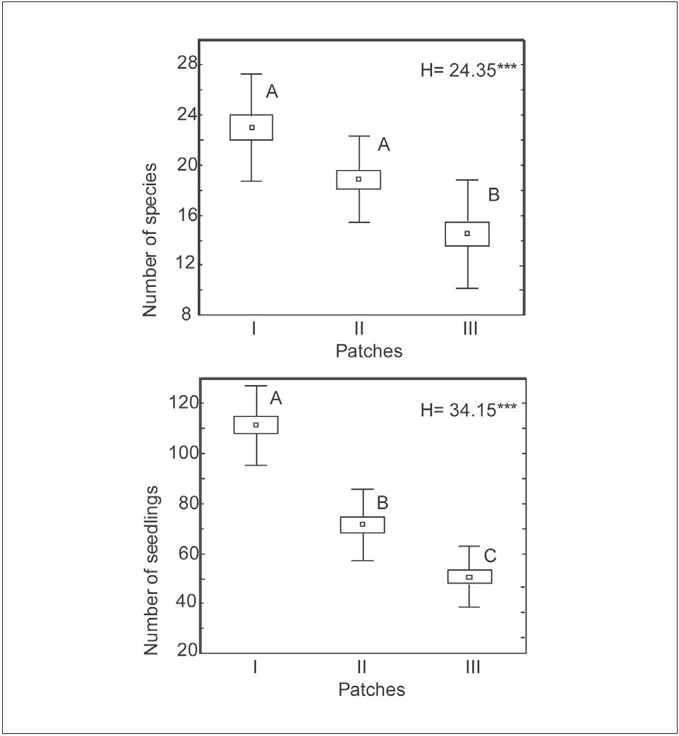
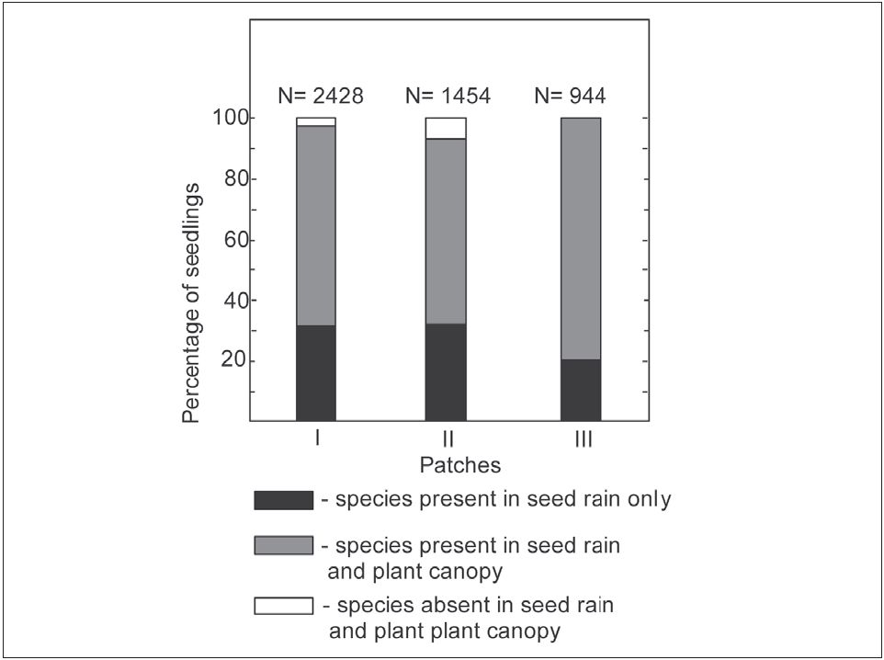
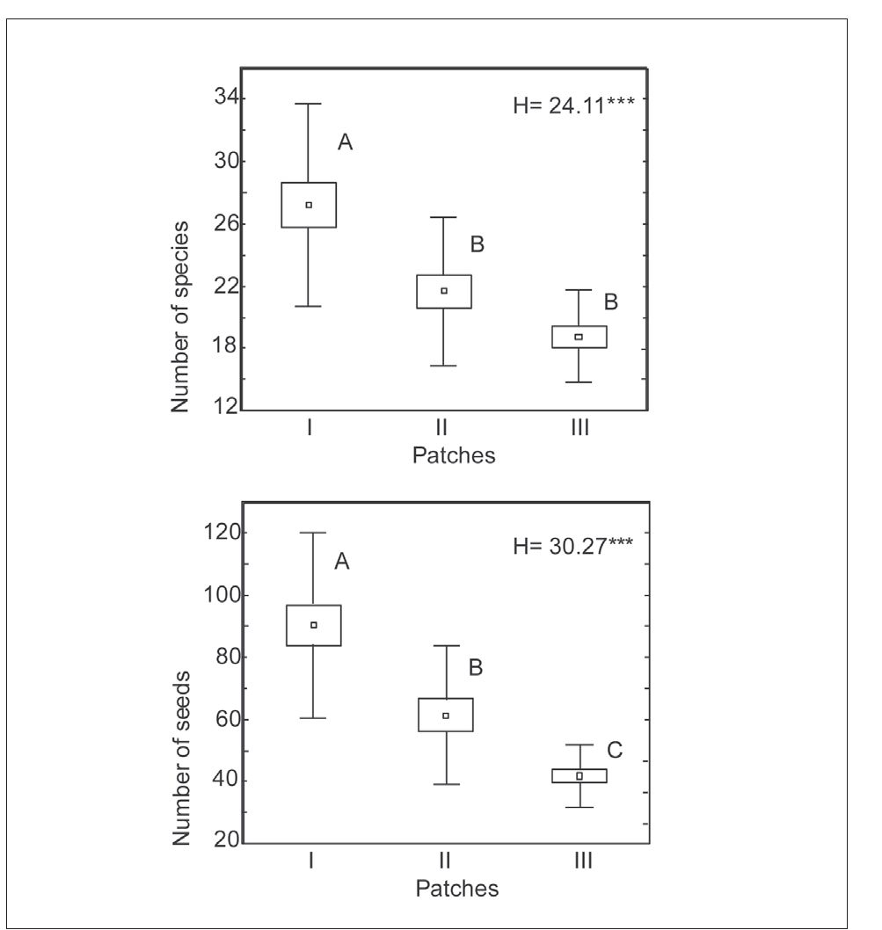
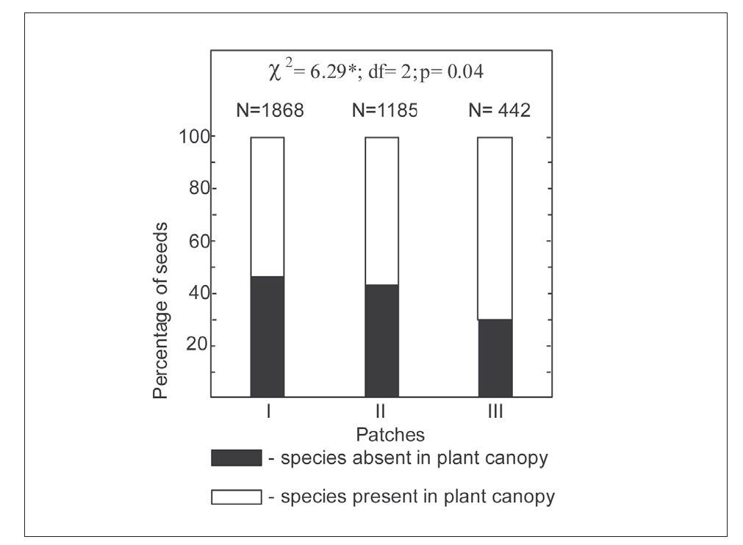
518
Arch Biol Sci. 2017;69(3):513-522
Fig. 1. Number of species and seeds in traps in study patches in
the years 2014 and 2015. Names of Patches as in Table 1. Box and
whisker plots give the mean (square), SE (box) and SD (whis-
kers). Asterisks mean that there are significant differences among
Patches at the 0.001 level (Kruskal-Wallis H test).
Fig. 2. Number of species and seedlings in gaps in study patches
in the years 2014 and 2015. Names of Patches as in Table 1, de-
scription of graphs and the statistical significance level as in Fig. 1.
infectivity of fungal pathogens, a major cause of mor-
tality of diaspores deposited in the soil [56]. On the
other hand, Bekker et al. [57] argued that the seeds
of most wetland plants survive better in waterlogged
conditions. The successive diminishment of species
and seedling number might also be caused by growing
shading of the soil surface in openings, particularly
by the neighboring large-tussock grasses and shrub
willows frequent in Patches II and III. The dimin-
ishing of seedling recruitment caused by insufficient
Fig. 3. Share of species absent and present in plant canopy appear-
ing in traps set in study patches in the years 2014 and 2015. Names
of Patches as in Table 1 Asterisk - significant differences among
Patches at the 0.01 level (x2 test); “N” - total number of seeds.
Fig. 4. Share of species present and absent in the seed rain ap-
pearing in gaps artificially created in study patches in the years
2014 and 2015. Names of Patches as in Table 1. Symbol “ns“ - no
significant differences among Patches (x2 test); “N” - total number
of seedlings.
Arch Biol Sci. 2017;69(3):513-522
519
light availability was observed in many meadow spe-
cies [58-61], while Hautier et al. [62] added that in
grasslands, lack of light is the main cause of seedling
mortality and species richness loss. Moreover, the low-
est recruitment of seedlings in Patch III might be due
of the allelopathic activities of Salix caprea inhibiting
the appearance of meadow species [63].
The observed sharp increase in Patch III of seed-
lings representing species found in the plant cover
also corresponds with previous observations showing
the gradual augmentation of the share of offspring
representing taxa resident in standing vegetation
along the successional gradient in Molinia caeruleae
meadows [9]. Furthermore, the occurrence of species
absent in the plant canopy and seed rain in Patches I
and II might suggest seedling recruitment from the
reserves of the soil seed bank, appearing as an effect
of diaspore accumulation combined with suppressed
germination by thick litter and shading. The lack of
seedlings representing species not occurring in the
plant canopy and seed rain in Patch III contrasts with
other studies conducted along the successional gradi-
ent in wet meadows [11,34,64-66], marshlands [67]
and oxbow wetlands [68], proving that even in the
advanced stages of overgrowth, the soil seed bank
contains viable diaspores of taxa deposited in earlier
successional phases.
The observed abundant recruitment of Filipen-
dula ulmaria L., Betonica officinalis L. (Trevis.), San-
guisorba officinalis L., Selinum carvifolia (L.), Ser-
ratula tinctoria L., Succisa pratensis Moench., Geum
rivale L. and Valeriana officinalis L. confirms previous
observations [9,10,17,18]. The colonization success
of the aforementioned taxa producing non persist-
ent diaspores [69] might be a consequence of their
substantial presence in the seed rain (Suppl. Table
S3) and great germination capability. The studies of
Grime et al. [70] provided evidence that the seeds of
Betonica officinalis, Filipendula ulmaria, Geum rivale,
Serratula tinctoria and Succisa pratensis could germi-
nate in Petri dishes immediately after collection, as
well as after storage at room temperatures for up to
a year. Also, further laboratory tests proved that the
seeds of Betonica officinalis [30,55], Selinum carvifo-
lia [30,71], Succisa pratensis [30,72] and Sanguisorba
officinalis [30,73] present substantial germination ca-
pacity under controlled conditions. The experimental
seed sowing in gaps left after the removal of the plant
canopy and litter layer in meadows showed consider-
able seedling recruitment of Betonica officinalis [30],
Geum rivale [74], Serratula tinctoria [30,72,75,76],
Selinum carvifolia [30,77,78], Sanguisorba officinalis
[30] and Succisa pratensis [30,72,78].
Additionally, it should be pointed out that al-
though the majority of species appearing in the seed-
ling pool are meadow taxa, the recruitment of native
weeds (i.e. Chenopodium album, Papaver rhoeas) and
pioneer trees (i.e. Betula pendula), as well as alien,
invasive perennials (i.e. Solidago canadensis) was also
noted. Moreover, the successful, abundant seedling re-
cruitment of the aforementioned taxa was repeatedly
observed in the laboratory [79-81], as well as in natu-
ral habitat conditions [10]. Similarly, other authors
emphasized the significant survival of seedlings and
juveniles of Betula pendula and Solidago canadensis
even in competitive environmental conditions [82,83].
Additionally, the investigations of Mei et al. [84], as
well as Sun et al. [85], proved the allelopathic activ-
ity of Solidago canadensis, contributing to inhibition
of the recruitment of seedlings of other species. Tak-
ing all this into account, it might be stated that the
recruitment of pioneer trees and invasive perennials
in Molinia caeruleae meadows should be carefully
monitored to avoid promotion of the secondary suc-
cession process.

CONCLUSIONS
The number of seeds and taxa appearing in the traps
decreased gradually along the successional gradient.
Species resident in the standing vegetation dominated
in the seed rain in all the study patches, and their
share augmented remarkably in the successive sites.
To the more successful dispersers (after the species
present in plant canopy) belong taxa producing wind-
or water-assisted diaspores that might be transported
from other locales.
The abundance of seedlings and taxa appearing
in openings in the plant cover and litter decreases
along the successional gradient. The majority of taxa
appearing in the seedling pool of all the patches oc-
curred in the seed rain, while the contribution of taxa
520
Arch Biol Sci. 2017;69(3):513-522
recruiting from the soil seed bank reserves (only in
the patches in the early and temporary successional
stages) was significantly lower. Creating gaps in the
plant cover and litter might be a very effective way of
active protection of Molinia caeruleae meadows, ena-
bling the recruitment of meadow taxa. On the other
hand, it might also contribute to the recruitment of
undesired native and alien taxa and should be closely
monitored to avoid promotion of the secondary suc-
cession process.
Acknowledgments: I acknowledge the support of the Institute of
Botany, Jagiellonian University, Poland, to which I am affiliated. I
am very grateful to my mother Maria Zaczynska-Kostrakiewicz
for her assistance in field work. Moreover, I would like to thank
the Editor and two anonymous Reviewers for their valuable sug-
gestions and remarks on the earlier version of manuscript.

REFERENCES
- Ellenberg H. Vegetation Ecology of Central Europe. New
York: Cambridge University Press; 1988. 732 p.
- Fuller RM. The changing extent and conservation interest
of lowland grasslands in England and Wales: a review of
grasslands surveys 1930-84. Biol Conserv. 1987;40:281300.
- Green BH. Agricultural intensification and loss of habitat,
species and amenity in British grasslands: a review of histori-
cal change and assessment of future prospects. Grass Forage
Sci. 1990;45:365-72.
- Joyce CB, Wade PM. European wet grasslands: biodiversity,
management and restoration. Chichester: Wiley; 1998. 385 p.
- Muller S. Diversity of management practices required to
ensure conservation of rare and locally threatened plant spe-
cies in grasslands: a case study at regional scale (Lorraine,
France). Biodivers Conserv. 2000;11:1173-84.
- K^cki Z. Variability and long-term changes in the species
composition of Molinion meadows in Poland: a case study
using a large data set from the Polish Vegetation Database.
Acta Bot Siles Monogr. 2012;7:1-131.
- Joyce Ch. Ecological consequences and restoration potential
of abandoned wet grasslands. Ecol Eng. 2014;66:91-102.
- Interpretation Manual of European Union Habitats - EUR
25 - NATURA 2000. [Brussels]: European Commission -
DG Environment; 2003. 127 p.
- Kostrakiewicz K. The effect of gap size on colonization proc-
ess in Molinietum caeruleae meadows with different habitat
conditions. Pol J Ecol. 2011;59:677-86.
- Kostrakiewicz-Gieralt K. The effect of the shape of gaps
on microenvironmental conditions and seedling recruit-
ment in Molinietum caeruleae meadows. Acta Agrobot.
2015;68(2):143-51.
- Falinska K. Alternative pathways of succession: species turn-
over patterns in meadows abandoned for 30 years. Phytoce-
nosis 15 (N.S.) Archiv Geobot. 2003;9:1-104.
- Spackova I, Leps L. Variability of seedling recruitment under
dominant, moss, and litter removal over four years. Folia
Geobot. 2004;39(1):41-55.
- Janecek S, Leps J. Effect of litter, leaf cover and cover of
basal internodes of the dominant species Molinia caerulea
on seedling recruitment and established vegetation. Acta
Oecol. 2005;28(2):141-7.
- Borkowska L. Patterns of seedling recruitment in experi-
mental gaps on mosaic vegetation of abandoned meadows.
Acta Soc Bot Pol. 2004;73:343-50.
- Borkowska L. Wzorce rekrutacji siewek gatunków klonalnych
w zbiorowisku niekoszonej łąki Cirsietum rivularis Ralski
1931. Phytocenosis 16 (N.S) Archiv Geobot. 2004;10:1-71.
- Borkowska L. The effect of disturbances on the floristic com-
position of vegetation in abandoned meadows. Pol Bot Stud.
2006;22:63-70.
- Kostrakiewicz-Gierałt K. The impact of disturbance gradient
on recruitment of clonal plant species in Molinietum caer-
uleae meadows. Pol J Ecol. 2013;61(3):519-33.
- Kostrakiewicz-Gierałt K. The impact of time of gap origin on
microsite conditions and seedling recruitment in Molinietum
caeruleae meadows. Inter J Conserv Sci. 2015;6(1):111-24.
- Fibich P, Vitova A, Macek P, Leps J. Establishment and
spatial associations of recruits in meadow gaps. J Veg Sci.
2012;24(3):496-505.
- Dubiel E, carthographer. Plant communities of the 3rd
Campus of the Jagiellonian University and its surroundings
[map]. Kraków: Institute of Botany Jagiellonian University;
2005. 1 sheet : 1; 96 x 56 cm. color.
- Dubiel E. Map of actual vegetation of the city of Cracow.
Zesz Nauk UJ, Prace Bot. 1991;22:121-33.
- Dubiel E. Meadows in Cracow. I. Molinio-Arrhenatheretea
class. Studia Ośr Dok Fizjogr. PAN. 1996;24:145-71.
- Matuszkiewicz W. A guide to identification of Polish plant
communities. Warszawa: Wydawnictwo Naukowe PWN;
2001. 536 p.
- Aulak W. Klucze do oznaczania nasion, siewek, pędów
drzew i krzewów leśnych. Warszawa: Fundacja Rozwój
SGGW; 1994. 118 p.
- Kulpa W. Fruits and seeds. The key for determination of
weed seeds. Warszawa: Państwowe Wydawnictwo Naukowe;
1958. 419 p.
- Cappers RTJ, Bekker RM. A Manual for the Identification
of plant seeds and fruits. Groningen Archaeological Studies
2013;23:1-273.
- Kostrakiewicz K. Taxonomic studies on Polish species of the
genus Vicia L. Springfield: U.S. Department of Agriculture
and National Science Foundation by the Foreign Scientific
Publications Department of the National Center for Scien-
tific. 1956. 54 p.
- Szafer W, Pawłowski B, editors. Flora of Poland. The Vascu-
lar Plants of Poland and neighboring lands. Vol. 7. Warsaw:
Państwowe Wydawnictwo Naukowe; 1955; 302 p.
- Jasiewicz A., editor. Flora of Poland. The Vascular Plants of
Poland and neighboring lands. Vol. 4. Warsaw: Państwowe
Wydawnictwo Naukowe; 1985; 306 p.
- Kotorova I, Leps J. Comparative ecology of seedling
recruitment in an oligotrophic wet meadow. J Veg Sci.
1999;10(2):175-86.
Arch Biol Sci. 2017;69(3):513-522
521
- Csapody V Keimlingsbestimmungsbuch der Dikotyledonen.
Budapeszt: Akademiai Kiado;1968. 286 p. German.
- Muller FM. Seedlings of the North-Western European low-
land. A flora of seedlings. 1st ed. The Hague, Boston: Dr W
Junk B.V. Publishers; 1978. 653 p.
- Mirek Z, Piękoś-Mirkowa H, Zając A, Zając M. Flower-
ing plants and pteridophytes of Poland. A checklist. 1st ed.
Kraków: W. Szafer Institute of Botany PAS; 2002. 442 p.
- Jensen K. Species composition of soil seed bank and seed
rain of abandoned wet meadows and their relation to above-
ground vegetation. Flora. 1998;193(4):345-59.
- Michalska-Hejduk D. Changes in species composition in
purple moor-grass meadows Molinietum caeruleae W. Koch
1926 in the Kampinos National Park in the period 1994-
2004. Studia Naturae. 2006;54(1):159-72.
- Michalska-Hejduk D. Changes of semi-natural vegetation
with a focus on Molinion meadows after 50 years of strict
protection. Pol J Environ Stud. 2012;6:1731-41.
- Kulik M. Changes in biodiversity and species composition
of Molinia meadow depending to use method. Pol J Environ
Stud. 2014;23(3):773-82.
- Soukupova L. Life histories in principal plant populations,
including their allelopathic interferences. In: Osbornova J,
Kovarova M, Leps J, Prach K, editors. Succession in Aban-
doned Fields: Studies in Central Bohemia, Czechoslovakia.
Dordrecht, Boston, London: Kluver Academic Publishers.
1990. p. 32-8.
- Middleton B, van Diggelen R, Jensen K. Seed dispersal in
fens. Appl Veg Sci. 2006;9(2):279-84.
- Ozinga WA, Romermann C, Bekker RM, Prinzing A,
Tamis WLM, Schaminee JHJ, Hennekens SM, Thompson
K, Poschlod P, Kleyer M, Bakker JP, van Groenendeael JM.
Dispersal failure contributes to plant losses in NW Europe.
Ecol Lett. 2009;12(1): 66-74.
- Galatowitsch SM, van der Valk AG. The vegetation of restored
and natural prairie wetlands. Ecol Appl. 1996;6:102-12.
- Debinski DM, Holt RD. A survey and overview of habitat
fragmentation experiments. Conserv Biol. 2000;14(2):342-55.
- Soons MB, Messelink JH, Jongejans E, Heil GW. Habitat
fragmentation reduces grassland connectivity for both
short-distance and long-distance wind-dispersed forbs. J
Ecol. 2005;93:1214-25.
- Pounden E, Greene DF, Quesadaand M, Contreras Sanchez
JM. The effect of collisions with vegetation elements on the
dispersal of winged and plumed seeds. J Ecol. 2008;96:591-8.
- Sheldon JC, Burrows FM. The dispersal effectiveness of the
achene-pappus
- units of selected compositae in steady winds with convec-
tion. New Phytol. 1973;72:665-75.
- Moore RJ. The biology of Canadian weeds. 13. Cirsium
arvense (L.) Scop. Can J Plant Sci. 1975;55:1033-48.
- Becker RL, Haar MJ, Kinkaid BD, Klossner LD, Forcella F.
Production and wind dispersal of Canada Thistle (Cirsium
arvense L.) achenes. Minnesota: Minnesota Department of
Transportation. 2008. 42 p.
- Werner PA, Bradbury IK, Gross RS. The biology of Cana-
dian weeds. 45. Solidago canadensis L. Can J Plant Sci.
1980;60:1393-409.
- Tackenberg O, Peter P, Bonn S. Assessment of wind dispersal
potential in plant species. Ecol Monogr. 2003;73(2):191-205.
- Atkinson MD. Betula pendula Roth (B. verrucosa Ehrh.) and
B. pubescens Ehrh. J. Ecol. 1992;80:837-70.
- Wagner S, Wälder K, Ribbens E, Zeibig A. Directionality in
fruit dispersal models for anemochorous forest trees. Ecol
Model. 2004;179:487-98.
- Merritt DM, Nilsson C, Jansson R. Consequences of
propagule dispersal and river fragmentation for riparian
plant community diversity and turnover. Ecol Monogr.
2010;80(4):609-26.
- Soomers H, Karssenberg D, Soons,MB, Verweij PA, Verho-
even JTA, Wassen MJ. Wind and Water Dispersal of Wet-
land Plants Across Fragmented Landscapes. Ecosystems.
2013;16(3): 434-51.
- Nordborg G. Studies on Sanguisorba officinalis L. Bot Not.
1963;116:267-88.
- Dusek K, Duskova E, Smekalova K. Betonica officinalis L.
in the Czech Republic. II. Seed production and quality and
variability of total polyphenols content. Herba Polonica.
2010;56(3):15-23.
- Blaney SC, Kotanen PM. Effects of fungal pathogens on
seeds of native and exotic plants: a test using the congeneric
pairs. J Appl Ecol. 2001;38:1104-13.
- Bekker RM, Oomes MJM, Bakker JP. The impact of
groundwater level on soil seed bank survival. Seed Sci Res.
1998;8(3):399-404.
- Krenova A, Leps J. Regeneration of a Gentiana pneumonan-
the population in an oligotrophic wet meadow. J Veg Sci.
1996;7(1):107-12.
- Jensen K, Meyer C. Effects of light competition and litter on
the performance of Viola palustris and on species composi-
tion and diversity of an abandoned fen meadow. Plant Ecol.
2001;155(2):169-81.
- Fu-Ping T, You L, Gao-Lin W, Shang-Li S. Seedling recruit-
ment of forb species under experimental habitats in alpine
grassland. Pak J Bot. 2015;47(6):2127-34.
- Li W, Cheng J, Yu K, Epstein HE, Du G. Short-term
responses of an alpine meadow community to removal of a
dominant species along a fertilization gradient. J Plant Ecol.
2015;8(5):1-10.
- Hautier Y, Niklaus PA, Hector A. Competition for light
causes plant biodiversity loss after eutrophication. Science.
2009;324:636-8.
- Mudrak O, Frouz J. Allelopathic effect of Salix caprea lit-
ter on late successional plants at different substrates
of post-mining sites: pot experiment studies. Botany.
2012;90(4):311-18.
- Falińska K. Long-term changes in size and composition of
seed bank during succession: from meadow to forest. Acta
Soc Bot Pol. 1998;67(3-4):301-11.
- Falińska K. Seed bank dynamics in abandoned meadows
during a 20-year period in the Białowieża National Park. J
Ecol. 1999;87(3):461-75.
- Ma M., Du G., Zhou X. Role of the soil seed bank during
succession in a subalpine meadow on the Tibetan Plateau.
Arc Antarc Alp Res. 2009;41(4):469-77.
522
- Amiaud B, Touzard B. The relationships between soil
seed bank, aboveground vegetation and disturbances
in old embanked marshlands of Western France. Flora.
2004;199:25-35.
- Yang D, Li W. Soil seed bank and aboveground vegetation
along a successional gradient on the shores of an oxbow.
Aquat Bot. 2013;110:67-77.
- Kleyer M, Bekker RM, Knevel IC, Bakker JP, Thompson K,
Sonnerschein M, Poschlod P, Van Groenendael JM, Klimes
L, Klimesova J, Klotz S, Rusch GM, Hermy M, Adriaens D,
Boedeltje G, Bossuyt B, Dannemann A, Endels P, Götzen-
berger L, Hodgson JG, Jackel A-K, Kühn I, Kunzmann D,
Ozinga WA, Römermann C, Stadler M, Schlegelmilch J,
Steenddam HJ, Tackenberg O, Wilmann B, Cornelissen
JHC, Eroksson O, Garnier E, Peco B. The LEDA Traitbase:
A database of life-history traits of Northwest European flora.
J Ecol. 2008;96:1266-74.
- Grime JP, Mason G, Curtis AV, Rodman J, Band SR, Mowfort
MAG, Neal AM, Shaw S. A comparative study of germina-
tion characteristics in a local flora. J Ecol. 1981;69(3):1017-59.
- Vandelook F, Bolle N, Van Assche JA. Multiple environmen-
tal signals required for embryo growth and germination of
seeds of Selinum carvifolia (L.) L. and Angelica sylvestris L.
(Apiaceae). Seed Sci Res. 2007;17:283-91.
- Stammel B, Kiehl K, Pfadenhauer J. Effects of experimental
and real land use on seedling recruitment of six fen species.
Basic Appl Ecol. 2006;7:334-46.
- Holloway PS, Matheke GEM. Seed Germination of Burnet,
Sanguisorba spp. Native Plants Journal 2003;4(2):95-9.
- Kiviniemi K. Population dynamics of Agrimonia eupatoria
and Geum rivale, two perennial grassland species. Plant Ecol.
2002;159(2):153-69.
- Bissels S, Donath TW, Hölzel N, Otte A. Effects of different
mowing regimes on seedling recruitment in alluvial grass-
lands. Basic Appl Ecol. 2006;7:433-42.
- Donath TW, Hölzel N, Otte A. Influence of competition by
sown grass, disturbance and litter on recruitment of rare
flood-meadow species. Biol. Conserv. 2006;130(3): 315-23.
- Spackova I, Kotorova I, Leps J. Sensitivity of seedling recruit-
ment to moss, litter and dominant removal in an oligo-
trophic wet meadow. Folia Geobot. 1998;33(1):17-30.
- Poschlod P, Biewer H. Diaspore and gap availability are
limiting species richness in wet meadows. Folia Geobot.
2005;40(1):13-34.
Arch Biol Sci. 2017;69(3):513-522
- Henson IE. The effect of light, potassium nitrate and tem-
perature on the germination of Chenopodium album L. Weed
Res. 1970;10:27-39.
- Thompson LJ, Naeem S. The effects of soil warming on plant
recruitment. Plant Soil. 1996;182(2):339-43.
- Yao S, Lan H, Zhang F. Variation of seed heteromorphism in
Chenopodium album and the effect of salinity stress on the
descendants. Ann Bot. 2010;105(6):1015-25.
- Hartnett DC, Bazzaz FA. The genet and ramet population
dynamics of Solidago canadensis in an abandoned field. J
Ecol. 1985;73(2):407-13.
- Kuznetsova T, Rosenvald K, Ostonen I, Helmisaaric H-S,
Mandre M, Lohmus K. Survival of black alder (Alnus gluti-
nosa L.), silver birch (Betula pendula Roth.) and Scots pine
(Pinus sylvestris L.) seedlings in a reclaimed oil shale mining
area. Ecol Eng. 2010;36(4):495-502.
- Mei L, Chen X, Tang J. Allelopathic effects of invasive
weed Solidago canadensis on native plants. J Appl Ecol.
2005;16(12):2379-82.
- Sun B, Tan JZ, Wan ZG, Gu FG, Zhu MD. Allelopathic
effects of extracts from Solidago canadensis L. against seed
germination and seedling growth of some plants. J Environ
Stud. 2006;18(2):304-9.
Supplementary Data
Supplementary Table S1. The average values (± SD) of light
availability (Lx), soil humidity (water content in %) and soil
temperature (°C) within artificially created gaps in the years
2014 and 2015. Names of Patches as in Table 1.
Table S1 can be accessed via the link: http://serbiosoc.org.rs/
sup/3/SupplementaryTableS1.docx
Supplementary Table S2. The list of taxa occurring in plant
canopy, seed rain or seedling pool in study Patches in the
years 2014-2015. Names of Patches as in Table 1.; symbol “+”
means presence, symbol “-“ means absence.
Table S2 can be accessed via the link:
http://serbiosoc.org.rs/sup/3/SupplementaryTableS2.docx
Supplementary Table S3. Total number of seeds found in traps
and total number of seedlings occurred in artificially cre-
ated gaps in study Patches in the years 2014-2015. Names of
Patches as in Table 1.
Table S3 can be accessed via the link:
http://serbiosoc.org.rs/sup/3/SupplementaryTableS3.docx

