

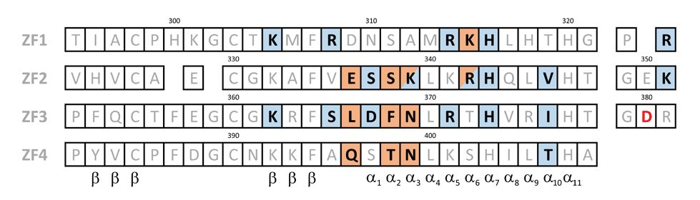

Vol. 67, No 1/2020
73-77
https://doi.org/10.18388/abp.2020_2911
Regular paper

The effect of D380Y pathogenic mutation in human Yin Yang 1
on the protein's structure and function*

Małgorzata Figiel^, Julia Łakomska, Marta Dziedzicka-Wasylewska and Andrzej Górecki
Department of Physical Biochemistry, Faculty of Biochemistry, Biophysics and Biotechnology, Jagiellonian University, Kraków, Poland
Yin Yang 1 is a human transcription factor that controls
a number of genes and takes part in the regulation of
cell cycle, proliferation, differentiation, and neuronal de-
velopment. Yin Yang 1 is composed of an N-terminal in-
trinsically disordered fragment and a C-terminal domain
responsible for binding to DNA, composed of four zinc
fingers. Recently, various alterations in the Yin Yang 1's
DNA binding domain were linked with an unexplained
intellectual disability named Gabriele-de Vries syndrome.
In this paper, a repetitively occurring substitution of as-
partate-380 for tyrosine was analyzed to assess its im-
pact on Yin Yang 1's structure and DNA binding. The
substitution was found to affect Yin Yang 1's secondary
and tertiary structure to a limited extent and to impair
the specificity of its interaction with DNA.
Key words: fluorescence anisotropy; circular dichroism; intrinsically
disordered protein; Yin Yang 1; protein-DNA interaction
Received: 12 November, 2019; revised: 08 January, 2020; accepted:
30 January, 2020; available on-line: 20 February, 2020
Ee-mail: m.figiel@uj.edu.pl
*Acknowledgements of Financial Support:
The costs of the article published as a part of the 44th FEBS Con-
gress Kraków 2019 - From molecules to living systems block are
financed by the Ministry of Science and Higher Education of the
Republic of Poland (Contract 805/P-DUN/2019).
This research was supported by grant number 35p/6/2015 from
the Faculty of Biochemistry, Biophysics and Biotechnology of Jag-
iellonian University. The Faculty of Biochemistry, Biophysics and Bi-
otechnology is a partner of the Leading National Research Center
(KNOW) supported by the Ministry of Science and Higher Educa-
tion.
Abbreviations: AAV-60, adeno-associated virus P5 promoter;
AAV+1, adeno-associated virus P5 initiator; CD, circular dichroism;
DBD, DNA-binding domain of Yin Yang 1 protein; DTT, dithiothrei-
tol; IgH, immunoglobulin heavy chain enhancer; LB, Luria-Bertani
broth; ROX, carboxy-x-rhodamine; SDS-PAGE, sodium dodecyl sul-
fate-polyacrylamide gel electrophoresis; YY1, Yin Yang 1.
of YY1 forms its DNA-binding domain (DBD) that in-
cludes four consecutive zinc fingers of C2H2 type (Hou-
baviy et al, 1996).
Pathogenic effects of substituting YY1 aspartate-380
for tyrosine was recently reported twice, in two differ-
ent exome-sequencing studies on individuals with unex-
plained intellectual disabilities (Vissers et al., 2010; Gabri-
ele et al, 2017). One of the studies was aimed at muta-
tions in yy1 locus and in fact found several substitutions
and deletions within the DBD (Gabriele et al, 2017).
The finders hypothesized that the common effect of the
discovered mutations could result from impaired DNA
binding by the YY1 mutants. Aspartate-380 is located in
the linker region that connects 3rd and 4th zinc fingers
of YY1 (Fig. 1). No direct contact between aspartate-380
and DNA was observed in the crystal structure of YY1
nucleoprotein (Houbaviy et al, 1996). However, molecu-
lar simulations predict that D380Y substitution disrupts
the network of hydrogen bonds on the surface of the
YY1 molecule (Gabriele et al, 2017). Moreover, YY1
D380Y exhibited compromised performance in chroma-
tin immunoprecipitation (Gabriele et al, 2017).
Our research group established a protocol for robust
production of active, recombinant YY1 protein (Gole-
biowski et al, 2011) as well as a sensitive, quantitative
equilibrium assay for YY1-DNA interaction (Golebio-
wski et al, 2012). These methods previously allowed us
to precisely analyze the effect of another YY1 mutation,
T372R, which is recurrent in insulinomas, and proved
it to affect YY1 binding to DNA in a sequence-specific
way (Nieborak & Gorecki, 2016). In this paper, we ana-
lyzed the impact of D380Y mutation on YY1 structure
and its interaction with DNA.
MATERIALS AND METHODS
INTRODUCTION
Yin Yang 1 (YY1) is a ubiquitously expressed human
transcription factor that can act as a transcription initia-
tor, activator or repressor. YY1 is crucial for cell cycle
control, proliferation, differentiation, and neuronal devel-
opment (Gordon et al, 2006; He & Casaccia-Bonnefil,
2008). Deletion of both yy1 alleles is lethal at the early
stages of embryo development, while yy1+/- heterozy-
gotes exhibit neurological defects and growth retarda-
tion, which was shown in Mus musculus and Xenopus laevis
(Donohoe et al., 1999; Morgan et al, 2004). Structur-
ally, YY1 is composed of two parts, differing in both
structure and function. The N-terminal fragment is in-
trinsically disordered (Gorecki et al, 2015) and fulfills a
regulatory role through a number of protein-protein in-
teractions. On the other hand, the C-terminal fragment
Plasmids. pET-21a/DBD — expression vector (No-
vagen) with cDNA of the DNA-binding domain of hu-
Figure 1. The amino acid sequence of the DNA-binding domain
of human YY1 (DBD).
The site of the pathogenic mutation is marked red. Blue and or-
ange boxes depict residues that interact with the phosphate back-
bone and nucleobases, respectively, in the co-crystal structure of
DBD and AAV P5 initiator (Houbaviy et al., 1996). ZF1-4 denotes
the four zinc fingers of YY1. a and в denote particular secondary
structures.
74
M. Figiel and others
2019
man YY1 (residues 295-414) cloned under the control of
T7lac promoter, preceded by MAS sequence encoded by
the vector.
Bacterial strains. E. coli DH5a (Invitrogen) — used in
cloning and for plasmid amplification; E. coli BL21(DE3)
(Invitrogen) — used for protein expression.
Oligonucleotide duplexes containing the DNA se-
quences specifically recognized by YY1 protein were
5’-labeled with carboxy-x-rhodamine (ROX) on the
antisense strand. The following sense sequences were
analyzed: immunoglobulin heavy chain enhancer (IgH):
5’-TGATCGGCCATCTTGACTCC-3’; adeno-associ-
ated virus P5 promoter (AAV-60): 5’-TTTTGCGA-
CATTTTGCGACA-3’; adeno-associated virus P5 initia-
tor (AAV+1): 5’-AGGGTCTCCATTTTGAAGCG-3’.
Site-directed mutagenesis. pET21a/DBD vec-
tor was subjected to mutagenesis with the use of the
QuikChange protocol (Stratagene). The sequences of the
mutagenic forward and reverse primers were: GTGC-
GAATCCATACCGGATACAGGCCCTATGTGTGC
and GCACACATAGGGCCTGTATCCGGTATGGAT-
TCGCAC, respectively. The obtained construct was se-
quenced to confirm the presence of the substitution.
Protein expression and purification. The plasmids
encoding wild-type DBD and its D380Y variant were
transformed into the E. coli strain BL21(DE3) (Novagen)
which were grown on the Luria-Bertani (LB) agar plates
with ampicillin (100 gg/mL) overnight at 37°C. LB-
ampicillin medium (50 mL) was inoculated with a single
colony from the plate and grown overnight at 180 rpm
shaking at 37°C. The precultures were added to 1.5 L of
LB-ampicillin and grown at 180 rpm shaking at 37°C.
The expression was induced at an O.D. 600 of 0.6—1.0
with 1 mM isopropyl в-d-l-thiogalactopyranoside for
three hours. At the time of induction, ZnCl2 was added
to the cultures to the final concentration of 0.1 mM.
The cells were harvested by centrifugation at 7 000 x g
for 15 min at 4°C, pelleted and stored frozen at —20°C.
The bacterial pellet from the 2 L culture was resus-
pended in 30 mL of buffer A (25 mM Tris-HCl, pH 7.9,
100 mM NaCl, 6 M guanidine hydrochloride, 1 mM phe-
nylmethylsulfonyl fluoride, 2 mM в-mercaptoethanol).
The suspension was sonicated for six 45-s bursts on
ice. The lysate was cleared by centrifugation (30 000 x g
30 min, 4C), and the supernat ant was loaded onto a 30-
mL nickel-nitrilotriacetic acid gravity-flow column (Nova-
gen) which was previously equilibrated in buffer A. The
column was washed with 3 column volumes of buffer
A. Proteins were then eluted in buffer A with addition
of 300 mM imidazole. 1.0-mL fractions were harvested.
The protein concentration was determined in triplicates
with the Bradford assay (Bradford, 1976), calibrated with
bovine serum albumin (BSA) (Sigma-Aldrich). The pu-
rification process was monitored by sodium dodecyl
sulfate-polyacrylamide gel electrophoresis (SDS-PAGE)
(Laemmli, 1970) in 15% gel. Fractions containing DBD
or its D380Y variant were pooled and reduced by a 30-
min incubation at 60°C with the addition of 10 mM eth-
ylenediamine tetraacetic acid and 100 mM dithiothreitol
(DTT). The proteins were refolded by a three-step di-
alysis at 4°C against buffer B (25 mM Tris-HCl, pH 7.9,
100 mM NaCl, 10 mM MgCl2, 0.1 mM ZnCl2, 5 mM
DTT) at 1:100 ratio. The final purification step was con-
ducted using ÄKTA Explorer system (Amersham Phar-
macia Biotech) on agarose resin with immobilized oli-
gos of IgH promoter sequence, as described previously
(Golebiowski et al, 2011). Briefly, the dialyzed samples
were loaded onto the column and the specifically bound
protein was eluted in the 10—100% gradient of buffers
A1 (25 mM Tris-HCl, pH 7.9, 10 mM MgCl2, 0.1 mM
ZnCl2 2 mM DTT) and A2 (25 mM Tris-HCl, pH 7.9,
1 M NaCl, 10 mM MgCl2, 0.1 mM ZnCl2, 1 mM DTT).
Protein content and purity in the collected fractions were
analyzed with the use of SDS-PAGE. Selected fractions
were pooled and dialyzed at 4°C against 500-fold excess
of buffer C (25 mM Tris-HCl, pH 7.9, 100 mM NaCl,
10 mM MgCl2, 0.1 mM ZnCl2, 5 mM DTT), in which all
the further analyses were performed.
Size-exclusion chromatography. Size exclusion ex-
periments were performed using ÄKTA Explorer sys-
tem (Amersham Pharmacia Biotech) on Superdex 200
Increase 10/300 column (GE). The separations were
monitored by absorbance measurements at 220 nm and
280 nm to determine the elution volumes of DBD pro-
tein variants. The Stokes radii were calculated based on a
calibration curve obtained for dextran blue and a set of
standard proteins: thyroglobulin, apoferritin, BSA, myo-
globin, cytochrome c.
Spectroscopic measurements. Circular dichroism
(CD) measurements were conducted using a J-710 spec-
tropolarimeter (Jasco) equipped with an F25 temperature
control unit (Julabo) in quartz cuvettes of 0.1 mm path-
length (Hellma). The spectra were recorded in the range
of 194—250 nm with 1 nm data pitch, 10 nm/min scan-
ning speed, 8 s integrating time, and 2 nm bandwidth
and averaged over three acquisitions. The protein con-
centration was 1.1 mg/ml and 1.3 mg/ml for wild-type
and D380Y, respectively. All spectra were corrected for
the effect from the buffer and all measurements were
converted to molar residual ellipticity units. Secondary
structure content was determined using SELCON3 pro-
gram from CDPro package (Sreerama & Woody, 2000).
Fluorescence anisotropy was measured using spec-
trofluorimeter Fluorolog-3 equipped with an F25 tem-
perature control unit (Julabo). The measurements were
conducted in a thermostated cuvette 3 x 3 mm (Hellma)
at 25°C, with 490 nm excitation, 525 nm emission, 0.1
s integration time, 8 nm and 7 nm slit widths on exci-
tation and emission monochromators, respectively, and
averaged over three acquisitions. The samples contained
0—38 gM DBD D380Y, in twofold serial dilutions, 50
nM ROX-labeled DNA, 25 mM Tris-HCl, pH 7.9, 50
mM NaCl, 10 mM MgCl2, 0.1 mM ZnCl2, 5 mM DTT,
0.1 mg/ml BSA, 0.04% (w/v) polyethylene glycol. The
samples were incubated on ice for 1 h and then equili-
brated at 25°C for 10 min just prior to the measurement.
RESULTS
To study the prospective changes in YY1’s structure
and function upon D380Y substitution, we produced a
recombinant protein carrying the mutation. The DNA-
binding domain of YY1 (DBD) was used, as the frag-
ment is solely responsible for DNA binding (Figiel &
Gorecki, 2017). Standard protocols were used for the ex-
pression and purification, that previously had been opti-
mized for the wild-type DBD (Golebiowski et al, 2011).
Notably, the final purification step employed an affinity
column with immobilized DNA of sequence recognized
by wild-type YY1. If the D380Y variant did not specifi-
cally bind DNA, this could reduce the purification yield,
though the mutant protein could still non-specifically
bind to the column through electrostatic interactions.
No such reduction was in fact observed; the procedure
was repeated twice and no significant difference in the
production yield was observed between the D380Y mu-
tant and the wild-type DBD1.
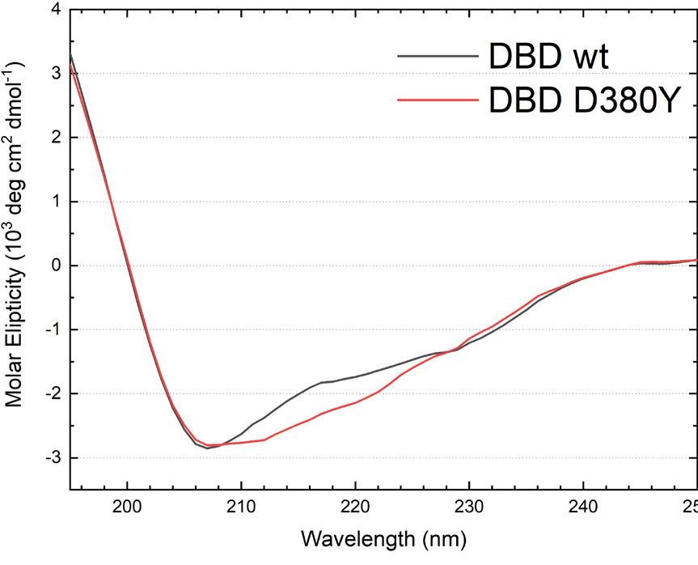
Vol. 66
The effect of D380Y mutation in human YY1
75
Figure 2. Far-UV CD spectra of wild-type (WT) and D380Y DBD.
Structure analysis
The analyzed substitution completely changed the
character of the side chain, replacing a charged aspartate
moiety with the aromatic ring of tyrosine. Changing the
protein charge, hydrophobicity and possibly the network
of hydrogen bonds on its surface could severely disturb
the spatial structure. To check this, we compared the
secondary and tertiary structures of the wild-type DBD
and its D380Y mutant.
Secondary structure content was assessed with the use
of CD measurements in the far-UV range. The spec-
tra obtained for the two protein variants had roughly
similar shapes but differed regarding the intensity of a
broad negative band centered at about 215 nm (Fig. 2).
However, deconvolution of the spectra yielded a simi-
lar content of particular secondary structure types in the
wild-type protein and the D380Y mutant (Table 1), sug-
gesting that the propensity to fold into zinc finger mo-
tifs was retained in the mutant protein. D380 residue is
located in the linker region between the third and fourth
zinc fingers. Although the region had no regular arrange-
ment in the crystal structure (Houbaviy et al, 1996), the
mutation could possibly impair the proper folding of
both zinc fingers. Yet the amount of particular second-
ary structures differed only to a small extent between the
wild-type and D380Y DBD. Possibly, the mutation af-
fected the distribution of conformations available for the
protein.
Next, we analyzed the impact of D380Y mutation
on the overall tertiary structure of DBD. Size exclu-
sion chromatography separations allowed us to com-
pare the compactness of conformation of wild-type and
D380Y DBD variants. Substituting tyrosine for aspartate
changed the protein’s charge and hydropathy, the two
properties that determine the propensity of the ordered
protein structure (Campen et al, 2008). Wild-type DBD
Table 1. Secondary structure content of the wild-type and D380Y
DBD protein inferred from their CD spectra (Fig. 2). Values de-
note the number of amino acid residues forming the given type
of secondary structure.
 | Wild-type | D380Y
a-helix | 6 | 5
в-sheet | 50 | 48
Turn | 23 | 23
Random | 42 | 45
Table 2. Hydrodynamic parameters of the wild-type and D380Y
DBD protein obtained from size exclusion chromatography sep-
arations. The presented values are means ± S.D. of three inde-
pendent separations.
 | Wild-type | D380Y
Apparent molecular mass [kDa] | 15.1±1.7 | 18.7±1.0
Apparent-to-formula molecular mass | 1.07 | 1.33
Stokes radius [Â] | 18.5±1.3 | 21.0±0.6
has a compact, ordered structure | (Gorecki | et al., 2015).
The compactness of the D380Y mutant was loosened
compared to the wild-type protein, as demonstrated by
its increased Stokes shift and a higher ratio of apparent
and formula molecular masses, presented in Table 2.
DBD1 D380Y binding to DNA
Protein-DNA interaction can be affected by mutations
in many different ways. The number of contacts can be
decreased by substitutions of either positively charged
residues that electrostatically interact with the phosphate
backbone or residues that make base-specific contacts
in the grooves of DNA helix. The preferred consensus
sequence may also be changed. Such an effect was ob-
served for T372R mutation of YY1, which is recurrent
in insulinomas. The 1st and 4th zinc fingers of YY1 par-
ticipate in DNA binding to a different extent in the wild
type protein and in the T372R mutant (Cromer et al,
2015). Similarly, the D380Y mutation might also affect
the concerted DNA binding by YY1’s 3rd and 4th zinc
finger, as it changes the sequence of their linker into a
non-optimal one. In order to capture such subtle differ-
ences, we measured the affinity of DBD1 D380Y for
three different sequences, derived from promoters actu-
ally bound by YY1, but characterized by a varying simi-
larity to the YY1 consensus motif: the immunoglobulin
heavy chain enhancer, the adeno-associated virus P5 pro-
moter and the adeno-associated virus P5 initiator.
Fluorescence anisotropy measurements demonstrated
that DBD1 D380Y bound DNA weaker than the wild-
type protein (Fig. 3). The affinity for IgH sequence
was decreased the most. As a result, the binding con-
stants (presented in Table 3) were similar for all three
sequences, even though the values differed for the wild
type protein. Thus, we observed no differences in the
affinity of the mutated protein for the tested sequences,
although such a difference was clearly visible in the wild-
type protein (Golebiowski et al, 2012).
DISCUSSION
The aim of this work was to evaluate how YY1 pro-
tein’s structure and its interaction with DNA is affected
Table 3. Dissociation constants for the interaction between DBD
and DNA, obtained from fluorescence anisotropy measurements.
The relative affinity is the ratio of association constants for the
mutant protein vs. the wild-type.
 | Wild-type* [pM] | D380Y [pM] | Relative affinity  (D380Y vs. wild-  -type)
IGH | 0.21 ± 0.02 | 7.8 ± 0.8 | 37
AAV+1 | 0.87 ± 0.08 | 7.3 ± 4.8 | 8
AAV-60 | 1.22 ± 0.33 | 8.7 ± 3.0 | 7
*Data obtained by Golebiowski and others (Golebiowski et al., 2012)
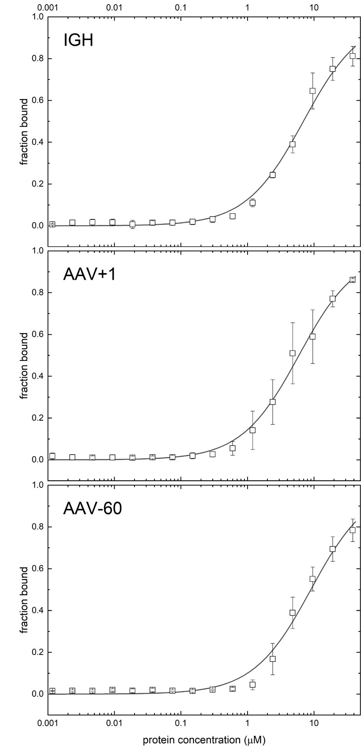
76
M. Figiel and others
2019
Figure 3. The binding curves obtained from the fluorescence
anisotropy measurements for the DBD D380Y variant and three
different promoter sequences.
by D380Y substitution that was discovered in two cases
of unexplained mental retardation. Aspartate-380 locates
within the linker that connects the third and fourth zinc
fingers of YY1 (Houbaviy et al, 1996). Linkers between
the consecutive zinc fingers are important structural ele-
ments for protein-DNA interactions. They exhibit a con-
sensus sequence GEK and a similar spatial arrangement
within the molecules of various proteins (Wolfe et al,
2000). Deviations from the consensus impede the con-
certed binding of the linked zinc fingers to DNA. For
instance, the linker between the first and second zinc
fingers of YY1 is shorter than the consensus, impeding
the interaction between the first zinc finger and DNA
(Figiel & Gorecki, 2017; Chen et al, 2019).
Aspartate-380 is located at the 3rd position of the
linker. Although it is not the optimal glutamate residue,
its side chain has a very similar chemical character. On
the contrary, D380Y substitution changes the proper-
ties completely, influencing both the hydropathy and the
charge, and possibly also introducing steric hindrance.
Based on the molecular simulations, D380Y substitution
is expected to disrupt the network of hydrogen bonds
and salt bridges on the YY1-DNA interface (Gabriele
et al, 2017). Our observations confirmed that the sub-
stitution affects YY1’s structure and its interaction with
DNA.
The CD spectra registered in the far-UV range dif-
fered between the two variants but still allowed us to
infer that the native secondary structure was retained
in the D380Y mutant. Size exclusion chromatography
separations indicated that the overall compactness of the
protein molecule was slightly affected by D380Y substi-
tution, as it affected both the charge and the hydropa-
thy of the protein. Moreover, the mutation compromised
YY1’s affinity to DNA and reduced its specificity. D380
locates in a region that is important for the interaction,
as it links the two zinc fingers that make the majority
of specific contacts with the nucleobases (Houbaviy et
al, 1996) (Fig. 1) and contribute the most to YY1-DNA
binding (Chen et al., 2019).
Interestingly, the changes in fluorescence anisotropy
of the DNA-bound ROX were more pronounced upon
binding of DBD1 D380Y than of the wild-type protein.
This could be explained by several mechanisms; firstly,
the mutant protein could be unstable and more prone
to aggregation than the wild-type protein, though the
hydrodynamic parameters did not confirm this. Alterna-
tively, the mutant protein binding could engage the first
zinc finger to a greater extent, decreasing the mobility of
the dye, which is attached to the 5’ end of the reverse
DNA strand. Such an effect was previously ascribed to
YY1 T372R mutant (Cromer et al., 2015). Finally, YY1
could electrostatically interact with the fluorescent dye
attached to DNA duplex within the nucleoprotein, alter-
ing its fluorescence parameters. Such interaction could
be abolished by D380Y substitution, as described else-
where for TraI36 mutants, E187A and R150A (Ander-
son et al, 2008).
One of the premises for investigation of YY1 D380Y
variant was its impaired chromatin immunoprecipitation,
previously reported by Gabriele and others (Gabriele et
al, 2017). Apart from a compromised affinity for DNA,
this could also be caused by abnormal interaction with
trans regulators. This is in line with the finding of Ga-
briele and others (Gabriele et al, 2017) that the peaks re-
tained in YY1 D380Y immunoprecipitates were enriched
in COREST, p300, PAX5 and HDAC1 motifs, com-
pared to those present only in wild-type YY1 immuno-
precipitates. In fact, D380 is located in a region involved
in many protein-protein interactions, i.e. with E1A (Lew-
is et al, 1995), ATF2a (Zhou et al, 1995), SAP30 (Huang
et al, 2003), or p53 (Sui et al, 2004).
The presented study was limited to an in vitro ap-
proach. An in vivo analysis would give a fuller insight
into the malfunctions caused by the D380Y substitution.
However, it would not allow for separate analyses of
particular structural aspects and interactions. The simpli-
fied model enabled a detailed, quantitative analysis and
allowed us to draw unequivocal conclusions regarding
the character of changes in YY1 interaction with DNA.
Functional studies on cells should be the next step to
comprehend a full picture of the effects of D380Y mu-
tation and fill the gap between the case-control study of
Gabriele and others (Gabriele et al, 2017) and the pre-
sented in vitro study of the underlying mechanisms.
To conclude, D380Y substitution was independently
suggested as the cause of unexplained mental retarda-
tion twice (Vissers et al., 2010; Gabriele et al, 2017). We
Vol. 66
The effect of D380Y mutation in human YY1
77
found that the substitution affected YY1’s secondary and
tertiary structure only to a limited extent, yet it impaired
DNA binding and decreased its specificity.
Acknowledgements
The authors would like to thank Ahmed Hal for the
preliminary measurements.
REFERENCES
Anderson BJ, Larkin C, Guja K, Schildbach JF (2008) Using fluoro-
phore-labeled oligonucleotides to measure affinities of protein-
DNA interactions. Methods En%ymol 450: 253—272. https://doi.
org/10.1016/S0076-6879(08)03412-5
Bradford MM (1976) A rapid and sensitive method for the quantitation
of microgram quantities of protein utilizing the principle of protein-
dye binding. Anal Biochem 72: 248—254. https://doi.org/10.1006/
abio.1976.9999
Campen A, Williams RM, Brown CJ, Meng J, Uversky VN, Dunker
AK (2008) TOP-IDP-scale: a new amino acid scale measuring pro-
pensity for intrinsic disorder. Protein Pept Lett 15: 956—963
Chen K, Lu Y, Shi K, Stovall DB, Li D, Sui G (2019). Functional
analysis of YY1 zinc fingers through cysteine mutagenesis. FEBS
Lett 593: 1392-1402. https://doi.org/10.1002/1873-3468.13431
Cromer MK, Choi M, Nelson-Williams C, Fonseca AL, Kunst-
man JW, Korah RM, Overton JD, Mane S, Kenney B, Malchoff
CD, Stalberg P, Akerstrom G, Westin G, Hellman P, Carling T,
Bjorklund P, Lifton RP (2015) Neomorphic effects of recurrent
somatic mutations in Yin Yang 1 in insulin-producing adenomas.
Proc Natl Acad Sci U S A 112: 4062-4067. https://doi.org/10.1073/
pnas.1503696112
Donohoe ME, Zhang X, McGinnis L, Biggers J, Li E, Shi Y (1999)
Targeted disruption of mouse Yin Yang 1 transcription factor re-
sults in peri-implantation lethality. Mol Cell Biol 19: 7237-7244. htt-
ps://doi.org/10.1128/mcb.19.10.7237
Figiel M, Gorecki A (2017) Physical Interaction of Human Yin
Yang 1 Protein with DNA. Crit Rev Oncog 22: 75-97. https://doi.
org/10.1615/CritRevOncog.2017020976
Gabriele M, Vulto-van Silfhout AT, Germain PL, Vitriolo A, Kumar R,
Douglas E, Haan E, Kosaki K, Takenouchi T, Rauch A, Steindl K,
Frengen E, Misceo D, Pedurupillay CRJ, Stromme P, Rosenfeld JA,
Shao Y, Craigen WJ, Schaaf CP, Rodriguez-Buritica D, Farach L,
Friedman J, Thulin P, McLean SD, Nugent KM, Morton J, Nicholl
J, Andrieux J, Stray-Pedersen A, Chambon P, Patrier S, Lynch SA,
Kjaergaard S, Torring PM, Brasch-Andersen C, Ronan A, van Haer-
ingen A, Anderson PJ, Powis Z, Brunner HG, Pfundt R, Schuurs-
Hoeijmakers JHM, van Bon BWM, Lelieveld S, Gilissen C, Nillesen
WM, Vissers L, Gecz J, Koolen DA, Testa G, de Vries BBA (2017)
YY1 Haploinsufficiency causes an intellectual disability syndrome
featuring transcriptional and chromatin dysfunction. Am J Hum Ge-
net 100: 907-925. https://doi.org/10.1016Zj.ajhg.2017.05.006.
Golebiowski FM, Gorecki A, Bonarek P, Dziedzicka-Wasylewska M
(2011) Efficient overexpression and purification of active full-length
human transcription factor Yin Yang 1 in Escherichia coli. Protein
Expr Purif 77: 198-206. https://doi.org/10.1016/j.pep.2011.01.016.
Golebiowski FM, Gorecki A, Bonarek P, Rapala-Kozik M, Kozik A,
Dziedzicka-Wasylewska M (2012) An investigation of the affinities,
specificity and kinetics involved in the interaction between the Yin
Yang 1 transcription factor and DNA. FEBS J 279: 3147-3158.
https://doi.org/10.1111/j.1742-4658.2012.08693.x
Gordon S, Akopyan G, Garban H, Bonavida B (2006) Transcription
factor YY1: structure, function, and therapeutic implications in
cancer biology. Oncogene 25: 1125-1142. https://doi.org/10.1038/
sj.onc.1209080
Gorecki A, Bonarek P, Gorka AK, Figiel M, Wilamowski M, Dziedzic-
ka-Wasylewska M (2015) Intrinsic disorder of human Yin Yang 1
protein. Proteins 83: 1284-1296. https://doi.org/10.1002/prot.24822
He Y, Casaccia-Bonnefil P (2008) The Yin and Yang of YY1 in
the nervous system. J Neurochem 106: 1493-1502. https://doi.
org/10.1111/j.1471-4159.2008.05486.x
Houbaviy HB, Usheva A, Shenk T, Burley SK (1996) Cocrystal struc-
ture of YY1 bound to the adeno-associated virus P5 initiator. Proc
Natl Acad Sci U S A 93: 13577-13582. https://doi.org/10.1073/
pnas.93.24.13577
Huang NE, Lin CH, Lin YS, Yu WC (2003) Modulation of YY1 activ-
ity by SAP30. Biochem Biophys Res Commun 306: 267-275. https://
doi.org/10.1016/s0006-291x(03)00966-5
Laemmli UK (1970) Cleavage of structural proteins during the assem-
bly of the head of bacteriophage T4. Nature 227: 680-685
Lewis BA, Tullis G, Seto E, Horikoshi N, Weinmann R, Shenk T
(1995) Adenovirus E1A proteins interact with the cellular YY1 tran-
scription factor. J Virol 69: 1628-1636
Morgan MJ, Woltering JM, In der Rieden PM, Durston AJ, Thiery JP
(2004) YY1 regulates the neural crest-associated slug gene in Xeno-
pus laevis. J Biol Chem 279: 46826-46834. https://doi.org/10.1074/
jbc.M406140200
Nieborak A, Gorecki A (2016) Significance of the pathogenic muta-
tion T372R in the Yin Yang 1 protein interaction with DNA-
- thermo dynamic studies. FEBS Lett 590: 838-847. https://doi.
org/10.1002/1873-3468.12106
Sreerama N, Woody RW (2000) Estimation of protein secondary struc-
ture from circular dichroism spectra: comparison of CONTIN,
SELCON, and CDSSTR methods with an expanded reference set.
Anal Biochem 287: 252-260. https://doi.org/10.1006/abio.2000.4880
Sui G, Affar el B, Shi Y, Brignone C, Wall NR, Yin P, Donohoe
M, Luke MP, Calvo D, Grossman SR, Shi Y (2004) Yin Yang 1
is a negative regulator of p53. Cell 117: 859-872. https://doi.
org/10.1016/j.cell.2004.06.004
Vissers LE, de Ligt J, Gilissen C, Janssen I, Steehouwer M, de Vries
P, van Lier B, Arts P, Wieskamp N, del Rosario M, van Bon BW,
Hoischen A, de Vries BB, Brunner HG, Veltman JA (2010) A de
novo paradigm for mental retardation. Nat Genet 42: 1109-1112.
https://doi.org/10.1038/ng.712
Wolfe SA, Nekludova L, Pabo CO (2000) DNA recognition by Cy-
s2His2 zinc finger proteins. Annu Rev Biophys Biomol Struct 29: 183—
212. https://doi.org/10.1146/annurev.biophys.29.L183
Zhou Q, Gedrich RW, Engel DA (1995) Transcriptional repression
of the c-fos gene by YY1 is mediated by a direct interaction with
ATF/CREB. J Virol 69: 4323-4330

