11th International Conference on Nucleus-Nucleus Collisions (NN2012) IOP Publishing
Journal of Physics: Conference Series 420 (2013) 012013 doi:10.1088/1742-6596/420/1/012013

Hades experiments: investigation of hadron
in-medium properties
Piotr Salabura
M.Smoluchowski Institute of Physics Jagiellonian University, 30-052 Krakw, Poland
E-mail: piotr.salabura@uj.edu.pl
for the HADES collaboration
G. Agakishiev6, C. Behnke7, D. Belver16, A. Belyaev6,
J.C. Berger-Chen8, A. Blanco1, C. Blume7, M. Bohmer9,
P. Cabanelas16, S. Chernenko6, C. Dritsa10, A. Dybczak2, E. Epple8,
L. Fabbietti8, O. Fateev6, P. Fonte1a, J. Friese9, I. Frohlich7,
T. Galatyuk4,b, J. A. Garzon16, K. Gill7, M. Golubeva11,
D. Gonzalez-Diaz4, F. Guber11, M. Gumberidze14, S. Harabasz4,2,
T. Hennino14, R. Holzmann3, P. Huck9, C. Hohne10, A. Ierusalimov6,
A. Ivashkin11, M. Jurkovic9, B. Kampfer5,c, T. Karavicheva11,
I. Koenig3, W. Koenig3, B. W. Kolb3, G. Korcyl2, G. Kornakov16,
R. Kotte5, A. Krasa15, E. Krebs7, F. Krizek15, H. Kuc214,
A. Kugler15, A. Kurepin11, A. Kurilkin6, P. Kurilkin6, V. Ladygin6,
R. Lalik8, S. Lang3, K. Lapidus8, A. Lebedev12, L. Lopes1,
M. Lorenz7, L. Maier9, A. Mangiarotti1, J. Markert7, V. Metag10,
J. Michel7, C. Muntz7, R. Miinzer8, L. Naumann5, M. Palka2,
Y. Parpottas13,d, V. Pechenov3, O. Pechenova7, J. Pietraszko7,
W. Przygoda2, B. Ramstein14, L. Rehnisch7, A. Reshetin11,
A. Rustamov7, A. Sadovsky11, P. Salabura2, T. Scheib7, H. Schuldes7,
J. Siebenson8, Yu.G. Sobolev15, S. Spataroe, H. Strobele7,
J. Stroth7,3, P Strzempek2, C. Sturm3, O. Svoboda15, A. Tarantola7,
K. Teilab7, P. Tlusty15, M. Traxler3, H. Tsertos13, T. Vasiliev6,
V. Wagner15, M. Weber9, C. Wendisch5,c, J. Wustenfeld5,
S. Yurevich3, Y. Zanevsky6
- LIP-Laboratório de Instrumentacao e Fisica Experimental de Partlculas ,
3004-516 Coimbra, Portugal
- Smoluchowski Institute of Physics, Jagiellonian University of Cracow, 30-059 Kraków,
Poland
- GSI Helmholtzzentrum fur Schwerionenforschung GmbH, 64291 Darmstadt, Germany
- Technische Universitat Darmstadt, 64289 Darmstadt, Germany
- Institut fur Strahlenphysik, Helmholtz-Zentrum Dresden-Rossendorf, 01314 Dresden,
Germany
- Joint Institute of Nuclear Research, 141980 Dubna, Russia
- Institut fur Kernphysik, Goethe-Universitat, 60438 Frankfurt, Germany
- Excellence Cluster ’Origin and Structure of the Universe’ , 85748 Garching, Germany
Published under licence by IOP Publishing Ltd
1
11th International Conference on Nucleus-Nucleus Collisions (NN2012) IOP Publishing
Journal of Physics: Conference Series 420 (2013) 012013 doi:10.1088/1742-6596/420/1/012013
- Physik Department E12, Technische Universitat Munchen, 85748 Garching, Germany
- II.Physikalisches Institut, Justus Liebig Universitat Giessen, 35392 Giessen, Germany
- Institute for Nuclear Research, Russian Academy of Science, 117312 Moscow, Russia
- Institute of Theoretical and Experimental Physics, 117218 Moscow, Russia
- Department of Physics, University of Cyprus, 1678 Nicosia, Cyprus
- Institut de Physique Nucleaire (UMR 8608), CNRS/IN2P3 - Universite Paris Sud,
F-91406 Orsay Cedex, France
- Nuclear Physics Institute, Academy of Sciences of Czech Republic, 25068 Rez, Czech
Republic
- LabCAF. Dpto. Fisica de Particulas, Univ. de Santiago de Compostela, 15706 Santiago de
Compostela, Spain
- Also at ISEC Coimbra, Coimbra, Portugal
- Also at ExtreMe Matter Institute EMMI, 64291 Darmstadt, Germany
- Also at Technische Universitat Dresden, 01062 Dresden, Germany
- Also at Frederick University, 1036 Nicosia, Cyprus
- Also at Dipartimento di Fisica Generale and INFN, Universita di Torino, 10125 Torino, Italy
Abstract.
Hadron modifications in nuclear matter are discussed in connection to chiral symmetry
restoration and/or hadronic many body effects. Experiments with photon, proton and heavy
ion beams are used to probe properties of hadrons embedded in nuclear matter at different
temperatures and densities. Most of the information has been gathered for the light vector
mesons p, u and p. HADES is a second generation experiment operating at GSI with the main
aim to study in-medium modifications by means of dielectron production at the SIS18/Bevelac
energy range. Large acceptance and excellent particle identification capabilities allows also for
measurements of strangeness production. These abilities combined with the variety of beams
provided by the SIS18 allow for a characterization of properties of the dense baryonic matter
properties created in heavy ion collisions at these energies. A review of recent experimental
results obtained by HADES is presented, with main emphasis on hadron properties in nuclear
matter.

1. Introduction
Sizable spectral modifications have been predicted by various theoretical models for hadrons
embedded in cold or hot and dense nuclear matter. In this respect, most attention has been
focused on properties of the light vector mesons (p, w, and 0) as probes of chiral symmetry
restoration (for reviews see [1, 2]). Early work based on QCD sum rules suggested a direct link
between changes of the meson masses and QCD vacuum properties, characterized by a reduction
of the expectation value of the two-quark condensate [3, 5]. More recent work shows however
that, while such a link indeed exists, it is much more sophisticated than originally thought and
offers a rather limited predictive power [1].
On the experimental side, a lot of experimental activities have been carried out over the last
years investigating the light vector meson production off nuclei with proton and photon beams,
and in heavy ion reactions. Two experimental approaches have been used to identify in-medium
modifications of the vector mesons: (i) directly, via the reconstruction of their invariant mass
distribution from the detected decay products and (ii) by quantifying the meson absorption in
nuclei from the production yields and by connecting it to the in-medium width Y^ot by model
calculations (this method is used for p(y)+A collisions). The best suited final state are dileptons,
which does not suffer strong final-state interactions (FSI) with the nuclear matter, but one has to
cope with the small branching ratios (~ 10-5). The densities and temperatures reached in heavy
ion collisions are of course higher, and larger effects can be expected but one has to properly
2
11th International Conference on Nucleus-Nucleus Collisions (NN2012) IOP Publishing
Journal of Physics: Conference Series 420 (2013) 012013 doi:10.1088/1742-6596/420/1/012013
model the time evolution of the collision system to calculate dilepton radiation. Moreover, in
order to access the true in-medium radiation one has to subtract the contribution of mesons
decaying in the late state of the heavy ion collision, that is after the so called ”freeze-out” where
all interactions between the produced particles have ceased.
Results from p(y) — A experiments are somehow controversial: while the E325 experiment
at KEK claims [4] the observation of a mass drop of the p meson in the e+e- invariant mass
spectrum according to the Brown-Rho scaling [5], investigations at JLAB (CLAS) [6] does
not corroborate such a conclusion showing only slight broadening of the p. Transparency
measurements for the w at ELSA/MAMI (CBELSA-TAPS) [8] and JLAB [7], and 0 at COSY
(ANKE) [9], LEPS at Spring8 [10] indicate large absorption of both mesons. However,
the extraction of the in-medium widths from the measured nuclear transparency is not
straightforward and even model dependant (for a review see T. Rodrigez's contribution to this
conference).
In heavy-ion collisions, the search for vector meson spectral modifications via dilepton
spectroscopy was pioneered by the CERES [11] and HELIOS [12] collaborations at the CERN
SPS and the DLS experiment [13] at Bevalac. A low-mass pair excess, below the p/w pole, above
the yield expected from free hadron decays after the freeze-out, was reported and was widely
discussed in many theoretical papers (for a review see [2]). Though the limited statistics of these
experiments did not allow to derive firm conclusions, results obtained at SPS indicate that the
excess is related to pions annihilating into the p meson, hence it is directly linked to the p in-
medium spectral function. The breakthrough in this field was achieved with the high-statistics
NA60 data set which allowed, for the first time, to extract the in-medium spectral function of the
p meson [14]. Comparisons to various theoretical calculations show that the spectral function
is mainly affected by two in-medium effects: (i) modification of the pion loop in the p meson
self-energy and (ii) direct rho-meson couplings to low-mass baryon resonance-hole excitations
[15]. Furthermore, it appears that the second mechanism plays the essential role in the observed
melting of the p meson in hot and dense nuclear matter. On the other hand, the naive mass
dropping scenario was found to be not supported by the data.
At top RHIC energies, the situation is less clear: first results from most central Au + Au
collisions at y/s=200 GeV obtained by PHENIX indicated even larger excess than at SPS [16].
However, new measurements performed by STAR (see contributions to this conference) do not
corroborate this observation.
On the other side of the energy scale at 1-2 AGeV, results of the DLS experiment could
not find a satisfactory explanation for a long time. Dielectron spectra measured even in light
C + C collisions were not described by any model calculation showing a large excess in the
mass 0.6>Me+e- >0.15 GeV/c2 range. However, nuclear matter probed in this energy range
is dominated by baryons (nucleons and up to 30% low mass-baryonic resonances) and it has a
different composition from the meson (mainly pion) dominated one probed at SPS. Therefore,
it was not clear if the excess is due to some particular features of baryonic sources not properly
modeled in the calculations or true in-medium effects.
A clarification of this dilemma was one of the main reasons to build the HADES experiment
at GSI [17]. It is a second generation versatile detector, shown in Fig.1, with excellent
particle identification capabilities and large acceptance. HADES (High Acceptance DiElectron
Spectrometer) has, for the first time in this energy regime, the capability to simultaneously
measure various rare probes like dielectrons, single (kaons, hyperons) and double strange hadrons
(2-(1321) and 0 mesons. The ability to study strangeness production is particularly interesting
from the point of view of still unsettled questions of kaon in-medium properties (for a review see
[18]). Experiments performed at GSI by means of KAOS and FOPI detectors provided many
interesting data. However, further precise measurements of kaon flow, low transverse momentum
distributions of kaons and 0 production are necessary to fully characterize kaon production in
3
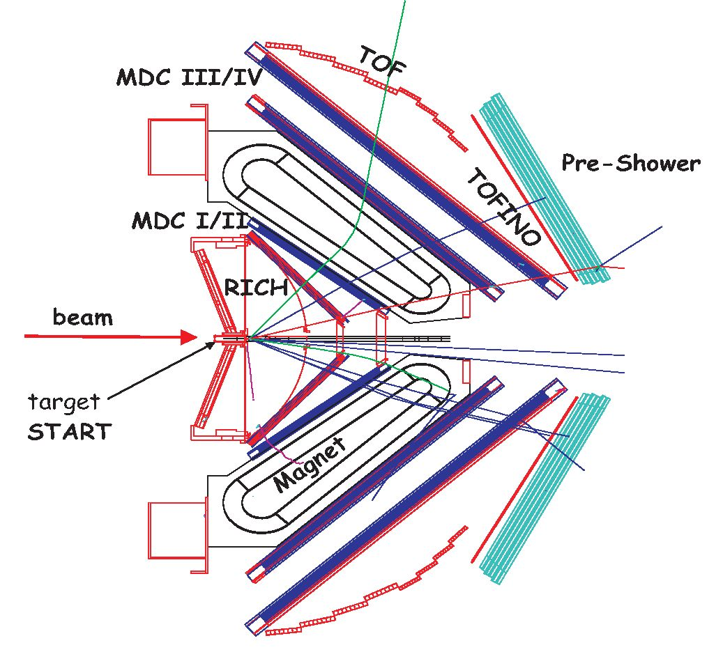
11th International Conference on Nucleus-Nucleus Collisions (NN2012) IOP Publishing
Journal of Physics: Conference Series 420 (2013) 012013 doi:10.1088/1742-6596/420/1/012013
heavy ion collisions. Furthermore, double strange hyperons have never been measured before at
SIS18 energies and likewise first data on 0 meson production have been only recently provided
by HADES and FOPI detectors.
Figure 1. Schematic layout of the HADES detector. A RICH detector with gaseous radiator, carbon
fiber mirror and UV photon detector with solid CsI photocathode is used for electron identification.
Two sets of Mini-DrifS Chambers (MDCs) with 4 modules per sector are placed in front and behind the
toroidal magnetic field to measure particle momentd. A time of flight; wall TOF/TOFINO ( the latter one
replaced in 2010 by a high granularity RPC) accompanied by a Pre-Shower detector at forward angles is
used for additional electron identification and trigger purposes. Thetarget is placed at half radius off the
center of the mirror. For reaction time measurement, a START detector is located in front of the target
[17]
Using the variety of proton, deuteron and ion beams HADES can study elementary and heavy
ion reactions creating dense (up) to 3p0) and hot (with temperatures up to T=80 MeV) nuclear
matter with relatively long; life time (~ 10 fm/c). With its future scientific programme at SIS100
at FAIR it will also cover tine 8-10 AGeV energy range, where there is no dielectron data up to
now. Therefore it also will, togettier with the future Compressed Baryonic Matter experiment
of FAIR [19], provide further valuable data to complete our understanding of the nuclear matter
phase diagram in the baryon rich region.
- Experimental programme of HADES
The HADES programme realized so far can be divided into three strongly interconnected parts.
Experiments studying dielectron, pion and baryon resonance production in proton-proton (at
1.25, 2.2 and 3.5 GeV) and d + p (at 1.25 GeV) reactions provided important constraints on
contributions of various e+e- sources and allowed to establish model independent reference
spectra for studies of proton-nucleus and nucleus-nucleus collisions. p + p collisions at 3.5 GeV
provided also valuable new data on hyperon £(1385) and A(1405) production. The vector mesons
and the neutral kaon productions were investigated in p + Nb collisions at 3.5 GeV to search for
meson modifications in cold nuclear matter. Small C + C and medium size Ar + KCl collision
4
11th International Conference on Nucleus-Nucleus Collisions (NN2012) IOP Publishing
Journal of Physics: Conference Series 420 (2013) 012013 doi:10.1088/1742-6596/420/1/012013
systems were explored in the 1 — 2 AGeV energy range to verify the origin of the dielectron excess
observed in DLS experiments and to study strangeness production (0, K-,+’°, A, 2-(1321)).
Studies of nucleus-nucleus collision systems has been continued in 2012 with Au + Au collisions
at 1.25 GeV. Below we present highlights of the results obtained so far, with emphasis on hadron
in-medium properties.

3. Results from N-N collisions
The special character of e+e- production in N — N collisions in the 1-2 GeV beam energy
range is given by a strong contribution of baryonic sources: Dalitz decays of nucleon resonances
R ^ Ne+e- (mainly A(1232)) and N — N bremsstrahlung, and a strongly rising excitation
functions of the n meson production [20]. The baryonic sources completely determine the e+e-
invariant mass distribution above the n° mass at beam energies below the n meson production
threshold (EbgaTO=1.25 GeV) [21]. The latter contributes via n ^ e+e-Y decay at the same level
as the baryonic sources already around 1.6 GeV. The vector meson production is small because
of the high production threshold (Ebham=1.88 GeV for w) and adds an important contribution to
the invariant mass spectrum at Me+e- > 0.6 GeV/c2 . While the exclusive w and n production
in p + p reactions close to the production threshold is very well known, the data on p are scarce.
Furthermore, in contrast to the w and 0 production mechanisms, which essentially do not show
resonance contributions, a strong coupling of the p meson to the low-mass baryonic resonances
(D13(1520),P13(1720),..) has been predicted by many models (see for example [22, 23]). Since
the p meson is a broad resonance these couplings can lead to the spectral function very different
from a simple Breit-Wigner distribution even in elementary reactions. On should underline that
a detailed understanding of these couplings is a prerequisite for any conclusions on in-medium
modifications in nuclear matter. This statement holds also for the situation at higher beam
energies where, as already discussed above, baryonic effects are of major importance for the
interpretation of NA60 and CERES data. One should also stress that decays processes like
R ^ Ne+e- (Dalitz) and R ^ p(^ e+e-)N are strongly linked and should not be in general
treated as a two separate decay channels. A natural connection should be provided by a structure
of the electromagnetic transition form factors in the time-like region, i.e its dependence on the
virtual photon (or e+e- invariant) mass. Calculations performed within the extended Vector
Meson Dominance (VMD) model [26] and the two component model [27, 28] indeed show the
importance of the vector mesons in such transitions. However, new precise data from proton
and, in particular, pion induced reactions on such decays are needed to provide more constraints
for calculations. We come to this issue in discussion of the HADES data obtained at higher
beam energy of 3.5 GeV.
The other silent feature of dielectron production in N + N reactions is a very strong
isospin dependence. This feature was already demonstrated by the DLS experiment measuring
excitation functions of the pair production in p + p and d + p collisions in the beam energy
range Ebeam 1-4.88 GeV [25]. Though the statistics gathered in these experiments is limited
and the systematic errors related to normalization are large, one can clearly see that there is
a strong increase of the non-trivial pair yield (in the Me+e- > Mno range) in d + p reactions
over the one measured in p + p below 2 GeV, with maximum around Ebeam=1.25 GeV. New
data obtained by HADES stimulated significant progress in understanding this phenomenon.
Fig. 2 shows the e+e- invariant mass distributions obtained in p + p and, for the first time, in
quasi-free n + p reactions, the latter one selected by tagging the proton spectator from d + p
collisions, at Ebeam=1.25 GeV. While the p+p data can be described rather well by the incoherent
superposition of the n° and A(1232) Dalitz decays, the p + n data shows a large excess over
these two contributions at Me+e- > Mno. The situation is not changed by adding a small
n contribution in the p + n case, appearing because of the neutron momentum distribution
5
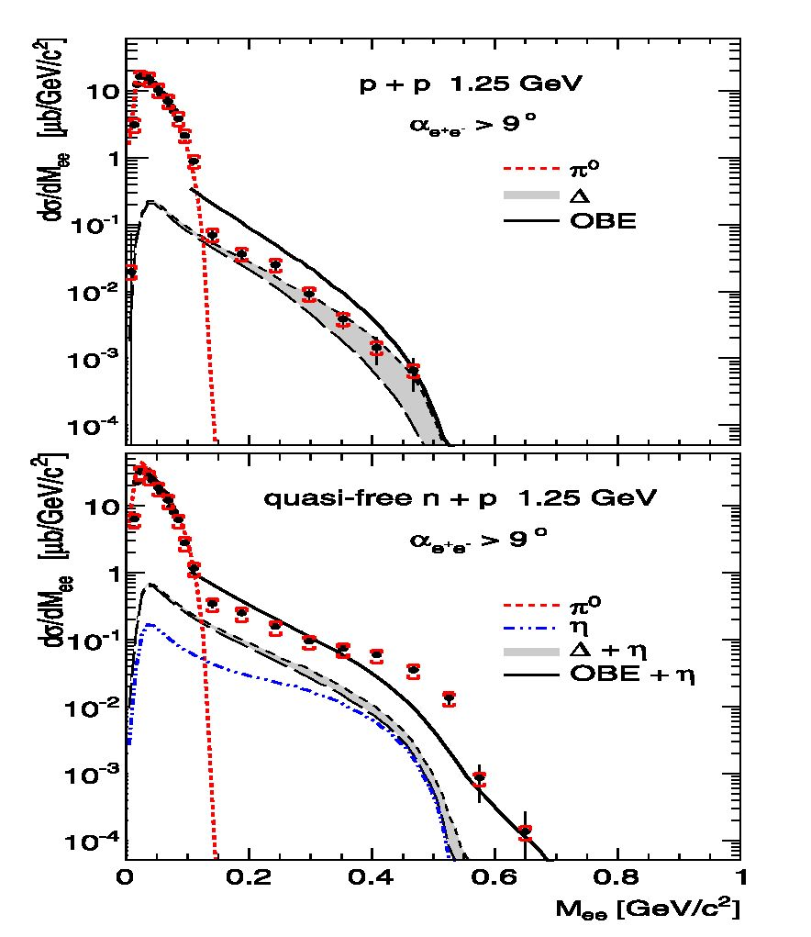
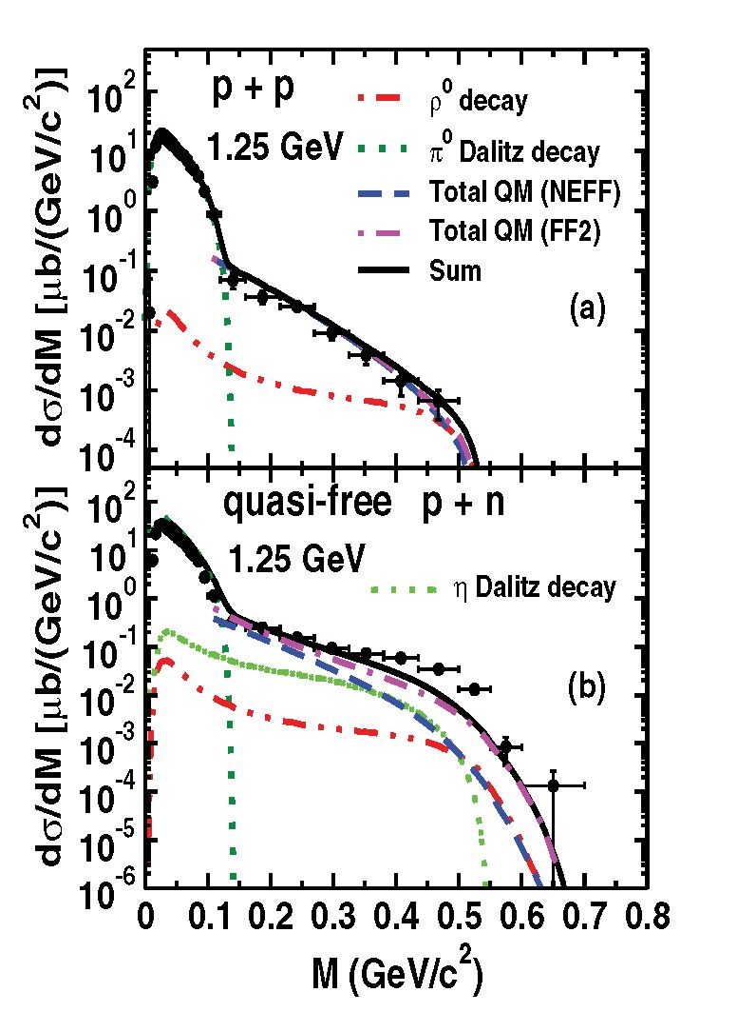
11th International Conference on Nucleus-Nucleus Collisions (NN2012) IOP Publishing
Journal of Physics: Conference Series 420 (2013) 012013 doi:10.1088/1742-6596/420/1/012013
Figure 2. Electron pair differential
cross sections as a function of invariant mass
(full circles) measured in p+p reactions (upper
panel) and in quasi-free n+p reactions (lower
panel) at 1.25 GeV. Systematic errors (constant
in thf whole mats range) are indicated by (red)
horizomtal bars, statistical errors by vertical
bars. Expected contributions irom tt°, A(1232)
and n Dalitz decays obtained by PLUTO evsnt
generator are shown separately [21]. Solid
curves show predictions from the One Boson
Exchange Model [29]
Figure 3. Experimentaf dti/tgi, (same as on
in Fig. 1) compared to the One Boson model
[30]. Results without (NEFF) and with (FF2)
incorporation of the electromagnitic form-
factor of charged pions are shown separately.
Solid curves show sum of these contributions
with the subthreshold p production
inside deuteron. The latter one is very well constrained by the known n meson production
cross section and nucleon momentum distribu2ion inside the deuteron (see for details [21]).
The shaded area shows the uncertainty related to the eleotromagnetic transition form-factor of
the A(1232) ^ Ne+e- decay calculated here within the Swo-component (quask core and pion
cloud) model [28]. The solid curve shows predictions of [1-9] based on One-Boson Exchange
model of the bremsstrahlung process taking into account the coherent sum of resonant SA(t232)
and non-resonant (so called ”quasi- elastic” bremsstrahlung) contributions [29]. In Fig. 3, we
show results of recent OBE calculations [30] compated to HADES data which provide a better
description. In particular, the very different shape of the p + n data is betteo accounted for, due
to the incorporation of the electromagnetic form iactor of the charged pion. This contribution
is possible since, in contrast to the p + p oeaction at charged pion can be exchanged. Although.
the theoretical description of the p + n data is not yet] finally settled, the data allow to construct
the experimentally derived N + N reference spectrum, which we use for heavy ion reactions to
account for the contribution of the baryonic sources.
6
11th International Conference on Nucleus-Nucleus Collisions (NN2012) IOP Publishing
Journal of Physics: Conference Series 420 (2013) 012013 doi:10.1088/1742-6596/420/1/012013

4. Results from p-A collisions
p + p and p + Nb collisions at a beam energy of 3.5 GeV have been studied by HADES
with the main goal to search for in-medium modification of vector mesons in cold nuclear
matter. The large acceptance of the detector and the low energy of the beam allow for a
detection of e+e- pairs down to low momenta (pe+e- < 1-0 GeV/c) which are not in the
CLAS and E325 experiments. Differential e+e- production cross sections as a function of the
e+e- invariant mass (shown in Fig. 4), the momentum and the rapidity have been measured
for both reactions [31]. The direct comparison of the measured distributions to the yields
expected from the known hadronic sources (from a PYTHIA calculation) is shown for p + p
collisions in Fig. 4 [24]. It reveals an unexplained strength below the vector meson pole
which becomes even more pronounced in proton-nucleus collisions. As already discussed in
the previous sections, one can expect such additional strength by a strong coupling of the
p meson to low-mass baryonic resonances, which are not included in PYTHIA. They should
be reflected in the respective electromagnetic transition form factors of R ^ Ne+e- decays.
Indeed, calculations [22] including the form factors of A ^ Ne+e-, obtained from the two
component model [28], describe the missing yield but leave no space for a contribution from
higher-mass resonances. Since the latter one are poorly known, an alternative approach, based
on a resonance model, is commonly used in transport models to describe these contributions.
Namely, the dilepton decays of resonances with known decay branches to Np are modeled as two
step process R ^ pN ^ Ne+e- using a e+e- mass dependent decay width calculated within the
VMD model. Indeed, such approach can describe our data, as shown by calculations performed
with GiBUU [22], assuming strong contributions from Di3(1520), S31 (1620), Pi3(1720) and
F35(1905). However, as the authors of [22] conclude, this result should be taken with caution
since the exact production cross sections of the resonances and their decay branches into pN
are subject of large uncertainties. We hope that further studies of exclusive reaction channels
p + p ^ nNN and p + p ^ ppe+e-, reconstructed in HADES, will shed more light on this
important aspect.
Coming back to the p + Nb data, we show in Fig. 5 comparison of the e+e- invariant mass
distribution to the one measured in p + p reactions for two momentum bins of the outgoing
dielectron pair. Here, the p + p cross sections have been scaled up by a ratio of the total cross
sections for both reactions and the averaged numbers of participants calculated with a Glauber
model: apNb/appx < >. With such scaling n0 production measured in N + N
describe describe our C + C data (see next section), and also, (see Fig. 5), pion Dalitz yield in
p + Nb. On the other hand, a strong increase of the e+e- yield below the vector meson pole
above the p + p reference is visible for low momenta pe+e- < 0.8 GeV/c (see Fig.6, left panel).
In order to better quantify this excess we subtract first, the w peak in both data samples
and further subtract the scaled p + p dielectron yield from the p + Nb yield. The difference,
shown in Fig. 6-right panel, represents the additional e+e- radiation excess due to the medium.
For the scaled spectra the resulting excess for pe+e- < 0.8 GeV/c corresponds to a factor 1.5
±0.3 of the p + p data in the invariant mass region between 0.3 and 0.7 GeV/c2 and shows
an exponential decrease with an additional enhancement directly below the vector meson pole
mass, i.e. between 0.6-0.7. Note that this enhancement is exactly at the position where a
discrepancy is observed when comparing the p + p data with the PYTHIA calculation (Fig. 4),
indicating that both observations might be linked by the same physical process. This might be
interpreted as a fingerprint of the contribution of secondary processes of the type p + p ^ nX,
nN ^ R ^ Ne+e- adding also to this mass region because of the aforementioned strong
resonance-p couplings. On the other hand, most of model calculations based on hadronic many-
body interactions predict that such couplings strongly modify the in-medium p meson spectral
function. Therefore, final conclusions about in medium modifications of the p meson in cold
7
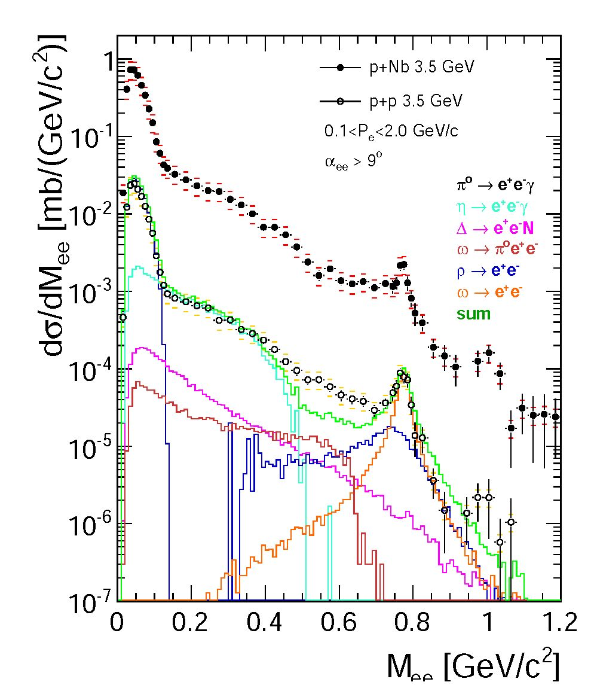
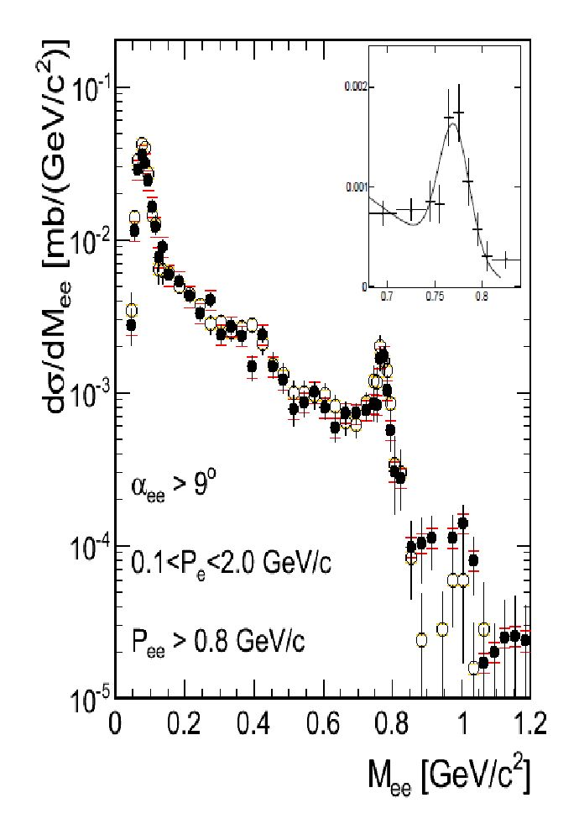
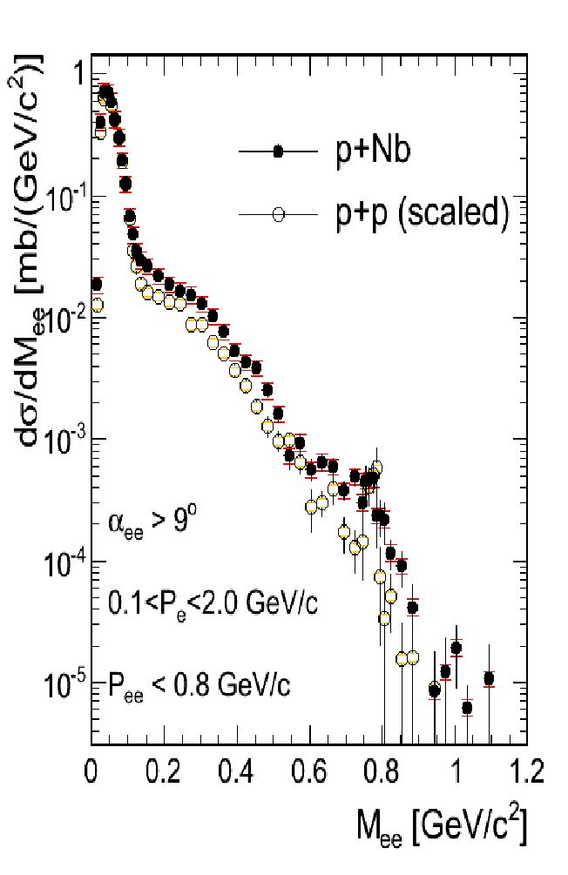
11th International Conference on Nucleus-Nucleus Collisions (NN2012) IOP Publishing
Journal of Physics: Conference Series 420 (2013) 012013 doi:10.1088/1742-6596/420/1/012013
Figure 4. Comparison of dielectron
cross sections as a function of the
invariant mass measured inp + p and
p + Nb sollisions at beam energy of 3.5
GeV. For the p + p data, a PYTHIA
dilepton cocktail composed of various
e+e- sources, defined in the legend, is
displayed in addition [31]
Figure 5. Comparison of the invariant mass spectra
for e+eV pairs with Pe+e- >0.8 GeV/c (left panel) from
p+p and p+Nb. The inset shows a linear zoom into the
vector meson region hogether with a fit to the ee peak
for the p+Nb data. Right: for pairs with Pe+e- <0.8
GeV/c. The p+p da.a have been scaled as described
in the text [31]
nuclear matter can be derived only, if a consistent treatment of the spectral shape of the meson
in the medium together with a correct handling od the additional yield from secondary reactions
is achieved.
As the os meson is concerned, we observe that for slow paics the yield at the of pole is not
-educeds however, the underlying smooth distribution is enhanced. Thus, the yield in the peak
is almost zero within eerors. This indicates a strong us absorption in con.rast to thepairs fram
the underlying continuum. Assuming that the or cross section scales with the mass number as
<+es6 = t—p x Aa we obtain as =0.38± 0.29 for slow pairs and ce=0.67 ±0.11 for pe+e- > 0.8
GeV/c. Furthermore, an analysis of the oo width shows, within the error bars, no significant
broadening;. Both observations are in line with the resulls of the CBELSA-TAPS experiment
- , although ooe should note that in contrast to the p + A reactions forthe fhoton induced
reactions no initial state effects and consequently a stronger scaling could be expected.

5. Results from A-A coUisions
In the 1 — 21 AGeV energy range, particle production in heavy-ion collisions is dominited by
fion production which originates mrinly from the A(!.232) resonanco. Multiplicities of heavier
mesons, mainly nl are already -very low (of order 1 — f%). Production multiplicities ior n0 and n
mesons are known from their decay into real phatons from former TAPS measurements at GSI
- . The dielectron invariant-mass distributions measured w it If HA DES in the light C + C (at
1.0, AGeV) [34] and the medium-heavy Ar + KCl (at 1.756 AGeV) [35] syslems are shown in
Fig- 7.
4?lie spectra are normalized to the mean of the charged pion (n+, n-) yields, measured
8
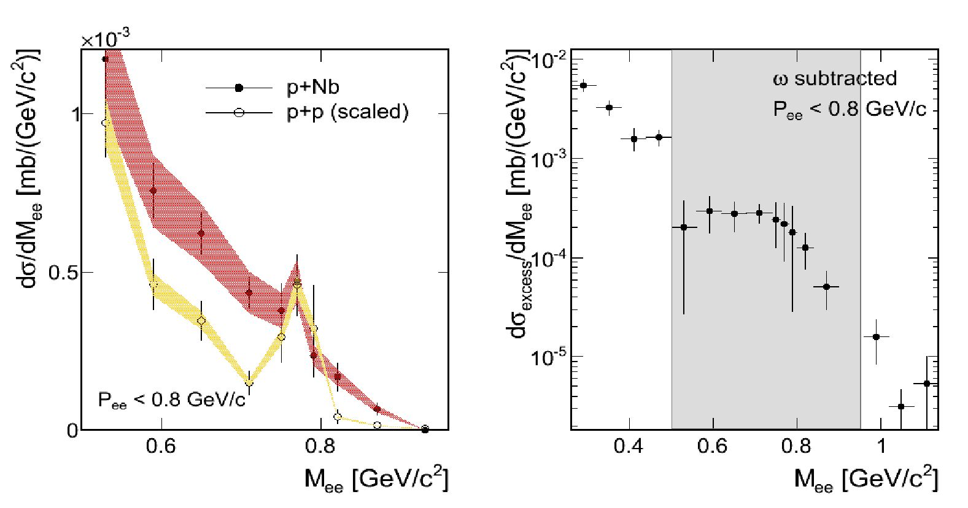
11th International Conference on Nucleus-Nucleus Collisions (NN2012) IOP Publishing
Journal of Physics: Conference Series 420 (2013) 012013 doi:10.1088/1742-6596/420/1/012013
Figure 6. Same as in Fig. 5 but zoomed into the vector meson region. The shaded bands represent the
systematic uncertainties due to the normalization. Right: Excess yield in the p+Nb data after subtraction
of the scaled p+p renerence data (tne w contribution has been subtracted in both data samples). The
grey region corresponds to the invariant mass range plotted in the left picture [31]
independontly by HADES, and extrapolaten to the full solid angle. At this energy and for these
collision systems, it is a good measure of neutral pion multiplicity. The differential distributions
obtained in such a way are compared to the expected mesonic e+e- cocktail from the n0,n
Dalitz and w decays according to the measured (for n0 and n) and extrapolated (from the mT
scaling for w) multiplicities. One should underline that the w peak visible in the invariant mass
distribution in Ar + KCl collisions allows for the first measurement of meson production at such
a low energy (below its free N — N threshold). As one can see, the e+eo cocktail composed from
the meson decays does not explain the measured yields for both collision systems and leave room
for a contribution expecttd )rom the baryonic sources dircussed above: resonance Dalitz decays
(mainly AS1232)) and nvcleon-bucleon bremsstrahlung. This conclusion is also supported by
our analysis of the shape of excitation function of the missing contribution that appears to be
very similar to the one measured fo) pions, governed t>e A(1232) creation, but very different
from the one established )or the n meson [35].
In order to search for a true in-medium radiatien off the dense nuclear phase of collisions we
compare e+e- production rates found in nucleus-nucleus reactions with a proper superposition
of the production rates measured in elementary collisions. For this purpose, we plon in Fig.
8 the ratio of the pair multiplicities mefsured in nucleus-nucleus collisions, shown in Fig. v
(and also for C + C at 2 AGeV), to the averagvd 1/2(Mppe + MgUf )/Mns obtained from
the e+e- cross sections shown in Fig. 2 and the known n0 fross section )or the elementary
reactions. Furthermore, before the ratios are computed we subtract for all distributions the
respective n Dalftz contriuutions. The latter is motivated by a very different excftation ffmction
of the n meson production in nucleus-nucleus and nucleon-nucleon refctions and hence allows
for comparison ol collisiou systems meassred at different beam energieu Normalizbtion to thv
Mno takes into account the Vfam energy dependence ol baryonic sources discusued above and
also the dependence of particle production on system-size via scaling with an average number
9
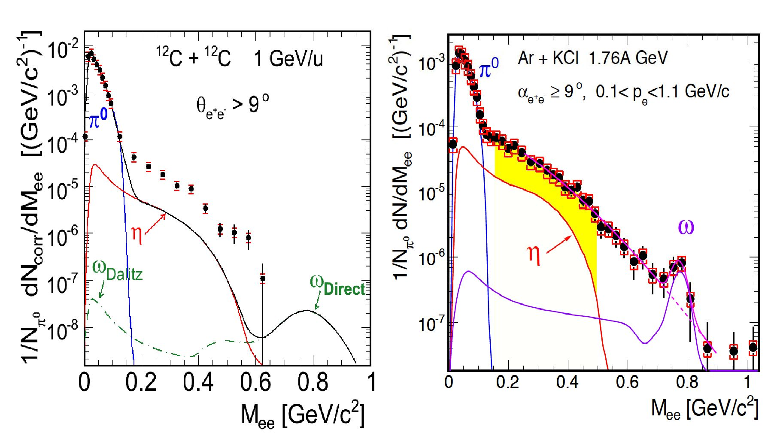
11th International Conference on Nucleus-Nucleus Collisions (NN2012) IOP Publishing
Journal of Physics: Conference Series 420 (2013) 012013 doi:10.1088/1742-6596/420/1/012013
Figure 7. Left: e+e- production rates normalized to the n° yield as a function of the invariant-mass
distribution measured in C + C collisions at 1 AGeV compared to thermal dielectron cocktail of mesonic
sources (n°,n,w) after freeze-out [34]. Right: Similar distributions but obtained for Ar + KCl collisions
at 1.756 AGeV [35]. Shaded area shows invariant mass region where the pair excess from in-medium
radiation has been identified (for details see text). Different widths of the w peak in simulated cocktails
accounts for different mass resolution in both experiments
of participants Apart, which holds at SIS18 energy range (for more details see [35]). As one
can see all distributions agree in the n0 mass range confirming our normalization procedure.
Furthermore, the ratio is consistent, within statistical and systematic errors, with the one for
C + C collisions at 1 and 2 AGeV. It means that indeed, pair production in the mass range
Me+e- < 0.6 GeV/c2 in C + C collisions can be described as sum of contributions stemming from
(i) baryonic sources, extracted from the N + N collisions, which yield scale as pion production
and (ii) the n, n0 mesons accounting for the radiation after freeze-out. This observation explains
the long standing ”DLS puzzle” of the unexplained yield measured in C + C collisions by not
correctly accounted baryonic contributions. In this context we emphasize that the DLS and
HADES data agree within errors bars as shown by a dedicated analysis [34].
However, a significant excess (2.5-3) with respect to the N + N reference is visible for the
Ar + KCl system above the n0 mass, signaling an additional contribution from the dense phase
of the heavy ion collision. This means that going to the larger collision system Ar + KCl (Apart
for Ar + KCl ~ 40 should be compared to Apart ~ 8 for C + C for our trigger conditions)
a stronger than linear scaling of the pair production with Apart is observed. This observation
can be interpreted as a signature of the onset of a contribution of multi-body and multi-step
processes in the hot and dense phase created in collisions of nuclei of sufficiently large size. In
this context, the propagation of short-lived baryonic resonances seems to play a main role. The
penetrating nature of the dilepton probe allows to observe an effect of ”shining” of the baryonic
matter integrated over the whole collision time. A further important test of this scenario will
be provided by data recently obtained from Au + Au collisions at 1.25 GeV .
Interesting new results on the vector meson production in heavy-ion collisions at SIS18 have
also been obtained from analysis of Ar + KCl data. Besides the w signal discussed above, a
surprisingly strong 0 meson production have been found from an analysis of the K+K- final
10
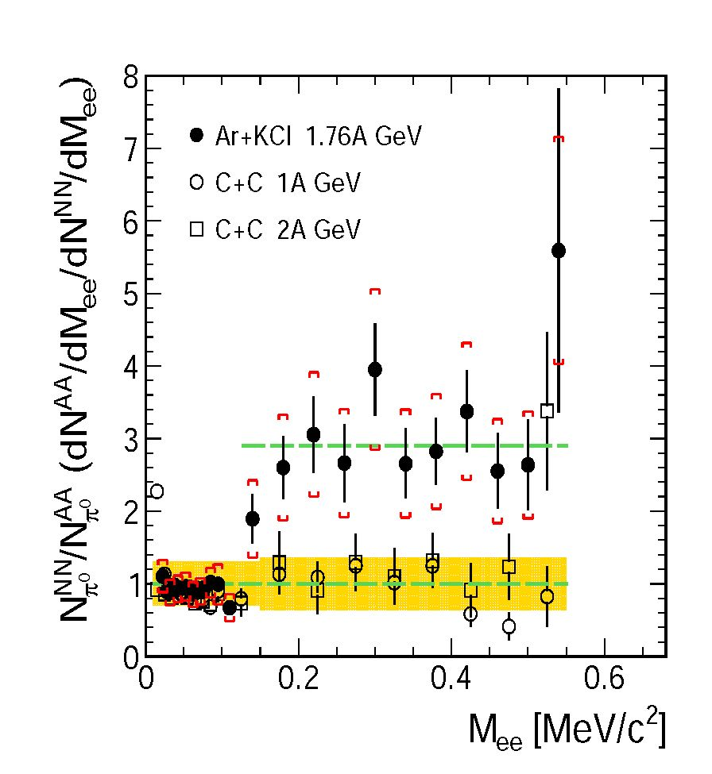
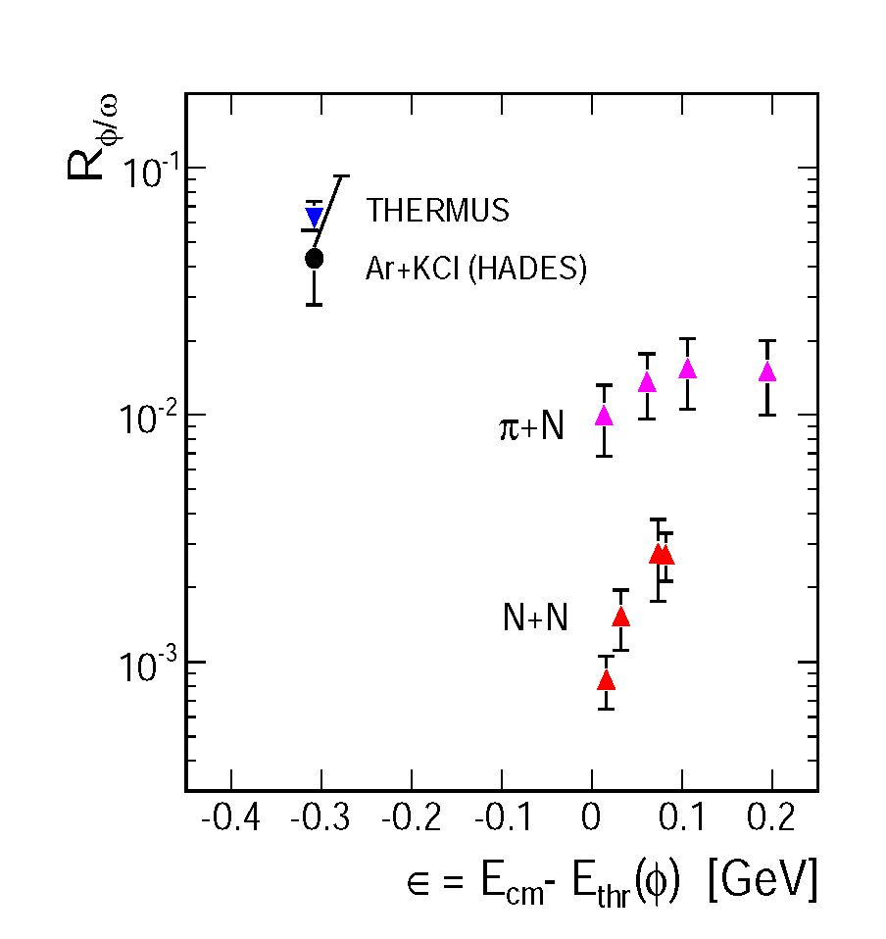
11th International Conference on Nucleus-Nucleus Collisions (NN2012) IOP Publishing
Journal of Physics: Conference Series 420 (20131;) 012013 doi:10.1088/1742-6596/420/1l012013
Figure d. Ratio of e+e- invariant mass
distributions measured in Ar+KCl and C+C
with subtracted rj meson contribution to
the N + N reterence spectrum, obtained ass
described in text. Total errors, statistical
and cystematic ate added quadoatically and
indicated by the shaded band [35].
Figure 9. Comparison of the measured
Ry/w ratio (HADES) and statistical model valum
8THERMUS fit) as wfll as a compilation of data
from the p+_p and n + N reactions Ssee text). The
ratio is plotted as a function of the excess energy
above the threshold for the exclusive production
in p + p and n + N reactions [35].
ctate (see Fig. 10) [36i. The acceptance corrected 0/K- ratio .is found to be 0.37 ± 0e13 which
translates info a fraction of 15! ± 7% of negative kaons coming faom 0 decay. Furthermore,
assuming that non-uesonant K+K- production is of the same size, as it is know from N -0- N
reactions, an even larger contribution of reactions other than strangeness exchange (7r_ hyperon
—it afiV), assumed brfore to Ire the dominant pro cess in K- pro ductio n, should 1) e expected.
This, for example, can indicate that the 0 meson is producod in multi-step processes involving
short-lived resonancest Luch scenorio is corroborated by BUU transport calculatfons [37] which
reproduce the yields and spsctral distribufions of K+i°- and 0 mesons.
Fig. 9 shows the ratio of the c/s to to1 multiplicities meaoured in Ar + KCl collisions at
1.756 AGeV, together with poedictions of the statistical model THERMUS and results from
elementary reactions [35, 36]. The date; points are plotted as a function of the excess energy
above the production threshold for the exclusive 0 production in p + p and nj-Af reaclions,
respectively. One can see from this compaaison that in the heavy-ion reaction Ay/W is more than
one ocder of magnitude larger than in A1 — A- collisions and also at l-ast a factor 3 — 5 farger than
in pion-induced processes. On fhe other hand, fhe ratio is consiftent with the thermal model
assuming full thermalization and no suppression due to OZI rules. The ratio could ot course also
tie influenced by different absorption processes of both mesons in nuclear matter. Indeed, the
results from cold matter experiments, mentioned in the introduction, indicate larger absorption
of the o meson as compared to the 0 what could enhance the in-medium Ry/W. The effect of
o absorption and the absence of such effect on the 0 was also observed by NA60 in In + In
collisions at 158 AGeV [38, 39].
In-medium effects on kaons have been studied by means of K0 meson transverse momentum
distributions in Ar+KCl collisions at 1.76AGeV taking advantage of the good acceptance of
11
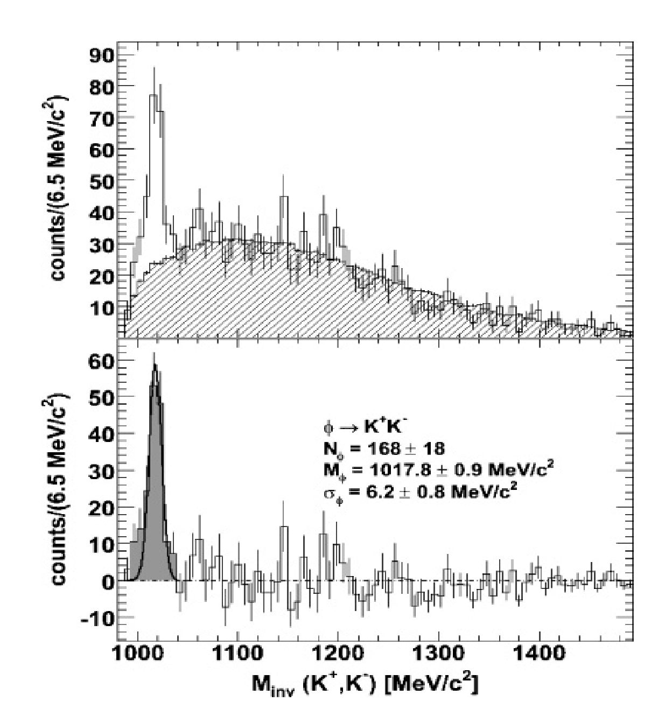
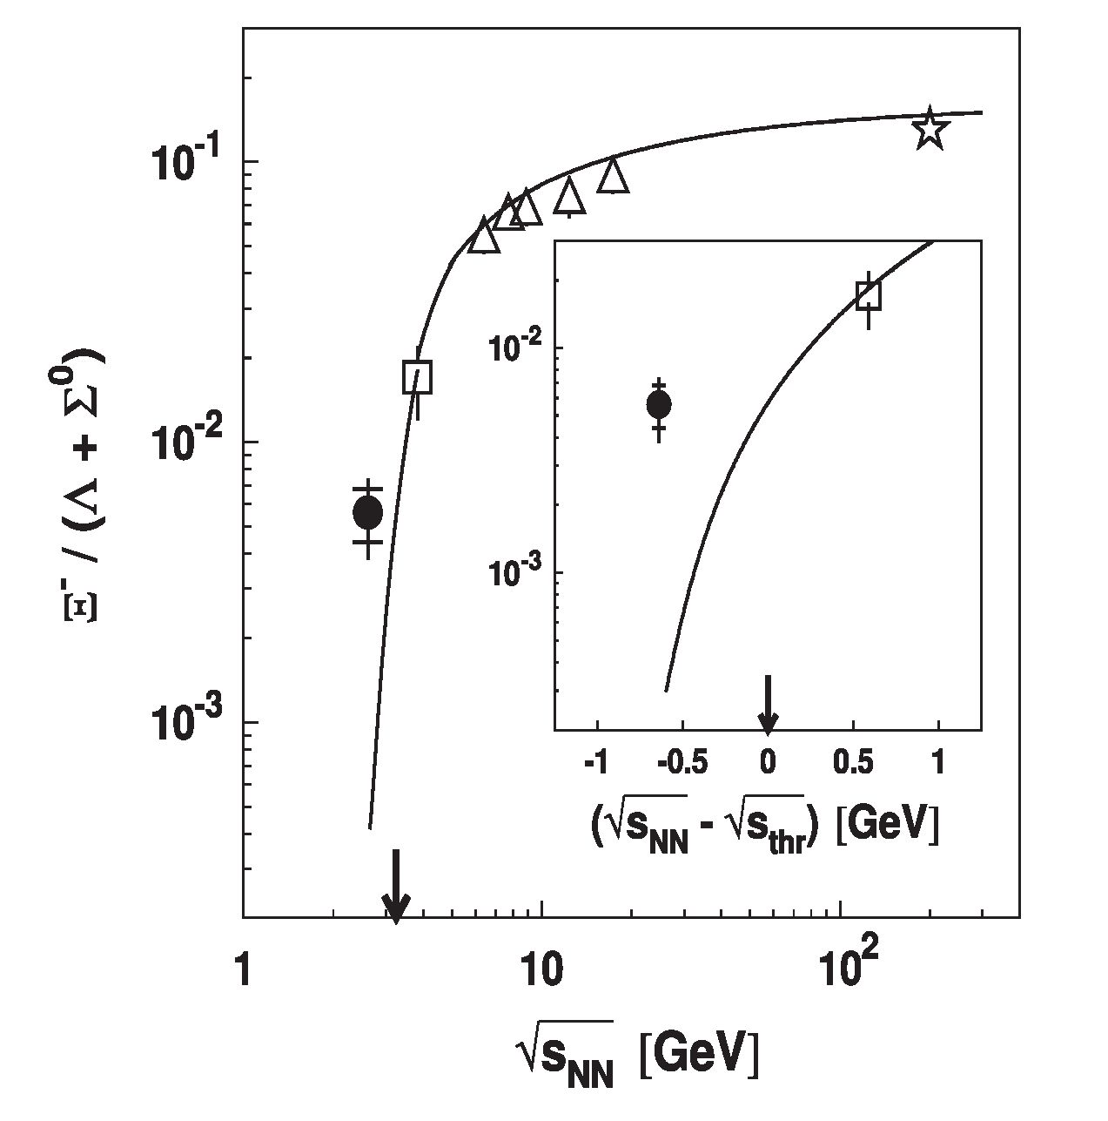
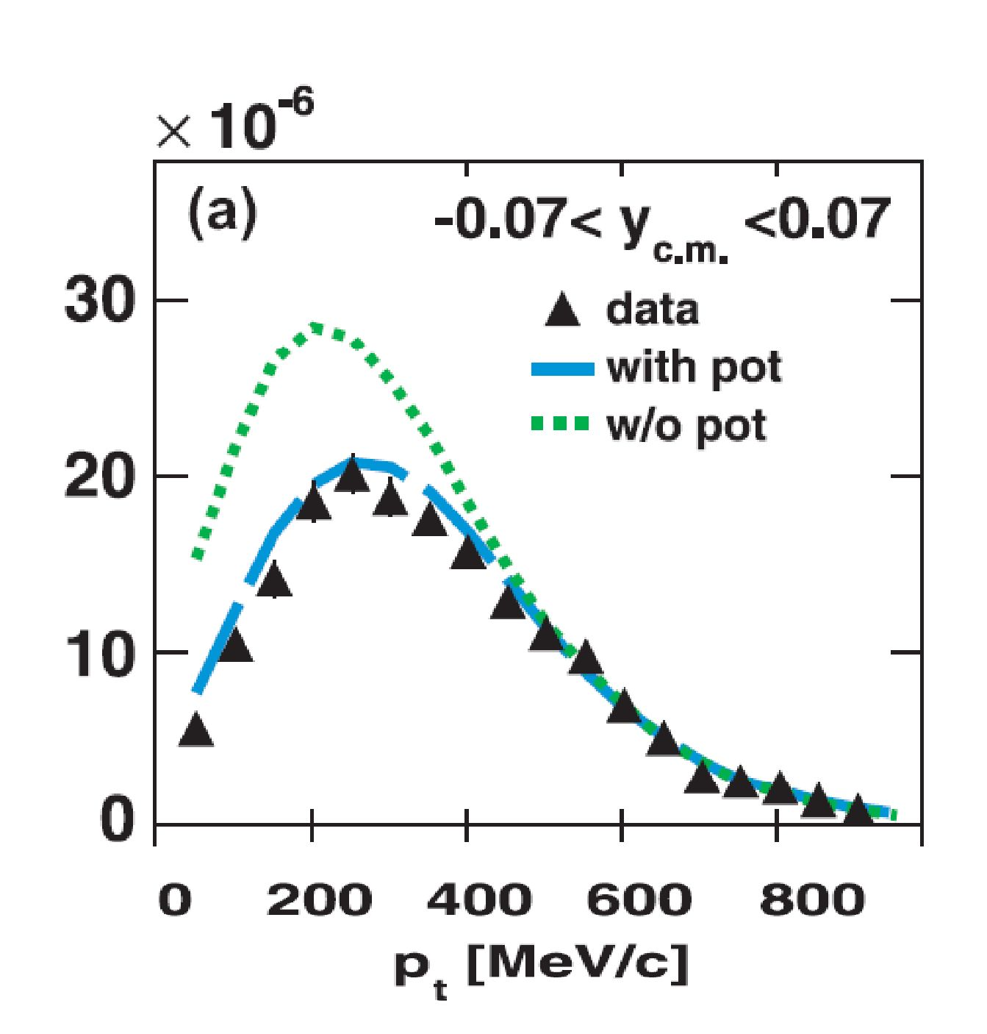
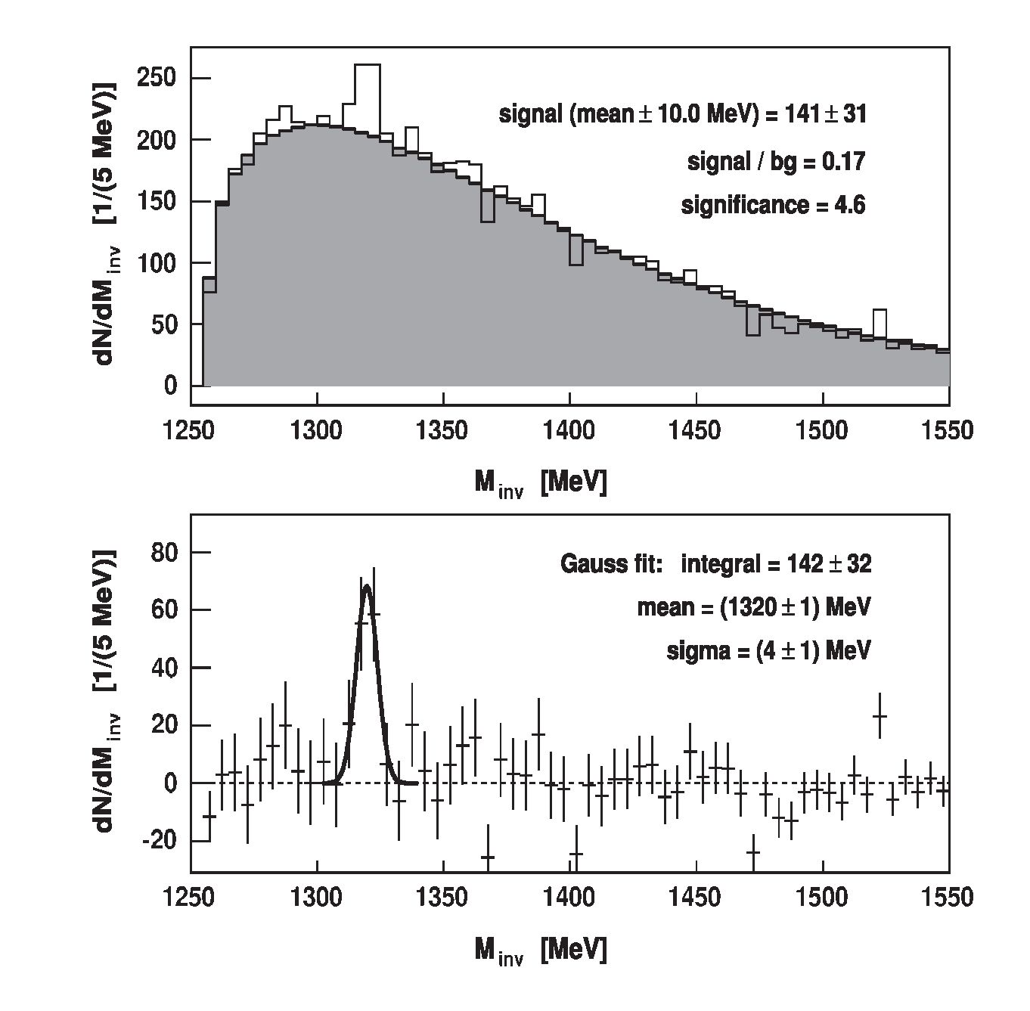
11th International Conference on Nucleus-Nucleus Collisions (NN2012) IOP Publishing
Journal of Physics: Conference Series 420 (2013) 012013 doi:10.1088/1742-6596/420/1/012013
Figure 10. Invariant mass distribution of
K+K~ pairs (top).The combinatorial back-
ground (shaded area) is obtained by the mixed-
event technique. The background-subtracted
distribution (bottom) shows a 0 meson signal
(grey awea with a Gaussian fit) [36]
Figure 11. pt distribution of the experimen-
tal Ks data (full triangles) together with the
results of the IQMD model including a repul-
sive K° -nucleus potential of 46 MeV (dashed
curves) and without potential (dotted curves)
[40].
Figure 12. Top: A — invariant
mass distribution with baengtound (hatched
hittogram) —alculatcd with event mixing.
Boitom: T1f invariant-mass diriaibugion after
background cubtraction. The fit lC curve
reptesents e Gadssian fit to thv !^_i1il21 sigpcall
Figure 13. The excitation function of the
E- (1321) to A + £° ratio measured by HADES
(full circles)cand otherihighnenergyaexperiments
(empty symbols) compared to statistical model
predictions [42] (solid curves). The arrow
depict the e-(1321) threshold [42]
12
HADES at low transverse momentum for the K0 ^ n reconstruction [40]. We compared pt
distributions for different rapidity bins with the corresponding results by the IQMD transport
11th International Conference on Nucleus-Nucleus Collisions (NN2012) IOP Publishing
Journal of Physics: Conference Series 420 (2013) 012013 doi:10.1088/1742-6596/420/1/012013
approach with and without taking into account a repulsive K0-nucleus potential. For all rapidity
bins, but most evidently at mid-rapidity (shown in Fig. 11), data support calculations with the
repulsive potential. Our data suggest a repulsive in-medium K0 potential of about 40MeV
strength which is slightly higher as compared to results obtained from experiments studying K°
production off nuclei [41].
The ability of HADES for the selection of displaced secondary vertices arising from week
decays and the high statistics accumulated for the collision system Ar + KCl at 1.76AGeV
allowed to investigate the deep-threshold production (^/sNN — ^/sthr =-640MeV) of the double-
strange 5-(1321) hyperon [42]. The 5-(1321) was reconstructed in the A — n- invariant mass
distribution, shown in Fig. 12, thanks to a high-purity signal of A identified in the p—n- invariant
mass distribution. Fig. 13 shows the ratio of production rates of 5-(1321) and A + E° as a
function of the total CM energy in N + N collisions measured by HADES and other high-energy
experiments. The reconstructed strength of the signal is compared to calculations performed for
Au + Au collisions with the statistical model of [43]. While high-energy data are well described,
the present experimental ratio is underestimated, by the model, by a factor of 10 yielding 4
x 10-4. Utilizing the statistical model package THERMUS [44] and fitting all particle yields,
except 5-(1321), measured in Ar + KCl collisions we obtained temperature T=73±5 MeV
and a chemical potential = 780 ± MeV [45] and an even lower (by factor 2) as compared
to [43] ratio of 5-(1321)/A + H° production. In the recent work [46], the strong 5-(1321)
production observed in our experiment has been accounted for by strange exchange reactions
of the type hyperon-hyperon ^ N5-(1321). nevertheless, further high statistics measurements,
in particular of the differential production cross sections, are needed to shed more light on this
problem.

6. Conclusions
We have presented new results on dielectron and strangeness production in N—N, proton-nucleus
and nucleus-nucleus collisions. The e+e- invariant mass distributions measured in p + p and
p + n collisions at 1.25 GeV reactions provide an important reference for heavy ion collisions.
In particular, we find that the anomalous increase of the pair production in p + n collisions,
stemming presumably from the bremsstrahlung process, is the main contribution explaining
dielectron production in the light C + C collisions. However, we also observe a significant pair
excess in the 0.15< Me+e- <0.5 GeV/c2 mass range with respect to this N + N reference for
the medium size Ar + KCl system, signaling an additional contribution from the dense phase of
the heavy ion collisions. We interpret this as a result of continuous radiation (’’shining”) from
short lived baryonic resonances (mainly A(1232)) regenerated in multi-step processes in dense
nuclear matter. An important verification of this scenario will be provided by Au + Au data
recently collected by HADES.
We find that p meson production in our energy range is strongly affected by a strong coupling
to low-mass baryonic resonances which is reflected in a significant broadening of the meson
spectral function already visible in p + p reactions. These interactions might lead to a further
meson modification in cold and dense nuclear matter but a quantitative assessment can only
be made after these couplings are better constrained. Presented results from p + p, p + Nb
collisions at 3.5 GeV and further planned studies of the resonance Dalitz decays in exclusive
reaction channels are of utmost importance.
Studies of the w production off nucleus show a strong absorption of the meson in nuclear
matter in accordance with the results from photon induced reactions. The w and 0 signals
have also been reconstructed in Ar + KCl collisions at energies below the N — N production
threshold. A surprisingly large R^/w production ratio (more than one order of magnitude larger
than in N + N collisions) has been found, indicating no suppression for the 0 production and
13
11th International Conference on Nucleus-Nucleus Collisions (NN2012) IOP Publishing
Journal of Physics: Conference Series 420 (2013) 012013 doi:10.1088/1742-6596/420/1/012013
consequently a significant contribution to the K- production. Also a strong enhancement of
the double strange 2-(1321) production has been found, even above predictions (factor 10) of
statistical models. This intriguing results calls for further experimental studies which will be
performed with larger collisions systems.
Our programme of investigations of the in medium kaon potential has been started with the
measurement of K0 production in Ar + KCl revealing a strong (U=40 MeV) repulsive potential.
Further studies of K0 potential in cold nuclear matter are on the way with already collected
p + Nb data. Charged kaon production by means of flow measurements are planned with future
Ag + Ag collisions.
The author thanks GSI Darmstadt for support for this work. The collaboration gratefully
acknowledges the support by CNRS/IN2P3 and IPN Orsay (France), LIP Coimbra, Coimbra
(Portugal): PTDC/FIS/113339/2009, SIP JU Cracow, Cracow (Poland): N N202 286038 28-
NN202198639, Helmholtz-Zentrum Dresden-Rossendorf (HZDR), Dresden (Germany): BMBF
06DR9059D, TU Munchen, Garching (Germany) MLLMunchenDFGEClust: 153VHNG- 330,
BMBF 06MT9156 TP5 TP6, GSI TMKrue 1012, NPI AS CR, GSI TMFABI 1012, Rez, Rez
(Czech Republic): MSMT LC07050 GAASCRIAA100480803, USC - S. de Compostela, Santiago
de Compostela (Spain): CPAN:CSD2007- 00042, Helmholtzalliance HA216/EMMI.

References
- S. Leupold, V. Metag and U. Mosel , Int. J. Mod. Phys. E 19, 147 (2010).
- R. Rapp and J. Wambach, Adv. Nucl. Phys. bf 25, 1 (2000).
- T. Hatsuda and S. H. Lee, Phys. Rev. C 46 34 (1992).
- M. Naruki et al., Phys. Rev. Lett. 96 092301 (2006).
- G. E. Brown and M. Rho, Phys. Rev. Lett. 66 2720 (1991).
- R. Nasseripour et al. (CLAS Collaboration), Phys. Rev. Lett. 99 262302 (2007).
- M. H. Wood et al. (CLAS Collaboration), Phys. Rev. Lett. 105 112301 (2010).
- M. Kotulla et al. (CBELSA/TAPS Collaboration), Phys. Rev. Lett. 100 192302 (2008).
- A. Polyanskiy et al. (ANKE Collaboration) Phys. Lett. B 695 74 (2011).
- T. Ishikawa et al., Phys. Lett. B 608 215 (2005).
- G. Agakishiev et al. (CERES Collaboration), Phys. Rev. Lett. 75 1272 (1995).
- M. Masera (HELIOS Collaboration), Nucl. Phys. A 590 93C (1995).
- R. J. Porter et al. (DLS Collaboration), Phys. Rev. Lett. 79 1229 (1997).
- R. Arnaldi et al. (NA60 Collaboration), Phys. Rev. Lett. 96 162302 (2006).
- H. van Hees and R. Rapp, Nucl. Phys. A 806 339 (2008).
- S. Afanasiev et al. (Phenix collaboration), Phys. Rev. C 81 034911 (2010).
- G. Agakishiev et al. (HADES Collaboration), Eur. Phys.J.A 41, 243 (2009).
- C. Fuchs Prog. Part. and Nucl. Phys., 56, 1 (2006).
- C. Haohne et al. (CBM) collaboration, contribution to this conference
- G. Agakishiev et al. (HADES Collaboration), Phys. Rev. C 85, 054005 (2012).
- G. Agakishiev et al. (HADES Collaboration), Phys. Lett. B 690, 118 (2010).
- J. Weil, H. van Hees and U. Mosel, arXiv:1203.3557, O. Buss et al., Phys.Rept. 512 1 (2012).
- K. Schmidt et al., Phys. Rev. C 79, 064908 (2009).
- G. Agakishiev et al. (HADES Collaboration), Eur. Phys. J. A 48, 64 (2012).
- W.K Wilson et al. (DLS Collaboration), Phys. Rev. C.57, 1865 (1998).
- M. I. Krivoruchenko et al., Ann. Phys. 296, 299 (2002).
- G. Ramalho, M.T. Pena, Phys.Rev. D. 85, 113014 (2012).
- Q. Wan, F. Iachello, Int. J. Mod. Phys. A 20, 1846 (2005) 1846.
- L. P. Kaptari and B. Kampfer, Nucl. Phys. A 764, 338 (2006); Phys. Rev. C 80, 064003 (2009).
- R. Shyam and U. Mosel Phys. Rev. C 82, 062201 (2010).
- G. Agakishiev et al., (HADES Collaboration), Phys. Lett.B 715,304 (2012).
- M. Nanova et al. (CBELSA-TAPS Collaboration), Phys. Rev. C 82, 035209 (2010).
- R. Averbeck et al., (TAPS Collaboration), Z. Phys. A 359, 65 (1997).
- G. Agakichiev et al., (HADES Collaboration), Phys. Lett. 663, 43 (2008).
- G. Agakichiev, et al., (HADES Collaboration), Phys. Rev.C 84, 014902 (2011).
14
11th International Conference on Nucleus-Nucleus Collisions (NN2012) IOP Publishing
Journal of Physics: Conference Series 420 (2013) 012013 doi:10.1088/1742-6596/420/1/012013
- G. Agakishiev et al. (HADES Collaboration), Phys. Rev. C 80, 025209 (2009).
- H. Schade, Gy. Wolf, B. Kampfer, Phys. Rev. C 81, 034902 (2010).
- R. Arnaldi et al. (NA60 Collaboration), Eur. Phys. J. C 61 711 (2009).
- R. Arnaldi et al. (NA60 Collaboration), Eur. Phys. J. C 64 1 (2009).
- G. Agakishiev et al. (HADES Collaboration), Phys. Rev. C 82, 044907 (2010).
- M.L. Benabderrahmane et al. (FOPI), Phys. Rev. Lett. 102, 182501 (2009).
- G. Agakishiev et al. (HADES Collaboration), Phys. Rev. Lett 103, 132301 (2009).
- A. Andronic, P. Braun-Munzinger, and K. Redlich, Nucl. Phys. A 765, 211 (2006).
- S. Wheaton, J. Cleymans, and M. Hauer, Comput. Phys. Commun. 180, 84 (2009).
- G. Agakishiev et al. (HADES Collaboration), Eur. Phys. J. A 47, 21 (2011).
- C. M. Ko et. al, Phys. Rev. C 85, 064902 (2012).
15

