
Psychopharmacology (2013) 227:583-593
DOI 10.1007/s00213-013-2990-3
ORIGINAL INVESTIGATION

Mesolimbic dopamine D2 receptor plasticity contributes
to stress resilience in rats subjected to chronic mild stress
Dariusz Żurawek • Agata Faron-Górecka •
Maciej Kuśmider • Magdalena Kolasa • Piotr Gruca •
Mariusz Papp • Marta Dziedzicka-Wasylewska
Received: 10 August 2012 /Accepted: 14 January 2013 /Published online: 3 February 2013
© The Author(s) 2013. This article is published with open access at Springerlink.com
Abstract
Rationale Few studies have investigated neurobiological
and biochemical differences between stress-resilient and
stress-vulnerable experimental animals.
Objectives We investigated alterations in mesolimbic dopa-
mine D2 receptor density and mRNA expression level in
stressed rats at two time points, i.e. after 2 and 5 weeks of
chronic mild stress (CMS).
Methods We used the chronic mild stress paradigm because it
is a well-established animal model of depression. Two groups
of stressed rats were distinguished during CMS experiments:
(1) stress reactive (70 %), which displayed a decrease in the
drinking of a palatable sucrose solution during the stress
regimen, and (2) stress resilient (30 %), which exhibited an
unaltered drinking profile when compared with the unchal-
lenged control group. [3H]Domperidone was used as a ligand
to label dopamine D2 receptors, and a mixture of three specific
oligonucleotides was used to evaluate dopamine D2 receptor
mRNA changes in various regions of the rat brain.
Results CMS strongly affected the mesolimbic dopamine cir-
cuit in stress-resilient group after 2 weeks and stress-reactive
group of rats after 5 weeks which exhibited a decrease in the
level of dopamine D2 receptor protein without alterations in
D2 mRNA expression. Stress-resilient animals, but not stress-
reactive animals, effectively adapted to the extended stress and
coped with it. The increase in D2 mRNA expression returned
the dopamine D2 receptor density to control levels in stress-
D. Zurawek • A. Faron-Gorecka • M. Kusmider • M. Kolasa •
P Gruca • M. Papp • M. Dziedzicka-Wasylewska (*)
Institute of Pharmacology, Polish Academy of Sciences,
12 Smetna Street,
31-343, Krakow, Poland
e-mail: wasyl@if-pan.krakow.pl
resilient rats after 5 weeks of CMS, but not in stress-reactive
animals.
Conclusions These results clearly demonstrate that, despite
earlier blunting, the activation of dopamine receptor biosyn-
thesis in the dopamine mesoaccumbens system in stress-
resilient rats is involved in active coping with stressful
experiences, and it exhibits a delay in time.
Keywords Chronic mild stress . Depression .
Domperidone . D2 receptor . Dopamine mesolimbic system .
In situ hybridisation . mRNA . Stress resilience . Rat
Introduction
Psychological resilience among people in the face of trau-
ma, adversity and chronic stress has received much attention
since the 1970s (Feder et al. 2009). Many behavioural and
psychological aspects have been investigated, and differ-
ences have been observed between stress-resilient and
stress-vulnerable people. The stress-resilient group exhibits
active coping in the face of trauma and an optimistic mood,
and they cognitively reinterpret stressful situations and may
possess a strong moral compass and life purpose (Haglund et
al. 2007; Feder et al. 2009; Cicchetti 2010; Rowland 2011).
Advanced biological, molecular and brain imaging tech-
niques as well as animal models of mental illnesses have
allowed the delineation of multiple genetic, biochemical,
neurological, neurochemical and neuroendocrine changes
that define the stress-vulnerable phenotype. However, rela-
tively few studies have examined differences in neurobio-
logical systems among individuals who are “resistant” to
stress. Therefore, further intensive study is required to de-
fine the molecular factors and aspects of resilience.

584
Psychopharmacology (2013) 227:583-593
Noradrenergic and serotonergic catecholamine circuits
are imbalanced in stress-evoked depression. This phenome-
non is well established, and these circuits are the main target
of action of antidepressant drugs. These drugs immediately
influence catecholamine concentrations, but their clinical
and behavioural effects appear after several weeks of chron-
ic administration. These two circuits are indirectly involved
in mood control via ascending innervations that regulate the
mesolimbic dopamine system (Willner et al. 2005; Dunlop
and Nemeroff 2007). However, the dopaminergic system
has received less attention regarding vulnerability and resil-
ience to depression under different circumstances. The mes-
olimbic dopamine circuit, particularly dopaminergic
projections from the ventral tegmental area (VTA) to the
nucleus accumbens septi (NAcc), is the downstream terminal
link in the nerve cascade that regulates reward- and aversion-
related behaviours (Gershon et al. 2007; Krishnan et al. 2007).
Stress exerts a strong influence on this system and elicits
specific responses depending on the type and duration of
aversive stimulation (Puglisi-Allegra et al. 1991; Cabib and
Puglisi-Allegra 1994, 1996a, b; Finlay and Zigmond 1997).
Therefore, impairment of the stress-induced mesolimbic do-
pamine system leads to the development of anhedonia, which
is a core symptom of depression. The rapid antidepressant
action of dopamine D2 receptor agonists, such as pramipexole
or bromocriptine, likely explains the direct involvement of the
mesolimbic circuit and dopamine D2 receptors in depression
(Dailly et al. 2004). Alterations in dopamine concentration in
the mesolimbic reward system and dopamine D2 receptors in
response to stress accompany the development of depression-
like psychopathology (Imperato et al. 1993; Papp et al. 1994;
Dziedzicka-Wasylewska et al. 1997; Larisch et al. 1997; Cabib
et al. 1998; Yadid et al. 2001; Gershon et al. 2007). Dopamine
concentrations in the NAcc are increased in response to and in
expectation of reward or aversive stimuli, but a blunted
response leads to anhedonia, which is a long-lasting effect
of mild chronic stress (Di Chiara and Tanda 1997, Di
Chiara et al. 1999; Dunlop and Nemeroff 2007). Our study
used the chronic mild stress (CMS) paradigm, which is a
well-characterised animal model of depression with good
face and predictive and construct validity. The chronic
exposure of rats to mild unpredictable stressors produces
behavioural deficits (anhedonia) that may be maintained for
several months, and chronic treatment with antidepressants
restores normal behaviour in stressed animals (Willner et al.
1987; Papp et al. 1994; Bielajew et al. 2002; Bekris et al.
2005). Approximately 30 % of animals that are subjected
to several weeks of CMS demonstrate stress resilience that
is manifested as unaltered consumption of a palatable 1 %
sucrose solution in this model (Bergstrom et al. Bergstrom
et al. 2008). These animals are usually rejected from further
analysis as “bad-responding” subjects that do not demon-
strate the behavioural response. However, this group mimics
the behavioural response to stress that is observed in people who
do not develop depression in the face of adversity. Therefore, the
present study investigated differences in the dopaminergic mes-
olimbic system, especially dopamine D2 receptor density and
mRNA expression, in various brain regions between stress-
reactive and stress-resilient rats which followed CMS paradigm.
The novel approach in our study involves the follow-up of
temporal changes in the dopamine circuit during the CMS
paradigm in both groups of animals, after 2 and 5 weeks of
the stress procedure. This study clearly demonstrates that resil-
ient animals exhibit strong neuroadaptive abilities that allow
them to dynamically and actively cope with stress and adversity.

Experimental procedures
Animals
Male Wistar Han rats (Charles River, Germany) were brought
into the laboratory 1 month prior to the start of the behavioural
and biochemical experiments and, with some exceptions de-
scribed below, were singly housed in plastic cages (40 x 25 x
15 cm) with food and water provided ad libitum on a 12-
h light/dark cycle under constant temperature (22±2 °C) and
humidity (50±5 %). The animals weighed between 300 and
400 g at the end of the behavioural experiments.
Behavioural procedure and tissue preparation
Two CMS experiments were performed according to the
method described by Papp et al. (1994). All animals (n=
100) were adapted to laboratory and housing conditions for
2 weeks and trained to a drink palatable sucrose solution
(1 %). The training procedure lasted 6 weeks and consisted
of 1-h testing sessions every week (at 10:00 AM on Tues-
days) in which the sucrose solution was presented to the rats
in their home cages after 14 h of food and water deprivation.
Sucrose intake was measured after each drinking test as
differences in bottle weight. Ten animals were excluded
from the experiment after the 6-week training procedure
because of non-stable drinking profiles. The remaining ani-
mals (n=90) were randomly divided into two groups and
subjected to control (n=20) or stress (n=70) conditions. The
stress regimen was initiated at week 6. Half of the stressed
animals (n=35) were subjected to the chronic mild stress
procedure for 2 weeks, and the other half (n=35) of the
stressed animals underwent CMS for five consecutive
weeks. The stress schedule included two periods of food
or water deprivation, a 45° cage tilt, intermittent illumina-
tion, a soiled cage (200 ml of water in the sawdust bedding),
paired housing, low-intensity stroboscopic illumination
(150 flashes/min) and two periods of no stress. All stressors
had a duration of 10-14 h and were applied individually and
Psychopharmacology (2013) 227:583-593
585
continuously during light and dark periods. Control animals
were remained undisturbed in a separate room with free
access to food and water, except for a period of overnight
deprivation for the sucrose consumption test once per week.
Three different groups of animals were identified based on
sucrose intake after 2 and 5 weeks of the CMS procedure:
- 2-week CMS: (1) control animals (n =10), (2) stress-
reactive rats (n=25) and (3) stress-resilient rats (n = 10);
- 5-week CMS: (1) control animals (n =10), (2) stress-
reactive rats (n=24) and (3) stress-resilient rats (n = 11).
Thirty percent of all rats that were subjected to the chronic
mild stress procedure were stress resilient (n=21). Ten repre-
sentative stress-reactive animals from the 2- and 5-week CMS
were selected for biochemical analyses. The remaining stress-
reactive animals (n=29) were used in another experiment, and
these animals were not included in this study.
The rats were sacrificed by decapitation 24 h after the last
sucrose test. The brains were rapidly removed and frozen
using a heptane-dry ice mixture. Coronal brain sections
(12 (cm) through the nucleus accumbens septi, striatum and
ventral tegmental area (Paxinos and Watson 1998) were cut
using a Jung CM 3000 cryostat microtome (Leica, Germany).
The slices were thaw mounted on gelatine-covered micro-
scope slides, air dried and stored at -20 °C until use.
[3H]Domperidone binding to dopamine D2 receptors
and analysis of autoradiograms
Tissue sections were pre-incubated in 50 mM Tris-HCl
buffer (pH7.4) at room temperature for 15 min to remove
endogenous dopamine. The brain slices were incubated for
2 h at room temperature in 50 mM Tris-HCl (pH7.4)
incubation buffer containing 0.4 nM [3H]domperidone and
the following ions: 120 mM NaCl, 1 mM EDTA, 1.5 mM
CaCl2, 4 mM MgCl2 and 5 mM KCl. [3H]Domperidone
concentrations corresponded to Kd value (Seeman et al.
2003). Parallel sections treated with 10 |cM (+)butaclamol
were incubated in the buffer described above to determine
non-specific binding. Incubation was terminated by washing
the sections twice in 50 mM Tris-HCl (pH7.4) at 4 °C for
5 min and once in ice-cold distilled water. The sections were
dried overnight under a stream of air. The labelled brain
slices were placed against an imaging plate (Fujifilm, Japan)
with autoradiographic microscales (GE Healthcare) for
7 days. The obtained autoradiograms were analysed and
quantified using ImageGauge software (Fujifilm, Japan).
The specific binding of radioligand to dopamine D2 receptors
was calculated by subtracting non-specific binding images in
adjacent brain slices from the total binding signal. The results
are expressed in femtomole of bound radioligand per milli-
gram of tissue (fmol/mg) in each examined structure.
Dopamine D2 receptor mRNA in situ hybridisation
The rat brain sections were fixed for 10 min in cold 4 %
formaldehyde, briefly washed in PBS and incubated for
10 min in an ice-cold acetic anhydride (0.25 %)—TEA
(0.1 M) solution—to minimise unspecific oligonucleotide
hybridisation. The fixed brain slices were dehydrated in a
graded series of alcohols and subjected to two 10-min
incubations in chloroform to remove lipids. The prepared
tissue slices were washed in ethanol and air dried. A mixture
of three commercially available oligonucleotides comple-
mentary to 4-51, 766-813 and 848-901 bp of the rat dopa-
mine D2 receptor mRNA was used in the in situ hybridisation
assays (Dziedzicka-Wasylewska et al. 1997; Bunzow et al.
1988). Oligonucleotide probes were labelled at the 3' end with
[ S]dADP (Hartmann Analytic, Germany) using terminal
transferase (Fermentas, Lithuania). The probes were sus-
pended to a final concentration of 1 x 106 disintegration per
minute (dpm) per 50 |cl of hybridisation buffer containing the
following components: 50 % (v/v) formamide, 10 % (w/v)
dextran sulphate, 4x saline-sodium citrate (SSC) (pH7.0), 1x
Denhardt’s solution (0.02 % polyvinylpyrrolidone/0.02 %
Ficoll/0.02 % bovine serum albumin), yeast tRNA (0.25 mg/ml),
sheared herring sperm DNA (0.2 mg/ml) and 10 mM dithio-
treitol. All solutions were prepared in deionised 0.1 % DEPC-
treated water. Hybridisation buffer containing 50 |cl of 1 x 106
dpm of radiolabelled oligonucleotides was applied to each
fixed and prehybridised slide, and the slides were covered
by Parafilm and incubated for 18 h at 37 °C in humid con-
ditions. Each slide was briefly washed twice in a 1x SSC
solution at room temperature after hybridisation followed by
four washes (15 min each) in 2x SSC with 50 % formamide at
42 °C and one for 15-min wash at room temperature in 1x SSC.
The hybridised brain sections were rinsed with deionised water,
dehydrated in increasing concentrations of ethanol and air dried.
Prepared tissue sections were placed into X-ray cassettes and
exposed to film plates (Kodak) for 20 days at a temperature of
-20 °C. The developed autoradiograms were analysed, quanti-
fied and normalised using ImageGauge software (Fujifilm,
Japan). Data are expressed as percent changes in mRNA signals
compared with the control group (expressed as 100 %).
Statistical analysis of the data
The values from the CMS behavioural tests represent the
mean sucrose intake at the corresponding time point. Two-
way ANOVA and independent repeated measures ANOVA
followed by Bonferroni’s post hoc test were used to analyse
the data from the 6 weeks of sucrose training and the 2 and
5 weeks of CMS. [ H]Domperidone-binding data are
expressed as the mean density of dopamine D2 receptor
protein per milligram of tissue [in femtomole per milligram
± standard error of the mean (SEM)] in each group. Data
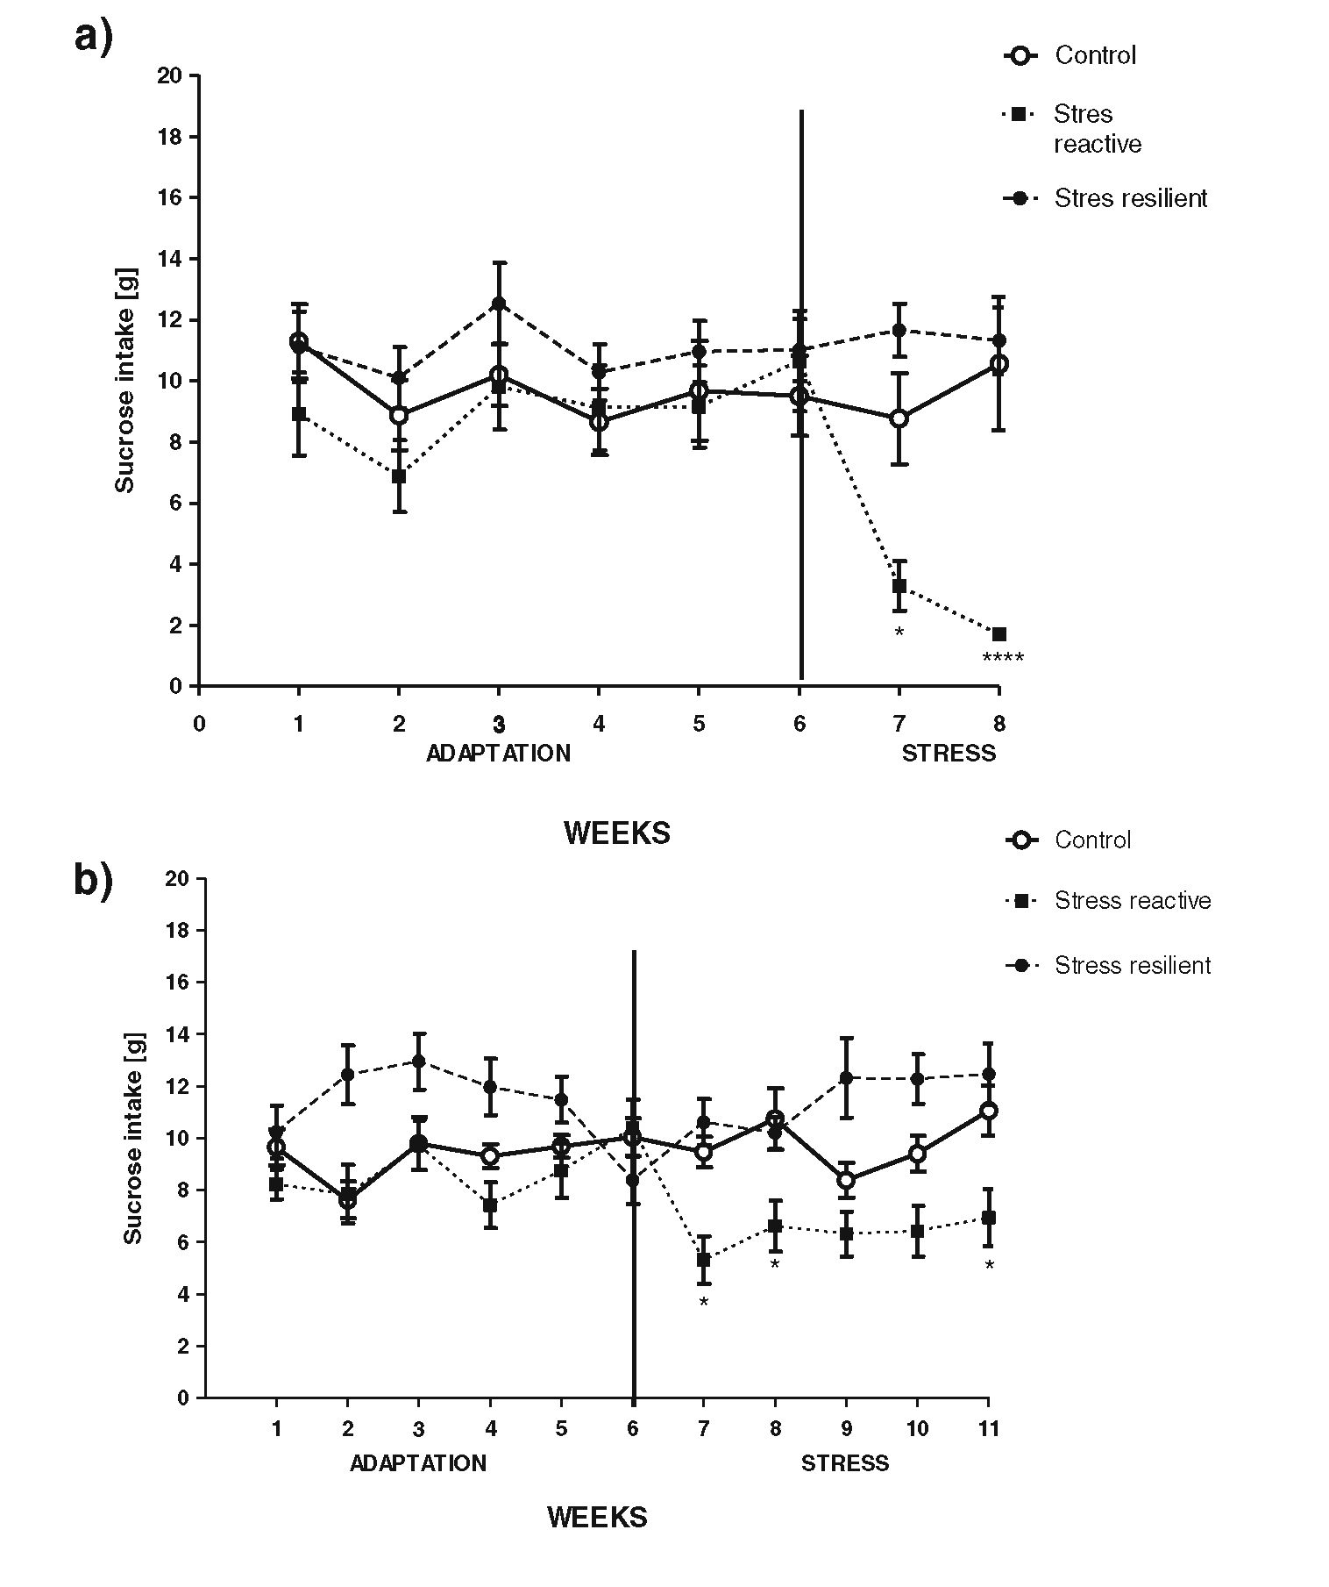
586
Psychopharmacology (2013) 227:583-593
from in situ hybridisation assays were normalised to the data
of the control group (expressed as 100 %). These data were
analysed using one-way ANOVA and Bonferroni’s multiple
comparison post hoc test by using GraphPad Prism software
(GraphPad Software, Inc., La Jolla, CA, USA).

Results
Sucrose intake
Independent analysis using repeated measures ANOVA test
did not show any significance of sucrose consumption
among animals during training procedure in 2- and 5-week
CMS experiment (F2, 29= 1.190; p=0.3271, and F2, 29 =
3.485; p=0.0526, respectively). After the CMS experi-
ments, we were able to ascribe the animals retrospectively
to the stress-resilient and stress-susceptible groups on the
basis of their individual drinking behaviour. Two-way
ANOVA revealed significant effects of stress (F14, 216=
17.51; p<0.001), time (F14, 216 = 2.630; p<0.05) and
stressxtime (F14, 216=2.531; p<0.005) on sucrose con-
sumption after 2 weeks of CMS. A significant effect of
stress (F20, 297=44.46; p<0.0001) and stressxtime (F20,
297 = 2.303; p<0.005) on sucrose consumption was observed
after 5 weeks of CMS in the respective groups of rats.
Repeated measures ANOVA revealed that the application
of the stress procedure for 2 weeks allowed the selection of
stress-reactive animals (F2, 29 = 14.74; p<0.005) which
exhibited a significant decrease in sucrose consumption as
compared to non-stressed control group. A separate group of
rats did not change their drinking behaviour when compared
with control rats (F2, 29=14.74; p>0.05) (Fig. 1a).
A similar response was observed in the 5-week CMS rats.
A proportion of the animals responded to stress with a
decrease in sucrose consumption (F2, 29=10.79; p<0.05),
Fig. 1 The effect of exposure
to chronic mild stress on the
consumption of a 1 % sucrose
solution. Control (empty circle
connected with straight lines),
stress-reactive (filled square
connected with bullet
operators) and stress-resilient
(filled circle connected with
broken lines) groups were
selected. a Two weeks of CMS,
b 5 weeks of CMS. Data
represent the mean ± SEM, n=
10; *p<0.05; **p<0.01; ****p
<0.0001 vs. control group
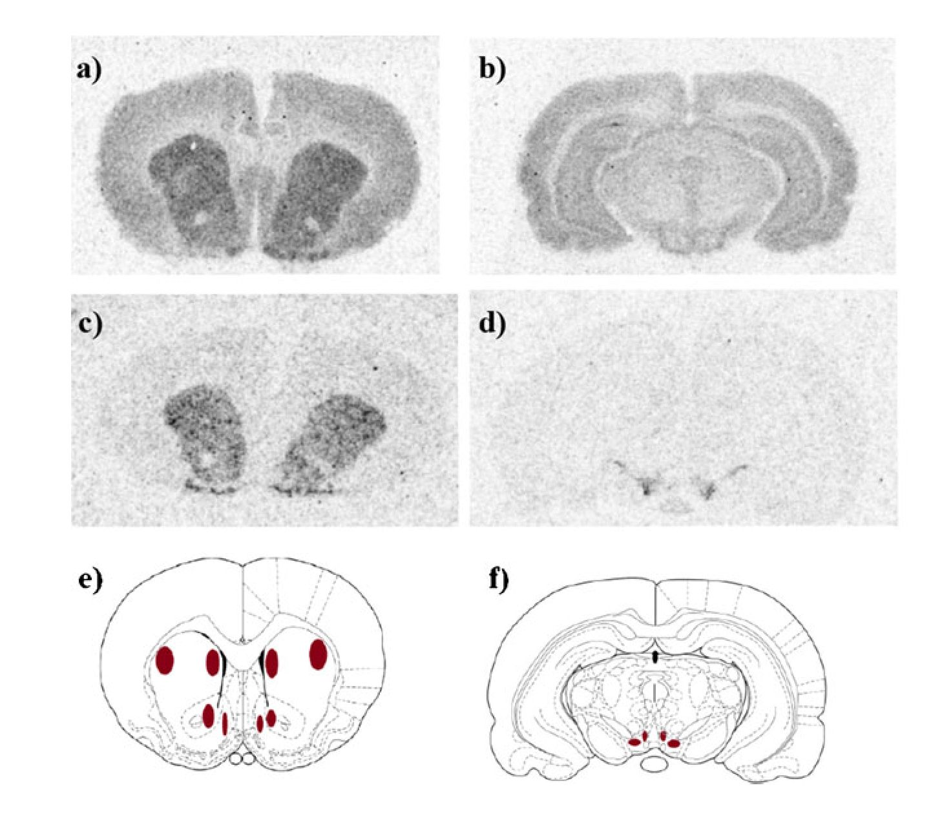
Psychopharmacology (2013) 227:583-593
587
and other animals were unaffected by stress (F2, 29=10.79;
p>0.05) as compared to control rats (Fig. 1b). Our arbitrary
retrospective observations have shown that anhedonic animals
decreased their sucrose consumption to below 7.5 g when
compared with the sucrose intake measurement performed at
the end of the sucrose training period (i.e. sixth week).
Effect of CMS procedure on dopamine D2 receptors
in the rat brain—autoradiography and in situ hybridisation
Representative autoradiograms of the distribution of [3H]
domperidone-binding sites and dopamine D2 receptor mRNA
in various regions of the rat brain are presented in Fig. 2. The
impact of the CMS procedure on dopamine D2 receptors was
examined in several rat brain areas. Two weeks of CMS
reduced [ H]domperidone binding in the striatum (medial
and lateral), nucleus accumbens (shell and core) and the
lateral, but not medial, ventral tegmental area. However, this
reduction only reached statistical significance in animals that
were resilient to CMS procedure (Fig. 3a-f).
Two weeks of CMS did not alter dopamine D2 receptor
mRNA expression in the examined brain regions (Fig. 4).
Five weeks of the CMS procedure reduced [3H]domperi-
done binding to dopamine D2 receptors in the striatum
(lateral and medial) and nucleus accumbens (core) in
stress-responsive rats. No significant differences in [3H]
domperidone binding were observed in the brains of
stress-resilient animals (Fig. 5a, b, d). However, the reduc-
tion in [3H]domperidone binding in the nucleus accumbens
shell was observed in both stress-reactive and stress-resilient
rats (Fig. 5c) No significant differences in [3H]domperidone
binding were observed in the ventral tegmental area when
compared with the control group. However, a statistically
significant difference was observed in dopamine D2 receptor
density between stress-reactive and stress-resilient animals in
the medial part of the VTA (Fig. 5e, f).
In situ hybridisation revealed a significant increase in do-
pamine D2 receptor mRNA in the striatum (lateral and medial),
nucleus accumbens (shell) and ventral tegmental area (lateral
and medial) in stress-resilient rats (Fig. 6a-f). No significant
differences were observed in stress-reactive animals.

Discussion
Recent research has focused on the mechanisms that under-
lie the susceptibility to stress (Larish et al. Larisch et al.
1997; Husseini et al. 2001; Zhu et al. 2011; Blugeot et al.
2011). However, only a small percentage of people who face
adverse events develop depression (Feder et al. 2009; Cic-
chetti 2010). Therefore, the factors that contribute to stress
resilience may be more worthy of investigation. The present
study examined stress-induced changes in mesolimbic dopa-
mine D2 receptor protein and mRNA using chronic mild stress
at two time points (after 2 and 5 weeks of CMS) in two groups
of animals with different behavioural responses to stress.
The CMS paradigm is a well-established animal behav-
ioural model of anhedonia, which is a core symptom of
Fig. 2 Representative
autoradiograms of specific [3H]
domperidone binding a, b and
dopamine D2 receptor mRNA c,
d in coronal sections of the rat
brain. The brain regions used
for quantitative analysis were
chosen according to Paxinos
and Watson (1998) e, f;
Bregma, 2.28-1.8 mm a, c and
(-5.04) to (-5.28)mm b, d
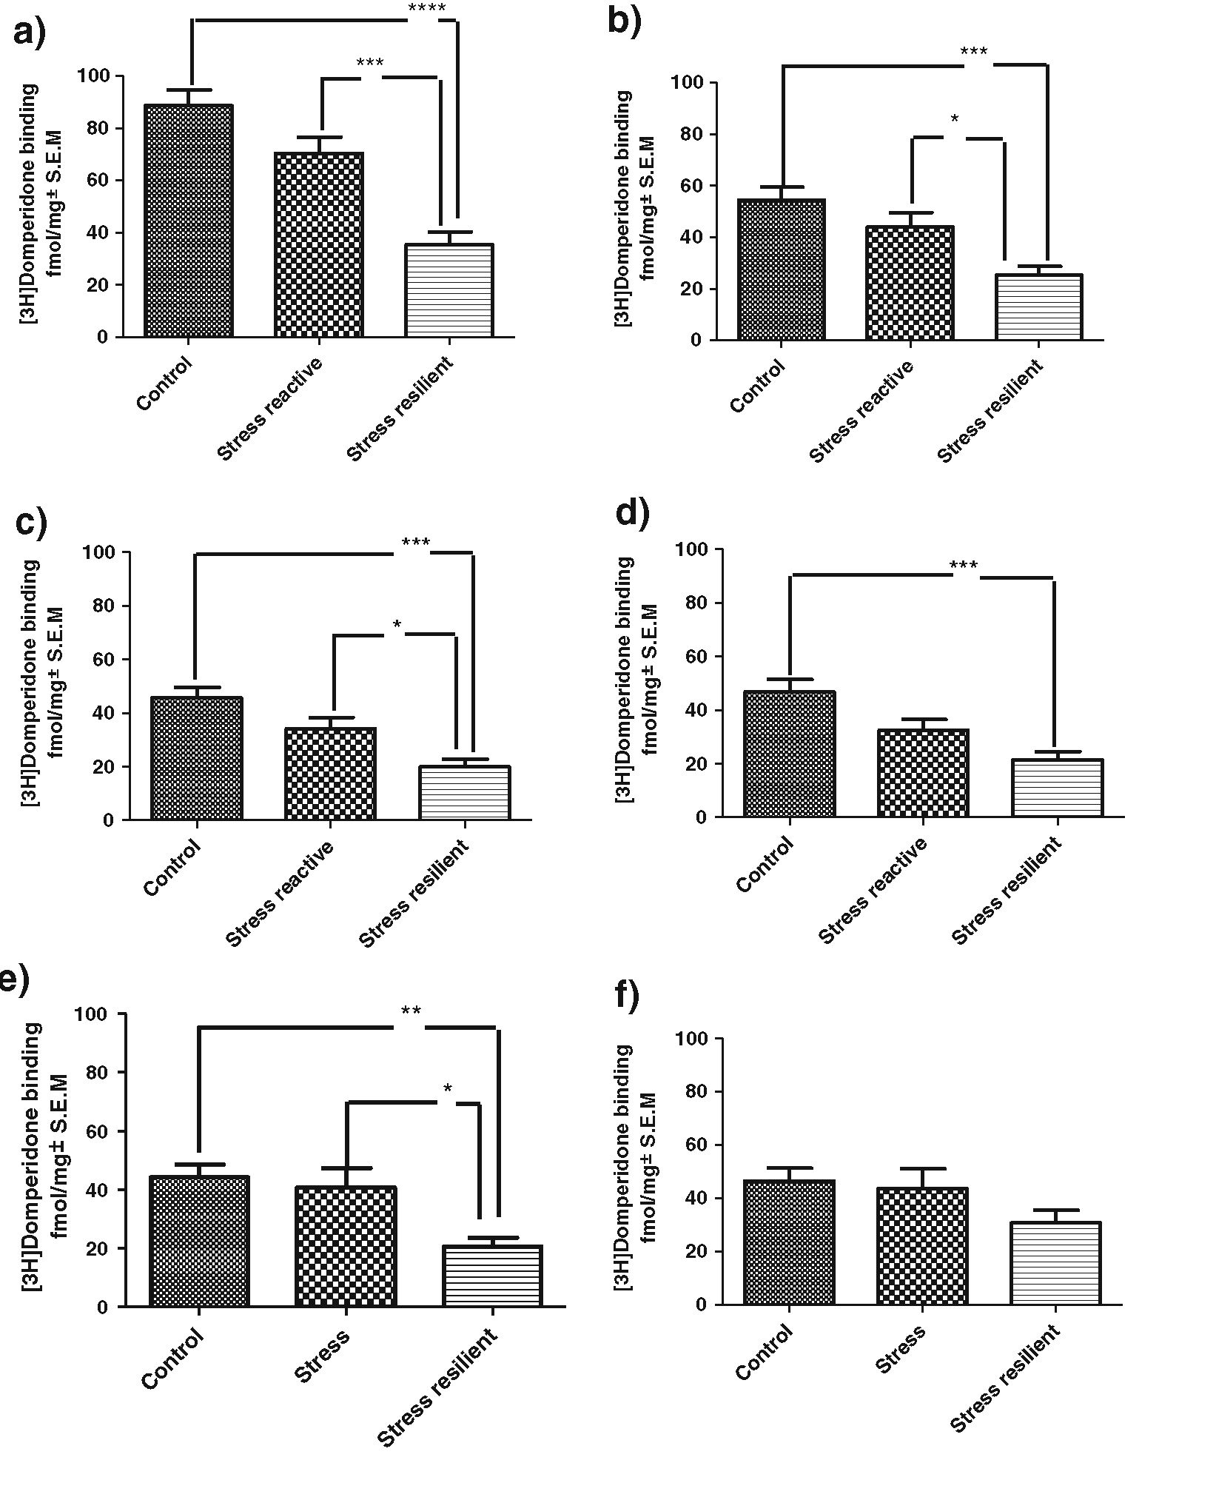
588
Psychopharmacology (2013) 227:583-593
Fig. 3 The effect of 2 weeks of
chronic mild stress on specific
[3H]domperidone binding in
various regions of the rat brain.
a Lateral striatum; b medial
striatum; c nucleus accumbens
septi, core; d nucleus
accumbens septi, shell; e lateral
ventral tegmental area; f medial
ventral tegmental area. Data
represent the means ± SEM; n =
10 (fmol/mg tissue); ANOVA
followed by Bonferroni’s
multiple comparison post hoc
test; *p<0.05; **p<0.01; ***p
<0.001; ****p<0.0001
depression. Male rodents are used in this model because males
are more biologically stable than females. The dopamine
reward circuit in female rats is strongly affected by hormonal
changes during the oestrus cycle (Becker 1999). Gonadal
hormones, such as oestrogen and progesterone, modulate
dopamine activity and receptor levels in the striatum and
nucleus accumbens in female rats. In contrast, oestrogen does
not affect striatal dopamine release in male rats, and male
hormones, such as testosterone, do not affect the brain dopa-
mine reward circuit (Becker 1999; Becker et al. 2005). These
factors support the selection of male rats in these experiments.
Behavioural experiments demonstrated that 70 % of rats
subjected to the CMS paradigm exhibited a decrease in the
consumption of palatable sucrose solution, which suggests
that these rats were vulnerable to stress. The remaining 30 %
of the stressed animals were stress resilient, and these ani-
mals are often rejected from further analysis, because they
do not exhibit the “appropriate” behavioural response to the
stress regimen (Bergstrom et al. 2008).
The stress-resilient group of animals is important for the
identification of the molecular factors that underlie the
mechanisms of active coping for stress and adversity. The
present study demonstrated that stress strongly affected the
mesolimbic dopamine circuit in stress-resilient and stress-
susceptible animals. This observation is consistent with that
of Krishnan et al. (2007) and Blugeot et al. (2011), who
demonstrated that stress-resilient and stress-susceptible ani-
mals exhibit elevated serum corticosterone levels. The
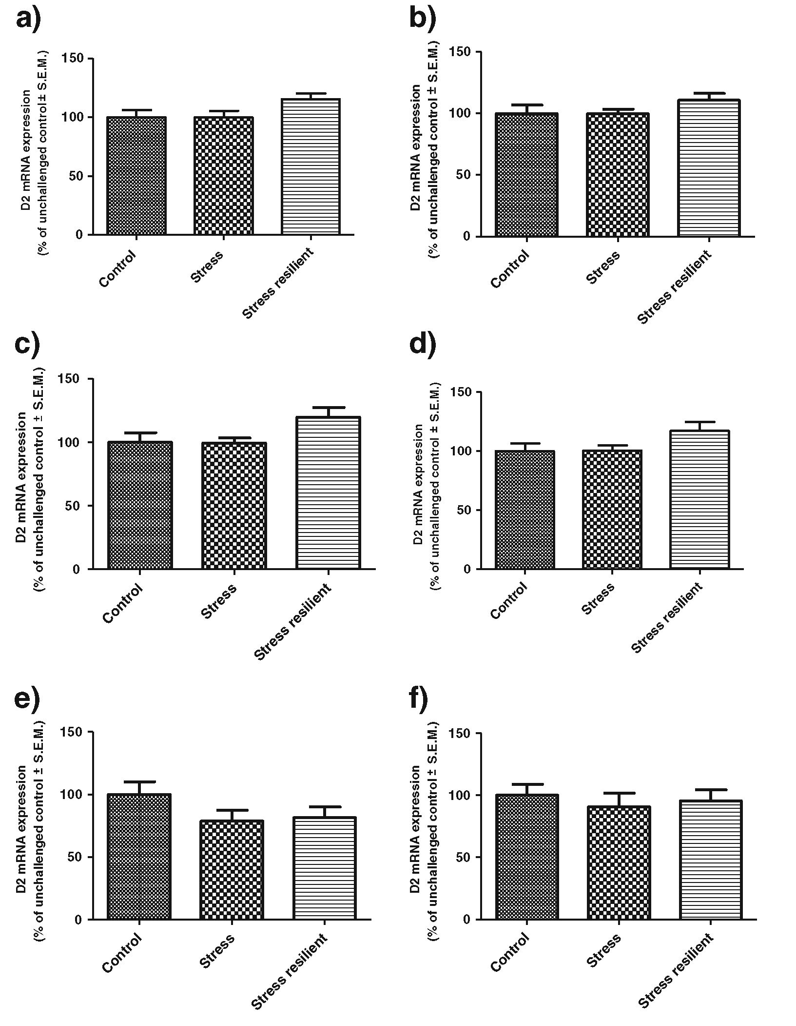
Psychopharmacology (2013) 227:583-593
589
Fig. 4 The effect of 2 weeks of
chronic mild stress on
dopamine D2 receptor mRNA
levels in various regions of the
rat brain. a Lateral striatum; b
medial striatum; c nucleus
accumbens septi, core; d
nucleus accumbens septi, shell;
e lateral ventral tegmental area;
f medial ventral tegmental area.
Data represent the means ±
SEM; n=7-10; ANOVA, non-
significant
stress-resilient group subjected to CMS exhibited a down-
regulation of dopamine D2 receptors in all of the examined
brain structures except the medial VTA. This effect was
significant following 2 weeks of the CMS procedure when
compared with control animals, which suggests an internal-
isation of the receptors in response to the enhanced dopa-
mine release, because no down-regulation of D2 receptor
biosynthesis (i.e. mRNA) was observed. However, the ex-
tension of CMS for 3 additional weeks (5 weeks total)
produced a different effect, which clearly supports active
processes in stress-resilient animals. This group displayed
strong neurobiological plasticity in dopamine D2 receptor
density and mRNA expression, in contrast to stress-reactive
animals. These alterations buffered the influence of stress
and thus normalised the mesolimbic dopamine circuit via
the elevation of dopamine D2 receptor biosynthesis to con-
trol levels in stress-resilient animals. This effect was not
observed in stress-reactive rats after 5 weeks of CMS. The
normalisation of the brain reward circuit in stress-resilient
animals may be the result of elevated dopamine D2 auto-
receptor biosynthesis in the VTA region, which decreases
the firing rate of dopamine neurons that project to the
ventral striatum in response to stress. D2 mRNA in the
striatum and nucleus accumbens is responsible for the
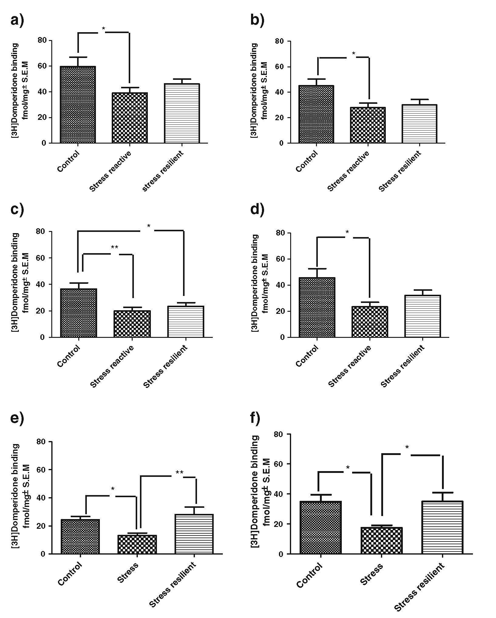
590
Psychopharmacology (2013) 227:583-593
Fig. 5 The effect of 5 weeks of
chronic mild stress exposure on
specific [3H]domperidone
binding in various regions of
the rat brain. a Lateral striatum;
b medial striatum; c nucleus
accumbens septi, core; d
nucleus accumbens septi, shell;
e lateral ventral tegmental area;
f medial ventral tegmental area.
Data represent the means ±
SEM; n =10-11 (fmol/mg
tissue); ANOVA followed by
Bonferroni’s multiple
comparison post hoc test; *p<
0.05; **p<0.01
biosynthesis of dopamine D2 receptors in non-dopaminergic
cells in these brain regions. We observed alterations in D2
mRNA levels in the VTA and regions receiving projections
from dopaminergic cells after 5 weeks of CMS. Therefore, we
conclude that the biosynthesis of both pre- and post-synaptic
dopaminergic D2 receptors was increased. These results fur-
ther support the hypothesis that stress resilience is a biochem-
ically and biologically active and dynamic process that occurs
very early at multiple levels in organisms that face trauma or
adversity (Haglund et al. 2007; Kanarik et al. 2011). More-
over, stress-reactive animals may exhibit a delayed dopamine
D2 receptor response to stress when compared with stress-
resilient animals, which produces an anhedonic mood. How-
ever, this hypothesis must be tested in further studies.
Chronic and unpredictable stress regimens decrease do-
pamine D2 mRNA expression and receptor density in the
mesoaccumbens circuit in stress-reactive animals (Puglisi-
Allegraetal. 1991; Papp etal. 1994; Dziedzicka-Wasylewska
et al. 1997; Cabib et al. 1998; Zhu et al. 2010). Dopamine D2
receptor density also increases after chronic antidepressant
treatment, which supports the potential antidepressant efficacy
of D2 receptor activation (Gershon et al. 2007; Dunlop and
Nemeroff 2007). Therefore, decreased D2 receptor density in
mesolimbic system may be a primary factor in reward sub-
sensitivity and anhedonia, which is a core symptom of
depression (Papp et al. 1994; Cabib et al. 1998). However,
few studies have focused on the molecular, neurobiological
and biochemical changes in dopamine D2 signalling in stress-
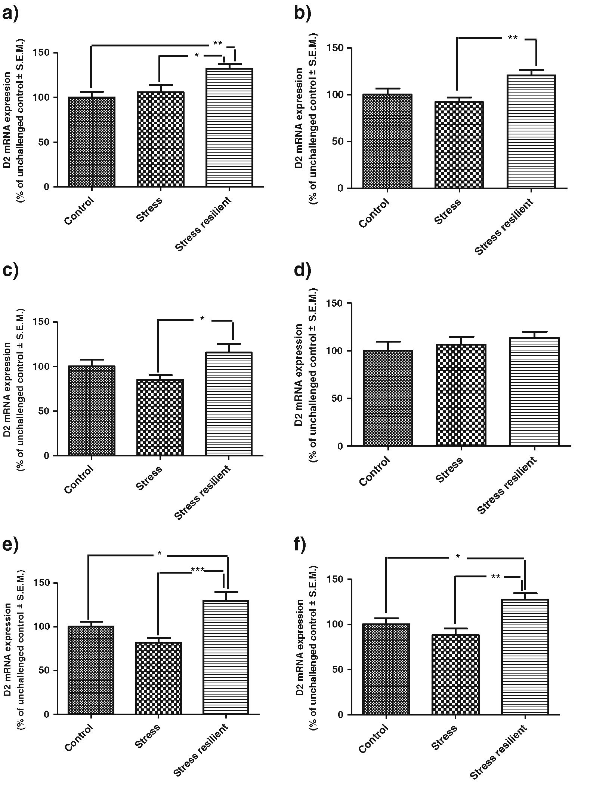
Psychopharmacology (2013) 227:583-593
591
Fig. 6 The effect of 5 weeks of
chronic mild stress exposure
dopamine D2 receptor mRNA
levels in various regions of the
rat brain. a Lateral striatum; b
medial striatum; c nucleus
accumbens septi, core; d
nucleus accumbens septi, shell;
e lateral ventral tegmental area;
f medial ventral tegmental area.
Data represent the means ±
SEM; n =10-11; ANOVA
followed by Bonferroni’s
multiple comparison post hoc
test; *p<0.05;
<0.001
*p<0.01; ***p
resilient animals (Krishnan et al. 2007; Bergstrom et al.
2008; Kanarik et al. 2011; Blugeot et al. 2011). Berg-
strom et al. (2008) have demonstrated that restraint
stress and 5 weeks of CMS do not alter dopamine D2
receptor mRNA expression in the nucleus accumbens of
control, stress-reactive and stress-resilient rats. However,
our work focused on the terminal and brain regions that
contain cell bodies (medial and lateral VTA) of the
dopamine mesolimbic system. Furthermore, we used a
mixture of three oligonucleotides that are complementa-
ry to three different regions of the D2 receptor mRNA
to enhance the sensitivity of in situ hybridisation. The
statistically significant parallel increases in dopamine D2
mRNA expression and receptor density in the medial
and lateral VTA in stress-resilient animals demonstrate
that the mesolimbic circuit can effectively adapt to new cir-
cumstances and allow the animals to cope with adversity
despite their sensitivity to chronic stress. In contrast, stress-
reactive rats exhibited a significant and persistent decrease in
dopamine D2 receptor density and unchanged mRNA expres-
sion levels. This phenomenon suggests that these animals
exhibit an impaired mesoaccumbens reward circuit that cannot
actively cope with stress (Stamford et al. 1991; Cabib et al.
1998; Kruk etal. 1998; Di Chiaraetal. 1999; Cao etal. 2010).
592
Psychopharmacology (2013) 227:583-593
We used domperidone to visualise dopamine D2 receptor
density in various brain regions. This compound is a specific
antagonist that recognises the high- and low-affinity confor-
mational states of the D2 receptor (Seeman et al. 2003, 2005).
Therefore, the observed changes in [ H]domperidone receptor
binding in the VTA and NAcc in both groups of animals may
be the sum of two phenomena: the down-regulation of D2
dopamine receptors and the switching of their conformation
into a low-affinity state (Rogoz and Dziedzicka-Wasylewska
1999; Seeman et al. 2005).
Our study suggests that the links between behavioural
and biochemical responses to stress are not straightforward.
The behavioural response to stress depends on various fac-
tors and systems and their mutual relationships at different
levels (Manji et al. 2001). The behavioural CMS experi-
ment suggests that resilient animals exhibit de facto resistance
to stress, which is expressed as unaltered consumption of a 1 %
sucrose solution. Biochemical analyses indicated an imbalance
in mesolimbic dopamine circuit in stress-resilient rats as dem-
onstrated by a decreased in [3H]domperidone binding when
compared with stress-reactive group after 2 weeks of CMS.
Mesolimbic D2 receptor density in the stress-resilient group,
but not the stress-reactive group, returned to normal levels after
5 weeks of CMS in all examined brain regions, except the
NAcc core region, which is related to the caudate and putamen,
and, in effect, less associated with the limbic reward system
(Deutch and Cameron 1992). Stress influences dopamine D2
receptors and other catecholamine circuits and these common
fluctuations produce specific behavioural responses to stress
that may not be directly related to changes in dopamine D2
receptors alone. An examination of all of these factors is very
important for a profound understanding on the mechanisms
underlying stress resilience. These results clearly demonstrate
that despite earlier blunting, the activation of dopamine recep-
tor biosynthesis in the dopamine mesoaccumbens system in
stress-resilient rats is involved in active coping for stressful
experiences, while in stress-reactive animals, this phenomenon
does not occur or may be delayed (Cabib and Puglisi-Allegra
1994; Puglisi-Allegra et al. 1991). However, further investiga-
tion is required to delineate the precise mechanisms underlying
the time-dependent normalisation of dopamine D2 receptor
levels in the mesolimbic system.
Acknowledgments This study was partly supported by the following
grants: (1) DeMeTer (project number P0IG.01.01.02-12-004/09; 3.6)
and (2) MNiSW NN401067438 and (3) Statutory activity of Institute
of Pharmacology Polish Academy of Sciences. We thank Dr. Joanna
Solich for invaluable technical support.
Open Access This article is distributed under the terms of the Creative
Commons Attribution License which permits any use, distribution, and
reproduction in any medium, provided the original author(s) and the
source are credited.

References
Becker JB (1999) Gender differences in dopamine function in striatum
and nucleus accumbens. Pharmacol Biochem Behav 64(4):803-
812. doi:10.1016/S0091-3057(99)00168-9
Becker JB, Arnold AP, Berkley KJ, Blaustein JD, Eckel LA, Hampson
E, Herman JP, Marts S, Sadee W, Steiner M, Taylor J, Young E
(2005) Strategies and methods for research on sex differences in
brain and behavior. Endocrinology 146(4):1650-1673.
doi:10.1210/en.2004-1142
Bekris S, Antoniou K, Daskas S, Papadopoulou-Daifoti Z (2005)
Behavioural and neurochemical effects induced by chronic mild
stress applied to two different rats strains. Behav Brain Res 161
(1):45-59. doi:10.1016/j.bbr.2005.01.005
Bergstrom A, Jayatissa MN, Mork A, Wiborg O (2008) Stress sensi-
tivity and resilience in the chronic mild stress rat model of
depression; an in situ hybridization study. Brain Res 1196:41-
52. doi:10.1016/j.brainres.2007.12.025
Bielajew C, Konkle AT, Merali Z (2002) The effects of chronic mild
stress on male Sprague-Dawley and Long Evans rats: I. Biochem-
ical and physiological analyses. Behav Brain Res 136(2):583-
592. doi:10.1016/S0166-4328(02)00222-X
Blugeot A, Rivat C, Bouvier E, Molet J, Mouchard A, Zeau B, Bernard
C, Benoliel JJ, Becker C (2011) Vulnerability to depression: from
brain neuroplasticity to identification of biomarkers. J Neurosci
31(36):12889-12899. doi:10.1523/JNEUR0SCI.1309-11.2011
Cabib S, Puglisi-Allegra S (1994) Opposite responses of mesolimbic
dopamine system to controllable and uncontrollable aversive
experiences. J Neurosci 14(5 Pt 2):3333-3340
Cabib S, Puglisi-Allegra S (1996a) Different effects of repeated stress-
ful experiences on mesocortical and mesolimbic dopamine me-
tabolism. Neuroscience 73(2):375-380. doi:10.1016/0306-4522
(96)00750-6
Cabib S, Puglisi-Allegra S (1996b) Stress, depression and the meso-
limbic dopamine system. Psychopharmacology (Berl) 128
(4):331-342. doi:10.1007/s002130050142
Cabib S, Giardino L, Calza L, Zanni M, Mele A, Puglisi-Allegra S
(1998) Stress promotes major changes in dopamine receptor den-
sities within the mesoaccumbens and nigrostriatal systems. Neu-
roscience 84(1):193-200. doi:10.1016/S0306-4522(97)00468-5
Cao JL, Covington HE 3rd, Friedman AK, Wilkinson MB, Walsh JJ,
Cooper DC, Nestler EJ, Han MH (2010) Mesolimbic dopamine
neurons in the brain reward circuit mediate susceptibility to social
defeat and antidepressant action. J Neurosci 30(49):16453-16458.
doi:10.1523/JNEUR0SCI.3177-10.2010
Cicchetti D (2010) Resilience under conditions of extreme stress: a
multilevel perspective. World Psychiatry 9(3):145-154
Dailly E, Chenu F, Renard CE, Bourin M (2004) Dopamine, depres-
sion and antidepressants. Fundam Clin Pharmacol 18(6):601-607.
doi:10.1111/j.1472-8206.2004.00287.x
Deutch AY, Cameron DS (1992) Pharmacological characterization of
dopamine systems in the nucleus accumbens core and shell.
Neuroscience 46(1):49-56. doi:10.1016/0306-4522(92)90007-0
Di Chiara G, Tanda G (1997) Blunting of reactivity of dopamine
transmission to palatable food: a biochemical marker of anhedo-
nia in the CMS model? Psychopharmacology (Berl) 134(4):351—
353. doi:10.1007/s002130050465, discussion 371-7
Di Chiara G, Loddo P, Tanda G (1999) Reciprocal changes in prefron-
tal and limbic dopamine responsiveness to aversive and rewarding
stimuli after chronic mild stress: implications for the psychobiol-
ogy of depression. Biol Psychiatry 46(12):1624-1633.
doi:10.1016/S0006-3223(99)00236-X
Dunlop BW, Nemeroff CB (2007) The role of dopamine in the path-
ophysiology of depression. Arch Gen Psychiatry 64(3):327-337
Psychopharmacology (2013) 227:583-593
593
Dziedzicka-Wasylewska M, Willner P, Papp M (1997) Changes in dopa-
mine receptor mRNA expression following chronic mild stress and
chronic antidepressant treatment. Behav Pharmacol 8(6-7):607-618
Feder A, Nestler EJ, Charney DS (2009) Psychobiology and molecular
genetics of resilience. Nat Rev Neurosci 10(6):446-457.
doi:10.1038/nrn2649
Finlay JM, Zigmond MJ (1997) The effects of stress on central dopa-
minergic neurons: possible clinical implications. Neurochem Res
22(11):1387-1394. doi:10.1023/A:1022075324164
Gershon AA, Vishne T, Grunhaus L (2007) Dopamine D2-like recep-
tors and the antidepressant response. Biol Psychiatry 61(2):145-
153. doi:10.1016/j.biopsych.2006.05.031
Haglund ME, Nestadt PS, Cooper NS, Southwick SM, Charney DS
(2007) Psychobiological mechanisms of resilience: relevance to
prevention and treatment of stress-related psychopathology. Dev
Psychopathol 19(3):889-920. doi:10.1017/S0954579407000430
Imperato A, Cabib S, Puglisi-Allegra S (1993) Repeated stressful
experiences differently affect the time-dependent responses of
the mesolimbic dopamine system to the stressor. Brain Res 601
(1-2):333-336. doi:10.1016/0006-8993(93)91732-8
Kanarik M, Alttoa A, Matrov D, Köiv K, Sharp T, Panksepp J, Harro J
(2011) Brain responses to chronic social defeat stress: effects on
regional oxidative metabolism as a function of a hedonic trait, and
gene expression in susceptible and resilient rats. Eur Neuropsycho-
pharmacol 21(1):92-107. doi:10.1016/j.euroneuro.2010.06.015
Krishnan V, Han MH, Graham DL, Berton O, Renthal W, Russo SJ,
Laplant Q, Graham A, Lutter M, Lagace DC, Ghose S, Reister R,
Tannous P, Green TA, Neve RL, Chakravarty S, Kumar A, Eisch
AJ, Self DW, Lee FS, Tamminga CA, Cooper DC, Gershenfeld
HK, Nestler EJ (2007) Molecular adaptations underlying suscep-
tibility and resistance to social defeat in brain reward regions. Cell
131(2):391 -404. doi:10.1016/j.cell.2007.09.018
Kruk ZL, Cheeta S, Milla J, Muscat R, Williams JE, Willner P (1998)
Real time measurement of stimulated dopamine release in the
conscious rat using fast cyclic voltammetry: dopamine release is
not observed during intracranial self stimulation. J Neurosci
Methods 79(1):9-19. doi:10.1016/S0165-0270(97)00156-8
Larisch R, Klimke A, Vosberg H, Löffler S, Gaebel W, Müller-Gärtner
HW (1997) In vivo evidence for the involvement of dopamine-D2
receptors in striatum and anterior cingulate gyrus in major depres-
sion. Neuroimage 5(4 Pt 1):251-260. doi:10.1006/nimg.1997.0267
Manji HK, Drevets WC, Charney DS (2001) The cellular neurobiology
of depression. Nat Med 7(5):541-547. doi:10.1038/87865
Papp M, Klimek V, Willner P (1994) Parallel changes in dopamine D2
receptor binding in limbic forebrain associated with chronic mild
stress-induced anhedonia and its reversal by imipramine. Psycho-
pharmacology (Berl) 115(4):441 -446. doi:10.1007/BF02245566
Puglisi-Allegra S, Kempf E, Schleef C, Cabib S (1991) Repeated stressful
experiences differently affect brain dopamine receptor subtypes.
Life Sci 48(13): 1263-1268. doi:10.1016/0024-3205(91)90521-C
Rogoz R, Dziedzicka-Wasylewska M (1999) Effects of antidepressant
drugs on the dopamine D2/D3 receptors in the rat brain differen-
tiated by agonist and antagonist binding—an autoradiographic
analysis. Naunyn Schmiedebergs Arch Pharmacol 359(3):178-
186. doi:10.1007/PL00005340
Rowland LM (2011) Who is resilient to depression? Multimodal im-
aging of the hippocampus in preclinical chronic mild stress model
may provide clues. Biol Psychiatry 70(5):406-407. doi:10.1016/
j.biopsych.2011.07.002
Seeman P, Tallerico T, Ko F (2003) Dopamine displaces [3H]domper-
idone from high-affinity sites of the dopamine D2 receptor, but not
[3H]raclopride or [3H]spiperone in isotonic medium: implications
for human positron emission tomography. Synapse 49(4):209-
215. doi:10.1002/syn.10232
Seeman P, Weinshenker D, Quirion R, Srivastava LK, Bhardwaj SK,
Grandy DK, Premont RT, Sotnikova TD, Boksa P, El-Ghundi M,
O’dowd BF, George SR, Perreault ML, Mannisto PT, Robinson S,
Palmiter RD, Tallerico T (2005) Dopamine supersensitivity cor-
relates with D2High states, implying many paths to psychosis.
Proc Natl Acad Sci U S A 102(9):3513-3518. doi:10.1073/
pnas.0409766102
Stamford JA, Muscat R, O’Connor JJ, Patel J, Trout SJ, Wieczorek
WJ, Kruk ZL, Willner P (1991) Voltammetric evidence that sub-
sensitivity to reward following chronic mild stress is associated
with increased release of mesolimbic dopamine. Psychopharma-
cology (Berl) 105(2):275-282. doi:10.1007/BF02244322
Willner P, Towell A, Sampson D, Sophokleous S, Muscat R (1987)
Reduction of sucrose preference by chronic unpredictable mild
stress, and its restoration by a tricyclic antidepressant. Psycho-
pharmacology (Berl) 93(3):358-364. doi:10.1007/BF00187257
Willner P, Hale AS, Argyropoulos S (2005) Dopaminergic mechanism
of antidepressant action in depressed patients. J Affect Disord 86
(1):37-45. doi:10.1016/j.jad.2004.12.010
Yadid G, Overstreet DH, Zangen A (2001) Limbic dopaminergic
adaptation to a stressful stimulus in a rat model of depression.
Brain Res 896(1-2):43-47. doi:10.1016/S0006-8993(00)03248-0
Zhu X, Li T, Peng S, Ma X, Chen X, Zhang X (2010) Maternal deprivation-
caused behavioral abnormalities in adult rats relate to a non-
methylation-regulated D2 receptor levels in the nucleus accumbens.
Behav Brain Res 209(2):281-288. doi:10.1016/j.bbr.2010.02.005
Zhu X, Peng S, Zhang S, Zhang X (2011) Stress-induced depressive
behaviors are correlated with Par-4 and DRD2 expression in rat
striatum. Behav Brain Res 223(2):329-335. doi:10.1016/
j.bbr.2011.04.052

