

Reac Kinet Mech Cat (2017) 121:225–240 DOI 10.1007/s11144-017-1141-y
Activating effect of cerium in hydrotalcite derived Cu–
Mg–Al catalysts for selective ammonia oxidation and the selective reduction of NO with ammonia
SylwiaBasa˛g¹•KlaudiaKocoł¹•ZofiaPiwowarska¹•
Małgorzata Rutkowska¹•Rafał Baran²•
Lucjan Chmielarz¹
Received: 24 November 2016 / Accepted: 7 January 2017 / Published online: 20 January 2017
©The Author(s) 2017. This article is published with open access at Springerlink.com
Abstract Hydrotalcite originated mixed metal Cu–Mg–Al oxide system was doped with various amounts of cerium (0.5 or 3.0 wt%) and tested in the role of catalysts for the selective catalytic oxidation of ammonia to dinitrogen (NH₃-SCO) and the selective catalytic reduction of NO with ammonia (NH₃-SCR). The activating effect of cerium was observed in both studied processes. However, the CeO₂loading is a very important parameter determining catalytic performance of the studied samples. It was shown that an introduction of cerium into Cu–Mg–Al mixed oxide resultedin its significant activation in the low-temperature NH₃-SCR process, independently of the CeO₂loading and a decrease in the efficiency of the NO reduction at higher temperatures, which was more significant for the catalyst with the lower cerium content. In the case of the NH₃-SCO process, the introduction of cerium into Cu– Mg–Al mixed oxide resulted in the activation of the low temperature reaction, which was more intensive for the catalyst with lower cerium content. These effects were related to the presence of cerium in the form of crystallites of various size and therefore their different reducibility.
Keywords Hydrotalcite·Copper·Cerium·DeNOx·Selective ammonia oxidation
&
Lucjan Chmielarzchmielar@chemia.uj.edu.pl
1
FacultyofChemistry,JagiellonianUniversity,Ingardena3,30-060Krako´w,Poland
Faculty of Energy and Fuels, AGH University of Science and Technology, Mickiewicza 30,30-059Krako´w,Poland
2
13

226
Reac Kinet Mech Cat (2017) 121:225–240
Introduction
Nitrogen containing pollutants, such as nitrogen oxides and ammonia, belong to the most serious environmental problems. Nitrogen oxides, mainly NO and NO₂, are produced as the side products of fuel combustion processes as well as in the chemical industry (e.g. N₂O is a side product in nitrogen fertilizer industry). On the other hand, the majority of ammonia emission is related to agricultural activities (e.g. volatilization from livestock wastes, losses from agriculture crops) and additionally to industrial processes and biomass burning [1]. Moreover, increasing ammonia emission is expected in the transportation sector due to the common useof cars with the systems of flue gases purification (e.g. Adblue system in diesel cars andTWCincarswithspark-ignitionengines)[2].
The most promising methods for the elimination of nitrogen oxides and ammonia from flue gases are based on their catalytic conversion to the non-toxic products. The NO and NO₂emitted from stationary and mobile sources are selectively catalytically reduced with ammonia to dinitrogen (NH₃-SCR, DeNO_{x}) [3,4]. On the other hand, the technology based on the selective catalytic oxidation of ammonia to dinitrogen (NH₃-SCO) has been reported to be the most promising for the elimination of NH₃from oxygen containing flue gases [1].
Among various catalytic systems studied in the processes mentioned above, the hydrotalcite originated mixed metal oxides containing various transition metals seem to be very promising [5–7]. Hydrotalcites, also called layered double hydroxides (LDHs), are minerals characterized by the brucite-like network,
Mg2?
aresix-coordinatedtoOH⁻.Partof
Mg2?
Mg(OH)₂, where octahedra of
cations is substituted by trivalent aluminum cations, what results in the positivechargingofthebrucite-likelayerscompensatingbyanions(typicallyCO₃²⁻),which, together with the water molecules, are located in the interlayer space of hydrotalcite. It is possible to synthesize materials with the hydrotalcite structure relatively easily under laboratory conditions. In such hydrotalcite-like materials, Mg^{2?}as well as Al^{3?}ions can be partially or completely replaced by various di- (e.g. Cu^{2?}, Co^{2?}, Ni^{2?}, Zn^{2?}) and/or trivalent (e.g. Fe^{3?}, Cr^{3?}) cations [8]. The rangeofvariousmetalcationsthatcanbeincorporatedintothebrucite-likelayersis relativelybroadandisdeterminedbytheirsize,whichshouldbesimilartothatof Mg^{2?}inthecaseofdivalentcationsandtoAl^{3?}inthecaseoftrivalentcations[8]. Thermal decomposition of hydrotalcite-like materials results in the formation of mixed metal oxides, which due to their relatively high surface area, porosityand homogenous distribution of metal cations are very promising for potential applicationsincatalysis[9–11],includingalsotheprocessesofselectivecatalytic reduction of NO with ammonia—DeNO_{x}, NH₃-SCR [12,13] as well asselective catalytic oxidation of ammonia to dinitrogen—NH₃-SCO [1,5–7].
Our previous studies have shown that the modification of the hydrotalcite originated Cu–Mg–Al mixed oxide with noble metals (Pt, Pd, Rh) resulted in its significant activation in the low-temperature NH₃-SCO process [14]. This effectwas explained by the activation of oxygen by noble metals for the reaction of ammonia oxidation. Moreover, it was shown that the process of the selective ammonia
13

Reac Kinet Mech Cat (2017) 121:225–240
227
oxidation proceeds in the presence of the hydrotalcite-based catalysts according to the so called internal selective catalytic reduction (i-SCR) [1,14]. Because of the relatively high cost of noble metals, a cheaper additive, cerium, known to be active in oxygen activation [15,16], was tested in the frame of the presented studies.
Experimental
Catalyst preparation
The hydrotalcite-like sample with the intended Cu/Mg/Al molar ratio of 5/62/33 wassynthesizedbyaco-precipitationmethodusingaqueoussolutionsofthe
following metal nitrates: Mg(NO₃)₂·6H₂O (Sigma), Al(NO₃)₃·9H₂O (Sigma) and
Cu(NO₃)₂·3H₂O (Sigma). A solution of NaOH (POCh) was used as a precipitating
agent. The solutions of nitrates and NaOH were simultaneously added to a vigorously stirred solution containing Na₂CO₃(POCh). The pH was maintained constant at 10.0±0.2 by the dropwise addition of NaOH solution. The obtained slurry was stirred at 60°C for a further 120 min, filtered, washed with distilled water and dried. Finally, the sample was calcined in an air atmosphere at 600°Cfor
12 h and then was kept in a desiccator in order to avoid the possible reconstruction of the hydrotalcite structure. The obtained sample is labelled as Cu₅Mg₆₂Al₃₃.
The Cu₅Mg₆₂Al₃₃catalyst was doped with cerium by the wet impregnation
method using an aqueous solution of Ce(NO₃)₃·6H₂O. After impregnation, the
samples were dried and calcined in an air atmosphere at 600°C for 12 h. The catalysts doped with 0.5 and 3.0 wt% of cerium are labelled as Cu₅Mg₆₂Al₃₃-Ce0.5% and Cu₅Mg₆₂Al₃₃-Ce3.0%, respectively.
Characterization of the catalysts
The thermal decomposition of the hydrotalcite-like samples was studied using thermogravimetry coupled with QMS analysis of evolved gases and in situ high temperature XRD. The TGA-DTG-QMS measurements were carried out using aMettlerToledo851eoperatedunderaflowofsyntheticair(80mLmin⁻¹)inthetemperaturerangeof25–1000°Cwithalinearheatingrateof10°Cmin⁻¹.Thegases evolved during the thermal decomposition process were continuously monitored by the quadrupole mass spectrometer ThermoStar (Balzers) connected on-line to the microbalance. In-situ high temperature XRD (HT-XRD) measure- ments were carried out at 25°C and then from 100 to 900°C with steps of 100°Cin air using a PANalytical-Empyrean diffractometer (Cu K_{a1/2}radiation,k=1.54060
A˚).Measurementswereperformedwithasequentialtemperatureincreaseof5°Cmin⁻¹andwithnotemperatureholdingtimebeforeeachanalysis.
The structure and phase composition of the calcined samples were studied by XRD method. The X-ray diffraction patterns of the as-synthesized and calcined
samples were recorded in the range of 8°–80°2h with steps of 0.02°2h by a D2Phaserdiffractometer(Bruker)usingCuK_{a1}radiation(k=1.54060A˚).
13

228
Reac Kinet Mech Cat (2017) 121:225–240
The chemical composition of the calcined hydrotalcite-like samples (cationic ratio) was determined by an electron microprobe analysis performed on a JEOL JCXA 733 Superprobe (electron probe microanalysis, EPMA).
ThespecificsurfaceareaofthecalcinedsampleswasdeterminedbyN₂adsorptionat-196°Cusinga3Flex(Micromeritics)automatedgasadsorptionsystem.Priortotheanalysis,thesampleswereoutgassedundervacuumat350°Cfor24h.ThespecificsurfaceareawasdeterminedusingtheBETequation.Thetotalvolumeofpores(atp/p₀=0.98)wascalculatedusingthesinglepointmodel.
The reducibility of the calcined samples was studied bytemperature-programmed reduction method (H₂-TPR). Experiments were carried out in a fixed-bed flow microreactor system starting from room temperature to 1000°C, with a linearheatingrateof5°Cmin⁻¹.H₂-TPRrunswerecarriedoutinaflow(10mLmin⁻¹)of 5 vol% H₂diluted in Ar (N5 quality, Messer). The evolution of hydrogen was detected by micro volume TCD (Valco). Prior to the H₂-TPR runs, the sampleswereoutgassedinaflowofpurehelium(20mLmin⁻¹)at600°Cfor1h.
The DR UV–Vis spectra were recorded using an Evolution 600 (Thermo) spectrophotometer. The measurements were performed in the range of 190–900 nmwith a resolution of 2 nm.
Catalytic studies
The calcined samples were tested as catalysts for the selective oxidation of ammonia to nitrogen and water vapor (HN₃-SCO) and for selective catalytic reduction of NO with ammonia (DeNO_{x}, NH₃-SCR). Catalytic tests were done in a fixed-bed flow microreactor system. The analysis of the reaction products was performed using QMS detector (PREVAC). Prior to the activity tests, the sample of the catalyst (200 mg) was outgassed at 600°C for 1 h in a flow of pure helium(20mLmin⁻¹).TheSCO-NH₃testswereperformedinaflowofthereactionmixture containing: [NH₃]=0.5 vol%, [O₂]=2.5 vol% [He]=97 vol%. The studies were performed in the temperature range of 100–500°C with alinear
heatingrateof10°Cmin⁻¹.TheDeNO_{x}testswerecarriedoutinaflowof
[NO]=0.25 vol%, [NH₃]=0.25 vol%, [O₂]=2.5 vol% and [He]=97 vol% inthetemperaturerangeof100–375°Cwithalinearheatingrateof10°Cmin⁻¹.Forbothreactions,thetotalflowrateofthereactionmixturewas40mLmin⁻¹.
Moreover, the reaction of NO oxidation to NO₂by O₂was studied by temperature-programmed reaction method. The experiments were carried out with the catalyst sample of 200 mg in a fixed-bed flow microreactor system starting from100to600°C,withalinearheatingrateof10°Cmin⁻¹inaflowofthereactionmixture containing: [NO]=0.5 vol%, [O₂]=2.5 vol% and [He]=97 vol%. Thetotalflowrateofthereactionmixturewas40mLmin⁻¹.Theanalysisofthereaction products was performed using QMS detector (PREVAC). Prior to theexperimentsthesampleswereoutgassedinaflowofpurehelium(20mLmin⁻¹)at600°C for 1 h.
13

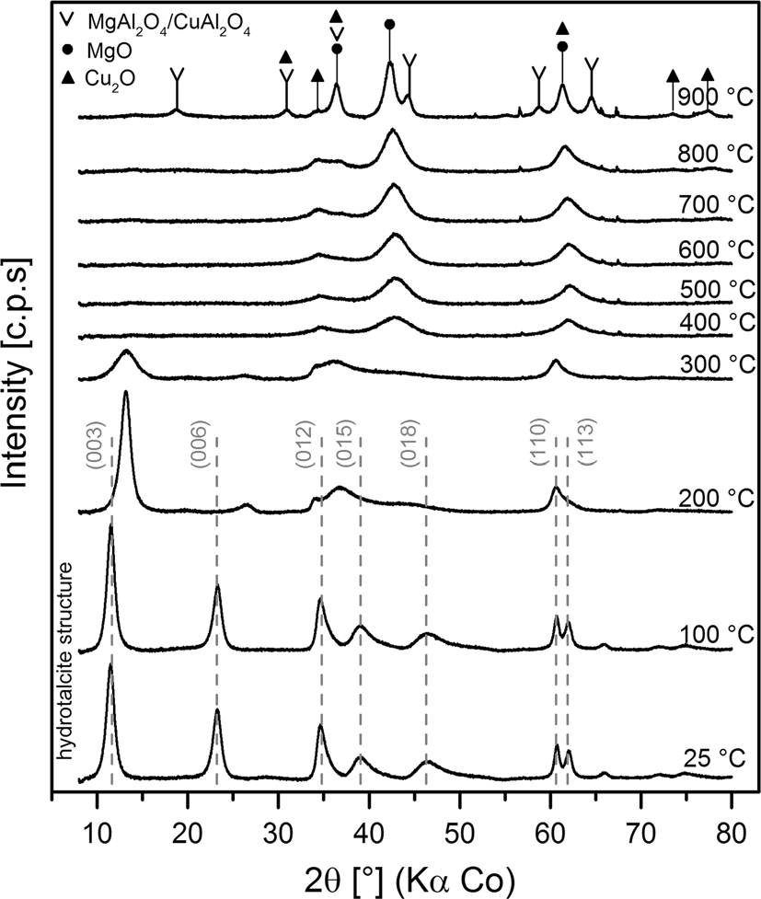
Reac Kinet Mech Cat (2017) 121:225–240
229
Results and discussion
The structure of the hydrotalcite-like sample as well as the transformations of its structure occurring during thermal treatment was analyzed by in situ high temperature XRD measurements and thermogravimetric method coupled with QMS analysis of evolved gases. The results of HT-XRD studies are presented in Fig.1. It can be seen that the diffractogram recorded at 25°C for the dried sampleis typical of the hydrotalcite structure without any reflections of the other phases [8]. Cell parameters ofaandcare 0.31 and 2.31 nm, respectively, while the average crystallite size is about 75 nm. The hydrotalcite structure was not damaged after heating the sample to 100°C. Thecparameter after heating the sample to 100°C was not changed indicating that water molecules located in the interlayer space of the hydrotalcite-like materials was not removed within this temperature range. An increase in temperature from 100 to 200°C significantly reduced thecparameter from 2.31 to 2.07 nm. Thus, it could be concluded that water molecules were intensively evacuated form the interlayer space of the sample in this temperature range. A further increase in temperature to 300°C resulted in a gradual decrease and broadening of the reflections characteristic of the hydrotalcite structure, which is related to the decreasing long distance ordering of the brucite-like layers and their gradual degradation. At higher temperatures, broad reflections at 2h values about 35°, 43°and 64°, characteristic of MgO (periclase), were formed. The intensity of these reflections increased with an increase in temperature, which is related to the progressive growth of this crystalline phase. At 900°C, new reflectionsat 19°, 31°,
36°,
45°,
59°,
65°and 78°related to the spinel phases (possibly MgAl₂O₄and
Fig. 1 Results of in situ hightemperature XRD measurementsfor not doped sample. sample: Cu₅Mg₆₂Al₃₃. Periclase (d – MgO), cuprite (m – Cu₂O) and spinelphases(v-MgAl₂O₄and CuAl₂O₄)
13

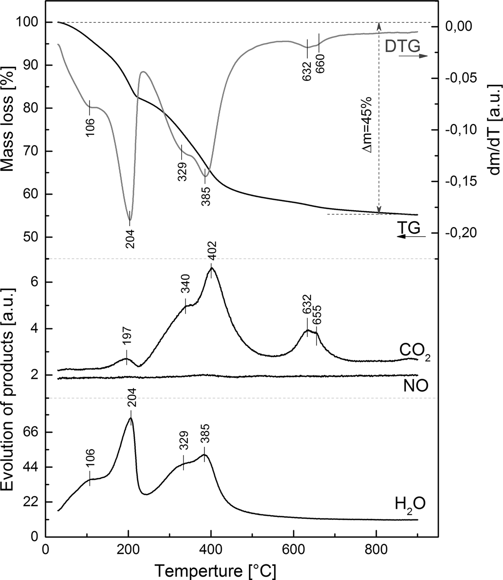
230
Reac Kinet Mech Cat (2017) 121:225–240
CuAl₂O₄) appeared in diffractograms [5,17]. Moreover, the reflections at 31°, 36°, 61°, 73°and 78°could be possibly assigned to cuprite (Cu₂O) [18]. However, it should be noted that the reflections at 31°, 36°, 78°are probably superpositions of thereflectionscharacteristicofCu₂Oandspinelphases,whilethereflectionat61°is possibly a superposition of the reflections characteristic of Cu₂O and MgO. Thus, only the weak and broad reflection located at 73°could individually represent the Cu₂O phase and therefore the presence of cuprite in the sample cannot be fully confirmed by in situ XRDstudies.
Thermogravimetry coupled with the QMS (quadrupole mass spectrometry) analysis of the released gases (TG-QMS) was another technique used in the studies of thermal deposition of the hydrotalcite-like materials into mixed metal oxides.The results of these studies are presented in Fig.2. The thermal behavior ofhydrotalcites is generally characterized by two main transitions: (i) the first one is related to the loss of interlayer water without collapse of the hydrotalcite structure at relatively low temperatures, while (ii) the second one is associated with the elimination of hydroxylgroupsfromthebrucite-likelayersandthedecompositionofinterlayer
Fig. 2 Results of TG-QMS analysis of the released gases obtained for the not doped Cu₅Mg₆₂Al₃₃sample
13

Reac Kinet Mech Cat (2017) 121:225–240
231
anions at higher temperatures [8]. The temperature ranges of these two transitions depend mainly on the composition of the hydrotalcite-like materials.
The DTG peak related to the release of interlayer water from the Cu₅Mg₆₂Al₃₃sample is spread from room temperature to about 230°C with two minima located at 106 and 204°C. The low temperature minimum is possibly related to the water adsorbed on the outer surface of the sample grains or crystallites, while the second one, with a minimum at 204°C, could be attributed to the release of interlayerwater molecules [18]. These results are fully consistent with the HT-XRD studies, which showed that thecparameter determined for the Cu₅Mg₆₂Al₃₃sample thermally treatedat25,100and200°Cis2.32,2.31and2.07nm.
Thesecondstageofthehydrotalcite-likesamplesdecomposition,includingdehydroxylation of the brucite-like layers as well as decompositionof interlayeranions, is represented by the DTG peaks and maxima of H₂O andCO₂evolutionlocatedintherangeof230–500°C.ThereleaseofCO₂andH₂Ofromthestudiedsampleisrepresentedinthistemperaturerangebydoublemaximaatabout335–350°Cand385–405°C.Thus,theOH⁻anionsinthebrucite-likelayersaswell as interlayer carbonates are differently stabilized in the studiedsample.ThecomparisonofthelocationsforthesepeakswithtemperaturesofpureAl(OH)₃andMg(OH)₂dehydroxylation,whichwasreportedtobeabout300°C[19]and380°C[20],respectively,maysuggestthatthelow-temperaturepeakcouldberelatedtothereleaseofOH⁻anionsattachedtoaluminum,whilethehigh-temperaturepeaktothedehydroxylationofOH⁻boundedtoMg^{2?}cations.Itshouldbenotedthatsmallamount of CO₂is released at temperatures about 640°C. A similar effectofthecarbonatestabilizationinthecoppercontaininghydrotalcite-likesampleswasobservedinourpreviousstudies[18,21].Thus,itseemsthattheformationofsuchstablecarbonatesischaracteristicofhydrotalcite-likematerialscontainingcopper.BasedontheHT-XRDandTG-QMSstudies,itwasdecidedtocalcinethehydrotalcite-likesampleat600°Cfor12h.Asitwasshownundersuchconditionsof thermal treatment, the hydrotalcite-like sample was thermally decomposedto
mixed metal oxide system.
Fig.3presents diffractograms recorded for the dried hydrotalcite-like sample and its calcined form (600°C/12 h) as well as the calcined samples doped with cerium (0.5 and 3.0 wt%). The diffractogram recorded for the calcined Cu₅Mg₆₂Al₃₃sample contains the reflections characteristic of periclase (MgO) at 2h values of36°, 43°and64°.Thedepositionofceriumresultedinanappearanceofthereflection
characteristic of CeO₂at about 29°,
47°and 56°. It should be noted that these
reflections are present in the samples with as low cerium content as 3 wt%, which could be explained by the tendency of cerium to the formation of aggregated crystallites on the surface of the calcined hydrotalcite sample. In the case of the Cu₅Mg₆₂Al₃₃-Ce3.0% sample, the average size of CeO₂crystallites, determined using the Scherrer method, is about 2.9 nm. The reflections characteristic of CeO₂in diffractogram recorded for Cu₅Mg₆₂Al₃₃-Ce0.5% are characterized by very low intensity, and therefore the determination of the average size of CeO₂crystallites in this case is impossible. However, the size of CeO₂crystallites in the Cu₅Mg₆₂Al₃₃- Ce0.5% sample is significantly lower in comparison the size of crystallites in Cu₅Mg₆₂Al₃₃-Ce3.0%.
13

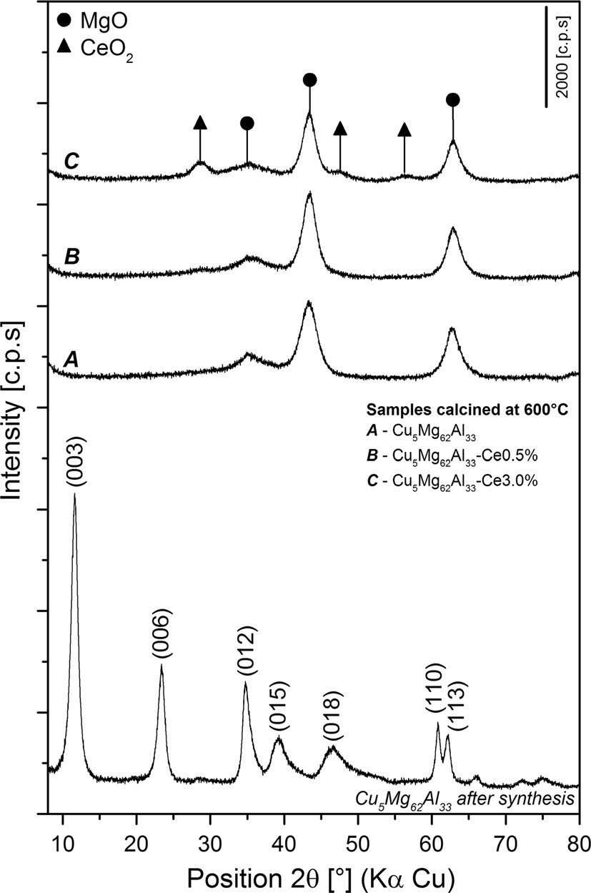
232
Reac Kinet Mech Cat (2017) 121:225–240
Fig. 3 X-ray diffractograms of not doped sample: Cu₅Mg₆₂Al₃₃dried and calcined at 600°C and doped with cerium (0.5 and 3.0 wt%). Periclase (black circle— MgO) and cerium(IV) oxide (black triangle—CeO₂)
The chemical composition and specific surface area of the calcined hydrotalcite- like samples are presented in Table1. The determined cation ratios in the studied samples are very close to the intended theoretical values. In the case of the studiedsamples,verysimilarvaluesofspecificBETsurfaceareasofabout240m²g⁻¹weredetermined.
The form and aggregation of copper in the Cu₅Mg₆₂Al₃₃sample and its modifications with cerium were studied by UV–Vis-DR spectroscopy (Fig.4). The spectra recorded for all the studied samples consist of the intensive asymmetric band, which is a superposition of the peaks indicating the charge-transfer between
Cu2?
mononuclear
ion and oxygen as well as copper in the form of oligomeric
Table 1 Chemical composition and specific surface area of calcined hydrotalcite like materials
BETsurfacearea(m²g⁻¹)
Sample
Cu/Mg/Al/Ce molar ratio (%)
Cu₅Mg₆₂Al₃₃Cu₅Mg₆₂Al₃₃-Ce0.5%Cu₅Mg₆₂Al₃₃-Ce3.0%
5.09/59.81/35.1/0.00
5.03/59.76/35.05/0.16
5.00/59.38/34.72/0.85
239
240
242
13

Reac Kinet Mech Cat (2017) 121:225–240
233
Cu2+
2+
[Cu-O-Cu]n
200
300
400
500
Cu5Mg62Al33-Ce3.0%
Cu5Mg62Al33-Ce0.5%
Cu5Mg62Al33
200
300
400
500
600
700
800
900
λ(nm)
Fig. 4 UV–Vis-DR spectra of the Cu₅Mg₇₇Al₁₈not doped sample and doped with cerium (0.5 and 3.0 wt%) calcined at 600°C
(Cu^{2?}–O²⁻–Cu^{2?})^{2?}species[22–24].Moreover,averybroadbandcenteredat
n
about 745–790 nm, is attributed to the d–d transition in Cu^{2?}located in a distorted octahedral coordination [25,26]. The insert in Fig.4presents the result of deconvolution of the original spectrum recorded the Cu₅Mg₆₂Al₃₃sample in the range characteristic of mononuclear and oligomeric copper species. The sharp band
Cu2?
centered at about 260 nm is assigned to mononuclear
ions, while the less
intensive peak at about 345 nm is related to the presence of copper in the form of oligomeric copper oxide species. A comparison of the intensity of these bands leads to the conclusion that copper in the form of mononuclear Cu^{2?}cations dispersed in the Mg–Al oxide matrix dominates in the studied sample. Thus, it could be concluded that copper is present in the well dispersed forms in the studied samples: monomeric and small oligomeric species dispersed in the Mg–Al oxide matrix. It should be also noted that introduction of cerium to the calcined hydrotalcite sample did not influence significantly the type and distribution of coppers species.
The reducibility of the hydrotalcite-based catalysts was studied by temperature- programmed reduction (H₂-TPR) method (Fig.5). The only peak in the H₂-TPR profile of the Cu₅Mg₆₂Al₃₃sample centered at about 230°C is related to the reduction of Cu^{2?}to Cu⁰[18,27]. The introduction of cerium to the Cu₅Mg₆₂Al₃₃sample resulted in a shift of this peak into higher temperatures by about 8–10°C and the appearance of two additional peaks. The first one located at about 110°C is possibly attributed to the reduction of surface Ce^{4?}to Ce^{3?}by atomic hydrogen species [28,29]. Such species are formed by the dissociation of the H₂moleculeson
the copper surface and then are spilled over to reduce the ceria surface oxygen [29]. The second peak located at 740 and 790°C for the samples doped with 0.5 and 3.0
Ce4? Ce3?
wt% of cerium is related to the reduction of
to
in CeO₂[29]. A
comparisonofthepeakintensitiesandpositionsleadstotheconclusionsthatthereis onlyasmallcontributionofsurfaceceriumreducedatlowtemperaturesbyatomic
13
Kubelka-Munk Units [c.p.s]
20 [c.p.s]

260

345



234
Reac Kinet Mech Cat (2017) 121:225–240
Cu2+Cu0
Ce4+Ce3+
Cu5Mg62Al33-Ce3.0%
Cu5Mg62Al33-Ce0.5%
Cu5Mg62Al33
100
200
300 400
500
600
700
800
900
Temperature [°C]
Fig. 5 Results of H₂-TPR analysis obtained for Cu₅Mg₆₂Al₃₃both not doped and doped with cerium (0.5 and 3.0 wt%) calcined at 600°C
hydrogen formed by the dissociation of H₂molecules on the copper species and moreover, the reduction of CeO₂(occurring at higher temperatures) strongly depends on its crystallinity.
The Ce^{3?}/Ce^{4?}ratios in the studied catalysts were determined based on the resultsofchemicalanalysis(EPMA,Table1)andH₂-TPRstudies.Itwasestimated that the molar Ce^{3?}/Ce^{4?}ratios are about 0.08 and 0.31 in the Cu₅Mg₆₂Al₃₃- Ce0.5% and Cu₅Mg₆₂Al₃₃-Ce3.0%samples.
The Cu₅Mg₆₂Al₃₃sample and its modifications with cerium were tested in the role of the catalysts for the selective catalytic reduction of NO with ammonia (NH₃- SCR, DeNO_{x}) and the selective catalytic oxidation of ammonia(NH₃-SCO).
In the case of the DeNO_{x}process, dinitrogen is a desired reaction product, while N₂O is an undesired side product. The results of the catalytic studies of this process are presented in Fig.6. The NO reduction by ammonia in the presence of the Cu₅Mg₆₂Al₃₃catalyst started at about 125°C and gradually increased to 92% at 325°C. Above this temperature, the efficiency of the DeNO_{x}process decreaseddue
to the side process of direct ammonia oxidation by oxygen present in the reaction mixture. It should be noted that the selectivity to dinitrogen in the whole studied temperature range is very high (above 90%). The introduction of cerium to the Cu₅Mg₆₂Al₃₃sample resulted in its significant activation in the low-temperature DeNO_{x}process. In the case of the Cu₅Mg₆₂Al₃₃-Ce05% and Cu₅Mg₆₂Al₃₃-Ce3.0% catalysts, the NO conversion profiles were shifted in the direction of lower temperatures by about 30–50°C in comparison with the Cu₅Mg₆₂Al₃₃sample. This effect was practically independent of the content of introduced cerium. The maximum of the NO conversion on the level of 96% was obtained for both cerium modified catalysts at about 275°C. Above this temperature, a significant decreasein the efficiency of the NO conversion, much more intensive in comparison with the Cu₅Mg₆₂Al₃₃catalyst and related to the side process of direct ammonia oxidationby
13
Hydrogen consumption [a.u.]
copper reduction in CuO-CeO2system
0.05 [a.u.]

Reac Kinet Mech Cat (2017) 121:225–240
235
100
Cu5Mg62Al33-Ce3.0%
98
96
Cu5Mg62Al33-Ce0.5%
94
92
Cu5Mg62Al33
90
100
150
200
250
300
350
100
80
60
40
20
0
100
150
200
250
300
350
Temparature [°C]
Fig. 6 Results of catalytic tests in the DeNO_{x}process for the Cu₅Mg₆₂Al₃₃sample not doped and doped with cerium (0.5 and 3.0 wt%) calcined at 600°C. Experimental error in determination of the NO conversion and selectivity to N₂is 1% (error barsmarked in figures)
oxygen, was observed. It should be noted that there are significant differences in the catalytic performances of the samples with various content of cerium in the high temperature range. In the case of the catalyst with lower cerium content (Cu₅Mg₆₂Al₃₃-Ce0.5%), a decrease in the efficiency of the NO conversion was significantly more significant in comparison to the sample with higher cerium loading (Cu₅Mg₆₂Al₃₃-Ce3.0%). It should also be noted that the selectivity to dinitrogen, obtained in the presence of the cerium doped catalysts, is very high (above 95%) in the whole studied temperature range, including also the high temperature region, where the process of direct ammonia oxidation dominated. Thus, it could be concluded that in this range, ammonia was oxidized nearly exclusively to dinitrogen. The activating role of cerium for the low-temperature DeNO_{x}process could be explained by supplying reactive oxygen as a result of the Ce^{4?}to Ce^{3?}reduction occurring on the surface of CeO₂crystallites being in the
13
Selectivity to N2[%]
NO conversion [%]

Cu5Mg62Al33-Ce0.5% Cu5Mg62Al33-Ce3.0%

Cu5Mg62Al33

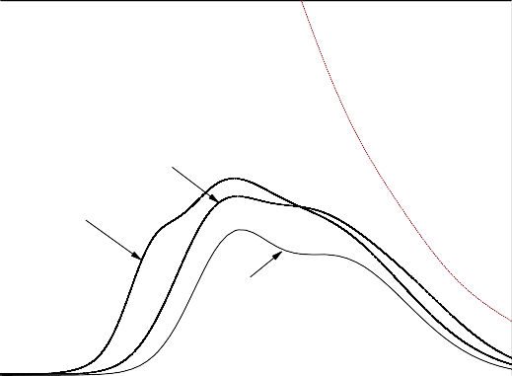
Equilibrium
236
Reac Kinet Mech Cat (2017) 121:225–240
contact with copper species (low temperatures) as well as in bulky CeO₂(high temperatures). As it was shown by H₂-TPR studies (Fig.5), the size of CeO₂crystallites is a very important factor influencing the reduction temperature of Ce^{4?}
to Ce^{3?}. The
Ce4?
cations in larger CeO₂crystallites are significantly more
effectivelystabilizedincomparisonwithsuchcationsinsmallerCeO₂crystallites. ThemajorityofthemechanismssuggestedfortheDeNO_{x}processincludeammonia chemisorption and activation as a crucial step [30]. In such mechanisms,oxygen couldreactwithchemisorbedammoniamoleculesresultinginprotonabstraction andtheformationof–NH₂adsorbedspecies,whichcouldbeconvertedbyNOto dinitrogenandwatermolecules(–NH₂?NO?N₂?H₂O)inthenextstep.Such amechanismwassuggestedinthescientificliteratureforvariouscatalyticsystems [30]. However, it needs verification in the case of the studied catalysts. Active oxygen supplied by CeO₂could also oxidize NO to very reactive NO₂. The reduction of the mixture of NO and NO₂with ammonia, known as fast-SCR [31,32],typicallyproceedsmuchmoreeffectivelyincomparisontothereductionof NOwithammonia.ThepossibleoxidationofNOtoNO₂overthestudiedcatalysts wastestedbytemperatureprogrammedreactionofNOwithoxygen.Theresultsof thesestudiesarepresentedinFig.7.ItcanbeseenthattheoxidationofNOtoNO₂occurred for all the studied catalysts. However, in the case of the samples doped with cerium, this effect is more significant. Therefore, it is possible that the activationroleofceriumisrelatedtotheintensificationoftheprocessofNOtoNO₂oxidation. Of course, the activation of the chemisorbed ammonia molecules by ceriumcannotbeexcludedinthisstageofthestudies.Adecreaseintheefficiency of the NO₂formation observed at higher temperatures is due to thermodynamic limitation(theequilibriumprofileispresentedinFig.7).Amoreintensivedecrease in the NO conversion observed for the samples with the lower cerium loading (Cu₅Mg₆₂Al₃₃-Ce0.5%)incomparisontothesamplewiththehigherceriumcontent (Cu₅Mg₆₂Al₃₃-Ce3.0%)ispossiblyrelatedtothehigheractivityofthesmallerCeO₂
40
30
Cu5Mg62Al33-Ce0.5%
20
Cu5Mg62Al33-Ce3.0%
10
Cu5Mg62Al33
0
200
300
400
500
600
Temperature [°C]
Fig. 7 Results of the oxidation of NO to NO₂occurred for the Cu₅Mg₆₂Al₃₃not doped and doped with cerium (0.5 and 3.0 wt%) calcined at 600°C
13
NO2/(NO+NO2) [%]

Reac Kinet Mech Cat (2017) 121:225–240
237
50
40
30
Cu5Mg62Al33-Ce3.0%
Cu5Mg62Al33-Ce0.5%
20
Cu5Mg62Al33
10
0
100
200
300
400
500
600
100
90
Cu5Mg62Al33
80
Cu5Mg62Al33-Ce0.5%
70
Cu5Mg62Al33-Ce3.0%
60
50
100
200
300
400
500
600
100
80
Cu5Mg62Al33-Ce0.5%
60
40
Cu Mg Al -Ce3.0%
5 62 33
20
Cu5Mg62Al33
0
100
200
300
400
500
600
Temperature [°C]
Fig. 8 Results of catalytic tests in the NH₃-SCO process for the Cu₅Mg₆₂Al₃₃not doped and doped with cerium(0.5and3.0wt%)calcinedat600°C.ExperimentalerrorsindeterminationoftheNH₃conversion andselectivitytoNOorN₂are1and1.5%,respectively(errorbarsmarkedinfigures)
13
Selectivity to NO [%]
Selectivity to N2[%]
NH3conversion [%]

238
Reac Kinet Mech Cat (2017) 121:225–240
crystallites in the process of
direct ammonia oxidation than larger crystalizes of
ceriumoxide.TakingintoaccounttheresultsofH₂-TPRstudies(Fig.5),thiseffect is not surprising because the smaller crystallites were reduced (Ce^{4?}?Ce^{3?}) at significantly lower temperature than larger crystallites ofCeO₂.
The second studied process was the selective catalytic oxidation of ammonia (NH₃-SCO) to dinitrogen, which is a desired reaction product. Nitrogen oxides(NO, N₂O and NO₂) are the undesired side products. The results of the catalytic studiedof this process are presented in Fig.8. The NH₃conversion in the presence of the Cu₅Mg₆₂Al₃₃catalyst started at about 275°C and continuously increased upto
500°C, when ammonia was completely converted in the reaction stream. The
introduction of a small amount of cerium (0.5 wt%) significantly activated the Cu₅Mg₆₂Al₃₃sample for the low-temperature ammonia oxidation. The ammonia conversion profile of the Cu₅Mg₆₂Al₃₃-Ce0.5% catalyst was shifted to lower temperatures by about 25°C relative to Cu₅Mg₆₂Al₃₃. An increase in cerium loading to 3.0 wt% only very slightly increased the ammonia conversion in comparison to the Cu₅Mg₆₂Al₃₃catalyst. Such a significant difference in the activationeffectobservedforthesamplesdopedwithvariousamountsofceriumis probably, similarly to the DeNO_{x}process, a result of different stabilization of oxygeninsmallerandlargerCeO₂crystallites.ThecatalystcontainingCeO₂inthe formofsmaller,andthereforeeasierreduced(Ce^{4?}?Ce^{3?})crystalliteswasfound tobemoreactiveinthelowtemperaturerangeincomparisonofthesampleswith largercrystallitesofceriumoxide,whichneedshighertemperaturetoreduceCe^{4?}toCe^{3?}.N₂andNOwerethemainproductsofammoniaoxidation.Moreover,small amounts of N₂O were formed (not shown in Fig.8). The formation of any other nitrogen containing products, including NO₂, was not detected. Dinitrogen and watervaporweretheonlyproductsofammoniaoxidationattemperaturesbelow 450°C.TheformationofNOstartedinthepresenceofthemostactive
Cu₅Mg₆₂Al₃₃-Ce0.5% catalyst at 450°C, while in the case of Cu₅Mg₆₂Al₃₃and
Cu₅Mg₆₂Al₃₃-Ce3.0%, the temperature was about 500°C. This effect, similarly to the differences in the ammonia conversion, could be explained by various size of CeO₂crystallites, which can release reactive oxygen at different temperatures. Therefore, in the case of the Cu₅Mg₆₂Al₃₃-Ce0.5% sample oxidation of ammonia can be‘‘deeper’’and results in the formation of NO at lower temperatures than for Cu₅Mg₆₂Al₃₃-Ce3.0%.
Conclusions
The hydrotalcite originated mixed metal Cu–Mg–Al oxide system was found to be effective catalyst for the selective reduction of NO with ammonia (DeNO_{x}, NH₃- SCR) and selective oxidation of ammonia to dinitrogen (NH₃-SCO). The further catalytic activation of such metal oxide system, especially for the low-temperature processes, was possible by the deposition of small amounts of cerium (0.5 or 3.0 wt%) using the impregnation method. It was shown that in the case of the DeNO_{x}process doping of mixed metal Cu–Mg–Al oxide with cerium resulted in its significant activation in the low-temperature range independently of the cerium
13

Reac Kinet Mech Cat (2017) 121:225–240
239
loading. On the other hand, a decrease in the NO conversion, related to the side process of direct ammonia oxidation, was less intensive for the sample with higher cerium loading. In the case of the NH₃-SCO process, only doping of the calcined hydrotalcite with a small amount of cerium (0.5 wt%) resulted in a significant activation of the catalyst for the low-temperature process. These differences in the catalytic properties of the samples loaded with various amounts of cerium were explained by the different size of deposited CeO₂crystallites. It was shown that the
Ce4? Ce3?
reduction of
to
occurs in smaller CeO₂crystallites at temperatures
significantly lower in comparison with the larger crystallites of cerium oxide. It seems that the redox properties of the catalysts are crucial for their performance inthe studied processes.
Open Access This article is distributed under the terms of the Creative Commons Attribution4.0 International License (http://creativecommons.org/licenses/by/4.0/), which permits unrestricted use, dis- tribution, and reproduction in any medium, provided you give appropriate credit to the original author(s) and the source, provide a link to the Creative Commons license, and indicate if changes were made.
References
- ChmielarzL,Jabłon´skaM(2015)Advancesinselectivecatalyticoxidationofammoniatodini-trogen: a review. RSC Adv54:43408–43431
- ZhaoD, Wang A (1994) Estimation of anthropogenic ammonia emissions in Asia. Atmos Environ 28:689–694
- LiJ, Chang H, Ma L, Hao J, Yang RT (2011) Low-temperature selective catalytic reduction of NO_{x}with NH₃over metal oxide and zeolite catalysts—a review. CatalToday 25:147–156
- YadavD, Prasad R (2016) Low temperature de-NO_{x}technology—a challenge for vehicular exhaust and its remedation: an overview. Proc Tech24:639–644
- Jabłon´skaM,ChmielarzL,We˛grzynA,GuzikK,PiwowarskaZ,WitkowskiS,WaltonRI,Dunne
PW, Kovanda F (2013) Thermal transformations of Cu-Mg(Zn)–Al(Fe) hydrotalcite-like materials into metal oxide systems and their catalytic activity in selective oxidation of ammonia to dinitrogen. J Therm Anal Calorim114:731–747
- ChmielarzL,Kus´trowskiP,Rafalska-ŁasochaA,DziembajR(2005)Selectiveoxidationof
ammonia to nitrogen on transition metal containing mixed metal oxides. Appl Catal B Environ 58:235–244
- ChmielarzL,We˛grzynA,WojciechowskaM,WitkowskiS,MichalikM(2011)Selectivecatalyticoxidation (SCO) of ammonia to nitrogen over hydrotalcite originated Mg–Cu–Fe mixed metal oxi- des. Catal Lett141:1345–1354
- CavaniF, Trifiro F, Vaccari A (1991) Hydrotalcite-type anionic clays: preparation, properties and applications. Catal Today11:173–301
- Nishida K, Li D, Zhan Y, Shishido T, Oumi Y, Sano T, Takehira K (2009) Effective MgO surface doping of Cu/Zn/Al oxides as water-gas shift catalysts. Appl Clay Sci44:211–217
- XuS,LiaoMC,ZengHY,ChenCR,DuanHZ,LiuXJ,DuJZ(2015)Magnetichydrotalcitesassolid basic catalysts for cellulose hydrolysis. Appl Clay Sci115:124–131
- Zhang LH, Li F, Evans DG, Duan X (2010) Cu–Zn-(Mn)–(Fe)–Al layered double hydroxides andtheir mixed metal oxides: physicochemical and catalytic properties in wet hydrogen peroxide oxi- dationofphenol.IndEngChemRes49:5959–5968
- ChmielarzL,Kus´trowskiP,Rafalska-ŁasochaA,MajdaD,DziembajR(2002)Catalyticactivityof
Co–Mg–Al, Cu–Mg–Al and Cu–Co–Mg–Al mixed oxides derived from hydrotalcites in SCR of NO with ammonia. Appl Catal B Environ 35:195–210
- Wang Z, Li Q, Wang L, Shangguan W (2012) Simultaneous catalytic removal of NO_{x}and soot particulatesoverCuMgAlhydrotalcitesderivedmixedmetaloxides.ApplClaySci55:125–130
13

240
Reac Kinet Mech Cat (2017) 121:225–240
- ChmielarzL,Jabłon´skaM,Strumin´skiA,PiwowarskaZ,We˛grzynA,WitkowskiS,MichalikM(2013) Selective catalytic oxidation of ammonia to nitrogen over Mg–Al, Cu–Mg–Al andFe–Mg–Al mixedmetaloxidesdopedwithnoblemetals.ApplCatalB130–131:152–162
- GoodJ, Duchesne PN, Zhang P, Koshut W, Zhou M, Jin R (2017) On the functional role of the ceriumoxidesupportintheAu₃₈(SR)₂₄/CeO₂catalystforCOoxidation.CatalToday280:239–245
- JeiraniZ, Soltan J (2016) Ozonation of oxalic acid with an effective catalyst based on mesoporous MCM-41 supported manganese and cerium oxides. J Water Proc Eng12:127–134
- KannanS,RiversV,Kno¨zingerH(2004)High-temperaturetransformationsofCu-richhydrotalcites.J Solid State Chem177:319–331
- Basa˛gS,PiwowarskaZ,KowalczykA,We˛grzynA,BaranR,GilB,MichalikM,ChmielarzL(2016)Cu–Mg–Al hydrotalcite-like materials as precursors of effective catalysts for selective oxidation ofammonia to dinitrogen—the influence of Mg/Al ratio and calcination temperature. Appl Clay Sci 129:122–130
- Taguchi M, Nakane T, Hashi K, Ohki S, Shimizu T, Sakka Y, Matsushit A, Abe H, Funazukuri T,Naka T (2013) Reaction temperature variations on the crystallographic state of spinel cobalt alu- minate. Dalton Trans42:7167–7176
- LiY, Lu G, Ma J (2014) Highly active and stable nano NiO–MgO catalyst encapsulated by silica with a core-shell structure for CO₂methanation. RSC Adv4:17420–17428
- Jabłon´skaM,ChmielarzL,We˛grzynA,Go´ra-MarekK,PiwowarskaZ,WitkowskiS,Bidzin´skaE,
Kus´trowski P, Majda D (2015) Hydrotalcite derived (Cu, Mn)–Mg–Al metal oxide systems doped with palladium as catalysts for low-temperature methanol incineration. Appl Clay Sci 114:273–282
- Marion MC, Garbowski E, Primet M (1990) Physicochemical properties of copper oxide loaded aluminainmethanecombustion.JChemSocFaradayTrans86:3027–3032
- MartinsL,PeguinRPS,WallauM,UrquietaGonza´lezEA(2004)Cu-,Co-,Cu/Ca-andCo/Ca-
exchanged ZSM-5 zeolites: activity in the reduction of NO with methane or propane. Stud Surf Sci Catal 154 C:2475–2483
- MendesFMT,SchmalM(1997)ThecyclohexanoldehydrogenationonRh-Cu/Al₂O₃catalystspart1. Characterization of the catalyst. Appl Catal A151:393–408
- PraliaudH,MikhailenkoS,ChajarZ,PrimetM(1998)SurfaceandbulkpropertiesofCu-ZSM-5andCu/Al₂O₃solids during redox treatments. Correlation with the selective reduction of nitric oxide by hydrocarbons. Appl Catal B6:359–374
- Das SK, Mukherjee S, Lopes LMF, Ilharco LM, Ferraria AM, Botelho AM, Pombeiro AJL (2014)Synthesis, characterization and heterogeneous catalytic application of copper integrated mesoporous matrices. Dalton Trans43:3215–3226
- Chmielarz L, Piwowarska Z, Rutkowska M, Wojciechowska M, Dudek B, Witkowski S, MichalikM(2012) Total oxidation of selected mono-carbon VOCs over hydrotalcite originated metal oxide catalysts. Catal Commun5:118–125
- Zheng XC, Zhang XL, Wang XY, Wangand SR, Wu SH (2005) Preparation and characterization ofCuO/CeO₂catalysts and their applications in low-temperature CO oxidation. Appl Catal A 295:142–149
- BeckersJ, Rothenberg G (2008) Redox properties of doped and supported copper–ceria catalysts. Dalton Trans46:6573–6578
- BuscaG, Lietti L, Ramis G, Berti F (1998) Chemical and mechanistic aspects of the selective catalyticreductionofNO_{x}byammoniaoveroxidecatalysts:areview.ApplCatalB18:1–36
- Pe´rezVe´lezR,EllmersI,HuangH,BentrupU,Schu¨nemannV,Gru¨nertW,Bru¨cknerA(2014)
Identifying active sites for fast NH₃-SCR of NO/NO₂mixtures over Fe-ZSM-5 by operando EPR and UV–Vis spectroscopy. J Catal 316:103–111
- Iwasaki M, Shinjoh H (2010) A comparative study of‘‘standard’’,‘‘fast’’and‘‘NO₂’’SCR reactions over Fe/zeolite catalyst. Appl Catal A390:71–77
13

