Medical Rehabilitation (Med Rehabil) 2017, 21 (4): 18-30 DOI: 10.5604/01.3001.0010.8159 eISSN 1896-3250 ISSN 1427-9622 © AWF Krakow

The influence of deep sensory foot stimulation on balance
and gait function in patients with hemiparesis

Wpływ głębokiej stymulacji czuciowej stopy na równowagę i funkcję
chodu chorych z niedowładem połowiczym

Agnieszka Śliwka 1 (A-F), Rafał Dębowski 2 (A-F)
- Unit of Rehabilitation in Internal Diseases, Institute of Physiotherapy, Faculty of Health Sciences, Jagiellonian University Medical Col-
lege, Krakow, Poland
- ”Pasternik” Non-public Medical Care Centre, Modlniczka, Krakow
Key words
stroke, hemiparesis, Bobath concept, balance, gait, sensory stimulation
Summary
Background: Current research emphasizes the importance of sensory afference for movement control. Multisensory informa-
tion may be processed in the brain even when its damage is located in multimodal association areas and specific sensory cortex.
Aim: The aim of the study was to assess the influence of sensory stimulation of the hemiparetic foot on balance and gait im-
provement in stroke patients with respect to the their age, time from onset and location of stroke.
Material and methods: The study was carried out from March to July 2016 and involved 40 consecutive inpatients (age 39-86
years; mean = 68,3; SD = 10.2) staying at the “Pasternik” rehabilitation centre in Modlniczka for 6 weeks. On the day of the
physician’s examination, medical history was recorded and patients were interviewed about their health condition. After that,
three functional tests were carried out: the Two-scale test, the Tinetti test and the Timed Up and Go test (TUG). The meas-
urements were taken: before sensory stimulation, after the first treatment, after 4 weeks of treatment and at 2 weeks of fol-
low-up. Every day, treatment consisted of individual sensory stimulation of the hemiparetic foot performed by a physiother-
apist according to the specific principles of the Bobath concept. Additionally, aimed at foot sensory stimulation, patients per-
formed their own supervised exercises using designated equipment at a gym.
Results: 4 weeks of treatment aimed at the sensory stimulation of the hemiparetic foot influenced balance and gait improve-
ment in stroke survivors. Significant improvement in weight distribution on the Two-scale test was detected immediately after
the first stimulation. The results of both gait tests measured after 4 weeks of physiotherapy allowed to classify subjects into the
group of average fall risks in comparison to the initial high-risk group. The study indicated more efficacy of sensory stimula-
tion in younger patients with left side paresis and a shorter period after stroke onset.
Conclusion: Foot sensory stimulation is a non-invasive, efficient therapeutic tool for regaining balance and gait improvement
in hemiparetic subjects after stroke.
Słowa klucze
udar, hemiplegia, koncepcja Bobath równowaga, chód, stymulacja czuciowa
Streszczenie
Wprowadzenie: Aktualnie prowadzone badania naukowe podkreślają znaczenie informacji sensorycznej dla kontroli ruchowej.
Informacja multisensoryczna może być przetwarzana przez mózg nawet wtedy, gdy jego uszkodzenie obejmuje multimodalne
obszary kory kojarzeniowej oraz specyficzne obszary kory czuciowej.
Cel: Celem badania była ocena wpływu stymulacji czuciowej stopy na równowagę i funkcję chodu osób z niedowładem poło-
wiczym z uwzględnieniem wieku badanych, okresu, który upłynął od udaru oraz jego lokalizacji.
The individual division of this paper was as follows: a - research work project; B - data collection; C - statistical analysis; D - data interpretation; E - manu-
script compilation; F - publication sear
Article received: 08.10.201717; Accepted: 28.01.2018
Please cite as: Śliwka A., Dębowski R. The influence of deep sensory foot stimulation on balance and gait function in patients with hemiparesis. Med
Rehabil 2017; 21(4): 18-30. DOI: 10.5604/01.3001.0010.8159
Internet version (original): www.rehmed.pl
18
Medical Rehabilitation (Med Rehabil) 2017, 21 (4): 18-30 DOI: 10.5604/01.3001.0010.8159 eISSN 1896-3250 ISSN 1427-9622 © AWF Krakow
Materiał i metody: Badaniami prowadzonymi od marca do lipca 2016 roku objęto grupę czterdziestu kolejnych chorych (wiek
39-86 lat; średnia = 68,3; SD= 10,2) leczonych w ośrodku rehabilitacyjnym NZOZ Pasternik w Modlniczce, przebywających
na 6 tygodniowym turnusie rehabilitacyjnym. W dniu konsultacji lekarskiej przeprowadzono wywiad i ankietę na temat stanu
zdrowia, a następnie przeprowadzono badanie przedmiotowe złożone z 3 testów funkcjonalnych: testu dwóch wag, testu Ti-
netti, oraz testu „Wstań i idź” (TUG). Pomiary wykonano czterokrotnie: przed rozpoczęciem usprawniania, pierwszego dnia
po fizjoterapii, po 4 tygodniowym okresie usprawniania oraz po 2 tygodniowej przerwie. Codzienna rehabilitacja obejmowała
indywidualną stymulację sensoryczną stopy wykonaną przez fizjoterapeutę zgodnie z założeniami koncepcji Bobath. Dodatko-
wo pacjenci mieli dostęp do sali gimnastycznej, gdzie wykonywali samodzielnie zadane ćwiczenia ukierunkowane na sensory-
kę stopy przy wykorzystaniu odpowiednich przyrządów terapeutycznych.
Wyniki: Czterotygodniowa fizjoterapia dedykowana stymulacji sensorycznej niedowładnej stopy wpłynęła na poprawę równo-
wagi i funkcji chodu u chorych z niedowładem połowiczym. Znamienną poprawę w symetrii rozkładu ciężaru ciała na dwóch
wagach zanotowano już po pierwszej stymulacji. Wyniki obu testów chodu po zakończeniu fizjoterapii pozwoliły na zakwa-
lifikowanie chorych do grupy osób o średnim ryzyku upadku z wyjściowo wysokiego ryzyka. Badanie wykazało również ko-
rzystniejszy wpływ terapii na usprawnienie osób młodszych, z porażeniem lewostronnym oraz krótszym okresem od incyden-
tu udarowego.
Wnioski: Stymulacja sensoryczna stopy jest nieinwazyjnym i skutecznym narzędziem terapeutycznym w przywracaniu równo-
wagi i poprawie chodu u osób z niedowładem połowiczym po przebytym udarze mózgu.

INTRODUCTION
Planning or executing any motion re-
quires the central nervous system to
selectively acquire and process senso-
ry information about the current and
predicted position of the body. This
is possible due to constant integration
of various sensory stimuli received
during the currently performed or
planned physical activity1. More than
half of the human cerebral cortex is
covered by associative areas that pro-
cess events occurring in the human
sensorimotor system. These areas are
responsible for planning, thinking,
memory processes, emotions and mo-
tor performance2. They execute con-
tinuous processing of sensory infor-
mation that modulates motor activity
at all levels of the central nervous sys-
tem. This integration is called multi-
sensory, and as suggested by research,
it is thanks to this integration that the
brain builds a coherent representa-
tion of its own body and environmen-
tal schema, also allowing detection
and localization of external phenom-
ena3. Combining information coming
from different sensory channels turns
out to be particularly beneficial in
a situation when a single-source sig-
nal can only slightly trigger a motor
response, or when the sensory system
as a whole is weakened3. Individuals
with neurological dysfunctions who
have lost one or more senses can,
therefore, have clearly marked motor
dysfunctions, even if they have main-
tained normal muscular strength. In
light of so much important informa-
tion for motor performance, it is in-
dicated that the effectiveness of reha-
bilitation after a stroke can be deter-
mined by the degree of sensory disor-
der, or that it is a prognostic factor of
neurorehabilitation results1. The di-
rect consequence of such beliefs is the
introduction of various sensory stimu-
lation techniques. Their implementa-
tion is based on the use of brain tissue
plasticity and the assumption that this
plasticity can be stimulated accord-
ingly. Generally speaking, the brain
adapts to pathological changes by us-
ing alternative connections to bypass
the damaged area4,5. In addition, re-
searchers confirm that multi-sensor
information may still be processed to
a certain extent, even when the dam-
age includes multimodal areas of the
cortex and specific areas of the senso-
ry cortex6. This is due to the fact that
many brain structures, including spe-
cific sensory centres, will still be able
to support the processing of such in-
formation. Multi-sensory stimulation
can trigger the reserve of neural ac-
tivity of the damaged area when it
comes from different senses simulta-
neously6. This is manifested, for ex-
ample, in its improved detection, as
the neuronal activity is able to exceed
the required threshold of excitability.
The sensory stimulation techniques
regard: proprioceptive stimulation,
the vestibular and visual systems7,8. As
indicated by the study results, these
interventions affect the reduction of
motor disorders after stroke, includ-
ing balance disturbances and signs of
spatial neglect9.

STUDY AIM
The aim of the study was to exam-
ine whether intense sensory stimula-
tion of the foot can influence the im-
provement of balance and gait func-
tions in patients after stroke.
The following research questions
were posed:
- Does deep sensory stimulation af-
fect the improvement of motor
function in patients?
- Does the effect of therapy persist
after its completion?
- Does the length of the period from
onset have an effect on the pa-
tient’s balance and gait function?
- Does the patient’s age influence
the outcome of stimulation?
- Does the location of damage in
the left or right hemisphere of the
brain contribute to the modifica-
tion of therapeutic results?

MATERIAL AND METHODS
Course of the study
The research conducted from March
to July 2016 included a group of
40 patients from the non-public
“Pasternik” rehabilitation centre in
Modlniczka, staying at the rehabili-
tation facility for 6 weeks. All sub-
jects were qualified for rehabilitation
by a physician, were informed about
the purpose and course of the study
and expressed their voluntary con-
sent for participation. On the day
of the medical consultation, an in-
19
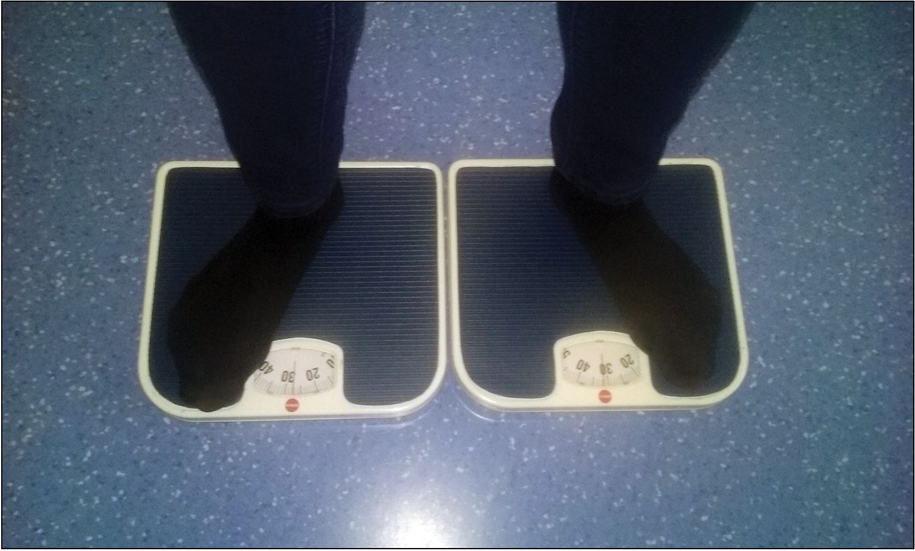
DOI: 10.5604/01.3001.0010.8159 eISSN 1896-3250 ISSN 1427-9622 © AWF Krakow
Medical Rehabilitation (Med Rehabil) 2017, 21 (4): 18-30
terview and questionnaire were con-
ducted regarding health, followed
by a physical examination. Each of
the patients underwent 3 function-
al tests: the Two-scale test, the Ti-
netti test and the Timed Up and Go
test (TUG) according to the follow-
ing scheme:
- before physical therapy (Measure-
ment No. 1)
- immediately after the first physi-
cal therapy session (Measurement
No. 2),
- after 4 weeks of physical therapy
(Measurement No. 3),
- after a 2-week break following the
completion of physical therapy
(Measurement No. 4).
Daily rehabilitation included 30
min. of individual therapy with
a physical therapist. In addition, pa-
tients had access to the gym, where
independently performed supervised
exercises using equipment.

Research tools
The Two-scale test
The Two-scale test — used to study
the symmetry of body mass distribu-
tion between the right and left low-
er limbs (Photo 1). The patient stands
on equal-sized scales so that the right
and left lower limbs are in the same
position, each on their own scale.
The permitted difference is 1-1.15
kg. This test was previously used in
stroke patients10.
Photo 1
The Two-scale test
The Timed Up and Go test
The Timed Up and Go test (TUG) is
used in the evaluation of functional
efficiency and the risk of falls11,12.
On “start”, the subject must:
- Stand up from a chair;
- Cover a 3 m distance;
- Cross the finish line of the ap-
pointed distance;
- Perform a 180 degree turn;
- Go back to the chair and assume
a seated position.
Interpretation of results:
- less than 10 seconds - standard,
functional efficiency (low risk of
falls),
- 10-19 seconds — the subject is in-
dependent in most everyday ac-
tivities and may go outside alone;
does not need walking aids (aver-
age risk of falls),
- exactly 19 seconds or more - func-
tional efficiency limited to a large
extent, the subject is not able to go
outside independently and needs
supportive equipment for walking
(high risk of falls)11,12.
The Tinetti test
The Tinetti test is a complex exami-
nation used to assess stability, balance
and gait function in older people as
well as those with neurological disor-
ders. It is similar to the Timed Up and
Go test, however, it is divided into 17
different tasks rated on a 0, 1 or 0,
1, 2 scale. The first part of the test is
dedicated to assessing balance in stat-
ic positions such as sitting and stand-
ing, as well as during changes in po-
sition, including the transition from
sitting to standing or rotation while
maintaining in one spot. For the 9
tasks of this part of the test, a max-
imum of 16 points can be achieved.
The second part of the test, in which
the next 7 tasks are assessed, concerns
gait. The test examines, among oth-
ers, the length and height of a step, its
symmetry, gait path as well as posture
of the examined subject. The correct
performance of this part of the test
allows to obtain another 12 points13.
Interpretation of the results13:
- below 19/28 points: a person with
a high risk of falls,
- 19 and 24/28 points: a person
prone to falls,
- above 24/28 points: a person with
low or no risk of falls.

Utilized therapeutic methods
In order to perform sensory stimula-
tion of the foot, therapeutic interac-
tions were applied in accordance with
the assumptions of the Bobath con-
cept. This concept is currently defined
as an individualized and comprehen-
sive approach to the examination and
therapy of people with functional,
motor and tension-related disorders
caused by damage to the central nerv-
ous system14,15. Many years of expert
work on this concept have led to the
formulation of the model of Bobath
clinical practice (MBCP), which ena-
bles therapists to build an individual-
ized intervention plan addressing all
components of motor performance16.
One of the fundamental principles of
the concept is the role of afferent stim-
ulation for optimizing body scheme,
performing a motor task and the mo-
tor learning process17. In the Bobath
approach, sensorimotor improvement
of significant motor tasks for the pa-
tient, with emphasis on the primary
disorder of body structures and func-
tions, is aimed at promoting plastici-
ty changes in the brain18. Based on
key components of the clinical prac-
tice model, i.e. the functional analy-
sis of movement, skilful facilitation
and clinical reasoning in individual
patients, the selected facilitation tech-
niques were used:
20
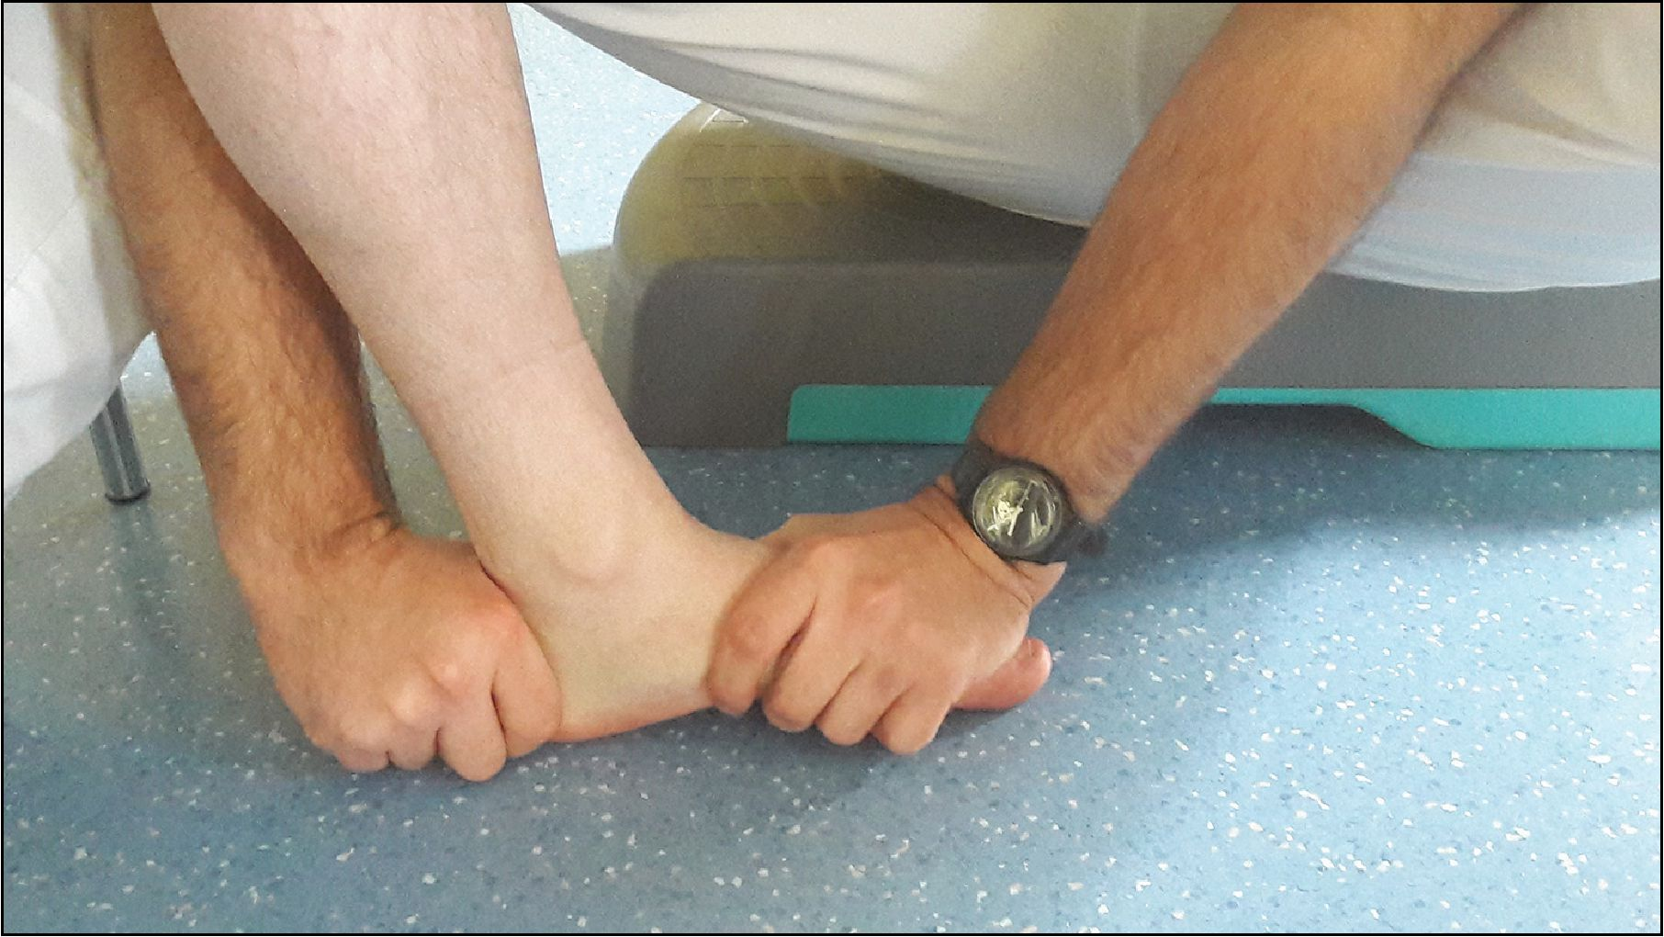
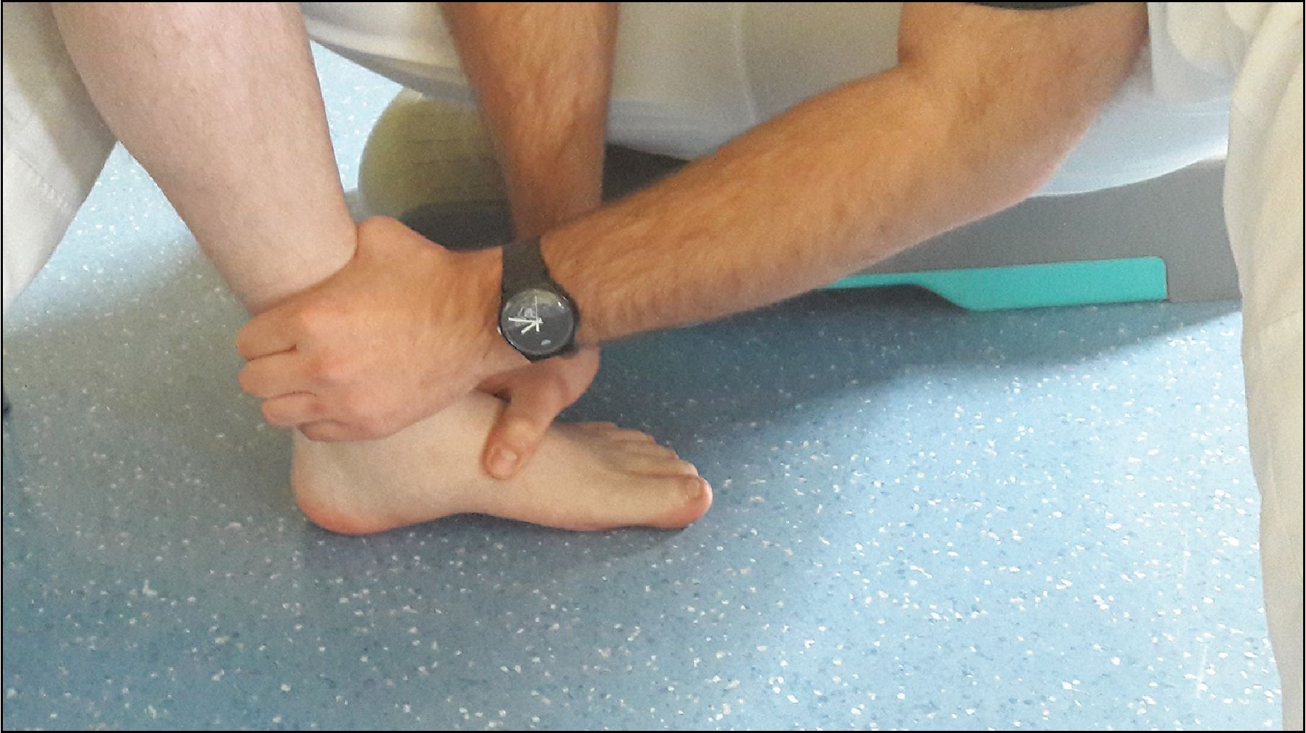
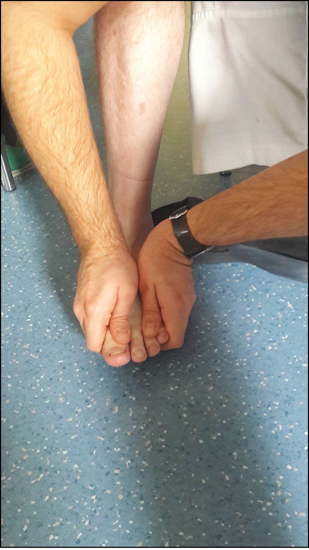
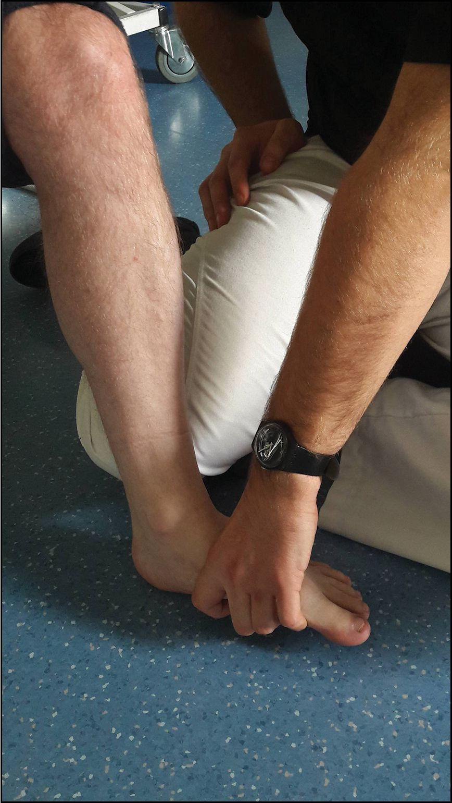
Medical Rehabilitation (Med Rehabil) 2017, 21 (4): 18-30 DOI: 10.5604/01.3001.0010.8159 eISSN 1896-3250 ISSN 1427-9622 © AWF Krakow
Photo 2
Stimulation of the longitudinal arch and lateral side of the foot along with mobilization
of the Achilles tendon along the course of the fibres
Photo 3
Sensory stimulation of the Achilles tendon by mobilising the tendon in the plantar
direction from the medial and lateral sides
Foot mobilization emphasizing
pronation, with plantar and dorsal
flexion of the foot;
Stimulation of the longitudinal arch
and the external part of the foot,
covering the Achilles tendon along
the course of the fibres (Photo 2);
Sensory stimulation of the Achilles
tendon rubbing its insertion in the
plantar direction from the medial
and lateral sides (Photo 3);
Mobilization of the metatarsus,
covering the transverse arch of the
foot (Photo 4);
Sensory stimulation of the heel
(Photo 5);
- Sensory stimulation of the foot,
with emphasis on pronation (Pho-
to 6);
- Mobilization of the triceps surae
muscle (Photo 7);
- Additionally, each patient had the
task of independently performing
stimulation of the bare foot. These
tasks were adapted to the patients’
capabilities and were performed
both with open and covered eyes.
An example of the task:
— stimulation using sensory cushions
(Photo 8).
Photo 4
Stimulation of the transverse arch of the
foot and mobilization of the metatarsus
Photo 5
Sensory stimulation of the heel
21
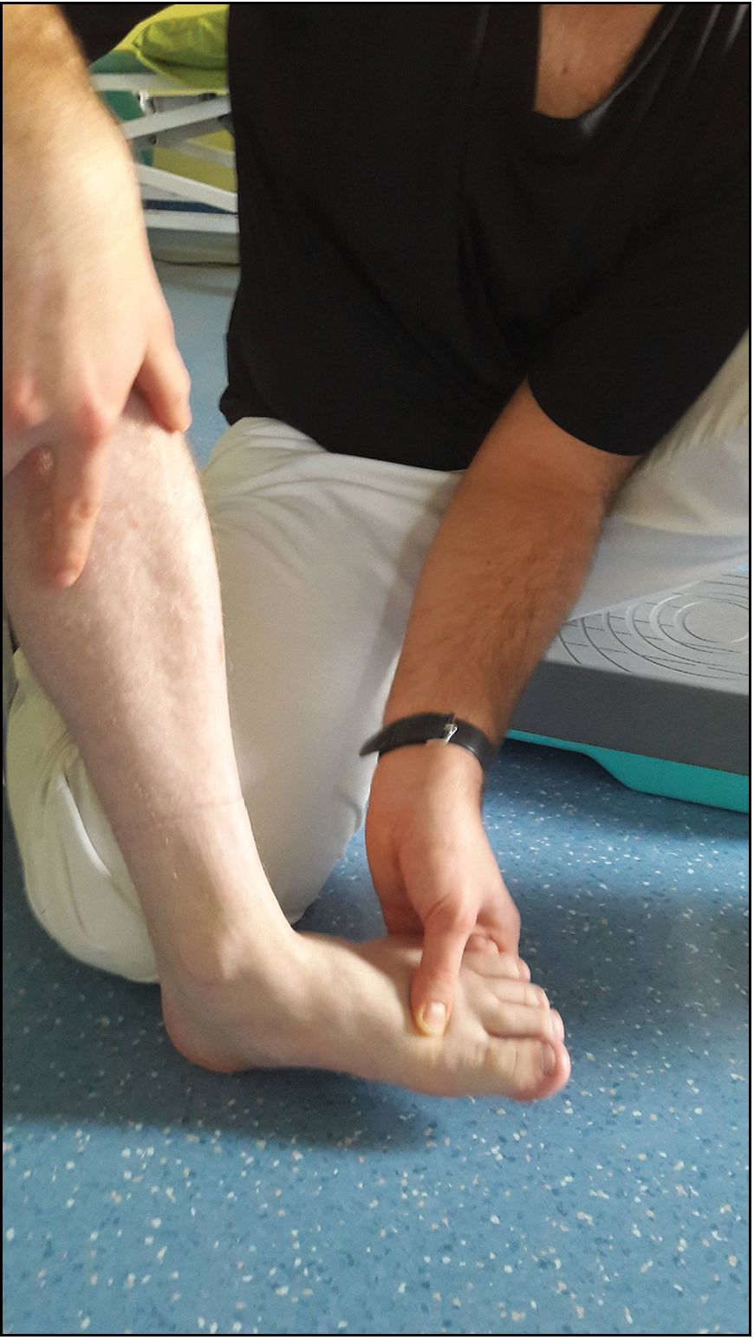
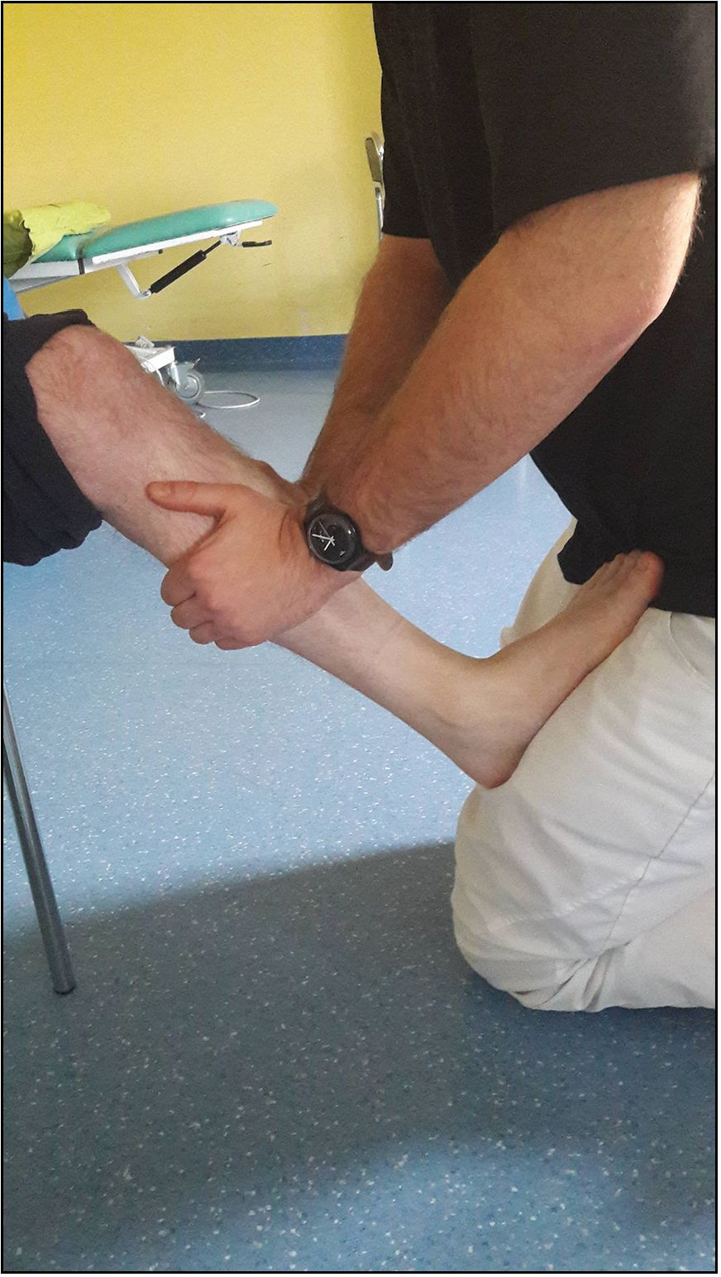
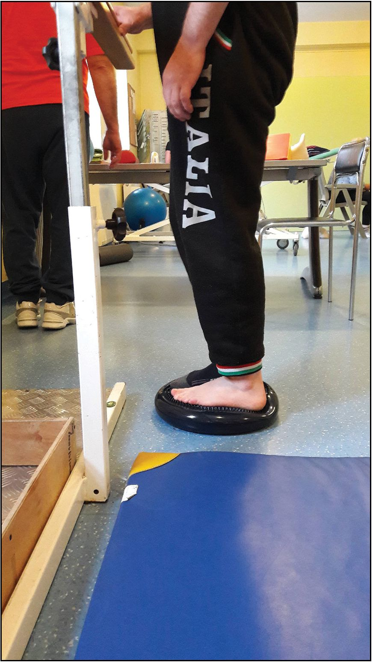
Medical Rehabilitation (Med Rehabil) 2017, 21 (4): 18-30
DOI: 10.5604/01.3001.0010.8159 eISSN 1896-3250 ISSN 1427-9622 © AWF Krakow
Photo 6
Sensory stimulation of the foot in
pronation
Photo 7
Mobilization of the triceps surae
Photo 8
Stimulation using sensory cushions
Tools and methods of statistical
analysis
During analysis, an Excel spread-
sheet and Statistica - version 10.0
were used. Significance tests - using
the STATISTICA programme, a se-
ries of tests was carried out for the
significance of differences regard-
ing dependent samples. These types
of tests are performed when analys-
ing the same group repeatedly. Each
variable marked with the number 1
means that the test was carried out
before treatment. In turn, each varia-
ble marked with the number 4 means
that analysis was carried out at the
completion of therapeutic tests. Sig-
nificance tests were carried out not
only for the whole group of patients,
but also, the division into individual
subgroups was taken into considera-
tion. It is worth noting that between
measurements No. 1 and 4, No. 2
and 3 also took place (respectively:
after the first therapy session, after
a month of therapy). Due to the fact
that not only the impact of the same
treatments on the improvement of
patients’ health is examined, but also
whether their effects are long-lasting,
it was decided to carry out signifi-
cance tests for the first measurement
and the last one. During the analysis,
the significance level was set at a =
0.05.
Correlation of results - in the cal-
culation of the results shown in the
Matrix correlation (Table 2), the Ex-
cel spreadsheet was used as well as
the built-in “=PEARSON” function,
which calculates the correlation level
of the two selected variables.
The Two-scale test variables 1, 2, 3,
4, were calculated as the absolute val-
ue of the difference between weights
A and B for each patient individually.
RESULTS
Detailed characteristics of the
study participants
30 patients with right- and left-sid-
ed paresis were included in the study.
The age of the patients oscillated be-
tween 39 and 86 years (mean: 68.3
years, SD = 10.2). Persons suffering
from left-sided paresis were on av-
erage 4 years younger (mean: 66.0
years, SD = 12.6) than those suffer-
ing from right-sided paresis (mean:
70.7 years, SD = 6.5). Among pa-
tients with right-sided paresis, there
was not a single person under the age
of 50.
Over half of the subjects (n = 23)
suffered a stroke less than two years
prior to the study. The average age
in this group was 70.7 years (SD =
8.1), which is an average of 6 years
more than among those who suffered
from stroke more than two years ear-
lier (mean = 65.0 years, SD = 12.0).
Functional test results
Two-scale test results
Before beginning physical therapy
(Measurement No. 1), asymmetry in
loading the right and left lower limbs
was found, 4.7 kg (SD = 2.9) on av-
erage. The subjects did not properly
weigh-down the directly affected low-
er limb. After the test (Measurement
No. 4), the obtained results indicated
a significant decrease in asymmetry -
mean = 2.7 kg (SD = 1.6) (p<0.0001).
22
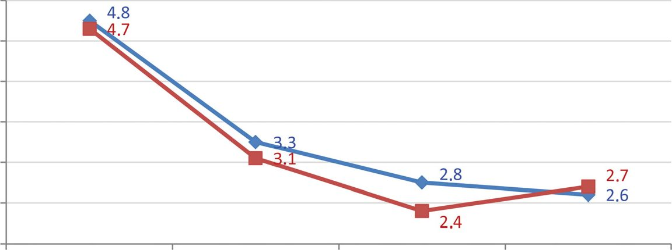
Medical Rehabilitation (Med Rehabil) 2017, 21 (4): 18-30 DOI: 10.5604/01.3001.0010.8159 eISSN 1896-3250 ISSN 1427-9622 © AWF Krakow
Table 1
Significance tests for the Two-scale test (Measurement No. 1 vs. Measurement No. 4)
Significance tests | Sub-group | Measure-  ment | Aver-  age | SD | Number  of consid-  ered vari-  ables | Differ-  ence | SD | t | df | p
Two-scale test | Total | Measure-  ment No. 1 | 4.7 | 2.9
 |  | Measure-  ment No. 4 | 2.7 | 1.6 | 40 | 2.1 | 2.4 | 5.4 | 39 | <0.0001
Two-scale test di-  vided according | < 68 years | Measure-  ment No. 1 | 4.8 | 2.2
to age |  | Measure-  ment No. 4 | 2.6 | 1.5 | 20 | 2.2 | 2.1 | 4.6 | 19 | <0.001
 | > 68 years | Measure-  ment No. 1 | 4.7 | 3.5
 |  | Measure-  ment No. 4 | 2.7 | 1.8 | 20 | 2.0 | 2.8 | 3.2 | 19 | <0.05
Two-scale test di-  vided according to | Right-sided pa-  resis (stroke in | Measure-  ment No. 1 | 4.3 | 2.5
side of paresis | left hemisphere) | Measure-  ment No. 4 | 2.5 | 1.7 | 20 | 1.8 | 2.2 | 3.7 | 19 | <0.05
 | Left-sided pa-  resis (stroke | Measure-  ment No. 1 | 5.2 | 3.3
 | in right hemi-  sphere) | Measure-  ment No. 4 | 2.9 | 1.5 | 20 | 2.3 | 2.7 | 3.8 | 19 | <0.05
Two-scale test di-  vided according to | More than two  years | Measure-  ment No. 1 | 4.4 | 2.4
time from stroke |  | Measure-  ment No. 4 | 2.7 | 1.8 | 17 | 1.7 | 2.4 | 2.9 | 16 | <0.05
 | Less than two  years | Measure-  ment No. 1 | 4.9 | 3.2
 |  | Measure-  ment No. 4 | 2.6 | 1.5 | 23 | 2.3 | 2.4 | 4.6 | 22 | <0.001
Measurement No. 1 - before beginning physical therapy; Measurement No. 4 - after a 2-week break following the completion of the performed physical
therapy
5.0
4.5
4.0
3.5
3.0
2.5
2.0
Measurement 1 Measurement 2 Measurements Measurement 4
♦ Average difference between measurements in individuals aged less than or equal
to 68 years
-B Average difference between measurements in individuals above the age of 68
Figure 1
Average difference in weight A and B in particular measurements for sub-groups dif-
fering in age (n=40)
These results were also observed in
subgroups that differed in age, stroke
location and time that elapsed since the
stroke incident (Table 1).
It should be noted that the results
of measurements made after the first
sensory stimulation session (Meas-
urement No. 2) have already indi-
cated a more symmetrical distribu-
tion of body mass between the low-
er limbs (mean = 3.2 kg, SD = 2.0)
(p<0.001). A further 4 weeks of
physical therapy resulted in evenly
balanced weight distribution (mean
2.6 kg, SD = 1.6) (Measurement No.
3), persisting for another 2 weeks de-
spite lack of sensory stimulation dur-
ing this period (mean = 2.7 kg; SD =
1.6) (Measurement No. 4).
The same analyses carried out in
subgroups of subjects differing in age
indicated higher effectiveness of sen-
sory therapy in patients over the age
of 68, however, discontinuation of
therapy caused slight deterioration in
this group. In younger patients (un-
der the age of 68), improvement was
maintained even after cessation of
stimulation (Figure 1).
Similar results were obtained by
analysing the subgroups of patients
23
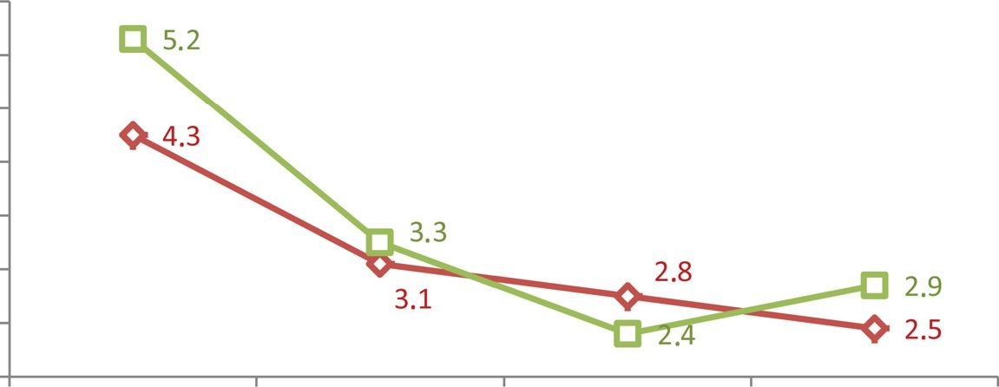
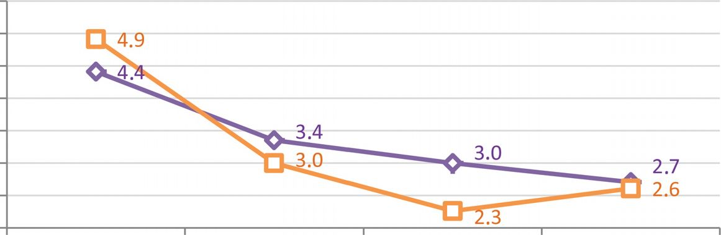
Medical Rehabilitation (Med Rehabil) 2017, 21 (4): 18-30 DOI: 10.5604/01.3001.0010.8159 eISSN 1896-3250 ISSN 1427-9622 © AWF Krakow
5.5
5.0
4.5
4.0
3.5
3.0
2.5
2.0
Measurement 1 Measurement 2 Measurements Measurement 4
-0- More than two years after the stroke (n=17)
-Q- Less than two years after the stroke (n=23)
Figure 2
Average differences between weight A and B in particular measurements among sub-
groups differing in time from stroke (n=40)
5.5
5.0
4.5
4.0
3.5
3.0
2.5
2.0
Measurement 1 Measurement 2 Measurements Measurement 4
-O- Stroke in left hemisphere (right-sided paresis, n=20)
Stroke in right hemisphere (left-sided paresis, n=20)
Figure 3
Average difference in weights A and B for particular measurements among sub-groups
differing in stroke location (n=40)
Table 2
differing in period of time from the
incident. People who had suffered
a stroke within the last two years
were better at distributing body mass
after the end of stimulation (Meas-
urement No. 3, p<0.001), but this
effect was not maintained when the
intervention ceased. In turn, in peo-
ple who had suffered stroke more
than two years earlier, the changes
were not so great, nonetheless, they
also persisted after the end of stimu-
lation (Figure 2).
Some insights are also provided by
analysis conducted among subgroups
differing in stroke location. Those
who had suffered a stroke in the right
hemisphere of the brain were better
at distributing body mass after the
end of stimulation (Measurement
No. 3), but this effect was not main-
tained at the same level after cessa-
tion of interventions. On the other
hand, people who had stroke in the
left hemisphere (right side directly
affected), were initially better at dis-
tributing weight better between the
lower limbs; the change after 4 weeks
was not so great but significant, and
more importantly, despite the end of
stimulation, the subjects maintained
the therapeutic effects, even slightly
improving their results (Figure 3).
Timed Up and Go test results
Before beginning physiotherapy, the
average results of the subjects in the
test qualified them to the group of
patients at a high risk of falls (perfor-
mance time over 19 seconds). In the
study, a statistically significant differ-
Significance tests for the Two-scale test (Measurement No. 1 vs. Measurement No. 4)
 |  |  |  |  | Number
Significance tests | Sub-group | Measure-  ment | Aver-  age | SD | of consid-  ered vari-  ables | Differ-  ence | SD t df | p
TUG | Total | Measure- | 21.7 | 6.0
 |  | ment No. 1 | 21.7 | 6.0
 |  | Measure-  ment No. 4 | 17.0 | 4.2 | 34 | 4.8 | 4.4 6.4 33 | <0.0001
TUG divided ac- | < 68 years | Measure- | 21.0 | 6.0
cording to age |  | ment No. 1 | 21.0 | 6.0
 | Measure-  ment No. 4 | 15.6 | 3.1 | 17 | 5.4 | 5.5 | 4.0 | 16 | <0.05
> 68 years | Measure-  ment No. 1 | 22.5 | 6.1
 | Measure-  ment No. 4 | 18.4 | 4.7 | 17 | 4.1 | 2.8 | 6.1 | 16 | <0.001
24
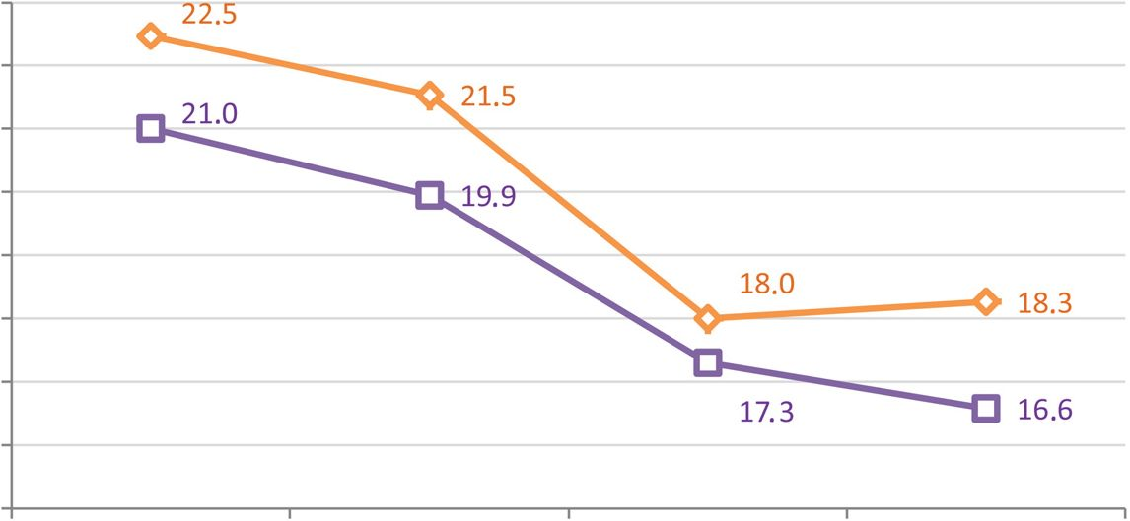
Medical Rehabilitation (Med Rehabil) 2017, 21 (4): 18-30 DOI: 10.5604/01.3001.0010.8159 eISSN 1896-3250 ISSN 1427-9622 © AWF Krakow
Table 2 (continued)
Significance tests | Sub-group | Measure-  ment | Aver-  age | SD | Number  of consid-  ered vari-  ables | Differ-  ence | SD | t | df | p
TUG divided ac-  cording to side of | Right-sided pa-  resis (stroke in | Measure-  ment No. 1 | 21.9 | 6.1
paresis | left hemisphere) | Measure-  ment No. 4 | 15.9 | 3.7 | 17 | 6.0 | 5.5 | 4.5 | 16 | <0.001
 | Left-sided pa-  resis (stroke | Measure-  ment No. 1 | 21.6 | 6.2
 | in right hemi-  sphere) | Measure-  ment No. 4 | 18.1 | 4.5 | 17 | 3.5 | 2.5 | 5.9 | 16 | <0.0001
TUG divided ac-  cording to time from | More than two  years | Measure-  ment No. 1 | 23.0 | 5.9
stroke |  | Measure-  ment No. 4 | 18.6 | 4.7 | 14 | 4.4 | 3.2 | 5.1 | 13 | <0.001
 | Less than two  years | Measure-  ment No. 1 | 20.9 | 6.0
 |  | Measure-  ment No. 4 | 15.8 | 3.4 | 20 | 5.1 | 5.1 | 4.4 | 19 | <0.001
Measurement No. 1 - before beginning physical therapy; Measurement No. 4 - after a 2-week break following the completion of the performed physical
therapy
ence in the measurements performed
before and after the therapy were
noted — and also within subgroups
differing in age, time from illness and
stroke location (Table 2).
Unlike the Two-scale test, in
which the first stimulation affected
significant improvement in loading
the inferior lower limb, in the gait
test, it caused an average change by
1 second. Only the next 4 weeks
of therapy allowed for significant
improvement in the obtained re-
sults, in which the time to cover the
path took only 17.6 seconds. After
a 2-week break, the obtained ther-
apeutic effects continued to per-
sist. By dividing the study popu-
lation into subgroups of different
ages, it was shown that elderly pa-
tients (over the age of 68) needed
more time to perform the test, how-
ever, even in this subgroup, the fi-
nal results obtained allowed the pa-
tients to be classified into the group
of patients at an average risk of falls
(Figure 4). It is worth noting that
the cessation of stimulation caused
slight deterioration of the results
only in the older subjects.
The test results analysed in sub-
groups that differ in time from the on-
set incident also showed a difference
between the subgroups (Figure 5).
People who suffered stroke relative-
ly recently (less than 2 years earlier),
performed the test tasks more quick-
ly (p<0.001), however, sensory stim-
ulation of the foot improved the re-
sults both in this group and in those
who had an onset incident more
than 2 years prior. The analysis of
test results in subgroups with differ-
ent stroke locations did not show sig-
nificant differences between patients
with left- or right-sided paresis.
Tinetti test results
The results of the Tinetti test per-
formed before beginning physiother-
apy qualified most of the subjects to
the group of patients at a high risk
of falls (result below 19 points). Af-
ter sensory stimulation, improvement
in balance and gait was achieved in
all subjects, also when the results
were analysed regarding subgroups
with different stroke sides, time from
stroke and at different ages.
23.0
22.0
21.0
20.0
19.0
18.0
17.0
16.0
15.0
Measurement 1 Measurement 2 Measurements Measurement4
-O-Average time (sec.) to cover the path by individuals above the age of 68
-O- Average time (sec.) to cover the path by individuals below or equal to the age of 68
Figure 4
Average performance time of the Timed Up and Go test in individual measurements
among the sub-groups differing in age
25
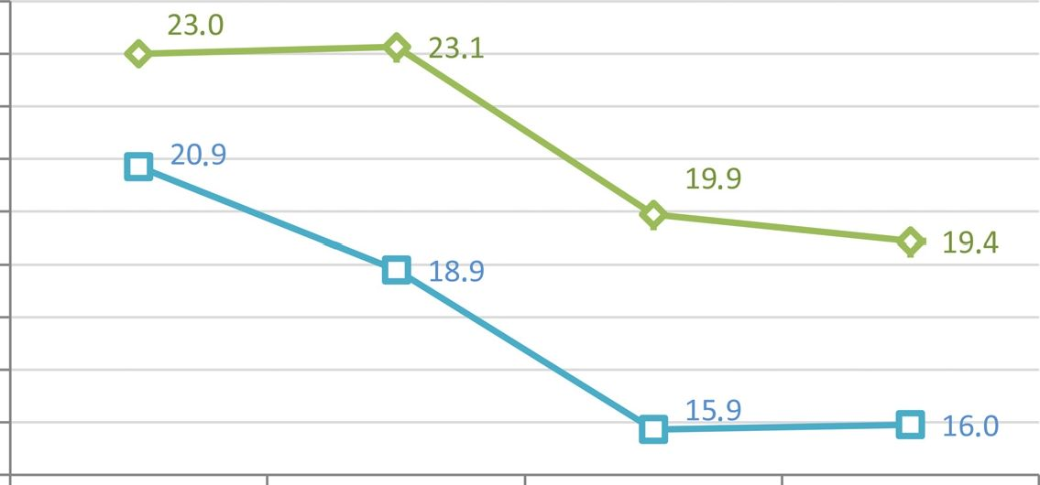
Medical Rehabilitation (Med Rehabil) 2017, 21 (4): 18-30 DOI: 10.5604/01.3001.0010.8159 eISSN 1896-3250 ISSN 1427-9622 © AWF Krakow
24.0
23.0
22.0
21.0
20.0
19.0
18.0
17.0
16.0
15,0
Measurement 1 Measurement 2 Measurements Measurement 4
-Q- More than two years after the stroke
Less than two years after the stroke
Figure 5
Average performance time of the Timed Up and Go test in individual measurements
among the sub-groups differing in time from stroke
Table 3
As in the case of the Timed Up and
Go test, the results of sensory ther-
apy did not provide as great effects
after the first treatment as after a se-
ries of them. The similarity of results
in these two tests also applies to the
results of analyses in subgroups. In
the Tinetti test, results were weaker
for those older or with a longer peri-
od since stroke when performing bal-
ance or gait-related tasks (Figures 6
and 7).
The results of the analysis of sub-
groups with different sides of paresis
showed that patients with left-sided
paresis achieved better results (green
curve on Figure 8). However, it was
noticed that the therapy had simi-
lar effects in both groups: slight im-
provement after the first treatment
and significant improvement after 4
weeks of treatment. In both groups,
the effects persisted despite cessation
of stimulation.
Significance tests for the Tinetti test (Measurement 1 vs. Measurement 4)
Significance tests | Sub-group | Measure-  ment | Aver-  age | SD | Number  of consid  ered vari-  ables | - Differ-  ence | SD | t | df | p
Tinetti test | Total | Measure-  ment No. 1 | 14.4 | 4.6
 |  | Measure-  ment No. 4 | 18.3 | 4.0 | 40 | -3.9 | 1.5 | -16.6 | 39 | <0.001
Tinetti test divided  according to age | < 68 years | Measure-  ment No. 1 | 15.2 | 4.6
 |  | Measure-  ment No. 4 | 19.3 | 3.9 | 20 | -4.2 | 1.5 | -12.1 | 19 | <0.001
 | > 68 years | Measure-  ment No. 1 | 13.7 | 4.5
 |  | Measure-  ment No. 4 | 17.4 | 4.1 | 20 | -3.7 | 1.4 | -11.5 | 19 | <0.001
Tinetti test divided  according to side of | Right-sided pa-  resis (stroke in | Measure-  ment No. 1 | 15.1 | 4.6
paresis | left hemisphere) | Measure-  ment No. 4 | 19.4 | 4.1 | 20 | -4.3 | 1.5 | -12.9 | 19 | <0.001
 | Left-sided pa-  resis (stroke | Measure-  ment No. 1 | 13.8 | 4.5
 | in right hemi-  sphere) | Measure-  ment No. 4 | 17.3 | 3.8 | 20 | -3.5 | 1.4 | -11.2 | 19 | <0.001
Tinetti test divided  according to time | More than two  years | Measure-  ment No. 1 | 15.3 | 4.7
from stroke |  | Measure-  ment No. 4 | 19.2 | 4.1 | 23 | -3.9 | 1.5 | -12.7 | 22 | <0.001
 | Less than two  years | Measure-  ment No. 1 | 13.2 | 4.2
 |  | Measure-  ment No. 4 | 17.2 | 3.7 | 17 | -3.9 | 1.6 | -10.4 | 16 | <0.001
Measurement No. 1 - before beginning physical therapy; Measurement No. 4 ■  therapy |  |  |  | - after a 2-week break following the completion of the performed physical
26
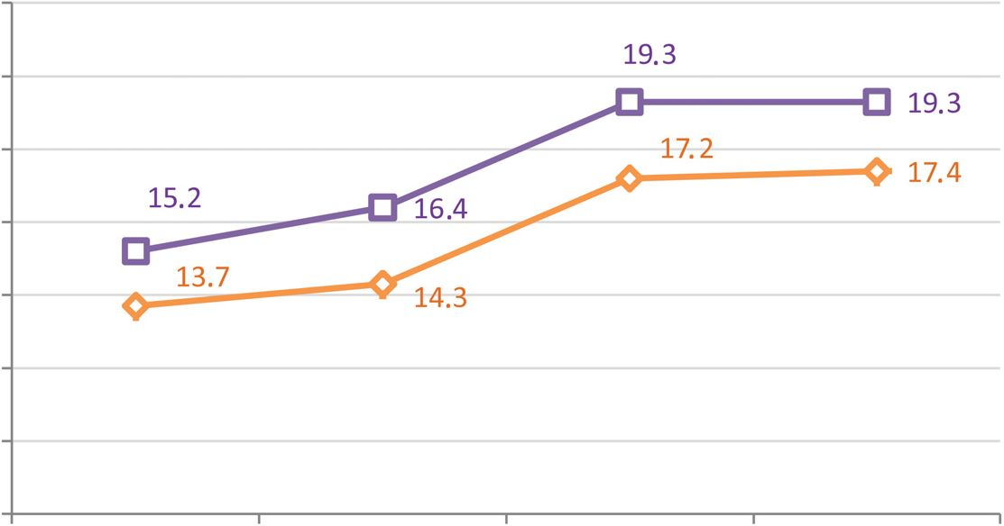
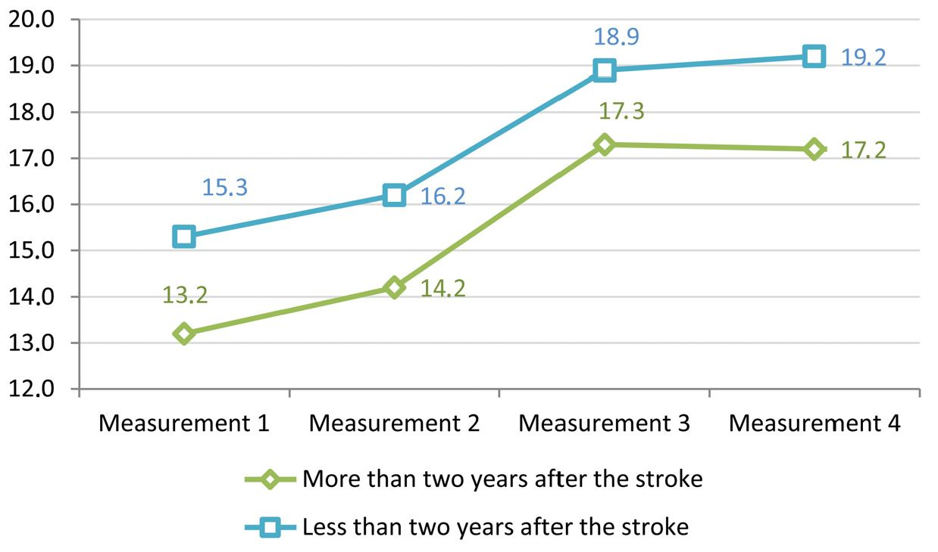
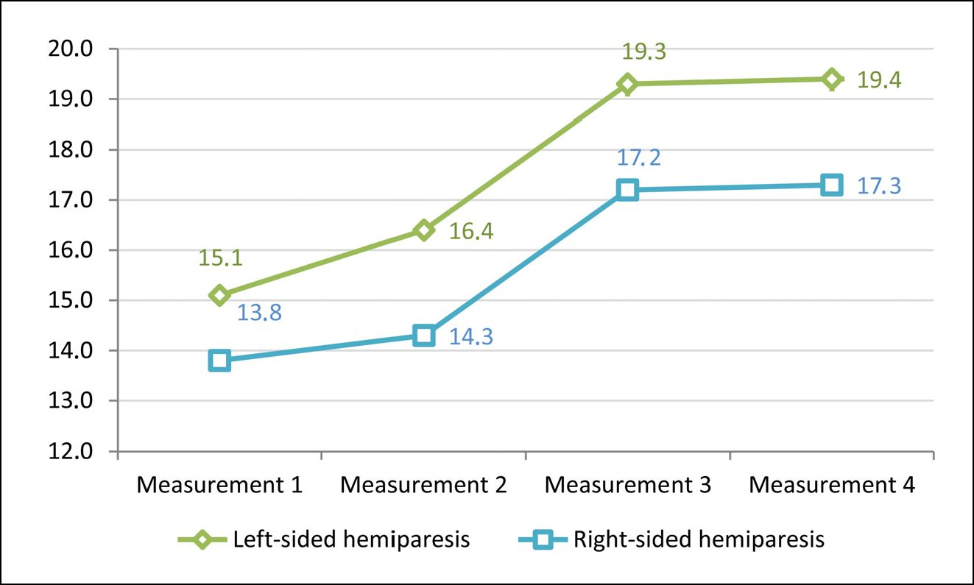
Medical Rehabilitation (Med Rehabil) 2017, 21 (4): 18-30 DOI: 10.5604/01.3001.0010.8159 eISSN 1896-3250 ISSN 1427-9622 © AWF Krakow
Measurement 1 Measurement 2 Measurements Measurement 4
—Results of the Tinetti test in individuals above the age of 68
Results of the Tinetti test in individuals below or equal to the age of 68
Figure 6
Results of the Tinetti test in particular measurements among sub-groups differing in age
Figure 7
Results of the Tinetti test in particular measurements among sub-groups differing in
time from stroke
Figure 8
Results of the Tinetti test in particular measurements among sub-groups differing in
stroke location
Considering the complexity of the
Tinetti test, sensory stimulation of
the feet resulted in the greatest im-
provement for the tasks directly re-
lated to taking on body mass by the
lower limbs and stability in a stand-
ing position during static and dy-
namic tasks. The greatest improve-
ment was recorded in the test with
open eyes, the attempt to stand on
a narrow base, balance after stand-
ing up and the knock-over attempt
with closed eyes. The point increases
for the particular tasks of the test are
shown in Figure 9.

Correlations between test
results
A very strong negative correla-
tion was observed between the av-
erage results of the Tinetti test and
the TUG test (r = -0.99, p<0.001).
This means that patients shortening
the time to overcome the distance
of 3 meters, simultaneously, also im-
proved the results of balancing tasks
and those related to gait in the Tinet-
ti test. Strong, negative correlations
were also observed between the test
results of the Two-scale test and both
gait tests (r = -0.87, p<0.001). The
improvement in weight distribution
between the lower limbs was there-
fore strongly associated with the im-
provement of the results of dynamic
activity, i.e. gait.

DISCUSSION
The aim of the study was to check the
influence of therapy aimed at senso-
ry stimulation of the foot in people
with hemiparesis on weight distri-
bution, balance and gait among this
group of subjects. The obtained re-
sults allowed to observe a positive ef-
fect of sensory therapy performed in
accordance with the Bobath concept
for balance and gait functions. Load-
ing of the directly affected lower limb
immediately improved after the com-
pletion of stimulation, as illustrated
by the results of the Two-scale test
carried out after the first stimulation
session. It can be assumed that the
stimulation of pressure and deep sen-
27
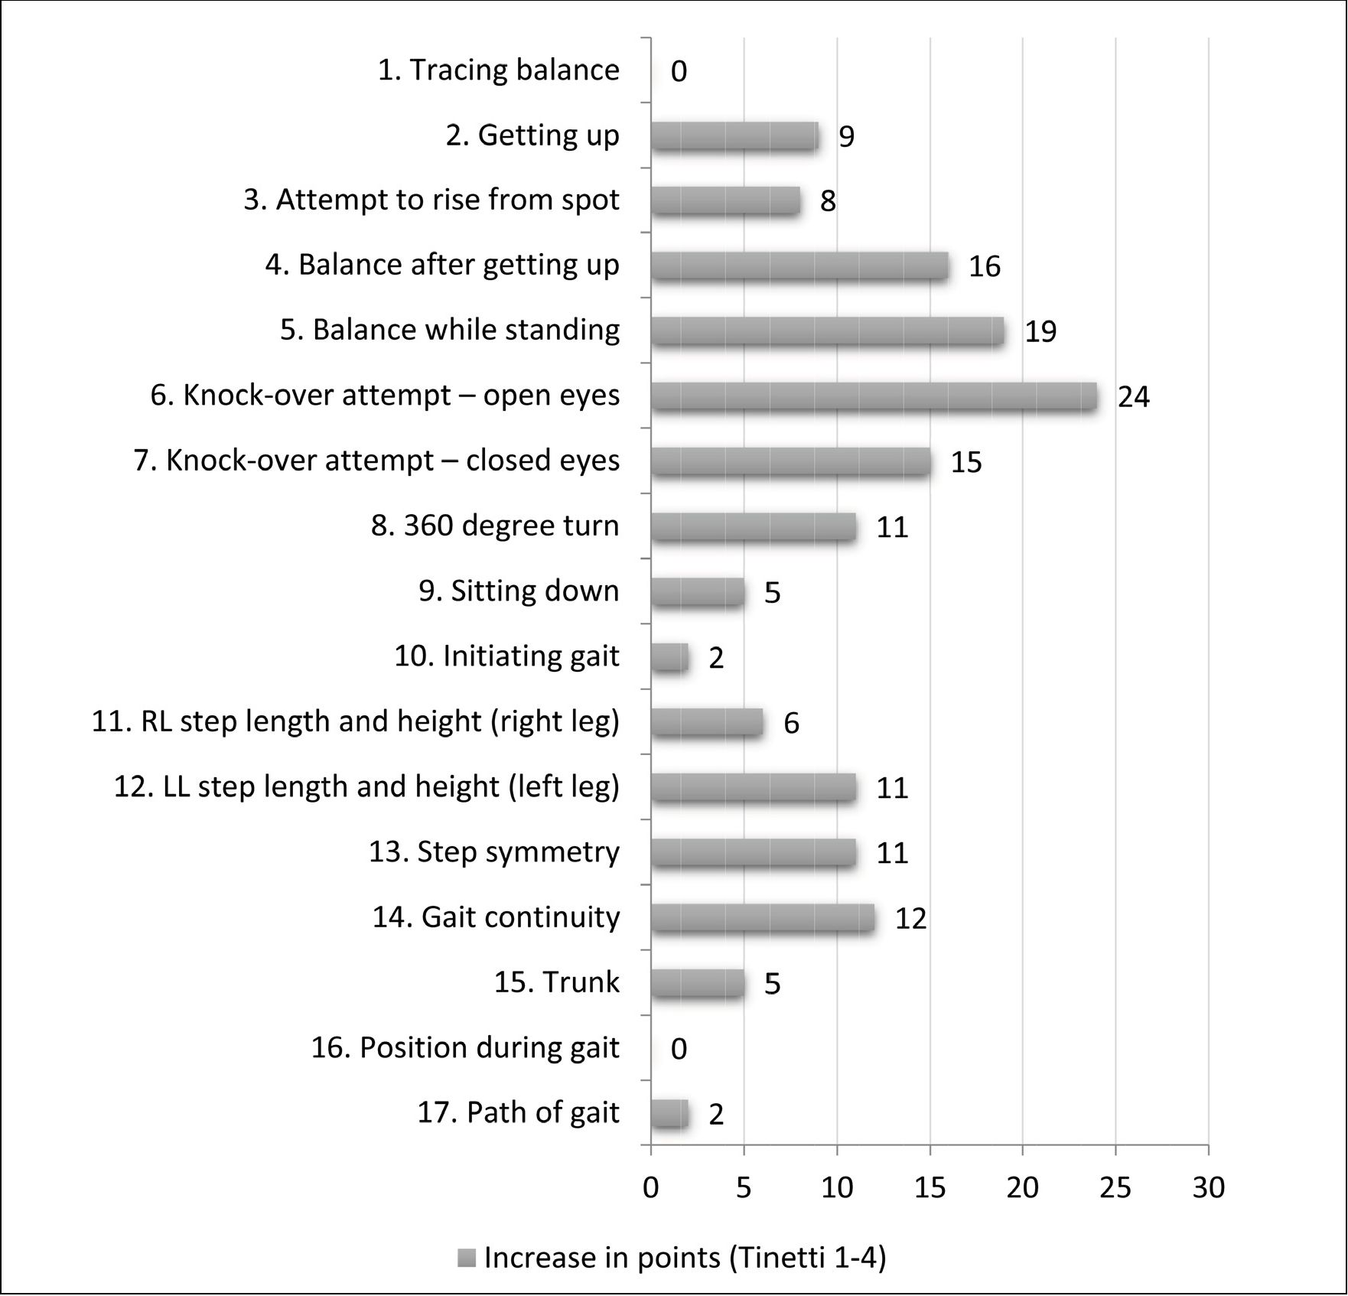
Medical Rehabilitation (Med Rehabil) 2017, 21 (4): 18-30 DOI: 10.5604/01.3001.0010.8159 eISSN 1896-3250 ISSN 1427-9622 © AWF Krakow
Figure 9
Increase in points obtained in the Tinetti test between Measurements No. 1 and 4 (n = 40)
sory receptors located in the muscles,
tendons and joint surfaces resulted in
a change of body scheme constructed
on the basis of the sensory informa-
tion currently received19. The nervous
system receives a continuous stream
of feedback from a wide range of ex-
ternal and internal receptors. It se-
lects information related to the state
of the body in face of planned and
performed complex motor behav-
iours, as well as related to monitor-
ing the course of currently performed
activities19. The applied sensory stim-
ulation of the foot combined with
visual control of the patient and his/
her concentration during experienc-
ing the sensations, allowed for bet-
ter integration of the inferior lower
limb into the body scheme and im-
proved motor performance which in
this case was gait. As the authors point
out, multisensory stimulation seems
to be a promising therapeutic tool in
stroke-induced sensory disorders, be-
cause information coming from dif-
ferent senses can improve detection,
localization and responses to exter-
nal stimuli, which reduces the disor-
der6. Our research proved that while
weight distribution improved imme-
diately, the improvement of gait test
results required repeated training of
this activity, but finally, a high corre-
lation was found between test results.
This is in line with the results of oth-
er reports in which the application of
therapy based on the assumptions of
the Bobath concept resulted in im-
provement of the results of gait tests
in the studied post-stroke patients20,21.
The applied somatosensory stimula-
tion of the inferior foot could there-
fore act as reinforcement of sensory
integration in the posterior parietal
cortex responsible for performing lo-
comotion guided by sight22. As it can
be seen from the results of other stud-
ies, sensory stimulation of the foot
performed using specialized inserts23,
platforms and vibration devices2425, or
also electrotherapy26, significantly af-
fects the balance and gait function of
people with neurological diseases.
The additional objective of our re-
search was to check whether the loca-
tion of the stroke affects the outcome
of the applied sensory stimulation.
For this purpose, patients with right-
and left-sided paresis were com-
pared. Persons with left-sided paresis
were initially characterized by infe-
rior weight distribution between the
28
Medical Rehabilitation (Med Rehabil) 2017, 21 (4): 18-30 DOI: 10.5604/01.3001.0010.8159 eISSN 1896-3250 ISSN 1427-9622 © AWF Krakow
lower limbs. As a result of stimula-
tion, this improved significantly, but
compared to people with right-sid-
ed paresis, the effect of stimulation
did not remain at the same level af-
ter its cessation. This situation can
be explained by the difference be-
tween centres located in both hemi-
spheres and their different function
during reception, processing and re-
action to sensory stimuli27. The right
part of the brain focuses on visual im-
pressions, processing information in
an intuitive and simultaneous man-
ner, first looking at the whole image,
and then the details. The left side of
the brain focuses on verbal stimuli,
processing information in an analyt-
ical and sequential way, looking first
at individual elements, assembling
them together. The left side of the
brain is responsible for reading, writ-
ing, counting and logical thinking;
the right controls three-dimension-
ality, creativity and artistic sense28.
Lateralization of specialized cortical
functions such as speech or spatial
orientation causes significant differ-
ences in the clinical image of a per-
son after stroke of the right and left
hemispheres of the brain. In gener-
al, speech disorders accompany dam-
age to the left hemisphere, and cog-
nitive disorders and depression to the
right-side29. In ischemic stroke, worse
functional abilities were noted in the
case of damage to the left hemisphere
compared to the right one27. Howev-
er, this difference may have resulted
from a longer hospitalization period
(including physical therapy) in pa-
tients with stroke to the right hem-
isphere, which accompanying cogni-
tive disorders, slow down the process
of rehabilitation. However, Rynkiew-
icz et al.30, and Laufer et al.31 indicate
that patients suffering from right-sid-
ed paresis reported better results of
rehabilitation. Mortality rate was
higher in the case of patients with
hemorrhagic stroke in the right hem-
isphere within the three months fol-
lowing the incident, however, there
were no differences in the function-
al performance of these subjects with
different bleeding site32. Other au-
thors also did not show the impact of
brain damage location on the effects
of rehabilitation33,34, which demon-
strates that an unequivocal resolution
of this issue would require exten-
sive, multi-centre studies. The limi-
tation of this study is the lack of de-
tailed data on the cause of the stroke
(bleeding vs. embolism) and its exact
location. The recruited patients were
also characterized by a different pe-
riod from the incident and history of
rehabilitation. There was also a sig-
nificant difference in age among both
subgroups — people with left-sided
paresis were significantly younger.
Taking the age of patients and the
period from the incident into ac-
count, it was observed that young-
er people with shorter periods since
the stroke showed relatively greater
improvement. This result can be ex-
plained by more efficient brain mech-
anism functioning of young organ-
isms, higher gene expression and
higher concentration of substances
released by the body as a conse-
quence of ischemia, including growth
factors contributing to the efficien-
cy of plasticity mechanisms35. Differ-
ent conclusions are presented by Bo-
hannon et al.36 who noticed that the
age and time since the incident did
not affect the tested balance. Due to
the complexity of the brain and the
multitude of connections between its
structures, not many puzzles of how
this organ functions during motion
control have been solved. Obtaining
an unambiguous answer to numer-
ous questions, including those raised
in the present study, requires further,
multi-centre studies using technolog-
ically advanced diagnostic methods
and accurate, sensitive and validated
research tools.

CONCLUSIONS
- Deep sensory stimulation consist-
ent with the Bobath concept con-
tributes to the improvement of
motor function in patients with
hemiparesis.
- The effects of stimulation persist
for 14 days after the completion
of 20 therapeutic sessions.
- The length of the post- period
from onset may affect the patient’s
balance and gait function. Better
results of stimulation are obtained
by patients who subject themselves
to it within less than two years af-
ter the stroke.
- The patient’s age influences the re-
sults of stimulation. Better effects
are obtained by people under the
age of 68.
- The possible influence of damage
location in the left or right hemi-
sphere of the brain on the modifi-
cation of the therapeutic results is
noted. Better progress has been re-
ported for patients with left-sided
paresis.
Conflict of interest: none
Piśmiennictwo / References
- Bolognini N., Russo C., Edwards D.J. The
sensory side of post-stroke motor rehabili-
tation. Restor Neurol Neurosci 2016; 34(4):
571-586.
- Szatkowska I. Pamięć operacyjna: integra-
cyjna rola kory przedczolowej. Prz Psychol
1999; 42(1-2): 151-165.
- Stein, B.E. (ed.). The new handbook of mul-
tisensoryprocessing. MIT Press. Cambridge
2012.
- Nudo R.J., Wise B.M., SiFuentes F., Milli-
ken G.W. Neural substrates for the effects
of rehabilitative training on motor recove-
ry after ischemic infarct. Science 1996;
272(5369): 1791-1794. doi: 10.1126/scien-
ce.272.5269.1791.
- Buma F., Kwakkel G., Ramsey N. Understan-
ding upper limb recovery after stroke. Restor
Neurol Neurosci 2013; 31(6): 707-722.
- Tinga A.M., Visser-Meily J.M., van der Smagt
M., Nijboer T.C. Multisensory Stimulation to
Improve Low- and Higher-Level Sensory De-
ficits after Stroke: A Systematic Review. Neu-
ropsychol Rev 2016; 26: 73-91. doi: 10.1007/
s11065-015-9301-1.
- Sambo C.F., Vallar G., Fortis P., Ronchi R.,
Posteraro L., Forster B., et al. Visual and
spatial modulation of tactile extinction: be-
havioural and electrophysiological evidence.
Front Hum Neurosci 2012; 25(6): 217. doi:
10.3389/fnhum.2012.00217.
- Shore S.E. Multisensory integration in the dor-
sal cochlear nucleus: unit responses to aco-
ustic and trigeminal ganglion stimulation. Eur
J Neurosci. 2005; 21(12): 3334-3348.
- Bonan I., Chochina L., Moulinet-Raillon A.,
Leblong E., Jamal K., Challois-Leplaideur
S. Effect of sensorial stimulations on postu-
ral disturbances related to spatial cognition
disorders after stroke. Neurophysiol Clin
2015; 45(4-5): 297-303. doi: 10.1016/j.neuc-
li.2015.09.006.
- Lennon S., Hastings M. Key physiotherapy
indicators for quality of stroke care Physio-
therapy, 1996, 82 (12), 655-664:.
- Bohannon R.W. Reference values for the
timed up and go test: a descriptive metaanal-
ysis. J Geriatr Phys Ther 2006; 29: 64-68.
- Shumway-Cook A., Brauer S., Woollacott M.
Predicting the probability for falls in communi-
ty-dwelling older adults using the Timed "Up
& Go" Test. Phys Ther 2000; 80: 896-903.
- Tinetti M.E., Doucette J., Claus E., Marottoli
R. Risk factors for serious injury during falls
by older persons in the community. J Am
Geriatr Soc 1995; 43: 12141221.
- Raine S. Defining the Bobath concept us-
ing the Delphi technique. Physiother Res Int.
2006; 11: 4-13.
29
Medical Rehabilitation (Med Rehabil) 2017, 21 (4): 18-30
DOI: 10.5604/01.3001.0010.8159 eISSN 1896-3250
ISSN 1427-9622 © AWF Krakow
- Vaughan-Graham J., Cott C., Wright F.V. The
Bobath (NDT) concept in adult neurological
rehabilitation: what is the state of the knowl-
edge? A scoping review. Part I: conceptu-
al Perspectives. Disabil Rehabil 2015; 37:
1793-1807.
- Michielsen M., Vaughan-Graham J., Hol-
land A., Magri A., Suzuki M. The Bobath
concept - a model to illustrate clinical prac-
tice. Disabil Rehabil 2017; 17: 1-13. doi:
10.1080/09638288.2017.1417496 [Epub
ahead of print]
- Vaughan-Graham J., Cott C. Phronesis:
practical wisdom the role of professional
practice knowledge in the clinical reasoning
of Bobath instructors. J Eval Clin Pract 2017;
23: 935-948.
- Cott C., Vaughan-Graham J., Brunton K.
When will the evidence catch up with clinical
practice. Physiother Can 2011; 63: 387-390.
- Mizelle J.C, Oparah A., Wheaton L.A. Reli-
ability of Visual and Somatosensory Feed-
back in Skilled Movement: The Role of the
Cerebellum. Brain Topogr 2016; 29(1): 27-41.
doi: 10.1007/s10548-015-0446-2.
- Benito Garcia M., Atin Arratibel M.Ä., Terra-
dillos Azpiroz M.E. The Bobath Concept in
Walking Activity in Chronic Stroke Measured
Through the International Classification of
Functioning, Disability and Health. Physioth-
er Res Int 2015; 20(4): 242-250.
- Brock K., Haase G., Rothacher G., Cotton S.
Does physiotherapy based on the Bobath
concept, in conjunction with a task practice,
achieve greater improvement in walking abil-
ity in people with stroke compared to physio-
therapy focused on structured task practice
alone?: a pilot randomized controlled trial?:
a pilot randomized controlled trial. Clin Re-
habil 2011; 25(10): 903-912.
- Marigold D.S., Andujar J.E., Lajoie K., Drew
T. Chapter 6-motor planning of locomotor
adaptations on the basis of vision: the role of
the posterior parietal cortex. Prog Brain Res
2011; 188: 83-100.
- Corbin D.M., Hart J.M., McKeon P.O., Inger-
soll C.D., Hertel J. The effect of textured in-
soles on postural control in double and sin-
gle limb stance. J Sport Rehabil 2007; 16:
363-372.
- Novak P., Novak V. Effect of step-synchro-
nized vibration stimulation of soles on gait in
Parkinson's disease: a pilot study. J Neuro-
eng Rehabil 2006; 3: 3-9.
- Priplata A.A., Patritti B.L., Niemi J.B., Hughes
R., Gravelle D.C., Lipsitz L.A., et al. Noise-en-
hanced balance control in patients with dia-
betes and patients with stroke. Ann Neurol
2006; 59(1): 4-12.
- Tyson S.F., Sadeghi-Demneh E., Nester
C.J. The effects of transcutaneous electri-
cal nerve stimulation on strength, proprio-
ception, balance and mobility in people with
stroke: a randomized controlled cross-over
trial. Clin Rehabil 2013; 27: 785-791.
- Hedna V.S., Bodhit A.N., Ansari S., Fal-
chook A.D., Stead L., Heilman K.M., et
al. Hemispheric differences in ischemic
stroke: is left-hemisphere stroke more
common? J Clin Neurol 2013; 9: 97-102.
- Shumway-Cook A.,Woollacott M.H. Motor
Control: Translating Research into Clinical
Practice. 4th Edition. Lippincott Williams &
Wilkins Baltimore; 2009: 93-96.
- Benejam B., Sahuquillo J., Poca M.A., Fra-
scheri L., Solana E., Delgado P., et al. Qu-
ality of life and neurobehavioral changes in
survivors of malignant middle cerebral ar-
tery infarction. J Neurol 2009; 256: 1126-
1133.
- Rynkiewicz M., Rogulska U., Czernicki J.
Ocena zmian sprawności funkcjonalnej
osób we wczesnym okresie po udarze mó-
zgu. Prz Med Uniw Rzesz 2011; 2: 325-339.
- Laufer Y., Sivan D., Schwarzmann R., Spre-
cher E. Standing balance and functional re-
covery of patients with right and left hemi-
paresis in the early stages of rehabilitation
Neurorehabilitation and Neural Repair 2003;
17(4): 207-213.
- Sato S., Heeley E., Arima H., Delcourt C.,
Hirakawa Y., Pamidimukkala V., et al. High-
er mortality in patients with right hemi-
spheric intracerebral haemorrhage: IN-
TERACT1 and 2. J Neurol Neurosurg Psy-
chiatry 2015; 86: 1319-1323.
- Czernicki J., Woldańska-Okońska M. Wplyw
strony niedowładu połowiczego na wyni-
ki rehabilitacji chorych po udarach mózgu.
Post Rehabil 1999; 13(1): 63-67.
- Fedak D., Latała B., Otfinowski J., Zajdel
K. Ocena wpływu fizjoterapii na równowa-
gę w pozycji stojącej w grupie pacjentów po
udarze mózgu, określona na podstawi ba-
dań posturograficznych. Acta Bio-Optica
et Informatica Medica. Inż Biomeda 2010;
16(3): 208-211.
- Johansson B.B. Brain plasticity and stroke
rehabilitation: The Willis lecture. Stroke 2000;
31: 223-230.
- Bohannon R.W., Smith M.B., Larkin P.A. Re-
lationship between independent sitting bal-
ance and side of hemiparesis. Phys Ther
1986; 66(6): 944-994.
Address for correspondence
Agnieszka Śliwka PhD
Institute of Physiotherapy
Faculty of Health Sciences
Jagiellonian University Medical College
Skawińska 8, 31-008 Krakow, Poland
e-mail: agnieszka.sliwka@uj.edu.pl
30

