Jerzy WILIŃSKI1
Danuta CZARNECKA1
Wiktoria WOJCIECHOWSKA1
Małgorzata KLOCH-BADEŁEK1
Marek JASTRZĘBSKI1
Bogumiła BACIOR1
Agnieszka KWIECIEŃ-SOBSTEL1
Kalina KAWECKA-JASZCZ1

Different response rates to cardiac resynchronization therapy (CRT) according to the applied definition
11 Klinika Kardiologii i Nadciśnienia Tętniczego Collegium Medicum
Uniwersytetu Jagiellońskiego w Krakowie Kierownik:
Prof, dr hab. med. Kalina Kawecka-Jaszcz
Dodatkowe słowa kluczowe: chronic heart failure cardiac resynchronization therapy CRT
Additional key words: przewlekła niewydolność serca terapia resynchronizaująca CRT
Background: Solid evidence shows that cardiac resynchronization therapy (CRT) improves prognosis, physical capacity and quality of life in selected groups of patients with chronic heart failure (CHF). Nonetheless, marked percentage of patients seem not to benefit from CRT. Material and methods: Sixty consecutive patients (aged 66.3 ± 8.7 years, 57 men - 95%, 3 women - 5%) with CHF ( 71.7% with ischaemic and 28,3% with non-ischa- emic origin) of stable for > 3 months NYHA III or IV class despite optimized pharmacotherapy, with left ventricle end-diastolic diameter (LVEDd) > 55 mm, left ventricular ejection fraction (EF) < 35% and QRS > 130 ms were evaluated before and 3 months after CRT implementation (biventricular stimulation BiV) echocardiographically and clinically. Results: EF increased (21.7% vs 26,6%, p<0,0001), 6-minute walk distance (6-MWT) rose (298.0 m vs 373.1 m, p<0,0001), left ventricular end-dia- stolic volume (LVEDV) and left ventricular end-systolic volume (LVESV) decreased (244.3 ml vs 226,4 ml, p=0.0002; 192.8 ml vs 168,7 ml, p<0,0001 respectively). Mean NYHA class dropped from 3.1 to 2.2 (p<0.0001). Absolute increase in EF of >4%, >5%, >6% was observed in 63.2%, 52.6%, and 35.7% respectively; relative increase of >25% presented 21.1%, >10% reduction of LVESV - 59.7%, >15% reduction of LVESV - 43.8%, decrease in NYHA class - 78.3%, >10% reduction of 6-MWT - 66.7%, no death and no hospitalization due to heart failure - 78.3%. Conclusions: Response to CRT rate differs markedly according to the applied definition.
Adres do korespondencji/
Corresponding address:
Lek. med. Jerzy Wiliński
I Klinika Kardiologii i Nadciśnienia Tętniczego CM Uniwersytetu Jagiellońskiego 31-501 Kraków, ul. Kopernika 17 e-mail: putamen@interia.pl
Introduction
Cardiac resynchronization therapy (CRT) corrects the atrioventricular, inter- and intraventricular mechanical dyssynchrony
Tło: Dowody z badań naukowych wskazują, że terapia resynchronizują- ca (CRT) poprawia rokowanie, wydolność fizyczną i jakość życia w wybranych grupach chorych z przewlekłą niewydolnością serca (NS). Pomimo tego, znaczący odsetek chorych poddawanych CRT nie odnosi zamierzonych korzyści. Materiał i metody: Sześćdziesięciu kolejnych chorych (w wieku 66,3 ± 8,7 lat, 57 mężczyzn - 95%, 3 kobiety - 5%) z NS (71,7% z niedokrwienną oraz 28,3% o tle nie-nie- dokrwiennym) pozostających przez co najmniej 3 miesiące w klasie NYHA III- IV pomimo optymalnej farmakoterapii, z wymiarem końcowo-rozkurczowym lewej komory serca (LVEDd) > 55 mm, frakcją wyrzutową lewej komory serca (EF) <35% i szerokością zespołów QRS >130 ms oceniano przed oraz 3 miesiące po zastosowaniu CRT (stymulacja dwukomorowa - BiV) echokardiograficznie oraz klinicznie. Wyniki: EF wzrosła istotnie (21,7% vs 26,6%, p<0,0001), istotnie wydłużył się dystans testu 6-minutowego marszu (6- MWT) (298,0 m vs 373,1 m, p<0,0001), objętość końcowo-rozkurczowa lewej komory serca (LVEDV) oraz objętość końcowo-skurczowa lewej komory serca (LVESV) zmalały (244,3 ml vs 226,4 ml, p=0,0002; 192,8 ml vs 168,7 ml, p<0,0001, odpowiednio). Średnia klasa NYHA spadła z 3,1 do 2,2 (p<0,0001). Absolutny wzrost EF o >4%, >5%, >6% obserwowano odpowiednio u 63,2%, 52,6%, i 35,7%; relatywny wzrost EF o >25% występował u 21,1%, >10% redukcja LVESV u 59,7%, >15% redukcja LVESV u 43,8%, spadek klasy NYHA u 78,3%, >10% wzrost dystansu 6-MWT u 66,7%, a brak zgonu i hospitalizacji z powodu niewydolności serca odnotowano u 78,3% badanych. Wnioski: Odsetek odpowiedzi na CRT różni się znacząco w zależności od zastosowanej definicji.
arising along with the development and progression of chronic heart failure (CHF). CRT improves filling of the left ventricle (LV) and increases LV ejection fraction (EF), cardiac
130
Przegląd Lekarski 2009 /66/3
J. Wiliński i wsp.

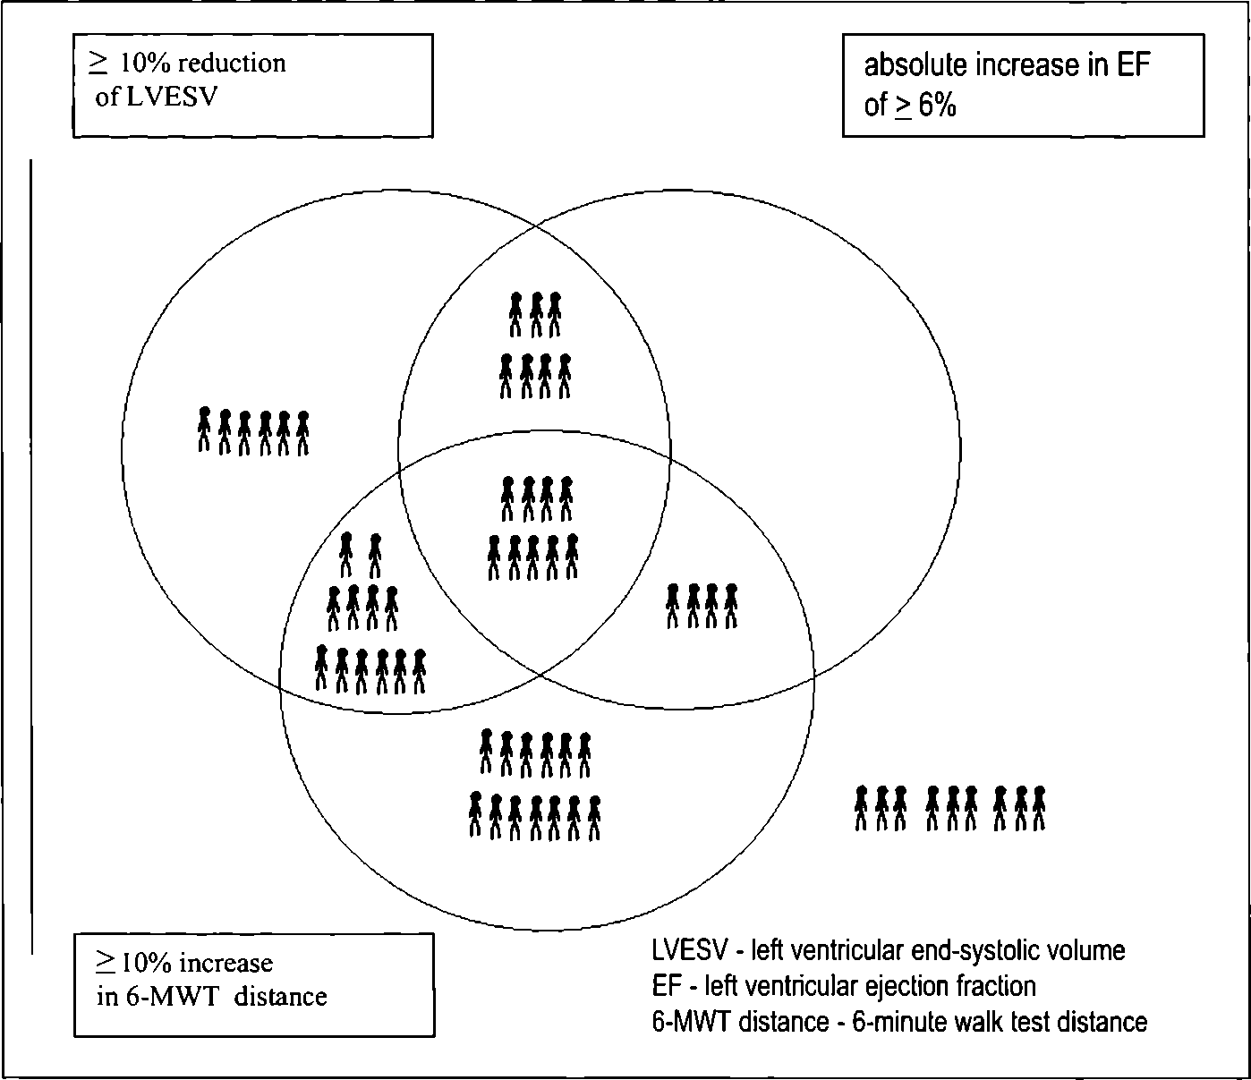
output and systolic blood pressure. In longterm observations CRT leads to LV reverse remodeling. Solid evidence from clinical trials has shown that CRT improves physical capacity, quality of life and decreases morbidity and mortality related to CHF. Nonetheless, patients benefit from CRT to a different extent [1,12,24]. On the one hand, this results from the fact that effect of CRT is conditioned by numerous factors like aetiology of heart failure, age, concomitant diseases, compliance etc, on the other, criteria of response to CRT used in different studies vary markedly. The aim of the study was to compare response rates to CRT according to different definitions applied in clinical trials.

Material and methods
The study group comprised sixty consecutive patients (aged 66.3 ± 8.7 years, 57 men - 95% , 3 women - 5%) with chronic heart failure (71.7% with ischaemic and 28,3% with non-ischaemic origin) of stable for >3 months NYHA III or IV class despite optimized pharmacotherapy, with left ventricle end-diastolic diameter (LVEDd) >55mm, left ventricular ejection (EF) < 35% and QRS > 130 ms.
Exclusion criteria included the presence of unstable angina, acute myocardial infarction, coronary artery bypass graft or percutaneous coronary intervention within 3 months; continuous or intermittent intravenous inotropic drug therapy, an estimated life expectancy of less than 12 months, a previously implanted CRT system, a mechanical right-side heart valve, heart transplant, pregnancy or concurrent enrollment in any study thought to confound the results. After enrolment, before CRT implantation and at 3 months of follow-up (12-16 weeks) individuals were evaluated clinically - NYHA class, history and 6-minute walk test (6-MWT), questions about hospitalizations - and echocardiographically (apparatus GE Vivid 7; LV volumes and EF were evaluated using biplane Simpson's method). All stored echo recordings were analyzed twice by an experienced physician.
During CRT all leads were implanted transvenous- ly. LV lead, guided by venogram, was placed in coronary sinus tributary in a stable lateral position, with a <3.5 V capture threshold. The right ventricular (RV) lead was placed in the septal or outflow tract (RVOT) position. Leads' tips positions were verified on frontal and sagittal chest X-ray. AV delay and V-V timing were optimized electrocardiographically. In the patients with persistent atrial fibrillation ventricles' rate control with betablockers and digoxin was assessed. In those with unsatisfactory pharmacologic effect ablation of atrioventricular junction was performed.
In the studied population 61.6% were in sinus rhythm, 16,7% had paroxysmal atrial fibrillation and 21.7% persistent fibrillation. Previously implanted pacemaker or ICD was upgraded to CRT in 11 patients (18.3%). Cardiac Resynchronization Therapy Defibrillator (CRT-D) was applied in 31.6%. Comorbidities comprised arterial hypertension - present in 65.0%, diabetes mellitus in 41.7%, chronic renal failure in 33.3%. Conduction disorders constituted - left bundle branch block - 65.0%, right bundle branch block -1.7%, ventricular conduction disturbances of other morphology - 33.3%. In the pharmacological treatment angiotensin converting enzyme inhibitors and/or angiotensin receptor blockers were used by 85.0%, beta-blockers by 96,7%, loop diuretics by 88.3%, digoxin by 21,7%. All prescriptions remained stable through the study.

Results
EF increased (21.7% vs 26.6%, p<0.0001), 6-MWT distance rose (298.0 m vs 373.1 m, p<0.0001), LVEDV and LVESV decreased (244.3 ml vs 226.4 ml, p=0.0002; 192.8 ml vs 168.7 ml, p<0.0001 respectively). Mean NYHA class dropped from 3.1
Graph 1
Response to cardiac resynchronization therapy (CRT) according to different definitions. Odpowiedź na terapię resynchronizującą (CRT) według różnych definicji.
Table I
Basic echocardiographic and clinical data before and 3 months after cardiac resynchronization therapy (CRT) implantation.
Podstawowe dane echokardiograficzne oraz kliniczne przed oraz 3 miesiące po wdrożeniu terapii resynchronizującej (CRT).
 | Before CRT | 3 months after CRT | P
LVEDd (mm) | 73.3 (8.9) | 71.5(9.8) | 0.0029
LVESd (mm) | 62.4 (10.0) | 60.6 (11.3) | 0.034
LVEDV (ml) | 244.3 (83.8) | 226.4 (88.6) | 0.0002
LVESV (ml) | 192.8 (71.9) | 168.7 (76.5) | <0.0001
SV (ml) | 51.5 (16.6) | 57.7 (16.9) | <0.0001
EF (%) | 21.7(4.8) | 26.0 (4.8) | <0.0001
6-MWT (m) | 298.0 (107.4) | 373.1 (127.1) | <0.0001
NYHA | 3.1 (0.2) | 2.2 (0.7) | <0.0001
LVEDd - left ventricular end-diastolic diameter; LVESd - left ventricular end-systolic diameter LVEDV - left ventricular end-diastolic volume; LVESV - left ventricular end-systolic volume SV - stroke volume; EF - left ventricular ejection fraction
6-MWT distance - 6-minute walk test distance; NYHA - NYHA class
to 2.2 (p<0.0001) (table I).
Three patients died in 3-month followup: one of stroke, one of myocardial infarction, one suddenly of unknown cause. In the observation period 10 patients were hospitalized due to CHF. Response rates according to different criteria used in clinical trials are listed in table II.

Discussion
Since its introduction in 1994, CRT has gained well established position in the treatment of CHF [3,8,12]. It soon appeared obvious that CRT targets an important pathophysiological processes progressing in CHF
- mechanical dyssynchrony of atria and ventricles performance. The effects of biventricular pacing comprise better filling of LV and synchronous contraction of LV. This leads to more efficient work of LV - an increased LVEF and reverse remodeling assessed by decreased LVEDV (left ventricle end-diastolic volume) and LVESV (left ventricle end-systolic volume). CRT diminishes also mitral insufficiency often present in patients with CHF. The clinical effect - improved physical capacity (assessed by NYHA class, 6-MWT distance) and quality of life, reduced mortality and lower rates of hospitalization due to CHF rate are, what is noteworthy, conditioned by numerous fac-
Przegląd Lekarski 2009 /66/3
131

Table II
Response to cardiac resynchronization therapy (CRT) rates according to different criteria used in clinical trials.
Odpowiedź na terapię resynchronizującą (CRT) w zależności od definicji użytej w badaniach naukowych.
Response to CRT criteria | Response to CRT rate
Absolute increase of EF > 4% [16] | 63, 2%
Absolute increase of EF > 5% [5] | 52, 6%
Absolute increase of EF > 6% [11] | 35, 7%
Relative increase of EF > 25% [18] | 21, 1%
Reduction of LVESV > 10% [29] | 59, 7%
Reduction of LVESV > 15% [9, 19] | 43, 8%
Decrease in NYHA class [15, 26] | 78, 3%
Increase of 6-MWT distance >10% [14] | 66, 7%
No death and no hospitalization due to head failure [6, 7, 10] | 78, 3%
EF - left ventricular ejection fraction; LVESV - left ventricular end-systolic volume 6-MWT distance - 6-minute walking test distance
tors like aetiology of CHF, age, concomitant diseases, physical activity, BMI, compliance, salt intake etc. [12, 20]. Additionally, a substantial placebo effect may be present even in 40% of individuals [1]. CRT decreases also sleep-related disorders that augment CHF, improves the functioning of autonomic nervous system and leads to fall of some inflammatory markers [2, 13, 21, 22, 25].
First clinical studies have shown significant improvement in clinical state of patients with drug refractory CHF undergoing CRT, but subjectives did not benefit equally from this novel therapy. The terms 'responder' and 'non-responder' to CRT were introduced to separate patients with and without beneficial effect of CRT implementation. Subsequent trials were designed in order to address the problem who the ideal candidate for CRT is and which groups would present with little or no potential advantage of CRT. Numerous studies used different criteria of response to CRT, even defining the same phenomenon like rise in LVEF or LV reverse remodeling (see Table II). The assessment of clinical outcome is more problematic. NYHA class and 6-MWT are most commonly adopted. In some studies special systems to evaluate the effect of CRT were engaged like Packer's clinical end point applied eg. in the PROSPECT study [17, 27]. The pitfalls of the assessment of patients with CHF is the high subjectivity of echocardiographic evaluation and often poor quality of the achieved echo recordings (demonstrated vividly in the PROSPECT trial) [9]. Clinical parameters are also subjective and mainly reflect symptoms. Moreover, clinical and echocardiographic response to CRT may not always appear simultaneously, and patients who respond clinically may not exhibit reverse remodeling and vice versa [4].
Compiling data from literature suggest that reversal of maladaptive remodeling mechanism in CHF observed in a few months after CRT implementation is the best predictor of long-term outcome. Yu et al. showed in a series of 141 CRT patients that reduction of LVESV of at least 10% was re
lated at a very low event rate - 6. 9% allcause mortality - at a mean follow-up period of 695 days [29]. Di Biase et al. in the analysis from a prospective registry including 398 consecutive patients, with the median duration of follow-up of 4, 4 years, demonstrated that the magnitude of reverse remodelling measured by LVEF after 3 months of CRT implementation irrespectively of aetiology predicted outcome. An increase of at least 6 points of LVEF gave an excellent event-free survival approaching 66% at 5 years of observation [11].
Our study group, after inclusion of individuals with atrial fibrillation and with pacemaker or ICD up-graded to CRT was heterogenous but highly reflected clinical profile of patients undergoing CRT in the daily practise. Considering the effects of CRT it is crucial to remember that, although presence of persistent atrial fibrillation is believed to predict poorer outcome, results of Upadhyay’s meta-analysis of prospective cohort studies including 1164 patients show that CRT in patients with chronic atrial fibrillation confers similar benefit of CRT to the group of patients with sinus rhythm [23]. Analogically, despite reservations about the accuracy and reproducibility of different methods to assess mechanical dyssynchrony of ventricles' performance, the source of dyssynchrony - either development along with natural course of CHF or induced by right ventricle stimulation seems to be of minor meaning [24, 28].
The multiplicity of definitions of response to CRT make difficult the comparison between different trials and drawing constructive conclusions about their results. In our analysis we show that response to CRT varies markedly according to the applied definition (21. 1-78. 3%). As it is illustrated in Graph 1, patients who would be classified as responders in certain trials, in another ones must have been considered as nonresponders. We claim that assessment of the effect of CRT pose another hardship in developing knowledge about resynchronization and elaborating more specific qualification criteria for CRT.

Conclusions
Response to CRT rate differs markedly according to the applied definition. More patients exhibit improvement in clinical parameters as compared to echocardiographic markers.

Study limitations
The study group was heterogenous but highly reflected clinical profile of patients undergoing CRT. Aditionally, small size of the analyzed population and short period of the follow-up precluded the strict application of the composite end point proposed by Packer [17].
RgTg rsnces
- Abraham W. T., Fisher W. G., Smith A. L. et al.: MIRACLE Study Group. Multicenter InSync Randomized Clinical Evaluation. Cardiac resynchronization in chronic heart failure. N. Engl. J. Med. 2002, 346, 1845.
- Adamson P.B., Kleckner K.J., VanHout W.L. et al.: Cardiac resynchronization therapy improves heart rate variability in patients with symptomatic heart failure. Circulation 2003,108, 266.
- Bakker I.P., Meijburg H., De Jonge N. et al.: Beneficial effects of biventricular pacing in congestive heart failure. PACE 1994,17, 820A.
- Bax J.J., Abraham T., Barold S.S. et al.: Cardiac resynchronization therapy: Part 1-issues before device implantation. J. Am. Coll. Cardiol. 2005, 46, 2153.
- Bax J.J., Marwick Т.Н., Molhoek S.G. et al.: Left ventricular dyssynchrony predicts benefit of cardiac resynchronization therapy in patients with end-stage heart failure before pacemaker implantation. Am. J. Cardiol. 2003, 92,1238.
- Bristow M.R., Saxon L.A., Boehmer J. et al.: Comparison of Medical Therapy,Pacing, Defibrillation in Heart Failure (COMPANION) Investigators: Cardiac- resynchronization therapy with or without an implantable defibrillator in advanced chronic heart failure. N. Engl. J. Med. 2004, 350, 2140.
- Cazeau S.J., Daubed J.C., Tavazzi L. et al.: Responders to cardiac resynchronization therapy with narrow or intermediate QRS complexes identified by simple echocardiographic indices of dyssynchrony: the DESIRE study. Eur. J. Heart Fail. 2008,10,273.
- Cazeau S., Ritter P., Bakdach S. et al.: Four chamber pacing in dilated cardiomyopathy. Pacing Clin. Electrophysiol. 1994, 17,1974.
- Chung E.S., Leon A.R., Tavazzi L. et al.: Results of the Predictors of Response to CRT (PROSPECT) trial. Circulation 2008,117, 2608.
- Cleland J.G., Daubed J.C., Erdmann E. et al.: The effect of cardiac resynchronization on morbidity and modality in head failure (the CArdiac REsynchro- nization-Heart Failure [CARE-HF] Trial). N. Engl. J. Med. 2005, 352, 1539.
- Di Biase L., Auricchio A., Sorgente A. et al.: The magnitude of reverse remodelling irrespective of aetiology predicts outcome of head failure patients treated with cardiac resynchronization therapy. Eur. Head J. 2008, 29,2497.
- Dickstein K., Cohen-Solal A., Filippatos G. et al.: ESC guidelines for the diagnosis and treatment of acute and chronic head failure 2008: the Task Force for the diagnosis and treatment of acute and chronic head failure 2008 of the European Society of Cardiology. Developed in collaboration with the Head Failure Association of the ESC (HFA) and endorsed by the European Society of Intensive Care Medicine (ESICM). Eur. J. Head Fail. 2008,10, 933.
- Lappegard K.T., Bjornstad H.: Anti-inflammatory effect of cardiac resynchronization therapy. Pacing Clin. Electrophysiol. 2006, 29, 753.
- Lecoq G., Leclercq C., Leray E. et al.: Clinical and electrocardiographic predictors of a positive response to cardiac resynchronization therapy in advanced head failure. Eur. Head J. 2005, 26,1094.
- Lozano I., Bocchiardo M., Achtelik M. et al.: Impact of biventricular pacing on mortality in a randomized crossover study of patients with head failure and ventricular arrhythmias. Pacing Clin.
132
Przegląd Lekarski 2009 /66/3
J. Wiliński i wsp.

Electrophysiol. 2000, 23,1711.
- Mangiavacchi M., Gasparini M., Faletra F. et al.: Clinical predictors of marked improvement in left ventricular performance after cardiac resynchronization therapy in patients with chronic heart failure. Am. Heart J. 2006,151,477.
- Packer M.: Proposal for a new clinical end point to evaluate the efficacy of drugs and devices in the treatment of chronic heart failure. J. Card. Fail. 2001,7,176.
- Penicka M., Bartunek J., De Bruyne B. et al.: Improvement of left ventricular function after cardiac resynchronization therapy is predicted by tissue Doppler imaging echocardiography. Circulation 2004, 109, 978.
- Pitzalis M.V., lacoviello M., Romito R. et al.: Cardiac resynchronization therapy tailored by echocardiographic evaluation of ventricular asynchrony. J. Am. Coll. Cardiol. 2002,40,1615.
- Ponikowski P., Reczuch K., Banasiak W.:
Niewydolność serca - postępy 2007. Med. Prakt. 2008,5,41.
- Sarzi Braga S., La Rovere M.T., Pedretti R.F.: Baroreflex sensitivity normalization after cardiac resynchronization therapy (Case report). Int. J. Cardiol. 2006,109,118.
- Skobel E.C., Sinha A.M., Norra C. et al.: Effect of cardiac resynchronization therapy on sleep quality, quality of life, and symptomatic depression in patients with chronic heart failure and Cheyne-Stokes respiration. Sleep Breath. 2005, 9,159.
- Upadhyay G.A., Choudhry N.K., Auricchio A. et al.: Cardiac resynchronization in patients with atrial fibrillation: a meta-analysis of prospective cohort studies. J. Am. Coll. Cardiol. 2008, 52,1239.
- Vardas P.E., Auricchio A., Blanc J.J. et al.: Guidelines for cardiac pacing and cardiac resynchronization therapy: the task force for cardiac pacing and cardiac resynchronization therapy of the European Society of Cardiology. Developed in collaboration with the European Heart Rhythm Association. Eur. Heart
J. 2007, 28, 2256.
- Wiliński J., Czarnecka D., Kloch-Badełek M.: Terapia resynchronizująca w leczeniu przewlekłej niewydolności serca. Przew. Lek. 2008,4, 48.
- Young J.B., Abraham W.T., Smith A.L. et al.: Combined cardiac resynchronization and implantable cardioversion defibrillation in advanced chronic heart failure: the MIRACLE ICD Trial. JAMA 2003, 289, 2685.
- Yu C.M., Abraham W.T., Bax J., et al.: Predictors of response to cardiac resynchronization therapy (PROSPECT) - study design. Am. Heart J. 2005,149, 600.
- Yu C.M., Bax J.J., Gorcsan J. 3rd: Critical appraisal of methods to assess mechanical dyssynchrony. Curr. Opin. Cardiol. 2009, 24,18.
- Yu C.M., Bleeker G.B., Fung J.W. et al.: Left ventricular reverse remodeling but not clinical improvement predicts long-term survival after cardiac resynchronization therapy. Circulation 2005,112,1580.
Przegląd Lekarski 2009 /66/3
133

