



Pala¨ontolZ(2015)89:795–806DOI 10.1007/s12542-015-0260-x
The trace fossilLepidenteron lewesiensis: a taphonomic window
on diversity of Late Cretaceous fishes
MałgorzataBien´kowska-Wasiluk¹•AlfredUchman²•AgataJurkowska^{2,3}•
EwaS´wierczewska-Gładysz⁴
Received: 18 November 2014 / Accepted: 27 February 2015 / Published online: 17 March 2015
©The Author(s) 2015. This article is published with open access at Springerlink.com
Abstract The trace fossilLepidenteron lewesiensis(Mantell1822) provides an exceptional taphonomic win- dow to diversity of fishes as shown for the Upper Creta- ceous of Poland, in the Middle Turonian–LowerMaastrichtiandepositsoftheOpoleTrough,Miecho´wTrough, Mazury-Podlasie Homocline, and SE part of the Border Synclinorium.Lepidenteron lewesiensisis an un- branched burrow lined with small fish scales and bones, without a constructed wall. It contains scales, vertebrae, and bones of the head belonging to ten taxa of teleostean fishes: two undetermined teleosteans, six undetermined Clupeocephala, one Dercetidae, and one undetermined euteleostean. The preservation of fish remains suggeststhat fishes were pulled down into the burrow by an animal, probably by eunicidpolychaetes.
Keywords Ichnofossil·Lepidenteron lewesiensis·Upper Cretaceous·Fishes·Taphonomy·Poland
Kurzfassung Das SpurenfossilLepidenteron lewesiensis(Mantell1822)ermo¨glichteinenbiostratinomischenEin-blickindieDiversita¨tvonFischen,wieFossilmaterialausder Oberkreide von Polen zeigt. Es stammt aus dem Mit-telturoniumbisUntermaastrichtiumdessu¨do¨stlichenAb-schnittes der Grenz-Synklinale, dem Opolen-Trog, demMiecho´w-TrogundderMasuren-Podlachien-Homoklinale.
L. lewesiensisist ein unverzweigter Grabgang ohne aus-gekleideteWa¨nde,dessenRa¨ndervonkleinenFis-chschuppen und—knochen gebildet werden. Diese setzensichausSchuppen,WirbelundScha¨delknochenvonzehnTeleostei-Taxa zusammen und zwar aus zwei unbestimmte Teleosteer, sechs unbestimmten Clupeocephala, einem Dercetidae und einem unbestimmten Euteleostei.DieErhaltungderFischu¨berrestedeutetdaraufhin,dassdieFische von einem Tier, wahrscheinlich einem Polychaeten derFamilieEunicidae,indenBaugezogenwurden.

&
Agata Jurkowskajurkowska.a@gmail.com
MałgorzataBien´kowska-Wasilukm.wasiluk@uw.edu.pl
Alfred Uchmanalfred.uchman@uj.edu.pl
EwaS´wierczewska-Gładyszeswiercz@geo.uni.lodz.pl
Schlu¨sselwo¨rter Spurenfossil·Lepidenteronlewesiensis·Oberkreide·Fischen·Taphonomie·Polen
Introduction
1
FacultyofGeology,UniversityofWarsaw,Z_wirkiiWigury93, 02-089 Warszawa, Poland
Institute of Geological Sciences, Jagiellonian University,Oleandry2a,30-063Krako´w,Poland
Faculty of Geology, Geophysics and Environmental Protection, AGH University of Science and Technology,Mickiewicza30,30-059Krako´w,Poland
Institute of Earth Science, University of Lodz, Narutowicza88,90-139Ło´dz´,Poland
Apart from otoliths or teeth, preservation of fishes requires special, restricted taphonomic conditions, such as anoxiaontheseafloororsuddenburial(Scha¨fer1972;AllisonandBriggs1991; Behrensmeyer1991). More rarely fish re- mains are preserved in coprolites of their predators or scavengers (Wilson1987). An exceptional taphonomic window for fish remains is exemplified by the trace fossilLepidenteron lewesiensis(Mantell1822). It isan
2
3
4
13
RESEARCH PAPER

M.Bien´kowska-Wasiluketal.
796
unbranched burrow lined with small fish scales and bones, without a constructed wall. Its age ranges from the Upper Triassic to the Miocene (Suhr1988), although it is mostly characteristic of the Upper Cretaceous epicontinental, it is mainly marly sediments of Europe (Jurkowska and Uch- man2013), in which the record of fishes is underrepre- sented because of a prevailing, non-anoxic sea floor duringdeposition. Fish remains in these burrows were noted from the Cenomanian–Maastrichtian Chalk of England (Mantell1822,1844,1851; Agassiz1843; Davies 1879; Bather1911) and the Turonian of the Czech Republic (Fritsch1878; see also Ekrt et al.2008), but without a precise characterization, and only Davies (1879) mentioned scales ofBeryx,Berycopsis,DercetisandOsmeroides. Since that time, fish remains fromLepidenteron lewesiensishave not been studied for over 135 years. In this paper, the first, more detailed description of actinopterygian fish remains from the trace fossilL. lewesiensis(Mantell1822) is pre- sented on the basis of material from the Cretaceous of Poland. This study contributes also to a better under- standing of this trace fossil and reconstruction of the di- versity of fishes during time interval represented by the studied trace fossils.
The material comes from the trace fossilLepidenteronlewesiensiscollected recently from the Campanian andMaastrichtianoftheMiecho´wSynclinorium(thesouthernpartoftheSzczecin-Miecho´wSynclinorium),southernPoland (see Jurkowska and Uchman2013). Additional material derives from other localities in Poland, i.e., from the Middle Turonian–Lower Maastrichtian deposits of the SE part of the Border Synclinorium, Opole Trough, and the Mazury-Podlasie Homocline (Fig.1). Fishes in the Middle Turonian–Lower Maastrichtian sediments of Poland are rare and are represented by isolated teeth of sharks(Ksia˛z_kiewicz1927;Niedz´wiedzkiandKalina2003).
recently best exposed in large quarries in the Opole Trough. During the late Late Cretaceous, monotonous carbonate sedimentation dominates (Marcinowski1974; Walaszczyk 1997). The Campanian and the MaastrichtianofMiecho´wSynclinoriumandBorderSynclinoriumarecomposed of opokas (siliceous limestones) and marls, while the Mazury-Podlasie Homocline is characterized by white chalkdeposits.
Opole Trough
The Cretaceous (Cenomanian–Middle Coniacian) succes- sion of the Opole Trough (Fig.1b) is about 100 m thick (Alexandrowicz and Radwan1973). The specimens ofLepidenteron lewesiensiscome from the Folwark Quarry (Fig.2). The same trace fossil occurs (first note) also in the Odra II Quarry in theInoceramus perplexusZone, but it was not analyzed.
The Folwark section, 54 m-thick, is in an active quarry of the cement industry, located about 10 km SW from the town of Opole (Fig.2). It is composed of Upper Turonian to Lower Coniacian deposits (Alexandrowicz and Radwan1973;Walaszczyk1988,1992;Tarkowski1991;Ke˛dzier-ski2008). The lower part of the succession is represented by marly limestones with thin layers of marls and clayey marls (Olszewska-Nejbert2007). These deposits belong probably to the uppermost part of theInoceramus per-plexusZone and the lower part of theMytyloides scupiniZone (Walaszczyk1992; Walaszczyk and Wood1998). Overlying marls, siliceous marls, and clayey marls belong to theM.scupini,Cremnoceramus waltersdorfensis wal-tersdorfensis,Cremnoceramus deformis erectus, and theCremnoceramus crassus crassus?Cremnoceramus de-formis deformisZones (Walaszczyk1992; Walaszczyk and Wood1998).
Specimens ofLepidenteron lewesiensiswere found in marls of theMytyloides scupiniandCremnoceramus wal-tersdorfensis waltersdorfensisZones. These deposits are rich in fossils, including siliceous sponges, mainly hex-
actinellids(e.g.,Leonhard1897;S´wierczewska-Gładysz
Geological setting
The outcrops studied are located in extra-CarpathianPoland:intheOpoleTrough,intheMiecho´wSynclinorium(thesouthernpartoftheSzczecin-Miecho´wSynclinorium),in the SE part of the Border Synclinorium, and in the Mazury-Podlasie Homocline (Fig.1).
Eustatically triggered transgression started in the middleAlbian and during the Turonian the sea covered rapidly most of the study territory(Poz_aryski1960; Marcinowski1974;MarcinowskiandRadwan´ski1983,1989),whereitpersisted until the Maastrichtian(Poz_aryski1960). Initial facies variability during the Albian and the Cenomanian was quickly followed by a uniform facies during the Turonian and Coniacian. The latter facies are represented mostly by limestones, marls, and claystones, which are
S´wierczewska-GładyszandJurkowska2013),bi-
2012b;
valves, especially inoceramids (Walaszczyk1988,1992;
Tarkowski1991), echinoids (Olszewska-Nejbert2007), and ammonites (Walaszczyk1988). The whole successionhasbeenintensivelybioturbated(Ke˛dzierskiandUchman2001).
Miecho´wSynclinorium
IntheMiecho´wSynclinorium(Fig.1a,b),Cretaceous
strata are represented by the Upper Albian trough of the Lower Maastrichtian (Rutkowski1965; Heller and Moryc1984; Hakenberg1986; Walaszczyk1992). The
13

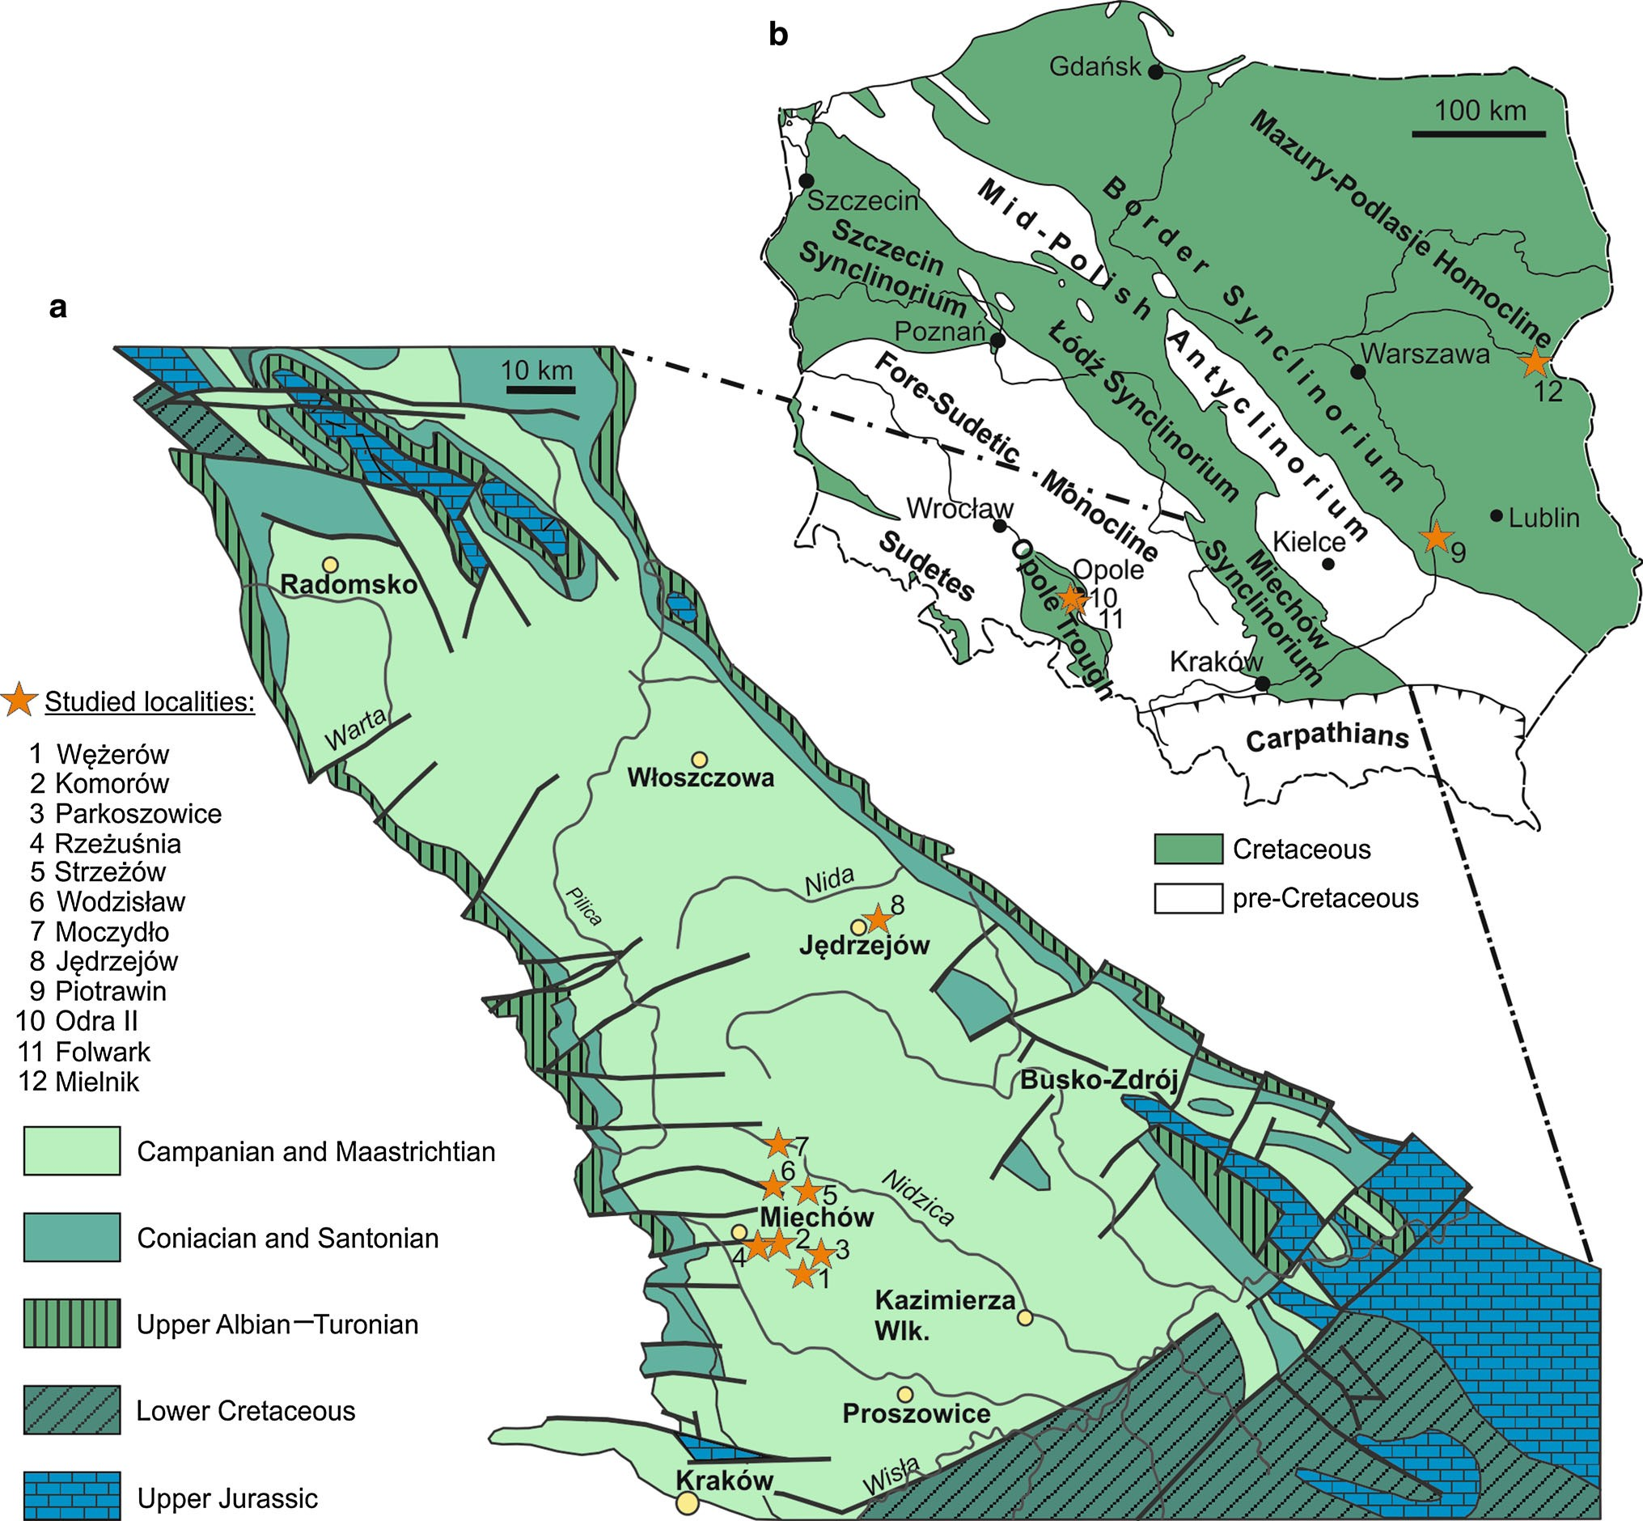
The trace fossilLepidenteron lewesiensis: a taphonomic window
797
Fig. 1 Location of sections withLepidenteron lewesiensis(Mantell1822).aGeologicalmapofMiecho´wSynclinorium(Dadlezetal.2000; Jurkowska and Uchman2013; modified). b Tectonic sketch mapofPolandwithouttheCenozoiccoveroutsidetheCarpathians
Poz_aryski1974;Z_elaz´niewicz2008;
(after Jaskowiak et al.1968;
Z_elaz´niewiczetal.2011;JurkowskaandUchman2013;changed)
Campanian–Lower Maastrichtian succession reaches about 300–400 m (Rutkowski1965; Heller and Moryc1984) and represents siliceous limestones (opokas) with marly inter- calations and cherts in the lower part.
The specimens ofLepidenteron lewesiensiswere col- lected in eight sections (Fig.3), where they are relatively common (Jurkowska and Uchman2013). Seven of them,i.e.,theRzez_us´nia,Parkoszowice,We˛z_ero´w,Komoro´w,Moczydło,Strzez_o´w,andWodzisławsections,arelocatedinthesouthernpartoftheMiecho´wTrough,whiletheJe˛drzejo´wsectionissituatedinitsnorthernpart(theGPS
coordinates and lithological details from these sections were described by Jurkowska and Uchman2013). The specimens come from the ‘Inoceramus’azerbaydjanen-
sis—‘I.’vorhelmensis,
‘I.’tenuilinetaus,Sphaeroceramus
pertenuformis, ‘I.’inkermanensis, ‘I.’costaceus—‘I.’redbirdensis,Endocostea typicazones (Fig.3).
IntheRzez_us´nia,We˛z_ero´w,Komoro´wandMoczydłosections, fossils are relatively abundant, dominated by hexactinellid sponges. Less common are lithistid sponges,bivalves,gastropodsandechinoids.IntheStrzez_o´w,Parkoszowice and Wodzisław sections, the depositsare
13

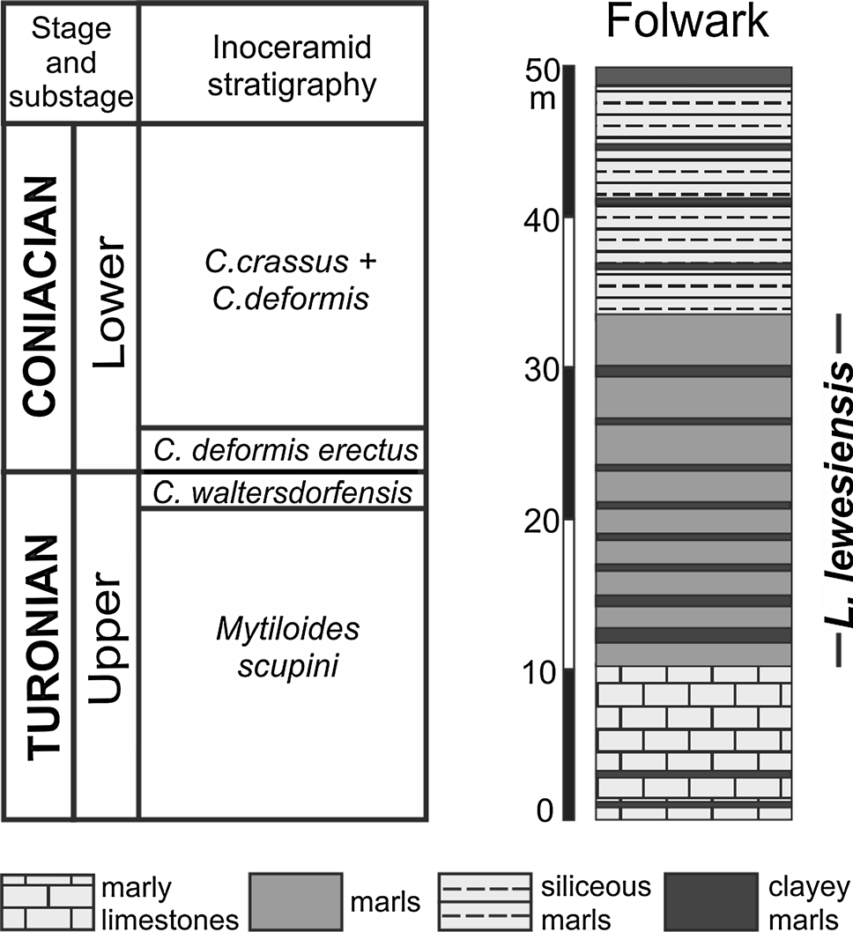
M.Bien´kowska-Wasiluketal.
798
Fig. 3
GeologicalcolumnofthestudiedsectionsintheMiecho´wc
S´wierczewska-Gładyszand
Synclinorium (after Jagt et al.2004;
Jurkowska2013; Jurkowska2014), the Border Synclinorium (after Walaszczyk2004), and part of the Mielnik section withLepidenteronlewesiensis(Mantell1822)
Lepidenteron lewesiensisis common, mostly in the upperpart of the section (‘I.’inkermanensisZone).
Mazury-Podlasie Homocline
The Mielnik section is located in the large, active Mielnik Quarry (Fig.1b), which displays a 30 m thick successionofCampanian–Maastrichtianwhitechalk(Gaz´dzicka1981;Peryt1981; Olszewska1990; Olszewska-Nejbertand
S´wierczewska-Gładysz2011).ThespecimensofLepiden-
teron lewesiensiswere collected only from upper part of the section, from the lower Middle Campanian (middlepart of the ‘Inoceramus’azerbaydjanensis—‘I’vorhelmensisZone (Z. Dubicka, pers. comm. 2014); (Fig.3). Fossils are rare,representedmainlybyhexactinellidsponges(Ol-
and S´wierczewska-Gładysz
szewska-Nejbert
2011),
belemnites (Olszewska1990), brachiopods (Bitner and Pisera1979), and bivalves.
Fig. 2
Geological column of studied sections in the Opole Trough
(lithology after Olszewska-Nejbert2007—simplified, with locationofthe trace fossilLepidenteron lewesiensis(Mantell1822); inoceramid stratigraphy after Walaszczyk1988,1992; Walaszczyk and Wood1998; Walaszczyk and Cobban2000a,b)
Materials and methods
very fossiliferous with abundant inoceramid and pectinid bivalves, sponges (mainly hexactinellids), gastropods andechinoids.
The studied collection ofLepidenteron lewesiensiscom- prises 53 specimens. Details of the fish remains were analyzed under a stereoscope microscope at the Institute of Geology of the Warsaw University. The studied specimens are kept at the Institute of Geological Sciences of the
SE part of the Border Synclinorium
Jagiellonian
University,
Krako´w,
collection
no
In the SE part of the Border Synclinorium (Fig.1b), theUpper Cretaceous succession is best exposed in the Middle
Vistula River section (e.g.,Poz_aryski1938; MarcinowskiandRadwan´ski1983;S´widrowska2007;Voigtetal.2008).
The specimens studied come from an inactive quarry lo- cated on the eastern bank of the Vistula river (Fig.1b), c. 500 m to the south of the village of Piotrawin, where the Upper Campanian siliceous limestones (opokas; the so- called Piotrawin Opoka after Walaszczyk2004), c. 30 m thick, crop out (Fig.3). The lower part of the succession corresponds to the ‘Inoceramus’altusZone, whereas the middle and upper parts belong to the ‘Inoceramus’inker-
manensisZone (Walaszczyk2004, 2012). The mostabundantfossilsaresiliceoussponges(S´wierczewska-
Gładysz2006,2012a;S´wierczewska-GładyszandJur-kowska2013), ammonites (Błaszkiewicz1980;Machalski
2012), belemnites (Kongiel1962; Remin2012), inoce- ramids (Walaszczyk2004), bivalves, and gastropods (Ab- del-Gawad1986,1990). The nautiloids, echinoids, brachiopods, and solitary corals also are numerous.
INGUJ220P/L/1–53, comparative material ofDercetisis kept in the Natural History Museum in Wien (NHMW).
The trace fossilLepidenteron lewesiensis
The specimens ofLepidenteron lewesiensisdescribed here are fragments of horizontal or oblique, simple, tubular, straight or slightly curved burrows, which are elliptical in cross section, 0.9–3.5 cm in width and 4–15 cm long. Every specimen contains fish scales, vertebrae, and bones of the head (see Fig.4). Fin rays are more difficult to recognize, but they were found in a few specimens. The specimens studied contain from one to four types, mostly two types of scales. Every type, except in one case, refers to a separate taxon of fish. Scales, vertebrae and bones of the head are disarticulated and displaced. They are con- centrated close to the lower margin of the burrow. The scales (Figs.4,5) are thin, in both cycloid and ctenoid forms, or thick in the form of scutes (bony plates). Only one specimen contains a few articulated vertebrae (Fig.5i).
13

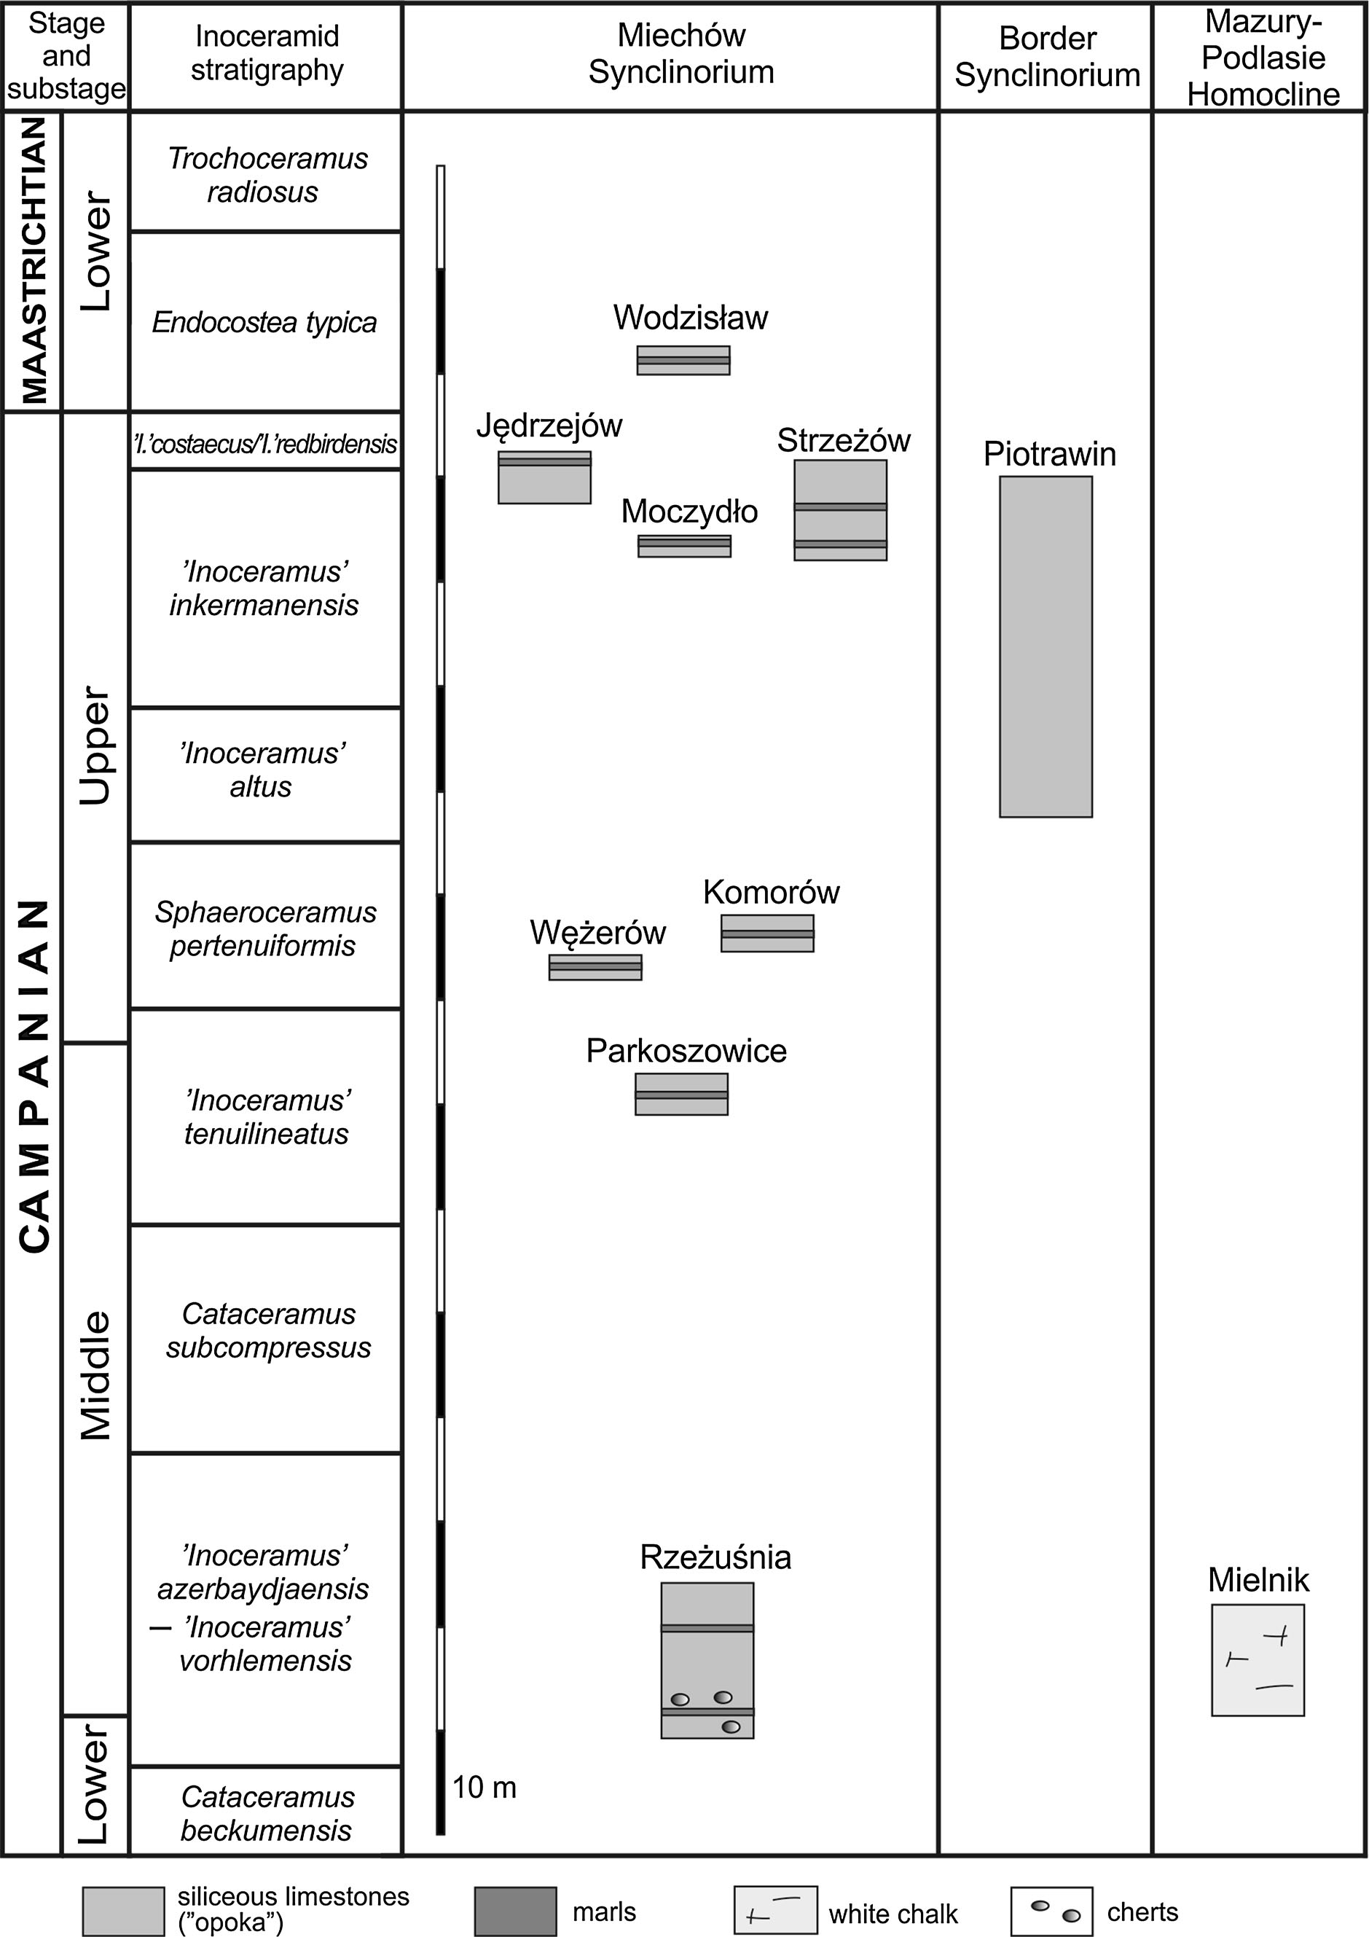
The trace fossilLepidenteron lewesiensis: a taphonomic window
799
13

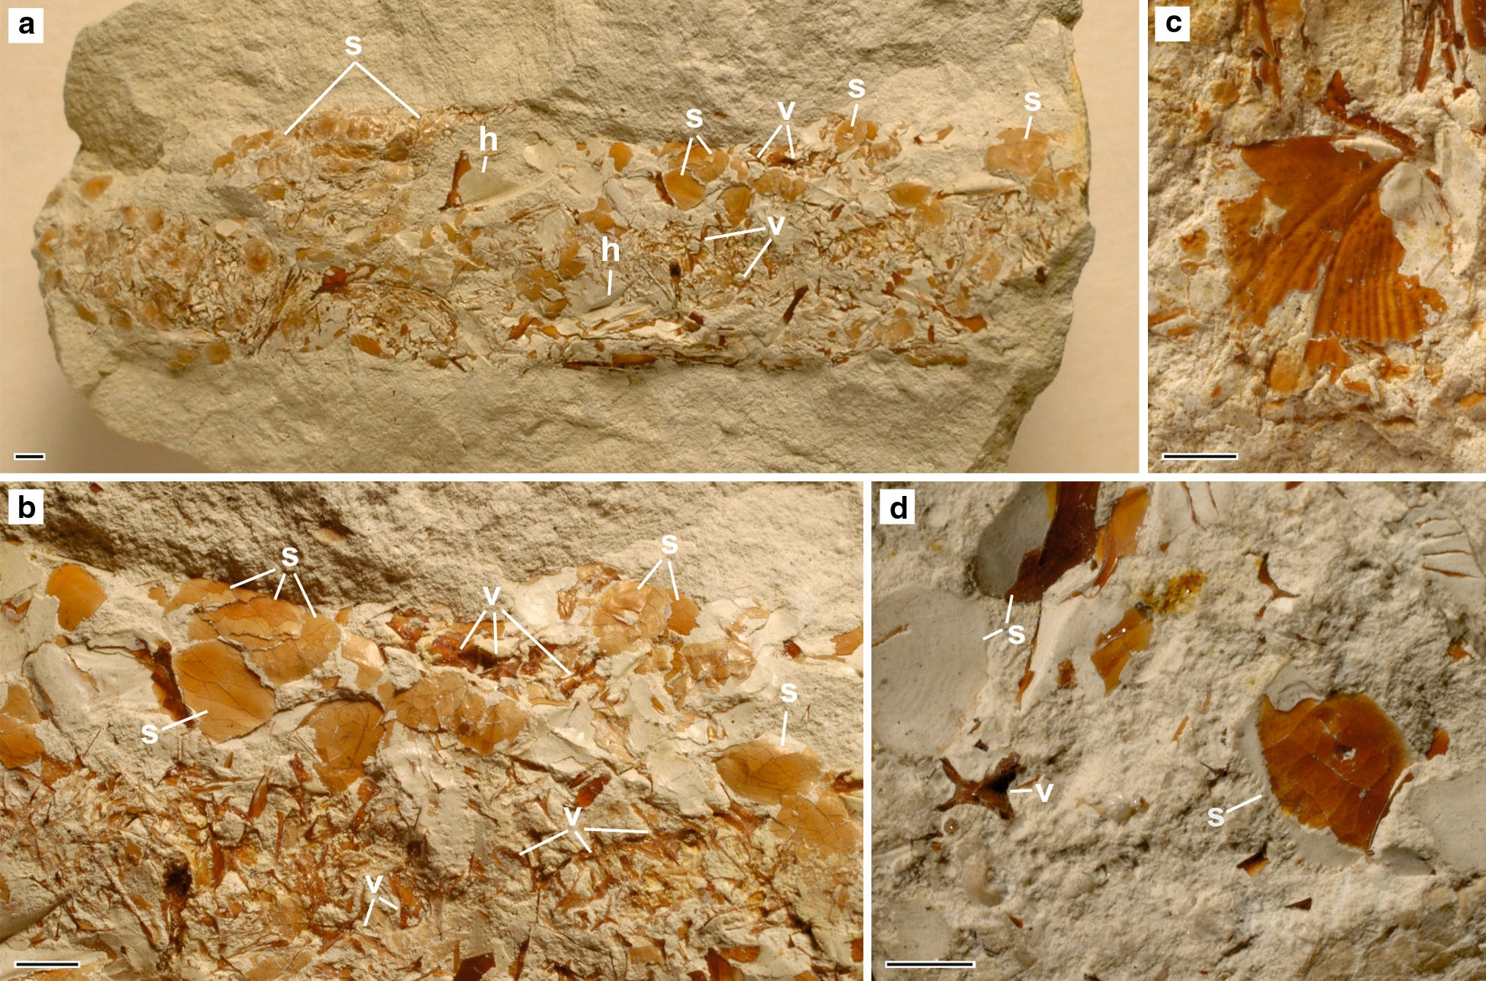
M.Bien´kowska-Wasiluketal.
800
IntheMiecho´wSynclinorium,Lepidenteronlewe-
siensis, calledalso ‘‘Terebella’’ (fortaxonomysee Suhr1988)occursin thetransition fromthedistalCruzianato theZoophycosichnofaciesintotallybioturbatedmarls, whichaccumulatedindeeper waters beyondtherangeoftempestites (Jurkowska and Uchman2013). Abundant hexactinellid sponges, co-occurringinallstudied stages withtheLepidenteron lewesiensisalsoindicateacalm-water environmentof adeeper shelfand aslow rateofsedimentation(e.g.,Olszewska-Ne-
jbertandS´wierczewska-Gładysz2011;S´wierczewska-
Fig. 5 Identified fish remains from the trace fossil
Lepidenteronc
lewesiensis. a Teleostei indet., cycloid scale, type 1 and 2; Piotrawin, INGUJ220P/L/33. b Teleostei indet., cycloid scale, type 3; Piotrawin, INGUJ220P/L/37. c Clupeocephala indet., ctenoid scale, type 1;Strzez_o´w,INGUJ220P/L/20.d,eClupeocephalaindet.,ctenoidscale, type2;Strzez_o´w,INGUJ220P/L/22.fClupeocephalaindet.,ctenoidscale,type3;Strzez_o´w,INGUJ220P/L/7.g,hClupeocephalaindet., ctenoid scale, type 4; Piotrawin, INGUJ220P/L/42. b–g anterior margin of scale oriented down; h view of the lower margin of a subhorizontal burrow. i Dercetidae indet., isolated flank scutes (s)andvertebrae(v)andTeleosteiindet.,cycloidscales(c);Komoro´w,INGUJ220P/L/11, view of the lower margin of a subhorizontal burrow. j, k Dercetidae indet., flank scute, posterior margins orienteddown;jKomoro´w,INGUJ220P/L/11,kWe˛z_ero´w,INGUJ220P/L/3.lDercetis triqueter, articulated flank scutes and vertebrae, posterior part of body, lateral view; Lebanon, NHMW 2014/0327/0001. m, n Euteleostei indet., thick scutes; Wodzisław, INGUJ220P/L/4, medial view of scutes. o Euteleostei indet., thick scutes and bones of indeterminate Teleostei; lateral view of dentary (d); supposed opercle (op?) and supposed preopercle (pop?),Wodzisław,
b;S´wierczewska-Gładysz
Gładysz2012a, kowska2013).
and
Jur-
Lepidenteron lewesiensisis interpreted as a burrow of a predator or scavenger of fishes and the fish debris, which accumulated fish debris as waste after feeding. The trace- maker is not certain, but eunicid polychaetes or anguillid
INGUJ220P/L/4, views of burrow.Scale bars2 mm
the
lower
margin
of
a
subhorizontal
fishes
were
considered
as
possible
candidates,
while
Fig. 4 Fish remains in the
trace fossilLepidenteron lewesiensis
(v) and scales (s); Piotrawin, INGUJ220P/L/38. c Opercle; Piotrawin, INGUJ220P/L/22, medial view. d Vertebrae (v) and ctenoid scales (s);Piotrawin,INGUJ220P/L/42.Scalebars2mm
(Mantell1822) in the Middle Vistula River section; views of the lower margin of a subhorizontal burrows. a Fish scales (s), bones of a head (h) and vertebrae (v); Piotrawin, INGUJ220P/L/38. b Vertebrae
13

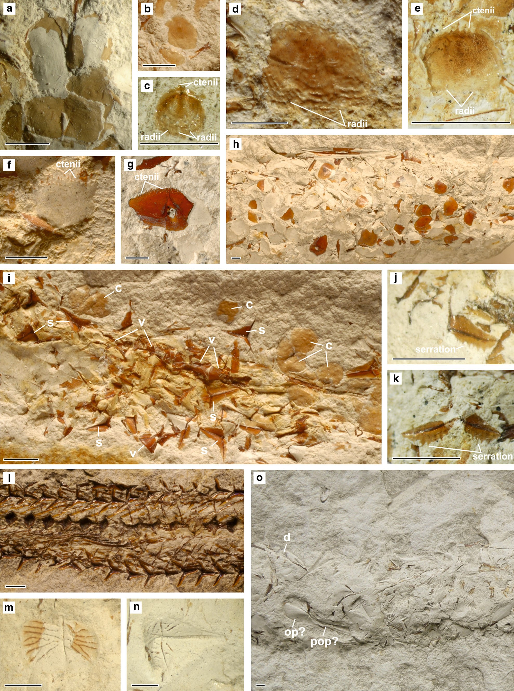
The trace fossilLepidenteron lewesiensis: a taphonomic window
801
13

M.Bien´kowska-Wasiluketal.
802
stomatopod crustaceans have been rather eliminated (Jur-kowska and Uchman2013).
1–5 mm in diameter, thin, with ctenii at the margin, with two radii (Fig.5d, e); (3) thin, about 5 mm in diameter with about one-third of the scale covered by ctenii (Fig.5f); (4) thick, about 5 mm with ctenii near the margin (Fig.5g, h). Two more types are present, but they were too poorly preserved to describethem.
Fishes fromLepidenteron lewesiensis
Super-class Actinopterygii Cope1887Infraclass Neopterygii Regan1923
DivisionTeleosteiMu¨ller1845(sensuPattersonandRosen1977)
Remarks: Many taxa have ctenoid scales. They are typical of advanced teleosts, acanthopterygians, but are also pre- sent in many lower teleosteans such as Characiformes or Myctophiformes (Roberts1993). In the same burrow, type 2 is accompanied by an opercle (Fig.4c) that resembles these belonging toEnchodus,Enchelurus,Hoplopteryx, orOsmeroides(see Cockerell1919; Woodward1902–1912; Patterson1964). The presence of six types of scales is referred to six taxa of fishes. More precise identification of the ctenoid scales from the study area must await the dis- covery of diagnostic skeletal remains.
Teleostei indet.
Figures4a, b and5a, b, i
Description: Cycloid scales, very thin, transparent, 2–5mm indiameter,theoverallshapecircular,ovalandrectangular. We observed three types: (1) oval, about 3 mm in diameter (Fig.5a);(2)rectangular,about3mmwide,withlateralline canal(Fig.5a);(3)circular,2–5mmindiameter(Fig.5b,i). Types 1 and 2 probably belong to the same taxon. Type 3 probably represents a few taxa, but the poor state of preser- vation does not permit a closerinterpretation.
Occurrence: Upper Turonian to Lower Coniacian—Fol- wark, type unnumbered (M.scupiniZone–C.waltersdor-fensis waltersdorfensisZone); Middle Campanian— Mielnik; type unnumbered (‘I.’azerbaydjanensis–‘I.’vorhelmensisZone),Rzez_us´niatype unnumbered (‘I.’azerbaydjanensis–‘I.’vorhelmensisZone), Parkoszowice, type 2 (‘I.’tenuilineatusZone), Upper Campanian—Pio- trawin; type 4 (‘I.’altusZone–‘I.’inkermanensisZone), Moczydło type unnumbered (‘I.’inkermanensisZone),Strzez_o´w;type1,2,3,twomoretypespossible(‘I.’inkermanensisZone)andJe˛drzejo´w;type2(‘I.’inkerma-nensisZone–‘I.’costaecus–‘I.’redbirdensisZone).
Remarks: Many telost taxa have cycloid scales. They are typical of primitive teleosts but are also present in many highly advanced ones. Type 1 could belong to ichthyodec- tiform orOsmeroides(see Geinitz1868; Fielitz1996), it resembles the recent salmoniformOncorhynchusand gadi- formMicrogadus(Patterson et al.2002). Some circular scales classified here in type 3 resemble scales of the Cre- taceousCyclolepisthat is sometimes synonimized withAu-lolepis(see Geinitz1868; Fritsch1878; Cockerell1919) or recentOsmeridae(Pattersonetal.2002).Thethreeformsof scales refer to at least two taxa of fishes. More precise identification of the cycloid scales from the study areamust await the discovery of diagnostic skeletalremains.
Sub-cohorte Euteleostei Greenwood et al.1966Order Aulopiformes Rosen1973
Family Dercetidae Pictet1850
Occurrence: Upper Turonian to Lower Coniacian—Fol- wark (M.scupiniZone–C.waltersdorfensis waltersdor-fensisZone); Middle Campanian—Parkoszowice (‘I.’tenuilineatusZone) and Mielnik (‘I.’azerbaydjanensis–‘I.’
Dercetidae indet. Figure5i–k
Description: A few vertebrae, some of them articulated and isolated tri-radiate flank scutes. Scutes, about 4 mm across, display serration on two posterior margins (Fig.5j, k). Vertebrae are elongate with hourglass-like profile (Fig.5i).Remarks: The fishes were about 25 cm long as can be es- timated by comparing the size of scutes and the total length ofDercetis triqueterPictet1850. The flank scutes differs fromNardodercetis vandewallei(Taverne2005a) andOphidercetis italiensis(Taverne2005b) known from Campanian–Maastrichtian of Italy andDercetis(Fig.5l), because they have serration on the posterior margins. Tri- radiate scutes have the recent pufferfish of the family Te- traodontidae and the porcupinefish of the family Diodon- tidae (see Williams et al.2012; fig. 2), but only one diodontid preserved as dental plate is known from the Cretaceous (Gallo et al.2009). The diversity of
vorhelmensis
Zone);
Upper
Campanian—Komoro´w
(S.pertenuiformisZone), Moczydło (‘I.’inkermanensisZone),Strzez_o´w(‘I.’inkermanensisZone)andPiotrawin(‘I.’inkermanensisZone–‘I.’costaceus–‘I.’redbirdensisZone); Lower Maastrichtian—Wodzisław (E.typicaZone).
Cohort Clupeocephala Patterson and Rosen1977
Clupeocephala indet. Figure5c–h
Description: Ctenoid scales, very thin to thick, 1–5 mm in diameter, the overall shape circular, oval, triangular, rect- angular or pentagonal. Four different types are easily dis- tinguishable: (1) small, about 1 mm in diameter, thin, with ctenii at the margin, with three radii (Fig.5c); (2) thin
13

The trace fossilLepidenteron lewesiensis: a taphonomic window
803
Tetraodontiformes from the Cretaceous is low; so far only three familes, i.e., Cretatriacanthidae, Plectocretacicidae, and Protriacanthidae, were recognized (Tyler and Sorbini1996; Santini and Tyler2003). The described herein tri- radiate scutes were not reported in Tetraodontiformes from the Cretaceous. Elongate shape of vertebrae is character- istic of Dercetidae, but the well-developed transverse processes typical of this family are not visible, probably they were broken or they are hidden in the matrix. The family Dercetidae is ranging from the Late Cretaceous (Cenomanian) to the Paleocene (Danian); its members are common in Tethyan deposits of Europe, in Asia, Africa, South America and Central America (Gallo et al.2005). More precise identification of the tri-radiate scutes fromthe study area must await the discovery of diagnostic skeletal remains.
Piotrawin (‘I’.altusZone–‘I.’inkermanensisZone)andStrzez_o´w(‘I.’inkermanensis);LowerMaastrichtian—Wodzisław (E. typicaZones).
Discussion
The trace fossilLepidenteron lewesiensiscontains some head bones such as opercles, preopercles, jaws, and fron- tales, but we did not find diagnostic features that allow taxonomic assignments. As there is considerable variation in scale shape and size even between different body parts of the same fish species, scale outline is not the best indicator for estimation of fish size. All scales were in size between 1 and 7 mm. The jaw bones suggest that the jaws were 1–2.5 cm long. Opercles are 0.5–1 cm high. Com- paring those sizes with the length of the body of some Cretaceous fishes, such asDercetis,Hoplopteryx,Berycopsis, the estimated length of fishes from the studied burrows ranges from a few cm to about 25 cm, and the height of their body ranges from about 1 cm to a few centimeters.
The burrows contain remains of one to four fish taxa, similarly to the observations from the Upper Cretaceous of England by Davies (1879), who stated that the burrows contain remains of a few individuals. The low diversity of fishes in burrow can indicate that the tracemaker was a selective predator and/or scavenger, or only a few fish taxa were available as food. It is less probable that the trace- maker used dispersed fish remains that could lay on the sea floor, because a higher diversity of fishes would be ex- pected in such a case.
Taking into account the estimated size of the fishes, it was possible that they were pulled into the burrow. This allowed preservation of scales and bones. The fish remains do not have signs of dissolution or abrasion. It seems that the studied fish remains did not pass through the digestive system of the tracemaker, which would have swallowedthe fish, but rather the fish body was peeled piece by piece and the scales and bones were accumulated as a waste. This excludes rather anguillid fishes as the tracemakers (see Jurkowska and Uchman2013), but favors animalswith catching body appendages, such as crustaceans or a predator with sharp appendages, like the bobbit worm (eunicidpolychaete).
Tracemakers fed on teleosteans with cycloid and cte- noid scales, and with scutes. It was either a predator, living hidden in sediment and hunting on fishes or a scavenger, feeding on fish carcasses. The trace marker had skeletal elements from at least ten taxa of teleostean fishes. Two of them were classified as the undetermined teleostans, six were ascribed to undetermined Clupeocephala, one to Dercetidae, and one to undetermined euteleostean.
Occurrence: Upper Turonian to Lower Coniacian—Fol- wark (M.scupiniZone–C.waltersdorfensis waltersdor-fensisZone);UpperCampanian—Komoro´wandWe˛z_ero´w(S.pertenuiformisZone).
Euteleostei indet. Figure5m–o
Description: Thick scutes with ornamentation (ridges and tubercles), 3–5 mm wide, the overall shape rectangular and diamond-like.
Remarks: Such ornamented scutes with ridges and tuber- cles are typical of many representatives of Gas- terosteiformes, especially the pipefishes and seahorses (Syngnathidae). Co-occurring bones, probably opercle and preopercle, also resemble these belonging to Syngnathidae (Fig.5o) (see Jungersen1910). The oldest representativeof the order, i.e.,Gasterorhamphosus zuppichiniiSorbini1981, comes from the Upper Cretaceous and does not have scutes. The oldest representative of the Syngnathidae comes from Eocene (Patterson1993). Ornamented scutes with ridges and tubercles display also the Cretaceous Te- traodontiformes (Tyler and Sorbini1996), but the analyzed scutes are not similar to them. As presented here, thescutes are different from aulopiform dercetid scutes that typically show a heart-shaped or tri-radiate form. They are also different from scutes of the aulopiformCimolichthysandEnchodus, that are hexagonal and rounded plates (see Woodward1902–1912), respectively. Also the acantho- morph teleosts from the Cretaceous have scutes (seeGonza´lez-Rodr´ıguezetal.2013),buttheyarenotsimilartothe studied material. More precise determination of those scutesawaitsthediscoveryofbetterpreservedmaterial.
Occurrence:UpperTuroniantoLowerConiacian—Folwark (M.scupiniZone–C.waltersdorfensis waltersdorfensisZone);UpperCampanian—Komoro´w(S.pertenuiformis),
13

M.Bien´kowska-Wasiluketal.
804
Preservation potential of fish remains in burrows washigher, because they were hidden from scavengers andprotected by the tracemaker. Moreover, the possible low- ered oxygenation within the burrow and possible action of microbes in the specific geochemical environment of bur-rows (e.g., Aller and Aller1986; Lalonde et al.2010) can conserve the fish remains. We do not expect any special geochemical conditions in the basins, because strong bio-turbation (Jurkowska and Uchman2013) points to good oxygenation conditions on the sea floor (which can cause quick decomposition of organic matter) andstenohalinefauna (e.g., ammonites, abundant inoceramids, andplanktic foraminifers) suggest a normal, stable salinity. Therefore,the trace fossilLepidenteron lewesiensis(Mantell1822) provides a taphonomic window on the diversity of fishes as shown for the Upper Cretaceous of Poland. Althoughtaxonomic assignment of the fish remains is not precise in the present state of study, probably new material in thefuture can provideinformation.
Abdel-Gawad, G.I. 1990. Some gastropods from the upper Campa- nian of the middle Vistula Valley, Central Poland.ActaGeologica Polonica40(1–2): 97–110.
Agassiz, L. 1833-1843.Recherches sur les poissons fossiles, vol. 5.
Neuchaˆtel:Petitpierre.
Alexandrowicz, S.W., and D. Radwan. 1973. Kreda opolska—problematykastratygraficznaizłoz_owa.Przegla˛dGeologiczny20(4):183–188.
Aller, J.Y., and R.C. Aller. 1986. Evidence for localized enhancement of biological activity associated with tube and burrow structures in deep-sea sediments at the HEBBLE site, western North Atlantic.Deep Sea Research, Part A33(6A): 755–790.
Allison, P.A., and D.E.G. Briggs. 1991. Taphonomy of nonmineral- ized tissues. InTaphonomy: releasing the data locked in fossilrecord, Topics in Geobiology, vol. 9, ed. P.A. Allison, and
D.E.G. Briggs, 25–70. New York: Plenum Press.
Bather, F.A. 1911. Upper Cretaceous terebelloids from England.
Geological Magazine8: 481–487 and 549–556.
Behrensmeyer, A.K. 1991. Terrestrial vertebrate accumulations. In Taphonomy: releasing the data locked in fossil record,Topics inGeobiology, Volume 9, eds P.A. Allison and D.E.G. Briggs, 291–335.
Bitner, A.M., and A. Pisera. 1979. Brachiopods from the Upper Cretaceous chalk of Mielnik (Eastern Poland).Acta GeologicaPolonica29(1): 67–88.
Błaszkiewicz, A. 1980. Campanian and Maastrichtian ammonites ofthe Middle Vistula River Valley, Poland; a stratigraphic-paleontological study.Prace Instytutu Geologicznego42: 1–63.Cockerell, T.D.A. 1919. Some American Cretaceous fish scales, withnotes on the classification and distribution of Cretaceous fishes.
United States Geological Survey Professional Paper120: 165–202.
Cope, E.D. 1887. Geology and paleontology.American Naturalist
21(11): 1014–1019.
Dadlez, R., S. Marek, and J. Pokorski. 2000.Geological map ofPoland without cenozoic deposits, scale 1:1,000,000. Warszawa:Pan´stwowyInstytutGeologiczny.
Davies, W. 1879. On some fish exuviae from the Chalk, Generally referred toDercetis elongatusAG; And on the new species offossil Annelide,Terebella lewesiensis.Geological Magazine6: 145–148.
Ekrt,B.,M.Kosˇˇta´k,M.Mazuch,S.Voigt,andF.Wiese.2008.New
records of teleosts from the Late Turonian (Late Cretaceous) ofthe Bohemian Cretaceous basin (Czech Republic).CretaceousResearch29: 659–673.
Fielitz, C. 1996. A late Cretaceous (Turonian) ichthyofauna from Lac des Bois, Northwest Territories, Canada, with paleobiogeo- graphic comparisons with Turonian ichthyofaunas of theWestern Interior Seaway.Canadian Journal of Earth Sciences33:1375–1389.
Fritsch,A.,1878.DieReptilienundFischederbo¨hmischenKreide-formation. Author published, Prag, Verlag des Verfrassers—InCommissionBeiFr.Rˇivna´cˇ,69pp.
Gallo, V., M.S.S. de Carvalho, and A.A. Suto. 2009. A possible occurrence of Diodontidae (Teleostei, Tetraodontiformes) inUpper Cretaceous of the Para´ıba Basin, northeastern Brazil.Cretaceous Research30(3): 599–604.
Gallo,V.,F.J.deFigueiredo,andH.M.A.daSilva.2005.Ana´lisefilogene´ticadosDercetidae(Teleostei,Aulopiformes).ArquivosdoMuseuNacional,RiodeJaneiro63(2):329–352.
Gaz´dzicka,E.1981.Coccolithsandindexforaminiferafromtheupper Cretaceous chalk of Mielnik region, Eastern Poland.ActaPalaeontologica Polonica26(1): 73–84.
Geinitz,H.B.1868.DiefossilenFischschuppenausdemPla¨nerkalkeinStrehlen.DenkschriftenderGesellschaftfu¨rNaturkundeundHeilkunde in Dresden2: 1–18.
Conclusions
The trace fossilLepidenteron lewesiensis(Mantell1822) occurs in Poland in the Middle Turonian–LowerMaas- trichtian deposits, which accumulated in a calm-water en- vironmentwithaslowrateofsedimentationofadeepershelf beyondtherangeoftempestites.Itcontainsscalesoftentaxa of teleostean fishes: two undetermined teleostans, sixunde- termined Clupeocephala, one Dercetidae, and one undeter- mined euteleostean. It also contains vertebrae and bones of heads of undetermined teleosteans. The preservation offish remains suggests that fish bodies were fragmented piece by piece by an animal, probably by an eunicidpolychaete.
Acknowledgments We are very grateful to Dr. Lionel Cavin (Geneva) and the anonymous reviewer for constructive comments on an earlier version of the manuscript. Additional support was provided by the Jagiellonian University (DS funds), National Science Center (Grant Number: PRO-2011/01/N/ST10/07717), and the Laboratory of Geology(UniversityofLodz)BStGrantNo.560/844.Wearegrateful to Dr. Johann Egger (Wien) and Kilian Eichenseer M.Sc. (Erlangen) for help with translating the abstract into German. We are grateful toDr.UrsulaGo¨hlich(Wien)foraccesstotheDercetisspecimen.
Open Access This article is distributed under the terms of the Creative Commons Attribution License which permits any use, dis- tribution, and reproduction in any medium, provided the original author(s) and the sourceare credited.
References
Abdel-Gawad, G.I. 1986. Maastrichtian non-cephalopod molluscs (Scaphopoda, Gastropoda and Bivalvia) of the middle Vistula Valley,CentralPoland.ActaGeologicaPolonica36(1–3):69–224.
13

The trace fossilLepidenteron lewesiensis: a taphonomic window
805
Gonza´lez-Rodr´ıguez,K.A.,H.P.Schultze,andG.Arratia.2013.Miniature armored acanthomorph teleosts from the Albian/ Cenomanian (Cretaceous) of Mexico. InMesozoic fishes 5—global diversity and evolution, ed. G. Arratia, H.P. Schultze, and
M.V.H.Wilson,457–487.Mu¨nchen:VerlagDr.FriedrichPfeil.Greenwood,P.H.,D.E.Rosen,S.H.Weitzman,andG.S.Myers.1966.Phyleticstudiesofteleosteanfishes,withaprovisionalclassi-ficationoflivingforms.BulletinoftheAmericanMuseumof
Natural History131(4): 339–456.
Hakenberg,M.1986.AlbianandCenomanianintheMiecho´wBasin(Central Poland).Studia Geologica Polonica86: 57–85.
Heller,I.,andW.Moryc.1984.Stratygrafiautworo´wkredygo´rnejPrzedgo´rzaKarpat.BiuletynInstytutuGeologicznego346:63–108.
Jaskowiak,M.,A.Krassowska,S.Marek,andA.Raczyn´ska.1968.Kreda. In Atlas Geologiczny Polski 1:2000000., ed. J. Znosko,Warszawa.
Jagt,J.W.M.,J.Walaszczyk,E.A.Yazykova,andM.Zaton´.2004.
Linking southern Poland and northern Germany: Campaniancephalopods, inoceramid bivalves and echinoids.ActaGeologicaPolonica54(4):573–586.
Jungersen, H.F.E. 1910. Ichthyotomical contributions. II. The struc- ture of the Aulostomidae, Syngnathidae and Solenostomidae.Me´moiresdel’Acade´mieRoyaledesSciencesetdesLettersdeDanemark8: 269–363.
Jurkowska, A. 2014. Stratygrafia inoceramowa i architektura depozy-cjiwyz_szejkredygo´rnejnieckimiechowskiej.UnpublishedPhDThesis,JagiellonianUniversity,Krako´w.
Jurkowska, A., and A. Uchman. 2013. The trace fossilLepidenteronlewesiensis(Mantell, 1822) from the Upper Cretaceous ofsouthern Poland.Acta Geologica Polonica63(4): 611–623.
Ke˛dzierski,M.2008.Calcareousnannofossilandinoceramidbios-tratigraphies of a Middle Turonian to Middle Coniacian sectionfrom the Opole Trough of SW Poland.Cretaceous Research29(3):451–467.
Ke˛dzierski,M.,andA.Uchman.2001.IchnofabricsoftheUpperCretaceous marlstones in the Opole region, southern Poland.Acta Geologica Polonica51(1):81–91.
Kongiel, R. 1962. On belemnites from Maastrichtian, Campanian andSantonian sediments in the Middle Vistula Valley.PraceMuzeum Ziemi5: 1–148.
Ksia˛z_kiewicz,M.1927.Lespoissonsfossilesducre`tace`supe`rieurdesenvironsdeCracovie.Bulletindel’Acade`miePolonaisedesSciences,Se`rieB:979–1006.
Lalonde, S.V., L.T. Dafoe, S.G. Pemberton, M.K. Gingras, and K.O. Konhauser. 2010. Investigating the geochemical impact ofburrowing animals: proton and cadmium adsorption onto themucus lining of terebellid polychaete worms.Chemical Geology271(1–2): 44–51.
Leonhard, R. 1897. Die Fauna der Kreideformation in Oberschlesien.
Palaeontographica44: 11–70.
Machalski, M. 2012. Stratigraphically important ammonites from theCampanian Maastrichtian boundary interval of the MiddleVistula River section, Central Poland.Acta Geologica Polonica62(1): 91–116.
Mantell,G.A.1822.TheFossilsoftheSouthDownsorillustrationsoftheGeologyofSussex,1–327.London:LuptonRelfe.
Mantell, G.A. 1844.The Medals of Creation, or First Lessons inGeology, and in the Study of Organic Remains, Volume 2. London: H.G. Bohn.
Mantell, G.A. 1851.Petrifaction and their Teaching, or a Handbookto the Gallery of Organic Remains of the British Museum.London: H.G. Bohn.
Marcinowski, R. 1974. The transgressive Cretaceous (Upper Albian trough Turonian) deposits of the Polish Jura Chain.ActaGeologica Polonica24: 117–217
Marcinowski,R.,andA.Radwan´ski.1983.Themid-Cretaceoustransgression onto the Central Polish Uplands (marginal part of the Central European Basin).Zitteliana10: 65–95.
Marcinowski,R.,andA.Radwan´ski.1989.Abiostratigraphic
approach to the mid-Cretaceous transgressive sequence of the Central Polish Uplands.Cretaceous Research10(2): 153–172.
Mu¨ller,J.1845.U¨berdenBauunddieGrenzenderGanoidenund
u¨berdasnatu¨rlichenSystemderFische.AbhandlungenderAkademie der Wissenschaften zu Berlin1845 (for 1844): 117–216.
Niedz´wiedzki,R.,andM.Kalina.2003.LateCretaceoussharksinthe
Opole Silesia region (SW Poland).Geologia Sudetica35: 13–24.Olszewska, D. 1990. Belemnites from the Upper Cretaceous Chalk ofMielnik (eastern Poland).Acta Geologica Polonica40(1):
111–128.
Olszewska-Nejbert, D. 2007. Late Cretaceous (Turonian—Coniacian) irregular echinoids of western Kazakhstan (Mangyshlak) and Poland (Opole).Acta Geologica Polonica57(1): 1–87.
Olszewska-Nejbert,D.,andE.S´wierczewska-Gładysz.2011.Cam-
panian (Late Cretaceous) hexactinellid sponges from the white chalk of Mielnik (Eastern Poland).Acta Geologica Polonica61(4): 383–417.
Patterson, C. 1964. A review of Mesozoic acanthopterygian fishes, with special reference to those of the English Chalk.Philo-sophical Transactions of the Royal Society of London. Series B, Biological sciences247(739): 213–482.
Patterson, C. 1993. Osteichthyes: Teleostei. InThe fossil record 2, ed.
M.J. Benton, 621–656. London: Chapman and Hall.
Patterson, C., and D.E. Rosen. 1977. Review of ichthyodectiform and other Mesozoic teleost fishes and the theory and practice of classifying fossils.Bulletin of the American Museum of NaturalHistory158(2): 83–172.
Patterson, R.T., C. Wright, A.S. Chang, L.A. Taylor, P.D. Lyons, A. Dallimore, and A. Kumar. 2002. Atlas of common squamato- logical (fish scale) material in coastal British Columbia and an assessment of the utility of various scale types in paleofisheries reconstruction.Palaeontologia Electronica4(2): 1–88.
Peryt, D. 1981. Planktonic foraminifers and the age of chalk fromMielnik(EastPoland).Bulletindel’Acade´miePolonaisedesSciences,Se´riedesSciencesdelaTerre29(2):137–142.
Pictet,F.J.1850.De´scriptiondequelquespoissonsfossilesduMontLiban.Ge´ne´ve:J.G.Fick.
Poz_aryski, W. 1938. Senons Stratigraphie im Durchbruch derWeichselzwischenRacho´wundPuławyinMittelpolen.BiuletynPan´stwowegoInstytutuGeologicznego6:1–94.
Poz_aryski, W. 1960. An outline of stratigraphy and Palaeogeography of the Cretaceous in the Polish Lowland.Prace InstytutuGeologicznego30: 377–418.
Poz_aryski, W. 1974. Tektonika cz. 1. Niz_Polski. In Budowa geologiczna Polski, IV, ed. W. Poz_aryski, 2–34. Wydawnictwa Geologiczne, Warszawa.
Regan, C.T. 1923. The skeleton ofLepidosteus, with remarks on the origin and evolution of the lower neopterygian fishes.Proceed-ings Zoological. Society London1923: 445–461.
Remin, Z. 2012. The Belemnella stratigraphy of the Campanian- Maastrichtian boundary; a new methodological and taxonomic approach.Acta Geologica Polonica62(4): 495–534.
Roberts, C.D. 1993. Comparative morphology of spined scales and their phylogenetic significance in the Teleostei.Bulletin ofMarine Science52(1): 63–113.
Rosen, D.E. 1973. Interrelationships of higher euteleostean fishes InInterrelationship of Fishes., eds Greenwood, P.H., Miles, R.S., and Patterson, C., 397–513. Zoological Journal of the Linnean Society 53, Supplement 1; London:Academic Press.
Rutkowski, J. 1965. Senon okolic Miechowa.Rocznik PolskiegoTowarzystwa Geologicznego35(1): 1–47.
13

M.Bien´kowska-Wasiluketal.
806
Santini, F., and J.C. Tyler. 2003. A phylogeny of the families of fossil and extant tetraodontiform fishes (Acanthomorpha, Tetraodon-tiformes), Upper Cretaceous to recent.Zoological Journal of theLinnean Society139(4): 565–617.
Scha¨fer,W.1972.Ecologyandpalaeoecologyofmarineenviron-ments.Chicago:TheUniversityofChicagoPress.
Sorbini, L. 1981. The Cretaceous fishes of Nardo. 1. Ordergasterosteiformes (Pisces).Bollettino del Museo Civico di StoriaNaturale di Verona8:1–27. [Zoological Record Volume 119].
Suhr,P.1988.TaxonomieundIchnologiefossilerWohnro¨hrenterebelloiderWu¨rmer.FreibergerForschungshefte419:81–87.
S´widrowska,J.2007.Kredawrejonielubelskim—sedymentacjaijejtektoniczneuwarunkowania.BiuletynPan´stwowegoInstytutu
Geologicznego422: 63–78.
S´wierczewska-Gładysz,E.2006.LateCretaceoussiliceoussponges
from the Middle Vistula River Valley (Central Poland) and theirpalaeoecological significance.Annales Societatis GeologorumPoloniae76(3): 227–296.
S´wierczewska-Gładysz,E.2012a.Hexactinellidspongeassemblages
across the Campanian-Maastrichtian boundary in the MiddleVistula River section, central Poland.Acta Geologica Polonica62(4): 561–580.
S´wierczewska-Gładysz,E.2012b.LateTuronianandEarlyConiacianventriculitid sponges (Lychniscosida) from Opole Trough
(southern Poland) and their palaeoecological significance.
Annales Societatis Geologorum Poloniae82(3): 201–224.
S´wierczewska-Gładysz,E.,andA.Jurkowska.2013.Occurrenceandpaleoecological significance of lyssacinosid sponges in the
Upper Cretaceous deposits of southern Poland.Facies59(4): 763–777.
Tarkowski, R. 1991. Stratigraphy, macrofossils and palaeogeography
Cenozoic, ed. T. McCann, 923–997. London:The Geological Society of London.
Walaszczyk, I. 1988. Inoceramid stratigraphy of the Turonian and Coniacian striata in the environs of Opole (Southern Poland).Acta Geologica Polonica38(1–4): 51–61.
Walaszczyk, I. 1992. Turonian through Santonian deposits ofthe Central Polish Uplands; their facies development, inoceramid paleontology and stratigraphy.Acta Geologica Polonica42(1–2):1–122
Walaszczyk, I. 1997. Biostratigraphie und Inoceramen des oberen Unter-Campan und unteren Ober-Campan. Norddeustchlands.GeologieundPala¨ontologieinWestfalen49:1–111
Walaszczyk, I. 2004. Inoceramids and inoceramid biostratigraphy of the Upper Campanian to basal Maastrichtian of the Middle Vistula River section, central Poland.Acta Geologica Polonica54(1): 95–168
Walaszczyk, I. 2012. Integrated stratigraphy of the Campanian- Maastrichtian boundary succession of the Middle Vistula River (central Poland) section; introduction.Acta Geologica Polonica62(4): 485–493
Walaszczyk, I., and W.A. Cobban. 2000a. Inoceramid faunas and biostratigraphy of the Upper Turonian–Lower Coniacian of the United States Western Interior.Special Papers in Palaeontology64: 1–117.
Walaszczyk, I., and W.A. Cobban. 2000b. Inoceramd faunas and biostratigraphy of the Upper Turonian-Lower Coniacian of the United States Western Interior.Paleontology Special Papers64: 1–117.
Walaszczyk, I., and C.J. Wood. 1998. Inoceramid and biostratigraphy at the Turonian/Coniacian boundary; based on the Salzgitter- Salder Quarry, Lower Saxony, Germany, and the SłupiaNadbrzez_nasection,CentralPoland.ActaGeologicaPolonica48(4):395–434.
Williams, J.T., E. Delrieu-Trottin, and S. Planes. 2012. A new species of Indo-Pacific fish,Canthigaster criobe, with comments onother Canthigaster (Tetraodontiformes: Tetraodontidae) at the Gambier Archipelago.Zootaxa3523: 80–88.
Wilson, M.V.H. 1987. Predation as a source of fish fossils in Eocene lake sediments.Palaios2(5): 497–504.
Woodward, A.S. 1902–1912. The fossil fishes of the English Chalk.MonographofthePalaeontographicalSociety,London,257pp.Z_elaz´niewicz,A.2008.RegionalizacjatektonicznaPolski—stanobecnyipro´bauporza˛dkowania.Przegla˛dGeologiczny56:
887–894.
Z_elaz´niewicz,A.,P.Aleksandrowski,Z.Buła,P.H.Karnkowski,A.Konon,N.Oszczypko,A.S´la˛czka,J.Z_aba,andK.Z_ytko.2011.Regionalizacja tektoniczna Polski. Wrocław: Komitet Nauk Geologicznych PAN.
of the Upper Cretaceous from the
Naukowe AGH, Geologia51: 3–156.Taverne,L.2005a.Lespoissonscre´tace´s
Opole
Trough.Zeszyty
22°.Nardo-
deNardo`.
dercetis vandewalleigen. et sp. nov. (Teleostei, Aulopiformes, Dercetidae).Bollettino del Museo Civico di Storia Naturale diVerona, Geologia Paleontologia Preistoria29: 81–93.
Taverne,L.2005b.Lespoissonscre´tace´sdeNardo`.21°.Ophidercetisitaliensisgen. et sp. nov. (Teleostei, Aulopiformes, Dercetidae).
Unesolutionoste´ologiqueauproble`medesgenresDercetisetBenthesikyme (=Leptotrachelus).Bollettino del Museo Civico diStoria Naturale di Verona, Geologia Paleontologia Preistoria29:55–79.
Tyler, J.C., and L. Sorbini. 1996. New superfamily and three new families of tetraodontiform fishes from the Upper Cretaceous: the earliest and most morphologically primitive plectognaths.Smithsonian Contributions to Paleobiology82:1–59.
Voigt, S., M. Wagreich, F. Surlyk, I. Walaszczyk, D. Ulicny, S. Cech,
T. Voigt, F. Wiese, M. Wilmsen, B. Niebuhr, M. Reich, H.Funk,
J. Michalik, J.W.M. Jagt, P.J. Felder, and A.S. Schulz. 2008. Cretaceous. InGeology of Central Europe, vol. 2: Mesozoic and
13

