
Basic and translational research
OPEN ACCESS
Handling editor Tore K Kvien
► Additional material is
published online only. To view
please visit the journal online
(http://dx.doi.org/10.1136/
annrheumdis-2012-202726).
For numbered affiliations see
end of article.
Correspondence to
Professor Patrick JW Venables,
University of Oxford, Kennedy
Institute of Rheumatology,
65 Aspenlea road,
London W6 8RF, UK;
patrick.venables@kennedy.ox.
ac.uk
Received 24 September 2012
Revised 8 January 2013
Accepted 3 February 2013
Published Online First
5 March 2013
Open Access
Scan to access more
free content
To cite: Quirke A-M,
Lugli EB, Wegner N, et al.
Ann Rheum Dis
2014;73:263-269.
EXTENDED REPORT
Heightened immune response to autocitrullinated
Porphyromonas gingivalis peptidylarginine
deiminase: a potential mechanism for breaching
immunologic tolerance in rheumatoid arthritis
Anne-Marie Quirke,1 Elena Birgitta Lugli,1 Natalia Wegner,1 Bart C Hamilton,2
Peter Charles,1 Muslima Chowdhury,1 A Jimmy Ytterberg,3 Roman A Zubarev,3
Jan Potempa,4,5 Shauna Culshaw,6 Yonghua Guo,5 Benjamin A Fisher,7
Geoffrey Thiele,2 Ted R Mikuls,2 Patrick JW Venables1
ABSTRACT
Background Rheumatoid arthritis (RA) is characterised
by autoimmunity to citrullinated proteins, and there is
increasing epidemiologic evidence linking Porphyromonas
gingivalis to RA. P gingivalis is apparently unique among
periodontal pathogens in possessing a citrullinating
enzyme, peptidylarginine deiminase (PPAD) with the
potential to generate antigens driving the autoimmune
response.
Objectives To examine the immune response to PPAD
in patients with RA, individuals with periodontitis (PD)
and controls (without arthritis), confirm PPAD
autocitrullination and identify the modified arginine
residues.
Methods PPAD and an inactivated mutant (C351A)
were cloned and expressed and autocitrullination of both
examined by immunoblotting and mass spectrometry.
ELISAs using PPAD, C351A and another P gingivalis
protein arginine gingipain (RgpB) were developed and
antibody reactivities examined in patients with RA
(n=80), individuals with PD (n=44) and controls (n=82).
Results Recombinant PPAD was a potent citrullinating
enzyme. Antibodies to PPAD, but not to Rgp, were
elevated in the RA sera (median 122 U/ml) compared
with controls (median 70 U/ml; p<0.05) and PD (median
60 U/ml; p<0.01). Specificity of the anti-peptidyl
citrullinated PPAD response was confirmed by the
reaction of RA sera with multiple epitopes tested with
synthetic citrullinated peptides spanning the PPAD
molecule. The elevated antibody response to PPAD was
abolished in RA sera if the C351A mutant was used on
ELISA.
Conclusions The peptidyl citrulline-specific immune
response to PPAD supports the hypothesis that, as a
bacterial protein, it might break tolerance in RA, and
could be a target for therapy.
INTRODUCTION
There is accumulating evidence that rheumatoid arth-
ritis (RA) is a true autoimmune disease characterised
by disease-specific antibodies to citrullinated protein
antigens (ACPA).1 Citrullinated proteins are generated
by peptidylarginine deiminases (PADs), enzymes that
catalyse the modification of peptidyl-arginine to
peptidyl-citrulline with ammonia as a secondary
product. Because the ACPA response is peptidyl
citrulline-specific, PADs are clearly of importance in
producing the autoantigens which drive autoimmun-
ity in RA.2 Of the five mammalian PADs charac-
terised, PAD2 and PAD4 are associated with
citrullinated proteins in RA as they are expressed in
inflammatory tissue cells involved in the immune
response, including those in synovial tissue.3-5
Recent studies have focussed on a bacterial PAD
expressed by Porphyromonas gingivalis (PPAD).
This bacterium is a major pathogen in periodontitis
(PD), a chronic inflammatory disease of the sup-
porting tissue of the teeth, characterised by proin-
flammatory cytokine production and erosion of
bone. Notably, P gingivalis is the only known peri-
odontal pathogen that expresses a bacterial PAD.
PPAD was originally identified and purified by
McGraw et al6 and subsequently cloned and
expressed by Rodriguez et al.7 Both studies showed
that PPAD differs from human PADs in that it is
not dependent on Ca2+, it is active at higher pH
and preferentially citrullinates C-terminal arginines.
In spite of the similarity between the biochemistry
of PPAD and the human PADs, PPAD is genetically
unrelated to the human PADs beyond being a
member of the guanadino superfamily. Members of
this family share a cysteine at the enzyme binding
site (at position 351 in PPAD) which we and others
have predicted is essential for catalysis.8 A striking
feature of PPAD is that it is autocitrullinated.6 7
Rodriguez et al found that the level of citrullina-
tion, determined by loss of arginine by amino acid
analysis together with colorimetric estimation of
citrulline, was equivalent to two of the 18 arginine
residues in the molecule being citrullinated.
Although this provided convincing evidence that
autocitrullination had occurred, it did not demon-
strate which of the arginine residues had been
citrullinated, in particular, whether internal rather
than C-terminal residues, were modified.
PPAD is often cited as the enzyme which may
explain breakdown in tolerance to citrullinated pro-
teins in RA. The citrullinated peptides generated by
P gingivalis are produced by the combined action
of arginine gingipains (Rgp) cleaving polypetides
into short peptides with C-terminal arginines
Quirke A-M, et al. Ann Rheum Dis 2014;73:263-269. doi:10.1136/annrheumdis-201 2-202726
263
Ann Rheum Dis: first published as 10.1136/annrheumdis-2012-202726 on 5 March 2013. Downloaded from http://ard.bmj.com/ on 4 March 2019 by guest. Protected by copyright.
http://bitly.com/TJ1b1R?r=qr

Basic and translational research
followed by rapid citrullination by PPAD. We have demonstrated
that PPAD can produce citrullinated peptides from two known
autoantigens, fibrinogen and a-enolase.9 It is possible that such
peptides could bypass tolerance because peptides bearing
C-terminal citrullines would not be produced by endogenous
human PADs, such as PAD2 and PAD4. An alternative hypoth-
esis is that PPAD itself, being autocitullinated and a bacterial
antigen, could be the inciting agent.
The current study investigates the extent of autocitrullination
in PPAD using mass spectrometry and examines the immune
response to autocitrullinated PPAD in RA, with C351A as an
uncitrullinated PPAD control.

METHODS
Cloning and expression of recombinant PPAD and gingipain
The full length PPAD coding sequence of P gingivalis W83 was
amplified from genomic DNA using the forward and reverse
primers containing the Kpnl and SacI restriction sites, respect-
ively (CATATC-GGTACC-TGAAAAAGCTTTTACAGGCTAAA
GCCTTGATTC and TCAAATAA-GAGCTC-TTATTTGAGAA
TTTTCATTGTCTCACGGATTC). The PCR product was
digested with Kpnl and SacI, purified and ligated into expression
vector pET-49b(+) (GST-His-tagged) or pET48b(+) with
Thioredoxin-His-tag (Trx-His)(Novagen). The PPAD constructs
were confirmed by nucleotide sequencing and expressed in
Escherichia coli BL21 (DES) strain (see online supplementary
text for further detail). Arginine gingipain (RgpB-6xHis) was
purified by affinity chromatography on Ni-Sepharose from the
culture medium of genetically modified P gingivalis W83 secret-
ing RgpB with the C-terminal hexahistidine-tag.10

Site-directed mutagenesis of PPAD
A PPAD oligonucleotide with a point mutation at the Cys codon
at position 351 in PPAD replacing Cys with Ala was designed
using the 50 and 30 ultrapure primer pair (HYPUR-grade from
MWG Eurofins)—atgccctgcatgcccgtactcacgag and ctgttcctaac-
caaggtgttcctgaag, respectively with 5'-phosphorylation (mis-
match in forward primer creating point mutation is underlined).
The mutated plasmid obtained from PCR was recircularised by
ligation and transformed into NovaBlue E coli cells for plasmid
amplification. The mutant construct was confirmed by commer-
cial nucleotide sequencing and expressed in BL21 (DES) and
purified as described above with a GST-His tag.

SDS-polyacrylamide gel electrophoresis (SDS-PAGE) and
immunoblotting
SDS-PAGE was performed using 4-12% NuPAGE Bis-Tris gels
(Invitrogen); 4x LDS sample buffer and 50 mM DTT (dithio-
threitol) were added to protein samples before denaturing at
70°C for 10 min. Sera were diluted 1:60 for immunoblotting
(see online supplementary text).
Citrullinated proteins were detected using the modified anti-
modified citrulline (AMC) kit (Upstate, Charlottesville, Virginia,
USA) according to the manufacturer’s instructions.

PPAD enzyme activity
The enzyme activity was measured using a colorimetric PAD
activity assay modified from Knipp and Vasak.11 (see online sup-
plementary text).

Mass spectrometry
Recombinant GST-His-tagged PPAD was digested by multiple
proteases. Peptide analysis by mass spectrometry achieved 90%
sequence coverage. Citrullination sites were validated manually
using standard protocols. For details of methods, see online sup-
plementary text.

Anti-PPAD antibody and localisation of PPAD expression
A rabbit polyclonal antibody recognising P gingivalis PAD
(PPAD) was generated by Cambridge Research Biochemicals,
Billingham, UK (see online supplementary text). This antibody
was used to identify the localisation of PPAD expression, using
immunohistochemistry and immunoblotting techniques, follow-
ing the culture of P gingivalis W83 and its cellular fractionation
based on methods of Nyugen et al12 (see online supplementary
text).

Serum samples from patients and control subjects
Serum samples, taken before treatment, were collected from 80
consecutive RA patients enrolled in clinical trials conducted by
the RA investigational network.13 14 The patients with RA satis-
fied the 1987 revised classification criteria,15 75% were women,
91% were anti-CCP (cyclic citrullinated peptide) positive, and
92% RF positive. The 82 age-matched and sex-matched control
volunteers (controls) were selected on the basis of absence of
any obvious joint disease, though they were not screened for
PD. The 44 PD patients attended the dental clinic and were
diagnosed on the basis of at least two periodontal pockets, >5
mm and bone loss on bitewing radiographs, and all were other-
wise in good general health and had no evidence of RA. Raised
antibodies to P gingivalis (titre >800u/ml) were found by
ELISA in 77% PD patients compared with 40% controls.13 All
patients provided written informed consent, and ethical
approval was obtained from the institutional review board of
the University of Nebraska Medical centre. Further details of
subjects can be found in the online supplementary text.

ELISA
The antigens, PPAD, C351A and RgpB, were diluted at 5 pg/ml
in coating buffer (50 mM carbonate buffer, pH 9.5). A 96-well
Nunc MaxiSorp ELISA plate were coated with 100 pl/well
protein solution or with coating buffer alone, and incubated
overnight at 4°C. Wells were washed four times with PBS (phos-
phate buffered saline)-Tween (0.05%) and blocked with 2% BSA
(bovine serum albumin) in PBS for 2 h at RT (room tempera-
ture). Serum was diluted 1:200 in RIA buffer (1% (w/v) BSA,
350 mM NaCl, 10 mM Tris-HCl (pH 7.6), 1% (v/v) Triton
X-100, 0.5% (w/v) Na-deoxycholate, 0.1% (w/v) SDS), added
in duplicates, and incubated for 1.5 h at RT. Plates were washed
as described above and incubated with peroxidase-conjugated
mouse antihuman IgG (1:1000) in RIA-buffer for 1 h at RT.
After a final wash, bound antibodies were detected with tetra-
methylbenzidine substrate (KPL, Gaithersburg, MD). The reac-
tion was stopped after 2 min by the addition of 1 M H2SO4 and
absorbance measured at 450 nm. A standard curve with serial
dilutions of pooled positive serum was used in order to measure
titres in arbitrary units and the 95th percentile of the control
sera was used to determine positivity.
PPAD peptide ELISA procedure was carried out as above with
minor modifications (see online supplementary text).

Statistical analyses
The Mann-Whitney test was used to compare differences
between antibody responses to the specific proteins in serum
samples. Calculations were performed using GraphPad Prism.
264
Quirke A-M, et al. Ann Rheum Dis 2014;73:263-269. doi:10.1136/annrheumdis-2012-202726
Ann Rheum Dis: first published as 10.1136/annrheumdis-2012-202726 on 5 March 2013. Downloaded from http://ard.bmj.com/ on 4 March 2019 by guest. Protected by copyright.

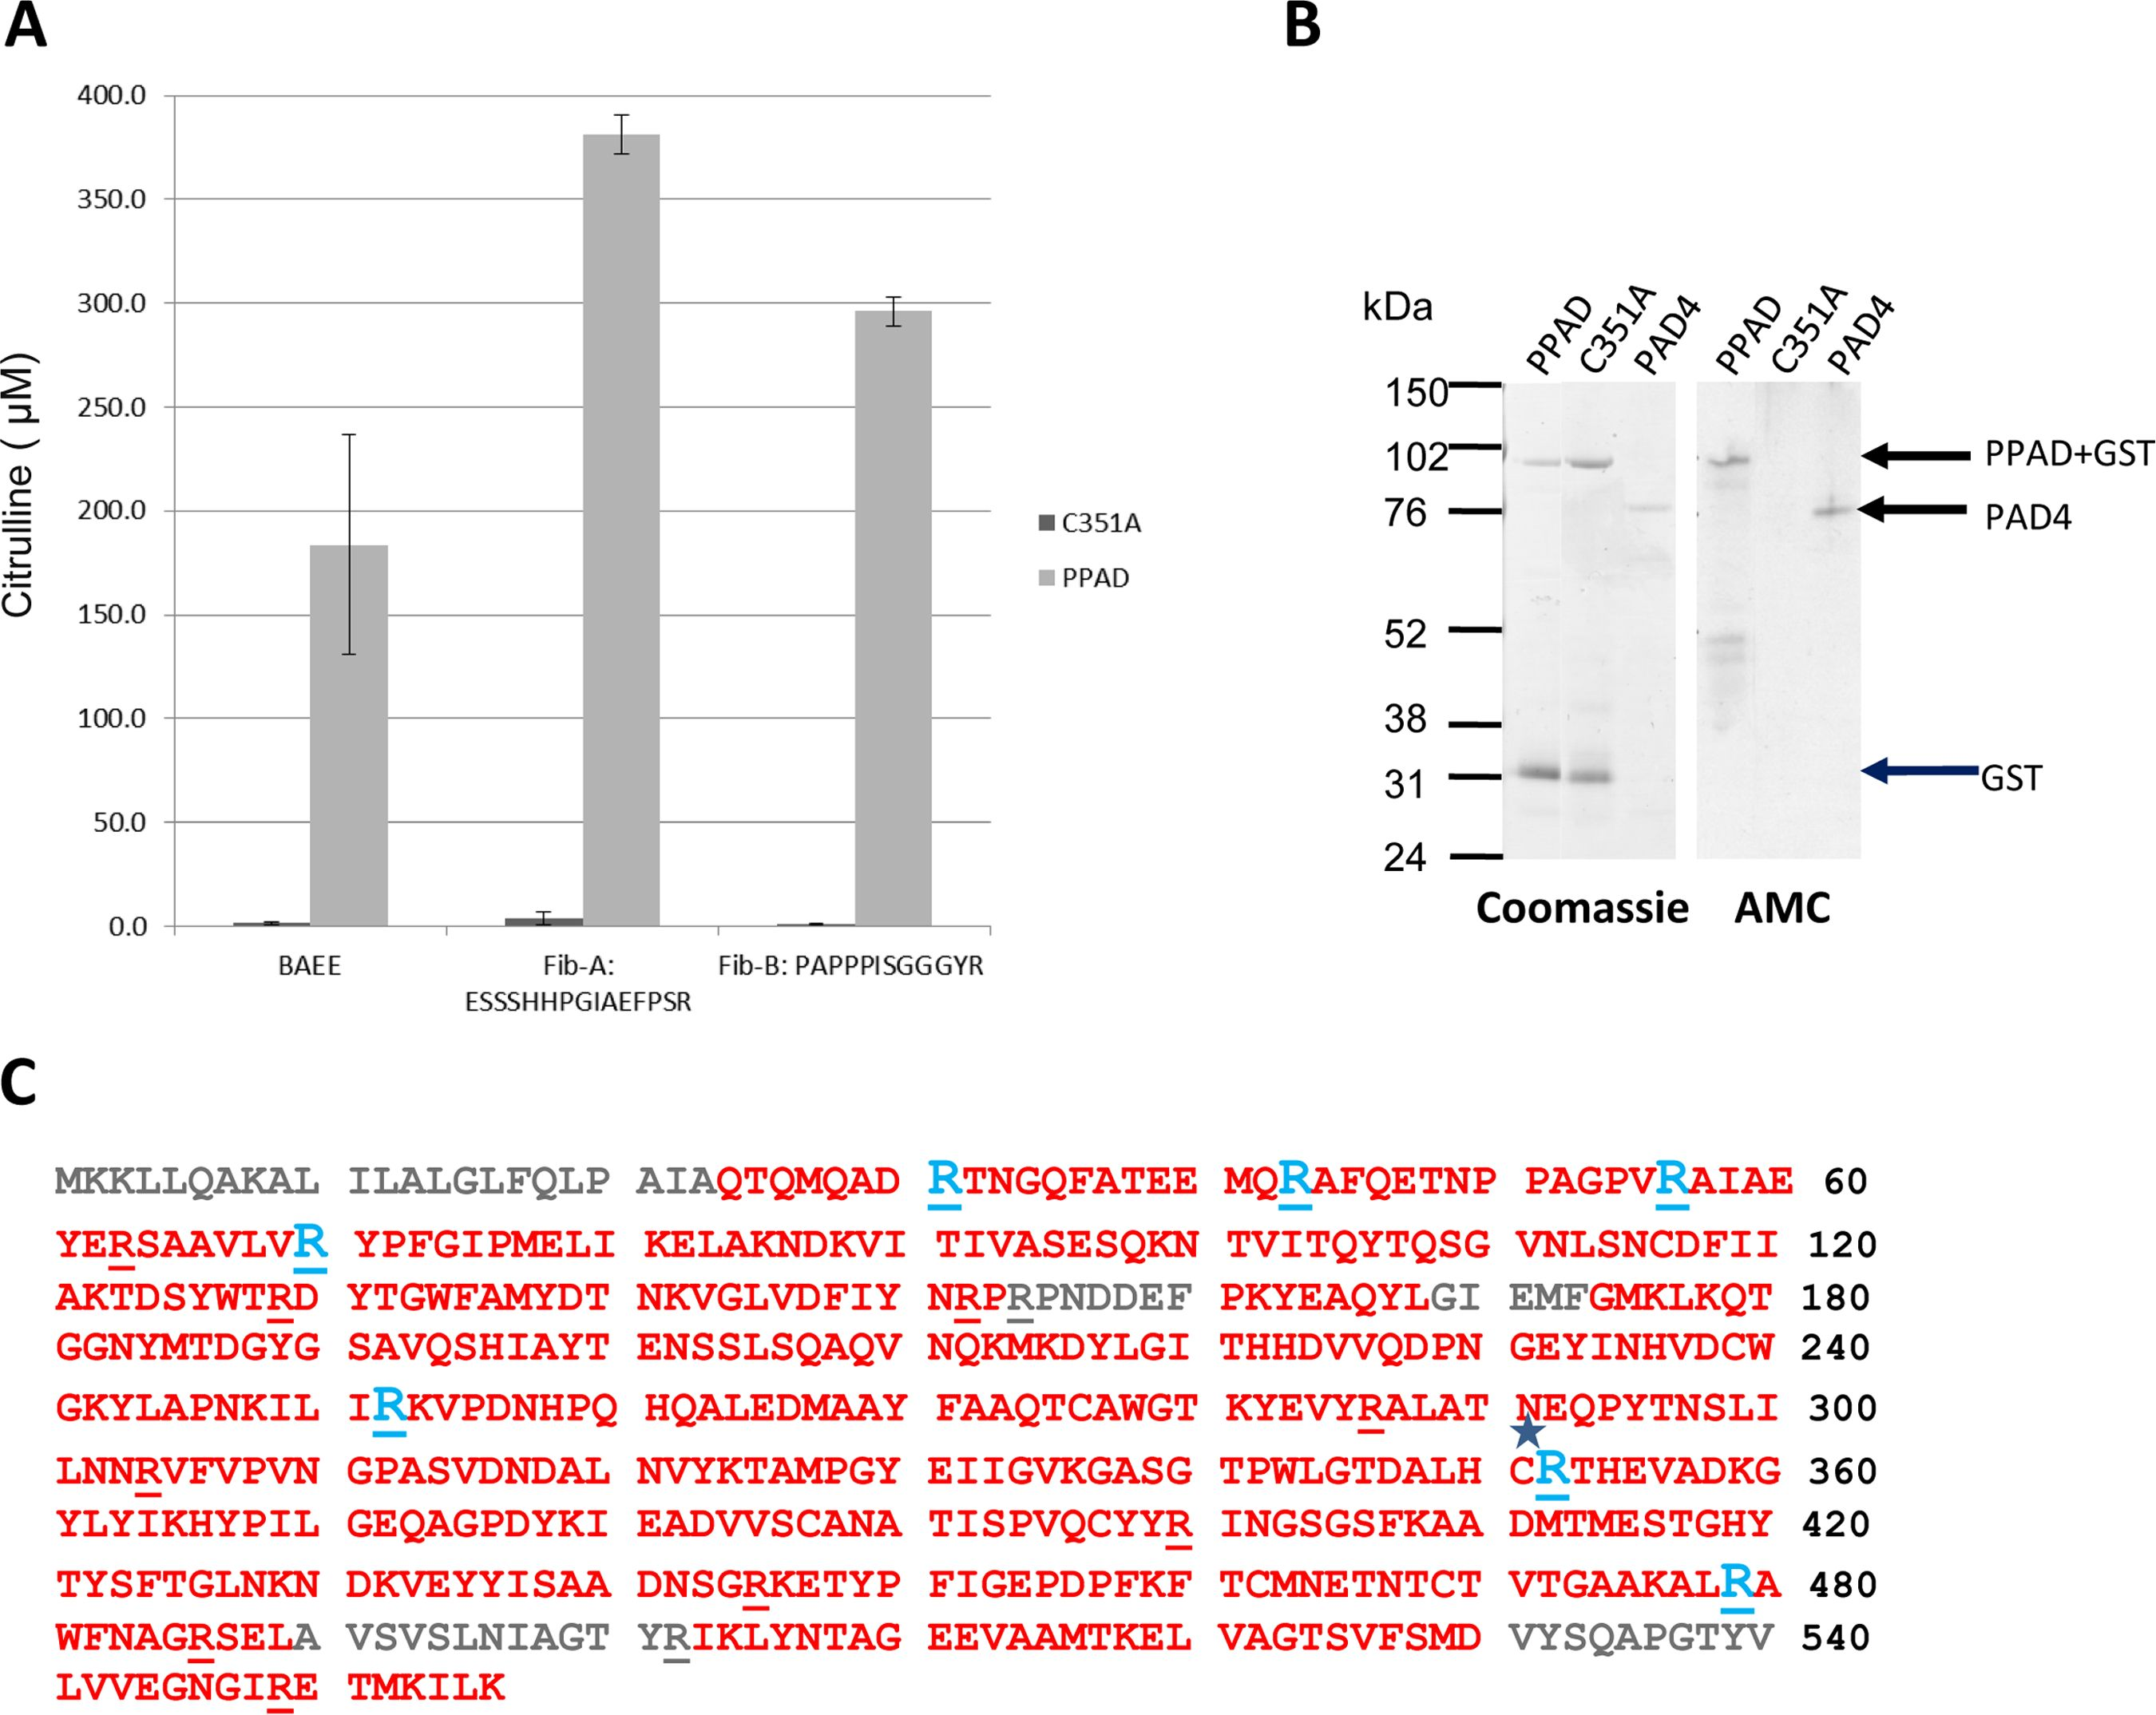
Basic and translational research

RESULTS
Cloning and expression of recombinant PPAD and an
inactivated mutant (C351A)
In order to investigate the immune response to PPAD, we
cloned and expressed recombinant PPAD and an inactivated
mutant (C351A). Using an in vitro citrullination assay, we con-
firmed that PPAD efficiently citrullinated a synthetic arginine
derivative, a-N-benzoyl-L-arginine ethyl ester (BAEE), as well as
two fibrinogen peptides with C-terminal arginine residues,
Fib-A (ESSSHHPGIAEFPSR) and Fib-B (PAPPPISGGGYR),
which were originally identified in P gingivalis fibrinogen digests
(figure 1A).9 C351A showed no enzymatic activity in this assay
(figure 1A). No citrullination was observed after incubation of
PPAD with a fibrinogen peptide containing internal arginines,
confirming the preference of PPAD for citrullinating peptides
with C-terminal arginines (data not shown). A control reaction
containing PPAD alone without substrate did not generate a
positive signal above background.
PPAD and C351Awere tested for autocitrullinating activity by
immunoblotting with an AMC antibody. The antibody detected
a band at the expected size for a PPAD GST /6-His fusion
protein (89 kDa) confirming that PPAD undergoes autocitrulli-
nation. By contrast, C351A showed no bands (figure 1B). PAD4
was blotted in parallel as a positive control, as it is known to
have autocitrullinating activity.16 Autocitrullination of PPAD was
confirmed by mass spectrometry. The sequenced regions
included 16 of the 18 arginines in the PPAD amino acid
sequence, and showed that seven arginines were citrullinated.
All citrullines detected were internal (figure 1C). Unmodified
and citrullinated versions of the same peptides could be
detected, indicating variability in the number and position of
modified arginine sites on PPAD.
The localisation of PPAD on the bacterial cell was explored in
an in vitro cell culture of P gingivalis-infected oral epithelial
cells by immunohistochemistry. This demonstrated PPAD
expression on the bacterium that adheres to the cultured cells
(figure 2A). To examine the subcellular localisation of PPAD, we
used Western blot analysis of P gingivalis fractions with the
anti-PPAD antibody (figure 2B). The anti-PPAD antibody
reacted with a 61 kd polypeptide, corresponding to the full-
length PPAD protein, in P gingivalis fractions containing cell
envelope (W83 CE), but not with the periplasm and cytoplasm
(W83 PP/CP) fraction. The strongest band was observed in the
outer membrane (W83 OM) fraction, indicating that PPAD is
expressed on the surface of P gingivalis.

The antibody response to autocitrullinated PPAD is
increased in RA
IgG anti-PPAD antibody levels were significantly elevated in RA
(median 122 U/ml) compared with the controls (median 70 U/
ml p<0.05) and PD (median 60 U/ml; p<0.01) sera (figure 3A),
whereas antibody levels to RgpB in RA (median 97 U/ml) did
not differ from controls (median 87 U/ml) but were significantly
increased in PD (median 522 U/ml; p<0.001) sera (figure 3B).
Twenty-five percent of the RA sera were anti-PPAD positive
compared with 11% of the PD sera and 5% of the controls
(figure 3A). To determine if the heightened antibody response
to PPAD in RA sera is due to PPAD autocitrullination, we tested
the antibody response to the inactivated mutant, C351A, as an
uncitrullinated control. No heightened immune response was
observed in the antibody response in RA (median 72 U/ml) com-
pared with PD (87 U/ml) and controls (118 U/ml) for the
mutant (figure 4A), indicating that the anti-PPAD response in
RA is peptidyl citrulline-specific. None of the RA sera and 2%
of the PD sera were anti-C351A positive (figure 4A). The
enhanced reactivity of RA sera to native PPAD is also demon-
strated by subtraction of the reactivity to the inactive PPAD
mutant (C351A) (figure 4B). Using the ninety-fifth percentile of
control as the cut-off, 38% of RA patients had peptidyl
citrulline-specific antibodies to PPAD, compared with only 2%
of PD patients (figure 4B).
To validate the antigen specificity of the ELISA, the relation-
ship with antibody responses to PPAD and RgpB was measured
by immunoblotting. This was demonstrated using an independ-
ent cohort of 10 control, 7 PD and 10 RA sera. Positive sera as
determined by immunoblotting gave significantly higher
Figure 1 PPAD efficiently
citrullinates BAEE and fibrinogen
peptides and is autocitrullinated. (A)
1 mM C351A PPAD mutant and
recombinant PPAD were tested for
enzyme activity using 1 mM BAEE,
Fib-A or Fib-B as substrate, with
citrullinated product quantified
spectrometrically. (B) Equivalent
amounts of recombinant GST-His-PPAD
(PPAD, 89 kDa), inactive mutant
(C351A, 89 kDa) and PAD4 (76 kDa)
were resolved by SDS-PAGE and
Coomassie stained. The resolved
proteins were transferred onto
nitrocellulose membranes and protein
citrullination detected with an
antimodified citrulline antibody.
(C) Mass spectrometry sequence
coverage map of PPAD. Sequence in
red indicates the identified sequence.
Arginine residues are underlined.
Arginine residues that were modified
to citrulline are shown in blue.
C* indicates the Cysteine residue
mutated to produce C351A inactive
mutant.
Quirke A-M, et al. Ann Rheum Dis 2014;73:263-269. doi:10.1136/annrheumdis-2012-202726
265
Ann Rheum Dis: first published as 10.1136/annrheumdis-2012-202726 on 5 March 2013. Downloaded from http://ard.bmj.com/ on 4 March 2019 by guest. Protected by copyright.

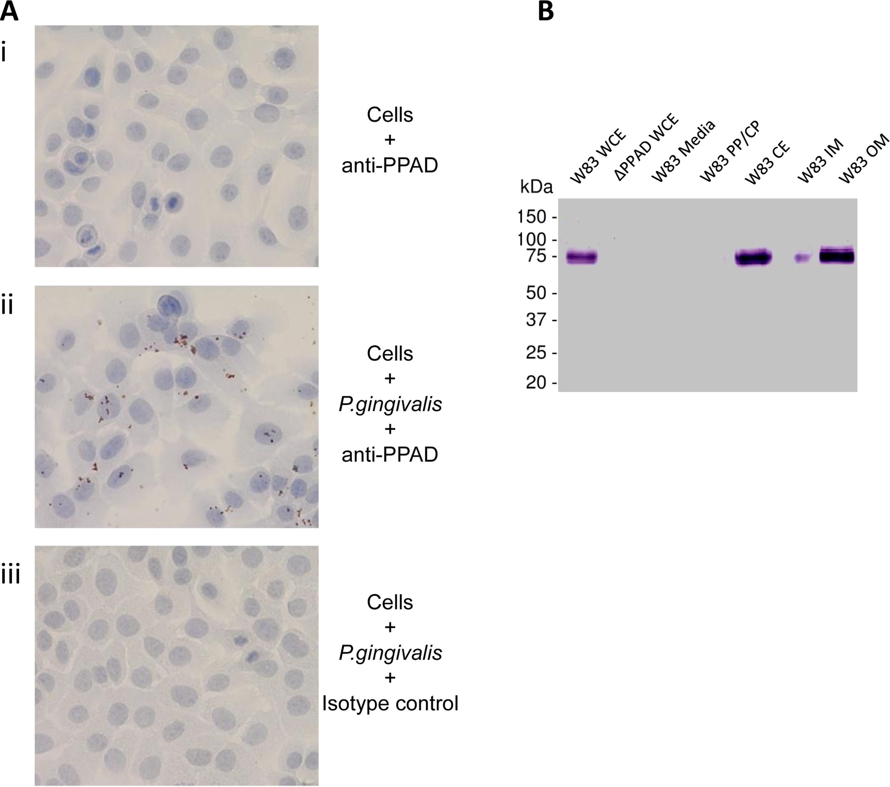
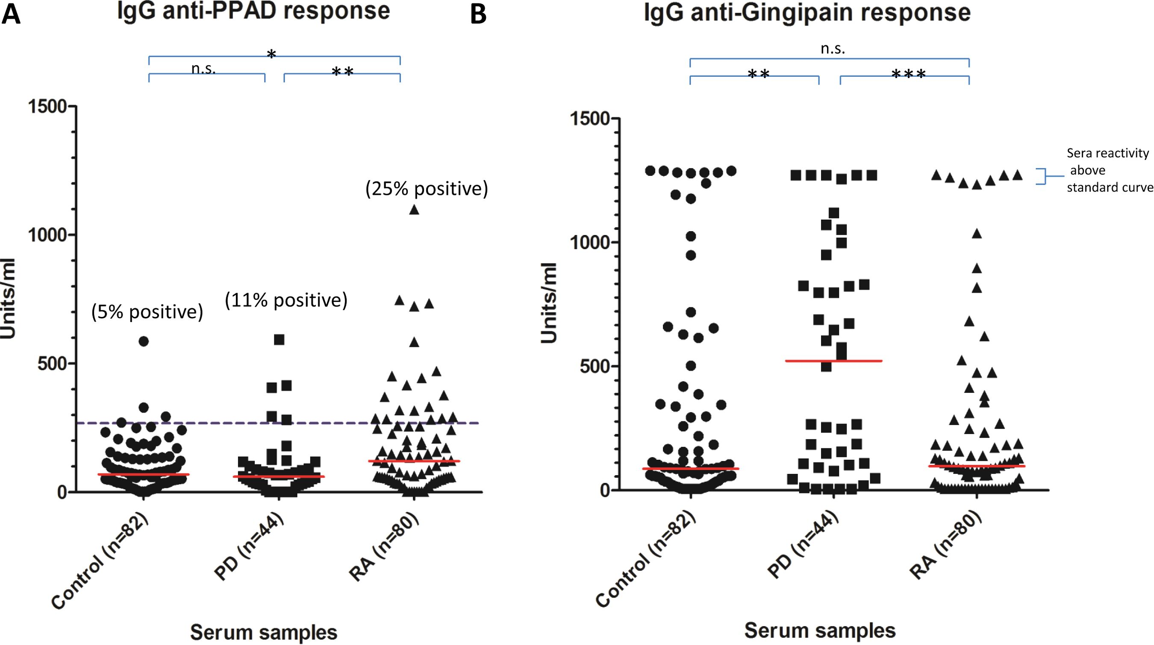
Basic and translational research
Figure 2 PPAD associates with the
bacterial cell and is expressed on the
outer membrane (OM). (A) An
immortalised oral keratinocyte cell line
(OKF6) was stained with anti-PPAD
antibody (i). Cells were infected with
Porphyromonas gingivalis and stained
with anti-PPAD antibody (ii) or isotype
control (iii). Cell nuclei were
counterstained blue. Magnification:
x400. (B) PPAD subcellular localisation
in P gingivalis. Bacteria culture from
an early stationary phase was
fractionated into whole cell extract
(WCE), particle-free growth media
(Media), soluble cell proteins derived
from periplasm and cytoplasm (PP/CP),
cell envelope containing inner and
outer membranes (CE), inner
membrane (IM) and outer membrane
(OM). Fractions were subjected to
Western blot analysis using anti-PPAD
antibody.
antibody responses with ELISA for PPAD (p<0.05) and RgpB
(p<0.001) than negative sera (figure 5A-C).
To further investigate the peptidyl citrulline-specific antibody
response to PPAD, we evaluated the antibody response in 20 RA
and 16 control sera to 13 cyclic 19-26-mer PPAD peptides
(CPP1-CPP13), encompassing the 18 arginine residues within
PPAD with arginine substituted by citrulline (table 1).
Antibodies to 10 of the 13 CPP peptides were detected in RA
sera (table 1).
In two PPAD peptides (CPP3 and CPP8) the percent positiv-
ity reached 40%, indicating that these two peptides could be
used for screening for anti-PPAD antibodies in future epidemio-
logical studies. Basic local alignment search tool analysis of the
native form of all 13 synthetic peptides did not reveal any sig-
nificant homology outside of the PPAD sequence itself.
DISCUSSION
There has been recent widespread interest in the possible role of
P gingivalis in the aetiopathogenesis of RA, based on epidemio-
logical data and its possession of an enzyme, PPAD, which is
capable of citrullinating host and/or other bacterial proteins. In
the context of a permissive HLA (human leukocyte antigen)
type, this might give rise to the ACPA that are characteristic of
RA. An additional mechanism is suggested by the data we
present here in which PPAD itself, as a citrullinated bacterial
protein, could break tolerance to citrullinated autoantigens, and
hence, give rise to the specific pattern of autoimmunity seen in
RA.
Previous reports have suggested that PPAD is capable of auto-
citrullination.6 7 This seems surprising given its documented
preference for C-terminal arginine residues,6 7 9 in
Figure 3 ELISA analysis of (A)
anti-PPAD and (B) anti-RgpB
antibodies in controls, periodontitis
and rheumatoid arthritis serum. The
red line indicates median units per ml.
Mann-Whitney U test was used to
calculate p values for differences
between the groups
(n.s.=no significant difference,
*=p<0.05 and **=p<0.01,
***=p<0.001). The cut-off for
anti-PPAD positive sera was calculated
based on the 95th percentile of the
control sample values (blue dashed
line).
266
Quirke A-M, et al. Ann Rheum Dis 2014;73:263-269. doi:10.1136/annrheumdis-2012-202726
Ann Rheum Dis: first published as 10.1136/annrheumdis-2012-202726 on 5 March 2013. Downloaded from http://ard.bmj.com/ on 4 March 2019 by guest. Protected by copyright.

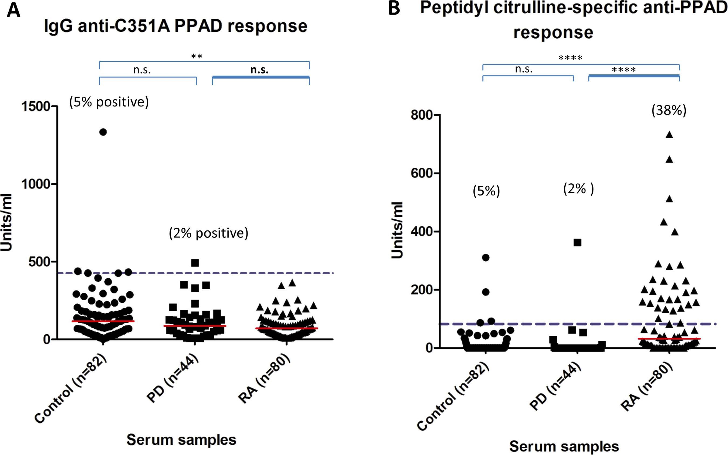
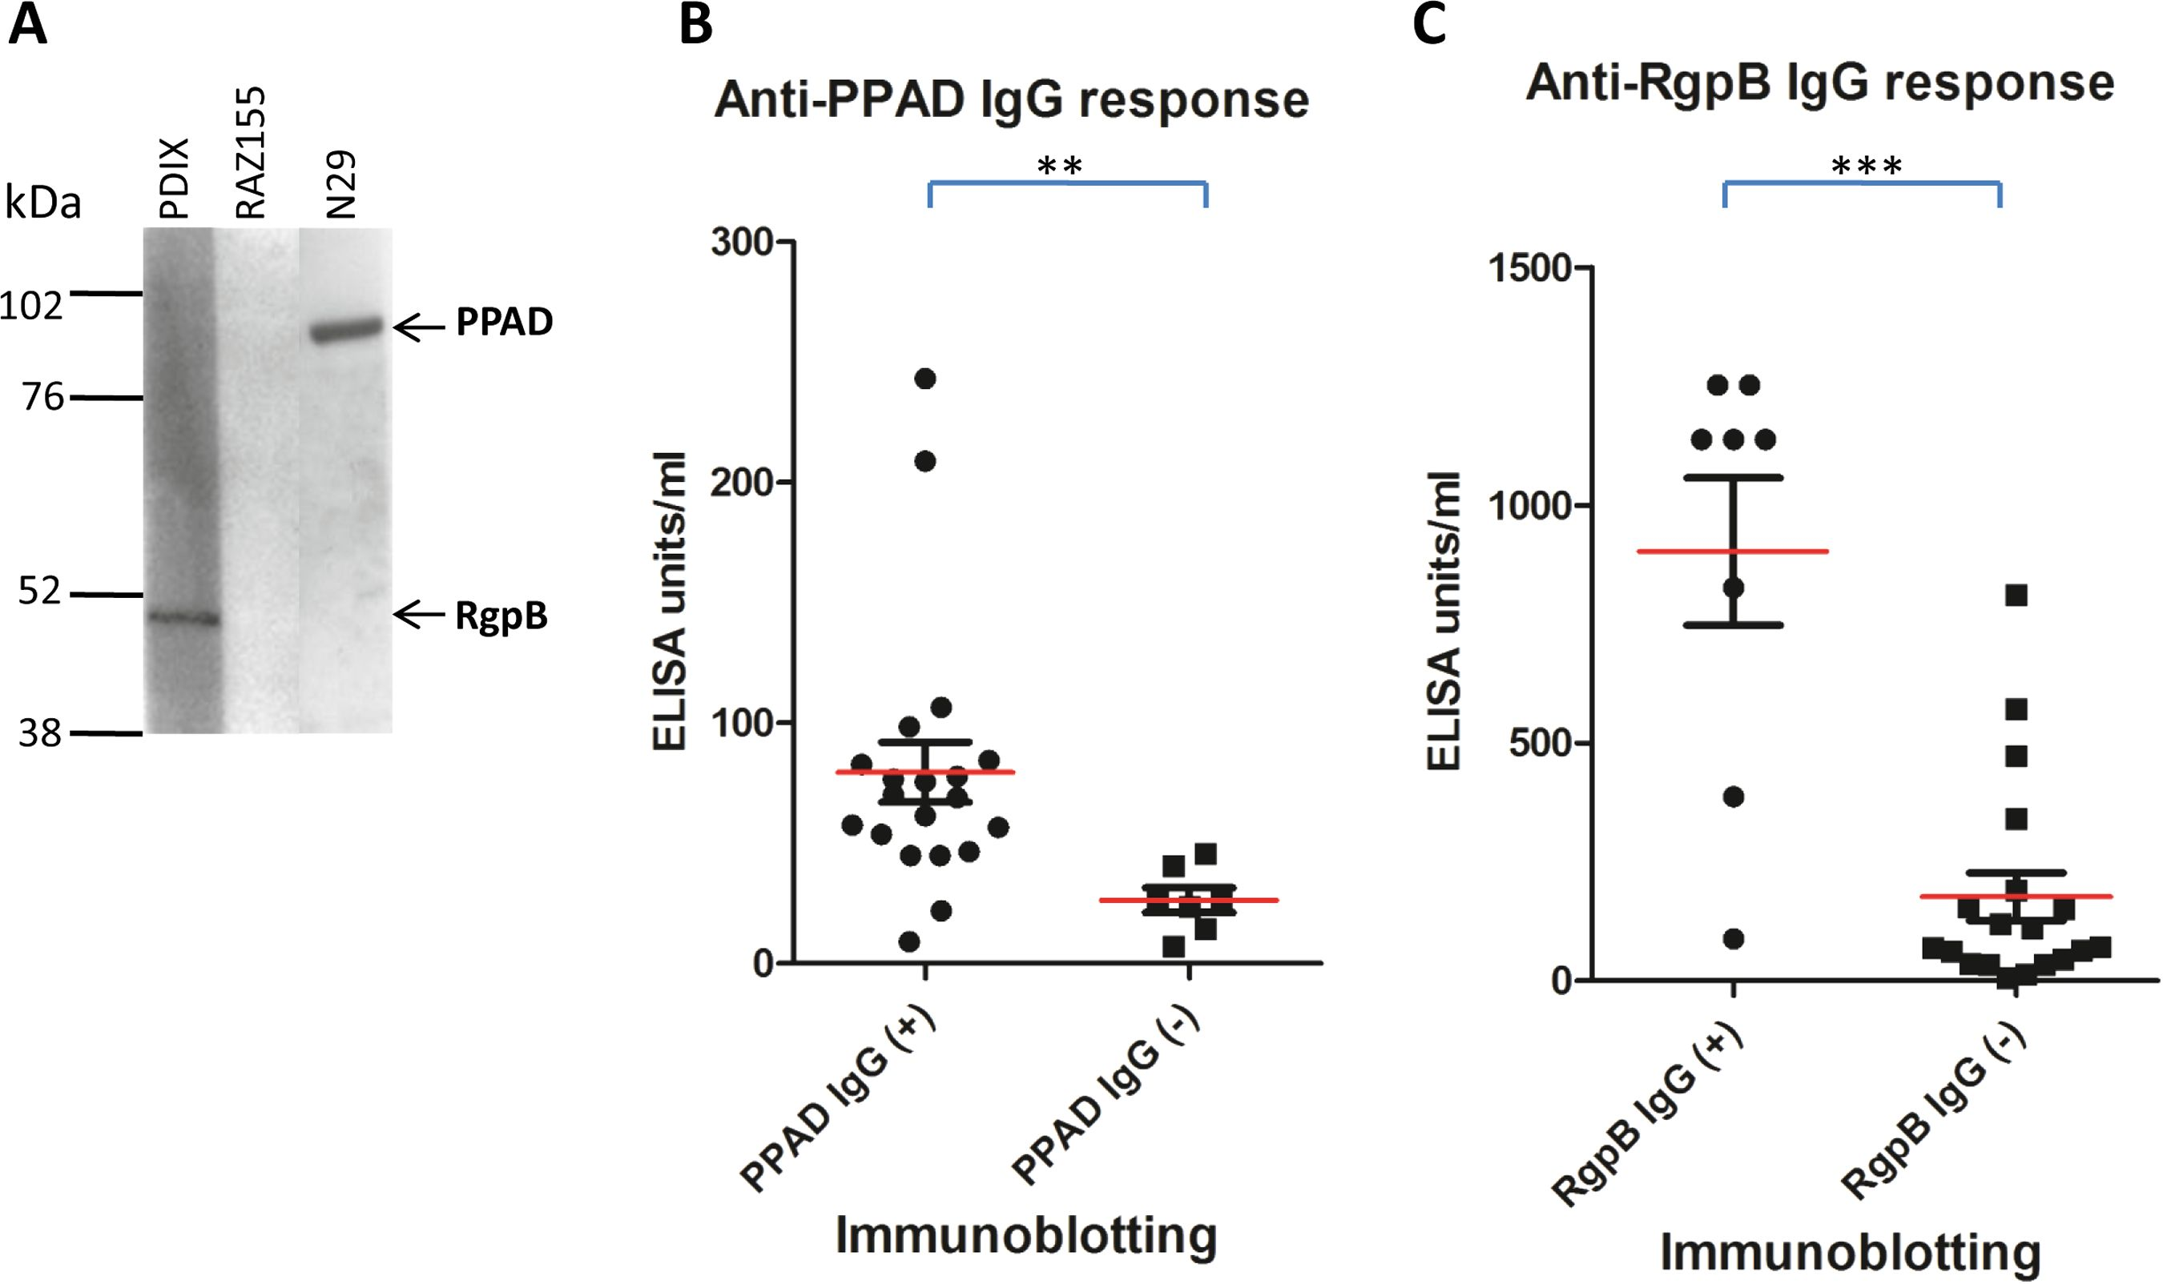
Basic and translational research
Figure 4 Peptidyl citrulline-specific
antibody response. (A) Anti-C351A
PPAD and (B) peptidyl citrulline
specific anti-PpAD antibodies in
controls, periodontitis and rheumatoid
arthritis serum. The red line indicates
median units per ml. Mann-Whitney U
test was used to calculate p values for
differences between the groups
(n.s.=no significant difference,
*=p<0.05 and **=p<0.01,
***=p<0.001, ****=p<0.0001). The
units/ml of the anti-C351A PPAD
response were subtracted from the
units/ml of the anti-PPAD response
giving the specific level of anti-peptidyl
citrulline antibody response. The
cut-off for the peptidyl citrulline
specific anti-PPAD antibodies was
calculated based on the 95th
percentile of the control sample values
(blue dashed line).
contradistinction to human PADs which efficiently deiminate
internal arginines.17 Nevertheless our data confirms the autoci-
trullination of PPAD. We extended these observations with a
mass spectrometry analysis, which demonstrated citrullination
of seven out of 18 Arg residues all of which were internal.
Rodriguez et al7 reported that autocitrullination of PPAD led
to a loss of enzymatic activity. Though we did not systematically
examine PPAD activity in relation to the degree of autocitrullina-
tion, our recombinant autocitrullinated PPAD was efficient at
citrullination in an in vitro assay. However, our mass spectrom-
etry data showed that in some PPAD molecules, there was citrulli-
nation of Arg-352. This is adjacent to Cys-351 which is an
essential nucleophile for PPAD enzymatic activity.8 Citrullination
at this site might potentially explain the reduction in enzymatic
activity observed by Rodriguez. This would be analogous to the
human PADs where autocitrullination of arginines around the
active site appears to inactivate the enzyme.16 18
The potential pathophysiologic role of autocitrullinated PPAD
in RA opens up a novel area for future investigations. We
demonstrated expression of PPAD on the bacterial OM, allow-
ing it to be readily available for citrullinating host proteins, but
also exposing it to the host immune system. Our findings of a
significantly elevated antibody response to PPAD, but not RgpB,
in RA compared with control and PD sera, indicates that PPAD
could be an antigen relevant to the pathogenesis of RA. The
further demonstration that the elevated response to PPAD was
peptidyl citrulline-specific in 38% of RA patients, and that this
was directed to multiple citrulline-containing PPAD peptides,
further suggests that this is a real antigenic target in RA.
We have shown that antibodies to the unmodified bacterial
enzyme PPAD and the bacterial protease RgpB are a common
occurrence in patients with PD and in healthy controls. This
reflects the fact that PPAD and RgpB are antigenic bacterial pro-
teins, and that P gingivalis infection is ubiquitous in the
Figure 5 Correlation of antibody
detection by ELISA and
immunoblotting. Representative
immunoblot positive and negative of
serum reacting to PPAD (PPAD-GST
89 kDa) and RgpB (RgpB-His 47kDa)
(A). Validation of the ElISA analysis
relative to the immunoblotting results
(B+C). The 27 sera (10 control, 7
peridontitis and 10 rheumatoid
arthritis) were divided into two groups
based on presence (+) or absence (-)
of IgG antibodies to (B) PPAD or (C)
RgpB as determined by
immunoblotting. The red line indicates
the ELISA mean U/ml value for the
serum groups. The Mann-Whitney U
test was used to calculate p values for
the difference between the arbitury
units for the anti-PPAD/anti-RgpB blot
positive (+) serum group and blot
negative (-) serum group (** p<0.05
and ***p<0.01).
Quirke A-M, et al. Ann Rheum Dis 2014;73:263-269. doi:10.1136/annrheumdis-2012-202726
267
Ann Rheum Dis: first published as 10.1136/annrheumdis-2012-202726 on 5 March 2013. Downloaded from http://ard.bmj.com/ on 4 March 2019 by guest. Protected by copyright.

Basic and translational research
Table 1 Porphyromonas gingivalis peptidylarginine deiminase
(PPAD) peptide sequences and the antibody response to these
peptides in patients with rheumatoid arthritis (RA)
PPAD  peptide  name | Sequence | Percentage  positive RA sera*  (n=20)
CPP1 | CQMQAD-Citt-TNGQFATEEMQ-Cit-AFQETC | 20
CPP2 | CPAGPV-Cit-AIAEYE-Cit-SAAVLV-Cit-YPFGC | 15
CPP3 | CAKTDSYWT-Cit-DYTGWFAMYDC | 40
CPP4 | CDFIYN-Cit-P-Cit-PNDDEFPKYC | 0
CPP5 | CLAPNKILI-Cit-KVPDNHPQHC | 15
CPP6 | CGTKYEVY-Cit-ALATNEQPYTC | 20
CPP7 | CNSLILNN-Cit-VFVPVNGPASC | 0
CPP8 | CLGTDALHC-Cit-THEVADKGC | 40
CPP9 | CTISPVQCYY-Cit-INGSGSFKC | 0
CPP10 | CSAADNSG-Cit-KETYPFIGEPC | 15
CPP11 | CKAL-Cit-AWFNAG -Cit-SELAVSVC | 30
CPP12 | CSLNIAGTY-Cit-IKLYNTAGEC | 30
CPP13 | CYVLVVEGNGI-Cit-ETMKILKC | 20
"Values are the percentage positive based on the 95th percentile response of the
control sample values at an OD450.
tCit: The arginine residue has been substituted with citrulline.
population. Given that PPAD autocitrullinates and is a common
antigenic target, it is plausible that this may trigger an immuno-
logical response to citrullinated proteins in a subset of RA
patients with PD, who also have a HLA type suited to the pres-
entation of citrullinated peptides.19 20 Antibodies generated to
autocitrullinated PPAD could perpetuate the immune response
through epitope spreading and cross-reactivity with citrullinated
human proteins, similar to the proposed mechanisms of P gingi-
valis mediated citrullination triggering ACPA in RA proposed by
us previously.8 21 22
The presence of antibodies to citrullinated proteins and citrul-
linating enzymes in RA, is remarkably analagous to the situation
in celiac disease, where exogenous gluten-derived deamidated
proteins and the deamidating human enzyme itself, transgluta-
midase 2 (TG2) are antigenic targets.23 Possible mechanisms
include antigenic neoepitopes in the enzyme/substrate complex,
epitope spreading, and activation of enzyme-specific B cells by
T cells which are specific for the post-translationally modified
peptides.24 25 The latter hypothesis would not require
TG2-specific CD4 T cells, and might help explain the
HLA-restriction of anti-TG2 antibodies and their disappearance
after exclusion of gluten from the diet. In RA, antibodies to
PAD4 might arise in a similar way and these are found in
approximately 40% of patients.26-29 They appear to recognise
autocitrullinated and uncitrullinated epitopes, and may be asso-
ciated with increased disease severity.26 27 29 However, in the
case of PPAD, a reversal of this mechanism could occur, with
the enzyme itself as the exogenous immunogen and the com-
plexed citrullinated proteins as the endogenous autoantigens. A
prediction of this particular hypothesis would be that antibodies
to PAD4 would generally arise after ACPA, as has been demon-
strated,26 whereas the immune response to PPAD would predate
other ACPA in the subset in which they occur.
With these possible mechanisms in mind, our data demon-
strating autocitrullination of PPAD and a raised antibody
response to this enzyme in RA sera, provides an explanation for
how a bacterial infection central to PD can prime the auto-
immune response in RA. While an aetiopathogenic link between
RA and PD has not been formally proven, many studies have
demonstrated epidemiological associations between the two
inflammatory diseases.30-33 They also share common inflamma-
tory mechanisms1 31 33 along with common risk factors, such as
HLA type19 20 and smoking.34 In line with our hypothesis,
ACPA titres in RA patients have been demonstrated to correlate
with the presence of PD.34
We therefore propose novel mechanisms explaining the appar-
ent link between PD and RA, based on immunity to autocitrulli-
nated PPAD within the PD infection in the gingiva, followed by
the breakdown of tolerance to specific citrullinated peptides and
host citrullinated proteins in the inflamed joint. This autocitrul-
linating activity of PPAD could render PPAD itself as a potential
target for RA treatment in ACPA-positive RA patients.
Author affiliations
'Kennedy Institute of Rheumatology, Nuffield Department of Orthopaedics,
Rheumatology and Musculoskeletal Sciences, University of Oxford, London, UK
2Department of Medicine, University of Nebraska Medical Center and Omaha VA
Medical Center, Wittson Hall, USA
3Deparment of Medical Biochemistry and Biophysics, Karolinska Institutet,
Stockholm, Sweden
4Faculty of Biochemistry, Biophysics and Biotechnology, Department of Microbiology,
Jagiellonian University, Krakow, Poland
5Oral Health and Systemic Research Group, University of Louisville, School of
Dentistry, Louisville, USA
6Infection and Immunity, University of Glasgow Dental School, School of Medicine,
College of Veterinary, Medical and Life Sciences, University of Glasgow, Glasgow,
UK
7Rheumatology Research Group, Centre for Translational Inflammation Research,
University of Birmingham, Birmingham, UK
Correction notice This article has been corrected since it was published Online
First. The author name Youngua Guo has been amended to Yonghua Guo.
Acknowledgements Funding was received from the Imperial National Institute of
Health Research (NIHR) Biomedical Research Centre, Arthritis Research UK, This
work was supported by the IMIJU funded project BeTheCure, contract no 115142-2
and by 'Gums & Joints', a European Union FP7 Grant FP7
HEALTH-F2-2010-261460.
Contributors PJV had full access to all of the data in the study and takes
responsibility for the integrity of the data and the accuracy of the data analysis.
Study design: AMQ, EBL, nW, BAF and PJV. Acquisition of data: AMQ, EBL, NW,
BH, PC, MC, AJY, RAZ, JP, SC, YG, GT and TM. Analysis and interpretation of data:
AMQ, EBL, NW, PC, BAF and PJV. Manuscript preparation: AMQ, EbL, PC, BAF and
PJV. All authors have read and approved the final manuscript.
Competing interests None.
Provenance and peer review Not commissioned; externally peer reviewed.
Open Access This is an Open Access article distributed in accordance with the
Creative Commons Attribution Non Commercial (CC BY-NC 3.0) license, which
permits others to distribute, remix, adapt, build upon this work non-commercially,
and license their derivative works on different terms, provided the original work is
properly cited and the use is non-commercial. See: http://creativecommons.org/
licenses/by-nc/3.0/

REFERENCES
- Wegner N, Lundberg K, Kinloch A, et al. Autoimmunity to specific citrullinated
proteins gives the first clues to the etiology of rheumatoid arthritis. Immunol Rev
2010;233:34-54.
- Vossenaar ER, Zendman AJ, van Venrooij WJ, et al. PAD, a growing family of
citrullinating enzymes: genes, features and involvement in disease. Bioessays
2003;25:1106-18.
- Vossenaar ER, Smeets TJ, Kraan MC, et al. The presence of citrullinated proteins is
not specific for rheumatoid synovial tissue. Arthritis Rheum 2004;50:3485-94.
- Foulquier C, Sebbag M, Clavel C, et al. Peptidyl arginine deiminase type 2 (PAD-2)
and PAD-4 but not PAD-1, PAD-3, and PAD-6 are expressed in rheumatoid arthritis
synovium in close association with tissue inflammation. Arthritis Rheum
2007;56:3541-53.
- Kinloch A, Lundberg K, Wait R, et al. Synovial fluid is a site of citrullination of
autoantigens in inflammatory arthritis. Arthritis Rheum 2008;58:2287-95.
- McGraw WT, Potempa J, Farley D, et al. Purification, characterization, and sequence
analysis of a potential virulence factor from Porphyromonas gingivalis,
peptidylarginine deiminase. Infect Immun 1999;67:3248-56.
268
Quirke A-M, et al. Ann Rheum Dis 2014;73:263-269. doi:10.1136/annrheumdis-2012-202726
Ann Rheum Dis: first published as 10.1136/annrheumdis-2012-202726 on 5 March 2013. Downloaded from http://ard.bmj.com/ on 4 March 2019 by guest. Protected by copyright.

Basic and translational research
10
12
13
14
15
16
17
18
19
Rodriguez SB, Stitt BL, Ash DE. Expression of peptidylarginine deiminase from
Porphyromonas gingivalis in Escherichia coli: enzyme purification and
characterization. Arch Biochem Biophys 2009;488:14-22.
Mangat P, Wegner N, Venables PJ, et al. Bacterial and human peptidylarginine
deiminases: targets for inhibiting the autoimmune response in rheumatoid arthritis?
Arthritis Res Ther 2010;12:209.
Wegner N, Wait R, Sroka A, et al. Peptidylarginine deiminase from Porphyromonas
gingivalis citrullinates human fibrinogen and alpha-enolase: implications for
autoimmunity in rheumatoid arthritis. Arthritis Rheum 2010;62:2662-72.
Potempa J, Nguyen KA. Purification and characterization of gingipains. Curr Protoc
Protein Sci 2007;Chapter 21:Unit 20:1-27.
Knipp M, Vasak M. A colorimetric 96-well microtiter plate assay for the
determination of enzymatically formed citrulline. Anal Biochem 2000;286:257-64.
Nguyen KA, Travis J, Potempa J. Does the importance of the C-terminal residues in
the maturation of RgpB from Porphyromonas gingivalis reveal a novel mechanism
for protein export in a subgroup of Gram-Negative bacteria? J Bacteriol
2007;189:833-43.
Mikuls TR, Payne JB, Reinhardt RA, et al. Antibody responses to Porphyromonas
gingivalis (P. gingivalis) in subjects with rheumatoid arthritis and periodontitis. Int
Immunopharmacol 2009;9:38-42.
Lundberg K, Kinloch A, Fisher BA, et al. Antibodies to citrullinated alpha-enolase
peptide 1 are specific for rheumatoid arthritis and cross-react with bacterial enolase.
Arthritis Rheum 2008;58:3009-19.
Arnett FC, Edworthy SM, Bloch DA, et al. The American Rheumatism Association
1987 revised criteria for the classification of rheumatoid arthritis. Arthritis Rheum
1988;31:315-24.
Andrade F, Darrah E, Gucek M, et al. Autocitrullination of human peptidyl arginine
deiminase type 4 regulates protein citrullination during cell activation. Arthritis
Rheum 2010;62:1630-40.
Sugawara K, Oikawa Y, Ouchi T. Identification and properties of peptidylarginine
deiminase from rabbit skeletal muscle. J Biochem 1982;91:1065-71.
Mechin MC, Coudane F, Adoue V, et al. Deimination is regulated at multiple levels
including auto-deimination of peptidylarginine deiminases. Cell Mol Life Sci
2010;67:1491-503.
MacGregor AJ, Snieder H, Rigby AS, et al. Characterizing the quantitative genetic
contribution to rheumatoid arthritis using data from twins. Arthritis Rheum
2000;43:30-7.
- Michalowicz BS, Aeppli D, Virag JG, et al. Periodontal findings in adult twins.
J Periodontol 1991;62:293-9.
- Lundberg K, Wegner N, Yucel-Lindberg T, et al. Periodontitis in RA-the citrullinated
enolase connection. Nat Rev Rheumatol 2010;6:727-30.
- Quirke AM, Fisher BA, Kinloch AJ, et al. Citrullination of autoantigens: upstream
of TNFalpha in the pathogenesis of rheumatoid arthritis. FEBS Lett
2011;585:3681-8.
- Dieterich W, Ehnis T, Bauer M, et al. Identification of tissue transglutaminase as the
autoantigen of celiac disease. Nat Med 1997;3:797-801.
- Sollid LM, Molberg O, McAdam S, et al. Autoantibodies in coeliac disease: tissue
transglutaminase-guilt by association? Gut 1997;41:851-2.
- Abadie V, Sollid LM, Barreiro LB, et al. Integration of genetic and immunological
insights into a model of celiac disease pathogenesis. Annu Rev Immunol
2011;29:493-525.
- Harris ML, Darrah E, Lam GK, et al. Association of autoimmunity to peptidyl
arginine deiminase type 4 with genotype and disease severity in rheumatoid
arthritis. Arthritis Rheum 2008;58:1958-67.
- Halvorsen EH, Pollmann S, Gilboe IM, et al. Serum IgG antibodies to
peptidylarginine deiminase 4 in rheumatoid arthritis and associations with disease
severity. Ann Rheum Dis 2008;67:414-17.
- Halvorsen EH, Haavardsholm EA, Pollmann S, et al. Serum IgG antibodies to
peptidylarginine deiminase 4 predict radiographic progression in patients with
rheumatoid arthritis treated with tumour necrosis factor-alpha blocking agents.
Ann Rheum Dis 2009;68:249-52.
- Zhao J, Zhao Y, He J, et al. Prevalence and significance of anti-peptidylarginine
deiminase 4 antibodies in rheumatoid arthritis. J Rheumatol 2008;35:969-74.
- Rosenstein ED, Greenwald RA, Kushner LJ, et al. Hypothesis: the humoral immune
response to oral bacteria provides a stimulus for the development of rheumatoid
arthritis. Inflammation 2004;28:311-18.
- Mercado FB, Marshall RI, Bartold PM. Inter-relationships between rheumatoid
arthritis and periodontal disease. A review. J Clin Periodontol 2003;30:761-72.
- Ogrendik M. Rheumatoid arthritis is linked to oral bacteria: etiological association.
Mod Rheumatol 2009;19:453-6.
- de Pablo P, Chapple IL, Buckley CD, et al. Periodontitis in systemic rheumatic
diseases. Nat Rev Rheumatol 2009;5:218-24.
- Dissick A, Redman RS, Jones M, et al. Association of periodontitis with rheumatoid
arthritis: a pilot study. J Periodontol 2010;81:223-30.
7
8
9
Quirke A-M, et al. Ann Rheum Dis 2014;73:263-269. doi:10.1136/annrheumdis-2012-202726
269
Ann Rheum Dis: first published as 10.1136/annrheumdis-2012-202726 on 5 March 2013. Downloaded from http://ard.bmj.com/ on 4 March 2019 by guest. Protected by copyright.

