
© by the Institute
of Forensic Research
Problems of Forensic Sciences 2005, LXIII, 227-234 ISSN 1230-7483

DETERMINATION OF FENTANYL AND ITS ANALOGUES
IN TOXICOLOGICAL EXPERT ANALYSES*
Agnieszka SKULSKA1, 2, Maria KALA2, Andrzej PARCZEWSKI1, 2
- Faculty of Chemistry, Jagiellonian University, Cracow
- Institute of Forensic Research, Cracow

Abstract
Fentanyl and its analogues are used in medicine (as anaesthetics and analgesics) and for non-medical (as narcotic and gas warfare
agents) purposes. Fentanyl class compounds have high analgesic potency and they are used at very low doses. So these com-
pounds appear in biological material at very low concentrations, not higher then several nanograms per millilitre or per gram.
Drugs at these concentrations cannot be detected by means of routinely used screening procedures. The aim of this study was to
develop and validate a screening method for identification and quantification of fentanyl and its three analogues (alfentanil,
sufentanil and remifentanil) in biological material. Liquid chromatography-mass spectrometry (LC-MS) was applied. The elabo-
rated method is characterised by a limit of quantification (LOQ) and limit of detection (LOD) ranging from 0.6 ng/ml to 2 ng/ml
and from 0.2 ng/ml to 0.6 ng/ml, respectively for the four above-mentioned compounds. The method was applied to determina-
tion of fentanyl in three forensic cases.

Key words
Fentanyl; Alfentanil; Sufentanil; Remifentanil; LC-MS.
Received 13 November 2005; accepted 30 December 2005

1. Introduction
The chemical structure of fentanyl enables it to be
easily modified - this has led to the molecular model-
ling of over 1400 derivatives. About 220 compounds
have been synthesised and their physico-chemical
properties have been described in the literature. Most
of the synthesised compounds are characterised by
strong biological activity, high analgesic potency and
a narrow therapeutic index. Therefore, only several of
them are used for medical purposes [11].
* Scientific work was financed from budget’s funds for science
for years 2005-2007 at the Ministry of Education and Science,
grant No. 0 T00C 035 28.
Fentanyl and its analogues, such as: alfentanil,
sufentanil and remifentanil, which are commonly
known as synthetic opiates, are used in medicine. These
compounds, when administered intravenously, are
characteristically quick-acting (after about 30 seconds),
have short duration of action (about 30 min) and are of
high potency of analgesic action (40 to 1000 times as
potent as morphine).
Compounds of the fentanyl class are also used as
narcotics (street drugs). Numerous fentanyl analogues
are sold under the name synthetic heroin, China white
or just heroin. The effects of the action of fentanyl and
its analogues are indistinguishable from the effects
produced by street heroin. The snortmg of 0.5 mg
fentanyl corresponds to the euphoric action of 20 mg
of heroin [2]. Fentanyl anatogues differ from each
228
A. Skulska, M. Kała, A. Parczewski
other in terms of strength and time of action, but they
have a common feature, which is that they act more
strongly than heroin, which often leads to overdose.
The lethal dose of fentanyl is 2 mg, p-fluorotentanyl
250 pg and alfa-methylfentanyl only 125 pg [10], while
the lethal dose of heroin ranges from 200 to 500 mg. In
the literature, well-documented cases are described, in
which persons strongly addicted to heroin have sur-
vived aft er int ake of 1800 mg heroin. It should be
stressed that in the case of “street drugs” there is no
safe dose. A more detailed comparison of features of
fentanyl and its analogues is presented by the same au-
thors in a previously published paper [9]. A significant
source of fentanyl is theft from in-patient health ser-
vice institutions [13, 15]. Then the drug finds its way
onto the drug market or is abused by medical person-
nel [6, 7].
Fentanyl-related compounds are applied as gas
warfare agents. They produce sudden respiratory de-
pression leadmg to death. This mechanism of death
was ascertained in over 100 hostages from Dubrovka
Theatre and it was caused by the use of a fentanyl ana-
logue in the form of gas [14].
In Poland, under the Drug Addiction Counteraction
Act of 29 July 2005 (Register of Laws 2005, No. 179,
item 1484), fentanyl and its analogues are included in
the I-N group (there are four N groups, termed “stupe-
fymg drugs” - to give the literal transtation). This
means that the compounds belonging to the N groups
can be used exclus ively for medi cal purposes, and
other utilisation is an offence.
Fentanyl and its analogues act on the human organ-
ism at very low doses of the order of 1 to 100 micro-
grams, which leads to low concentrations in the
organism, not higher than several nanograms per milli-
litre of body fluid or gram of tissue [1, 3, 8]. Detection
of these compounds is possible by means of targeted
analysis.

2. Materials and methods
  - Materials
In our study the foUowmg pharmacopeal purity
standards were used: fentanyl (Polfa, Poland,
alfentanil and sufentanil (Pharmaceutica, Belgium)
and remifentanil (Glaxo Wellcome, Great Britain). As
an internal standard, papaverine purchased from
Merck (Darmstadt, Germany) was used. Solvents were
obtained from POCh (Gliwice, Pot and) and Merck
(Darmstadt, Germany). All glass vials and tubes were
silanised before use.
Blood free of drugs (control blood) obtained from
the blood bank in Krakow and bile collected during au-
topsy of persons with no history of opioid group drug
use was used to calibrate the method.
Blood samples, blood from lungs and bile were
sent to the Institute of Forensic Research in Cracow for
toxicological examinations.
  - Case history
Case I: A young man riding a motorcycle caused
a road accident. As a result of the accident, he broke
his limbs. He received 100 pg of fentanyl during medi-
cal treatment.
Case II: A woman was involved in a road accident.
During surgery, her anaesthetic included fentanyl.
Case III: A 15-year old girl died during a dental
procedure. She had been anaesthetised by an intrave-
nous injection of fentanyl.
  - Methods
Identification and determination of fentanyl and its
three anaiogues (alfentanil, remifentanil and sufenta-
nil) was carried out by means of a liquid chromat
tograph HP-1100 Series (Agilent Technologies) cou-
pled to a mass spectrometer. Chemical ionisation
mode under atmospheric pressure (APCI) was applied.
The mass detector was maintained in the selected ion-
monitoring (SIM) mode. The following molecular ions
(m/z) were registered: fentanyl - 337, alfentanil - 417,
sufentanil - 387, remifentanil - 377 and paverine (in-
ternal standard, IS) - 340.
Separation of analytes was performed in gradient
conditions, using a LiChroCART Lichrospher 60
RP-select B (125 x 4 mm) column. The mobile phase
consisted of 0.1% formic acid in acetonitril (B) and in
wat er (A). The flow rate of the mobile phase was
1 ml/min. The gradient was programmed as foliows:
0 min - 10% B, 7 min - 70% B, 15 min - 70% B,
16 min - 10%, 20 min - 10%.
  - Extraction procedure
Calibration curves were constructed using control
blood samples spiked with standard solutions. Calibra-
tion concentrations of fentanyl, alfentanil, sufentanil
and remifentanil were 2.5, 5.0, 10.0 and 25 ng/ml.
Papaverine was added to the analysed samples as an
internal standard at a concentration of 5 ng/ml (10 pl
sotution in a concentration of 500 ng/ml). Then the
samples were extracted by the liquid-liquid technique
according to the following procedure.
Problems of Forensic Sciences 2005, LXIII, 227-234
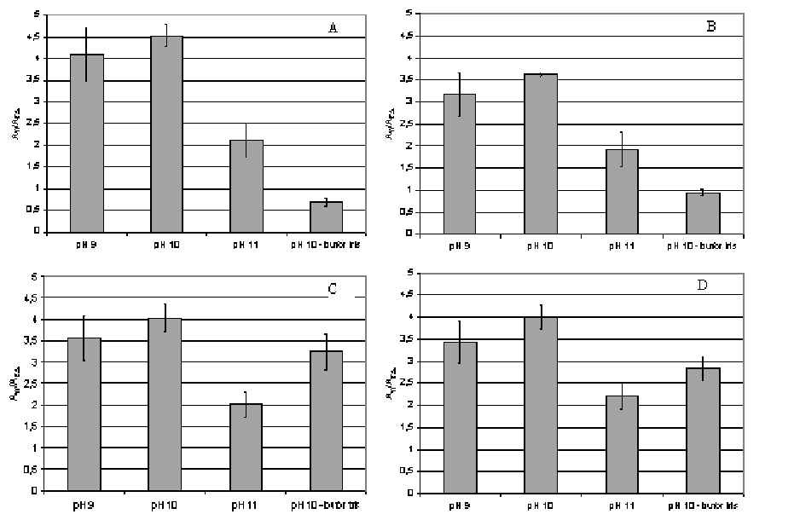
Determination of fentanyl and its analogues in toxicological..
229
1 ml of material (blood, blood from lungs or bile)
was placed in a 20-ml glass tube and papaverine (IS)
solution was added. After addition of 1 ml of carbonic
buffer (pH 11), the mixture was extracted with 5 ml of
n-butyl chloride. Then the mixture was centrifuged for
5 min at 4000 rpm. 4 ml of organic layer was trans-
ferred to another 20-ml tube and its volume was re i
duced to approximately 0.5 ml at 40°C under a stream
of nitrogen. The concentrated organic layer was trans-
ferred to a 2-ml glass tube and evaporated to dryness at
40°C under a steam of nitrogen. The dry residue was
dissolved in 100 pl of mobile phase and an aliquot of
20 pl was injected by autosampler into the LC-MS sys-
tem.

3. Results and discusion
Effective extraction from the biological matrix, ap-
propriate selection of chromatographic separation
conditions and parameters of detection are fundamen-
tal factors in achieving reliable results of analytes de-
termination. Optimisation of MS parameters was
performed to obtain the most intense ions for selected
ion monitoring (SIM) mode. The main setting MS de-
tector paramet ers were as foltows: fragmentor volt t
age - 80 V, capiltary voltage - 4000 V, vaporiser
temperature - 350°C, corona current - 4 pA, nebuliser
pres ture - 40 psi, nebuliser and drymg gas flow -
5 l/min.
At the next stage, an extraction procedure for
fentanyl, remifentanil, sufentanil and alfentanil was
developed. The compounds were isolated from blood
by means of liquid-liquid extraction. In accordance
with data from the literature, n-butyl chloride was ap-
plied as an extracting solvent [4, 5, 12].
The influence of the type of buffers and their pH on
the efficiency of analytes isot ation and purity of ex-
tracts was studied. Extraction was carried out usmg
a carbonate buffer at pH 9, 10 and 11, and a TRIS
buffer at pH 10. The obtained results show (Figure 1)
that the most effective extraction for fentanyl,
sufentanil, remifentanil and alfentanil was by means of
a carbonate buffer at pH 11. Carbonate buffer at pH 11
was chosen because it allows the most effective extrac-
tion for sufentanil, compound which was characterised
by the lowest analytical signal.
The elaborated method was validated. Validation
parameters such as limit of quantification (LOQ), limit
of detection (LOD), correlation coefficient (r2) and ex-
traction recovery (at a concentration of 5 ng/ml) were
determined and summarised in Table I.
TABLE I. VALIDATION DATA OF THE LC/MS METHOD
FOR QUANTITATIVE DETERMINATION OF
FENTANYL AND ITS THREE ANALOGUES
Analyte | LOD  [ng/ml] | LOQ  [ng/ml] | 2  r | Recovery  [%]
Fentanyl | 0.6 | 1.9 | 0.995 | 84.6
Sufentanil | 0.4 | 1.2 | 0.989 | 68.0
Remifentanil | 0.2 | 0.6 | 0.999 | 90.7
Alfentanil | 0.2 | 0.8 | 0.998 | 100
Fig. 1. Influence of extraction pH on efficiency of isolation:
A - fentanyl, B - sufentanil, C - remifentanil, D - alfentanil.
It is possible to achieve lower values of LOD and
LOQ for particular compounds. For this purpose, the
extraction should be performed in the presence of the
buffer giving the highest extraction efficiency. Addi-
tionally, mass detector parameters should be set at the
optimal values for the particular compound, and not
the group of compounds.
The elaborated screening method for determination
of fentanyl and its three anal ogues was linear in the
tested concentration ranges of 2.5-25 ng/ml for all
four compounds. Correlation coefficients (r2) of cali-
bration curves were higher than 0.99.
TABLE II. CONCENTRATIONS OF FENTANYL IN THREE
FORENSIC CASES
Material Case number Concentration
[ng/ml]
Blood I
Blood II
Blood from lung III
Bile
1.7
- c.a. 1
Not detected
Problems of Forensic Sciences 2005, LXIII, 227-234
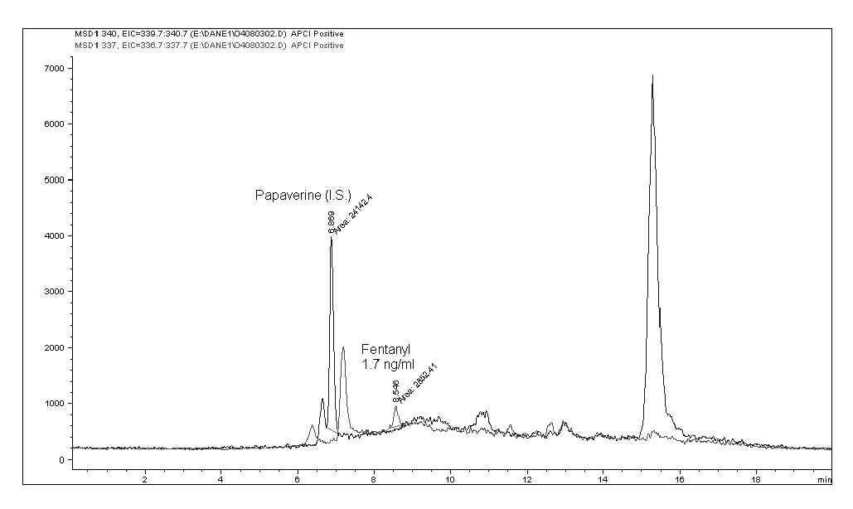
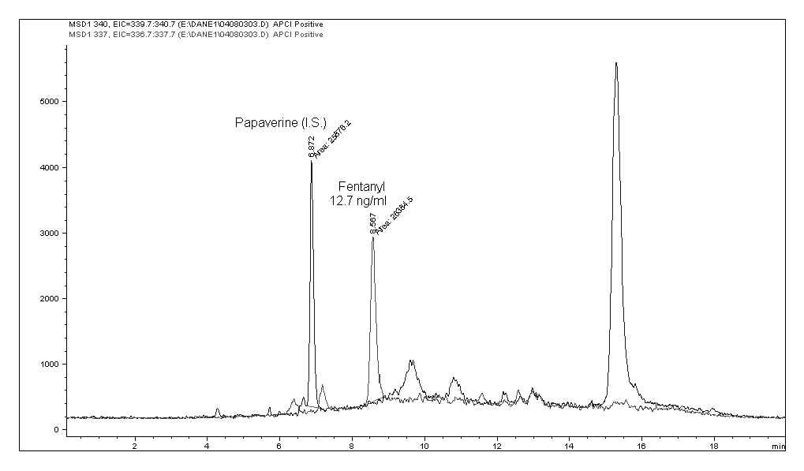
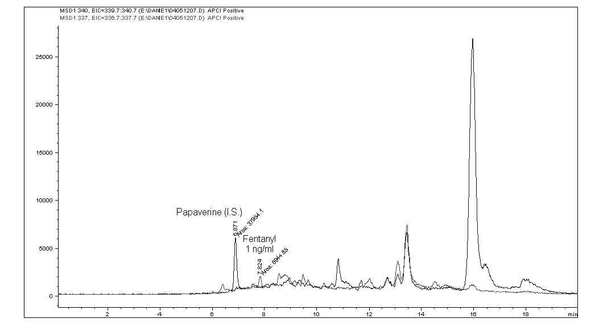
230
A. Skulska, M. Kała, A. Parczewski
Fig. 2. LC-APCI-MS SIM chromatogram of an extract of
blood sample from case I.
Fig. 3. LC-APCI-MS SIM chromatogram of an extract of
blood sample from case II.
Fig. 4. LC-APCI-MS SIM chromatogram of an extract of
blood from the lung sample from case III.
Materials from the three described forensic cases
were analysed. The obtained results of fentanyl deter-
mination are presented in Table II and Figures 2, 3
and 4. Determined fentanyl concentrations in blood
samples were 1.7 ng/ml and 12.7 ng/ml. These values
were in the therapeutic concentration range. The
putrefactively decomposed biological matrix of bile
and blood from lung made it impossible to quantify the
fentanyl concentration in these materials. The esti-
mated concentration in blood from lung did not exceed
1 ng/ml.

4. Conclusions
Use of fentanyl and its analogues for the purpose of
intoxication has not yet become common in Poland.
However, there are frequent reports of abuse of sub-
stances from the fentanyl group in the USA, Switzer-
land and Sweden. On the basis of information on the
increasing abuse of fentanyl and its analogues, it can
be concluded that these compounds may become pop-
ular on the drug market in Poland in the near future.
The elaborated method may be used for determina-
tion of these compounds in fatal, toxic and therapeutic
concentration ranges.
This is the first report of a screening method for
fentanyl class compounds.

References
- Baselt R. C., Disposition of toxic drugs and chemicals in
man, Biomedical Publications, Foster City 2002.
- Bernhard W., Aebi B., Regenscheit P. [et al.], Clandestine
fentanyl synthesis in Bern, Switzerland, TIAFT Bulletin
2004, 55.
- Chaturvedi A. K., Rao N. G. S., A death due to self-ad-
ministered fentanyl, Journal of Analytical Toxicology
1990, 14, 385-387.
- Choi H. S., Shin H. C., Khang G. [et al.], Quantitative
analysis of fentanyl in rat plasma by gas chromatography
with nitrogen-phosphorus detection, Journal of Chroma-
tography B 2001, 765, 63-69.
- Fryirsa B., Woodhouse A., Huang J. L. [et al.], Determi-
nation of subnanogram concentrations of fentanyl in plas-
ma by gas chromatography-mass spectrometry: compar-
ison with standard radioimmunoassay, Journal of Chro-
matography B 1997, 688, 79-85.
- http://hyperreal.info/neuro_groove/script/comment.php/
art-2353/1.
- http://hyperreal.info/neuro_groove/script/comment.php.
- Kronstrand R., Druid H., Holmgren P. [et al.], A cluster of
fentanyl-re lated deaths among drug addicts in Sweden,
Forensic Science International 1997, 88, 185-195.
- Skulska A., Kała M., Parczewski A., Fentanyl and its ana-
logues in the forensic laboratory. Medical and analytical
problems, Problems of Forensic Sciences 2004, 59, 127-
142.
- Szukalski B., Narkotyki zmodyfikowane. Część II.
Związki o działaniu opiatopodobnym, Problemy Krymi-
nalistyki 2004, 244, 5-11.
- Valter K., Arrizabalaga P., De tigner drugs directory,
Elsevier, New York 1998.
Problems of Forensic Sciences 2005, LXIII, 227-234
Determination of fentanyl and its analogues in toxicological..
231
- Watts V. W., Caplan Y. H., Evaluation of the Coat-A-
Count 125I Fentanyl RIA: comparison of 125I RIA and
GC/MS-SIM for quantification of fentanyl in case of
urine specimens, Journal of Analytical Toxicology 1990,
14, 266-272.
- www.kurier.lublin.pl/modules.php?op=modload&na-
me=News&file=article&sid=9448
- www.rmf.fm/wiadomosci/index.html?id=45631 &loc= 1
- www.rmf.fm/wiadomosci/index.html?id=49428&loc= 1
Corresponding author
Agnieszka Skulska
Wydział Chemii Uniwersytetu Jagiellońskiego
ul. Ingardena 3
30-060 Kraków
e-mail: skulska@chemia.uj.edu.pl
Problems of Forensic Sciences 2005, LXIII, 227-234

Problems of Forensic Sciences 2005, LXIII, 227-234

FENTANYL I JEGO POCHODNE W EKSPERTYZIE
TOKSYKOLOGICZNEJ*
- Wstęp
Struktura chemiczna fentanylu pozwala na łatwe jej mo-
dyfikacje, co sprawiło, że wymodelowano ponad 1400 po-
chodnych tej substancji. Do tej pory zsyntetyzowano i zba-
dano własności fizykochemiczne około 220 związków, któ-
re opisano w literaturze. Większość z nich charakteryzuje
się silną aktywno ścią biologiczną, wysoką siłą działania
przeciwbólowego i wąskim indeksem terapeutycznym.
Dlatego też tylko kilka z nich znalazło zastosowanie w lecz-
nictwie [11].
Fentanyl i jego pochodne, takie jak alfentanyl, sufen-
tanyl i remifentanyl, powszechnie nazywane syntetycz-
nymi opiatami, są stosowane w medycynie. Związki te,
podane dożylnie, działają szybko (po ok. 30 s) i silnie
przeciwbólowo (40 do 1000 razy silniej niż morfina).
Są one również sto śowane jako środki oduizające.
Liczne pochodne fentanylu są sprzedawane pod nazwą
syntetyczna heroina, China white lub heioina. Efekty
działania fentanylu i jego pochodnych są nieodróżnialne
od wywoływanych przez „uliczną” heroinę. Wciągnięcie
przez nos 0,5 mg fentanylu jest równoważne z działaniem
euforyzującym 20 mg heroiny [2]. Analogi fentanylu róż-
nią się siłą i czasem działania. Jednak ich wspólną cechą
jest to, że działają silniej niż heroina, co prowadzi często
do przedawkowania. Dawka śmiertelna fentanylu wynosi
2 mg, p-fluorofentanylu 250 pg, a a-metylofentanylu już
tylko 125 pg [10], podczas gdy dawka śmiertelna heroiny
wynosi od 200 do 500 mg. W literaturze opisano jednak
dobrze udokumentowane przypadki, gdy osoby silnie
uzależnione od heroiny przeżywały spożycie dawki
1800 mg. Nalśży jednak podkreślić, że w przypadku
„narkotyków ulicznych” nie ma dawki bezpiecznej.
Bardziej szczegółowe porównanie właściwości fentan-
ylu i jego analogów opisano we wcześniej opublikowanej
pracy [9]. Istotnym źródłem fenśanylu są jego kradzieże
z placówek lecznictwa zamkniętego [13, 15]. Następnie lek
ten trafia na rynek narkotykowy lub jest używany w celu
odurzania się przez personel medyczny [6, 7].
Związki z grupy fentanylu znajdują także zastosowa-
nie jako gazy bojowe. Wywołują one nagłą depresję od-
dechową prowadzącą do śmierci. Taki mechanizm zgonu
stwierdzono u ponad 100 zakładników w Teatrze na Du-
browce, który był spowodowany użytą pochodną fenta-
nylu w postaci gazu [14].
W Polsce ustawa z dnia 29 lipca 2005 r. o przeciw-
działaniu narkomanii zalicza fentanyl oraz jego analogi
do środków oduizających grupy I-N. Oznacz a to, że
środki te mogą być używane wyłącznie w cel ach me-
dycznych, a inne ich użycie jest karalne.
Fentanyl i jego analogi oddziałują na organizm w nie-
wielkich dawkach rzędu 1 do 100 mikzogramów, pro i
wadząc do wysśępowania nizkich stężeń, nie przekra-
czających kilku nanogramów na mililitr płynu ustrojowe-
go lub gram tkanki [1, 3, 8]. Wykrycie tych związków jest
możliwe za pomocą analizy ukierunkowanej.
- Materiały i metody
  - Materiały
Do badań wykorzystano następujące substancje
wzorcowe o czystości farmakopealnej: fentanyl (Polfa,
Warszawa), alfentanyl i sufentanyl (Pharmaceutica, Bel-
gia) oraz remifentanyl (Glaxo Wellcome, Wielka Bryta-
nia). Jako standard wewnętrzny stosowano papawerynę
zakupioną w firmie Merck (Darmstadt, Niemcy). Roz-
puszczalniki pochodziły z POCh (Gliwice, Polska) i Merck
(Darmstadt, Niemcy). Wszystkie szklane probówki i bu-
teleczki były silanizowane przed użyciem.
Do wzorcowania meśody stosowano krew wolną od
leków (krew konśrolna) otrzymaną ze stacji krwiodaw-
stwa w Krakowi e oraz żółć pobraną w czazie sekzji
zwłok osób, które nie przyjmowały leków z grupy opio-
idów.
Próby krwi, ociekliny z płuc i żółci zostały nadesłane
do Instytutu Ekspertyz Sądowych w Krakowie w celu
przeprowadzenia badań toksykologicznych.
  - Opis przypadków
Przypadek I: Młody mężczyzna, kierując motocyk-
lem, spowodował wypadek. W wypadku złamał sobie
kończyny. Przy udzielaniu pomocy medycznej otrzymał
100 pg fentanylu.
Przypadek II: Kobieta brała udział w wypadku dro-
gowym. W skład narkozy przy operacji wchodził fenta-
nyl.
Przypadek III: 15-letnia dziewczyna zmarła podczas
operacji stomatologicznej. Do narkozy zastosowano do-
żylnie wstrzyknięty fentanyl.
* Praca naukowa finansowana ze środków budżetowych na
naukę w latach 2005-2007 jako projekt badawczy Minister-
stwa Edukacji i Nauki, nr 0 T00C 035 28.
Fentanyl i jego pochodne w ekspertyzie toksykologicznej
233
  - Metody
Identyfikację i oznaczenia fentanylu i jego trzech po-
chodnych (alfentanylu, remifentanylu i sufentanylu)
przeprowadzano za pomocą chromatografu cieczowego
HP 1100 firmy Agilent Technologies sprzężonego ze
spektrometrem mas. Zastosowano chemiczną jonizację
pod ciśnieniem atmosferycznym (APCI). Detektor ma-
sowy pracował w trybie selektywnego monitorowania jo-
nów (SIM). Monitorowano następujące pro tonowane jo-
ny molekularne (m/z): fentanyl - 337, alfentanyl - 417,
sufentanyl - 387, remifentanyl - 377 oraz papawerynę
(standard wewnętrzny, IS) - 340.
Rozdział analitów prowadzono na kolumnie LiChro-
CART Lichrospher 60 RP-select B (125 x 4 mm) w sys-
temie elucji gradientowej. Jako fazę ruchomą zastosowa-
no 0,1% kwas mrówkowy w acetonitrylu (B) i wodzie (A).
Przepływ fazy ruchomej wynosił 1 ml/min. Program gra-
dientu składu fazy był nasiępujący: 0 min - 10% B,
7 min - 70% B, 15 min - 70% B, 16 min - 10% B,
20 min - 10% B.
  - Procedura ekstrakcji
Krzywe kalibracyjne wykonano, stosując krew kon-
trolną z dodatkiem roztworów wzorcowych. Uzyskano
następujące stężenia fentanylu, alfentanylu, sufentanylu
- remifentanylu: 2,5; 5; 10 i 25 ng/ml. Dodatkowo do każ-
dej próbki dodawano papawerynę jako standard wew-
nętrzny (10 pl roztworu o stężeniu 500 ng/ml). Następnie
próbki krwi poddawano ekstrakcji ciecz-ciecz według
procedury podanej poniżej.
W 20 ml szklanej fiolce umieszczano po 1 ml badane-
go materiału (krwi, ociekliny z płuc oraz żółci) i dodawa-
no roztwór papaweryny (IS). Po dodaniu 1 ml buioru
węglanowego (pH 11) mieszaninę ekstrahowano 5 ml
chlorku n-butylu. Następnie mieszaninę wirowano przez
5 minut (4000 rpm). 4 ml warstwy organicznej przeno-
szono do kolejnej fiolki i odparowywano w temperaturze
40oC pod strumieniem azotu do objętości ok. 0,5 ml. Zre-
dukowaną objętość warstwy organicznej przenoszono do
- ml szklanej fiolki i odparowywano do sucha w tempera-
turze 40oC pod strumieniem azotu. Suchą pozosiałość
rozpuszczano w 100 pl fazy ruchomej i 20 pl roziworu
wprowadzano do kolumny chromatograficznej za po-
mocą automatycznego podajnika próbek.
- Wyniki i ich dyskusja
Jednym z podstawowych elementów uzyskania wia-
rygodnych wyników oznaczeń analitów jest ich efek-
tywna ekstrakcj a z mairycy bio logicznej oraz właściwy
dobór parametrów rozdziału chromatograficznego i de-
tekcji. Optymalizację parametrów detektora masowego
przeprowadzano w celu uzyskania jonów o największej
intensywności do monitorowania. Optymalne wartości
parametrów detektora masowego wynosiły: napięcie
fragmentora - 80 V, napięcie kapilary - 4000 V, tempe-
ratura odparowainika - 350°C, prąd igły koionowej -
- pA, ciśnienie - 40 psi i przepływ gazów rozpylającego
oraz osuszającego - 5 l/min.
W kolejnym etapie opracowano procedurę ekstrakcji
fentanylu, remifentanylu, sufentanylu i alfentanylu
z prób krwi. Związki te wyosobniano z prób krwi metodą
ekstrakcji ciecz-ciecz. Zgodnie z danymi zaczerpniętymi
z piśmiennictwa jako rozpuszczalnik ekstrahujący za-
stosowano chlorek n-butylu [4, 5, 12]. Zbadano wpływ
pH środowiska ekstrakcji na efektywność wyizolowy-
wania analitów oraz czystość ekstraktów. Ekstrakcję wy-
konywano z buforem węglanowym o następujących war-
tościach pH: 9, 10 i 11 oraz z buforem TRIS. Uzyskane
wyniki (rycina 1) wskazują, że dla fentanylu, sufentany-
lu, remifentanylu i alfentanylu ekstrakcja jest najbardziej
efektywna, gdy jest wykonywana w obecności buforu wę-
glanowego o pH 11. Wybrano bufor węglanowy o pH 11,
ponieważ eksirakcj a w jego obecności jest najbardziej
efektywna dla sufentanylu - związku dającego najniższy
sygnał analityczny.
Opracowaną metodę poddano walidacji. Wyznaczo-
no parametry walidacyjne, takie jak granica oznaczalnoś-
ci (LOQ), granica wykrywalności (LOD), współczynnik
korelacji (r2) oraz wydajność eksirakcii (przy stężeniu
- ng/ml) (tabela I).
Możliwe jest osiągnięcie niższych wartości LOD
i LOQ dla poszczególnych związków. W tym celu należy
wykonać eksirakcj ę w obeiności buioru, dla którego
efektywność ekstrakcji jest największa. Dodatkowo
można ustawić parametry detektora mas na wartości
optymalne dla danego związku, a nie grupy związków.
Opracowana metoda skryningowa oznaczania fen-
tanylu i jego trzech pochodnych jest liniowa w zakresie
badanych stężeń (2,5-25 ng/ml) dla wszystkich czterech
związków. Współczynniki korelacji (r2) dla krzywych
kalibracyjnych były wyższe niż 0,99.
Próbki z trzech opisanych przypadków przesłane do
badań dla celów sądowych poddano analizie. Uzyskane
wyniki oznaczeń fentanylu podano w tabeli II oraz przed-
stawiono na rycinach 2, 3 i 4.
Wyznaczone stężenia fentanylu w próbach krwi wy-
niosły 1,7 ng/ml i 12,7 ng/ml. Wartości te mieściły się
w zakresie stężeń terapeutycznych. Gnilnie rozłożona
matryca bioiogiczna ociekiiny z płuc i żółci uniemożli-
wiła wyznaczenie stężeń fentanylu w tym materiale.
Oszacowane jego stężenie w ocieklinie z płuc nie prze-
kraczało 1 ng/ml.
Problems of Forensic Sciences 2005, LXIII, 227-234
234
A. Skulska, M. Kala, A. Parczewski

4. Podsumowanie
W Polsce stosowanie fentanylu i jego pochodnych
w celu wprowadzania się w stan odurzenia nie jest jesz-
cze rozpowszechnione. Liczne doniesienia o nadużywa-
niu środków z grupy fentanylu pochodzą ze Stanów Zjed-
noczonych, Szwajcarii i Szwecji. Na podstawie pojawia-
jących się coraz częściej informacji na temat naduży-
wania tego związku i jego pochodnych do celów pozame-
dycznych można wni oskować, że w niedługim czas ie
substancje te mogą stać się popularne na rynku narkoty-
ko wym.
Opracowana meioda może być stosowana do oznai
czania tych związków zarówno w zakresie stężeń śmier-
telnych, toksycznych, jak i terapeutycznych.
Niniejsza publikacja jako pierwsza opisuje przesie-
wową metodę oznaczania związków z grupy fentanylu.
Problems of Forensic Sciences 2005, LXIII, 227-234

