
Signature:©PolJRadiol,2010;75(4):47-50
CASEREPORT
Aneurysmoftheaberrantrightsubclavianartery
Received:2009.12.07
Accepted:2010.09.08
–acasereport
JanuszGodlewski1,TomaszWidawski2,MaciejMichalak3,4,ZbigniewKmieć1
1DepartmentofHumanHistologyandEmbryology,FacultyofMedicalSciences,UniversityofWarmiaandMazuryinOlsztyn,
Olsztyn,Poland
2EuromedicDiagnosticsinOlsztyn,Olsztyn,Poland
3DivisionofOncology,FacultyofMedicalSciences,UniversityofWarmiaandMazuryinOlsztyn,Olsztyn,Poland
4DepartmentofRadiology,HospitaloftheMinistryofInteriorwithOncologicalCentreinOlsztyn,Olsztyn,Poland
Author’saddress:JanuszGodlewski,Bankowców35Str.,10-628Olsztyn,Poland,e-mail:janusz350@poczta.onet.pl
Summary
Therightsubclavianartery,originatingnotfromthebrachiocephalictrunkbutdirectlyfromtheaorticarch,isarareanatomicalabnormality.‘Arterialusoria’istheacceptednameoftheretroesophagealrightsubclavianartery.Suchavessellocation,betweenthevertebralcolumnandtheesophagus,determinesitscoursetotheright.Thisdefectmaybeasymptomatic,foundduringautopsyorcoincidentallyduringdiagnosticprocedures.However,itmayalsobesymptomatic.Thecourseofthismajorbloodvesselinthelimitedanatomicalspacemaycausesymptomsofmediastinalorgancompression.Theaimofthispaperwastopresenttwocasesofabnormalanatomicalcourseoftherightsubclavianarteryanditsaneurismaldilation.Inthisstudy,CTscansofthesaccularaneurysmoftheretroesophagealrightsubclavianarterywereused:ofamalepatientdiagnosedatEuromedicDiagnosticsinOlsztynandofafemalepatient,fromtheresourcesoftheRadiologicalDept.atMSWiAHospitalinOlsztyn
An85-year-oldfemalewasadmittedtoHospitalERforcongestiveheartfailuredecompensation.HerchestX-rayrevealedaroundmassintheupperrightmediastinum.ChestCTconfirmedthepresenceofasaccularaneurysmofthelusoryartery,6.5cmindiameter,partiallyfilledwiththromboticmaterial.Thepatientdiedinhospitalfrommyocardialinfarctionthatwasnotrelatedtotheaneurysm.
A61-year-oldmalepatienthadachestX-raywhichshowedaroundopacityontheapexoftherightlung.Thediagnosticprocesscomprisedalsochestcomputedtomography.Theexaminationshowedananomalousoriginoftherightsubclavianartery,withaneurysmaldilationandcompressionoftheoesophagusandofthetrachea.Anintraluminalthrombuswasfound.ThepatientremainedunderobservationtillthenextCTexamination,6monthslater.
Thepresentedrarecasesofarterialusoriaaneurysmarenotonlycasuisticreports.Theyalsoshowthe value of modernMDCT diagnostics. Multi detector CTexaminationsallow for aproperevaluationofthevascularanomaliesinmediastinum.Theanalysisofvascularpathologiesandaccompanyingcompressionofadjacentorgansmakesfurthertreatmentpossible.
Background:
CaseReports:
Conclusions:
Keywords:
vascularanomalies•lusoryartery•rightsubclavianarteryaneurysm•lusoryarteryaneurysm
PDFfile:
http://www.polradiol.com/fulltxt.php?ICID=881341
Background
thearteryformsabowovertheapexoftherightlung.Itcomesoutfromtheupperthoracicapertureoverthefirstribbetweentheanteriorandmiddlescalenemuscles.Itissuperficiallylocatedintherightomoclaviculartriangleoftheneck.Thearteryleadsdowntowardstheaxillaand
Therightsubclavianarteryarisesfromthebifurcationofthebrachiocephalictrunkatthelevelofthesternocla-viculararticulation.Travellingupwardsandthenlaterally
47

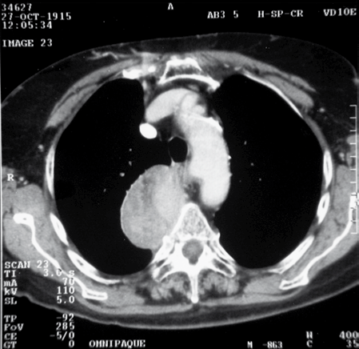
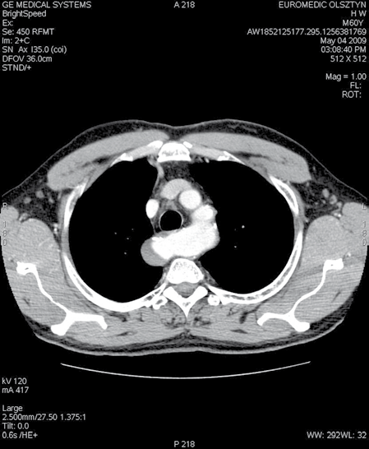
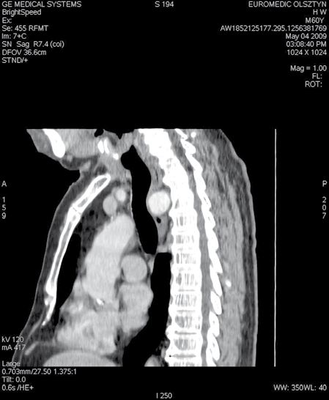
CaseReport
©PolJRadiol,2010;75(4):47-50
Figure1.CTaxialscan.Asaccularaneurismofthelusoryartery,withparietalthrombosis.
changesitsnameattheleveloffirstribtotherightaxil-laryartery.
Figure2.CTaxialscan.Anaberrantrightsubclavianarteryaneurysmlocatedbehindtheoesophagus.Aparietalthrombusintheaneurism.
One of the congenital, ring-typevascular anomalies is therightsubclavianarteryoriginatingdirectlyfromtheaorticarchasthelastarterialbranch,withitscourseinthespacebetweentheoesophagusandthespinetowardstherightupperlimb[1,2].
Inthecourseofembryonicmorphogenesis,sixpairsofpharyngealarcharteriesaredeveloped.Thearchoftheaortaandthesubclavianarteriesoriginatingfromitareformedfromthefourthpairofarchesbetweenweek4and7ofpregnancy.Disturbancesofdevelopmentofthefourthpharyngealarch,connectedwiththeseparationoftherightcervicalarteryandtherightsubclavianartery,leadtothisanomaly.Localprotrusionoftheleftpartoftheaorticwall
–leftKommerell’sdiverticulum,mayalsoarise.
Suchacourseoftherightsubclavianarteryisconvention-allynamedthe‘lusoryartery’.IntheEnglishliterature,itiscalledARSA–aberrantrightsubclavianartery.Theanoma-lyispresentin0.2–2%ofthegeneralpopulation[2,3].Thisanomalymightbeanisolateddefectorconcurrentwithothercongenitalheartdefects.Asanisolateddefect,itismostlyasymptomaticandthusrecognisedincidentallydur-inginvestigationsorautopsy.Thelusoryarteryformsanincompletevascularringandtherefore,itseldomcausespressureanddislocationoftheoesophagusortrachea[1,2,4].Thisdefectwasfirstfoundinananatomicresearchatthebeginningofthe18thcentury.In1794,Bayfordwasthefirsttodescribethepathologicaleffectsofthisabnor-malsubclavianarterycourse[1,5].Atpresent,thisanomalyisusuallydiagnosedinpatientswithcomplaintsinmedias-tinum,bymeansofradiologicalexaminations.
Figure3.CTsagittalscan.Ananeurismcompressingtheposteriorwalloftheoesophagusandofthetrachea.
HerchestX-rayshowedawell-definedtumoroftheupperrightmediastinumandanenlargedcardiacsilhouette.Asaccular,partiallythrombosedaneurysm,6cmindiam-eter,wasrevealedonCT(Figure1).Inthesecondweekofhospitalisation,thepatientdiedofmyocardialinfarction
CaseReports
An85-year-oldfemalewasadmittedtotheEmergencyDepartmentfordecompensatedheartfailuresymptoms.
48

©PolJRadiol,2010;75(4):47-50
GodlewskiJetal–Aneurysmoftheaberrantrightsubclavianartery…
andpulmonaryoedema,whichwerenotrelatedtothearterialaneurysm.
Complicationsof thisvascularanomaly,such astheaneu-rismoftheaberrantrightsubclavianartery,havebeendescribedveryrarelysofar.Anaveragesizeofthisaneu-rism,quotedintheliterature,is3.3cm(from2.5toeven5cm).Ananeurismofthissize,locatedintheuppermedias-tinum,usuallycausesailmentsandcompressiononadja-centorgansandpredisposestoruptures[12–14].Duetoaloweramountofelasticfibresincomparisontothesmoothmuscletissueinthearterialtunicamedia,thesubclavianarteryisclassifiedasanarteryofmusculartype.Apro-gressivedegradationofconnectivetissuefibres,mostlytheelasticfibresbutalsothecollagenones,mayleadtoaneu-rism formation.
A61-year-oldmalewastreatedinspring2009inthedepart-mentofinternaldiseases,inthedistricthospital,forarte-rialhypertensionandparoxysmalatrialfibrillation.AnovalopacityontheapexoftheleftlungwasdemonstratedonthechestX-ray.AnoutpatientCTexaminationshowedastronglycalcifiedsternalendofthefirstleftrib,whichgavetheopac-ityintheapexofleftlungonthechestX-ray.Moreover,CTshowedavascular anomalyintheupper mediastinum–therightsubclavianarteryoriginatingfromtheaorticarchasthelastbranch.Thelamellarcalcificationof the arterialwall,aswellasaneurysmaldilationofupto25mmindiameterwerealsoconfirmed.Moreover,aparietal,semilunarthrombus,14mmwide,waspresentinthearteriallumen(Figure2).
Resectionofthearterythroughleftthoracotomyisatreat-mentofchoiceinsymptomaticARSA.Translocationandreimplantationofthearteryisrecognizedasanunrecom-mendedmethod.QuicklydevelopingmodernmicroinvasivetechniquesallowforaresectionoftheARSAbymeansofvideothoracoscopy.Averyshortrecoverytimeisanadvan-tageofthisaccess[1].
Theaneurismlargelycompressedtheadjacentupperpartofthethoracicesophagusanddislocateditanteriorlytogetherwiththetrachea(Figure3).
Accordingtothedatacollectedbytheauthors,thepatienthasnotbeenoperatedonyetandremainsunderobservationwitharecommendationforangio-CTinsixmonths’time.
AsthecasesofsymptomaticARSAaneurismareveryrare,thereisnotonerecommendedmethodoftreatment.Surgicalproceduresarechosenindividuallyforeverycase.Supraclavicularresectionoftherightsubclavianartery,withitstranslocationtotherightsideoftheaorticarch,isperformed.Theresectionofthearterialaneurismisper-formedbyleftthoracotomy[3,13].Thedissectionoftheaneurismalbasishasbeenappliedaswell.
Discussion
Symptomaticanomaliesoftheaorticarchbranches,formingvascularrings,aretreatedsurgicallybythoracicsurgeonsinchildhood,duetotheircongenitalcharacterandseri-oussequelae.Also,anyabnormalcourseofthesubclavianarterycausing essentialailments andcompressiondefor-mationswithinthemediastinum,istreatedsurgically.Thelusoryarterymaycompressnotonlytheesophagus,butalsothetrachea,andmaycauselessormoreintensiveailmentsoftherespiratorysysteminchildhood,including:dyspnoea,pneumonia,orevenapulmonaryemphysema[1,6–8].
Theliteraturereportsonpatientstreatedwithatranslo-cationandrevascularisationofthelusoryarteryfromsupraclavicularapproachandonendovascularexclusionofaneurismswithaorticstent-graft[15,16].
Conclusions
Suchadefectmayalsoremainsilentandgiveailmentslaterinlife.Anincompletevascularringofthelusoryartery,whichcompressesorevendislocatestheesopha-gus,causingseriousdysphagia,constitutesanindicationforoperationinadultage[3,5,9–11].Suchanimpairmentoftheesophagealpatency,causingmalnutritionand,inaconsequence,patient’sdeath,wasalreadydescribedbyBayford.Itwascalled‘dysphagialusoria’andthisnamehasbeenusedtilltoday[1,5].
Vascularanomaliessuchasthearterialusoriaarerarebutwell-knownanddescribedintheliterature.Theywerefirstdescribedin18thcentury,basingonautopsyobservations.Aneurismsofthelusoryarteryareveryrare.Casuisticreportsonthispathologyemphasizeitsincidentalcharac-ter.Individualcasescomefromlargegroupsofpatientsofthoracosurgicalclinics,observedfor manyyears. Despitetheabovementionedfacts,thepresentedcasesofARSAaneurismshowaveryhighefficiencyofthecontemporaryradiological diagnosticmethods.
Nowadays,bariumX-rayisperformedtodiagnosedyspha-gia.Fillingdefectobservedonexaminationiscausedbythepressureoftheabnormalarterialbranch.Similarly,thepath-ologicalpressureoftheoesophagusmaybevisualisedwithesophagoscopy.Forafulldiagnosisofthisvascularanomaly,chestCTisused.Thisexaminationvisualisesthecourseandlocationofthesubclavianartery,allowsfortheevaluationofthedegreeofcompressiononadjacentmediastinalorgans,andisabletoshowthepresenceofothervascularanomalies.
Computedtomographyofthechestallowsnotonlytovisu-aliseavascularanomalyofthearterialbranchesofthisarea,butalsotoanalyseapotentialpathologyintheseves-sels.Theabovepresentedexaminationshowednotonlythediameteroftheaneurismbutalsoitsatheroscleroticallychangedwall.Moreover,theperformedspatialreconstruc-tionofthearterialaneurismallowedtodiagnosethecom-pression anddislocationofadjacentorgans.
References:
1.SkalskiJH,ReligaZ:Kardiochirurgiadziecięca.WydawnictwoŚląsk,2003;2:361–72
2.SaitoT,TamatsukuriY,HitosugiTetal:Threecasesofretroesophagealrightsubclavianartery.JNipponMedSch,2005;72:375–82
49

CaseReport
©PolJRadiol,2010;75(4):47-50
- EpsteinDA,DebordJR:Abnormalitiesassociatedwithaberrantrightsubclavianarteries-acasereport.VascEndovascularSurg,2002;36:297–303
- CzerwinskiF,MierzwaA,KrzanowskiKetal:Rarecasesofarteriesbranchingdirectlyfromaorticarchintheman.FoliaMorphol,1993;52:223–31
- Czekajska-ChehabE,UhligS,StaskiewiczGetal:Arterialusoriainpatientswithanormalandaright-sidedaorticarchdiagnosed
withmulti-slicecomputedtomography:areportoftwocases.FoliaMorphol,2007;66:74–77
- BertoliniA,PelizzaA,PanizzonGetal:Vascularringsandslings.Diagnosisandsurgicaltreatmentof49patients.JCardiovascSurg,1987;28:301–12
- MaksoudFilhoJG,GoncalvesME,TannuriUetal:Compressionofesophagusandtracheabyaorticarchanomaliesinchildhood.RevAssocMedBras,1993;39:165–69
- RobertsCS,OthersenHB,SadeRMetal:Tracheoesophagealcompressionfromaorticarchanomalies:analysisof30operativelytreatedchildren.JPediatrSurg,1994;29:334–37
- KalkeBR,MagotraR,DoshiSM:Anewsurgicalapproachtothemanagementofsymptomaticaberrantrightsubclavianartery.AnnThoracSurg,1987;44:86–89
- KuntscherV,TreskaV,NovakMetal:Hybridproceduresinthetreatmentofpseudoaneurysmsoftheaorticarch–casereport.RozhlChir,2008;87:384–87
- StorkT,GareisR,KrumholzKetal:Aberrantrightsubclavianartery(arterialusoria)asararecauseofdysphagiaanddyspneain
a79-yearoldwomenwithrightmediastinalandretrotrachealmass,andco-existingcoronaryarterydisease.Vasa,2001;30:225–28
- TurkenburgJL,VersteeghMI,ShawPC:Casereport:aneurysmofanaberrantrightsubclavianarterydiagnosedwithMRimaging.ClinRadiol,1994;49:837–39
- KamiyaH,KnoblochK,LotzJetal:Surgicaltreatmentofaberrantrightsubclavianartery(arterialusoria)aneurysmusingthreedifferentmethods.AnnThoracSurg,2006:82:187–90
- WelchTJ,McKusickMA:AneurysmofaberrantrightsubclavianarteryarisingfromdiverticulumofKommerellAJR,1993;1314–17
- AttmannT,BrandtM,Muller-HulsbeckSetal:Two-stagesurgicalandendovasculartreatmentofananeurysmalaberrantrightsubclavian(Lusoria)artery.EurJCardiothoracSurg,2005;27:1125–27
- ShennibH,DiethrichEB:Novelapproachesforthetreatmentoftheaberrantrightsubclavianarteryanditsaneurysms.JVascSurg,2008;47:1066–70
50

