


WorldJournalofMicrobiologyandBiotechnology(2018)34:115https://doi.org/10.1007/s11274-018-2497-5
ExaminationofnovelAureobasidiumpullulansisolatesdominatingapplemicrofloraandassessingtheirpotentialforapplejuicespoilage
ŁukaszWajda1 ·MagdalenaWyderka2·ZuzannaPolak2·AleksandraDuda-Chodak2 ·MałgorzataMakarewicz2
Received:14April2018/Accepted:7July2018/Publishedonline:11July2018
©TheAuthor(s)2018
Abstract
Thereisverylittleuptodateinformationregardingapplemicroflorasointhecurrentstudywedecidedtoaddressthatissueandassesswhetherdominantfungiwhichresideinfruitmightspoilapplejuice.MicroorganismswereisolatedfromapplesofKoksaGórskaharvestedinthemiddleofOctoberin2016and2017.IdentificationofisolateswasbasedonthesequencingofribosomalDNA.SomeisolateswerecharacteristicforaparticularyearbutinbothyearsapplemicroflorawasdominatedbyAureobasidiumpullulans.Basedonphylogenetic analysisitwasstatedthatonlyoneisolate(LW81)wascloselyrelatedtostrainswhicharealreadydescribedinavailabledatabases.Allotherisolatescollectedinthecurrentstudydifferedsignifi-cantlyfromsequencesstoredindatabases,tendingtoformacommoncluster.ItwaspossibletopredictsecondarystructureofITS2regiononlyfortheisolateLW81,whilewemanagedtoestablishthelengthandlocationof5.8SgeneinRfamdatabaseforallsequences.A.pullulansisknownexopolysaccharideproducersoobtainedmicroorganismsweretestedfortheirabilitytosynthesisethosesubstancesonCzapek-Doxagar.Thestrainwhichprovedtobethemostsignificantexopolysaccharideproducer(isolateLW14)wasinoculatedinthesterilisedapplejuiceatthreedifferentinitialcellnumber(100,1000and10,000cfu/ml)andsubjectedtopasteurisation.Inallcasespasteurisationeliminatedfungalgrowtheffectively,thereforeA.pullulansstrainsshouldnotposeanyrisktothequalityofpasteurisedapplejuices.
KeywordsAureobasidiumpullulans
- Fungi·Apple·Juice
Introduction
Knowledgeabout microbial species residing inrawmateri-
als,e.g.fruitsorvegetables,isessentialforpredictingissuesrelatedtopost-harvestlossesorspoilageoffruitproducts,
i.e.juices,jam,marmaladesetc.Moreover,whenfoodmanufacturersareawareofmicroorganismswhichmightdeterioratethequalityoffinishedgoods,theyareabletoselectadequatefoodprocessingmethodstoprovidethehigh-estqualityoftheirproducts,e.g.byadjustingparametersofthermalprocessing,introducingcertainchemicalsforwashinganddisinfectionwhichareeffectiveagainstfungietc.SinceappleisoneofthemostpopularfruitinPoland,wedecidedtoaddressidentificationoffungiresidinginapplewhichmightdeterioratethequalityofapple-basedproducts.Literatureavailableonthatsubjectisveryscarce,andmostly,outdated.Majorityoftheresearchwascarriedoutbeforemolecularmethodsbecamecommonlyavailable(Williams1955;PennycookandNewhook1981;Bernieretal.1996).Moreover,moststudiesfocusedonchangesofapplemicrofloraduringcoldstorageofharvestedfruits
*
ŁukaszWajda
l.wajda@uj.edu.pl
MagdalenaWyderkamagdalena.wyderka95@gmail.com
ZuzannaPolakzanna.polk@gmail.com
AleksandraDuda-Chodakaleksandra.duda-chodak@urk.edu.pl
MałgorzataMakarewiczmalgorzata.makarewicz@urk.edu.pl
1
MalopolskaCentreofBiotechnology,Jagiellonian
University,Gronostajowa7Astr,30-387Krakow,Poland
Department of FermentationTechnologyandTechnicalMicrobiology,FacultyofFoodTechnology,University
of Agriculture inKrakow,ul.Balicka122, 30-149Krakow,Poland
2
13
ORIGINALPAPER

115Page2of11
WorldJournalofMicrobiologyandBiotechnology(2018)34:115
(Mirzwa-Mrózetal.2012;Alwakeel2013)oronmould
knownascommonapplepathogens(Grantina-Ievina2015).Ithasbeendemonstratedthatvariousfungalspeciesmightsurvivepasteurisation,i.e.Zygosaccharomycesbailli,Can-didakrusei,Saccharomycesbisporus,Schizosaccharomy-cespombe,Pichiamembranifaciens,Byssochlamysfulva,
B.nivea,Neosartoryafischeri,andTalaromyces(Anejaetal.2014)buttherearealsootherswhichmightcauseeco-nomicallossesinthemanufacturingofjuicesorsoftdrinks.Theirpresenceinbeveragescouldberelatedtothequal-ityofrawmaterialsandpoorhygienepractices(WareingandDavenport2007).Mostofspeciesisolatedfromjuicesandproductionplantsarenon-pathogenic,however,thosemicroorganismssynthetasecompoundsthatareunwantedinfoodproducts.
Sincemostofthedataregardingapplemicrofloraisout-dated,wedecidedtoidentifyfungalspeciesresidingonapplesintwosubsequentyears.Inourunpublishedstudy,wedemonstratedthatapplemicrofloraisdominatedbyAureobasidiumpullulansstrains.Microorganismsbelong-ingtothatspeciesusedtobedividedintofourvarieties:pul-lulans,melanogenum,subglacialeandnamibiae(Zalaretal.2008),however,afterin-depthgeneticalanalysis,theywereredefined asseparate species(Gostinčaretal.2014). Inthecurrentresearch,wedecidedtoexamineA.pullulansisolatesobtainedfromapplecultivar(KoksaGórska)whichisusedbylocalproducersofapplejuices(Łososina,Poland).Thestudywascarriedoutintwosubsequentyears(2016and2017).Wesubjectedthe structureofobtainedsequencestodetailedanalysisusingsoftwareavailableforthatpurpose.Thenweassessedthepossibilityofjuicespoilagebythemostpotentexopolysaccharideproducers.
ladder,AmrescoLLC,Canada)andDNAladderforPCR
withITSprimers(100bpDNALadderRTU,GeneDireXInc.,LasVegasCity,Nevada,USA).Applejuiceconcentrate(Ambar-Aldo,Brzezie,Poland)wasusedforthepreparationofsterilisedapplejuice.
Isolationoffungalstrains
FruitofKoksaGórska(Łososina,Poland)washarvestedin
themiddleofOctober2016andOctober2017.Thisculti-varwasselectedbecauseitwaspopularamonglocalmanu-facturersofnaturalapplejuices(personalhearing).Inbothyearsfruitswerecollecteddirectlyfromtreesandimmedi-atelydeliveredtothelaboratoryforanalysis.Homogenisedfruit(5min,UltraTurraxT-25-basichomogeniser,IKA-WerkeGmbH&Co.KG,Staufen,Germany)wasusedforthepreparationofserialdilutionswithpeptone–salinewater.Peptone–salinewaterwasasolutioncontaining0.1%ofbac-teriologicalpeptoneand0.85%ofsodiumchloride.Forthepourplatemethod,WL(WallersteinLaboratory)nutrientagarsupplementedwithchloramphenicol(100mg/l)wasused.Afterincubation(72h/28°C),colonieswhichweremostabundantorthemostcharacteristicforeachcultivarwereselectedandstreakplatedonfreshWLnutrientagar.Morphologyofeachcolonywasannotatedandmicroscopicobservationswerecarriedoutforeachofthem.In2016,13isolateswereobtained,whilein2017itwas20isolates.Strainswerestoredat4°Candweretransferredonfreshagarslantsevery3weeks.
DNAisolationandPCR
BeforeDNAisolation,eachfungalisolatewasincubated
at28°Cfor24h(72hforputativemouldisolates)inSab-ourauddextrosebroth(10ml)supplementedwithchlo-ramphenicol(100mg/l)in100mlErlenmayerflasksontherotaryshaker(Orbit1000,LabnetInternationalInc.,Edison,NJ,USA)at120rpm.Thencellsuspensionwascentrifuged(2750×g/15min,MPW-350R,MPWMed.Instruments,Warszawa,Poland).Afterwashingwith5mlofsteriledeionisedwater(2750×g/15min)obtainedbio-masswasre-suspendedin1mlofsteriledeionisedwater.Thefinalsuspensionwascentrifugedat14,000×g/1min(MPW-65R,MPWMed.Instruments,Warszawa,Poland)andgenomicDNAwasobtainedusingBead-BeatMicroAXGravityassaykitaccordingtothemanufacturer’sinstruc-tions.Mouldbiomasswassubjectedtothreecyclesoffreezing(−86°C/24h)—thawing(50°C/30min)beforeisolation.ObtainedDNAwaskeptat−20°Cuntilfurtheranalysis.Thereactionmixturecontained26.75µlofsterilewater,10µlof5×OneTaqstandardreactionbuffer,0.25µlofOneTaqDNAPolymerase(5000U/ml),1µlofdNTP’s,1µlofforwardITS1primer,1µlofreverseITS4primer
Materialsandmethods
MicrobiologicalmediawerepurchasedfromBIOCORP
(Gliwice,Poland)andchloramphenicolwasobtainedfromA&ABiotechnology(Gdańsk,Poland).GenomicBead-BeatMicroAXGravitykit(DNAisolation)andClean-upAX(purificationofPCRproducts)werepurchasedfromA&ABiotechnology(Gdańsk,Poland).Thefollowingchemi-calswereusedforthePCR:OneTaqDNAPolymerasewithreactionbuffer(Lab-Jot,Warszawa,Poland),dNTP’smix(Symbios,Straszyn,Poland),sterilewater(Aquaproinjection,PolpharmaSAPharmaceuticalWorks,Gdansk,Poland),andprimers(GenomedS.A.,Warszawa,Poland)ITS1(5′-TCCGTAGGTGAACCTGCG-3′)andITS4(5′-TCCTCCGCTTATTGATATGC-3′);orM13(5′-GTTTTC
CCAGTCACGAC-3′). ReagentsforelectrophoresiswereAgaroseBiotechnologicalGrade(BioshopCanadaInc.,Burlington,Ontario,Canada),SimlySafedye(EURxLtd.,Gdańsk,Poland),DNAladderforRAPD-PCR(100bp
13

WorldJournalofMicrobiologyandBiotechnology(2018)34:115
Page3of11115
and10µloftheDNAtemplate.Thereactionwascarried
outinaMultigeneMinithermocycler(LabnetInternational,Edison,NJ,USA)asdescribedbyFujitaetal.(2001).Theelectrophoresisofagarosegels(1.7%w/v,5µlofSimplySafedye/100ml)wascarriedoutfor60min/100Vagainsta100bpDNARTUladder.ThereactionmixtureforRAPD-PCR(50µl)wasthesameasforthereactionwithITSprim-ersbutitcontained1µlofM13primer.RAPD-PCRandgelelectrophoresisafterwardswerecarriedoutasdescribedpreviously(Andrighettoetal.2000).Insomecases,itwasnecessarytoprepareaten-folddilutionoftheDNAtemplateforPCRandRAPD-PCRtodilutenaturalinhibitorsofPCR.
withTreeDyn(v198.3)(Chevenetetal.2006).Allbranches
withsupportvalues <70%weredropped.ForphylogeneticanalysisKabatiellamicrostictastrainCBS342.66(accessionnumberEU167608.1)wasselectedasanoutgroupsinceitwascloselyrelatedtomosttestedmicroorganisms.
Predictingsequencestructures
ThesequenceofITS2regionanditsstructurewasmodelled
withITS2Database(Koetschanetal.2009;Mergetetal.2012).Thesequenceof5.8SregionwasmodelledwithRfam(Nawrockietal.2015;Kalvarietal.2018)onhttp://rfam.xfam.orgafterconvertingDNAtoRNA.
DNAsequencinganddatainterpretation
Screeningforexopolysaccharideproduceranditsresistancetopasteurisation
Clean-upAXkitwasusedforthepurificationoftheDNA
obtainedafteramplificationanddilutedwithnucleasefreewaterto50ng/µl.5µloftheDNAsolutionwascombinedwith5µlofITS1orITS4primer(5pmol/µl).DNAsequenc-ingwascarriedoutbyMacrogenEurope(Amsterdam,Neth-erlands)usingtheSangerdeoxynucleotidemethod.Identi-ficationoffungalstrainswasbasedontheamplificationofpartial18SrDNA,ITS1region,5.8SrDNA,ITS2regionandpartial28SrDNA.SequenceswereeditedinBioEdit,ver-sion 7.2, 2005 (Hall1999) and ambiguous fragments atthebeginningandtheendofobtainedsequencesweretrimmed.ObtainedresultswereanalysedinaBLASTsearchengine(https://blast.ncbi.nlm.nih.gov/Blast.cgi)andthoseforwhichidentitywasatleast98%conclusiveweresubmittedtotheNCBI,accessionnumberswereassignedtoeachstrain.
AllA.pullulansstrainsobtainedinthecurrentstudywere
streakedonCzapek-Doxagarsupplementedwithchlo-ramphenicol(100mg/l).Thismediumcontainssucrosewhichhasbeendemonstratedtobethemostoptimumcar-bonsourceforproducingexopolysaccharidesbyA.pullu-lans(Chengetal.2011).Plateswereincubatedfor5daysat28°Candcheckedfortheformationofslimycolonies.IsolateswhichproducedthemostsignificantquantitiesofexopolysaccharidesonplateswereexaminedagainsttheirabilityforproducingthosesubstancesinliquidmediumasdescribedbyYoonetal.(2012).Testswerecarriedoutatthreedifferentinitialcellnumber[cfu/ml]:1000,10,000and100,000.Weverifiedthat1,000,000cfu/mloftestedstrainequals1.25McFarlandmeasuredwithDEN-1BMcFarlandDensitometer(Biosan,Riga,Latvia).
Applejuicewaspreparedwithapplejuiceconcen-trateanditsfinalparameterswereasfollows:totalacid-ityexpressedasmalicacid10g/l,pH3.5andextract10°Bx.Aftersterilisation,applejuicewascooleddownandstoredat4°Cforfurtherexperimentsbutnolongerthan24h.ThestrainofA.pullulansthatproducedthemostexopolysaccharidesonCzapek-Doxmediumwasinoculatedinsterilisedapplejuice(10ml)andincubatedontheOrbit1000rotaryshaker24hbeforetheexperi-ment.Thenobtainedfungalsuspensionwasdilutedwithsterilisedapplejuiceto10,000cfu/ml(suspension1);100,000cfu/ml(suspension2)and1,000,000cfu/ml(sus-pension3).Therestofsterilisedapplejuicewasdividedinto99mlaliquotsto100mlcappedsterilebottles.Eachfungalsuspension(1ml)wasaddedtofivebottleswithsterilisedjuicesofinalcellnumberwas100,1000,and10,000cfu/ml.Allexperimentalvariantswerekeptinboilingwaterbathfor5minimmediatelyafterinocula-tion,whichwassufficienttimeforreaching92°Cfor5s.Allbottlesweretransferredintotheicewaterbath.Coldjuicewaspassedthroughthemembranefilter(porosity
Buildingphylogenetictree
Theanalysiswasperformedonthephylogeny.frplatform
(Dereeperetal.2008).SequenceswerealignedwithMUS-CLE(v3.7)configuredforhighestaccuracy(Edgar2004).Afteralignment,ambiguousregions(i.e.containinggapsand/orpoorlyaligned)wereremovedwithGblocks(v0.91b)(Castresana2018)usingthefollowingparameters:mini-mumlengthofablockaftergapcleaning-10,nogapposi-tionswereallowedinthefinalalignment,allsegmentswithcontiguousnonconservedpositionsbiggerthaneightwererejected,minimumnumberofsequencesforaflankpositionwas85%.ThephylogenetictreewasreconstructedusingthemaximumlikelihoodmethodimplementedinthePhyMLprogram(v3.0)(Guindonetal.2010).TheHKY85substitu-tionmodelwasselectedassuminganestimatedproportionofinvariantsitesandfourgamma-distributedratecategoriestoaccountforrateheterogeneityacrosssites.Thegammashapeparameterwasestimateddirectlyfromthedata.Reli-abilityforinternalbranchwasassessedusingtheaLRTtest(SH-Like)(StreetandKingdom2006).Graphicalrepresen-tationandeditionofthephylogenetictreewereperformed
13

115Page4of11
WorldJournalofMicrobiologyandBiotechnology(2018)34:115
Phylogeneticanalysisandstructuralanalysisofobtainedsequences
0.2µm,cellulosenitratefilter,SartoriusStedimPoland,
KostrzynWielkopolski,Poland)andfiltersweretrans-ferredonplateswithWLnutrientagarsupplementedwithchloramphenicol(100mg/l).Allplateswereincubatedat28°Cfor72h,examinedforcolonygrowthandkeptintheincubatorforanother7days.
PhylogeneticanalysiscarriedoutforA.pullulansisolates
collectedinbothyearsofthestudy,indicatedstrongdiver-gencebecausemostofbrancheshadtobedroppedsincetheirsupportvalueswere<70%(Fig.1a).Evenwhensequenceswereconsideredseparatelyforparticularyear(Fig.1b,c),thesedidnottendtoformcommonclusters.Branchlengthsshowedsignificantnumberofnucleo-tidesubstitutionspersite.EspeciallyisolateLW81dif-feredfromothertestedmicroorganisms.ThosedifferenceswereexplainedwhenwecarriedouttheanalysisofLW81sequenceintheITS2Database—itwastheonlysequencewhichwemanagedtoannotatewith5.8Sand28SmotifsandasaresultITS2regionwasfoundandthenitssecondarystructurewaspredicted(Fig.2).Inallothercases,itwasnotpossibletoobtainthesequenceofITS2region.
Toannotate5.8Sgenesequencesinallanalysedstruc-tures,wetranscribedDNAtoRNAandexaminedconvertedsequencesinRfamdatabase.InthecaseofLW81isolatethedatabaseallocatedpartialsequence of 28S gene as well(Table3).5.8Sgeneishighlyconservativeregioninriboso-malDNAoffungisoafterdefiningitineachanalysediso-latewemadeanalignmentinphylogeny.frbasedonMUS-CLEalgorithm.ItalsoconfirmedthatthesequenceoftheisolateLW81variedfromallotherswhileothersequencesdemonstratedhighhomology(Fig.3).Phylogenetictreeobtainedwith5.8Ssequencesalsodidnotindicatehomol-ogyofobtainedisolatesandsupportvaluesofbrancheswerenotsatisfactory(below70%,datanotshown).
ThenextstepinthecurrentstudywastoanalysesequencesintheBLASTnenginerestrictingthesearchonlytoculturetypematerials.ThehighestmaximumscorewasobtainedforA.pullulansstrainCBS584.75(accessionno.KT693733.1).Thatstrainhasgotdefinedlocationofribo-somalDNAcomponentssosequencesconsideredinthecur-rentstudywerecomparedtothosefragmentstoassesstheirlocationsinanalysedsequences(Table3).
Results
Identificationoffungalisolates
Thenumberoftotalfungideterminedinfruitin2017
washigher(1.37±0.03×104cfu/g)thanin2016(3.95±0.55×103cfu/g).Ontheotherhand,thenumberofisolates obtainedin2016wasmuchlowerthanin2017becauseisolatesfrom2016weremoredifficulttomaintainonagarslants.Microscopicobservationswerenotusefulfortheinitialidentificationofyeast,however,inthecaseofA.pullulansisolates(Table1),thepresenceofchar-acteristicfusiformcellswasnoted(Zalaretal.2008).A.pullulansdominatedapplemicroflorainbothyearsbutobtained isolates demonstrated great variabilityincolonyappearance,consideringcolourandtexture(Table1).Weidentifiedmicroorganismscharacteristicforeachyearofstudy,e.g.P.membranifaciensandCandidarailenensisfor2016orRhodotorulamucilaginosafor2017(Table1).Moreover,FusariumandCladosporiumstrainswerefoundonlyamongisolatesobtainedin2017.Observationofmicroscopeslideswithmouldisolatesenabledidentifi-cationoftheAlternariastrainscollectedin2016tothegenuslevelduetothepresenceofcharacteristic8-trans-verseseptate sporesin(Table1)butitwasnothelpfulforidentifyingisolatesLW78,LW23andLW79.
BandsizesobtainedafterPCRwithITS1andITS4primersforisolatescollectedin2016differedbetweeneachother,whileforsomestrainsfrom2017,bandsizeswereidenticalevenifisolatesbelongedtodiffer-entspeciesorgenera,e.g.FusariumandCladosporium(Table2).Therefore,thoseresultscouldnotbeusedforreliableidentificationoffungi.OnlythebandobtainedforMetschnikowiapulcherrimasignificantlydifferedfromothertestedmicroorganismsandcouldbeusefulforitsini-tialidentification.Ontheotherhand,thebanddetectedforMetschnikowiasp. isolateLW18had the length similartothemajorityofotherfungiisolatedinbothyears.AlthoughthemajorityoftestedmicroorganismsbelongedtotheA.pullulansspecies,theirbandsizesvaried.Ontheotherhand,inthecaseofRAPD-PCR,A.pullulansisolatescol-lectedin2016hadonecommonband(1190bp)whileisolatesobtainedin2017weremorevariable(Table2).
Identificationofexopolysaccharideproducers
OnlyfewstrainsofA.pullulansformedslimycolonieson
Czapek-Doxmedium,however,mostofthemmanagedtogrowonthatmedium(Table4).Themajorityofisolatesdidnotproduceblackpigment.Weselectedfiveisolatesforassessingtheirabilityforformingexopolysaccharidesinliquidmedium:LW25,LW12,LW13,LW14andLW16.Itwasdemonstratedthatthegreatestquantitiesofexopol-ysaccharidewereformedwheninitialcellnumberwas100,000cfu/ml(Fig.4)inalltestedcases.ThemostpotentexopolysaccharideproducerwasisolateLW14whileLW13demonstratedsignificantlyweakerabilitiestosynthetase
13

WorldJournalofMicrobiologyandBiotechnology(2018)34:115
Page5of11115
Table1Descriptionandidentificationoffungal strainsfrom KoksaGórskacultivar
Year
Microorganismname
Isolate no.
Accessionno.
Colonyappearance/microscopicobservations
Candidarailenensis
2016
LW24
MG890257
Dark-blueandsmoothcolonies;smoothcolonymargins;noredpigment
releasedtothegrowthmedium/ovalandcylindricalcells; nopseudohyphaeorhyphae
Yellow-browncolonies;eroded,yellowcolonymargins;noredpigmentreleasedtothegrowthmedium;butyroustexture/ovalandcylindricalcells; nopseudohyphaeorhyphae
Off-whitecolonieswithgreencolonymargins; smoothcolonies;erodedcolonymargins;noredpigmentreleasedtothegrowthmedium/ovalandcylindricalcells; nopseudohyphaeorhyphae
Blue colonies;smoothcolonymargins;noredpigmentreleasedtothegrowthmedium;butyroustexture/oval,round,fusiformandcylindricalcells; nopseudohyphaeorhyphae
Dirtyorangecolonies;smoothcolonymargins;noredpigmentreleasedtothegrowthmedium;butyroustexture/ovalandcylindricalcells; nopseudohyphaeorhyphae
Darkgreen colonies;smoothcolonymargins;redpigmentreleasedtothegrowthmedium;butyroustexture/verysmallroundandovalcells; no pseudo-hyphaeorhyphae
Beigecolonies with bluemargins;erodedcolonymargins;noredpigmentreleasedtothegrowthmedium;butyroustexture/oval,roundandfusiformcells; nopseudohyphaeorhyphae
Blacksuedeflatcolonies/noseptatehyphae; 8-transvereseptatesporesBlacksuedeflatcolonies/noseptatehyphae; 8-transvereseptatesporesBeigecolonies with bluemargins;erodedcolonymargins;noredpigment
releasedtothegrowthmedium;butyroustexture/oval,roundandfusiform
cells; nopseudohyphaeorhyphae
Beigecolonies;darkeranderodedcolonymargins;noredpigmentreleasedtothegrowthmedium;butyroustexture/ovalandfusiformcells; nopseudohy-phae orhyphae
Light-browncolonies;erodedcolonymargins;noredpigmentreleasedtothegrowthmedium;butyroustexture/oval,roundandfusiformcells; no pseudo-hyphaeorhyphae
Pink colonies;smoothcolonymargins;noredpigmentreleasedtothegrowthmedium;slimytexture/ovalandroundcells; nopseudohyphaeorhyphae
Dark-greencolony centres;off-white,erodedcolony margins;noredpigmentreleasedtothegrowthmedium;consistenttexture/ovalandroundcells; nopseudohyphaeorhyphae
Blue colonies;smoothcolonymargins;noredpigmentreleasedtothegrowthmedium;butyroustexture/oval,round,fusiformandcylindricalcells; nopseudohyphaeorhyphae
Light-green colonies;smoothcolonymargins;redpigmentreleasedtothegrowthmedium;butyroustexture/verysmallroundandovalcells; no pseudo-hyphaeorhyphae
Yellow-browncolonies;smoothcolonymargins;noredpigmentreleasedtothegrowthmedium;butyroustexture/oval,fusiformandcylindricalcells; nopseudohyphaeorhyphae
Blue colonies;smoothcolonymargins;noredpigmentreleasedtothegrowthmedium;butyroustexture/oval,round,fusiformandcylindricalcells; nopseudohyphaeorhyphae
Yellow-browncolonies;smoothcolonymargins;noredpigmentreleasedtothegrowthmedium;butyroustexture/oval,fusiformandcylindricalcells; nopseudohyphaeorhyphae
Blue colonies;smoothcolonymargins;noredpigmentreleasedtothegrowthmedium;butyroustexture/oval,round,fusiformandcylindricalcells; nopseudohyphaeorhyphae
Off-white,fluffycolonies;beigecolonymargins/septatehyphae;fusiformseptate conidia
Aureobasidiumpullulans
LW25
MG890258
Pichiamembranifaciens
LW26
MG890259
Aureobasidiumpullulans
LW12
MG561921
Aureobasidiumpullulans
LW10
MG561919
Metschnikowiapulcherrima
LW8
MG561918
Aureobasidiumpullulans
LW80
MG561917
AlternariaalternataAlternariasp.
Aureobasidiumpullulans
LW76
LW77LW81
MH095980
MH095981 MG654656
2017
Aureobasidiumpullulans
LW13
MG669474
Aureobasidiumpullulans
LW14
MG669476
Rhodotorulamucilaginosa
LW15
MG669558
Aureobasidiumpullulans
LW16
MG669580
Aureobasidiumpullulans
LW17
MG669639
Metschnikowiasp.
LW18
MG669655
Aureobasidiumpullulans
LW19
MG669656
Aureobasidiumpullulans
LW20
MG669657
Aureobasidiumpullulans
LW21
MG670093
Aureobasidiumpullulans
LW22
MG670094
Fusariumsp.
LW78
MH095979
13

115Page6of11
WorldJournalofMicrobiologyandBiotechnology(2018)34:115
Table1(continued)
YearMicroorganismname
Isolate no.
Accessionno.
Colonyappearance/microscopicobservations
Fusariumsp.
LW23
MG685829
Off-white,fluffycolonies;yellow-browncolonybase;beigecolonymargins/
septatehyphae;fusiformseptate conidia
Dark-brown,suede colonies/septatehyphae;shield-shaped andfusiformconidiainchains
Cladosporiumsp.
LW79
MH095978
Table2TheresultsofPCRcarriedout withITS1andITS4primers and RAPD-PCRobtainedforfungalstrainsisolated intwosubsequentharvestseasons
Year
Microorganismname
Isolate no.
PCR band
RAPD-PCR band sizes (bp)
size (bp)

2016
CandidarailenensisAureobasidiumpullulansPichiamembranifaciensAureobasidiumpullulansAureobasidiumpullulansMetschnikowiapulcherrimaAureobasidiumpullulansAlternariaalternataAlternariasp.
AureobasidiumpullulansAureobasidiumpullulansAureobasidiumpullulansRhodotorulamucilaginosaAureobasidiumpullulansAureobasidiumpullulansMetschnikowiasp.
AureobasidiumpullulansAureobasidiumpullulansAureobasidiumpullulansAureobasidiumpullulansFusariumsp.
Fusariumsp.
Cladosporiumsp.
LW24
LW25LW26LW12LW10LW8LW80LW76LW77LW81LW13LW14LW15LW16LW17LW18LW19LW20LW21LW22LW23LW78LW79
623
610
613
595
595
379
582
574
560
576
576
566
605
570
551
556
564
564
564
564
539
525
539
3712, 3220, 1698, 1108
3071,1190
1658
1190
3071,1190
–
3071,1190
–
598, 531
3070, 2758,1211
–
3671,1211
3070, 2858, 2661, 2306, 1999
3070, 2858, 2072, 1169
1211
–
3182,1211
1211
1169
3070, 1128
614
400
2567, 1999
2017
BandsizesmarkedinboldineachyearindicatebandswhichwerecommonformostA.pullulansisolatesobtained ineachseason
thosecompounds.Basedonthesefindings,isolateLW14
wasaddedtotheapplejuiceandsubjectedtopasteurisation.Theresultsindicatedthatselectedisolatedidnotsurvivepasteurisation.
neighbourhoodoftheorchardwherefruitsforthecurrent
researchwereharvested.ThepresenceofA.pullulansinappleorchardshasbeenalreadyreported(Bernieretal.1996;Mirzwa-Mrózetal.2014).However,studiescarriedoutbyBernieretal.(1996)wereconductedwithoutappli-cationofmolecularbiologymethodssotheresultsmighthavebeenbiasedbytheinaccuracyofclassicalmethodsusedformicrobialidentification.InthestudyconductedbyMirzwa-Mrózetal.(2014)PCRproductofonlyoneisolate(outof16)wassequencedsothereisstillverylittleknownaboutA.pullulansisolatescollectedfromapples.Moreover,wedemonstratedthatbandsizesobtainedafteramplifica-tionwithIST1andITS4primersdonotprovideconclu-siveinformationfortheidentificationofmicroorganisms.
Discussion
Accordingtoourknowledge,ourstudywasthefirsttodem-
onstratethatC.railenensismightbepresentinapples—itwaspreviouslyfoundonthefruitof an English oak(Isaevaetal.2009)oronthedecayedwoodintheevergreenforest(RamírezandGonzález1984).Itspresenceinapplefruitisnotsurprisingsincethereareoaktreesgrowinginthe
13

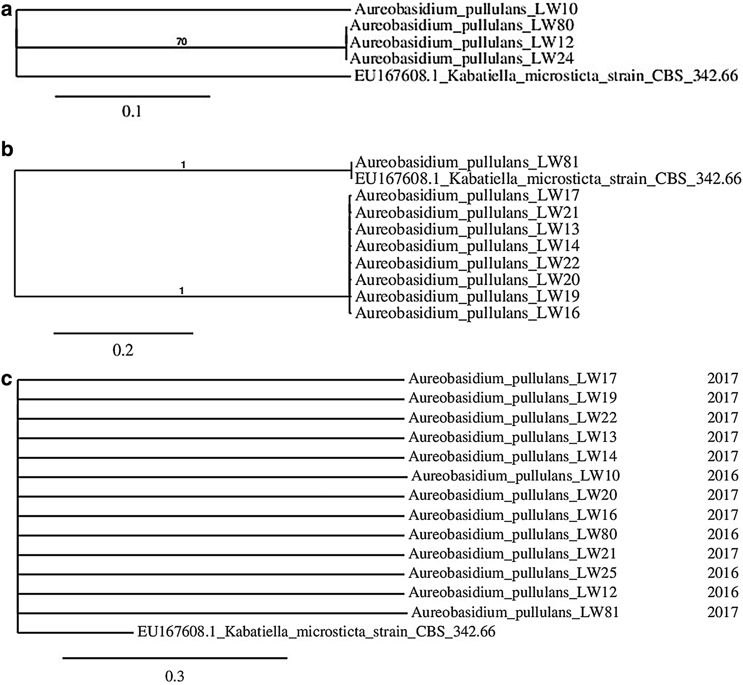
WorldJournalofMicrobiologyandBiotechnology(2018)34:115
Page7of11
115
Fig.1PhylogenetictreeobtainedforA.pullulansisolates collected in2016 (a), in 2017 (b) and inbothyears(c)
Additionally,resultsofRAPD-PCRwithM13cannotbe
usedasareferenceinfurtherresearchsincethatmethodwasproveninefficientandunreliable(Gil-Lamaignereetal.2003).Ontheother,applicationofthatmethodcouldbeusefulfordifferentiationofobtainedisolates.TomakethatmethodfeasibleforA.pullulans,otherprimersneedtobeselected.Basedonourexperience,RAPD-PCRneedstobecarriedoutwithatleasttwodifferentprimers.Inourcaseallisolatesdemonstratedvariousbandpatterns,therefore,itwasnotnecessarytosearchforanotherprimer.
Surprisingly,wedidnotdetectanyPenicilliumisolates,despitethefacttheycommonlyresideinappleinvariousgeographicregions(Bernieretal.1996;Scheperetal.2007;Welkeetal.2010;Alwakeel2013). Their absence couldberelatedtotheabundanceofA.pullulanswhichisconsideredasabiocontrolagenteffectivelyinhibitingthegrowthofPenicilliumspecies(Marietal.2012).WealsoidentifiedoneisolateofP.membranifacienswhichcouldbepotentially
aproducerofkillertoxins(MuccilliandRestuccia2015)
andthesecompoundsareknowntoinhibitfungalgrowthaswell.Moreover,thecurrentstudywasnotfocusedonthequantitativeanalysisofeachfungalspeciessothereisachancethattherewerePenicilliumstrainsamongisolateswhichwerenotselectedforDNAextraction.Othermouldfoundinfruitinthecurrentstudy—Fusarium,AlternariaandCladosporium,commonlyresideinapple(Bernieretal.1996;Grantina-Ievina2015;Abdelfattahetal.2016).InthestudycarriedoutinItaly,alsothepresenceofM.pulcher-rimaandsomePichiaandRhodotorulaspecieshasbeenconfirmed(Pellicciaetal.2011).
IsolatesofA.pullulansobtainedinthecurrentstudydemonstratedgreatdivergencewhichwastransparentintheirgrowthcharacteristicson WLnutrientagarandCza-pek-Doxagarbutalsointheirabilitytoproduceexopoly-saccharides.Theseobservationswereconfirmedbytheresultsofphylogeneticanalysis: the alignmentwhichwas
13

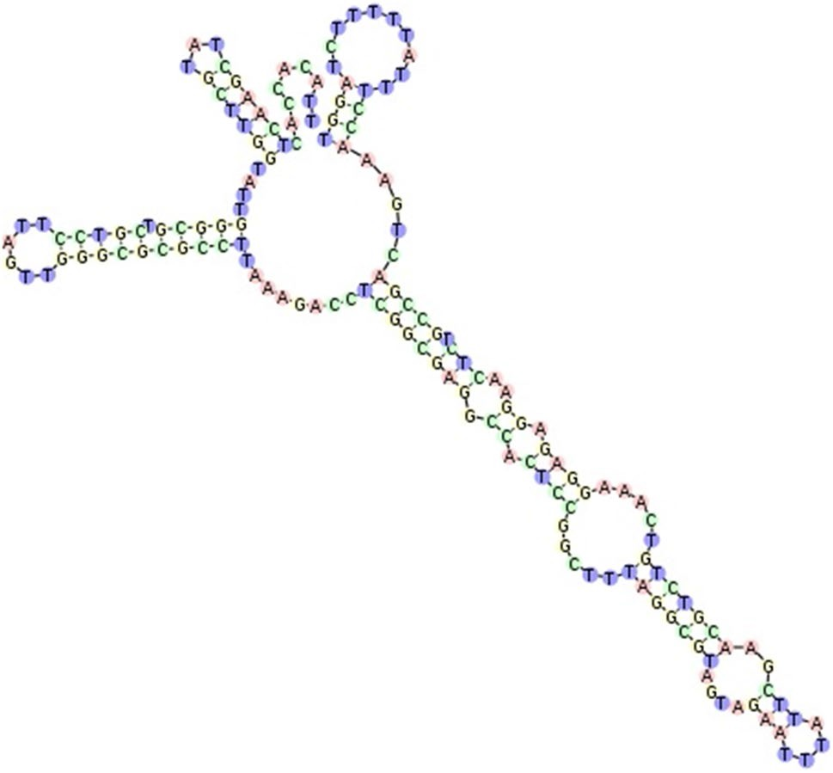
115Page8of11
WorldJournalofMicrobiologyandBiotechnology(2018)34:115
Duetotheannualchangesofweather,amountofprecipi-
tation,averageseasonaltemperaturesandgroundfrost,theselectionoflocalfarmsmightvaryfrom1yeartoanotherbecauseallmentionedfactorswouldinfluencetheyieldoffruit.Therefore,eachyearmicroorganismsaretransferredfromoneorchardtoanother,fromtheareathatmightsometimesreachupto20km(personalhearing).Anotherpossibleroutefortransmittingmicroorganismsisplantingyoungtreestoreplaceoldones.Also,duetochangesincustomerdemands,itisnecessarytoimplementnovelfruitvarietiesortoimportvarietieswhicharenotcommonfortheregionwhereorchardislocated.
AnotherimportantaspectwhichwasrevealedinthephylogeneticanalysisandextractingDNAregionsisthatthegenepoolwithinA.pullulansspeciescouldbechang-ing.Therewasonlyoneisolate(LW81)whichresembledalreadyknownsequencesstoredintheGenBankwhileallothers(12isolates)representednewcluster,perhapsanovelvarietyofA.pullulans.Changesinthegenomecouldbearesponsetovariousfactors,includingimplementationofinnovationstohorticulturalpractices,e.g.newtypesoffungicideorfertiliser.Ontheotherhand,thereisverylittledataavailableonmicroorganismsobtainedfromapplesobeforemakingambiguousconclusions,moredatashouldbecollectedandanalysed.
Intheindustrialproductionofpullulan,morethan70%yieldsoftheinitialcarbonsourcesareobtained(Leathers2003).Inthestudiesfocusedonoptimisationofpullulanpro-duction,29g/lwasobtainedafter84hfermentation(Yoonetal.2012)whileitwas17.2g/lwhensyntheticmediumwasused(Göksunguretal.2005).Inthecurrentstudy,iso-lateLW14produced13.58gofexopolysaccharide/l.Thesedifferencescouldbecausedbyvariousconcentrationsof
Fig.2SecondaryITS2region
structureforA.pullulansisolate
LW81.ThestructurewashomologymodelledbyAureobasidium
sp.JSKim-2015(accessionnumber:LC018758.1,GInumber:
747743838).Thescorecalculatedforthatmodelwas675,detected
gaps3/163(1.8%),identity160/163(98.2%)andsimilarity160/163(98.2%).Helixtransferwasasfollows:Helix1:100%,Helix2:100%,
Helix3:100%,Helix4:100%
preparedinthefirststageclearlyindicatedthatsequences
werenothomologoussotherewerenotwothesameiso-latesthatresidedinbothyearsofthestudy.Therearevariousscenariosto explainthisphenomenon.Nowadays,especiallysmallcompanieswhichhavetheirownorchards,purchasecultivarsofvariousfruitfromsmalllocalfarmsandthendelivergoodstosupermarketsorshopsincities.
Table3LocationofITS1andITS2regionsand 5.8S andpartial28SgenesinA.pullulanssequences
Year
Isolate no.
ITS1
5.8S
ITS2
28S

2016
LW25
LW12LW10LW80LW81LW13LW14LW16LW17LW19LW20LW21LW22
CBS 584.75
1–140
1–147
1–141
1–141
1–136
1–158
1–153
1–158
1–145
1–140
1–159
1–161
1–161
12–191
141–294
148–301
142–295
159–315
137–290
159–312
154–317
159–312
146–299
141–294
160–313
162–315
162–315
192–348
295–450
302–457
296–451
316–461
291–450
316–461
318–463
313–457
300–455
295–450
314–469
316–471
316–471
349–504
451–500
458–500
452–500
462–510
451–510
462–521
464–528
458–521
456–486
451–501
470–521
472–521
472–521
505–542
2017
A.pullulans
(KT693733.1)
In the case of isolatemarkedin boldITS2regionwasannotatedinITS2Database
13

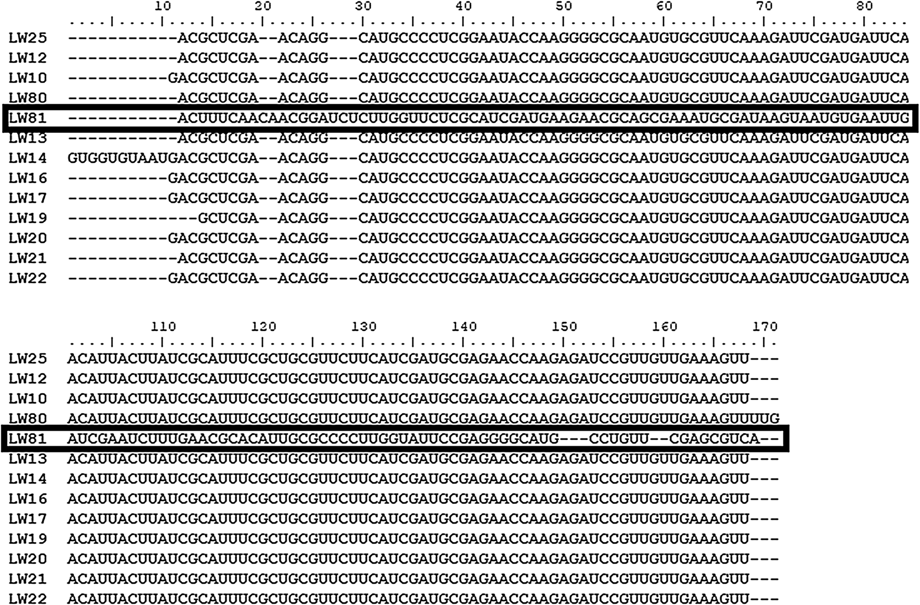
WorldJournalofMicrobiologyandBiotechnology(2018)34:115
Page9of11
115
Fig.3Thealignmentof5.8SgenesequencesofA.pullulansisolatesobtainedinRfam.ThealignmentwasbasedonMUSCLEalgorithm.Thesequencemarkedinboldindicatesisolatewhichdiffered significantlyfromallotheranalysed microorganisms
Table4ScreeningforexopolysaccharideproducersamongA.pullulansstrainsobtained intwosubsequentharvestseasons
Year
Isolate no.
Colonyappearance
Growthintensity
Intensity of
exopolysaccharide
production

2016
LW25
LW12LW10LW80LW81
Black-browncolonies, smallroundcolonies
Black-browncolonies, smallroundcoloniesBlack-browncolonies with wrinkledsurfaceNogrowth
Black-browncolonies with wrinkledsurface,smallroundcolonies
Black-browncolonies, smallroundcoloniesBlack-browncolonies, smallroundcoloniesBrowncolonies with wrinkledsurface
Beige-browncoloniesBrowncolonies
Nogrowth
Beigecolonies, smallroundcoloniesBlackcolonies with wrinkledsurface
++++
++++
+++
–
++++
++++
++
–
–
–
2017
LW13
LW14LW16LW17LW19LW20LW21LW22
++++
+++++
+++
+++
++
–
++++
++++
++++
++++++
++
–
–
–
–
–
‘–’Nogrowth/slimycoloniesformation;‘+’veryweakgrowth/slightcolonysliminess;‘++’weakgrowth/
slightcolonysliminess;‘+++’moderategrowth/slightcolonysliminess;‘++++’goodgrowth/slightcol-onysliminess;‘+++++’verygoodgrowth/slightcolonysliminess.Isolatemarkedinboldwasthemostsignificantexopolysaccharideproducer
sucrose,whichwas165.73g/l(Yoonetal.2012),51.4g/l
(Göksunguretal.2005)and30g/l(currentstudy),respec-tively.Otherfactorsthatcouldcontributetotheseoutcomes
were:fermentationtime,variousconcentrationsofmineral
saltsandaerationrates.Sinceoptimisationofexopolysac-charideproductionwasnotthemainfocusofthecurrent
13

115Page10of11
WorldJournalofMicrobiologyandBiotechnology(2018)34:115
productionbyselected isolates
abc
cell numbers. The sameletters
abovecolumnsforeachinitial
14
a
bc
b
b
statisticallysignificantdiffer-
encesatp<0.05,n=5
10
8
6
4
2
0
a
ab
a
a
a
a
LW25
LW12
LW13
Isolatenumber
LW14
LW16
1,000cfu/ml
10,000cfu/ml
100,000cfu/ml
study,nofurtherexperimentswerecarriedoutinthatdirec-
tion.Ontheotherhand,isolateLW14seemstobeverypromisingcandidateforpullulanproductionsointhefuturestudiesshouldbecontinuedtooptimiseexopolysaccharideproduction.
ItwasdemonstratedthattheisolateLW14shouldnotposeanyrisktothequalityofpasteurisedapplejuice.Furtherstudiesshouldbeinitiatedtoverifyhowthispar-ticularisolateaffectsthequalityofunpasteurisedjuices.Itisagroupofproductswhichisgainingalotofconsumerinterest.
AnejaKR,DhimanR,AggarwalNK,AnejaA(2014)Emerging
preservationtechniquesforcontrollingspoilageandpatho-genicmicroorganismsin fruitjuices.Int JMicrobiol.https://doi.org/10.1155/2014/758942
BernierJ,CarisseO,PaulitzTC(1996)FungalcommunitiesisolatedfromdeadappleleavesfromorchardsinQuébec.Phytoprotection77:129–134.https://doi.org/10.7202/706109ar
CastresanaJ(2018)Selectionofconservedblocksfrommultiplealign-mentsfortheiruseinphylogeneticanalysis.MolBiolEvol.https
://doi.org/10.1093/oxfordjournals.molbev.a026334
ChengK-C,DemirciA,CatchmarkJM(2011)Pullulan:biosynthesis,production,and applications. ApplMicrobiolBiotechnol92:29–44.https://doi.org/10.1007/s00253-011-3477-y
ChevenetF,BrunC,BañulsALetal(2006)TreeDyn:towardsdynamicgraphicsandannotationsforanalysesoftrees.BMCBioinform7:1–9.https://doi.org/10.1186/1471-2105-7-439
DereeperA,GuignonV,BlancGetal(2008)Phylogeny.fr:robustphylogeneticanalysisforthenon-specialist.NucleicAcidsRes36:465–469.https://doi.org/10.1093/nar/gkn180
EdgarRC(2004)MUSCLE:Multiplesequencealignmentwithhighaccuracyandhighthroughput.NucleicAcidsRes32:1792–1797.https://doi.org/10.1093/nar/gkh340
FujitaS-I,SendaY,NakaguchiS,HashimotoT(2001)MultiplexPCR usinginternaltranscribedspacer1and2regionsforrapiddetectionandidentificationofyeaststrains.JClinMicrobiol39:3617–3622.https://doi.org/10.1128/JCM.39.10.3617
Gil-LamaignereC,RoilidesE,HackerJ,MüllerFMC(2003)Moleculartypingforfungi—acriticalreviewofthepos-sibilitiesandlimitationsofcurrentlyandfuturemethods.ClinMicrobiolInfect9:172–185.https://doi.org/10.1046/j.1469-0691.2003.00649.x
GöksungurY,DǎgbaǧliS,UçanA,GüvençU(2005)OptimizationofpullulanproductionfromsyntheticmediumbyAureoba-sidiumpullulansinastirredtankreactorbyresponsesurfacemethodology.JChemTechnolBiotechnol80:819–827.https://doi.org/10.1002/jctb.1254
GostinčarC,OhmR,KogejTetal(2014)GenomesequencingoffourAureobasidiumpullulansvarieties:biotechnologicalpoten-tial,stresstolerance,anddescriptionofnewspecies.BMCGenomics15:549.https://doi.org/10.1186/1471-2164-15-549
Grantina-IevinaL(2015)Fungicausingstoragerotofapplefruitinintegratedpestmanagementsystemandtheirsensitivityto
AcknowledgementsThepurchaseofmaterialsforDNAisolation,purificationandsequencinginthisresearchwasfinancedbytheMinis-tryofScienceandHigherEducationoftheRepublicofPoland.ProjectNumber4767/KTFiMT/2017.
OpenAccessThisarticleisdistributedunderthetermsoftheCrea-tiveCommonsAttribution4.0InternationalLicense(http://creativecommons.org/licenses/by/4.0/),whichpermitsunrestricteduse,distribu-tion,andreproductioninanymedium,providedyougiveappropriatecredittotheoriginalauthor(s)andthesource,providealinktotheCreativeCommonslicense,andindicateifchanges weremade.
References
AbdelfattahA,WisniewskiM,DrobyS,SchenaL(2016)Spatialand
compositionalvariationinthefungalcommunitiesoforganicandconventionallygrownapplefruitattheconsumerpoint-of-purchase.HorticRes.https://doi.org/10.1038/hortres.2016.47
AlwakeelSS(2013)MolecularidentificationofisolatedfungifromstoredapplesinRiyadh,SaudiArabia.SaudiJBiolSci20:311–317.https://doi.org/10.1016/j.sjbs.2013.05.002
AndrighettoC,PsomasE,TzanetakisNetal(2000)Randomlyampli-fiedpolymorphicDNA(RAPD)PCRfortheidentificationofyeastsisolatedfromdairyproducts.LettApplMicrobiol30:5–9.https://doi.org/10.1046/j.1472-765x.2000.00589.x
13
Exopolysaccharideproduction[g/l]

WorldJournalofMicrobiologyandBiotechnology(2018)34:115
Page11of11115
fungicides.RuralSustainRes34:2–11.https://doi.org/10.1515/
plua-2015-0007
GuindonS,DufayardJF,LefortVetal(2010)Newalgorithmsandmethodstoestimatemaximum-likelihoodphylogenies:assess-ingtheperformanceofPhyML3.0.SystBiol59:307–321.https
://doi.org/10.1093/sysbio/syq010
HallTA(1999)BioEdit:auser-friendlybiologicalsequencealign-menteditorandanalysisprogramforWindows95/98/NT.NucleicAcidsSympSer41:95–98
IsaevaOV,GlushakovaAM,YurkovAM,ChernovIY(2009)TheyeastCandida railenensisinthefruitsof English oak (QuercusroburL.).Microbiology78:355–359.https://doi.org/10.1134/S002626170903014X
Kalvari I,ArgasinskaJ,Quinones-OlveraNetal(2018)Rfam13.0:shiftingtoagenome-centricresourcefornon-codingRNAfami-lies.NucleicAcidsRes46:D335–D342.https://doi.org/10.1093/nar/gkx1038
KoetschanC,FörsterF,KellerAetal(2009)TheITS2DatabaseIII—sequencesandstructuresforphylogeny.NucleicAcidsRes38:275–279.https://doi.org/10.1093/nar/gkp966
LeathersTD(2003)Biotechnologicalproductionandapplicationsofpullulan.ApplMicrobiolBiotechnol62:468–473.https://doi.org/10.1007/s00253-003-l386-4
MariM,MartiniC,SpadoniAetal(2012)Biocontrolofappleposthar-vestdecaybyAureobasidiumpullulans.PostharvestBiolTechnol73:56–62.https://doi.org/10.1016/j.postharvbio.2012.05.014
MergetB,KoetschanC,HacklTetal(2012)TheITS2Database.JVisExp.https://doi.org/10.3791/3806
Mirzwa-MrózE,DzięciołR,PiteraE,JurkowskiA(2012)Influenceofsooty blotchandflyspeck(SBFS)fungi onapplefruits duringstorage.ActaSciPolHortorumCultus11:39–46
Mirzwa-MrózE,Wińska-KrysiakM,DzięciołR,MiękusA(2014)CharacteristicsofAureobasidiumpullulans(deBaryetLöwen-thal)G.Arnaudisolatedfromapplesandpearswithsymptomsofsooty blotchinPoland.ActaSciPolHortorumCultus13:13–22
MuccilliS,RestucciaC(2015)Bioprotectiveroleofyeasts.Micro-organisms3:588–611.https://doi.org/10.3390/microorganisms3
040588
NawrockiEP,BurgeSW,BatemanAetal(2015)Rfam12.0:updates
totheRNAfamiliesdatabase.NucleicAcidsRes43:D130–D137.https://doi.org/10.1093/nar/gku1063
PellicciaC,AntonielliL,CorteLetal(2011)Preliminaryprospec-tionoftheyeastbiodiversityonappleandpearsurfacesfromNorthernItalyorchards.AnnMicrobiol61:965–972.https://doi.org/10.1007/s13213-011-0220-y
PennycookSR,NewhookFJ(1981)Seasonalchangesintheapplephylloplanemicroflora.NZJBot19:273–283.https://doi.org/10.1080/0028825X.1981.10426380
RamírezC,GonzálezA(1984)Fivenewfilamentous,glucose-ferment-ingCandidaisolatedfromdecayedwoodintheevergreenrainyValdivianforestofsouthernChile.Mycopathologia88:83–92.https://doi.org/10.1007/BF00436436
ScheperRWA,RogersDJ,WalkerJTSetal(2007)Theincidenceofstoragerotsafterpostharvestapplewashing.NZPlantProt60:7–14
StreetG,KingdomU(2006)Approximatelikelihood-ratiotestforbranches:afast,accurate,andpowerfulalternative.SystBiol55:539–552.https://doi.org/10.1080/10635150600755453
WareingP,DavenportRR(2007)Microbiologyofsoftdrinksandfruitjuices.In:Chemistryandtechnologyofsoftdrinksandfruitjuices,2ndedn.Blackwell,London,pp279–299.https://doi.org/10.1002/9780470995822.ch11
WelkeJE,HoeltzM,DottoriHA,NollIB(2010)Fungiandpatulininapplesandtheroleofprocessingonpatulinlevelsinjuices:astudyonnaturallycontaminatedapples.JFoodSaf30:276–287.https://doi.org/10.1111/j.1745-4565.2009.00205.x
WilliamsAJ(1955)Changesinthemicrofloraofapplesduringripen-ingandcoldstorage.McGillUniversity
YoonS,HongE,KimSetal(2012)OptimizationofculturemediumforenhancedproductionofexopolysaccharidefromAureobasid-iumpullulans.BioprocessBiosystEng35:167–172.https://doi.org/10.1007/s00449-011-0620-1
ZalarP,GostinčarC,deHoogGSetal(2008)RedefinitionofAureoba-sidiumpullulansanditsvarieties.StudMycol61:21–38.https://doi.org/10.3114/sim.2008.61.02
13

