
PAPER

Localized electrochemical redox reactions in yttria-stabilized zirconia
OPEN ACCESS

RECEIVED
31 October 2019

REVISED
20 December 2019

ACCEPTED FOR PUBLICATION
14 January 2020

PUBLISHED
9 July 2020

Original content from this work may be used under the terms of the Creative Commons Attribution 4.0 licence.
Any further distribution of this work must maintain attribution to the
author(s) and the title of
the work, journal citation and DOI.

single crystals
Christian Rodenbücher1,4 , Kristof Szot2 , Dominik Wrana3 , Benedykt R Jany3 , Franciszek Krok3 and Carsten Korte1
1 Institute of Energy and Climate Research (IEK-14), Forschungszentrum Jülich GmbH, 52425 Jülich, Germany
2 A. Chełkowski Institute of Physics, University of Silesia, 41-500 Chorzów, Poland
3 Marian Smoluchowski Institute of Physics, Jagiellonian University, 30-348 Krakow, Poland
4 Author to whom any correspondence should be addressed.
E-mail: c.rodenbuecher@fz-juelich.de

Keywords: YSZ, solid electrolyte, electroreduction, blackening

Abstract
Herein, electroreduction in yttria-stabilized zirconia are investigated by means of Hebb-Wagner polarization experiments. By performing optical and thermal microscopy on single crystals and thin ﬁlms during the application of an electric ﬁeld under vacuum or oxygen-tight sealed conditions, the movement of the reduction front from the cathode to the anode, which causes a blackening of the material, is monitored. When performing electrocoloration experiments on thin ﬁlm samples, the progressing reaction of the blackened region was found to be inhomogeneous and evolves as a dendrite-like ﬁnger structure. The progression of the blackening ﬁngers follow preferentially the electric ﬁeld lines and thus are inﬂuenced by distortions in the ﬁeld that can be caused by metallic particles embedded in the oxide. In contrast to this, in the ﬁrst stage of the reduction process no signiﬁcant inﬂuence of mechanically-induced dislocations on the morphology or kinetics on the electroreduction can be found. Only after a heavy electroreduction was a localized transformation of the surface region observed. There is an evolution of highly oxygen deﬁcient ZrOx regions, which have a characteristic checked topography pattern at the microscale level.

- Introduction

The emissions-free energy system of the future depends on the efﬁcient storage of energy. Hence, the development and optimization of electrochemical energy converters have become a key task. Solid oxide fuel cells (SOFCs), employing the reaction of oxygen and hydrogen to form water, have been identiﬁed as highly reliable and cost- effective energy converters [1]. They can also be operated as solid oxide electrolysis cells (SOECs) producing hydrogen by water-splitting and thus offering a complete solution for the conversion of electrical to chemical energy and vice versa [2]. However, it has become apparent that when operating such a cell in the electrolysis mode, degradation effects can occur, which eventually limit the device’s lifetime [3–5]. Hence, the investigation of the solid ion conductors that are used as SOEC electrolytes under the gradients of electrical potential is of highly relevant.
Here, we focus on electroreduction phenomena in the prototype solid electrolyte, yttria-stabilized zirconia (YSZ), which also ﬁnds widespread application in technologies such as oxygen sensors, as a thermally-stable construction material or in memristive electronics [6–10]. The high ionic conductivity of YSZ is related to the partial substitution of tetravalent Zr by trivalent Y, leading to the evolution of oxygen vacancies to balance the charge in the solid solution of yttria and zirconia [11]. Although it can accommodate a large degree of non- stoichiometry, making it a very stable material, prolonged reduction leads to a blackening effect of the originally transparent material [12–14]. In particular, when YSZ is exposed to an electric ﬁeld using partially blocking electrodes in Hebb-Wagner-type geometry, the local effect of electroreduction can be readily seen as a change in the transparency related to a black reaction front moving through the material from cathode to anode [15]. This effect is well-known and has been the subject of various studies in recent decades. To understand the physical

© 2020 The Author(s). Published by IOP Publishing Ltd

nature of the blackening, which is crucial to develop stable SOEC devices based on YSZ, approaches employing transmission electron microscopy and x-ray photoelectron spectroscopy have been followed, indicating that in
the blackened regions, Zr4+ is reduced to a lower valence (even metallic Zr0 has been found) [16]. This
mechanism was found to be related to the formation of zirconium suboxides (ZrO2−x), leading to enhanced electronic conductivity [16–18]. While such a phase transformation might be problematic for SOEC applications where a pure ionic conductivity of the solid electrolyte is needed, the possibility of changing the material properties upon electroreduction has generated a lot of attention in the ﬁeld of heterogeneous catalysis. It has been reported that the catalytic activity of a metal deposited on a solid electrolyte can be increased signiﬁcantly upon electrochemical treatment, which is called the NEMCA (non-Faradaic electrochemical modiﬁcation of catalytic activity) effect [19]. This effect is presumably caused by an additional electrochemical supply of reactive oxygen species via the electrolyte upon anodic polarization of the metal electrode but it is very controversially discussed in the literature [20]. Depending on the contact of the electrode and the possibility of matter exchange to the surrounding gas phase, morphologic changes can also occur at the electrode during this process, which further modify its properties. In this way, the length of the three-phase boundary formed
between the electrode, solid electrolyte and surrounding gas atmosphere can be changed signiﬁcantly [21]. In the case of a dense and closed PLD-fabricated Pt ﬁlm in a direct contact with YSZ, the oxygen accumulating below the electrode was found to lead to the evolution of bubbles in the metal ﬁlm, causing the formation of cracks and eventually a partial delamination of the ﬁlm [22, 23]. Detailed studies of the bubble evolution have been conducted, revealing a characteristic sequence starting from triangular bubbles on the nanoscale that coalesce to irregularly-shaped larger bubbles over the course of time [24]. Those bubbles were found to be hollow inside, but
the underside of the delaminated Pt ﬁlm had oxidized to PtOx due to the high oxygen activity at the electrode/
electrolyte interface under anodic polarization [25].
A further aspect of the ionic conductance of YSZ that must be considered is the inﬂuence of internal interfaces, such as dislocations and grain boundaries [26]. The oxygen ion transport across a grain boundary in YSZ was found to be hindered due to the presence of space charge zones related to the segregation of vacancies at the dislocation sites [27]. The question as to whether ion transport along a grain boundary in a solid electrolyte is decreased or increased compared to the bulk is complex in general and contradictory results have been
published [28–30]. On YSZ crystals that were mechanically deformed to generate a high density of dislocations, a signiﬁcant enhancement of the ionic conductivity was found, indicating that pipe diffusion plays an important role [31]. This ﬁnding is in agreement with oxygen isotope tracer experiments on nanocrystalline YSZ, revealing an oxygen diffusion coefﬁcient along grain boundaries that is three times higher than in the bulk [32]. In another study using the same technique, however, the opposite effect, namely a hindered diffusion along the grain boundary, was found [33]. The reasons for this discrepancy could relate to difﬁculties in sample preparation, as segregation effects or the evolution of microcracks can have a signiﬁcant impact on the obtained results.
Regarding simulation studies using molecular dynamics, no enhancement or even a hindering of oxygen ion transport along grain boundaries at high temperatures has been calculated [34–36]. A recent investigation of single dislocations in YSZ by atomic resolution scanning transmission electron microscopy (STEM) was again in favour of easy diffusion along dislocations, proposing that the interplay of a tensile strain ﬁeld and dopant segregation leads to the formation of a path with faster ionic conductivity around the core of the dislocation [37].
The impact of strain and dislocations on the ionic transport in YSZ thin ﬁlms has been addressed in many studies. By depositing thin ﬁlms on substrates with different lattice constants such as Y2O3, Lu2O3, or Sc2O3 or
by fabricating YSZ/Y2O3 heterostructures, an increase in ionic conductivity with the lattice mismatch and with
the increasing number of phase boundaries have been observed [38–40]. These ﬁndings agree with theoretical calculations, indicating a distinct correlation between the tensile strain and ion diffusion up to a critical value of the strain [41]. However, the ion transport measurements also obtained on thin ﬁlm samples display a signiﬁcant scattering and there are reports that conclude no or only a negligible impact of strain and dislocations [42]. The reason for these ambiguous results may be related to the impact of the ﬁlm texture and grain size, making it difﬁcult to compare thin ﬁlms prepared under different conditions and to separate strain effects from grain boundary effects [43]. This illustrates that the nature of conductance in metal oxides is complex, but due to the high technological relevance for their use in energy converters, a further detailed analysis is of the utmost importance.
Here, we focus on the effect of electroreduction of YSZ to pinpoint the potential failure mechanisms of SOECs. We use single crystals as well-deﬁned starting materials and conduct the experiments under clean high vacuum conditions. This approach has been followed in many studies on solid metal oxides to investigate electrically induced redox phenomena [44–47]. The present study is partially based on our previous investigation of electroreduction effects in SrTiO3 [48]. In this material, the electroreduction leads to local self- doping inducing ﬁlamentary current paths for electronic conductivity turning the initially insulating material into an electronic conductor. This transformation was found to be strongly inﬂuenced by the presence of dislocations that act as preferential reduction sites [49]. In this article, we aim to answer the question of whether

similar effects are also present in YSZ. Although both materials share some similarities as transition metal oxides where valence change and electronic conductivity can be introduced via redox processes, the ionic conductivity of YSZ is much higher than that of SrTiO3 and hence differences in the kinetics of the transformation are to be expected. In our investigation, we placed special emphasis on the role of extended defects such as dislocations, geometrical distortions or secondary phases. We analyse different states of the material degradation, starting from short electroreduction where we compare single crystals with different dislocation densities, via the investigation of YSZ thin ﬁlms to make the movement of the reduction front and its morphologic evolution
on the microscale visible up to heavy electroreduction, resulting in a distinct surface transformation and the evolution of new phases.

- Methods

  - Electroreduction of single crystals
Commercial ZrO2 single crystals doped with 9.5 mol% Y2O3 produced by skull growth (Crystec, Berlin, Germany) were used. The crystal samples, with a thickness of 0.5 mm, were aligned along the (100) direction and both sides were polished. As electrical contacts, Pt electrodes were deposited on the crystal surfaces by sputtering. The electroreduction experiments were conducted under high vacuum conditions (<10−6 mbar) and maintained by a turbomolecular pump (Leybold, Cologne, Germany). The sample was positioned on a heater at 400 °C and an external power supply (BOP 1000 M, Kepco, Flushing, USA) was used to apply a voltage of 1 kV via a series resistor of 100 kΩ, thus providing a current compliance at 10 mA. Optical in situ analysis
of the electrocoloration was performed by a microscope (Stemi2000, Zeiss, Oberkochen, Germany) in combination with a digital camera (Powershot, Canon, Tokyo, Japan), while thermal imaging was obtained by means of an infrared camera (X6540sc, FLIR Systems, Täby, Sweden).

  - Electroreduction of thin ﬁlms
Thin ﬁlms of YSZ were prepared by means of pulsed laser deposition (PLD) using a KrF (λ = 248 nm) excimer laser (ComPEX 201, Lambda-Physik, Göttingen, Germany). As substrates, polished sapphire substrates with a size of 10 × 10 × 0.5 mm3 in (0001) orientation (TBL Kelpin, Neuhausen, Germany) were used and as the target, polycrystalline YSZ ceramics (HTM Reetz, Berlin, Germany) was employed. After the deposition of
100 μm-thick YSZ layers on the substrates, Pt electrodes were sputtered and, ﬁnally, a thin cover layer of Al2O3 to partially seal the electrolyte from the ambient was applied by PLD. In this way, a Hebb-Wagner type geometry could be established with the blocking electrode negatively poled. For electrical polarization, a manual electric probe system (SÜSS MicroTec, Garching, Germany) equipped with a light microscope, a heater (750 °C) and contacts for applying an electrical voltage connected to a power supply (1 kV, Heinzinger, Rosenheim,
Germany) were used. The spatial evolution of the electrocoloration front during polarization was analysed
in situ by a CCD camera.

  - Analytical methods
The single crystal samples were analysed after the electroreduction at ﬁrst by optical inspection. Using optical microscopy in transmission light mode, as well as in reﬂection mode with polarized light (Axio imager, Zeiss, Oberkochen, Germany), the morphology of the electroreduced areas was imaged. Scanning electron microscopy (SEM) imaging in terms of secondary electrons SE (topography) and backscattered electrons BSE (chemical contrast), in combination with energy-dispersive x-ray spectroscopy (EDX), was performed at 5 keV electron energy (Quanta 3D FEG, FEI, Hillsboro, USA). The EDX maps were recorded in hyperspectral mode i.e. in each spatial pixel full EDX spectrum was recorded. After the acquisition, the EDX data were bremsstrahlung background deconvoluted pixel by pixel to produce ﬁnal background free net counts maps and line proﬁles.
The surface topography was mapped by atomic force microscopy (AFM) in contact mode (Cypher S, Asylum Research, Santa Barbara, USA).

Results

  - Short electroreduction in single crystals
In order to follow the electroreduction in YSZ single crystals, we deposited two oblong Pt electrodes on the surface, which were separated by 3 mm from each other. After heating the sample under high vacuum conditions to 400 °C, the electrodes were connected to a voltage source of 1 kV with a 100 kΩ series resistor as
illustrated in ﬁgure 1(a). The current recorded during electroreduction is shown in ﬁgure 1(b). It can be seen that the current increased with the degradation time almost linearly but stayed in the μA range. This indicates that within the observed time window of 80 min, the electronic conductivity related to the ongoing electroreduction

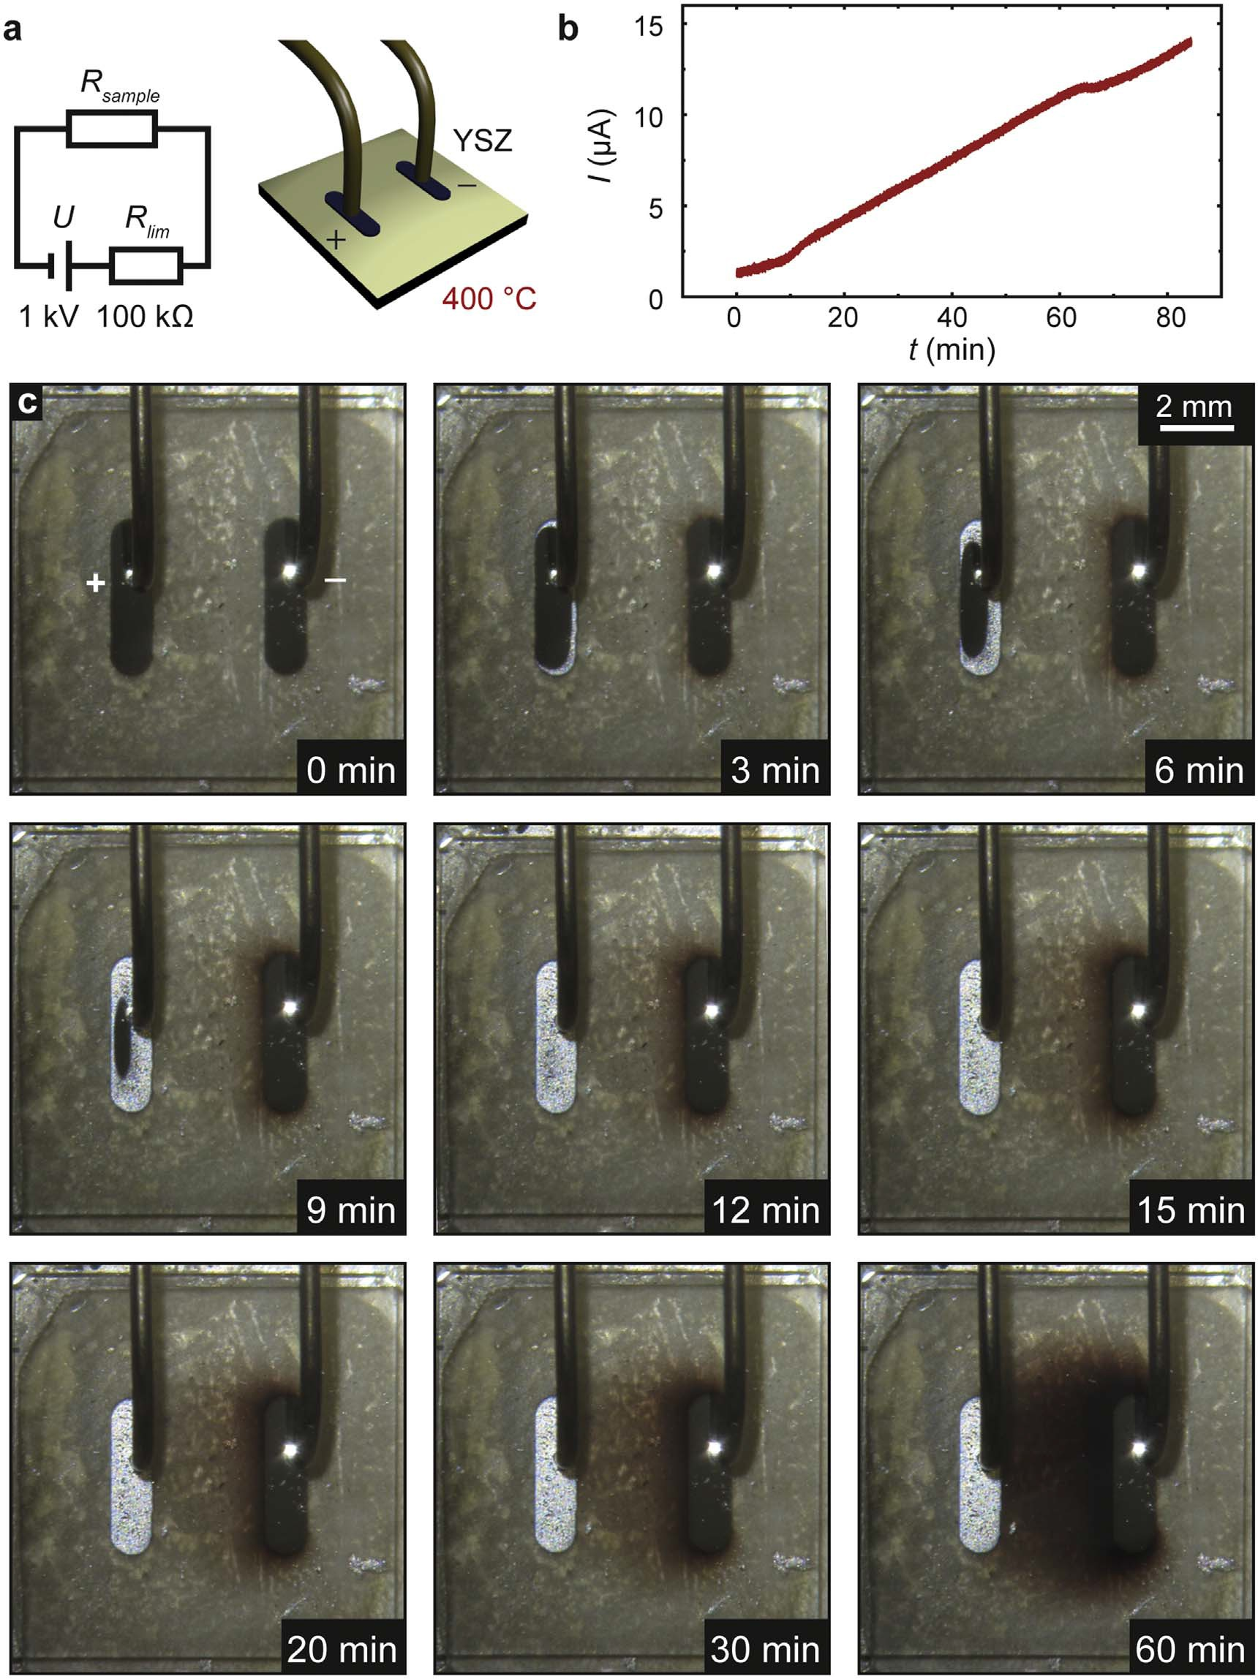

Figure 1. Electroreduction of a YSZ single crystal under vacuum conditions: (a) Electrical circuit and schematics of the electrode contact; (b) current as a function of degradation time; (c) optical images of the sample during electroreduction.

only increased slightly. However, the effect on the colour of the sample was remarkable. As is shown in the optical photographs obtained during the electroreduction process (ﬁgure 1(c)), a blackening of the crystal started directly after turning on the voltage. The electrocoloration front evolved from the cathode (right electrode in ﬁgure 1(c)) and then proceeded towards the anode over time. Simultaneously, the anode (left electrode in ﬁgure 1(a)) began to ﬂake off gradually. This further illustrates that the current was mainly ionic and
the evolving oxygen gas at the anode formed bubbles in the sputtered Pt electrode, which eventually ruptured. As the cathode consisted of sputtered Pt, which can be regarded as gas-tight, and additionally the vacuum atmosphere provided only a reduced amount of oxygen, the oxygen incorporated into the crystal is much lower than the oxygen that is transported and eventually released from the anode.

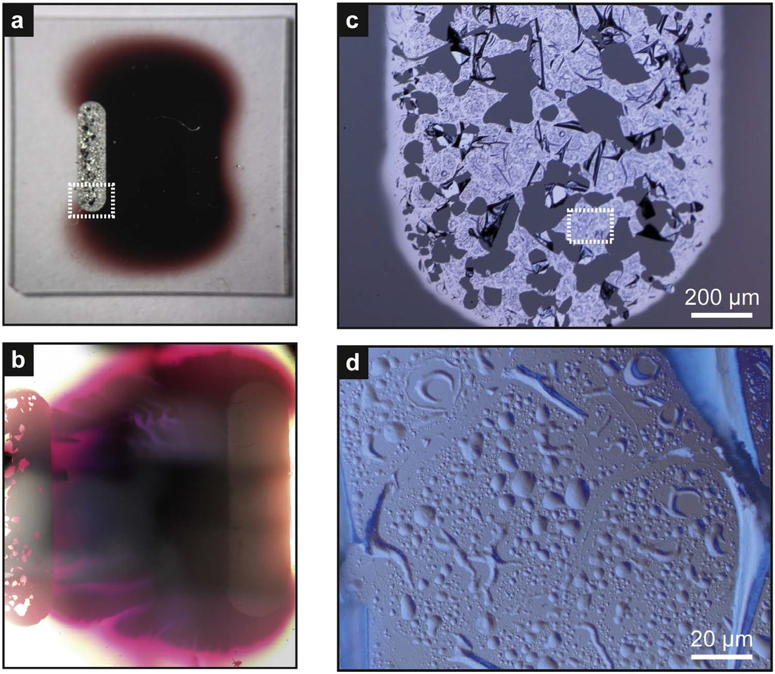

Figure 2. Analysis of the electroreduced sample by optical microscopy. (a) Overview of the crystal in reﬂection light mode; (b) the blackened area in transmission light mode; (c) the lower part of the anode in reﬂection light mode with phase contrast (dashed area in a); (d) magniﬁcation of (c).

After the electroreduction had been conducted for 80 min, the changes in the sample were investigated
ex situ by optical microscopy. In ﬁgure 2(a), the overview of the sample in reﬂection light mode is shown, revealing that the entire area between the electrodes has been reduced and its colour changed to reddish black. When imaging the very same area in transmission light mode however, it can be seen that the blackened area possesses a substructure with ﬁnger-like structures having different optical transmissions (ﬁgure 2(b)). This shows that although the electroreduced area mainly follows the distribution of the electric-ﬁeld lines, a certain degree of localization and inhomogeneity was present.
In ﬁgures 2(c) and (d), we analyse the anode itself using optical microscopy in reﬂection light mode with
phase contrast. The surface of the electrode that had initially been prepared by sputtering 30 nm Pt through a shadow mask changed signiﬁcantly. It can be seen that the electrode area was not completely covered anymore, but that large areas with diameters of several tens of micrometres were uncovered and the Pt ﬁlm had folded up, forming agglomerations protruding from the surface. Zooming in to an area still covered by Pt (ﬁgure 2(d)),a heterogeneous distribution of bubbles can be detected on the microscale. Smaller bubbles with diameters below one micrometre, as well as larger bubbles with diameters of a few micrometres, can be observed. Moreover, some bubbles also appear to have been deﬂated again, showing that the excorporation of oxygen at the anode
during electroreduction is a highly dynamic process. As the Pt with 30 nm thickness was directly sputtered on the surface without additional layers in between, its adhesion was relatively low and it could be easily lifted when oxygen evolved at the interface. These observations of the bubble formation upon anodic polarization are in agreement with earlier reports discussed above [22–25].
In order to check whether dislocation-rich areas inﬂuence the movement of the electroreduction front, we
followed the same approach as in our previous study that investigated the electroreduction of SrTiO3 [48] and scratched the crystal with a diamond scraper. In this way, the two electrodes were connected by a line having a large density of mechanically-induced dislocations. In ﬁgure 3, optical images at the beginning, middle, and end of the electroreduction process of this sample are exemplarily shown. The parameters of the electroreduction process such as voltage, current compliance, pressure and temperature were kept constant. When comparing the distribution of the blackened region to the sample without a scratch (ﬁgure 1), no signiﬁcant changes can be

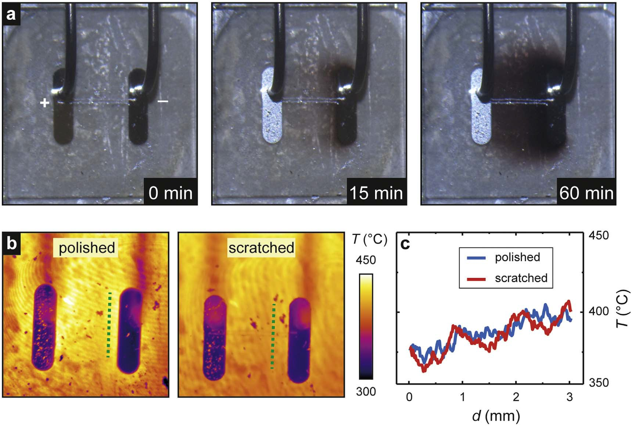

Figure 3. Electroreduction of a YSZ single crystal with a scratch increasing the dislocation density locally: (a) Optical microscopy during electroreduction; (b) comparison of thermal images of the polished and scratched sample obtained at 15 min; (c) line scans extracted along the dashed lines of (b).

identiﬁed. The spatial distribution of the blackening as well as the electroreduction kinetics was comparable indicating that the mechanically-induced distortions did not signiﬁcantly alter the degradation of the material.
To analyse the spatial distribution of electronic conductance during the electroreduction, we employed thermal microscopy and detected Joule heating effects. In ﬁgure 3(b), thermal images obtained during the electroreduction of the polished and scratched samples are compared. It can be seen that the temperature distribution in both cases is nearly identical and no increase in the temperature close to the scratch is observed. This is emphasized in the line proﬁles of ﬁgure 3(c), extracted along the dashed lines in between the electrodes. In general, the temperature stayed close to the base temperature of the sample during electroreduction, which shows that Joule heating effects did not prevail. As we have used the same geometry to investigate the inﬂuence of dislocations on the electroreduction of SrTiO3 [48], we can also make a comparison between these two
materials. While we do not observe a distinct impact of dislocations on the electroreduction of YSZ, in SrTiO3 the temperature along the scratch was signiﬁcantly increased, indicating a channelling of the electronic current along dislocations, acting as preferential reduction sites.

  - Detailed analysis of the moving reaction front
The electroreduction of single crystals using surface mounted electrodes leads to the evolution of a heterogeneous blackening area between the electrodes. For a more detailed analysis of the progressing reaction front and the evolution of the blackened region studies on thin ﬁlm samples were performed. Thus, polycrystalline YSZ thin ﬁlms grown on an Al2O3 substrate and covered with an Al2O3 thin ﬁlm were used. The schematic of the sample structure in ﬁgure 4(a)) shows that a Hebb-Wagner polarization can be realized by sealing the surface of a thin ﬁlm. Hence, similar conditions as in a vacuum electroreduction experiment of the single crystals were ascertained. As the thickness of the ﬁlm (100 μm) was much lower than that of the single crystals, the moving reaction front could be easily monitored by optical microscopy. A Pt microparticle was embedded in the centre of the sample, serving as a geometrical distortion of the electrical ﬁeld. The micrographs obtained during the electroreduction process at 750 °C (ﬁgure 4(b)) reveal the evolution of dendrite-like ﬁngers. As discussed in the introduction, the reduced phase has a much better electronic conductivity compared to the unreduced one. As the ionic conductivities are comparable, the total conductivity of the reduced phase will also exceed the value for the unreduced one. In the case of the electroreduction process a better conducting phase grows into a comparable bad conducting phase. This will amplify each distortion of the reaction front as the electric ﬁeld and thus the necessary ionic transport is focused to this location. The initial distortion will evolve to

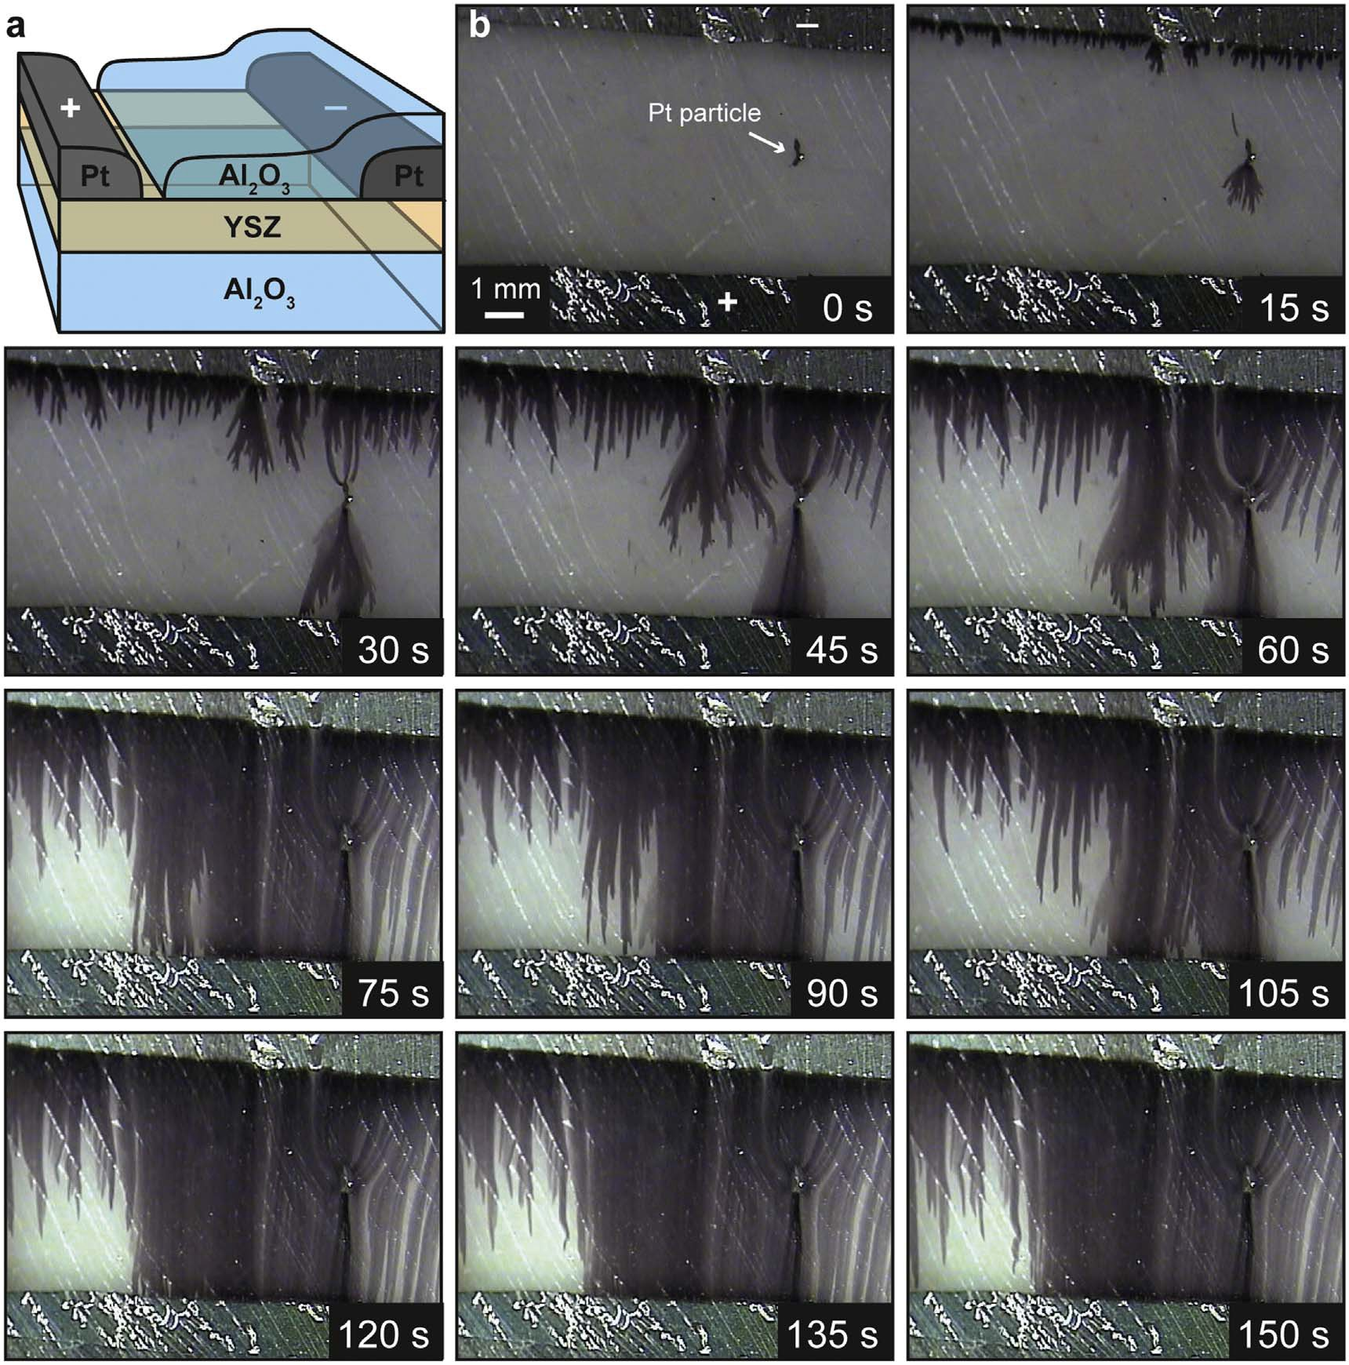

Figure 4. Electroreduction of a YSZ thin ﬁlm sandwiched between Al2O3 as the sealing material at 750 °C: (a) Outline of the cell structure; (b) microscopic images obtained during the electroreduction of the ﬁlm. The cathode can be seen at the top of the images and the anode at the bottom.

the observed ‘blackening ﬁngers’. The chemical reactions related to the ‘morphological instability’ of reacting boundaries are thoroughly discussed in literature [15, 50, 51]. Having a closer look to the Pt microparticle, it can be observed that the ﬁrst blackening ﬁngers evolved directly at this particle as soon as the voltage (1 kV) was applied to the electrodes. This can be explained by taking into account that the metallic particle is a shortcut within the electric ﬁeld and thus acts as local cathode with a high electric ﬁeld gradient. Subsequently, blackening ﬁngers also started to grow directly at the cathode (15 s). In the course of the electroreduction, some blackening ﬁngers that started at the cathode converge towards the Pt particle, while the ﬁngers that started at the particle diverged and reached the anode within a few seconds (30–60 s). Finally, the ﬁngered blackening front that
started at the cathode also reached the anode, leading to nearly complete electroreduced ﬁlm (>75 s). The
darkest blackening is reached along the initial directions of the blackening ﬁnger and in particular between the microparticle and the anode. This indicates the evolution of a channel with high electronic conductivity. This may be understood regarding the ﬂuxes of the charge carries. Several blackening ﬁngers connect the cathode with the microparticle which can be imagined as inﬂuent streams while only one main ﬁnger acts as efﬂuent stream towards the anode. The presence of areas with different levels of blackening even at prolonged electroreduction of 150 s reveals that the transformation of the material can be considered as localized effect causing a substantial degree of heterogeneity.

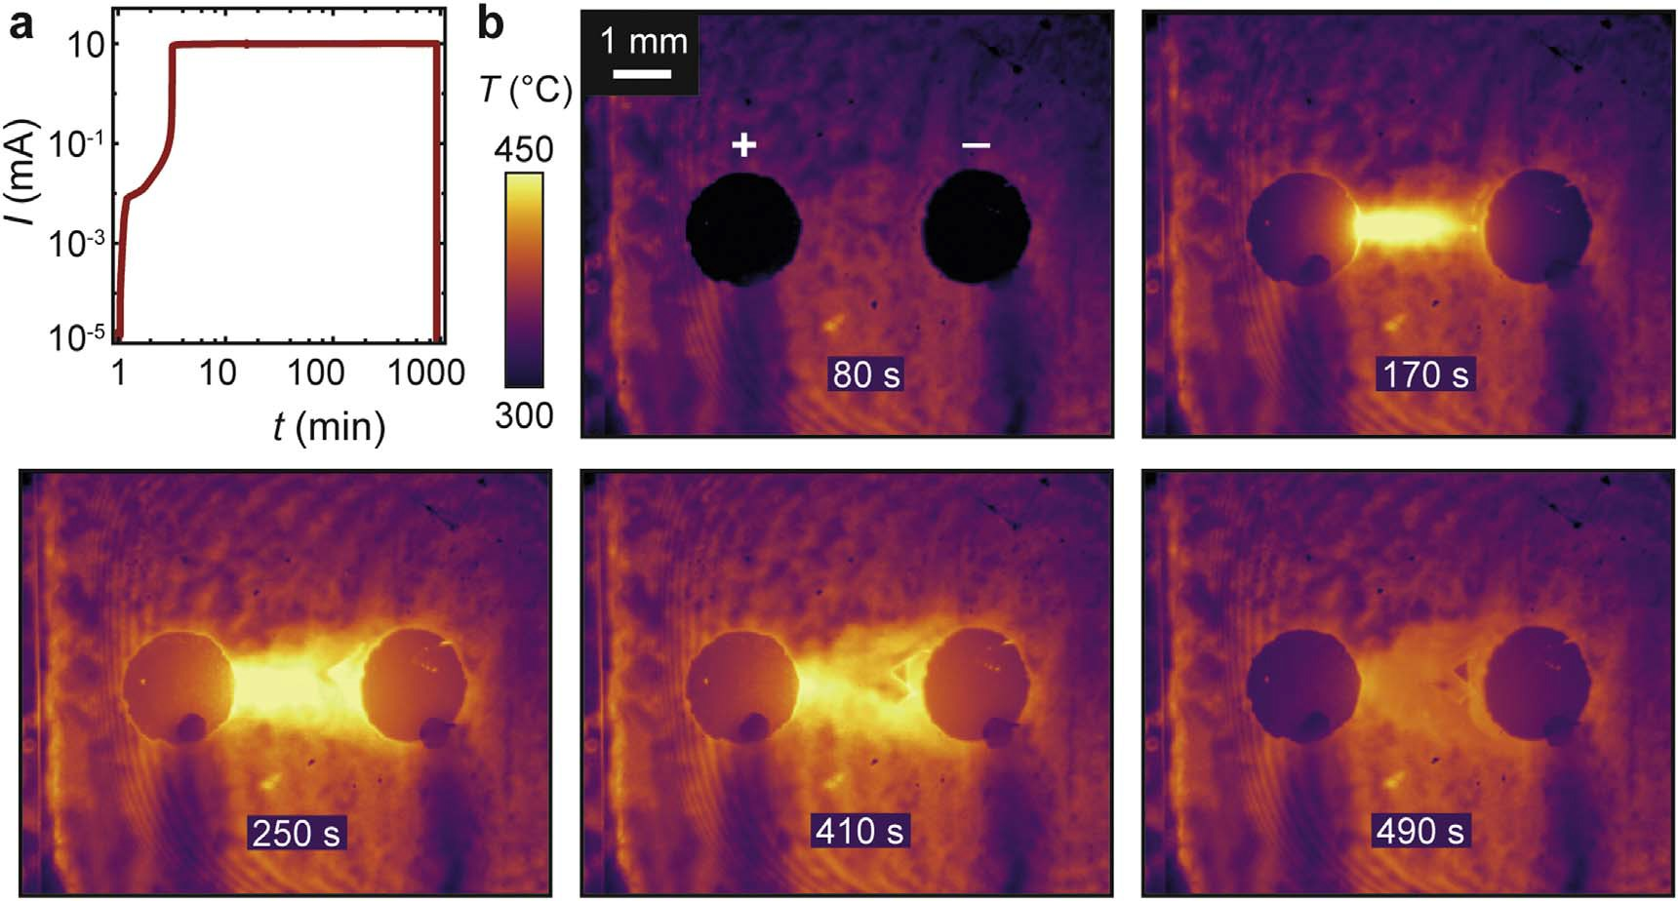

Figure 5. In situ analysis of heavy electroreduction of a YSZ single crystal using round Pt electrodes: (a) Current as a function of electroreduction time; (b) thermal microscopy of the ﬁrst stage of electroreduction. The cathode can be seen on the right and the anode on the left of the images.

  - Heavy electroreduction
In the following, we concentrate on the effect of the heavy electroreduction of YSZ single crystals using the same electroreduction setup as presented in ﬁgure 1(a). Instead of using oblong electrodes, round Pt pads were deposited by sputtering to concentrate the electric ﬁeld lines in the region between the electrodes. Additionally, the thickness of the Pt was increased to 100 nm in order to suppress bubble formation and electrode delamination effects. The electroreduction was again conducted at 1 kV, with 10 mA current compliance. As is illustrated in ﬁgure 5(a), the kinetics of the electroreduction were much faster than in the experiment with the oblong electrodes and the current compliance was reached within only a few minutes. Due to the higher current, the Joule heating effect was also more pronounced and a temperature increase of more than 50 °C occurred in the ﬁrst stage of the electroreduction as revealed by thermal microscopy (ﬁgure 5(b)). Also, the morphology
of the sample already changed in the ﬁrst stage of electroreduction visible as the triangularly-shaped region in the thermal images. After the resistance of the sample decreased below the resistance of the series resistor, the voltage drop on the sample reduced to a few tens of volts, causing the temperature to decrease again. The experiment was kept running for 16 h and eventually the sample resistance decreased from originally 1011 Ω to below 1.8 kΩ. The change of the resistance by many orders of magnitude also indicates a change of charge carriers. Due to the
electroreduction process, electronic charge carriers are induced changing the material from a pure ionic conductor into a mixed ionic-electronic conductor.
After the electroreduction, the sample was investigated by optical microscopy. Aside from the well-known electrocoloration effect causing a blackening of the region between the electrodes, the surface of this area also changed signiﬁcantly, as can be seen in the image obtained using reﬂection light mode in combination with phase contrast (ﬁgure 6(a)). A heterogeneous region with a sharp boundary to the rest of the surface, which remained in the ﬂat polished state, can be observed. Additionally, on the anode, a dendrite-like pattern can be seen that resembles a Lichtenberg ﬁgure [52] and presumably related to the application of a high voltage to an initially insulating sample, leading to discharge effects. The triangularly-shaped region close to the cathode, which was already visible in the thermal microscopy images, can be recognized in the (optical) micrographs. This indicates that the base of the evolving structure was already established in the ﬁrst stage of heavy electroreduction. Figure 6(b) shows a magniﬁcation of this triangularly-shaped region. It becomes apparent that it has a characteristic surface structure on the microscale related to stripes aligned along the main crystallographic axes of the sample. A similar pattern can be found when zooming in on the region close to the anode (ﬁgure 6(c)). In some regions, the observed stripes form a dense checked pattern with additional irregular point-like surface distortions on the micrometre scale (ﬁgure 6(d)). To gain a detailed insight into the surface structure of the checked pattern, AFM measurements in contact mode were performed, as presented in
ﬁgure 6(e). The scan area was tilted by 45° with respect to the crystallographic axes of the sample in order to
avoid an interference of the motion of the AFM tip with the surface pattern. In the topography images, the checked pattern can be clearly identiﬁed. Along the dashed line on the right image in ﬁgure 6(e), a line proﬁle was

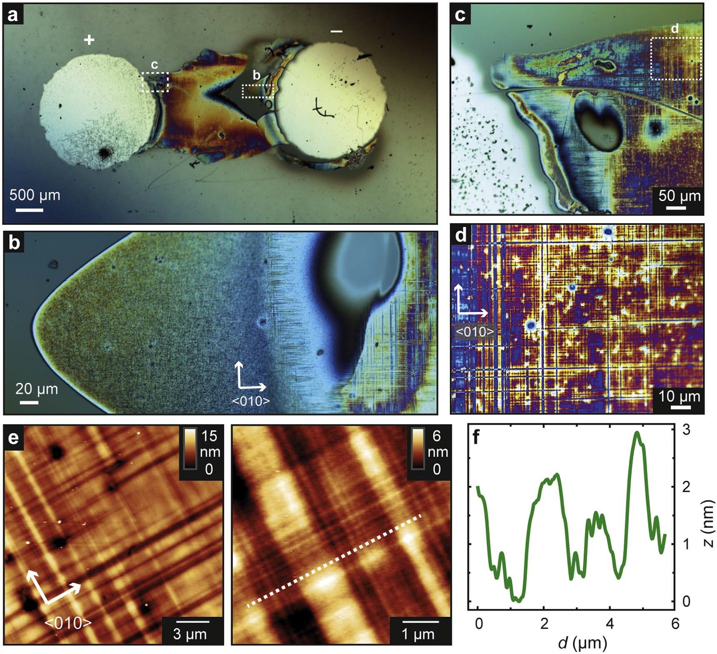

Figure 6. Phase contrast optical microscopy of the heavily electroreduced YSZ single crystal: (a) Overview; (b) magniﬁcation of the cathode region; (c) magniﬁcation of the anode region; (d) magniﬁcation of the checked pattern in the anode region; (e) topography of
(d) measured by AFM in contact mode; (f) line proﬁle extracted along the dashed line in (e).

extracted, as shown in ﬁgure 6(f), revealing that the lines of the pattern differ by more than 2 nm in height. Taking into account that the crystal had been epipolished with a surface roughness well below 0.5 nm, we can conclude that signiﬁcant material transport occurred on the surface during heavy electroreduction.
In order to characterize the chemical composition of the transformed surface region, we employed SEM with EDX. For these measurements, we employed a second sample that was also heavily electroreduced, using the same parameters as previously. In ﬁgure 7(a), the optical image of the surface close to the cathode region is shown. Although the outer shape of the transformed region is slightly different from that shown in ﬁgure 6, the
inner structure with lines oriented along the crystal axis is similar, showing that the effect of surface modiﬁcation by electroreduction is reproducible. In the corresponding SEM micrograph in ﬁgure 7(b) using the back- scattered electron (BSE) detector, the transformed region can clearly be identiﬁed. It appears brighter in the micrograph indicating a different chemical composition (higher average electron density, more heavy elements,
i.e. oxygen deﬁcient). We recorded an EDX spectrum in the dashed area 1 marked in ﬁgure 7(b) and compared it to a YSZ reference (pristine sample) spectrum obtained at one edge on the same crystal far from the transformed region. In order to avoid charging effects, the sample was coated with a carbon layer for the SEM investigation beforehand. Hence, the EDX spectra shown in ﬁgure 7(c) were normalized to the C Kαpeak intensity. It can be seen that the peaks of Zr and Y are almost identical, while the O signal of the transformed region is signiﬁcantly reduced as compared to the reference. To quantify the degree of reduction, the ratios of the measured atomic
percentages of Zr and O were calculated. While in the reference region, a Zr/O ratio of 1.8 was obtained, the
value in area 1 was only 1.1. This is signiﬁcantly lower compared to reference region. Considering the Y2O3 doping this implies almost identical amount of Zr and O in the surface layer and could indicate the presence of phases with a composition close to ZrO. In ﬁgure 7(d), a magniﬁcation of the transformed region is shown. The oriented stripes that were already found by optical microscopy and AFM in ﬁgure 6 can be retrieved in the BSE

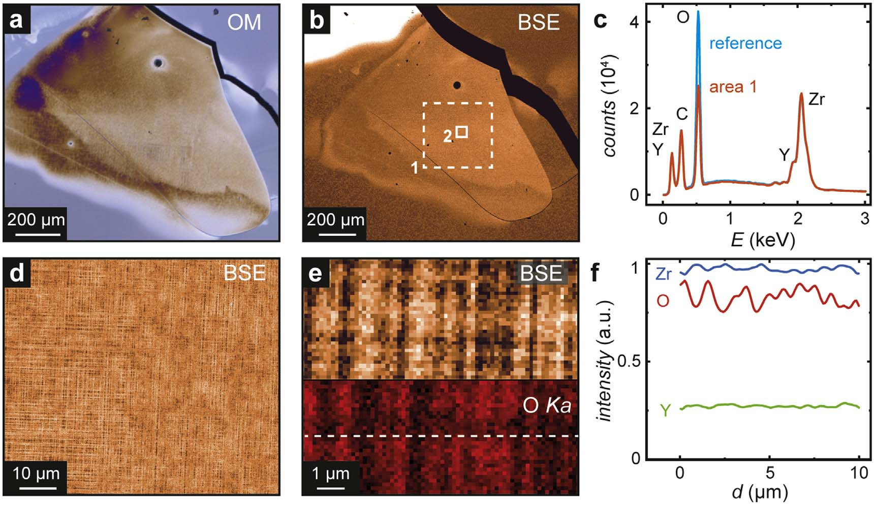

Figure 7. EDX analysis of a heavily electroreduced crystal: (a) Phase contrast optical microscopy; (b) SEM BSE image (chemical contrast); (c) EDX spectrum of the area 1 in (b) in comparison to a YSZ reference (pristine sample); (d) SEM BSE image of area 2;
(e) magniﬁcation of the striped region (area 2) in combination with an EDX net counts map of the O Kα line; (f) EDX line scan of Zr, O and Y obtained along the dashed line in (e).

image. In order to elucidate the chemical composition of the stripes, EDX mapping with high magniﬁcation was obtained and is shown in ﬁgure 7(e) for the O Kα line and illustrated as a line scan in ﬁgure 7(f). It can be seen that the stoichiometry is not constant, but correlated with the topography of the stripes. By tilting the crystal and comparing the secondary electrons (SE) contrast with the backscattered electrons (BSE) contrast, we were able to conclude that the highly oxygen-deﬁcient stripes correspond to a topographic depression and vice versa. These
results could indicate that the formation of different substoichiometric ZrOx phases on the microscale is creating a characteristic striped/checked surface pattern. The orientation of the stripes along of the main crystal axes of
the original crystal suggests that the oxygen deﬁcient region is strongly related to the surrounding, still oxygen- rich, YSZ crystal and that new dislocations have been formed compensating the lattice mismatch.
Just to estimate an electromotive force (EMF) which should be sufﬁcient to drive a reduction process if
exceeded, one could consider the free enthalpy of the formation reaction of ZrO from zirconium and oxygen. At 500 °C this would yield and equilibrium oxygen activity of 10−64, respectively an EMF of 2.4 V [15, 53]. This is
the thermodynamic limit. Due to the low conductivity of YSZ at this temperature, a potential difference in this order of magnitude would only allow very small current and thus only an as well very slowly proceeding reduction process. According to Levy [13], a signiﬁcant increase of the electronic conductivity can be observed if the oxygen deﬁciency δ of Zr1−yY2yO2+y−x−δ is higher than 0.01. This indicates that in principle under such an oxygen activity the degradation process already sets in which will eventually lead to the formation of a new phase. However, the kinetics of the reduction process will depend signiﬁcantly on the temperature (conductivity), the voltage applied (driving force) and the surrounding atmosphere (simultaneous re-oxidation), which makes it difﬁcult to give a precise value for SOEC application, leading to signiﬁcant effect within a chosen time scale.

Conclusions

In this work, we illustrated localized phenomena related to electroreduction in YSZ single crystals. In the ﬁrst state of electroreduction, an electrocoloration (blackening) effect occurs, changing the optical properties of the crystal from its initial transparent state to opaque. This effect appears as a reaction front starting at the cathode and moving gradually to the anode. While a distinct inﬂuence of mechanically-induced dislocation on the kinetics and morphology of the blackening could not be identiﬁed, the blackened area itself exhibits an irregular structure related to the presence of ‘blackening ﬁngers’. Comparable experiments on YSZ revealed that the blackening ﬁngers mainly follow the electric ﬁeld lines and are thus inﬂuenced by distortions of the ﬁeld distribution as can be caused by metallic microparticles acting as electric dipoles. Finally, after heavy reduction, not only does the colour of the crystal, but also the surface structure, change signiﬁcantly, causing the local

evolution of regions exhibiting a checked pattern aligned along the crystal axes with a high amount of oxygen non-stoichiometry. Our experiments indicate that the application of electric ﬁeld gradients on a solid electrolyte such as YSZ can lead to localized electroreduction, resulting in the evolution of electronically conducting paths, which could be a challenge for using the material as an SOEC electrolyte. This will be of particular importance for miniaturized SOECs with electrolyte thickness in the micrometre range where comparable electric ﬁeld gradients, as in our model systems, are present. Intrinsic structural defects such as dislocations or grain boundaries do not appear to play a dominant role in this process. However, during fabrication of the electrolyte, great care should be taken to avoid the inclusion of metallic particles, as they could signiﬁcantly alter the local distribution of the electric ﬁeld in the electrolyte. Hence, they could act as seeds for the evolution of electroreduced current paths and thus signiﬁcantly accelerate the kinetics of device degradation.

Acknowledgments

We gratefully acknowledge A Everwand and K Klafki for experimental support, as well as R Dittmann and R Waser for providing access to the electroreduction setup. The measurements shown in ﬁgure 4 were conducted at the Justus-Liebig-Universität Gießen, Physikalisch-Chemisches Institut, and we thank B Datoussaid, J Janek
and N Schichtel. F K acknowledges additionally the support by the Polish National Science Center (UMO-2018/
29/B/ST5/01406). We are indebted to C Wood for proofreading the manuscript.

ORCID iDs

Christian Rodenbücher https://orcid.org/0000-0001-8029-3066 Kristof Szot https://orcid.org/0000-0001-8773-2754
Dominik Wrana https://orcid.org/0000-0002-8239-0043 Benedykt R Jany https://orcid.org/0000-0002-3196-7244 Franciszek Krok https://orcid.org/0000-0002-6931-3545 Carsten Korte https://orcid.org/0000-0001-6574-6223

References
[1] Blum L, de Haart L G J, Malzbender J, Margaritis N and Menzler N H 2016 Anode-supported solid oxide fuel cell achieves 70 000 h of continuous operation Energy Technol. 4 939–42
[2] Liu M, Lynch M E, Blinn K, Alamgir F M and Choi Y 2011 Rational SOFC material design: new advances and tools Mater. Today 14
534–46
[3] Frey C E, Fang Q, Sebold D, Blum L and Menzler N H 2018 A detailed post mortem analysis of solid oxide electrolyzer cells after long- term stack operation J. Electrochem. Soc. 165 F357–64
[4] Nechache A, Boukamp B A, Cassir M and Ringuedé A 2019 Accelerated degradation of yttria stabilized zirconia electrolyte during high- temperature water electrolysis J. Solid State Electrochem. 23 871–81
[5] Mogensen M, Jensen K V, Jørgensen M J and Primdahl S 2002 Progress in understanding SOFC electrodes Solid State Ion. 150 123–9
[6] Arndt B et al 2017 Spectroscopic indications of tunnel barrier charging as the switching mechanism in memristive devices Adv. Funct.
Mater. 27 1702282
[7] Liu Y, Parisi J, Sun X and Lei Y 2014 Solid-state gas sensors for high temperature applications—a review J Mater Chem A 2 9919–43
[8] Di Girolamo G, Marra F, Blasi C, Serra E and Valente T 2011 Microstructure, mechanical properties and thermal shock resistance of plasma sprayed nanostructured zirconia coatings Ceram. Int. 37 2711–7
[9] Kärkkänen I et al 2015 Impedance spectroscopy study of the unipolar and bipolar resistive switching states of atomic layer deposited polycrystalline ZrO2 thin ﬁlms Phys. Status Solidi a 212 751–66
[10] Vendrell X and West A R 2018 Electrical properties of yttria-stabilized zirconia, YSZ single crystal: local AC and long range DC
conduction J. Electrochem. Soc. 165 F966–75
[11] Kirchheim R 2018 On the mixed ionic and electronic conductivity in polarized yttria stabilized zirconia Solid State Ion. 320 239–58
[12] Farley J M, Thorp J S, Ross J S and Saunders G A 1972 Effect of current-blackening on the elastic constants of yttria-stabilised zirconia
J. Mater. Sci. 7 475–6
[13] Levy M 1988 Model for the electrical conductivity of reduced stabilized zirconia J. Electrochem. Soc. 135 1584
[14] Zhu L, Zhang L and Virkar A V 2016 Electroreduction of zirconia using embedded electrodes J. Electrochem. Soc. 163 F714–8
[15] Janek J and Korte C 1999 Electrochemical blackening of yttria-stabilized zirconia - morphological instability of the moving reaction front Solid State Ion. 116 181–95
[16] Luerßen B, Janek J, Günther S, Kiskinova M and Imbihl R 2002 Microspectroscopy at a moving reduction front in zirconia solid electrolyte Phys. Chem. Chem. Phys. 4 2673–9
[17] Siegel D A, El Gabaly F, McCarty K F and Bartelt N C 2015 In situ characterization of the formation of a mixed conducting phase on the surface of yttria-stabilized zirconia near Pt electrodes Phys. Rev. B—Condens. Matter Mater. Phys. 92 125421
[18] Moghadam F K, Yamashita T and Stevenson D A 1983 Characterization of the current-blackening phenomena in scandia stabilized zirconia using transmission electron microscopy J. Mater. Sci. 18 2255–9
[19] Vernoux P, Gaillard F, Bultel L, Siebert E and Primet M 2002 Electrochemical promotion of propane and propene oxidation on Pt/YSZ
J. Catal. 208 412–21
[20] Vayenas C G, Bebelis S and Neophytides S 1988 Non-Faradaic electrochemical modiﬁcation of catalytic activity J. Phys. Chem. 92
5083–5

[21] Opitz A K, Lutz A, Kubicek M, Kubel F, Hutter H and Fleig J 2011 Investigation of the oxygen exchange mechanism on Pt|yttria stabilized zirconia at intermediate temperatures: surface path versus bulk path Electrochim. Acta 56 9727–40
[22] Mutoro E, Günther S, Luerßen B, Valov I and Janek J 2008 Electrode activation and degradation: morphology changes of platinum electrodes on YSZ during electrochemical polarisation Solid State Ion. 179 1835–48
[23] Beck G and Bachmann C 2014 Oxygen removal at grain boundaries in platinum ﬁlms on YSZ Solid State Ion. 262 508–11
[24] Pöpke H, Mutoro E, Luerßen B and Janek J 2011 The potential of in situ-scanning electron microscopy—Morphology changes of electrically polarized thin ﬁlm Pt(O2)/YSZ model electrodes Solid State Ion. 189 56–62
[25] Keller T F, Volkov S, Navickas E, Kulkarni S, Vonk V, Fleig J and Stierle A 2019 Nano-scale oxide formation inside electrochemically- formed Pt blisters at a solid electrolyte interface Solid State Ion. 330 17–23
[26] Gregori G, Merkle R and Maier J 2017 Ion conduction and redistribution at grain boundaries in oxide systems Prog. Mater Sci. 89
252–305
[27] Guo X and Zhang Z 2003 Grain size dependent grain boundary defect structure: case of doped zirconia Acta Mater. 51 2539–47
[28] Skinner S J 2019 Recent advances in the understanding of the evolution of surfaces and interfaces in solid oxide cells Adv. Mater.
Interfaces 6 1900580
[29] Szot K, Rodenbücher C, Bihlmayer G, Speier W, Ishikawa R, Shibata N and Ikuhara Y 2018 Inﬂuence of dislocations in transition metal oxides on selected physical and chemical properties Crystals 8 241
[30] Guo X, Vasco E, Mi S, Szot K, Wachsman E and Waser R 2005 Ionic conduction in zirconia ﬁlms of nanometer thickness Acta Mater. 53
5161–6
[31] Otsuka K, Kuwabara A, Nakamura A, Yamamoto T, Matsunaga K and Ikuhara Y 2003 Dislocation-enhanced ionic conductivity of yttria-stabilized zirconia Appl. Phys. Lett. 82 877–9
[32] Knöner G, Reimann K, Röwer R, Södervall U and Schaefer H-E 2003 Enhanced oxygen diffusivity in interfaces of nanocrystalline ZrO2·Y2O3 Proc. Natl Acad. Sci. 100 3870–3
[33] De Souza R A, Pietrowski M J, Anselmi-Tamburini U, Kim S, Munir Z A and Martin M 2008 Oxygen diffusion in nanocrystalline yttria-
stabilized zirconia: the effect of grain boundaries Phys. Chem. Chem. Phys. 10 2067
[34] Huang H C, Su P-C, Kwak S K, Pornprasertsuk R and Yoon Y-J 2014 Molecular dynamics simulation of oxygen ion diffusion in yttria stabilized zirconia single crystals and bicrystals Fuel Cells 14 574–80
[35] Fisher C A J and Matsubara H 1999 Molecular dynamics investigations of grain boundary phenomena in cubic zirconia Comput. Mater.
Sci. 14 177–84
[36] González-Romero R L, Meléndez J J, Gómez-García D, Cumbrera F L and Domínguez-Rodríguez A 2012 A Molecular dynamics study of grain boundaries in YSZ: structure, energetics and diffusion of oxygen Solid State Ion. 219 1–10
[37] Feng B, Ishikawa R, Kumamoto A, Shibata N and Ikuhara Y 2019 Atomic scale origin of enhanced ionic conductivity at crystal defects
Nano Lett. 19 2162–8
[38] Schichtel N, Korte C, Hesse D and Janek J 2009 Elastic strain at interfaces and its inﬂuence on ionic conductivity in nanoscaled solid electrolyte thin ﬁlms—theoretical considerations and experimental studies Phys. Chem. Chem. Phys. 11 3043
[39] Korte C, Peters A, Janek J, Hesse D and Zakharov N 2008 Ionic conductivity and activation energy for oxygen ion transport in superlattices—the semicoherent multilayer system YSZ (ZrO2 + 9.5 mol% Y2O3)/Y2O3 Phys. Chem. Chem. Phys. 10 4623
[40] Korte C, Keppner J, Peters A, Schichtel N, Aydin H and Janek J 2014 Coherency strain and its effect on ionic conductivity and diffusion in solid electrolytes—an improved model for nanocrystalline thin ﬁlms and a review of experimental data Phys. Chem. Chem. Phys. 16 24575–91
[41] Kushima A and Yildiz B 2010 Oxygen ion diffusivity in strained yttria stabilized zirconia: where is the fastest strain? J. Mater. Chem.
20 4809
[42] Harrington G F, Cavallaro A, McComb D W, Skinner S J and Kilner J A 2017 The effects of lattice strain, dislocations, and microstructure on the transport properties of YSZ ﬁlms Phys. Chem. Chem. Phys. 19 14319–36
[43] Keppner J, Schubert J, Ziegner M, Mogwitz B, Janek J and Korte C 2018 Inﬂuence of texture and grain misorientation on the ionic conduction in multilayered solid electrolytes—interface strain effects in competition with blocking grain boundaries Phys. Chem.
Chem. Phys. 20 9269–80
[44] Waser R, Baiatu T and Hardtl K-H 1990 dc electrical degradation of perovskite-type titanates: II. Single crystals J. Am. Ceram. Soc. 73
1654–62
[45] Long D, Creange N, Moballegh A and Dickey E C 2019 Electromigration-induced leakage current enhancement and its anisotropy in single crystal TiO2 J. Appl. Phys. 125 184101
[46] Rodenbücher C et al 2018 Electrically controlled transformation of memristive titanates into mesoporous titanium oxides via
incongruent sublimation Sci Rep. 8 3774
[47] Wang J-J, Huang H-B, Bayer T J M, Moballegh A, Cao Y, Klein A, Dickey E C, Irving D L, Randall C A and Chen L-Q 2016 Defect chemistry and resistance degradation in Fe-doped SrTiO3 single crystal Acta Mater. 108 229–40
[48] Rodenbücher C, Menzel S, Wrana D, Gensch T, Korte C, Krok F and Szot K 2019 Current channeling along extended defects during
electroreduction of SrTiO3 Sci. Rep. 9 2502
[49] Marrocchelli D, Sun L and Yildiz B 2015 Dislocations in SrTiO3; easy to reduce but not so fast for oxygen transport J. Am. Chem. Soc.
137 4735–48
[50] Martin M 1994 Interface stability during reactions Mater. Sci. Forum 155–156 429–44
[51] Martin M, Tigelmann P, Schimschal-Thölke S and Schulz G 1995 Solid state reactions and morphology Solid State Ion. 75 219–28
[52] Merrill F H and Von Hippel A 1939 The atomphysical interpretation of lichtenberg ﬁgures and their application to the study of gas discharge phenomena J. Appl. Phys. 10 873–87
[53] Kubaschewski O, Alcock C B and Spencer P J 1993 Materials Thermochemistry (Oxford: Pergamon)

