
Signature:©PolJRadiol,2009;74(4):47-54
ORIGINALARTICLE
UsefulnessofCardiacMagneticResonanceDelayed
Received:2009.07.20
Accepted:2009.10.06
Enhancementtechniqueintheassessmentofthepostinfarctionscar size and the function of the leftventricleinpatientsaftermyocardialinfarction,treatedwithPrimaryPercutaneousCoronaryIntervention
AgataBrzozowska-Czarnek1,AndrzejUrbanik1,PaulinaKarcz1,
JoannaDomagała1,TomaszRakowski2,WaldemarMielecki2,DariuszDudek2,IzabelaHerman-Sucharska1
1RadiologyDepartment,CollegiumMedicumJagiellonianUniwersity,Cracow,Poland2IICardiologyClinic,CollegiumMedicumJagiellonianUniwersity,Cracow,Poland

Author’saddress:AgataBrzozowska-Czarnek,RadiologyDepartmentoftheJagiellonianUniversity,CollegiumMedicum,Kopernika19Str.,31-501Cracow,Poland,e-mail:piotrczarnek@wp.pl
Summary
TheaimofthisstudyistopresentusefulnessofCardiacMagneticResonancelateenhancementtechniqueintheassessmentofpostinfarctionscarlocation,itsprecisesize,andtype,aswellasintheevaluationoftheleftventricularfunction(EF,EDV,ESV)inpatientsaftermyocardialinfarction,treatedwithPrimaryPercutaneusCoronaryIntervention(PPCI).
Weanalysedagroupof117patientswhounderwentmyocardialinfarction,andweretreatedwithPPCI.CMRwithDelayedEnhancementsequencewasperformedafter6monthswiththeuseofa1.5TSignaExcitescanner,surfaceCoilTORSOPA,andexaminationtechniquesincludingECG
–gatedGradientEchoBreathHold,ECG–gatedGradientFIESTABreathHold,withsegmentedk-spaceacquisitionandDelayedEnhancement(15minafteri.v.contrastadministration).Weassessedinfarctsizeand leftventricularfunction.
A highly significant correlationwas found between:EF and cardiac magneticresonance infarct size(thebiggertheinfarctsize,thesmallertheEF),EDVandcardiacmagneticresonanceinfarctsize(thebiggertheinfarctsize,thehighertheEDV),ESVandcardiacmagneticresonanceinfarctsize(thebiggertheinfarctsize,thehighertheESV).
CardiacMagneticResonancewithDelayedEnhancementtechniqueisaneffectivemethodtoassessedtheinfarctsizeandtheleftventricularfunctioninpatientsaftermyocardialinfarction,treatedwithPPCI.
Background:
Material/Methods:
Results:
Conclusions:
Keywords:
cardioMR•delayedenhancement•leftventricularinfarct•postmyocardialinfarctionscar•leftventricularfunctionparameters(EF,EDV,ESV)
PDFfile:
http://www.polradiol.com/fulltxt.php?ICID=900377
Background
atheromatousplaques.Closureofthecoronaryvesselmayalsofollowfrom:anacuteinflammationinthecourseofvasculitis,injuryorembolismwithinthecoronaryarteries.Itmayaswellbetheconsequenceofanincreasedbloodviscosity,asinthecaseofpatientswiththrombocytosisorpolycythemiavera,orwithinnatemalformationsofthecoronaryarteries[1].
Heartinfarctisanirreversiblenecrosisofthecellsoftheheartmuscleduetoalongerischaemia.InPoland,theincidenceofacutemyocardialinfarctionperyearreach-es100thousandpeople.Over85%oftheMIcasesresultfromarecentclotoccludingacoronaryarterystenosedby
47

OriginalArticle
©PolJRadiol,2009;74(4):47-54
Theabsenceofflowwithinthecoronaryartery,result-ingfromitsocclusion,causesadisturbedperfusionoftheheartmuscleanddiastolicdysfunction,leadingtoleftven-tricularsystolicdysfunctionthatprecedestheappearanceofECGchangesandanginapectoris[2].
DiagnosisofMIbasesonatypicalhistory,characteristicchangesintheECG(electrocardiography)andchangesoftheprofileofsomespecificserumenzymes.
Accordingtothecurrentlyapplyingclassificationofacutecoronarysyndromes,patientswithpaininthechestaredividedintotwogroups,onthebasisoftheinitialECGrecording:thosewithSTsegmentelevation(STEMI–STsegmentelevationmyocardialinfarction)andwithoutSTsegmentelevation(NSTEMI–Non-STsegmenteleva-tionmyocardialinfarction)[2].Echocardiographyhelpsinlocalisationoftheischaemiclesionswithintheheartwall.Italsoenablestheevaluationoftheglobalandsegmen-talcontractilityoftheleftventricle,whensearchingforthefeaturesofischaemiaorMI.Thelocationandsizeofinfarctcanbedeterminedonthebasisofrevealeddisor-dersofsegmentalcontractility,intheregionsuppliedbythepostinfarctionartery.TheevaluationofsegmentalcontractilityoftheleftventricleispossiblewithECGinabout90%ofpatients.ThedegreeofcontractilitydisordersdependsonthefactwhethertheischaemiaoftheLVwallistransmuralornot,andontheexistenceofthecollateralcirculation[2].
Acuteischaemiatriggersacascadeofbiochemicalandpathophisiologicalchangesoftheheartmuscle.PathomorphologicallyrecentMImaybediagnosedonthebasisoftheextensionofwallnecrosis.Thetransmuralinfarctioninvolvestheventricularmuscleinitsfullwidth,thesubendocardialinfarctionregardsonlythemostinnerlayeroftheheartmuscle,andthenontransmuralinfarc-tioninvolvesmorethan25–75%ofthewallthickness.Inmostofthecases,theischaemiaandinfarctionstartatthesubendocardiallayer,thenspreadlaterallyandtotheout-side,towardstheepicardium.Theextensionofthemyocar-dialinfarctionisthemostimportantprognosticfactoranddependson:themassoftheheartmusclesuppliedbytheoccludedvessel,oxygendemand oftheheart muscle withinthepathologicalregion,efficiencyofthecollateralvesselsandreactionofthetissuestotheprocessesmodifyingtheischaemia.
Functionalchangesoftheleftventricleinclude:decreasedcardiacoutputduetodisturbedcontractibilityoftheheartmuscleattheearlystageofMI.Thereisadecreaseincon-tractilesynchrosityofthemusclefibres,leadingtohypo-kinesis(decreasedcontractility),akinesis(nocontractility)ordyskinesis(aneurismalbulgeofthewall–totheout-side–duringthesystole).Inthecourseofthemyocardialinfarction,thecontractilityofventricles,andveryoftenalsothecardiacoutput,changesveryfast.Approximately30%ofthecasesofthetransmuralinfarctionareconnectedwithaprogressofwallthinninganddilatationoftheven-triclewithinthenecroticwall.Thissituationmayleadtotheformationofadyskineticregionortothrombusresult-ingfrombloodretentioninthispartoftheventricle[1].Aneurysmsoftheheartareformedinthecourseofinfarctwideningandthethinningofthemyocardium.Therearetrueandspuriousaneurysms.Thewallofthetrueaneu-rysmismadeofalllayersoftheheartwall.Trueaneurysmmeansdeformationoftheleftventricle,bothinthediastoleandinsystole.Thewalloftheaneurysmshowsakineticordyskineticmovementduringthesystole.Spuriousaneu-rysmsareformedinthecourseofafractureofthefreeleftventricularwall[2].
Thewholeregionofinfarction,bothatanearlystageandafterscarformation,maybevisualisedwithCardiacMagneticResonancewithDelayedEnhancementtech-nique[3–7].Moreover,aftertheCMRexaminationwithtransverse(shortaxis)imagingoftheleftventricle,inthesequencesofgradientecho,andofsteady-statefreepreces-sion,weobtainallfunctionalparametersoftheleftventri-clewiththeuseoffunctionaltests,socalledcineMR,thatrevealahightime-resolution.Theseparametersarethenprocessedwithaspecialcomputerprogram[8–11].
TheaimoftheworkwastoassesstheusefulnessofCardioMRwithDEtechniqueinlocalisationandevaluationoftheexactsizeandtypeofthepostinfarctionscar,aswellastheleftventricularfunction.
MaterialandMethods
PatientswithECGandechocardiography(performedrightafterheartattack)resultssuggestiveofthepresenceoftheinfarctareawerequalifiedforheartMRI.Thosepatientsunderwentasuccessfulcoronaryangioplastywithstentimplantationwithinthefirst6hoursfromthemomentofMIsymptomspresentation.
Latepathomorphologicallesionsinthecourseofarecentmyocardialinfarctioninvolvethedepositionofcollagen,untilthecreationofthescartissue.Theprocessofscarfor-mationendsapprox.7weeksafterMI[1].Postinfarctionscarisnotcontractible.Whentheheartbeats,thescarsizegetsextended,whichleadstothethinningoftheheartwall.
Thefollowingexclusioncriteriawereapplied:claustro-phobia,beingunabletoliedowninsupinepositionforabout45–90minutes/e.g.severedegenerativelesionsofthespine/,maximumweightexceeding100kg,pacemak-er,insulinpomporanyotherdeviceapplyingmedicines,neurostimulatororanyotherbiostimulator,artificialvalve(ventriculovenousorventriculoperitoneal),anyferromag-neticelementswithinthebody–boththerapeuticalandforeignbodies,patientswithallkindsofarrhythmiaandirregularheartrate,heartrateabove90/minorbelow50/min,beingunabletoholdbreathforabout25seconds,infectionswithintheupperairwaysconnectedwithcough,andcoughofotherorigin/allergiccough,difficultieswithbreathingandsoon/,aswellasbeinguncooperative.
Theearliestpossiblerevascularisationofthecoronaryves-selsconsiderablydecreasestheinfarctsize.
Thecurrentlypreferredmethodofpatientmanagementinacutemyocardialinfarctionsistheprimarypercutaneouscoronaryintervention (PPCI)with stentimplantation with-inthe coronaryarterythat caused the infarct.
48

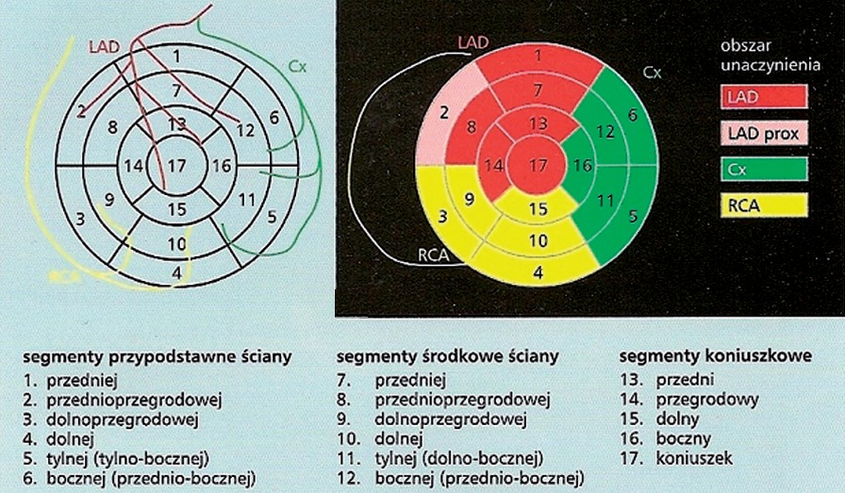
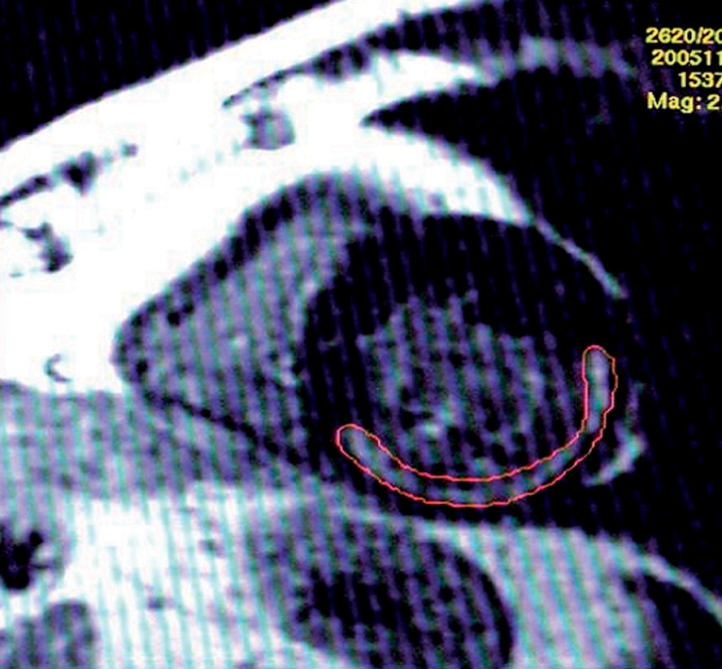
©PolJRadiol,2009;74(4):47-54
Brzozowska-CzarnekAetal–Usefulnessofcardiacmagneticresonance…
Figure1.LeftVentricularSegmentation(usingbull-eyediagram),definedbyASE,withtheMainCoronaryArteryrouts(A)andwith theassignmentofsegmentstoCoronaryArterialterritories,signedbycolours(B).(LAD–Leftanteriordescending,Cx–Circumflexcoronaryartery,RCA–Rightcoronaryartery).
Figure2.Tracingofpostinfarctionscarcontours.Delayedenhancementperfusiontransverse(shortaxis)imaging.
Finally,117patients(20womenand97men)intheageof33–77years(meanageof55)weresubjectedtoheartMRIinthesixthmonthfollowingtheinfarction,duetoasus-pected(onthebasisofECGandechocardiography)postin-farctionscarwithinthemuscleoftheleftventricle.
makesurethatthenormal,unchangedmyocardiumwasblackinT1sequenceoftheMRIexamination,i.e.thecon-trastmediumwaswashedoutcompletely,andthatthescartissueremainedwhite(hyperintensivesignal)andrevealedaprolongedcontrastpresence.
TheexaminationswereperformedwiththeuseofMRSIGNAEXCITE1.5TGEsystem, withasuperficial coil,TORSOPA,andinthefollowingsequences:ECG–gatedGradientEchoBreathHoldforlocalisers,ECG–gatedGradientFIESTABreathHold,withsegmentedk-spaceacquisitionandDelayedEnhancement–about15minutesaftertheintravenousadministrationof20mlofparamag-neticcontrast.
DEsequenceinvolvedthesamesections(inshortaxis)oftheleftheartventricle,astheFIESTAsequence.
ThemorphologyoftheleftventriclewasevaluatedonthebasisofimagesobtainedintheFIESTAsequence.Thefunc-tionalparametersoftheleftventriclewereassessedafterbeingprocessedwithahighlyspecialisedcomputerprogram,MASSMedisPlus.Thefollowingparametersoftheleftven-tricleweremeasured:mass,wallthickness,dimensionsoftheheartchambers,EDV,ESVandenjectionfraction(EF).Thecontractilityoftheheartmusclewasassessedaswell.
Thefollowingparametersofexaminationwereused:
- TR(Timeto repeat)=8ms,
- TE(Timetoecho)=3.8ms,
- TI(Timetoinversion)=160–300ms/setforeachpatientindividually,
- FOV(Fieldof view) 42×42cm,
- FA(Flipangle)=40–50°
•matrix256×192
- slicethickness8mm/interval0mm,
- NEX(Numberofexcitation)=2.
Inordertolocatethelesions,theleftventriclewasdividedinto17segments(Figure1).
PostinfarctionscarwasevaluatedintheDEsequence.Inthissequence,wemaywitnessaprolongedretentionofthecontrastmediumwithinthescartissue.Thelocationofthescarwasevaluatedonthebasisofadivisionappliedin echocardiography– i.e.the divisionof theLVmuscleinto17segments.Alsothetypeofthescarwasdefined:suben-docardial,nontransmural,transmural.
Tovisualisethewholeleftventricle,fromitsbase(i.e.fromthelevelofthemitralvalve)toitstip,theFIESTAsequencewasused(afastimagingmethodthatcarriesoutdataacquisitioninasteadystate),with9–15slices,8mmeach,without intervalsbetween them.Everysectionincluded 15phasesoftheheartrate,sothepatienthadtoholdhis/herbreathfor10–17seconds,dependingonthespeedofhis/herheartrate (from 70/minuteto 49/minute).
Thetotalinfarctsizewasmeasuredafterthedelineationofthescartissue(Figure2),i.e.theregionofretainedcontrastmedium(regions of delayed enhancement)in DE sequence,inalllayersofthetransversesectionoftheleftventricularmyocardium.
AcquisitionforDEwasperformedduring15minutesfromthemomentofintravenouscontrastadministration.Duringthat time, the contrast medium gets completely washed outfromanormal,healthymuscle,butremainsintheregionsmadeupoffibrous tissuemainly.
Theanalysisofcorrelationsbetweentheexaminedfea-tures(correlationbetweenEF–ejectionfraction,EDV–end-diastolicvolume,ESV–end-systolicvolume,andthesizeofthescar)wasperformedwiththeuseofaprogram‘Statistica’.Pearsonlinearcorrelationcoefficientwascal-culatedineverycase.
Toobtainpossiblythebesttransverseimagesoftheleftventricle,thetimetoinversion(TI)wasestablishedforeachpatientindividually(rangefrom160sto300s),to
49

A B

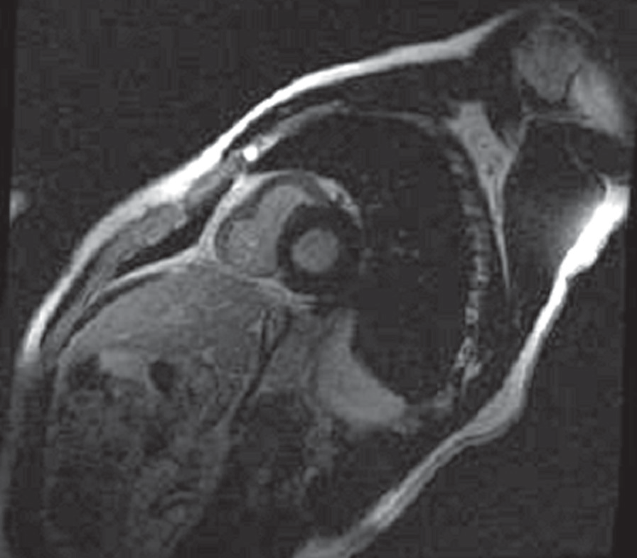
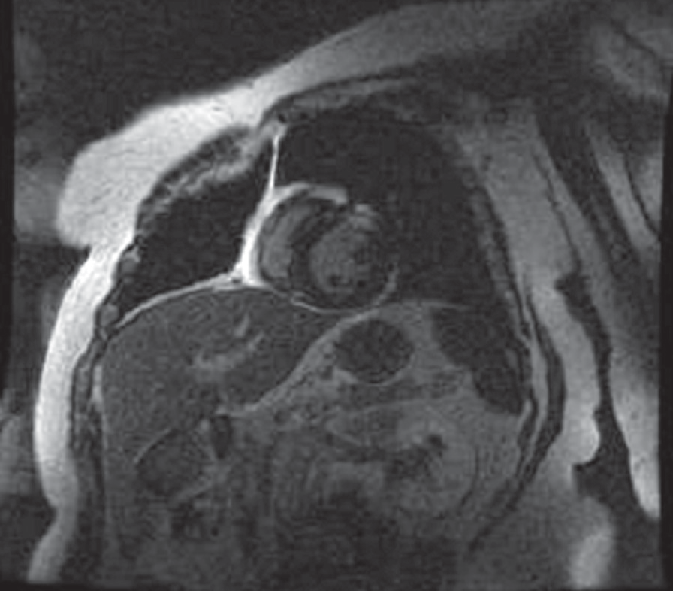
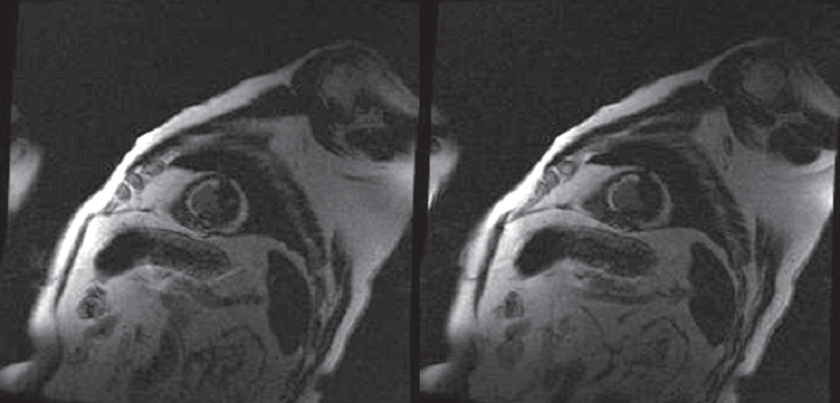
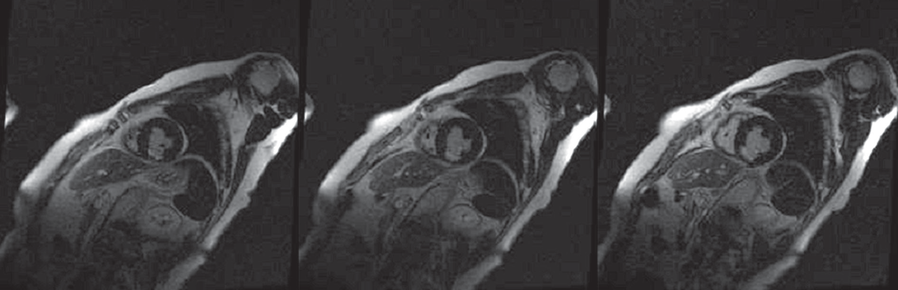
OriginalArticle
©PolJRadiol,2009;74(4):47-54
Figure3.Normalleftventriclemyocardium–Delayedenhancementperfusionshortaxisimaging.
Figure4.Smallsubendocardialpostinfarctionscarwithintheanteriorsegmentoftheleftventricle–atransverse(shortaxis)delayedenhancementperfusionimaging.
Figure5.Smallsubendocardialpostinfarctionscarwithintheinferiorsegmentoftheleftventricle–atransverse(shortaxis)delayedenhancementperfusionimaging.
Figure6.Subendocardialpostinfarctionscarwithintheinferoseptal,superoseptalandanteriorsegmentoftheleftventricle–atransverse(shortaxis)delayedenhancementperfusionimaging.
Results
withinthemyocardiumoftheleftventricle.Itsvolumerangedfrom1.07to52.15ml(meanvalueof15.30ml).
Onehundredandseventeenpatientsweresubjectedtoexaminations.In9cases(7.7%,8menand1woman),thepostinfarctionscarwasnotpresent,whichwasconcludedfromadiagnosedprocessofnormalreconstructionofthemyocardiumwithintheMIsite(Figure3).Theleftventricu-larenjectionfractioninthosepatientsrangedfrom43.6%to68.1%(meanvalueof56.94%).Intheremaining108cases(92.3%),werevealedthepresenceofthepostinfarctionscar
Dependingontheinfarctsize,werevealed:subendo-cardialinfarctions(Figures4–6)–thescarinvolvedthemostinnerlayerofthemyocardium;transmuralinfarc-tions(Figures7,8)–thescarinvolvedthewholemusclein its transversedimension; andnontransmural infarctions(Figures9–11)wherethescarinvolvedalargerareathaninthecaseofsubendocardialinfarctions,butitdidnot
50

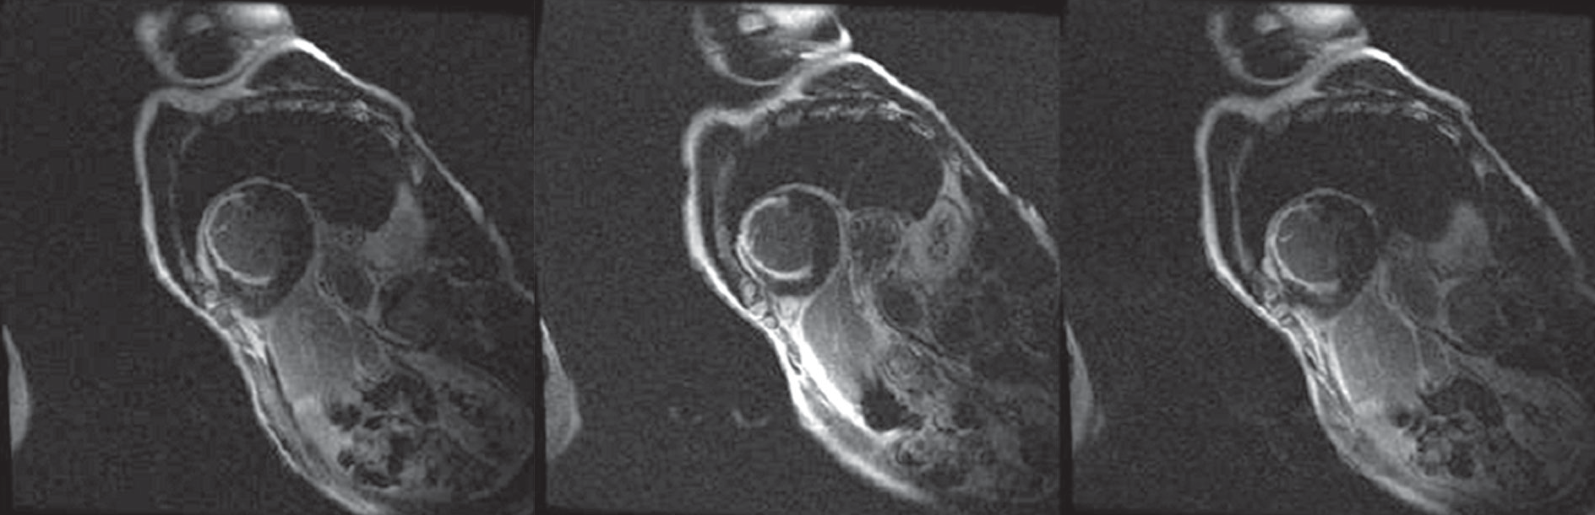
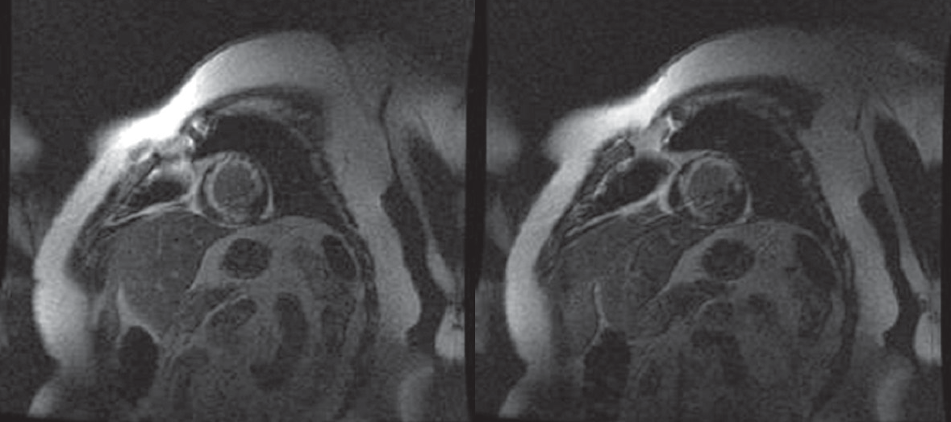
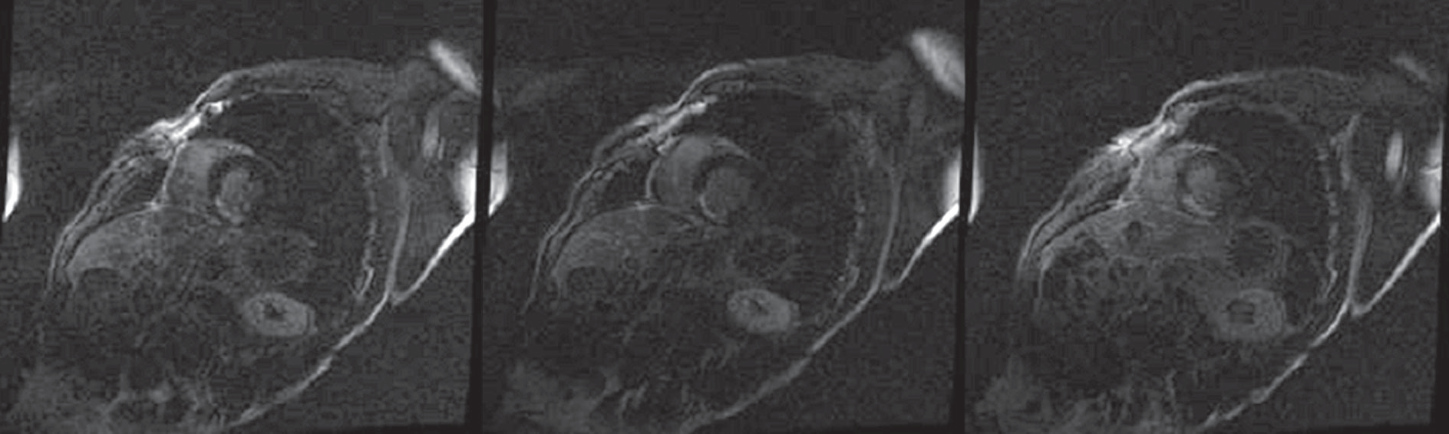
©PolJRadiol,2009;74(4):47-54
Brzozowska-CzarnekAetal–Usefulnessofcardiacmagneticresonance…
Figure7.Vasttransmuralpostinfarctionscar oftheinferoseptal,superoseptalandanteriorsegmentsofthe leftventricle.Delayedenhancementperfusiontransverse(shortaxis)imaging.
Figure8.Vasttransmuralpostinfarctionscaroftheinferior,inferoseptal,superoseptal,anteriorandsuperolateralsegmentsoftheleftventricle.Delayedenhancement
perfusiontransverse(shortaxis)imaging.
Figure9.Nontransmuralpostinfarctionscaroftheinferoseptalandinferiorsegmentsoftheleftventricle–Delayedenhancementperfusiontransverse(shortaxis)imaging.
involvethewholewall–mostofthetimeitwas25%to75%ofthepathologicallychangedwall.
In4cases(3.7%),thescarwasfoundwithinthelateralwalloftheleftventricle,andtheenjectionfractionoftheleftventriclerangedfrom42.3%to58.2%(mean50.17%).
Subendocardialscarwasfoundin54patients(50%).Thevolumeofthescarrangedfrom1.07mlto43.53ml.Transmuralscarwasfoundin7individuals(6.5%):volumerangingfrom1.85mlto50.30ml,andin18cases(16.7%)thescarwasnontransmural:volumerangingfrom2.66to
52.15ml.Intheremaining29patients(26.8%),wefoundscarsofamixedtype(subendocardial,nontransmuralandtransmural).
In2patients(1.8%)withEFof51.8%and56.3%,thescarwasfoundwithintheanteriorwalloftheLV.
In13individuals(12%),thescarwasrevealedintheintra-ventricularseptum,EFoftheleftventriclerangedinherefrom29.4%to63.5%(mean48.04%).
In14cases(13%),thescarinvolvedtheinferiorwall,andtheenjectionfractionoftheLVrangedfrom42.6%to63.8%(mean48.2%).
Onthebasisofthe17-segmentdivision,thelocationofthepostinfarctionscarwasdetermined.
Intheremaining75cases(69.5%),therewereexten-sivepostinfarctionscarsinvolvingmorethanonewallin
51

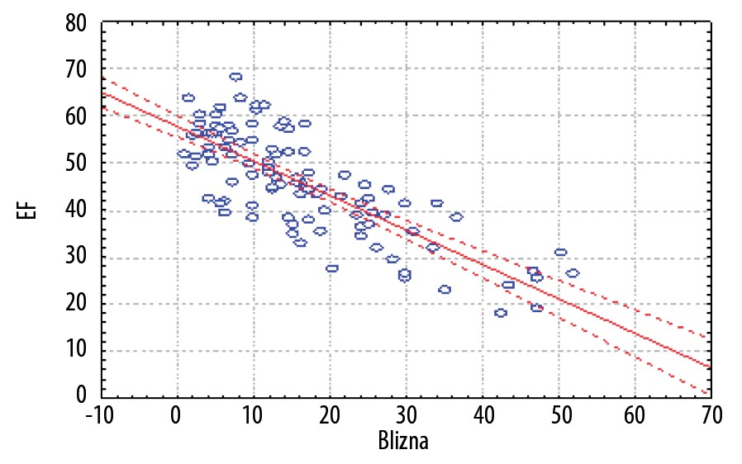
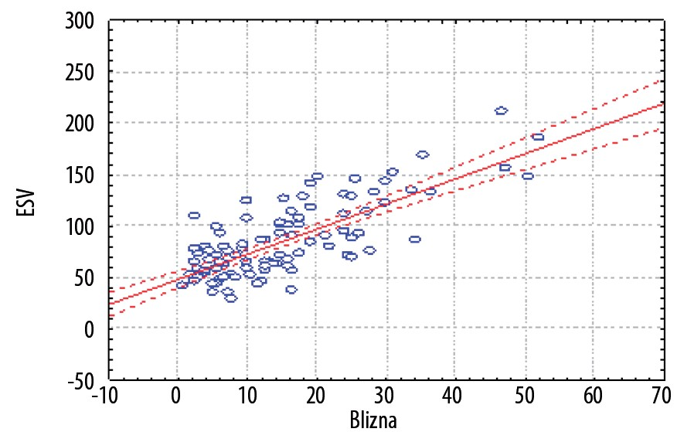
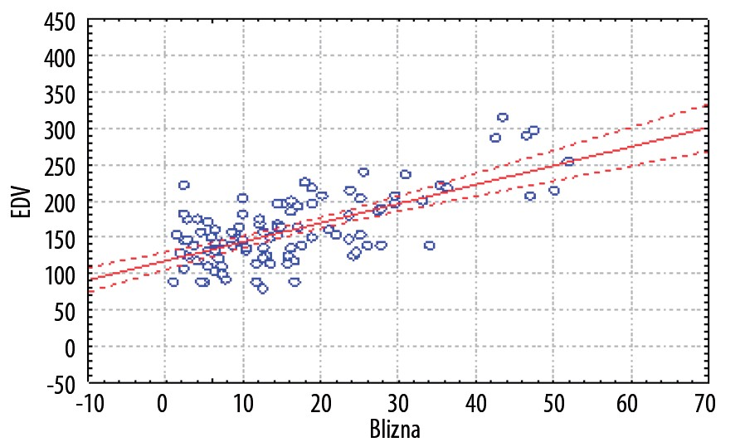
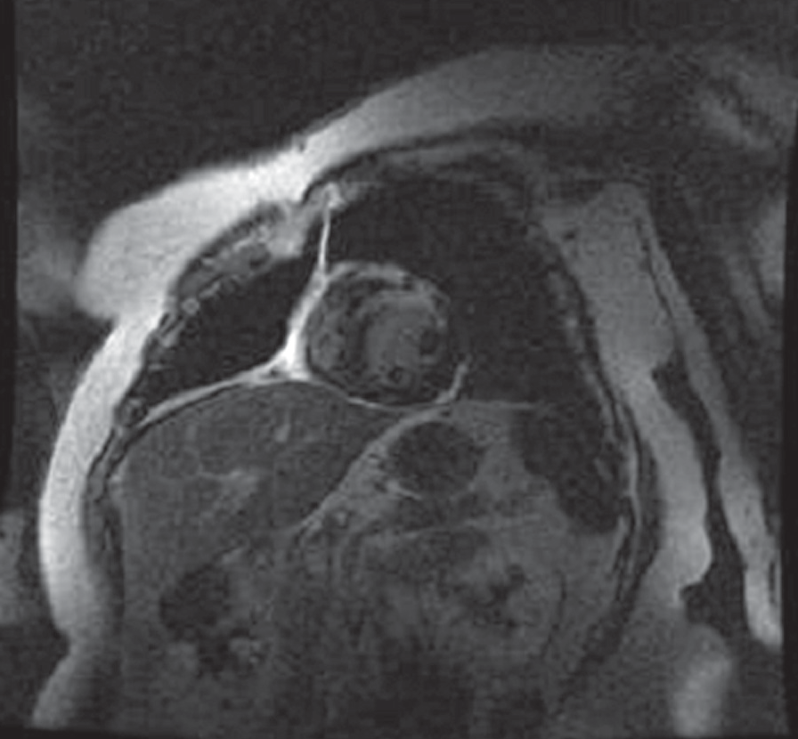
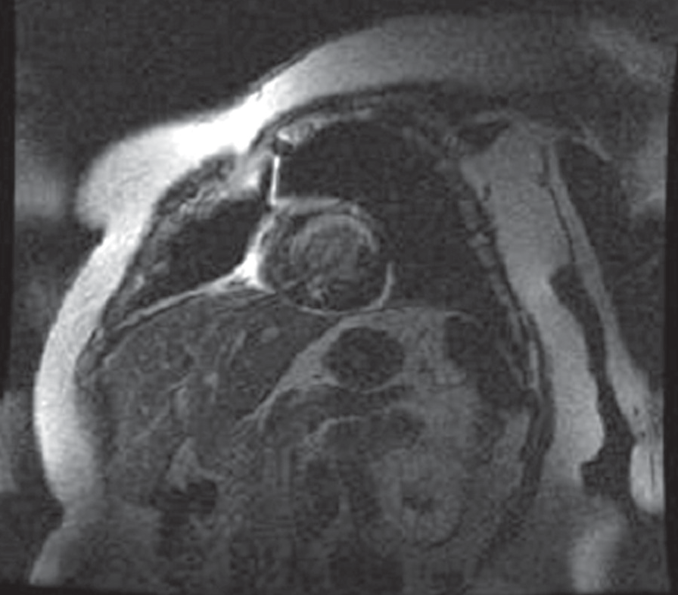
OriginalArticle
©PolJRadiol,2009;74(4):47-54
Figure12.CorrelationbetweenpostmyocardialscarformationsizeandEF:r=–0.7929.Confidenceinterval0.95.
Figure10.Nontransmuralpostinfarctionscarofthesuperoseptalandanteriorsegmentsoftheleftventricle.Delayedenhancementperfusiontransverse(shortaxis)imaging.anteriorandsuperolateralsegmentsoftheleftventricle.Delayedenhancementperfusiontransverse(shortaxis)imaging.
Figure13.CorrelationbetweenpostmyocardialscarformationsizeandEDV:r=0.65639.Confidenceinterval0.95.
Figure11.Nontransmuralpostinfarctionscarofthesuperoseptal,anteriorandsuperolateralsegmentsoftheleftventricle.Delayedenhancementperfusiontransverse(shortaxis)imaging.
Figure14.CorrelationbetweenpostmyocardialscarformationsizeandESV:r=0.78455.Confidenceinterval0.95.
differentsegments.Inthatgroup,4patients(5.3%)hadtheirscarswithintheinferiorandlateralsegments,3patients(4%)inanteriorandlateralsegments,14patients(18.7%)inseptalandanteriorsegments,and19(25%)inseptalandinferiorsegmentsoftheleftventricle.
muscle,in13cases(12%)–theanteriorpapillarymuscle,andin4patients(3.7%)–bothpapillarymusclesoftheleftventricle.Intheremaining88patients(81.5%),therewerenormalpapillarymusclesoftheleftventricle–notinvolvedwithpostinfarctionscarring.
In35patients(47%),theinfarctionscarswerefoundwithin3ormoresegmentsandwallsoftheLV.Inthisgroupof75patients,theenjectionfractionrangedfrom18.0%to56.0%(mean42.2%).
WhenanalysingthevalueofEFinthewholeexaminedgroupof17patients,thevalueoftheEFwasfoundouttobeapprox.48.08%(from18.0%to63.8%).Thereferencevalueamountedto69±6%(8).
Whenanalysingtherelationsbetweenthelocationofthescarandofthepapillarymuscles,itwasrevealedthatin3patients(2.8%)thescarinvolvedtheposteriorpapillary
52

©PolJRadiol,2009;74(4):47-54
Brzozowska-CzarnekAetal–Usefulnessofcardiacmagneticresonance…
Theenjectionfractionexceeding60%wasfoundin14patients (12%); EFof 50-59%in 36patients (30.8%),EF of
40–49%in35patients(29.9%),EFof30–39%in21patients
(17.9%),EFof20–29%in9patients(7.7%),andEFbelow
20%in2patients(1.7%).
withsubendocardialscars)orakinesis(mainlyinpatientswithlargernontransmuralscars),aswellasdyskinesis(inpatientswithtransmuralscars).
Discussion
Theend-diastolicvolumeoftheleftventricleinthegroupof117patientsamountedtoapproximately164.46ml(from
85.31mlto335.5ml).Thereferencevalue:160±29ml(8).
Myocardiumevaluationinpatientswithischaemicheartdiseasehasposedachallengetocliniciansformanyyears.Alivemyocardiummayfullyregainitsnormalfunctionafteracourseofreperfusivetreatment(PPCIinmostcases).Theregionoftheheartmusclethatunder-wentnecrosisorscarringisnotabletoregainitsnormalcontractilefunction.Thatiswhyitisveryimportanttobeabletoevaluatetheheartmuscle,andnottoputthepatientatunnecessaryriskconnectedwithcoronaryrevas-cularisationindetectednecrosisorpostinfarctionscar[12].
Normalvalueswerefoundin94patients(80.4%),slightlyincreased(rangefrom190to210ml)in8patients(6.8%)–from195.94mlto207.15ml,andsignificantlyincreased(over210ml)–from211.56mlto335.5ml!in15patients(12.8%).
Theend-systolicvalueoftheleftventricleinthegroupof117patientsamountedto94.31mlonaverage(from35.01mlto250.01ml).Thenormalreferencevalueamountedto50±16ml(8).
Untilrecently,thediagnosisofthemyocardialinfarctionbasedsolelyonatypicalhistory,characteristicECGchang-esandchangesintheprofileofspecificserumenzymes.
Normalvalues–from35.01mlto64.92mlwerefoundin57patients(48.8%),slightlyincreased(rangefrom70ml
to90ml)in17patients(14.5%)–from74.50mlto89.41ml,increased(rangefrom90mlto150ml)in33individ-uals(28.2%)–from90.17to148.25ml,andsignificantlyincreased(over150ml)–from152.29mlto250.01ml!in10(8.5%)patients.
Additionally,echocardiographywashelpfulinlocalisationoftheischaemicfocuswithinthewalloftheheartmus-cle.However,itwasnotgivingaclearanswertotheques-tionwhetherthepostinfarctionregionofthemyocardiumunderwenta:normalremodelling,necrosisorscarring.
ThewholepostinfarctionregionmaybevisualisedwiththeDEtechniqueinCardioMRexaminationwhichallowsfordetermination ofthepresenceofthepostinfarctionscar,itslocationandrange.
Everypatientunderwentevaluationofthecontractil-itydisorderswithintheLVwalls.Thefollowingcontrac-tiledisorderswerefound:hypokinesisregardingoneortwopostinfarctionsegmentsoftheleftventricle–in62patients(53%),hypokinesiswithinmorethantwosegmentswithsegmentalakinesis–in2cases(1.7%),hypokinesisinmorethantwosegments,withsegmentaldyskinesis–in24patients(20.5%),aswellashypokinesis,withinmorethantwoinfarctionsegments,withsegmentalakinesisanddys-kinesis–in7patients(6%).
Timoetal.[13]performedCardioMRexaminationin22patients,after5daysandafterabout5monthsfromtheMIincident.ThesepatientsweretreatedwithPPCEandstentimplantation.Everyexaminationwascarriedoutwiththeuseofa1.5Tscanner.FIESTAsequencewasusedtoevaluatethevolumeandcontractilityofthewallsoftheLV,andT1IRGEsequencewithDEat10–20minutesafterintravenouscontrastadministration,toevaluatethepostinfarctionscar.
In22patients(18.8%),anormalcontractilityoftheleftventricularmuscle was found.
Inthestudiedgroupofpatients,15cases(70%)hadapostinfarctscarwithin theanterior segment,and 7persons(30%)withintheinferiororlateralsegment.
Weexaminedinterrelationsbetweenthescarsizeanddif-ferentparametersoftheLV(EF,EDV,ESV).Asignificantreversecorrelationwasfoundbetweenthescarsizeandthevalueoftheleftventricularenjectionfraction–thebig-gerthescarsize,thelowertheenjectionfraction,whichwasequaltoworseprognosis.
TheauthorsfoundasignificantincreaseinEF–from48±11%inthefirstexamination,to55±9%inthefollow-upstudy,anincreaseinEDV:from160±44mlto172±55mlandinsignificantdifferenceswithinESV–from84±4mlto81±4ml.Inthisgroup,contractility disordersoftheLVwallswerefoundinpatientswithaCMR-detectednontransmuralscar,involvingmorethan75%ofthewallthickness,andinpatientswithtransmuralscars.
Theend-diastolicandend-systolicvolumeswereincreas-ingwiththeincreasingsizeofthescarwithintheleftventricle.
Thestatisticalanalysisshowedaveryhighreversecor-relationbetweenthescarsizeandEF(Figure12).Pearsonlinearcorrelationcoefficientamountedto-07929.Therewasahigh correlationbetweenthe scar size andEDV(r=0.65639)(Figure13)andbetweenthescarsizeandESV(r=0.78455).Thesecorrelationswerestatisticallysig-nificant,withsignificancelevelof0.05(Figure14).Thesizeofthescaranditstransmuralitysignificantlyinflu-encedtheabnormalsystolicfunctionoftheleftventri-cle,resultinginslighthypokinesis(especiallyinpatients
RasmusSejerstenRipaetal.[14]performedCMRsin58patients,rightaftertheirincidenceofheartattackandPPCItreatment,andthenafter1monthand6months.Theexami-nationsat6monthsrevealedasignificantincreaseinEF,ascomparedtobothpreviouslyperformedCMRexaminations
- from52.9±13.4%to61±11.9%,anincreaseinEDV–from128±35mlto140±35ml,andinsignificantESVdifferences
- from63±34to57±30ml.WiththeuseoftheDEsequence,theauthorsfoundasignificantdecreaseintheinfarctsize
53

OriginalArticle
©PolJRadiol,2009;74(4):47-54
intheexaminationperformed1monthafterthebaselineexamination(rightafterthemyocardialinfarction).Theydidnotrevealanysignificantdifferenceintheinfarctsizewhencomparingtheresultsoftheexaminationperformedafteronemonthandtheonecarriedoutafter6months.
However,RasmusSejerstenRipaetal.[14]pointouttothefactthattheobjectiveCMRresultsinpatientsafterMInotalwayscorrelatewithsubjectivefeelingsofthepatients.Itisworthremembering.Itshouldalsobeunderscoredthatwhentheinfarctiscomplicatedbyaneurysm,itispossiblethentodefine(withtheuseoftheDEsequence)therangeofthepostinfarctionaneurysm,anditstype:trueorspuri-ous,andtoevaluatetheproportionofthescarwithintheaneurysm.
Someauthors–Gerberetal.[15]–believethatthebestperi-odforthefollow-upCMRstudyis7monthsaftertheheartattack.Others–Tayloret al.[16]think thisis3months.
Conclusions
Inourmaterial,wherethepatientshadtheirCMRexamina-tionperformed after6monthsfromthedayoftheir myocar-dialinfarction,itwaspossibletodetecttheprocessofscarformation.Basingonourstudiesandexperiencesofotherauthors[12–16],webelievethatthetimeof3–7monthsfromthemomentofMIisoptimalfortheevaluationofthepostinfarctionscar,asnosignificantdifferencesinthescarsizewererevealedinthatperiod,becausethestrongestremodellingoftheischaemicmyocardiumcanbeobservedduringthefirstmonthfromthePCIprocedure[14].
TheMRIexaminationwith DelayedEnhancementtech-niqueevaluatedthepresence,preciselocationandsizeoftheinfarctionscar.Moreover,theexaminationallowedforevaluationofthecharacterofmuscle‘remodelling’:scarformation–subendocardial,nontransmural,transmuralorunchanged(normal)structureoftheheartmuscle.ThestatisticalanalysisrevealedaveryhighreversecorrelationbetweenthescarsizeandEF.Thereisalsoahighcorrela-tionbetweenthescarsizeandEDV,andbetweenthescarsizeandESV.
Allauthorsofthearticles([12–16],andothers)revealedahighcorrelationbetweentheinfarctsizeorthescarsizeandthedisordersofLVcontractility,aswedid.Noregionsofabnor-malcontractilitywerefoundifthescarwasnotpresent.
CardioMR iscurrently an optimaldiagnostic methodin thedetectionandevaluationofthepostinfarctionscars.
References:
- LillyLS:Patofizjologiachoróbserca.Wrocław;WydawnictwoMedyczneUrban&Partner,1996
- PodolecP,TraczW,HoffmanPetal:Echokardiografiapraktyczna
–tomIII,kolegiumRedakcyjneMedycynaPraktycznaorazAstraZeneka,Kraków2005
- IsbellDC,KramerCM:Cardiovascularmagneticresonance:structure,function,perfusionandviability.JNuclCardiol,2005;12:324–36
- LinD,KramerCM:LateGadolinum-enhancedCardiacMagneticResonance.CurrCardiolRep,2008,10:72–78
- SieversB,ElliottMD,HurwithLetal:Rapiddetectionof
myocardialinfarctionbysubsecond,freebreathingdelayedcontrast-enhancementcardiovascularmagneticresonance.Circulation,2007;115:236–44
- BarbierCE,BjernerT,JohanssonLetal:Myocardialscarsmorefrequentthanexpected:magneticresonanceimagingdetectspotentialriskgroup.JAmCollCardiol,2006;48:765–71
- KimRJ,WuE,RafaelAetal:Theuseofcontrast-enhancedmagneticresonanceimagingtoidentifyreversiblemyocardialdysfunction.NEnglJMed,2000;343:1445–53
- HudsmithLE,PetersenSE,FrancisJMet al: Normalhuman left andrightventricularandleftatrialdimentionsusingsteadystatefreeprecessionmagneticresonanceimaging.JCardiovascMagnReson,2005;7:775–82
- BellengerNG,GatehousePD,RajappanKetal:LeftventricularquantificationinHeartFailurebyCardiovascularMRusingprospectiverespiratorynavigatorgating:comparisonwithbreath-holdacquisition.JMagnResonImag,2000;11:411–17
- SuzukiJ,NagaiR,NishikawaJetal.:EvaluationoftheheartwithMagneticResonanceImaging.CardiacMRImaging,2000;41:417–24
- PrasadS,PennellDJ:Magneticresonanceimagingintheassessmentofpatientswithheartfailure.JNuclKardiol,2002;9:S60–70
- EngblomH,ArhedenH,FosterJetal:Myocardialinfarctquantification:Ismagneticresonanceimagingreadytoserveasagoldstandardforelectrocardiography?JElectrocardiol,2007;40:243–45
- BaksT,VanGeuns RJ,Biagini E et al: Recoveryof left ventricularfunctionafterprimaryangioplastyforacutemyocardialinfarction.EurHeartJ,2005;1–8
- RipaRS,NilssonJC,YongzhongWetal:Short-andlong-termchangesinmyocardialfunction,morphology,edemaandinfarctmassafterST-segmentelevationmyocardialinfarctionevaluatedbyserialmagneticresonanceimaging.AmHeartJ,2007;154:929–36
- GerberBL,GarotJ,BluemkeDAetal:Accuracyofcontrast-enhancedmagneticresonanceimaginginpredictingimprovementofregionalmyocardialfunctioninpatientsafteracutemyocardialinfarction.Circulation,2002;106:1083–89
- TaylorAJ, Al-Saadi N,Abdel-AtyH et al: Detectionof acutelyimpairedmicrovascularreperfusionafterinfarctangioplastywithmagneticresonanceimaging.Circulation,2004;109:2080–85
54

