A&A 632, A13 (2019)
https://doi.org/10.1051/0004-6361/201935558
© Y. Stein et al. 2019
A&stronomy
Astrophysics

CHANG-ES

XIX. Galaxy NGC4013: a diffusion-dominated radio halo with plane-parallel disk
and vertical halo magnetic fields*

Y. Stein12, R.-J. Dettmar2,3, M. Wezgowiec4, J. Irwin5, R. Beck6, T. Wiegert5, M. Krause6, J.-T. Li7,
V. Heesen8, A. Miskolczi2, S. MacDonald5, and J. English9
- Observatoire astronomique de Strasbourg, Universitó de Strasbourg, CNRS, UMR 7550, 11 rue de l’Universitó,
67000 Strasbourg, France
e-mail: yelena.stein@astro.unistra.fr
- Ruhr-Universitat Bochum, Fakultat fur Physik und Astronomie, Astronomisches Institut (AIRUB), 44780 Bochum, Germany
- Ruhr-Universitat Bochum, Research Department: Plasmas with Complex Interactions, 44780 Bochum, Germany
- Obserwatorium Astronomiczne Uniwersytetu Jagiellonskiego, ul. Orla 171, 30-244 Kraków, Poland
- Department of Physics, Engineering Physics & Astronomy, Queen’s University, Kingston, Ontario K7L 3N6, Canada
- Max-Planck-Institut fur Radioastronomie, Auf dem Hugel 69, 53121 Bonn, Germany
- Department of Astronomy, University of Michigan, 311 West Hall, 1085 S. University Ave, Ann Arbor, MI 48109-1107, USA
- Universitat Hamburg, Hamburger Sternwarte, Gojenbergsweg 112, 21029 Hamburg, Germany
- Department of Physics and Astronomy, University of Manitoba, Winnipeg, Manitoba R3T 2N2, Canada
Received 27 March 2019 / Accepted 17 June 2019
ABSTRACT
Context. The radio continuum halos of edge-on spiral galaxies have diverse morphologies, with different magnetic field properties
and cosmic ray (CR) transport processes into the halo.
Aims. Using the Continuum HAloes in Nearby Galaxies - an EVLA Survey (CHANG-ES) radio continuum data from the Karl G.
Jansky Very Large Array (VLA) in two frequency bands, 6 GHz (C-band) and 1.5 GHz (L-band), we analyzed the radio properties,
including polarization and the transport processes of the CR electrons (CREs), in the edge-on spiral galaxy NGC 4013. Supplementary
LOw-Frequency ARray (LOFAR) data at 150 MHz are used to study the low-frequency properties of this galaxy and X-ray data are
used to investigate the central region.
Methods. We determined the total radio flux densities (central source, disk, halo and total) as well as the radio scale heights of the radio
continuum emission at both CHANG-ES frequencies and at the LOFAR frequency. We derived the magnetic field orientation from
CHANG-ES polarization data and rotation measure synthesis (RM synthesis). Furthermore, we used the revised equipartition formula
to calculate the magnetic field strength. Lastly, we modeled the processes of CR transport into the halo with the 1D SPINNAKER model.
Results. The central point source dominates the radio continuum emission with a mean of ~35% of the total flux density emerging
from the central source in both CHANG-ES bands. Complementary X-ray data from Chandra show one dominant point source
in the central part. The XMM-Newton spectrum shows hard X-rays, but no clear AGN classification is possible at this time. The
radio continuum halo of NGC 4013 in C-band is rather small, while the low-frequency LOFAR data reveal a large halo. The scale
height analysis shows that Gaussian fits, with halo scale heights of 1.2kpc in C-band, 2.0kpc in L-band, and 3.1 kpc at 150MHz,
better represent the intensity profiles than do exponential fits. The frequency dependence gives clear preference to diffusive CRE
transport. The radio halo of NGC 4013 is relatively faint and contributes only 40% and 56% of the total flux density in C-band and
L-band, respectively. This is less than in galaxies with wind-driven halos. While the SPINNAKER models of the radio profiles show that
advection with a launching velocity of ~20 km s-1 (increasing to ~50 km s-1 at 4 kpc height) fits the data equally well or slightly better,
diffusion is the dominating transport process up to heights of 1-2 kpc. The polarization data reveal plane-parallel, regular magnetic
fields within the entire disk and vertical halo components indicating the presence of an axisymmetric field having a radial component
pointing outwards. The mean magnetic field strength of the disk of NGC 4013 of 6.6uG is rather small. Large-scale vertical fields are
observed in the halo out to heights of about 6 kpc.
Conclusions. The interaction and the low star formation rate (SFR) across the disk of NGC 4013 probably influence the appearance
of its radio continuum halo and are correlated with the low total magnetic field strength. Several observable quantities give consistent
evidence that the CR transport in the halo of NGC 4013 is diffusive: the frequency dependence of the synchrotron scale height, the
disk/halo flux density ratio, the vertical profile of the synchrotron spectral index, the small propagation speed measured modeled with
SPINNAKER, and the low temperature of the X-ray emitting hot gas.
Key words. diffusion - X-rays: galaxies - galaxies: halos - galaxies: individual: NGC 4013 - galaxies: magnetic fields -
radio continuum: galaxies
* A copy of the reduced images is available at the CDS via anonymous ftp to cdsarc.u-strasbg.fr (138.79.128.5) or via
http://cdsarc.u-strasbg.fr/viz-bin/cat/J/A+A/632/A13
A13, page 1 of 21
Open Access article, published by EDP Sciences, under the terms of the Creative Commons Attribution License (https://creativecommons.org/licenses/by/4.0),
which permits unrestricted use, distribution, and reproduction in any medium, provided the original work is properly cited.
A&A 632, A13 (2019)
1. Introduction
Studies of star-forming galaxies in the local Universe provide
knowledge of evolutionary properties and their driving physi-
cal processes. The investigation of cosmic rays (CRs) transport
mechanisms is crucial to understand the disk-halo interac-
tion and the formation of radio halos in galaxies (e.g., Parker
1992). Whereas diffusion-dominated CR transport in galax-
ies leads to small radio halos (e.g., NGC 7462; Heesen et al.
2016), advection-dominated galaxies show large radio halos
(e.g., NGC 4666; Stein etal. 2019). Polarization observations
reveal large-scale magnetic fields in many spiral galaxies (e.g.,
NGC 4666; Stein etal. 2019). One proposed mechanism to
explain these large-scale fields is the mean-field a-u dynamo
(see e.g., Ruzmaikin et al. 1988; Beck etal. 1996; Chamandy
2016; Henriksen 2017; Henriksen et al. 2018). Turbulent gas
motions, for example driven by supernova explosions, and the
Coriolis force (a-process), combined with shear motions due to
differential rotation (u-process) amplify and order the magnetic
field.
In this paper, the radio halo of the edge-on spiral galaxy,
NGC 4013, is analyzed using data from the Continuum HAlos
in Nearby Galaxies - an Evla Survey (CHANG-ES) program
observed with the Karl G. Jansky Very Large Array (VLA).
NGC 4013 is a spiral galaxy with a nearly edge-on orienta-
tion at a distance of 16Mpc. The basic galaxy parameters
are listed in Table 1. It exhibits a boxy bulge in optical light
(Tully et al. 1996). There is strong evidence that the galaxy har-
bours a bar potential from CO and optical wavelength mea-
surements (Garcfa-Burillo et al. 1999). Martfnez-Delgado et al.
(2009) found a tidal stellar stream extending 3kpc above the
plane of the disk, which they claim to be caused by a minor
merger. NGC 4013 has a a strongly warped outer Hi gaseous disk
(Bottema 1996) and a lagging Hi halo (Zschaechner & Rand
2015). A lagging halo can be caused by an active disk-halo
interface, such as expected for a “galactic fountain”. In spite of
clear hints of interaction, there is no obvious partner in the group
of 16 galaxies of which NGC 4013 is a member. Wang et al.
(2015) suggest that a one-to-three major merger would explain
all observable features, meaning the boxy bulge, the huge Hi
warp and the tidal stellar streams.
Comerón et al. (2011) found a second thick stellar disk (in
Spitzer 3.6um-band data), which is smoothly distributed. They
suggest that this third component was formed during galaxy for-
mation, when an initially thick disk was dynamically heated by
a past merger and then subsequently a new thick disk formed
within. Follow-up analysis by Comerón et al. (2018) confirmed
the existence of the two thick disks in NGC 4013.
Ho etal. (1997) classified the nucleus of NGC 4013 as a
“transition object”. This class of objects was described by
Ho etal. (1993) as having an emission line nucleus with [OI]
strengths intermediate between those of Hll nuclei and low-
ionization nuclear emission-line regions (LINERs). Ho et al.
(1993) proposed that transition objects can be explained as
LINERs whose integrated spectra are weakened or contaminated
by neighboring Hll regions.
In the VLA 1.49 GHz (d20 cm) image from Condon (1987),
the galaxy shows a boxy shape, suggesting the existence of a
radio halo. But the radio structure is blurred due to the large
beam size of 48", making a distinction between disk and halo
emission difficult. Conversely, the A6 cm VLA+Effelsberg radio
map by Hummel et al. (1991) shows a strong central source to
be visible as well as a thin radio disk. Baldi et al. (2018) investi-
gated eMERLIN array data of NGC 4013 and found radio emis-
Table 1. Basic galaxy parameters of NGC 4013.
RA | 11h58m31.38 (1)
Dec | +43d56m4757 (1)
Distance (Mpc) | 16.0 (1)
Inclination (°) | 89 ± 2 (2)
PA (°) | 65 ± 3 (2)
Major axis (arcmin) | 5.2 (3)
Minor axis (arcmin) | 1.0 (3)
vSyS (kms-1) | 831 (3)
vrot (kms-1) | 195(4)
SFR (Mq yr-1) | 0.5 (5)
SFRD (10-3 Mq yr-1 kpc-2) | 2.4 (5)
Classification | Hii, LINER (1)
References. (1) Irwin etal. (2012). (2) This work. (3) NASA/IPAC
Extragalactic Database (NED, https://ned.ipac.caltech.edu).
(4) Bottema (1996).(5) Star formation rate (SFR) and star formation rate
surface density (SFRD) from Wiegert et al. (2015).
sion in a circular shape with a diameter of 2.5"-3" around the
optical center. They state that this emission is probably asso-
ciated with a nuclear star-forming ring and thus internal to the
galaxy.
In this paper, we investigate the radio continuum emis-
sion of NGC 4013 of the halo and its central source. We
present flux density measurements at the two frequencies (1.5
and 6 GHz) of CHANG-ES as well as measurements of sup-
plemental radio continuum data at 150 MHz from the LOw-
Frequency ARray (LOFAR) Two-metre Sky Survey (LoTSS,
Shimwell et al. 2017). With supplementary X-ray data from
Chandra and XMM-Newton we have hints about the central
source of NGC 4013. Interestingly, the XMM-Newton data show
an extended X-ray halo confined to the middle part of the galaxy
where most of the polarized radio emission was detected. We fur-
ther analyze radio scale heights and the linear polarization. The
synchrotron map (with thermal emission subtracted) was used
to determine the magnetic field strength. The CR transport was
analyzed assuming 1D pure diffusion and advection for the CR
electrons.
This paper is organized as follows. Section 2 gives an
overview of the radio and X-ray data. In Sect. 3, we present
our results. This section contains the Stokes I maps, the scale
height analysis, the polarized intensity maps (created both with
and without rotation measure (RM) synthesis), the map of the
magnetic field strength using equipartition, and the 1D cosmic-
ray transport model. In Sect. 4 main results are discussed and in
Sect. 5 the results are summarized and conclusions are drawn.

2. Data
  - VLA
The radio continuum data are part of the CHANG-ES sur-
vey (Irwin et al. 2012) observed with the Karl G. Jansky Very
Large Array (VLA) . Observations were obtained in B-, C-, and
D-configurations at L-band (1.5 GHz, 500 MHz bandwidth, with
a gap of 144 MHz width where strong radio frequency inter-
ference is located), and in the C- and D-configurations at
C-band (6 GHz, 2 GHz bandwidth). We used 2048 spectral chan-
nels in 32 spectral windows at 1.5 GHz and 1024 channels in 16
spws at 6 GHz. All polarization products (Stokes I, Q, U, and V)
were obtained. The D-configuration data (Wiegert et al. 2015)
A13, page 2 of 21
Y. Stein et al.: CHANG-ES XIX. Galaxy NGC 4013
Table 2. Observation parameters of NGC 4013.
Dataset | Observing date | Time on source  (before flagging)
L-band B-configuration | 11. Aug 2012 | 2h
L-band C-configuration | 31. Mar 2012 | 30 min
L-band D-configuration | 18. Dec 2012 | 20 min
C-band C-configuration | 19. Feb 2012 | 3h
C-band D-configuration | 27. Dec 2012 | 40 min
are public1 and the B- and C-configuration data will become
public soon (Irwin et al., in prep., Walterbos et al., in prep.).
The data reduction for Stokes I (total power) and Stokes
Q and U (linear polarization) was carried out for all five
data sets of NGC 4013 (see Table 2) separately, using the
Common Astronomy Software Applications (CASA) package
(McMullin et al. 2007) and following the calibration procedures
as described in the CHANG-ES paper by Irwin et al. (2013). We
used J1331+3030 (3C286) as the primary calibrator (also as the
bandpass and polarization angle calibrator), J1246-0730 as the
secondary calibrator, and J1407+2827 as the zero polarization
calibrator. The calibrated data from the different configurations
were then combined for C-band and L-band and were used for
imaging Stokes I, Q, and U.
Large-scale flux density for extended structures is missed
by the VLA at C-band in C- and D-configuration for struc-
tures larger than 240". In L-band B-configuration missing flux
density is expected for structures larger than 120" and C- and
D-configuration for structures larger than 970". As the radio
extent of NGC 4013 in the CHANG-ES bands is 205", we expect
no significant influence by missing spacings in the configuration-
combined images of both bands (potential missing spacings due
to the B-configuration in the L-band setup are compensated by
the inclusion of the other two configurations).
The Stokes I maps were produced by cleaning with a robust
weighting (Briggs 1995) parameter of zero, as implemented in
CASA and uv-tapering of 18 kT. The polarization and magnetic
field orientation maps were created from the Stokes Q and U
maps, which were cleaned with a robust parameter of two in
order to be more sensitive to faint structures.
Table A.1 shows all rms values for the different maps pro-
duced for this study. The achieved rms from the combined
(C- and D-configuration) C-band data for Stokes I (rob 0,
18 kT taper) is 4.3 juJybeam-1 with a beam size (i.e. resolu-
tion/FWHM) of 5.2" x 5.3". The resulting rms of the combined
(B-, C- and D-configuration) L-band data for Stokes I (rob 0,
18 kT taper) is 16.7uJy beam-1 with a beam size of 5.9" x 6.0".
Smoothed images of Stokes I of both bands were produced for
the scale height analysis and the thermal and nonthermal sep-
aration and the following determination of the magnetic field
strength and the CR transport analysis. For RM-synthesis, Stokes
Q and Stokes U were imaged for each spw with a robust weight-
ing parameter of two. The technique was performed following
Steinetal. (2019).
  - LOFAR
The LoTSS is a sensitive, high-resolution, low-frequency
(120-168 MHz) survey of the northern sky using LOFAR
(Shimwell et al. 2017). LoTSS data of NGC 4013 were obtained
1 CHANG-ES data release I available at www.queensu.ca/changes.
Table 3. Parameters of the XMM-Newton observations of NGC 4013.
Galaxy | NGC 4013
ObsID/obs.date | 0306060201/13.11.2005
 | 0306060301/15.11.2005
nH (a) | 1.26 x 1020 cm-2
MOS filter/obs.mode | Medium/Full Frame
pn filter/obs.mode | Medium/Full Frame
Total/clean MOS time | 94/79 ks
Total/clean pn time | 71/67 ks
Notes. (a) Weighted average value after LAB Survey of Galactic HI
Kalberla et al. (2005).
from data release 1 (DR1, Shimwell et al. 2019)2. In DR1,
images with two resolutions of 6" and 20" are provided. We use
the 6" image of NGC 4013 and applied Gaussian smoothing of
10" for the scale height analysis and of 18" to show the extent
in comparison to C-band.
  - XMM-Newton
The X-ray analysis of the emission from NGC 4013 was per-
formed with the use of the XMM-Newton archive data (see
Table 3) processed with the SAS 15.0.0 package (Gabriel et al.
2004). Using the standard reduction procedures, event lists for
two EPIC-MOS cameras (Turner et al. 2001) and the EPIC-pn
camera (Struder et al. 2001) for each of the two observations
were produced and subsequently filtered for periods of high-
energy emission.
To increase the sensitivity of the resulting spectrum, informa-
tion from all three EPIC cameras was used in the spectral anal-
ysis. Spectra were extracted from each of the event lists from
a circular central region having a radius of 12", that allowed
a full sampling of the PSF of the instrument. The position of
the region was chosen to match the radio center of the galaxy.
The background spectra were obtained using blank sky event
lists (see Carter & Read 2007), using the same procedures as
in the case of the source event lists. For each spectrum ancil-
lary files (response matrices and effective area files) were used
to correct for the instrumental effects. The spectra from all three
EPIC cameras of each observation were then merged using the
SAS task epicspeccombine. Merging of the spectra was accom-
panied by subtraction of the background spectra. It is important
to note, that the subtraction takes place only after both source
spectra and background spectra are combined. This leads to
higher signal-to-noise ratios in both resulting spectra, assuring
best subtraction of the background. XSPEC 12 (Arnaud 1996)
was used to fit model to the final spectrum of the core region of
NGC 4013.
  - Chandra
Further supplemental X-ray data were gained from Chandra.
The Chandra data were used to detect point sources reliably due
to their high angular resolution. The parameters of the Chandra
observations are presented in Table 4. The data were taken
from (Li & Wang 2013), where the details about the observa-
tions and data reduction techniques, including calibration, can be
found.
2 LoTSS data are publicly available at: https://lofar-surveys.
org.
A13, page 3 of 21
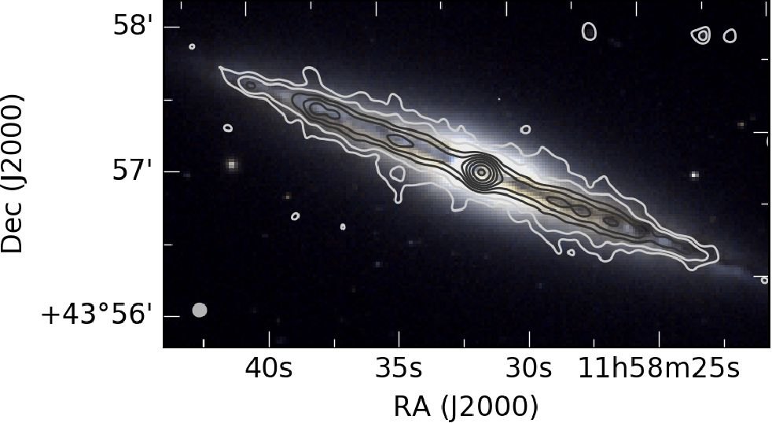
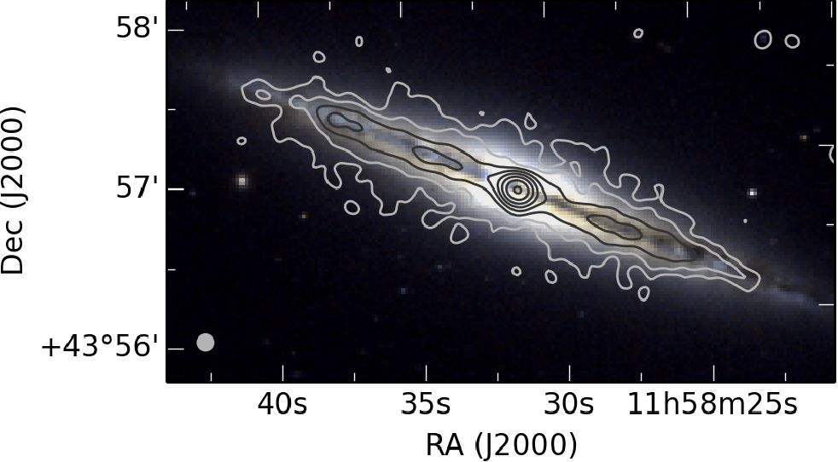
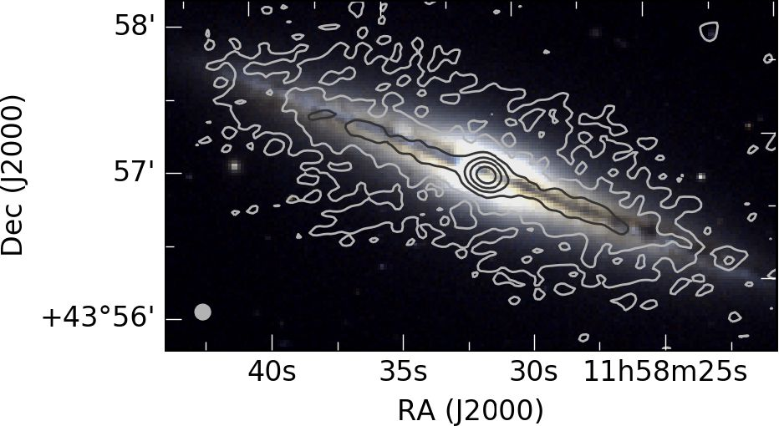
A&A 632, A13 (2019)
Table 4. Parameters of the Chandra observations ofNGC4013.
Obs ID | Instr. | Exp. (s) | PI | Data mode | Exp mode | Start date
4739 | ACIS-S | 79.10 | Strickland | FAINT | TE | 2004-02-03 09:31:16
4013 | ACIS-S | 4.90 | Satyapal | FAINT | TE | 2003-03-16 17:09:05
Fig. 1. NGC 4013 total intensity image of combined
(C- and D-configuration) VLA C-band data at 6 GHz. Contours
start at the 3a level with an rms noise a of 3.6juJybeam-1 and increase
in powers of 2 (up to 256). The beam size is 5.2" x 5.3" and is shown
in the bottom left corner of the image. A tapering of 18kT was used,
while the robust parameter was set to zero.
Fig. 2. NGC 4013 total intensity image of combined (B-, C- and
D-configuration) VLA L-band data at 1.6 GHz. Contours start at the
3a level with a a of 16.7juJybeam-1 and increase in powers of 2 (up to
128). The beam size is 5.9 x 6.0" and is shown in the bottom left corner
of the image. A tapering of 18kA was used, while the robust parameter
was set to zero.

3. Data analysis and results
  - Radio continuum total intensity maps
The total power contours from Stokes I are overlaid on the opti-
cal SDSS images made from the ugr-filters using the formulas
of Lupton (2005)3. The Stokes I contour map of C-band is dis-
played in Fig. 1, the one of L-band in Fig. 2 and the total intensity
LOFAR image in Fig. 3. The radio emission is dominated by the
central point source, which is seen in all frequencies. Especially
in C-band, the emission from the disk is weak and only a thin
radio disk and a small radio halo are observed. The presented
CHANG-ES images are produced with a uv-tapering of 18kT to
Fig. 3. NGC4013 total intensity image of LOFAR data at 150 MHz.
Contours start at the 3a level with a a of 94.3 juJybeam-1 and increase
in powers of 2 (up to 32). The beam size is 6.0" x 6.0" and is shown in
the bottom left corner of the image.
Table 5. Integrated flux densities ofNGC4013.
Observation | Freq | Flux density
 | (GHz) | (Jy)
This work (1) | 0.15 | 0.218 ± 0.021
Condon et al.(1998)(2) | 1.40 | 0.0405 ± 0.0023
This work (3) | 1.58 | 0.0368 ± 0.0018
This work (3) | 6.00 | 0.0118 ± 0.0006
3 www.sdss.org/dr12/algorithms/sdssUBVRITransform/
#Lupton2®®5
Notes. (1) The LOFAR Two-metre Sky Survey (LoTSS), measured on
the 10" resolution images. (2) The nRaO vLa Sky Survey (NVSS).
(3) CHANG-ES with effective frequency after flagging measured on the
10" resolution image.
enhance the extended flux of the galaxy and to achieve similar
resolutions for a quantitative comparison.
The L-band radio halo shows an extent of up to 2 kpc above
and below the mid plane and the LOFAR radio halo is extended
to 3 kpc, where both values were measured within the 3a-
contours. In L-band the radio halo is observable further out in
comparison to the C-band map and at 150 MHz even further
than in L-band. This is the expected behaviour for spectral age-
ing, where older cosmic ray electrons (CREs) corresponding to
lower energies (emitting at lower frequencies) are transported
away from their sources within the disk of the galaxy, while los-
ing energy due to various loss processes. No boxy structure is
found, in contrast to what the observations of Condon (1987)
suggest, but a slightly dumbbell-shaped thick disk can be seen in
the L-band and 150 MHz maps.
With the total flux density of 11.8 ± 0.6mJy in C-band and
36.8 ± 1.8 mJy in L-band the radio spectral index is a = -0.85 ±
0.05. The spectral index between 150 MHz and 1.58 GHz is
a = -0.76 ± 0.05. There is only one additional flux density mea-
surement in the literature, which is from NVSS (see Table 5).
This value of 40.5 ± 2.3mJy at 1.4 GHz is in agreement with
the flux densities obtained in this work. The observed radio
spectral indices are in good agreement with expected values for
A13, page 4 of 21
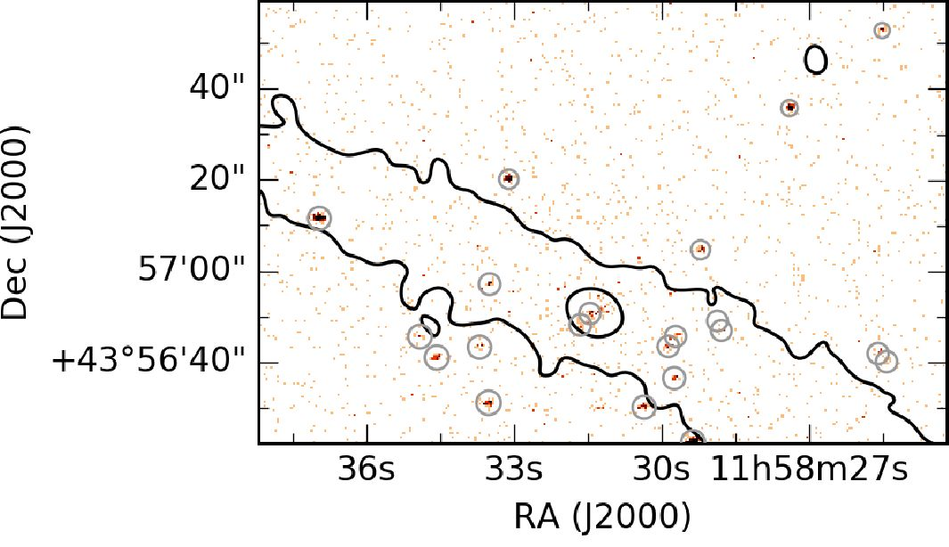
Y. Stein et al.: CHANG-ES XIX. Galaxy NGC 4013
Table 6. NGC 4013 flux density measurement of the central source.
 | Flux  (mJy) | Beam  size  (") | Region  size  (") | Obs. date
BL | 10.09 ± 0.44 | 10 | 20 | Aug. 11/2012
DC | 4.52 ± 0.20 | 10 | 20 | Dec. 27/2012
CC | 4.52 ± 0.20 | 10 | 20 | Feb. 19/2012
LOFAR | 28.3 ± 1.7 | 10 | 20 | Jan. 21/2015
Notes. Measurements of the different array configurations
B-configuration L-band (BL), D-configuration C-band (DC) and
C-configuration C-band (CC)
synchrotron emission. The low-frequency radio spectral index
below 1.5 GHz is slightly steeper (with a difference of 2^) than
the value of a = -0.57 ± 0.104 found by Chyży etal. (2018).
Also, we see only a small break in the radio continuum spec-
trum with Aa = aiow - ahigh = 0.09 ± 0.05, whereas Chyży et al.
(2018) found A a = 0.18 ± 0.20. This suggests different CR elec-
tron propagation and energy losses in NGC 4013 compared to
other spiral galaxies.
- Central point source
The galaxy NGC 4013 was classified as a LINER by Ho et al.
(1997) and Irwin etal. (2012). There is an additional X-ray
observation published by Dudik et al. (2005). In their study of
high-resolution X-ray imaging of nearby LINERs observed by
Chandra, a nuclear point source of NGC 4013 was not detected.
They concluded either a lack of an energetically significant
AGN or a highly obscured AGN with column densities of
11 x 1023 cm-2 to 10.2 x 1024 cm-2, implying that the AGN has a
luminosity between 2 x 1038 erg s-1 and 9.5 x 1042 erg s-1. Here,
we investigate the “central point source”, meaning a centrally
peaked source, although it is not an unresolved source in both
dimensions as defined in Irwin et al. (2019). Using the radio
continuum data of both CHANG-ES bands and LOFAR data
as well as the X-ray data from Chandra and XMM-Newton we
further constrain the classification of this galaxy and its central
source.
- Radio continuum
A clear detection of a central point source is visible in both bands
of the CHANG-ES data as well as in the LOFAR data. To fur-
ther investigate the central source, variability in the total inten-
sity of the central source was checked. Therefore, flux densities
of the central source were measured in images from the two dif-
ferent VLA array configurations of the C-band data, which are
observed at different times (see Table 6). As one C-band observa-
tion was done in the beginning of 2012 and the other in the end of
2012, time variability could be tested. Additionally, the flux den-
sity of the central source in B-configuration L-band and LOFAR
150 MHz was measured. To do so, all images were smoothed
to the same beam size of 10 arcsec in order to overcome beam-
dependent errors in the flux density measurement. The flux den-
sity was then measured via a Gaussian profile fit to the intensity,
using CASA.
4 Quoted uncertainties for results by Chyży et al. (2018) refer to the
standard deviation rather than the smaller standard deviation of the
mean.
Fig. 4. NGC 4013 Chandra image with combined (C- and
D-configuration) VLA C-band contours (same data as Fig. 1) at
3- and 30-ix-levels overlaid. The false-color represents the Chandra
color from 0.3 to 7 keV. Gray cycles denote Chandra point-like sources.
The image is off-centered to show the location of the two point-like
sources in the northern halo of NGC 4013.
We chose a circular region two times larger than the beam
size. To measure the error, the chosen region was varied from
the beam size to four times the beam size. The difference in the
flux density measurements were then used to calculate a mean
error. The integrated flux density of the central source of both
C-band configurations is 4.52 ± 0.20 mJy. Therefore, no measur-
able variability is found between our C-band observations. The
flux density level of the galaxy was 0.14 and 0.17 mJy beam-1,
respectively. The integrated flux density of the central source
in B-configuration L-band is 10.09 ± 0.44 mJy with a galaxy
flux density level of 0.35 mJy beam-1. The flux density of the
LOFAR observations is 28.33 ± 1.73 mJy with a base level of
2.28 mJy beam-1.
A resulting radio spectral index of a = -0.66 ± 0.05 is cal-
culated between the C-band flux density and the B-configuration
L-band flux density as well as a = -0.44 ± 0.05 between the
L-band and the LOFAR flux densities. The values suggest a flat-
tening of the spectral index towards lower frequencies due to syn-
chrotron self-absorption, which requires a very compact object
and hints at an AGN. As some AGN show circular polarization
(Irwin et al. 2018), this was investigated as well. In the Stokes V
image, no circular polarized emission could be found. In sum-
mary, apart from the fact that the central source dominates the
emission of the galaxy and that the spectral index is relatively flat
towards lower frequencies, no strong indication that the central
object might be an AGN can be found from its radio properties.
- X-ray
Chandra. To further constrain the nature of the central point
source, Chandra X-ray data (Li & Wang 2013) on Stokes I con-
tours are shown in Fig. 4. Clearly, there is a Chandra point-like
source located at the same position as the central radio source,
which is the dominant source within the entire surroundings
apart from another less strong point-like source next to it. This
finding corroborates the LINER classification since we expect
X-ray emission emanating from an AGN but not from a star-
burst nucleus.
XMM-Newton. The core region of NGC 4013 was fit with
a complex model consisting of a gaseous component that
accounted for the emission from the hot gas and a power-law
model, that accounted for the central source. The mekal model
is a model of an emission spectrum from hot diffuse gas based on
A13, page 5 of 21
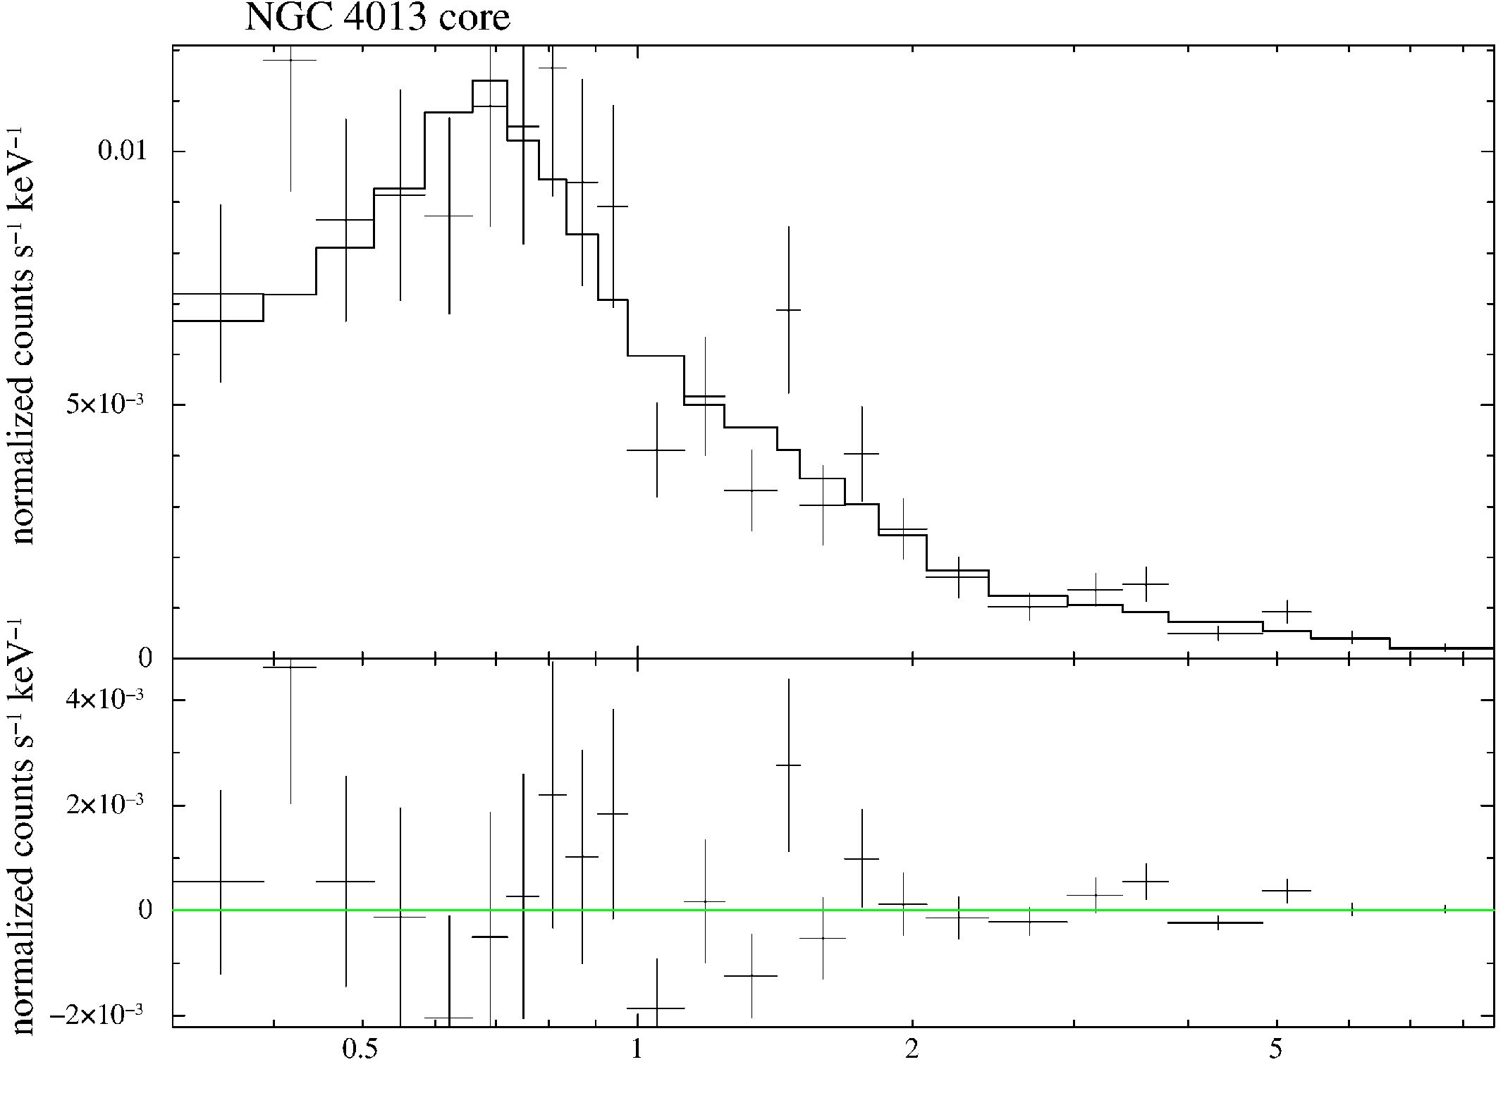
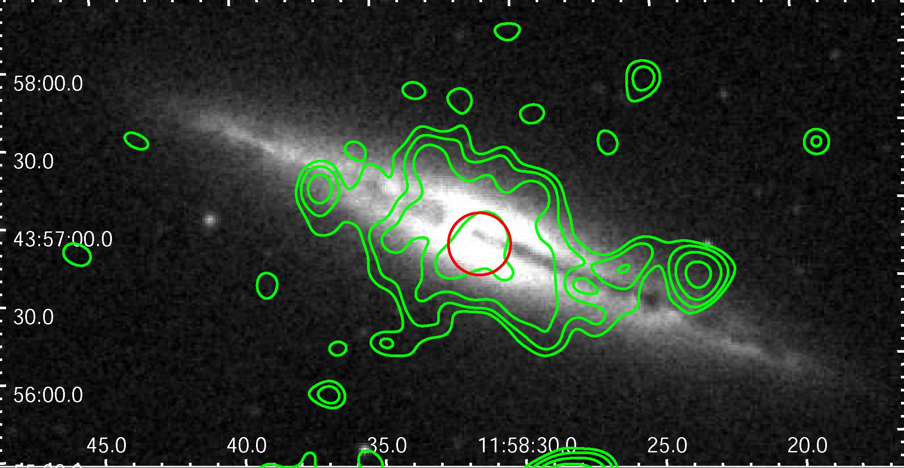
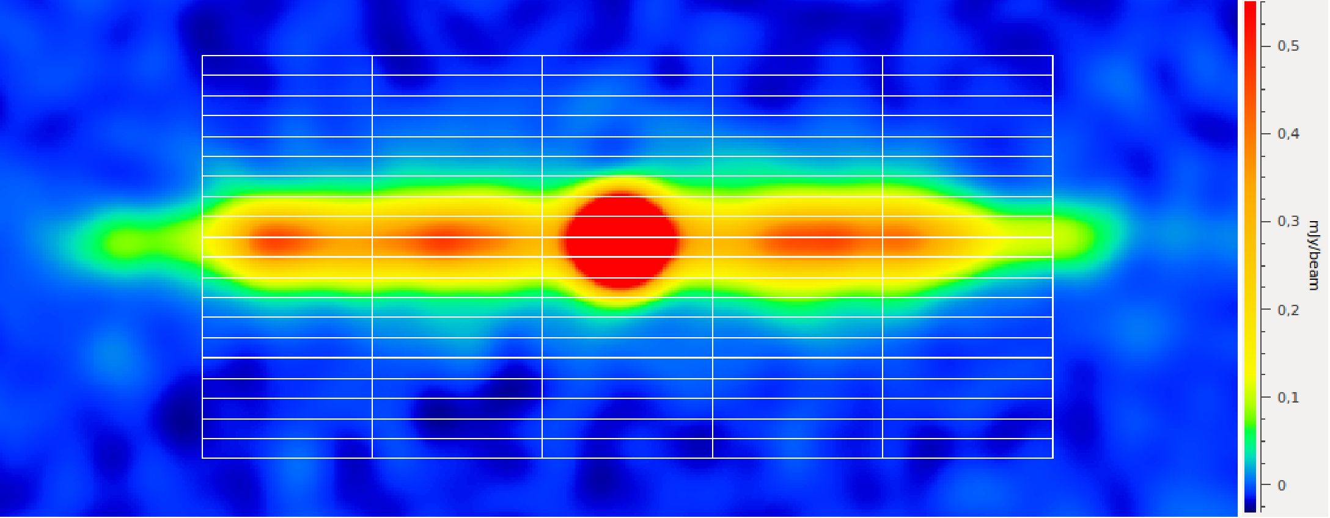
A&A 632, A13 (2019)
Table 7. Physical parameters derived from the model fit to the spectrum
of the NGC 4013 core region.
kT
Mekal flux
Photon Index
Core flux
Core luminosity
0.27-0.06 keV
(3.13+0.70 x 106 K)
2.00-0 89 x 10 15 erg cm 2s 1
1 10-022
A.A -0.21
2.31-169 x 10-14 erg cm-2 s-1
7.1+5o x 1038 ergs-1
Energy (keV)
Fig. 5. XMM-Newton EPIC spectrum of the core region of NGC 4013.
Fig. 6. XMM-Newton EPIC emission of NGC 4013 in the energy band
0.2-1 keV (contours) overlaid on the DSS blue image. The contours
start at 3, 3.5, 4.5, 6a levels. The image is adaptively smoothed with
the largest smoothing scale of 10" and the signal-to-noise ratio of 10.
The spectral core region is marked with a red circle.
Fig. 7. NGC 4013 screenshot of the strips used with NOD3 (combined
C-band).
the model calculations of Mewe and Kaastra (Mewe et al. 1985;
Kaastra 1992).
Since we assumed that most of the power-law flux would
be attributed to the central source (see also Fig. 4) and given
the relatively large uncertainties of its value, we used this flux
to calculate the luminosity of the central source. We obtained a
value of 7.1+3 2 x 1038 erg s-1 (Table 7).
The spectrum of the core region of NGC 4013 is presented in
Fig. 5. No clear AGN characteristics are visible, but significant
hard emission (above 2 keV) and a relatively flat photon index
suggest a prominent central source.
The average temperature of the hot gas in the core region of
NGC 4013 is 0.270 04 keV. Assuming a spherical emitting vol-
ume of the region, the model fit yields a number density of
5.37+107 x 10-3 cm-3 and the corresponding thermal energy den-
sity of 3.50+144 x 10-12 erg s-1.
Figure 6 shows the extended emission from NGC 4013 in the
0.2-1 keV energy band. The spectral region used for the analy-
sis is marked with a red circle. Most of the emission of the hot
gas comes from the central parts of the galactic disk with some
outflows into the halo visible.
  - Intensity profiles of the radio disk and halo
    - Scale heights - Strip fitting
The total intensity profiles perpendicular to the major axis of
edge-on spiral galaxies are fit by exponential or Gaussian func-
tions to determine scale heights of the thin and thick disk. The
thin disk refers to the disk and the thick disk refers to the
radio continuum halo of the galaxy, which are the used terms
in this work. Following Dumke et al. (1995), the observed inten-
sity profile can be described by the convolution of a Gaussian
beam profile with the true intensity profile of the galaxy, which
could be either exponential or Gaussian.
We used the “BoxModels” tool within the NOD3 software
package (Muller etal. 2017) with the combined configuration
maps of C-band and L-band as well as the LOFAR map, which
were smoothed to the same beam size of 10" x 10" in order to
compare the results. The scale height analysis was carried out
in an analogous way to Krause et al. (2018) using five strips per-
pendicular to the major axis (see Fig. 7). The box height was cho-
sen to be approximately half of the beam size, which was 4" in
both bands. The box width was 35" to cover the major axis with
the five strips. We note that with the LOFAR data it would have
been possible to measure seven strips due to the larger extent of
the major axis. A two-component exponential and Gaussian fit
was executed for all three frequencies to the five strips of radio
intensity profiles of NGC 4013. We achieved a fit with similar
X using Gaussian distributions in comparison with exponentials
for the C-band intensity profile, but better results for a Gaussian
fit for the L-band and LOFAR intensity profiles.
The parameters of NOD3 are summarized in Table 8. The
intensity profiles of the five strips and the two-component
Gaussian fits are displayed in Fig. 8 for C-band in Fig. 9 for
L-band and in Fig. 10 for the 150 MHz LOFAR data.
The resulting Gaussian scale heights of the strip fitting are
presented in Table 9. For the final scale height determination,
the central strip was omitted in order to exclude contamination
by the central source. The scale height analysis of NOD3 shows
an increasing thin disk component from higher to lower fre-
quencies. The ratio between the thin disk scale height and the
halo scale height is similar for C-band and L-band and decreases
slightly towards the lower frequency range of LOFAR. For the
A13, page 6 of 21
Y. Stein et al.: CHANG-ES XIX. Galaxy NGC 4013
Table 8. NGC 4013 parameters for the scale height fitting.
Parameter | C-band | L-band | LOFAR
Beam size (") | 10.0 | 10.0 | 10.0
Effective beam size (") | 10.2 | 10.2 | 10.2
Inclination (°) | 89 | 89 | 89
Position Angle (°) | 65 | 65 | 65
rms (mJy beam-1) | 0.010 | 0.025 | 0.10
Galaxy diameter (") | 205 | 205 | 230
Box width (") | 35 | 35 | 35
Box height (") | 4 | 4 | 4
Number of boxes in X | 5 | 5 | 5
Number of boxes in Y | 20 | 20 | 24
thin disk (“disk”) scale heights, we find 2.8" ± 0.7" (220 pc)
in C-band, 4.7" ± 0.3" (360 pc) in L-band, and 6.1" ± 0.6"
(470 pc) at 150 MHz. For the thick disk (“halo”) component, the
scale heights are 15.3" ± 3.0" (1.2kpc) in C-band, 25.8" ± 1.5"
(2.0kpc) in L-band, and40.4"±4.0" (3.1 kpc) at 150MHz. Inter-
estingly, the halo scale heights are similar to the measured 3^
extent measured in Sect. 3.1. This underlines the faintness of the
radio halo, which we can observe only to an extent of the scale
height.
The radio scale heights are influenced by the contribution
from thermal emission. Whereas exponential scale heights seem
to be the same within the errors in C-band for NGC 4565, the
Gaussian scale heights of the total radio continuum emission in
the halo are about 1 kpc smaller compared to nonthermal scale
heights (Schmidt et al. 2019). C-band data are most affected
by the thermal contribution, so that the halo scale height of
15.3" (1.2 kpc) is a lower limit. (The profiles of the nonther-
mal emission for C-band (see Sect. 3.6) could only be fit with
large uncertainties with a resulting Gaussian halo scale height
of 19.8" ± 4.0".) The thermal contribution diminishes at lower
frequencies, making the ratio of scale heights at L-band and
150 MHz suited for studying CRE propagation (see below).
Our radio scale heights differ from the ones determined by
Krause etal. (2018), the main reason being that we fit double
Gaussian functions while they fit exponential ones. In order
to make a comparison possible, we show the fitting of two-
component exponential functions in Figs. A.1-A.3, for C-band,
L-band, and LOFAR, respectively. With the combined config-
uration C-band data, the two-component exponential fits are
comparable to the D-configuration C-band fit from Krause et al.
(2018). With the exponential fit in L-band (Fig. A.2) we achieve
slightly larger scale heights but they are within the uncer-
tainties of Krause etal. (2018). We conclude that Gaussian
scale heights cannot easily be compared to exponential scale
heights.
We now compare the exponential scale heights with other
values from the literature. Hummel et al. (1991) found a radio
scale height of 4" from VLA C-band observations. This is half
of our exponential scale height measured for the halo compo-
nent of 8.1", which, however, equates only to 0.6kpc and thus
shows the halo to be difficult to detect at C-band. With Hi
data of NGC 4013, a scale height of 3" (210 pc) was found by
Zschaechner &Rand (2015), which is in good agreement with
the Gaussian C-band scale height of the thin disk and is also
similar to the mean scale height of the thin disk at 5 GHz, for
which Heesen et al. (2018) found 0.25 ± 0.13 kpc. Spitzer data at
3.6um, analyzed by Comerón et al. (2011), suggest a thin disk
of 122.5 pc and a thick disk of 557.5 pc. These values are roughly
half the values found here for the Gaussian C-band radio scale
heights.
In summary, the scale height analysis shows Gaussian func-
tions to better represent the vertical radio intensity profiles than
exponential functions at L-band and the LOFAR frequency. For
C-band, the fit quality is similar. Nevertheless, the Gaussian pro-
file represents the data slightly better visually.
    - Amplitudes and integrated flux densities of Gaussian
profiles
With the Gaussian fit to the intensity profile, we gather the scale
heights as well as the amplitudes of the Gaussian functions in
each of the five strips. In Table 9 we present the mean disk ampli-
tude and halo amplitude as well as the ratio of them together with
the mean scale height values. As expected, the disk amplitude
dominates in all cases. But even more interesting is the question
of which component of the total flux density is the dominating
one, i.e. the disk or the halo. With the parameters of the Gaus-
sian fit, we determine the integrated flux density, i.e. calculate
the integral of the Gaussian function. To do so, we derive the
mean amplitudes and mean scale heights. This is done for four
strips omitting the central strip, because we want to find the gen-
eral Gaussian function describing the galaxy without the central
source.
With the Gaussian distribution of the intensity profile for the
mean of the four strips:
w(z) = VV0 exp (-z2/z02) (1)
the integrated flux density becomes:
W (mJy ■ arcsec/beam) = Vn" w0 z0 , (2)
where the mean amplitude w0 is measured in mJy per beam area
and the mean scale height z0 in arcsec. We divide W by the beam
area b in arcsec (b = 113.3 arcsec2) to obtain the integrated flux
density W in mJy per arcsec, i.e. the flux density for a layer of
one arcsec thickness perpendicular to the strip, and averaged the
values for all strips. To determine the total flux density of the
thin disk and the halo, which is to be compared with the mea-
sured total integrated flux densities, we multiply with the extent
e along the major axis:
F(mJy) = Vn w0 z0 ■ e / b. (3)
The extent e is chosen to best represent the mean Gaussian
profile of the galaxy. First, we estimate the extent of the galaxy
at each frequency (Table 8), then we lower this extent to account
for the contributing size of the central source. In the last step we
consider the total flux densities of Table 5 as a reference point
and increase the value until the calculated and measured total
flux densities are similar. We obtain e = 160" ± 15" in C-band,
e = 190" ± 15" in L-band, and e = 195" ± 15" at 150 MHz. The
total emission of the “disk + halo” is the integrated flux den-
sity of Table 5 minus the central source flux density of Table 6,
which is (11.8 ± 0.6mJy) - (4.5 ± 0.2mJy) = 7.3 ± 0.6mJy in
C-band, (36.8 ± 1.8 mJy) - (10.1 ± 0.4 mJy) = 26.7 ± 2.2 mJy in
L-band, and (218 ± 21 mJy) - (28.3 ± 1.7 mJy) = 190 ± 21 mJy for
the LOFAR data. These values are presented on the right-hand
side of Table 9 along with the flux densities of the central source
(from Table 6) for comparison. The results of the integrated flux
densities of the disk and halo as well as their ratio are presented.
As a consistency check, we added up the flux densities of the
disk and halo Gaussian intensity models and confirmed that they
agree with the measured total flux densities.
A13, page 7 of 21
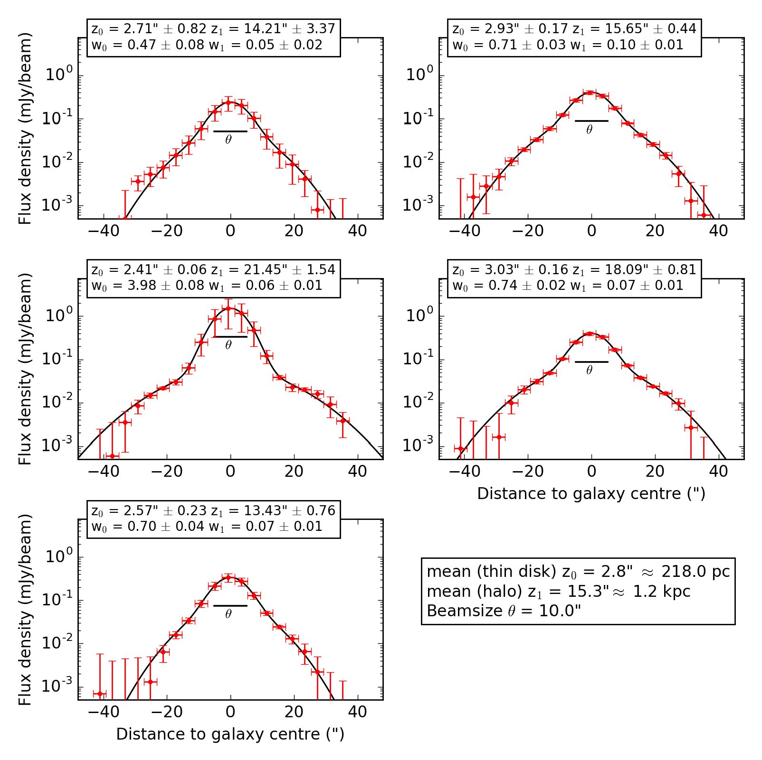
A&A 632, A13 (2019)
Fig. 8. Strip fitting with NOD3 for
five strips of NGC 4013 on the combined
(C- and D-configuration) C-band data with a
two-component Gaussian fit (x2otal = 0.05).
The first plot is at 75" on the major axis and
the last plot is at -75" on the major axis
from the center. The red dots represent the
mean intensity of each box and the black
line is the fit to the data done by NOD3. The
black horizontal line shows the size of the
beam d. The parameters of the exponential
fit function are given in the boxes on top
of each strip. The mean of the four scale
heights omitting the central strip as well as
the beam size are given in the box to the
lower right.
The C-band total flux densities are approximately the same
for the disk and the central source, whereas the halo flux density
is lower. In L-band, the halo flux density dominates mildly, but
still agrees with the contribution from the disk within the uncer-
tainties, while the flux density of the central source is slightly
smaller. At 150 MHz, the contribution from the halo to the flux
density clearly dominates. The ratio of the integrated flux density
of the disk to the integrated flux density of the halo shows a trend
with frequency: from 6 GHz to 150 MHz, the ratio decreases
from 1.7 to 0.3. The amplitude ratios follow the same trend,
decreasing from 9.4 to 1.9. The CREs emitting at lower frequen-
cies have longer lifetimes and thus can be transported into the
halo more easily.
  - Polarization and the large-scale magnetic field structure
The results from the C-band polarization data are shown at high
and low angular resolution in Figs. 11 and 12, respectively. In
Fig. 11, a symmetric structure in the disk is visible east and
west of the central point-like source with the peak of the polar-
ized emission in the east. The orientation of the magnetic field is
disk-parallel everywhere and no large-scale polarized structures,
besides that of the disk field, are detected. The low-resolution
map (beam size of 18" x 18") presented in Fig. 12 reveals new
structures. As before, a plane-parallel magnetic field in the disk
is observed, but now many polarized features reaching far into
the halo with vertical field orientations are seen as well. Because
the total radio intensity is not very high (11.8 ± 0.06 mJy in
C-band), the polarized intensity is even lower (1.63 ± 0.08 mJy
in C-band from Fig. 12). However, strong smoothing (18") in
combination with imaging with a robust weighting parameter
of 2 made it possible to reveal the large-scale magnetic field in
NGC 4013. For comparison, C-band, L-band and LOFAR Stokes
I contours are shown at a 3-^ level in Fig. 12. The polarized
emission extends as far as the LOFAR emission and the L-band
outer contour shows an elongation towards the northern polar-
ization “blob”, lending credibility to the detection. The rotation
curve of the galaxy indicates that the eastern part is approach-
ing the observer (e.g., Bottema 1996). Thus, within the disk, the
approaching side shows more polarized emission than the reced-
ing side, similar to NGC 4666 (Stein et al. 2019).
The vertical magnetic field structure in the halo cannot be
explained by diffusion alone and indicates an additional outflow.
To investigate this further, we follow the strategy described in
Damas-Segovia et al. (2016), who used the projected distance of
polarized structures together with an estimate of the CRE life-
time to measure the outflow speed. The maximum extent of the
north-western polarized emission blob above the disk is about
82" (6.4 kpc). The synchrotron lifetime follows from:
tsyn = 1.06 x 109 B-3/2 v-1/2yr
(4)
with the total field strength B in pG and v in GHz. We assume
a decline of the magnetic field strength of the disk towards the
halo, going from the disk value of B ^ 6.6pG (see Sect. 3.7)
to B ^ 2pG at the maximum z-extent of 6.4 kpc. In order to
account for inverse Compton losses, we added the average mag-
netic field strength Bhalo ^ 4.0pG encountered by CREs trav-
elling into the halo and the equivalent magnetic field strength
BCMB in quadrature, with the latter accounting for the energy
A13, page 8 of 21
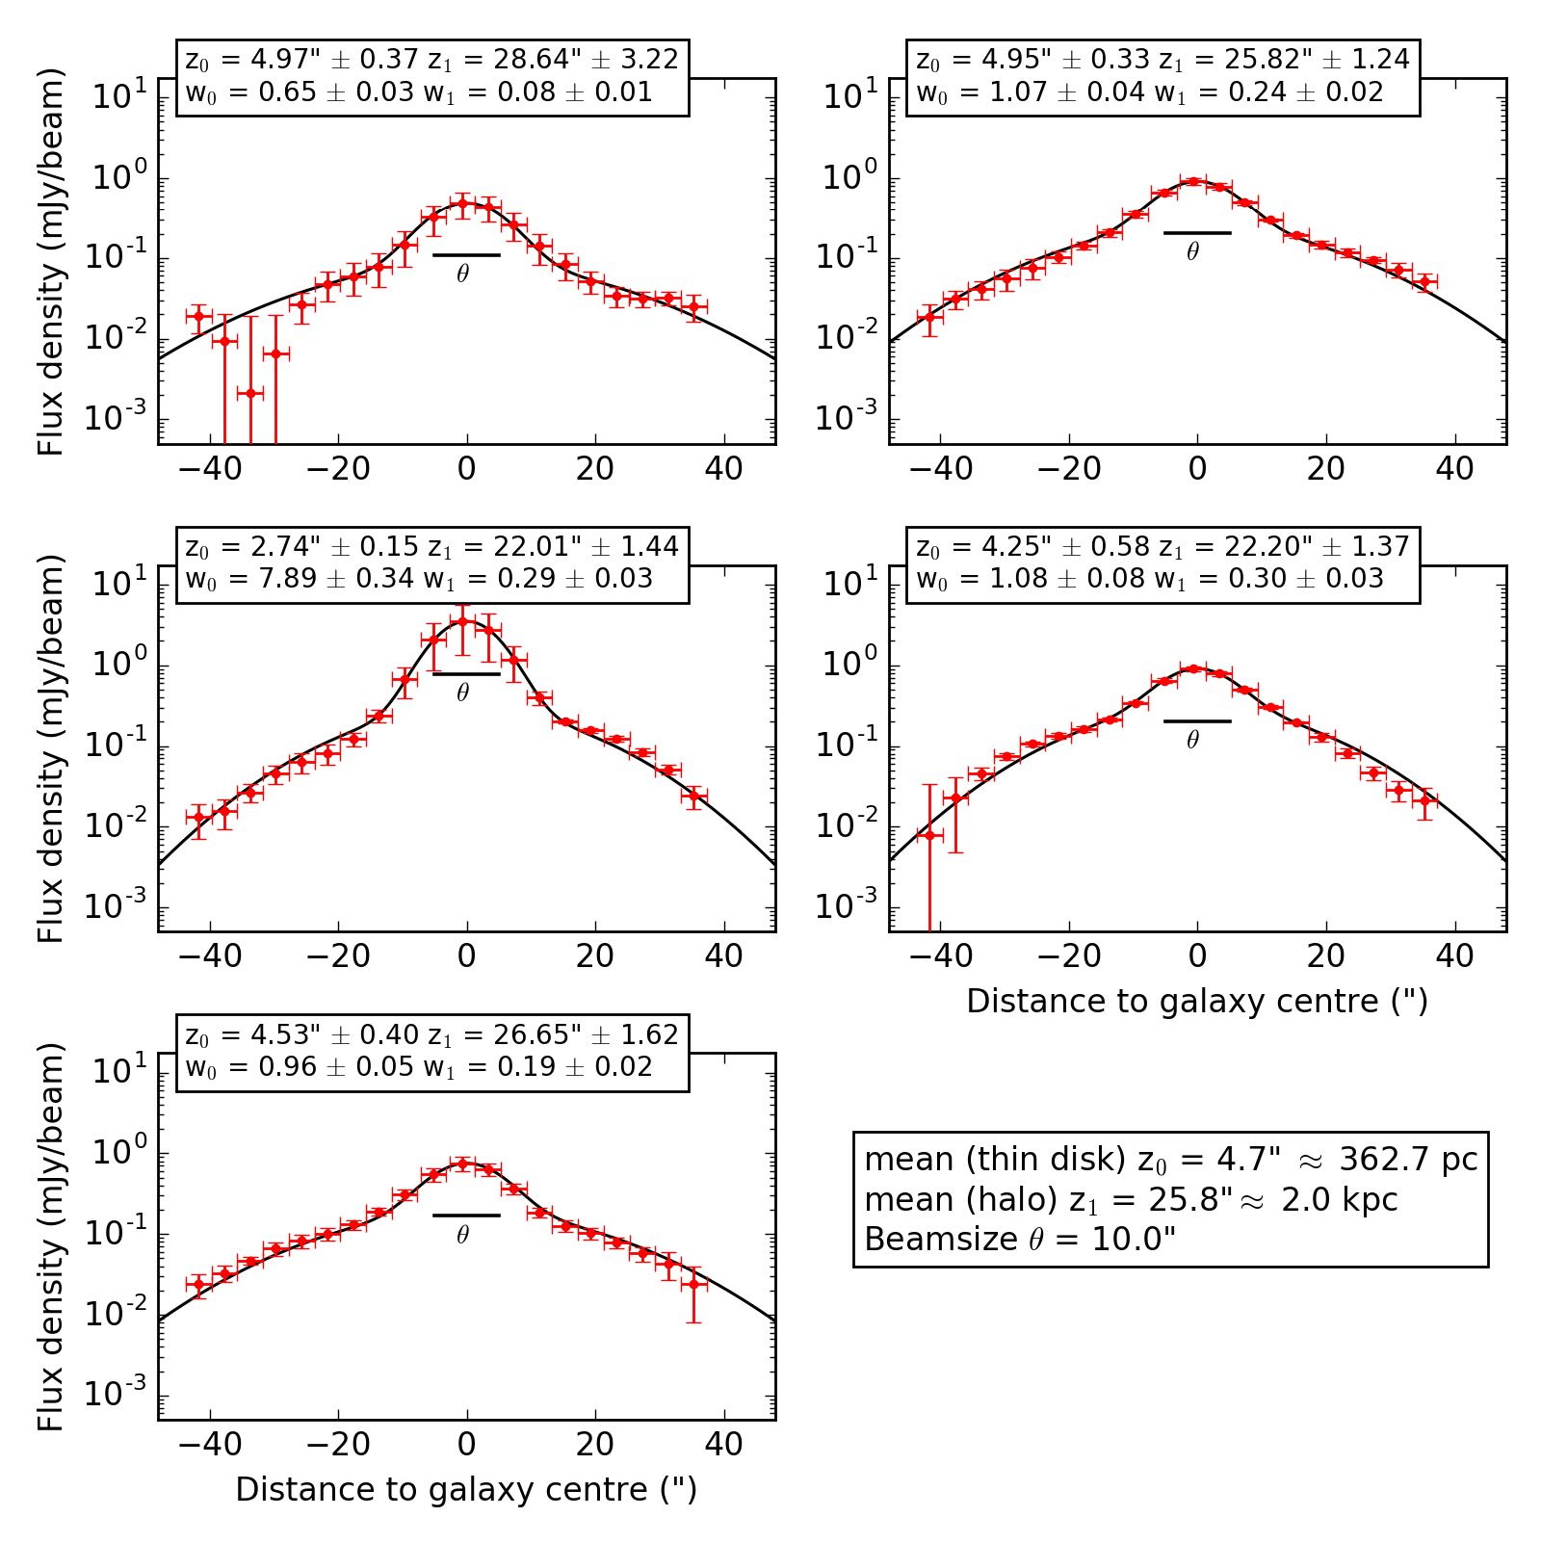
Y. Stein et al.: CHANG-ES XIX. Galaxy NGC 4013
Fig. 9. Strip fitting with NOD3 for
five strips of NGC 4013 on the combined
(B-, C- and D-configuration) L-band data
with a two-component Gaussian fit (x20tal =
0.92). Designations are the same as for Fig. 8.
density of the CMB:
V(B2alo + BCmb) = V(4.02 + 3.252) - 5uG. (5)
The synchrotron lifetime then is tsyn - 3.8 x 107 yr (B -
5uG, v = 6 GHz). Thus, the velocity which is needed to trans-
port CREs to 6.4 kpc height in the halo of NGC 4013 is about
160kms-1. This is a low advection velocity in comparison to
other galaxies (Heesen et al. 2018).
The X-ray emission, presented in Fig. 6, is mainly located
where we observe the strongest polarized emission of NGC 4013
(yellow/orange color in Fig. 12). The southern polarization struc-
ture in the halo pointing roughly towards the center (Region I
in Fig. 13) seems to be present in the XMM-Newton image as
well. The polarized “blob” in the halo to the north (Region II)
shows the same orientation of the magnetic field vectors in an
area of more than two beams. We find two distinct X-ray emis-
sion features within that blob, but these could be associated with
two point sources confirmed by Chandra (see Fig. 4), proba-
bly background sources. Furthermore, a source is located in the
upper part of the blob (RA 11:58:26.87, Dec +43:57:46.14), vis-
ible in C-band Stokes I (e.g., Fig. 11) and in the optical (e.g.,
in SDSS) as a diffuse source, possibly a background galaxy.
The possibility that these sources could generate an extended
polarized blob seems unlikely. Therefore, we assume this polar-
ization feature to originate from NGC 4013. The polarization
structure to the northeast of the galaxy (Region III) reaches far
into the halo. This location coincides with an extended HI fil-
ament (Bottema 1996) showing that this galaxy seems to have
local outflows, which have lower velocities than the escape
velocity.
In the L-band data, no polarized emission is detected.
Polarized emission in L-band is expected to be affected by
depolarization due to Faraday rotation. As this effect is wave-
length dependent, the depolarization is stronger in L-band than
in C-band. Therefore, images were produced with almost natu-
ral weighting (robust = 2), strong uv-tapering, and additional
use of RM-Synthesis, but still no polarized flux density within
the central disk could be recovered, with the exception of a few
patches of low intensity emission. These are at a level of 2a
(with a a of 29 uJy beam-1) and consistent with the peaks of the
C-band emission.
  - Rotation measures and the magnetic field configuration
in the disk
The polarization angle of an electromagnetic wave experiences
a frequency dependent rotation while propagating through a
magnetized plasma. This effect is called Faraday rotation with
the rotation of the polarization angle x being proportional to the
wavelength squared and the RM.
We perform RM synthesis following Stein et al. (2019), with
the important parameters presented in Table 10. From the data
in Xu & Han (2014), the Galactic foreground RM of NGC 4013
is determined. This value (RMforeground = -8.1 ± 1.2) is sub-
tracted from the final RM-cube to correct for the foreground
contribution.
The maps of polarized intensity and Faraday RM, both pro-
duced with RM-synthesis, are shown in Fig. 14. We overlay the
total intensity map with polarization contours, and the intrinsic
magnetic field orientation, corrected for Faraday rotation, and
the RM map with total intensity contours. As in Fig. 11, the
A13, page 9 of 21
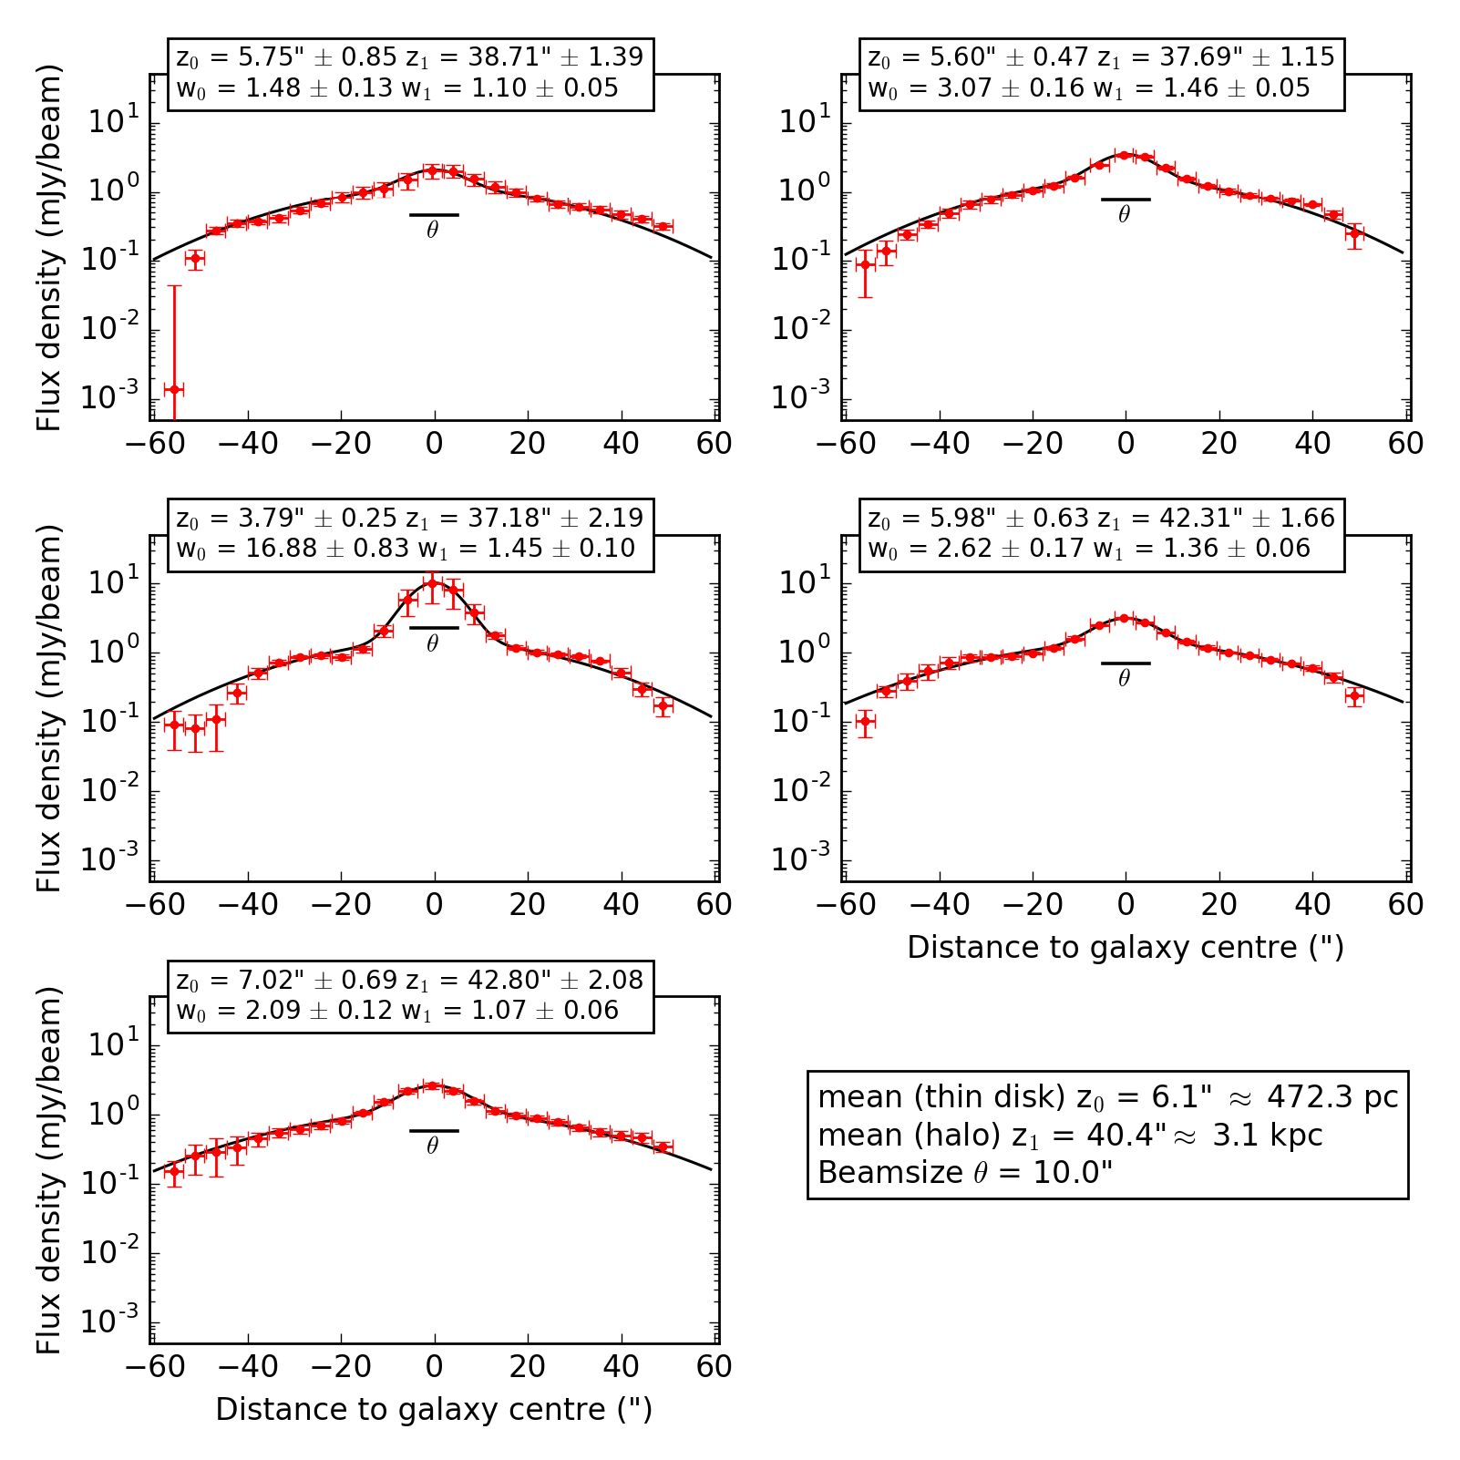
A&A 632, A13 (2019)
Fig. 10. Strip fitting with NOD3 for five strips
of NGC 4013 on the LOFAR data with a two-
component Gaussian fit (x2otal = 1-07). Desig-
nations are the same as for Fig. 8.
Table 9. Integrated flux densities and scale heights of the thin disk and halo of NGC 4013.
Gaussian fits From total flux densities
w0 1 Z0 (1) Z0 flux density disk + halo disk + halo central source
(mJy beam(1)) (") (kpc) (mJy) (mJy) (mJy) (mJy)
C-band  Disk  Halo  Ratio | 0.66 ± 0.08  0.07 ± 0.03  9.4 | 2.8 ± 0.7  >15.3 ± 3.0 (2)  <0.18 (2) | 0.2 ± 0.1  >1.2 ± 0.22 | - ± 1.7  - ± 2.0  1.7 | 7.3 ± 2.6 | 7.3 ± 0.6 | 4.5 ± 0.2
L-band  Disk  Halo  Ratio | 0.9 ± 0.2  0.2 ± 0.1  4.5 | 4.7 ± 0.3  25.8 ± 1.5  0.18 | 0.36 ± 0.05  2.0 ± 0.1 | 11.5 ± 1.7  14.9 ± 4.6  0.8 | 26.4 ± 4.9 | 26.7 ± 2.2 | 10.1 ± 0.4
LOFAR  Disk  Halo  Ratio | 2.3 ± 1.1  1.2 ± 0.1  1.9 | 6.1 ± 0.6  40.4 ± 4.0  0.15 | 0.47 ± 0.10  3.1 ± 0.3 | 43 ± 17  148 ± 11  0.3 | 191 ± 20 | 190 ± 21 | 28.3 ± 1.7
Notes. (1) w0 is the mean amplitude omitting the central strip, z0 is the mean scale height omitting the central strip. (2) Lower limit if only the
synchrotron emission is considered.
magnetic field orientation is disk-parallel everywhere and the
polarized intensity is confined to the central third of the galaxy,
which coincides with the inner part of the hot X-ray halo (Fig. 6).
The RM map shows values between -300 ± 25 rad m-2 and
+300 ± 25 radm-2. The sign of RM changes along the disk
from east to west, where three overlapping patches are visible.
The magnetic field of the patch furthest to the east of the cen-
tral source is pointing away from the observer (negative RM),
whereas the magnetic field of the westernmost patch is point-
ing towards the observer (positive RM). This is a signature of a
spiral field that is axisymmetric with respect to the center and
symmetric (even parity) with respect to the plane. Assuming
trailing spiral arms and considering the rotation of the galaxy
with the north-eastern side of the disk being the approaching side
A13, page 10 of 21
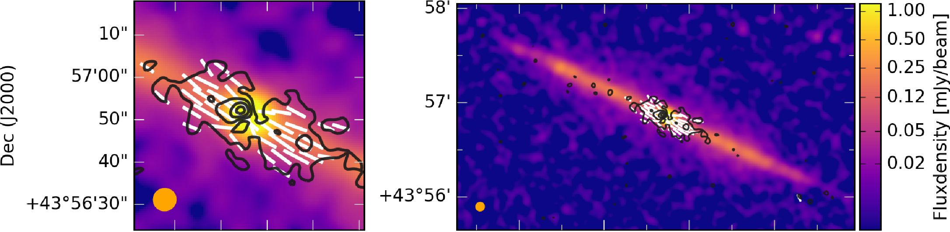
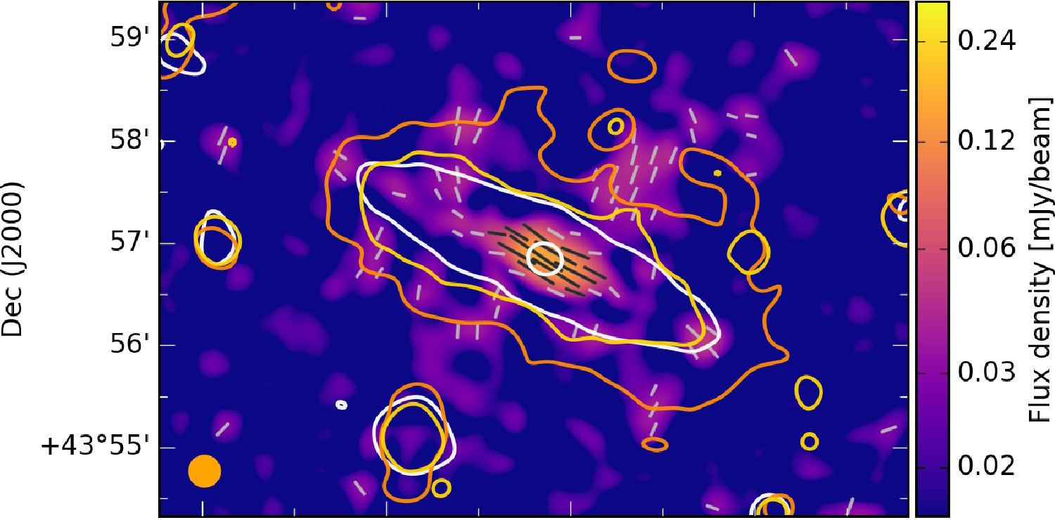
Y. Stein et al.: CHANG-ES XIX. Galaxy NGC 4013
32s Ilh58m30s 40s 35s 30s Ilh58m25s
RA (J2000) RA (J2000)
Fig. 11. NGC 4013 combined (C- and D-configuration) C-band Stokes I image (same data shown in Fig. 1) with apparent magnetic field ori-
entations and polarized intensity contours at 3, 6, 9, and 12a levels with a a of 2.5pJybeam-1. The beam size is 5.2" x 5.3" and is shown
in the bottom left corner of the image. No tapering was used and the robust parameter was set to two. Left image: enlargement of the central
region.
50s 40s 30s Ilh58m20s
RA (J2000)
Fig. 12. NGC 4013 combined (C- and D-configuration) C-band polarized intensity from Fig. 11, but smoothed to a beam size of 18" x 18" with a
a of 8.6 pJy beam-1. Apparent magnetic field orientations are shown in light grey, where the polarized intensity is at the 2.5a level or higher, black
apparent magnetic field orientations are shown for polarized intensity of 5a level or higher. Stokes I intensity contours of C-band are displayed
in white at 3 and 64a levels with a a of 13pJy beam-1 obtained with an uv-taper of 12kT and Gaussian smoothing. The yellow contours of the
L-band Stokes I intensity obtained with an uv-taper of 18 kT and Gaussian smoothing are displayed at 3a level with a a of 50 pJybeam-1. The
orange contours represent the Stokes I intensity of LOFAR at 3a with a a of 204pJy beam-1.
(Bottema 1996), the RM values suggest that the radial compo-
nent of the magnetic field vectors is pointing outwards. Dynamo
theory predicts that the radial components of axisymmetric spiral
fields should point either inwards or outwards with equal prob-
ability, which is indeed the case (with similar numbers of cases
found each so far, see Beck 2016).
The field of the central region east of the center shows a field
pointing towards the observer in the bottom part (positive RMs)
and away from the observer in the upper part (negative RMs).
The western side shows hints of the opposite trend, where the
upper part points towards the observer and the lower left part
points away from the observer. This RM pattern could be caused
by an antisymmetric (odd parity) magnetic field structure. A sim-
ilar pattern, i.e. symmetric in the outer disk and antisymmetric in
the inner disk, was proposed for the magnetic field in the Milky
Way (Han et al. 1997; Han 2006).
The signal-to-noise ratios of our polarization data are small,
so uncertainties remain about the large-scale structure of the
magnetic field. Deeper observations with a wider T2-space dis-
tribution are necessary to further investigate the magnetic field
structure of this galaxy.
  - Thermal and nonthermal emission
    - Thermal and nonthermal separation
The separation of thermal and nonthermal (synchrotron) emis-
sion in spiral edge-on galaxies was explored by Vargas et al.
(2018). We followed their recommended approach of calculating
the thermal flux by correcting the Ha flux for internal absorption
by dust with mid-infrared data, in our case WISE 22 pm data,
with the revised correction factor for edge-on galaxies of 0.042
(replacing the 0.031 in Eq. (5) of Calzetti et al. 2007). Nonther-
mal maps were produced for the CHANG-ES bands with a final
resolution of 15" x 15" (see Stein et al. 2019, for details). For
the LOFAR data, the expected thermal contribution is small and
we disregard it.
A13, page 11 of 21
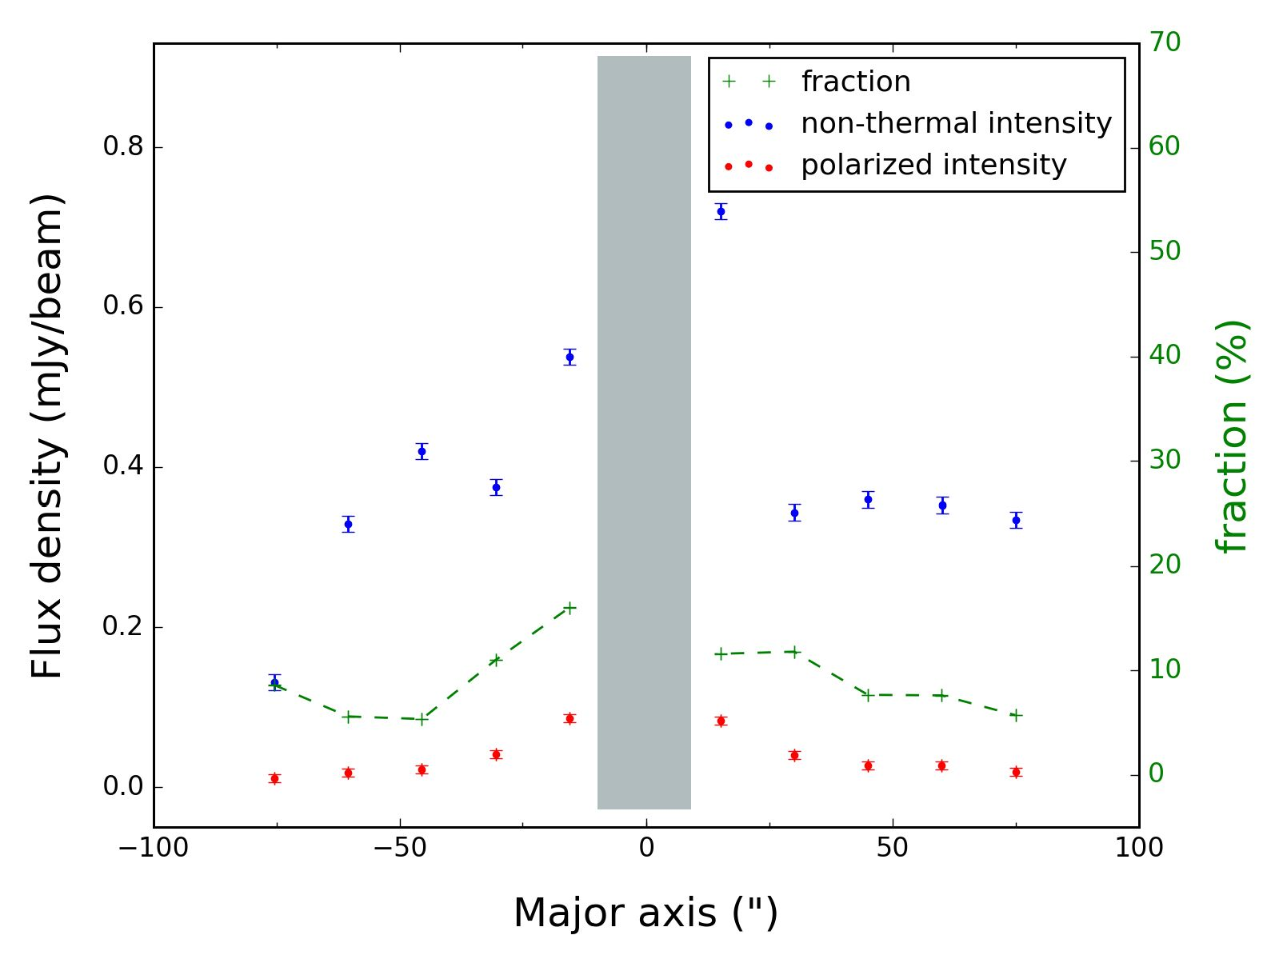
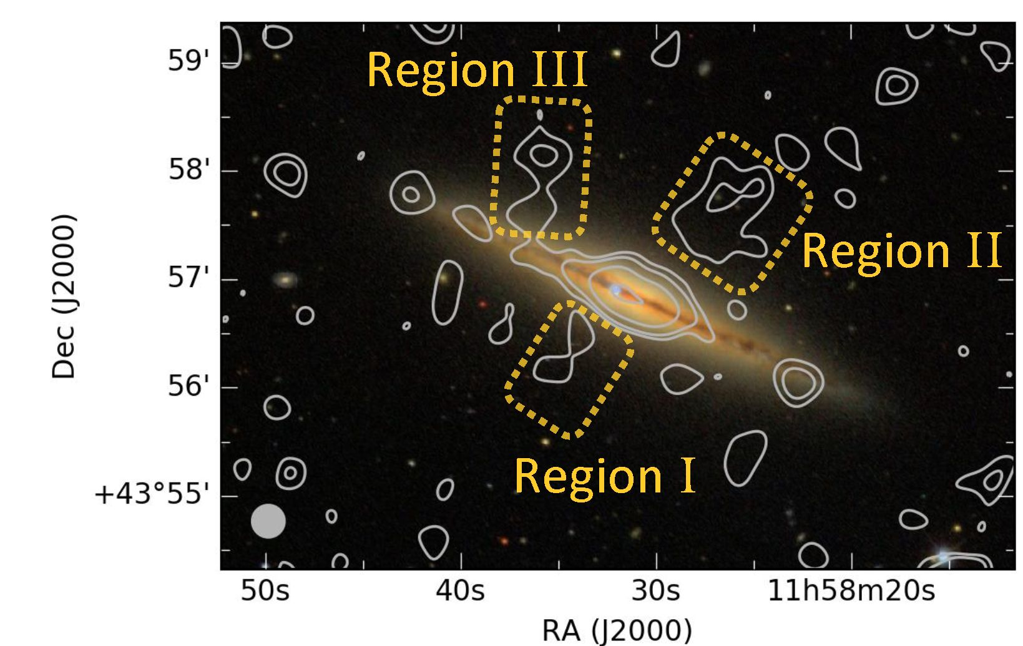
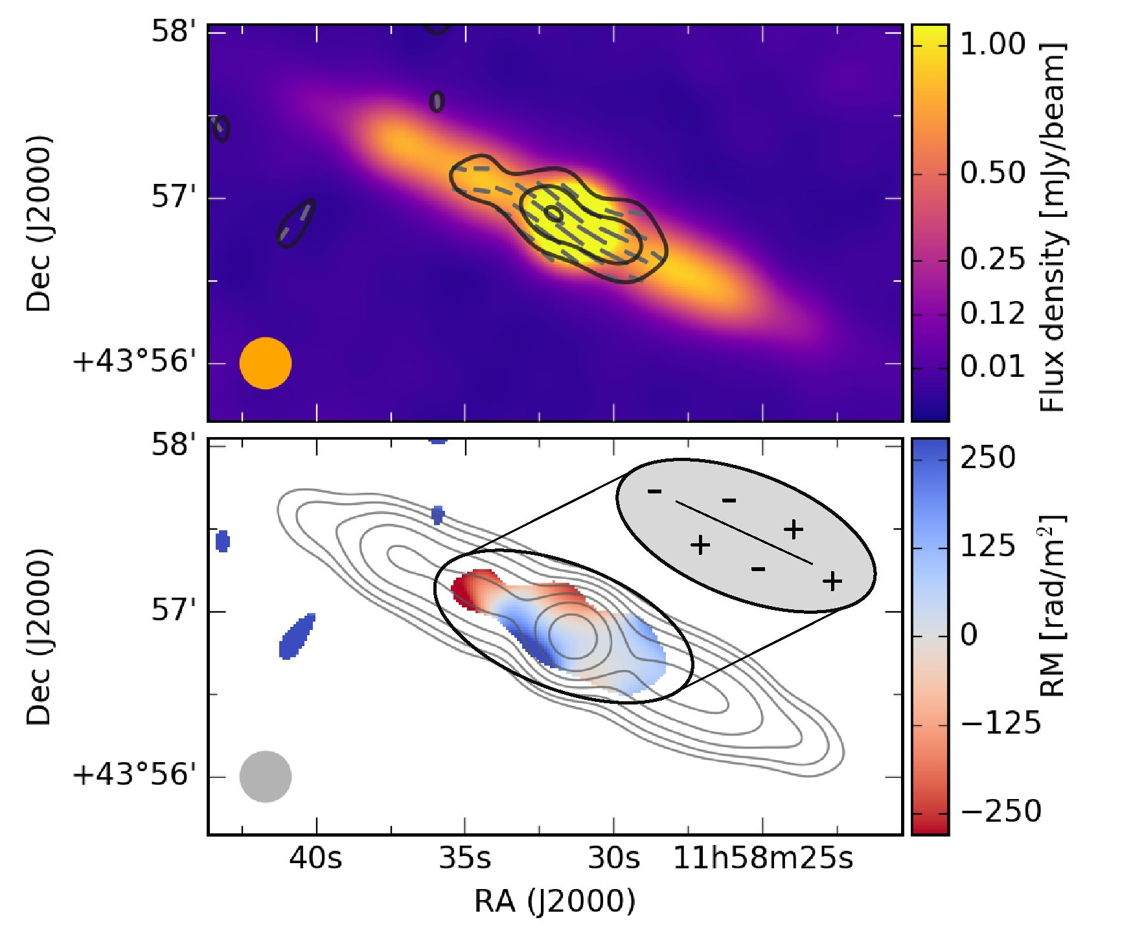
A&A 632, A13 (2019)
 | C-band | L-band
Bandwidth [GHz]  Vmin to Vmax [GHz]  AT2 = Ą - T2 [m2]  00 = [radm-2] | 2  5 to 7  0.00184  1882 | 0.5  1.2 to 1.75 [gap]  0.0336  103
Tmin [m] | 0.042 | 0.17
maxscale = jh [radm-2] | 1781 | 109
spw-width óf [MHz] | 125 | 16
ÓT2 [m2] | 0.0001735 | 0.001447
RMmax = J [radm-2] | 9983 | 1197
Fig. 13. NGC 4013 combined (C- and D-configuration) C-band polar-
ized intensity contours from Fig. 12 with contours at 2.5, 4, 8 and 16a
levels on SDSS color image (retrieved via Aladin sky atlas, https:
//aladin.u- strasbg.fr). Regions I, II, and III discussed in the text
are marked in yellow.
Table 10. RM-synthesis parameters.
Fig. 14. NGC 4013 images from RM-synthesis. Top: total intensity
color image with polarization contours at 3, 9, 12a levels with a of
11.6 pJy. Magnetic field orientations are shown in black. Bottom: RM
map of NGC 4013 from C-band on Stokes I contours with a uv-taper of
12 kT and Gaussian smoothing resulting in a beam size of 18" x 18".
Contours start at the 3a level with a a of 15.0pJybeam-1 and increase
in powers of 2 (up to 256). The RM map is cut at the 3a level of
35 pJybeam-1 of the polarized intensity map. The mean RM error is
25 radm-2.
Notes. Channel width: SA2, width of the A2 distribution: A A2, shortest
wavelength squared: A^. FWHM of the resolution (RMSF) in O space:
5(p (radm-2). Largest scale in O space to which the observation is sensi-
tive: max-scale (radm-2). Maximum observable RM (resp. O): RMmax
(radm-2) (from Brentjens & de Bruyn 2005).

3.6.2. Degree of polarization of the nonthermal emission
To further investigate the appearance of the polarized emis-
sion, we plot C-band flux densities of the nonthermal intensity,
polarized intensity as well as the fraction of both values within
boxes along the major axis. The box width and height were cho-
sen to be equal to the beam size of 15". The result is shown in
Fig. 15. The values of the polarized fraction in the disk vary
between 4% and 12%, which is a normal range for C-band.
Generally, the polarized fraction is highest in the center and
decreases with increasing distance along the major axis. The
steep increase towards the edges can be explained by the lower
rms noise of the polarized intensity map in comparison to the
total intensity map, so that we detect polarized emission out to
larger distances.

3.6.3. Nonthermal fractions
Maps of the nonthermal fraction for both C-band and L-band
are shown in Fig. 16. The central point-like source dominates
the galaxy and shows synchrotron emission of high intensity as
Fig. 15. NGC 4013 box integration along the major axis with a box size
of 15" x 15", showing the nonthermal intensity (blue data points), the
polarized intensity (red data points) as well as the degree of polarization
(green) of C-band. The grey box shows the region of the central source,
where the data are not considered.
well as a high nonthermal fraction of 93% in C-band. Such a
high nonthermal fraction suggests a strong synchrotron source
including a high magnetic field strength. The nonthermal frac-
tion of the disk has a mean value of 76%. This implies a thermal
fraction of 24% in C-band, which agrees well with the mean
thermal fraction of (23 ± 13)% in late-type galaxies at 5 GHz
(Tabatabaei et al. 2017).
The nonthermal fraction map in L-band looks similar to
the C-band map, but with a more extended distribution towards
the halo. The central point-like source is again dominating and
A13, page 12 of 21
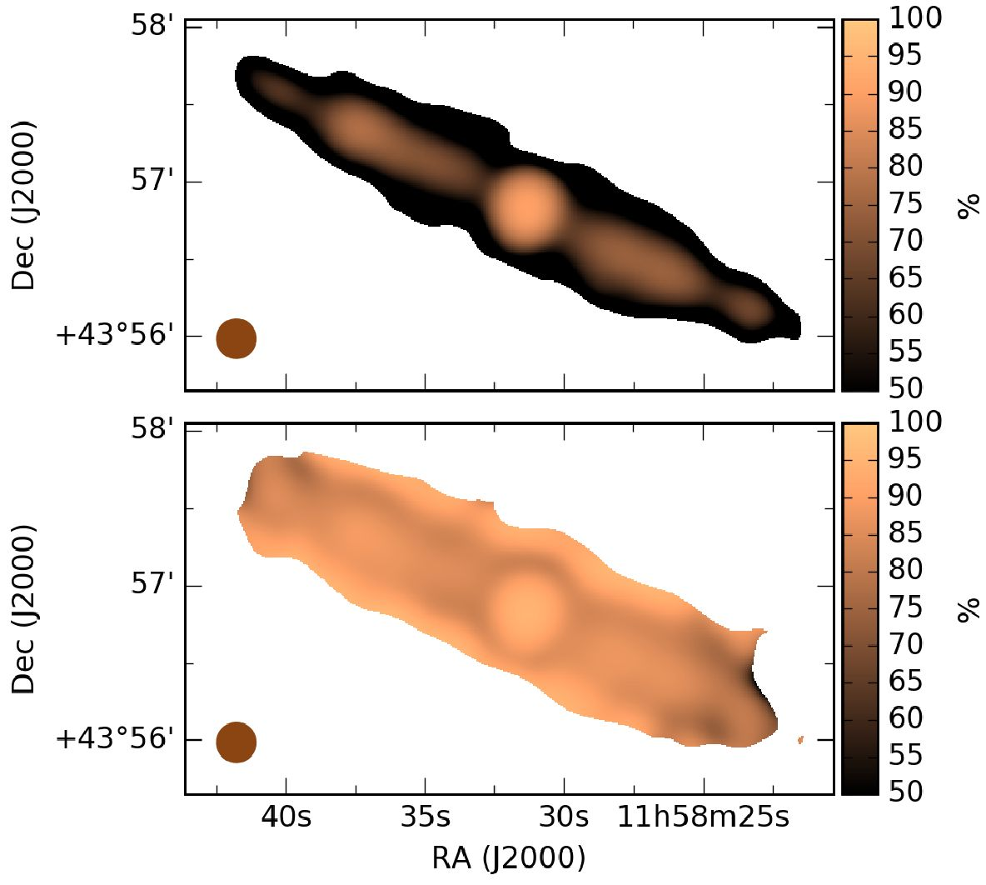
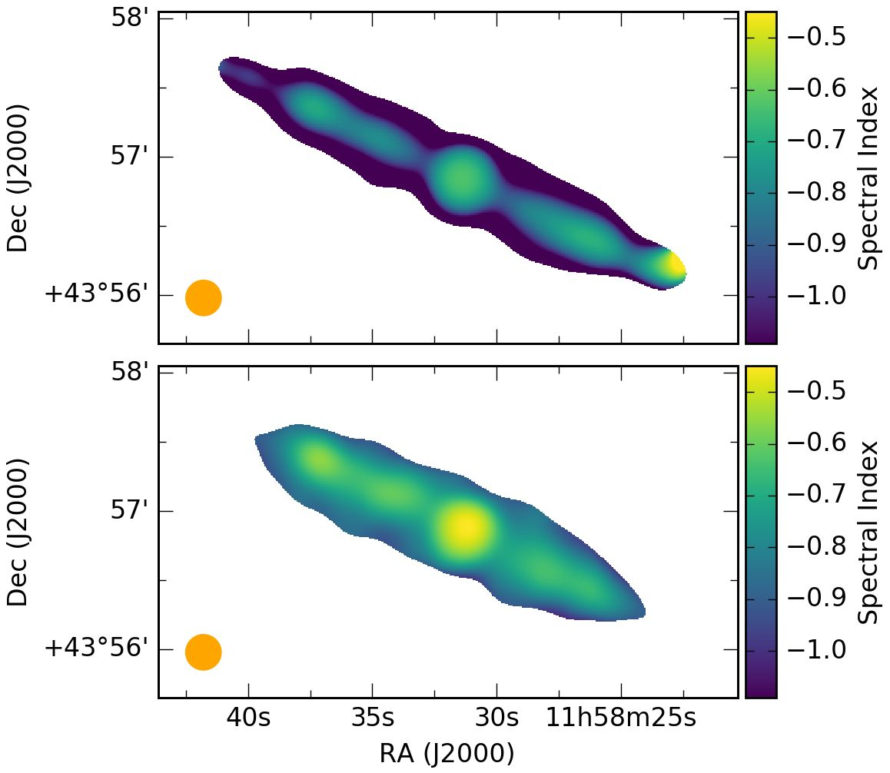
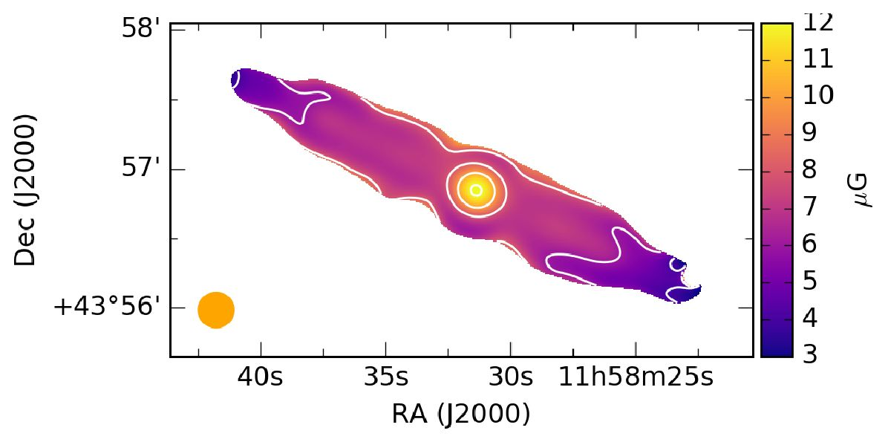
Y. Stein et al.: CHANG-ES XIX. Galaxy NGC4013
Fig. 16. NGC 4013 nonthermal fractions of C-band (top) and L-band
(bottom). The beam size of 15" x 15" is shown in brown.
Fig. 17. Maps of the nonthermal spectral index. Top: calculated between
C- and L-band. Bottom: calculated between L-band and LOFAR. The
mean error is 0.05; the error is largest towards the edges with values of
up to 0.3. The beam size of 15" x 15" is shown in orange.
exhibits a nonthermal fraction of 97%, which is very high and
confirms the C-band results. The entire galaxy disk shows a
mean nonthermal fraction of 90% with a corresponding thermal
fraction of 10% in L-band. This is in very good agreement with
the mean thermal fraction of (10 ± 9)% in late-type galaxies at
- GHz (Tabatabaei et al. 2017).

3.6.4. Nonthermal spectral index
As in Stein et al. (2019), we derive the nonthermal spectral index
map, here from the nonthermal maps of C-band and L-band
as well as from the nonthermal map of L-band and LOFAR,
which are presented in Fig. 17. We also created a map of the
uncertainties, using error propagation, where we found a mean
Fig. 18. NGC 4013 magnetic field strength calculated pixel-by-pixel via
the equipartition formula using the nonthermal spectral index map and
the nonthermal intensity map. The beam size of 15 x 15" is shown in
orange.
uncertainty of 0.05. The spectral index map was blanked in
places where the uncertainty equals or exceeds 0.3.
The mean spectral index of the disk between C-band and
L-band (top of Fig. 17) of ant = -0.84 ± 0.05 agrees well
with the expected theoretical spectral slope of synchrotron emis-
sion. The central region shows a slightly flatter spectral index of
ant = -0.63 ± 0.03. At the south-western end of the disk, a region
with a flat spectral index of about ant = -0.3 ± 0.2 is visible. The
large error is a result of the weak intensity levels towards the
edge of the galaxy. Nevertheless, the flat spectral index indicates
a large thermal fraction. This is corroborated by the fact that this
region coincides with a star-forming region seen in Ha emission.
This origin is additionally supported by the lower nonthermal
fraction in this region seen in L-band.
The mean spectral index of the disk between L-band and
LOFAR (bottom of Fig. 17) of ant = -0.69 ± 0.05 is flatter in
comparison to the higher frequency spectral index. The central
source shows a flat spectral index of ant = -0.48 ± 0.03.

3.7. Magnetic field strength via the equipartition assumption
The map of the magnetic field strength was determined using
the revised equipartition formula by Beck & Krause (2005). The
calculations were done in a pixel-by-pixel fashion by combining
the nonthermal intensity map of C-band and the spectral index
map between C-band and L-band (top of Fig. 17). As path length,
we used 90% of the extent in the radio continuum of 15kpc.
Further, a proton to electron ratio of K0 = 100 is assumed. The
uncertainties in the assumptions lead to an error in field strength
of about 20% (e.g., Beck 2016).
The resulting map of the magnetic field strength is presented
in Fig. 18. The magnetic field strength of the central point source
is 12.1 uG. The mean field strength in the disk is weak with
6.6uG, omitting the central region. In the inner disk, the mag-
netic field strength is 7.0uG and the field strength decreases
towards the edges of the disk. This map can explain our results
from the analysis of the polarized emission. The polarized emis-
sion is mostly concentrated in the inner third of the disk along the
major axis, where, according to the map shown here, the mag-
netic field is comparably strong.

3.8. Cosmic-ray transport model
Using the 1D CR transport model SPectral INdex Numer-
ical Analysis of K(c)osmic-ray Electron Radio-emission
(spinnaker, Heesen et al. 2016, 2018) the transport processes
of CRs from the disk into the halo (perpendicular to the galaxy
disk) are derived. Analogous to the analysis of NGC 4666
A13, page 13 of 21
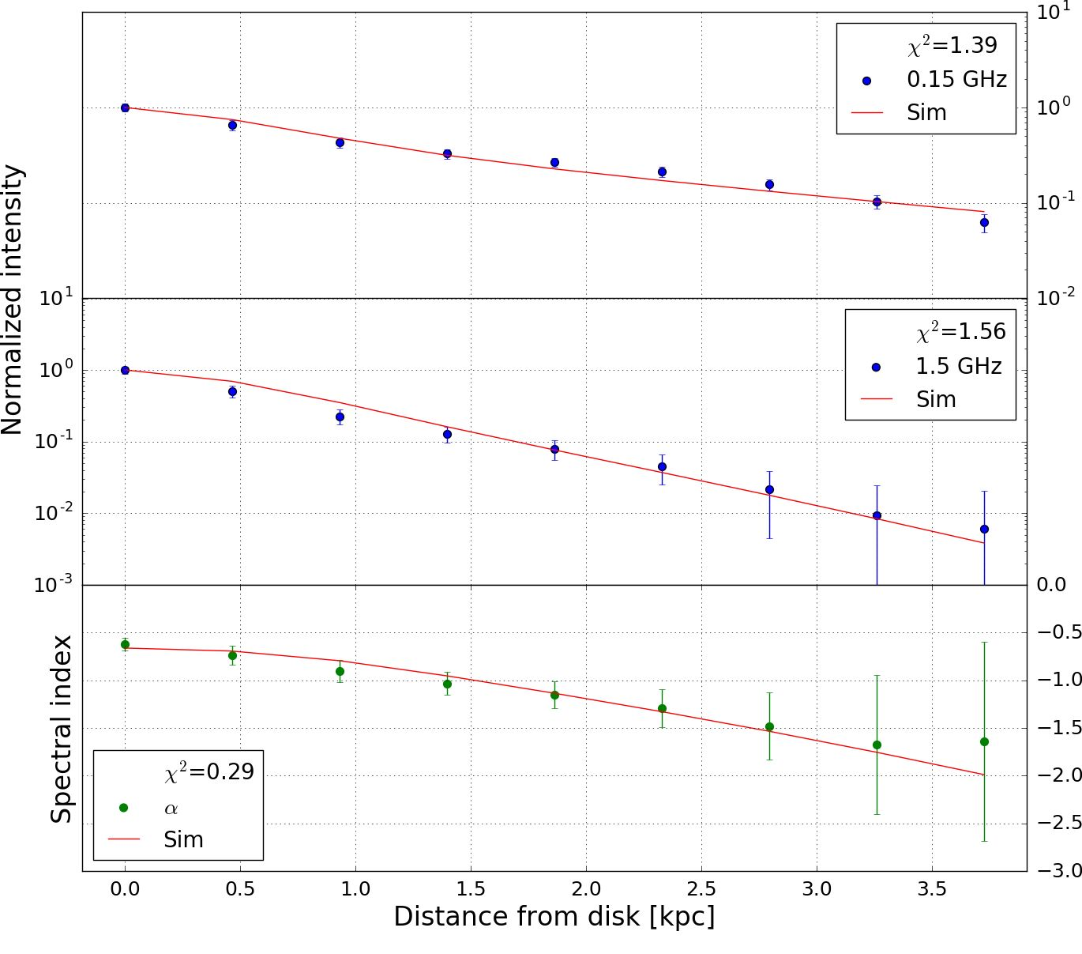
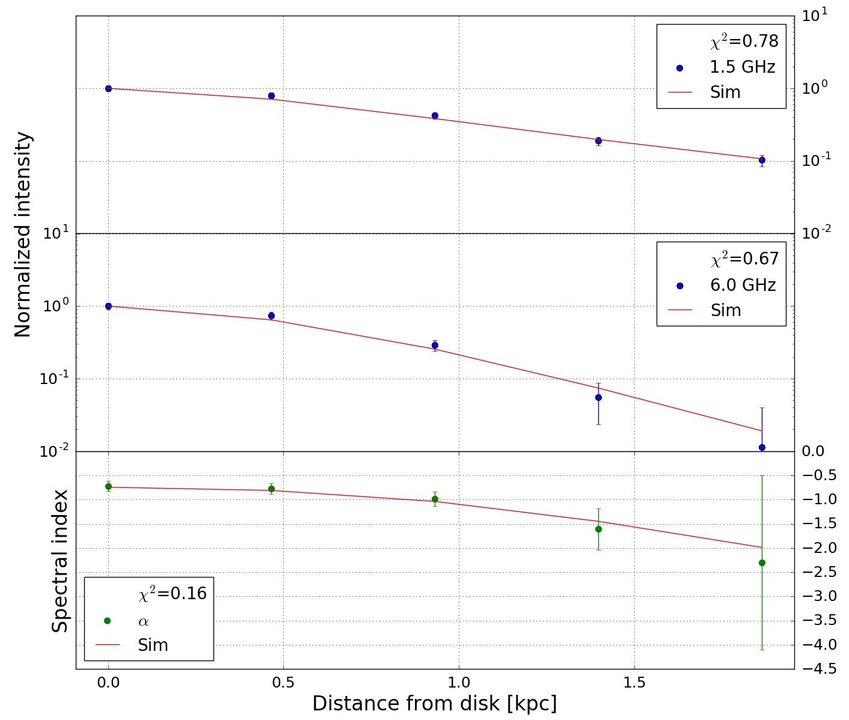
A&A 632, A13 (2019)
Fig. 19. Best-fitting CRE advection model with an increasing speed for
NGC 4013. Top panel: nonthermal intensities at 150 MHz (LOFAR),
middle panel: 1.5 GHz (L-band) data, and bottom panel: nonthermal
radio spectral index. In all panels, the solid red line represents the model
simulation. The errors are represented by a weighted standard devi-
ation. The best-fitting parameters are listed in Table 11 (SPINNAKER
and SPINTERACTIVE are available at: www.github.com/vheesen/
Spinnaker).
(Stein et al. 2019), we carried our an interactive analysis on the
intensity profiles of NGC 4013 in order to find the best-fitting
model. Because the galaxy is very thin, especially in C-band,
only five data points could be measured in the vertical direction
(box size of 6" x 165") for the L- and C-band data (Fig. 20),
and nine for the L-band and LOFAR data (Fig. 19). Since we are
using the nonthermal radio continuum maps, we have an angular
resolution of 15" (1.1 kpc).
The models assume either pure diffusion or advection for
the CRE, which are injected with a power-law in the disk. The
CRE number density is then N(E) <x E-Y, where E is the CRE
energy. The power-slope can be related to the nonthermal spec-
tral index via ant = (1 - y)/2. Then, a steady state solution is
reached between CRE injection and energy losses (synchrotron
and inverse Compton losses). The magnetic field strength is
described as a double exponential function with the superposi-
tion of a thin and thick disk:
B(z) = B1 exp(-z/hB1) + (B0 - B1) exp(-z/hB2), (6)
where B0 is the magnetic field strength in the disk, B1 is the
thin disk magnetic field strength, and hB1 and hB2 are the scale
heights of the thin and thick disk, respectively.
To find the best-fitting model, we minimize xT, which is
the quadratic sum of the ^2-values for the intensity and spectral
index profiles. We tested three different models, which are:
- Cosmic ray diffusion.
- Cosmic-ray advection with constant speed.
- Cosmic-ray advection with an increasing speed.
The accelerating wind speed is parametrized as follows:
V(z) = V„(i + ^ j. (7)
For the diffusion model, we assumed no energy dependence
for the diffusion coefficient. We fit the three different frequencies
Fig. 20. Best-fitting CRE advection model with an increasing speed
for NGC 4013. Top panel: nonthermal intensities at 1.5 GHz (L-band),
middle panel: 6 GHz (C-band) data, and bottom panel: nonthermal radio
spectral index. In all panels, the solid red line represents the model sim-
ulation. The errors are represented by a weighted standard deviation.
The best-fitting parameters are listed in Table 11.
simultaneously pairwise, combining LOFAR and L-band data as
well as L-band and C-band data.
In this section, we present the best-fitting profiles for advec-
tion with increasing speed [model (iii)] in Figs. 19 and 20, with
the other models presented in Appendix A.4. We find that diffu-
sion [model (i)] can describe our L-band and C-band data equally
well as advection [models (ii) and (iii)] with each xT less than
one and thus no possible quantitative statement about which
model is the best. While the profile of the radio spectral index
between L-band and C-band has a parabolic shape that is typical
for diffusion, this can also be explained with advection due to the
convolution with the large effective beam (FWHM = 1.1 kpc).
For advection, we expect the spectral index profile to be linear,
but this assumes the vertical profile to be well resolved. For the
profile in Fig. 20 the influence of the angular resolution becomes
visible, so that, due the Gaussian convolution with an effective
beam size of FWHM = 1.1 kpc, the resulting spectral index pro-
files have a shape similar to the one for diffusion.
In contrast, the shape of the spectral index profile between
LOFAR and L-band has a linear shape and thus cannot be well fit
with diffusion. In Fig. 19 the best-fitting advection model assum-
ing an increasing advection speed is shown, which is preferred
over the constant speed since it ensures that energy equipartition
is approximately fulfilled in the halo. Nevertheless, the model
fits to the LOFAR data are better approximated with diffusion
(first row in Fig. A.5) with a smallerX in comparison to advec-
tion. The best-fitting advection speed of V0 = 18 - 22kms-1
(increasing to only ~50kms-1 at 4 kpc height) is very low, not
comparable to wind speeds of typically hundreds of kilometers
per second. Furthermore, it is lower compared to the outflow
velocity estimated in Sect. 3.4, which suggests a basic differ-
ence between the global transport mechanisms averaged over
the entire galaxy (modeled with SPINNAKER) and local mech-
anisms that can lead to higher velocities. The best-fitting advec-
tion model has xT = 0.5-1.1, which shows that the data can be
adequately fit with this simple model.
A13, page 14 of 21
Y. Stein et al.: CHANG-ES XIX. Galaxy NGC 4013
Table 11. NGC 4013 SPINNAKER best-fitting parameters.
Parameter
B0 (pG) | 6.6 (fixed)
Model (i) - Diffusion
Y | 2.6
B1 (pG) | 4.9
hB1 (kpc) | 0.1
hB2 (kpc) | 9.5
D (1028 cm2 | s-1) 0.55-0.65
xT | 0.9-2.0
Model (ii) | - Advection (constant speed)
Y | 2.4
B1 (pG) | 4.7
hB1 (kpc) | 0.1
hB2 (kpc) | 5.5
V0 (kms-1) | 19-22
xT | 0.5-1.2
Model (iii) - | Advection (increasing speed)
Y | 2.2
B1 (pG) | 2.6
hB1 (kpc) | 0.4
hB2 (kpc) | 15.0
V0 (kms-1) | 18-22
hV (kpc) | 3
uV | 0.5-1.1

4. Discussion
  - Cosmic ray transport
The main cosmic ray transport of this galaxy is analysed via var-
ious indicators discussed in this section.
    - Halo scale heights
The frequency dependence of the halo scale height (z0 ^ vx)
gives information about the type of CRE propagation, in the
case of dominating synchrotron losses (Mulcahy et al. 2018;
Krause etal. 2018; Stein etal. 2019). An exponent x = -0.25
is expected for diffusive transport and x = -0.5 for advective
transport. A scenario, where the CREs emit most of their energy
within the galaxy halo, is referred to as an electron calorime-
ter. We are working with this assumption (even though it may
not be fully valid for the LOFAR 150 MHz data) while keeping
in mind that this galaxy has local outflows which are not char-
acterizing the global mechanisms. Using z"0 for the halo from
Table 9 gives x > -0.38 ± 0.15 between 6 GHz and 1.5 GHz.
Considering the nonthermal Gaussian scale height in C-band it
is x = -0.20 ± 0.10. Thus the smaller C-band/L-band exponent
can be attributed to the influence of thermal emission on the scale
height at C-band. Together with an exponent of x = -0.19 ± 0.05
between 1.5 GHz and 150 MHz this gives a clear preference for
diffusive CRE propagation.
    - Fitting the total intensity distribution
The scale height analysis performed here shows that Gaussian
functions fitbetter to the vertical radio intensity profiles than expo-
nential functions at L-band and the LOFAR frequency. Although
the quality of both fits was similar for C-band, the Gaussian pro-
file seems to represent the data slightly better. This suggests that
the main transport mechanism of the CREs is diffusion, whereas
Table 12. Mean amplitude ratios w (w0/w1) (Disk/Halo) and mean scale
height ratios z (z0/z1) (Disk/Halo) of the thin disk/halo from Gaussian
fits for NGC 4013 and from exponential fits for NGC 4666.
 | C-band | L-band | LOFAR
NGC 4013  w(w0/wO  z(z0/z1)  w * z | 9.40  0.18  1.7 | 4.50  0.18  0.81 | 1.90  0.15  0.29
NGC 4666
w(w0/wO | 1.38 | 0.97 | -
z(z0/z1) | 0.26 | 0.34 | -
w * z | 0.36 | 0.33 | -
exponential intensity profiles suggest advection as the main trans-
port process (Heesen et al. 2016). Dominating CRE diffusion
implies that no wind or only a slow advection velocity is present in
NGC 4013. This results in slow escape of CREs, so that the calori-
metric assumption may be used. Therefore, the scale height ratio
corroborates the finding of dominating diffusion.
    - Integrated flux densities of disk and halo
The derived ratios of the integrated flux densities between disk
and halo (Table 9) decrease from C-band towards lower frequen-
cies with values of 1.7 for C-band, 0.8 for L-band, and 0.3 for
the LOFAR frequency. This result shows that the halo becomes
more dominant towards lower frequencies. To compare the deter-
mined values with another galaxy, we have undertaken the same
analysis for the two-component exponential fit of NGC 4666.
Stein etal. (2019) derived scale heights for the upper and the
lower halo separately for one large strip. The mean amplitudes
and scale heights for the two CHANG-ES bands are presented
in Table A.2. Interestingly, the ratios of the integrated flux den-
sities for the thin disk and the halo of NGC 4666 are 0.35 in
C-band and 0.33 in L-band, much smaller than in NGC 4013
and almost independent of frequency. The halo of NGC 4666
contributes about 74% and 75% of the total flux density in
C-band and L-band, respectively, while the corresponding values
for the halo of NGC 4013 are about 37% and 56%. The contri-
bution of the halo of NGC 4013 becomes dominant at 150MHz
with 77% of the total flux density. NGC 4666 is transporting
the CRs much faster into the halo by an advective wind emerg-
ing from the entire galaxy. The halo of NGC 4666 is relatively
bright and the disk/halo flux density ratio does not vary with fre-
quency. NGC 4013 is clearly different, with a relatively faint halo
and a strong frequency dependence of the disk/halo flux den-
sity ratio. A possible reason is diffusive transport of CREs which
leads to a more rapid aging due to stronger (energy-dependent)
synchrotron losses, explaining why the contribution of the halo
decreases with increasing frequency.
As a result we propose to use the multiplication of the mean
amplitude ratios w(w0/wO (Disk/Halo) and mean scale height
ratios z(z0/z1) (Disk/Halo) of different frequencies to get hints
on the propagation of cosmic rays in the galaxy. In Table 12 the
main values are given. The values of the last row (w * z) show
different frequency dependencies for the two galaxies NGC 4013
(diffusion-dominated) and NGC 4666 (wind-dominated).
    - Velocity of cosmic rays
A local transport velocity was determined in Sect. 3.4 via
the extent of an emission blob and the synchrotron lifetime,
A13, page 15 of 21
A&A 632, A13 (2019)
resulting in a value of 160 km s-1. This velocity is lower than
the rotational velocity of the galaxy (see Table 1), whereas other
galaxies have advection speeds of (2-3) x vrot (Heesen et al.
- . Consequently, NGC4013 hosts only a slow wind that
does not reach the escape velocity within a few kpc from the
disk. Furthermore, the calculated velocity refers to a local out-
flow and is therefore different from global advection velocities
found via SPINNAKER.
    - Transition from diffusion to advection
The CRE transport is a superposition of diffusion and advec-
tion. Our combined C- and L-band data are equally well modeled
by diffusion and advection. In contrast, our best-fitting model
for the combined L-band and LOFAR data is advection with
an accelerating velocity, which fits slightly better than diffusion.
Even then, diffusion may play a large role beside advection, as
the resulting advection speed of about 20 km s-1 is fairly slow
near the disk, but accelerates to about 50km s-1 at the edge of
the observed halo at 4 kpc height. More precisely, diffusion is
expected to dominate over advection near the disk, where the
CREs are relatively young (observed at L- and C-band), while
at larger heights, where the CREs are older (as observed with
LOFAR), advection is the dominant transport. The reason for
this is that the height that cosmic rays travel scales as z k VD7
for diffusion5, whereas for advection the travelling distance is
z k V t. Hence, diffusion dominates over advection for young
CRE, whereas for old CRE the opposite is true. Consequently,
there is a certain time (CRE age), from which on advection dom-
inates over diffusion.
For a constant wind speed, the transition from the diffusion-
dominated regime near the disk to the advection-dominated
regime in the halo occurs at a height of (Recchia et al. 2016):
D28
s* * (0.3-0.6) x-28 kpc, (8)
V100
where D28 is the diffusion coefficient in units of 1028 cm2 s-1 and
V100 is the advection speed in units of 100 km s-1. With an advec-
tion speed of V100 = 0.2 and a diffusion coefficient of D28 = 0.6,
we see that for our case s* * 1-2 kpc. Hence, for the low advec-
tion speeds we measure, diffusion would dominate the cosmic-
ray transport up to a height of about 2 kpc.
    - X-ray emission
Due to sensitivity of the data and the overall low X-ray bright-
ness of NGC 4013, it was only possible to obtain a reliable
spectral model fit to the emission from the galactic core. Nev-
ertheless, since most of the X-ray emission seems to be associ-
ated with the inner part of the disk, the derived parameters of the
hot gas should be representative for the entire area of the central
disk, especially within uncertainties.
The derived temperature of the hot gas in the central region
of NGC 4013 of about 3 x 106 K (Table 7) is surprisingly
low for the disk of a star-forming galaxy, as such tempera-
tures are more typical for galactic halos (e.g., Strickland et al.
2004; Tullmann et al. 2006). The low thermal energy density and
hence low internal pressure may not be sufficient to drive an effi-
cient outflow. This would confirm the findings from the analysis
of the radio data.
5 For 1D anisotropic diffusion, or z k V4D t for 3D isotropic diffusion.
  - Correlation of magnetic field strength with star formation
rate
Comparing NGC 4013 to other galaxies, we found NGC 4594
(M104; the Sombrero galaxy) to be quite similar. They both have
a comparably low star formation rate (SFR). They both have a
dust lane in the optical and have undergone some interaction,
with NGC 4013 having a huge warp and tidal stellar streams
and NGC 4594 having a dominant nuclear bulge. The radio
continuum and polarization intensities of both galaxies are com-
parable, without signs of an ongoing interaction. The radio con-
tinuum observations of NGC 4594 (Bajajaetal. 1988) show a
similarly thin disk but with polarization only observable in the
inner part of the galaxy rather than along the entire disk, as
shown in our RM-synthesis results. In more recent observations
by Krause et al. (2006), a plane-parallel disk field, as well as ver-
tical magnetic field components were found, comparable to our
findings. In their study the magnetic field strength of NGC 4594
was determined to be 5.0pG, which is quite small in comparison
to other star-forming spiral galaxies (Beck 2016; Krause etal.
2018, for edge-on galaxies). We found here a similarly small
magnetic field strength for NGC 4013 of 6.6 pG.
A possible correlation between the SFR and the magnetic
field strength is revealed from the low magnetic field strength
value in NGC 4013 and NGC 4594 (the Sombrero galaxy)
and their low SFR of 0.5 M0 yr-1 in NGC 4013 (Wiegert et al.
2015) and 0.13 M0 yr-1 in NGC 4594 (Kharb et al. 2016). Other
galaxies following this trend are UGC 10288, with a SFR of
0.4 M0 yr-1 and a mean magnetic field strength in the disk
of 6.3pG (Krauseetal. 2018), and NGC4565, with a SFR of
0.74 M0 yr-1 (Wiegert et al. 2015) and a mean magnetic field
strength in the disk of 6.0pG (Schmidt et al. 2019). A corre-
lation between the radio continuum and the SFR is expected,
which follows from the well-defined FIR-radio-correlation (e.g.,
Schleicher & Beck 2013), where the emission is believed to
originate in both wavelength regimes from the same population
of young stars. To further study this correlation, a larger sam-
ple of galaxies should be analyzed and the different components
of the magnetic field, namely the turbulent and ordered mag-
netic field component in galaxies, should be considered (e.g.,
Drzazga et al. 2011).
The efficiency of the a-effect of the mean-field a-rn dynamo
is coupled to the SFR of a galaxy (e.g., Beck et al. 1996). The
SFR influences the supernova rate and thus the SN-induced tur-
bulence of the ISM and the magnetic field. The dependence of
the magnetic field strength on the SFR is also expected from
theoretical simulations (e.g., Bendreetal. 2015). A small-scale
dynamo can efficiently amplify the turbulent magnetic field that
serves as the seed for the large-scale dynamo (Arshakian et al.
2009). If the SFR is small, the small-scale dynamo is working
less effectively.
  - Central source
The total intensity distribution of NGC 4013 is dominated by
the central point source, with 40% of total flux density in
C-band, 30% in the L-band, and 13% at LOFAR 150MHz
coming from that region. The radio continuum observations
show a central intensity peak at this position. The radio spec-
tral index flattens towards the lower frequencies to a = -0.44
between L-band and the LOFAR frequency. The high resolu-
tion L-band B-configuration data of CHANG-ES (including the
data of NGC 4013 we use here), are used in Irwin et al. (2019)
to search for AGN features in 35 edge-on spiral galaxies, in the
radio regime. NGC 4013 does not show any of the characteristic
A13, page 16 of 21
Y. Stein et al.: CHANG-ES XIX. Galaxy NGC 4013
features associated with AGNs and was concluded not to be a
clear AGN candidate.
The complementary XMM-Newton data show a hard X-ray
spectrum and a relatively flat photon index but no clear AGN
fingerprint. A dominant X-ray point source coinciding with the
location of the radio peak is detected by Chandra. These data are
suggestive of an AGN.
The fact that we do not see clear signs of an AGN in
NGC 4013 could be related to large amounts of dust in the galac-
tic disk (Mosenkov et al. 2018), with the highest concentration
in the galactic core. According to Dudik et al. (2005) the central
source is possibly a Compton-thick AGN. Due to the high inter-
nal absorption in such a case, the obtained X-ray luminosity for
the central source of 7.1+5 2 x 1038 erg s-1 can be considered as a
lower limit. -

5. Summary and conclusions
We present radio continuum CHANG-ES VLA and LOFAR data
of the edge-on spiral galaxy NGC 4013 to analyze the total inten-
sity characteristics, the central source and the large scale mag-
netic field as well as the cosmic ray transport. The total radio
continuum intensity distribution of NGC 4013 is dominated by
the central point source. The radio and supplemental X-ray data
hint at the central source being a Compton-thick AGN as sug-
gested by Dudik et al. (2005). The disk of NGC 4013 shows faint
radio emission extending into the halo in C-band with a Gaus-
sian halo scale height of 1.2 kpc. The halo increases in L-band
to a scale height of 2.0kpc and at 150MHz to 3.1 kpc, so that
at low frequencies a large radio halo is observed. The frequency
dependence shows a clear preference for diffusive CRE trans-
port. The appearance of a small radio halo in C- and L-band is
very different from other spiral galaxies with higher star forma-
tion rates, e.g., in NGC 4666 (Stein et al. 2019), where the radio
halo at the CHANG-ES frequencies is more extended with a fast
advective wind being apparent. It seems that in NGC 4013 fewer
or less energetic CREs are reaching the halo, with probably a
much weaker wind across the galaxy. This is confirmed by the
analysis of the X-ray data, showing a low temperature of the hot
gas in the central region of NGC 4013. The resulting lower ther-
mal energy densities of the hot gas could prevent it from leaving
the disk plane efficiently.
In this paper, the total flux densities have been derived sep-
arately for the thin disk and the halo of a galaxy for the first
time. The radio halo of NGC 4013 is relatively faint and con-
tributes only 37% and 56% of the total flux density in C-band and
L-band, respectively, compared to 74% and 75% for the bright,
wind-driven halo of NGC 4666. The decreasing trend of the ratio
of the thin disk to halo with frequency, from C-band to LOFAR
150 MHz, also suggests diffusion to be the main transport pro-
cess in NGC 4013.
An advective outflow has also been found in the halo of our
Milky Way (Everett et al. 2008), which is consistent with the
bright radio halo that contributes about 90% of the total flux
density at 408 MHz (Beuermann et al. 1985). We propose using
either the multiplication of the mean amplitude ratios w (wo/w1)
(Disk/Halo) and mean scale height ratios z (z0 /z1) (Disk/Halo) or
the ratio of flux densities between disk and halo at different fre-
quencies as another indicator of the type of CRE transport that
is occurring.
Previous observations of Condon (1987) suggested a boxy
halo around NGC 4013. This is not found here, but hints of a
slightly dumbbell-shaped halo in L-band are seen, where the
extent of radio emission perpendicular to the major axis is
smaller towards the galaxy’s center. This could be explained by
synchrotron losses as the main energy loss of the CRE particles.
The smaller extent of observed radio emission towards the center
is due to the larger magnetic fields near the center of the galaxy,
which leads to stronger energy losses.
Our 1D model suggests that diffusion or a slow and acceler-
ated advective velocity of ~20-50 kms-1 fit equally well as the
main CR transport. While a slow advection velocity cannot be
ruled out, the cosmic ray transport would be still dominated by
diffusion up to 2 kpc height in the halo. Diffusion was found for
NGC 7462 by Heesen et al. (2016) with the radio profile being
better approximated by a Gaussian than by an exponential fit
like in NGC4013. Scale heights determined by fitting exponen-
tial functions are different from Gaussian ones, as a comparison
in the three frequencies shows.
Polarized emission in the halo with vertical magnetic field ori-
entations was observed up to about 6 kpc above the plane, indi-
cating an outflow in addition to diffusion. The velocity needed
to transport CREs to such height is about 160kms-1, less than
observed in halos driven by a galactic wind. Considering this out-
flows as a local feature, they are consistent with the result from
our transport model for the global transport properties.
In summary, the arguments for a synchrotron-loss dominated
CRE halo of NGC 4013 with diffusive propagation are:
- the characteristic frequency dependence of the halo scale
heights (Table 9),
- the large disk/halo flux density ratio in C-band, decreasing
towards lower frequencies, showing that the halo becomes
more dominant over the disk at lower frequencies (Table 9),
- the parabolic shape of the spectral index profile (Fig. 20),
- the low temperature of the X-ray emitting gas (Table 7).
A regular, plane-parallel magnetic field was found to be appar-
ent in the disk of NGC 4013. Additionally, in the low res-
olution polarized intensity image of C-band (robust 2), halo
emission and vertical magnetic field orientations were found.
The XMM-Newton image shows corresponding emission in the
inner part of the galaxy as well as the halo, especially the
south and the north-eastern parts show a similar distribution.
We propose that the magnetic field has influenced the hot gas
dynamics. This is supported by previous findings of other
CHANG-ES galaxies like NGC 4631 (Mora-Partiarroyo et al.
- or NGC 4666 (Stein et al. 2019), where the magnetic field
and X-ray morphologies are also similar.
The mean disk magnetic field strength derived with the
equipartition formula of 6.6 uG is rather low. NGC 4013 has low
intensity radio continuum and polarization emission and a rather
small radio halo. This is probably caused by the low SFR lead-
ing to a less effectively working small-scale dynamo. Neverthe-
less, considering the strong impact of the past interaction(s) on
NGC 4013, it is quite remarkable that a large-scale plane-parallel
field in the entire galaxy disk as well as a vertical field in the halo
is observed in polarization. Our RM data indicate that the large-
scale dynamo is still able to generate an axisymmetric spiral field
in the disk.
In conclusion, the interaction and the low SFR across the
disk probably influence the appearance in the radio continuum
of NGC4013. In the inner third of the galaxy somewhat stronger
star formation is apparent, with hints of a star-forming ring,
where the polarized emission is strongest and the X-ray emis-
sion reaches into the halo.
Acknowledgements. We thank the anonymous referee as well as Hans-Rainer
Klockner for constructive and helpful suggestions to improve this work. This
research is kindly supported and funded by the Hans-Bockler Foundation. This
A13, page 17 of 21
A&A 632, A13 (2019)
research was also supported and funded by the DFG Research Unit 1254
"Magnetisation of Interstellar and Intergalactic Media: The Prospects of Low-
Frequency Radio Observations". The LOFAR related research at Ruhr-University
Bochum is supported by BMBF Verbundforschung under D-LOFAR IV - FKZ:
05A17PC1. The project has in part also benefit from the exchange programme
between Jagiellonian University Kraków and Ruhr-University Bochum. This
research has made use of the NASA’s Astrophysics Data System Bibliographic
Services, and the NASA/IPAC Extragalactic Database (NED) which is operated
by the Jet Propulsion Laboratory, California Institute of Technology, under con-
tract with the National Aeronautics and Space Administration and has made use
of “Aladin sky atlas” developed at CDS, Strasbourg Observatory, France.

References
Arnaud, K. A. 1996, ASP Conf. Ser., 101, 17
Arshakian, T. G., Beck, R., Krause, M., & Sokoloff, D. 2009, A&A, 494, 21
Bajaja, E., Dettmar, R.-J., Hummel, E., & Wielebinski, R. 1988, A&A, 202, 35
Baldi, R. D., Williams, D. R. A., McHardy, I. M., et al. 2018, MNRAS, 476,
3478
Beck, R. 2016, A&ARv, 24, 4
Beck, R., & Krause, M. 2005, Astron. Nachr., 326, 414
Beck, R., Brandenburg, A., Moss, D., Shukurov, A., & Sokoloff, D. 1996,
ARA&A, 34, 155
Bendre, A., Gressel, O., & Elstner, D. 2015, Astron. Nachr., 336, 991
Beuermann, K., Kanbach, G., & Berkhuijsen, E. M. 1985, A&A, 153, 17
Bottema, R. 1996, A&A, 306, 345
Brentjens, M. A., & de Bruyn, A. G. 2005, A&A, 441, 1217
Briggs, D. S. 1995, in American Astronomical Society Meeting Abstracts,
BAAS, 27, 1444
Calzetti, D., Kennicutt, R. C., Engelbracht, C. W., et al. 2007, ApJ, 666, 870
Carter, J. A., & Read, A. M. 2007, A&A, 464, 1155
Chamandy, L. 2016, MNRAS, 462, 4402
Chyzy, K. T., Jurusik, W., Piotrowska, J., et al. 2018, A&A, 619, A36
Comerón, S., Elmegreen, B. G., Knapen, J. H., et al. 2011, ApJ, 738, L17
Comerón, S., Salo, H., & Knapen, J. H. 2018, A&A, 610, A5
Condon, J. J. 1987, ApJS, 65, 485
Condon, J. J., Cotton, W. D., Greisen, E. W., et al. 1998, AJ, 115, 1693
Damas-Segovia, A., Beck, R., Vollmer, B., et al. 2016, ApJ, 824, 30
Drzazga, R. T., Chyzy, K. T., Jurusik, W., & Wiórkiewicz, K. 2011, A&A, 533,
A22
Dudik, R. P., Satyapal, S., Gliozzi, M., & Sambruna, R. M. 2005, ApJ, 620, 113
Dumke, M., Krause, M., Wielebinski, R., & Klein, U. 1995, A&A, 302, 691
Everett, J. E., Zweibel, E. G., Benjamin, R. A., et al. 2008, ApJ, 674, 258
Gabriel, C., Denby, M., Fyfe, D. J., et al. 2004, ASPC, 314, 759
Garcia-Burillo, S., Combes, F., & Neri, R. 1999, A&A, 343, 740
Han, J. L. 2006, Chin. J. Astron. Astrophys. Suppl., 6, 211
Han, J. L., Manchester, R. N., Berkhuijsen, E. M., & Beck, R. 1997, A&A, 322,
98
Heesen, V., Dettmar, R.-J., Krause, M., Beck, R., & Stein, Y. 2016, MNRAS,
458, 332
Heesen, V., Krause, M., Beck, R., et al. 2018, MNRAS, 476, 158
Henriksen, R. N. 2017, MNRAS, 469, 4806
Henriksen, R. N., Woodfinden, A., & Irwin, J. A. 2018, MNRAS, 476, 635
Ho, L. C., Shields, J. C., & Filippenko, A. V. 1993, ApJ, 410, 567
Ho, L. C., Filippenko, A. V., & Sargent, W. L. W. 1997, ApJS, 112, 315
Hummel, E., Beck, R., & Dettmar, R.-J. 1991, A&AS, 87, 309
Irwin, J., Beck, R., Benjamin, R. A., et al. 2012, AJ, 144, 43
Irwin, J., Krause, M., English, J., et al. 2013, AJ, 146, 164
Irwin, J. A., Henriksen, R. N., Wezgowiec, M., et al. 2018, MNRAS, 476, 5057
Irwin, J., Wiegert, T., Merritt, A., et al. 2019, AJ, 158, 21
Kaastra, J. S. 1992, An X-Ray Spectral Code for Optically Thin Plasmas, Internal
SRON-Leiden Report, updated version 2.0
Kalberla, P. M. W., Burton, W. B., Hartmann, D., et al. 2005, A&A, 440, 775
Kharb, P., Srivastava, S., Singh, V., et al. 2016, MNRAS, 459, 1310
Krause, M., Wielebinski, R., & Dumke, M. 2006, A&A, 448, 133
Krause, M., Irwin, J., Wiegert, T., et al. 2018, A&A, 611, A72
Li, J.-T., & Wang, Q. D. 2013, MNRAS, 428, 2085
Martinez-Delgado, D., Pohlen, M., Gabany, R. J., et al. 2009, ApJ, 692, 955
McMullin, J. P., Waters, B., Schiebel, D., Young, W., & Golap, K. 2007, ASP
Conf. Ser., 376, 127
Mewe, R., Gronenschild, E. H. B. M., & van den Oord, G. H. J. 1985, A&AS,
62, 197
Mora-Partiarroyo, S. C., Krause, M., Basu, A., et al. 2019, A&A, 632, A11
Mosenkov, A. V., Allaert, F., Baes, M., et al. 2018, A&A, 616, A120
Mulcahy, D. D., Horneffer, A., Beck, R., et al. 2018, A&A, 615, A98
Muller, P., Krause, M., Beck, R., & Schmidt, P. 2017, A&A, 606, A41
Parker, E. N. 1992, ApJ, 401, 137
Recchia, S., Blasi, P., & Morlino, G. 2016, MNRAS, 462, 4227
Ruzmaikin, A. A., Sokolov, D. D., & Shukurov, A. M. 1988, in Magnetic fields
of galaxies, Astrophys. Space Sci. Libr., 133
Schmidt, P., Krause, M., Heesen, V., et al. 2019, A&A, 632, A12
Schleicher, D. R. G., & Beck, R. 2013, A&A, 556, A142
Shimwell, T. W., Rottgering, H. J. A., Best, P. N., et al. 2017, A&A, 598,
A104
Shimwell, T. W., Tasse, C., Hardcastle, M. J., et al. 2019, A&A, 622, A1
Stein, Y., Dettmar, R.-J., Irwin, J., et al. 2019, A&A, 623, A33
Strickland, D. K., Heckman, T. M., Colbert, E. J. M., Hoopes, C. G., & Weaver,
K. A. 2004, ApJS, 151, 193
Struder, L., Briel, U., Dennerl, K., et al. 2001, A&A, 365, 18
Tabatabaei, F. S., Schinnerer, E., Krause, M., et al. 2017, ApJ, 836, 185
Tullmann, R., Pietsch, W., Rossa, J., Breitschwerdt, D., & Dettmar, R.-J. 2006,
A&A, 448, 43
Tully, R. B., Shaya, E. J., & Pierce, M. J. 1996, VizieR Online Data Catalog:
J/A+A/208/479
Turner, M. J. L., Abbey, A., Arnaud, M., et al. 2001, A&A, 365, 27
Vargas, C. J., Mora-Partiarroyo, S. C., Schmidt, P., et al. 2018, ApJ, 853, 128
Wang, J., Hammer, F., Puech, M., Yang, Y., & Flores, H. 2015, MNRAS, 452,
3551
Wiegert, T, Irwin, J., Miskolczi, A., et al. 2015, AJ, 150, 81
Xu, J., & Han, J.-L. 2014, Res. Astron. Astrophys., 14, 942
Zschaechner, L. K., & Rand, R. J. 2015, ApJ, 808, 153
A13, page 18 of 21

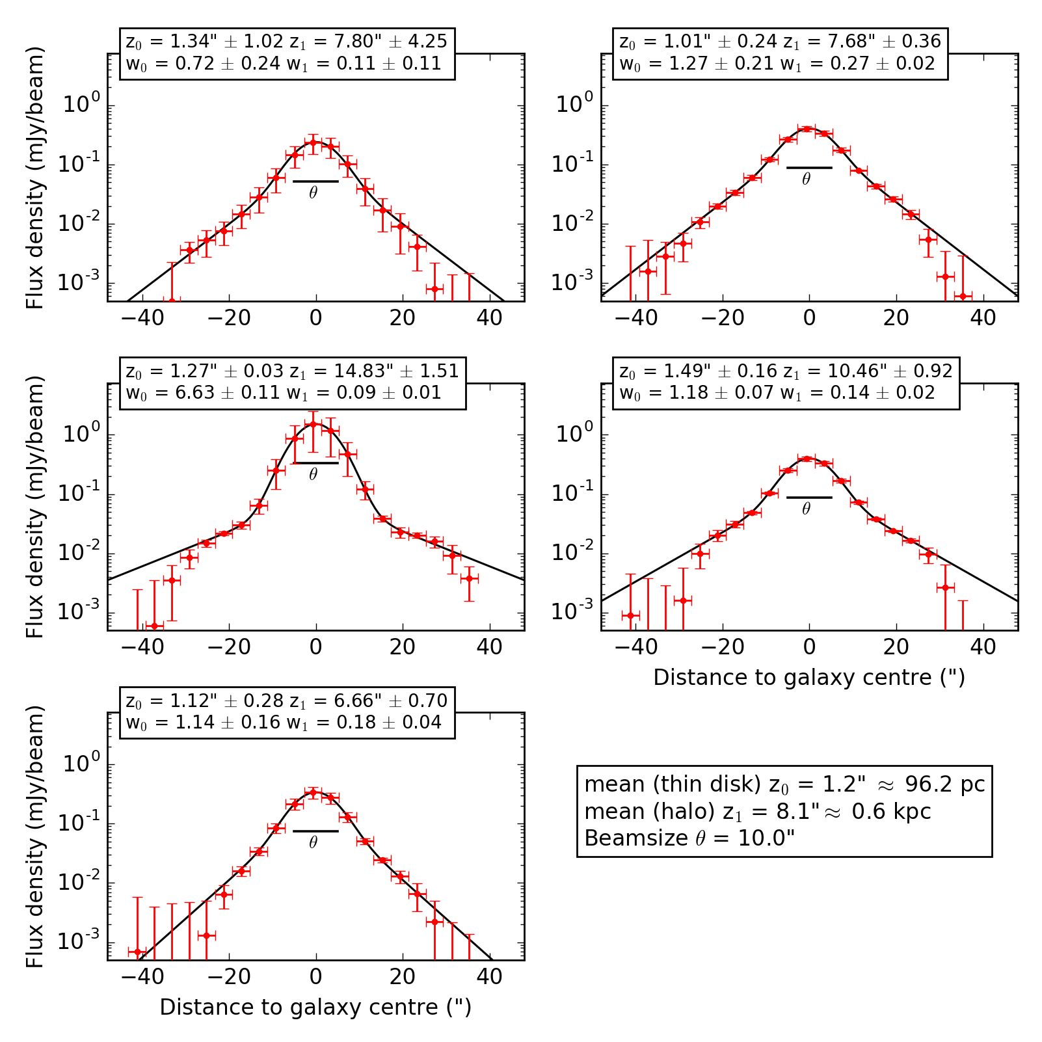
Y. Stein et al.: CHANG-ES XIX. Galaxy NGC 4013

Appendix A: Additional tables and figures
A.1. Imaging values
In Table A.1 we list all achieved rms values for the different
images used in this study.
A.2. Exponential scale height fits of NGC 4013
In Fig. A.1-A.3 we show the exponential fits of the C-band,
L-band and LOFAR data.
A.3. Derived Gaussian flux densities of NGC 4666
With the same approach as for NGC 4013, we derive exponential
flux densities of the thin disk and halo for NGC 4666. With the
exponential distribution of an intensity profile of a galaxy:
w(z) = w exp (- z/z0). (A.1)
The integral between zero and infinity of this exponential is.
W(mJy • arcsec / beam) = w0 • z0. (A.2)
Table A.1. rms values of NGC 4013.
The full integral under the exponential curve is twice larger.
w0 is measured in mJy beam-1 and z0 in arcsec. As the integrated
flux density W is in units per beam area, first we divide by the
beam area in arcsec (b = 200.4 arcsec2). To determine the total
flux density F of the thin disk and the halo, we multiply with the
extent of the major axis, e = 145" in C-band, e = 155" in L-
band, and use again the mean values of the amplitude and scale
height:
F(mJy) = 2 • w • z0 • e / b. (A.3)
The results are presented in Table A.2 where the entries to
the right are taken from Stein et al. (2019) for comparison.
A.4. CR transport models
In this section, we show the best-fitting diffusion and advec-
tion models with a constant wind speed. The diffusion models
are shown in Figs. A.4 and A.5 and the advection models in
Figs. A.6 and A.7.
Observation | Freq  (GHz) | Weighting | Resolution  ('') | rms  (pJy beam-1)
LOFAR | 0.15 | rob 0 | 6 x 6 | 94.3
 |  | rob 0 | 10 x 10 | 110
 |  | rob 0 | 18 x 18 | 204
CHANG-ES L-band | 1.58 | rob 0, 18 kT taper | 5.9 x 6.0 | 16.7
 |  | rob 0, 18 kT taper | 10 x 10 | 21.9
 |  | rob 0, 18 kT taper | 18 x 18 | 50.0
CHANG-ES C-band | 6.00 | rob 0, 18 kT taper | 5.2 x 5.3 | 3.6
 |  | rob 0, 18 kT taper | 10 x 10 | 6.8
 |  | rob 0, 18 kT taper | 18 x 18 | 13.0
Polarization | 6.00 | rob 2 | 5.2 x 5.3 | 2.5
 |  | rob 2 | 15 x 15 | 8.0
 |  | rob 2 | 18 x 18 | 8.6
Notes. Images with 10'
Stokes U.
resolution were used for the scale height analysis, the a of the polarization was measured with the mean of Stokes Q and
Fig. A.1. Strip fitting with NOD3 for five strips of NGC 4013 on
the combined (C- and D-configuration) C-band data with a two-
component exponential fit (x2otal = 0.03) for comparison. Designa-
tions are the same as for Fig. 8.
A13, page 19 of 21
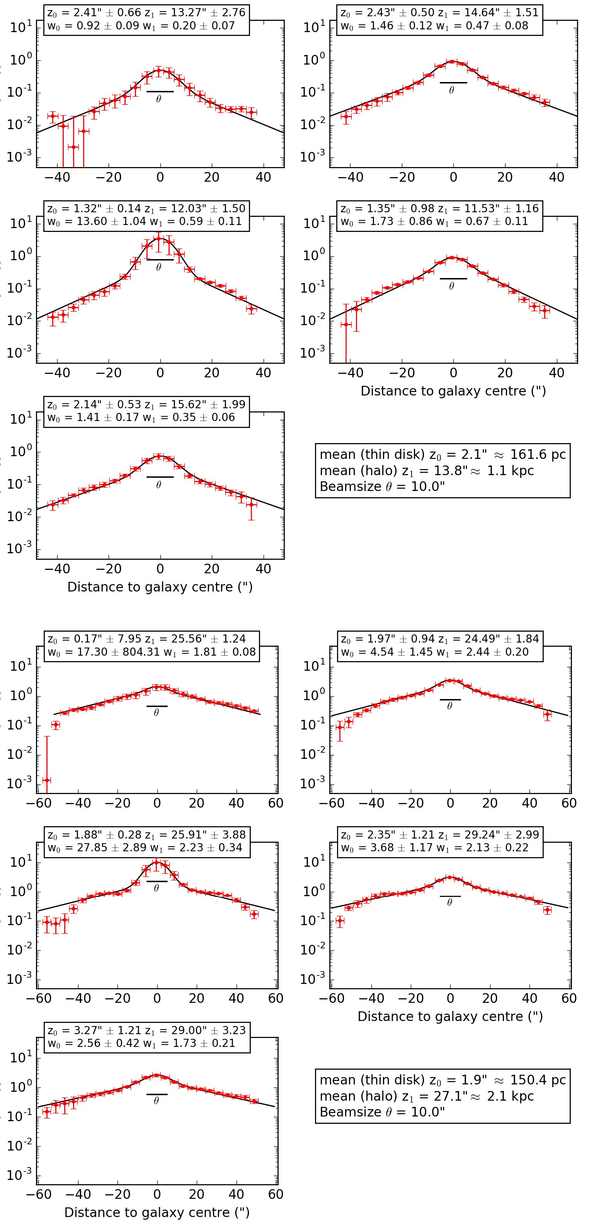
Flux density (mly/beam) Flux density (mly/beam) Flux density (mly/beam) Flux density (mly/beam) Flux density (mly/beam) Flux density (mly/beam)
A&A 632, A13 (2019)
Fig. A.2. Strip fitting with NOD3 for five strips of
NGC 4013 on the combined (B-, C- and D-configuration)
L-band data with a two-component exponential fit (Xotal =
1.11) for comparison. Designations are the same as for
Fig. 8.
Fig. A.3. Strip fitting with NOD3 for five strips of
NGC 4013 on the LOFAR data with a two-component
exponential fit (x2otal = 1.86) for comparison. Designations
are the same as for Fig. 8.
A13, page 20 of 21

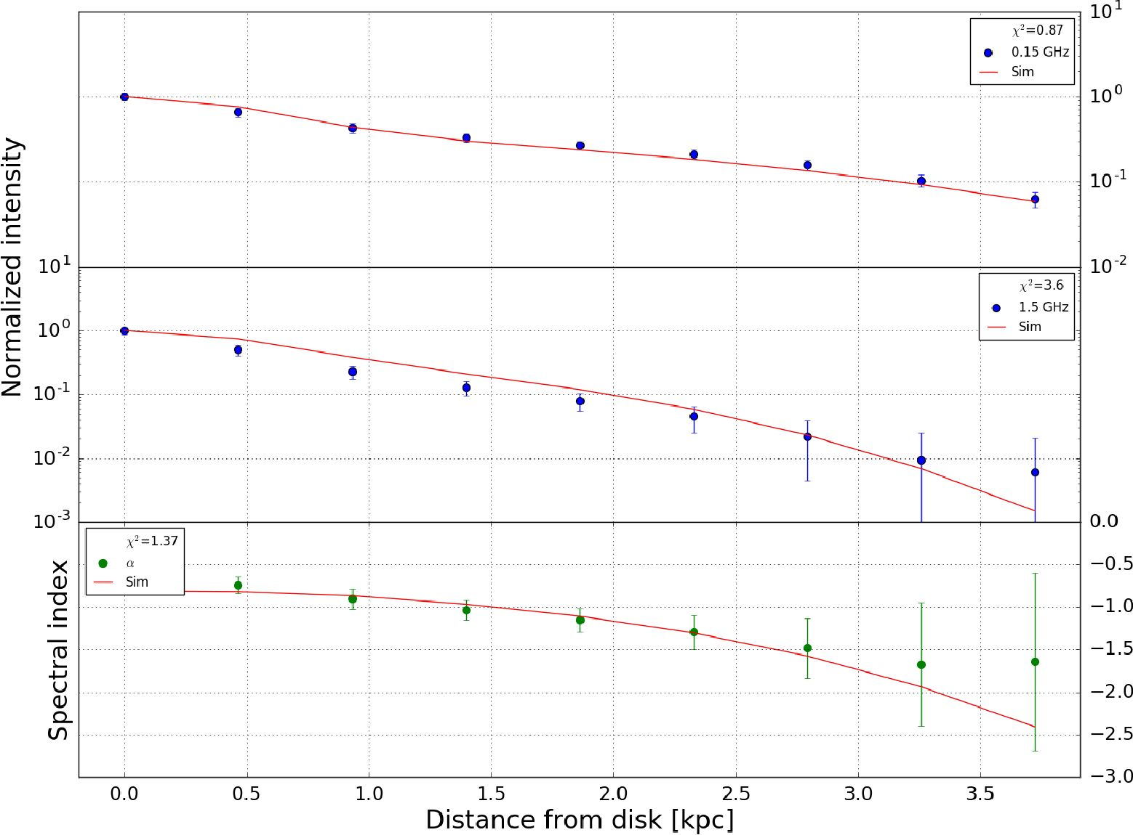
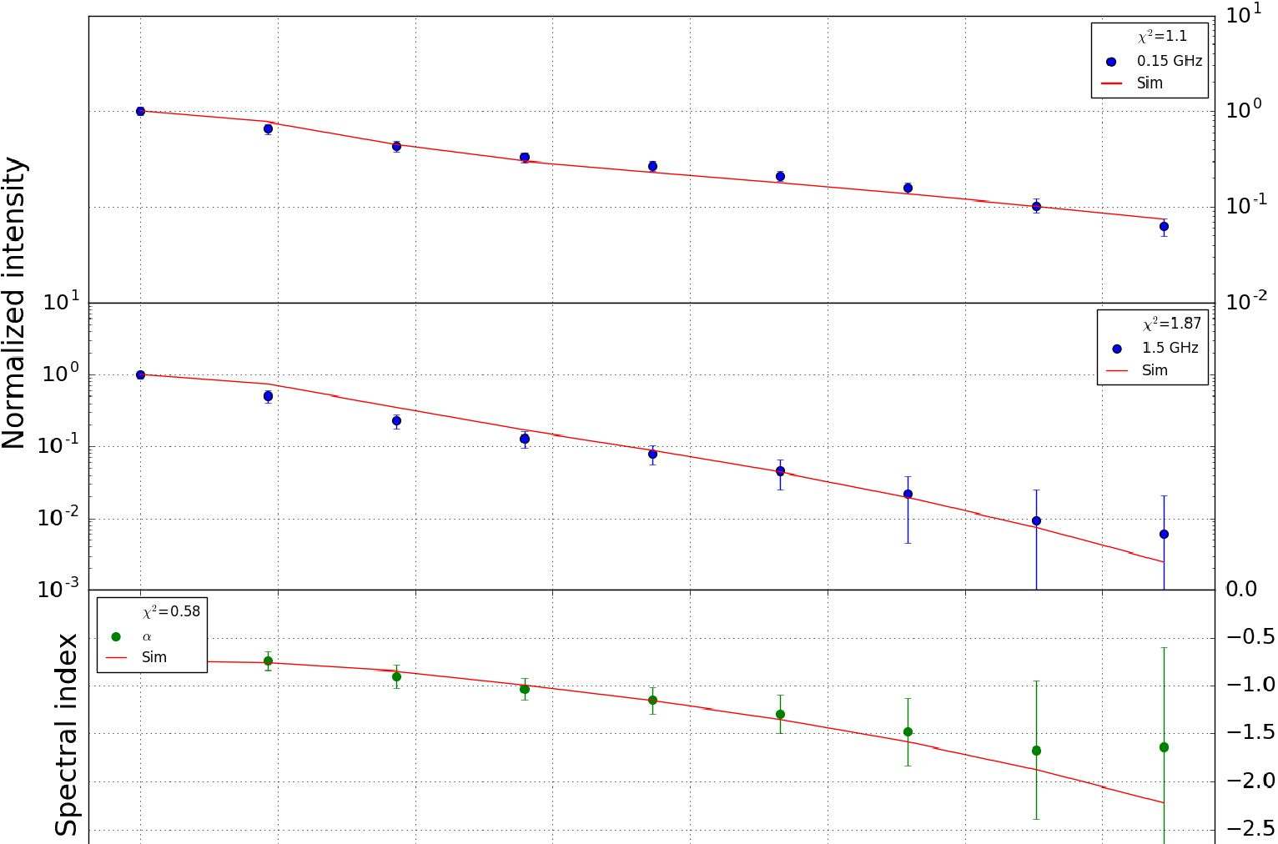
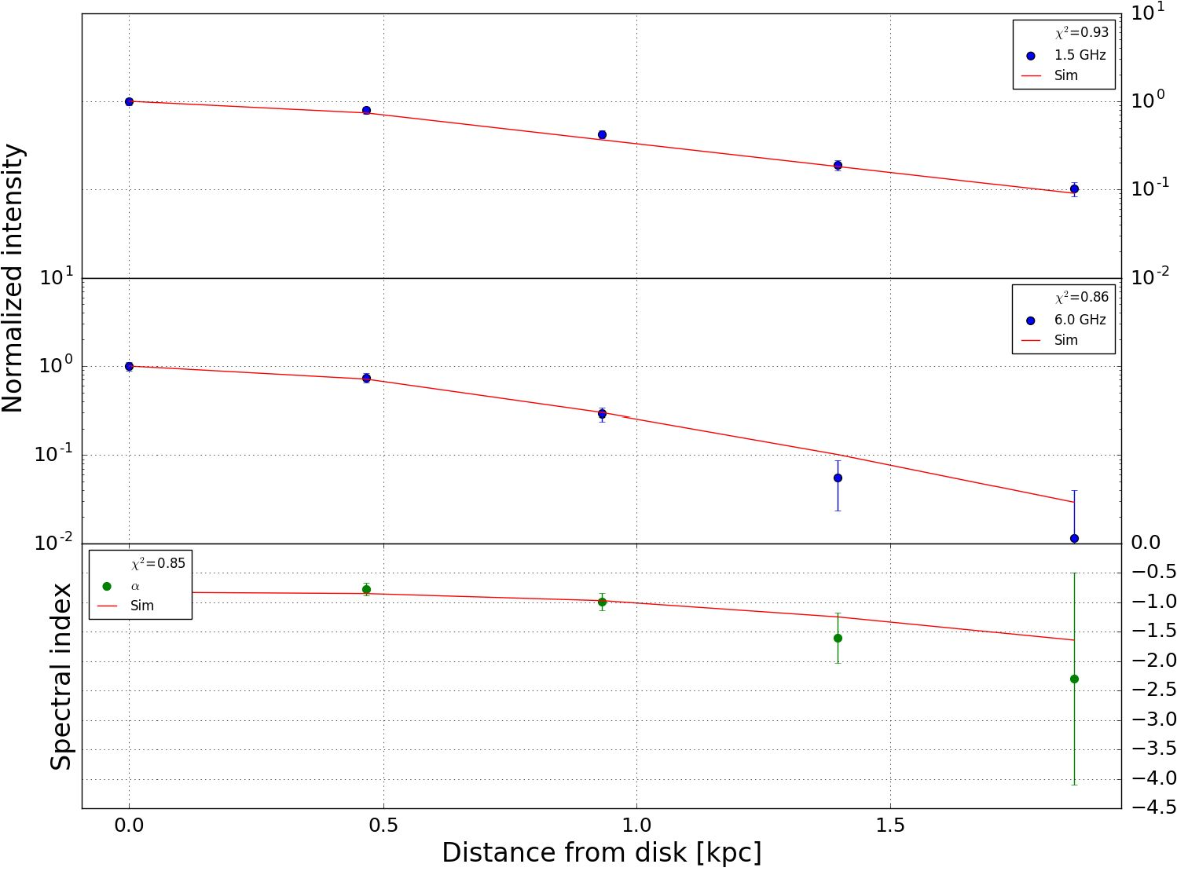
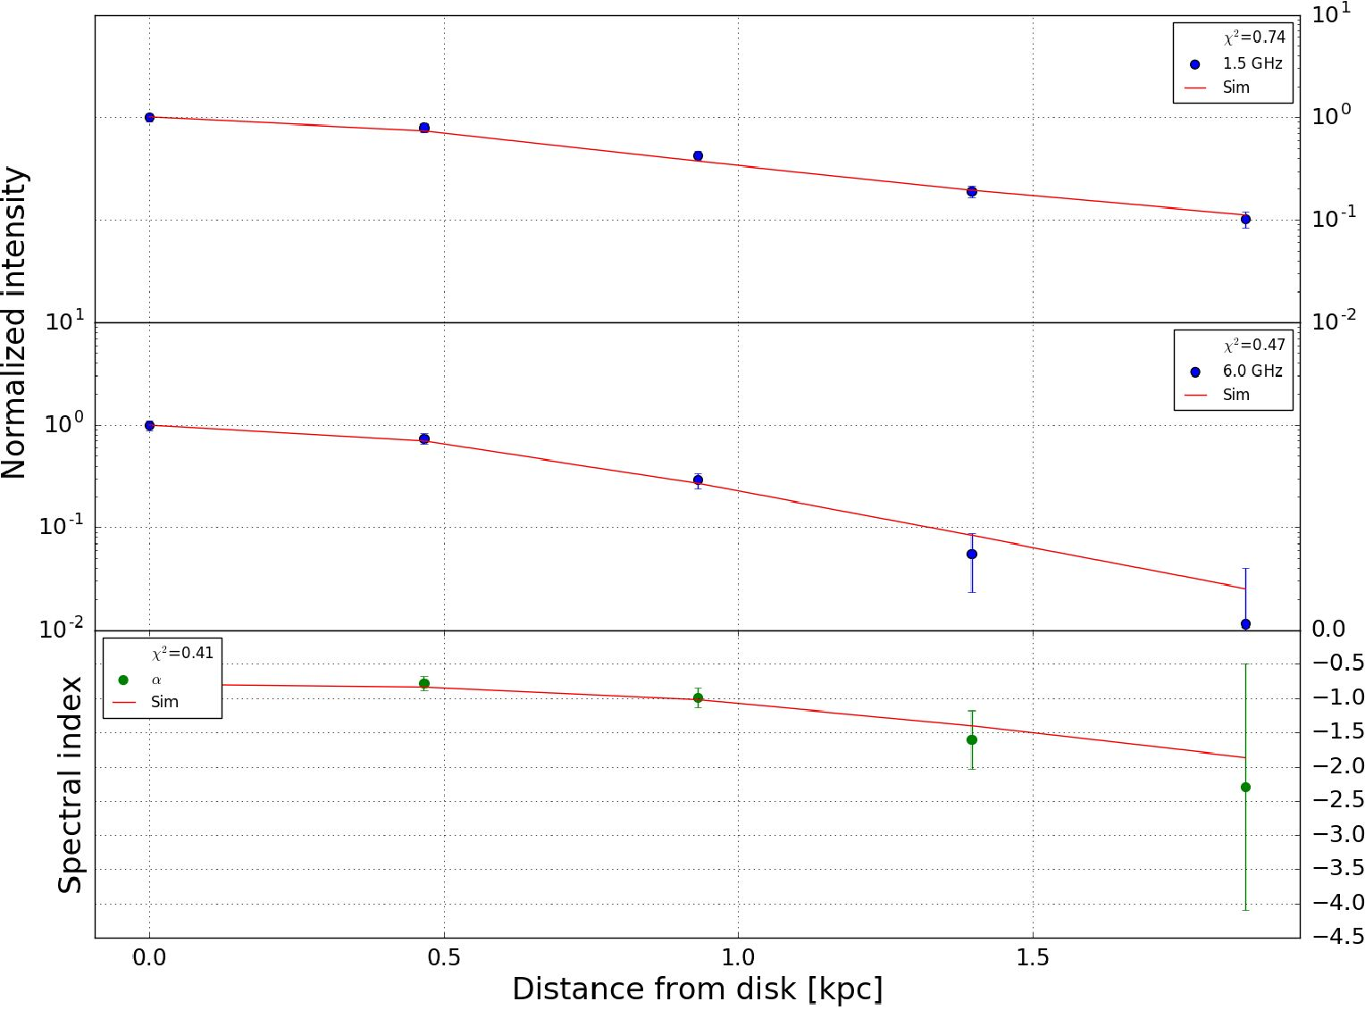
Y. Stein et al.: CHANG-ES XIX. Galaxy NGC 4013
Table A.2. Integrated flux densities of the thin disk and the halo of NGC 4666.
 |  | Exponential fits |  |  |  | From total flux densities
 | w0  (mJy beam-1) | z0  (") | z0  (kpc) | flux density  (mJy) | disk + halo  (mJy) | disk + halo  (mJy) | central source  (mJy)
C-band  Disk  Halo  Ratio | 6.7 ± 1.5  4.9 ± 0.4  1.38 | 3.0 ± 1.2  11.7 ± 0.5  0.26 | 0.4 ± 0.1  1.6 ± 0.2 | 29 ± 13  82 ± 8  0.35 | 111 ± 15 | 109 ± 1 | 1.8 ± 0.2
L-band  Disk  Halo  Ratio | 11.6 ± 0.8  11.9 ± 1.4  0.97 | 5.5 ± 0.9  16.2 ± 0.9  0.34 | 0.74 ± 0.1  2.1 ± 0.1 | 99 ± 18  298 ± 40  0.33 | 397 ± 44 | 398 ± 2 | 4.4 ± 0.4
Notes. w0 being the mean amplitude, z0 being the mean scale height.
Fig. A.4. Best-fitting CRE diffusion model for NGC 4013. Top panel:
150 MHz (LOFAR) data, middle panel: 1.5 GHz (L-band) data, and
bottom panel: nonthermal radio spectral index. In all panels, the solid
red line represents the model simulation. The errors are represented by
a weighted standard deviation. The best-fitting parameters are listed in
Table 11.
i i i i i i i —3.0
0.0 0.5 1.0 1.5 2.0 2.5 3.0 3.5
Distance from disk [kpc]
Fig. A.6. Best-fitting CRE advection model with a constant wind speed
for NGC 4013. Top panel: 150 MHz (LOFAR) data, middle panel:
- GHz (L-band) data, and bottom panel: nonthermal radio spectral
index. In all panels, the solid red line represents the model simula-
tion. The errors are represented by a weighted standard deviation. The
best-fitting parameters are listed in Table 11.
Fig. A.5. Best-fitting CRE diffusion model for NGC4013. Top panel:
- GHz (L-band) data, middle panel: 6 GHz (C-band) data, and bot-
tom panel: nonthermal radio spectral index. In all panels, the solid red
line represents the model simulation. The errors are represented by a
weighted standard deviation. The best-fitting parameters are listed in
Table 11.
Fig. A.7. Best-fitting CRE advection model with a constant wind speed
for NGC4013. The top panel shows the 1.5 GHz (L-band) data, mid-
dle panel: 6 GHz (C-band) data, and bottom panel: nonthermal radio
spectral index. In all panels, the solid red line represents the model
simulation. The errors are represented by a weighted standard devia-
tion. The best-fitting parameters are listed in Table 11.
A13, page 21 of 21

