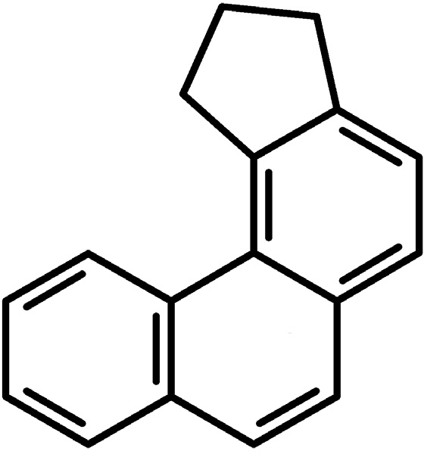
10
ENVIRONMENTAL BIOTECHNOLOGY 3 (1) 2007, 10-14
Cyclopenta[c]phenanthrene induction of CYP1A in brain of rainbow trout (Oncorhynchus mykiss)*
Paweł Brzuzan1, Maciej Woźny1, Michał K. Łuczyński2, Maciej Góra3, Sławomir Ciesielski1, Henryk Kuźmiński4
1 Department of Environmental Biotechnology, University of Warmia and Mazury, S∏oneczna 45G, 10-712 Olsztyn, Poland, e-mail: brzuzan@uwm.edu.pl
2 Department of Chemistry, University of Warmia and Mazury in Olsztyn, pl. ¸ódzki 4, 10-957 Olsztyn, Poland
3 Department of Organic Chemistry, Jagiellonian University, Ingardena 3, 30-060 Kraków, Poland
4 Department of the Salmonid Research in Rutki, Inland Fisheries Institute in Olsztyn, Rutki, 83-330 ˚ukowo, Poland Keywords: benzo[a]pyrene, brain, CYP1A, cyclopenta[c]phenanthrene, mRNA absolute quantification, rainbow trout
ABSTRACT
exposure, only B[a]P-treated rainbow trout had 10-fold higher number of CYP1A transcripts (mean = 3.63·106 transcripts·µg-1 total RNA) than control fish (3.24·105 transcripts·µg-1 total RNA; Tukey test, P<0.05). After 48 hrs, significantly higher levels of CYP1A expression (Tukey test, P<0.001) were found in either CP[c]Ph- or B[a]P- induced group (1.45·106 and 6.92·106 transcripts·µg-1 total RNA, respectively) over a control group (mean=1.41·105 transcripts·µg-1 total RNA). The finding that CYP1A in brain tissue was inducible by CP[c]Ph, a polycyclic aromatic hydrocarbon (PAH) of different than B[a]P planar characteristics, may further validate the use of rainbow trout brain CYP1A mRNA levels as a biomarker of PAH exposure.
We assessed the effects of cyclopenta[c]phenanthrene (CP[c]Ph) and benzo[a]pyrene (B[a]P; positive control) on CYP1A gene expression in brain of juvenile rainbow trout (Oncorhynchus mykiss) using the quantitative reverse transcription polymerase chain reaction (Q-RT-PCR). A group of hatchery raised rainbow trout, with an average body mass of 49.4 g and total length of
15.5 cm were given an intraperitoneal injection (10 mg·kg-1) of either CP[c]Ph or B[a]P in corn oil (2 mg·ml-1 corn oil) or corn oil alone (control). After 24 and 48 h, trout brains were collected for mRNA isolation and analysis. After 24 hours of the
INTRODUCTION
showed greater induction potential than head kidney, that contains hematopoietic, lymphoid and endocrine tissue (Brzuzan et al. 2006).
Cyclopenta[c]phenanthrene (CP[c]Ph; Figure 1) is a poly- cyclic aromatic hydrocarbon (PAH) compound that has been the subject of structural and toxicological investigations in our laboratory (Brzuzan et al. 2006; ¸uczyƒski et al. 2007). On the basis of X-ray measurements we have found that the molecule of this pseudo fjord region hydrocarbon is planar, the structural feature that enables high-affinity binding of a PAH to an intracellular receptor complex (the aryl hydro- carbon receptor; AhR). This suggested ability of CP[c]Ph to cause toxicity through activation of the AhR-dependent genes that encode enzymes involved in the oxidative meta- bolism, including CYP1A. Indeed, experiments in our labo- ratory with the rainbow trout (Oncorhynchus mykiss) have shown that CP[c]Ph induces the expression of CYP1A. Furthermore, we have found that though a planar PAH compound, CP[c]Ph is less potent at inducing CYP1A gene expression than benzo[a]pyrene (B[a]P), a well known Ah-receptor agonist (Hahn et al. 2005). For either PAH, the liver, a significant biotransformation site for PAHs,
Figure 1. Chemical structure of cyclopenta[c]phenanthrene (CP[c]Ph).
* Presented at The First International Environmental Best Practices Conference, 07-10 August 2006, Olsztyn, Poland

CP[c]Ph induction of CYP1A in brain of rainbow trout 11
Chemical exposure
For the gene induction study, individuals were randomly sampled, anesthetized by immersion in 1 ppm Etomidate solution, and injected intraperitoneally with either B[a]P (positive control) or CP[c]Ph (both dissolved in corn oil at doses of 10 mg·kg-1 body weight). B[a]P was purchased from Fluka (Germany), whereas CP[c]Ph was synthesized according to Brzuzan et al. (2006). The control fish were injected with corn oil only. Fish were placed in an 800 l flow-through tank (well water, 600 l·h-1) for 48 h at 7°C. Samples (4 random fish each) of control and each experimental group were taken after 24 h, and at the end of the experiment, from each PIT-identified group. Then fish were anesthetized, sacrificed, and their brains were immediately stored in RNALaterTM at
-20°C (Qiagen; Hilden, Germany).
Brzuzan et al.
In the present study, we extended our investigations on effects of CP[c]Ph on CYP1A gene expression in fish brain, an organ that can easily be a target for waterborne PAHs. The CYP1A-mediated cellular toxicity of PAHs in the brain may have adverse consequences by disrupting neuronal and neuro- endocrine functions (Andersson et al. 1993; Huang et al. 2000). In addition to PAHs, halogenated aromatic hydro- carbons such as 2,3,7,8-tetrachlorodibenzo-p-dioxin (TCDD) has been reported to alter local brain circulation, and to cause multifocal hemorrhages in zebrafish (Andreasen et al. 2002) and in Fundulus heteroclitus (Toomey et al. 2001). Studies in some species including salmonids indicate that CYP1A enzyme activities are induced in olfactory organs of fish exposed to xenobiotics (Chung-Davidson et al. 2004), which serve as first line of defense in the brain against xeno- biotic exposure. Because olfactory receptor neurons in the olfactory epithelia are in direct and continuous contact with the external environment, it seems advantageous for fish to have highly inducible CYP1A proteins. Constitutive levels of CYP1A in other brain areas may play a protective role by eliminating xenobiotics from the central nervous system (Chung-Davidson et al. 2004).
The above-mentioned studies warrant the need for using molecular markers in feral fish to assess the contamination of water bodies from PAHs that enter the aquatic environment through land runoff, industrial discharges and dredging ope- rations. Toward this end, we studied the effects of CP[c]Ph on the AhR-regulated CYP1A gene expression in brain of rain- bow trout (Oncorhynchus mykiss) using the quantitative reverse transcription polymerase chain reaction (Q-RT-PCR). To do this, we modified the CYP1A-specific real time assay previously reported by Rees and Li (2004), by applying a re-
RNA isolation, quantification and storage RNALaterTM preserved brain tissues, that included midbrain region, were homogenized and extracted for total RNA isolation using Total RNA Mini isolation kit (A&A Bio- technology; Gdynia, Poland) according to the manufacturer’s protocol. RNA samples were incubated at 37°C for 30 min with RNase-free DNase (A&A Biotechnology) to eliminate
genomic DNA contamination in further analyses. To verify that RNA concentrations and dilutions were accurate, A260/A280 ratios were measured and quantified using BioPhotometer
(Eppendorf; Hamburg, Germany).
RT-PCR
Total RNA was used to synthesize cDNA using a commercially available RevertAidTM First Strand cDNA Synthesis Kit (Fermentas; Burlington, Canada). The cDNA reaction for each sample contained 1 µg of total RNA and 0.5 µg of oligo(dT)18 primers, and the reaction was performed according to the manufacturer’s recommendations. cDNA samples were stored in autoclaved water at -20°C until used.
combinant DNA standard to generate standard curves in each set of reactions.
MATERIAL AND METHODS
Animals
The fish were treated in accordance with the regulations set forth by the Local Ethical Commission No. 38/N issued on 29.07.2004 (conforming to principles of Laboratory Animal Care, NIH publication No. 86-23, revised in 1985). Juvenile rainbow trout (mean body weight 49.4 ± 5.8 g; mean body length 15.5 ± 0.6 cm) were held at the Department of Salmonid Research in Rutki, Inland Fisheries Institute in Olsztyn, Poland. Fish were individually tagged with passive integrated transponders (PIT) which allowed further automated data acquisition using data-entry station (Prentice et al. 1990). The fish were acclimated for two weeks at 7°C. During the acclimation period, rainbow trout were fed a diet of Aquastart 2 (BioMar A/S; DK-730 Brande, Denmark) four times a day to satiation. A photoperiod of 15 h natural light and 9 h dark was kept during the duration of the experiment. Trout were not fed for 2 days prior to injections.
Preparation and calibration of standard curve
A CYP1A recombinant DNA (Figure 2) standard was used to generate standard curves. A pair of primers specific to the CYP1A gene of Oncorhynchus mykiss (forward CYP1As-F 5’-TTG TCA TCC CAA CAG AGG AAA AGG-3’ and reverse CYP1As-R 5’-TGA AGT AGC CAT TGA GGG ATG
TGT C-3’) was designed using Primer Express 2.0 (Applied Biosystems; Foster City, CA) software (Figure 2A), based on the sequence S69278 available in GenBank, and purchased from Institute of Biochemistry and Biophysics (Polish Academy of Sciences, IBB PAN, Warsaw, Poland). The CYP1As primer pair was used to amplify a cDNA fragment by conventional PCR (Figure 2B). The 50 µl reaction mixture consisted of 5 µl of 10x PCR buffer with Mg2+ (A&A Bio- technology), 0.5 µM of each primer, 200 µM of each dNTP (Promega; Madison, USA), 1 U of Taq polymerase (A&A Biotechnology), 1 µl of previously synthesized first strand cDNA as a template. The reaction was performed with a
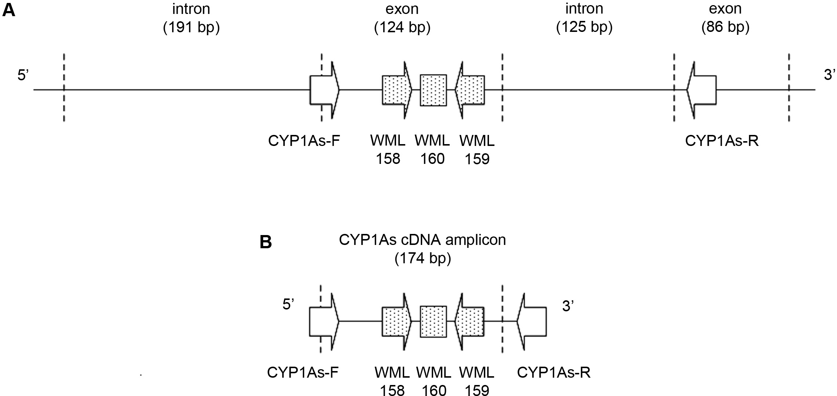
12
ENVIRONMENTAL BIOTECHNOLOGY 3 (1) 2007
Figure 2. Design of PCR primers for DNA standard construction and further examining of CYP1A expression in rainbow trout.
- The positioning of primers CYP1As-F and CYP1As-R within a CYP1A gene of rainbow trout (GenBank Acc. No. S69278) is indicated by white arrows, whereas that of WML 158 and 159 primers is depicted by gray arrows. Gray square indicates the position of a WML160 TaqMan® probe.
- For standard curve construction cDNA was used as a template.
Mastercycler gradient thermal cycler (Eppendorf) according to the following temperature profile: pre-denaturation at 95°C for 4 min, 35 cycles of 1 min at 95°C, 30 s at 62°C,
30 s at 72°C; and 1 min at 72°C for final extension. The ob- tained PCR product was purified using the Clean-Up kit (A&A Biotechnology) and cloned into pCR®2.1-TOPO vector (Invitrogen; Carlsbad, CA). Plasmid clones, containing CYP1As DNA fragments, were purified with Plasmid Mini kit (A&A Biotechnology) and the concentration was measured using a BioPhotometer (Eppendorf).
In order to quantify CYP1A mRNA levels, a plate of sam- ples was normalized against a set of standard curve reactions. To generate standard curves, real time assays were carried out on a dilution series (1011–105 molecules) of the plasmid containing CYP1A gene fragment. Amplification plots were analyzed on the ABI 7500 (Applied Biosystems; Foster City, CA, USA), and Ct values for each of the reactions in the dilution series were calculated. Ct values were plotted against starting quantity of the plasmid template to generate the standard curve. The method outlined by Lee et al. (2006) was used to calculate the number of plasmid molecules (mlcs) corresponding to the measured concentration, as follows: mlcs number = [6.02 x 1023 (mlcs/mol) x DNA amount(g)] / [DNA length (dp) x 660 (g/mol/dp)]. Additional control reactions were also run on plates including a no template (PCR-grade H2O) negative control.
Absolute quantification in real-time quantitative PCR For assays, real-time PCR primers, forward WML158 5’-CCA ACT TAC CTC TGC TGG AAG C-3’ and reverse WML159
5’-GGT GAA CGG CAG GAA GGA-3’, were adopted from Rees and Li (2004) and purchased from the Institute of Bio-
chemistry and Biophysics (Polish Academy of Sciences, IBB PAN). A TaqMan® probe (WML160 5’-TTC ATC CTG GAG ATC TTC CGG CAC TC-3’, BHQ1-FAM; Rees and Li
(2004)) was purchased from Generi Biotech Ltd. (Hradec Králové, Czech Republic). Real-Time PCR was performed in MicroAmpTM optical tubes (Applied Biosystems) using the ABI 7500 Real-Time PCR system (Applied Biosystems). Each 20 µl of reaction mixture contained 10 µl of TaqMan® Univer- sal PCR Master Mix (Applied Biosystems), 0.25 µM of each primer, 0.25 µM of TaqMan® probe, and 1 µl of cDNA as a template (or DNA standard). The reaction was performed as follows: 50°C for 2 min, 95°C for 10 min, then 40 cycles of 95°C for 15 s and 60°C for 1 min. Tissue extracts of each experimental group of fish as well as the DNA standard dilutions were assayed in duplicate.
Statistical analysis
All data were log-transformed to fulfill normality requirements and analyzed using a two-way analysis of variance, ANOVA
(n =
4 in each sample) using Statistica software version 7.1
(StatSoft Inc.; Tulsa, OK, USA). All pairwise comparisons were tested for significance using a Tukey HSD test (Statistica v. 7.1).
RESULTS AND DISCUSSION
The reactions for the standard curve were run on the same plate as all analyzed samples. Ct values were plotted against concentrations of standard cDNA and analyzed using linear re- gression. The standard curve had a slope of -4.0 and a coefficient of variation of 0.99 (Figure 3). All Ct values of cDNA from each individual fell within the linear range of the standard curve.
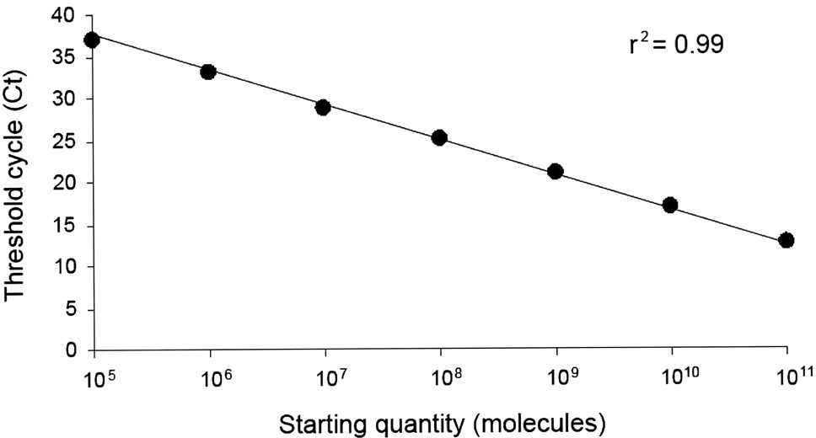
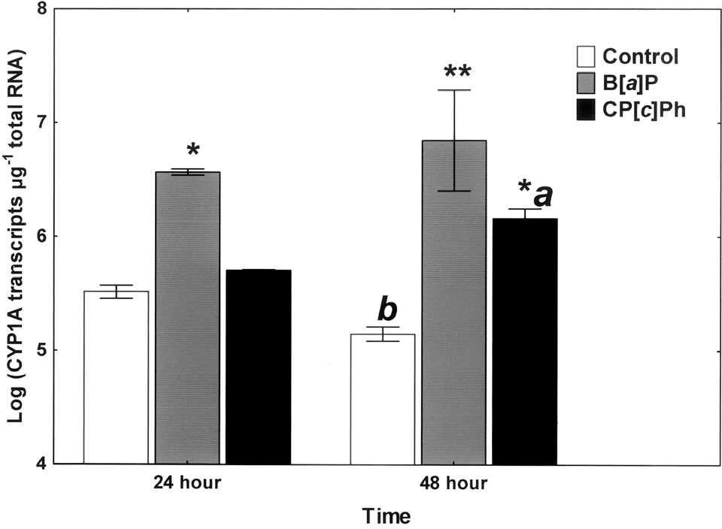
CP[c]Ph induction of CYP1A in brain of rainbow trout 13
Brzuzan et al.
Figure 3. Standard curve for the real-time CYP1A quantitative PCR assay. A 10-fold dilution series was carried out for the standard curve (plasmid containing fragment of CYP1A cDNA) from 1011 to 105 molecules and amplified during PCR for 40 cycles. Ct (cycle threshold indicating the first detection of CYP1A PCR product) values were plotted against initial concentration followed by standard linear regression (r2 = 0.99).
Figure 4. Expression patterns of CYP1A mRNA levels in brain of rainbow trout measured by Q-RT-PCR. Juvenile rainbow trout were randomly assigned to treatment groups (N = 4 for each treatment group) and given an intraperitoneal injection of 10 mg·kg-1 of either CP[c]Ph or B[a]P in corn oil, or corn oil alone (control). Whole brain tissue was collected at two time periods: 24 and 48 hour. Total RNA was extracted and analyzed for CYP1A mRNA levels using Q-RT-PCR. Data were analyzed using two-way ANOVA followed by Tukey’s multiple comparison test. Symbols (*) indicate groups that showed significantly higher levels of CYP1A mRNA over a respective control group (* P < 0.05, ** P < 0.001). Different letters denote exposure group means that were significantly different between time points (* P < 0.05).
Figure 4 shows the expression of brain CYP1A mRNA in the control and CP[c]Ph or B[a]P treated rainbow trout after 24 and 48 hours of experiment. At 24 hour time point, only B[a]P-exposed group showed significantly higher CYP1A levels (mean = 3.63·106 transcripts·µg-1 total RNA) than control (3.24·105 transcripts·µg-1 total RNA; Tukey test, P < 0.05). After 48 hours, significantly higher levels of CYP1A expression (Tukey test, P < 0.001) were found in either CP[c]Ph- or B[a]P-exposed group (1.45·106 and 6.92·106 transcripts·µg-1 total RNA, respectively) over a control group (mean=1.41·105 transcripts·µg-1 total RNA). Control levels of CYP1A were significantly lower after 48 hour of the experiment compared to those determined at 24 hour (Tukey test, P < 0.05). The results of Q-RT-PCR over a 48 h period showed that the increase of CYP1A mRNA levels in rainbow trout brain was substantial (more than 10·fold for CP[c]Ph and about 50·fold for B[a]P), and comparable with that observed in B[a]P- induced Fundulus heteroclitus (from about 26 to 36·fold; Wang et al. 2006).
The CYP1A levels reported here are in agreement with
CYP1A mRNA expression levels noticed in brain tissue of lake trout that was exposed to b-naphthoflavone (BNF) for a comparable period of time (Chung-Davidson et al. 2004). These authors showed that CYP1A mRNA increase in response to BNF occurred rapidly and continued to rise in the BNF- treated lake trout after 4h, with a peak at 2 days. Furthermore, a significant initial rise in brain CYP1A mRNA levels of the control group within the first 8 hours from the start of the experiment was observed. The expression returned to basal levels after 2 days of exposure. Intere- stingly, we observed a reduction in CYP1A expression in control group of rainbow trout between studied time points, 24 and 48 h (Figure 4). It is likely that during the initial hours of the present experiment a similar trend occurred, rising CYP1A mRNA level and then returning it to the basal level, the latter being observed in our data. It
seems reasonable to assume that the changes in mRNA levels of CYP1A in the control fish may be due to the effects of handling stress (Blom and Förlin 1997; Chung-Davidson et al. 2004).
Our results are congruent with previously reported data of CYP1A expression in liver and head kidney of rainbow trout exposed to either CP[c]Ph or B[a]P, which indicated B[a]P being more potent at inducing the gene than CP[c]Ph (Brzuzan et al. 2006). On the other hand, the elevated levels of CYP1A mRNA in the brain in response to the two polycyclic aromatic hydrocarbons (CP[c]Ph and B[a]P) may be indicative of phase I biotransformation reactions in rainbow trout, aimed at eliminating the xenobiotic from the central nervous system. Accordingly, brain biotransformation, in addition to liver and gill biotransformation (Levine and Oris 1999), may be essential to the viability of the organism by influencing the toxicity of endogenous and waterborne PAH chemicals.
In fish and mammals, B[a]P exposure is associated with a suite of toxicities including immunosuppression, oxidative stress, vascular dysfunction, stable DNA adduct formation and mutagenicity (Payne et al. 2003). The rise of CYP1A mRNA levels following the PAH exposure results in higher catalytic activity of CYP1A protein, higher biotransformation rate of the compound and rapid accumulation of activated electrophilic metabolites (Chang et al. 2002; ¸uczyƒski et
14
ENVIRONMENTAL BIOTECHNOLOGY 3 (1) 2007
al. 2005). The most common genotoxic effects exerted by these reactive compounds are DNA-adducts, which are responsible for the chromosome damage and subsequent formation of micronuclei and other nuclear abnormalities (Vienneau et al. 1995). Indeed, we have shown recently that, the ability of both, B[a]P and CP[c]Ph, to induce CYP1A in liver is predictive of the incidences of clastogenic changes in rainbow trout erythrocytes (Brzuzan et al. 2006). Further research, integrating cellular and molecular biology techni- ques, may help identify the mechanisms associated with both CP[c]Ph-induced bioactivation and toxicity, which represent the first steps toward understanding its adverse health effects to fish.
trout (Salvelinus namaycush Walbaum). Journal of Experimental Biology 207: 1533-1542.
Hahn, M.E., R.R. Merson, S.I. Karchner. 2005. Xenobiotic receptors in fish: Structural and functional diversity and evolutionary insights. In: Biochemical and Molecular Biology of Fishes, Volume 6, Environmental Toxicology (ed. T.W. Moon, T.P. Mommsen), pp. 191-228. Elsevier, New York.
Huang, P., A. Rannug, E. Ahlbom, H. Hakansson, S. Ceccatelli. 2000. Effect of 2,3,7,8-tetrachlorodibenzo-p-dioxin on the expression of cytochrome P4501A1, the aryl hydrocarbon receptor and the aryl hydrocarbon receptor nuclear translocator in rat brain and pituitary. Toxicology and Applied Pharmacology 169: 159-167.
Lee, C., J. Kim, S.G. Shin, S. Hwang. 2006. Absolute and relative QPCR quantification of plasmid copy number in Escherichia coli. Journal of Biotechnology 123: 273-280.
Levine, S.L., J.T. Oris. 1999. CYP1A expression in liver and gill of rainbow trout following waterborne exposure: implications for biomarker determination. Aquatic Toxicology 46: 279-287.
¸uczyƒski, M.K., M. Góra, P. Brzuzan, J. Wilamowski, B. Kozik. 2005. Oxidative metabolism, mutagenic and carcinogenic properties of some polycyclic aromatic hydrocarbons. Environmental Bio- technology 1: 16-28.
¸uczyƒski, M.K., M. Góra, D. Miel˝yƒska, S. Tejs, P. Pirogowicz,
P. Brzuzan, M. Luczynski. 2007. Preliminary evaluation of mutagenic activity of two amino derivatives of cyclopenta[c]phenanthrene. Environmental Biotechnology 3: xx-xx.
NIH 1985. Guide for the care and use of laboratory animals. National Institute of Health, Public Health Service. NIH publication No. 86-23. Bethesda.
Payne, J. F., A. Mathieu, T.K. Collier. 2003. Ecotoxicological studies focusing on marine and freshwater fish. In: PAHs—An Eco- toxicological Perspective (ed. P.E.T. Dauben), pp. 191-224. Wiley, West Sussex, UK.
Prentice, E.F., T.A. Flagg, C.A. McCutcheon, D.F. Brastow, D.C. Cross. 1990. Equipment, methods, and automated data-entry station for PIT tagging. American Fisheries Society Symposium 7: 335-340.
Rees, C.B., W. Li. 2004. Development and application of a real-time quantitative PCR assay for determining CYP1A transcripts in three genera of salmonids. Aquatic Toxicology 66: 357-368.
Toomey, B.H., S. Bello, M.E. Hahn, S. Cantrell, P. Wright, D.E. Tillitt,
R.T. Di Giulio. 2001. 2,3,7,8-Tetrachlorodibenzo-p-dioxin induces apoptotic cell death and cytochrome P4501A expression in developing Fundulus heteroclitus embryos. Aquatic Toxicology 53: 127-138.
Vienneau, D.S., U. DeBoni, P.G. Wells. 1995. Potential genoprotective role for UDP-glucuronosyltransferases in chemical carcinogenesis: initiation of micronuclei by benzo[a]pyrene and benzo[e]pyrene in UDP-glucuronosyltransferase-deficient cultured rat skin fibro- blasts. Cancer Research 55: 1045-1051.
Wang, L., B.E. Scheffler, K.L. Willett. 2006. CYP1C1 messenger RNA expression is inducible by benzo[a]pyrene in Fundulus heteroclitus embryos and adults. Toxicological Sciences 93: 331–340.
ACKNOWLEDGMENTS
We thank three anonymous reviewers for helpful comments on the paper. This work was supported by the Polish Committee for Scientific Research, Project No. 2 P06D 001 29.
REFERENCES
Andersson, T., L. Förlin, S. Olsen, A. Fostier, B. Breton. 1993. Pituitary as a target organ for toxic effects of P4501A1 inducing chemicals. Molecular and Cellular Endocrinology 91: 99-105.
Andreasen, E.A., J.M. Spitsbergen, R.L. Tanguay, J.J. Stegeman,
W. Heideman, R.E. Peterson. 2002. Tissue-specific expression of AHR2, ARNT2, and CYP1A in zebrafish embryos and larvae: effects of developmental stage and 2,3,7,8-tetrachlorodibenzo-p-dioxin exposure. Toxicological Sciences 68: 403-419.
Blom, S., L. Förlin. 1997. Effects of PCB on xenobiotic biotransformation enzyme activities in the liver and 21-hydroxylation in the head kidney of juvenile rainbow trout. Aquatic Toxicology 39: 215-230.
Brzuzan, P., M. Góra, M.K. ¸uczyƒski, ¸. Jurczyk, H. Kuêmiƒski,
W. Nitek, M. Woêny. 2006. Molecular geometry, CYP1A gene induction and clastogenic activity of cyclopenta[c]phenanthrene in rainbow trout. Polycyclic Aromatic Compounds 26: 345-365.
Chang, H.-F., D.M. Huffer, P. Chiarelli, L.R. Blankenship, S.J. Culp,
B.P. Cho. 2002. Characterization of DNA adducts derived from syn-benzo[ghi]fluoranthene-3,4-dihydrodiol-5,5a-epoxide and comparative DNA binding studies with structurally-related anti-
-diolepoxides of benzo[ghi]fluoranthene and benzo[c]phenanthrene. Chemical Research in Toxicology 15: 198-208.
Chung-Davidson, Y.-W, C.B. Rees, H. Wu, S.S. Yun, W. Li. 2004.
b-naphthoflavone induction of CYP1A in brain of juvenile lake

