


Intelligence 92 (2022) 101644
High individual alpha frequency brains run fast, but it does not make them smart
Michał Ociepka *, Patrycja Kałamała, Adam Chuderski
Cognitive Science Department, Institute of Philosophy, Jagiellonian University in Krakow, Poland
A R T I C L E I N F O
A B S T R A C T
Keywords:
Individual alpha frequency EEG
MEG
Cognitive ability Intelligence
Evidence for the relationship between individual alpha frequency (IAF) and cognitive ability (general intelli- gence) is inconclusive, and the role of alpha rhythm in shaping cognition is hotly debated. This study aimed to provide more conclusive evidence. EEG was recorded during three resting state sessions, a vigilance session, and a short-term visual memory task. Six respective IAF estimates were calculated for a total of 153 participants. Participants also completed the battery of 17 tests measuring four main dimensions of cognitive ability: fluid reasoning, working memory, visual discrimination, and processing speed. Confirmatory factor analysis indicated that the factors reflecting fluid reasoning, working memory, and visual discrimination, as well as the higher- order factor reflecting general intelligence, were unrelated to the IAF factor. At the same time, IAF positively correlated with processing speed, sharing 5.5% of variance. The EEG findings were replicated in another sample
(N = 94) using MEG data and a different cognitive-ability assessment. Overall, the study implies that brains with
higher IAFs do run faster, but it does not make them smarter. The study clarifies the so far equivocal relationship between the individual frequency of the dominating alpha rhythm and cognitive functioning.
1. Introduction

Physiological markers predicting – typically profound – individual differences in cognitive functioning have been tracked for more than a century (Galton, 1883). Nowadays, cognitive neuroscience has sug- gested several neurophysiological predictors of cognitive ability, including the amount and distribution of grey matter in the cortex (Colom et al., 2009; Santarnecchi, Emmendorfer, & Pascual-Leone, 2017), the integrity of subcortical fiber tracts (Clayden et al., 2012; Pineda-Pardo, Martínez, Roma´n, & Colom, 2016), brain metabolism (Neubauer & Fink, 2009), as well as temporal and spatial patterns of brain activity (Finn et al., 2015; Schultz & Cole, 2016). In particular, cognitive functioning has been linked with spectral properties of the M/ EEG signal (Gągol et al., 2018; Pahor & Jauˇsovec, 2014; Palva, Monto, Kulashekhar, & Palva, 2010), including oscillatory activity in the alpha band.
The alpha band comprises the most prominent brain rhythm in the power spectrum, spanning 7–13 Hz (Klimesch, 1999). Alpha oscillations are relevant to various cognitive domains (e.g. perception, attention, working memory, long-term memory; for review see Klimesch, 2012). Typically, when the cortex starts dealing with a cognitive task, its task
relevant areas display a drop in alpha power, often interpreted as a result of withdrawing inhibitory signals from neural mechanisms required for the task (see Neubauer & Fink, 2009). By contrast, insufficient alpha power in such areas may also lead to a decrease in task performance (Clayton, Yeung, & Cohen Kadosh, 2018) when the alpha rhythm takes part in processing (e.g., in visual working memory; Roux & Uhlhaas, 2014). These findings suggest that the alpha band role is to both inhibit and activate brain areas in order to coordinate neural processing (Doesburg, Green, McDonald, & Ward, 2009; Jensen & Mazaheri, 2010). Substantial research has focused on the alpha power spectrum at the maximum peak, which can be clearly identified for the majority of the population. Such a peak, called individual alpha frequency (IAF), is typically identified around 10 Hz with a parietal distribution. IAF is commonly assumed to reflect fundamental properties of neural coordi- nation and integration, such as long-range signal transmission speed (Steriade, Gloor, Llinas, Da Silva, & Mesulam, 1990; Vald´es-Herna´ndez et al., 2010), global inhibitory pace (Klimesch, Sauseng, & Hanslmayr, 2007), and sensory sampling (Samaha & Postle, 2015). Importantly, it
has been shown to display robust trait-like properties: high heritability (h2 > 0.80; Posthuma, Neale, Boomsma, & De Geus, 2001; Smit, Wright, Hansell, Geffen, & Martin, 2006; van Beijsterveldt & Boomsma, 1994),
* Corresponding author.
E-mail address: Michal.Ociepka@doctoral.uj.edu.pl (M. Ociepka).
https://doi.org/10.1016/j.intell.2022.101644
Received 1 October 2021; Received in revised form 21 February 2022; Accepted 14 March 2022
Available online 1 April 2022
0160-2896/© 2022 The Authors. Published by Elsevier Inc. This is an open access article under the CC BY license (http://creativecommons.org/licenses/by/4.0/).
Contents lists available at ScienceDirect

Intelligence
journal homepage: www.elsevier.com/locate/intell

M. Ociepka et al.

stability over time (Grandy et al., 2013; Kondacs & Szabo´, 1999; Levin
Intelligence 92 (2022) 101644

between IAF and cognitive functioning in young healthy adults is elusive. Positive findings do not yet comprise a coherent picture. Research varies in cognitive functions for which significant relationships were observed; moreover, positive effects were primarily weak-to- moderate in size and were reported for small- to medium-sized sam- ples, which considerably undermines their reliability (Button et al., 2013). In contrast, several sufficiently-powered studies (Clark et al., 2004; Posthuma et al., 2001; Smit et al., 2006; two studies in Pahor & Jauˇsovec, 2016) suggested negligible links.
Of all the available studies, the study by Grandy et al. (2013) de- serves special attention, as it offers a promising explanation for the mixed evidence on the links between IAF and cognitive ability. These researchers proposed that IAF could be a marker of general intelligence – a higher-order factor of cognitive ability (commonly called g factor; Spearman, 1927) representing the variance shared by diverse categories of cognitive tests (McGrew, 2009). As any specific test makes only an imperfect indicator of general intelligence, correlations between IAF and cognitive ability in single tests are likely to be obscured. Therefore, according to Grandy et al., the real strength of the IAF-cognition rela- tionship can be validly assessed only for a higher-order statistical factor derived from a wide battery of cognitive tests. To test this hypothesis, Grandy et al. used data from 85 cognitive-training participants exam- ined with an intelligence test (Berlin Intelligence Structure, BIS) assessing the processing speed, memory, and reasoning abilities, using verbal, numerical, and figural material. By means of covariance struc- ture modeling (an advanced method of modeling latent variables and their links; Kline, 2016), they calculated three respective broad cognitive-ability factors as well as the g factor that loaded them. Finally, the IAF factor was calculated using two IAF values per participant (derived from the eyes-closed and the eyes-open resting-state EEG ses-
et al., 2020), and substantial individual variability in population (SD =
2.8 Hz), but limited sensitivity to experimental manipulations (SD = 0.9
Hz; Haegens, Cousijn, Wallis, Harrison, & Nobre, 2014; see also Maurer et al., 2015).
Several recent studies have consistently shown that IAF is reduced in aging (Aurlien et al., 2004; Clark et al., 2004; Grandy, Werkle-Bergner, Chicherio, Schmiedek, et al., 2013). However, attempts to link IAF with cognitive abilities in the adult population have yielded mixed results. On the one hand, studies have reported positive correlations between IAF and scores on cognitive tests, such as short-term memory recognition and retrieval (Angelakis, Lubar, Stathopoulou, & Kounios, 2004; Kli- mesch, Schimke, Ladurner, & Pfurtscheller, 1990; Klimesch, Schimke, & Pfurtscheller, 1993), vocabulary (Angelakis, Lubar, & Stathopoulou, 2004), and processing speed (Klimesch, Doppelmayr, Schimke, & Pachinger, 1996; Surwillo, 1961). However, these studies included
relatively small samples (e.g., N = 16 in Klimesch et al., 1993; N = 19 in
Angelakis, Lubar, & Stathopoulou, 2004, Angelakis, Lubar, Stathopou- lou, & Kounios, 2004) and used median splits instead of correlational analyses, with both these factors hindering firm conclusions (Preacher & MacCallum, 2002). In fact, only two studies suggesting the significant links were based on sample sizes acceptable for correlational analyses
(typically N > 100). For 101 military crew, using three different intel-
ligence tests (Raven's SPM, Amthauer's IST, and Horn's LPS), Anokhin &
Vogel (1996) reported moderately positive IAF links with factor scores
on abstract reasoning (r = 0.30) and verbal ability (r = 0.36), but failed
to find such links for spatial ability and arithmetic ability. Clark et al. (2004) examined 700 people spanning from 11 to 70 years of age. Working memory scores correlated weakly yet significantly with IAF (r
= 0.11) in the entire sample. However, as Clark et al. did not report
correlations for the young and the middle-aged cohorts separately, the positive relationship reported in this study might have resulted from the effects of cognitive maturation and/or decline at the extremes of age range, not necessarily pertaining to its center.
On the other hand, null relationships between IAF and cognitive functioning were reported by several highly powered studies. Posthuma et al. (2001) examined this relationship in over 300 young and over 300 middle-aged adults using Wechsler's WAIS-III. The researchers reported virtually no IAF correlation with any of the test dimensions (verbal ability, working memory, geometric reasoning, processing speed). Only in the middle-aged subsample did IAF weakly predict working memory
sions). Its correlation with the g factor equaled r = 0.40, suggesting a
reliable IAF-cognition link at the higher-order level.
It should be noted, however, that a closer inspection of Grandy, Werkle-Bergner, Chicherio, Lo¨vd´en, et al.'s (2013) model raises several methodological problems, which pose serious challenges to the inter- pretation of IAF in terms of cognitive functioning. First, the final sample comprised two different age groups (data were z-scored): young adults (around 25 years old) and elderly people (around 70 years old). The IAF-
BIS score correlation for older participants was visibly weaker (r = 0.19)
than the one for the young adults (r = 0.38). Second, the reliability of the
IAF estimates was much lower in the elderly group, as the two IAF
(r = 0.15). These findings led the researchers to conclude that “smarter
measurements correlated “only” at r = 0.52 (the younger group dis-
brains do not seem to run faster.” Smit et al. (2006) also reported the null links between IAF and several cognitive abilities (i.e., knowledge, arithmetic, spatial, and memory scores) in almost one thousand 16-year- olds. The links of IAF with cognitive abilities were only found for the
played an almost perfect correlation of r = 0.87), suggesting that at older
age IAF no longer has such trait-like characteristics as it has earlier in life. Therefore, the potential consequences of introducing two such different groups into one and the same model are unclear. Third, the IAF factor comprised only two measurements, while at least three mea- surements are recommended to obtain a credible factor (ibidem). Fourth, the inspection of the factor loadings indicated that links with IAF in the younger adults were primarily driven by the speed factor (and to some extent the memory factor), whereas the reasoning factor was un- related to g. This finding is at odds with dominating theoretical views that the g factor is very strongly related with reasoning ability (Gus- tafsson, 1984; McGrew, 2009), as well as with empirical evidence showing that various indices of processing speed are only moderately related with g (Doebler & Scheffler, 2016; Schubert, 2019; Sheppard & Vernon, 2008), with the speed contribution to g being often fully mediated by working memory (Conway, Cowan, Bunting, Therriault, & Minkoff, 2002; Jastrzębski, Kroczek, & Chuderski, 2021; Rammsayer & Troche, 2014). Therefore, the relationship between IAF and the g factor reported by Grandy et al. should be considered with caution. It may not reflect a genuine contribution of IAF as a neurophysiological trait to general cognition, but may primarily indicate that a higher frequency of the alpha rhythm translates into faster stimulus processing in perception and memory.
The relationship between IAF and general cognitive ability
vocabulary score, but the reported effect was negligible (r = 0.09).
Another two large-sample studies on the links between IAF and
cognitive ability additionally accounted for a potentially moderating effect of sex (Pahor & Jauˇsovec, 2016). In the first study, IAF correlated with three of WAIS-R subtests neither in the entire sample of 417 stu- dents nor in the groups of women and men considered separately. In a subsample of 188 students examined with all 11 WAIS-R subtests, male
IAF predicted the spatial ability factor based on two subtests (r = 0.43),
but no significant relationship was observed for females. The second study comprised 115 students tested with four working memory tests (the forward and backward variants of digit span and Corsi blocks) and a variant of the change detection test. While the working memory tests yielded completely null results, some relationships between IAF and cognitive functioning were observed in the change detection task. Spe- cifically, the IAF increase from rest to task negatively predicted accuracy for men, but positively correlated with reaction time for women, sug- gesting that cognitive functioning may be related to induced changes in IAF (this state-like property of IAF could also explain some of the results reported by Klimesch et al., 1990, 1993, Klimesch et al., 1996).
Overall, the available evidence for the presumed relationship
2
M. Ociepka et al.
Intelligence 92 (2022) 101644

had to be recalled by pointing to them among all the nine shapes shown on the monitor screen. Each trial ended with a 2-s pause. In total, 72 trials were presented, 24 per each set size, preceded by three training trials.
The EEG session ended with two five-minute stimulus categorization tasks which were a part of another abovementioned project. Before and after the EEG recording, mean pupil sizes were measured using the EasyLink 1000 eye tracker. Additionally, several questionnaires (tap- ping personality, rationality, cognitive style, etc.) were applied outside the EEG cabin after the EEG recordings. The pupil-size and questionnaire data were beyond the scope of this study. The entire EEG session lasted around 2 h.
  - Cognitive tasks

Scores on cognitive tasks served as measures of four dimensions of general cognitive ability: processing speed, visual discrimination, working memory, and fluid reasoning, summing up to 17 cognitive tasks in total. The tasks were computerized and applied in the behavioral session (unless otherwise stated in the task description).
    - Processing speed (inspection time)
Inspection time tasks were based on the computerized flash mask task (Evans & Nettelbeck, 1993), shown to capture the minimal time interval (inspection time) needed to reliably detect the difference be- tween two stimuli presented close to each other. Stimuli were presented horizontally at the center of the computer screen (for timing, see below), followed by a 350-ms mask. The task was to decide as quickly as possible which of two presented lines was longer (the Lines variant), which of two circles was bigger (the Circles variant), and which of two squares was rotated (the Squares variant). The task variants were administered al- ways in the presented order. Participants responded with the left (right) keyboard button for the stimulus presented on the left (right). The time of the stimuli presentation was adjusted to a participant's performance using the adaptive staircase procedure. The initial time interval equaled 105 ms for Lines and 126 ms for Circles and Squares. The presentation time decreased following three consecutive correct responses, and increased after each incorrect response, with the step of 7 ms (one monitor frame). Each task ended after 10 reversals of the stimuli pre- sentation time, which indicated that the participant reached a stable accuracy level of about 80%. The averaged stimuli presentation time from the last eight reversals served as the individual inspection time index for each task and participant. Lower values of inspection time indicated higher processing speed. Each task was preceded by 32 non- adaptive training trials.
    - Visual discrimination
In the three variants of the computerized stimulus discrimination task, participants compared the visual features of a pair of objects pre- sented horizontally at the center of the computer screen. The stimuli were presented for 1000 ms. Participants were given a 4000-ms interval, counted from the beginning of stimuli presentation, to decide which of two circles was bigger (the Size variant), which of two squares was brighter (the Brightness variant), and which of two rectangles was more rotated (the Orientation variant). The task variants were administered in the fixed order. The responses were given in the same manner as in the inspection time tasks. In each variant, one of the presented stimuli (fixed stimulus) always had the same physical characteristics (90 pixels of size
for circles, 50% of brightness for squares, and 45० of orientation for
rectangles). The difference between a constant stimulus and the other
stimulus was adapted according to the same procedure as in the case of
inspection time tasks, with the step of 1 pixel for circles, 1% of bright- ness for squares, and 1० of rotation for rectangles. The mean difference between the two stimuli across the last eight reversals served as the
individual discrimination score for each task and participant. Each task was preceded by 32 non-adaptive training trials.
hypothesized by Grandy, Werkle-Bergner, Chicherio, Lo¨vd´en, et
al.
(2013) provides an interesting theoretical account of the role of IAF in
cognition. However, this hypothesis requires validation in a sufficient and homogenous sample of adults, using improved measures of both IAF and cognitive functioning. This was the aim of the present study. A large sample of young adults performed a battery of six reasoning tests, five working memory tasks, three inspection time tasks, as well as three stimulus discrimination tasks, which altogether reflected four main di- mensions of general cognitive ability: fluid reasoning, working memory, processing speed, and visual discrimination ability, respectively. IAF was derived from six EEG measurements. The covariance structure model estimated how strongly IAF is associated with cognitive func- tioning. In general, the study was meant to provide important ramifi- cations for the neurophysiological models of individual differences in cognition.
- Materials and methods
  - Participants

A total of 175 participants were recruited via internet advertise- ments. Two participants resigned during the study, two did not follow instructions for the inspection time tasks (the adaptive procedure did not converge correctly), and eighteen participants were discarded due to the lack of a clearly distinguishable IAF peak. The final sample consisted of
153 volunteers (72 women) aged 18–40 years (M = 23.5, SD = 4.3). All
participants had no history of neurological diseases and had normal or corrected-to-normal vision. They were informed that they could inter- rupt data collection and exit the laboratory at any moment. Volunteers provided signed written consent to participate and were paid the equivalent of 20 euros. Participants were informed that the study con- cerned human thinking, and their data would be anonymous. The study was approved by the faculty ethics board, and fully conformed to the Declaration of Helsinki.
2.2. Procedure

Tasks included in this study were part of a larger research project, which consisted of two consecutive sessions. The first session (referred to as the behavioral session) included 15 cognitive tests measuring in- spection time (an aspect of processing speed; 3 tasks), stimulus discrimination (3 tasks), working memory (5 tasks) and fluid reasoning (4 tests). Some participants completed four additional tasks (i.e., visual feature memory, numerosity discrimination, choice reaction time, and iconic memory task), which belonged to another unrelated project (modeling the structure of sensorimotor discrimination ability). The entire behavioral session lasted about an hour and a half.
In the second session, conducted from one to seven days after the behavioral session, each participant underwent EEG recording in a soundproof, dimly-lit cabin, under the supervision of an experimenter. The EEG session started with a six-minute open-eyes resting session (resting session 1) followed by the five-minute vigilance session, in which the participants were asked to concentrate on their own breathing. Af- terwards, the participants completed two fluid reasoning tests: Raven's Advanced Progressive Matrices (RAPM) and the figural analogy test (Figural Analogies), administered in random order (see Section 2.3.4). After each of these two tests, a four-minute eyes-open resting session was recorded (resting sessions 2 and 3).
Next, participants completed a visual short-term memory (VSTM) task. In each trial of this task, the participants first fixed their eyes on a central point for 7 s (fixation interval). Then, two to four black shapes were presented in random positions around the central point, which were drawn from the pool of nine simple but hardly verbalizable geometric
shapes, each about 3 × 3 cm in size. After 5 s, the shapes were replaced
by a black mask and the participants were instructed to actively hold the shapes in memory. After 7 s (retention interval), the memorized shapes
3
M. Ociepka et al.

    - Working memory
Working memory capacity (WMC) was measured using the five tasks, administered in a fixed order. Each of them was preceded by several training trials.
      - Letter complex span. Each trial consisted of four, six, or eight (set size) letters (out of nine visually distinctive consonants) presented centrally one by one, for 1200 ms each. The participant's task was to remember the letters in the order they were shown. After the presen-
Intelligence 92 (2022) 101644

1973), participants had 30 min to complete 50 items divided into four parts: series completion, classifications, matrices, and topological re- lations (See Fig. 1).
The Paper Folding Test (Ekstrom, French, Harman, & Dermen, 1976; version 2007) required participants to correctly imagine unfolding a piece of paper that had been folded and punched in a few places. There were five unfolded options to choose from (only one correct). Ten mi- nutes were allowed for solving 20 test items (See Fig. 1.).
The Pattern Completion Test was developed in our lab. Each of its 16 items included the sequence of shapes organized according to a few geometric transformations. The participants had to find its correct continuation by selecting one out of a few response options. Twenty minutes were allowed to complete the test (See Fig. 1.).
The Number Series Test was also developed in our laboratory and required finding the hidden rule according to which a sequence or an array of numbers was constructed, and completing it with the missing number. Twenty minutes were allowed to complete 18 test items (See Fig. 1.).
tation of a letter sequence, a 3 × 3 matrix appeared with all nine letters
(the letters were always in the same order in the matrix). Participants had to indicate the previously displayed letters in the correct order using the mouse. There were 15 trials, 5 per set size. To prevent chunking, a simple arithmetic equation was shown after each letter, and the par- ticipants decided if it was correct or not. The final score was the pro- portion of correct responses (Unsworth & Engle, 2007).
2.3.3.2. Spatial simple span. In each trial, four, six, or eight (set size) 3
The RAPM (Raven & Court, 1998) consisted of a 3 × 3 matrix of
× 3 matrices were presented one by one, for 1200 ms per matrix. In each
geometrical patterns with the lower right-hand entry missing. The par-
matrix, a single random cell was highlighted in red. Then, an empty 3 ×
ticipant's task was to identify the relationship between the eight avail- able patterns and select the missing one among eight possible alternative solutions (See Fig. 1.).
In Figural Analogies (Chuderski & Necka, 2012), items had an A:B::C: D format, where A, B, and C were simple patterns of shapes, B was generated from A using several geometric transformations (e.g. orien- tation, size, filling), and D was empty. Participants had to select the pattern which was transformed from C in the same way as B was transformed from A by selecting one out of the four available response options (See Fig. 1.).
Both the RAPM and Figural Analogies included two training trials and 34 experimental trials. In each trial, first, the matrix/analogy
3 matrix was presented. The participant's task was to remember the locations of the red cells and indicate their locations on the empty matrix using the mouse. There were 15 trials, 5 per set size. The final score was the proportion of correct responses.
2.3.3.3. Mental counters. The task was based on Larson, Merritt, and Williams (1988). A sequence of 120 letters was presented centrally. Each letter was shown for 2500 ms. There were three target letters: B, C, and
D. Participant had to press the “M” keyboard button when the letter was presented for the fourth time; otherwise the “Z” button should be pressed. The counter for each of the three letters had to be updated and reset when the letter was displayed for the fourth time. The final score was the proportion of hits to targets minus the proportion of false alarms to non-targets (Snodgrass & Corwin, 1988).
      - N-back. The task was based on Chuderski and Necka (2012). A sequence of 162 simple geometric shapes was presented centrally. Each shape was shown for 1000 ms. Participants were required to press the spacebar whenever a currently presented shape was the same as the one presented exactly two elements before. Final score was the proportion of hits to targets minus the proportion of false alarms to all remaining shapes.
      - Change detection task. The task was based on Luck & Vogel (1997). There were three types of stimuli: Greek symbols, colored squares, and shapes (trials blocked in this order). Each block had 6 training trials and 80 experimental trials. The pattern of either six or eight stimuli (set size) was shown for 2000 ms, and covered by a 1500-ms mask. Then, the pattern was shown again for 4000 ms, with one random stimulus surrounded by a rim. In half of the trials in a given block, the marked stimulus was the same in both patterns, and in the other half it differed across the patterns. The “Z” or “M” keyboard button was to be pressed depending on whether the cued stimulus was new or unchanged, respectively. Final score was the proportion of hits to new stimuli minus the proportion of false alarms to unchanged stimuli, multiplied by the set size (Cowan, 2001), and averaged across the set sizes (task blocks).
2.3.4. Fluid reasoning
Fluid reasoning was measured using six tests. Four of these tests (corresponding to first four descriptions below), were administered in the paper-and-pencil format in the behavioral session and their order was fixed. The other two tests were computerized and applied in the random order in the EEG session.
In the Culture Fair Intelligence Test version 3 (CFT-3; Cattell & Cattell,
(approx. 15 × 10 cm) was presented at the center of the screen. After 30
s, the response options were shown below the stimuli for 20 s. This two- step procedure motivated the participants to mentally construct the solutions and disuse response elimination strategies. During the second step, a computer mouse served to select the response. The order of the 34 items of each test was randomized across participants (as required by another project unrelated to the current study, which studied relation- ships between various EEG markers and the difficulty of the reasoning test items). Before the tests, the participants read printed instructions and completed three example paper-and-pencil items.
2.4. EEG data acquisition and preprocessing

The EEG was recorded at 256 Hz from 64 Ag/AgCl scalp electrodes using the Biosemi Active Two system. The electrodes were secured in an elastic cap using the 10–20 international electrode placement system, and referenced online to the Common Mode Sense electrode located at the C1 electrode. The horizontal and vertical electrooculograms (EOGs) were monitored using four additional electrodes placed above and below the left eye and in the external canthi of both eyes.
The EEG data were preprocessed using the EEGLab 14.1.2 MATLAB toolbox (Delorme & Makeig, 2004). The data were re-referenced to the average of all electrodes and filtered using 1 Hz high-pass and notch (i.e. 49.5–50.5 Hz) digital filters. Ocular artifacts were then corrected using the recursive least squares method (He, Wilson, & Russell, 2004). In the next step, the EEG data from the VSTM task were segmented into 650 ms long epochs relative to stimulus onset. The data from the resting state sessions and vigilance session were divided into equal 650-ms segments.
Any epochs with voltage deflections exceeding ±80 μV were rejected
using a semi-automatic method. The data were then screened manually for any other artifacts.
4
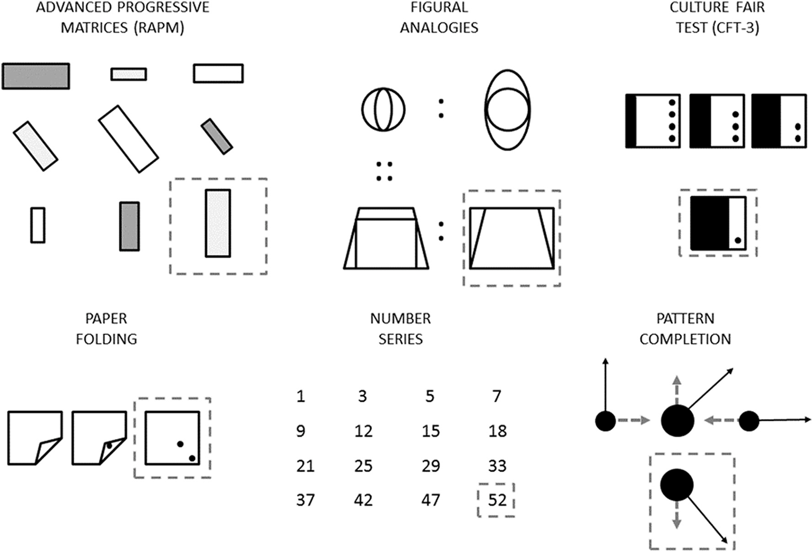
M. Ociepka et al.
Intelligence 92 (2022) 101644
Fig. 1. Exemplar items (not actual ones) of each of the six fluid reasoning tests in the study. The correct response (framed by a dashed line) was missing, and had to be selected from the item's response bank (four to eight options depending on a test). RAPM and Figural Analogies were computerized, the remaining tests were applied in the paper-and-pencil format.
2.5. Calculating individual alpha frequency

EEG data collected during resting sessions (1,2,3), the vigilance session, and the fixation and retention intervals of the VSTM task served to calculate 6 IAF estimates (one IAF per session per participant). The
AF4, F3, F1, Fz, F2, F4, FC3, FC1, FCz, FC2, FC4). At this step,
additional 2% of all IAF values were identified.
- The algorithm output from steps (a) and (b) was checked manually to remove evident mistakes, such as IAF values for spectra with two or more peaks. This check was carried out by two co-authors working together.
- The fourth step consisted of the manual inspection of the alpha power spectra not identified by the algorithm. The alpha elevations were classified as IAFs if they included a clearly identifiable peak not wider than 2 Hz.
Out of 171 people for whom the EEG signal was analyzed, 18 par- ticipants (10.5% of the total sample size) were removed, because no more than two reliable IAFs could be identified for them. Such a rejec- tion rate is typical for studies on IAF (e.g., Posthuma et al., 2001). For the 153 participants analyzed further, as many as 91.4% of IAF values were successfully defined (i.e., 839 values out of 918). At least three IAF values were identified for each participant, with 5.48 values identified
average length of continuous EEG signal analyzed equaled 310 s (SD =
27.30) for resting session 1, M = 221 s (SD = 14.95) for resting session 2,
M = 223 s (SD = 14.66) for resting session 3, and M = 236 s (SD = 35.71)
for the vigilance session. The EEG signal from the fixation and retention intervals was cut to 6500-ms epochs each. On average, there were 138
IAFs were estimated using the Philistine package (Corcoran, Alday, Schlesewsky, & Bornkessel-Schlesewsky, 2018) implemented in Python. Its savgol_iaf function first applied a Fast Fourier Transform to the EEG data, then ran a Savitzky-Golay filter to smooth computed power spec- trum, and finally either detected local maxima to estimate the IAF or reported that a unique IAF value could not be found. For the IAF calculation, we followed the guidelines from the authors of the package. Overall, the procedure consisted of two automatic and two manual steps:
- The Philistine package extracted IAFs from the parietal electrodes (CP3, CP1, CPz, CP2, CP4, P3, P1, Pz, P2, P4, PO3, POz, PO4). Pa- rameters of the algorithm were set to search for IAF between 4 and 14 Hz with a resolution of 0.25 Hz. All peaks below 7 Hz found by the algorithm were removed, because the package had a tendency to select the lowest possible value from the given range (the output close to 4 Hz indicated that no univocal IAF had been found; for a detailed argument, see Klimesch et al., 1996; Klimesch, 1999; Kli- mesch, Doppelmayr, Russegger, Pachinger, & Schwaiger, 1998). At this step, 69% of all IAF values were reliably identified.
- The missing IAF values were attempted by applying the algorithm described in (a) to the signal from the frontal electrodes (AF3, AFz,
epochs (SD = 6.58) per participant.
on average (SD = 0.89). The missing 79 values were imputed using the
expectation maximization algorithm (IBM SPSS Statistics, v. 27.0, IBM Corp).
2.6. Modeling relationships between IAF and cognitive ability

The relationships between IAF and the variables reflecting the four assumed cognitive abilities (processing speed, visual discrimination, working memory, and fluid reasoning) were established using the covariance structure modeling (Kline, 2016). Specifically, the variant called confirmatory factor analysis (CFA) was used, which assumed that the variance across measures reflecting a given ability (e.g., the three inspection time estimates from Lines, Circles, and Squares; so-called manifest variables) was driven by some latent ability (e.g., processing speed; the so-called latent variable), which could not be directly
5
M. Ociepka et al.

observed, but loaded on each manifest variable to some extent. Because the estimation of particular IAF values had limited reliability, IAF was also represented as a latent variable loading the six IAF values. Due to defining abilities as latent variables (i.e., as the variance shared by all the respective manifest variables), the task-specific and unrelated vari- ance could be filtered out, and the resulting latent variable likely dis- played near-perfect reliability. The relationships between the latent variables were estimated using maximum likelihood, as implemented in the Sepath package (TIBCO Software Inc.). The resulting model's validity was assessed by comparing the fit of the covariance matrix reproduced by the model to the observed covariance matrix, as indicated by the
standardized root mean square residual [SRMR, criterion value <0.08), the root mean square error of approximation [RMSEA <0.08], and Bentler's confirmatory fit index [CFI > 0.92] (see Kline, 2016). Latent
variable loadings on manifest variables should surpass 0.40 (Matsunaga, 2010).
Two CFA models were fitted. Model 1 estimated the correlations between the IAF latent variable and the four cognitive ability latent variables (processing speed, visual discrimination, working memory, and fluid reasoning). Model 2 estimated the correlation between the IAF latent variable and a higher-order latent variable loading the four cognitive ability latent variables, aimed to reflect general intelligence (g factor).

- Results
  - IAF distribution, sensitivity, and consistency

Table 1 presents descriptive statistics and Table 2 presents Pearson correlations for all variables included in the CFA models. Skew close to zero and kurtosis below 1 except for IAF during resting session 1 (1.15) indicated that all six IAF estimates approximated the normal distribu- tion (see Table 1). None of them was significantly related to sex, each t
(151) < 1.08.
Next, we tested whether IAF increased with increasing cognitive activation, that is, from resting state to vigilance session (increased attention), and from the latter session to the VSTM task (increased attention plus memory load), as previously observed empirically (e.g., Haegens, Vergara, Rossi-Pool, Lemus, & Romo, 2017) and predicted in computer simulations (Mierau, Klimesch, & Lefebvre, 2017). Indeed, the
Intelligence 92 (2022) 101644

mean IAF value significantly varied across the six measurements, F
η2
(5,760) = 24.36, p < .001, = 0.13. Although, IAF significantly
decreased from resting session 1 (10.39 Hz) to resting session 2 (10.21
Hz) and 3 (10.10 Hz), F(1, 152) = 57.99, p < .001, probably reflecting
the novelty effect in session 1, it significantly increased between the
three resting sessions and the vigilance session (10.42 Hz), F(1, 152) =
30.82, p < .001, as well as between the vigilance session and the fixation and retention intervals of the VSTM task (10.54 and 10.52 Hz, respec-
tively), F(1, 152) = 4.56, p = .034. Therefore, IAF values in our study
were subject to the cognitive activation effects that were expected by the alpha band literature.
To further validate the IAF estimates, we tested whether the amount of increase in the IAF from resting sessions to VSTM task is related to the performance on this task, trying to replicate the result that presumed cognitive activation facilitates working memory, observed by Pahor and Jauˇsovec (2016). Specifically, we averaged the IAF values for the fixa- tion and retention intervals of the VSTM task, from the resulting mean we subtracted the averaged IAFs from resting session 2 and 3, and finally
we correlated the resulting difference in means (ΔM = 0.37 Hz, SD =
0.58) with accuracy on the VSTM task (M = 0.84, SD = 0.08). Five
outlying participants (three women, two men), who scored below 0.60 in the VSTM task, were excluded from this analysis. The overall corre-
lation was not significant, r = 0.123, p = .137, but when computed
separately for women and men, it revealed a substantial difference be- tween the two groups: IAF was significantly related to female VSTM
performance, r = 0.308, p = .009, but unrelated to male performance, r
= -0.012, p = .917 (Fig. 2).
Regarding its reliability, IAF showed strong consistency across the
three resting sessions and the vigilance session, with a grand-mean
correlation of r = 0.895. This result indicates a substantial trait-like
property of IAF (see Grandy, Werkle-Bergner, Chicherio, Schmiedek, et al., 2013). The fixation and retention intervals from the VSTM tasks yielded relatively lower IAF correlations with the other sessions, with a
grand-mean correlation of r = 0.752. The observed difference in corre-
lation across the IAF measurements might in part result from the dif- ference in the form of the EEG signal (continuous for resting and vigilance sessions vs. epoched for the fixation and retention intervals).
Table 1
Descriptive statistics for all measures used in the CFA models (N = 153).
Mean
Standard deviation
Minimum
Maximum
Skew
Kurtosis
IAF – resting 1 IAF – resting 2 IAF – resting 3 IAF – vigilance
IAF – VSTM fixation IAF – VSTM retention Gf – RAPM
Gf – Figural Analogies Gf – Pattern Completion Gf – Number Series
Gf – CFT-3
Gf – Paper Folding WM – Mental Counters WM – N-back
WM – Simple Span WM – Complex Span
WM – Change Detection Inspection time – Circles Inspection time – Lines Inspection time – Squares Perception – Size Perception – Orientation Perception – Brightness
10.39
10.21
10.10
10.42
10.54
10.52
20.38
21.45
9.18
10.59
28.60
10.20
0.24
0.57
0.53
0.62
1.90
102.77
91.16
74.71
2.30
4.74
4.01
0.99
0.99
0.90
0.94
1.08
1.02
4.94
4.56
3.23
3.41
5.36
3.41
0.19
0.26
0.15
0.19
1.34
31.18
38.13
28.21
1.03
2.68
2.09
7.50
7.25
7.25
7.50
7.75
7.50
3.00
5.00
1.00
2.00
9.00
1.00
13.75
13.25
12.75
13.00
13.25
13.50
31.00
30.00
16.00
17.00
41.00
16.00
0.74
0.99
0.87
0.99
5.23
224.00
271.25
250.25
5.62
14.62
11.88
-0.06
1.15
0.73
0.67
0.48
-0.15
-0.28
-0.28
-0.13
-0.19
0.11
0.09
1.18
0.48
-0.91
-0.56
-0.01
-0.51
-0.14
-0.60
-0.23
0.05
-0.26
-0.59
-0.18
0.12
-0.45
-0.10
-0.42
-0.58
0.19
0.11
0.09
-0.39
-0.36
-0.47
-0.51
0.32
0.95
1.85
2.03
0.83
1.17
1.32
-0.84
52.50
40.25
15.75
0.38
0.88
1.25
0.98
4.84
9.36
0.51
1.38
2.00
Note. Table present descriptive statistics for all measures used in the CFA models (N = 153). VSTM = visual short-term memory; Gf = fluid intelligence (factor); RAPM
= Raven's Advanced Progressive Matrices; CFT-3 = Culture Free Test Version 3; WM = working memory (factor).

6

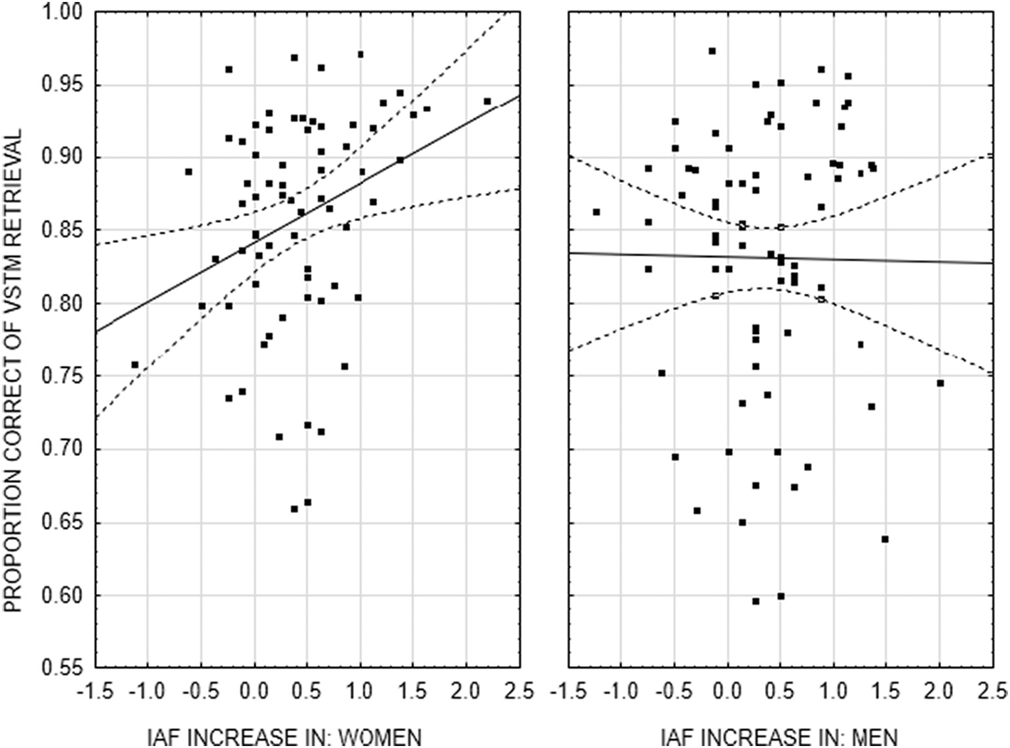
M. Ociepka et al.
Intelligence 92 (2022) 101644
Table 2
Correlations for all measures used in the CFA models (N = 153).
IAF resting 1
IAF resting 2
IAF resting 3
IAF vigilance
IAF VSTM fixation
IAF VSTM fixation
IAF – resting 1 IAF – resting 2 IAF – resting 3 IAF – vigilance
IAF – VSTM fixation IAF – VSTM retention Gf – RAPM
Gf – Figural Analogies Gf – Pattern Completion Gf – Number Series
Gf – CFT-3
Gf – Paper Folding WM – Mental Counters WM – N-back
WM – Simple Span WM – Complex Span
WM – Change Detection Inspection time – Circles Inspection time – Lines Inspection time – Squares Perception – Size Perception – Orientation Perception – Brightness
–
0.92
0.88
0.85
0.70
0.83
–
0.93
0.89
0.74
0.77
–
0.90
0.74
0.79
–
0.71
0.76
–
0.76
0.05
0.09
–
-0.07
-0.02
-0.02
-0.06
-0.08
-0.05
-0.03
-0.04
-0.04
-0.03
-0.08
-0.06
-0.10
-0.10
-0.02
-0.10
0.02
0.05
0.05
0.04
0.01
0.03
0.03
0.01
0.02
0.10
-0.03
0.01
-0.10
-0.10
-0.11
-0.12
-0.03
-0.10
0.05
0.10
0.02
0.06
0.02
0.04
0.07
0.00
0.02
0.09
0.01
0.05
0.00
0.04
0.08
-0.01
0.00
0.00
0.00
-0.02
-0.00
-0.00
0.00
0.01
-0.02
-0.03
0.05
0.09
-0.01
-0.03
-0.12
-0.10
-0.09
-0.04
-0.12
-0.17
-0.19
-0.17
-0.16
-0.16
-0.14
-0.19
-0.16
-0.17
-0.17
-0.19
-0.15
-0.20
-0.08
-0.06
-0.05
-0.08
-0.14
-0.06
0.12
0.17
0.21
0.17
0.05
0.10
-0.14
-0.14
-0.10
-0.08
-0.15
-0.08
Note. Table present correlations between 6 individual alpha frequency (IAF) values and 17 behavioral results from cognitive tasks. Correlations stronger than r = |0.16|
(r = |0.21|) were significant at the p < .05 (p < .01) level. VSTM = visual short-term memory; Gf = fluid intelligence (factor); RAPM = Raven's Advanced Progressive
Matrices; CFT-3 = Culture Free Test Version 3; WM = working memory (factor).
Fig. 2. Correlation between the increase in individual alpha frequency (IAF) from the resting sessions to the visual short-term memory (VSTM) task and accuracy on the latter task in women (left panel) and men (right panel). Solid line = regression line, dotted lines = 95% confidence belt.
3.2. Correlations between IAF and cognitive ability variables

The variables representing cognitive abilities approximated the
visual discrimination and inspection time tasks could not be calculated, but their latent level correlations with the training session accuracy approaching one suggested good test-retest reliability.
normal distribution (skew < 2, kurtosis < 5), except for one inspection
All cognitive tasks intercorrelated significantly, except for several
time task (Squares variant; see Table 1). All the six fluid reasoning tests correlations yielded by two discrimination tasks (i.e., Size and Bright- showed good internal consistency, yielding Cronbach's α > 0.70. Simi- ness; see supplementary materials). The intercorrelations of the tasks larly, Cronbach's α > 0.87 for the five working memory tasks were very within consecutive cognitive-ability categories were strong, justifying good. Because of the adaptive algorithm, internal consistency for the treating the variables from a given category as manifesting an
7

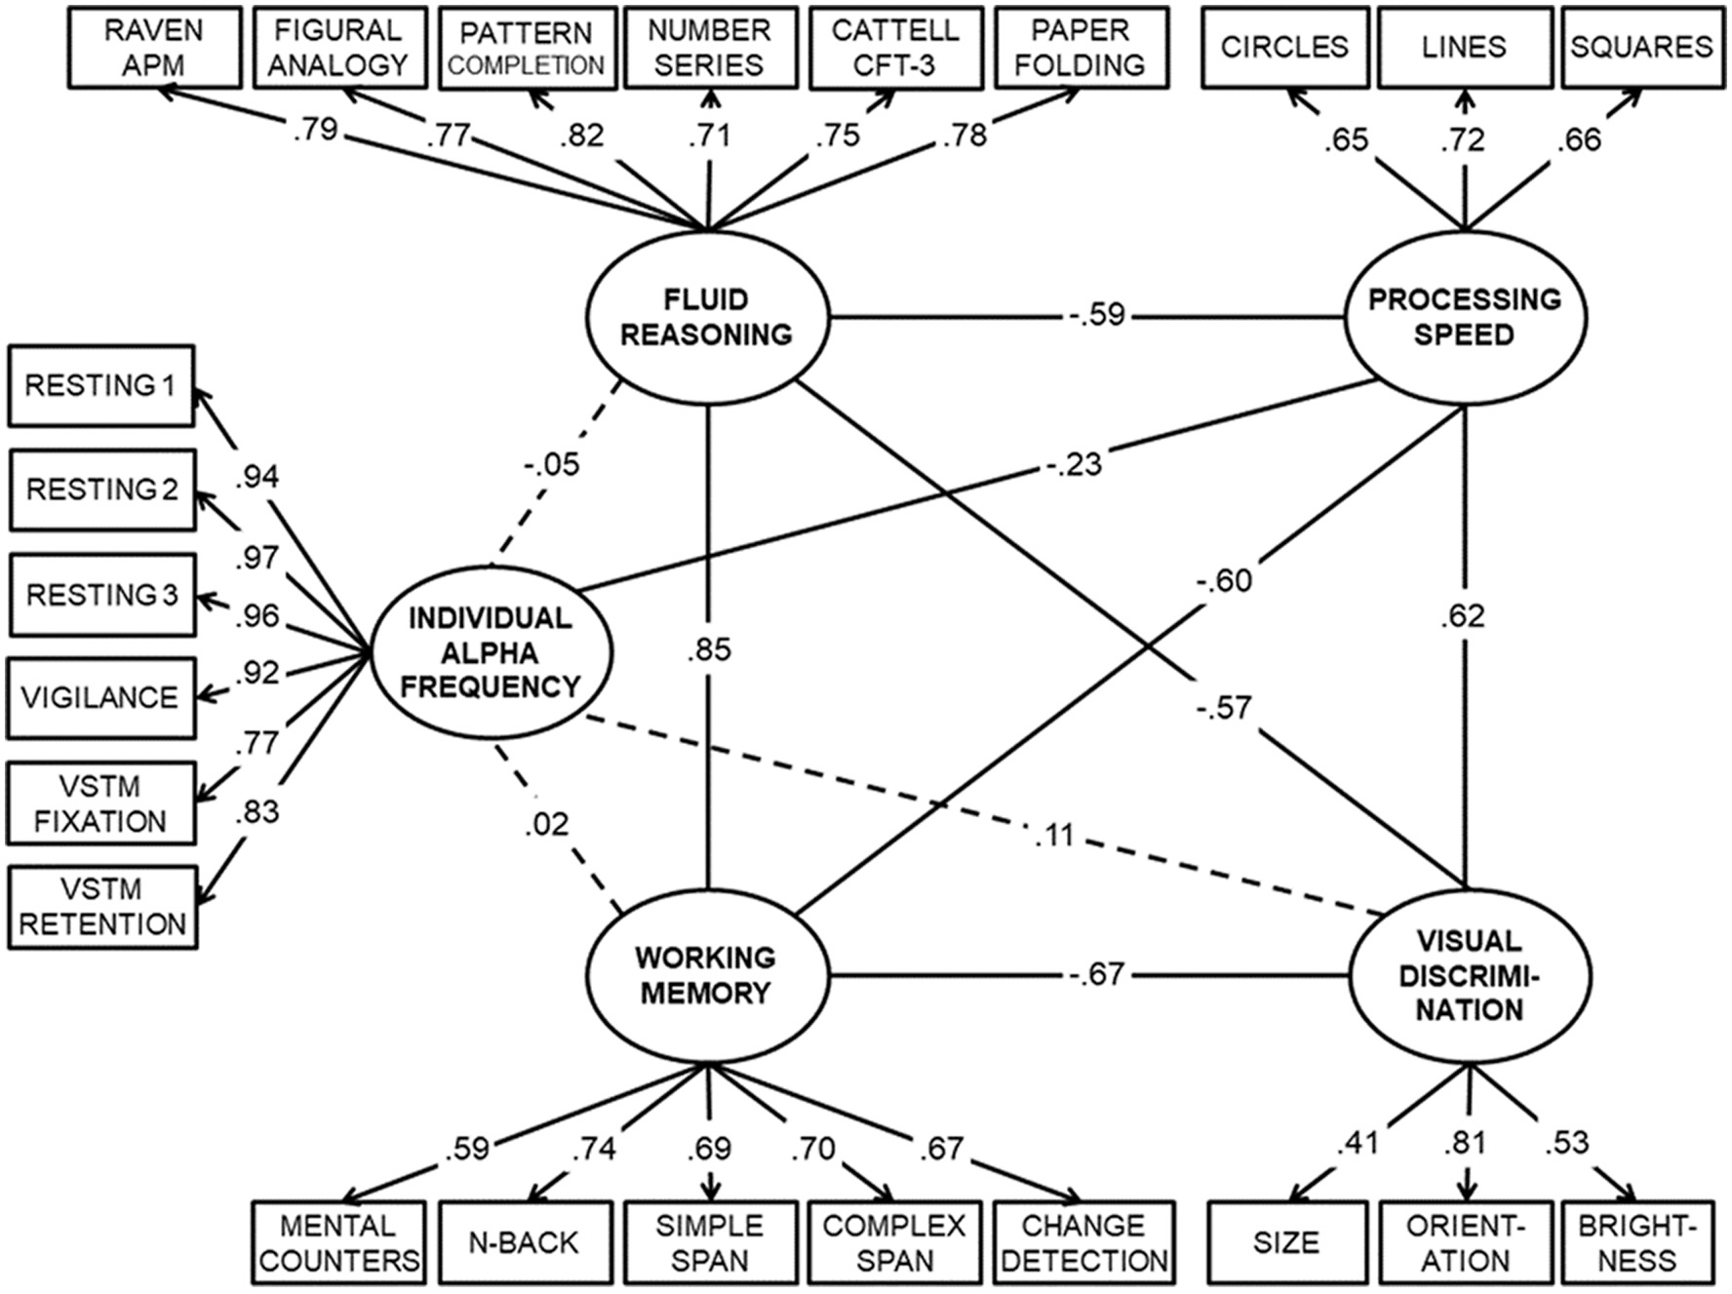
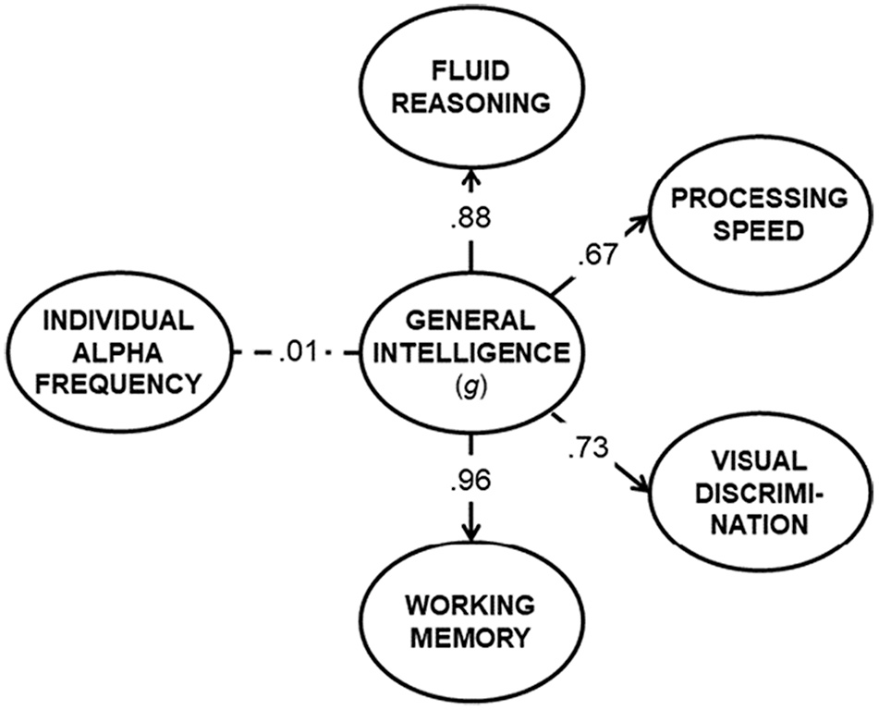
M. Ociepka et al.

underlying cognitive ability. The correlations for five out of the six IAF estimates with the Square and Lines variants of the inspection time task, as well as one such correlation for the Circles variant, were significant
Intelligence 92 (2022) 101644

(see McGrew, 2009), the higher-order factor relied primarily on
reasoning (the factor loading equaling λ = 0.876) and memory (λ =
0.964), while the loadings of discrimination and speed were substan-
but weak, r = -0.160 to -0.197. Three significant weak IAF links led to
tially lower (λ = 0.731 and 0.667, respectively). The higher-order var-
the Orientation task, but not to the two other discrimination tasks. No other relationship between cognitive tasks and IAF reached the level of statistical significance.
Although age weakly but significantly predicted IAF from the resting
iable correlation with IAF was virtually null (see Fig. 4). Actually, when it was fixed to zero, the fit of the model dropped negligibly, Δ χ2(1) =
session 3, r = 0.162, p = .045, and from the retention interval, r = 0.173,
p = .032 (for the remaining IAFs, p > .09), correcting for age affected
significantly no IAF correlation with cognitive variables, all Δr < 0.04.
3.3. Relationships between IAF and specific and general cognitive factors

Significant IAF correlations with two inspection time tasks but virtually no other correlations with cognitive variables suggested that the IAF latent variable might be related with processing speed, but un- related to reasoning, memory, and discrimination. Model 1 (Fig. 3)
yielded a very good fit to the data, χ2(220) = 324.21, SRMR = 0.056,
RMSEA = 0.046 [0.030, 0.060], CFI = 0.955. All latent variables
significantly loaded their respective measurements. In line with the correlation matrix, the four cognitive latent variables intercorrelated
strongly (from r = -0.567 to r = 0.855). However, only the processing
speed latent variable correlated significantly with the IAF latent vari-
able, r = -0.235, p = .011. The remaining correlations were not sig-
nificant, all p > .20.
In Model 2, the four cognitive latent variables were loaded by a higher-order latent variable, reflecting general intelligence (g factor), and the latter variable was allowed to correlate with the IAF variable.
Fig. 4. CFA model of the relationship between latent variables (ovals) reflecting individual alpha frequency, as measured with EEG, and general in- telligence (g factor), the latter loading four cognitive abilities. Numbers by solid lines (arrows) represent correlation coefficients (loadings). Dotted line indicates non-significant value.
The model yielded a good fit, χ2(225) = 344.51, SRMR = 0.068, RMSEA
= 0.047 [0.032, 0.061], CFI = 0.948. In line with the extant literature
Fig. 3. CFA model of the relationships between latent variables (ovals) reflecting individual alpha frequency (measured with EEG) and four cognitive abilities. Boxes represent manifest variables. Numbers by lines (arrows) represent correlation coefficients (loadings). Dashed lines mark non-significant values.
8
M. Ociepka et al.

0.15, ns.
Finally, to test whether it was possible to turn a null IAF-g correlation (Model 2) into a significant one when the g factor relied primarily on the processing speed variable (the case of the model by Grandy, Werkle- Bergner, Chicherio, Lo¨vd´en, et al., 2013), we intentionally mis-
Intelligence 92 (2022) 101644

spatial, design, and numerical relations in order to select the correct response out of five options. The difficulty of items increased gradually (from the easiest to the hardest). The score was the number of correct responses. The PMRT conceptually matched the RAPM test.
Spatial discrimination ability was measured using the Penn Line Orientation Test (PLOT; Moore et al., 2015). The PLOT included 24 items, each presenting two line segments differing in orientation. The participant's task was to rotate one of the segments so it became parallel to the other segment. The score was the number of correctly rotated line segments. The PLOT conceptually matched the Orientation task from the EEG study.
Working memory was measured using The List Sorting Test (Tulsky et al., 2014) from the NIH Toolbox Cognitive Battery (all NIH Toolbox- related materials are ©2015 Northwestern University and the National Institutes of Health). Either single or double lists of animals and food, ranging from two to seven objects, were presented visually and vocally. The participant's task was to recite the names of the objects sorted ac- cording to size in the single lists, and also recite them separately for each category in the double lists. The score was the number of correctly recited objects, transformed to standardized t-metric.
The Pattern Comparison Processing Speed Test (PCPS; Carlozzi, Beaumont, Tulsky, & Gershon, 2015) measured so-called clerical speed and required categorizing, using computer buttons, as many pairs of simple pictures as possible into either identical or differing in shape or color. The speed score was the number of items completed correctly within 90 s. Therefore, conversely to the inspection time scores reported for the EEG study, lower PCPS scores indicated lower processing speed.
4.3. Relationship between alpha individual frequency and cognitive factors
IAFs equaled 7 Hz for 1, 8 Hz for 5, 9 Hz for 16, 10 Hz for 36, 11 Hz for 27, and 12 Hz for 9 participants, thus being normally distributed. IAF
specified our higher-order model by fixing a strong loading (λ = 0.80) of
the g factor on the speed variable, while decreasing the respective
loadings on reasoning, memory, and discrimination to λ = 0.70 (all these
values matched the loadings in Grandy, Werkle-Bergner, Chicherio, Lo¨vd´en, et al., 2013). As a result, such a “g factor” (actually, primarily
the speed factor) started to correlate with IAF, r = -0.435, p < .001;
however, this misspecified model fitted the data poorly, SRMR = 0.390,
CFA = 0.798.
- Follow-up analysis

The analyses performed above indicated that the IAF is unrelated to general cognitive ability. The null links were observed both at the zero- order correlation level and the latent variable level. The sole relation- ship of IAF with cognition was limited to its weak link with processing speed, the latter operationalized as the inspection time. In order to confirm the above conclusion, we re-analyzed the publicly available MEG data of 94 young healthy adults (45 women; aged 22–35 years) obtained from The Human Connectome Project (HCP; https://www.hu manconnectome.org/study/hcp-young-adult), in which the IAF values had already been estimated for the MEG signal from three eyes-open resting sessions and three cognitive tasks. The participants completed several cognitive tasks outside the MEG scanner.
  - MEG data from the human connectome project

MEG data in the HCP were collected using the whole head MAGNES 3600 (4D Neuroimaging, San Diego, CA) system housed in a magneti- cally shielded room, located at the Saint Louis University medical campus.
Each participant completed a three-hour MEG recording procedure, which began with a 5-min “empty room scan” to detect hardware mal- functions or excessive environmental noise as well as one-minute scan for magnetic artifacts. First, three sessions of six-minute eyes-open resting state recordings were collected. Next, the signal was recorded from three tasks administered in the following order: the N-back task, Language Processing task (Binder et al., 2011), and Motor task (Buckner, Krienen, Castellanos, Diaz, & Yeo, 2011).
The alpha peak frequency for each participant was calculated by the HCP staff in two steps. First, sensors were divided into four arrays (anterior left and right and posterior left and right). For each resting session and each task, the spectra were calculated for all arrays and then averaged within each group of sensors and across time. Second, the alpha peaks were automatically estimated. Algorithm fitted polynomial function to the spectra data. The task alpha peaks were determined as maximum of this function in the range of 6–14 Hz. After estimation, the alpha peaks were manually verified and corrected if necessary. The final peak frequency for each participant equaled the median of all the peak frequencies defined by the algorithm, with a resolution of 1 Hz. For more detail see https://wiki.humanconnectome.org/display/PublicData/Indi
did not vary with age (F = 0.56). Males displayed significantly larger IAF
values (M = 10.41 Hz) than females (M = 9.91 Hz), t(92) = 2.32, p =
.023. The PMRT, PLOT, and List Sorting scores were moderately inter-
correlated (r ≈ 0.3), but were unrelated to IAF (all r < 0.090, p > .40). In
contrast, the PCPS score was not significantly related to PMRT, r =
0.104, p = .321, and List Sorting, r = 0.133, p = .202, while its corre-
lation with PLOT was marginal, r = 0.198, p = .055, but it significantly
predicted the IAF value, r = 0.253, p = .014 (note that this time the
correlation was positive because clerical speed was operationalized as the number of items processed in a given time interval).
Similarly as for EEG data, for the MEG data we analyzed relation- ships between the scores and IAF using the CFA model. The general intelligence (g) latent variable was loaded by PMRT, PLOT, and List Sorting. Because the PCPS score did not correlate significantly with the three other scores, it was set to load another latent variable (processing speed) as a single measure, with loading forced to 1.0. Also the IAF latent variable was loaded by a single IAF measurement, with loading
forced to 1.0. The model yielded good fit, χ2(4) = 2.90, SRMR = 0.031,
RMSEA = 0.0 [0.0, 0.133], CFI = 1.0, although the fit indices were not
fully informative because of the low number of the model's degrees of freedom. Fig. 5 shows that the speed and the g factor were weakly and
marginally related, r = 0.248, p = .056, there was a weak but significant
vidual+Subject+Alpha+and+Beta+Peak+Frequency+Determination.
link between IAF and processing speed, r = 0.256, p = .009, but no
Algorithm used in HCP to calculate IAF was similar to the Philistine
relationship between IAF and g, r = 0.050, p = .711. Forcing the latter
link to 0 did not significantly affect the model fit, Δ χ2(1) = 0.13, ns.
- General discussion
  - Results summary

Reviewing the existing literature on the links between IAF and cognition, Grandy, Werkle-Bergner, Chicherio, Lo¨vd´en, et al. (2013), (p.
11) hypothesized that individual alpha frequency “is linked to cognitive
package used to calculate IAFs for the EEG data used in this publication. The main difference between them was that the HCP approach fitted polynomial functions instead of using a smoothing filter.
4.2. Cognitive tasks in the human connectome project

Reasoning ability was measured using the Penn Matrix Reasoning Test (PMRT; Moore, Reise, Gur, Hakonarson, & Gur, 2015). The PMRT included 24 items that required the identification and application of
9
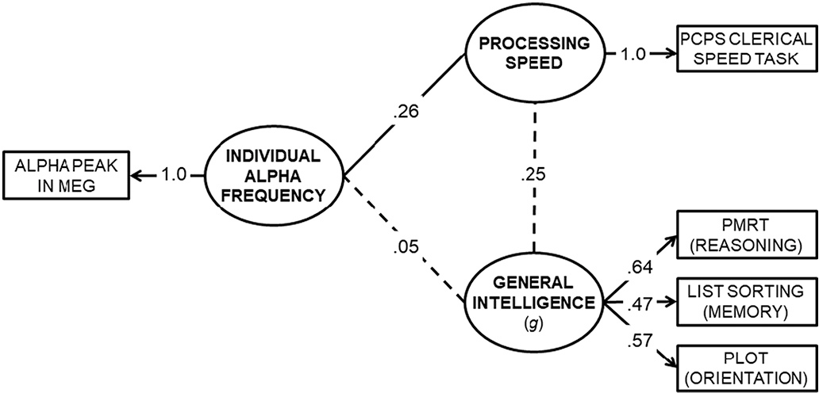
M. Ociepka et al.
Intelligence 92 (2022) 101644

Clayton, Yeung, & Kadosh, 2015; Gągol et al., 2018; Klimesch, 2012; Lisman & Jensen, 2013; Mathewson, Gratton, Fabiani, Beck, & Ro, 2009; Pahor & Jauˇsovec, 2014; Roux & Uhlhaas, 2014; Samaha & Postle, 2015; Sauseng, Peylo, Biel, Friedrich, & Romberg-Taylor, 2019; Van- Rullen, 2016). At the same time, research on the neurophysiological underpinning of cognitive ability largely converges to the idea that in- telligence is a complex and widely-distributed property of the brain, stemming from its structural (Clayden et al., 2012; Deary, Penke, & Johnson, 2010; Ohtani et al., 2014; Pineda-Pardo et al., 2016) and functional connectivity (Finn et al., 2015; Haier & Jung, 2016; Hilger, Ekman, Fiebach, & Basten, 2017, Hilger et al., 2020; Schubert, Hage- mann, Lo¨ffler, Rummel, & Arnau, 2021; Schultz & Cole, 2016; Thatcher, North, & Biver, 2005; Van Den Heuvel, Stam, Kahn, & Pol, 2009) as well as dynamic (re)organization (Barbey, 2018; Gu et al., 2015; Santar- necchi, Galli, Polizzotto, Rossi, & Rossi, 2014).
As mentioned in Section 1, IAF, being the most prominent rhythm in the power spectrum and displaying trait-like properties, has been asso- ciated with coordinating and integrating brain function (Clayton et al., 2018; Doesburg et al., 2009; Jensen & Mazaheri, 2010; Klimesch, 2012; Roux & Uhlhaas, 2014). More specifically, a shorter alpha cycle was theorized to translate into a faster fronto-parietal-thalamic cycle, resulting in a more efficient information propagation and integration across widely-distributed brain regions (Vald´es-Herna´ndez et al., 2010). Therefore, IAF seemed to be a promising candidate for a neurophysio- logical marker of general cognitive ability. Why then has our compre- hensive analysis of two independent datasets failed to provide evidence for a link between IAF and general cognitive ability? We propose that IAF contribution to general intelligence may be negligible for at least two reasons.
First, recent theorizing (e.g. Bas¸ar & Güntekin, 2012; Clayton et al., 2018) suggests that the alpha rhythm is not bound to a single specific neural mechanism, but reflects several distinct functions, with the co- ordination of brain activity being just one of them, along with inhibi- tory, sampling, predictive, and stabilizing functions, as well as stimuli maintenance in working memory (Leszczyn´ski, Fell, & Axmacher, 2015; Roux & Uhlhaas, 2014; Sauseng et al., 2019). Therefore, the alpha rhythm most likely reflects several spatially and temporally distinct oscillations, with the majority of them actually being unrelated to in- telligence. IAF recorded by means of EEG or MEG may comprise some resultant aggregated frequencies, and consequently it may be unable to precisely reflect these specific functions which are critical for cognitive ability.
Second, the coordination of the brain functioning, presumed to un- derpin efficient cognition, seems to constitute a much more complex phenomenon than just the above mentioned duration of the fronto- parietal-thalamic cycle, associated with IAF. In the temporal dimen- sion, efficient cognition seems to be rooted in the subtle and precise synchronization and modulation of various oscillatory rhythms, such as phase locking of distant generators of a single band (Palva et al., 2010; Polanía, Nitsche, Korman, Batsikadze, & Paulus, 2012; Singer, 1999), or cross-frequency coupling between phases and amplitudes of distinct bands (Canolty et al., 2006; Canolty & Knight, 2010; Cohen, 2011; Fell & Axmacher, 2011; Gągol et al., 2018; Jensen & Colgin, 2007; Leszczyn´ski et al., 2015; Pahor & Jauˇsovec, 2014; Palva et al., 2010; Sauseng, Freunberger, Feldheim, & Hummel, 2011). It is unlikely that a single index such as IAF is able to capture the functional characteristics of multiple within- and cross-frequency synchronizations in the brain. Also in the spatial dimension, efficient cognition was associated with certain complex patterns of brain connectivity beyond IAF, such as relying on particular communication hubs (Takeuchi et al., 2021; Van Den Heuvel et al., 2009), dynamic changes in connectivity patterns (Gu et al., 2015; Hilger et al., 2020; Schubert et al., 2021), exploiting weak functional connections (Santarnecchi et al., 2014), and maintaining arbitrary connections that violate well-established communication routes (Bar- bey, 2018).
Fig. 5. CFA model of the relationship between latent variables (ovals) reflecting individual alpha frequency, as measured with MEG, general intelli- gence (g factor), and the processing speed (data from the Human Connectome Project). Numbers by solid lines (arrows) represent correlation coefficients (loadings). Dotted lines indicate non-significant values. Note that the speed variable is reversed (number of items categorized in a given time interval).
performance in a general rather than in a specific manner”. In line with this hypothesis, their higher-order latent variable representing the variance shared by processing speed, memory, and reasoning tasks (presumed to reflect a general cognitive ability) correlated with IAF at r
= 0.40. However, our careful evaluation of their study revealed several
methodological problems which undermine the credibility of their findings. The most prominent methodological flaws of the study by Grandy et al. likely include the bimodal age distribution, insufficient measurement of IAF at the latent level (only two measures), an arguable calculation of the g factor (which in their study was dominated by processing speed, while in the general literature is associated primarily with fluid reasoning; see McGrew, 2009). Therefore, whether IAF is or is not related with general cognition (intelligence) was still an open question, which was addressed by the present study.
EEG data served to extract six highly reliable IAF estimates in a group of 153 young adults. Cognitive performance was assessed using six fluid reasoning tests, five working memory tasks, three inspection time tasks, and three stimulus discrimination tasks. Both the broad abilities (the fluid reasoning, working memory, processing speed, and visual discrimination first-order factors) and the general cognitive ability (the higher-order latent variable explaining correlations among the broad ability factors) were modeled. For the broad ability factors, only the speed factor correlated weakly with the IAF latent variable (5.5% of variance shared). The higher-order cognitive factor was unrelated to the IAF variable. However, when this factor was deliberately misspecified to match the factor structure presented in Grandy, Werkle-Bergner, Chi- cherio, Lo¨vd´en, et al. (2013), we were able to recreate the relationship reported by Grandy, Werkle-Bergner, Chicherio, Lo¨vd´en, et al. (2013). Yet, a misspecified higher-order cognitive factor fitted poorly and cannot be validly interpreted as reflecting general intelligence.
The weak correlation of IAF with speed as well as its null relationship with the general ability factor were replicated in another dataset, ac- quired using a different methodology (MEG instead of EEG). Impor- tantly, the IAF values in the MEG study were estimated with a somewhat different procedure than in the EEG study, which additionally supports the robustness of the findings reported in the current study. Collectively, the results of the present study implicate that, although IAF can be considered a reliable neural index in young adults, it should not be considered a predictor of a general cognitive ability (intelligence, g factor).
5.2. Why has IAF failed to predict general cognitive ability in the adult population?
The rich literature has highlighted the importance of coordinated oscillatory activity for cognitive processing (Canolty & Knight, 2010;
10
M. Ociepka et al.

  - IAF as a marker of processing speed

A significant negative correlation between IAF and processing speed observed in the first latent-variable model suggests that a higher IAF value is related to faster processing. The observation of this relationship is not unexpected, as it has been previously reported in adult samples (Angelakis et al., 2007; Klimesch et al., 1996). However, despite the available evidence, there is still no consensus in the literature on the origin of this relationship. We considered two viable explanations.
The most straightforward explanation is that the higher the oscilla- tion rate in the brain, the faster the brain processes information. Faster brain processing directly translates into faster reaction time, as indexed by inspection time tasks (Huang, Jung, & Makeig, 2009). The alternative explanation stems from research showing that different alpha phase windows differently affect stimulus processing. While certain alpha phase windows (typically, troughs) have been shown to facilitate stim- ulus processing, some other windows (peaks) were argued to delay this process (Leszczyn´ski et al., 2015; Mathewson et al., 2012; VanRullen, 2016). Therefore, the presentation of the stimulus during a suboptimal alpha cycle window may lead to slower stimulus processing, reflected in longer reaction times (Klimesch et al., 1996; Naruse, Takiyama, Okada, Umehara, & Sakaguchi, 2015). It is possible that the higher the IAF, the faster the optimal alpha cycle window occurs that allows the stimulus to be processed. This conjecture is supported by observations that an effective synchronization between the frontal and parietal brain regions at the higher alpha frequency, but not at the lower frequency, facilitates stimulus processing, which translates into faster reaction times (Lobier, Palva, & Palva, 2018).

  - Task sensitivity of IAF

While IAF is commonly considered a stable neuro-trait (Grandy, Werkle-Bergner, Chicherio, Schmiedek, et al., 2013; Klimesch et al., 2007; Levin et al., 2020; Posthuma et al., 2001; van Beijsterveldt & Boomsma, 1994), several studies have also pointed to its state-like property (Haegens et al., 2014; Mierau et al., 2017; Pahor & Jauˇsovec, 2016). In particular, research has suggested that the magnitude of IAF may depend on the cognitive load. Importantly, the study by Pahor and Jauˇsovec (2016) showed that this effect may differ between men and women. In the current study, the IAF estimates were obtained from six EEG measurements that differed in the cognitive load (from no cognitive load in the resting sessions to a relatively high load in the VSTM task) and the groups of women and men were roughly equal in the dataset (47% of the sample were women). Therefore, this study is also of rele- vance for research investigating the state nature of IAF.
The observed reduction in IAF in the first resting session, as compared to the following two resting sessions, might have resulted from the fact it was the first session in the entire experiment, potentially related to novelty and stress. At the same time, however, the observed increase in IAF from the resting session to the vigilance session sug- gested that even a slight cognitive load (such as the need to focus on one's own breathing) can affect the magnitude of IAF. A further increase in IAF from the vigilance session to the VSTM sessions even more strongly suggests that IAF is sensitive to the degree of cognitive load (a greater load when performing a memory retrieval task, as compared to focusing on breathing), in line with previous studies (Haegens et al., 2014; Mierau et al., 2017). In addition to the differences in the magni- tude of the IAF across EEG measurements, we have also observed some between-sex differences related to IAF. Specifically, the increase in IAF in women from resting sessions 2 and 3 to the VSTM task predicted their scores on this task, replicating the results reported by Pahor and Jau-
ˇsovec (2016) and suggesting that additional mobilization of the cogni-
tive system to higher cognitive demand involves faster cycles of the alpha rhythm (Mierau et al., 2017). However, the equivalent effect was absent in male participants, which cannot be easily explained without further studies (see the next section).
Intelligence 92 (2022) 101644
5.5. Limitations and future directions

One limitation of our study stems from the lack of a fully automatic IAF calculation algorithm. Unfortunately, creating this kind of algorithm is extremely demanding, due the fact that a certain proportion of the population displays no univocal alpha peak and some individuals display two peaks. Therefore, the use of semi-automatic algorithms has been a typical approach in research on IAF so far (Roelofs et al., 2021; Zhang, Lu, Wang, Zhou, & Xu, 2021). However, to minimize the chance that our findings were influenced by the procedure of IAF estimation, these findings were corroborated successfully in an independent MEG dataset that used a different IAF estimation procedure.
The second potential limitation is the total length of the EEG mea- surement (90 min in total). Specifically, Benwell et al. (2019) suggested that the frequency of alpha peak oscillations (such as IAF) increases systematically with time-on-task. If this was the case, then the reported increase in IAF from resting-state sessions through the vigilance session to the VMST task might have not necessarily reflected between-task differences in cognitive load, but might have been a mere conse- quence of the duration of the EEG measurement. Therefore, the potential effect of time-on-task on the IAF data would undermine the state-like property of IAF discussed in Section 5.4. However, the 0.29-Hz drop in IAF from the first resting session to the second and third resting ses- sion suggests that the time-on-task effect was absent or even reversed in this study. Moreover, this potential shortcoming of the study does not affect its main correlational results, that is, the null IAF link with general cognitive ability as well as its weak link with processing speed, because all of the participants undertook the same EEG (and MEG) measurement procedure, in which the order of tasks was fixed.
Finally, the lack of significant relationships between IAF and g may be related with the difference in the level of their generalization (so- called Brunswick [a]symmetry; see Kretzschmar, Spengler, Schubert, Steinmayr, & Ziegler, 2018; Wittmann & Süß, 1999), as g reflected a broad level of aggregation, while IAF represented a narrow variable. It is at least theoretically possible that when either the overall brain fre- quency was represented more broadly (e.g., as a higher-order variable computed using diverse bands, including also theta and beta, and various EEG sites) or the cognitive ability was defined more narrowly (e. g., as cognitive efficiency, not effectiveness), their correlation would strengthen. Although the role of Brunswick symmetry for the relation- ships between neural and cognitive constructs should be considered in the future studies, the relatively weak links between IAF and both in- spection time and clerical speed (i.e., relatively narrow constructs) in our study suggest that even on the comparable level of aggregation the IAF contribution to cognitive abilities may not be substantial. Moreover, we aimed to examine IAF specifically, as a considerable, but – as reviewed – inconclusive literature pertained to this very frequency.
Despite the potential limitations discussed above, the study has some important implications for future research. While the high power of the present study allows to reject the hypothesis that IAF is “linked to cognitive performance in a general … manner” postulated by Grandy, Werkle-Bergner, Chicherio, Lo¨vd´en, et al. (2013); (p. 11), the reliable link between IAF and processing speed paves the way for the future studies on the neuronal mechanisms underpinning the relationship be- tween the frequency of the dominating alpha rhythm and the speed of making simple decisions and responses. Another interesting avenue is to investigate the state-property of IAF more deeply. Since we failed to replicate the relationship between an IAF increase and working memory performance in males, previously reported by Pahor and Jauˇsovec (2016), it seems important to systematically examine the relationships between the differences in IAF and cognitive performance in various tasks.
6. Conclusion
The hypothesis that IAF and general cognitive ability are related at
11
M. Ociepka et al.

the latent variable level was rejected in two relatively large datasets, each comprising measurements of the brain's cortical activity (M/EEG) and a representative battery of cognitive tests. IAF was unrelated to fluid reasoning, working memory, and visual discrimination, but, at the same time, it consistently predicted processing speed, indexed either by in- spection time (in the EEG dataset) or the number of processes items (in the MEG dataset). The results suggest that indeed brains with a higher IAF run faster, but this does not make them smarter. The study thus clarified the to date equivocal nature of the relationship between the frequency of dominating alpha rhythm and cognition.
Data and code availability statement
All raw data and the code needed to reproduce the results are openly available at the Open Science Framework (https://osf.io/kv2sx/).
Intelligence 92 (2022) 101644

Chuderski, A., & Necka, E. (2012). The contribution of working memory to fluid reasoning: Capacity, control, or both? Journal of Experimental Psychology: Learning, Memory, and Cognition, 38(6), 1689. https://doi.org/10.1037/a0028465
Clark, C. R., Veltmeyer, M. D., Hamilton, R. J., Simms, E., Paul, R., Hermens, D., & Gordon, E. (2004). Spontaneous alpha peak frequency predicts working memory performance across the age span. International Journal of Psychophysiology, 53(1), 1–9. https://doi.org/10.1016/j.ijpsycho.2003.12.011
Clayden, J. D., Jentschke, S., Munoz, M., Cooper, J. M., Chadwick, M. J., Banks, T., … Vargha-Khadem, F. (2012). Normative development of white matter tracts: Similarities and differences in relation to age, gender, and intelligence. Cerebral Cortex, 22(8), 1738–1747. https://doi.org/10.1093/cercor/bhr243
Clayton, M. S., Yeung, N., & Cohen Kadosh, R. (2018). The effects of 10 Hz transcranial alternating current stimulation on audiovisual task switching. Frontiers in Neuroscience, 12, 67. https://doi.org/10.3389/fnins.2018.00067
Clayton, M. S., Yeung, N., & Kadosh, R. C. (2015). The roles of cortical oscillations in sustained attention. Trends in Cognitive Sciences, 19(4), 188–195. https://doi.org/ 10.1016/j.tics.2015.02.004
Cohen, M. X. (2011). It’s about time. Frontiers in Human Neuroscience, 5, 2. https://doi. org/10.3389/fnhum.2011.00002
Colom, R., Haier, R. J., Head, K., A´lvarez-Linera, J., Quiroga, M.A´., Shih, P. C., &
Jung, R. E. (2009). Gray matter correlates of fluid, crystallized, and spatial intelligence: Testing the P-FIT model. Intelligence, 37(2), 124–135. https://doi.org/ 10.1016/j.intell.2008.07.007
Conway, A. R., Cowan, N., Bunting, M. F., Therriault, D. J., & Minkoff, S. R. (2002).
A latent variable analysis of working memory capacity, short-term memory capacity, processing speed, and general fluid intelligence. Intelligence, 30(2), 163–183. https:// doi.org/10.1016/S0160-2896(01)00096-4
Corcoran, A. W., Alday, P. M., Schlesewsky, M., & Bornkessel-Schlesewsky, I. (2018).
Toward a reliable, automated method of individual alpha frequency (IAF) quantification. Psychophysiology. , Article e13064. https://doi.org/10.1111/ psyp.13064
Cowan, N. (2001). The magical number 4 in short-term memory: a reconsideration of mental storage capacity. Behavioral and brain sciences, 24(1), 87–114.
Deary, I. J., Penke, L., & Johnson, W. (2010). The neuroscience of human intelligence differences. Nature Reviews Neuroscience, 11(3), 201–211. https://doi.org/10.1016/ S0166-2236(97)01070-9
Delorme, A., & Makeig, S. (2004). EEGLAB: An open source toolbox for analysis of single- trial EEG dynamics including independent component analysis. Journal of Neuroscience Methods, 134(1), 9–21. https://doi.org/10.1016/j. jneumeth.2003.10.009
Doebler, P., & Scheffler, B. (2016). The relationship of choice reaction time variability and intelligence: A meta-analysis. Learning and Individual Differences, 52, 157–166. https://doi.org/10.1016/j.lindif.2015.02.009
Doesburg, S. M., Green, J. J., McDonald, J. J., & Ward, L. M. (2009). From local inhibition to long-range integration: A functional dissociation of alpha-band synchronization across cortical scales in visuospatial attention. Brain Research, 1303, 97–110. https://doi.org/10.1016/j.brainres.2009.09.069
Ekstrom, R. B., French, J. W., Harman, N. H., & Dermen, D. (1976). Kit of factor- referenced cognitive tests (Rev. ed.). Princeton, NJ: Educational Testing Service.
Evans, G., & Nettelbeck, T. (1993). Inspection time: A flash mask to reduce apparent movement effects. Personality and Individual Differences, 15(1), 91–94. https://doi. org/10.1016/0191-8869(93)90045-5
Fell, J., & Axmacher, N. (2011). The role of phase synchronization in memory processes.
Nature Reviews Neuroscience, 12(2), 105–118. https://doi.org/10.1038/nrn2979 Finn, E. S., Shen, X., Scheinost, D., Rosenberg, M. D., Huang, J., Chun, M. M., …
Constable, R. T. (2015). Functional connectome fingerprinting: Identifying individuals using patterns of brain connectivity. Nature Neuroscience, 18(11), 1664–1671. https://doi.org/10.1038/nn.4135
Gągol, A., Magnuski, M., Kroczek, B., Kałamała, P., Ociepka, M., Santarnecchi, E., & Chuderski, A. (2018). Delta-gamma coupling as a potential neurophysiological mechanism of fluid intelligence. Intelligence, 66, 54–63. https://doi.org/10.1016/j. intell.2017.11.003
Galton, F. (1883). Inquiries into human faculty and its development. Macmillan. https://doi. org/10.1037/14178-000
Grandy, T. H., Werkle-Bergner, M., Chicherio, C., Lo¨vd´en, M., Schmiedek, F., &
Lindenberger, U. (2013). Individual alpha peak frequency is related to latent factors of general cognitive abilities. Neuroimage, 79, 10–18. https://doi.org/10.1016/j. neuroimage.2013.04.059
Grandy, T. H., Werkle-Bergner, M., Chicherio, C., Schmiedek, F., Lo¨vd´en, M., & Lindenberger, U. (2013). Peak individual alpha frequency qualifies as a stable neurophysiological trait marker in healthy younger and older adults.
Psychophysiology, 50(6), 570–582. https://doi.org/10.1111/psyp.12043
Gu, S., Pasqualetti, F., Cieslak, M., Telesford, Q. K., Alfred, B. Y., Kahn, A. E., … Bassett, D. S. (2015). Controllability of structural brain networks. Nature Communications, 6(1), 1–10. https://doi.org/10.1038/ncomms9414
Gustafsson, J. E. (1984). A unifying model for the structure of intellectual abilities.
Intelligence, 8(3), 179–203. https://doi.org/10.1016/0160-2896(84)90008-4 Haegens, S., Cousijn, H., Wallis, G., Harrison, P. J., & Nobre, A. C. (2014). Inter-and
intra-individual variability in alpha peak frequency. Neuroimage, 92, 46–55. https:// doi.org/10.1016/j.neuroimage.2014.01.049
Haegens, S., Vergara, J., Rossi-Pool, R., Lemus, L., & Romo, R. (2017). Beta oscillations reflect supramodal information during perceptual judgment. Proceedings of the National Academy of Sciences, 114(52), 13810–13815. https://doi.org/10.1073/ pnas.1714633115
Haier, R. J., & Jung, R. E. (2016). The psychometric brain. Psychological Inquiry, 27(3), 218–219. https://doi.org/10.1080/1047840X.2016.1181515
Declaration of Competing Interest

None.

Acknowledgements

Raw data and experimental procedures can be obtained from htt ps://osf.io/kv2sx/ or the corresponding author via email. This project was sponsored by the National Science Centre of Poland under grant #2019/33/B/HS6/00321 provided to Adam Chuderski. The funding sources had no role in any part of the study.
References
Angelakis, E., Lubar, J. F., & Stathopoulou, S. (2004). Electroencephalographic peak alpha frequency correlates of cognitive traits. Neuroscience Letters, 371(1), 60–63. https://doi.org/10.1016/j.neulet.2004.08.041
Angelakis, E., Lubar, J. F., Stathopoulou, S., & Kounios, J. (2004). Peak alpha frequency: An electroencephalographic measure of cognitive preparedness. Clinical Neurophysiology, 115(4), 887–897. https://doi.org/10.1016/j.clinph.2003.11.034
Angelakis, E., Stathopoulou, S., Frymiare, J. L., Green, D. L., Lubar, J. F., & Kounios, J. (2007). EEG neurofeedback: A brief overview and an example of peak alpha frequency training for cognitive enhancement in the elderly. The Clinical Neuropsychologist, 21(1), 110–129. https://doi.org/10.1080/13854040600744839
Anokhin, A., & Vogel, F. (1996). EEG alpha rhythm frequency and intelligence in normal adults. Intelligence, 23(1), 1–14.
Aurlien, H., Gjerde, I. O., Aarseth, J. H., Eldøen, G., Karlsen, B., Skeidsvoll, H., & Gilhus, N. E. (2004). EEG background activity described by a large computerized database. Clinical Neurophysiology, 115(3), 665–673. https://doi.org/10.1016/j. clinph.2003.10.019
Barbey, A. K. (2018). Network neuroscience theory of human intelligence. Trends in Cognitive Sciences, 22(1), 8–20. https://doi.org/10.1016/j.tics.2017.10.001
Bas¸ ar, E., & Güntekin, B. (2012). A short review of alpha activity in cognitive processes and in cognitive impairment. International Journal of Psychophysiology, 86(1), 25–38. https://doi.org/10.1016/j.ijpsycho.2012.07.001
Benwell, C. S., London, R. E., Tagliabue, C. F., Veniero, D., Gross, J., Keitel, C., & Thut, G. (2019). Frequency and power of human alpha oscillations drift systematically with time-on-task. Neuroimage, 192, 101–114.
Binder, J. R., Gross, W. L., Allendorfer, J. B., Bonilha, L., Chapin, J., Edwards, J. C., & Weaver, K. E. (2011). Mapping anterior temporal lobe language areas with fMRI: a multicenter normative study. Neuroimage, 54(2), 1465–1475.
Buckner, R. L., Krienen, F. M., Castellanos, A., Diaz, J. C., & Yeo, B. T. (2011). The organization of the human cerebellum estimated by intrinsic functional connectivity. Journal of Neurophysiology, 106(5), 2322–2345. https://doi.org/10.1152/ jn.00339.2011
Button, K. S., Ioannidis, J., Mokrysz, C., Nosek, B. A., Flint, J., Robinson, E. S., & Munafo`, M. R. (2013). Power failure: why small sample size undermines the reliability of neuroscience. Nature reviews neuroscience, 14(5), 365–376.
Canolty, R. T., Edwards, E., Dalal, S. S., Soltani, M., Nagarajan, S. S., Kirsch, H. E., … Knight, R. T. (2006). High gamma power is phase-locked to theta oscillations in human neocortex. Science, 313(5793), 1626–1628. https://doi.org/10.1126/ science.1128115
Canolty, R. T., & Knight, R. T. (2010). The functional role of cross-frequency coupling.
Trends in Cognitive Sciences, 14(11), 506–515. https://doi.org/10.1016/j. tics.2010.09.001
Carlozzi, N. E., Beaumont, J. L., Tulsky, D. S., & Gershon, R. C. (2015). The NIH toolbox pattern comparison processing speed test: Normative data. Archives of Clinical Neuropsychology, 30(5), 359–368. https://doi.org/10.1093/arclin/acv031
Cattell, R. B., & Cattell, A. K. S. (1973). Culture fair intelligence tests: CFIT. Institute for Personality & Ability Testing.
12
M. Ociepka et al.

He, P., Wilson, G., & Russell, C. (2004). Removal of ocular artifacts from electro- encephalogram by adaptive filtering. Medical and Biological Engineering and Computing, 42(3), 407–412. https://doi.org/10.1007/BF02344717
Hilger, D., Kumar, K. K., Hu, H., Pedersen, M. F., O’Brien, E. S., Giehm, L., …
Kobilka, B. K. (2020). Structural insights into differences in G protein activation by family A and family B GPCRs. Science, 369(6503), Article eaba3373. https://doi.org/ 10.1126/science.aba3373
Hilger, K., Ekman, M., Fiebach, C. J., & Basten, U. (2017). Intelligence is associated with the modular structure of intrinsic brain networks. Scientific Reports, 7(1), 1–12. https://doi.org/10.1038/s41598-017-15795-7
Huang, R. S., Jung, T. P., & Makeig, S. (2009). Tonic changes in EEG power spectra during simulated driving. In International conference on foundations of augmented cognition (pp. 394–403). Berlin, Heidelberg: Springer. https://doi.org/10.1007/978- 3-642-02812-0_47.
Jastrzębski, J., Kroczek, B., & Chuderski, A. (2021). Galton and Spearman revisited: Can single general discrimination ability drive performance on diverse sensorimotor tasks and explain intelligence? Journal of Experimental Psychology: General, 150, 1279–1302. https://doi.org/10.1037/xge0001005
Jensen, O., & Colgin, L. L. (2007). Cross-frequency coupling between neuronal oscillations. Trends in Cognitive Sciences, 11(7), 267–269. https://doi.org/10.1016/j. tics.2007.05.003
Jensen, O., & Mazaheri, A. (2010). Shaping functional architecture by oscillatory alpha activity: Gating by inhibition. Frontiers in Human Neuroscience, 4, 186. https://doi. org/10.3389/fnhum.2010.00186
Klimesch, W. (1999). EEG alpha and theta oscillations reflect cognitive and memory performance: A review and analysis. Brain Research Reviews, 29(2–3), 169–195. https://doi.org/10.1016/S0165-0173(98)00056-3
Klimesch, W. (2012). Alpha-band oscillations, attention, and controlled access to stored information. Trends in Cognitive Sciences, 16(12), 606–617. https://doi.org/10.1016/ j.tics.2012.10.007
Klimesch, W., Doppelmayr, M., Russegger, H., Pachinger, T., & Schwaiger, J. (1998). Induced alpha band power changes in the human EEG and attention. Neuroscience letters, 244(2), 73–76.
Klimesch, W., Doppelmayr, M., Schimke, H., & Pachinger, T. (1996). Alpha frequency, reaction time, and the speed of processing information. Journal of Clinical Neurophysiology, 13(6), 511–518. https://doi.org/10.1097/00004691-199611000-
00006
Klimesch, W., Sauseng, P., & Hanslmayr, S. (2007). EEG alpha oscillations: the inhibition-timing hypothesis. Brain Research Review, 53, 63–88.
Klimesch, W., Schimke, H., Ladurner, G., & Pfurtscheller, G. (1990). Alpha frequency and memory performance. Journal of Psychophysiology, 4(4), 381–390.
Klimesch, W., Schimke, H., & Pfurtscheller, G. (1993). Alpha frequency, cognitive load and memory performance. Brain Topography, 5(3), 241–251. https://doi.org/ 10.1007/BF01128991
Kline, R. B. (2016). Principles and practice of structural equation modeling. Guilford Publications.
Kondacs, A., & Szabo´, M. (1999). Long-term intra-individual variability of the background EEG in normals. Clinical Neurophysiology, 110(10), 1708–1716. https:// doi.org/10.1016/S1388-2457(99)00122-4
Kretzschmar, A., Spengler, M., Schubert, A. L., Steinmayr, R., & Ziegler, M. (2018). The relation of personality and intelligence—What can the Brunswik symmetry principle tell us? Journal of Intelligence, 6(3), 30. https://doi.org/10.3390/ jintelligence6030030
Larson, G. E., Merritt, C. R., & Williams, S. E. (1988). Information processing and intelligence: Some implications of task complexity. Intelligence, 12(2), 131–147. https://doi.org/10.1016/0160-2896(88)90012-8
Leszczyn´ski, M., Fell, J., & Axmacher, N. (2015). Rhythmic working memory activation in the human hippocampus. Cell Reports, 13(6), 1272–1282. https://doi.org/ 10.1016/j.celrep.2015.09.081
Levin, A. R., Naples, A. J., Scheffler, A. W., Webb, S. J., Shic, F., Sugar, C. A., & Autism Biomarkers Consortium for Clinical Trials. (2020). Day-to-day test-retest reliability of EEG profiles in children with autism spectrum disorder and typical development. Frontiers in integrative neuroscience, 14, 21.
Lisman, J. E., & Jensen, O. (2013). The theta-gamma neural code. Neuron, 77(6), 1002–1016. https://doi.org/10.1016/j.neuron.2013.03.007
Lobier, M., Palva, J. M., & Palva, S. (2018). High-alpha band synchronization across frontal, parietal and visual cortex mediates behavioral and neuronal effects of visuospatial attention. Neuroimage, 165, 222–237. https://doi.org/10.1016/j. neuroimage.2017.10.044
Luck, S. J., & Vogel, E. K. (1997). The capacity of visual working memory for features and conjunctions. Nature, 390(6657), 279–281.
Mathewson, K. E., Gratton, G., Fabiani, M., Beck, D. M., & Ro, T. (2009). To see or not to see: Prestimulus α phase predicts visual awareness. Journal of Neuroscience, 29(9), 2725–2732. https://doi.org/10.1523/JNEUROSCI.3963-08.2009
Mathewson, K. E., Prudhomme, C., Fabiani, M., Beck, D. M., Lleras, A., & Gratton, G. (2012). Making waves in the stream of consciousness: Entraining oscillations in EEG alpha and fluctuations in visual awareness with rhythmic visual stimulation. Journal of Cognitive Neuroscience, 24(12), 2321–2333. https://doi.org/10.1162/jocn_a_
00288
Matsunaga, M. (2010). How to factor-analyze your data right: Do’s, don’ts, and how-to’s.
International Journal of Psychological Research, 3(1), 97–110. https://doi.org/ 10.21500/20112084.854
Maurer, U., Brem, S., Liechti, M., Maurizio, S., Michels, L., & Brandeis, D. (2015). Frontal midline theta reflects individual task performance in a working memory task. Brain Topography, 28(1), 127–134. https://doi.org/10.1007/s10548-014-0361-y
Intelligence 92 (2022) 101644

McGrew, K. S. (2009). CHC theory and the human cognitive abilities project: Standing on the shoulders of the giants of psychometric intelligence research. Intelligence, 37(1). https://doi.org/10.1016/j.intell.2008.08.004
Mierau, A., Klimesch, W., & Lefebvre, J. (2017). State-dependent alpha peak frequency shifts: Experimental evidence, potential mechanisms and functional implications. Neuroscience, 360, 146–154. https://doi.org/10.1016/j.neuroscience.2017.07.037
Moore, T. M., Reise, S. P., Gur, R. E., Hakonarson, H., & Gur, R. C. (2015). Psychometric properties of the Penn Computerized Neurocognitive Battery. Neuropsychology, 29 (2), 235. https://doi.org/10.1037/neu0000093
Moore, T. M., Scott, J. C., Reise, S. P., Port, A. M., Jackson, C. T., Ruparel, K., …
Gur, R. C. (2015). Development of an abbreviated form of the Penn Line Orientation Test using large samples and computerized adaptive test simulation. Psychological Assessment, 27(3), 955. https://doi.org/10.1037/pas0000102
Naruse, Y., Takiyama, K., Okada, M., Umehara, H., & Sakaguchi, Y. (2015). Phase shifts in alpha-frequency rhythm detected in electroencephalograms influence reaction time. Neural Networks, 62, 47–51. https://doi.org/10.1016/j.neunet.2014.07.012
Neubauer, A. C., & Fink, A. (2009). Intelligence and neural efficiency. Neuroscience & Biobehavioral Reviews, 33(7), 1004–1023. https://doi.org/10.1016/j. neubiorev.2009.04.001
Ohtani, T., Nestor, P. G., Bouix, S., Saito, Y., Hosokawa, T., & Kubicki, M. (2014). Medial frontal white and gray matter contributions to general intelligence. PLoS One, 9(12), Article e112691. https://doi.org/10.1371/journal.pone.0112691
Pahor, A., & Jauˇsovec, N. (2014). Theta–gamma cross-frequency coupling relates to the level of human intelligence. Intelligence, 46, 283–290. https://doi.org/10.1016/j. intell.2014.06.007
Pahor, A., & Jauˇsovec, N. (2016). Making brains run faster: Are they becoming smarter?
The Spanish Journal of Psychology, 19. https://doi.org/10.1017/sjp.2016.83
Palva, J. M., Monto, S., Kulashekhar, S., & Palva, S. (2010). Neuronal synchrony reveals working memory networks and predicts individual memory capacity. Proceedings of the National Academy of Sciences, 107(16), 7580–7585. https://doi.org/10.1073/ pnas.0913113107
Pineda-Pardo, J. A., Martínez, K., Roma´n, F. J., & Colom, R. (2016). Structural efficiency
within a parieto-frontal network and cognitive differences. Intelligence, 54, 105–116. https://doi.org/10.1016/j.intell.2015.12.002
Polanía, R., Nitsche, M. A., Korman, C., Batsikadze, G., & Paulus, W. (2012). The importance of timing in segregated theta phase-coupling for cognitive performance. Current Biology, 22(14), 1314–1318. https://doi.org/10.1016/j.cub.2012.05.021
Posthuma, D., Neale, M. C., Boomsma, D. I., & De Geus, E. J. C. (2001). Are smarter brains running faster? Heritability of alpha peak frequency, IQ, and their interrelation. Behavior Genetics, 31(6), 567–579. https://doi.org/10.1023/A:
1013345411774
Preacher, K. J., & MacCallum, R. C. (2002). Exploratory factor analysis in behavior genetics research: Factor recovery with small sample sizes. Behavior Genetics, 32(2), 153–161. https://doi.org/10.1023/A:1015210025234
Rammsayer, T. H., & Troche, S. J. (2014). In search of the internal structure of the processes underlying interval timing in the sub-second and the second range: a confirmatory factor analysis approach. Acta Psychologica, 147, 68–74.
Raven, J. C., & Court, J. H. (1998). Raven’s progressive matrices and vocabulary scales (Vol.
759). Oxford, England: Oxford Psychologists Press.
Roelofs, C. L., Krepel, N., Corlier, J., Carpenter, L. L., Fitzgerald, P. B., Daskalakis, Z. J.,
… Arns, M. (2021). Individual alpha frequency proximity associated with repetitive transcranial magnetic stimulation outcome: An independent replication study from the ICON-DB consortium. Clinical Neurophysiology, 132(2), 643–649. https://doi. org/10.1016/j.clinph.2020.10.017
Roux, F., & Uhlhaas, P. J. (2014). Working memory and neural oscillations: Alpha–gamma versus theta–gamma codes for distinct WM information? Trends in Cognitive Sciences, 18(1), 16–25. https://doi.org/10.1016/j.tics.2013.10.010
Samaha, J., & Postle, B. R. (2015). The speed of alpha-band oscillations predicts the temporal resolution of visual perception. Current Biology, 25(22), 2985–2990. https://doi.org/10.1016/j.cub.2015.10.007
Santarnecchi, E., Emmendorfer, A., & Pascual-Leone, A. (2017). Dissecting the parieto- frontal correlates of fluid intelligence: A comprehensive ALE meta-analysis study. Intelligence, 63, 9–28. https://doi.org/10.1016/j.intell.2017.04.008
Santarnecchi, E., Galli, G., Polizzotto, N. R., Rossi, A., & Rossi, S. (2014). Efficiency of weak brain connections support general cognitive functioning. Human Brain Mapping, 35(9), 4566–4582. https://doi.org/10.1002/hbm.22495
Sauseng, P., Freunberger, R., Feldheim, J. F., & Hummel, F. C. (2011). Right prefrontal TMS disrupts interregional anticipatory EEG alpha activity during shifting of visuospatial attention. Frontiers in Psychology, 2, 241. https://doi.org/10.3389/ fpsyg.2011.00241
Sauseng, P., Peylo, C., Biel, A. L., Friedrich, E. V., & Romberg-Taylor, C. (2019). Does cross-frequency phase coupling of oscillatory brain activity contribute to a better understanding of visual working memory? British Journal of Psychology, 110(2), 245–255. https://doi.org/10.1111/bjop.12340
Schubert, A. L. (2019). A meta-analysis of the worst performance rule. Intelligence, 73, 88–100. https://doi.org/10.1016/j.intell.2019.02.003
Schubert, A.-L., Hagemann, D., Lo¨ffler, C., Rummel, J., & Arnau, S. (2021).
A chronometric model of the relationship between frontal midline theta functional connectivity and human intelligence. Journal of Experimental Psychology: General, 150(1), 1–22. https://doi.org/10.1037/xge0000865
Schultz, D. H., & Cole, M. W. (2016). Higher intelligence is associated with less task- related brain network reconfiguration. Journal of Neuroscience, 36(33), 8551–8561. https://doi.org/10.1523/JNEUROSCI.0358-16.2016
Sheppard, L. D., & Vernon, P. A. (2008). Intelligence and speed of information- processing: A review of 50 years of research. Personality and Individual Differences, 44 (3), 535–551. https://doi.org/10.1016/j.paid.2007.09.015
13
M. Ociepka et al.

Singer, P. C. (1999). Humic substances as precursors for potentially harmful disinfection by-products. Water Science and Technology, 40(9), 25–30. https://doi.org/10.2166/ wst.1999.0434
Smit, C. M., Wright, M. J., Hansell, N. K., Geffen, G. M., & Martin, N. G. (2006). Genetic variation of individual alpha frequency (IAF) and alpha power in a large adolescent twin sample. International Journal of Psychophysiology, 61(2), 235–243. https://doi. org/10.1016/j.ijpsycho.2005.10.004
Snodgrass, J. G., & Corwin, J. (1988). Pragmatics of measuring recognition memory: Applications to dementia and amnesia. Journal of Experimental Psychology: General, 117(1), 34. https://doi.org/10.1037/0096-3445.117.1.34
Spearman, C. E. (1927). The abilities of man (Vol. 89). New York: Macmillan. https://doi. org/10.1126/science.68.1750.38-a
Steriade, M., Gloor, P. L. R. R., Llinas, R. R., Da Silva, F. L., & Mesulam, M. M. (1990). Basic mechanisms of cerebral rhythmic activities. Electroencephalography and clinical neurophysiology, 76(6), 481–508.
Surwillo, W. W. (1961). Frequency of the ‘alpha’ rhythm, reaction time and age. Nature, 191(4790), 823–824. https://doi.org/10.1038/191823a0
Takeuchi, H., Taki, Y., Nouchi, R., Yokoyama, R., Kotozaki, Y., Nakagawa, S., … Kawashima, R. (2021). General intelligence is associated with working memory- related functional connectivity change: Evidence from a large-sample study. Brain Connectivity, 11(2), 89–102. https://doi.org/10.1089/brain.2020.0769
Thatcher, R. W., North, D., & Biver, C. (2005). EEG and intelligence: Relations between EEG coherence, EEG phase delay and power. Clinical Neurophysiology, 116(9), 2129–2141. https://doi.org/10.1016/j.clinph.2005.04.026
Tulsky, D. S., Carlozzi, N., Chiaravalloti, N. D., Beaumont, J. L., Kisala, P. A., Mungas, D.,
… Gershon, R. (2014). NIH Toolbox Cognition Battery (NIHTB-CB): The list sorting
Intelligence 92 (2022) 101644

test to measure working memory. Journal of the International Neuropsychological Society: JINS, 20(6), 599. https://doi.org/10.1017/S135561771400040X
Unsworth, N., & Engle, R. W. (2007). On the division of short-term and working memory: An examination of simple and complex span and their relation to higher order abilities. Psychological Bulletin, 133(6), 1038. https://doi.org/10.1037/0033-
2909.133.6.1038
Vald´es-Herna´ndez, P. A., Ojeda-Gonza´lez, A., Martínez-Montes, E., Lage-Castellanos, A., Viru´es-Alba, T., Vald´es-Urrutia, L., & Valdes-Sosa, P. A. (2010). White matter architecture rather than cortical surface area correlates with the EEG alpha rhythm.
Neuroimage, 49(3), 2328–2339. https://doi.org/10.1016/j.neuroimage.2009.10.030 van Beijsterveldt, C. E. M., & Boomsma, D. I. (1994). Genetics of the human
electroencephalogram (EEG) and event-related brain potentials (ERPs): a review.
Human Genetics, 94, 319–330.
Van Den Heuvel, M. P., Stam, C. J., Kahn, R. S., & Pol, H. E. H. (2009). Efficiency of functional brain networks and intellectual performance. Journal of Neuroscience, 29 (23), 7619–7624. https://doi.org/10.1523/JNEUROSCI.1443-09.2009
VanRullen, R. (2016). Perceptual cycles. Trends in Cognitive Sciences, 20(10), 723–735. https://doi.org/10.1016/j.tics.2016.07.006
Wittmann, W. W., & Süß, H.-M. (1999). Investigating the paths between working memory, intelligence, knowledge, and complex problem-solving performances via Brunswik symmetry. In P. L. Ackerman, P. C. Kyllonen, & R. D. Roberts (Eds.), Learning and individual differences: Process, trait and content determinants (pp.
77–104). Washington, DC: APA.
Zhang, Y., Lu, Y., Wang, D., Zhou, C., & Xu, C. (2021). Relationship between individual alpha peak frequency and attentional performance in a multiple object tracking task among ice-hockey players. PLoS One, 16(5), Article e0251443. https://doi.org/ 10.1371/journal.pone.0251443
14

