BULLETIN OF GEOGRAPHY Socio-economic Series No. 15/2011
ANNA ŁOBODZIŃSKA
Jagiellonian University, Poland

IMMIGRANTS AND IMMIGRATION POLICY IN AGEING FINLAND
DOI: http://dx.doi.org/10.2478/v10089-011-0003-z
ABSTRACT. The paper addresses the issue of current immigration to Finland in the
context of population ageing. It is estimated that about 40% of the present labour force
will have withdrawn from the Finnish labour market by the year 2020. The government
of this rapidly ageing country is seeking possible remedies to the problem of a shrinking
labour force. The necessity of attracting a new workforce as well as the growing number of
immigrants in the ethnically homogeneous Finnish society create a need for more detailed
and creative immigration policy. The paper analyzes the age and economic structure of
the immigrant population, its participation in the labour market as well as the importance
of immigration in contemporary demographic changes in Finland. Another aim of this
paper is to outline major issues concerning Finnish immigration policy.
KEY WORDS: Finland, immigrants, immigration policy, ageing, labour shortages,
integration.

INTRODUCTION
Finland is a European country where demographic changes towards the
ageing of the population are at the most advanced stage. In 2009 the elderly (aged
65 and over) constituted 17% of the population. Furthermore, over 27% of the
elderly were those aged 80 and over. According to population projections in the
year 2020 almost one third of the Finnish population will be over 60 years old.
This shift in the age structure will be reflected in a decline of the working-age
population and an increase in the number of pensioners. It is estimated that about
40% of the present labour force will have withdrawn from the labour market by
the year 2020. The threat of labour shortages is currently one of the most important
issues that the Finnish government needs to address (Ilmarinen, 2006: 17). The
economic consequences of a shrinking labour force create the need for specific
actions and changes, especially in the area of immigration policy. Attracting
foreign labour may be part of the solution to this looming problem.
Anna Łobodzińska
With its peripheral location and unfavourable climate conditions, Finland
has been traditionally a country of emigration. Until the end of the 1970s, the
annual rate of emigration had exceeded the annual rate of immigration. The
Swedish-speaking Finns constitute the largest group among the traditional ethnic
minorities living in Finland (approximately 5.5%). Other major ethnic minorities
are: the Sami (indigenous people inhabiting mainly Lapland) and the Romani. In
2009 Finnish was the mother tongue of almost 91% of the population. Foreign
citizens constituted only 2.9% of the population. Although Finnish society is
still perceived as being ethnically homogeneous, the number of immigrants
has been increasing constantly, as has been the demand for additional workers.
The rethinking of certain elements of immigration policy such as work permits,
citizenship, eligibility for social assistance, equal opportunity in the labour market,
and the integration of newcomers has become a vital issue in recent years.
The purpose of the paper is to characterize and evaluate current trends in
immigration to Finland in relation to the demographic situation in the country as
well as to existing immigration policy. The data used herein were acquired from
two online statistical databases: StatFin and Statistics Finland. Administrative
regions in Finland were used as a basic spatial unit (20 regions in 2010). The
majority of the data describe the situation in the year 2008 and 2009. Migration
and population time series from 1945 to 2009 and projections up to the year 2060
were also used.

IMMIGRANTS IN FINLAND
In the period between World War II and the 1970s, Finnish society was ‘closed’
with an insignificant proportion of foreign-born inhabitants and negative net
migration. Starting in the early 1980s, the number of immigrants in Finland has
been surpassing the number of emigrants (Heikkila, Peltonen, 2002: 2). Until the
end of the 1980s, immigration to Finland consisted primarily of Finnish citizens
returning from Sweden (85%) who had emigrated there 10 to 20 years earlier
in order to pursue better job opportunities. A significant increase in the number
of immigrants occurred in the early 1990s (Fig. 1). Several factors influenced
this growth including the collapse of the Soviet Union, the return migration
of ethnically Finnish Ingrians, the immigration of Estonians, and the influx of
refugees from the former Yugoslavia (mainly Bosnia and Herzegovina), Africa
(Somalia), and Asia (Iraq). Today, most new immigrants in Finland come from
Sweden, Estonia, the Russian Federation, United Kingdom, and Germany. The
net migration rate for Finland in 2009 was 2.72%o, with the immigration rate
(5%o) being almost twice as high as the emigration rate.
— 44 —
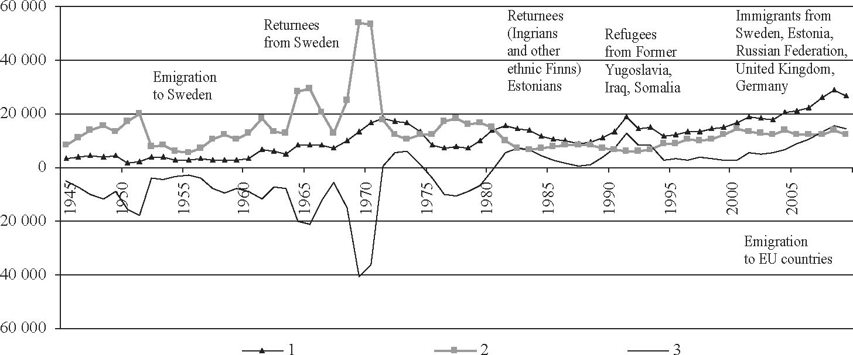
IMMIGRANTS AND IMMIGRATION POLICY IN AGEING FINLAND

Fig. 1. Changes in immigration, emigration and net migration in Finland in 1945-2009
Explanation: 1 - net migration; 2 - net emigration; 3 - net immigration
Source: Own calculations based on StatFin
The integration policy formulated by the Finnish government in the 1980s
assumed a dispersion of refugees and returnees to smaller towns and sparsely
populated areas. However, immigrants have tended to settle in certain places,
especially the capital region of Helsinki (Heikkila, Peltonen, 2002: 4). In
2009 about 27% of the entire foreign population in Finland lived in Helsinki,
whereas the Helsinki Metropolitan Area (includes Helsinki, Espoo, Vantaa,
and Kauniainen) concentrated more than 44% of the foreign citizens living in
Finland, and 88% of those living in Uusimaa Region. At the same time, half of the
entire foreign population in Finland was centred in the Uusimaa Region, which
constituted almost 5.5% of the population of this particular region. Furthermore,
the rate of immigration to the Uusimaa Region (2.22%o in 2009) is significantly
different than that for other regions.
Other major clusters of foreigners are the municipalities of Turku and
Tampere. The relatively high percentages of foreign citizens in Aland (the
autonomous, Swedish-speaking region of Finland) and Ostrobothnia are the
result of the concentration of the Swedish population. The lowest percentages of
foreign citizens are noted in the already sparsely populated regions of Etela-Savo,
South Ostrobothnia, and Pohjois Savo. The regions of Uusimaa, Pirkanmaa, and
Varsinais-Suomi received the largest number of immigrants in 2009 (Fig. 2).
Most of the new immigrants chose to settle in major cities such as Helsinki,
Tampere and Turku.
The age structure of the immigrant population is one of the most important
issues connected with demographic changes towards the ageing of the population
and the resulting consequences for the labour market. Currently about 66%
— 45 —
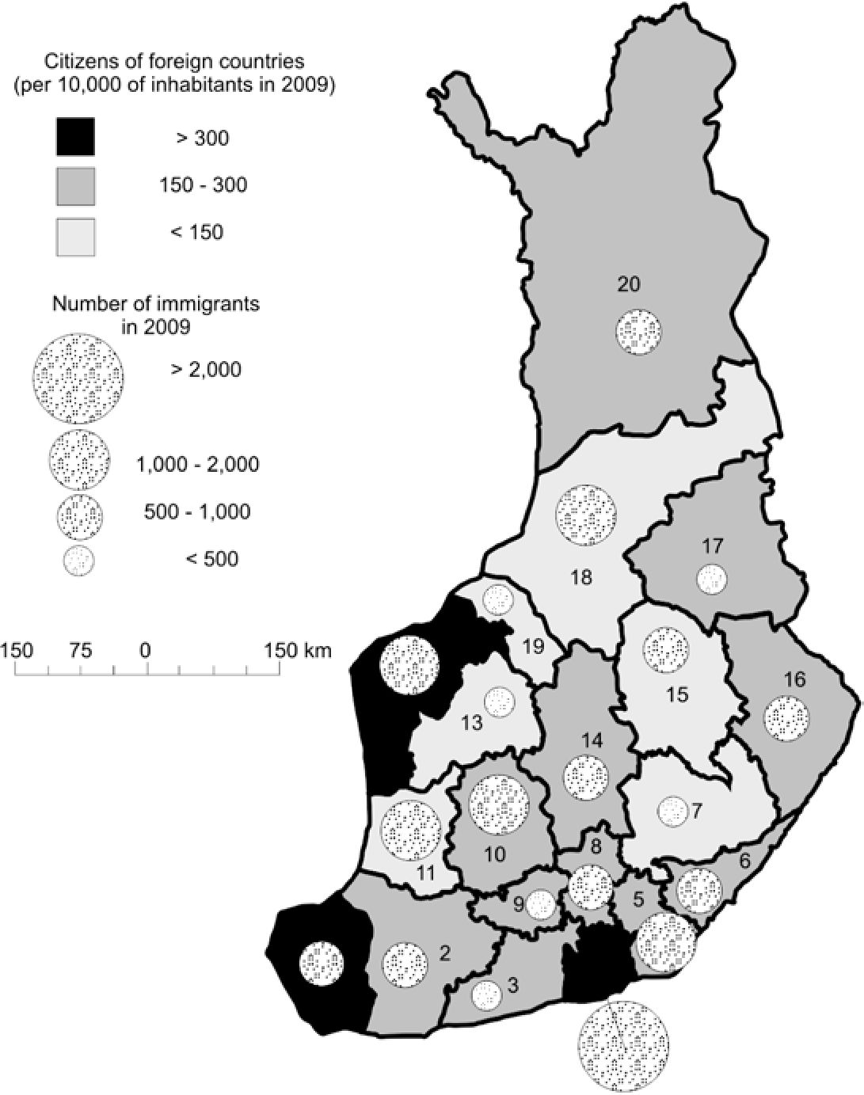
Anna Łobodzińska

Fig. 2. Spatial distribution of foreign citizens and number of immigrants coming to
Finland by regions in 2009
Explanation: 1 - Aland; 2 - Varsinais-Suomi; 3 - Ita-Uusimaa; 4 - Uusimaa;
5 - Kymenlaakso; 6 - South Karelia; 7 - Etela-Savo; 8 - Paijat-Hame;
10 - Pirkanmaa; 11 - Satakunta; 12 - Ostrobothnia; 13 - South Ostrobothnia;
14 - Central Finland; 15 - Pohjois-Savo; 16 - North Karelia; 17 - Kainuu;
18 - North Ostrobothnia; 19 - Central Ostrobothnia; 20 - Lapland
Source: Own calculations based on StatFin
of the Finnish population is of working age (15-64). The proportion of the
young (aged 0-14) is slightly smaller than that of the elderly (aged 65 and
over). The population pyramid for Finland for 2009 possesses a shape typical
of a population that is starting to decline - narrow at the bottom with large
proportions of the oldest age groups (Fig. 3A). The greying of the population is
even more readily visible on the diagram constructed for the year 2040 (Fig. 3B).
— 46 —
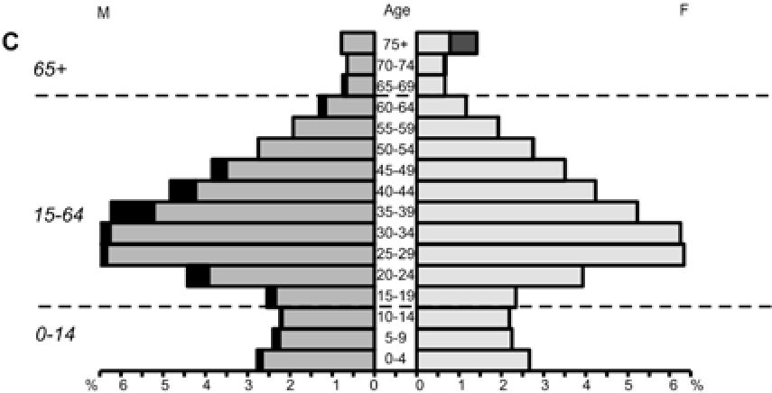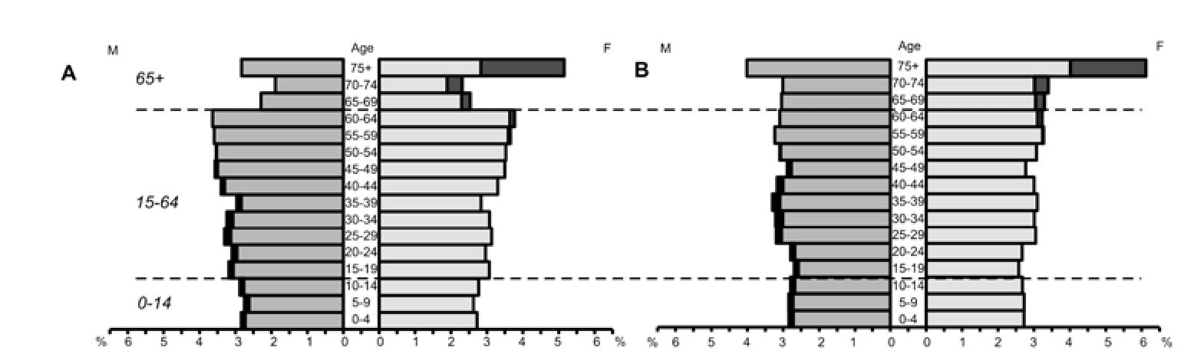
IMMIGRANTS AND IMMIGRATION POLICY IN AGEING FINLAND

Fig. 3. Age and gender structure of population in Finland
Explanation: A - Finland 2009; B - Finland 2040; C - Foreign citizens 2009
Source: Own calculations based on StatFin
In this diagram, the oldest groups are more numerous than the youngest groups
and the share of the working-age group is smaller by almost 9% compared to
the year 2009. On the other hand, the majority (80.5%) of foreign citizens living
in Finland and the majority of immigrants who arrived in the country in 2009
(79.5%) were of working age. Only 5% of the former and 2.5% of the latter
consisted of the elderly (Fig. 3C).
The ratio of the elderly population to the working-age population - known as
the old age dependency ratio - was 25.6 (per 100 population at working age) for
Finland in 2009. It is estimated that during the next fifty years, the share of the
elderly population will increase from a current level of 17% to almost 30%, while
the share of the working-age population will decrease to 55.8% (Fig. 4). The
increase in the old age dependency ratio to a level of 51.5 (per 100 population at
working age) in the year 2060 means that there will be fewer than two persons of
working age per one pensioner.
Considering the projected demographic changes, attracting immigrants
appears to be a necessity. Although the current level of immigration does not have
a significant effect on the age structure of the overall population in Finland, future
increases in immigration might contribute to a rejuvenation of the population
of Finland. It is assumed that future trends in the level of births and deaths will
— 47 —

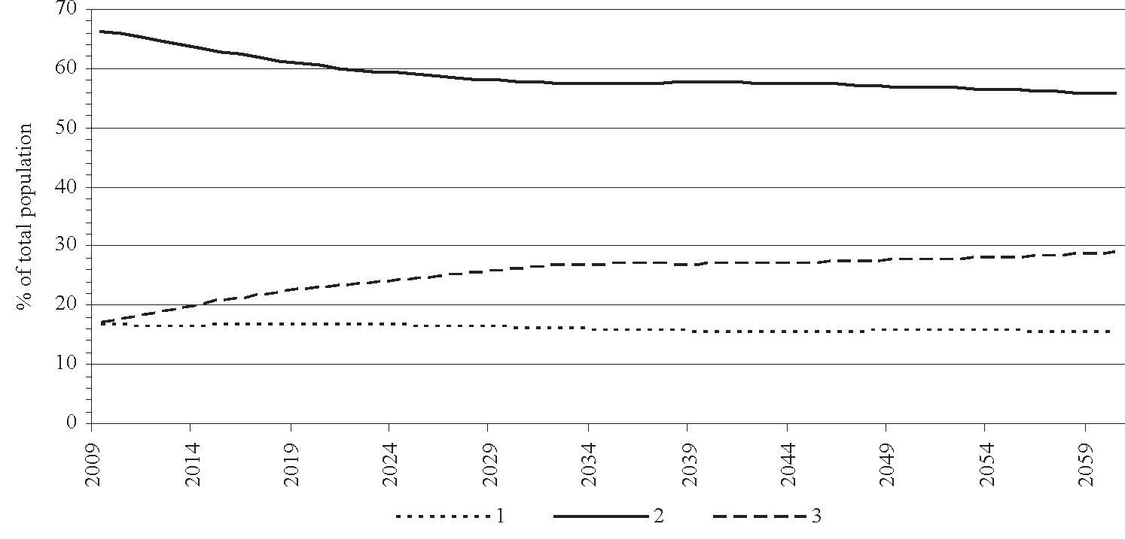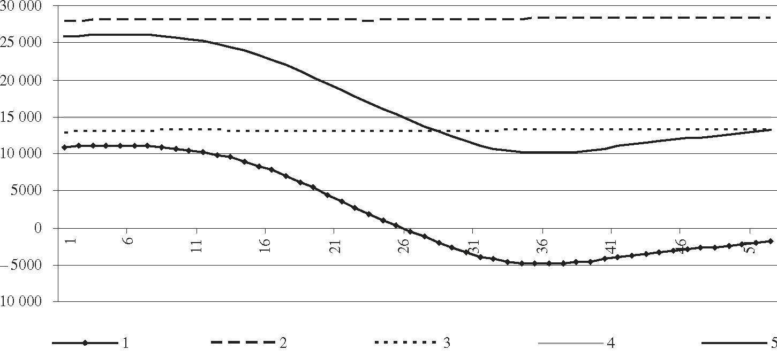
Anna Łobodzińska

Fig. 4. Projected changes in proportions of different age groups in Finland in 2009-2060
Explanation: 1 - aged 0-14; 2 - aged 15-64; 3 - aged 65+
Source: Own calculations based on StatFin

Fig. 5. Projected demographic changes in Finland in 2009-2060
Explanation: 1 - natural increase; 2 - net immigration; 3 - net emigration; 4 - net
migration; 5 - population increase
Source: Own calculations based on StatFin
— 48 —
IMMIGRANTS AND IMMIGRATION POLICY IN AGEING FINLAND
result in a negative natural increase starting in 2034 (Fig. 5). An increase in the
influx of immigrants could positively affect the birth rate, as it is usually higher
among immigrants, especially those from the less developed countries. Although
the total fertility rate for foreign population in Finland is only slightly higher
than that for the native population, significant differences are observed within
the foreign population (e.g., in the year 2006 the birth rate for Somali population
was 26%o, whereas for Russian and Estonian populations - around 9%o; the
birth rate for the whole population of Finland was 11%o) (Saarto, 2007: 36).
However, the fact that immigrant women tend to stay at home and take care of
their families more often than they work outside the home (Heikkila, Peltonen,
2002: 5) must be taken into account. Moreover, a relatively large working-age
population will enter the pension system at some point in time. Therefore, it is
important to increase the rate of influx of working-age immigrants. Assuming
that the number of immigrants and emigrants will stay at the current stable level,
with immigration exceeding emigration, Finland is going to experience a decline
in population growth, especially between 2020 and 2040.
In the context of the population structure, it is also important to analyze the
age and educational profile of emigrants from Finland. The main destinations
for Finnish emigrants in 2009 were Sweden, the United Kingdom, Estonia, the
United States, and Germany. The largest proportion of emigrants was of working
age - almost 83%. In addition, more than one third of emigrants were people in
the 25-34 age group. Finns emigrating to other European countries are usually
young and well-educated. It is estimated that the majority of Finnish emigrants
are going abroad to work for either international companies or Finnish companies
doing business abroad (Koivukangas, 2003: 3). This type of emigration can be
perceived as a form of brain drain. In this context, the educational profile of
immigrants also deserves special attention. There are no sufficient statistics on
the immigrants’ level of education. Approximations concerning the education
level of foreign population are based on the average education level in the
country of origin. The average education level of immigrants, measured as the
average number of years of education, is 8 years, which is less than the duration
of compulsory education in Finland (Johansson, 2008: 12). Moreover, the survey
investigating the education level of immigrants shows that it varies within the
foreign population (Paananen, Pohjanpaa, 2003). In the year 2002 one fourth of
the Somali population aged 25-64 had no training. On the other hand around 60%
of Russians and 80% of Estonians had at least secondary level qualifications.
What is more, almost 40% of Russians attained higher education degree. The
structure of foreign population education informs about the potential and chances
of immigrants on the labour market, and the possible demand for different forms
of education and training for foreigners.
— 49 —
Nationality | 1 | 2 | 3 | 4
Finland | 67.09 | 8.94 | 9.98 | 7.87
Foreign countries | 51.16 | 19.16 | 16.40 | 22.97
Estonia | 66.55 | 10.72 | 10.54 | 10.88
Germany | 62.13 | 7.26 | 6.88 | 8.00
Iraq | 18.44 | 60.94 | 55.22 | 79.56
Russia | 45.88 | 27.80 | 22.20 | 32.35
Somalia | 19.01 | 55.15 | 47.03 | 69.32
Sweden | 60.18 | 11.85 | 12.53 | 10.76
United Kingdom | 64.37 | 10.06 | 10.51 | 7.57
Explanation: 1 - total | employment | rate (%); 2 | - total | unemployment
rate (%); 3 - unemployment rate among men (%); 4 - unemployment
rate among women (%)
Source: Own calculations based on Statistics Finland
In the data description Statistics of Finland specifies that the total number of
individuals in the labour force consists ofthe working-age population (aged 15-64)
except students, military conscripts, homemakers, etc. The total unemployment
rate for foreigners in Finland, calculated as a share of unemployed foreigners in
the ‘foreign labour force’ in Finland, is twice as high as for the general Finnish
population (Table 1). Moreover, it is the highest for immigrants from less developed
— 50 —
IMMIGRANTS AND IMMIGRATION POLICY IN AGEING FINLAND
countries in Asia and Africa. More than half of Somali immigrants and almost 61%
of Iraqi immigrants in the Finnish labour force remained unemployed in 2008.
The unemployment rate for immigrants from Russia was also significantly high.
Only half of the foreign population of working age (aged 15-64) was employed
in 2008. The total employment rate was calculated as a proportion of employed
individuals in the working-age population. Employment rates among Estonians
and Britons were similar to those of the general Finnish population, whereas the
employment rates for Somalis and Iraqis were less than 20%. A substantially higher
unemployment rate among Somali and Iraqi women confirms the suggestion that
a significant proportion of foreign women tends to stay at home and take care of
their families rather than work outside the home. Hence, they are counted as ‘not
in the labour force’.
Although the introduction of a new labour force to the labour market appears
to be profitable from the perspective of economic growth, the new immigrants’
actual path to employment is often difficult. The key obstacles mentioned by
immigrants in Finland include insufficient language skills, potential employers’
lack of recognition of college diplomas, and other qualifications obtained abroad,
general employer prejudice, a low degree of respect for foreign workers as well
as general discrimination (Heikkila, Peltonen, 2002: 5). Language proficiency
requirements normally prolong the job search. Moreover, most first jobs given
to immigrants are jobs in the cleaning or catering industry. The fact is that if
well-educated immigrants are not able to find satisfying employment, they will
most likely move on to another foreign country (Heikkila, 2002: 16/ In light
of the growing elderly population and the shrinking labour force, Finland is
likely to experience increasing demand for workers in fields such as health care
and general elderly care. Current trends in immigration to Finland, especially
the influx of foreigners from Western Europe, may have a positive effect on the
educational level of the foreign population in the country. Finland needs to attract
skilled and well-educated individuals by enabling them to easily enter the Finnish
labour market.

SELECTED ISSUES IN FINNISH IMMIGRATION POLICY
A proactive immigration policy involves changes in administrative, social
and educational areas. The integration of immigrants with general society is an
essential part of a proactive immigration policy in the traditionally homogeneous
and ‘closed’ Finnish society. The basic act of law regulating the status of
immigrants in Finland is the Aliens Act (301/2004). The document is designed to
define the rights and obligations of foreigners in Finland with respect to a variety
— 51 —
Anna Łobodzińska
of basic issues such as arrival in the country, the granting of citizenship, access
to medical care, etc. The Act on the Integration of Immigrants and Reception of
Asylum Seekers (439/1999) contains an outline of Finnish immigrant integration
policy. According to this document, ‘integration, equality and freedom of choice
for immigrants through measures which help them to acquire the essential
knowledge and skills they need to function in society’ and ensuring ‘the essential
livelihood and welfare of asylum seekers by arranging for their reception’ are key
elements of Finnish immigration policy. Integration is defined as self-development
of the immigrant, especially through active participation in the labour market. His
or her original culture and language are perceived as particularly valuable. The
integration plan is based on providing immigrants with support including language
skills, vocational training and counselling, and the education of immigrant
children. All actions are based on the agreement between local authorities, the
local employment office and the immigrant in question. Both registration as an
unemployed jobseeker and application for social assistance entitles an immigrant
to an integration plan (Act on the Integration of Immigrants and Reception of
Asylum Seekers, 1999). Immigrants intending to stay permanently in Finland are
eligible to obtain social security benefits based on the Act on the Application
of Residence-Based Social Security Legislation (1573/1993). Disability and
advanced age entitle immigrants to Special Assistance for Immigrants on the
condition that they have been residing in Finland for a consecutive period of at
least 5 years immediately prior to the granting of the financial assistance (KELA,
2010: 360).
As the number of immigrants has increased over the last 30 years, issues
related to migration policy have become the subject of discussion for the Finnish
government. In order to participate in the immigration debate in one way or another,
a group of influential immigrants is currently working on the establishment of
an independent and non-political Immigrant Parliament of Finland (IPM). The
project aims to unite the interests of immigrants from different backgrounds. The
election of fifty IPM members is scheduled to take place together with Finnish
Parliamentary elections in April, 2011 (Official site of the Immigrant Parliament
of Finland: http://www.ipf.fi/ipf/).
Finland has introduced fixed annual quotas for refugees and asylum seekers
(750 in recent years). The Finnish Parliament sets the annual quota, taking into
consideration the national budget for the current fiscal year (Official site of
the Finnish Immigration Service: http://www.migri.fi). There also exist certain
regulations that apply to Ingrian Finns moving to Finland. They are required to
prove their knowledge of the Finnish or Swedish language (at least A2 level) and
to have accommodations arranged in Finland. Moreover, Ingrian Finns need to
— 52 —
IMMIGRANTS AND IMMIGRATION POLICY IN AGEING FINLAND
be on a waiting list and must complete a form concerning their educational and
vocational background as well as job preferences. In order to match the labour
force with the demand for workers, the job forms are sent to employers and
municipalities who express an interest in new workers (Saarto, 2007: 17-18).
Population projections for Finland assume that immigration will remain at
a stable level for the next 50 years. In light of potential labour shortages in the
future, Finnish immigration policy should be based on incentives that would
attract young and well-educated immigrants. Current Finnish immigration policy
creates an image of an immigrant actively participating in the labour market,
fluent in the Finnish language, highly skilled, eager to integrate with the local
community, and constantly developing new skills.

CONCLUSIONS
The influx of immigrants creates both opportunities and challenges, especially
for a homogeneous society such as that in Finland, which is not used to large
numbers of immigrants. Therefore, it is essential to recognize the different
characteristics of immigrant populations. The key strengths of immigrants and
immigration policy in Finland are: (a) favourable age structure of the newcomers
(79.5% of working age); (b) possibly positive influence on birth rate and
rejuvenation of Finland’s age structure (the birth rates for Somalis and Iraqis
twice as high as for the whole population of Finland); (c) immigration policy
based on integration; (d) the development of skills and the pursuit of equality
and respect for cultural diversity as the basic rules in the immigrant integration
process. On the other hand, the key weaknesses are: (a) attitudes and prejudices
of employers; (b) obstacles in the job recruitment process such as a lack of
recognition of foreign college diplomas and a lack of Finnish language skills
among immigrants; (c) unemployment rate among foreigners twice as high as
Finland’s national rate; (d) low participation of female immigrants from the less
developed countries in the labour market; (e) relatively low educational level of
immigrants (especially among refugees).
A national policy of attracting immigrants in order to offset a shrinking
domestic labour force should include the creation of support systems for the
newcomers but one that does not overly burden the national budget and does
lead immigrants down the path to full employment. Educational programmes,
vocational training and the promotion of long-term employment (both among
employers and the unemployed) should help immigrants to fully participate in the
labour market and should be key elements of a proactive immigration policy.
— 53 —
Anna Łobodzińska

REFERENCES
Act on the Application of Residence-Based Social Security Legislation (1573/1993),
1993: Helsinki: Ministry of Social Affairs and Health, accessed on: http://www.
finlex.fi/fi/laki/kaannokset/1993/en19931573.pdf, DoA: 24.01.2011.
Act on the Integration of Immigrants and Reception of Asylum Seekers (439/1999),
1999: Helsinki: Ministry of Labour, accessed on: http://www.finlex.fi/pdf/saadkaan/
E9990493.PDF, DoA: 26.01.2011.
Aliens Act (301/2004), 2004: Helsinki: Ministry of the Interior, accessed on: http://www.
finlex.fi/en/laki/kaannokset/2004/en20040301.pdf, DoA: 27.01.2011.
Heikkila, E. 2002: Immigrants and their position in the Finnish labour market. In:
Documentation from 1st International Conference on Migration in the Baltic Sea
Area, 14-17 November 2002, accessed on: http://www.baltic-migration.com/
documentation/documentation2.pdf, DoA: 23.01.2011.
Heikkila, E. and Peltonen, S. 2002: Immigrants and integration in Finland, Turku:
Institute of Migration, accessed on: http://www.migrationinstitute.fi/articles/069_
Heikkila-Peltonen.pdf, DoA: 15.05.2008.
Ilmarinen, J. 2006: Towards a Longer Worklife! Ageing and the Quality of Worklife in
the European Union, Helsinki: Finnish Institute of Occupational Health and Ministry
of Social Affairs, p. 17.
Johansson, E. 2008: Does Finland Suffer from Brain Drain?, Helsinki: The Research
Institute of the Finnish Economy, accessed on: http://www.etla.fi/files/2141_Dp1153.
pdf, DoA: 18.03.2011.
KELA, 2010: Statistical Yearbook of the Social Insurance Institution 2009, Helsinki: The
Social Insurance Institution, accessed on: http://www.kela.fi/it/kelasto/kelasto.nsf/
alias/Yearbook_09_pdf/$File/Yearbook_09.pdf? OpenElement, DoA: 23.01.2011.
Koivukangas, O. 2003: European Immigration and Integration: Finland, National Europe
Centre Paper, No. 63, accessed on: http://dspace.anu.edu.au/bitstream/1885/41774/2/
koivukangas1.pdf, DoA: 23.01.2011.
OECD, 2004: Ageing and Employment Policies: Finland, Paris: OECD Publishing.
Official site of the Finnish Immigration Service, 2011: http://www.migri.fi/netcomm/
Default.asp? language=EN, DoA: 23.01.2011.
Official site of the Immigrant Parliament of Finland, 2011: http://www.ipf.fi/ipf/, DoA:
23.01.2011.
Paananen, S. and Pohjanpaa, K. 2003: Maahanmuuttajat opiskelevat ahkerasti,
Helsinki: Statistics Finland, accessed on: http://www.stat.fi/tup/tietoaika/tilaajat/
ta_12_03_maahanmuuttajat.html, DoA: 18.03.2011.
Saarto, A. 2007: Finland. OECD/SOPEMI. International Migration Outlook 2007,
Helsinki: Ministry of Labour, accessed on: http://www.intermin.fi/intermin/
images.nsf/files/4fa9c2d5f18675d9c22573cc0040597b/$file/finland2007.pdf, DoA:
24.01.2011.
Statistics Finland, 2011: http://www.stat.fi/til/index_en.html, DoA: 25.01.2011. StatFin,
2011: http://pxweb2.stat.fi/database/StatFin/databasetree_en.asp, DoA: 25.01.2011.
— 54 —
IMMIGRANTS AND IMMIGRATION POLICY IN AGEING FINLAND

CORRESPONDENCE TO:
Anna Łobodzińska
Jagiellonian University
Institute of Geography and Spatial Management
Department of Geography of Population, Settlement and Agriculture
Gronostajowa 7, 30-387 Cracow, Poland
[e-mail: anna.lobodzinska@uj.edu.pl]

