

Evolutionary Ecology (2018) 32:623–641https://doi.org/10.1007/s10682-018-9961-4
Trade-offsbetweenstorageandsurvivalaffectdiapausetimingincapitalbreeders
Øystein Varpe1,2· Maciej J. Ejsmond1,3
Received:4July2018/Accepted:16October2018/Publishedonline:10November2018
© The Author(s) 2018
Abstract
Many organisms spend the unfavourable part of the year, such as the winter season, in dia- pause or dormancy and reproduce in spring shortly after emergence. Reserves are acquired prior to diapause to cover metabolic costs and in some species also reproduction (capital breeding) directly after diapause. Storage is then a component of future reproduction, and capital breeders consequently pay a pre-breeding cost of reproduction as they risk dying while obtaining and carrying the reserves. How large should the reserves be, and to what extent should optimal storage, and thereby timing of diapause, depend on predation risk and reproductive strategy?Wepresent a general and simplistic life history model of an arthropod (e.g. crustaceans or insects) that is exposed to background mortality risk when it accumulates reserves before diapause. The model optimizes diapause timing and resultant reservesforincome, mixed and capital breeders, and predicts how mortality risk affects the degree of capital breeding. For income breeders, timing of diapause is insensitive to the risk while obtaining reserves asthey,regardless of risk, acquire the minimum amount needed to survive the winter. For capital breeders, the higher the risk the earlier the dia- pause and less is consequently stored. Mixed breeders diapause late and store as much as pure capital breeders when exposed to low risk, but behave as income breeders and dia- pause early when mortality is high. Our model shows that the degree of capital breeding impacts phenology of diapause in a risk-dependent manner. This prediction should impact how diapause timing is thought of across a wide range of taxa, including the much studied marine copepods. Timing of diapause, including triggers and cues, can only be understood when the diversity of reproductive strategies and the adaptive value of storage is taken into account.
KeywordsEnergyreserves·Life-historytheory·Predationrisk·Resourceallocation· State-dependence · Incomebreeding
ElectronicsupplementarymaterialTheonlineversionofthisarticle(https://doi.org/10.1007/s10682-018-9961-4) contains supplementary material, which is available to authorizedusers.
Øystein Varpeoystein.varpe@unis.no
DepartmentofArcticBiology,TheUniversityCentreinSvalbard,9171Longyearbyen,Norway Akvaplan-niva, Fram Centre, 9296 Tromsø,Norway
Institute of Environmental Sciences, Jagiellonian University, 30-387 Kraków, Poland
*
1

2

3
13
ORIGINAL PAPER

Evolutionary Ecology (2018) 32:623–641
624
Introduction
Organismshave evolveda large arsenal of adaptations to both sense andavoidpredators and other risks. Understanding the risk-sensitivity of animal behaviors and life strategies is a central challenge in evolutionary ecology (Lima and Dill1990; Werner and Anholt1993; Houston and McNamara1999). Life history theory shows that trade-offs thatinvolverisk, and therefore survival, can be understood when translated into fitness gains, or more pre-cisely,currentandresidualreproductivesuccess(Williams1966;Stearns1992;Roff2002). For example, current production of offspring is weighed against parental survival, which in turn determines the potentialforfuture reproduction (Drent and Daan1980; Ydenberg1989; Reznick et al.1990; Ghalambor and Martin2001).Weinvestigate how differentlev-els of risk impact the trade-off between survival and storage (accumulation of reserves), where storage can be viewed as a component of future reproduction.Weare interested in how this trade-off is solved differentlyforreproductive strategies that range from income to capital breeding, and how this trade-off impacts the degree of capital breeding itself. Income breeders base reproduction on current food intake whereas capital breeders rely on reserves stored prior to breeding, in seasonal environments often the year before (Jönsson1997;Varpeet al.2009). Consequently,forcapital breeders, storage is an investment in future reproduction and we would expect the amount of reserves accumulated to dependon the riskinvolvedin obtainingthem.
Internal body reserves (typically as lipids and proteins) is a key trait of many life histo- ries, particularly for organisms in environments with a seasonal food source (Varpe2017). Reserves are often considered an energy buffer needed for survival of unpredictable times (Fischer et al.2011; Giacomini and Shuter2013) or to cover maintenance costs during periodical shortage of food such as a winter season or diapause (Giacomini and Shuter2013). Such a view of storage is valid for income breeders, but does not capture the selec- tive forces acting upon capital breeders which through storage indirectly invest in repro- duction long before the fitness payoff is released as offspring (Jönsson1997; Varpe et al.2009). Capital breeders consequently pay a pre-breeding cost of reproduction as they risk dying while obtaining and carrying the reserves.
The timing of annual activities, such as diapause, migrations, reproduction and stor- age, has fitness consequences, linking phenology and life-time perspectives (McNamara and Houston2008; Forrest and Miller-Rushing2010;Varpe2017). Our work investigates the phenology consequences brought by risk-driven optimization of storage strategies.Wefocus on diapause (or dormancy) which is a common adaptation to seasonal food availabil- ity (Cohen1970; Tauber et al.1986;Varpe2012). Building reserves takes time and capital breeders therefore need to forageforlonger than income breeders before they enter dia- pause. The difference in time usedforstorage would in turn impact the onset of diapause timing.Fitnessconsequencesofdiapausetimingmustthereforebeconsideredinrelationto how the storage-survival trade-off depends on breedingstrategy.
Many marine and terrestrial arthropodshave evolveddiapause or some level of dor- mancy,yettheir reliance on reservesforreproduction is highly diverse. Some are purecap- ital breeders (Miller et al.1984; Tammaru and Haukioja1996), but a mixed breeding strat- egy that combines income with some degree of capital breeding is common, asforinsects (Jervis et al.2008;Javoišet al.2011; Kivelä et al.2012) and marine crustaceans (Hagen and Schnack-Schiel1996; Rey-Rassat et al.2002; Daase et al.2013). There is growing interest in the ultimate drivers that position the breeding strategy on an income to capi- talbreedingcontinuum.Seasonalityinoffspringcontributiontofitness,highrateoffood
13

Evolutionary Ecology (2018) 32:623–641
625
supplyfrommothertooffspring,lowpredationriskinseasonalenvironments,stochasticity in food availability, or allometric scaling of metabolism with body size are among thedriv- ers selectingforcapital breeding (Reznick and Braun1987; Houston et al.2007; Stephens et al.2009;Varpeet al.2009; Ejsmond et al.2015,2018).Weneed studies of how the amount of reserves acquired depends on the mortality risk during the acquisition period, and how the degree of capital breeding interacts with other components of the annual rou- tine, such as timing of diapause or seasonalmigrations.
One inspirationforour work is the diapause and reproductive strategies of copepods in high latitude marine ecosystems and the discussion about cues and drivers of timing of diapause and the accompanying seasonal migrations. Seasonal deep-water diapause is part of the annual routinefora range of abundant marine species of calanoid copepods (Conover1988; Hirche1996; Atkinson1998; Ohman et al.1998;Varpe2012) that are regarded central herbivorous links between lower (phytoplankton) and higher trophic level production. The non-productive part of the year is spent in the deep and safer parts of the ocean,awayfrom the surface habitat where they feed. This diapause is spent as well-devel- oped and near mature or mature stages, but with metabolism much reduced and fueled by reserves. Despite similar morphologies and overall life cycles, these copepod species span the full gradient from capital to income breeding (Miller et al.1984; Conover1988), and this diversity of capital and income breeding relates to phenology, annual routine, and life history variability(Varpeet al.2009; Ejsmond et al.2018). Our work is also relevant to arthropods moregenerally.Many insects in seasonal environments diapause in a mature or near mature stage (e.g. pupal stage in holometabolous insects), store reserves prior to diapause, and reproduce in spring shortly after diapause (Tauber et al.1986; Hahn and Denlinger2011). Examples include many butterflies (Lepidoptera), beetles (Coleoptera), stoneflies (Plecoptera) or mayflies (Ephemeroptera) (Lillehammer et al.1989; Brittain1990; Tammaru and Haukioja1996; Morewood and Ring1998; Walczynska et al.2010; Haugen and Gotthard2015).Weask: when should these organisms stop building reserves and instead prioritize survival by entering the safer diapause, and how should this timing depend on mortality risk?
We present a life history model designed for analyses of the risk-sensitivity of diapause timing and how this sensitivity depends on the positioning of the breeding strategy on a gradient from income to capital breeding. We expect the time used for storage to be par- ticularly risk-sensitive in capital breeders. Our strategy gradient includes a mixed breeder category that can combine capital and income breeding, allowing us to also study how the degree of capital breeding is determined by risk. We analyze the sensitivity of the model predictions to seasonality in food availability, metabolic costs during diapause, stage- dependent mortality, and seasonality in offspring value. A central point emerging from our work is that we must recognise the role storage plays in reproduction to make predictions about the timing of diapause in seasonal environments.
The model
Lifehistoryandenvironment
The model considers a short lived arthropod that is exposed to background mortality when itaccumulatesreserves.Themodelorganismdoesnotreproduceduringitsfirstgrowthand winter season (we refer to it as a juvenile during this period), but builds reserves andenters
13

Evolutionary Ecology (2018) 32:623–641
626
diapause before the winter and emerges readyforreproduction in spring (then referred to as adult). The model is well suitedfororganisms with diapause followed by reproduction, such as many copepods and other crustaceans, and to the many diapausing insects that build reserves prior to diapause and reproduce directly after or shortly after diapause. The model environment is seasonal, with the year lastingforT_{y}=360dayswith two seasons, a summer and a winter with lengthsT_{S}andT_{w}days, respectively (Fig.1), set to 150 summer and 210 winterdaysin the examples presentedbelow.During summer, juveniles feed and acquire resources and are exposed to the risk of death given by daily mortality ratem_{a}. The diapause state is characterized by daily mortality ratem_{d}. For the copepod life histories that in part inspire our work, the active phase is equivalent to feeding in the surface waters whereas entering diapause matches the migration to the deep-water refuge. Akeyassump- tion of our model is that diapause is a relatively safe state, in comparison to the feeding state, and we therefore assumedm_{a}>m_{d}forall modelled scenarios. Staying active in sum- mer allows juveniles to accumulate reserves, with potential pay-off through capital breed- ing in the following spring, but the longer in the feeding habitat the longer is the exposure torisk.Thislife-historytrade-offbetweensurvivalandtimededicatedtoacquirereserves
fp
fT
δ
tj
T_{s}
T_{y}
Timet
Capital breeder
Income breeder Mixed strategy
Capital-based Income-based
reproduction reproduction
Storage
Diapause
Fig.1Thebasicschemeofaseasonallifehistorymodelwheretheyear,withdurationofT_{y}days,isdivided into two seasons; food is available duringT_{s}summer days (green lines), and unavailable during winter. Food level at the beginningf_{p}and endf_{T}of the summer defines food availability.Twofood scenarios are modelled (solid and broken green lines). The seasonally declining food availability may alternatively be thought of as seasonally declining food quality. The first point in time when development has reached a stagethatallowsfordiapauseisdefinedbyt_{j}.Thedownwardredarrowindicatesthedaywhendiapause
startsδ, which is optimized in order to maximize fitness, and the accompanying amount of reservesS_{a}
(depicted by the dark grey area). The upward red arrow represents the end of diapause. For the copepod case that we discuss, the arrows also represent seasonal migrations, to and from the deep-water diapause habitat. During diapause, organisms utilize reserves withS_{d}being the reserves needed to cover maintenance costs during this period (the light gray area). For the three modelled life history strategies (capital breeder, income breeder, and mixed strategy), the periods for possible storage, diapause and reproduction are pre- sented as horizontal color bars
13
Food availability
Sa(Reserves)

Summer
Winter

Summer

Foodf

Sd(maintenance during diapause)

Evolutionary Ecology (2018) 32:623–641
627
isacrucialelementofthemodel.Wekeepthemodelgeneralandeasytofollowforabroad audience by assuming that subsequent cohorts of adults do not overlap and by excluding trade-offs with growth and feedback from the optimal strategy on the environment. Juve- nile and adult mortality in our model is the same and equal tom_{a}(but see analyses of stage-dependent mortality, Electonic supplementary material, Fig. S1), and we assume no seasonality in the value of newborn (but see analysesforscenarios with seasonally declin- ing offspring value, Electronic supplementary material, Fig.S2).
Themodelseeksthedayofdiapauseinitiationδ(Fig.1)thatmaximizesfitness.Toaccountforcomplex development, with several larval stages in somearthropods,weassumethatittakest_{j}days(Fig.1),setto30daysintheexamplespresentedbelow,to developfromaneggatthebeginningofthesummertoastagecapableofaccumulat-ingreservesandsubsequentlydiapause.Ittakessometimetobuildreserves,henceδ>t_{j}(Fig.1).Asweassumethatallindividuals,nomatterbreedingstrategy,followthesamestrategy until timet_{j}, we can omit this first part of the life cycle fromfurtherconsideration.Physiologicalprocessesinthemodelarekeptgeneralandnotparameterizedforapar-ticularspecies,andratesoffoodgain,metabolismandmaintenancecostsarekeptrelativetoeachother.Thissimplicityallowsthemodeltobegeneralenoughtocoverabroadrangeof life histories. The dynamics of food availabilityf(t), defining rate ofenergy assimilation(e.g. joule per unit of time), (Eq.1) is assumed linear. In case of a marineenvironment,f(t)isasimplifiedandflexiblerepresentationofapopulationofprimaryproducingalgaedur-
ing the year, and can be given by:
fp−fT
(1)
f(t)=− t+fp
T
S
Food availability depends on food level at the beginning and end of the summer,f_{p}andf_{T}respectively (Fig.1). By manipulatingf_{T}we modeled different scenarios including a con- stant food gain whenf_{p}=f_{T}(see Fig.1).
Themodeledarthropodconvertsacquiredfoodtoreservesandcoversmaintenancecosts
C_{m}(Eq.2) whereτis a time index equal to 0 att_{j}.
dS=f(r)−C
(2)
m
dr
By solving Eq.2we get the amount of reservesS_{a}, at the time of diapause initiationδ(see
Eq.3).
(

f(t)+f(D)
(
)
j
(3)
S=D−t
−C
a
j
m
2
There is no upper limit to the amount of reserves, but we do not consider strategies where individuals spend the winter in an active state. Hence, the time availableforfeeding during summer determines the maximal level of reserves.
We assume that there are no costs of entering diapause and during diapause reserves are used for metabolism at a rate given by
dS= −xC
(4)
m
dr
wherexis a coefficient that expresses the maintenance costs during diapause relative to the costs when in the active phase. Estimates of relative magnitude of maintenance costs in arthropodsaretaxonorevenspeciesspecific.Inmarinecopepods,themetabolicratemay
13

Evolutionary Ecology (2018) 32:623–641
628
beasmuchas10timeslowerduringdiapausethanduringtheactivephase(Pasternaketal.1994), which corresponds tox= 0.1 in our model. For the copepodCalanus glacialisthese costsarearound6–3timeslower(MorataandSøreide2015),hencexbetween0.17and
0.33. To keep our model general we considerxranging from 0 (no reserves used during diapause) to 1 (same maintenance cost during active and diapause phase).
Allindividuals,nomatterdiapauseinitiationstrategy,matureandemergefromdiapause at the beginning of the next summer (Fig.1) and are then ready to produce eggs. This can be kept simple as our focus is the onset ofdiapause.
The energetic value of the reserves necessary to cover maintenance costs during dia- pauseS_{d}is equal to
(5)
Sd= −TY−DxCm
and the reserves available after diapause are the outcome of the balance between net
assimilation in summer and reserves used to cover metabolic processes during diapause
i.e.S_{a}+S_{d}(note thatS_{d}is a negative number, Eq.5). We assumed that when reserves were insufficient to cover metabolic costs during diapause i.e. fromδto the beginning of the next summer, the organism dies during diapause.
Breedingstrategiesandmortalityrate
In our model we consider three types of breeding strategies: (1) pure capital breeding, i.e. egg production covered by reserves obtained during the previous year; (2) income breed- ing, i.e. egg production covered by current food intake; and (3) a mixed strategy, which is a combination of capital and income breeding (Fig.1).Weassumed that capital breeders die after reserves are emptied and that income and mixed breeders die before their second winter (cf.Varpe2012).
The optimal strategy maximizes expected reproductive success, a measure related to the amount of reserves (see Eq.3), and the risk taken while in the active versus the diapause state. Survival of the period from timet_{j}(Fig.1) to the beginning of summer is with prob- abilitypgiven by
(6)
p(D)=exp−ma(D−tj)−md(Ty−D)
wherem_{a}andm_{d}are mortality rates during the active phase and diapause, respectively.
We test our model for a broad range of mortality rates. Estimation of death rates in
marine arthropods can be difficult due to advection of water masses and the large spatial
scales ofteninvolved.For copepods, daily survival rates range from close to 0 and up to 20% of the individuals dying (e.g. Aksnes and Ohman1996; Gentleman et al.2012),repre- sentinglifeexpectanciesfromaround2weekstoseveralyears.Consequently,wetesteda
range of mortality ratesma∈0.005, 0.035 for the feeding habitat, broad enough to cover observed variability of adult and juvenile life expectancies in a range of arthropods (e.g.
Walczyńska2010; Remmel et al.2011;Vogt2012). Assumed mortality rates represent environments in which the expected proportion of individuals surviving a 3-month period intheiractivephasefallsbetween64and4%.Importantly,forthewiderangeofm_{a}consid- ered and assuming thatm_{a}>m_{d}, our results were not affected qualitatively by the level of mortality ratesm_{d}during diapause. Hence, we did not parameterize mortality during dia- pause, but assumedm_{d}= 0.004, corresponding to 30% of the individuals dying if a popula- tion diapausesfor3months.
13

Evolutionary Ecology (2018) 32:623–641
629
Income,capitalandmixedstrategyofbreeding
Wemeasure egg production as energetic units allocated to reproduction.
Capital breederThe expected egg production for a pure capital breederV_{C}
equals
the energetic value of reserves at the first day of the summer, i.e. the day when eggs are released multiplied by the probability of surviving to this day (Fig.1), and given by
VC=p(D)Sa+Sd=p(D)RC
(7)
whereR_{C}is allocation to reproduction by a pure capital breeder andp(δ) the probability to survive the winter.
Income breederAn income breeder cannot use reserves for reproduction, but will pro- duce eggs if there is food available. We assume it to produce eggs continuously (Fig.1). The expected number of produced eggs for an income breeder that survived the winterR_{I}, is given by
TS
RI=exp(−mat)(f(t)−Cm)dt
(8)
t=0
(forthesolutionofEq.8seeSupplementarymaterial).ThefitnessoftheincomebreederV_{I}depends on day of diapause initiationδand the probability of survival to the end of winter, and is givenby
VI=p(D)RI
(9)
Mixed capital and incomeAn organism with a mixed strategy first breeds as a capital
breeder and then as an income breeder (Fig.1). The expected egg production for the mixed strategyV_{M}is the sum of the expected income and capital breeding strategies.
(10)
VM=p(D)RC+RI
Note that the timing of diapause of the mixed breeder determines its breeding strategy
through the amount of reserves gathered, and thereby position it along the income to capi- tal breeder continuum. Depending on the selection pressures, the optimality considerations can therefore result in mixed-breeders positioned anywhere from an income breeder to a pure capital breeder with large reserves.
OptimizationFor each of the three strategies we calculate the optimal onset of diapauseδthat maximizes fitness, by solving the condition in which the derivative of the expected reproductive success equals zero (Supplementary material). Note that the rate of resource assimilation during the active phase only depends on food availabilityf(t) andmaintenance costsC_{m}. Consequently, our results are general and depend on the relative amount of food needed to cover maintenancecosts.
Relaxingtwoofthemodelassumptions
Weadd additional analyses of two of our assumptions. (1)Weanalyze how sensitive the model predictions are to differences in summer-season mortality ratem_{a}forindividuals in juvenile (e.g. prior to diapause, see Eq.6) versus the adult stage (i.e. after diapause, see Eq.8). This analysis of stage-dependent mortality is particularly motivated by the different lifeformsandthereforesometimesdifferentmortalityratesofholometaboleousinsects.(2)
13

Evolutionary Ecology (2018) 32:623–641
630
Werelax our baseline assumption of birth-time independent offspring value. Other lines of our workhavehighlighted that offspring produced at different times of the seasonhaveunequal future prospects (Ejsmond et al.2010),forinstance to decline as the season pro- gresses(Varpeet al.2007).Wetherefore add a scenario of seasonally declining offspring value(cf.methodologyinEjsmondetal.2010).Bothofthesemodelmodifications,includ- ing their results, are presented in the Supplementary material, but discussedbelow.
Results
Baselinemodel,withconstantfoodandnomaintenancecostsduringdiapause
When food is constantoverthe summer season,f(t) =f_{p}, and the costs of maintenance dur- ing diapause are negligiblex= 0, the optimal diapause strategyforthe three strategies dif- fersandaregivenbyconditions11to12.SubscriptsI,CandMrefertotheincome,capital and mixed breeder strategy, respectively (see Electronic supplementary materialforcalcu- lations). Diapause strategies that maximize fitness (Eqs.11–13) are presented in twoways,by time in the seasonδor level of reservesγ(given in theparentheses)
I=tj, yI=0
(11)
(y
\
f−C
+ 1 ,
ma−md
p m
(12)
=t
=
C j
C
ma−md
RI
(y
)
= −
,
=y−R
(13)
M C
M C I
fp−Cm
In the baseline model we assumed that costs of maintenance during diapause are irrelevant and the income breeder gets no pay-off from reserves that remain at the end of winter. An income breeder should therefore enter diapause immediately after reaching the develop- mental stage that allowsfordiapause (Eq.11, Fig.2). Importantly, this decision is inde- pendent of the mortality risk and rate of energy assimilation. For a pure capital breeder, on the other hand, the day of entering diapauseδ, as well as amount of reservesγ, is inversely related to the rate of mortality in the feeding habitatm_{a}(Eq.12, Fig.2) i.e. the higher the mortality the earlier diapause and less reserves are gathered. The capital breeder maximizes expected amount of reserves availableforegg production next year, where this expectation takes into account the risk of death during the feeding phase when reserves are accumulated. Because we express reserves in the same energetic units as assimilated food,γ_{C}also scales with energy assimilation (Eq.12, Fig.2). Finally,forthe mixed strategy,dia- pause initiation takes placeforreserve levels that fall betweenγ_{I}andγ_{C}, and the difference in optimal diapause thresholdfora mixed breederγ_{M}and capital breederγ_{C}is proportional to the benefit from income breedingR_{I}(see Eq.8). The optimal reproductive strategy by the mixed breeder,δ_{M}andγ_{M}(Eq.13), shows that both high mortalitym_{a}when reserves are accumulated and high rate of reproduction from incoming resourcesR_{I}select against capital breeding.
13

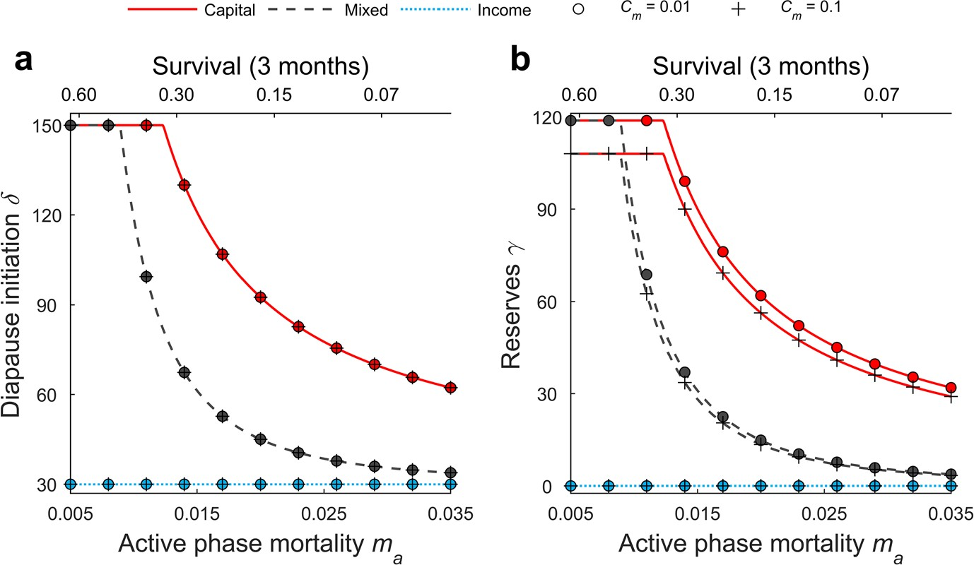
Evolutionary Ecology (2018) 32:623–641
631
Fig. 2Baseline model. The day of diapause initiationδ(a) and the optimal level of reservesγ(b)presented for a gradient of mortalitym_{a}during the active phase of the year, for the capital, mixed and income breed- ing strategies. Metabolic costs in the active phaseC_{m}are given in the legend and can be interpreted as a proportion of daily consumption rate. Diapause initiation was calculated under the assumption that costs of metabolism during diapause are negligible (relative cost of maintenance during diapausex= 0) and for con- stant food during the summer (f_{p}=f_{T}). Note the plateau inγandδfor low mortality ratesm_{a}caused by stor- age taking place to the end of the feeding season, henceδ=T_{s}.Because costs of maintenance are negligible during winter, income breeders initiate diapause immediately after reachingt_{j}i.e. the first stage allowed to diapause
Modelwithmetaboliccostsduringdiapause
The baseline model did not take into account that reserves are used during diapause. The amount of reserves needed for maintenance during diapause determines the minimal value ofγand time spent in the active phase, set byδ. Hence, for an income breeder, the level of reserves increases with costs of maintenance during diapause but is constant across differ- ent mortality risksm_{a}(see the black surface in Fig.3). Capital and mixed breeders store more than is needed for diapause (Fig.3). Their breeding strategies are risk sensitive under both low (Fig.3a) and high (Fig.3b) costs of maintenance during diapause. When mor- tality during the active phase increases, they start the diapause earlier and with smaller reserves (Fig.3). Under low mortality, capital and mixed breeders stay active as long as possible i.e. to the last day of summer, gathering maximal amounts of reserves (note flat planes in Fig.3a, b).
Model with dynamicfood
For our analyses we also add seasonality in food availability. We set food consumption at the end of the season lower than at the beginning, i.e.f_{T}<f_{p}, and equal to the metabolic costsC_{m}, which means that the energy balance will turn negative on the first day of win- ter. The risk sensitivity of the predicted diapause strategies is not affected by the assumed
13

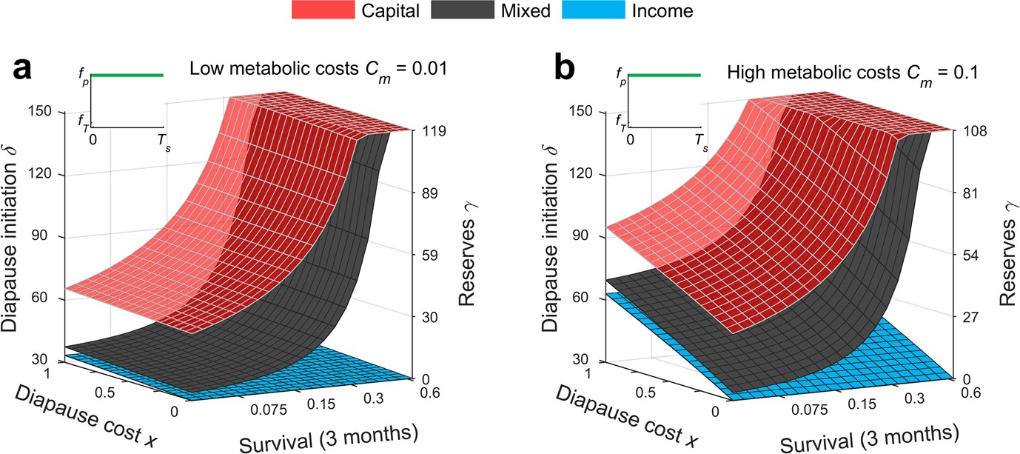
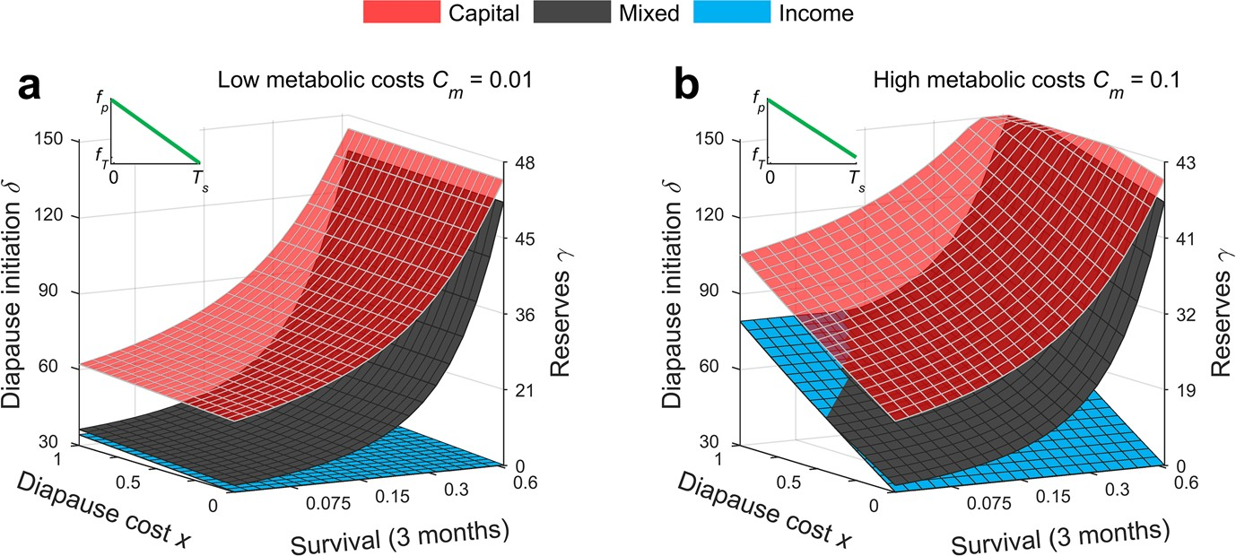
Evolutionary Ecology (2018) 32:623–641
632
Fig. 3Constant food scenario. Optimal diapause timingδand level of reservesγfor an income breeder (blue surface), pure capital breeder (transparent red surface) and mixed breeder (gray surface) when food intake (f_{p}=f_{T}) is constant during summer (see inserts), for low metabolic costs during the active phaseC_{m}= 0.01 (a) and for high such costsC_{m}= 0.1 (b). The blue surface also represents the critical reserves necessary to survive the winter. Note that when relative cost of maintenance during diapausex= 0, i.e. no reserves used during diapause, income breeders migrate with no reservesγ_{I}= 0 at dayδ_{I}=t_{j}i.e. as early as possible. The critical amount of reserves increases with the coefficientxscaling the maintenance costs dur- ing diapause (Eq.4.)

seasonality in food, regardless of reproductive strategy, and the degree of capital breeding is highest in the safest environments (Figs.3a, b versus4a, b). With decreasing food dur- ing summer, the model organisms need more time to store for diapause. Capital and mixed
Fig. 4Seasonally declining food scenario. Optimal timingδand level of reservesγfor an income breeder (blue surface), pure capital breeder (transparent red surface) and mixed breeder (gray surface) considered under seasonally decreasing food availability (see inserts), and under low metabolic costs during the active phaseC_{m}= 0.01 (a) and high such costsC_{m}= 0.1 (b). Food availability at the end of the summer was set tof_{T}=C_{m}. Note that the blue surface also represents the critical reserves necessary to survive the winter, which increases with a coefficientxscaling the maintenance costs during diapause (Eq.4). The reservesγdo not increase proportionally with day of diapause initiationδ(note the nonlinear scale of the reserves axis) because the rate of food intake declines as the summer season progresses. For legibility in panel b, the gray surface indicatingδandγfor the mixed breeder was removed when identical with the income breeder strategy
13

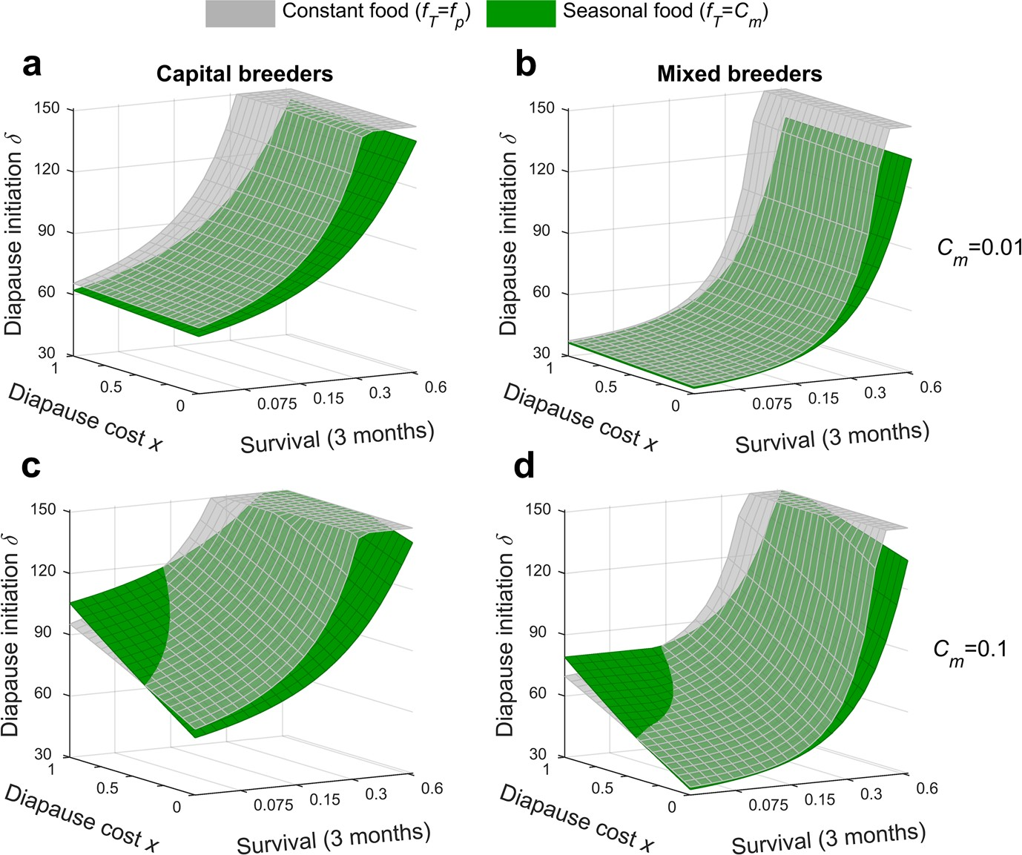
Evolutionary Ecology (2018) 32:623–641
633
breeders store less than under constant food availability (Figs.3a, b versus4a, b). When the food conditions deteriorate during the feeding season and the maintenance costs of dia- pause arelow,capital and mixed breeders diapause earlier than under constant food availa- bility (Fig.5a, b). High mortality risk forces them to diapauseearly,and whenmaintenance costs are high they may need to stayforlonger than under constant food to gather reserves needed to survive to reproduction (Fig.5c, d). Mixed breeders consequently behave as income breeders when the risk while feeding and costs of diapause are high (Fig.4b).
Discussion
Westudy diapause timing as akeyseasonal event, a transition from a risky feeding mode to a safer and less energy demanding non-feeding mode. Our analyses link phenology and breeding strategies through a fitness perspective on the consequences of storage prior to diapause. The model predictions suggest that mortality risk is an important driver of dia- pause timing and the capital component of reproduction. Mixed breeders, and pure capital breeders in particular, respond to elevated risk by entering diapause earlier and with less reserves.Theseresultslargelyremainwhenmortalityriskisallowedtobestage-dependent.
Fig. 5Comparisons of the constant and seasonally declining food scenarios. Optimal timing of diapauseδfor a capital (a,c) and mixed breeder (b,d) considered under constant (transparent surface) and seasonally decreasing food availability (filled green surface), and under lowC_{m}= 0.01 (a,b) and highC_{m}= 0.1 (c,d) metabolic costs during the active phase
13

Evolutionary Ecology (2018) 32:623–641
634
However, when mortality risk is high and adults survive better than juveniles, then dia- pause timing in mixed breeders moves towards that of income breeders (Fig. S1). This change occurs because fitness gains from income breeding pay off relatively more than continued storage prior to diapause. Furthermore, including seasonally declining offspring value does not affect our general conclusions, but mixed breeders shift towards capital breeding when offspring produced late contribute poorly to fitness (Fig. S2).
Based on our predictions, we argue that the role of predators in shaping diapause phe- nology and breeding strategy in arthropods should be highlighted. Specifically, predation risk should be listed among other drivers of diapause timing in capital breeders such as feeding season length (Sainmont et al.2014), food supply (Walczynska et al.2010) and birth-time dependent offspring prospects(Varpeet al.2007). The trade-off betweenstorage and survival that wehavemodelled is not limited to short lived invertebrates.Weexpect similar selective forcesforthe timing of dormancy, amount of gathered reserves, and degree of capital breeding in longer lived organismsforinstance fish, reptiles, and mam- mals (Reznick and Braun1987; Atkinson and Ramsay1995; Bonnet et al.2002; McBride et al.2015).However,understanding how the trade-off between storage and survival impacts diapause (or migration) phenology in longer-lived species require additional life- history trade-offs,forinstance relating to body size, indeterminate growth and iteroparity (Houston et al.2007; Stephens et al.2014; Ejsmond et al.2015;Varpe2017).
Risk-sensitivelifehistoriesandthetrade-offsinvolved
Capital breeding comes with survival costs due to predation risk when reserves are gathered, a pre-breeding cost of reproduction (Jönsson1997). Our study broadens this perspective and explores changes in phenology and life-history of capital breeders driven by the level of mortality risk. The model predicts strong selection for timing of diapause in organisms that optimize the time dedicated for foraging in response to experienced risk. For those who store for reproduction, such optimization should lead to large reserves (and much time spent feeding) when predation risk is low and smaller reserves (and less time) when the risk is high. Consequently, the trade-off between stor- age and survival influences both individual state (body condition) and phenology. In pure income breeders, only a minimum and fixed threshold level of reserves should be obtained in order to survive the winter, given that winter costs and duration is predict- able. In life history theory, storage is often considered a reservoir preventing from death in fluctuating environments (Fischer et al.2011) or during long unproductive seasons of variable duration (Giacomini and Shuter2013). Capital breeding complicates this per- spective as building up long-term reserves for reproduction generates a multitude of life history trade-offs in particular with growth (Reznick and Braun1987; Jørgensen et al.2006; Ejsmond et al.2015). The predicted trade-off between survival and storage is in principle synonymous with the well-established life-history theory of optimal growth rate mediated by foraging rate (Werner and Anholt1993; Anholt and Werner1995). This theory, founded on the premise that foraging is risky, predicts that organisms maxi- mize fitness by adjusting the growth rate and risk taken while foraging i.e. they trade off growth rate with survival (see also Kozłowski2006). One of the ultimate drivers for growth is that larger size means higher fecundity and so growth is a long-term invest- ment in future reproduction (Williams1966; Ejsmond et al.2010). Preparation for capi- talbreedingissimilartogrowthbybeinganinvestmentinfuturereproduction,hence
13

Evolutionary Ecology (2018) 32:623–641
635
forms part of the residual reproductive value (Williams1966; Ejsmond et al.2015). Similarly to risk-driven optimization of growth rate, capital breeders exposed to high risk compromise feeding and the amount of reservesobtained.
Mortalityasadriverofdiapausephenologyincapitalbreeders
Wefind that the more a strategy depends on capital breeding, the more risk-sensitive are timing and storage decisions. Testable predictions emerge. The amount of reserves built by capital breeders should be sensitive to variability in risk, and capital breeders should store less when the risk is high, and thereby sacrifice reproduction. Furthermore, consistently high mortality rate during the productive season selects for reproductive strategies more toward income breeding. The conclusions about risk-dependent storage andtimingofdiapauseareparticularlyrelevantforseveralarthropodgroups.
Many insects change their behavior in response to increased mortality risk. Females of the leaf feeding two-spotted spider mite(Tetranychusurticae) lower their metabolic rate, abandon the leaf environment and migrate to winter diapause refuges (i.e. bark crevices and soil litter) when exposed to volatile predator-associated cues or predator presence (Kroon et al.2004,2008). The longer the diapause duration the lower the rate of oviposi- tion, peak rate of oviposition, and total egg production, which suggests a significantcapital component of reproductive investment in these mites (Kroon and Veenendaal1998).
Allmayflies(Ephemeroptera)andmanyspeciesofstoneflies(Plecoptera)arepurecapi- tal breeders with juveniles storing all the resources that later fuel reproduction (Lilleham- mer et al.1989; Brittain1990). The reproducing adults do not feed. In line with our model predictions, juveniles of these freshwater insects develop faster, and molt to the adult stage at a smaller size, when exposed to predators, which increases the survival probability atthe expense of fecundity (Dahl and Peckarsky2003). Risk-dependent duration of the juvenile period in turn drives differences in the phenology of metamorphosis as found when com- paring timing and size at emergence in streams and lakes with and without predatory fish (Peckarskyetal.2001).Thevariabilityintimingofemergenceinmayfliesiscausedbythe same trade-off between survival and time spent building reserves as describedforthe pure capital breeder strategy in our model. In sum, predators may act as an important determi- nant of metamorphosis phenology in the aboveexamples.
Among Lepidoptera, different families represent the full continuum of strategies from income to capital breeding (Tammaru and Haukioja1996) with some evidence for degree of capital being dependent on predation risk. In several moth species, larvae that are exposed to lower bird predation early in the season, reach larger pupal size than later larvae (Teder et al.2010), which likely means more reserves that can be used for reproduction (Liu et al.2007). In the Geometridae family, moths well-known for their use of reserves for reproduction, the degree of capital breeding is associated with sev- eral morphological traits as well as the lifestyle of adults (Davis et al.2016). Our model adds the possibility that some of this diversity is caused by differences in mortality risk prior to diapause. Furthermore, in these moths, the degree of capital breeding and tim- ing of storage for reproduction has been hypothesized to depend on the relation between the abundance of oviposition targets and the abundance of food for adults (Javoiš et al.2011). An alternative prediction from our model would be that mortality differs between habitats, which would lead to variability in the duration of the juvenile period, amount of reserves, and degree of capitalbreeding.
13

Evolutionary Ecology (2018) 32:623–641
636
Driversofdiapauseandmigrationtiming:thecopepodcase
Ourworkis in part inspiredbya long debate about the cues of diapause and the drivers oflifehistory diversity in akeygroup of ocean herbivores, the calanoid copepods. Represent- atives of seasonal migrants with a diapause-like overwintering stage include theCalanussppspecies of the Atlantic andNeocalanus sppin the Pacific Ocean(Conover1988),Cala-noides acutusin the Southern Ocean (Atkinson1998), but also lower-latitude species with strong elements of storage and deep-water dormancy (Ohman et al.1998). These copepods spanthefullrangefromincometopurecapitalbreedingspecies.SomeNeocalanusspp.are pure capital breeders unable tofeedin their adult stage (Miller et al.1984).Calanushyper-boreuscanalsoberegardedacapitalbreeder(Hirche2013),butitisiteroparousincontrast tothesemelparousNeocalanusspp(seealsoVarpeandEjsmond2018).Others,suchas
C. glacialisorC. acutus,adopt a mixed strategy where the same individualmayperform capital breeding early in the seasonfollowed byincome breeding during the bloom (Hirche and Kattner1993; Hagen andSchnack-Schiel1996; Daase et al.2013).Yetothers, such asCalanus finmarchicusorC. helgolandicus,are predominantly income breeders (Bonnet et al.2005), although a slight component of capital breeding is sometimes suggestedforC.finmarchicus(Rey-Rassatetal.2002).Followingourmodelpredictions,theirpositononthe capital to income breeder continuum should impacthowcopepods respond to risk during thestorageperiod,andtherebydeterminethetimingoftheirseasonalmigrations.
There is much interest, but so farfewclear answers, as to what governs the timing of seasonal migrations, and thereby diapause, in copepods. Several suggestionshavebeen made about drivers of diapause initiation, including food availability (Hind et al.2000), predation risk (Kaartvedt2000), temperature (Niehoff and Hirche2005), environmental stochasticity (Fiksen2000), or combinations of these. A mechanism that has received con- siderable attention is the role of lipid reserves and the prediction that copepods migrate and enter diapause as soon as theyhavestored sufficient reserves to fuel them through the winter (Johnson et al.2008; Maps et al.2010), incorporated into models as a fixed ratio of lipids to body mass. Our work is consistent with this prediction onlyforincome breeders, such as the much studiedCalanus finmarchicusorC. helgolandicus. The logicof a fixed reserve does not work when capital breeding forms part of the reproductive strat-egy.Instead, capital breeders should be impacted by the risk of obtaining the reserves and also by the relative survival probability in the feeding- versus the diapause-habitat. There arefewempirical tests of how long individuals should keep storing, and how much they should store (but seeHayset al.2001; Schmid et al.2018); this despite the well-defined oil sac of these copepods and the ease with which individual body condition therefore can be measured(Vogedeset al.2010). Further studies are also needed of the complex interac- tions between the short-term predator avoidance offered by diel vertical migrations and the longer term seasonal migrations (Bandara et al.2018).
Should the risk-driven timing of diapause in capital breeders be regarded a fixed strat- egy produced by contemporary evolution (cf. Peijnenburg and Goetze2013) or a strategy with plasticity and the ability to respond to cues about mortality risk? Organisms unable to perceive reliable cues about mortality risk are more likely toevolvefixed routines or bet-hedging strategies (Ji2011), which through a fluctuating selection regime couldevenmaintain genetic variation in genes responsiblefordiapause timing. Plastic responses on the other hand demand predator-derived cues to be a reliable signal, and there are indeed several proximate mechanisms responsibleforrisk-sensitive behavior in zooplankton. Predator-derived kairomones trigger diverse morphological, behavioral andlife-history
13

Evolutionary Ecology (2018) 32:623–641
637
responses in freshwater and marine zooplankton (reviewed by Lass and Spaak2003), such as transition to diapause in daphnids (Slusarczyk et al.2013). The role of chemical cues as a reliable source of information is often doubted in marine environments with strong advection. But marine copepodshavepredator induced responses, such as reduced feeding activity (Cieri and Stearns1999) or altered development and growth (Bjærke et al.2014) inresponsetopredator-derivedchemicals,orincreaseddielverticalmigration(Bollensand Frost1989) andevenreversed diel vertical migration (Ohman et al.1983). Mechanical and visual stimuli, asforinstance predator encounter, may also induce risk-sensitivebehavioral reactions (Bollens et al.1994). In sum, there are multiple studies of copepods showing escape related activities when exposed to predators. These are all examples of the ecology of fear (Brown and Kotler2004), a concept referring to the strong effects of predator cues and signals on preybehavior.
Our model predictions translate to hypotheses that can be tested in field or laboratory studies. (1) Because predation risk can outweigh the fitness gains of larger reserves, we predict there to be situations when there is plentiful food available but where individuals from capital breeding species nevertheless descend before the end of the feeding season and with less than full reserves. (2)Weexpect capital breeders to be most successful in areas with relatively low predation risk, and particularly when predation risk is low during thelaterpartsofthebloomwhenreservesareaccumulated.Fewstudiessofarincludesuch top-down perspectives when discussing large scale patterns of copepod life history strate- gies, but see (Kaartvedt2000;Varpeet al.2015). Finally, a potential corollary of our pre- dictions is that capital breeders, because of their pre-breeding costs of reproduction,havemore to gain from adjusting to predation risk and thereforehave evolveda more elaborated repertoire of detecting and responding to variability inrisk.
Concludingremarks
There are many ecological consequences of the predicted risk-sensitivity, such as carry-overeffects onto the timing of diapause emergence in spring, which also may depend on reserves(Varpeet al.2009; Williams et al.2017). There would also be population dynami- cal consequences, as an increase in predator numbers would impact the level of reserves and therefore fecundity of capital breeders. Such top-down regulation would also impact meta-ecosystem processes;forinstance the lipid (and therefore carbon) flow between the surface habitat and the deep oceans (Jónasdóttir et al.2015), caused by deep water dia- pause in copepods.
Income and capital breeding arthropods are diverse with respect to life history traits and multiple trade-offs should ideally be modelled. That wouldhowevermake it more difficult toexplainthespecifictrade-offbetweenstorageandsurvivalfocusedonhere.Asanexam- ple of trade-off complexity, generation time, structural size and degree of capital breeding are related in arthropods through trade-offs between growth, reproduction and storage. In recentwork,wefoundthatlargecapitalbreedersperformbestunderlowmortalityriskand short feeding seasons, and when more is allocated to structural size then less is allocated to reserves (Ejsmond et al.2018). Long feeding seasons and high mortality selectforearly maturation because instead of growing larger, it is optimal to place multiple generations within one feeding season (Roff1980; Ejsmond et al.2018).
Our analyses excluded explicit proximate mechanisms shaping seasonal reproductive tactics as this would compromise generality and is less important from the point of the presented fitness considerations. We also did not consider stochasticity in the amount of
13

Evolutionary Ecology (2018) 32:623–641
638
reserves needed to survive the winter. These simplifications allowed us to keep our work didactic and focused on the core risk-related trade-off operating along the income to capi- tal breeder gradient. An important aim for us is to stimulate research on risk sensitivity of capital breeding. Empirical work could show to what extent phenotypic plasticity in dia- pause timing can mediate responses to risk exposure and the degree of capital breeding. Our arthropod examples only offer indirect evidence as they either investigate risk expo- sure or degree of capital breeding, but not both of them in parallel. For future model devel- opments we find it particularly promising to open up for environmental stochasticity in the amount of reserves needed for diapause and variation in mortality risk between years. The later aspect is tightly linked to whether organisms are able to perceive and forecast preda- tion risk.
At the general life history level, our model represents a clear case of how the trade-off between storage and survival impacts the evolution of diapause timing. Large diversity in the adaptive value of reserves across taxa leads to variability in diapause strategies and timing. The position of a life history on the income to capital breeding gradient is one such source of variability and should be taken into account, or perhaps even taken as a starting point, for studies of diapause phenology.
AcknowledgementsThisworkwassupportedbyaGrantfromtheNationalScienceCentreinPolandfor Project No. 2014/15/B/NZ8/00236 and Jagiellonian University funds (DS/WB/INoS 757/18). ØV also thanks the Fulbright Arctic Initiative for funding.Wethank Toomas Tammaru and an anonymous reviewer for very helpful comments on an earlier version of thearticle.
Compliance with ethical standards
Conflict of InterestThe authors declare no conflict of interest.

Open AccessThis article is distributed under the terms of the Creative Commons Attribution 4.0 Interna- tional License (http://creativecommons.org/licenses/by/4.0/), which permits unrestricted use, distribution, and reproduction in any medium, provided you give appropriate credit to the original author(s) and the source, provide a link to the Creative Commons license, and indicate if changes were made.
References
Aksnes DL, Ohman MD (1996) A vertical life table approach to zooplankton mortality estimation. LimnolOceanogr 41:1461–1469
Anholt BR, Werner EE (1995) Interaction between food availabiltiy and predation mortality mediated byadaptive behavior. Ecology 76:2230–2234
Atkinson A (1998) Life cycle strategies of epipelagic copepods in the Southern Ocean. J Mar Syst15:289–311
Atkinson SN, Ramsay MA (1995) The effects of prolonged fasting of the body-composition and reproduc-tive success of female polar bears (Ursus maritimus). Funct Ecol 9:559–567
Bandara K, Varpe Ø, Ji R, Eiane K (2018) A high-resolution modeling study on diel and seasonal verticalmigrations of high-latitude copepods. Ecol Model 368:357–376
Bjærke O, Andersen T, Titelman J (2014) Predator chemical cues increase growth and alter development innauplii of a marine copepod. Mar Ecol Prog Ser 510:15–24
Bollens SM, Frost BW (1989) Predator-induced diel vertical migration in a planktonic copepod. J PlanktonRes 11:1047–1065
Bollens SM, Frost BW, Cordell JR (1994) Chemical, mechanical and visual cues in the vertical migrationbehavior of the marine planktonic copepodAcartia hudsonica. J Plankton Res 16:555–564
Bonnet X, Lourdais O, Shine R, Naulleau G (2002) Reproduction in a typical capital breeder: costs, curren- cies, and complications in the aspic viper. Ecology 83:2124–2135
13

Evolutionary Ecology (2018) 32:623–641
639
Bonnet D, Richardson A, Harris R et al (2005) An overview ofCalanus helgolandicusecology in Europeanwaters. Prog Oceanogr 65:1–53
Brittain JE (1990) Life history strategies in Ephemeroptera and Plecoptera. In: Mayflies and stoneflies: lifehistories and biology. Springer, Berlin, pp 1–12
Brown JS, Kotler BP (2004) Hazardous duty pay and the foraging cost of predation. Ecol Lett 7:999–1014 Cieri MD, Stearns DE (1999) Reduction of grazing activity of two estuarine copepods in response to the
exudate of a visual predator. Mar Ecol Prog Ser 177:157–163
Cohen D (1970) A theoretical model for optimal timing of diapause. Am Nat 104:389–400
Conover RJ (1988) Comparative life histories in the generaCalanusandNeocalanusin high-latitudes of thenorthern hemisphere. Hydrobiologia 167:127–142
Daase M, Falk-Petersen S, Varpe Ø et al (2013) Timing of reproductive events in the marine copepod
Calanus glacialis: a pan-Arctic perspective. Can J Fish Aquat Sci 70:871–884
Dahl J, Peckarsky BL (2003) Developmental responses to predation risk in morphologically defended may-flies. Oecologia 137:188–194
Davis RB, Javois J, Kaasik A et al (2016) An ordination of life histories using morphological proxies: capi-tal vs. income breeding in insects. Ecology 97:2112–2124
Drent RH, Daan S (1980) The prudent parent: energetic adjustments in avian breeding. Ardea 68:225–252 Ejsmond MJ, Czarnoleski M, Kapustka F, Kozlowski J (2010) How to time growth and reproduction during
the vegetative season: an evolutionary choice for indeterminate growers in seasonal environments. AmNat 175:551–563
Ejsmond MJ, Varpe Ø, Czarnoleski M, Kozlowski J (2015) Seasonality in offspring value and trade-offswith growth explain capital breeding. Am Nat 186:E111–E125
Ejsmond MJ, McNamara JM, Søreide J,VarpeØ (2018) Gradients of season length and mortality risk cause shifts in body size, reserves and reproductive strategies of determinate growers. Funct Ecol32:2395–2406
Fiksen Ø (2000) The adaptive timing of diapause: a search for evolutionarily robust strategies inCalanusfinmarchicus. ICES J Mar Sci 57:1825–1833
Fischer B, Dieckmann U, Taborsky B (2011) When to store energy in a stochastic environement. Evolution65:1221–1232
Forrest J, Miller-Rushing AJ (2010) Toward a synthetic understanding of the role of phenology in ecologyand evolution. Philos Trans R Soc Lond B 365:3101–3112
Gentleman WC, Pepin P, Doucette S (2012) Estimating mortality: clarifying assumptions and sources ofuncertainty in vertical methods. J Mar Syst 105:1–19
Ghalambor CK, Martin TE (2001) Fecundity-survival trade-offs and parental risk-taking in birds. Science292:494–497
Giacomini HC, Shuter BJ (2013) Adaptive responses of energy storage and fish life histories to climaticgradients. J Theor Biol 339:100–111
Hagen W, Schnack-Schiel SB (1996) Seasonal lipid dynamics in dominant Antarctic copepods: energy foroverwintering or reproduction? Deep-Sea Research Part I 43:139–158
Hahn DA, Denlinger DL (2011) Energetics of insect diapause. Annu Rev Entomol 56:103–121
Haugen IMA, Gotthard K (2015) Diapause induction and relaxed selection on alternative developmentalpathways in a butterfly. J Anim Ecol 84:464–472
Hays GC, Kennedy H, Frost BW (2001) Individual variability in diel vertical migration of a marine cope-pod: why some individuals remain at depth when others migrate. Limnol Oceanogr 46:2050–2054
Hind A, Gurney WSC, Heath M, Bryant AD (2000) Overwintering strategies inCalanus finmarchicus. MarEcol Prog Ser 193:95–107
Hirche HJ (1996) Diapause in the marine copepodCalanus finmarchicus: a review. Ophelia 44:129–143 Hirche HJ (2013) Long-term experiments on lifespan, reproductive activity and timing of reproduction in
the Arctic copepodCalanus hyperboreus. Mar Biol 160:2469–2481
Hirche HJ, Kattner G (1993) Egg-production and lipid-content ofCalanus glacialisin spring: indication ofa food-dependent and food-independent reproductive mode. Mar Biol117:615–622
Houston AI, McNamara JM (1999) Models of adaptive behaviour. Cambridge University Press, Cambridge Houston AI, Stephens PA, Boyd IL et al (2007) Capital or income breeding? A theoretical model of female
reproductive strategies. Behav Ecol 18:241–250
JavoišJ,MollemanF,TammaruT(2011)Quantifyingincomebreeding:usinggeometridmothsasanexam-ple. Entomol Exp Appl139:187–196
Jervis MA, Ellers J, Harvey JA (2008) Resource acquisition, allocation, and utilization in parasitoid repro-ductive strategies. Annu Rev Entomol 53:361–385
Ji R (2011)Calanus finmarchicusdiapause initiation: new view from traditional life history-based model.
Mar Ecol Prog Ser 440:105–114
13

Evolutionary Ecology (2018) 32:623–641
640
Johnson CL, LeisingAW,RungeJAet al (2008) Characteristics ofCalanus finmarchicusdormancy patternsin the Northwest Atlantic. ICES J Mar Sci 65:339–350
Jónasdóttir SH, VisserAW,Richardson K, Heath MR (2015) Seasonal copepod lipid pump promotes carbonsequestration in the deep North Atlantic. Proc Natl Acad Sci USA 112:12122–12126
Jönsson KI (1997) Capital and income breeding as alternative tactics of resource use in reproduction. Oikos78:57–66
Jørgensen C, Ernande B, Fiksen Ø, Dieckmann U (2006) The logic of skipped spawning in fish. Can J FishAquat Sci 63:200–211
Kaartvedt S (2000) Life history ofCalanus finmarchicusin the Norwegian Sea in relation to planktivorousfish. ICES J Mar Sci 57:1819–1824
Kivelä SM, Välimäki P, Carrasco D et al (2012) Geographic variation in resource allocation to the abdomenin geometrid moths. Naturwissenschaften 99:607–616
Kozłowski J (2006) Why life histories are diverse. Pol J Ecol 54:585–605
Kroon A, Veenendaal RL (1998) Trade-off between diapause and other life-history traits in the spider mite
Tetranychus urticae. Ecol Entomol 23:298–304
Kroon A, Veenendaal RL, Bruin J et al (2004) Predation risk affects diapause induction in the spider mite
Tetranychus urticae. Exp Appl Acarol 34:307–314
Kroon A, Veenendaal RL, Bruin J et al (2008) “Sleeping with the enemy”-predator-induced diapause in amite. Naturwissenschaften 95:1195–1198
Lass S, Spaak P (2003) Chemically induced anti-predator defences in plankton: a review. Hydrobiologia491:221–239
LillehammerA,BrittainJE,SaltveitSJ,NielsenPS(1989)Eggdevelopment,nymphalgrowthandlifecyclestrategies in Plecoptera. Holarct Ecol12:173–186
Lima SL, Dill LM (1990) Behavioral decisions made under the risk of predation: a review and prospectus.
Can J Zool 68:619–640
Liu ZD, Gong PY, Wu KJ et al (2007) Effects of larval host plants on over-wintering preparedness and survival of the cotton bollworm,Helicoverpa armigera(Hubner) (Lepidoptera: Noctuidae). J InsectPhysiol 53:1016–1026
Maps F, Plourde S, Zakardjian B (2010) Control of dormancy by lipid metabolism inCalanus finmarchicus:a population model test. Mar Ecol Prog Ser 403:165–180
McBride RS, Somarakis S, Fitzhugh GR et al (2015) Energy acquisition and allocation to egg production inrelation to fish reproductive strategies. Fish Fish 16:23–57
McNamara JM, Houston AI (2008) Optimal annual routines: behaviour in the context of physiology andecology. Philos Trans R Soc Lond B 363:301–319
Miller CB, FrostBW,Batchelder HP et al (1984) Life histories of large, grazing copepods in a subarc- tic ocean gyre:Neocalanus plumchrus,Neocalanus cristatus, andEucalanus bungiiin the NortheastPacific. Prog Oceanogr13:201–243
Morata N, Søreide JE (2015) Effect of light and food on the metabolism of the Arctic copepodCalanusglacialis. Polar Biol 38:67–73
Morewood WD, Ring RA (1998) Revision of the life history of the High Arctic mothGynaephora groen-landica(Wocke) (Lepidoptera: Lymantriidae). Can J Zool 76:1371–1381
Niehoff B, Hirche HJ (2005) Reproduction ofCalanus glacialisin the Lurefjord (western Norway): indica-tion for temperature-induced female dormancy. Mar Ecol Prog Ser 285:107–115
Ohman MD, Frost BW, Cohen EB (1983) Reverse diel vertical migration—an escape from invertebratepredators. Science 220:1404–1407
Ohman MD, Drits AV, Clarke ME, Plourde S (1998) Differential dormancy of co-occurring copepods.
Deep-Sea Res Part II 45:1709–1740
Pasternak AF, Kosobokova KN, Drits AV (1994) Feeding, metabolism and body composition of the domi-nant Antarctic copepods with comment on their life cycles. Russ J Aquat Ecol 3:49–62
Peckarsky BL, Taylor BW, McIntosh AR et al (2001) Variation in mayfly size at metamorphosis as a devel-opmental response to risk of predation. Ecology 82:740–757
Peijnenburg KTCA, Goetze E (2013) High evolutionary potential of marine zooplankton. Ecol Evol3:2765–2781
RemmelT,DavisonJ,TammaruT(2011)Quantifyingpredationonfolivorousinsectlarvae:theperspectiveof life-history evolution. Biol J Linn Soc104:1–18
Rey-Rassat C, Irigoien X, Harris R, Carlotti F (2002) Energetic cost of gonad development inCalanus fin-marchicusandC. helgolandicus. Mar Ecol Prog Ser 238:301–306
Reznick DN, Braun B (1987) Fat cycling in the mosquitofish (Gambusia affinis): fat storage as a reproduc- tive adaptation. Oecologia 73:401–413
13

Evolutionary Ecology (2018) 32:623–641
641
Reznick DA, Bryga H, Endler JA (1990) Experimentally induced life-history evolution in a natural popula-tion. Nature 346:357–359
RoffD(1980)Optimizingdevelopmenttimeinaseasonalenvironment:the‘upsanddowns’ofclinalvaria-tion. Oecologia 45:202–208
Roff DA (2002) Life history evolution. Sinauer Associates, Sunderland
Sainmont J, Andersen KH, Varpe Ø, Visser AW (2014) Capital versus income breeding in a seasonal envi-ronment. Am Nat 184:466–476
Schmid MS, Maps F, Fortier L (2018) Lipid load triggers migration to diapause in Arctic Calanus copep-ods-insights from underwater imaging. J Plankton Res 40:311–325
Slusarczyk M, Ochocka A, Biecek P (2013) Prevalence of kairomone-induced diapause inDaphnia magna
from habitats with and without fish. Hydrobiologia 715:225–232
Stearns SC (1992) The evolution of life histories. Oxford University Press, Oxford
Stephens PA, Boyd IL, McNamara JM, Houston AI (2009) Capital breeding and income breeding: theirmeaning, measurement, and worth. Ecology 90:2057–2067
Stephens PA, Houston AI, Harding KC et al (2014) Capital and income breeding: the role of food supply.
Ecology 95:882–896
Tammaru T, Haukioja E (1996) Capital breeders and income breeders among Lepidoptera: consequences topopulation dynamics. Oikos 77:561–564
Tauber MJ, Tauber CA, Masaki S (1986) Seasonal adaptations of insects. Oxford University Press, NewYork
Teder T, Esperk T, Remmel T et al (2010) Counterintuitive size patterns in bivoltine moths: late-season lar-vae grow larger despite lower food quality. Oecologia 162:117–125
Varpe Ø (2012) Fitness and phenology: annual routines and zooplankton adaptations to seasonal cycles. JPlankton Res 34:267–276
Varpe Ø (2017) Life history adaptations to seasonality. Integr Comp Biol 57:943–960
Varpe Ø, Ejsmond MJ (2018) Semelparity and Iteroparity. In: Wellborn G, Thiel M (eds) Natural history ofcrustacea. Life histories, vol 5. Oxford University Press, Oxford, pp 97–124
VarpeØ,JørgensenC,TarlingGA,FiksenØ(2007)Earlyisbetter:seasonaleggfitnessandtimingofrepro-duction in a zooplankton life-history model. Oikos116:1331–1342
VarpeØ,JørgensenC,TarlingGA,FiksenØ(2009)Theadaptivevalueofenergystorageandcapitalbreed-ing in seasonal environments. Oikos118:363–370
Varpe Ø, Daase M, Kristiansen T (2015) A fish-eye view on the new Arctic lightscape. ICES J Mar Sci72:2532–2538
Vogedes D, Varpe Ø, Søreide JE et al (2010) Lipid sac area as a proxy for individual lipid content of arcticcalanoid copepods. J Plankton Res 32:1471–1477
Vogt G (2012) Ageing and longevity in the Decapoda (Crustacea): a review. Zool. Anz. 251:1–25Walczyńska A (2010) Is wood safe for its inhabitants? Bull Entomol Res 100:461–465
Walczynska A, Danko M, Kozlowski J (2010) The considerable adult size variability in wood feeders isoptimal. Ecol. Entomol. 35:16–24
Werner EE, Anholt BR (1993) Ecological consequences of the trade-off between growth and mortality ratesmediated by foraging activity. Am Nat 142:242–272
Williams GC (1966) Natural selection, the costs of reproduction, and a refinement of Lack’s principle. AmNat 100:687–690
Williams CT et al (2017) Seasonal reproductive tactics: annual timing and the capital-to-income breedercontinuum. Philos Trans R Soc Lond B 372:20160250
Ydenberg RC (1989) Growth-mortality trade-offs and the evolution of juvenile life histories in the Alcidae.
Ecology 70:1494–1506
13

