PHYSICAL REVIEW D 92, 072004 (2015)

Search for massive, long-lived particles using multitrack displaced
vertices or displaced lepton pairs in pp collisions at a/s = 8 TeV
with the ATLAS detector
*
- Aad et al.
(ATLAS Collaboration)
(Received 21 April 2015; revised manuscript received 19 August 2015; published 13 October 2015)
Many extensions of the Standard Model posit the existence of heavy particles with long lifetimes. This
article presents the results of a search for events containing at least one long-lived particle that decays at a
significant distance from its production point into two leptons or into five or more charged particles. This
analysis uses a data sample of proton-proton collisions at yfs = 8 TeV corresponding to an integrated
luminosity of 20.3 fb-1 collected in 2012 by the ATLAS detector operating at the Large Hadron Collider.
No events are observed in any of the signal regions, and limits are set on model parameters within
supersymmetric scenarios involving R-parity violation, split supersymmetry, and gauge mediation. In some
of the search channels, the trigger and search strategy are based only on the decay products of individual
long-lived particles, irrespective of the rest of the event. In these cases, the provided limits can easily be
reinterpreted in different scenarios.
DOI: 10.1103/PhysRevD.92.072004 PACS numbers: 12.60.Jv, 13.85.Rm, 14.80.Ly, 14.80.Pq

I. INTRODUCTION
Several extensions to the Standard Model (SM) predict
the production at the Large Hadron Collider (LHC) of
heavy particles with lifetimes of order picoseconds to
nanoseconds (e.g., see Ref. [1] and references therein).
At the LHC experiments, the decay of a long-lived particle
(LLP) with lifetime in this range could be observed as a
displaced vertex (DV), with daughter particles produced at
a significant distance from the interaction point (IP) of the
incoming proton beams. Particle decays may be suppressed
by small couplings or high mass scales, thus resulting in
long lifetimes. An example of a small-coupling scenario is
supersymmetry with R-parity violation (RPV) [2,3]. The
present (largely indirect) constraints on RPV couplings
allow the decay of the lightest supersymmetric particle
(LSP) as it traverses a particle detector at the LHC. In
general gauge-mediated supersymmetry breaking (GGM)
scenarios [4], the next-to-lightest supersymmetric particle
(NLSP) decays into an SM particle and the LSP, which is a
very light gravitino. The NLSP width is suppressed by the
large supersymmetry-breaking scale, and may be such that
its decay leads to the formation of a DV. Within split
supersymmetry [5,6], gluino (g) decay is suppressed by the
high mass of the squarks. Long-lived gluinos then hadron-
ize into heavy “R-hadrons” that may decay at a detectable
distance from their production point. Additional scenarios
*Full author list given at the end of the article.
Published by the American Physical Society under the terms of
the Creative Commons Attribution 3.0 License. Further distri-
bution of this work must maintain attribution to the author(s) and
the published article’s title, journal citation, and DOI.
with LLPs include hidden-valley [7], dark-sector gauge
bosons [8], and stealth supersymmetry [9]. Some of the
models are disfavored [10] by the recent observation of a
Higgs boson at mH « 125 GeV [11,12].
This article presents the results of a search for DVs that
arise from decays of long-lived, heavy particles, at radial
distances of millimeters to tens of centimeters from the
proton-proton IP in the ATLAS detector at the LHC. Two
types of signatures are considered. In the dilepton signa-
ture, the vertex is formed from at least two lepton
candidates (with “lepton” referring to an electron or a
muon), with opposite electric charges. In the multitrack
signature, the DV must contain at least five charged-particle
tracks. This signature is divided into four different final
states, in which the DV must be accompanied by a high-
transverse-momentum (high-pT) muon or electron candi-
date that originates from the DV, jets, or missing transverse
momentum (Em155). These signatures are labeled
DV + muon, DV + electron, DV + jets, and DV + Emiss,
respectively. In all signatures, at least one DV is required
per event. In all cases, the expected background is much
less than one event.
The multitrack results improve on the previous ATLAS
searches for this signature [13,14] in several ways. The
LHC center-of-mass energy is increased to 8 TeV, and the
integrated luminosity is more than 4 times larger. While
the previous search required only a high-pT muon trigger,
the current search also uses high-pT electron, jets, or Emss
triggers. Furthermore, the detector volume used for the
search has been enlarged by more than a factor of 3.
This is the first search for high-mass, displaced lepton
pairs at ATLAS. A previous ATLAS search [15] considered
pairs of muons that were highly collimated due to the low
1550-7998/2015/92(7)/072004(37)
072004-1
© 2015 CERN, for the ATLAS Collaboration
G. AAD et al.
mass of the decaying particle. ATLAS has also searched for
long-lived particles that decay inside the hadronic calo-
rimeter [16,17], the inner detector, or the muon spectrom-
eter [18], or that traverse the entire detector [19].
Related searches have been performed at other
experiments. The CMS Collaboration has searched for
decays of a long-lived particle into a final state containing
two electrons, two muons [20,21], an electron and a
muon [22], or a quark-antiquark pair [23]. The LHCb
Collaboration has searched for long-lived particles that
decay into jet pairs [24]. The Belle Collaboration has
searched for long-lived heavy neutrinos [25], and the
BABAR Collaboration has searched for displaced vertices
formed of two charged particles [26]. The D0 Collaboration
has searched for displaced lepton pairs [27] and bb pairs
[28], and the CDF Collaboration has searched for long-
lived particles decaying to Z bosons [29]. LLPs have also
been searched for by the ALEPH Collaboration at
LEP [30].
This article is organized as follows. First, the ATLAS
detector and event samples used are described in Secs. II
and III, respectively. The event reconstruction and vertex
selection criteria are given in Sec. IV, while the signal
efficiency is detailed in Sec. V. The background estimation
is given in Sec. VI, with the systematic uncertainties on
background and signal in Sec. VII. Finally, the search
results are given in Sec. VIII, along with their interpreta-
tions in various supersymmetric scenarios.

II. THE ATLAS DETECTOR
The ATLAS experiment1 [31] is a multipurpose detector
at the LHC. The detector consists of several layers of
subdetectors. From the IP outwards, there is an inner
tracking detector (ID), electromagnetic and hadronic cal-
orimeters, and a muon spectrometer (MS).
The ID is immersed in a 2 T axial magnetic field and
extends from a radius of about 45 mm to 1100 mm and to
|z| of about 3100 mm. It provides tracking and vertex
information for charged particles within the pseudorapidity
region |n| < 2.5. At small radii, silicon pixel layers and
stereo pairs of silicon microstrip detectors provide high-
resolution position measurements. The pixel system con-
sists of three barrel layers, and three forward disks on either
side of the IP. The barrel pixel layers, which are positioned
at radii of 50.5 mm, 88.5 mm, and 122.5 mm, are of
particular relevance to this work. The silicon microstrip
tracker (SCT) comprises four double layers in the barrel
1ATLAS uses a right-handed coordinate system with its origin
at the nominal IP in the center of the detector and the z axis along
the beam pipe. The x axis points from the IP to the center of the
LHC ring, and the y axis points upward. Cylindrical coordinates
(r, </>) are used in the transverse plane, <p being the azimuthal
angle around the beam pipe. The pseudorapidity is defined in
terms of the polar angle 0 as n = — ln tan (0/2).
PHYSICAL REVIEW D 92, 072004 (2015)
and nine forward disks on either side. The radial position of
the innermost (outermost) SCT barrel layer is 30.3 cm
(52.0 cm). A further tracking system, a transition-radiation
tracker (TRT), is positioned at larger radii, with coverage
up to |n| = 2.0. This device has two hit thresholds, the
higher of which is used to assist in the identification of
electrons through the production of transition radiation
within the TRT.
The calorimeter provides coverage over the range
|n| < 4.9. It consists of a lead/liquid-argon electromagnetic
calorimeter, a hadronic calorimeter comprising a steel and
scintillator-tile system in the barrel region, and a liquid-
argon system with copper and tungsten absorbers in the
end caps.
The MS provides muon identification and contributes to
the muon momentum measurement. This device has a
coverage in pseudorapidity of |n| < 2.7 and is a three-layer
system of gas-filled tracking chambers. The pseudorapidity
region |n| < 2.4 is additionally covered by separate trigger
chambers, used by the hardware trigger for the first level of
triggering (level-1). The MS is immersed in a magnetic
field that is produced by a set of toroid magnets, one for the
barrel and one each for the two end caps.
Online event selection is performed with a three-level
trigger system. It is composed of a hardware-based level-1
trigger that uses information from the MS trigger chambers
and the calorimeters, followed by two software-based
trigger levels.

III. DATA AND SIMULATED EVENTS
The data used in this analysis were collected in 2012 at a
pp center-of-mass energy of = 8 TeV. After the
application of detector and data-quality requirements,
the integrated luminosity of the data sample is 20.3 fb—1.
The uncertainty on the integrated luminosity is ±2.8%. It is
derived following the same methodology as that detailed in
Ref. [32]. With respect to the origin of the ATLAS
coordinate system at the center of the detector, the mean
position of the pp collision, averaged throughout the
collected data sample, is (x) = —0.3 mm, (y) = 0.7 mm,
(z) = —7.7 mm. The root-mean-square spread of the z
distribution of the collisions is az = 47.7 mm, and the
spreads in the x and y directions are less than 0.1 mm.
Samples of simulated Monte Carlo (MC) events are used
to study the reconstruction and trigger efficiency for signal
events within RPV, split supersymmetry, and GGM sce-
narios. In each simulated event, two gluinos or two squarks
are created in the pp collision. Both of these primary
particles undergo decay chains described by the same set of
effective operators. In the simulated GGM and RPV
scenarios, the LLP is the lightest neutralino j~0. In the
split-supersymmetry scenario, the LLP is the gluino.
Diagrams representing the simulated processes are shown
in Fig. 1.
072004-2
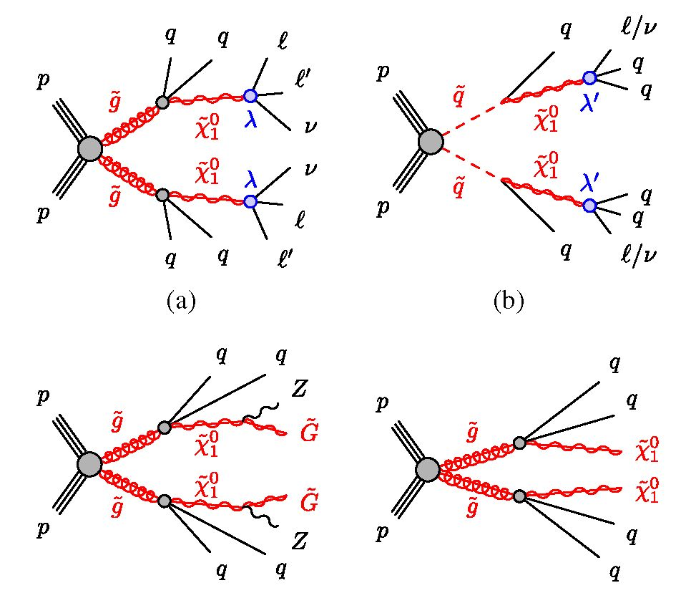
SEARCH FOR MASSIVE, LONG-LIVED PARTICLES ...
(c)
(d)
FIG. 1 (color online). Diagrams representing some of the
processes under study, corresponding to the simulated event
samples. In RPV scenarios, the long-lived neutralino may decay
via the (a) or (b) couplings. (c) Long-lived neutralino
decay in a GGM scenario. (d) Long-lived R-hadron decay in a
split-supersymmetry scenario. The quarks and leptons shown
may have different flavors. Filled circles indicate effective
interactions.
All samples are generated with the AUET2B ATLAS
underlying-event tune [33] and the CTEQ6L1 parton
distribution function (PDF) set [34]. Events are generated
consistently with the position of the pp luminous region
and weighted so as to yield the correct z distribution of the
collisions. Each generated event is processed with the
GEANT4-based [35] ATLAS detector simulation [36] and
treated in the same way as the collision data. The samples
include a realistic modeling of the effects of multiple pp
collisions per bunch crossing observed in the data, obtained
by overlaying additional simulated pp events generated
using PYTHIA8 [37], on top of the hard scattering events,
and reweighting events such that the distribution of the
number of interactions per bunch crossing matches that in
the data.
In what follows, the notation P ^ A[L ^ F] denotes an
MC sample in which a primary particle P produced in the
pp collision decays into a long-lived particle L and
additional particles denoted A. The decay of the LLP into
final state F is enclosed in square brackets. Samples where
the primary particle is long-lived are denoted with [L ^ F].
In both cases, masses may be indicated with parentheses, as
in [L(100 GeV) ^ F]. The symbol q indicates a w- or d-
quark unless otherwise specified, and l indicates an
electron or a muon. Charge conjugation of fermions is
to be understood where appropriate.
RPV samples of the type g ^ qq[X~0 ^ ffv] are pro-
duced with herwig++ 2.6.3 [38]. Decays of the neutralino
into a neutrino and light leptons, which may be e+e-,
PHYSICAL REVIEW D 92, 072004 (2015)
p+p-, or e±p^, take place due to the nonzero values of the
RPV couplings i121 and i122 [2].
RPV samples of q ^ q[^ Iqq/vqq] are generated
with PYTHIA6.426.2 [39]. The;~° decay into two light quarks
and an electron, muon, or neutrino is governed by the
nonzero RPV coupling ij11. Samples containing heavy-
flavor quarks, q ^ q[^ Iqb] (produced with X'i13 ± 0)
and q ^ q[jX? ^ Icb] (corresponding to ij23 ^ 0) are also
generated, in order to study the impact of long-lived charm
and bottom hadrons on the efficiency of DV reconstruction.
A g ^ qq[ j0 ^ Iqq] sample is used to quantify the effect
of prompt NLSP decays on the reconstruction efficiency, by
comparing with the corresponding model with squark
production.
PYTHIA6.426.2 is used to produce GGM samples denoted
g ^ qq[j0 ^ GZ], in which the NLSP j0 is a Higgsino-
like neutralino. Both the leptonic and hadronic decays of
the Z boson are considered.
Within a split-supersymmetry scenario, PYTHIA6.427 is
used to simulate production and hadronization of a primary,
long-lived gluino. GEANT4 simulates the propagation of the
R-hadron through the detector [40], and pythia decays the
R-hadron into a stable neutralino plus two quarks (w, d, s, c,
or b), a gluon, or two top quarks. The resulting samples are
denoted [g ^ qq^?], [g ^ gX0], or [g ^ tijx0], respectively.
Signal cross sections are calculated to next-to-leading
order in the strong coupling constant, adding the resumma-
tion of soft gluon emission at next-to-leading-logarithmic
accuracy (NLO + NLL) [41-45]. The nominal cross section
and its uncertainty are taken from an envelope of cross-
section predictions using different PDF sets and factorization
and renormalization scales, as described in Ref. [46].
In addition to these signal samples, MC samples of QCD
dijet events, Drell-Yan events, and cosmic-ray muons are
used for estimating some systematic uncertainties and some
of the smaller background rates, as well as for validation of
aspects of the background-estimation methods.

IV. EVENT RECONSTRUCTION
AND SELECTION
The event-reconstruction and selection procedures are
designed, based on MC and experience from previous
analyses [13,14], to strongly suppress background and
accommodate robust background-estimation methods
(described in Sec. VI), while efficiently accepting signal
events over a broad range of LLP masses, lifetimes, and
velocities.
The initial event selection is performed with a com-
bination of triggers that require the presence of lepton
candidates, jets, or Fm“s. This selection is described in
Sec. IV A.
Off-line selection criteria for leptons, jets, and FTmiss (see
Sec. IV B) are used to further filter events for off-line
processing, as described in Sec. IV C.
072004-3
- AAD et al.
Events satisfying the filter requirements undergo a CPU-
intensive process termed “retracking,” aimed at efficient
reconstruction of tracks with large impact parameter (d0)
with respect to the transverse position of any primary vertex
(PV) of particles formed from the pp collision. Retracking
is described in Sec. IV D.
At the final event-selection stage, the presence of a pp
collision is ensured by first requiring the event to have a PV
formed from at least five tracks and situated in the
longitudinal range |z| < 200 mm, consistent with the IP.
The final selection is based on the reconstruction of a
multitrack DV or dilepton DV, described in Secs. IV E and
IV F, respectively.

A. Trigger requirements
Events must satisfy trigger requirements based on muon,
electron, jets, or FTmiss criteria.
Where muon triggers are used, a muon candidate is
required by the trigger algorithm to be identified in the MS
with transverse momentum pT > 50 GeV. Its pseudora-
pidity must be in the MS-barrel region |n| < 1.07, to reduce
the trigger rate from fake muons due to beam background
in the end cap region.
Photon triggers are used for channels requiring electron
candidates, since the ID track of a high-d0 electron may not
be reconstructed. These require only a high-energy deposit
in the electromagnetic calorimeter and have no veto or
selection based on ID tracks. Photon triggers provide
significantly less background rejection than muon triggers.
Therefore, the trigger used for final states involving
electrons requires either a single photon candidate
with pT > 120 GeV or two photon candidates with pT >
40 GeV each.
The trigger requirement for the DV + FTmiss search is
Em- > 80 GeV. The DV + jets trigger requires four jets
with pT > 80 GeV, five jets with pT > 55 GeV, or six jets
with pT > 45 GeV.

B. Off-line object definition
The reconstruction and selection criteria for Em“8, muon,
electron, and jet candidates are described in what follows.
These object definitions are used by the off-line filter
(Sec. IV C) and the final analysis (Secs. IV E and IV F).
1. Muon selection
Muon candidates are required to be reconstructed in both
the MS and the ID. The ID track associated with the muon
candidate is required to have at least four SCT hits, but the
number of required hits is reduced if the track crosses
nonoperational sensors. Furthermore, the track must satisfy
an |n|-dependent requirement on the number of TRT hits.
No pixel hit requirement is applied to the muon-candidate
track, which is different from the standard ATLAS muon-
reconstruction algorithm [47].
PHYSICAL REVIEW D 92, 072004 (2015)
- Photon and electron selection
Photon and electron candidates are identified with
criteria based on the fraction of the candidate energy
deposited in the hadronic calorimeter and on the shape
of the electromagnetic shower. In addition, electron can-
didates must be in the pseudorapidity region |n| < 2.47 and
must satisfy requirements on the number of TRT hits
associated with the ID track, the fraction of high-threshold
TRT hits, and the pseudorapidity difference between the
electron-candidate track and the associated calorimeter
cluster. In contrast to the standard ATLAS electron-
selection requirements [48], no requirement on the number
of silicon hits is applied.
- Jet and E™ss selection
Jet candidates are reconstructed using the anti-kt jet
clustering algorithm [49,50] with a radius parameter
R = 0.6. The inputs to this algorithm are the energies of
clusters [51,52] of calorimeter cells seeded by those with
energy significantly above the measured noise. Jet
momenta are constructed by performing a four-vector
sum over these cell clusters, treating each cell as a four-
momentum with zero mass. Jets are initially calibrated to
the electromagnetic energy scale, which correctly measures
the energy deposited in the calorimeter by electromagnetic
showers [51]. Further jet-energy scale corrections are
derived from MC simulation and data, and used to calibrate
the energies of jets to the scale of their constituent particles
[51]. Jets are required to satisfy |n| < 4.5 after all correc-
tions are applied.
A special category of jets is termed “trackless” jets.
These are reconstructed as above, except that the anti-kt
radius parameter is R = 0.4, the jet pseudorapidity is in the
range |n| < 2.5, and the scalar sum of the transverse
momenta of the tracks in the jet is required to satisfy
JgtrpT < 5 GeV. Trackless jets may arise from decays of
LLPs that take place far from the PV, where track-
reconstruction efficiency is low.
The measurement of the missing transverse momentum
ETmiss is based on the calibrated transverse momenta of all
jet and lepton candidates, as well as all calorimeter energy
clusters not associated with such objects [53,54].

C. Off-line-filter requirements
Events are selected for retracking and subsequent off-
line analysis based on off-line filters that require one of the
following:
- A muon candidate with pT > 50 GeV, an electron
candidate with pT > 110 GeV, or a photon candi-
date with pT > 130 GeV. Electron candidates, and
muon candidates that are associated with an ID track
at this stage, are required to have d0 > 1.5 mm. The
sample selected by this criterion contains 8.5 x 106
events.
072004-4
SEARCH FOR MASSIVE, LONG-LIVED PARTICLES
PHYSICAL REVIEW D 92, 072004 (2015)
- A pair of candidate electrons, photons, or an
electron-photon pair, with pT thresholds between
38 and 48 GeV per object, and electron impact
parameter satisfying d0 > 2.0 mm or d0 > 2.5 mm
depending on the channel. This criterion selects
2.4 x 106 events.
- Either two 50 GeV trackless jets and Emiss >
100 GeV (selecting 1.9 x 104 events) or one
45 GeV trackless jet and between four and six jets
passing the same pT thresholds as those applied in
the trigger, listed in Sec. IVA (selecting 4.6 x 105
events).

D. Retracking
In standard ATLAS tracking [31], several algorithms are
used to reconstruct charged-particle tracks. In the silicon-
seeded approach, combinations of hits in the pixel and SCT
detectors are used to form initial track candidates (seeds)
that are then extended into the TRT. Another algorithm
starts from track segments formed of TRT hits, and
extrapolates back into the SCT, adding any silicon hits
that are compatible with the reconstructed trajectory. Both
of these methods place constraints on the transverse and
longitudinal impact parameters of track candidates that
result in a low efficiency for tracks originating from a DV,
many of which have large d0.
To recover some of these lost tracks, the silicon-seeded
tracking algorithm is rerun off-line, using only hits that are
not associated with existing tracks, for the events that
satisfy the trigger and filter requirements (Secs. IV A and
IV C). This retracking procedure is performed with the
looser requirement d0 < 300 mm and |z0| < 1500 mm.
Furthermore, retracking requires a track to have at least
five detector hits that are not shared with other tracks, while
the corresponding requirement in standard silicon-seeded
tracking is at least six hits. To reduce the rate of false seed
tracks, it is required that these additional tracks have
pT > 1 GeV, while the standard-tracking requirement
is pT > 400 MeV.
The remainder of the analysis proceeds with both the
standard-tracking tracks and retracking tracks. To realize
the benefits of retracking for lepton candidates, the lepton-
identification algorithms are rerun with the retracking
tracks.

E. Multitrack vertex reconstruction
and final selection
- Multitrack vertex reconstruction
Tracks used for DV reconstruction are required to satisfy
pT > 1 GeV and to have at least two SCT hits, to ensure
high track quality. The requirement d0 > 2 mm is also
applied, rejecting at least 97% of tracks originating from a
PV. The tracks are rejected if they have no TRT hits and
fewer than two pixel hits, in order to remove fake tracks.
The selected tracks are used to construct a multitrack DV
by means of an algorithm based on the incompatibility-
graph approach [55].
The algorithm starts by finding two-track seed vertices
from all pairs of tracks. Seed vertices that have a vertex fit
X2 of less than 5.0 (for 1 degree of freedom) are retained. If
the seed vertex is inside the innermost pixel layer, both
tracks must have a hit in this layer. If the vertex is between
the first and second (second and third) pixel layers, both
tracks must have a hit in either the second or third pixel
layer (third pixel layer or the SCT). A seed vertex is
rejected if any of its tracks have hits at radial positions
smaller than that of the vertex. The interesting case of a
charged LLP is not precluded by this selection, as the track
formed by the LLP itself fails the d0 > 2 mm requirement,
and is therefore not included in the seed vertex. To ensure
consistency between the position of the seed vertex and the
direction p of the three-momentum vector of the seed-
vertex tracks, the requirement d ■ p > —20 mm is applied,
where d = rDV — rPV is referred to as the “distance vector”
between the position of the DV and that of the first PV. The
first PV is defined as the PV with the largest p2T, where
the sum is over tracks associated with the PV.
Multitrack vertices are formed from combinations of
seed vertices in an iterative process, as follows. If a track is
assigned to several vertices, the vertex DV1 with respect to
which it has the largest x2 is identified. If this x2 is larger
than 6, the track is removed from DV1. Otherwise, the
algorithm finds the vertex DV2 that has the smallest value
of D/od, where D is the distance between DV1 and DV2,
and oD is the estimated uncertainty on D. If D/oD < 3, a
single vertex is formed from all the tracks of both vertices.
If this is not the case, the track is removed from DV1. This
process continues until no track is associated with more
than one vertex. Finally, vertices are combined and refitted
if they are separated by less than 1 mm. No requirement is
made on the total charge of the tracks forming a vertex.
- Vertex selection
The reduced x2 of the DV fit is required to be smaller
than 5.0. The DV position must be within the fiducial
region rDV < 300 mm, | zDV | < 300 mm, where rDV and
zDV are the radial and longitudinal DV positions with
respect to the origin. To minimize background due to tracks
originating from the PVs, the transverse distance Axy =
\/(xdv — XPV)2 + (yDV — ypv)2 between the DV and any
of the PVs is required to be at least 4 mm. Here x and y are
the transverse coordinates of a given vertex, with the
subscripts PV and DV denoting the type of vertex.
DVs that are situated within regions of dense detector
material are vetoed using a three-dimensional map of the
detector within the fiducial region. The map is constructed
in an iterative process, beginning with geometrically simple
detector elements that are fully accounted for in the MC
072004-5
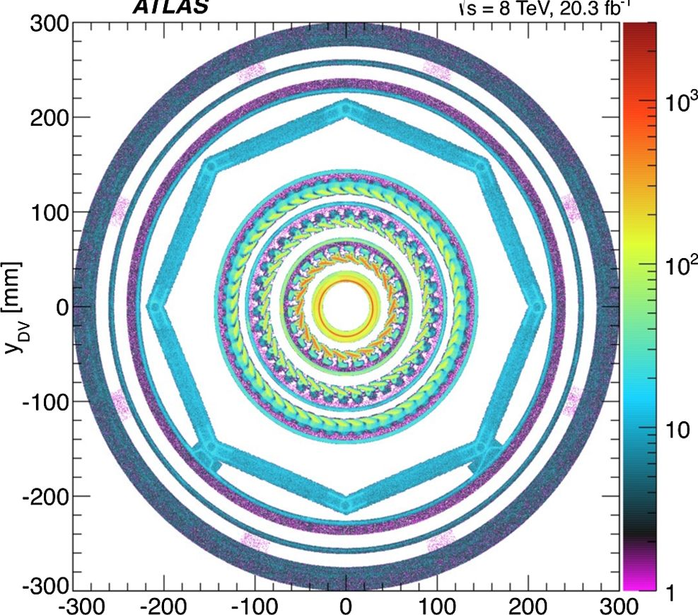
G. AAD et al.
simulation. Subsequently, detailed structures, as well as the
positioning and thickness of the simple elements, are
obtained from the spatial distribution of vertices obtained
from the data, taking advantage of the known ^ periodicity
of the detector to reduce statistical uncertainties. The
vertices used to construct the map are required to be
formed from fewer than five tracks, in order to avoid the
signal region defined below. The invariant mass of these
vertices, assuming massless tracks, must be greater than
50 MeV, to suppress vertices from photon conversions,
which have low spatial resolution due to the small opening
angle between the electrons, as well as electron scattering.
Vertices arising from decays of K°S mesons are removed
with an invariant-mass criterion. The transverse-plane
projection of the positions of vertices that occur inside
the material regions is shown in Fig. 2.
As the final step in multitrack DV selection, the number
of tracks forming the DV is required to satisfy Ntr > 5, and
the invariant mass mDV of all the tracks in the vertex must
be greater than 10 GeV. In calculating mDV, each track is
taken to have the mass of the charged pion. Candidate
vertices that pass (fail) the mDV > 10 GeV requirement are
hereafter referred to as being high-mDV (low-mDV) vertices.
The typical position resolution of the DV in the multi-
track signal MC samples is tens of microns for rDV and
about 200 ^m for zDV near the IP. For vertices beyond the
outermost pixel layer, which is located at a radius of
xDV [mm]
FIG. 2 (color online). Transverse-plane density (in arbitrary
units) of vertices with fewer than five tracks in material regions
that are excluded by the material veto in the region
|z| < 300 mm. The innermost circle corresponds to the beam
pipe. This is surrounded by the three pixel layers. The octagonal
shape and outermost circles are due to support structures
separating the pixel and SCT detectors.
PHYSICAL REVIEW D 92, 072004 (2015)
122.5 mm, the typical resolution is several hundred microns
for both coordinates.
- DV + lepton selection
In the DV + muon search, the muon candidate is required
to have triggered the event and have transverse momentum
pT > 55 GeV, which is well into the region where the
trigger efficiency is approximately independent of the muon
momentum. The muon candidate is further required to be in
the range jnj < 1.07 and have transverse impact parameter
d0 > 1.5 mm. A cosmic-ray muon traversing the entire
ATLAS detector is reconstructed as two back-to-back muon
candidates. To reject cosmic-ray background, events are
discarded if they contain two muon candidates with
ARcosmic = V(n - A^)2 - (ni + %)2 < 0.04, where n
and n2 are the pseudorapidities of the two reconstructed
muon candidates and is their angular separation in the
azimuthal plane. This has a negligible impact on the signal
efficiency.
In the DV + electron search, the electron candidate is
required to have triggered the event and to satisfy pT >
125 GeV and d0 > 1.5 mm.
To ensure that the lepton candidate is associated with the
reconstructed DV, the distance of closest approach of the
selected muon or electron candidate to the DV is required to
be less than 0.5 mm. This requirement ensures that the
reconstructed DV gave rise to the muon or electron
candidate that triggered the event, and so the selection
efficiency for each LLP decay is independent of the rest of
the event. This facilitates a straightforward calculation of
the event-selection efficiency for scenarios with different
numbers of LLPs. The aforementioned selections are
collectively referred to as the vertex-selection criteria.
Events containing one or more vertices satisfying these
criteria are accepted.
- DV + jets and DV + Emss selection
The DV + jets selection requires one of the following:
four jets with pT > 90 GeV; five jets with pT > 65 GeV;
or six jets with pT > 55 GeV. All jets considered in these
selection criteria are required to have jnj < 2.8. DV + jet
candidate events are discarded if they contain any candidate
jet failing to satisfy quality criteria designed to suppress
detector noise and noncollision backgrounds [56,57]. This
has a negligible effect on the signal efficiency. In the DV +
ET search, the requirement £miss > 180 GeV is applied.
For these selection criteria, the trigger efficiency is approx-
imately independent of the Emiss and the jet transverse
momenta.

F. Dilepton selection
In the dilepton search, muon candidates are required to
satisfy pT > 10 GeV, jnj < 2.5, and d0 > 2 mm. For
electron candidates, the requirements are pT > 10 GeV
072004-6
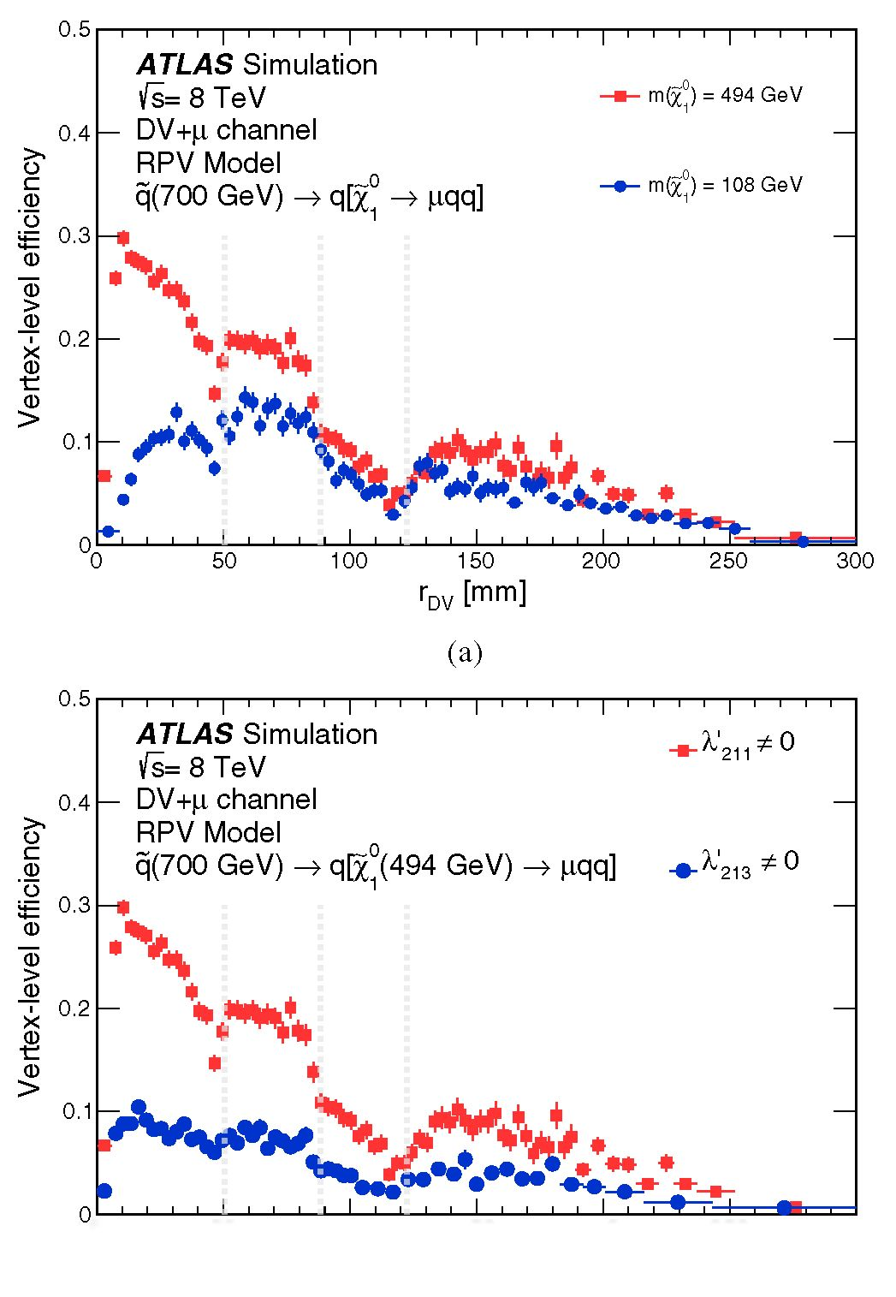
SEARCH FOR MASSIVE, LONG-LIVED PARTICLES ...
PHYSICAL REVIEW D 92, 072004 (2015)
and d0 > 2.5 mm. A lepton candidate is discarded if its ID
track is in the pseudorapidity region |n| < 0.02, where the
background-estimation procedure is observed to be unre-
liable (see Sec. VI).
To avoid double counting of vertices, lepton candidates
used to form a dilepton DV must not have the same ID
track as another lepton candidate. If two muon candidates
or two electron candidates do share an ID track, the
candidate that has the lower transverse momentum is
discarded. If muon and electron candidates share an ID
track, the electron candidate is discarded. Cosmic-ray
muons, even those that interact while traversing the
detector, are rejected by requiring that all lepton-candidate
pairs satisfy ARcosmic > 0.04.
A dilepton DV is formed from at least two opposite-
charge tracks identified as two electrons, two muons, or an
electron and a muon. Any number of additional tracks may
be included in the vertex. At this stage, it is verified that the
dilepton selection criteria applied at the trigger and filter
level (see Secs. IVA and IV C) are satisfied by the two
lepton candidates forming the DV. Finally, the dilepton DV
is required to satisfy the DV selection criteria specified in
Sec. IV E 2, except for the requirement on the number of
tracks, which is Ntr > 2. As in the DV + lepton case, the
dilepton-DV selection relies only on the leptons in the DV
and is independent of the rest of the event.
V. SIGNAL EFFICIENCY
In the dilepton and DV + lepton searches, where the
selection criteria rely only on the particles produced in
the DV, the vertex-level efficiency eDV is defined to be the
product of acceptance and efficiency for reconstructing one
signal DV, produced in the given search model, with all the
trigger, filter, and final selection criteria. The event-level
efficiency eev, defined as the probability for an event
containing two DVs to be identified with at least one
DV satisfying all the selection criteria, is then obtained
from the relation
eev — 2BDv — b2gDV;
(1)
where B is the LLP branching fraction into the specific
search channel. In the DV + jets and DV + Em“5 searches,
only the event-level efficiency is defined, since the selec-
tion criteria involve the entire event.
The efficiency for reconstructing a multitrack or dilepton
DV with the above selection criteria depends strongly on
the efficiencies for track reconstruction and track selection,
which are affected by several factors: (1) The number of
tracks originating from the DV and their total invariant mass
increase with the LLP mass. (2) More tracks fail the
minimal-d0 requirement for small rDV, or when the LLP
is highly boosted. (3) The efficiency for reconstructing
tracks decreases with increasing values of d0. (4) When an
LLP decays at a radius somewhat smaller than that of a
pixel layer, many tracks share hits on that pixel layer,
failing to meet the track-selection criteria. The resulting
impact on efficiency can be seen in Fig. 3 at radii around
45 mm, 80 mm, and 115 mm.
The efficiency for reconstructing a multitrack DV is
reduced when the LLP decays to charm or bottom hadrons,
resulting in two or more nearby DVs. Each of these DVs
has a high probability of failing to meet the Ntr and mDV
criteria, resulting in low efficiency if these DVs are not
merged. This happens less at large values of rDV, where
DVs are more readily merged due to the worse position
resolution.
The vertex-level efficiency does not depend appreciably
on whether the primary particle is a squark or a gluino.
0 50 100 150 200 250 300
rDV [mm]
(b)
FIG. 3 (color online). Comparisons of the vertex-level effi-
ciency as a function of the vertex radial position rDV for different
RPV samples. The vertical gray lines show the position of the
first, second, and third pixel layers. (a) For the q ^ q[x0 ^
(^211) samples with mq = 700 GeV, comparing two cases of
different LLP masses: m^o = 494 GeV, and m^o = 108 GeV.
(b) For the q ^ q[ ^ ¡iqq\ (22n) and q ^ q[^ fjqb\ (2213)
samples, indicated by the relevant nonzero RPV couplings.
072004-7
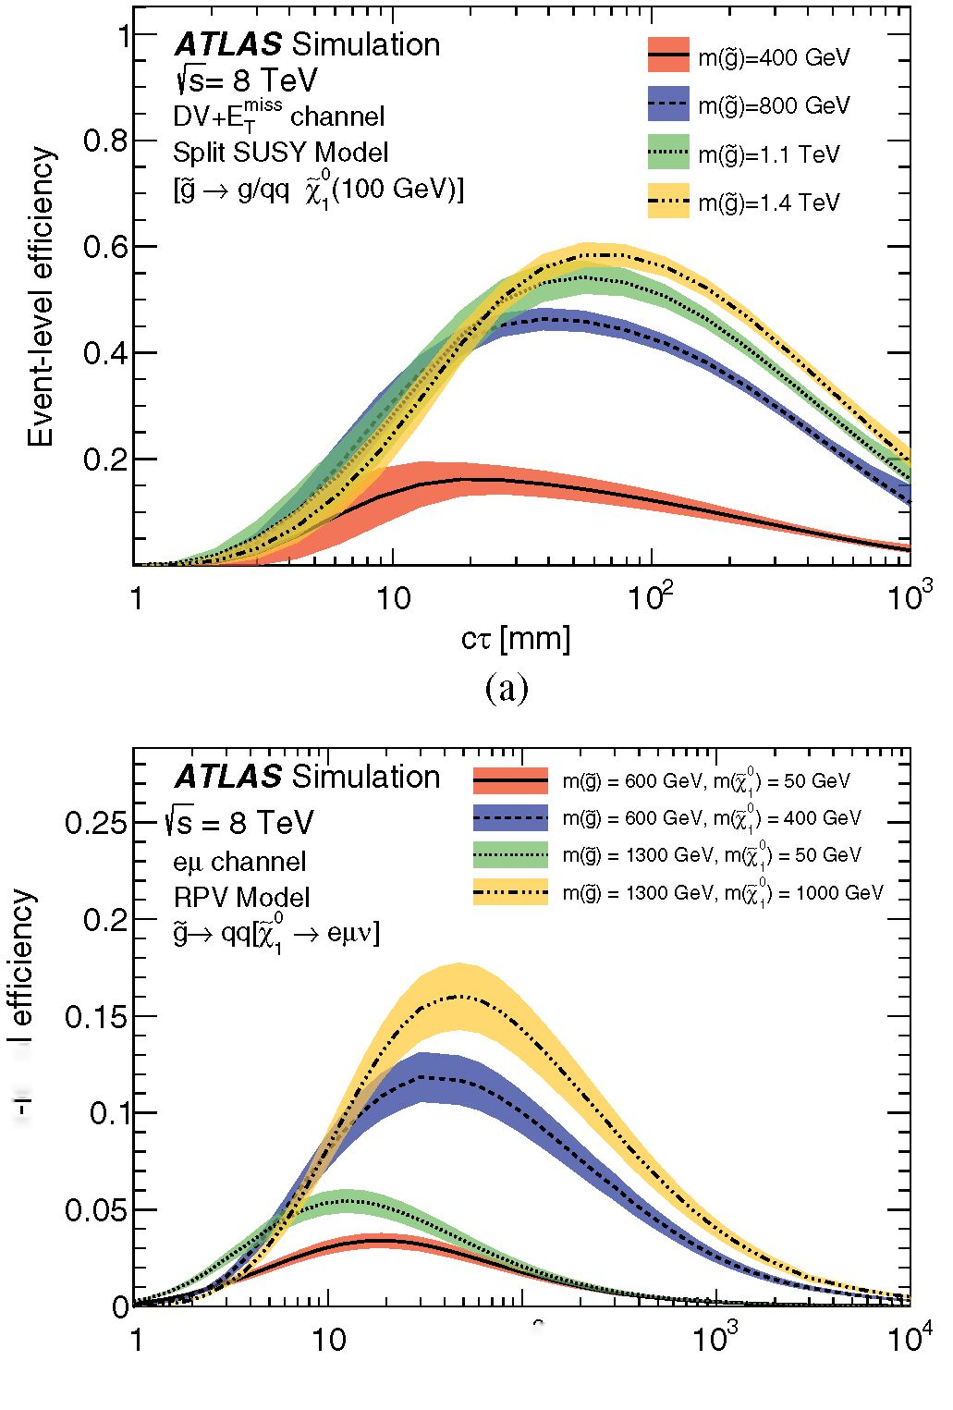
G. AAD et al.
PHYSICAL REVIEW D 92, 072004 (2015)
a)
>
_a>
><
a)
t
a)
>
102
ct [mm]
(b)
FIG. 4 (color online). (a) The event-level efficiency as a function
of ct for split-supersymmetry \g ^ g/gg;~j)(100 GeV)] samples
with various gluino masses, reconstructed in the DV + Em^
channel. (b) The vertex-level efficiency for the RPV g ^
qq\x1 ^ egv] samples with combinations of gluino and neutralino
masses, reconstructed in the eg dilepton channel. The total
uncertainties on the efficiencies are shown as bands (see Sec. VII).
However, the nature of the primary particle determines the
number of jets, and hence impacts the event-level efficiency
in the DV + jets and DV + Ems channels.
Examples of the impact of LLP boost, mass, and
heavy-flavor decays on the vertex-level efficiency are
an
shown in Fig. 3 for q > q\X~1
samples. As
example of the benefits of retracking, it is worthwhile to
note that without retracking, the vertex-level efficiency for
the m(jfi) = 494 GeV, A'211 ± 0 sample shown in this
figure is about 1% at rDV = 80 mm and is negligible for
larger radii.
Events in each MC sample are generated with a fixed
value of the LLP lifetime tmc. To obtain the vertex-level
efficiency for a different lifetime t, each LLP is given a
weight
Wdv(t; t)= — exp (—
t Vtmc
(2)
where t is the true proper decay time of the generated LLP.
The vertex-level efficiency is then the sum of weights for
LLPs that satisfy all the criteria in the sample. The same
procedure is applied when calculating the event-level
efficiency, except that the entire event is weighted by
Wevt(t1;t2; t) = WDV(t1; t)WDV(t2; t);
(3)
where t1 and t2 are the true proper decay times of the two
LLPs in the event. Examples of the resulting dependence of
eDV and eev on the average proper decay distance ct are
shown in Fig. 4. For most models considered in this
analysis, the peak efficiency is typically greater than 5%,
and it occurs in the range 10 < ct < 100 mm.

VI. BACKGROUND ESTIMATION
The expected number of background vertices is esti-
mated from the collision data for each channel. Since the
number of events satisfying the final selection criteria is
very small, the general approach is to first obtain a high-
statistical-precision assessment of the probability for
background-vertex formation using a large data control
sample. That probability is then scaled by the size of the
signal-candidate sample relative to that of the control
sample.

A. Multitrack-vertex background estimation
Background vertices that are due to accidental spatial
crossing of tracks in a jet, particle interactions with
material, or heavy-flavor decays have low values of mDV
and/or Ntr and thus fail the selection requirements. Such
vertices may contribute to high-mDV, high-Ntr background
vertices via two mechanisms.
- The dominant source of backgrounds are low-mDV
vertices that are accidentally crossed by an unre-
lated, high-pT track at large angle [O(1 radian)] to
the other tracks in the vertex. This is referred to as
the accidental-crossing background.
- A much smaller background contribution is due to
merged vertices. In this case, two low-mDV vertices
are less than 1 mm apart, and thus may be combined
by the vertex-reconstruction algorithm into a single
vertex that satisfies the Ntr and mDV criteria.
The expected background levels from the two sources
are estimated from the data. In order for the background
estimate to have high statistical precision, it is performed
with a large sample containing all events that have under-
gone retracking. This includes the events selected for this
search, as described in Sec. IV C, as well as events used for
other ATLAS analyses. The sample is divided into three
subsamples, referred to as the muon stream, the electron
stream, and the jets + E™ss stream, with the name
t
072004-8
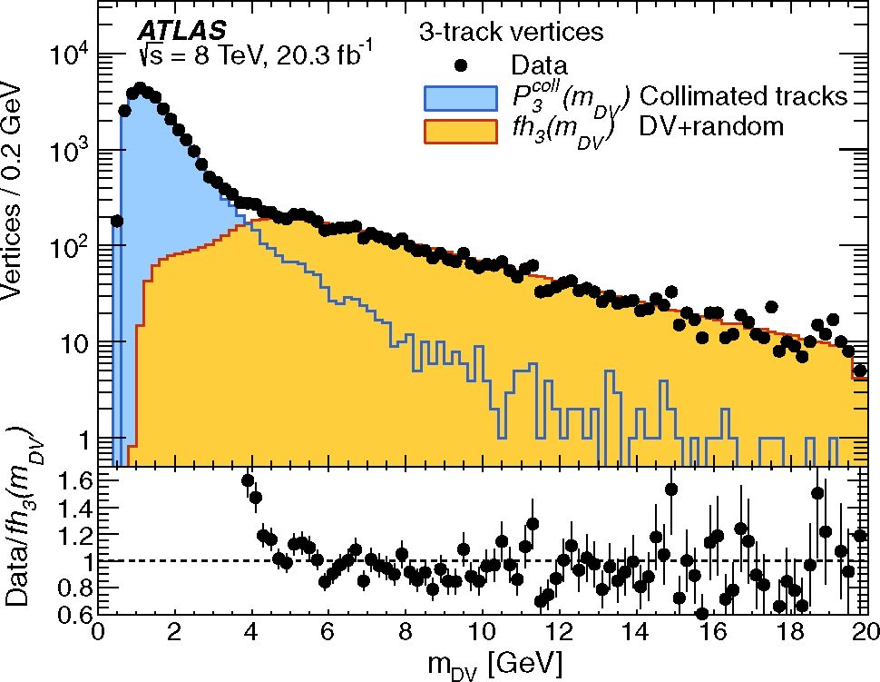
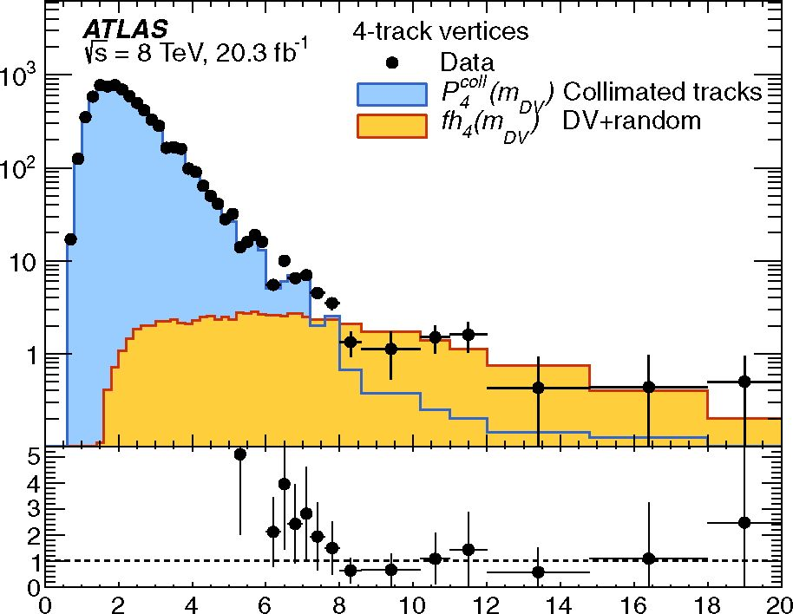
SEARCH FOR MASSIVE, LONG-LIVED PARTICLES
PHYSICAL REVIEW D 92, 072004 (2015)
indicating the type of trigger used to select the events.
The background level is estimated separately in each of
these streams with the methods described below, and the
results are used for the DV + muon, DV + electron, and
DV + jets and DV + Em“5 signal regions, respectively.
To obtain the final background estimate in the signal
region, the background estimate in each stream is multi-
plied by a final-selection scale factor Fstream, which is the
fraction of events in the given stream that satisfy the final
event-selection criteria, other than the DV selection criteria.
The values of these fractions are 0.08%, 5.0%, 1.45%, and
- 04%, for the DV + muon, DV + electron, DV + jet, and
DV + ET searches, respectively. This use of Fstream
assumes that the average number of vertices per event,
NDV, is independent of the selection criteria. Based on the
change in NDV when the final selection criteria are applied,
an upward bias correction of 60% is applied to the
estimated background level in the DV + electron channel
(the correction is included in the Fstream = 5.0% value
quoted above). The other channels have negligible bias. A
10% systematic uncertainty is estimated for all channels
from the statistical uncertainty of the bias estimate.
- Background from accidental vertex-track crossings
The accidental-crossing background is estimated sepa-
rately in six radial regions, ordered from the inside out.
Region 1 is inside the beam pipe. Regions 2, 3, and 4
correspond to the volumes just before each of the three
pixel layers. Regions 5 and 6 are outside the pixel layers.
Region 5 extends outwards to rDV = 180 mm, where there
is essentially no detector material, while Region 6 covers
the volume from 180 < rDV < 300 mm. In each region, a
study of the mDV distribution of Ntr-track vertices, where
Ntr = 3 through 6, leads to identification of two types of
background vertices, as follows.
The first type, which dominates the low-mDV range, is
due to accidental track crossings in Region 1, and particle-
material interactions in the other regions. This contribution
to the mDV spectrum is referred to as collimated-tracks
background, reflecting the typically small angle between
the tracks. The mDV distribution PNO^^dv) for this
contribution is modeled from the Ntr-track vertices for
which the average three-dimensional angle between every
pair of tracks is less than 0.5. In Fig. 5, P3°U(mDv) is seen to
fully account for 3-track vertices with mDV less than
about 3 GeV. However, it does not account for vertices
with higher masses, particularly the signal region,
mDV > 10 GeV.
The high-mDV part of the mDV distribution is dominated
by the second contribution, referred to as “DV + track.” In
this case, a (Ntr — 1)-track vertex is crossed by an unrelated
track at a large angle with respect to the momentum vector
of the vertex tracks. To construct a model of the DV + track
mDV distribution of Ntr-track vertices, every (Ntr — 1)-track
(a)
mDV [GeV]
(b)
FIG. 5 (color online). The mass distribution for (a) 3-track and
(b) 4-track vertices (data points) from the jets + Emiss stream in
Region 6, overlaid with the model fh3 (mDv) of Eq. (5) (yellow-
shaded histogram) at high mass. The lower panel of each plot
shows the ratio of the data to this model. The model for the
collimated-track contribution P3°U(todv ) (blue-shaded histo-
gram), which is correlated with the low-mass data but not used
for estimating the signal-region background, is also shown.
vertex, referred to as an “acceptor” vertex, is paired with a
“donated” track that is taken from a “donor” vertex in
another event. This is done for Ntr — 1 in the range 2-5,
where acceptor vertices with five tracks are required to have
mass below 10 GeV, to avoid the signal region.
The pairing of a vertex and a track is performed with the
following procedure. The donor vertex must satisfy all the
DV selection criteria, except that the requirement on its
mass is not applied, and it may have as few as two tracks.
To ensure that the donated track is able to accurately model
the effects of a large-angle crossing, it is required that the
donor vertex be from the same radial region as the acceptor
vertex, and that there is a large angle between the direction
072004-9
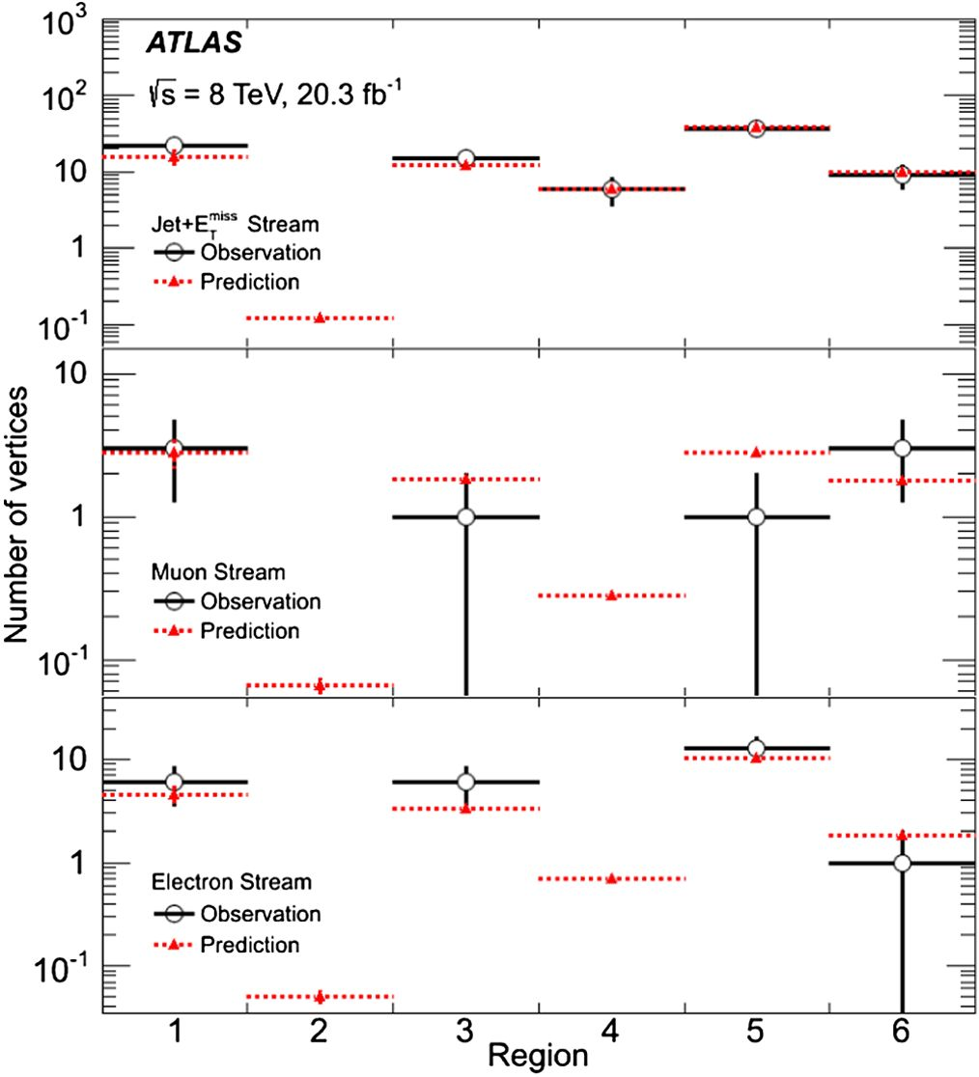
G. AAD et al.
of the donated track and the distance vector of the donor
vertex.
In all regions apart from Region 1, the momentum vector
of the donated track is then rotated, so that its azimuthal and
polar angles (A^donor and A#donor) with respect to the
distance vector of the acceptor vertex match those that it
originally had with respect to the donor vertex. This ensures
that the contribution of the donated track to the acceptor
vertex mass correctly reflects the accidental-crossing prob-
ability as a function of Andonor and A^donor.
Then, the four-momentum of the acceptor vertex and the
rotated four-momentum of the track are added, obtaining
the mDV value of the Ntr-track vertex that would have been
formed from an accidental crossing of the acceptor vertex
and the rotated donated track. The resulting mDV distribu-
tion for the Npairs DV + track pairs found in each region is
denoted (mDV), such that
PHYSICAL REVIEW D 92, 072004 (2015)
hN(j (mDV)dmDV — N]
pairs1
(4)
Tracks from donor vertices in Region 1 are treated differ-
ently, since they tend to have high pseudorapidity, which
impacts their DV-crossing probability more than their
A^donor and A#donor values. Therefore, a Region-1 track
is not rotated before its four-momentum is added to that of
the acceptor vertex.
The high-mDV distribution for Ntr-track vertices is then
modeled by
FIG. 6 (color online). Summary of the number of observed
(black open circles) 4-track, high-mDV vertices in each of the
radial regions and filter-selection streams and the predicted
number (red triangles), from Eq. (7). In Region 1, the prediction
includes the contribution from merging of two 2-track vertices
(see Sec. VIA 2). The error bars on the prediction are too small to
be visible, and in some bins no events are observed.
0
(mDV) fhA,tI (mDV); (5)
where
N10 GeV
f RlO GeV h3(mDV)dmDV ( )
is the scale factor that normalizes the model to the data,
and N30 GeV is the number of 3-track vertices with
mDV > 10 GeV. The model-predicted number of Ntr-track
background vertices with mDV > 10 GeV for a given
stream and region is given by
= [" Pv (mDV)dmDv (7)
J10 GeV
The model describes the high-mDV background distri-
bution in data well, as seen in Fig. 5 for jets + Em^-stream
3-track and 4-track vertices in Region 6. Also shown is the
collimated-track contribution, which accounts for the low-
mDV part of the distribution. Using 4-track vertices to
validate Eq. (7), the prediction for each of the three streams
and six regions is compared with the observed number of
vertices. The comparison, summarized in Fig. 6, shows
good agreement within the statistical precision.
The final numbers of expected background vertices, after
multiplying by the scale factor Fstream, are shown in
Table I. tr
- Background due to merged vertices
In the last step of DV reconstruction (see Sec. IV E 1),
vertices are combined if they are separated by less than
1 mm. To estimate the background arising from this
procedure, the distribution of the distance d2DV between
two 2-track or 3-track vertices is studied. Each of the
selected vertices is required to satisfy the DV selection
criteria of Sec. IV E 2 except the mDV and Ntr requirements,
TABLE I. Estimated numbers of background vertices satisfying
all of the multitrack signal selection criteria, which arise from a
low-mass DV accidentally crossed by an unrelated track. In each
entry, the first uncertainty is statistical, and the second is
systematic (see Sec. VII).
Channel | No. of background vertices (x10 3)
DV + jet | 410 ± 7 ± 60
DV + £™ss | 10.9 ± 0.2 ± 1.5
DV + muon | 1.5 ± 0.1 ± 0.2
DV + electron | 207 ± 9 ± 29
072004-10
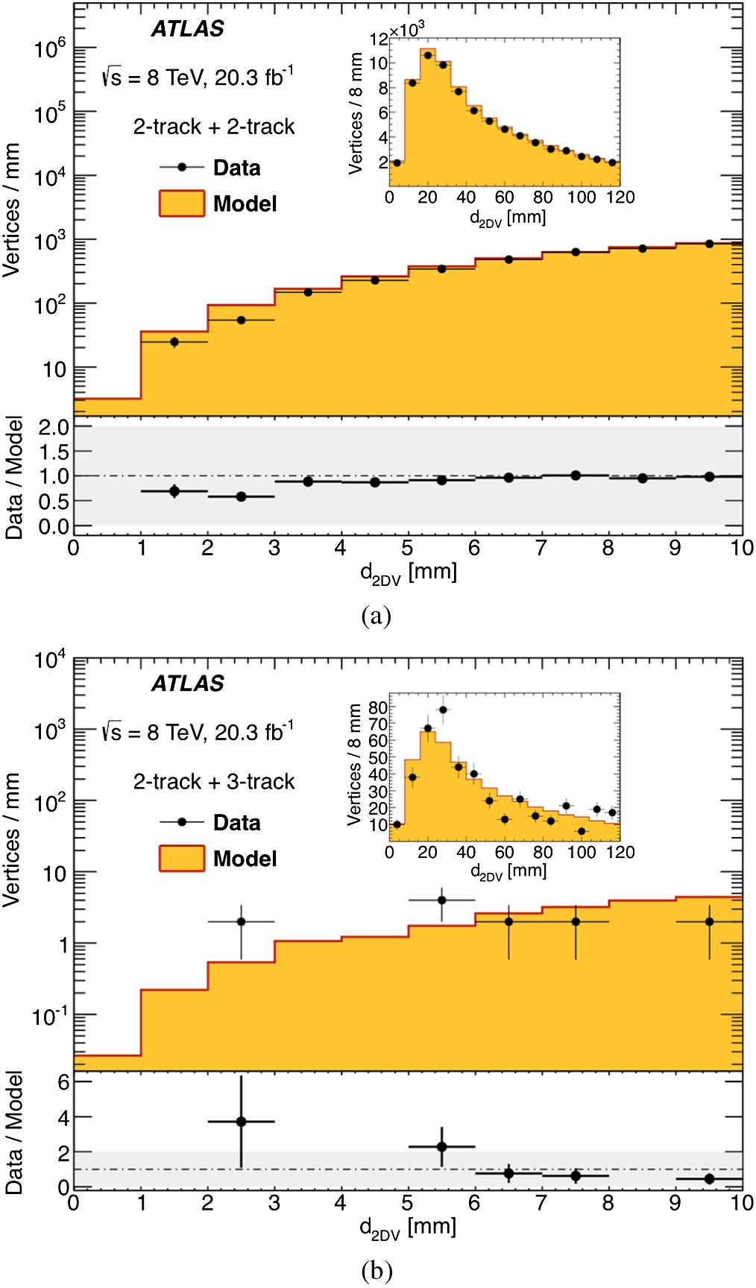
SEARCH FOR MASSIVE, LONG-LIVED PARTICLES ...
and their combined mass is required to be greater than
10 GeV. To obtain a sufficient number of vertices for
studying the d2DV distribution, the distribution is recon-
structed from a much larger sample of vertex pairs, where
each vertex in the pair is found in a different event. This is
referred to as the “model” sample.
To validate the d2DV distribution of the model sample, it
is compared to that of vertices that occur in the same event,
referred to as the “same-event” sample. It is found that the z
positions of vertices in the same event are correlated, since
more vertices are formed in high-track-multiplicity regions
corresponding to jets. This effect is absent in the model
sample. As a result, the distributions of the longitudinal
distance between the vertices in the model and the same-
event samples differ by up to 30% at low values of d2DV. To
correct for this difference, each vertex pair in the model
sample is weighted so as to match the z component
distribution of the same-event sample. After weighting,
the model distribution of the three-dimensional distance
d2DV agrees well with that of the same-event sample in the
entire study range of d2DV < 120 mm. This is demon-
strated in Fig. 7 for pairs of 2-track vertices and for the case
of a 2-track vertex paired with a 3-track vertex.
The background level for the analysis requirement of
Ntr > 5 tracks is estimated from vertex pairs where one
vertex has two tracks and the other has three tracks. The
area under the model distribution in the range d2DV <
1 mm yields a background prediction of 0.02 ± 0.02 events
in each of the DV + lepton channels, and 0.03 ± 0.03
events in the DV + jets and DV + E™ss channels. After
multiplication by Fstream, this background is negligible
relative to the accidental-crossing background, described
in Sec. VIA 1. Background from the merging of two 3-
track vertices or a 2-track and a 4-track vertex is deemed
much smaller still.

B. Dilepton-vertex background estimation
Background DVs in the dilepton search may arise from
two sources:
- The dominant background is due to accidental
spatial crossings of unrelated lepton candidates that
happen to come close enough to satisfy the vertex-
reconstruction criteria.
- Minor backgrounds, due to tracks originating from
the PV wrongly associated with a DV, decays of SM
long-lived particles, or cosmic-ray muons. The
levels of background from these sources are deter-
mined to be negligible relative to the accidental-
crossing background.
1. Background from accidental lepton crossing
The level of the accidental-crossing background is
estimated by determining the crossing probability, defined
as the probability for two unrelated lepton-candidate tracks
to be spatially nearby and reconstructed as a vertex. Pairs of
PHYSICAL REVIEW D 92, 072004 (2015)
FIG. 7 (color online). The distribution of the distance d2DV
between (a) two 2-track vertices and (b) a 2-track vertex and a
3-track vertex with a combined mass above 10 GeV for the
jets + Emiss stream data (data points) and in the model sample, in
which the two vertices are in different events (histogram). A
conservative 100% uncertainty on the model is shown in the data/
model ratio plot. The inset shows the d2DV distance up to values
of 120 mm. The merged-vertex background estimate is deter-
mined from the area under the model distribution in the range
d2Dv < 1 mm in (b).
opposite-charge lepton candidates are formed, where each
lepton candidate in a pair is from a different event and
satisfies the lepton-selection criteria. The momentum vec-
tor of one of the two lepton candidates, selected at random,
is rotated through all azimuthal angles by a step 8<p. At each
rotation step, the two lepton candidates are subjected to a
vertex fit and the DV selection criteria. If the pair satisfies
the selection criteria, it is assigned a weighted probability
8<p/2n. Averaging the weighted probabilities over all pairs
072004-11
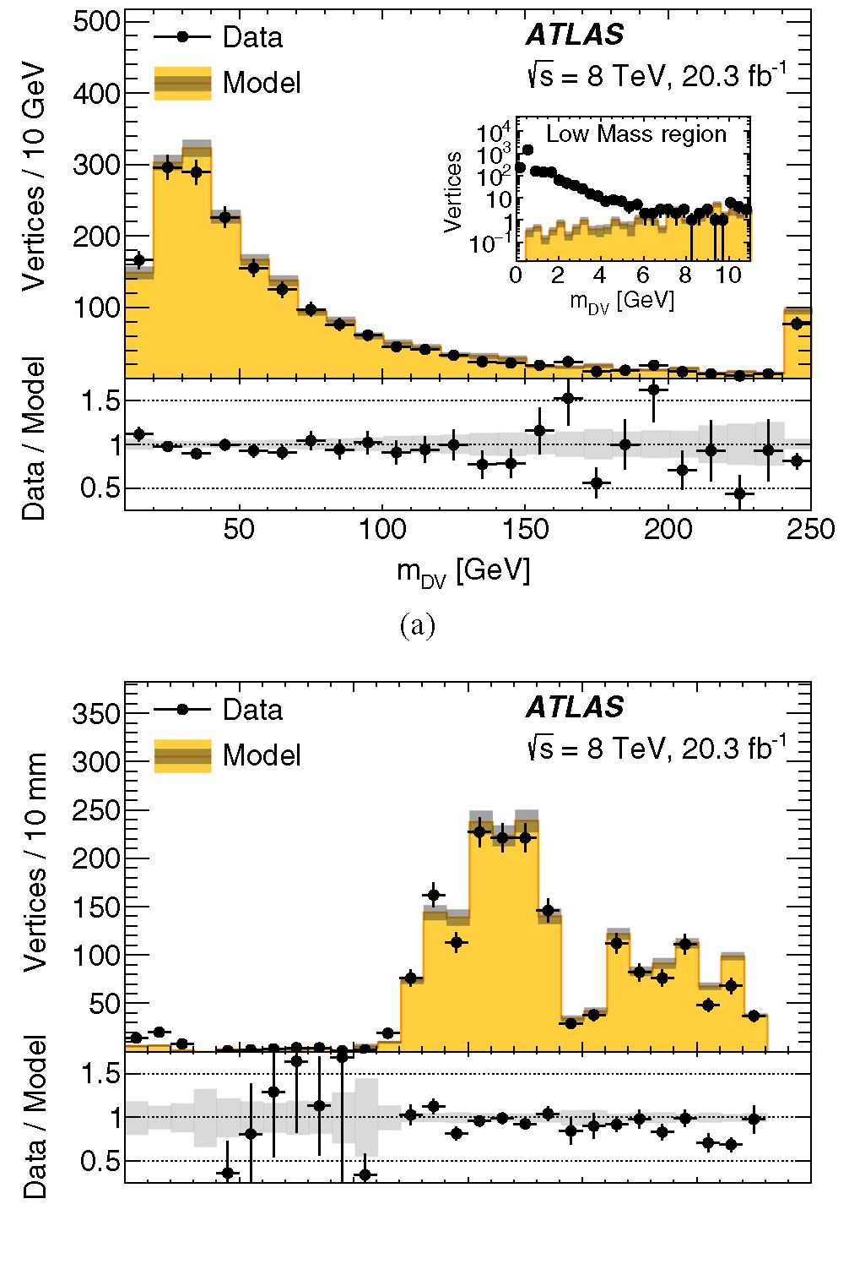
G. AAD et al.
TABLE II. Estimated numbers of background vertices satisfy-
ing all of the dilepton signal selection criteria, arising from
random combinations of lepton candidates. In each entry, the first
uncertainty is statistical, and the second is systematic (see
Sec. VII).
PHYSICAL REVIEW D 92, 072004 (2015)
Channel
No. of background vertices (x10 3)
-1- —
^ + ^
1.0 ± 0.2+0.6
2.4 ± 0.9+0.5
2.0 ± 0.5+04
gives the probability for a lepton-candidate pair to acci-
dentally form a vertex. The probability is observed to be
independent of 8<p for 8<p < 0.03. To obtain the final
background estimate, this probability is multiplied by the
number N^ of data events containing two opposite-charge
lepton candidates that satisfy the lepton-selection criteria.
This procedure yields the background predictions shown in
Table II. Compared with these predictions, the background
level for a 3-track vertex, where at least two of the tracks are
lepton candidates, is negligible.
The validity of this method for estimating the number of
dilepton DVs, including the assumption that the tracks are
uncorrelated, is verified in several ways. Using Z ^ p+p-
and tt MC samples, the procedure is applied to vertices
formed from two lepton candidates, a lepton candidate and
another track, or two tracks that are not required to be
lepton candidates. It is observed that the method correctly
predicts the accidental-crossing background to within about
10%. The background-estimation method is tested also on
pairs of tracks in the data, excluding pairs of lepton
candidates, with a variety of selection criteria. The pre-
dicted and observed numbers of background vertices are
again found to agree to within 10% for all selection criteria.
The method also reproduces well the distributions of mDV,
rDV, zDV, d ■ p, and the azimuthal angle between the two
lepton candidates, in both MC simulation and data. As an
example, Fig. 8 shows the mDV and rDV distributions
observed for data vertices composed of two nonlepton
tracks and the distributions predicted by pairing two tracks
in different events. Some differences between the model
and the data are seen at certain radii (e.g., rDV < 50 mm
and 250 < rDV < 270 mm), but these do not substantially
affect the total number of DVs and are covered by the
assigned systematic uncertainty (see Sec. VIIA 2). The
prediction is accurate down to DV masses of 6 GeV, well
below the DV selection criterion of 10 GeV. At smaller
masses, contributions from other background sources
become significant.
This background-estimation method ignores the pos-
sibility of angular correlations between the leptons forming
a background vertex. The associated systematic uncertainty
is described in Sec. VIIA 2.
0 50 100 150 200 250 300
rDV [mm]
(b)
FIG. 8 (color online). Distributions of the (a) vertex mass and
(b) vertex position radius for vertices composed of two nonlepton
tracks in the data sample (data points), and the predicted model
distribution obtained from vertices formed by combining tracks
from two different data events (shaded histograms). The ratio of
the data to the model distributions is shown below each plot. The
gray bands indicate the statistical uncertainties for the predicted
distributions. The inset shows the mass distribution in the low-
mass region, elsewhere mDV > 10 GeV is required. In (a), the
highest bin shows the histogram overflow.
- Minor backgrounds
Backgrounds from the following sources are found to be
negligible relative to the accidental-crossing background,
and are therefore neglected.
A potential source of background is prompt production
of hard lepton pairs, notably from Z ^ f+f~ decays.
Requiring Axy < 4 mm and removing the mDV >
10 GeV requirement yields no dilepton-vertex candidates,
so the data show no evidence for prompt background.
Therefore, MC simulation is used to estimate the proba-
bility for leptons originating from Z ^ f+f~ decays to
satisfy the minimum-d0 requirements, the probability for
such leptons to satisfy the vertex requirements, and the
+
072004-12
SEARCH FOR MASSIVE, LONG-LIVED PARTICLES .
probability for a Z ^ 1+1- event to pass the analysis
kinematic requirements. Multiplying the product of these
probabilities by the number of Z ^ 1+1- events produced
at ATLAS yields an estimate of 10-5 Z ^ p+p- events and
10-4 Z ^ e+e- events in the Axy < 4 mm sideband. Thus,
the background from this source is negligible.
Background from cosmic-ray muons is studied with the
ARcosmic distribution of the two highest-pT muon candi-
dates in each event, which satisfy the selection criteria
except the ARcosmic > 0.04 requirement. The distribution
drops rapidly as ARcosmic increases, with the highest pair
having ARcosmic = 0.014. The pairs that also satisfy the DV
selection criteria constitute less than 7% of this sample
and have a similar ARcosmic distribution, terminating at
ARcosmic ~ 0.0045. Therefore, it is concluded that the rate
for cosmic-ray background muons satisfying the
AR cosmic > 0.04 requirement is several orders of magnitude
below the accidental-crossing background. In the case of a
partially reconstructed cosmic-ray muon crossing a recon-
structed lepton candidate from a pp collision, the two
tracks are uncorrelated and any contribution to the back-
ground is already accounted for in the results shown in
Table II.
Background from decays of known long-lived hadrons is
studied from vertices in which only one track is required to
be a lepton candidate. It is found to be negligible, due to the
small probability for a hadron to be misidentified as a
lepton candidate and the mass resolution of the detector.

VII. SYSTEMATIC UNCERTAINTIES
AND CORRECTIONS
The dominant systematic uncertainties are those asso-
ciated with the efficiency for reconstructing displaced
electrons and with the jet and ETmiss selection criteria.
Since the background level is low, uncertainties on the
background estimation have a minor effect on the results of
the analysis. The methods for evaluation of the systematic
uncertainties are described in detail below.

A. Background-estimation uncertainties
- Multitrack DV background uncertainties
The choice of the mDV > 10 GeV mass range for
determining the scale factor f (see Sec. VIA 1), as well
as differences between the mDV distribution of the vertices
and that of the model, are a source of systematic uncertainty
on the background prediction. To estimate this uncertainty,
f is obtained in the modified mass ranges mDV > 5 GeV
and mDV > 15 GeV. The resulting 10% change in the
background prediction for DVs passing the final selection
requirements is used as a systematic uncertainty. An
additional uncertainty of 10% is estimated from the
variation of Fstream as the selection criteria are varied
(see Sec. VIA 1). Compared with these uncertainties, the
PHYSICAL REVIEW D 92, 072004 (2015)
uncertainty on the much smaller merged-vertex back-
ground level is negligible.
- Dilepton background uncertainties
The background-estimation procedure for the dilepton
search (see Sec. VIB 1) normalizes the background to the
number Ng1 of events containing two lepton candidates
that could give rise to a DV that satisfies the selection
criteria. Contrary to the underlying assumption of the
background estimation, the two lepton candidates may
be correlated, impacting their probability for forming a
high-mDV vertex. To study the impact of such correlation,
Ngg is recalculated twice, placing requirements on the
azimuthal angle between the two lepton candidates, A<pg1,
of 0.5 < A<pg1 < n and 0 < A<pg1 < n - 0.5. The resulting
variation yields the relative uncertainty estimates on N1g of
+54%, -499%, and -50% for the p+p-, e±pT, and e+e-
channels, respectively.
An uncertainty of 15% on the background prediction is
estimated from the validation studies performed using MC
simulation and data, described in Sec. VIB 1. The resulting
systematic uncertainties are shown in Table II.

B. Signal-efficiency uncertainties and corrections
1. Trigger efficiency
The muon trigger efficiency is studied with a “tag-and-
probe” method, in which the invariant-mass distribution of
pairs of tracks is fitted to the sum of a Z ^ p+p- peak and a
background contribution. To reduce the background, one of
the muon candidates (the “tag”) is required to be identified
as a muon. The muon-trigger efficiency is determined from
the fraction of Z ^ p+p- decays in which the other muon
candidate (the “probe”) satisfies the trigger criteria. Based
on the results of this study in data and MC simulation, a
correction of Ae = -2.5% is applied to the MC-predicted
trigger efficiency. A total uncertainty of ae = 1.7% is
estimated by comparing the trigger efficiency as a function
of the muon candidate pT in data and MC simulation, and
by comparing the results of the tag-and-probe method,
applied to Drell-Yan MC, with MC generator-level infor-
mation. Similar studies of the trigger selections used for the
electron channels lead to Ae = -1.5% and ae = 0.8% for
the pT > 120 GeV photon trigger, and Ae = -0.5%, ae =
2.1% for the two-photon pT > 40 GeV trigger. The jets
and ET triggers are fully efficient after the off-line cuts.
- Off-line track-reconstruction efficiency
The uncertainty associated with the reconstruction effi-
ciency for tracks that originate far from the IP is estimated
by comparing the decay radius distributions for mesons
in data and MC simulation. The comparison is carried out
with the ratio
072004-13
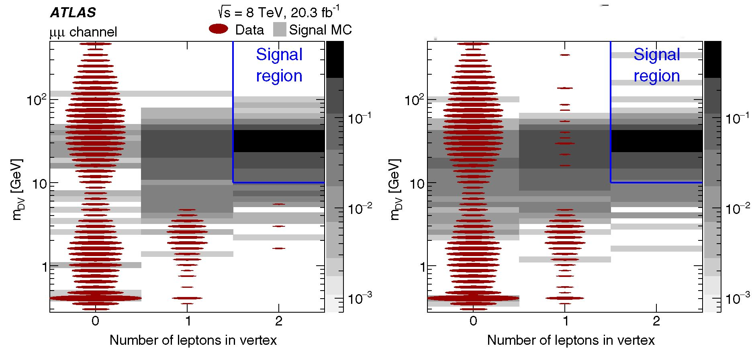
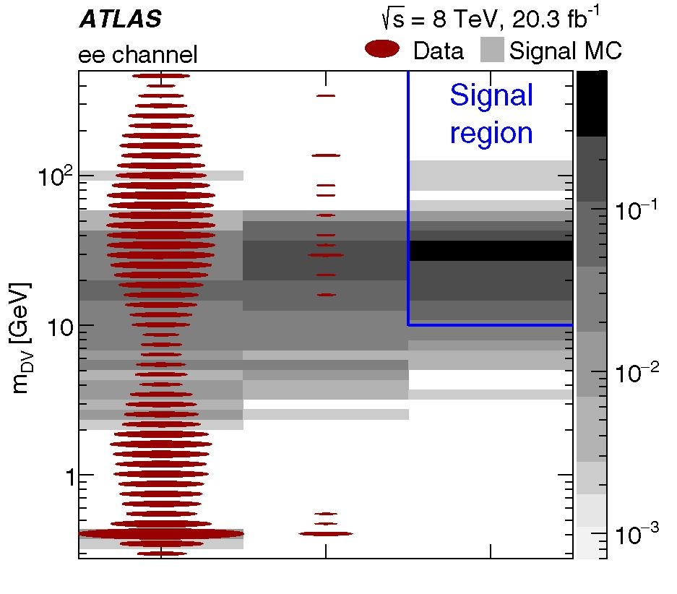
G. AAD et al.
PHYSICAL REVIEW D 92, 072004 (2015)
ATLAS is = 8 TeV, 20.3 fb'1
ep channel • Data | Signal MC
(a)
(b)
0 1 2
Number of leptons in vertex
(c)
FIG. 9 (color online). The distribution of dilepton-vertex candidates in terms of the vertex mass versus the number of lepton candidates
in the vertex, in the (a) ^+^-, (b) e±^T, and (c) e+e- search channels. The data distributions are shown with red ovals, the area of the
oval being proportional to the logarithm of the number of vertex candidates in that bin. The gray squares show the g(600 GeV) ^
qq[J~i (50 GeV) ^ ^v/e^v/eev] signal MC sample. The shape of the background mDV distribution arises partly from the lepton-
candidate pT requirements. The signal region defined by the two-lepton and mDV ^ 10 GeV requirements is indicated.
p.-(*S)=

Ndata(KS)
NMC(KS);
(8)
where i = 1,..., 4 labels four radial regions between 5 mm
and 40 mm, and Ndata/MC(KS ) is the number of K°S mesons
in radial region i in data/MC simulation, obtained by fitting
the two-track mass distributions. In the calculation of
NMc (Ks), the KS candidates in MC are weighted so that
their |n| and pT distributions match those seen in the data.
The ratio pi(K^ ) is constructed separately for |n| < 1 and
> 1. The difference Apt(K°s) = Pt(K°s) - p1(K°s)
quan-
tifies the radial dependence of the data-MC discrepancy.
The discrepancy is largest in the outermost radial region,
with Ap4(KS) = -0.03 for |n| < 1 and Ap4(K^ ) = -0.2
for |n| > 1. The statistical uncertainties on pi(K^) are
negligible compared to these discrepancies.
To propagate this maximal discrepancy into a
conservative uncertainty on the signal efficiency, DV
daughter tracks are randomly removed from signal-MC
vertices before performing the vertex fit. The single-track
removal probability is taken to be Ap4(KS) /2 in each of the
072004-14
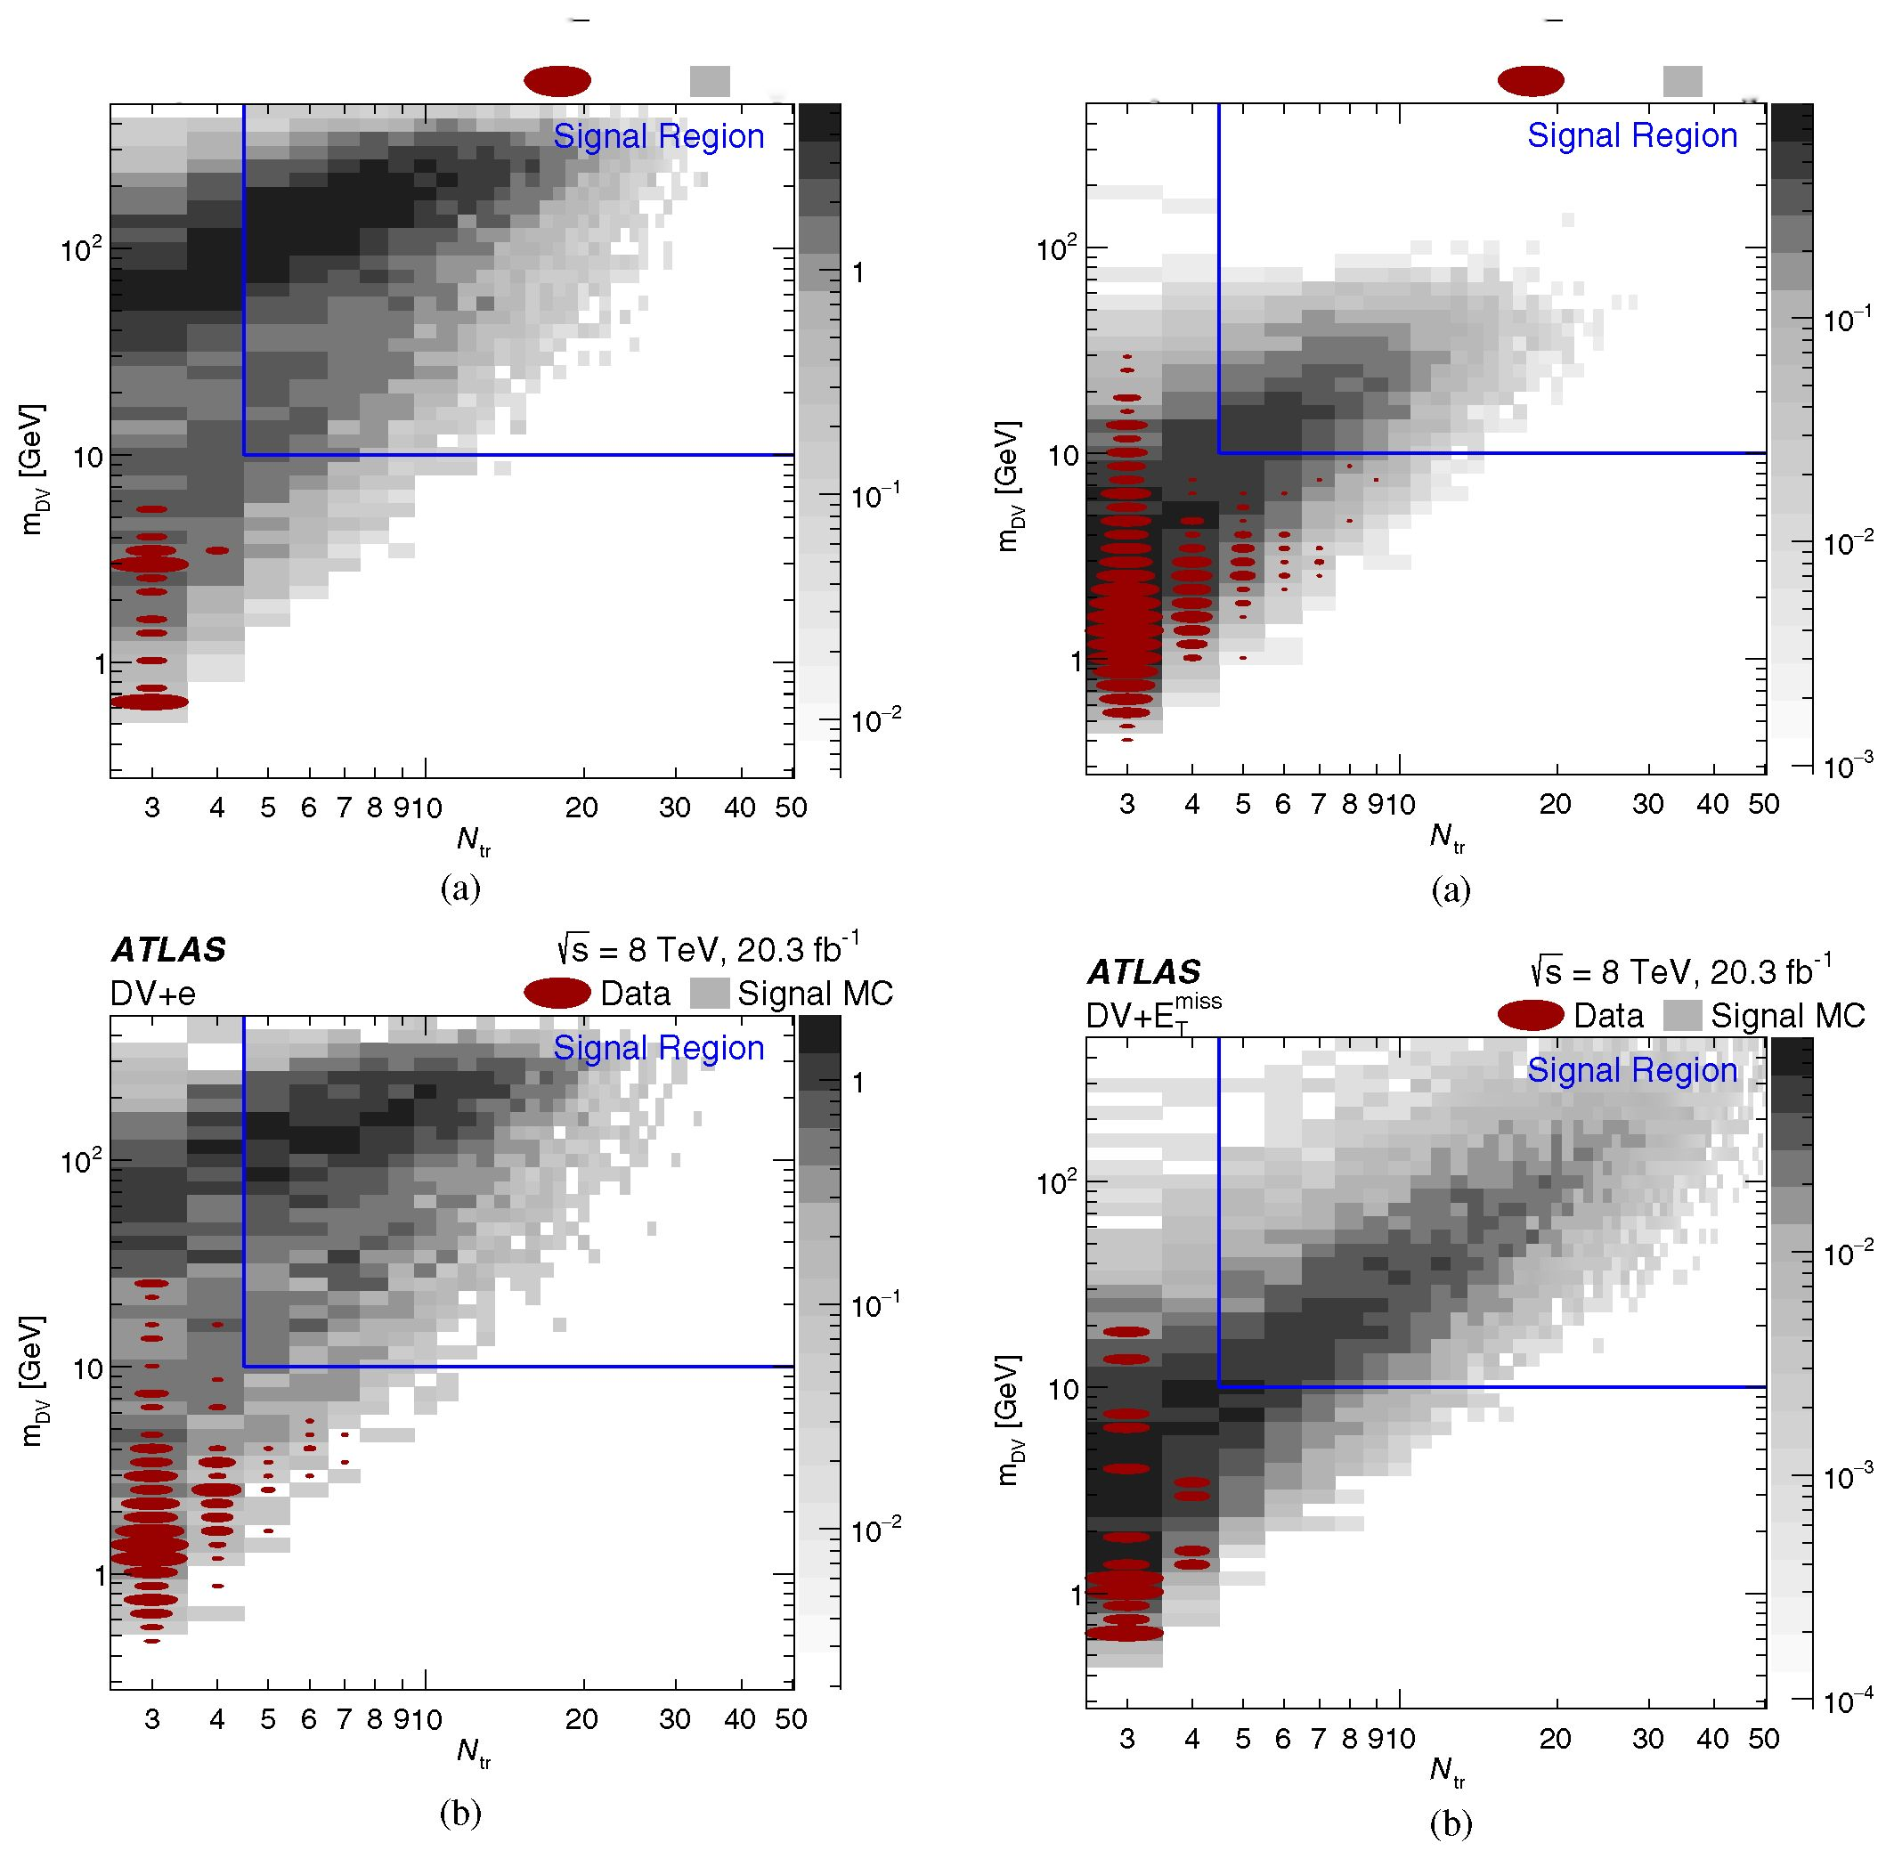
SEARCH FOR MASSIVE, LONG-LIVED PARTICLES ...
ATLAS is = 8 TeV, 20.3 fb'1
DV+[x Data Signal MC
FIG. 10 (color online). The distribution of (a) DV + muon and
(b) DV + electron candidates in terms of the vertex mass versus
the number of tracks in the vertex. The data distribution is shown
with red ovals, the area of each oval being proportional to the
logarithm of the number of vertex candidates in that bin. The gray
squares show the q (700 GeV) ^ q\X'i(494 GeV) ^ Iqq] RPV
signal MC sample. The signal region Ntr > 5, mDV ^ 10 GeV is
indicated.
PHYSICAL REVIEW D 92, 072004 (2015)
ATLAS is = 8 TeV, 20.3 fb-1
DV+jets Data Signal MC
FIG. 11 (color online). The distribution of (a) DV + jets and (b)
DV + Em^ candidates in terms of the vertex mass versus the number
of tracks in the vertex. The data distribution is shown with red ovals,
the area of each oval being proportional to the logarithm of the number
of vertex candidates in that bin. The gray squares show the
g(1.1 TeV)^qq^!(400GeV)^-GZ] GGM signal MC sample in
- andthe \g(1.4 TeV) ^gg)*(100 GeV)qq/g] split-supersymmetry
sample in (b). The signal region Ntr > 5, mDV > 10 GeV is indicated.
two etaj regions. The resulting change in the DV efficiency
is taken as the tracking-efficiency systematic uncertainty.
This uncertainty is evaluated separately for each value of
ct, and is generally around 1%.
- Off-line lepton-identification efficiency
The lepton-identification efficiency uncertainty is
determined in ATLAS using Z ^ ll decays and is
typically less than 1%. For this analysis, an additional
072004-15
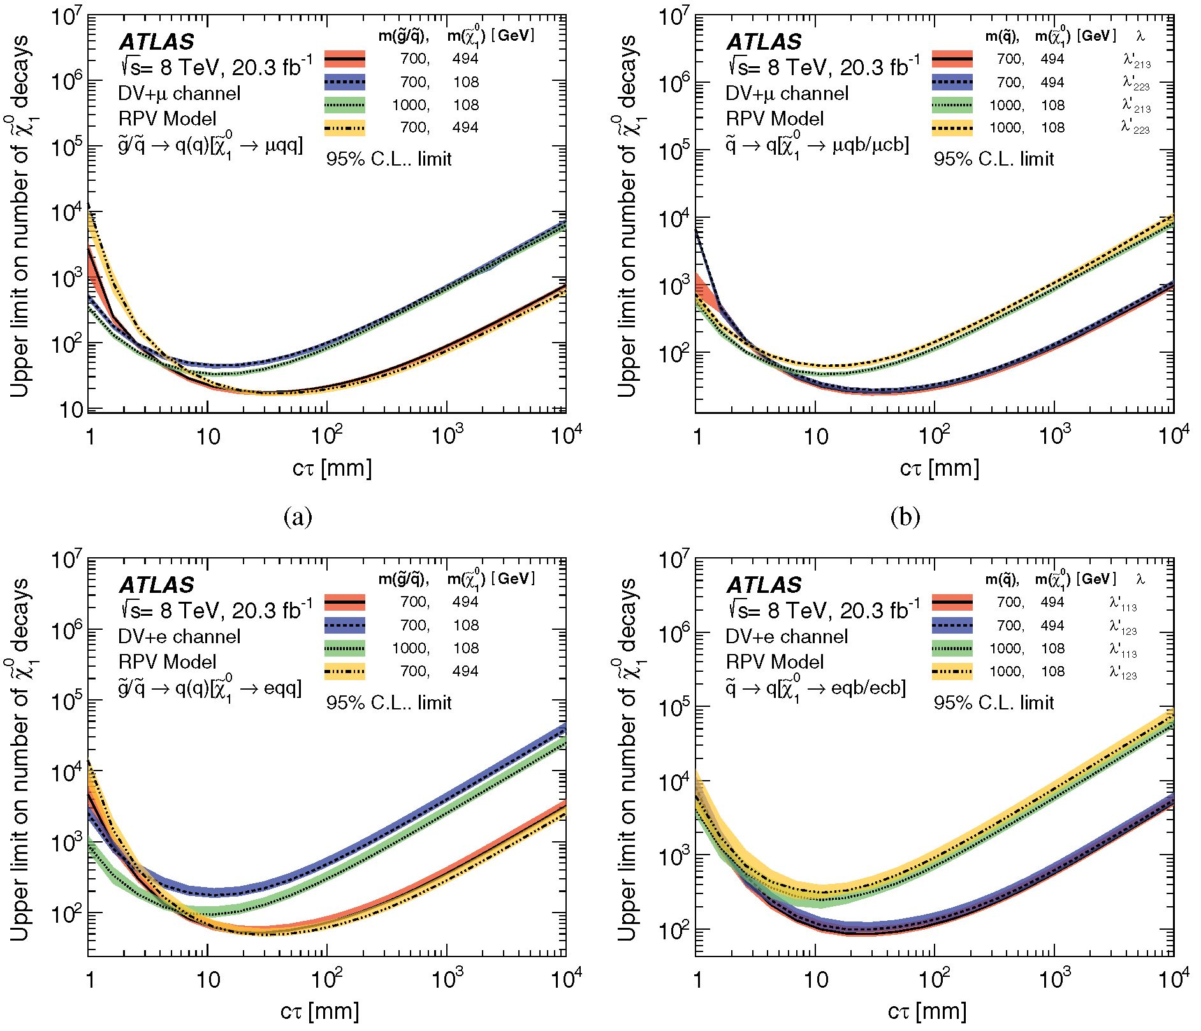
G. AAD et al.
PHYSICAL REVIEW D 92, 072004 (2015)
TABLE III. Model-independent 95% confidence-level upper lim-
its on the visible cross section for new physics in each of our searches.
Channel | Upper limit on visible cross section [fb]
DV + jet | 0.14
DV + £™ss | 0.15
DV + muon | 0.15
DV + electron | 0.15
e+e- | 0.14
- | 0.14
e±iT | 0.15
uncertainty associated with identification of high-d0 lep-
tons is evaluated.
For muons, this is done by comparing a cosmic-ray
muon simulation to cosmic-ray muon candidates in data.
The events are required to pass the muon trigger and
to have two muon candidates that fail the muon veto (see
Sec. IV B 1). The MC muons are weighted so that their n
and ^ distributions are in agreement with those of the data.
Comparing the ratio of the muon candidate d0 distributions
in data and in MC simulation yields a d0-dependent
efficiency correction that is between 1% and 2.5%, with
an average value of 1.5%. The uncertainty associated with
this procedure is taken from the statistical uncertainty, and
is 2% on average.
Unlike in the case of cosmic-ray muons, there is no
easily identifiable, high-rate source of large-d0 electrons.
Therefore, the performance of the simulation is validated
by comparing the electron-identification efficiency ee(z0)
as a function of the longitudinal impact parameter z0 of the
(c)
(d)
FIG. 12 (color online). RPV-scenario upper limits at 95% confidence level on the number of neutralinos in 20.3 fb-1 that decay into (a)
iqq (with q indicating a u- or d-quark), (b) iqb and ¡icb (indicated by the nonzero RPV couplings 2213 and 4223, respectively), (c) eqq,
and (d) eqb and ecb (2'113 and 4'123, respectively). The upper limits account for the vertex-level efficiency for each value of the neutralino
proper decay distance ct. The different curves show the results for different masses of the primary gluino or squark and of the long-lived
neutralino, while the shaded bands indicate ±1<r variations in the expected limit.
072004-16
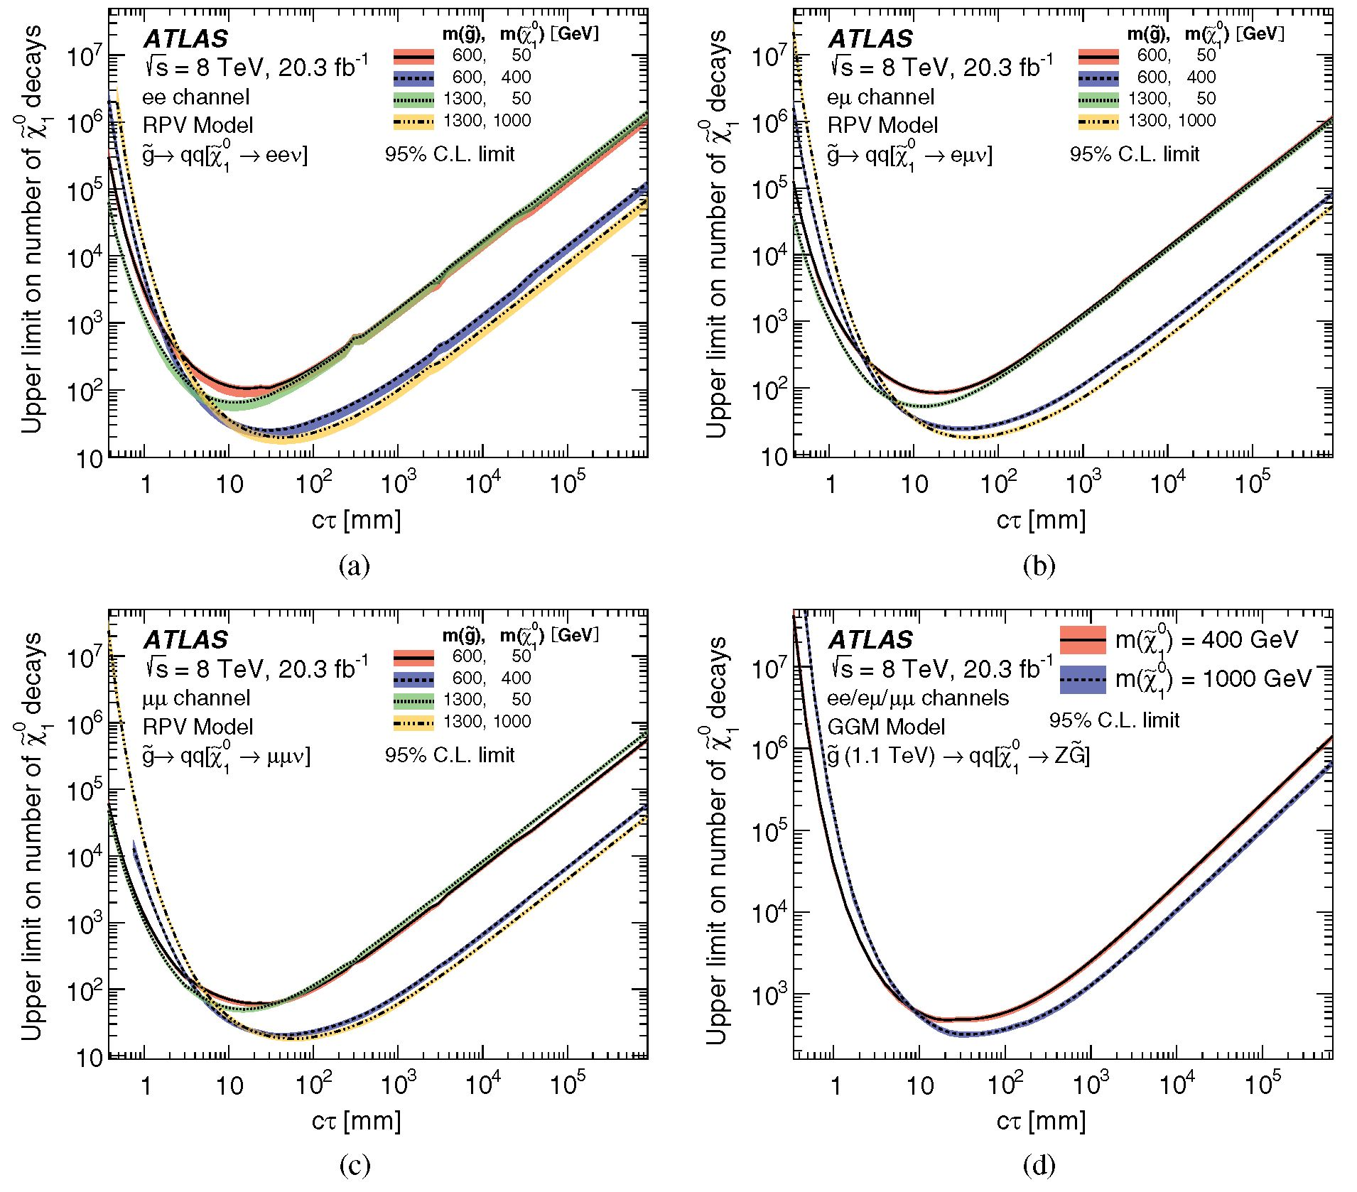
SEARCH FOR MASSIVE, LONG-LIVED PARTICLES ...
PHYSICAL REVIEW D 92, 072004 (2015)
FIG. 13 (color online). Upper limits at 95% confidence level on the number of neutralinos in 20.3 fb 1 that decay into (a) eev in the
RPV model, (b) epv in the RPV model, (c) ppv in the RPV model, and (d) ZG in the GGM model. The upper limits account for the
vertex-level efficiency for each value of the neutralino proper decay distance ct. The different curves show the results for different
masses of the primary gluino and of the long-lived neutralino, while the shaded bands indicate ±1<r variations in the expected limit. In
some cases limits are terminated for ct < 1 mm due to limited statistical precision.
electron candidate in data and MC simulation, measured
with the tag-and-probe method using Z ^ e+e- events. It
is observed that ee(z0) is consistent in data and in MC
simulation to better than 1% for jz0j < 250 mm, beyond
which there are too few events for an accurate measure-
ment. Furthermore, the value of ee obtained with the tag-
and-probe method is consistent to within 1% with that
determined from MC generator-level information. This
data-MC agreement in ee (z0) is taken as an indication that
the d0 dependence of the efficiency, ee(d0), is also well
described by simulation. In signal MC samples, the
function ee (d0) varies by about 10% due to kinematic
correlations between d0 and factors that affect the effi-
ciency, such as the value of rDV and the boost of the LLP.
To account for the possibility of an additional d0
dependence that may not be well simulated, a systematic
uncertainty of 10% on the electron-identification efficiency
is assigned. This conservative uncertainty weakens the
upper limits by less than 1%.
- Jets and Emiss reconstruction
The impact on the signal efficiency of uncertainties in the
jet-energy scale calibration and jet-energy resolution is
evaluated following the methods described in Refs. [57]
and [58], respectively. An additional uncertainty on the jet
pT is evaluated for jets that originate from the decay of an
LLP, by linearly parametrizing the pT mismeasurement
in MC simulation as a function of rDV and zDy. The
only significant dependence observed is a relative pT
072004-17
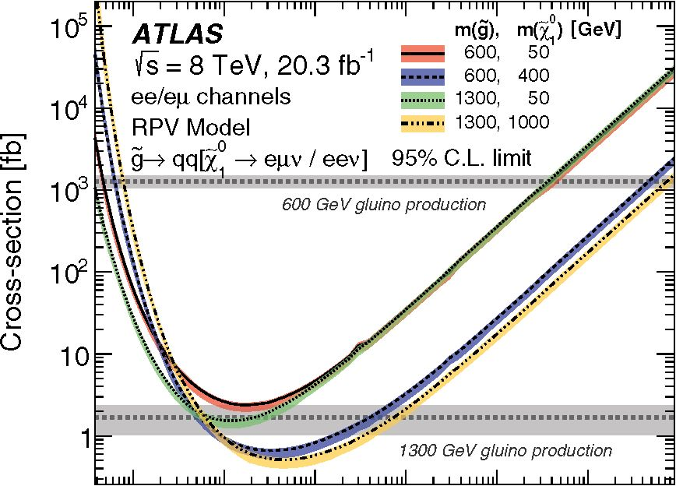
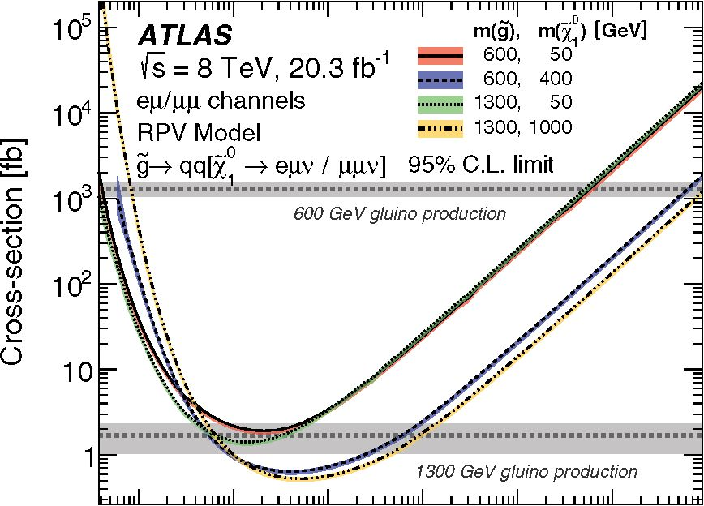
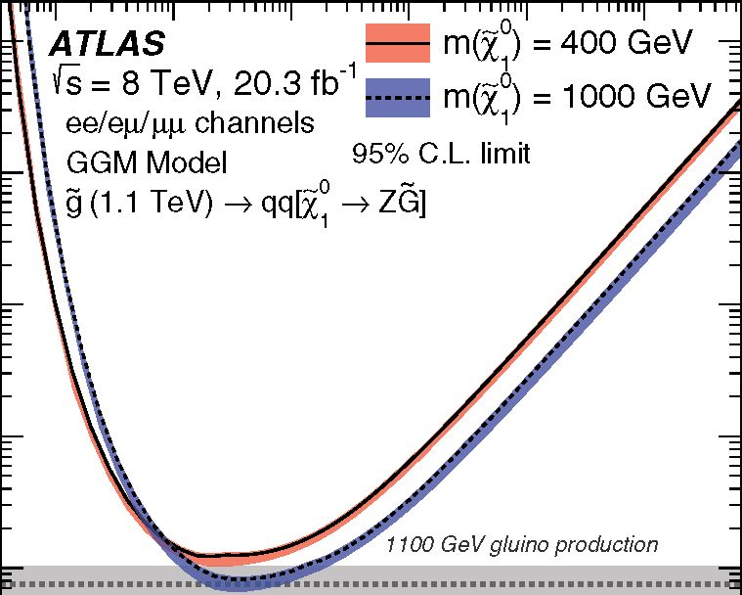
G. AAD et al.
1 10 1 02 1 03 1 04 1 05
ct [mm]
(a)
1 10 1 02 1 03 1 04 1 05
ct [mm]
(b)
FIG. 14 (color online). The 95% confidence-level upper limits,
obtained from the dilepton search, on the production cross section
for a pair of gluinos of different masses that decay into two quarks
and a long-lived neutralino in different models: (a) the RPV
scenario with a pure A121 coupling, (b) the RPV scenario with a
pure A122 coupling. All relevant final-state lepton-flavor combi-
nations are used. The shaded bands around the observed limits
indicate ±1<r variations in the expected limit, while the horizontal
bands show the theoretical cross sections and their uncertainties.
In some cases limits are terminated for ct < 1 mm due to limited
statistical precision.
mismeasurement of (4 ± 1) x 10-5(rDV/mm), which is
propagated to the jet-selection efficiency as a systematic
uncertainty. To account for possible mismodeling of
trackless jets, an uncertainty is obtained by varying the
requirement on J^trpT for these jets. Systematic uncertain-
ties in the ET measurement are evaluated with the
methods described in Refs. [53,54] and propagated to
the efficiency uncertainty. The impact of uncertainties in
the simulation of initial-state radiation is estimated by
varying the pT distribution of the primary particles accord-
ing to the distribution observed in madgraph5 [59]
PHYSICAL REVIEW D 92, 072004 (2015)
105
E 104
c
o
O a n3
10
<n
in
n
o
o 102
10
FIG. 15 (color online). The 95% confidence-level upper limits,
obtained from the dilepton search, on the production cross section
for a pair of gluinos of mass 1.1 TeV that decay into two quarks
and a long-lived neutralino in the GGM scenario for two values of
the neutralino mass. For further details see Fig. 14.
samples. The resulting efficiency uncertainty varies
between 2% and 10%.
5. Multiple pp interactions
The dependence of the reconstruction efficiency on the
number of pp interactions per bunch crossing is studied by
varying the average number of interactions per LHC bunch
crossing in the simulation by 4%. This value reflects
uncertainties in the detector acceptance, trigger efficiency,
and modeling of additional pp interactions. The resulting
relative uncertainty is typically of order 1% or less.
VIII. RESULTS
Figure 9 shows the distribution of mDV versus the
number of associated lepton candidates in the selected
data sample before the final selection requirements on these
variables are applied. The distributions of mDV versus the
number of tracks in the vertex obtained for the multitrack-
DV search are shown in Figs. 10 and 11. No events are seen
in the signal region for any of the seven channels. In
addition, no same-charge dilepton vertices are seen with
mDV > 10 GeV. The distributions expected for some of the
signal samples are also shown for comparison.
Given the lack of a signal observation, 95% confidence-
level upper limits on the total visible cross section for new
physics are shown in Table III.
Furthermore, for each of the physics scenarios consid-
ered, 95% confidence-level upper limits on the signal yields
and production cross sections are calculated for different
values of the proper decay distance ct of the LLP and
presented in the figures in this section. The limits are
calculated using the CLS prescription [60] with the
profile likelihood used as the test statistic, using the
~ 11 ml i i i i mil ' ' ' i ""I ' ' ' i ■ ml i i i i mil ' ' ' 'mil ■ i i i~
1 10 102 103 104 105
ct [mm]
072004-18
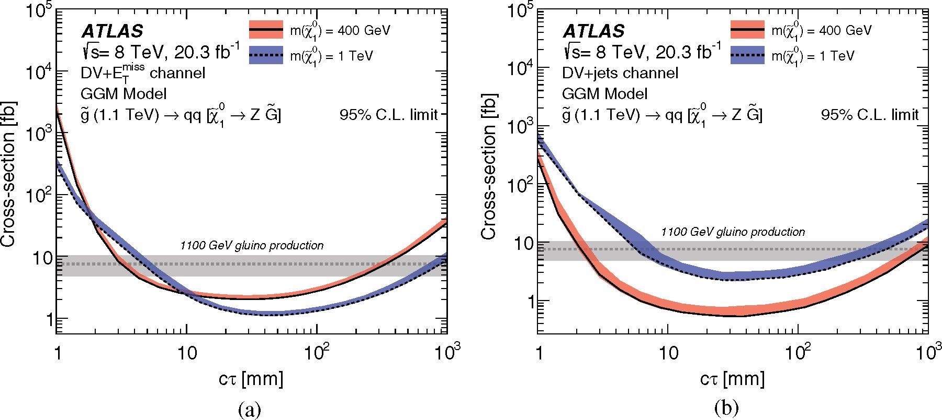
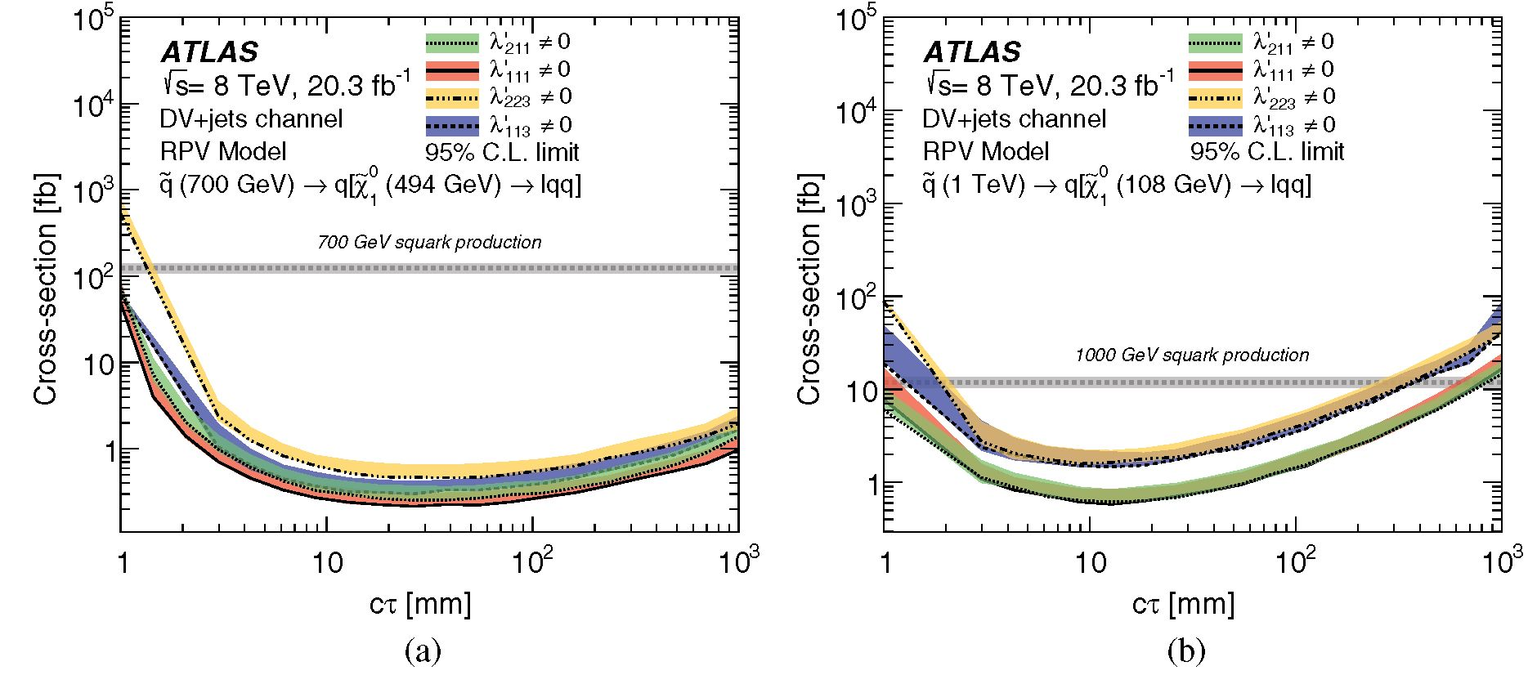
SEARCH FOR MASSIVE, LONG-LIVED PARTICLES
PHYSICAL REVIEW D 92, 072004 (2015)
FIG. 16 (color online). The 95% confidence-level upper limits, obtained from the DV + jets search, on the production cross section for
a pair of squarks in the RPV scenario, with the neutralino decaying to a lepton and two quarks, according to the nonzero X couplings
indicated in each case. The squark and neutralino masses are (a) 700 GeV and 494 GeV or (b) 1 TeV and 108 GeV, respectively,
representing the results for different neutralino masses and boosts. For further details see Fig. 14.
HistFitter [61] framework. Uncertainties on the signal effi-
ciency and background expectation are included as nui-
sance parameters, and the CLS values are calculated by
generating ensembles of pseudoexperiments corresponding
to the background-only and signal-plus-background
hypotheses.
Since less than one background event is expected in all
cases and no events are observed, the observed limits are
very close to the expected limits.
In the case of the dilepton and DV + lepton searches,
where the trigger and reconstruction depend almost exclu-
sively on the signal DV, upper limits on the number of
vertices produced in 20.3 fb-1 of data are presented for
each channel, accounting for the vertex-level efficiency at
each value of ct. Figure 12 shows these number limits for
the DV + lepton search signatures. The limits are given
separately for different masses of the long-lived neutralino
and the primary squark or gluino, as well as for different
Xj couplings, which give rise to light- or heavy-flavor
quarks in the final state (see Sec. V for a discussion of the
heavy-flavor and mass impact on efficiency). The number
limits for the dilepton search signatures are shown in
Fig. 13 for the final states ee, gg, eg, as well as for the
combination of Z ^ ee, Z ^ gg, and Z ^ tt.
FIG. 17 (color online). The 95% confidence-level upper limits, obtained from the (a) DV + Em“ and (b) DV + jets searches, on the
production cross section for a pair of gluinos of mass 1.1 TeV that decay into two quarks and a long-lived neutralino in the GGM
scenario. For further details see Fig. 14.
072004-19
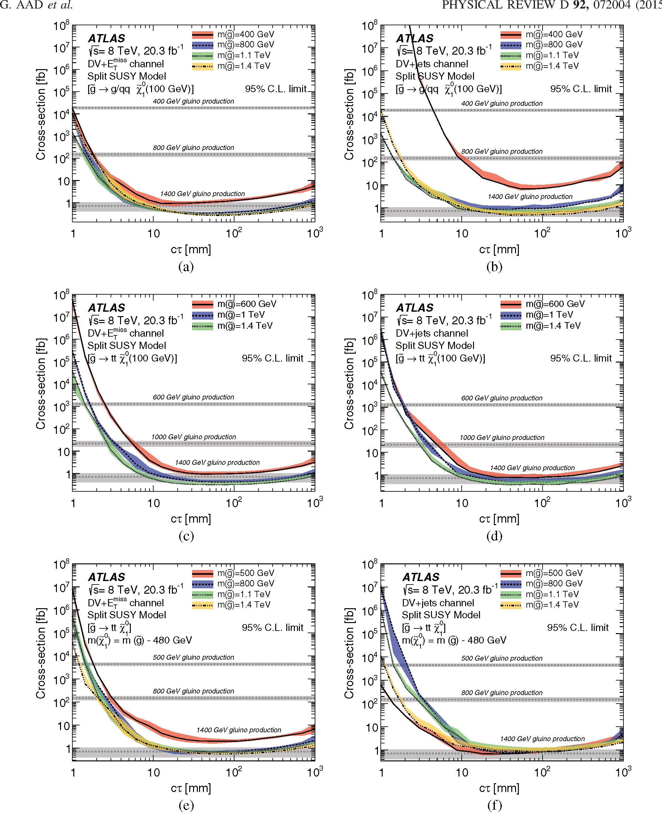
FIG. 18 (color online). The 95% confidence-level upper limits, obtained from the (a), (c), (e) DV + Em1“ and (b), (d), (f) DV + jets
searches, on the cross section for gluino pair production in the split-supersymmetry model, with the gluino decaying to a neutralino plus
either (a), (b) a gluon or a light-quark pair or (c), (d), (e), (f) a pair of top quarks. The mass of the neutralino is 100 GeV in (a), (b), (c), (d)
and is 480 GeV smaller than the gluino mass in (e), (f). For further details see Fig. 14.
072004-20
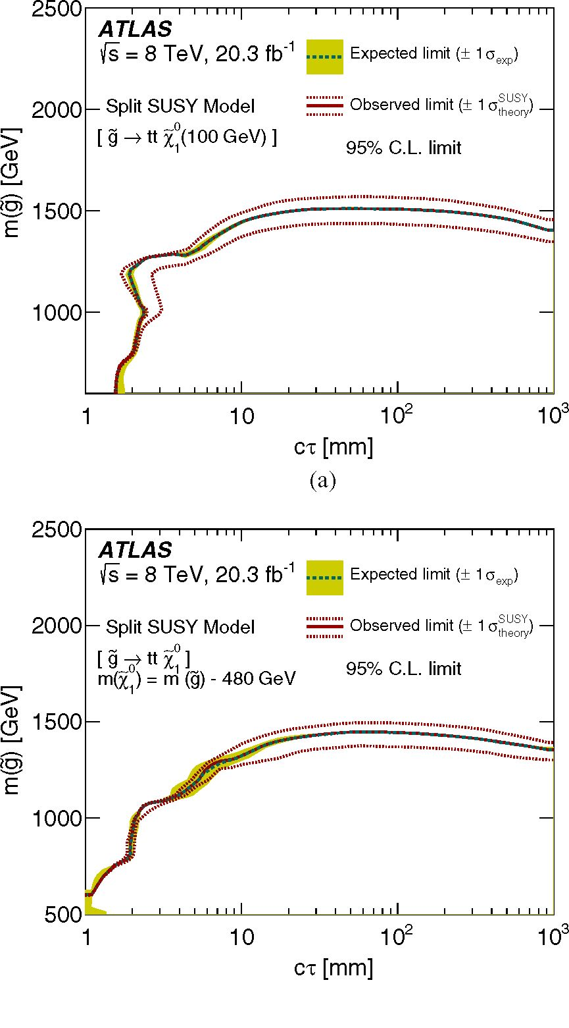
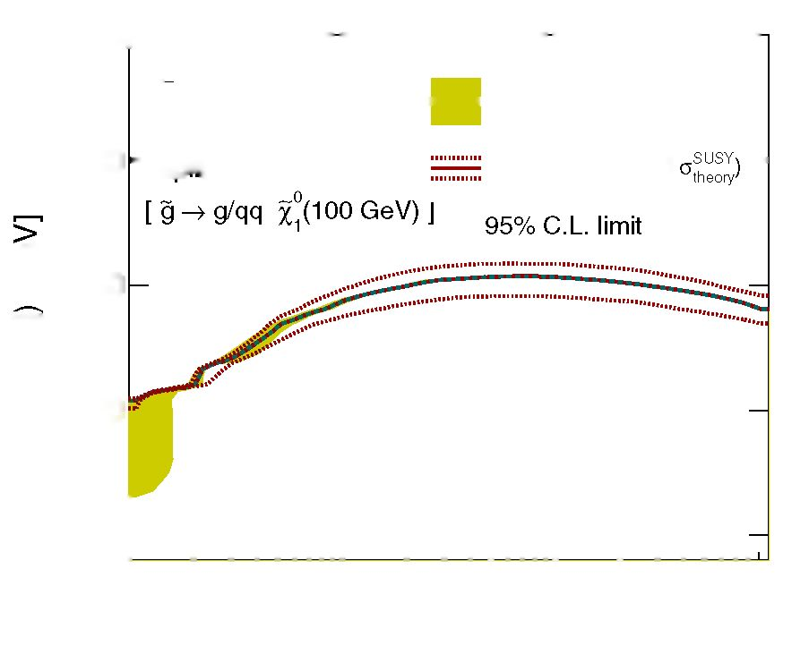
SEARCH FOR MASSIVE, LONG-LIVED PARTICLES
PHYSICAL REVIEW D 92, 072004 (2015)
In addition, limits on the production cross sections for
events are presented for the different simulated scenarios.
Figures 14 and 15 show cross-section upper limits
obtained with the dilepton-DV search. Upper limits are
shown for gluino-pair production in the RPV scenario, with
neutralino decays determined by the choice of nonzero RPV
coupling X121 or X122, as well as within the GGM scenario
with leptonic decays of the Z boson. For example, the RPV
scenario is excluded for gluino mass mg = 600 GeV,
neutralino mass m£0 = 400 GeV, and neutralino proper
decay distance in the range 0.7 < ct < 3 x 105 mm.
Cross-section upper limits obtained with the multitrack-
DV search are shown in the remaining figures. These limits
are calculated up to proper decay distances of ct = 1 m, to
avoid inaccuracies associated with reweighting events to
very high lifetimes when the efficiency depends on both
LLPs in the event.
Figure 16 shows the upper limits on the production cross
section of two squarks in the RPV scenario, with different
squark and neutralino masses, as well as different X
parameters governing the neutralino decay. These limits
are obtained with the DV + jets search, which results in
tighter limits than the DV + lepton searches for this
scenario. These results exclude a mq = 1 TeV squark for
m£0 = 108 GeV and 2.5 < ct < 200 mm with either light-
or heavy-quark neutralino decays. Figure 17 shows the
cross-section upper limits for gluino-pair production
within the GGM scenario, using hadronic Z decays. The
scenario is excluded, for instance, for mg = 1.1 TeV and
mx0 = 400 GeV in the proper decay distance range
X1
3 < ct < 500 mm.
25001 1—i— 1—i— 1—i—
ATLAS
is = 8 TeV, 20.3 fb'1 Expected limit (± 1 OeXp)
2000 - Split SUSY Model Observed limit (± 1 ~
<D
S 1500
!S
E
1000
500 h
1 10 102 103
ct [mm]
FIG. 19 (color online). The 95% confidence-level excluded
regions lie below the curves shown in the mass-versus-CT plane
for the split-supersymmetry samples, with the gluino decaying
into a gluon or light quarks, plus a 100 GeV neutralino. The
shaded bands indicate ±1<r variations in the expected limit, while
the dotted lines indicate the effect of varying the production cross
section by 1 standard deviation. The expected and observed limits
are identical.
Figure 18 shows the upper limits on gluino-pair pro-
duction cross section in the split-supersymmetry model.
These limits are obtained from the results of the DV + Em+s
and DV + jets searches. The sensitivity is greater for
the cases with mX0 = 100 GeV than for those with
m^ti = mg — 480 GeV, and the DV + E™ss search performs
better than DV + jets in these scenarios, excluding mg <
1400 GeV in the range of proper decay lengths
15 mm < ct < 300 mm.
In Figs. 19 and 20, the region of gluino mass versus
proper decay distance that is excluded by these limits is
shown. The limit for each point in parameter space is taken
from the channel that is expected to yield the most stringent
limit, which is DV + Em“s for most points. For the region
(b)
FIG. 20 (color online). The 95% confidence-level excluded
regions lie below the curves shown in the mass-versus-CT plane
for the split-supersymmetry samples, with the gluino decaying
into (a) a top quark pair and a 100 GeV neutralino, or (b) a top
quark pair and a neutralino with a mass that is 480 GeV smaller
than the gluino mass. The shaded bands indicate ±1<r variations
in the expected limit, while the dotted lines indicate the effect of
varying the production cross section by 1 standard deviation. The
expected and observed limits are identical.
072004-21
G. AAD et al.
of parameter space where the sensitivity is greatest,
20 mm < ct < 250 mm and = 100 GeV, gluino
A 1
masses of m~g < 1500 GeV are excluded. This range of
masses is comparable to or slightly larger than those
excluded by prompt searches [62], searches for long-lived
R-hadrons stopped in the ATLAS calorimeter [17], or
searches for stable, massive, charged particles [19].

IX. SUMMARY AND CONCLUSIONS
This article reports on a search for long-lived particles
decaying into two leptons or five or more charged particles.
In the latter case, events are selected using associated lepton
candidates, jets, or missing transverse momentum. The
main signature of the search is a displaced vertex with an
invariant mass greater than 10 GeV. This signature corre-
sponds to a wide variety of new-physics models, many of
which have not been searched for previously. The search
uses the full data sample of pp collisions collected by the
ATLAS detector at the LHC with a center-of-mass energy
of ^fs = 8 TeV and an integrated luminosity of 20.3 fb-1.
Less than one background event is expected in each of the
channels, and no events are observed. Upper limits are
provided on the number of long-lived particle decays in the
data sample and on the cross section for production of
particles that give rise to the search signatures in a variety of
supersymmetric models. These upper limits exclude sig-
nificant regions of the parameter space of new-physics
models with particle masses within reach of the LHC.

ACKNOWLEDGMENTS
We thank CERN for the very successful operation of the
LHC, as well as the support staff from our institutions
PHYSICAL REVIEW D 92, 072004 (2015)
without whom ATLAS could not be operated efficiently.
We acknowledge the support of ANPCyT, Argentina;
YerPhI, Armenia; ARC, Australia; BMWFW and FWF,
Austria; ANAS, Azerbaijan; SSTC, Belarus; CNPq and
FAPESP, Brazil; NSERC, NRC, and CFI, Canada; CERN;
CONICYT, Chile; CAS, MOST, and NSFC, China;
COLCIENCIAS, Colombia; MSMT CR, MPO CR, and
VSC CR, Czech Republic; DNRF, DNSRC, and Lundbeck
Foundation, Denmark; EPLANET, ERC, and NSRF,
European Union; IN2P3-CNRS, CEA-DSM/IRFU,
France; GNSF, Georgia; BMBF, DFG, HGF, MPG, and
AvH Foundation, Germany; GSRT and NSRF, Greece;
RGC, Hong Kong SAR, China; ISF, MINERVA, GIF, I-
CORE, and Benoziyo Center, Israel; INFN, Italy; MEXT
and JSPS, Japan; CNRST, Morocco; FOM and NWO,
Netherlands; BRF and RCN, Norway; MNiSW and NCN,
Poland; GRICES and FCT, Portugal; MNE/IFA, Romania;
MES of Russia and NRC KI, Russian Federation; JINR;
MSTD, Serbia; MSSR, Slovakia; ARRS and MIZS,
Slovenia; DST/NRF, South Africa; MINECO, Spain;
SRC and Wallenberg Foundation, Sweden; SER, SNSF,
and Cantons of Bern and Geneva, Switzerland; NSC,
Taiwan; TAEK, Turkey; STFC, the Royal Society, and
Leverhulme Trust, United Kingdom; DOE and NSF, United
States of America. The crucial computing support from all
WLCG partners is acknowledged gratefully, in particular
from CERN and the ATLAS Tier-1 facilities at TRIUMF
(Canada), NDGF (Denmark, Norway, Sweden), CC-IN2P3
(France), KIT/GridKA (Germany), INFN-CNAF (Italy),
NL-T1 (Netherlands), PIC (Spain), ASGC (Taiwan), RAL
(UK), and BNL (USA) and in the Tier-2 facilities
worldwide.
[1] M. Fairbairn, A. C. Kraan, D. A. Milstead, T. Sjostrand,
P. Skands, and T. Sloan, Stable massive particles at colliders,
Phys. Rep. 438, 1 (2007).
[2] R. Barbier et al., R-parity violating supersymmetry, Phys.
Rep. 420, 1 (2005).
[3] B. C. Allanach, M. A. Bernhardt, H. K. Dreiner, C. H. Kom,
and P. Richardson, Mass Spectrum in R-Parity Violating
mSUGRA and Benchmark Points, Phys. Rev. D 75, 035002
(2007).
[4] S. Dimopoulos, M. Dine, S. Raby, and S. D. Thomas,
Experimental Signatures of Low-Energy Gauge Mediated
Supersymmetry Breaking, Phys. Rev. Lett. 76, 3494 (1996).
[5] J. L. Hewett, B. Lillie, M. Masip, and T. G. Rizzo, Sig-
natures of long-lived gluinos in split supersymmetry, J. High
Energy Phys. 09 (2004) 070.
[6] A. Arvanitaki, N. Craig, S. Dimopoulos, and G. Villadoro,
Mini-Split, J. High Energy Phys. 02 (2013) 126.
- M. J. Strassler and K. M. Zurek, Echoes of a hidden valley at
hadron colliders, Phys. Lett. B 651, 374 (2007).
- P. Schuster, N. Toro, and I. Yavin, Terrestrial and Solar
Limits on Long-Lived Particles in a Dark Sector, Phys. Rev.
D 81, 016002 (2010).
- J. Fan, M. Reece, and J. T. Ruderman, Stealth Supersym-
metry, J. High Energy Phys. 11 (2011) 012.
- A. Arbey, M. Battaglia, A. Djouadi, F. Mahmoudi, and
J. Quevillon, Implications of a 125 GeV Higgs for super-
symmetric models, Phys. Lett. B 708, 162 (2012).
- ATLAS Collaboration, Observation of a new particle
in the search for the Standard Model Higgs boson with
the ATLAS detector at the LHC, Phys. Lett. B 716, 1
(2012).
- CMS Collaboration, Observation of a new boson at a mass
of 125 GeV with the CMS experiment at the LHC, Phys.
Lett. B 716, 30 (2012).
072004-22
SEARCH FOR MASSIVE, LONG-LIVED PARTICLES
PHYSICAL REVIEW D 92, 072004 (2015)
- ATLAS Collaboration, Search for displaced vertices arising
from decays of new heavy particles in 7 TeV pp collisions at
ATLAS, Phys. Lett. B 707, 478 (2012).
- ATLAS Collaboration, Search for long-lived, heavy par-
ticles in final states with a muon and multi-track displaced
vertex in proton-proton collisions at PS = 7 TeV with the
ATLAS detector, Phys. Lett. B 719, 280 (2013).
- ATLAS Collaboration, Search for displaced muonic lepton
jets from light Higgs boson decay in proton-proton colli-
sions at Ps = 7 TeV with the ATLAS detector, Phys. Lett.
B 721, 32 (2013).
- ATLAS Collaboration, Search for pair-produced long-lived
neutral particles decaying in the ATLAS hadronic calorim-
eter in pp collisions at PS = 8 TeV, Phys. Lett. B 743, 15
(2015).
- ATLAS Collaboration, Search for long-lived stopped
R-hadrons decaying out-of-time with pp collisions using
the ATLAS detector, Phys. Rev. D 88, 112003 (2013).
- ATLAS Collaboration, Search for long-lived, weakly inter-
acting particles that decay to displaced hadronic jets in
proton-proton collisions at s = 8 TeV with the ATLAS
detector, Phys. Rev. D 92, 012010 (2015).
- ATLAS Collaboration, Searches for heavy long-lived charged
particles with the ATLAS detector in proton-proton collisions
at Ps = 8 TeV, J. High Energy Phys. 01 (2015) 068.
- CMS Collaboration, Search in leptonic channels for heavy
resonances decaying to long-lived neutral particles, J. High
Energy Phys. 02 (2013) 085.
- V. Khachatryan et al. (CMS Collaboration), Search for long-
lived particles that decay into final states containing two
electrons or two muons in proton-proton collisions at
PS = 8 TeV, Phys. Rev. D 91, 052012 (2015).
- CMS Collaboration, Search for “Displaced Supersym-
metry” in Events with an Electron and A Muon with Large
Impact Parameters, Phys. Rev. Lett. 114, 061801 (2015).
- CMS Collaboration, Search for long-lived neutral particles
decaying to quark-antiquark pairs in proton-proton colli-
sions at PS = 8 TeV, Phys. Rev. D 91, 012007 (2015).
- LHCb Collaboration, Search for long-lived particles
decaying to jet pairs, Eur. Phys. J. C 75, 152 (2015).
- D. Liventsev et al. (Belle Collaboration), Search for heavy
neutrinos at Belle, Phys. Rev. D 87, 071102 (2013).
- J. P. Lees et al. (BABAR Collaboration), Search for Long-
Lived Particles in e+e- Collisions, Phys. Rev. Lett. 114,
171801 (2015).
- V. M. Abazov et al. (D0 Collaboration), Search for Neutral,
Long-Lived Particles Decaying into Two Muons in pp
Collisions at PS = 1.96 TeV, Phys. Rev. Lett. 97, 161802
(2006).
- V. M. Abazov etal. (D0 Collaboration), Search for Resonant
Pair Production of Neutral Long-Lived Particles Decaying
to bb in pp Collisions at PS = 1.96 TeV, Phys. Rev. Lett.
103, 071801 (2009).
- F. Abe et al. (CDF Collaboration), Search for long-lived
parents of Z0 bosons in pp collisions at ps = 1.8 TeV,
Phys. Rev. D 58, 051102 (1998).
- A. Heister et al. (ALEPH Collaboration), Search for gauge
mediated SUSY breaking topologies in e+e- collisions at
center-of-mass energies up to 209 GeV, Eur. Phys. J. C 25,
339 (2002).
- ATLAS Collaboration, The ATLAS Experiment at the
CERN Large Hadron Collider, J. Instrum. 3, S08003 (2008).
- ATLAS Collaboration, Improved luminosity determination
in pp collisions at p = 7 TeV using the ATLAS detector
at the LHC, Eur. Phys. J. C 73, 2518 (2013).
- ATLAS Collaboration, ATLAS tunes of PYTHIA 6 and
Pythia 8 for MC11, Report No. ATL-PHYS-PUB-2011-
009, http://cds.cern.ch/record/1363300/, 2011.
- P. M. Nadolsky, H.-L. Lai, Q.-H. Cao, J. Huston, J. Pumplin,
D. Stump, Wu-Ki Tung, and C.-P. Yuan, Implications of
CTEQ global analysis for collider observables, Phys. Rev. D
78, 013004 (2008).
- S. Agostinelli et al. (GEANT4 Collaboration), GEANT4: A
Simulation toolkit, Nucl. Instrum. Methods Phys. Res., Sect.
A 506, 250 (2003).
- ATLAS Collaboration, The ATLAS Simulation Infrastruc-
ture, Eur. Phys. J. C 70, 823 (2010).
- T. Sjöstrand, S. Mrenna, and P. Z. Skands, A Brief Introduction
to PYTHIA 8.1, Comput. Phys. Commun. 178, 852 (2008).
- M. Bähr et al., Herwig + + Physics and Manual, Eur. Phys.
J. C 58, 639 (2008).
- T. Sjöstrand, S. Mrenna, and P. Z. Skands, PYTHIA 6.4
Physics and Manual, J. High Energy Phys. 05 (2006) 026.
- R. Mackeprang and D. Milstead, An Updated Description of
Heavy-Hadron Interactions in GEANT-4, Eur. Phys. J. C 66,
493 (2010).
- W. Beenakker, R. Höpker, M. Spira, and P. M. Zerwas,
Squark and gluino production at hadron colliders, Nucl.
Phys. B492, 51 (1997).
- A. Kulesza and L. Motyka, Threshold Resummation for
Squark-Antisquark and Gluino-Pair Production at the LHC,
Phys. Rev. Lett. 102, 111802 (2009).
- A. Kulesza and L. Motyka, Soft gluon resummation for the
production of gluino-gluino and squark-antisquark pairs at
the LHC, Phys. Rev. D 80, 095004 (2009).
- W. Beenakker, S. Brensing, M. Krämer, A. Kulesza, E.
Laenen, and I. Niessen, Soft-gluon resummation for squark
and gluino hadroproduction, J. High Energy Phys. 12
(2009) 041.
- W. Beenakker, S. Brensing, M. Krämer, A. Kulesza, E.
Laenen, L. Motyka, and I. Niessen, Squark and Gluino
Hadroproduction, Int. J. Mod. Phys. A 26, 2637 (2011).
- M. Krämer, A. Kulesza, R. v. d. Leeuw, M. Mangano, S.
Padhi, T. Plehn, and X. Portell, Supersymmetry production
cross sections in pp collisions at p = 7 TeV, arXiv:
1206.2892.
- ATLAS Collaboration, Measurement of the muon
reconstruction performance of the ATLAS detector using
2011 and 2012 LHC proton-proton collision data, Eur. Phys.
J. C 74, 3130 (2014).
- ATLAS Collaboration, Electron and photon energy calibra-
tion with the ATLAS detector using LHC Run 1 data, Eur.
Phys. J. C 74, 3071 (2014).
- M. Cacciari, G. P. Salam, and G. Soyez, The anti-kt jet
clustering algorithm, J. High Energy Phys. 04 (2008) 063.
- M. Cacciari and G. P. Salam, Dispelling the N3 myth for the
jet-finder, Phys. Lett. B 641, 57 (2006).
- ATLAS Collaboration, Jet energy measurement with the
ATLAS detector in proton-proton collisions at p = 7 TeV,
Eur. Phys. J. C 73, 2304 (2013).
072004-23

G. AAD et al.
- W. Lampl, S. Laplace, D. Lelas, P. Loch, H. Ma, S. Menke,
S. Rajagopalan, D. Rousseau, S. Snyder, and G. Unal,
Calorimeter clustering algorithms: Description and perfor-
mance, Report No. ATL-LARG-PUB-2008-002, http://cds.
cern.ch/record/1099735/, 2008.
- ATLAS Collaboration, Performance of Missing Transverse
Momentum Reconstruction in Proton-Proton Collisions at
7 TeV with ATLAS, Eur. Phys. J. C 72, 1844 (2012).
- ATLAS Collaboration, Performance of Missing Transverse
Momentum Reconstruction in ATLAS studied in Proton-
Proton Collisions recorded in 2012 at 8 TeV, Report
No. ATLAS-CONF-2013-082, http://cds.cern.ch/record/
1570993/, 2013.
- S. R. Das, On a new approach for finding all the modified
cut-sets in an incompatibility graph, IEEE Trans. Comput.
C-22, 187 (1973).
- ATLAS Collaboration, Characterisation and mitigation of
beam-induced backgrounds observed in the ATLAS
detector during the 2011 proton-proton run, J. Instrum. 8,
P07004 (2013).
PHYSICAL REVIEW D 92, 072004 (2015)
- ATLAS Collaboration, Jet energy measurement and its
systematic uncertainty in proton-proton collisions at y(s =
7 TeV with the ATLAS detector, Eur. Phys. J. C 75, 17
(2015).
- ATLAS Collaboration, Jet energy resolution in proton-
proton collisions at y/s = 7 TeV recorded in 2010 with
the ATLAS detector, Eur. Phys. J. C 73, 2306 (2013).
- J. Alwall, M. Herquet, F. Maltoni, O. Mattelaer, and T.
Stelzer, MadGraph 5 : Going Beyond, J. High Energy Phys.
06 (2011) 128.
- A. L. Read, Presentation of search results: The CL(s)
technique, J. Phys. G 28, 2693 (2002).
- M. Baak, G. J. Besjes, D. Côté, A. Koutsman, J. Lorenz, and
D. Short, HistFitter software framework for statistical data
analysis, Eur. Phys. J. C 75, 153 (2015).
- ATLAS Collaboration, Search for squarks and gluinos
with the ATLAS detector in final states with jets and
missing transverse momentum using yfs = 8 TeV proton-
proton collision data, J. High Energy Phys. 09 (2014)
176.
G. Aad,85 B. Abbott,113 J. Abdallah,151 O. Abdinov,11 R. Aben,107 M. Abolins,90 O. S. AbouZeid,158 H. Abramowicz,153
- Abreu,152 R. Abreu,30 Y. Abulaiti,146a’146b B.S. Acharya,164a’164b’b L. Adamczyk,38a D. L. Adams,25 J. Adelman,108
S. Adomeit,100 T. Adye,131 A. A. Affolder,74 T. Agatonovic-Jovin,13 J. A. Aguilar-Saavedra,126a’126f S. P. Ahlen,22
F. Ahmadov,65’c G. Aielli,133a’133b H. Akerstedt,146a’146b T. P. A. Äkesson,81 G. Akimoto,155 A. V. Akimov,96
G. L. Alberghi,20a’20b J. Albert,169 S. Albrand,55 M. J. Alconada Verzini,71 M. Aleksa,30 I. N. Aleksandrov,65 C. Alexa,26a
G. Alexander,153 T. Alexopoulos,10 M. Alhroob,113 G. Alimonti,91a L. Alio,85 J. Alison,31 S. P. Alkire,35
- M. M. Allbrooke,18 P. P. Allport,74 A. Aloisio,104a104b A. Alonso,36 F. Alonso,71 C. Alpigiani,76 A. Altheimer,35
- Alvarez Gonzalez,30 D. Alvarez Piqueras,167 M. G. Alviggi,104a104b B. T. Amadio,15 K. Amako,66 Y. Amaral Coutinho,24a
- Amelung,23 D. Amidei,89 S. P. Amor Dos Santos,126a’126c A. Amorim,126a’126b S. Amoroso,48 N. Amram,153
G. Amundsen,23 C. Anastopoulos,139 L. S. Ancu,49 N. Andari,30 T. Andeen,35 C. F. Anders,58b G. Anders,30 J. K. Anders,74
K. J. Anderson,31 A. Andreazza,91a’91b V. Andrei,58a S. Angelidakis,9 I. Angelozzi,107 P. Anger,44 A. Angerami,35
F. Anghinolfi,30 A. V. Anisenkov,109’d N. Anjos,12 A. Annovi,124a’124b M. Antonelli,47 A. Antonov,98 J. Antos,144b
- Anulli,132a M. Aoki,66 L. Aperio Bella,18 G. Arabidze,90 Y. Arai,66 J. P. Araque,126a A. T. H. Arce,45 F. A. Arduh,71
J-F. Arguin,95 S. Argyropoulos,42 M. Arik,19a A. J. Armbruster,30 O. Arnaez,30 V. Arnal,82 H. Arnold,48 M. Arratia,28
O. Arslan,21 A. Artamonov,97 G. Artoni,23 S. Asai,155 N. Asbah,42 A. Ashkenazi,153 B. Äsman,146a’146b L. Asquith,149
K. Assamagan,25 R. Astalos,144a M. Atkinson,165 N. B. Atlay,141 B. Auerbach,6 K. Augsten,128 M. Aurousseau,145b
- Avolio,30 B. Axen,15 M. K. Ayoub,117 G. Azuelos,95’e M. A. Baak,30 A. E. Baas,58a C. Bacci,134a’134b H. Bachacou,136
K. Bachas,154 M. Backes,30 M. Backhaus,30 E. Badescu,26a P. Bagiacchi,132a’132b P. Bagnaia,132a’132b Y. Bai,33a T. Bain,35
J. T. Baines,131 O. K. Baker,176 P. Balek,129 T. Balestri,148 F. Balli,84 E. Banas,39 Sw. Banerjee,173 A. A. E. Bannoura,175
- S. Bansil,18 L. Barak,30 S. P. Baranov,96 E. L. Barberio,88 D. Barberis,50a 50b M. Barbero,85 T. Barillari,101
M. Barisonzi,164a164b T. Barklow,143 N. Barlow,28 S. L. Barnes,84 B. M. Barnett,131 R. M. Barnett,15 Z. Barnovska,5
- Baroncelli,134a G. Barone,49 A. J. Barr,120 F. Barreiro,82 J. Barreiro Guimaraes da Costa,57 R. Bartoldus,143 A. E. Barton,72
P. Bartos,144a A. Bassalat,117 A. Basye,165 R. L. Bates,53 S. J. Batista,158 J. R. Batley,28 M. Battaglia,137 M. Bauce,132a132b
- Bauer,136 H. S. Bawa,143 f J. B. Beacham,111 M. D. Beattie,72 T. Beau,80 P. H. Beauchemin,161 R. Beccherle,124a124b
P. Bechtle,21 H. P. Beck,17 g K. Becker,120 M. Becker,83 S. Becker,100 M. Beckingham,170 C. Becot,117 A. J. Beddall,19c
- Beddall,19c V. A. Bednyakov,65 C. P. Bee,148 L. J. Beemster,107 T. A. Beermann,175 M. Begel,25 J. K. Behr,120
- Belanger-Champagne,87 P. J. Bell,49 W. H. Bell,49 G. Bella,153 L. Bellagamba,20a A. Bellerive,29 M. Bellomo,86
K. Belotskiy,98 O. Beltramello,30 O. Benary,153 D. Benchekroun,135a M. Bender,100 K. Bendtz,146a146b N. Benekos,10
Y. Benhammou,153 E. Benhar Noccioli,49 J. A. Benitez Garcia,159b D. P. Benjamin,45 J. R. Bensinger,23 S. Bentvelsen,107
072004-24
SEARCH FOR MASSIVE, LONG-LIVED PARTICLES
PHYSICAL REVIEW D 92, 072004 (2015)
L. Beresford,120 M. Beretta,47 D. Berge,107 E. Bergeaas Kuutmann,166 N. Berger,5 F. Berghaus,169 J. Beringer,15
- Bernard,22 N. R. Bernard,86 C. Bernius,110 F. U. Bernlochner,21 T. Berry,77 P. Berta,129 C. Bertella,83 G. Bertoli,146a146b
- Bertolucci,124a124b C. Bertsche,113 D. Bertsche,113 M. I. Besana,91a G. J. Besjes,106 O. Bessidskaia Bylund,146a146b
M. Bessner,42 N. Besson,136 C. Betancourt,48 S. Bethke,101 A. J. Bevan,76 W. Bhimji,46 R. M. Bianchi,125 L. Bianchini,23
M. Bianco,30 O. Biebel,100 S. P. Bieniek,78 M. Biglietti,134a J. Bilbao De Mendizabal,49 H. Bilokon,47 M. Bindi,54 S. Binet,117
A. Bingul,19c C. Bini,132a132b C. W. Black,150 J. E. Black,143 K. M. Black,22 D. Blackburn,138 R. E. Blair,6 J.-B. Blanchard,136
J. E. Blanco,77 T. Blazek,144a I. Bloch,42 C. Blocker,23 W. Blum,83a U. Blumenschein,54 G. J. Bobbink,107
V. S. Bobrovnikov,109’4 S. S. Bocchetta,81 A. Bocci,45 C. Bock,100 M. Boehler,48 J. A. Bogaerts,30 A. G. Bogdanchikov,109
- Bohm,146a V. Boisvert,77 T. Bold,38a V. Boldea,26a A. S. Boldyrev,99 M. Bomben,80 M. Bona,76 M. Boonekamp,136
A. Borisov,130 G. Borissov,72 S. Borroni,42 J. Bortfeldt,100 V. Bortolotto,60a’60b’60c K. Bos,107 D. Boscherini,20a M. Bosman,12
J. Boudreau,125 J. Bouffard,2 E. V. Bouhova-Thacker,72 D. Boumediene,34 C. Bourdarios,117 N. Bousson,114 A. Boveia,30
J. Boyd,30 I. R. Boyko,65 I. Bozic,13 J. Bracinik,18 A. Brandt,8 G. Brandt,54 O. Brandt,58“ U. Bratzler,156 B. Brau,86
J. E. Brau,116 H. M. Braun,175 a S. F. Brazzale,164a164c K. Brendlinger,122 A. J. Brennan,88 L. Brenner,107 R. Brenner,166
S. Bressler,172 K. Bristow,145c T. M. Bristow,46 D. Britton,53 D. Britzger,42 F. M. Brochu,28 I. Brock,21 R. Brock,90
J. Bronner,101 G. Brooijmans,35 T. Brooks,77 W. K. Brooks,32b J. Brosamer,15 E. Brost,116 J. Brown,55
P. A. Bruckman de Renstrom,39 D. Bruncko,144b R. Bruneliere,48 A. Bruni,20a G. Bruni,20a M. Bruschi,20a L. Bryngemark,81
T. Buanes,14 Q. Buat,142 P. Buchholz,141 A. G. Buckley,53 S. I. Buda,26a I. A. Budagov,65 F. Buehrer,48 L. Bugge,119
M. K. Bugge,119 O. Bulekov,98 D. Bullock,8 H. Burckhart,30 S. Burdin,74 B. Burghgrave,108 S. Burke,131 I. Burmeister,43
E. Busato,34 D. Büscher,48 V. Büscher,83 P. Bussey,53 C. P. Buszello,166 J. M. Butler,22 A. I. Butt,3 C. M. Buttar,53
J. M. Butterworth,78 P. Butti,107 W. Buttinger,25 A. Buzatu,53 R. Buzykaev,109d S. Cabrera Urban,167 D. Caforio,128
V. M. Cairo,37a 37b O. Cakir,4a P. Calafiura,15 A. Calandri,136 G. Calderini,80 P. Calfayan,100 L. P. Caloba,24a D. Calvet,34
S. Calvet,34 R. Camacho Toro,49 S. Camarda,42 P. Camarri,133a133b D. Cameron,119 L. M. Caminada,15
R. Caminal Armadans,12 S. Campana,30 M. Campanelli,78 A. Campoverde,148 V. Canale,104a,104b A. Canepa,159a
M. Cano Bret,76 J. Cantero,82 R. Cantrill,126a T. Cao,40 M. D. M. Capeans Garrido,30 I. Caprini,26a M. Caprini,26a
M. Capua,37a37b R. Caputo,83 R. Cardarelli,133a T. Carli,30 G. Carlino,104a L. Carminati,91a91b S. Caron,106 E. Carquin,32a
- D. Carrillo-Montoya,8 J. R. Carter,28 J. Carvalho,126a126c D. Casadei,78 M. P. Casado,12 M. Casolino,12
- Castaneda-Miranda,145b A. Castelli,107 V. Castillo Gimenez,167 N. F. Castro,126ah P. Catastini,57 A. Catinaccio,30
J. R. Catmore,119 A. Cattai,30 J. Caudron,83 V. Cavaliere,165 D. Cavalli,91a M. Cavalli-Sforza,12 V. Cavasinni,124a,124b
- Ceradini,134a134b B. C. Cerio,45 K. Cerny,129 A. S. Cerqueira,24b A. Cerri,149 L. Cerrito,76 F. Cerutti,15 M. Cerv,30
A. Cervelli,17 S. A. Cetin,19b A. Chafaq,135a D. Chakraborty,108 I. Chalupkova,129 P. Chang,165 B. Chapleau,87
J. D. Chapman,28 D. G. Charlton,18 C. C. Chau,158 C. A. Chavez Barajas,149 S. Cheatham,152 A. Chegwidden,90
S. Chekanov,6 S. V. Chekulaev,159a G. A. Chelkov,65 i M. A. Chelstowska,89 C. Chen,64 H. Chen,25 K. Chen,148 L. Chen,33dj
S. Chen,33c X. Chen,33f Y. Chen,67 H. C. Cheng,89 Y. Cheng,31 A. Cheplakov,65 E. Cheremushkina,130
R. Cherkaoui El Moursli,135e V. Chernyatin,25 a E. Cheu,7 L. Chevalier,136 V. Chiarella,47 J. T. Childers,6 G. Chiodini,73a
- S. Chisholm,18 R. T. Chislett,78 A. Chitan,26a M. V. Chizhov,65 K. Choi,61 S. Chouridou,9 B. K. B. Chow,100
V. Christodoulou,78 D. Chromek-Burckhart,30 M. L. Chu,151 J. Chudoba,127 A. J. Chuinard,87 J. J. Chwastowski,39
L. Chytka,115 G. Ciapetti,132a132b A. K. Ciftci,4a D. Cinca,53 V. Cindro,75 I. A. Cioara,21 A. Ciocio,15 Z. H. Citron,172
M. Ciubancan,26a A. Clark,49 B. L. Clark,57 P. J. Clark,46 R. N. Clarke,15 W. Cleland,125 C. Clement,146a,146b Y. Coadou,85
M. Cobal,164a,164c A. Coccaro,138 J. Cochran,64 L. Coffey,23 J. G. Cogan,143 B. Cole,35 S. Cole,108 A. P. Colijn,107 J. Collot,55
T. Colombo,58" G. Compostella,101 P. Conde Muino,126a126b E. Coniavitis,48 S. H. Connell,145b I. A. Connelly,77
S. M. Consonni,91a,91b V. Consorti,48 S. Constantinescu,26a C. Conta,121a,121b G. Conti,30 F. Conventi,104a,k M. Cooke,15
- D. Cooper,78 A. M. Cooper-Sarkar,120 T. Cornelissen,175 M. Corradi,20a F. Corriveau,874 A. Corso-Radu,163
- Cortes-Gonzalez,12 G. Cortiana,101 G. Costa,91a M. J. Costa,167 D. Costanzo,139 D. Côté,8 G. Cottin,28 G. Cowan,77
- E. Cox,84 K. Cranmer,110 G. Cree,29 S. Crépé-Renaudin,55 F. Crescioli,80 W. A. Cribbs,146a146b M. Crispin Ortuzar,120
M. Cristinziani,21 V. Croft,106 G. Crosetti,37a 37b T. Cuhadar Donszelmann,139 J. Cummings,176 M. Curatolo,47 C. Cuthbert,150
- Czirr,141 P. Czodrowski,3 S. D’Auria,53 M. D’Onofrio,74 M. J. Da Cunha Sargedas De Sousa,126a126b C. Da Via,84
W. Dabrowski,38a A. Dafinca,120 T. Dai,89 O. Dale,14 F. Dallaire,95 C. Dallapiccola,86 M. Dam,36 J. R. Dandoy,31
N. P. Dang,48 A. C. Daniells,18 M. Danninger,168 M. Dano Hoffmann,136 V. Dao,48 G. Darbo,50a S. Darmora,8 J. Dassoulas,3
- Dattagupta,61 W. Davey,21 C. David,169 T. Davidek,129 E. Davies,120,m M. Davies,153 P. Davison,78 Y. Davygora,58a
072004-25
G. AAD et al. PHYSICAL REVIEW D 92, 072004 (2015)
- Dawe,881. Dawson,139 R. K. Daya-Ishmukhametova,86 K. De,8 R. de Asmundis,104a S. De Castro,20a’20b S. De Cecco,80
N. De Groot,106 P. de Jong,107 H. De la Torre,82 F. De Lorenzi,64 L. De Nooij,107 D. De Pedis,132a A. De Salvo,132a
U. De Sanctis,149 A. De Santo,149 J. B. De Vivie De Regie,117 W. J. Dearnaley,72 R. Debbe,25 C. Debenedetti,137
D. V. Dedovich,65 I. Deigaard,107 J. Del Peso,82 T. Del Prete,124a124b D. Delgove,117 F. Deliot,136 C. M. Delitzsch,49
M. Deliyergiyev,75 A. Dell’Acqua,30 L. Dell’Asta,22 M. Dell’Orso,124a124b M. Della Pietra,104ak D. della Volpe,49
M. Delmastro,5 P. A. Delsart,55 C. Deluca,107 D. A. DeMarco,158 S. Demers,176 M. Demichev,65 A. Demilly,80
S. P. Denisov,130 D. Derendarz,39 J. E. Derkaoui,135d F. Derue,80 P. Dervan,74 K. Desch,21 C. Deterre,42 P. O. Deviveiros,30
A. Dewhurst,131 S. Dhaliwal,107 A. Di Ciaccio,133a133b L. Di Ciaccio,5 A. Di Domenico,132a132b C. Di Donato,104a104b
A. Di Girolamo,30 B. Di Girolamo,30 A. Di Mattia,152 B. Di Micco,134a134b R. Di Nardo,47 A. Di Simone,48 R. Di Sipio,158
- Di Valentino,29 C. Diaconu,85 M. Diamond,158 F. A. Dias,46 M. A. Diaz,32a E. B. Diehl,89 J. Dietrich,16 S. Diglio,85
- Dimitrievska,13 J. Dingfelder,21 F. Dittus,30 F. Djama,85 T. Djobava,51b J. I. Djuvsland,58a M. A. B. do Vale,24c D. Dobos,30
M. Dobre,26a C. Doglioni,49 T. Dohmae,155 J. Dolejsi,129 Z. Dolezal,129 B. A. Dolgoshein,98 a M. Donadelli,24d
S. Donati,124a124b P. Dondero,121a121b J. Donini,34 J. Dopke,131 A. Doria,104a M. T. Dova,71 A. T. Doyle,53 E. Drechsler,54
M. Dris,10 E. Dubreuil,34 E. Duchovni,172 G. Duckeck,100 O. A. Ducu,26a’85 D. Duda,175 A. Dudarev,30 L. Duflot,117
L. Duguid,77 M. Dührssen,30 M. Dunford,58a H. Duran Yildiz,4a M. Düren,52 A. Durglishvili,51b D. Duschinger,44
M. Dyndal,38a C. Eckardt,42 K. M. Ecker,101 R. C. Edgar,89 W. Edson,2 N. C. Edwards,46 W. Ehrenfeld,21 T. Eifert,30
- Eigen,14 K. Einsweiler,15 T. Ekelof,166 M. El Kacimi,135c M. Ellert,166 S. Elles,5 F. Ellinghaus,83 A. A. Elliot,169 N. Ellis,30
J. Elmsheuser,100 M. Elsing,30 D. Emeliyanov,131 Y. Enari,155 O. C. Endner,83 M. Endo,118 R. Engelmann,148 J. Erdmann,43
A. Ereditato,17 G. Ernis,175 J. Ernst,2 M. Ernst,25 S. Errede,165 E. Ertel,83 M. Escalier,117 H. Esch,43 C. Escobar,125
- Esposito,47 A. I. Etienvre,136 E. Etzion,153 H. Evans,61 A. Ezhilov,123 L. Fabbri,20a 20b G. Facini,31 R. M. Fakhrutdinov,130
S. Falciano,132a R. J. Falla,78 J. Faltova,129 Y. Fang,33a M. Fanti,91a91b A. Farbin,8 A. Farilla,134a T. Farooque,12 S. Farrell,15
S. M. Farrington,170 P. Farthouat,30 F. Fassi,135e P. Fassnacht,30 D. Fassouliotis,9 M. Faucci Giannelli,77 A. Favareto,50a50b
L. Fayard,117 P. Federic,144a O. L. Fedin,123 n W. Fedorko,168 S. Feigl,30 L. Feligioni,85 C. Feng,33d E. J. Feng,6 H. Feng,89
- B. Fenyuk,130 P. Fernandez Martinez,167 S. Fernandez Perez,30 S. Ferrag,53 J. Ferrando,53 A. Ferrari,166 P. Ferrari,107
R. Ferrari,121a D. E. Ferreira de Lima,53 A. Ferrer,167 D. Ferrere,49 C. Ferretti,89 A. Ferretto Parodi,50a 50b M. Fiascaris,31
- Fiedler,83 A. Filipcic,75 M. Filipuzzi,42 F. Filthaut,106 M. Fincke-Keeler,169 K. D. Finelli,150 M. C. N. Fiolhais,126a126c
L. Fiorini,167 A. Firan,40 A. Fischer,2 C. Fischer,12 J. Fischer,175 W. C. Fisher,90 E. A. Fitzgerald,23 M. Flechl,481. Fleck,141
P. Fleischmann,89 S. Fleischmann,175 G. T. Fletcher,139 G. Fletcher,76 T. Flick,175 A. Floderus,81 L. R. Flores Castillo,60“
M. J. Flowerdew,101 A. Formica,136 A. Forti,84 D. Fournier,117 H. Fox,72 S. Fracchia,12 P. Francavilla,80 M. Franchini,20a20b
- Francis,30 L. Franconi,119 M. Franklin,57 M. Fraternali,121a121b D. Freeborn,78 S. T. French,28 F. Friedrich,44
- Froidevaux,30 J. A. Frost,120 C. Fukunaga,156 E. Fullana Torregrosa,83 B. G. Fulsom,143 J. Fuster,167 C. Gabaldon,55
O. Gabizon,175 A. Gabrielli,20a,20b A. Gabrielli,132a,132b S. Gadatsch,107 S. Gadomski,49 G. Gagliardi,50a,50b P. Gagnon,61
- Galea,106 B. Galhardo,126a,126c E. J. Gallas,120 B. J. Gallop,131 P. Gallus,128 G. Galster,36 K. K. Gan,111 J. Gao,33b,85
Y. Gao,46 Y. S. Gao,143’f F. M. Garay Walls,46 F. Garberson,176 C. García,167 J. E. García Navarro,167 M. Garcia-Sciveres,15
R. W. Gardner,31 N. Garelli,143 V. Garonne,119 C. Gatti,47 A. Gaudiello,50a50b G. Gaudio,121a B. Gaur,141 L. Gauthier,95
P. Gauzzi,132a,132b I. L. Gavrilenko,96 C. Gay,168 G. Gaycken,21 E. N. Gazis,10 P. Ge,33d Z. Gecse,168 C. N. P. Gee,131
- A. A. Geerts,107 Ch. Geich-Gimbel,21 M. P. Geisler,58a C. Gemme,50a M. H. Genest,55 S. Gentile,132a132b M. George,54
S. George,77 D. Gerbaudo,163 A. Gershon,153 H. Ghazlane,135b B. Giacobbe,20a S. Giagu,132a132b V. Giangiobbe,12
P. Giannetti,124a,124b B. Gibbard,25 S. M. Gibson,77 M. Gilchriese,15 T. P. S. Gillam,28 D. Gillberg,30 G. Gilles,34
- M. Gingrich,3 e N. Giokaris,9 M. P. Giordani,164a164c F. M. Giorgi,20a F. M. Giorgi,16 P. F. Giraud,136 P. Giromini,47
- Giugni,91a C. Giuliani,48 M. Giulini,58b B. K. Gjelsten,119 S. Gkaitatzis,154 I. Gkialas,154 E. L. Gkougkousis,117
L. K. Gladilin,99 C. Glasman,82 J. Glatzer,30 P. C. F. Glaysher,46 A. Glazov,42 M. Goblirsch-Kolb,101 J. R. Goddard,76
J. Godlewski,39 S. Goldfarb,89 T. Golling,49 D. Golubkov,130 A. Gomes,126a126b126d R. Gonpalo,126a
J. Goncalves Pinto Firmino Da Costa,136 L. Gonella,21 S. González de la Hoz,167 G. Gonzalez Parra,12 S. Gonzalez-Sevilla,49
L. Goossens,30 P. A. Gorbounov,97 H. A. Gordon,251. Gorelov,105 B. Gorini,30 E. Gorini,73a73b A. Gorisek,75 E. Gornicki,39
- T. Goshaw,45 C. Gössling,43 M. I. Gostkin,65 D. Goujdami,135c A. G. Goussiou,138 N. Govender,145b H. M. X. Grabas,137
L. Graber,54 I. Grabowska-Bold,38a P. Grafström,20a20b K-J. Grahn,42 J. Gramling,49 E. Gramstad,119 S. Grancagnolo,16
V. Grassi,148 V. Gratchev,123 H. M. Gray,30 E. Graziani,134a Z. D. Greenwood,79’“ K. Gregersen,78 I. M. Gregor,42
P. Grenier,143 J. Griffiths,8 A. A. Grillo,137 K. Grimm,72 S. Grinstein,12p Ph. Gris,34 J.-F. Grivaz,117 J. P. Grohs,44
072004-26
SEARCH FOR MASSIVE, LONG-LIVED PARTICLES
PHYSICAL REVIEW D 92, 072004 (2015)
- Grohsjean,42 E. Gross,172 J. Grosse-Knetter,54 G. C. Grossi,79 Z. J. Grout,149 L. Guan,33b J. Guenther,128 F. Guescini,49
- Guest,176 O. Gueta,153 E. Guido,50a50b T. Guillemin,117 S. Guindon,2 U. Gul,53 C. Gumpert,44 J. Guo,33e S. Gupta,120
P. Gutierrez,113 N. G. Gutierrez Ortiz,53 C. Gutschow,44 C. Guyot,136 C. Gwenlan,120 C. B. Gwilliam,74 A. Haas,110
- Haber,15 H. K. Hadavand,8 N. Haddad,135e P. Haefner,21 S. Hageböck,21 Z. Hajduk,39 H. Hakobyan,177 M. Haleem,42
J. Haley,114 D. Hall,120 G. Halladjian,90 G. D. Hallewell,85 K. Hamacher,175 P. Hamal,115 K. Hamano,169 M. Hamer,54
- Hamilton,1454 S. Hamilton,161 G. N. Hamity,145c P. G. Hamnett,42 L. Han,33b K. Hanagaki,118 K. Hanawa,155 M. Hance,15
P. Hanke,58a R. Hanna,136 J. B. Hansen,36 J. D. Hansen,36 M. C. Hansen,21 P. H. Hansen,36 K. Hara,160 A. S. Hard,173
T. Harenberg,175 F. Hariri,117 S. Harkusha,92 R. D. Harrington,46 P. F. Harrison,170 F. Hartjes,107 M. Hasegawa,67
S. Hasegawa,103 Y. Hasegawa,140 A. Hasib,113 S. Hassani,136 S. Haug,17 R. Hauser,90 L. Hauswald,44 M. Havranek,127
C. M. Hawkes,18 R. J. Hawkings,30 A. D. Hawkins,81 T. Hayashi,160 D. Hayden,90 C. P. Hays,120 J. M. Hays,76
- S. Hayward,74 S. J. Haywood,131 S. J. Head,18 T. Heck,83 V. Hedberg,81 L. Heelan,8 S. Heim,122 T. Heim,175
- Heinemann,15 L. Heinrich,110 J. Hejbal,127 L. Helary,22 S. Hellman,146a146b D. Hellmich,21 C. Helsens,30 J. Henderson,120
R. C. W. Henderson,72 Y. Heng,173 C. Hengler,42 A. Henrichs,176 A. M. Henriques Correia,30 S. Henrot-Versille,117
- H. Herbert,16 Y. Hernández Jiménez,167 R. Herrberg-Schubert,16 G. Herten,48 R. Hertenberger,100 L. Hervas,30
- G. Hesketh,78 N. P. Hessey,107 J. W. Hetherly,40 R. Hickling,76 E. Higón-Rodriguez,167 E. Hill,169 J. C. Hill,28
K. H. Hiller,42 S.J. Hillier,18 I. Hinchliffe,15 E. Hines,122 R. R. Hinman,15 M. Hirose,157 D. Hirschbuehl,175 J. Hobbs,148
N. Hod,107 M. C. Hodgkinson,139 P. Hodgson,139 A. Hoecker,30 M. R. Hoeferkamp,105 F. Hoenig,100 M. Hohlfeld,83
- Hohn,21 T. R. Holmes,15 T. M. Hong,122 L. Hooft van Huysduynen,110 W. H. Hopkins,116 Y. Horii,103 A. J. Horton,142
J-Y. Hostachy,55 S. Hou,151 A. Hoummada,135a J. Howard,120 J. Howarth,42 M. Hrabovsky,115 I. Hristova,16 J. Hrivnac,117
T. Hryn’ova,5 A. Hrynevich,93 C. Hsu,145c P. J. Hsu,151q S.-C. Hsu,138 D. Hu,35 Q. Hu,33b X. Hu,89 Y. Huang,42 Z. Hubacek,30
- Hubaut,85 F. Huegging,21 T. B. Huffman,120 E. W. Hughes,35 G. Hughes,72 M. Huhtinen,30 T. A. Hülsing,83
N. Huseynov,65 c J. Huston,90 J. Huth,57 G. Iacobucci,49 G. Iakovidis,25 I. Ibragimov,141 L. Iconomidou-Fayard,117
- Ideal,176 Z. Idrissi,135e P. Iengo,30 O. Igonkina,107 T. Iizawa,171 Y. Ikegami,66 K. Ikematsu,141 M. Ikeno,66 Y. Ilchenko,31r
- Iliadis,154 N. Ilic,158 Y. Inamaru,67 T. Ince,101 P. Ioannou,9 M. Iodice,134a K. Iordanidou,35 V. Ippolito,57 A. Irles Quiles,167
- Isaksson,166 M. Ishino,68 M. Ishitsuka,157 R. Ishmukhametov,111 C. Issever,120 S. Istin,19a J. M. Iturbe Ponce,84
R. Iuppa,133a’133b J. Ivarsson,81 W. Iwanski,39 H. Iwasaki,66 J. M. Izen,41 V. Izzo,104a S. Jabbar,3 B. Jackson,122 M. Jackson,74
P. Jackson,1 M. R. Jaekel,30 V. Jain,2 K. Jakobs,48 S. Jakobsen,30 T. Jakoubek,127 J. Jakubek,128 D. O. Jamin,151 D. K. Jana,79
- Jansen,78 R. W. Jansky,62 J. Janssen,21 M. Janus,170 G. Jarlskog,81 N. Javadov,65’c T. Javurek,48 L. Jeanty,15 J. Jejelava,51a’s
- -Y. Jeng,150 D. Jennens,88 P. Jenni,48’1 J. Jentzsch,43 C. Jeske,170 S. Jézéquel,5 H. Ji,173 J. Jia,148 Y. Jiang,33b S. Jiggins,78
J. Jimenez Pena,167 S. Jin,33a A. Jinaru,26a O. Jinnouchi,157 M. D. Joergensen,36 P. Johansson,139 K. A. Johns,7
K. Jon-And,146a,146b G. Jones,170 R. W. L. Jones,72 T. J. Jones,74 J. Jongmanns,58a P. M. Jorge,126a,126b K. D. Joshi,84
J. Jovicevic,159a X. Ju,173 C. A. Jung,43 P. Jussel,62 A. Juste Rozas,12,p M. Kaci,167 A. Kaczmarska,39 M. Kado,117
- Kagan,111 M. Kagan,143 S.J. Kahn,85 E. Kajomovitz,45 C.W. Kalderon,120 S. Kama,40 A. Kamenshchikov,130
N. Kanaya,155 M. Kaneda,30 S. Kaneti,28 V. A. Kantserov,98 J. Kanzaki,66 B. Kaplan,110 A. Kapliy,31 D. Kar,53
K. Karakostas,10 A. Karamaoun,3 N. Karastathis,10,107 M. J. Kareem,54 M. Karnevskiy,83 S. N. Karpov,65 Z. M. Karpova,65
K. Karthik,110 V. Kartvelishvili,72 A. N. Karyukhin,130 L. Kashif,173 R. D. Kass,111 A. Kastanas,14 Y. Kataoka,155 A. Katre,49
J. Katzy,42 K. Kawagoe,70 T. Kawamoto,155 G. Kawamura,54 S. Kazama,155 V. F. Kazanin,109d M. Y. Kazarinov,65
R. Keeler,169 R. Kehoe,40 J. S. Keller,42 J. J. Kempster,77 H. Keoshkerian,84 O. Kepka,127 B.P. Kersevan,75 S. Kersten,175
R. A. Keyes,87 F. Khalil-zada,11 H. Khandanyan,146a146b A. Khanov,114 A. G. Kharlamov,109,4 T. J. Khoo,28 V. Khovanskiy,97
- Khramov,65 J. Khubua,51bu H. Y. Kim,8 H. Kim,146a146b S. H. Kim,160 Y. Kim,31 N. Kimura,154 O. M. Kind,16 B. T. King,74
M. King,167 R. S. B. King,120 S. B. King,168 J. Kirk,131 A. E. Kiryunin,101 T. Kishimoto,67 D. Kisielewska,38a F. Kiss,48
K. Kiuchi,160 O. Kivernyk,136 E. Kladiva,144b M. H. Klein,35 M. Klein,74 U. Klein,74 K. Kleinknecht,83 P. Klimek,146a146b
- Klimentov,25 R. Klingenberg,43 J. A. Klinger,84 T. Klioutchnikova,30 E.-E. Kluge,58a P. Kluit,107 S. Kluth,101
- Kneringer,62 E. B. F. G. Knoops,85 A. Knue,53 A. Kobayashi,155 D. Kobayashi,157 T. Kobayashi,155 M. Kobel,44
M. Kocian,143 P. Kodys,129 T. Koffas,29 E. Koffeman,107 L. A. Kogan,120 S. Kohlmann,175 Z. Kohout,128 T. Kohriki,66
T. Koi,143 H. Kolanoski,16 I. Koletsou,5 A. A. Komar,96,a Y. Komori,155 T. Kondo,66 N. Kondrashova,42 K. Köneke,48
- C. König,106 S. König,83 T. Kono,66v R. Konoplich,110w N. Konstantinidis,78 R. Kopeliansky,152 S. Koperny,38a
L. Köpke,83 A. K. Kopp,48 K. Korcyl,39 K. Kordas,154 A. Korn,78 A. A. Korol,109 d I. Korolkov,12 E. V. Korolkova,139
O. Kortner,101 S. Kortner,101 T. Kosek,129 V. V. Kostyukhin,21 V. M. Kotov,65 A. Kotwal,45 A. Kourkoumeli-Charalampidi,154
072004-27
G. AAD et al.
PHYSICAL REVIEW D 92, 072004 (2015)
C. Kourkoumelis,9 V. Kouskoura,25 A. Koutsman,159a R. Kowalewski,169 T. Z. Kowalski,38a W. Kozanecki,136
130 99 75 98 80 30
A. S. Kozhin, V. A. Kramarenko, G. Kramberger, D. Krasnopevtsev, M. W. Krasny, A. Krasznahorkay,
J. K. Kraus,21 A. Kravchenko,25 S. Kreiss,110 M. Kretz,58c J. Kretzschmar,74 K. Kreutzfeldt,52 P. Krieger,158 K. Krizka,31
K. Kroeninger,43 H. Kroha,101 J. Kroll,122 J. Kroseberg,21 J. Krstic,13 U. Kruchonak,65 H. Krüger,21 N. Krumnack,64
Z. V. Krumshteyn,65 A. Kruse,173 M. C. Kruse,45 M. Kruskal,22 T. Kubota,88 H. Kucuk,78 S. Kuday,4b S. Kuehn,48
A. Kugel,58c F. Kuger,174 A. Kuhl,137 T. Kuhl,42 V. Kukhtin,65 Y. Kulchitsky,92 S. Kuleshov,32b M. Kuna,132a132b T. Kunigo,68
A. Kupco,127 H. Kurashige,67 Y. A. Kurochkin,92 R. Kurumida,67 V. Kus,127 E. S. Kuwertz,169 M. Kuze,157 J. Kvita,115
T. Kwan,169 D. Kyriazopoulos,139 A. La Rosa,49 J. L. La Rosa Navarro,24d L. La Rotonda,37a 37b C. Lacasta,167
- Lacava,132a’132b J. Lacey,29 H. Lacker,16 D. Lacour,80 V. R. Lacuesta,167 E. Ladygin,65 R. Lafaye,5 B. Laforge,80
T. Lagouri,176 S. Lai,48 L. Lambourne,78 S. Lammers,61 C. L. Lampen,7 W. Lampl,7 E. Lançon,136 U. Landgraf,48
M. P. J. Landon,76 V. S. Lang,58a J. C. Lange,12 A. J. Lankford,163 F. Lanni,25 K. Lantzsch,30 S. Laplace,80 C. Lapoire,30
J. F. Laporte,136 T. Lari,91a F. Lasagni Manghi,20a20b M. Lassnig,30 P. Laurelli,47 W. Lavrijsen,15 A. T. Law,137 P. Laycock,74
O. Le Dortz,80 E. Le Guirriec,85 E. Le Menedeu,12 M. LeBlanc,169 T. LeCompte,6 F. Ledroit-Guillon,55 C. A. Lee,145b
S. C. Lee,151 L. Lee,1 G. Lefebvre,80 M. Lefebvre,169 F. Legger,100 C. Leggett,15 A. Lehan,74 G. Lehmann Miotto,30 X. Lei,7
W. A. Leight,29 A. Leisos,154 A. G. Leister,176 M. A. L. Leite,24d R. Leitner,129 D. Lellouch,172 B. Lemmer,54
K.J. C. Leney,78 T. Lenz,21 B. Lenzi,30 R. Leone,7 S. Leone,124a124b C. Leonidopoulos,46 S. Leontsinis,10 C. Leroy,95
C. G. Lester,28 M. Levchenko,123 J. Levêque,5 D. Levin,89 L. J. Levinson,172 M. Levy,18 A. Lewis,120 A. M. Leyko,21
M. Leyton,41 B. Li,33bx H. Li,148 H. L. Li,31 L. Li,45 L. Li,33e S. Li,45 Y. Li,33cy Z. Liang,137 H. Liao,34 B. Liberti,133a
A. Liblong,158 P. Lichard,30 K. Lie,165 J. Liebal,21 W. Liebig,14 C. Limbach,21 A. Limosani,150 S. C. Lin,151z T. H. Lin,83
- Linde,107 B. E. Lindquist,148 J. T. Linnemann,90 E. Lipeles,122 A. Lipniacka,14 M. Lisovyi,42 T. M. Liss,165 D. Lissauer,25
- Lister,168 A. M. Litke,137 B. Liu,151aa D. Liu,151 J. Liu,85 J. B. Liu,33b K. Liu,85 L. Liu,165 M. Liu,45 M. Liu,33b Y. Liu,33b
M. Livan,121a121b A. Lleres,55 J. Llorente Merino,82 S. L. Lloyd,76 F. Lo Sterzo,151 E. Lobodzinska,42 P. Loch,7
W. S. Lockman,137 F. K. Loebinger,84 A. E. Loevschall-Jensen,36 A. Loginov,176 T. Lohse,16 K. Lohwasser,42
M. Lokajicek,127 B. A. Long,22 J. D. Long,89 R. E. Long,72 K. A. Looper,111 L. Lopes,126a D. Lopez Mateos,57
- Lopez Paredes,139 I. Lopez Paz,12 J. Lorenz,100 N. Lorenzo Martinez,61 M. Losada,162 P. Loscutoff,15 P. J. Lösel,100
X. Lou,33a A. Lounis,117 J. Love,6 P.A. Love,72 N. Lu,89 H.J. Lubatti,138 C. Luci,132a132b A. Lucotte,55 F. Luehring,61
W. Lukas,62 L. Luminari,132a O. Lundberg,146a146b B. Lund-Jensen,147 D. Lynn,25 R. Lysak,127 E. Lytken,81 H. Ma,25
L. L. Ma,33d G. Maccarrone,47 A. Macchiolo,101 C. M. Macdonald,139 J. Machado Miguens,122,126b D. Macina,30
- Madaffari,85 R. Madar,34 H. J. Maddocks,72 W. F. Mader,44 A. Madsen,166 S. Maeland,14 T. Maeno,25 A. Maevskiy,99
- Magradze,54 K. Mahboubi,48 J. Mahlstedt,107 C. Maiani,136 C. Maidantchik,24a A. A. Maier,101 T. Maier,100
- Maio,126a’126b’126d S. Majewski,116 Y. Makida,66 N. Makovec,117 B. Malaescu,80 Pa. Malecki,39 V. P. Maleev,123 F. Malek,55
U. Mallik,63 D. Malon,6 C. Malone,143 S. Maltezos,10 V. M. Malyshev,109 S. Malyukov,30 J. Mamuzic,42 G. Mancini,47
- Mandelli,30 L. Mandelli,91a I. Mandic,75 R. Mandrysch,63 J. Maneira,126a126b A. Manfredini,101
L. Manhaes de Andrade Filho,24b J. Manjarres Ramos,159b A. Mann,100 P. M. Manning,137 A. Manousakis-Katsikakis,9
- Mansoulie,136 R. Mantifel,87 M. Mantoani,54 L. Mapelli,30 L. March,145c G. Marchiori,80 M. Marcisovsky,127
- P. Marino,169 M. Maijanovic,13 F. Marroquim,24a S. P. Marsden,84 Z. Marshall,15 L. F. Marti,17 S. Marti-Garcia,167
- Martin,90 T. A. Martin,170 V. J. Martin,46 B. Martin dit Latour,14 M. Martinez,12p S. Martin-Haugh,131 V. S. Martoiu,26a
- C. Martyniuk,78 M. Marx,138 F. Marzano,132a A. Marzin,30 L. Masetti,83 T. Mashimo,155 R. Mashinistov,96 J. Masik,84
- L. Maslennikov,109’4 I. Massa,20a’20b L. Massa,20a’20b N. Massol,5 P. Mastrandrea,148 A. Mastroberardino,37a’37b
T. Masubuchi,155 P. Mättig,175 J. Mattmann,83 J. Maurer,26a S. J. Maxfield,74 D. A. Maximov,109,d R. Mazini,151
S. M. Mazza,91a,91b L. Mazzaferro,133a,133b G. Mc Goldrick,158 S. P. Mc Kee,89 A. McCarn,89 R. L. McCarthy,148
T. G. McCarthy,29 N. A. McCubbin,131 K. W. McFarlane,56 a J. A. Mcfayden,78 G. Mchedlidze,54 S.J. McMahon,131
R. A. McPherson,1694 M. Medinnis,42 S. Meehan,145a S. Mehlhase,100 A. Mehta,74 K. Meier,58a C. Meineck,100 B. Meirose,41
- R. Mellado Garcia,145c F. Meloni,17 A. Mengarelli,20a,20b S. Menke,101 E. Meoni,161 K. M. Mercurio,57 S. Mergelmeyer,21
P. Mermod,49 L. Merola,104a,104b C. Meroni,91a F. S. Merritt,31 A. Messina,132a,132b J. Metcalfe,25 A. S. Mete,163 C. Meyer,83
- Meyer,122 J-P. Meyer,136 J. Meyer,107 R. P. Middleton,131 S. Miglioranzi,164a,164c L. Mijovic,21 G. Mikenberg,172
M. Mikestikova,127 M. Mikuz,75 M. Milesi,88 A. Milic,30 D. W. Miller,31 C. Mills,46 A. Milov,172 D. A. Milstead,146a,146b
- A. Minaenko,130 Y. Minami,1551. A. Minashvili,65 A. I. Mincer,110 B. Mindur,38a M. Mineev,65 Y. Ming,173 L. M. Mir,12
T. Mitani,171 J. Mitrevski,100 V. A. Mitsou,167 A. Miucci,49 P. S. Miyagawa,139 J. U. Mjörnmark,81 T. Moa,146a,146b
072004-28
SEARCH FOR MASSIVE, LONG-LIVED PARTICLES ... PHYSICAL REVIEW D 92, 072004 (2015)
K. Mochizuki,85 S. Mohapatra,35 W. Mohr,48 S. Molander,146a,146b R. Moles-Valls,167 K. Mönig,42 C. Monini,55 J. Monk,36
- Monnier,85 J. Montejo Berlingen,12 F. Monticelli,71 S. Monzani,132a132b R. W. Moore,3 N. Morange,117 D. Moreno,162
M. Moreno Llácer,54 P. Morettini,50a M. Morgenstern,44 M. Morii,57 M. Morinaga,155 V. Morisbak,119 S. Moritz,83
A. K. Morley,147 G. Mornacchi,30 J. D. Morris,76 S. S. Mortensen,36 A. Morton,53 L. Morvaj,103 H. G. Moser,101
M. Mosidze,51b J. Moss,111 K. Motohashi,157 R. Mount,143 E. Mountricha,25 S.V. Mouraviev,96’a E. J. W. Moyse,86
S. Muanza,85 R. D. Mudd,18 F. Mueller,101 J. Mueller,125 K. Mueller,21 R. S. P. Mueller,100 T. Mueller,28 D. Muenstermann,49
P. Mullen,53 Y. Munwes,153 J. A. Murillo Quijada,18 W. J. Murray,170131 H. Musheghyan,54 E. Musto,152
A. G. Myagkov,130,bb M. Myska,128 O. Nackenhorst,54 J. Nadal,54 K. Nagai,120 R. Nagai,157 Y. Nagai,85 K. Nagano,66
- Nagarkar,111 Y. Nagasaka,59 K. Nagata,160 M. Nagel,101 E. Nagy,85 A. M. Nairz,30 Y. Nakahama,30 K. Nakamura,66
T. Nakamura,155 I. Nakano,112 H. Namasivayam,41 R. F. Naranjo Garcia,42 R. Narayan,31 T. Naumann,42 G. Navarro,162
R. Nayyar,7 H. A. Neal,89 P. Yu. Nechaeva,96 T. J. Neep,84 P. D. Nef,143 A. Negri,121a’121b M. Negrini,20a S. Nektarijevic,106
- Nellist,117 A. Nelson,163 S. Nemecek,127 P. Nemethy,110 A. A. Nepomuceno,24a M. Nessi,30’cc M. S. Neubauer,165
M. Neumann,175 R. M. Neves,110 P. Nevski,25 P. R. Newman,18 D. H. Nguyen,6 R. B. Nickerson,120 R. Nicolaidou,136
- Nicquevert,30 J. Nielsen,137 N. Nikiforou,35 A. Nikiforov,16 V. Nikolaenko,130’bb I. Nikolic-Audit,80 K. Nikolopoulos,18
J. K. Nilsen,119 P. Nilsson,25 Y. Ninomiya,155 A. Nisati,132a R. Nisius,101 T. Nobe,157 M. Nomachi,118 I. Nomidis,29
T. Nooney,76 S. Norberg,113 M. Nordberg,30 O. Novgorodova,44 S. Nowak,101 M. Nozaki,66 L. Nozka,115 K. Ntekas,10
- Nunes Hanninger,88 T. Nunnemann,100 E. Nurse,78 F. Nuti,88 B. J. O’Brien,46 F. O’grady,7 D. C. O’Neil,142 V. O’Shea,53
- G. Oakham,29e H. Oberlack,101 T. Obermann,21 J. Ocariz,80 A. Ochi,67 I. Ochoa,78 S. Oda,70 S. Odaka,66 H. Ogren,61
- Oh,84 S. H. Oh,45 C. C. Ohm,15 H. Ohman,166 H. Oide,30 W. Okamura,118 H. Okawa,160 Y. Okumura,31 T. Okuyama,155
- Olariu,26a S. A. Olivares Pino,46 D. Oliveira Damazio,25 E. Oliver Garcia,167 A. Olszewski,39 J. Olszowska,39
- Onofre,126a126e P. U. E. Onyisi,31r C. J. Oram,159a M. J. Oreglia,31 Y. Oren,153 D. Orestano,134a134b N. Orlando,154
- Oropeza Barrera,53 R. S. Orr,158 B. Osculati,50a50b R. Ospanov,84 G. Otero y Garzon,27 H. Otono,70 M. Ouchrif,135d
- A. Ouellette,169 F. Ould-Saada,119 A. Ouraou,136 K. P. Oussoren,107 Q. Ouyang,33a A. Ovcharova,15 M. Owen,53
R. E. Owen,18 V. E. Ozcan,19a N. Ozturk,8 K. Pachal,142 A. Pacheco Pages,12 C. Padilla Aranda,12 M. Pagácová,48
S. Pagan Griso,15 E. Paganis,139 C. Pahl,101 F. Paige,25 P. Pais,86 K. Pajchel,119 G. Palacino,159b S. Palestini,30 M. Palka,38b
- Pallin,34 A. Palma,126a126b Y. B. Pan,173 E. Panagiotopoulou,10 C. E. Pandini,80 J. G. Panduro Vazquez,77 P. Pani,146a146b
S. Panitkin,25 L. Paolozzi,49 Th. D. Papadopoulou,10 K. Papageorgiou,154 A. Paramonov,6 D. Paredes Hernandez,154
M. A. Parker,28 K. A. Parker,139 F. Parodi,50a50b J. A. Parsons,35 U. Parzefall,48 E. Pasqualucci,132a S. Passaggio,50a
- Pastore,134a134ba Fr. Pastore,77 G. Pásztor,29 S. Pataraia,175 N. D. Patel,150 J. R. Pater,84 T. Pauly,30 J. Pearce,169
- Pearson,113 L. E. Pedersen,36 M. Pedersen,119 S. Pedraza Lopez,167 R. Pedro,126a126b S. V. Peleganchuk,109 D. Pelikan,166
- Peng,33b B. Penning,31 J. Penwell,61 D. V. Perepelitsa,25 E. Perez Codina,159a M. T. Pérez García-Estañ,167 L. Perini,91a91b
- Pernegger,30 S. Perrella,104a104b R. Peschke,42 V. D. Peshekhonov,65 K. Peters,30 R. F. Y. Peters,84 B.A. Petersen,30
T. C. Petersen,36 E. Petit,42 A. Petridis,146a,146b C. Petridou,154 E. Petrolo,132a F. Petrucci,134a,134b N. E. Pettersson,157
R. Pezoa,32b P. W. Phillips,131 G. Piacquadio,143 E. Pianori,170 A. Picazio,49 E. Piccaro,76 M. Piccinini,20a20b
M. A. Pickering,120 R. Piegaia,27 D. T. Pignotti,111 J. E. Pilcher,31 A. D. Pilkington,84 J. Pina,126a126b126d
M. Pinamonti,164a164c dd J. L. Pinfold,3 A. Pingel,36 B. Pinto,126a S. Pires,80 M. Pitt,172 C. Pizio,91a91b L. Plazak,144a
M.-A. Pleier,25 V. Pleskot,129 E. Plotnikova,65 P. Plucinski,146a146b D. Pluth,64 R. Poettgen,83 L. Poggioli,117 D. Pohl,21
- Polesello,121a A. Policicchio,37a37b R. Polifka,158 A. Polini,20a C. S. Pollard,53 V. Polychronakos,25 K. Pommes,30
L. Pontecorvo,132a B. G. Pope,90 G. A. Popeneciu,26b D. S. Popovic,13 A. Poppleton,30 S. Pospisil,128 K. Potamianos,15
- N. Potrap,65 C. J. Potter,149 C. T. Potter,116 G. Poulard,30 J. Poveda,30 V. Pozdnyakov,65 P. Pralavorio,85 A. Pranko,15
S. Prasad,30 S. Prell,64 D. Price,84 L. E. Price,6 M. Primavera,73a S. Prince,87 M. Proissl,46 K. Prokofiev,60c F. Prokoshin,32b
- Protopapadaki,136 S. Protopopescu,25 J. Proudfoot,6 M. Przybycien,38a E. Ptacek,116 D. Puddu,134a134b E. Pueschel,86
- Puldon,148 M. Purohit,25 ee P. Puzo,117 J. Qian,89 G. Qin,53 Y. Qin,84 A. Quadt,54 D. R. Quarrie,15 W. B. Quayle,164a164b
M. Queitsch-Maitland,84 D. Quilty,53 S. Raddum,119 V. Radeka,25 V. Radescu,42 S.K. Radhakrishnan,148 P. Radloff,116
P. Rados,88 F. Ragusa,91a91b G. Rahal,178 S. Rajagopalan,25 M. Rammensee,30 C. Rangel-Smith,166 F. Rauscher,100 S. Rave,83
T. Ravenscroft,53 M. Raymond,30 A. L. Read,119 N. P. Readioff,74 D. M. Rebuzzi,121a121b A. Redelbach,174 G. Redlinger,25
R. Reece,137 K. Reeves,41 L. Rehnisch,16 H. Reisin,27 M. Relich,163 C. Rembser,30 H. Ren,33a A. Renaud,117 M. Rescigno,132a
S. Resconi,91a O. L. Rezanova,109 d P. Reznicek,129 R. Rezvani,95 R. Richter,101 S. Richter,78 E. Richter-Was,38b O. Ricken,21
M. Ridel,80 P. Rieck,16 C. J. Riegel,175 J. Rieger,54 M. Rijssenbeek,148 A. Rimoldi,121a121b L. Rinaldi,20a B. Ristic,49
072004-29
G. AAD et al. PHYSICAL REVIEW D 92, 072004 (2015)
- Ritsch,62 I. Riu,12 F. Rizatdinova,114 E. Rizvi,76 S. H. Robertson,871 A. Robichaud-Veronneau,87 D. Robinson,28
J. E. M. Robinson,84 A. Robson,53 C. Roda,124a’124b S. Roe,30 O. R0hne,119 S. Rolli,161 A. Romaniouk,98 M. Romano,20a’20b
S. M. Romano Saez,34 E. Romero Adam,167 N. Rompotis,138 M. Ronzani,48 L. Roos,80 E. Ros,167 S. Rosati,132a
K. Rosbach,48 P. Rose,137 P. L. Rosendahl,14 O. Rosenthal,141 V. Rossetti,146a146b E. Rossi,104a104b L. P. Rossi,50a
R. Rosten,138 M. Rotaru,26a I. Roth,172 J. Rothberg,138 D. Rousseau,117 C. R. Royon,136 A. Rozanov,85 Y. Rozen,152
X. Ruan,145c F. Rubbo,143 I. Rubinskiy,42 V. I. Rud,99 C. Rudolph,44 M. S. Rudolph,158 F. Rühr,48 A. Ruiz-Martinez,30
Z. Rurikova,48 N. A. Rusakovich,65 A. Ruschke,100 H. L. Russell,138 J. P. Rutherfoord,7 N. Ruthmann,48 Y. F. Ryabov,123
M. Rybar,129 G. Rybkin,117 N. C. Ryder,120 A. F. Saavedra,150 G. Sabato,107 S. Sacerdoti,27 A. Saddique,3
- F-W. Sadrozinski,137 R. Sadykov,65 F. Safai Tehrani,132a M. Saimpert,136 H. Sakamoto,155 Y. Sakurai,171
- Salamanna,134a134b A. Salamon,133a M. Saleem,113 D. Salek,107 P. H. Sales De Bruin,138 D. Salihagic,101 A. Salnikov,143
J. Salt,167 D. Salvatore,37a’37b F. Salvatore,149 A. Salvucci,106 A. Salzburger,30 D. Sampsonidis,154 A. Sanchez,104a’104b
J. Sánchez,167 V. Sanchez Martinez,167 H. Sandaker,14 R. L. Sandbach,76 H. G. Sander,83 M. P. Sanders,100 M. Sandhoff,175
C. Sandoval,162 R. Sandstroem,101 D. P. C. Sankey,131 M. Sannino,50a’50b A. Sansoni,47 C. Santoni,34 R. Santonico,133a133b
- Santos,126a I. Santoyo Castillo,149 K. Sapp,125 A. Sapronov,65 J. G. Saraiva,126a’126d B. Sarrazin,21 O. Sasaki,66
Y. Sasaki,155 K. Sato,160 G. Sauvage,5’“ E. Sauvan,5 G. Savage,77 P. Savard,158’e C. Sawyer,120 L. Sawyer,79’“ J. Saxon,31
- Sbarra,20a A. Sbrizzi,20a’20b T. Scanlon,78 D. A. Scannicchio,163 M. Scarcella,150 V. Scarfone,37a’37b J. Schaarschmidt,172
P. Schacht,101 D. Schaefer,30 R. Schaefer,42 J. Schaeffer,83 S. Schaepe,21 S. Schaetzel,58b U. Schäfer,83 A. C. Schaffer,117
- Schaile,100 R. D. Schamberger,148 V. Scharf,58a V. A. Schegelsky,123 D. Scheirich,129 M. Schernau,163 C. Schiavi,50a’50b
- Schillo,48 M. Schioppa,37a’37b S. Schlenker,30 E. Schmidt,48 K. Schmieden,30 C. Schmitt,83 S. Schmitt,58b S. Schmitt,42
- Schneider,159a Y. J. Schnellbach,74 U. Schnoor,44 L. Schoeffel,136 A. Schoening,58b B.D. Schoenrock,90 E. Schopf,21
A. L. S. Schorlemmer,54 M. Schott,83 D. Schouten,159a J. Schovancova,8 S. Schramm,158 M. Schreyer,174 C. Schroeder,83
N. Schuh,83 M. J. Schultens,21 H.-C. Schultz-Coulon,58a H. Schulz,16 M. Schumacher,48 B. A. Schumm,137 Ph. Schune,136
- Schwanenberger,84 A. Schwartzman,143 T. A. Schwarz,89 Ph. Schwegler,101 Ph. Schwemling,136 R. Schwienhorst,90
J. Schwindling,136 T. Schwindt,21 M. Schwoerer,5 F. G. Sciacca,17 E. Scifo,117 G. Sciolla,23 F. Scuri,124a124b F. Scutti,21
J. Searcy,89 G. Sedov,42 E. Sedykh,123 P. Seema,21 S. C. Seidel,105 A. Seiden,137 F. Seifert,128 J. M. Seixas,24a
- Sekhniaidze,104a K. Sekhon,89 S.J. Sekula,40 K. E. Selbach,46 D.M. Seliverstov,123’a N. Semprini-Cesari,20a’20b
- Serfon,30 L. Serin,117 L. Serkin,164a’164b T. Serre,85 M. Sessa,134a’134b R. Seuster,159a H. Severini,113 T. Sfiligoj,75
- Sforza,101 A. Sfyrla,30 E. Shabalina,54 M. Shamim,116 L. Y. Shan,33a R. Shang,165 J. T. Shank,22 M. Shapiro,15
P. B. Shatalov,97 K. Shaw,164a’164b S. M. Shaw,84 A. Shcherbakova,146a’146b C. Y. Shehu,149 P. Sherwood,78 L. Shi,151’ff
S. Shimizu,67 C. O. Shimmin,163 M. Shimojima,102 M. Shiyakova,65 A. Shmeleva,96 D. Shoaleh Saadi,95 M. J. Shochet,31
S. Shojaii,91a’91b S. Shrestha,111 E. Shulga,98 M. A. Shupe,7 S. Shushkevich,42 P. Sicho,127 O. Sidiropoulou,174 D. Sidorov,114
- Sidoti,20a’20b F. Siegert,44 Dj. Sijacki,13 J. Silva,126a’126d Y. Silver,153 S. B. Silverstein,146a V. Simak,128 O. Simard,5
Lj. Simic,13 S. Simion,117 E. Simioni,83 B. Simmons,78 D. Simon,34 R. Simoniello,91a’91b P. Sinervo,158 N. B. Sinev,116
- Siragusa,174 A. N. Sisakyan,65’a S. Yu. Sivoklokov,99 J. Sjölin,146a’146b T. B. Sjursen,14 M. B. Skinner,72 H. P. Skottowe,57
P. Skubic,113 M. Slater,18 T. Slavicek,128 M. Slawinska,107 K. Sliwa,161 V. Smakhtin,172 B. H. Smart,46 L. Smestad,14
S. Yu. Smirnov,98 Y. Smirnov,98 L. N. Smirnova,99’gg O. Smirnova,81 M. N. K. Smith,35 M. Smizanska,72 K. Smolek,128
A. A. Snesarev,96 G. Snidero,76 S. Snyder,25 R. Sobie,1694 F. Socher,44 A. Soffer,153 D. A. Soh,151’ff C. A. Solans,30
M. Solar,128 J. Solc,128 E. Yu. Soldatov,98 U. Soldevila,167 A. A. Solodkov,130 A. Soloshenko,65 O. V. Solovyanov,130
V. Solovyev,123 P. Sommer,48 H. Y. Song,33b N. Soni,1 A. Sood,15 A. Sopczak,128 B. Sopko,128 V. Sopko,128 V. Sorin,12
- Sosa,58b M. Sosebee,8 C. L. Sotiropoulou,124a’124b R. Soualah,164a’164c P. Soueid,95 A. M. Soukharev,109’d D. South,42
S. Spagnolo,73a’73b M. Spa11a,124a’124b F. Spano,77 W. R. Spearman,57 F. Spettel,101 R. Spighi,20a G. Spigo,30 L. A. Spiller,88
M. Spousta,129 T. Spreitzer,158 R. D. St. Denis,53’a S. Staerz,44 J. Stahlman,122 R. Stamen,58a S. Stamm,16 E. Stanecka,39
- Stanescu,134a M. Stanescu-Bellu,42 M. M. Stanitzki,42 S. Stapnes,119 E. A. Starchenko,130 J. Stark,55 P. Staroba,127
P. Starovoitov,42 R. Staszewski,39 P. Stavina,144a’a P. Steinberg,25 B. Stelzer,142 H. J. Stelzer,30 O. Stelzer-Chilton,159a
- Stenzel,52 S. Stern,101 G. A. Stewart,53 J. A. Stillings,21 M. C. Stockton,87 M. Stoebe,87 G. Stoicea,26a P. Stolte,54
S. Stonjek,101 A. R. Stradling,8 A. Straessner,44 M. E. Stramaglia,17 J. Strandberg,147 S. Strandberg,146a’146b A. Strandlie,119
- Strauss,143 M. Strauss,113 P. Strizenec,144b R. Ströhmer,174 D. M. Strom,116 R. Stroynowski,40 A. Strubig,106 S. A. Stucci,17
- Stugu,14 N. A. Styles,42 D. Su,143 J. Su,125 R. Subramaniam,79 A. Succurro,12 Y. Sugaya,118 C. Suhr,108 M. Suk,128
- V. Sulin,96 S. Sultansoy,4c T. Sumida,68 S. Sun,57 X. Sun,33a J. E. Sundermann,48 K. Suruliz,149 G. Susinno,37a’37b
072004-30
SEARCH FOR MASSIVE, LONG-LIVED PARTICLES ... PHYSICAL REVIEW D 92, 072004 (2015)
M. R. Sutton,149 S. Suzuki,66 Y. Suzuki,66 M. Svatos,127 S. Swedish,168 M. Swiatlowski,143 I. Sykora,144a T. Sykora,129
- Ta,90 C. Taccini,134a134b K. Tackmann,42 J. Taenzer,158 A. Taffard,163 R. Tafirout,159a N. Taiblum,153 H. Takai,25
R. Takashima,69 H. Takeda,67 T. Takeshita,140 Y. Takubo,66 M. Talby,85 A. A. Talyshev,109 d J. Y. C. Tam,174 K. G. Tan,88
J. Tanaka,155 R. Tanaka,117 S. Tanaka,66 B. B. Tannenwald,111 N. Tannoury,21 S. Tapprogge,83 S. Tarem,152 F. Tarrade,29
91a 129 127 68 37a,37b 126a,126b 135d
- F. Tartarelli, P. Tas, M. Tasevsky, T. Tashiro, E. Tassi, A. Tavares Delgado, Y. Tayalati,
- E. Taylor,94 G. N. Taylor,88 W. Taylor,159b F. A. Teischinger,30 M. Teixeira Dias Castanheira,76 P. Teixeira-Dias,77
K. K. Temming,48 H. Ten Kate,30 P. K. Teng,151 J. J. Teoh,118 F. Tepel,175 S. Terada,66 K. Terashi,155 J. Terron,82 S. Terzo,101
M. Testa,47 R. J. Teuscher,1584 J. Therhaag,21 T. Theveneaux-Pelzer,34 J. P. Thomas,18 J. Thomas-Wilsker,77
- N. Thompson,35 P. D. Thompson,18 R. J. Thompson,84 A. S. Thompson,53 L. A. Thomsen,36 E. Thomson,122
M. Thomson,28 R. P. Thun,89 a M. J. Tibbetts,15 R. E. Ticse Torres,85 V. O. Tikhomirov,96^ Yu. A. Tikhonov,109’4
S. Timoshenko,98 E. Tiouchichine,85 P. Tipton,176 S. Tisserant,85 T. Todorov,5 a S. Todorova-Nova,129 J. Tojo,70 S. Tokar,144a
K. Tokushuku,66 K. Tollefson,90 E. Tolley,57 L. Tomlinson,84 M. Tomoto,103 L. Tompkins,143 ii K. Toms,105 E. Torrence,116
- Torres,142 E. Torro Pastor,167 J. Toth,85 jj F. Touchard,85 D. R. Tovey,139 T. Trefzger,174 L. Tremblet,30 A. Tricoli,30
- M. Trigger,159“ S. Trincaz-Duvoid,80 M. F. Tripiana,12 W. Trischuk,158 B. Trocme,55 C. Troncon,91a
M. Trottier-McDonald,15 M. Trovatelli,134a134b P. True,90 L. Truong,164a164c M. Trzebinski,39 A. Trzupek,39 C. Tsarouchas,30
J. C-L. Tseng,120 P. V. Tsiareshka,92 D. Tsionou,154 G. Tsipolitis,10 N. Tsirintanis,9 S. Tsiskaridze,12 V. Tsiskaridze,48
- G. Tskhadadze,51a 1.1. Tsukerman,97 V. Tsulaia,15 S. Tsuno,66 D. Tsybychev,148 A. Tudorache,26a V. Tudorache,26a
A. N. Tuna,122 S. A. Tupputi,20a,20b S. Turchikhin,99gg D. Turecek,128 R. Turra,91a,91b A. J. Turvey,40 P. M. Tuts,35
A. Tykhonov,49 M. Tylmad,146a,146b M. Tyndel,1311. Ueda,155 R. Ueno,29 M. Ughetto,146a,146b M. Ugland,14 M. Uhlenbrock,21
- Ukegawa,160 G. Unal,30 A. Undrus,25 G. Unel,163 F. C. Ungaro,48 Y. Unno,66 C. Unverdorben,100 J. Urban,144b
P. Urquijo,88 P. Urrejola,83 G. Usai,8 A. Usanova,62 L. Vacavant,85 V. Vacek,128 B. Vachon,87 C. Valderanis,83 N. Valencic,107
S. Valentinetti,20a,20b A. Valero,167 L. Valery,12 S. Valkar,129 E. Valladolid Gallego,167 S. Vallecorsa,49 J. A. Valls Ferrer,167
W. Van Den Wollenberg,107 P. C. Van Der Deijl,107 R. van der Geer,107 H. van der Graaf,107 R. Van Der Leeuw,107
N. van Eldik,152 P. van Gemmeren,6 J. Van Nieuwkoop,142 I. van Vulpen,107 M. C. van Woerden,30 M. Vanadia,132a,132b
W. Vandelli,30 R. Vanguri,122 A. Vaniachine,6 F. Vannucci,80 G. Vardanyan,177 R. Vari,132a E. W. Varnes,7 T. Varol,40
- Varouchas,80 A. Vartapetian,8 K. E. Varvell,150 F. Vazeille,34 T. Vazquez Schroeder,87 J. Veatch,7 F. Veloso,126a,126c
T. Velz,21 S. Veneziano,132a A. Ventura,73a,73b D. Ventura,86 M. Venturi,169 N. Venturi,158 A. Venturini,23 V. Vercesi,121a
M. Verducci,132a,132b W. Verkerke,107 J. C. Vermeulen,107 A. Vest,44 M. C. Vetterli,142’e O. Viazlo,81 I. Vichou,165
T. Vickey,139 O. E. Vickey Boeriu,139 G. H. A. Viehhauser,120 S. Viel,15 R. Vigne,30 M. Villa,20a20b M. Villaplana Perez,91a91b
- Vilucchi,47 M. G. Vincter,29 V. B. Vinogradov,65 I. Vivarelli,149 F. Vives Vaque,3 S. Vlachos,10 D. Vladoiu,100
M. Vlasak,128 M. Vogel,32a P. Vokac,128 G. Volpi,124a’124b M. Volpi,88 H. von der Schmitt,101 H. von Radziewski,48
- von Toerne,21 V. Vorobel,129 K. Vorobev,98 M. Vos,167 R. Voss,30 J. H. Vossebeld,74 N. Vranjes,13
M. Vranjes Milosavljevic,13 V. Vrba,127 M. Vreeswijk,107 R. Vuillermet,30 I. Vukotic,31 Z. Vykydal,128 P. Wagner,21
W. Wagner,175 H. Wahlberg,71 S. Wahrmund,44 J. Wakabayashi,103 J. Walder,72 R. Walker,100 W. Walkowiak,141 C. Wang,33c
- Wang,173 H. Wang,15 H. Wang,40 J. Wang,42 J. Wang,33a K. Wang,87 R. Wang,6 S. M. Wang,151 T. Wang,21 X. Wang,176
- Wanotayaroj,116 A. Warburton,87 C. P. Ward,28 D. R. Wardrope,78 M. Warsinsky,48 A. Washbrook,46 C. Wasicki,42
P.M. Watkins,18 A. T. Watson,18 I. J. Watson,150 M. F. Watson,18 G. Watts,138 S. Watts,84 B.M. Waugh,78 S. Webb,84
M. S. Weber,17 S. W. Weber,174 J. S. Webster,31 A. R. Weidberg,120 B. Weinert,61 J. Weingarten,54 C. Weiser,48 H. Weits,107
P. S. Wells,30 T. Wenaus,25 T. Wengler,30 S. Wenig,30 N. Wermes,21 M. Werner,48 P. Werner,30 M. Wessels,58a J. Wetter,161
K. Whalen,29 A. M. Wharton,72 A. White,8 M. J. White,1 R. White,32b S. White,124a,124b D. Whiteson,163 F. J. Wickens,131
W. Wiedenmann,173 M. Wielers,131 P. Wienemann,21 C. Wiglesworth,36 L. A. M. Wiik-Fuchs,21 A. Wildauer,101
- G. Wilkens,30 H. H. Williams,122 S. Williams,107 C. Willis,90 S. Willocq,86 A. Wilson,89 J. A. Wilson,18
- Wingerter-Seez,5 F. Winklmeier,116 B.T. Winter,21 M. Wittgen,143 J. Wittkowski,100 S. J. Wollstadt,83 M. W. Wolter,39
- Wolters,126a,126c B. K. Wosiek,39 J. Wotschack,30 M. J. Woudstra,84 K. W. Wozniak,39 M. Wu,55 M. Wu,31 S. L. Wu,173
X. Wu,49 Y. Wu,89 T. R. Wyatt,84 B. M. Wynne,46 S. Xella,36 D. Xu,33a L. Xu,33b,kk B. Yabsley,150 S. Yacoob,145bdl
R. Yakabe,67 M. Yamada,66 Y. Yamaguchi,118 A. Yamamoto,66 S. Yamamoto,155 T. Yamanaka,155 K. Yamauchi,103
Y. Yamazaki,67 Z. Yan,22 H. Yang,33e H. Yang,173 Y. Yang,151 L. Yao,33a W-M. Yao,15 Y. Yasu,66 E. Yatsenko,5
K. H. Yau Wong,21 J. Ye,40 S. Ye,251. Yeletskikh,65 A. L. Yen,57 E. Yildirim,42 K. Yorita,171 R. Yoshida,6 K. Yoshihara,122
- Young,143 C. J. S. Young,30 S. Youssef,22 D.R. Yu,15 J. Yu,8 J.M. Yu,89 J. Yu,114 L. Yuan,67 A. Yurkewicz,108
072004-31
G. AAD et al.
PHYSICAL REVIEW D 92, 072004 (2015)
- Yusuff,28,mm B. Zabinski,39 R. Zaidan,63 A. M. Zaitsev,130’bb J. Zalieckas,14 A. Zaman,148 S. Zambito,57 L. Zanello,132a’132b
- Zanzi,88 C. Zeitnitz,175 M. Zeman,128 A. Zemla,38a K. Zengel,23 O. Zenin,130 T. Zenis,144a D. Zerwas,117 D. Zhang,89
- Zhang,173 J. Zhang,6 L. Zhang,48 R. Zhang,33b X. Zhang,33d Z. Zhang,117 X. Zhao,40 Y. Zhao,33d117 Z. Zhao,33b
A. Zhemchugov,65 J. Zhong,120 B. Zhou,89 C. Zhou,45 L. Zhou,35 L. Zhou,40 N. Zhou,163 C. G. Zhu,33d H. Zhu,33a J. Zhu,89
Y. Zhu,33b X. Zhuang,33a K. Zhukov,96 A. Zibell,174 D. Zieminska,61 N. I. Zimine,65 C. Zimmermann,83 S. Zimmermann,48
Z. Zinonos,54 M. Zinser,83 M. Ziolkowski,141 L. Zivkovic,13 G. Zobernig,173 A. Zoccoli,20a’20b M. zur Nedden,16
- Zurzolo,104a’104b and L. Zwalinski30
(ATLAS Collaboration)
1 Department of Physics, University of Adelaide, Adelaide, Australia
2Physics Department, SUNY Albany, Albany, New York, USA
3Department of Physics, University of Alberta, Edmonton, Alberta, Canada
4aDepartment of Physics, Ankara University, Ankara, Turkey
4bIstanbul Aydin University, Istanbul, Turkey
4cDivision of Physics, TOBB University of Economics and Technology, Ankara, Turkey
5LAPP, CNRS/IN2P3 and Université Savoie Mont Blanc, Annecy-le-Vieux, France
6High Energy Physics Division, Argonne National Laboratory, Argonne, Illinois, USA
1 Department of Physics, University of Arizona, Tucson, Arizona, USA
8Department of Physics, The University of Texas at Arlington, Arlington, Texas, USA
9Physics Department, University of Athens, Athens, Greece
10Physics Department, National Technical University of Athens, Zografou, Greece
11 Institute of Physics, Azerbaijan Academy of Sciences, Baku, Azerbaijan
12Institut de Física d’Altes Energies and Departament de Física de la Universitat Autónoma de Barcelona,
Barcelona, Spain
13Institute of Physics, University of Belgrade, Belgrade, Serbia
14Department for Physics and Technology, University of Bergen, Bergen, Norway
15Physics Division, Lawrence Berkeley National Laboratory and University of California,
Berkeley, California, USA
16Department of Physics, Humboldt University, Berlin, Germany
17Albert Einstein Center for Fundamental Physics and Laboratory for High Energy Physics,
University of Bern, Bern, Switzerland
18School of Physics and Astronomy, University of Birmingham, Birmingham, United Kingdom
19aDepartment of Physics, Bogazici University, Istanbul, Turkey
19bDepartment of Physics, Dogus University, Istanbul, Turkey
19cDepartment of Physics Engineering, Gaziantep University, Gaziantep, Turkey
20aINFN Sezione di Bologna, Bologna, Italy
220a Dipartimento di Fisica e Astronomia, Università di Bologna, Bologna, Italy
21Physikalisches Institut, University of Bonn, Bonn, Germany
22Department of Physics, Boston University, Boston, Massachusetts, USA
23Department of Physics, Brandeis University, Waltham, Massachusetts, USA
24aUniversidade Federal do Rio De Janeiro COPPE/EE/IF, Rio de Janeiro, Brazil
24bElectrical Circuits Department, Federal University of Juiz de Fora (UFJF), Juiz de Fora, Brazil
24cFederal University of Sao Joao del Rei (UFSJ), Sao Joao del Rei, Brazil
24dInstituto de Fisica, Universidade de Sao Paulo, Sao Paulo, Brazil
25
Physics Department, Brookhaven National Laboratory, Upton, New York, USA
26aNational Institute of Physics and Nuclear Engineering, Bucharest, Romania
26bNational Institute for Research and Development of Isotopic and Molecular Technologies,
Physics Department, Cluj Napoca, Romania
26cUniversity Politehnica Bucharest, Bucharest, Romania
26dWest University in Timisoara, Timisoara, Romania
27Departamento de Física, Universidad de Buenos Aires, Buenos Aires, Argentina
28Cavendish Laboratory, University of Cambridge, Cambridge, United Kingdom
29Department of Physics, Carleton University, Ottawa, Ontario, Canada
30CERN, Geneva, Switzerland
31Enrico Fermi Institute, University of Chicago, Chicago Illinois, USA
32aDepartamento de Física, Pontificia Universidad Católica de Chile, Santiago, Chile
32bDepartamento de Física, Universidad Técnica Federico Santa María, Valparaíso, Chile
072004-32
SEARCH FOR MASSIVE, LONG-LIVED PARTICLES
PHYSICAL REVIEW D 92, 072004 (2015)
33aInstitute of High Energy Physics, Chinese Academy of Sciences, Beijing, China
33bDepartment of Modern Physics, University of Science and Technology of China, Anhui, China
33c Department of Physics, Nanjing University, Jiangsu, China
33dSchool of Physics, Shandong University, Shandong, China
33eDepartment of Physics and Astronomy, Shanghai Key Laboratory for Particle Physics and Cosmology,
Shanghai Jiao Tong University, Shanghai, China
33fPhysics Department, Tsinghua University, Beijing 100084, China
34Laboratoire de Physique Corpusculaire, Clermont Université and Université Blaise Pascal and
CNRS/IN2P3, Clermont-Ferrand, France
35Nevis Laboratory, Columbia University, Irvington, New York, USA
36Niels Bohr Institute, University of Copenhagen, Kobenhavn, Denmark
37aINFN Gruppo Collegato di Cosenza, Laboratori Nazionali di Frascati, Italy
37b'Dipartimento di Fisica, Università della Calabria, Rende, Italy
38aAGH University of Science and Technology, Faculty of Physics and Applied Computer Science,
Krakow, Poland
38bMarian Smoluchowski Institute of Physics, Jagiellonian University, Krakow, Poland
35Institute of Nuclear Physics Polish Academy of Sciences, Krakow, Poland
40Physics Department, Southern Methodist University, Dallas, Texas, USA
41 Physics Department, University of Texas at Dallas, Richardson, Texas, USA
42DESY, Hamburg and Zeuthen, Germany
43Institut für Experimentelle Physik IV, Technische Universität Dortmund, Dortmund, Germany
^Institut für Kern- und Teilchenphysik, Technische Universität Dresden, Dresden, Germany
45Department of Physics, Duke University, Durham, North Carolina, USA
46SUPA - School of Physics and Astronomy, University of Edinburgh, Edinburgh, United Kingdom
41INFN Laboratori Nazionali di Frascati, Frascati, Italy
48Fakultät für Mathematik und Physik, Albert-Ludwigs-Universität, Freiburg, Germany
49Section de Physique, Université de Genève, Geneva, Switzerland
50aINFN Sezione di Genova, Genova, Italy
50b'Dipartimento di Fisica, Università di Genova, Genova, Italy
51aE. Andronikashvili Institute of Physics, Iv. Javakhishvili Tbilisi State University, Tbilisi, Georgia
51bHigh Energy Physics Institute, Tbilisi State University, Tbilisi, Georgia
52
II Physikalisches Institut, Justus-Liebig-Universität Giessen, Giessen, Germany
53
SUPA - School of Physics and Astronomy, University of Glasgow, Glasgow, United Kingdom
54II Physikalisches Institut, Georg-August-Universität, Göttingen, Germany
55Laboratoire de Physique Subatomique et de Cosmologie, Université Grenoble-Alpes, CNRS/IN2P3,
Grenoble, France
56Department of Physics, Hampton University, Hampton, Virginia, USA
57
Laboratory for Particle Physics and Cosmology, Harvard University, Cambridge,
Massachusetts, USA
5aKirchhoff-Institut für Physik, Ruprecht-Karls-Universität Heidelberg, Heidelberg, Germany
58bPhysikalisches Institut, Ruprecht-Karls-Universität Heidelberg, Heidelberg, Germany
58cZITI Institut für technische Informatik, Ruprecht-Karls-Universität Heidelberg, Mannheim, Germany
59Faculty of Applied Information Science, Hiroshima Institute of Technology, Hiroshima, Japan
60aDepartment of Physics, The Chinese University of Hong Kong, Shatin, N.T., Hong Kong, China
60bDepartment of Physics, The University of Hong Kong, Hong Kong, China
60cDepartment of Physics, The Hong Kong University of Science and Technology, Clear Water Bay,
Kowloon, Hong Kong, China
61 Department of Physics, Indiana University, Bloomington, Indiana, USA
62Institut für Astro- und Teilchenphysik, Leopold-Franzens-Universität, Innsbruck, Austria
63University of Iowa, Iowa City, Iowa, USA
64Department of Physics and Astronomy, Iowa State University, Ames, Iowa, USA
65Joint Institute for Nuclear Research, JINR Dubna, Dubna, Russia
66KEK, High Energy Accelerator Research Organization, Tsukuba, Japan
67Graduate School of Science, Kobe University, Kobe, Japan
68Faculty of Science, Kyoto University, Kyoto, Japan
69Kyoto University of Education, Kyoto, Japan
70Department of Physics, Kyushu University, Fukuoka, Japan
llInstituto de Física La Plata, Universidad Nacional de La Plata and CONICET,
La Plata, Argentina
72Physics Department, Lancaster University, Lancaster, United Kingdom
072004-33
G. AAD et al.
PHYSICAL REVIEW D 92, 072004 (2015)
73aINFN Sezione di Lecce, Lecce, Italy
73b'Dipartimento di Matematica e Fisica, Universita del Salento, Lecce, Italy
14Oliver Lodge Laboratory, University of Liverpool, Liverpool, United Kingdom
75Department of Physics, Jozef Stefan Institute and University of Ljubljana, Ljubljana, Slovenia
16School of Physics and Astronomy, Queen Mary University of London, London, United Kingdom
11 Department of Physics, Royal Holloway University of London, Surrey, United Kingdom
78Department of Physics and Astronomy, University College London, London, United Kingdom
79Louisiana Tech University, Ruston, Louisiana, USA
80Laboratoire de Physique Nucléaire et de Hautes Energies, UPMC and Université Paris-Diderot and
CNRS/IN2P3, Paris, France
81Fysiska institutionen, Lunds universitet, Lund, Sweden
82Departamento de Fisica Teorica C-15, Universidad Autonoma de Madrid, Madrid, Spain
83Institut für Physik, Universität Mainz, Mainz, Germany
84School of Physics and Astronomy, University of Manchester, Manchester, United Kingdom
85CPPM, Aix-Marseille Université and CNRS/IN2P3, Marseille, France
86Department of Physics, University of Massachusetts, Amherst, Massachusetts, USA
87Department of Physics, McGill University, Montreal, Québec, Canada
88School of Physics, University of Melbourne, Victoria, Australia
89Department of Physics, The University of Michigan, Ann Arbor, Michigan, USA
90Department of Physics and Astronomy, Michigan State University, East Lansing, Michigan, USA
91aINFN Sezione di Milano, Milano, Italy
91bDipartimento di Fisica, Universita di Milano, Milano, Italy
92B.I. Stepanov Institute of Physics, National Academy of Sciences of Belarus, Minsk, Republic of Belarus
93National Scientific and Educational Centre for Particle and High Energy Physics,
Minsk, Republic of Belarus
94Department of Physics, Massachusetts Institute of Technology, Cambridge, Massachusetts, USA
95Group of Particle Physics, University of Montreal, Montreal Québec, Canada
96P.N. Lebedev Institute of Physics, Academy of Sciences, Moscow, Russia
91 Institute for Theoretical and Experimental Physics (ITEP), Moscow, Russia
98National Research Nuclear University MEPhI, Moscow, Russia
99D.V. Skobeltsyn Institute of Nuclear Physics, M.V. Lomonosov Moscow State University, Moscow, Russia
100Fakultät für Physik, Ludwig-Maximilians-Universität München, München, Germany
1101 Max-Planck-Institut für Physik (Werner-Heisenberg-Institut), München, Germany
102Nagasaki Institute of Applied Science, Nagasaki, Japan
103Graduate School of Science and Kobayashi-Maskawa Institute, Nagoya University, Nagoya, Japan
104aINFN Sezione di Napoli, Napoli, Italy
104bDipartimento di Fisica, Universita di Napoli, Napoli, Italy
105Department of Physics and Astronomy, University of New Mexico, Albuquerque, New Mexico, USA
106Institute for Mathematics, Astrophysics and Particle Physics, Radboud University Nijmegen/Nikhef
Nijmegen, Netherlands
101Nikhef National Institute for Subatomic Physics and University of Amsterdam, Amsterdam, Netherlands
108Department of Physics, Northern Illinois University, DeKalb, Illinois, USA
109Budker Institute of Nuclear Physics, SB RAS, Novosibirsk, Russia
110Department of Physics, New York University, New York, New York, USA
111Ohio State University, Columbus, Ohio, USA
112Faculty of Science, Okayama University, Okayama, Japan
113Homer L. Dodge Department of Physics and Astronomy, University of Oklahoma, Norman,
Oklahoma, USA
114Department of Physics, Oklahoma State University, Stillwater, Oklahoma, USA
115Palacky University, RCPTM, Olomouc, Czech Republic
116Center for High Energy Physics, University of Oregon, Eugene, Oregon, USA
111LAL, Université Paris-Sud and CNRS/IN2P3, Orsay, France
118Graduate School of Science, Osaka University, Osaka, Japan
119Department of Physics, University of Oslo, Oslo, Norway
120Department of Physics, Oxford University, Oxford, United Kingdom
121aINFN Sezione di Pavia, Pavia, Italy
121bDipartimento di Fisica, Universita di Pavia, Pavia, Italy
122Department of Physics, University of Pennsylvania, Philadelphia, Pennsylvania, USA
123Petersburg Nuclear Physics Institute, Gatchina, Russia
124aINFN Sezione di Pisa, Pisa, Italy
072004-34
SEARCH FOR MASSIVE, LONG-LIVED PARTICLES
PHYSICAL REVIEW D 92, 072004 (2015)
124b'Dipartimento di Fisica E. Fermi, Université di Pisa, Pisa, Italy
125
Department of Physics and Astronomy, University of Pittsburgh, Pittsburgh,
Pennsylvania, USA
126aLaboratorio de Instrumentacao e Fisica Experimental de Particulas - LIP, Lisboa, Portugal
126bFaculdade de Ciencias, Universidade de Lisboa, Lisboa, Portugal
126cDepartment of Physics, University of Coimbra, Coimbra, Portugal
126dCentro de Física Nuclear da Universidade de Lisboa, Lisboa, Portugal
126eDepartamento de Fisica, Universidade do Minho, Braga, Portugal
126fDepartamento de Fisica Teorica y del Cosmos and CAFPE, Universidad de Granada, Granada, Spain
126gDep Fisica and CEFITEC of Faculdade de Ciencias e Tecnologia, Universidade Nova de Lisboa,
Caparica, Portugal
127Institute of Physics, Academy of Sciences of the Czech Republic, Praha, Czech Republic
128Czech Technical University in Prague, Praha, Czech Republic
129Faculty of Mathematics and Physics, Charles University in Prague, Praha, Czech Republic
130State Research Center Institute for High Energy Physics, Protvino, Russia
131Particle Physics Department, Rutherford Appleton Laboratory, Didcot, United Kingdom
132aINFN Sezione di Roma, Roma, Italy
132b'Dipartimento di Fisica, Sapienza Université di Roma, Roma, Italy
133aINFN Sezione di Roma Tor Vergata, Roma, Italy
133bDipartimento di Fisica, Université di Roma Tor Vergata, Roma, Italy
134aINFN Sezione di Roma Tre, Roma, Italy
134bDipartimento di Matematica e Fisica, Université Roma Tre, Roma, Italy
135aFaculté des Sciences Ain Chock, Réseau Universitaire de Physique des Hautes Energies -
Université Hassan II, Casablanca, Morocco
135bCentre National de l’Energie des Sciences Techniques Nucleaires, Rabat, Morocco
135cFaculté des Sciences Semlalia, Université Cadi Ayyad, LPHEA-Marrakech, Morocco
135dFaculté des Sciences, Université Mohamed Premier and LPTPM, Oujda, Morocco
135eFaculté des sciences, Université Mohammed V-Agdal, Rabat, Morocco
136DSM/IRFU (Institut de Recherches sur les Lois Fondamentales de l’Univers), CEA Saclay
(Commissariat é l’Energie Atomique et aux Energies Alternatives), Gif-sur-Yvette, France
137Santa Cruz Institute for Particle Physics, University of California Santa Cruz,
Santa Cruz, California, USA
138Department of Physics, University of Washington, Seattle Washington, USA
139Department of Physics and Astronomy, University of Sheffield, Sheffield, United Kingdom
140Department of Physics, Shinshu University, Nagano, Japan
141 Fachbereich Physik, Universität Siegen, Siegen, Germany
142Department of Physics, Simon Fraser University, Burnaby BC, Canada
143SLAC National Accelerator Laboratory, Stanford, California, USA
144aFaculty of Mathematics, Physics & Informatics, Comenius University,
Bratislava, Slovak Republic
144bDepartment ofSubnuclear Physics, Institute of Experimental Physics of the Slovak Academy of Sciences,
Kosice, Slovak Republic
145aDepartment of Physics, University of Cape Town, Cape Town, South Africa
145bDepartment of Physics, University of Johannesburg, Johannesburg, South Africa
145cSchool of Physics, University of the Witwatersrand, Johannesburg, South Africa
146aDepartment of Physics, Stockholm University, Stockholm, Sweden
146bThe Oskar Klein Centre, Stockholm, Sweden
147Physics Department, Royal Institute of Technology, Stockholm, Sweden
148Departments of Physics & Astronomy and Chemistry, Stony Brook University,
Stony Brook, New York, USA
149Department of Physics and Astronomy, University of Sussex, Brighton, United Kingdom
150School of Physics, University of Sydney, Sydney, Australia
151Institute of Physics, Academia Sinica, Taipei, Taiwan
152Department of Physics, Technion: Israel Institute of Technology, Haifa, Israel
153
Raymond and Beverly Sackler School of Physics and Astronomy, Tel Aviv University, Tel Aviv, Israel
154Department of Physics, Aristotle University of Thessaloniki, Thessaloniki, Greece
155International Center for Elementary Particle Physics and Department of Physics,
The University of Tokyo, Tokyo, Japan
156Graduate School of Science and Technology, Tokyo Metropolitan University, Tokyo, Japan
157Department of Physics, Tokyo Institute of Technology, Tokyo, Japan
072004-35
G. AAD et al.
PHYSICAL REVIEW D 92, 072004 (2015)
158Department of Physics, University of Toronto, Toronto, Ontario, Canada
159aTRIUMF, Vancouver, British Columbia, Canada
159bDepartment of Physics and Astronomy, York University, Toronto, Ontario, Canada
160Faculty of Pure and Applied Sciences, University of Tsukuba, Tsukuba, Japan
161 Department of Physics and Astronomy, Tufts University, Medford, Massachusetts, USA
162Centro de Investigaciones, Universidad Antonio Narino, Bogota, Colombia
163Department of Physics and Astronomy, University of California Irvine, Irvine, California, USA
164aINFN Gruppo Collegato di Udine, Sezione di Trieste, Udine, Italy
164bICTP, Trieste, Italy
164cDipartimento di Chimica, Fisica e Ambiente, Università di Udine, Udine, Italy
165Department of Physics, University of Illinois, Urbana, Illinois, USA
166Department of Physics and Astronomy, University of Uppsala, Uppsala, Sweden
161 Instituto de Física Corpuscular (IFIC) and Departamento de Física Atómica, Molecular y Nuclear and
Departamento de Ingeniería Electrónica and Instituto de Microelectrónica de Barcelona (IMB-CNM),
University of Valencia and CSIC, Valencia, Spain
168Department of Physics, University of British Columbia, Vancouver, British Columbia, Canada
169Department of Physics and Astronomy, University of Victoria, Victoria, British Columbia, Canada
170Department of Physics, University of Warwick, Coventry, United Kingdom
121Waseda University, Tokyo, Japan
172Department of Particle Physics, The Weizmann Institute of Science, Rehovot, Israel
173Department of Physics, University of Wisconsin, Madison, Wisconsin, USA
174Fakultät für Physik und Astronomie, Julius-Maximilians-Universität, Würzburg, Germany
175 ^
Fachbereich C Physik, Bergische Universität Wuppertal, Wuppertal, Germany
176Department of Physics, Yale University, New Haven, Connecticut, USA
171Yerevan Physics Institute, Yerevan, Armenia
178Centre de Calcul de l’Institut National de Physique Nucléaire et de Physique des Particules (IN2P3),
Villeurbanne, France
aDeceased.
bAlso at Department of Physics, King’s College London, London, United Kingdom.
cAlso at Institute of Physics, Azerbaijan Academy of Sciences, Baku, Azerbaijan.
dAlso at Novosibirsk State University, Novosibirsk, Russia.
eAlso at TRIUMF, Vancouver BC, Canada.
fAlso at Department of Physics, California State University, Fresno CA, USA.
gAlso at Department of Physics, University of Fribourg, Fribourg, Switzerland.
hAlso at Departamento de Fisica e Astronomia, Faculdade de Ciencias, Universidade do Porto, Portugal.
'Also at Tomsk State University, Tomsk, Russia.
jAlso at CPPM, Aix-Marseille Université and CNRS/IN2P3, Marseille, France.
kAlso at Università di Napoli Parthenope, Napoli, Italy.
lAlso at Institute of Particle Physics (IPP), Canada.
mAlso at Particle Physics Department, Rutherford Appleton Laboratory, Didcot, United Kingdom.
nAlso at Department of Physics, St. Petersburg State Polytechnical University, St. Petersburg, Russia.
oAlso at Louisiana Tech University, Ruston LA, USA.
pAlso at Institucio Catalana de Recerca i Estudis Avancats, ICREA, Barcelona, Spain.
qAlso at Department of Physics, National Tsing Hua University, Taiwan.
rAlso at Department of Physics, The University of Texas at Austin, Austin TX, USA.
sAlso at Institute of Theoretical Physics, Ilia State University, Tbilisi, Georgia.
tAlso at CERN, Geneva, Switzerland.
uAlso at Georgian Technical University (GTU),Tbilisi, Georgia.
vAlso at Ochadai Academic Production, Ochanomizu University, Tokyo, Japan.
wAlso at Manhattan College, New York NY, USA.
xAlso at Institute of Physics, Academia Sinica, Taipei, Taiwan.
yAlso at LAL, Université Paris-Sud and CNRS/IN2P3, Orsay, France.
zAlso at Academia Sinica Grid Computing, Institute of Physics, Academia Sinica, Taipei, Taiwan.
aaAlso at School of Physics, Shandong University, Shandong, China.
bbAlso at Moscow Institute of Physics and Technology State University, Dolgoprudny, Russia.
ccAlso at Section de Physique, Université de Genève, Geneva, Switzerland.
ddAlso at International School for Advanced Studies (SISSA), Trieste, Italy.
eeAlso at Department of Physics and Astronomy, University of South Carolina, Columbia SC, USA.
ffAlso at School of Physics and Engineering, Sun Yat-sen University, Guangzhou, China.
072004-36
SEARCH FOR MASSIVE, LONG-LIVED PARTICLES
PHYSICAL REVIEW D 92, 072004 (2015)
ggAlso at Faculty of Physics, M.V.Lomonosov Moscow State University, Moscow, Russia.
611 Also at National Research Nuclear University MEPhI, Moscow, Russia.
“Also at Department of Physics, Stanford University, Stanford CA, USA.
jjAlso at Institute for Particle and Nuclear Physics, Wigner Research Centre for Physics, Budapest, Hungary.
^Also at Department of Physics, The University of Michigan, Ann Arbor MI, USA.
llAlso at Discipline of Physics, University of KwaZulu-Natal, Durban, South Africa.
mmAlso at University of Malaya, Department of Physics, Kuala Lumpur, Malaysia.
072004-37

