Kraków at the Turn of the Century
Jacek Purchla

Kraków at the turn of the Century
Krakow did not conform to the typical pattern of city develop-
ment in the 19th century. This was observed by contemporaries,
but was most aptly expressed on the threshold of our century by
Tadeusz Boy-Zelenski, one of the creators of the Mloda Polska
(The Young Poland: Polish Art Nouveau period) in a well-known
and oft-quoted section of his book Znasz-li ten kraj? (Do you
know this Country?) Turn-of-the-century Kraków was a 'unique
creation' indeed, though perhaps 'not the most original city
under the sun’ and 'the world's unicum of all times’, as Boy-
Zelenski would have it.
The peculiar and unique character of Kraków around 1900
resulted from a combination of various factors. Realizing the
limitations, complexity and chronology of Krakow's development
in the 19th century is also a key to analysing the phenomenon of
Mloda Polska and Kraków's artistic development at that time.
It is rarely remembered nowadays that Kraków was only
permanently incorporated into the Habsburg Monarchy for a
62
Art Nouveau i Central Europa
longer time comparatively late, after 1846. This event is even
more rarely associated with the disaster of liquidating the Free
City of Kraków. This specific paradox is primarily a result of the
exceptional role Kraków was able to play at the turn of the
century, largely thanks to Austrian liberalism, and so, Polish
thinking about the relationship between Kraków and Vienna in
the 19th century was ambiguous from the very beginning.
In the period of the so-called first Austrian occupation in 1795-
1809, Kraköw's long-lasting downfall and provincialization reach-
ed its bottom. Formally Kraków remained the capital of the Polish
State until the end of the 18th century, but the main royal resi-
dence and the seat of parliament had already moved to Warsaw
in the first half of the 17th century.
The metropolitan status of Kraków - despite the provincializa-
tion and decline of the city - took on an unexpectedly new dimen-
sion in the 19th century. During the Congress of Vienna Kraków
had already become an object of sharp competition between all
three partitioning powers, for it was continually regarded as a
symbol of Polish sovereignty. Therefore in the wake of a compro-
mise between Austria, Prussia and Russia, in the years 1815-1846
Kraków became a notionally independent Republic (Freistaat
Krakau). The era of Romanticism and the romantic view of history
then made it possible to revive the myth of Kraków - the old
capital of Poland - as a symbol of the magnificent historic past
of a nation deprived of independence, a sacred place for Poles.
Solemn funerals of the Napoleonic era heroes, count Jozef
Poniatowski and Tadeusz Koúciuszko in 1817 and 1818 confirmed
the function of Wawel as the national Pantheon. Kraków was
perceived not only as a history book but also as a protoplast city,
ithe Polish Romei, and at times the Polish Troyi.
For reactionary Austria, Kraków in 1846 was not only its
possession, but also a dangerous hotbed of Polonism, liberalism
and conspiracy. Kraköw's future fate, however, was decided by
fundamental changes in the situation of Kraków, reincorporated
63
Kraków at the Turn of the Century
into the Austrian Monarchy, rather than by incidental political
and economic repression.
Incorporation into Austria diametrically reoriented Kraków's
economic system. Liquidation of the Free City in 1846 under-
mined the foundations of Kraków's relative economic prosperity
in the 1830s and 40s. The city, which had so far enjoyed freedom
of trade, was incorporated into the Austrian customs area. Trade
with the Kingdom of Poland as well as with neighbouring Prussia
slumped. Kraków became a suburbanly located centre of a small
local market for a long time, and it failed to play the role of a
major communication, or even administrative, centre. As the
only large city in the Austrian Monarchy Kraków was not even the
capital of the province. These changes created a deep economic
crisis, and even temporary depopulation of the city after 1846.
The crisis was systemic in character, all the more so as Kraków
became a part of Galicia, the most backward province of Cislei-
thania. Economically, then, Kraków had no possibility of quick
metropolitan development until the First World War. It was a
relatively poor city, without industry and bourgeoisie.
This was also largely due to the fact that Kraków was trans-
formed in 1846 into a frontier fortress, as for Austria it was also
an important strategic point. Lying at the border, on the orogra-
phically left bank of the Vistula, it formed a natural bridge head
of essential military importance in the event of war with Russia.
The decision that the newly captured city should be transformed
into a military camp was no doubt supported by the events of
1846 and 1848 in Kraków itself, which for Austria still symbolized
the Poles' striving for independence. Especially in the first period,
fortification of the town bore the marks of an occupation, and
the military authorities had scant regard for the city's interests.
Kraków remained a great fortress and Austrian frontier garrison
until 1918. Throughout this time Kraków's development was
based on a distinct discrepancy between the city (symbol of
Poland and Polishness) and the fortress (symbol of foreign
64
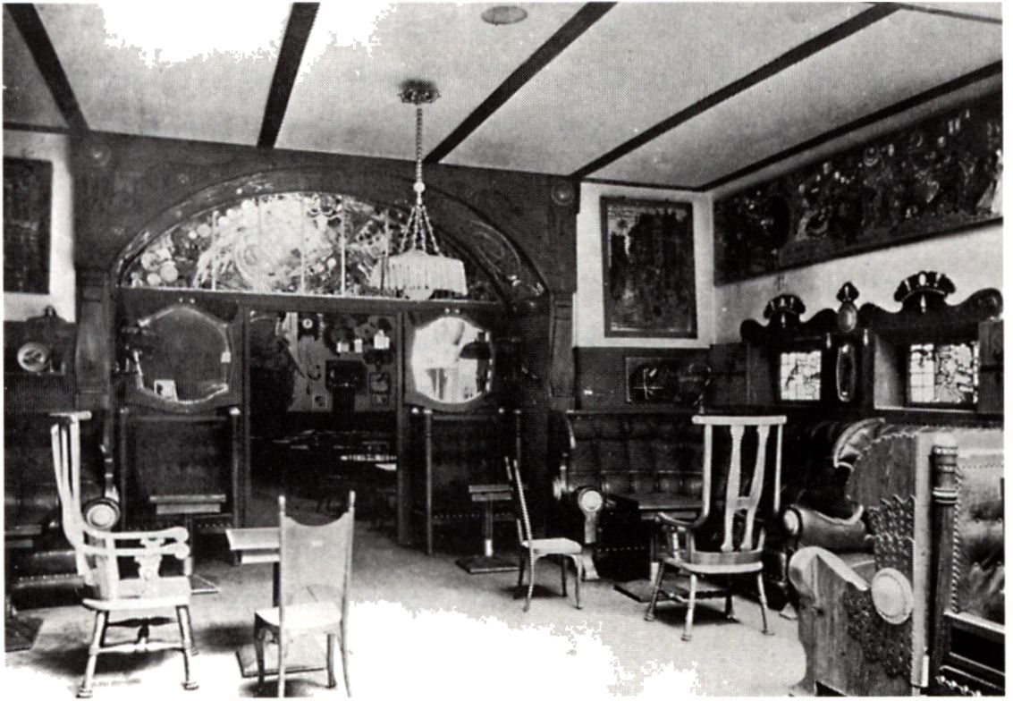
Kraków Interior fra Llov the-salon /
Interior of the Llov Teashop, 1910

65
Kraków at the turn of the Century
domination).
Liberal and conspiratorial Kraków of the late 40's changed
in the 50's 'from a recent nest of conspirators .... into a grand
aristocratic salon'. However, growing interest in Kraków among
the nobility resulted primarily from a new situation in which the
Polish lands and the Polish national cause found themselves in
the 1860s. The tragedy of the January Uprising, brutally sup-
pressed by Russia on the one hand, and a turn to liberalism and
profound internal transformations of the Habsburg Monarchy
on the other, as a result of which Galicia was granted far-reaching
autonomy, added a new meaning to the symbolic role of Kraków
in the life of the Poles.
Annexed in the latter half of the 19th century to Austria,
Kraków from the outset recognized the uniqueness of its situa-
tion in comparison with the Russian-occupied sector of Poland,
which was seized by repression and mourning after an uprising,
and the Prussian-occupied sector of Poland, gripped by pro-
gressive Germanization. The city quickly took on the role of the
nation's spiritual capital, a place integrating all Poles. Wawel
Cathedral became a venue for symbolic royal funerals. The
municipal district, supported by private founders from all Polish
lands, took on the role of a surrogate for a non-existent state.
At the turn of the century, the City of Kraków founded such
institu-tions as the National Museum and the National Theatre.
Acquisition of Wawel from the hands of the Austrian army
became for Stanislaw Wyspiański, the greatest turn-of-the-century
Polish artist, an opportunity to create a Neo-Romantic vision of
Wawel Hill transformed into the Polish Acropolis to accommo-
date central institutions of the non-existent state. In this way
Kraków, in a small way, followed in the footsteps of its elder
sisters, Prague and Budapest, which in the 19th century fulfilled,
as part of the Habsburg Monarchy, their roles as national capitals
in the modern sense of the word. In reaching this goal Kraków
was helped by historicism, which was the Zeitgeist and the legiti-
66
Art Nouveau i Central Europa
mizing factor. The example of Kraków also shows that even lost
metropolitan status can become a positive factor for further
development.
However, this programme was also implemented as a con-
sequence of a new political concept, adopted in the 60s by Polish
conservative and land-owning circles - the so-called Austro-
Polish solution. Kraków was to find a special place in this concept.
Not only was it the only large Polish city (in addition to Lwow)
in which national life could develop unrestrictedly after 1863, but
also by force of its tradition and cultural legacy it was a unique
place predestined to be the centre of conservative thought.
Designated by the political camp of the so-called Stanczyks (a
group of Kraków conservatives) to be the spiritual capital of the
nation, Kraków became a historical symbol of the Poles' striving
for independence. The success of such a solution was possible
thanks to the political clout of Galician conservatives in the par-
liamentary system of the Austro-Hungarian Monarchy up until
the outbreak of the First World War. Kraków's relations with
Vienna and the Habsburg Monarchy also changed substantially.
This change was symbolized by the triumphant visit of Franz
Joseph I to Kraków. During this visit the emperor agreed to
recognize Wawel - transformed by the Austrians into a citadel
in 1846 - as one of his official residences. This made it possible
to start long-term negotiations with the military authorities, as a
result of which Wawel was bought from the Austrians, and their
army left the one-time residence of the Polish kings.
Development of Kraków at the turn of the century was beset
with many contradictions. The systemic weakness of the city's
economy was offset by Kraków's exceptional significance to the
Poles. The function of the nation's spiritual capital was at vari-
ance with its function as a frontier fortress and provincial garrison
of a foreign army. Seen from the perspective of Vienna, which was
transformed into a great cosmopolitan metropolis at the turn of
the century, Kraków was merely a medium sized peripheral city.
67
Kraków at the turn of the Century
Seen from a Polish state policy perspective, Kraków, poverty-
stricken as it was, fulfilled the function of the national capital
of the non-existent Polish state. These and other contradictions
determined the phenomenon and the unique situation of Kraków
under Austrian rule.
At that time Kraków not only fulfilled the role of a Polish
Athens, but also of a Polish Piedmont. Whereas Lwow at the turn
of the century primarily performed the function of the capital city
of Galicia, the largest Austrian province, Kraków was primarily the
main centre of integration of Polish national life. This role became
even stronger after the revolution of 1905 was suppressed in the
Kingdom. On the threshold of the First World War the most
important political groups based their activities in Kraków. Jozef
Piłsudski was also active here. In August 1914 he marched out
from Kraków in the vanguard of the Polish legions to struggle for
independence against Russia, but still at Austria's side. Four years
later - on 31 October 1918 - Polish legionaries were in charge of
disarming Austrian soldiers. In this way the period of Austrian
rule ended in Kraków. It had been divided into two, if not three,
clear stages - the first was repressive in nature, and the remaining
two were based on liberalism and autonomy.
The early 1890s were doubtless the turning point which divided
the Kraków of the autonomy period into two distinct phases. Two
concurrent events formed a symbolic border: the opening of a
new Municipal Theatre at Sw. Ducha Square in October and Jan
Matejko's death in November 1893.
While Matejko was a symbol of Kraków in the second half of
the 19th century, the new Theatre foretold and symbolized a new
phase in the city's development, although in an aesthetic sense
its architecture summarized the long lesson of 19th-century
historicism rather than anticipated the nascent Art Nouveau. It
was also no coincidence that Matejko as a representative of the
receding era of intensified historicism and reverence for the past,
a symbol of the receding Kraków of the Stanczyks, immediately
66
Art Nouveau i Central Europa
took a stand against the idea of building - in place of a medieval
monastery - a monumental Theatre building, which anticipated
the force and modernity of capitalism approaching the city's gates
(the Theatre was the first building in Kraków to be electrically lit!).
Attention should also be paid to the antinomy between Matejko
and his work, and the cosmopolitanism and academic pomposity
of the Theatre's architecture, in which Siemiradzki's curtain was
hung instead of master Jan's.
The new Theatre thus became not only a symbol of conflict
between matter and spirit, but primarily a sign that Kraków was
entering its metropolitan phase of development. In 1890 there
were just 70,000 inhabitants in Kraków (not including the army
garrison) squeezed into an area of only 5.77 km2. However,
from the 1880s, despite restrictions from the army authorities,
16 boroughs surrounding Kraków, of which only the industrial
Podgórze enjoyed civic rights, started to develop rapidly. These
areas should have been considered partly urbanized by then,
partly because of their spatial arrangement, but perhaps mainly
because of the functions they fulfilled and the professional activity
of their inhabitants. On the threshold of the 20th century, it was
written, ‘a great number of officials, functionaries of private
institutions, professors and military men, who have posts and
practise their profession in Kraków, live there because of cheap
flats, location close to open areas, and cheaper food in Podgórze,
Dębniki, Polwsie Zwierzynieckie, Czarna Wies, Krowodrza, in the
part of Prądnik Czerwony closest to Kraków, and in Grzegórzki.
In addition to the class of people mentioned, the neighbouring
boroughs are inhabited by many industrialists who have shops
and enterprises in Kraków. All the working people of the sub-
urban boroughs are workers and wage-earners in Kraków'.
By 1900 the population of these 15 boroughs (excluding the
city of Podgorze) amounted to 1/3 of Kraków's inhabitants and
was growing dynamically.
Kraków's entrance into a phase of urban development after
69
Kraków at the turn of the Century
ígoo coincided with a clear crystallization of capitalist relations
in Galicia. The plan to create Greater Kraków, undertaken by the
mayor of Kraków, Juliusz Leo, meant not only connecting a dozen
or so external boroughs and a considerable extension of the city's
administrative area (from 5.77 km2 to 46.90 km2), but above all
pushing Kraków on the track of real capitalist development, using
industry, trade, transportation, and financial capital. Implemen-
tation of these undertakings in 1909-1915 meant that the concept
of Kraków as a non-industrial city was finally abandoned. This
great opening to 20th-century dynamism and modernness also
created a need for rapid changes in social awareness.
In this situation, complex and full of discrepancies, Kraków also
became the most important centre of Polish architectural thought
in 1890-1914, despite the fact that Warsaw and Lódz as well as
Lwow and Poznan were better off economically, witnessing more
dynamic urban development and more intensive building activity.
The primacy of Kraków and the creation of a strong architectural
milieu here were based on the efflorescence of intellectual and
artistic life at Wawel Hill rather than on a building boom. For
architects active in Kraków, the former capital of Poland was still
a laboratory for artistic experiments rather than a fast-growing
metropolis. Therefore, as a rule, any major construction was
chosen by competition, provoking creative discussions that went
beyond local limits. After a period of consolidation and building
according to different architectural schools (Munich, Berlin,
Vienna, Paris), Kraköw's architectural circles already in the 19th
century entered the stage of creation, forming their own specific
aesthetics of forms. This was the result of universal tendencies
transposed from abroad and of creative use of local tradition.
These aesthetics distinguished Kraków favourably from other
Polish cities, endowing it with a uniquely individual character.
Early 20th-century Kraków was thus in the process of deep
transformation. The hitherto dominant national perspective
and force of tradition had to face liberalism, universalism and
70
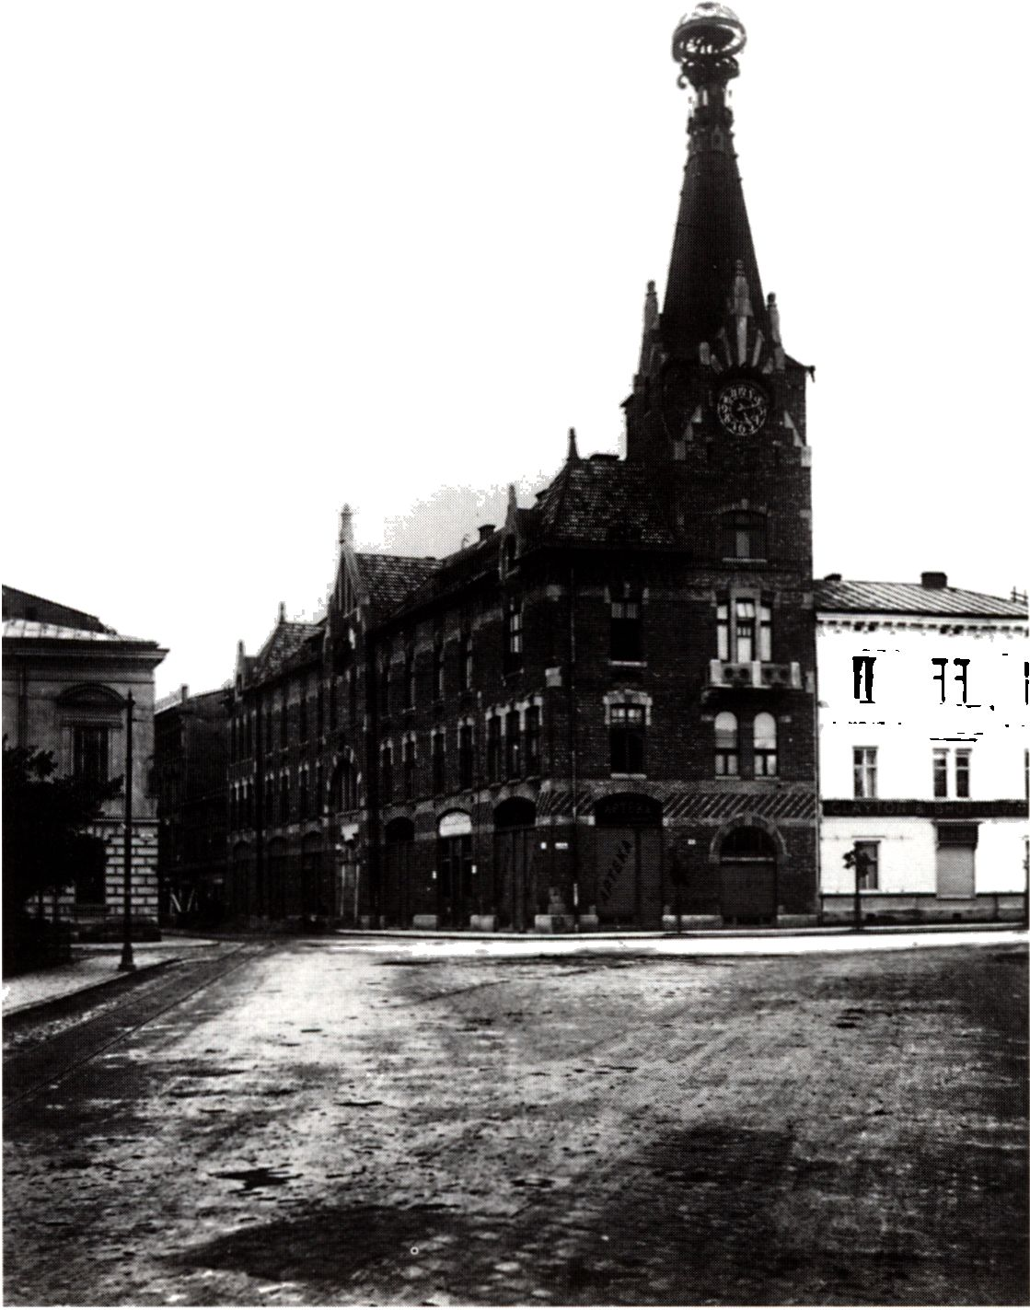
Kraków ‘Huset med kloden’ / the ‘House with the Globe' 1916

71
Kraków at the turn of the Century
cosmopolitanism, which triumphed towards the end of the
multinational Habsburg state. Provincialization, stagnation and
regressive social relations were defied by the openness and dyna-
mism of great capitalist urbanization. The pervasive historicist
attitude was set against modernism in a European dimension.
Mloda Polska Kraków meant not only a local variant of univer-
sal response to historicism around 1900, but also a belated entry
into the capitalist and metropolitan phase of development based
on the achievements of liberalism. This meant having to over-
come the quasi-feudal, clerical and paternalistic model of Kraków
of the Stanczyks, which was held in the clutches of the Austrian
fortifications. This also meant the intensification of con-flicts and
contradictions, including mental ones, as evidenced by what I
wrote some years ago: ‘Basically, we should speak of several
Krakóws during that period - we have aristocratic and clerical
Kraków, that of Czas and the Stanczyks; the Kraków of illumi-
nated intelligentsia, the Kraków of the University and Academy
of Learning; the Kraków of artists, academic and avantgardě;
the Jewish Kraków, with the whole atmosphere of vibrant shops
in Kazimierz; the suburban Kraków with its unique folklore and,
connected with it, the ever-growing working-class Kraków; the
Kraków of prudish middle classes and of the first socialist deputy,
the people's tribune Ignacy Daszyński, who irritated the middle
classes; the fortress Kraków with numerous barracks and military
units in them; and the Kraków of independence activists headed
by Piłsudski. All those strands - different as they are - drawn
together make up a closed whole .... This is why it is so difficult
to provide a clear yet true picture of fin de siécle and belle époque
Kraków.’
72
Art Nouveau i Central Europa

Selected bibliography
- Bieniarzowna J., Małecki J. M., Dzieje Krakówa. Т. 3.
Kraków w latach 1796-1918
(A History of Kraków. Vol. 3. Kraków in the Years 1796-1918).
Kraków 1979.
- Purchla J, Jak powstał nowoczesny Kraków (How Modern
Kraków Arose). Second edition, revised and enlarged. Kraków
1990, 144 pp. + 151 illus.
- Purchla J., Krakau unter österreichischer Herrschaft. 1846-1918.
Faktoren seiner Entwicklung. Wien-Köln-Weimar 1993, 144 pp. +
18 illus.
- Purchla J., Das Theater und sein Architekt. Zum hundersten
Jahrestag der Eröffnung des Juliusz-Slowacki-Theaters in Krakau.
Kraków 1993,126 pp. + appendix + 92 illus.
- Purchla J., 'Krakau um die Jahrhundertwende und sein kreatives
Milieu’. In: Brix E., Janik A. (Ed.): Kreatives Milieu Wien um 1900.
Ergebnisse eines Forschungsgespräches der Arbeitsgemeinschaft
Wien um 1900. Wien München 1993, pp. 54-84.
73

