
Eur. Phys. J. C (2016) 76:198
DOI 10.1140/epjc/s10052-016-4003-2

The European
Physical journal C
CrossMark
Regular Article - Experimental Physics

Production of A-hyperons in inelastic p+p interactions at 158 GeV/c
NA61/SHINE Collaboration
A. Aduszkiewicz16, Y. Ali14,30, E. Andronov22, T. Antićić3, N. Antoniou8, B. Baatar20, F. Bay24, A. Blondel26,
M. Bogomilov2, A. Brandin21, A. Bravar26, J. Brzychczyk14, S. A. Bunyatov20, O. Busygina19, P. Christakoglou8,
M. Ćirković23, T. Czopowicz18, A. Damyanova26, N. Davis8, H. Dembinski5, M. Deveaux7, F. Diakonos8,
S. Di Luise24, W. Dominik16, J. Dumarchez4, K. Dynowski18, R. Engel5, A. Ereditato25, G. A. Feofilov22,
Z. Fodor9,17, A. Garibov1, M. Gaździcki712, M. Golubeva19, K. Grebieszkow18, A. Grzeszczuk15, F. Guber19,
A. Haesler26, T. Hasegawa10, A. E. Hervé5, M. Hierholzer25, S. Igolkin22, A. Ivashkin19, S. R. Johnson28,
K. Kadija3, A. Kapoyannis8, E. Kaptur15, J. Kisiel15, T. Kobayashi10, V. I. Kolesnikov20, D. Kolev2,
V. P. Kondratiev22, A. Korzenev26, K. Kowalik13, S. Kowalski15, M. Koziel7, A. Krasnoperov20, M. Kuich16,
- Kurepin19, D. Larsen14, A. László9, M. Lewicki17, V. V. Lyubushkin20, M. Maćkowiak-Pawłowska18,
- Maksiak18, A. I. Malakhov20, D. Manić23, A. Marcinek1417, A. D. Marino28, K. Marton9, H. -J. Mathes5,
T. Matulewicz16, V. Matveev20, G. L. Melkumov20, B. Messerly29, G. B. Mills27, S. Morozov19,21, S. Mrówczyński12,
Y. Nagai28, T. Nakadaira10, M. Naskręt17, M. Nirkko25, K. Nishikawa10, A. D. Panagiotou8, V. Paolone29,
M. Pavin3,4, O. Petukhov19,21, C. Pistillo25, R. Płaneta14, B. A. Popov4,20, M. Posiadała16, S. Puławski15,
J. Puzović23, W. Rauch6, M. Ravonel26, A. Redij25, R. Renfordt7, E. Richter-Wąs14, A. Robert4, D. Röhrich11,
E. Rondio13, M. Roth5, A. Rubbia24, B. T. Rumberger28, A. Rustamov1,7, M. Rybczynski12, A. Sadovsky19,
K. Sakashita10, K. Schmidt15, T. Sekiguchi10, I. Selyuzhenkov21, A. Seryakov22, P. Seyboth12, D. Sgalaberna24,
M. Shibata10, M. Słodkowski18, P. Staszel14, G. Stefanek12, J. Stepaniak13, H. Ströbele7, T. Šuša3,a, M. Szuba5,
M. Tada10, A. Taranenko21, D. Tefelski18, V. Tereshchenko20, R. Tsenov2, L. Turko17, R. Ulrich5, M. Unger5,
M. Vassiliou8, D. Veberič5, V. V. Vechernin22, G. Vesztergombi9, L. Vinogradov22, A. Wilczek15, Z. Włodarczyk12,
A. Wojtaszek-Szwarc12, O. Wyszyński14, L. Zambelli4,10, E. D. Zimmerman28
- National Nuclear Research Center, Baku, Azerbaijan
- Faculty of Physics, University of Sofia, Sofia, Bulgaria
- Ruder Boskovic Institute, Zagreb, Croatia
- LPNHE, University of Paris VI and VII, Paris, France
- Karlsruhe Institute of Technology, Karlsruhe, Germany
- Fachhochschule Frankfurt, Frankfurt, Germany
- University of Frankfurt, Frankfurt, Germany
- University of Athens, Athens, Greece
- Wigner Research Centre for Physics of the Hungarian Academy of Sciences, Budapest, Hungary
- Institute for Particle and Nuclear Studies, Tsukuba, Japan
- University of Bergen, Bergen, Norway
- Jan Kochanowski University in Kielce, Kielce, Poland
- National Centre for Nuclear Research, Warsaw, Poland
- Jagiellonian University, Cracow, Poland
- University of Silesia, Katowice, Poland
- University of Warsaw, Warsaw, Poland
- University of Wrocław, Wrocław, Poland
- Warsaw University of Technology, Warsaw, Poland
- Institute for Nuclear Research, Moscow, Russia
- Joint Institute for Nuclear Research, Dubna, Russia
- National Research Nuclear University “MEPhI” (Moscow Engineering Physics Institute), Moscow, Russia
- St. Petersburg State University, St. Petersburg, Russia
- University of Belgrade, Belgrade, Serbia
- ETH Zurich, Zurich, Switzerland
- University of Bern, Bern, Switzerland
- University of Geneva, Geneva, Switzerland
- Los Alamos National Laboratory, Los Alamos, USA
- University of Colorado, Boulder, USA
- University of Pittsburgh, Pittsburgh, USA
- Present address: Department of Physics, COMSATS Institute of Information Technology, Islamabad 44000, Pakistan
Received: 5 November 2015 / Accepted: 7 March 2016 / Published online: 12 April 2016
© The Author(s) 2016. This article is published with open access at Springerlink.com
1 Springer
198 Page 2 of 18
Eur. Phys. J. C (2016) 76:198
Abstract Inclusive production of A-hyperons was mea-
sured with the large acceptance NA61/SHINE spectrome-
ter at the CERN SPS in inelastic p+p interactions at beam
momentum of 158GeV/c. Spectra of transverse momentum
and transverse mass as well as distributions of rapidity and
xF are presented. The mean multiplicity was estimated to be
- 120 ± 0.006 (stat.) ±0.010 (sys.). The results are com-
pared with previous measurements and predictions of the
Epos, UrQMD and Fritiof models.
1 Introduction
Hyperon production in proton-proton (p+p) interactions has
been studied in a long series of fixed target and collider exper-
iments. However, the resulting experimental data suffers
from low statistics, incomplete beam momentum coverage,
and large differences between the measurements reported by
different experiments. Also popular models of proton-proton
interactions mostly fail to reproduce the measurements. The
data on A production and the model predictions are reviewed
at the end of this paper.
At the same time rather impressive progress was made
in measurements of hyperon production in nucleus-nucleus
(A+A) collisions [1]. This has two reasons. Firstly, mean
multiplicities of all hadrons in central heavy ion collisions
are typically two to three orders of magnitude higher than
the corresponding multiplicities in inelastic p+p interactions.
Secondly, the hyperon yields per nucleon are enhanced by
substantial factors in A+A collisions with respect to p+p
interactions. This enhancement, which increases with the
strangeness content of the hyperon in question, has raised
considerable interest over the past decades. It has in particular
been brought into connection with production of the Quark-
Gluon Plasma, a ’deconfined’ state of matter at that time
hypothetical [2,3]. Nowadays, for the energies well below
the LHC energy range, nucleus-nucleus collisions are inves-
tigated mainly to find the critical point of strongly interact-
ing matter as well as to study the properties of the onset
of deconfinement [4,5]. In particular, precise measurements
of inclusive hadron production properties as a function of
beam momentum (13A-158A GeV/c) and size of colliding
nuclei (p+p, p+Pb, Be+Be, Ar+Sc, Xe+La) are performed
by NA61/SHINE [6]. Results on inelastic p+p interactions
are an important part of this scan.
NA61/SHINE already published results on n±, K±, pro-
ton, A and K°s production in p+C interactions at beam
momentum of 31 GeV/c [7-10], as well as n- production
in p+p collisions at 20-158 GeV/c [11].
This paper presents the first NA61/SHINE results on
strange particle production in p+p interactions. Since all F0
hyperons decay electromagnetically via E0 ^ Ay, which is
ae-mail: Tatjana.Susa@irb.hr
indistinguishable from direct A production, A in the follow-
ing denotes the sum of both A directly produced in strong p+p
interactions and A from decays of F0 hyperons produced in
these interactions.
The particle rapidity is calculated in the collision centre of
mass system (cms): y = atanh(^L), where pL = pL/E is the
longitudinal component of the velocity, pL and E are longitu-
dinal momentum and energy in the cms and xF = pL /pbeam
is Feynman’s scaling variable with pbeam the incident pro-
ton momentum in the cms. The transverse component of the
momentum is denoted as pT and the transverse mass mT is
defined as mT = ^Jm2 + pT, where m is the particle mass.
The collision energy per nucleon pair in the centre of mass
system is denoted as ^sNN.
2 The experimental setup
The NA61/SHINE experiment [6] uses a large acceptance
hadron spectrometer located in the H2 beam-line at the
CERN SPS accelerator complex. The layout of the exper-
iment is schematically shown in Fig. 1. Hereby we describe
only the components relevant for the analysis. The main
detector system is a set of large volume time projection
chambers (TPCs). Two of them (VTPC-1 and VTPC-2)
are placed inside super-conducting magnets (VTX-1 and
VTX-2) with a combined bending power of 9 Tm. The stan-
dard current setting for data taking at 158 GeV/c corresponds
to full field, 1.5T, in the first and reduced field, 1.1T, in the
second magnet. Two large TPCs (MTPC-L and MTPC-R)
are positioned downstream of the magnets, symmetrically
to the undeflected beam. A fifth small TPC (GAP-TPC) is
placed between VTPC-1 and VTPC-2 directly on the beam
line and covers the gap between the sensitive volumes of the
other TPCs. The NA61/SHINE TPC system allows a pre-
cise measurement of the particle momenta p with a reso-
lution of o(p)/p2 ^ (0.3 - 7) x 10-4 (GeV/c)-1 at the
full magnetic field used for data taking at 158 GeV/c and
provides particle identification via the measurement of the
specific energy loss, dE/dx, with relative resolution of about
4.5%.
A set of scintillation and Cherenkov counters, as well as
beam position detectors (BPDs) upstream of the main detec-
tion system provide a timing reference, as well as identifica-
tion and position measurements of the incoming beam par-
ticles. The 158 GeV/c secondary hadron beam was produced
by 400GeV/c primary protons impinging on a 10 cm long
beryllium target. Hadrons produced at the target are trans-
ported downstream to the NA61/SHINE experiment by the
H2 beamline, in which collimation and momentum selection
occur. Protons from the secondary hadron beam are identi-
fied by a differential Cherenkov counter (CEDAR) [12]. Two
scintillation counters, S1 and S2, together with the three veto
1 Springer
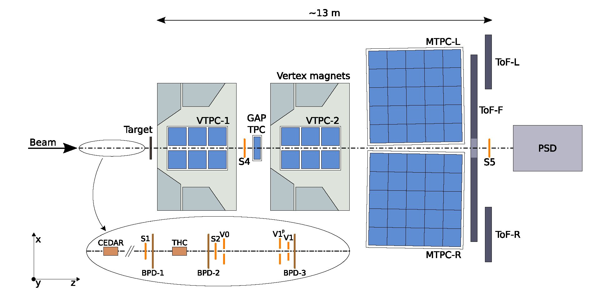
Eur. Phys. J. C (2016) 76:198
Page 3 of 18 198
Fig. 1 Schematic layout of the NA61/SHINE experiment at the CERN
SPS (horizontal cut in the beam plane, not to scale). The beam and trig-
ger counter configuration used for data taking on p+p interactions in
2009 is presented. The chosen right-handed coordinate system is shown
on the plot. The incoming beam direction is along the z axis. The mag-
netic field bends charged particle trajectories in the x-z (horizontal)
plane. The drift direction in the TPCs is along the y (vertical) axis [6].
See details in Sect. 2
counters V0, V1 and V1p were used to select beam particles.
Thus, beam particles were required to satisfy the coincidence
S1-S2V 0V1V1p -CEDAR in order to become accepted as a
valid proton. Trajectories of individual beam particles were
measured in a telescope of beam position detectors placed
along the beam line (BPD-1/2/3 in Fig. 1). These are multi-
wire proportional chambers with two orthogonal sense wire
planes and cathode strip readout, allowing to determine the
transverse coordinates of the individual beam particle at the
target position with a resolution of about 100 pm. For data
taking on p+p interactions a liquid hydrogen target (LHT) of
20.29 cm length (2.8 % interaction length) and 3 cm diameter
was placed 88.4 cm upstream of VTPC-1.
Data taking with inserted and removed liquid hydrogen
(LH) in the LHT was alternated in order to calculate a data-
based correction for interactions with the material surround-
ing the liquid hydrogen. Interactions in the target are selected
by requiring an anti-coincidence of the selected beam pro-
tons with the signal from a small scintillation counter of
- cm diameter (S4) placed on the beam trajectory between
the two spectrometer magnets. Further details on the experi-
mental setup, beam and the data acquisition can be found in
Ref. [6].
3 Analysis technique
In the following section the analysis technique is described,
starting with the event reconstruction followed by the event
and V0 selections. Next the A signal extraction and the cal-
culation of A-yields are presented. Then the correction pro-
cedure and the estimation of statistical and systematic uncer-
tainties are discussed. Finally quality tests are performed on
the final results. More details can be found in Ref. [13].
- Track and main vertex reconstruction
The main steps of the track and vertex reconstruction proce-
dure are:
- cluster finding in the TPC raw data, calculation of the
cluster centre-of-gravity and total charge,
- reconstruction of local track segments in each TPC sep-
arately,
- matching of track segments into global tracks,
- track fitting through the magnetic field and determina-
tion of track parameters at the first measured TPC clus-
ter,
- determination of the interaction vertex using the beam
trajectory (x and y coordinates) fitted in the BPDs and
the trajectories of tracks reconstructed in the TPCs (z
coordinate),
- matching of ToF hits with the TPC tracks.
- Event selection
A total of 3.5 x 106 events recorded with the LH inserted
(denoted I) and 0.43 x 106 with the LH removed from the
target (denoted R) were used for the analysis. The two con-
figurations were realised by filling the target vessel with LH
and emptying it.
12n
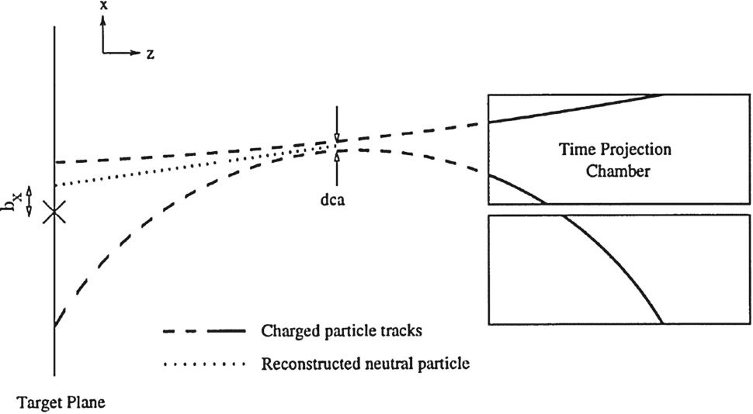
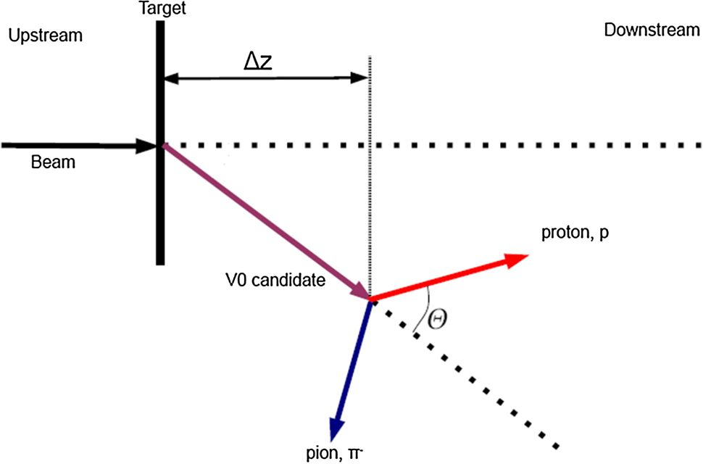
198 Page 4 of 18
Eur. Phys. J. C (2016) 76:198
Interaction events were selected by the following require-
ments:
- no off-time beam particle was detected 1 ps before and
after the trigger particle,
- the trajectory of the beam particle was measured in at
least one of BPD-1 or BPD-2 and in the BPD-3 detector
and was well reconstructed (BPD-3 is positioned close
to and upstream of the LHT),
- the fit of the z-coordinate of the primary interaction
vertex converged and the fitted z position is found within
±40 cm of the centre of the LHT.
The number of events after these selections (N1 = 1.66 x
106 for the LH inserted configuration of the target, NR =
43 x 103 for the LH removed) is treated as the raw number
of recorded inelastic events.
- V0 reconstruction and selection
A hyperons are identified by reconstructing their decay topol-
ogy A ^ p + n— (branching ratio 63.9 %). In the first step
pairs were formed from all measured positively and nega-
tively charged particles. V0 candidates were required to have
a distance of closest approach (dca, Fig. 2) between the two
trajectories of less than 1 cm anywhere between the posi-
tion of the first measured points on the tracks and the pri-
mary vertex. In the second step, the position of the secondary
vertex and the momenta of the decay tracks were fitted by
performing a 9-parameter x2 fit employing the Levenberg-
Marquardt fitting procedure [15,16]. In the fit the fitted sec-
ondary vertex was added as the first point to the tracks at
which the momenta were recalculated. Finally, for each can-
didate the invariant mass was calculated assuming proton
(pion) mass for positively (negatively) charged particles. To
ensure a good momentum determination and reduce the com-
binatorial background from random pairs, a set of quality cuts
was imposed:
- For each track, the minimum number of clusters in at
least one of VTPC-1 and VTPC-2 was required to be
15.
- Proton and pion candidates were selected by requiring
their specific energy loss measured by the TPCs to be
within 3 a around the nominal Bethe-Bloch value. This
cut was applied only to experimental data.
- For the simulated data (see below) the background was
totally discarded by matching, i.e. by using only those
reconstructed tracks which were identified as originat-
ing from the corresponding A decay. The identification
was performed by matching the clusters found in the
TPCs with the clusters generated in the simulation. In
case more than one reconstructed track was matched to
a A decay daughter the one with the largest number of
matched clusters was selected.
- The combinatorial background concentrated in the
vicinity of the primary vertex is reduced by imposing
a distance cut on the difference between the z coordi-
nate of the primary and A vertex (Az = zA — zprimary,
see Fig. 3). To maximise the fraction of rejected back-
ground while minimising the number of lost A candi-
dates, arapiditydependent cut was applied: Az > 10 cm
for y < 0.25, Az > 15cm for y e [0.25,0.75],
Az > 40cm for y e [0.75, 1.25], and Az > 60cm
for higher rapidities.
- A further significant part of the background (e.g. pairs
from photon conversions) was rejected by imposing a
cut on cos $, where $ is defined as the angle between the
vectors y', and n, where y' is the vector perpendicular to
the momentum of the V0-particle which lies in the plane
spanned by the y-axis and the V0-momentum vector,
and n is a vector normal to the decay plane (see Fig.
4). A rapidity dependent cut was used: | cos $| < 0.95
Fig. 2 Definition of distance of the closest approach (dca), and bx. The
variable by is defined on the yz-plane in analogy with bx. The target
plane is defined as the plane parallel to the xy-plane containing the main
vertex marked with a cross (taken from Ref. [14])
Fig. 3 Definition of Az variable used for the V selection (see text)

12n
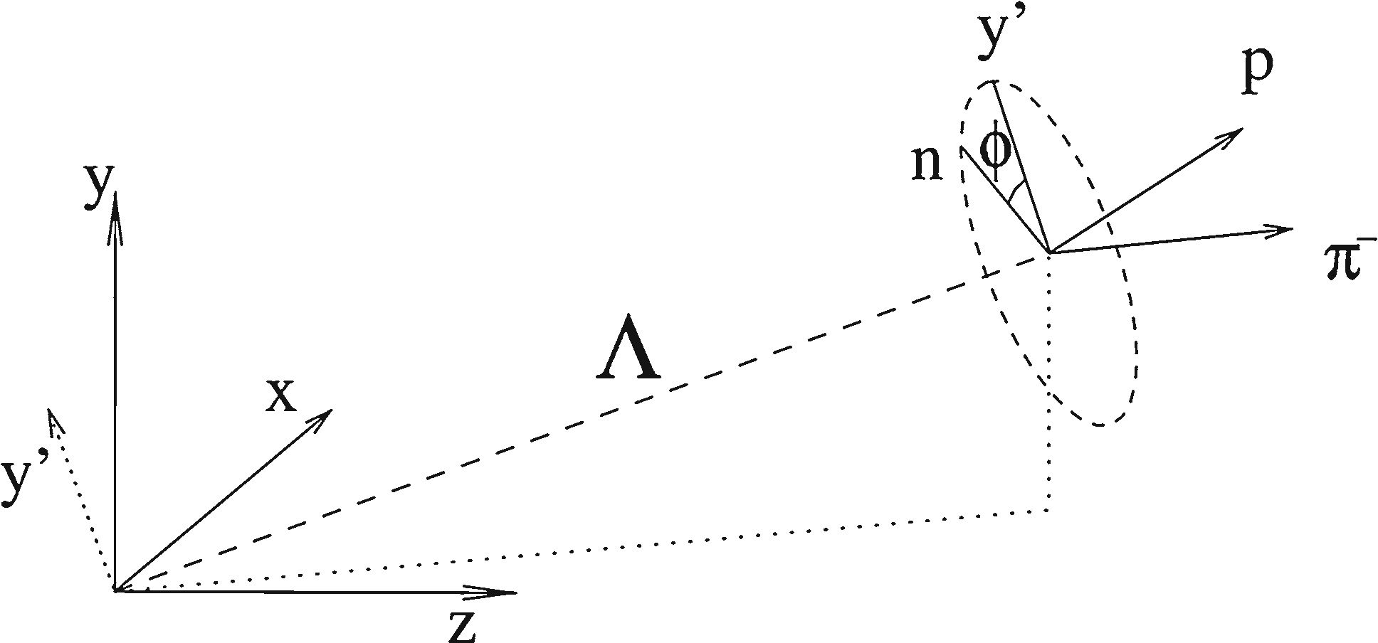
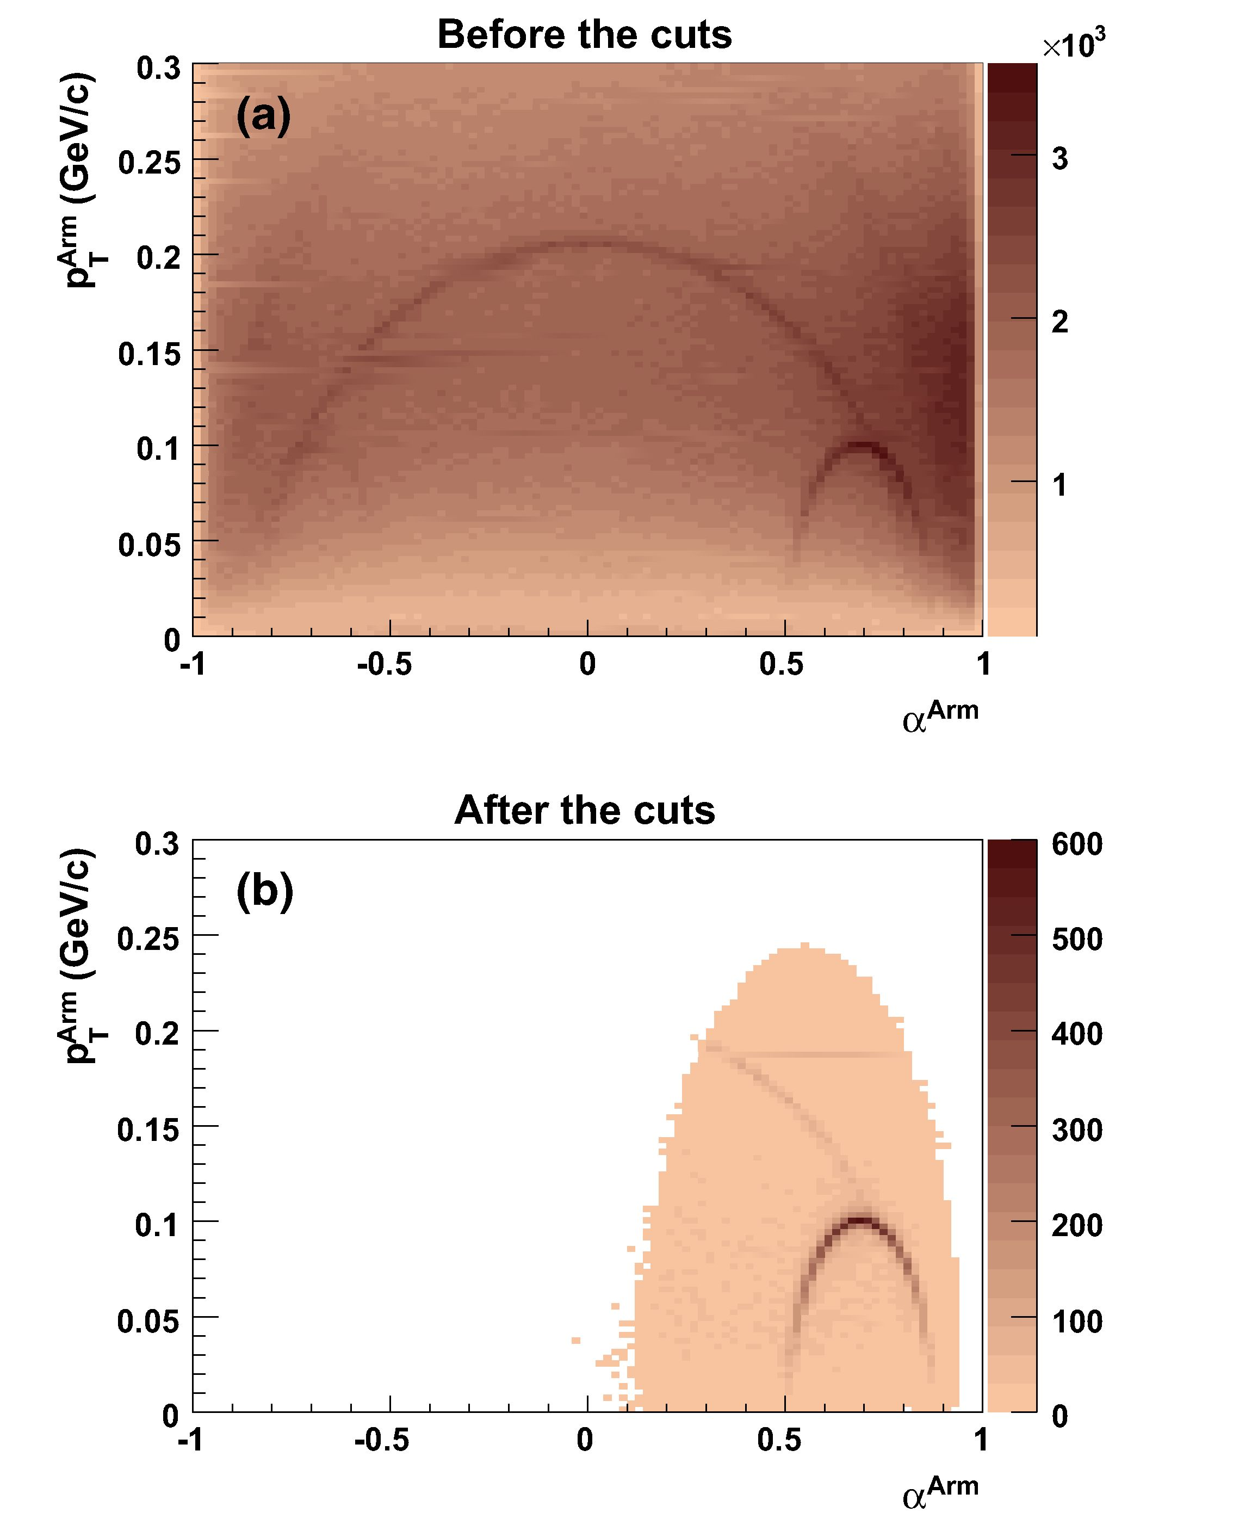
Eur. Phys. J. C (2016) 76:198
Page 5 of 18 198
Fig. 4 Definition of 0-variable used for the V0 selection (see text)
for y < -0.25, | cos 01 < 0.9 for y e [-0.25, 0.75],
| cos 01 < 0.8 for higher rapidities.
- The trajectories of the A candidates were calculated
using the decay vertex and the momentum vectors
of the decay particles. Extrapolation back to the pri-
mary vertex plane resulted in impact parameters bx (in
the magnetic bending plane) and by (see Fig. 2). As
the resolution of impact parameters is approximately
twice better in y than in x direction, an elliptic cut
^(bx /2)2 + b2 < 1 cm was imposed in order to reduce
the background from A candidates which do not origi-
nate from the primary vertex.
The selection cuts lead to a high degree of purification
of the A signal. This is demonstrated by the Armenteros-
Podolanski plots [17] of Fig. 5 in which the A decays popu-
late the ellipses on the lower right.
- Signal extraction
The raw yield of A hyperons was obtained by performing a
fit of the invariant mass spectra with the sum of a background
and a signal function. The shape of the A signal was described
by the Lorentzian function:
2r
L (m) = A \ —2, (1)
(m - m0)2 + (2 r)
where m is the invariant mass of the candidate (pn-) pair,
A is a normalisation factor, m0 is the mass parameter and r
is the FWHM (full width at half maximum) of the A peak.
As the natural width of A decay is negligible, the observed
width of the A peak is caused almost solely by the detec-
tor response. In the standard approach, the background was
represented by a Chebyshev polynomial of 2nd order. The
uncertainty introduced by choosing this particular functional
form was estimated by trying other background functions
(see Sec. 3.6).
The sum of the Lorentzian and the background func-
tion was fitted in the mass range from 1.080 (1.076 for
Fig. 5 Armenteros-Podolanski plot for reconstructed V0 decays
before the A candidate selection cuts (a), and after the cuts are applied
(b). The shading indicates the number of entries per bin. The axis
variables are: p^Arm, the transverse momentum of the decay parti-
cles with respect to the direction of motion of the V0 and aArm =
(p+ — p—)/(p+ + p—) where p+ and p— are the longitudinal momenta
of the positive and negative decay particle respectively
y = 0.5, 1.073 for y = 1.0) to 1.250GeV/c2. In order
to ensure the stability of the fit results, even in the case
of low statistics, a three step procedure was developed. In
the first step, a pre-fit was performed in order to estimate
the initial parameters of the background function. For that
purpose, the invariant mass region containing the A peak
(1.100-1.135 GeV/c2) was excluded from the fit. In the sec-
ond step, the invariant mass spectrum was fitted to the sum
of the signal and the background. The initial values for the
parameters of the background function were taken from the
first step, while the mass parameter m0 was fixed to the PDG
value mA = 1.115683GeV/c2 [18] and the width was set to
3 MeV. The obtained values were used as the initial param-
eters for the third step, where no parameter was fixed. The
invariant mass distribution of the A candidates for the inter-
vals y e [—0.75, —0.25] andpT e [0.2, 0.4] GeV/c, together
with the result of the final fit is shown in Fig. 6. For the data
set with LH inserted, the fits were performed in (k, l) bins,
Springer
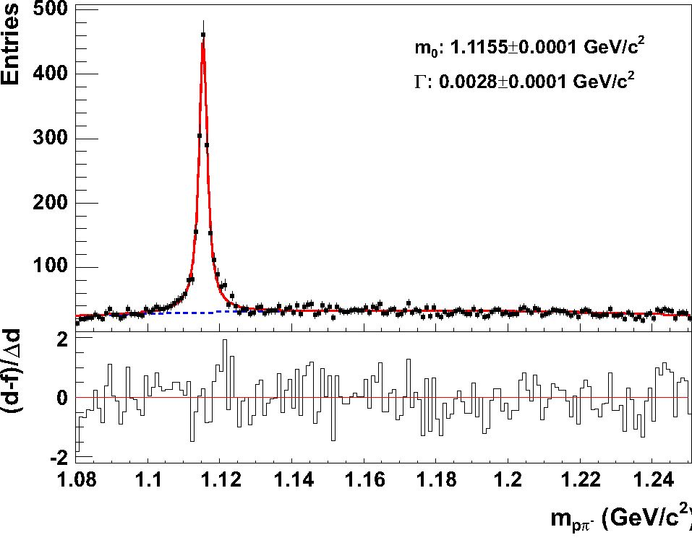
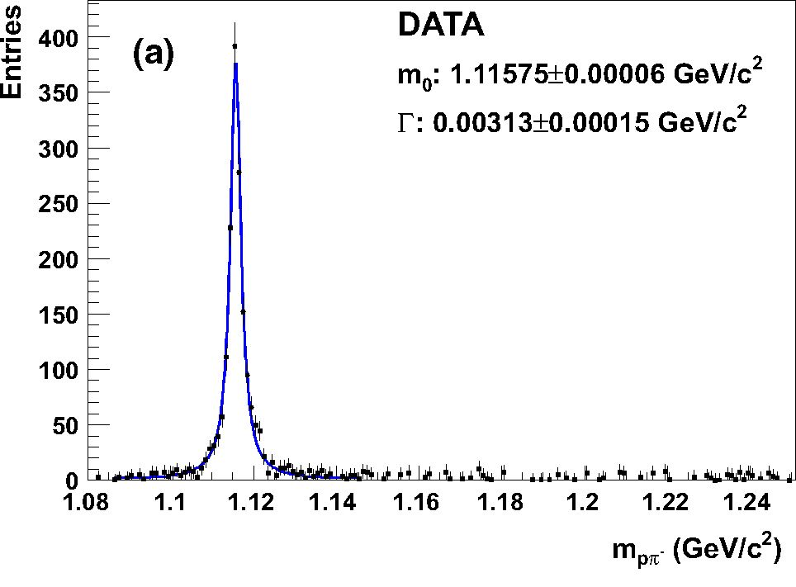
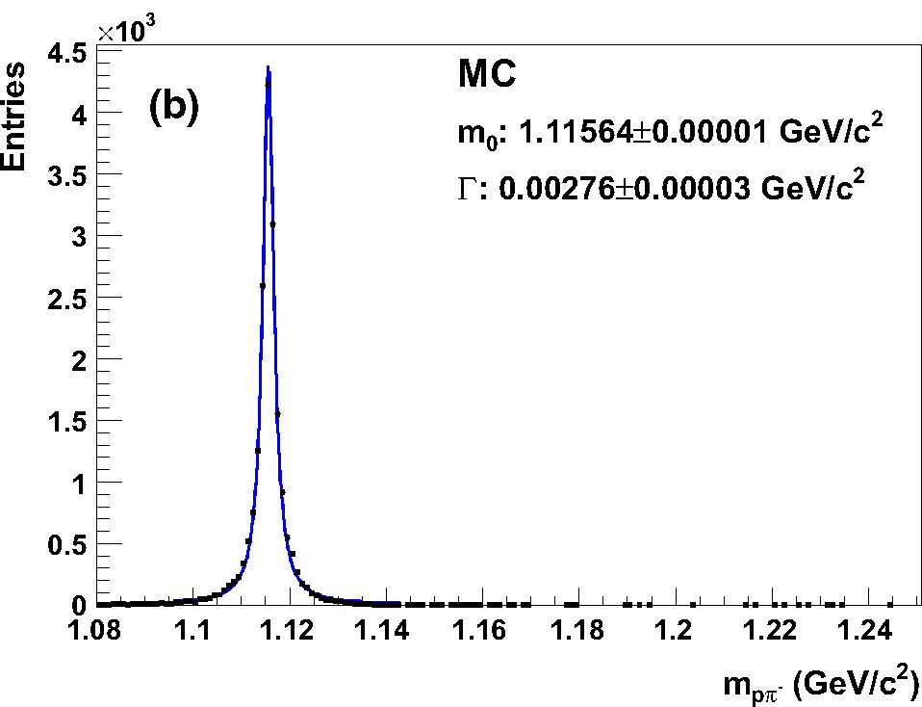
198 Page 6 of 18
Eur. Phys. J. C (2016) 76:198
Fig. 6 The invariant mass distribution of A candidates for y e
[-0.75, -0.25] and pT e [0.2, 0.4] GeV/c is shown in the upper plot
(LH inserted). The solid line shows a fit to signal plus background, while
the dashed line represents the background contribution. The lower part
of the plot shows the difference between the data points and the fit,
normalised to the statistical error of the data points
Fig. 7 The invariant mass distribution of A candidates for y e
[-0.25, 0.25] and pT e [0.2, 0.4] GeV/c with the LH inserted after
subtraction of the fitted background (a), and for the simulation (b)
12n
where k stands for the bin in rapidity y or Feynman xF, and
l for the bin in transverse momentum pT or transverse mass
mT — mA. The raw number of A-hyperons (n1 (k, l)) was then
obtained by subtracting the fitted background and integrat-
ing the remaining signal distributions in the mass window
m0 ± 3T (see Fig. 7), where m0 is the fitted A mass. The low
statistics of the LH removed data set, forced to restrict the fits
to y (xF) bins summed over the transverse variable, resulting
in nR (k). In order to obtain the raw number of A-hyperons
in (k, l) bins, it was assumed that the shape of the pT distri-
butions and the efficiencies for a given y (xF) bin were the
same for the two data sets, and nR (k, l) was calculated as
nR(k, l) — nR(k)"1{k,i),).
EX (k,l)
- Correction factors
In order to determine the number of A hyperons produced in
inelastic p+p interactions, three corrections were applied to
the extracted raw number of A hyperons:
- The contribution from interactions in the material out-
side of the liquid hydrogen volume of the target was sub-
tracted:
n1 (k, l) - BnR (k, l)
N1 - BNr ' ( )
The normalisation factor B was derived by comparing
the distribution of the fitted z coordinate of the interaction
vertex far away from the target [9] for filled and empty
target vessel:
Nfarz
B — ^Hz — 3.93, (3)
NR
far z
where Njarz (NRarz) is the number of events in the
region 100 < z < 280 cm downstream of the target cen-
tre for the data sample with inserted (removed) hydrogen
in the target vessel.
- The loss of the A hyperons due to the dE/dx requirement,
was corrected by a constant factor
1
cd E/dx — ^2 — I.005, (4)
where e — 0.9973 is the probability for the proton (pion)
to lie within 3a around the nominal Bethe-Bloch value.
- A detailed Monte Carlo simulation was performed to
correct for geometrical acceptance, reconstruction effi-
ciency, losses due to the trigger bias, the branching ratio
of the A decay, the feed-down from hyperon decays as
well as the quality cuts applied in the analysis. The cor-
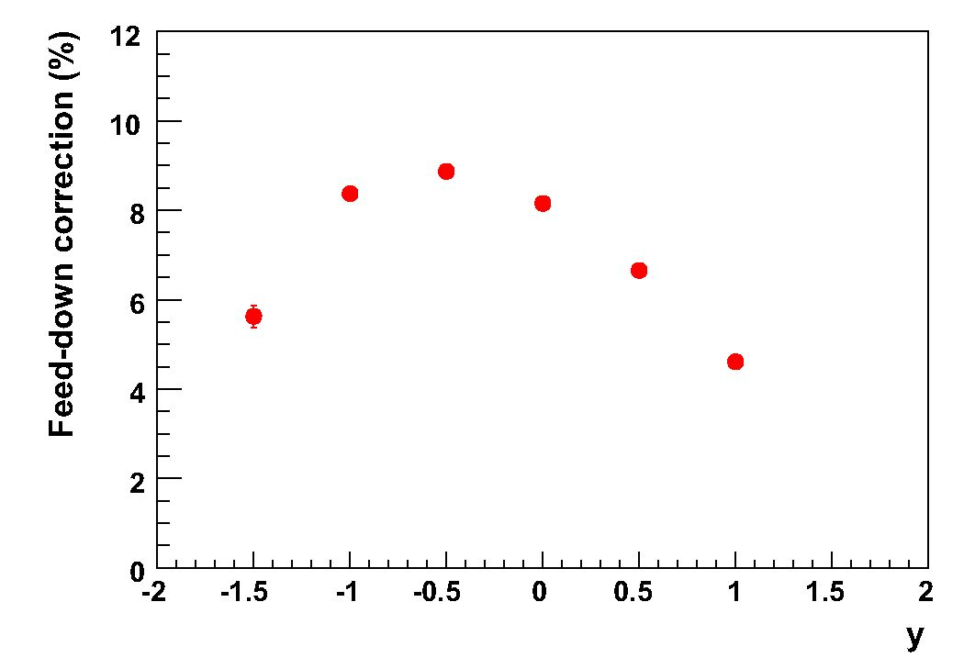
Eur. Phys. J. C (2016) 76:198
Page 7 of 18 198
rection factors are based on 20 x 106 inelastic p+p events
produced by the Epos1.99 event generator [19]. The
particles in the generated events were tracked through
the NA61/SHINE apparatus using the Geant3 pack-
age [20]. The TPC response was simulated by dedicated
NA61/SHINE software packages which take into account
all known detector effects. The simulated events were
reconstructed with the same software as used for real
events and the same selection cuts were applied (except
the identification cut). As seen from Fig. 7 the shape and
position of the A peak is well reproduced by the simula-
tion while the width is about 10% narrower. More details
on MC validation can be found in Ref. [11].
For each (k, l) bin, the correction factor cMC (k, l) was
calculated as
c (k l) _ nMnc(k, l) / nMC(k,l) (5)
cMC(K’ l) ATgen Aracc ’ (5)
NMC I NMC
where
- ngMC (k, l) is the number of A hyperons produced in a
given (k, l) bin in the primary interactions, including
A hyperons from the £° decays,
- nMC (k, l) is the number of reconstructed A hyper-
ons in a given (k, l) bin, determined by matching the
reconstructed A candidates to the simulated A hyper-
ons based on the cluster positions,
- NMC is the number of generated inelastic p+p inter-
actions (19 961 x 103),
- NMCC is the number of accepted p+p events (15 607 x
103),
- k = y or xF, and l = pT or mT - mA.
These factors also include the correction for feed-down
from weak decays (mostly of H- and H0, see Fig. 8).
The H- yields as function of rapidity generated by the
Epos1.99 simulation agree within 10 % with the measure-
ments reported in Ref. [21]. The values of the correction
factors are presented in Fig. 9.
Statistical errors of the correction factors were calculated
using the following approach: The correction factor (cMC)
consists of two parts:
c ln ngiC(k,l) / nMC(k,l)
cMC (k, l) = ATgen Aracc
NMC I NMC
nmc / naMC (k, l) a (6)
NgMeC/ ngMC (k, l) P(k, lr
where a describes the loss of inelastic events due to
the event selection, and j3 takes into account the loss of
A hyperons due to the V0-cuts, efficiency, and the other
aforementioned effects.
Fig. 8 Feed-down correction: the contribution from H and H0 to total
A decays calculated using Epos1.99 model
1 Springer
The error of a was calculated assuming a binomial dis-
tribution, while the part j3 involving the fitting procedure
takes into account the error of the fit:
A _ Ia(1 - a) in\
^a J Ngen ’ (7)
V NMC
mkj) = K )2 + f )2,
\ V nMC(k’l) / V (nMC(k’ l)) /
(8)
where AnMC (k, l) is the uncertainty of the fit, and
AngMC (k, l) = JnMC (k, l). The total statistical error
of cMC was calculated as follows:
ACmc=j (^) + (-^) • (9)
Finally, the double-differential yield of A hyperons per
inelastic event in a bin (k, l) amounts to:
d2n CdE/dxCmc(k, l) n1 (k, l) - BnR(k, l)
dkdl = AkAl N1 - BNR ’ ( )
with
- nI/R the uncorrected number of A hyperons for the
hydrogen inserted/removed target configurations,
- NI/R the number of events for the hydrogen inserted/rem-
oved data after event cuts,
- cdE/dx, cMC the correction factors described in Sec. 3.5,
- B the normalisation factor (defined in Sec. 3.5),
- k = y or xF, and l = pT or mT - mA,
- Ak and Al the bin widths.
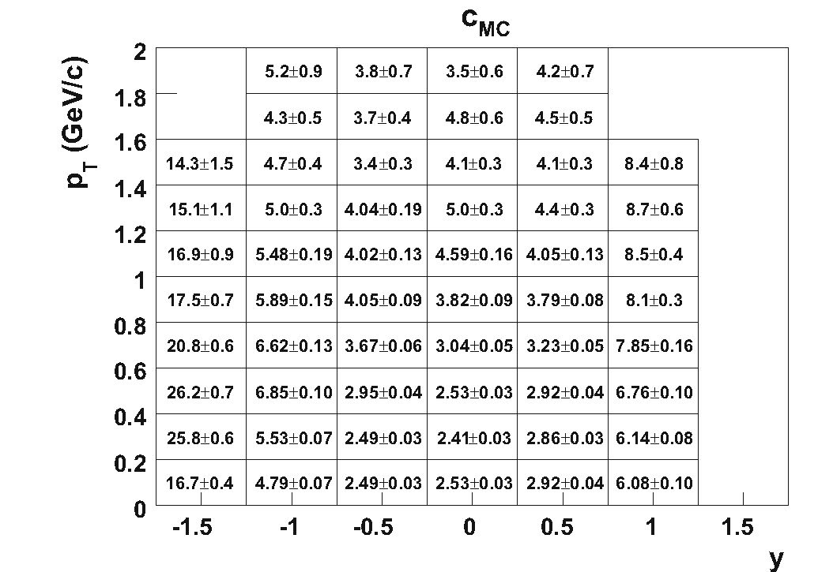
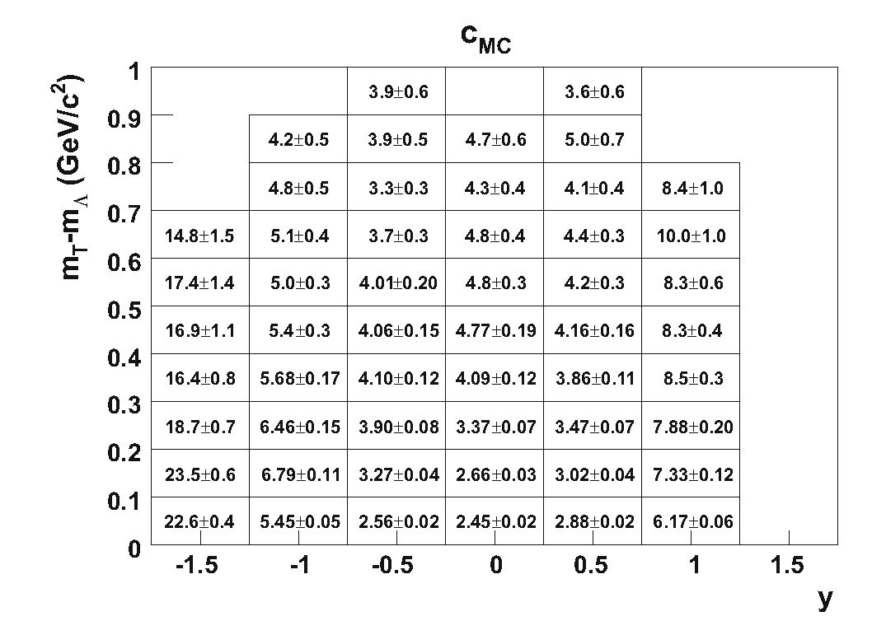
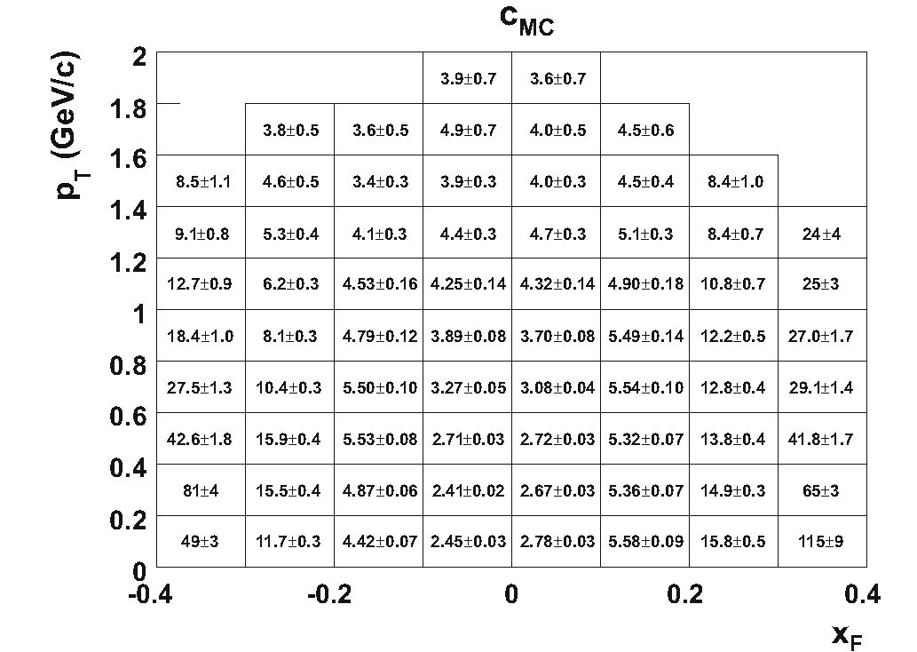
198 Page 8 of 18
Eur. Phys. J. C (2016) 76:198
Fig. 9 Correction factors cMC for binning in (y, pt) at top, (y, mT —
mA)at centre and (xf, pt) at bottom. The error AcMC ranges from 0.02
to 1.48 for binning in (y, pT) and (y, mT), and from 0.02 to 8.70 for
(xF , pT)
- Statistical and systematic uncertainties
The statistical errors of the corrected double differential
yields (see Eq. 10) take into account the statistical errors
of cMC (see Eq. (9)) and the statistical errors on the fitted A
yields in the LH inserted and removed configurations. The
statistical errors on B and cdE/dx were neglected.
The systematic uncertainties were estimated taking into
account four sources. For each source modifications to
the standard analysis procedure were applied and the devia-
tion of the results from the standard procedure were calcu-
lated. As the effects of the modifications are partially cor-
related, the maximal positive and negative deviation from
the standard procedure was determined for each bin and
source separately. Then, the positive (negative) systematic
uncertainties were calculated separately by adding in quadra-
ture the positive (negative) contribution from each source.
The considered sources of the systematic uncertainty and
the corresponding modifications of the standard method were
the following:
- The uncertainty due to the signal extraction procedure:
- The standard function used for background fit, a
Chebyshev polynomial of 2nd order, was changed
for a Chebyshev polynomial of 3rd order and for a
standard polynomial of 2nd order.
- The range within which the raw number of A particles
is summed up was changed from 3 T to2.5r and3.5r.
- The lower limit of the fitting range was changed from
1.08 GeV/c2 (1.076 for y = 0.5,1.073 for y = 1.0) to
1.083GeV/c2 (1.079 for y = 0.5,1.076 for y = 1.0).
- The initial value of the T parameter of the signal
function was changed by ±8%.
- the initial value for the mass parameter of the Lorentz
function was changed by ±0.3 MeV.
- The effect of the event and quality cuts were checked by
performing the analysis with the following cuts changed
compared to the values presented in Secs. 3.2 and 3.3.
- The cut on the z-position of the interaction vertex
was changed from ±40 to ±30 cm and ±50 cm with
respect to the centre of the target.
- The window in which off-time beam particles are not
allowed was increased from 1 to 1.5 ^s.
- The elliptic cut on the impact parameters was reduced
by a factor of 2: ^b2 + (2by )2 < 1cm.
- The dE/dx cut was modified to ±2.8a or 3.2a to esti-
mate possible systematic effects ofdE/dx calibration.
- The matching procedure used to reject background in
the simulation was turned off.
- The required minimal number of charge clusters in at
least one of the VTPCs for both V0-decay products
was decreased to 12 or increased to 18.
- The cut on Az, the distance between the decay and
the primary interaction vertex, was changed from the
standard values to the values shown in columns A and
B in the following table:
1 Springer
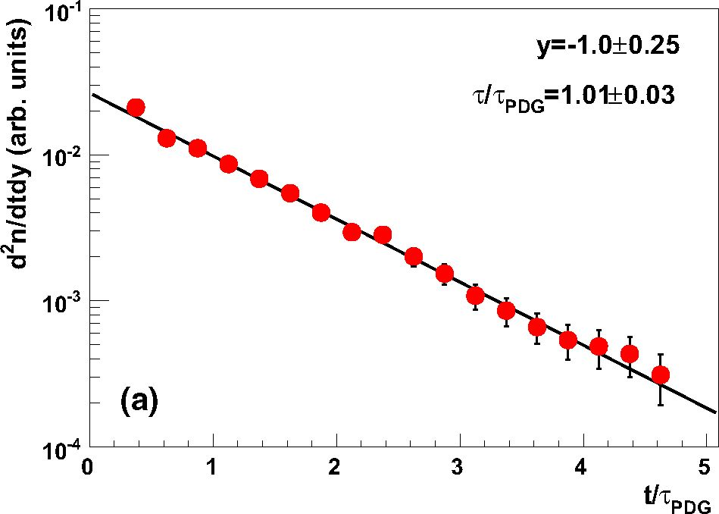
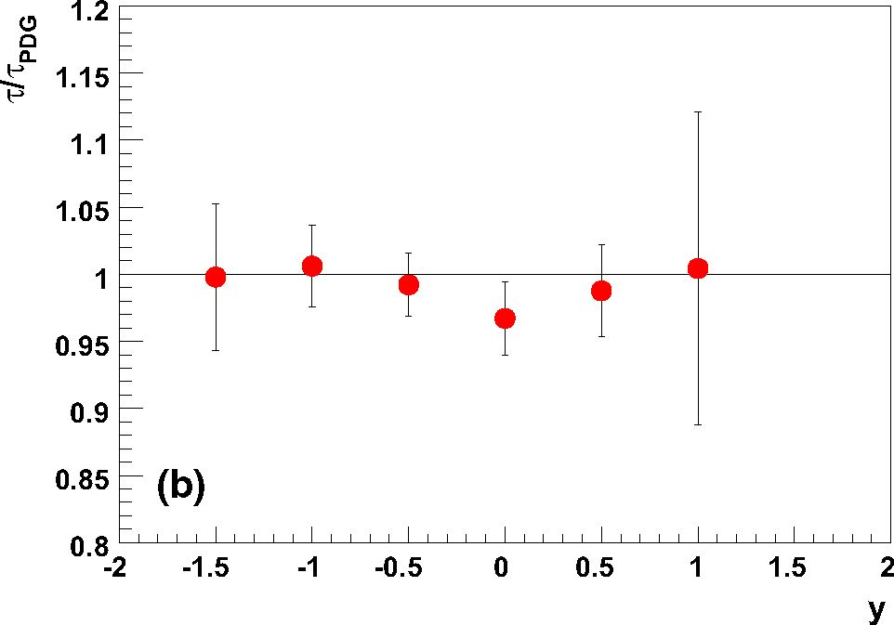
Eur. Phys. J. C (2016) 76:198
Page 9 of 18 198
Minimal Az (cm) allowed
ymin | ymax | Standard | A | B
—1.75 | 0.25 | 10 | 7.5 | 12.5
0.25 | 0.75 | 15 | 11.25 | 18.75
0.75 | 1.25 | 40 | 30 | 50
- The limits for the cut on cos $ were changed from
the standard values to the values shown in columns
A and B in the following table:
Maximal | cos $| allowed
ymin | ymax | Standard | A | B
—1.75 | —0.25 | 0.95 | 0.975 | 0.925
—0.25 | 0.75 | 0.9 | 0.95 | 0.85
0.75 | 1.25 | 0.8 | 0.85 | 0.75
- In order to find the systematic uncertainty of the nor-
malisation factor B in Eq. (3) for the LH removed con-
figuration, the limits of the region for which this param-
eter was calculated was varied in steps of 0.1 m. For
each combination of the lower limit (ranging from 0.8
to 1.8 m from the target) and upper limit in z (from 2.8
to 3.8 m from the target) the B-factor was calculated.
The smallest and the highest value of B obtained in this
way is taken as the systematic uncertainty range of B.
- For estimation of the uncertainty due to the feed-down
correction a conservative systematic uncertainty of 30 %
on the S — and s0 yields predicted by Epos1.99 was
assumed.
The systematic uncertainties are shown in the figures as
light blue shaded bars. They are asymmetric (larger down-
ward) mainly due to the differences between the results with
or without track matching and the change of the background
function to a Chebyshev polynomial of 3rd order. For both
changes the shift of the results increases with rapidity.
The distribution of the proper life-time of A hyperons was
obtained using an analysis procedure analogous to the one
presented in Sec. 4. The data for the lifetime analysis were
binned in rapidity k = y (from —1.5 to +1.0, in steps of 0.5)
and life-time normalised to the mean lifetime t/tpdg [18]
(from 0.00 to 4.75, in steps of 0.25) with ctpdg = 7.89 cm.
The life-time was calculated using the distance r between
the V0-decay vertex and the interaction vertex of the V0-
candidates (t = r/(yP), where y, P are the Lorentz vari-
ables). Then d2n/(dydt) was calculated and an exponential
function was fitted to the life-time distribution for each rapid-
ity bin separately (see the example in Fig. 10afor y = —1.0).
The ratio of the fitted mean life-time t to the corresponding
PDG value tPDF is shown in Fig. 10b as a function of rapid-
ity. The fitted mean life-times are seen to agree with the PDG
Fig. 10 Top an example of the corrected proper life-time distribution
for A hyperons produced in inelastic p+p interactions at 158GeV/c in
the rapidity interval y = —1.0 ± 0.25. Bottom the ratio of the fitted
mean life-time to its PDG [18] value as a function of rapidity
value for all rapidities indicating good accuracy of the cor-
rection procedure.
The expected forward-backward symmetry of the data was
also checked. The final double- and single-differential distri-
butions used for this test were found to agree for the corre-
sponding backward and forward rapidities within the statis-
tical errors.
In addition, the stability of results in different periods dur-
ing the data taking was investigated. For that purpose, the
data set was divided into two subsets, containing runs from
the first and the second half of the data taking period. These
subsets were analysed separately and the results are found to
be consistent.
4 Results
- Formalism
The double-differential yields of A hyperons in inelastic p+p
interactions at 158 GeV/c were calculated in kinematic (k, l)
bins (with k = y or xF, and l = pT or mT — mA) using
1 n
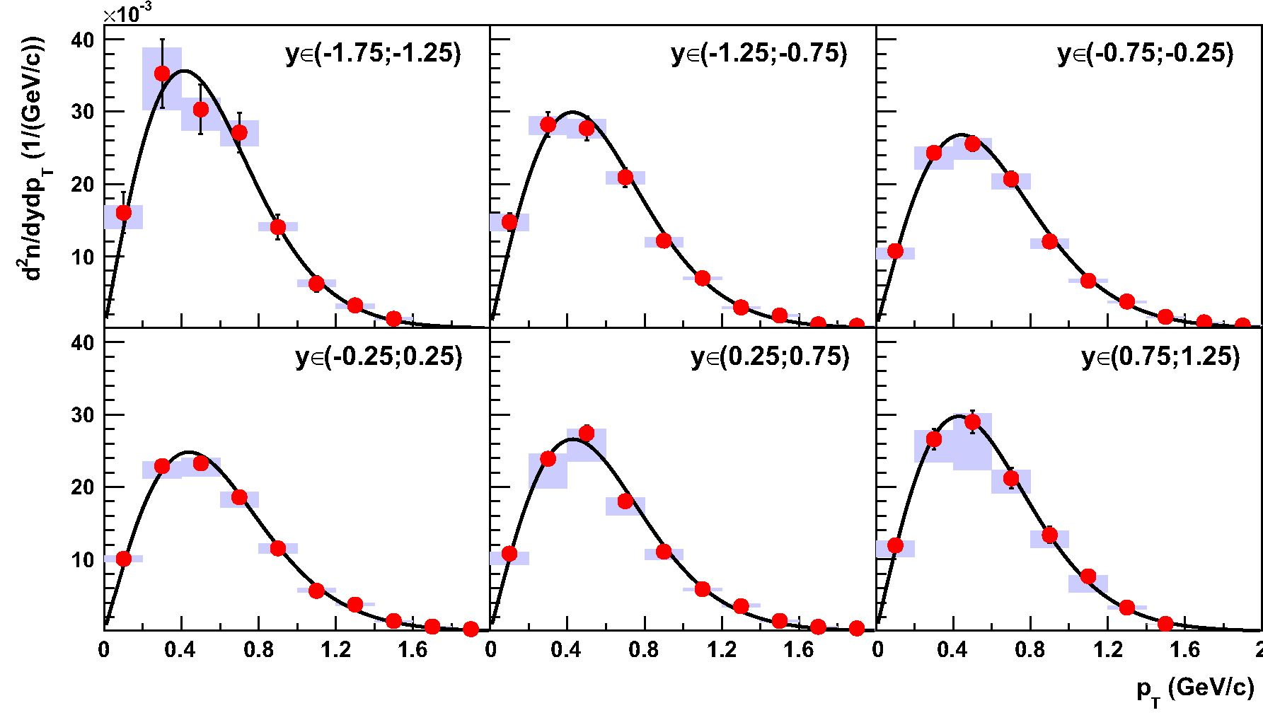
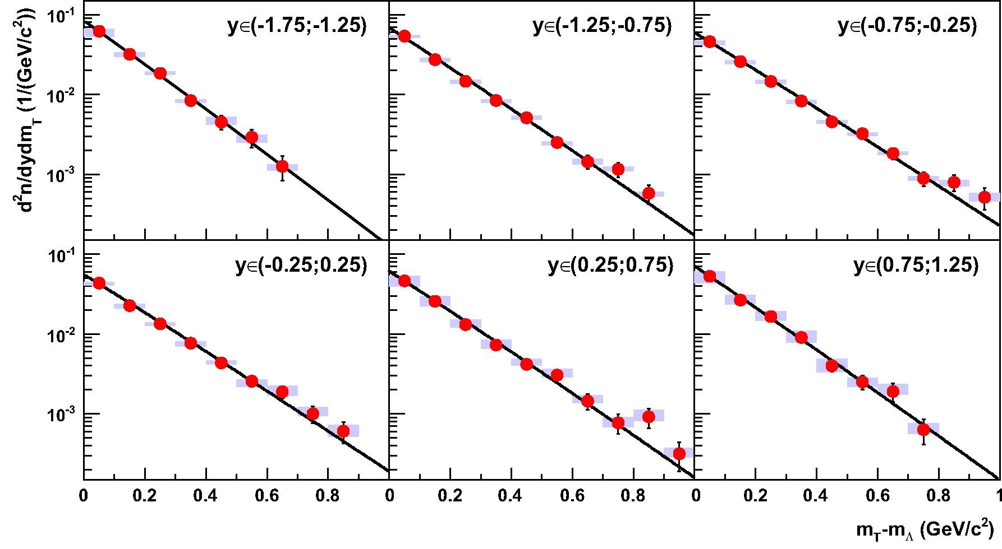
198 Page 10 of 18
Eur.Phys. J.C(2016) 76:198
Fig. 12 Spectra d^dm for six bins in rapidity y. The fitted function is given by Eq. (12). The numerical data are listed in Table 2 and the mean
transverse mass (mT) — mA for each of the bins in Table 5
1 n
Fig. 11 Spectra for six bins in rapidity y. The fitted function is given by Eq. (12). The numerical data are listed in the Table 1 and the fitted
inverse slope parameter for each of the bins in Table 5
Eq. (10). The following spectra are presented: dyJp-, dfdm ,
dXFdP and f (XF ' Pt ),where
2 E * d2 n 1 E * d2n
fn (xF, Pt ) = —T -—-r~2 =—r — 1—T~ ■ (11)
n^/s dxFdp2 Pt dxFdpT
E* is the energy of the A hyperon in the centre of mass
system. The weighting factor, E*/pT, was calculated at the
centre of each (xF, pT) bin and is consistent with the average
value (E*/pT) obtained using the EPOS generator.
Single-differential dn distributions are obtained by sum-
ming the double-differential yields for a given k over l. In
order to estimate the yield in the unmeasured high pT range,
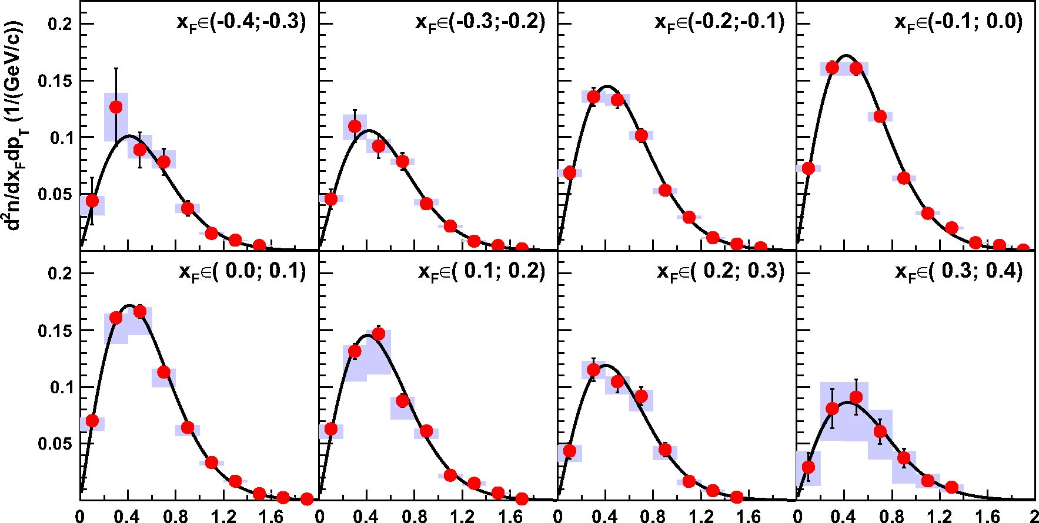
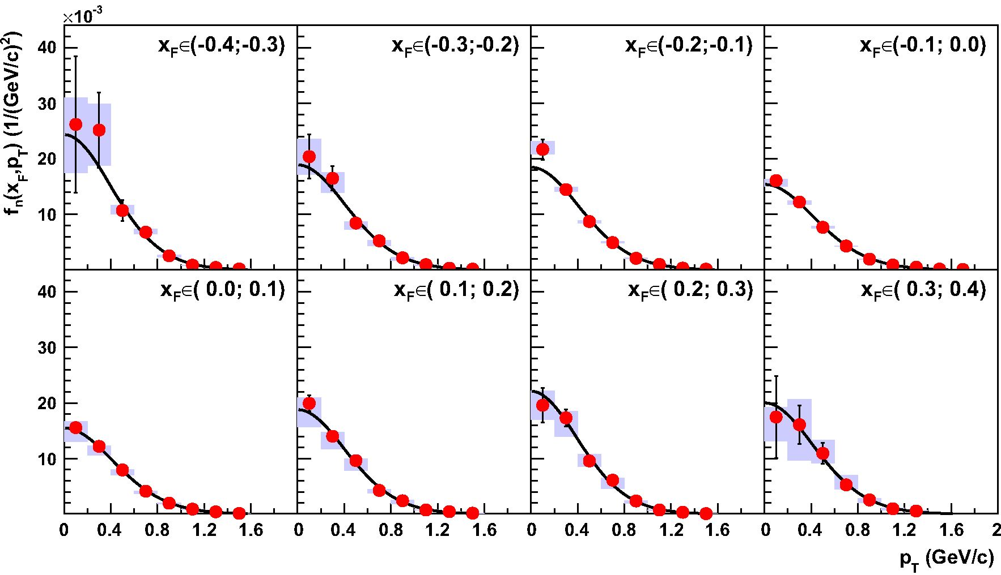
Eur. Phys. J. C (2016) 76:198
Page 11 of 18 198
Fig. 14 Spectra fn for eight bins in xF. The fitted function was obtained from Eq. (12) by multiplying the right-hand side by pT. The numerical
data are listed in Table 3 for xF > 0 and in Table 4 for xF < 0
1 Springer
Fig. 13 Spectra dxd dip for eight bins in xF. The fitted function is given by Eq. (12). The numerical data are listed in Table 3 for xF > 0 and in
Table 4 for xF > 0 F T
the function
1 d2n 1 d2n mT
u — — — Ae-— (12)
pT dkdpT mT dkdmT
was fitted to the data and integrated beyond the measured pT,
where A denotes the normalisation factor and T the inverse
slope parameter. Single-differential invariant yields Fn (xF)
were obtained by performing an integration of Eq. (11) with
respect to p^:
2 2 d2n
Fn(xF) — ) fn(xF, pT)dp, — n-rsjE d~dr/p"
0 0
(13)
198 Page 12 of 18
Eur. Phys. J. C (2016) 76:198
Table 1 Double-differential yield ,d\n
J dydpT
y | PT | d2n | Astat  ( 1 1 | A—ys | A+  sys
y | PT | dydpT  x103 | Astat  ( 1 1 | A—ys | A+  sys
y | PT | dydpT  x103 | \GeV/c ) | A—ys | A+  sys
-1.5 | 0.1 | 16.0 | 2.8 | 2.2 | 1.0
 | 0.3 | 35.3 | 4.8 | 5.0 | 3.5
 | 0.5 | 30.3 | 3.4 | 2.9 | 1.6
 | 0.7 | 27.1 | 2.7 | 1.9 | 1.7
 | 0.9 | 14.0 | 1.7 | 0.5 | 0.7
 | 1.1 | 6.2 | 1.1 | 0.4 | 0.5
 | 1.3 | 3.22 | 0.71 | 0.44 | 0.19
 | 1.5 | 1.36 | 0.45 | 0.18 | 0.22
-1.0 | 0.1 | 14.7 | 1.2 | 1.3 | 1.1
 | 0.3 | 28.2 | 1.7 | 1.4 | 1.1
 | 0.5 | 27.7 | 1.7 | 1.4 | 1.2
 | 0.7 | 20.9 | 1.3 | 0.9 | 0.8
 | 0.9 | 12.16 | 0.89 | 0.89 | 0.46
 | 1.1 | 6.96 | 0.64 | 0.26 | 0.22
 | 1.3 | 2.93 | 0.39 | 0.15 | 0.12
 | 1.5 | 1.80 | 0.30 | 0.12 | 0.13
 | 1.7 | 0.59 | 0.16 | 0.04 | 0.04
 | 1.9 | 0.38 | 0.14 | 0.04 | 0.02
-0.5 | 0.1 | 10.74 | 0.59 | 1.11 | 0.37
 | 0.3 | 24.31 | 0.95 | 2.34 | 0.85
 | 0.5 | 25.5 | 1.0 | 2.2 | 0.8
 | 0.7 | 20.68 | 1.00 | 1.41 | 0.72
 | 0.9 | 12.05 | 0.77 | 0.96 | 0.42
 | 1.1 | 6.61 | 0.55 | 0.28 | 0.23
 | 1.3 | 3.74 | 0.41 | 0.18 | 0.13
 | 1.5 | 1.62 | 0.25 | 0.12 | 0.09
 | 1.7 | 0.87 | 0.19 | 0.07 | 0.05
 | 1.9 | 0.42 | 0.14 | 0.06 | 0.06
0.0 | 0.1 | 10.06 | 0.56 | 0.47 | 0.42
 | 0.3 | 22.89 | 0.87 | 1.75 | 0.61
 | 0.5 | 23.26 | 0.91 | 1.83 | 0.73
 | 0.7 | 18.58 | 0.89 | 1.44 | 0.75
 | 0.9 | 11.50 | 0.78 | 0.66 | 0.63
 | 1.1 | 5.63 | 0.59 | 0.20 | 0.33
 | 1.3 | 3.74 | 0.49 | 0.22 | 0.22
 | 1.5 | 1.45 | 0.27 | 0.09 | 0.08
 | 1.7 | 0.69 | 0.20 | 0.05 | 0.04
 | 1.9 | 0.34 | 0.11 | 0.06 | 0.08
0.5 | 0.1 | 10.79 | 0.63 | 1.55 | 0.24
 | 0.3 | 23.89 | 0.95 | 4.07 | 0.66
 | 0.5 | 27.4 | 1.0 | 3.9 | 0.6
 | 0.7 | 18.03 | 0.88 | 1.94 | 0.51
 | 0.9 | 11.04 | 0.78 | 1.13 | 0.36
 | 1.1 | 5.87 | 0.57 | 0.27 | 0.15
 | 1.3 | 3.50 | 0.49 | 0.14 | 0.34
Table 1 continued
y | PT | (-i CD  2  X | Astat  i^GeV/c) | A—ys | A+  sys
 | 1.5 | 1.47 | 0.30 | 0.14 | 0.15
 | 1.7 | 0.65 | 0.21 | 0.09 | 0.05
 | 1.9 | 0.45 | 0.14 | 0.46 | 0.01
1.0 | 0 1 | 11.91 | 0.91 | 1.55 | 0.68
 | 0.3 | 26.6 | 1.4 | 3.2 | 1.2
 | 0.5 | 29.0 | 1.5 | 6.6 | 1.2
 | 0.7 | 21.2 | 1.4 | 2.1 | 1.1
 | 0.9 | 13.4 | 1.1 | 1.7 | 0.6
 | 11 | 7.65 | 0.80 | 2.26 | 0.11
 | 1.3 | 3.32 | 0.56 | 0.20 | 0.29
 | 1.5 | 1.06 | 0.28 | 0.00 | 0.00
1 Springer
y | mT —  mA | d2n | Astat  ( 1 1 | A—ys | A+ys
y | mT —  mA | dydmT  x103 | Astat  ( 1 1 | A—ys | A+ys
y | mT —  mA | dydmT  x103 | \GeV/c2 ) | A—ys | A+ys
-1.5 | 0.05 | 62.0 | 6.2 | 8.8 | 4.5
 | 0.15 | 31.9 | 3.2 | 2.3 | 1.5
 | 0.25 | 18.5 | 2.1 | 0.8 | 1.1
 | 0.35 | 8.4 | 1.3 | 0.5 | 0.3
 | 0.45 | 4.51 | 0.92 | 0.30 | 0.72
 | 0.55 | 2.91 | 0.73 | 0.43 | 0.21
 | 0.65 | 1.26 | 0.43 | 0.15 | 0.08
-1.0 | 0.05 | 53.8 | 2.5 | 2.4 | 1.7
 | 0.15 | 27.3 | 1.6 | 1.5 | 1.1
 | 0.25 | 14.6 | 1.0 | 0.9 | 0.7
 | 0.35 | 8.40 | 0.72 | 0.48 | 0.31
 | 0.45 | 5.10 | 0.54 | 0.25 | 0.34
 | 0.55 | 2.50 | 0.36 | 0.19 | 0.08
 | 0.65 | 1.44 | 0.28 | 0.11 | 0.14
 | 0.75 | 1.16 | 0.24 | 0.06 | 0.08
 | 0.85 | 0.58 | 0.16 | 0.05 | 0.03
-0.5 | 0.05 | 45.9 | 1.4 | 4.3 | 1.5
 | 0.15 | 25.9 | 1.1 | 1.7 | 0.8
 | 0.25 | 14.56 | 0.86 | 1.04 | 0.61
 | 0.35 | 8.28 | 0.63 | 0.63 | 0.29
 | 0.45 | 4.54 | 0.45 | 0.21 | 0.23
 | 0.55 | 3.23 | 0.38 | 0.19 | 0.10
 | 0.65 | 1.83 | 0.28 | 0.07 | 0.10
 | 0.75 | 0.89 | 0.18 | 0.05 | 0.06
 | 0.85 | 0.79 | 0.19 | 0.09 | 0.06
 | 0.95 | 0.51 | 0.16 | 0.06 | 0.07
0.0 | 0.05 | 43.4 | 1.3 | 3.0 | 1.3
 | 0.15 | 22.63 | 0.93 | 1.82 | 1.19
Table 2 Double-differential yield ,dln
J dydmj
Eur. Phys. J. C (2016) 76:198
Page 13 of 18 198
Table 2 continued
y | mT -  mA | d2n | Astat  ( 1 1 | A-ys | A+  ^sys
y | mT -  mA | dydmT  x103 | Astat  ( 1 1 | A-ys | A+  ^sys
y | mT -  mA | dydmT  x103 | \ GeV/c2 J | A-ys | A+  ^sys
 | 0.25 | 13.38 | 0.79 | 0.66 | 0.48
 | 0.35 | 7.67 | 0.67 | 0.68 | 0.42
 | 0.45 | 4.34 | 0.52 | 0.20 | 0.32
 | 0.55 | 2.56 | 0.39 | 0.39 | 0.14
 | 0.65 | 1.89 | 0.34 | 0.19 | 0.35
 | 0.75 | 1.00 | 0.24 | 0.06 | 0.22
 | 0.85 | 0.61 | 0.18 | 0.09 | 0.11
0.5 | 0.05 | 46.2 | 1.4 | 6.9 | 7.6
 | 0.15 | 25.7 | 1.0 | 3.5 | 4.2
 | 0.25 | 13.10 | 0.79 | 1.12 | 2.15
 | 0.35 | 7.28 | 0.63 | 0.76 | 1.20
 | 0.45 | 4.17 | 0.48 | 0.13 | 0.69
 | 0.55 | 3.05 | 0.43 | 0.17 | 0.60
 | 0.65 | 1.44 | 0.32 | 0.09 | 0.27
 | 0.75 | 0.77 | 0.21 | 0.10 | 0.14
 | 0.85 | 0.92 | 0.25 | 0.11 | 0.21
 | 0.95 | 0.32 | 0.13 | 0.03 | 0.06
1.0 | 0.05 | 52.8 | 2.1 | 9.4 | 8.2
 | 0.15 | 26.6 | 1.5 | 3.0 | 4.3
 | 0.25 | 16.5 | 1.2 | 1.9 | 2.7
 | 0.35 | 9.04 | 0.94 | 1.19 | 1.97
 | 0.45 | 4.00 | 0.61 | 0.67 | 0.88
 | 0.55 | 2.51 | 0.49 | 0.31 | 0.33
 | 0.65 | 1.90 | 0.49 | 0.16 | 0.46
 | 0.75 | 0.63 | 0.22 | 0.08 | 0.13
1 Springer
For the calculation of Fn (xF), the weighting factor E* was
calculated at the centre of each (xF, pT) bin. For the extrap-
olation into the unmeasured high pT region Eq. (12) was
used.
Invariant cross-section is obtained from Fn (xF) by multi-
plying it by the inelastic cross-section ainel:
F (xf ) = OinelFn (xf ). (14)
The mean transverse mass (mT) was calculated from the
function Eq. (12) fitted to the mT distribution as follows:
m , Zc+“ mTU(mT )dmT (15)
\mT ) r+OT / . , ' (15)
J0 u (mT )dmT
- Spectra
Double-differential dydp-, ddT, dSp and fn (xF, Pt )
spectra are shown in Figs. 11,12,13,14. The numerical val-
ues for djspr and dym are presented in Tables 1 and 2,
while invariant and non-invariant xF yields are shown in
Table 3 for xF < 0 and Table 4 for xF > 0.
The values of the pT integrated dy rapidity distribution
are presented in Table 5. The table also contains the values of
the inverse slope parameter T and the mean transverse mass
\mT) - mA as function of rapidity. The single-differential
xF distributions are summarised in Table 6. In Sec. 5 below,
the obtained single-differential distributions are compared
to model predictions and previously published experimental
results.
The mean multiplicity of A hyperons (\A)) was deter-
mined from the xF distribution. As the models applicable
in the SPS energies range show large discrepancies in the
region not measured by NA61/SHINE (see Fig. 20), the A
yield in the unmeasured xF region (|xF| >0.4) was approx-
imated by the straight line shown in Fig. 20. The line is
defined assuming symmetry of the distribution. It crosses
the points A± = (±0.35, ± (ddn(-0.35) + (0.35)))
and B± = (±1, 0). For the estimation of statistical part
of the extrapolation error, the value of the point A was
increased/decreased by 1 (a j-(-0.35) + A j- (0.35)).
The extrapolation amounts to 34.3 % of the total A yield
and results in \A) = 0.120 ± 0.006 (stat.) of the mean A
multiplicity.
For the Epos model, not used for this extrapolation, the
yield outside of NA61/SHINE acceptance to the total yield
amounts to 38.0%.
The systematic uncertainty of the mean multiplicity was
calculated following the procedure described in Sec 3.6.
An additional source of systematic uncertainty arises from
the extrapolation of the A multiplicity to full phase-space.
This was estimated by an alternative procedure based on a
parametrisation of published rapidity distributions. In an iter-
ative procedure a symmetric polynomial of 4th order [22]was
fitted to the (1 /\n))(dn/dz) distributions obtained by five
bubble-chamber experiments [23-27] andtheNA61/SHINE
data, where z stands for y/ybeam. First, the fit included only
the five bubble-chamber datasets. Next, the NA61/SHINE
spectrum was normalised to the fit result obtained in the first
step and added as the 6th set for the fit. Finally, the pro-
cedure was iterated using those six datasets until the nor-
malisation factor converged. The ratio of the integral of the
fitted function A. d. (z) = 0.394 + 1.99z2 - 2.66z4 (see
Fig. 15) for the full range of rapidity to the integral in the
range outside of the NA61/SHINE acceptance was used as
the extrapolation factor for the NA61/SHINE results. This
ratio amounted to 1.92 ± 0.12, i.e. 48 % of the total produc-
tion is outside of the acceptance for this procedure resulting
in a mean multiplicity of \A) = 0.129 ± 0.008. The dif-
ference between this result and the linear extrapolation of
the xF distribution is added in quadrature to the (positive)
systematic error.
198 Page 14 of 18
Eur. Phys. J. C (2016) 76:198
~ d2n |  | A A- |  | A+  sys | fn (xf , pt )  x 103 | Astat  ( 1 1 | A s-ys | As+ys
FT | d^Fd^T  x103 | ^stat  ( 1 1 | L-*sys
FT | d^Fd^T  x103 | \GeV/c ) | L-*sys | A+  sys | fn (xf , pt )  x 103 | \(GeV/c)2J | A s-ys | As+ys
-0.35 0.1 | 44 | 21 | 13 | 4 | 26 | 12 | 9 | 5
0.3 | 127 | 34 | 30 | 12 | 25.2 | 6.8 | 6.4 | 4.7
0.5 | 89 | 15 | 8 | 13 | 10.7 | 1.9 | 0.6 | 1.0
0.7 | 78 | 12 | 6 | 10 | 6.8 | 1.0 | 0.4 | 0.6
0.9 | 37.4 | 6.4 | 3.7 | 4.0 | 2.56 | 0.44 | 0.22 | 0.19
1.1 | 15.4 | 3.4 | 0.8 | 1.0 | 0.88 | 0.19 | 0.06 | 0.04
1.3 | 9.3 | 2.2 | 0.8 | 0.1 | 0.46 | 0.11 | 0.04 | 0.02
1.5 | 4.6 | 1.5 | 0.8 | 0.6 | 0.201 | 0.066 | 0.029 | 0.042
-0.25 0.1 | 45.5 | 8.9 | 2.0 | 3.5 | 20.4 | 4.0 | 3.2 | 3.2
0.3 | 110 | 14 | 11 | 10 | 16.5 | 2.2 | 2.6 | 1.1
0.5 | 92 | 11 | 6 | 6 | 8.44 | 0.98 | 1.14 | 0.32
0.7 | 78.9 | 7.4 | 2.8 | 2.3 | 5.25 | 0.49 | 0.94 | 0.13
0.9 | 41.4 | 4.5 | 1.4 | 3.9 | 2.20 | 0.24 | 0.48 | 0.06
1.1 | 21.8 | 2.8 | 1.0 | 1.0 | 0.97 | 0.13 | 0.17 | 0.04
1.3 | 8.5 | 1.6 | 0.6 | 0.6 | 0.334 | 0.062 | 0.077 | 0.012
1.5 | 4.7 | 1.1 | 0.3 | 0.5 | 0.165 | 0.038 | 0.032 | 0.033
1.7 | 1.71 | 0.58 | 0.13 | 0.17 | 0.055 | 0.019 | 0.008 | 0.005
-0.15 0.1 | 68.7 | 5.8 | 3.7 | 3.0 | 21.7 | 1.8 | 0.9 | 1.5
0.3 | 135.6 | 7.8 | 4.7 | 5.4 | 14.46 | 0.83 | 0.36 | 0.46
0.5 | 132.9 | 7.4 | 5.4 | 4.9 | 8.73 | 0.48 | 0.30 | 0.22
0.7 | 101.6 | 6.0 | 3.4 | 4.0 | 4.94 | 0.29 | 0.10 | 0.19
0.9 | 53.4 | 3.9 | 3.0 | 1.9 | 2.11 | 0.15 | 0.09 | 0.05
1.1 | 29.6 | 2.7 | 1.2 | 1.3 | 1.008 | 0.092 | 0.033 | 0.039
1.3 | 11.6 | 1.6 | 0.6 | 0.5 | 0.352 | 0.049 | 0.014 | 0.011
1.5 | 5.9 | 1.1 | 0.6 | 0.4 | 0.165 | 0.030 | 0.016 | 0.015
1.7 | 2.64 | 0.73 | 0.20 | 0.11 | 0.069 | 0.019 | 0.005 | 0.002
-0.05 0.1 | 72.7 | 3.4 | 2.8 | 2.5 | 16.08 | 0.75 | 1.05 | 0.26
0.3 | 161.4 | 5.4 | 6.9 | 4.5 | 12.23 | 0.41 | 0.43 | 0.26
0.5 | 160.8 | 5.6 | 6.3 | 5.4 | 7.68 | 0.27 | 0.23 | 0.24
0.7 | 118.5 | 5.2 | 4.4 | 3.5 | 4.33 | 0.19 | 0.11 | 0.07
0.9 | 64.1 | 4.0 | 2.6 | 2.2 | 1.97 | 0.12 | 0.06 | 0.05
1.1 | 33.0 | 2.9 | 1.2 | 1.5 | 0.899 | 0.078 | 0.024 | 0.036
1.3 | 20.2 | 2.3 | 1.4 | 1.0 | 0.506 | 0.059 | 0.031 | 0.036
1.5 | 7.2 | 1.2 | 0.5 | 0.4 | 0.169 | 0.029 | 0.016 | 0.008
1.7 | 4.8 | 1.2 | 0.3 | 0.3 | 0.108 | 0.027 | 0.010 | 0.006
1.9 | 0.55 | 0.32 | 0.07 | 0.06 | 0.0120 | 0.0070 | 0.0016 | 0.0032
The final result for the A multiplicity in inelastic p+p
interactions at 158 GeV/c then reads as follows:
(A) = 0.120 ± 0.006 (stat.) ± 0.010 (sys.)
5 Comparison with world data and model predictions
The single-differential spectra from NA61/SHINE are com-
pared in Fig. 15 to results from five bubble-chamber exper-
iments which measured p+p interactions at beam momenta
close to 158GeV/c. The experiments published data for the
backward hemisphere, however, with rather small statis-
tics [23-27] and correspondingly large uncertainties. In order
to account for the difference in beam momentum the spec-
tra are shown in terms of the scaled rapidity z = y/ybeam
and were normalised to unity in order to compare the
shapes. Note, that the same data sets were also used to
compute the alternative correction factor used to estimate
1 Springer
Table 3 Double-differential yields, d n and fn(xF, pt), for xF < 0
x F pT F F
Eur. Phys. J. C (2016) 76:198
Page 15 of 18 198
xF | Pt | d2n  dxFdpj  x 103 | Astat  ( 1 1 | A-ys |  | A+  sys | fn (Xf , Pt )  vin3 |  | Astat  1 | 1 | A s-ys | A+  sys
 |  | d2n  dxFdpj  x 103 | \GeV/c ) |  |  |  |  |  | \(GeV/c)2}
0.05 | 0.1 | 70.3 | 3.5 | 8.9 |  | 2.7 | 15.56 |  | 0.77 |  | 2.49 | 1.11
 | 0.3 | 160.9 | 5.4 | 22.8 |  | 3.7 | 12.20 |  | 0.41 |  | 1.59 | 0.15
 | 0.5 | 166.4 | 5.6 | 20.8 |  | 4.0 | 7.95 |  | 0.27 |  | 0.97 | 0.09
 | 0.7 | 113.1 | 4.9 | 13.3 |  | 2.9 | 4.13 |  | 0.18 |  | 0.45 | 0.08
 | 0.9 | 64.4 | 4.2 | 7.4 |  | 1.7 | 1.97 |  | 0.13 |  | 0.16 | 0.04
 | 1.1 | 33.5 | 3.2 | 2.5 |  | 1.0 | 0.913 |  | 0.086 |  | 0.065 | 0.028
 | 1.3 | 17.0 | 2.3 | 1.1 |  | 0.8 | 0.426 |  | 0.058 |  | 0.035 | 0.017
 | 1.5 | 6.0 | 1.3 | 0.2 |  | 0.4 | 0.141 |  | 0.030 |  | 0.004 | 0.009
 | 1.7 | 2.56 | 0.82 | 0.33 |  | 0.14 | 0.058 |  | 0.018 |  | 0.007 | 0.003
 | 1.9 | 1.19 | 0.51 | 0.21 |  | 0.23 | 0.026 |  | 0.011 |  | 0.005 | 0.006
0.15 | 0.1 | 63.1 | 4.5 | 8.5 |  | 3.4 | 19.9 |  | 1.4 |  | 4.3 | 1.0
 | 0.3 | 131.5 | 6.6 | 26.7 |  | 5.1 | 14.02 |  | 0.70 |  | 2.28 | 0.71
 | 0.5 | 146.8 | 7.0 | 35.4 |  | 3.5 | 9.64 |  | 0.46 |  | 1.79 | 0.35
 | 0.7 | 87.8 | 5.7 | 16.2 |  | 3.4 | 4.27 |  | 0.28 |  | 0.54 | 0.19
 | 0.9 | 61.2 | 4.7 | 6.7 |  | 1.8 | 2.42 |  | 0.19 |  | 0.62 | 0.09
 | 1.1 | 22.3 | 2.7 | 2.4 |  | 1.1 | 0.758 |  | 0.091 |  | 0.077 | 0.039
 | 1.3 | 15.1 | 2.5 | 2.2 |  | 1.3 | 0.460 |  | 0.077 |  | 0.039 | 0.043
 | 1.5 | 6.6 | 1.4 | 1.0 |  | 0.4 | 0.185 |  | 0.039 |  | 0.032 | 0.012
 | 1.7 | 1.39 | 0.63 | 0.14 |  | 0.29 | 0.036 |  | 0.017 |  | 0.007 | 0.007
0.25 | 0.1 | 43.7 | 7.0 | 9.4 |  | 5.2 | 19.6 |  | 3.1 |  | 2.6 | 2.6
 | 0.3 | 115 | 10 | 8 |  | 8 | 17.3 |  | 1.5 |  | 3.4 | 1.2
 | 0.5 | 104.7 | 9.4 | 11.1 |  | 4.7 | 9.57 |  | 0.86 |  | 1 .00 | 1 . 20
 | 0.7 | 91.9 | 8.2 | 13.4 |  | 5.4 | 6.12 |  | 0.55 |  | 1.58 | 0.41
 | 0.9 | 44.7 | 5.8 | 8.9 |  | 2.7 | 2.37 |  | 0.31 |  | 0.46 | 0.09
 | 1.1 | 16.8 | 3.3 | 3.5 |  | 1.5 | 0.75 |  | 0.15 |  | 0.17 | 0.05
 | 1.3 | 8.7 | 2.1 | 0.7 |  | 0.8 | 0.341 |  | 0.082 |  | 0.039 | 0.045
 | 1.5 | 2.9 | 1.1 | 0.4 |  | 0.4 | 0.102 |  | 0.037 |  | 0.015 | 0.010
0.35 | 0.1 | 29 | 12 | 16 |  | 14 | 17.5 |  | 7.4 |  | 4.3 | 1.7
 | 0.3 | 81 | 17 | 28 |  | 23 | 16.1 |  | 3.4 |  | 6.4 | 4.6
 | 0.5 | 91 | 16 | 39 |  | 13 | 10.9 |  | 1.9 |  | 1.8 | 2.4
 | 0.7 | 61 | 11 | 25 |  | 19 | 5.28 |  | 0.95 |  | 0.81 | 1.79
 | 0.9 | 37.4 | 8.2 | 22.3 |  | 6.0 | 2.56 |  | 0.56 |  | 0.48 | 0.26
 | 1.1 | 17.3 | 5.1 | 6.3 |  | 6.0 | 0.99 |  | 0.29 |  | 0.29 | 0.13
 | 1.3 | 11.7 | 3.6 | 4.3 |  | 2.6 | 0.57 |  | 0.18 |  | 0.18 | 0.14
1 Springer
Table 4 Double-differential yields, d n and fn(xF, pj), for xF > 0
xfPt
y | cn  O  sl ^  Tsh x | Astat | A-ys | A+  sys | T  (MeV) | Astat | A-ys | A+  sys | (mT) —mA  ( GeV \  I c2 ) | Astat | A-ys | A+  sys
— 1.5 | 26.8 | 1.5 | 2.4 | 1.4 | 143.8 | 6.3 | 5.4 | 3.3 | 0.156 | 0.013 | 0.005 | 0.006
— 1.0 | 23.30 | 0.65 | 1 .02 | 0.73 | 152.8 | 3.8 | 4.2 | 4.1 | 0.1687 | 0.0076 | 0.0050 | 0.0046
-0.5 | 21.35 | 0.43 | 1.71 | 0.64 | 163.0 | 3.2 | 4.5 | 5.1 | 0.1813 | 0.0067 | 0.0050 | 0.0056
0.0 | 19.65 | 0.40 | 1.14 | 0.60 | 160.7 | 3.6 | 4.3 | 5.2 | 0.1777 | 0.0076 | 0.0051 | 0.0068
0.5 | 20.64 | 0.42 | 2.53 | 0.43 | 154.0 | 3.6 | 3.9 | 8.4 | 0.1697 | 0.0070 | 0.0037 | 0.0102
1.0 | 22.98 | 0.62 | 2.96 | 0.65 | 153.9 | 4.1 | 4.0 | 4.6 | 0.1640 | 0.0085 | 0.0028 | 0.0084
Table 5 pT integrated yield djn, the inverse slope parameter T and the mean transverse mass (mT) — mA
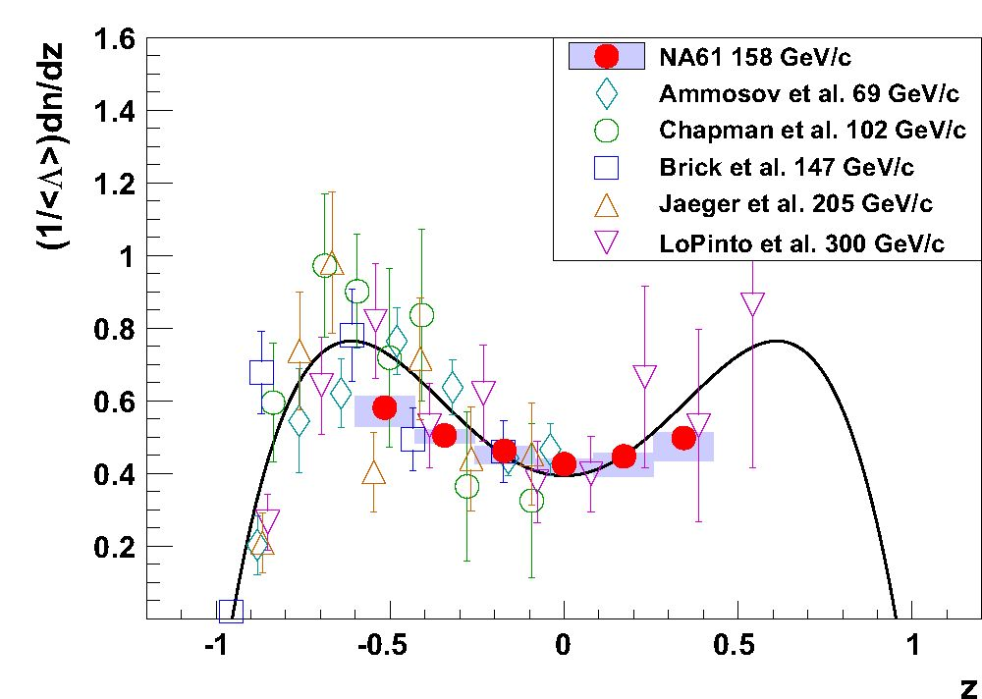
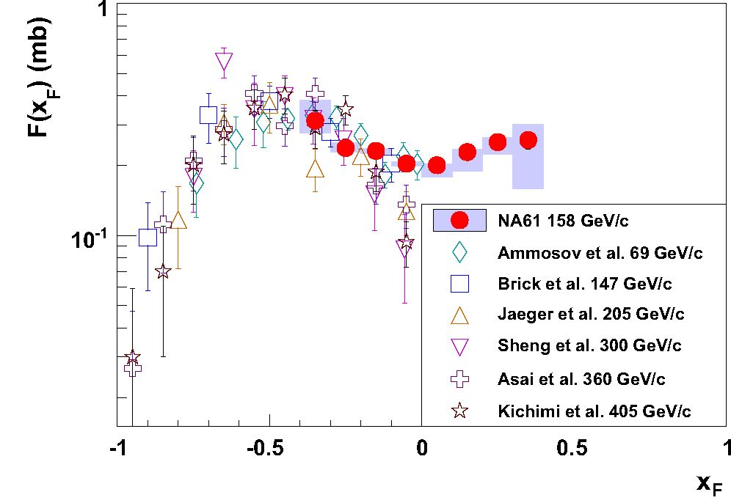
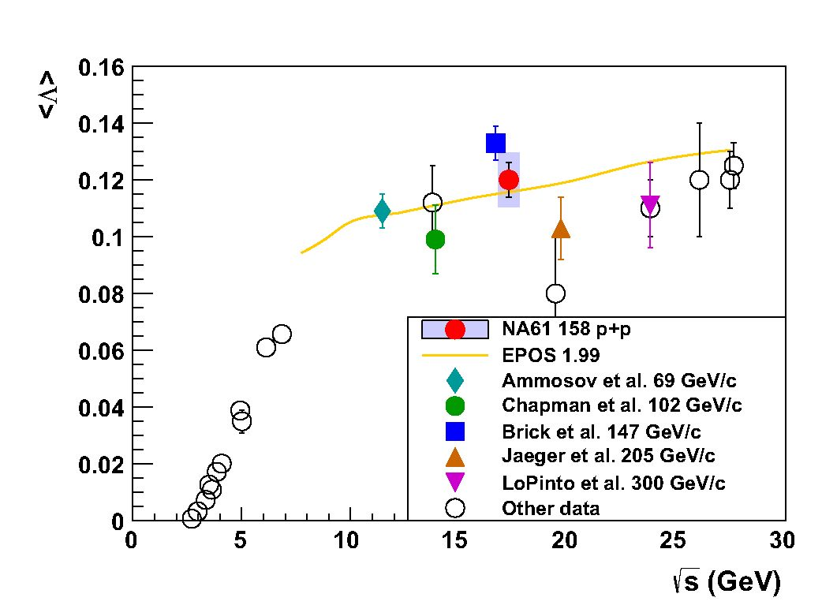
198 Page 16 of 18
Eur. Phys. J. C (2016) 76:198
xf | dn  dxF  x 103 | Astat | Asys | A+ys | F (xf )  x 103 (mb) | Astat | A-ys | A+  sys
-0.35 | 81.3 | 9.0 | 9.3 | 6.5 | 313 | 34 | 36 | 70
-0.25 | 81.1 | 4.4 | 3.9 | 4.7 | 239 | 13 | 10 | 13
-0.15 | 108.6 | 2.9 | 3.9 | 3.5 | 231.6 | 6.1 | 5.9 | 4.9
-0.05 | 128.7 | 2.3 | 4.7 | 3.7 | 204.1 | 3.7 | 5.2 | 4.5
0.05 | 127.2 | 2.3 | 14.4 | 3.0 | 200.9 | 3.7 | 22.3 | 2.2
0.15 | 107.3 | 2.7 | 18.5 | 3.0 | 228.9 | 5.8 | 39.2 | 6.7
0.25 | 86.0 | 3.8 | 9.8 | 4.0 | 253 | 11 | 29 | 12
0.35 | 67.0 | 6.1 | 25.8 | 11.6 | 258 | 23 | 99 | 45
Fig. 15 The scaled A yield as function of scaled rapidity z — y /ybeam
in inelastic p+p interactions measured by NA61/SHINE and selected
bubble-chamber experiments [23-27]. The symmetric polynomial of
4th order used for estimation of the systematic uncertainty of A mean
multiplicity (see Sec. 4.2) is plotted to guide the eye
the systematic uncertainty of (A) (see Sec. 4) obtained by
NA61/SHINE.
Though the statistical error and the systematic uncertainty
of the NA61/SHINE measurement is much smaller than for
the other experiments, and the results are consistent with all
the datasets used for the comparison, the general tendency
obtained by fitting a symmetric polynomial of 4th order does
not describe well the NA61/SHINE data. On the other hand,
the result of Brick et al. for which the beam momentum
(147 GeV/c) differs the least from the NA61/SHINE momen-
tum, shows the best agreement.
The mean multiplicity of A for 158GeV/c inelastic p+p
interactions is compared in Fig. 16 with the world data [28]
as well as with predictions of the Epos1.99 model in its valid-
ity range. A steep rise in the threshold region is followed by
a more gentle increase at higher energies that is well repro-
duced by the Epos1.99 model.
The dependence of the invariant spectrum on xF for
NA61/SHINE and published results from bubble chamber
1 Springer
Fig. 17 Comparison of the invariant xf spectra (see Eq. (14), Oined =
3T8 mb [18]) from the NA61/SHINE with the data from bubble-
chamber experiments at beam momenta close to 158GeV/c [23,25,26,
29-31]. The NA61/SHINE data points are indicated by filled circles.
The systematic uncertainty is shown as a band around the points
Fig. 16 Collision energy dependence of mean multiplicity of A hyper-
ons produced in inelastic p+p interactions. Full symbols indicate bubble
chamber results [23-27], the solid red dot shows the NA61/SHINE
result. Open symbols depict the remaining world data [28]. The
Epos1.99 [19] prediction is shown by the curve. The systematic uncer-
tainty of the NA61/SHINE result is indicated by the shaded bar
Table 6 pT integrated yield —
1 xf
and the invariant cross section
F (xf )
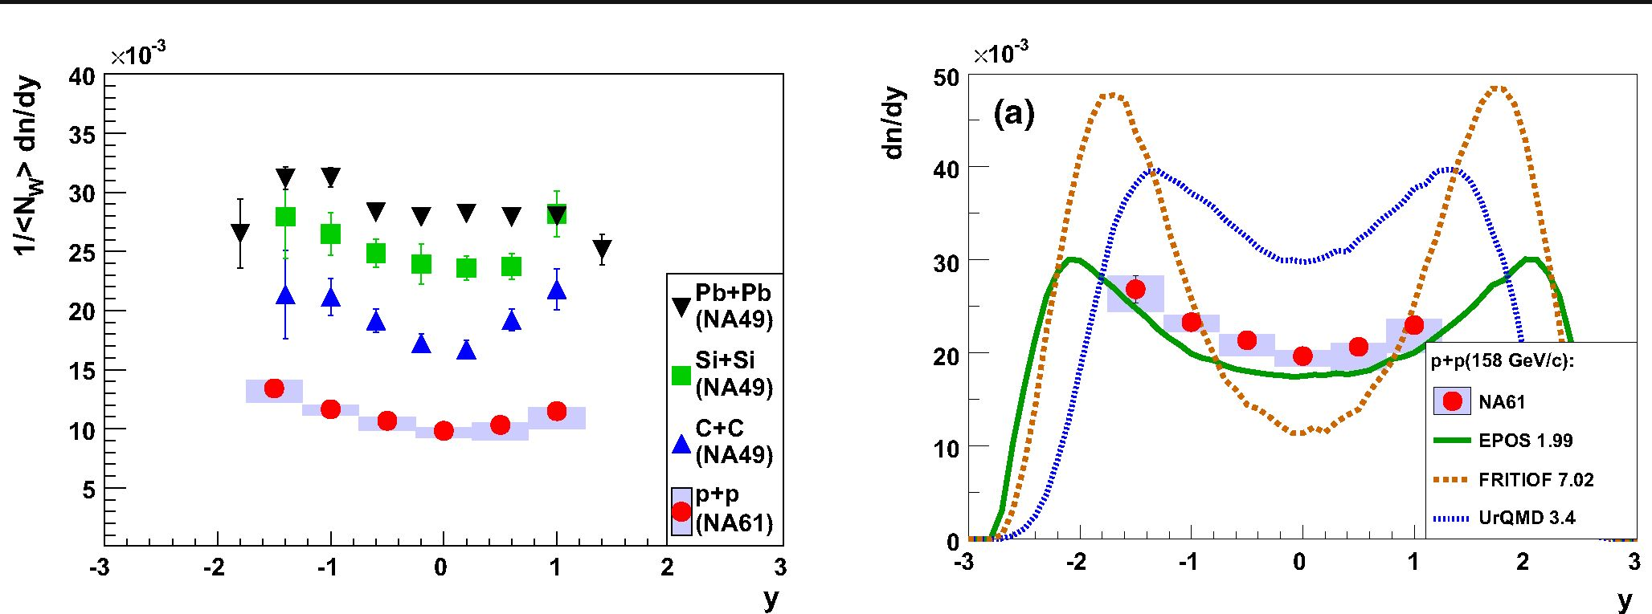
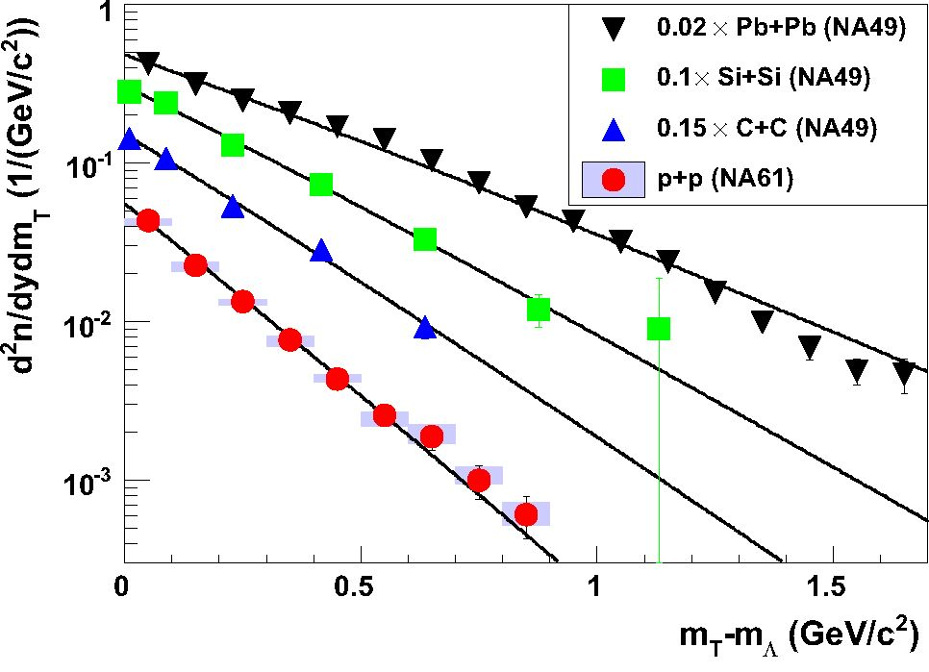
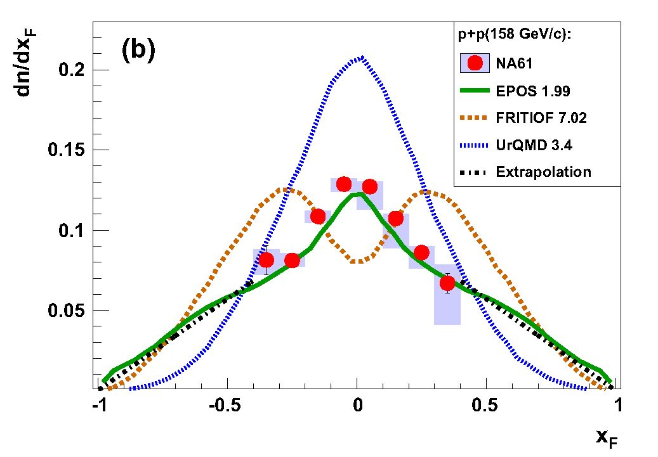
Eur. Phys. J. C (2016) 76:198
Page 17 of 18 198
Fig. 18 Rapidity spectra of A hyperons divided by the mean number
of wounded nucleons in inelastic p+p interactions (NA61/SHINE) and
central C+C, Si+Si [32], and Pb+Pb [33] collisions at 158 A GeV/c
Fig. 19 Spectra of mT at mid-rapidity (|y| < 0.4 for A+A, |y| <
0.25 for p+p) from NA61/SHINE inelastic p+p interactions and central
C+C, Si+Si [32], and Pb+Pb [33] collisions for beam momentum of
158 A GeV/c. The lines are fitted using Eq. (12)
experiments [23,25,26,29-31] at nearby beam momenta is
shown in Fig. 17. The NA61/SHINE results are consistent
with the experiments performed at proton beams of lower
energy, although the dip-like structure visible at central xF
in the data from the experiments operating at higher energies
is not observed.
Figure 18 shows a comparison of rapidity spectra divided
by the mean number of wounded nucleons 1 /(NW) in inelas-
tic p+p interactions (this paper) and central C+C, Si+Si and
Pb+Pb collisions (NA49 [32,33]) at 158 A GeV/c. The yield
of A hyperons per wounded nucleon increases with increas-
ing (NW) as a consequence of strangeness enhancement in
nucleus-nucleus collisions.
Figure 19 displays mT spectra at mid-rapidity for inelas-
tic p+p interactions (this paper) and central nucleus-nucleus
Fig. 20 Comparison of dy (a), and -d~ (b) distributions with calcu-
lations of the Epos [19], UrQMD [34,35] and Fritiof [36] models. The
chain line was used to extrapolate the NA61/SHINE measurements to
full phase space. For details see text
collisions (NA49 [32,33]) at 158 A GeV/c. The inverse slope
parameter of the spectrum increases with increasing nuclear
size due to increasing transverse flow.
A comparison with calculations from the models
Epos1.99 [19], UrQMD3.4 [34,35], and Fritiof7.02 [36]
embedded in Hsd2.0 [37] is presented in Fig. 20.
The best agreement is found for the Epos1.99 model.
6 Summary
Inclusive production of A-hyperons was measured with the
large acceptance NA61/SHINE spectrometer at the CERN
SPS in inelastic p+p interactions at beam momentum of
158 GeV/c. Spectra of transverse momentum (up to 2 GeV/c)
and transverse mass as well as distributions of rapidity (from
-1.75 to 1.25) and xF (from -0.4 to 0.4) are presented. The
mean multiplicity was found to be 0.120 ± 0.006 (stat.) ±
1 Springer
198 Page 18 of 18
Eur. Phys. J. C (2016) 76:198
0.010 (sys.). The new results are in reasonable agreement
with measurements from bubble-chamber experiments at
nearby beam momenta, but have much smaller uncertainties.
Predictions of the Epos, UrQMD and Fritiof models were
compared to the new NA61/SHINE measurements reported
in this paper. While Epos describes the data quite well,
significant discrepancies are observed with the latter two
models.
The results expand our knowledge of elementary proton-
proton interactions, allowing for a more precise description of
strangeness production. They are expected to be used not only
as an important input in the research of strongly interacting
matter, but also as an input for tuning MC-generators, includ-
ing those used for cosmic-ray shower and neutrino beams
simulations.
Acknowledgments This work was supported by the Hungarian Sci-
entific Research Fund (Grants OTKA 68506 and 71989), the Janos
Bolyai Research Scholarship of the Hungarian Academy of Sci-
ences, the Polish Ministry of Science and Higher Education (Grants
667/N-CERN/2010/0, NN202484339 and NN202231837), the Pol-
ish National Science Centre (Grants 2011/03/N/ ST2/03691, 2012/04/
M/ ST2/00816 and 2013/11/ N/ ST2/03879), the Foundation for Polish
Science—MPD program, co-financed by the European Union within the
European Regional Development Fund, the Federal Agency of Educa-
tion of the Ministry of Education and Science of the Russian Federa-
tion (SPbSU research Grant 11.38.193.2014), the Russian Academy of
Science and the Russian Foundation for Basic Research (Grants 08-02-
00018, 09-02-00664 and 12-02-91503-CERN), the Ministry of Educa-
tion, Culture, Sports, Science and Technology, Japan, Grant-in-Aid for
Scientific Research (Grants 18071005,19034011,19740162,20740160
and 20039012), the German Research Foundation (Grant GA1480/2-
2), the EU-funded Marie Curie Outgoing Fellowship, Grant PIOF-GA-
2013-624803, the Bulgarian Nuclear Regulatory Agency and the Joint
Institute for Nuclear Research, Dubna (bilateral contract No. 4418-1-
15/17), Ministry of Education and Science of the Republic of Serbia
(Grant OI171002), Swiss Nationalfonds Foundation (Grant 200020-
117913/1) and ETH Research Grant TH-0107-3. Finally, it is a pleasure
to thank the European Organisation for Nuclear Research for strong
support and hospitality and, in particular, the operating crews of the
CERN SPS accelerator and beam lines who made the measurements
possible.
Open Access This article is distributed under the terms of the Creative
Commons Attribution 4.0 International License (http://creativecomm
ons.org/licenses/by/4.0/), which permits unrestricted use, distribution,
and reproduction in any medium, provided you give appropriate credit
to the original author(s) and the source, provide a link to the Creative
Commons license, and indicate if changes were made.
Funded by SCOAP3.
References
- C. Blume, C. Markert, Prog. Part. Nucl. Phys. 66, 834 (2011).
arXiv:1105.2798 [nucl-ex]
- J. Rafelski, B. Muller, Phys. Rev. Lett. 48, 1066 (1982)
- J. Rafelski, B. Muller, Phys. Rev. Lett. 56, 2334 (1986)
- M. Gazdzicki, M. Gorenstein, P. Seyboth, Acta. Phys. Polon. B 42,
307 (2011). arXiv:1006.1765 [hep-ph]
- M. Gazdzicki, P. Seyboth, Acta Phys. Polon. (to appear).
arXiv:1506.08141 [nucl-ex]
- N. Abgrall et al., NA61/SHINE Collaboration. JINST 9, P06005
(2014)
- N. Abgrall et al., NA61/SHINE Collaboration. Phys. Rev. C 84,
034604 (2011)
- N. Abgrall et al., NA61/SHINE Collaboration. Phys. Rev. C 85,
035210 (2012)
- N. Abgrall et al., NA61/SHINE Collaboration. Phys. Rev. C 89,
025205 (2014)
- N. Abgrall et al., NA61/SHINE Collaboration. Eur. Phys. J. C 76,
84 (2016)
- N. Abgrall et al., NA61/SHINE Collaboration. Eur. Phys. J. C 74,
2794(2014)
- C. Boved et al., IEEE Trans. Nucl. Sci. 25, 572 (1977)
- A. Wilczek, Ph. D. Thesis, University of Silesia, Katowice,
Poland (2015)
- T. Yates et al., NA49 Collaboration. J. Phys. G 23, 1889 (1997)
- K. Levenberg, Q. Appl. Math. 2, 164 (1944)
- D. Marquardt, SIAM J. Appl. Math. 11, 431 (1963)
- J. Podolanski, R. Armenteros, Philosphical Magazine Series 7,
45:360, 13 (1953)
- K.A. Olive et al., Particle data group. Chin. Phys. C 38, 090001
(2014)
- K. Werner, F.-M. Liu, T. Pierog, Phys. Rev. C 74, 044902 (2006)
- R. Brun, F. Carminati, GEANT Detector Description and Simula-
tion Tool, CERN Program Library Long Writeup W5013 (1993)
- T. Susa, Nucl. Phys. A 698, 491c (2002)
- M. Gazdzicki, O. Hansen, Nucl. Phys. A 528, 754 (1991)
- V.V. Ammosov et al., Nucl. Phys. B 115, 269 (1976)
- J.W. Chapman et al., Phys. Lett. 47B, 465 (1973)
- D. Brick et al., Nucl. Phys. B 164, 1 (1980)
- K. Jaeger et al., Phys. Rev. D 11, 2405 (1975)
- F. LoPinto et al., Phys. Rev. D 22, 573 (1980)
- M. Gazdzicki, D. Rohrich, Z. Phys. C 71, 55 (1996)
- A. Sheng et al., Phys. Rev D 11, 1733 (1975)
- M. Asai et al., Z. Phys. C 27, 11 (1985)
- H. Kichimi et al., Phys. Rev. D 20, 37 (1979)
- C. Alt et al., NA49 Collaboration. Phys. Rev. Lett. 94, 052301
(2005)
- T. Alt et al., NA49 Collaboration. Phys. Rev. C 78, 034918 (2008)
- S.A. Bass et al., Prog. Part. Nucl. Phys. 41, 225 (1998)
- M. Bleicher et al., J. Phys. G 25, 1859 (1999)
- B. Anderson, G. Gustafson, Hong Pi, Z. Phys. C 57, 485 (1993)
- J. Geiss, W. Cassing, C. Greiner, Nucl. Phys. A 644, 107 (1998)
12n

