Tumor Biol. (2016) 37:15185-15191 /»V
H CrossMark
DOI 10.1007/s 13277-016-5354-x
ORIGINAL ARTICLE

Integrin-linked kinase regulates cadherin switch
in bladder cancer

Dorota Gil 0 • Dorota Ciołczyk-Wierzbicka1 • Joanna Dulińska-Litewka1 • Piotr Laidler1
Received: 4 April 2016 /Accepted: 7 September 2016 /Published online: 28 September 2016
© The Author(s) 2016. This article is published with open access at Springerlink.com
Abstract Cadherin switch is specific of epithelial-mesenchymal
transition (EMT) and is closely related to tumor cell invasion.
However, the molecular mechanism that promotes the phenotyp-
ic changes remains unclear and elusive. We found that integrin-
linked kinase (ILK) is a key factor involved in cadherin switch.
The expression and activity of ILK are elevated in a variety of
cancers but its mechanisms are not exactly understood. In this
report, we studied the role and mechanism of ILK in EMT of
human bladder cancer. We showed that silencing of ILK expres-
sion by small interfering RNA (siRNA) significantly abolished
the nuclear translocation or the presence of markers associated
with EMT like Snail, Twist, Zeb, and beta-catenin. ILK knock-
down by siRNA suppressed N-cadherin expression and in-
creased re-expression of E-cadherin in bladder cancer cells. We
suggest that ILK is a major signaling factor involved in EMT. It
is essential to understand the molecular mechanism of EMT in
aim to possibly use it in search for new therapeutic targets.
Keywords Cadherin . ILK . Snail . Twist. Zeb . EMT

Introduction
Bladder cancer is the ninth most frequently diagnosed cancer
and the 12th leading cause of deaths worldwide. It is the
Electronic supplementary material The online version of this article
(doi:10.1007/s13277-016-5354-x) contains supplementary material,
which is available to authorized users.
* Dorota Gil
dorotabeata.gil@uj.edu.pl
1 Chair of Medical Biochemistry, Jagiellonian University Medical
College, ul.Kopernika 7, 31-034 Kraków, Poland
second most common urinary tract malignancy and the fifth
most common cancer in men and the 19th in women [1]. Of
these tumors, 95 % are transitional cell carcinoma (TCC).
Muscle invasive bladder cancer is related with high frequency
of metastasis. Approximately 80 % of bladder cancers are
nonmuscle invasive bladder cancer that rarely progress, and
patients have good prognosis, but 30 % of those tumors prog-
ress into more aggressive and lethal forms. It is important to
understand the molecular mechanism of bladder cancer me-
tastasis to prevent cancer’s spread or to detect new therapeutic
targets.
Epihtelial-mesenchymal transition (EMT) is a process by
which epithelial cells lose their epithelial properties and obtain
a mesenchymal phenotype. Tumor cells undergo epithelial to
mesenchymal transition which transforms them from a quies-
cent cancer cells to a malignant phenotype. Loss of E-cadherin
expression and induction of N-cadherin expression are a hall-
mark of the EMT process, which is needed for epithelial cells
to adopt mesenchymal characteristic, a process also known as
the cadherin switch [2]. A reduction or loss in expression of E-
cadherin has been associated with bladder tumorigenesis.
Supression of E-cadherin expression by transcriptional fac-
tors, including Snail, Twist, and Zeb, is engaged in various
malignancies.
We have previously demonstrated that EMT markers in
melanoma cells are dependent on ILK function [3]. ILK is a
multifunctional intracellular effector of cell-matrix interac-
tions and controls many cellular processes, including prolifer-
ation, survival, differentiation, migration, and invasion. ILK is
a serine-threonine protein kinase which interacts directly with
cytoplasmic domains of the (31 or |33 integrin subunits [4].
ILK coordinates several signaling pathways. In particular, it
phosphorylates and activates Akt at Ser 473 which controls
the genes essential for survival [4]. ILK can also directly phos-
phorylates GSK-3|3 at Ser 9, inactivate it, and lead to
Springer
15186
Tumor Biol. (2016) 37:15185-15191
activation of some transcription factors [5]. Overexpression of
ILK leads to downregulation of E-cadherin and nuclear accu-
mulation of |3-catenin andNF-KB activating the expression of
other mesenchymal genes [3, 5-7]. The mechanism by which
ILK induces the loss of E-cadherin and the progression of
EMT is still unexplored, but current data suggest that ILK
transcriptionally regulates Snail [8] or through Poly (ADP-
ribose) polymerase-1 (PARP-1), [9] an unknown mechanism.
The mechanism associated with the role of ILK in tumor
progression of bladder cancer is not well understood. Gao
et al. [10] presented that ILK is involved in bladder cancer
cell proliferation, growth, and apoptosis, and Matsui et al. [11]
suggest that ILK expression is up regulated in invasive blad-
der cancer and plays a significant role in the EMT of bladder
cancer by the control of E-cadherin and MMP-9 expression.
They indicate that ILK regulates the EMT of bladder cancer
and the mechanism depends on cell types. Although ILK is
believed to be a key factor in EMT, its role in bladder cancer
progression is not completely understood. The aim of the
present study was to elucidate the mechanism of ILK-
induced EMT and cadherin switch as a hallmark, in bladder
cancer cells.

Materials and methods
Cell culture
The studies were carried out on two human cell lines: HCV29
(nonmalignant transitional epithelial cells of the urether,
ATCC) and T24 (transitional cancer cells of the urine bladder,
ATCC). Cells were cultured in RPMI-1640 medium supple-
mented with 10 % fetal bovine serum and penicillin/
streptomycin in 95 % air and 5 % CO2 atmosphere.

ILK knockdown using siRNA
Bladder cells were grown until 60 % confluence was reached
and then transfected using INTERFERin™ according to the
manufacturer’s protocol (Polyplus Transfection) with three
different 21 bp double-stranded small interfering RNA
(siRNA) molecules specifically targeting the ILK (Ambion
ID#288570; ID#145116; ID#145117) or a control
nonsilencing sequence (Ambion). Both cell lines were in each
case transfected with 60 nM siRNA.

Preparation of cytoplasmic, membrane, nuclear,
and cytoskeletal cell lysates
Cytoplasmic, membrane, nuclear, and cytoskeletal extracts
were prepared using the ProteoExtract® Subcellular
Proteome Extraction Kit (MERC Millipore) according to
producer’s protocol, and afterwards, equal amounts of protein
were used for immunoblot analysis.

Western blot analysis
Cell lysis and western blot were carried out as we previously
described [3]. Antibodies for ILK, Akt, E-cadherin, Vimentin,
GSK-3 (3, phospho-GSK-3 |3 (Y216), (3-catenin (all
Transduction Laboratories, BD), phospho-Akt (S473),
phospho-GSK-3 3 (S9), phospho-|3-catenin (S552),
phospho-3-catenin (T41, S33,37) (all Cell Signaling
Technology), N-cadherin (R&D) and 3-actin, ZEB1,
TWIST1 (all Sigma) SNAIL (ABGENT), PARP-1,
Calnexin, and HSP-90 (all Calbiochem) were used to detect
indicated proteins.

RNA extraction, cDNA synthesis, and RT-PCR analysis
Total RNA was isolated using RNeasy Kit (Qiagen) as per the
manufacturer’s protocol. One microgram of total RNA was
used for reverse transcription using Omniscript (Qiagen).
The RT-PCR amplification was performed accordingly to pre-
vious method [3].

Results

Knockdown of ILK decreases Akt kinase activity
Akt kinase is activated by phosphorylation at two sites, T308
in the kinase domain and S473 in the regulatory tail, and Akt
is one of ILK targets. Expression of activated Akt was moni-
tored by phospho-specific antibodies against phospho-Akt
(S473). The results indicated that ILK in both bladder cell
lines could activate Akt throughout the increase of its phos-
phorylation as knockdown of ILK expression using ILK
siRNA, resulted in unanimous reduction of Akt activation
with slight difference in its total expression (Fig. 1).

ILK knockdown activates GSK-3 3
GSK-3 3 activity is inhibited by direct phosphorylation at Ser
9. On the other hand, GSK-3 3 also possesses a tyrosine phos-
phorylation site (Tyr 216) that upon phoshporylation increases
its activity [12]. siRNA silencing of ILK was sufficient for the
activation of GSK-3 3 because the phosphorylation of GSK-
33 on Tyr 216 was significantly higher, while phosphoryla-
tion on Ser 9 was markedly lower compared with control
nonsilencing RNA-treated bladder cells (Fig. 1). There was
however no change in the expression of total GSK-3 3.
Ô Springer
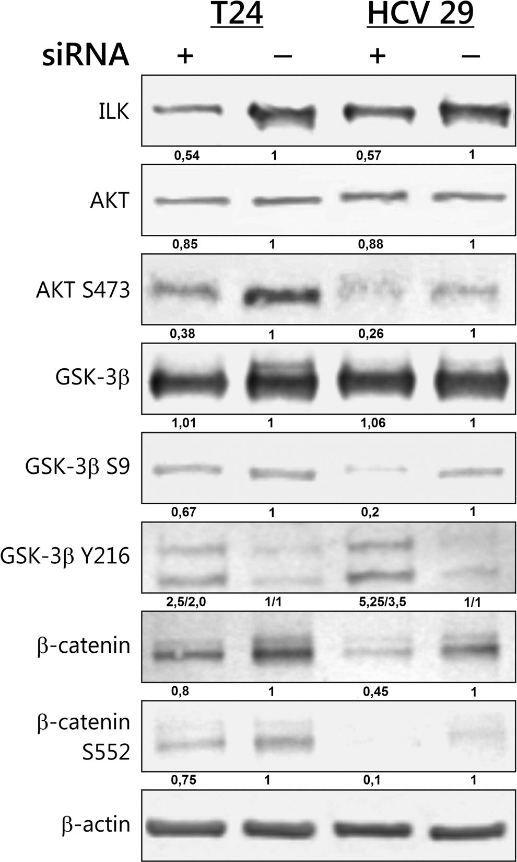
Tumor Biol. (2016)37:15185-15191
15187
Fig. 1 Knockdown of ILK inhibited activity of downstream signaling
targets protein: Akt, GSK-3P, and P-catenin. Bladder cells were
transfected with nonsilencing control siRNA or three different 21 bp
double-stranded siRNA targeting the ILK. Forty-eight hours after
transfection, protein expression was analyzed by Western blot. Total
protein loading was determined by probing the membranes for p-actin.
Densitometry was used to normalize to p-actin protein level and for
quantitative comparison after siRNA knockdown. Presented are
representative membranes of at least three independent experiments
with similar results

ILK regulates the transcriptional activity of p-catenin
Because the key protein regulated by GSK-3P is P- catenin,
we next examined the relationship between the lower phos-
phorylation of Ser 9 GSK-3P and the levels of total P-catenin
and its nuclear accumulation. P-catenin is phosphorylated in
its N-terminal domain by GSK-3 P, which leads to its degra-
dation by ubiquitination [5]. Knocking down ILK reduced the
total level of P-catenin in both studied cell lines (Fig. 1). We
detected increased GSK-3-mediated phosphorylation of P-
catenin on S33, S37, and T41 after silencing of ILK, that is
associated with the P-catenin destruction (Fig. 2). We also
observed the reduction of nuclear accumulation of P-catenin
in both cell lines after ILK depletion (Fig. 2).
Nuclear P-catenin combines with transcription factors of
the TCF/LEF-1 family and promotes tumor progression, but
nuclear translocation is not adequate for transcriptional activ-
ity of P-catenin. Phosphorylation of P-catenin at C-terminal
residues Ser 552 mediated by Akt is necessary for its tran-
scriptional activity [13]. This phosphorylation of P-catenin
was reduced in the T24 transitional cancer cells and complete-
ly abolished in the HCV29 nonmalignant transitional epithe-
lial cells of the urether upon ILK siRNA transfection (Fig. 1).
The nuclear accumulation of P-catenin phosphorylated on
S552 was suppressed (Fig. 2).

ILK regulates cadherin switch
Studied bladder cell line T24 expresses N-cadherin but no or
little E-cadherin at the protein level, and a low amount on
messenger RNA (mRNA) level (Fig. 3). HCV 29 cells express
a lower level of both E- and N-cadherins. The increase of N-
cadherin expression in bladder cancer has been shown to be
important in cancer progression [14]. We checked whether the
ILK signaling pathway was necessary for cadherin switch in
bladder cell lines. As shown in Figs. 3 and 4, inhibition ofILK
activity caused by siRNA was sufficient to downregulate the
expression of N-cadherin on protein level in both cell lines
and significant decrease on mRNA level in HCV29. In this
study, the effects of re-expression of E-cadherin on mRNA
and protein level were markedly higher in HCV29 compared
with control nonsilencing RNA, and the re-expression of E-
cadherin on protein level was slightly visible upon silencing of
ILK in T24 bladder cancer cells (Figs. 3 and 4).

siRNA-mediated knockdown of ILK inhibits nuclear
translocation of key transcription factors including Snail,
Twist, and Zeb
Genes of a family of transcriptional factors including Snail,
Twist, and Zeb are called “EMT master genes”. The function
of these transcription factors is regulated at the transcriptional,
translational, and posttranslational levels [15]. Because nucle-
ar accumulation of key transcriptional factors is one common
EMT markers, we examined whether ILK signaling pathways
result in production and intracellular localization of these fac-
tors. Western blot analysis of subcellular fraction (Fig. 4)
showed that Snail, Twist-1, and Zeb-1 protein nuclear trans-
location was inhibited in T24 bladder cancer cells depleted of
ILK. HCV29 nonmalignant transitional epithelial cells did not
express detectable levels of any of the three transcriptional
factors in nuclear fraction.
Ô Springer
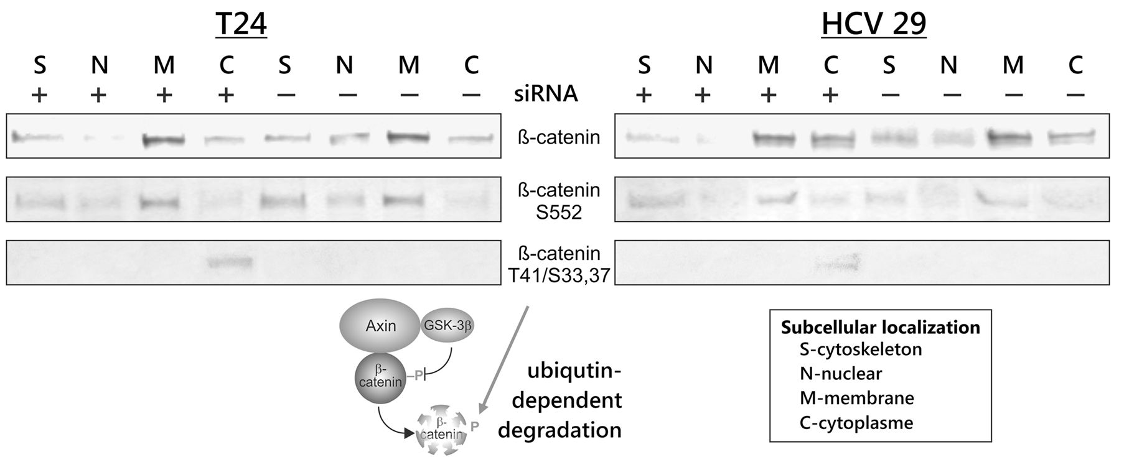
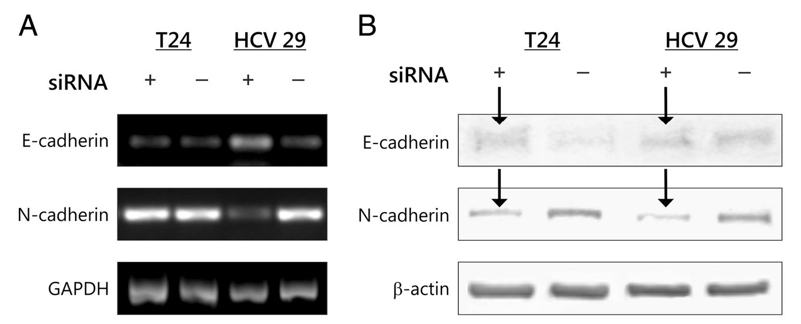
15188
Tumor Biol. (2016) 37:15185-15191
Fig. 2 p-catenin expression in effect of ILK silencing. Various
subcellular fractions of bladder cancer cells were analyzed for p-catenin
expression by Western blotting. ILK silencing increases p-catenin
degradation which is flagged for degradation by phosphorylation at
S33, 37 T41. ILK regulates also the nuclear translocation and
transcriptional activity of p-catenin. Cytoplasmic (C), nuclear (N),
membrane (M), and cytoskeleton (S) proteins were extracted as
described in “Materials and methods” section. Data were obtained from
triplicate experiments

ILK regulates PARP-1 expression
The nuclear protein PARP-1(poly-ADP-ribose polymerase 1),
known to function as a DNA damage sensor and to play a role
in DNA repair pathways, has recently been implicated in tran-
scriptional regulation [16]. PARP-1 regulates transcription by
modifying chromatin structure and through interaction with
other transcription factors. The siRNA reduction of ILK ex-
pression had significant effects on PARP-1 protein levels in
the bladder cancer cell line T24 (Fig. 4).

Discussion
The epithelial-mesenchymal transition gives mesenchymal
properties on epithelial cells and is closely linked with devel-
opment of aggressive traits by cancer cells. A pivotal alter-
ation that occurs during EMT is the “cadherin switch”, in
which the expression of E-cadherin is substituted by abnormal
expression of N-cadherin. This downregulation of epithelial
cadherin is linked with the release of P-catenin, which then
travels to the nucleus and activates transcription of other genes
responsive for EMT.
A large amount of research demonstrate interactions be-
tween cadherins and integrins, suggesting a connection be-
tween signaling pathways both integrin and cadherin.
Alexander et al. [17] presented that the induction of N-
cadherin mRNA is dependent on p1 integrin in PC-3 prostate
adenocarcinoma cell line. In addition, in mouse mammary
epithelial cells, Shintani et al. [18] documented that upregula-
tion of N-cadherin and EMT is initiated by collagen I recep-
tors. Koenig et al. [19] evidenced that collagen type I by in-
teraction with p1 integrins caused loss ofE-cadherin-mediated
cell-cell contacts and promoted proliferation ofpancreatic car-
cinoma cells. Additionally, Kim et al. [20] reported that dele-
tion of a3p1 integrin in epithelial cells prevented EMT re-
sponse to TGF-p. Our data demonstrate a new molecular
mechanism in which ILK can regulate the “cadherin switch”.
Fig. 3 ILK regulates cadherin switch in bladder cells. a. E-cadherin and
N-cadherin expressions on mRNA level were determined by reverse
transcription-PCR 48 h after transfection. b. Inhibition of ILK
expression by siRNA is sufficient also to cadherin switch on protein
level, Western blotting. Total protein loading was determined by
probing the membranes for p-actin. Shown are representative
membranes of at least three independent experiments with similar results
Springer
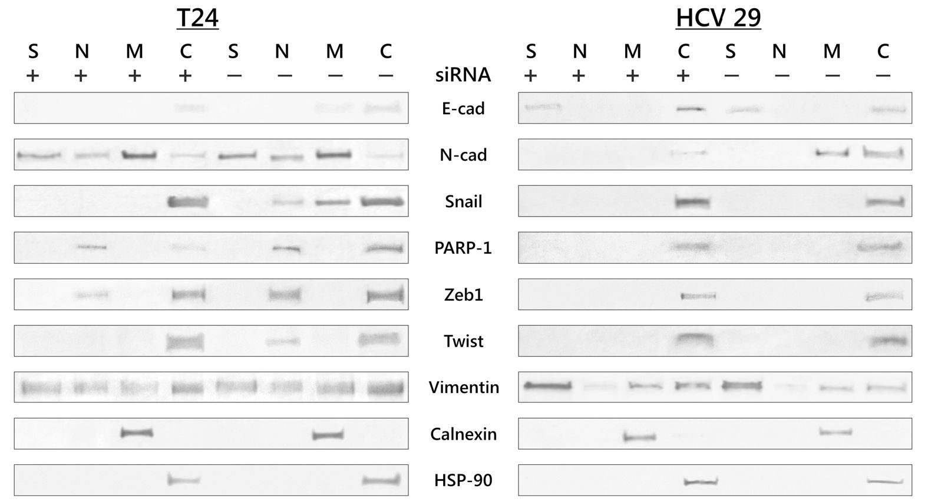
Tumor Biol. (2016)37:15185-15191
15189
Fig. 4 ILK regulates expression
and cellular localization of key
transcriptional factors and
markers of EMT. Cytoplasmic
(C), nuclear (N), membrane (M),
and cytoskeleton (S) proteins
were extracted as described in
“Materials and methods” section.
Calnexin and HSP-90 were used
as marker proteins specific for the
appropriate fraction. Data were
obtained from triplicate
experiments
In our earlier work, we suggested that ILK may mediate cross-
talk between adhesion molecules in melanoma cells and the
control of cadherin expression by integrins might be a general
feature common to all motile cells [3].
It is known that ILK suppresses E-cadherin expression by
controling the expression of its suppressor, Snail [5].
Overexpression of ILK was associated with the expression
of the E-cadherin repressor Snail and N-cadherin in pancreatic
adenocarcinoma [21]. Matsui et al. [11] presented that ILK
overexpression correlates with bladder invasiveness via the
control of E-cadherin and matrix metalloprotease 9 (MMP-
9). We also noticed that ILK can regulate expression of
MMP-9 (Supplementary Fig. 1). Activation of ILK causes
the regulation of numerous signaling pathways that in turn
regulate EMT. We showed that knockdown of ILK diminished
phosphorylation of downstream signaling target protein ki-
nase Akt and glycogen synthase kinase -3|3 (GSK-3|3),
whereas the levels of Akt and GSK-313 protein remained al-
most unchanged. GSK activity is regulated through both ser-
ine and tyrosine phosphorylation [22]. Akt phosphorylates
GSK-313 at Ser 9, leading to inactivation of its kinase activity,
and ILK can phosphorylate GSK-3 P at Ser 9 in Akt-
independent way [23]. Luo et al. [24] demonstrated that ILK
knockdown inhibits EMT through inhibition of GSK-3 P
phosphorylation at Ser 9. On the other hand, actions which
promote cell death, such as growth factor removal, stimulate
kinase activity by increasign phosphorylation within the cata-
lytic domain at Tyr 216. On top of it, Meares and Jope [12]
presented that phosphorylation of Tyr 216 of GSK-3 P is re-
sponsible for the nuclear distribution of GSK-3 p. They dem-
onstrated that upon mutation of Tyr 216 to Phe, less GSK-3 P
is shifted to the nucleus. ILK knockdown in this study de-
creased the levels of phospho-Ser 9 GSK-3 P form with a
significant increase in the level of GSK-3 P phospho-Tyr 216
form. We had similar results after silencing the ILK in
melanoma cells [3]. This was accompanied by significant de-
crease in expression of P-catenin, compared to the control. It
is well known that Akt, GSK-3, and P-catenin are important
mediators of ILK signaling. Yang et al. [25] described the
similar observation that ILK can regulate P-catenin accumu-
lation in the nucleus and its activation in epithelial cells or
intercellular communication via gap junctions. P-catenin
plays also a critical structural role in cadherin-based adhesion.
Although E-cadherin-bound P-catenin is relatively stable, the
availability of P-catenin for binding cadherins is regulated by
its phosphorylation [13]. The cytosolic pool of P-catenin is
also regulated by a phosphorylation-based mechanism. P-
catenin is phosphorylated by GSK-3 P at Ser 33, Ser 37, and
Thr 47 within the N-terminal domain, which leads to its deg-
radation by the ubiquitin/proteasome pathway. Our data show
that siRNA-mediated depletion of ILK caused a phosphoryla-
tion on N-terminal residues and decrease in the total level of
P-catenin in both bladder cell lines. These studies indicate
ILK as a critical factor for nuclear translocation of P-catenin
and activation of transcription factors, which upregulate the
expression of oncogenic and mesenchymal genes in bladder
cells. Furthermore, Fang etal. [13] documentedthat P-catenin
accumulation in the nucleus is not sufficient for P-catenin/
TCF transcriptional activity. They showed that cells stably
transfected with P-catenin S552A had a lower transcriptional
activity that has been linked to tumor cell invasiveness. They
proved that phosphorylation of P-catenin at C-terminal resi-
dues Ser 552 by Akt was necessary for the promotion of P-
catenin transcriptional activity. Additionally, Miyabayashi and
collegues [26] suggested that phosphorylation of P-catenin
may dictate to which particular co-activators bound to P-
catenin and as a result, target genes can be activated. Our
results also indicate the essential role of phosphorylation in
the regulation of P-catenin function, based on the data that
phosphorylation of P-catenin at Ser 552 is eliminated upon
Ô Springer
15190
Tumor Biol. (2016) 37:15185-15191
ILK silencing in both cell lines. |3-catenin transcriptional ac-
tivity has been associated with tumor progression, and nuclear
translocation of |3-catenin is very often used as an EMT mark-
er. Our observation that ILK regulates expression of either
EMT-inducing transcription factors Twsit-1, Zeb-1, and
Snail indicates that ILK may function as upstream regulator
of EMT associated signaling networks. Twist-1, Zeb-1, and
Snail are zinc-finger transcriptional repressors that bind direct-
ly to the E-boxes of the promoter of the E-cadherin coding
gene, and Twist-1 has been suggested as the major regulator of
N-cadherin expression during gastrulation in Drosophila and
promoting the N-cadherin expression in gastric cancers [27].
Our data indicated that regulation of cadherin switch by ILK
pathway was mediated by the transcriptional repressors, as the
loss ofnuclear translocation of Snail, Zeb-1, and Twist-1 leads
to upregulation of E-cadherin. E-cadherin re-expression also
supports relocalization of |3-catenin from the nucleus to the
plasma membrane.
Several investigators reported new insights to control the
production, stability, and intracellular localization of these
transcriptional repressors [9, 15, 28, 29].
McPhee et al. [9] took notice that PARP-1 binds the SIRE
sequence in Snail-1 promoter only in the presence but not the
absence of ILK. They also showed that loss of ILK expression
in prostate cancer cells had no effect on PARP-1 protein
levels. The date presented in this study indicated that the
amount of PARP-1 protein was reduced when ILK expression
was inhibited. Snail activity can also be controlled by GSK-3.
Zhou et al. [28] reported that Snail-1 is phosphorylated by
GSK-3 on two distinct motifs. Phosphorylation of two serines
in the first motif leads to Snail ubiquitination, whereas phos-
phorylation of four serines on the second motif directs nuclear
export. Mutation of all six serines increased the half-life of the
Snail which resides exclusively in the nucleus to induce EMT.
We did not observe detectable levels of Snail in nuclear frac-
tion of HCV29 nonmalignant transitional epithelial cells, and
we have shown inhibition of nuclear translocation of Snail in
T24 bladder transitional cancer cells after silencing of ILK.
Thus, Snail and GSK-313 together function as a molecular
switch for many ILK signaling pathways that lead to EMT.
We demonstrated that targeting ILK could control also the
nuclear translocation of Zeb-1 and Twist in T24 bladder tran-
sitional cancer cells. Wu et al. [29] suggested that Zeb-1 ex-
pression is necessary for transitional cancer cell invasion and
distant metastasis in bladder cancer and that |3-catenin induces
Zeb-1 transcription. They also found that Zeb-1 could regulate
expression of cytokeratins, vimentin, and MMP-2 but not N-
cadherin expression. Although the mechanisms regulating the
aberrant expression of N-cadherin in carcinoma progression
remain unknown, the Twist-1 expression has been indicated to
be necessary for N-cadherin expression during gastrulation in
Drosophila. Yang and colleagues suggested that Twist expres-
sion was sufficient to induce in vitro EMT [27], and
Alexander and colleagues demonstrated that integrin-
mediated adhesion is involved in the Twist-1 nuclear translo-
cation and is necessary for N-cadherin expression in PC-3
prostate carcinoma cells [17]. Recently, Yang and coauthors
discovered that knocking down ILK or inhibiting FAK,
MAPK/ERK, or PI3K/Akt signaling suppressed Twist-
induced EMT [30]. Notably, they found that integrin p1 acts
as a core regulator in this network. Our date confirmed that
ILK is implicated in nuclear translocation of Twist, because
Twist was absent in the nucleus after ILK silencing in com-
parison to control cells in T24 cells. Although the total level of
Twist-1 did not change significantly, Twist protein was present
only in cytoplasm fraction. Our results showed that in T24
cells, the alteration of protein level was more significant than
that of the mRNA of N-cadherin, suggesting posttranscrip-
tional regulation ofN-cadherin by Twist, as it has been recent-
ly observed in gastric cancer [27]. Twist protein is able to form
homo and heterodimers, and posttranslational modification,
such as phosphorylation, can alter its interaction with other
proteins and the binding to DNA. In our previous work, after
ILK silencing in melanoma cells, we observed a decrease in
expression ofN-cadherin but only at the protein level; the re-
expression of E-cadherin on mRNA or protein level was not
observed [3]. The specific mechanism through ILK modulates
N-cadherin expression is not clear. Presented results show that
ILK pathway regulates the cadherin switch of bladder cancer
through multiple mechanisms, including transcriptional and
posttranslational regulation.
It is difficult to indicate a common pathway controlling
EMT under ILK regulation, assuming that various pathways
may be involved and may vary in different cell types.
Acknowledgments This work was supported by a grant from the
Ministry of Science & Higher Education (MNiSW) through the
Jagiellonian University Medical College K/ZDS/003783 and K/ZDS/
006459. The publication of this article was supported by the Faculty of
Medicine, Jagiellonian University Medical College, Leading National
Research Centre (KNOW) 2012-2017.
Compliance with ethical standards
Conflicts of interest None.
Open Access This article is distributed under the terms of the Creative
Commons Attribution 4.0 International License (http://
creativecommons.org/licenses/by/4.0/), which permits unrestricted use,
distribution, and reproduction in any medium, provided you give
appropriate credit to the original author(s) and the source, provide a link
to the Creative Commons license, and indicate if changes were made.

References
- Ferlay J, Steliavova-Foucher E, Lortet-Tieulent J, et al. Cancer in-
cidence and mortality patterns in Europe: estimates for 40 countries
in 2012. Eur J Cancer. 2013;49:1374-403.
£) Springer
Tumor Biol. (2016)37:15185-15191
15191
- Wheelock MJ, Shintani Y, Maeda M, Fukumoto Y, Johnson KR.
Cadherin switching. J Cell Sci. 2008;121:727-35.
- Gil D, Ciolczyk-Wierzbicka D, Dulinska-Litweka J, Zwawa K,
McCubrey JA, Laidler P. The mechanism of contribution of integrin
linked kinase (ILK) to epithelial-mesenchymal transition (EMT.
Adv Enzym Regul. 2011;51:195-207.
- McDonalds PC, Fielding AB, Dedhar S. Integrin-linked kinase—
essential roles in physiology and cancer biology. J Cell Sci.
2008;121:3121-32.
- Oloumi A, McPhee T, Dedhar S. Regulation of E-cadherin expres-
sion and ß-catenin/Tcf transcriptional activity by the integrin-linked
kinase. Biochim Biophys Acta. 2004;1691:1-15.
- Novak A, SC H, Leuhg-Hagesteijn C, et al. Cell adhesion and the
integrin-linked kinase regulate the LEF-1 and ß-catenin signaling
pathways. Proc Natl Acad Sci USA. 1998;95:4374-9.
- Medici D, Nawshad A, Type I. Collagen promotes epithelial-
mesenchymal transition through ILK-dependent activation of NF-
kB and LEF-1. Matrix Biol. 2009;29:161-5.
- Tran C, Costello P, Sanghera J, et al. Inhibition of integrin linked
kinase (ILK) suppresses beta-catenin-Lef/Tcf-dependent transcrip-
tion and expression of the E-cadherin repressor, snail in APC-/-
human colon carcinoma cells. Oncogene. 2001;20:133-40.
- McPhee TR, McDonald PC, Oloumi A, Dedhar S. Integrin-linked
kinase regulates E-cadherin expession through PARP-1. Dev
Dynam. 2008;237:2737-47.
- Gao J, Zhu J, Li H-Y, Pan H-Y, Jiang R, Chen J-X. Small interfering
RNA targeting integrin-linked kinase inhibited the growth and in-
duced apoptosis in human bladder cancer cells. Int J Biochem Cell
B. 2011;43:1294-304.
- Matsui Y, Assi K, Ogawa O, et al. The importance of integrin-
linked kinase in the regulation of bladder cancer invasion. Int J
Cancer. 2012;130:521-31.
- Meares GP, Jope RS. Resolution of the nuclear localization mech-
anism of glycogen synthase kinase-3. J Biol Chem. 2007;282:
16989-7001.
- Fang D, Hawke D, Zheng Y, Xia Y, Meisenhelder J, Nika H, et al.
Phosphorylation of ß-catenin by AKT promotes ß-catenin tran-
scriptional activity. JBiol Chem. 2007;282:11221-9.
- Bryan RT, Tselepis C. Cadherin switching and bladder cancer. J
Urol. 2010;184:423-31.
- Lamouille S, Xu J, Derynck R. Molecular mechanism ofepithelial-
mesenchymal transition. Nat Rev Mol Cell Biol. 2014;15:178-96.
- Schreiber V, Dantzer F, Ame JG, de Murcia G. Poly(ADP-ribose):
novel functions for an old molecule. Nat Rev Mol Cell Biol.
2006;7:517-28.
- Alexander NR, Tran NL, Rekapally H, Summers CE, Glackin C,
Heimark RLN. Cadherin gene expression in prostate carcinoma is
modulated by integrin-dependent nuclear translocation of Twist1.
Cancer Res. 2006;66:3365-9.
- Shintani Y, Fukumoto Y, Chaika N, Svoboda R, Wheelock MJ,
Johnson KR. Collagen I-mediated up-regulation of N-cadherin re-
quires cooperative signals from integrins and discoidin domain re-
ceptor 1. J. Cell Biol. 2008;180:1277-89.
- Koenig A, Mueller C, Hasel C, Adler G, Menke A. Collagen type I
induces disruption of E-cadherin-mediated cell-cell contacts and
promotes proliferation of pancreatic carcinoma cells. Cancer Res.
2006;66:4662-71.
- Kim Y, Kugler MC, Wei Y, et al. Integrin a3p1-dependent p-ca-
tenin phosphorylation links epithelial Smad signaling to cell con-
tacts. J. Cell Biol. 2009;184(2):309-22.
- Schaeffer DF, Assi K, Chan K, et al. Tumor expression of integrin-
linked kinase (ILK) correlates with the expression of the E-cadherin
repressor snail: an immunohistochemical study in ductal pancreatic
adenocarcinoma. Virchows Arch. 2010;456:261-8.
- McCubrey JA, Davis NM, Abrams SL, et al. Diverse roles of GSK-
3: tumor promoter-tumor suppressor, target in cancer therapy. Adv
Biol Regulation. 2014;54:176-96.
- Wu C, Dedhar S. Integrin-linked kinase (ILK) and its interactors: a
new paradigm for the coupling of extracellular matrix to actin cy-
toskeleton and signaling complexes. J Cell Biol. 2008;155:505-10.
- Luo L, Liu H, Dong Z, Sun L, Peng Y, Liu F. Small interfering RNA
targeting ILK inhibits EMT in human peritoneal mesothelial cels
through phosphorylation of GSK-3p. Mol Med Rep. 2014;10:137-
44.
- Yang Y, Lin H, Zhu Y, Wu H, Zhang J, et al. Integrin-linked kinase
inactives the Wnt pathway through connexin. Biochem Pharmacol
(Los Angel). 2015. doi:10.4172/2167-0501.1000192.
- Miyabayashi T, Teo JL, Yamamoto M, McMillan M, Nguyen C,
Kahn M. Wnt/p-catenin/CBP signaling maintains long-term mu-
rine embryonic stem cell pluripotency. Proc Natl Acad Sci USA.
2007;104:5668-73.
- Yang Z, Zhang X, Gang H, et al. Up-regulation of gastric cancer cell
invasion by Twist is accompanied by N-cadherin and fibronectin
expression. BBBRC. 2007;925-930.
- Zhou BP, Deng J, Xia W, et al. Dual regulation of Snail by GSK-
3p-mediated phosphorylation in control of epithelial-mesenchymal
transition. Nat Cell Biol. 2004;6:931-40.
- Wu K, Fan J, Zhang L, et al. PI3K/Akt to GSK3 p-catenin signaling
cascade coordinates cell colonization for bladder cancer bone me-
tastasis through regulating ZEB1 transcription. Cell Signal. 2012;4:
2273-82.
- Yang J, Hou Y, Zhou M, Wen S, Zhou J, Xu L, et al. Twist induces
epithelial-mesenchymal transition and cell motility in breast cancer
via ITGB1-FAK/ILK signaling axis and its associated downstream
network. Int J Biochem Cell B. 2016;71:62-71.
Springer

