

© Pol J Radiol 2022; 87: e281-e285
DOI: https://doi.org/10.5114/pjr.2022.116913
Received: 26.04.2021
Accepted: 15.06.2021
Published: 25.06.2022
http://www.polradiol.com
Original paper
Is there a relationship between adenomyosis and nabothian cyst?
Pinar Diydem Yilmaz1,B,F, Cengiz Kadiyoran1,A,B,C,E, Jule Horasanli2,B,E,F
1Department of Radiology, Meram Medical Faculty, Necmettin Erbakan University, Konya, Turkey
2Department of Obstetrics and Gynaecology, Meram Medical Faculty, Necmettin Erbakan University, Konya, Turkey
Abstract
Purpose: The aim of this study was to investigate whether there is a relationship between adenomyosis and nabothian cyst (NC) in a large patient series.
Material and methods: The patient’s data were scanned retrospectively and patients with a junctional zone thickness of 12 mm and above on magnetic resonance imaging were accepted as group adenomyosis (group A). Patients with a junctional zone thickness of less than 12 mm were not admitted as adenomyosis (control group). Both groups were compared for NC.
Results: In group A, 176 (69.8%) patients had NC (n = 250), while in the control group (n = 202), 57 (28.2%) patients had NC. NC was significantly higher in group A than in the control group (p < 0.001).
Conclusions: The aetiology of NC is still unclear. According to our results, similar factors may affect adenomyosis and NC aetiopathogenesis.
Key words: adenomyosis, junctional zone, magnetic resonance imaging, nabothian cyst.
Diffuse enlargement of the uterus is also seen in leiomyo
ma. Leiomyoma and endometriosis accompany these pa tients frequently [7,8]. Although it was frequently seen in pathology specimens of multiparous patients in the past, it is also common in the infertile patient group [9].
The uterine cervical nabothian cyst (NC) in women of reproductive age is a common gynaecological disorder. It is a chronic inflammation of the cervix due to interstitial or epithelial squamous metaplasia, which obstructs the orifice of the gland, causing the endocervical glands to dilate cysti cally and the cervix to expand. NC can grow in the cervix and is usually small and asymptomatic [10]. Nabothian cysts are generally a few millimetres in diameter. Large and extensive cysts are located deeper in the cervix [11]. The nabothian cyst tunnel cluster is observed as a result of multicystic dilatation of the endocervical glands. There are two types of tunnel cluster: type A (noncystic) and type B (cystic). These lesions are present in up to 8% of women. As long as malignancy is excluded and definitive tun nel clusters diagnosis is identified, no care or followup is
Introduction
Adenomyosis is a benign myometrial invasion of endo
metrial stroma and glands, which leads to hypertrophic and hyperplastic myometrium [1]. Adenomyosis, which af fects the reproductive period of life, is a common disorder. The prevalence is estimated in literature as 570%, and it is difficult to precisely determine for several reasons. Adenomyosis is an asymptomatic condition in onethird of cases and may also be rarely detected by pelvic ultrasound or found in hysterectomy samples conducted for other medical reasons [2]. Adenomyosis is a disease of unknown aetiology and is seen especially in premenopausal multipa rous women [4]. Multiparity, myomectomy, chronic endo metritis, hyperoestrogenaemia are thought to be responsible for its aetiology [35]. Its common symptoms as dysmenor rhoea (30%), abnormal uterine bleeding (50%), and chronic pelvic pain [6]. However, those are nonspecific complaints and are sometimes seen with other disorders, such as leiomyoma, endometriosis, and uterine malignancies.
Correspondence address:
Cengiz Kadiyoran, Department of Radiology, Meram Medical Faculty, Necmettin Erbakan University, Konya, Turkey, e-mail: ckadiyoran@hotmail.com
Authors’ contribution:
A Study design ∙ B Data collection ∙ C Statistical analysis ∙ D Data interpretation ∙ E Manuscript preparation ∙ F Literature search ∙ G Funds collection
This is an Open Access journal, all articles are distributed under the terms of the Creative Commons Attribution-Noncommercial-No Derivatives 4.0 International (CC BY-NC-ND 4.0). License (https://creativecommons.org/licenses/by-nc-nd/4.0/).
e281

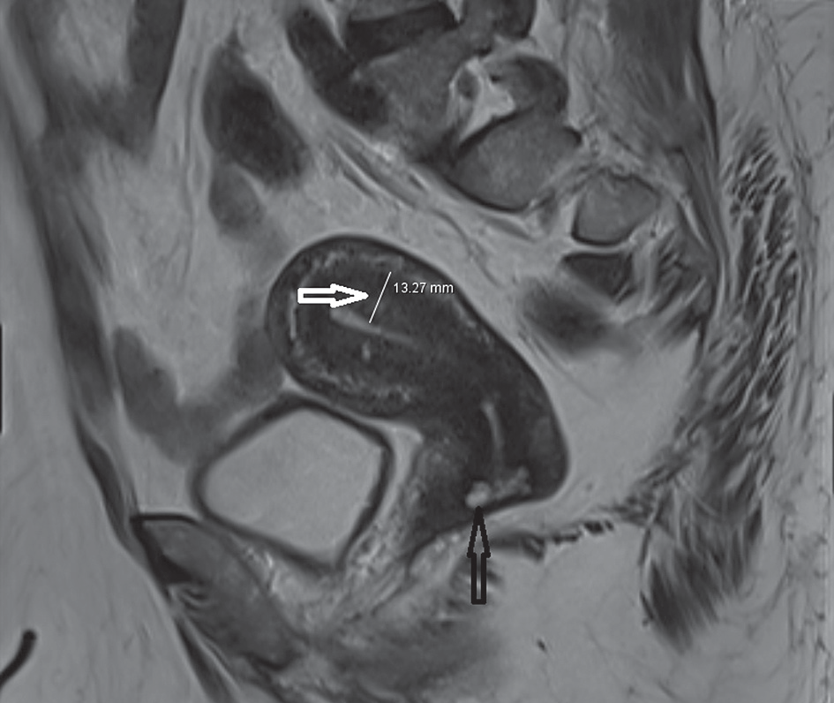
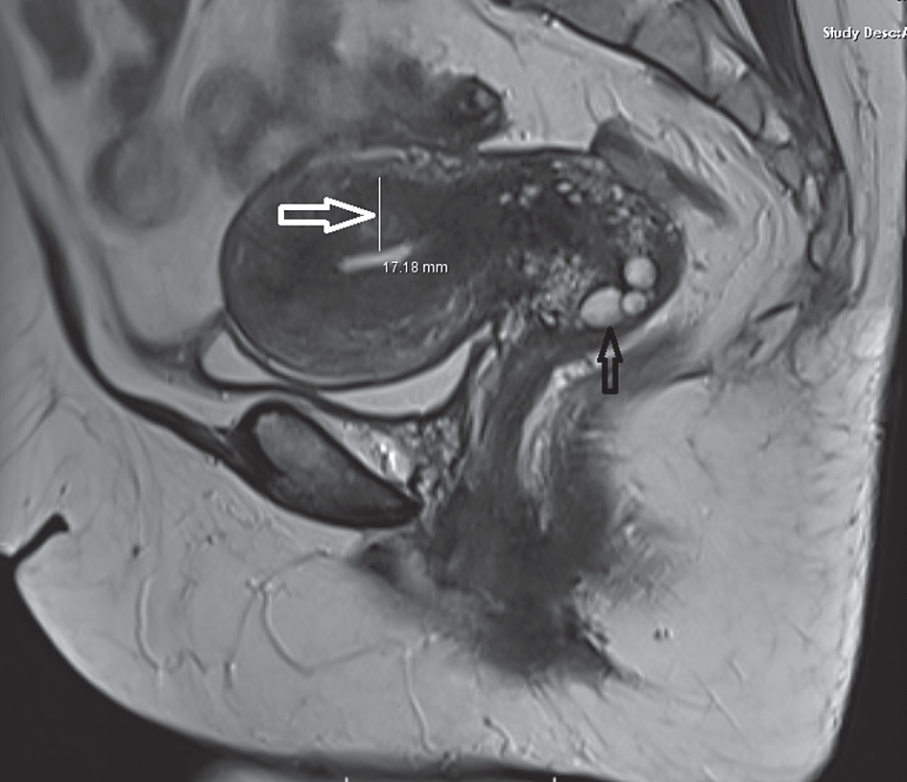
Pinar Diydem Yilmaz, Cengiz Kadiyoran, Jule Horasanli
needed for these entities [12]. Magnetic resonance imaging
(MRI) is useful in the diagnosis of adenomyosis, with high sensitivity (7888%) and high specificity (6793%).
The presence of endometrial glands deeper than a quar ter of the myometrium or > 2.5 mm below the endometrium myometrium transition zone or with endometrium myometrium junctional (EMJ) zone thickness 12 mm and above is defined as adenomyosis [13,14]. It is frequently found in women of reproductive age in NC, such as adeno myosis, and can be easily diagnosed by MRI [15]. There is no study revealing whether there is a relationship between adenomyosis and NC in the current literature. We investi gated whether there is a relationship between adenomyosis and NC in this large series study.
Ethical issue
All performed procedures were in accordance with the stan dards of the Ethics Committee (registration no. 2020–2373).
Statistical analysis
Whether both groups showed a homogeneous distribu tion was ascertained with the KolmogorovSmirnov test. The groups showed homogeneous distribution. Continu ous variables were evaluated by independent ttest, and categorical data were evaluated by the χ2 test.
Results
The mean age of group A patients was 45.47 ± 8.01 years,
and the mean age of the control group was 44.53 ± 9.80 years. In group A, the EMJ zone thickness measured 16.74
± 4.61 mm, and in control group the EMJ zone thickness measured 6.54 ± 2.15 mm (Table 1). In the group A, 176
(69.8%) patients had NC (Figure 1), while 76 (30.2%) pa tients did not have NC. 57 (28.2%) patients had NC in the control group, while 145 (71.8%) patients had no NC. The incidence of NC in the adenomyosis group was remark ably high compared to the control group (p < 0.001) (Table 2).
Material and methods
We screened our image archive program PACS (Picture Ar
chiving and Communication System) to evaluate whether there is a relationship between adenomyosis and NC. In a 2year period, 250 patients diagnosed with adenomyosis on MRI were included in the study as the adenomyosis group (group A). In patients in group A on sagittal T2weighted MRI images, endometriummyometrium junctional (EMJ) zone thickness was 12 mm and above measured by a radi ologist. NC shows isointense or hypointense signal intensity on T1weighted images and has hyperintense signal inten sity on T2weighted images. For the control group, the PACS archive was screened. 296 patients who underwent pelvic MRI scans for any reason were obtained. 94 patients with prior pelvic surgery and a history of radiation therapy were excluded from the study. One radiologist evaluated the MRI images of the remaining 202 patients. The 202 patients with EMJ zone thickness below 12 mm were accepted as the con trol group. MRI images were evaluated in both groups, and NC and leiomyomas were noted. The patient files and sagittal T2 images were examined, and it was noted whether there was a caesarean section history. The patients included in the study were also evaluated according to their age: women of childbearing age and menopausal women.
Table 1. Endometrium-myometrium junctional zone (EMJ) thickness
Table 2. Nabothian cysts presence in patients from the adenomyosis group and control group
Figure 1. Adenomyosis in a 36-year-old woman. Sagittal T2-weighted image shows thickening of the junctional zone (white arrow) and nabothian cyst (black arrow)
e282
© Pol J Radiol 2022; 87: e281-e285
Groups Nabothian Nabothian p-value cyst (+) % cyst (–) %
Adenomyosis group, n (%)
176 (69.8)
76 (30.2)
< 0.001
Control group, n (%)
57 (28.2)
145 (71.8)
0.023
Groups EMJ thickness (mm)
Adenomyosis group
16.74 ± 4.61
Control group
6.54 ± 2.15

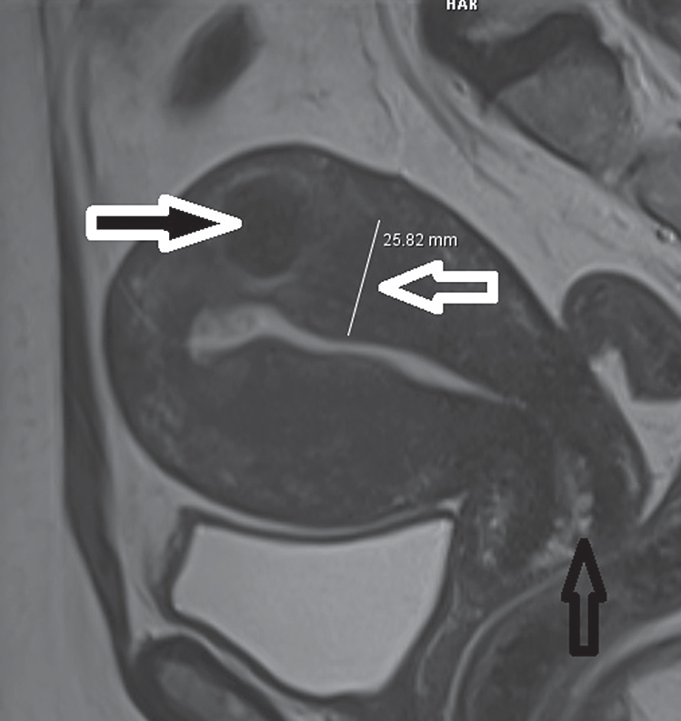
Is there a relationship between adenomyosis and nabothian cyst?
Table 3. Distribution of the patients in the adenomyosis group and control group by mean age, caesarean section history, leiomyoma presence, repro- ductive age, and menopausal age
Table 4. Leiomyoma presence in patients from the adenomyosis group and the control group
Figure 2. Adenomyosis in a 48-year-old woman. Sagittal T2-weighted image shows thickening of the junctional zone (white arrow) and nabothian cyst (black arrow), associated with intramyometrial myoma (blacked filled white arrow)
lowing processes that occur in the control of oestradiol.
It is thought that iatrogenic trauma in the uterus increases the risk of developing endometriosis and adenomyosis [17]. Adenomyosis induced by “firststep injury” is then fol lowed by an increase in injury size; TIAR strengthens this inflammatory process, resulting in the proliferation of stromal fibroblasts. Adenomyotic lesions are mostly fibromuscular [13]. Caesarean section is a trauma to the uterus. Rigs et al. reported a strong relationship between adenomyosis and previous caesarean section [4]. When two groups were compared regarding caesarean section history in our study, 62 (24.6%) patients in the adeno myosis group and 33 (16.3%) patients in the control group had a history of caesarean section. There was a statistically significant difference between the caesarean section his tory of 2 groups (p = 0.024).
Uterine leiomyomas (fibroids or myomas), which are
benign myometrial neoplasms, are the most common indication of hysterectomy [18]. Adenomyosis and leio myomas usually coexist. The incidence of accompanying adenomyosis in hysterectomy specimens of women with leiomyoma is between 15 and 57% [17,19]. In our series, we found a high incidence of leiomyoma in patients with adenomyosis. When the presence of leiomyoma in both groups was compared, 67 patients (26.5%) were found in patients with adenomyosis.
Nabothian cysts are a common gynaecological pa thology. There are different points of view depending on whether large and deep nabothian cysts need to be treated. The classic cases of nabothian cysts do not need treatment unless malignancy has developed. In general, a patient is recommended in symptomatic cases charac terized by pain and when the malignancy cannot be ruled out with an unclear lesion character. In cases in require of treatment, it usually consists of draining [15]. Nabothian
Of the 250 patients in the adenomyosis group, 113 were
in reproductive age and 137 were menopausal age. Of the 202 patients in the control group, 95 were in child bearing age and 107 were menopausal age (Table 3). When 2 groups were compared regarding caesarean section his tory, 62 (24.6%) patients in the adenomyosis group and 33 (16.3%) patients in the control group had caesarean sec tion history (Table 3). There was a statistically significant difference between the caesarean section history of the two groups (p = 0.024). When leiomyoma presence was compared in both groups, 67 (26.5%) patients in the ad enomyosis group (Figure 2) and 42 (20.7%) patients in the other group had leiomyomas (Table 4). The difference was statistically significant (p = 0.015).
Discussion
Adenomyosis is a benign gynaecological disease charac
terized by the displacement of the endometrial glands and stroma toward the myometrium. Adenomyosis is results from endometrial displacement during pregnancy, birth, endometrial curettage, caesarean section, myomectomy, or metroplasty. This condition leads to myometrial hyper trophy and hyperplasia and enlargement of the uterus [1]. Childbirth, trauma, chronic endometritis, and hyperoes trogenaemia are accepted as aetiological factors [1416]. After implantation of the endometrium, inflammation and tissue remodelling start and myometrial hypertrophy occur. Leyendecker et al. [13] expressed the basic pathol ogy as a tissue damage and repair (TIAR) mechanism. The same pathophysiology is present in the development of deeply infiltrating endometriosis and adenomyosis, and the main problem is localized uterine trauma and the fol
© Pol J Radiol 2022; 87: e281-e285
e283
Variables Group A Control group p-value
Leiomyoma, n (%)
62 (24.6)
33 (16.3)
0.024
C/S history, n (%)
67 (26.5)
42(20.7)
0.015
Factor Adenomyosis
group (n = 250)
Control group p-value (n = 202)
Mean age, years
45.47 ± 8.01
44.53 ± 9.80

Caesarean section history, n (%)
62 (24.6)

33 (16.3)

0.015

Leiomyoma presence,
n (%)
67 (26.5)

42 (20.7)

0.024

Reproductive age, n (%)
113 (45.0)
137 (67.0)

Menopausal age, n (%)
95 (38.0)
107(53.0)

Pinar Diydem Yilmaz, Cengiz Kadiyoran, Jule Horasanli
cysts can be detected in 12% of pelvic magnetic resonance
imaging (MRI) scans. It is usually seen in women of re productive age; it is a translucent or opaque lesion and can be observed in numbers of one or more [20].
Adenomyosis, endometriosis, endosalpingiosis, and endocervicosis are embryonic Müllerian diseases, in which the misplacement of organoid structures during organogenesis. Nabothian cysts are characterized by pseu doneoplastic glandular lesions and an array of glands that are usually cystically dilated and extend into the paracer vical tissue [20,21].
TIAR mechanisms play a role in the formation of na bothian cysts, as in adenomyosis. Columnar and squa mous cells combine to form a transformation zone. In this zone the repair process is persistent. Squamous metaplasia and inflammation may close the gland orifice by narrow ing, endocervical columnar cells continue to be secreted, secretions cannot be evacuated because the orifice of the gland is closed, and a mucous retention cyst surrounded by squamous epithelium occurs [21]. Because the clini cal findings are nonspecific for adenomyosis, imaging techniques play an accurate role in diagnosing of A [22]. The archimyometrium from the lower part of the cervix through the uterine corpus Fallopian tubes continue as the Cornua muscle layer. Archimyometrium is seen as a hypodense “halo” and a hypointense “connection zone” with a surrounding width of 48 mm in magnetic reso nance imaging (MRI) [20]. There are welldefined diag nostic findings for A in MRI. Sagittal T2weighted images play a key role in diagnosis. In A, the EMJ zone thickness increases and is seen as hypointensity on T2weighted images measuring 12 mm and above. Also, bright foci of heterotopic endometrial glands may be seen. When haem orrhage occurs within these ectopic endometrial tissues, the foci are also bright on T1weighted images [2123]. Typical findings are uterine enlargement, asymmetry, and measurement of EMJ thickness 12 mm and above on sag ittal T2weighted MR images [3,24,25]. NC is often found incidentally on MRI. They are intermediate or high sig
nal intensity on T1weighted and high signal intensity on
T2weighted images. It is easy to recognize them. Our study observed the EMJ zone thickness in adenomyosis patients as significantly thicker than the control group.
The aetiopathogenesis of both diseases may be simi lar. Both diseases occur in reproductive age and women who have given birth to one or more children. Both ad enomyosis and NC are benign conditions and do not become malignant. TIAR mechanisms play a role in the formation of nabothian cysts and adenomyosis. A scan of the literature revealed a few case reports of these two diseases together [26]. A previous article reported that adenomyosis and NC can coincidentally coexist [27]. Sosnovski et al. [28] reported that large NCs might devel op from adenomyosis. Hormonedependent pelvic lesions such as leiomyomas, endometriosis, endometrial, and cer vical polyps are found to be associate with adenomyosis [29]. Our patients had a history of leiomyoma and caesar ean in both the adenomyosis and control groups. In this study, we have found that NC is associated with adeno myosis on the base of TIAR. We think there may be an association between these two diseases.
Conclusions
The aetiopathogenesis of adenomyosis and NC may be
similar. While MRI is required for the diagnosis of pa tients with adenomyosis, the diagnosis of NC is easily made by a gynaecological examination. The frequency of NC in patients with adenomyosis is higher than the nor mal population. When NC is found incidentally in pelvic MRI, measurement of EMJ zone thickness will be help ful for the early diagnosis of adenomyosis, especially in asymptomatic patients.
Conflict of interest
The authors report no conflict of interest.
References
- Zaloudek C, Norris HJ. Mesenchymal tumors of the uterus. In:
Blaustein’s Pathology of the Female Genital Tract. Kurman J (ed.). Springer, New York 1994; p. 487528.
- Azziz R. Adenomyosis: current perspectives. Obstet Gynecol Clin North Am 1989; 16: 221235.
- Kuligowska E, Deeds L III, Lu K III. Pelvic pain: overlooked and un derdiagnosed gynecologic conditions. Radiographics 2005; 25: 320.
- Riggs JC, Lim EK, Liang D, et al. Cesarean section as a risk factor for the development of adenomyosis uteri. J Reprod Med 2014; 59: 2024.
- Kadiyoran C. Adenomyosis and subcutaneous fatty tissue thickness relationship. J Med Sci Health 2019; 5: 1214.
- Lacheta J. Uterine adenomyosis: pathogenesis, diagnostics, symp
tomatology and treatment. Ceska Gynekol 2019; 84: 240246.
- Garavaglia E, Audrey S, Annalisa I, et al. Adenomyosis and its impact
on women fertility. Iranian J Reprod Med 2015; 13: 327336.
- Munro MG. Uterine polyps, adenomyosis, leiomyomas, and endo metrial receptivity. Fertil Steril 2019; 111: 629640.
- Barrier BF, Malinowski MJ, Dick EJ Jr, et al. Adenomyosis in the baboon is associated with primary infertility. Fertil Steril 2004; 82: 10911094.
- Casey PM, Long ME, Marnach ML. Abnormal cervical appearance: what to do, when to worry? Mayo Clin Proc 2011; 86: 147150.
- Novak ER, Woodruff JD. Novak’s Gynecologic and Obstetric Pathol ogy: with Clinical and Endocrine Relations. W.B. Saunders Company, Philadelphia 1962.
- Brandão P, Malheiro F, Ferreira J. Large cervical tunnel cluster. Acta
Obstet Ginecol Port 2019; 13: 5455.
e284
© Pol J Radiol 2022; 87: e281-e285

Is there a relationship between adenomyosis and nabothian cyst?
- Leyendecker G, Wildt L. A new concept of endometriosis and adeno
myosis: tissue injury and repair (TIAR). Hormone Molecular Biology and Clinical Investigation 2011; 5: 125142.
- Tamai K, Togashi K, Ito T, et al. MR imaging findings of adenomyo sis: correlation with histopathologic features and diagnostic pitfalls. Radiographics 2005; 25: 2140.
- Okamoto Y, Tanaka YO, Nishida M, et al. MR imaging of the uter ine cervix: imagingpathologic correlation. Radiographics 2003; 23: 425445.
- Templeman C, Marshall SF, Ursin G, et al. Adenomyosis and endo metriosis in the California Teachers Study. Fertil Steril 2008; 90: 415424.
- Counseller VS. Endometriosis: a clinical and surgical review. Am J Obstet Gynecol 1938; 36: 877888.
- Walker CL, Stewart EA. Uterine fibroids: the elephant in the room. Science 2005; 308: 15891592.
- Bergholt T, Eriksen L, Berendt N, et al. Prevalence and risk factors of adenomyosis at hysterectomy. Hum Reprod 2001; 16: 24182421.
- Temur I, Ulker K, Sulu B, et al. A giant cervical nabothian cyst com pressing the rectum, differential diagnosis and literature review. Clin Exp Obstet Gynecol 2011; 38: 276279.
- Bazot M, Daraï E. Role of transvaginal sonography and magnetic resonance imaging in the diagnosis of uterine adenomyosis. Fertil
Steril 2018; 109: 389397.
- Novellas S, Chassang M, Delotte J, et al. MRI characteristics of the
uterine junctional zone: from normal to the diagnosis of adenomyo sis. Am J Roentgenol 2011; 196: 12061213.
- Agostinho L, Cruz R, Osório F, et al. MRI for adenomyosis a pictorial review. Insights Imaging 2017; 8: 549556.
- 24.Tellum T, Matic GV, Dormagen BJ, et al. Diagnosing adenomyosis with MRI: a prospective study revisiting the junctional zone thick ness cutoff of 12 mm as a diagnostic marker. Eur Radiol 2019; 29: 69716981.
- Chapron C, Vannuccini S, Santulli P, et al. Diagnosing adenomyosis: an integrated clinical and imaging approach. Hum Reprod Update 2020; 26: 392411.
- Wu Z, Zou B, Zhang X, et al. A large nabothian cyst causing chronic urinary retention: a case report. Medicine (Baltimore) 2020; 99: e19035.
- Benagiano G, Brosens I, Habiba M. Adenomyosis: a lifecycle ap proach. Reprod Biomed Online 2015; 30: 220232.
- Sosnovski V, Barenboim R, Cohen HI, et al. Complex Nabothian cysts: a diagnostic dilemma. Arch Gynecol Obstet 2009; 279: 759761.
- Tetikkurt S, Çelik E, Taş H, et al. Coexistence of adenomyosis, adeno
carcinoma, endometrial and myometrial lesions in resected uterine specimens. Mol Clin Oncol 2018; 9: 231237.
© Pol J Radiol 2022; 87: e281-e285
e285

