
Eur. Phys. J. C (2016) 76:605
DOI 10.1140/epjc/s10052-016-4418-9

The European
Physical journal C
CrossMark
Regular Article - Experimental Physics

Search for the Higgs boson produced in association with a W
boson and decaying to four b-quarks via two spin-zero particles
in pp collisions at 13 TeV with the ATLAS detector
ATLAS Collaboration*
CERN, 1211 Geneva 23, Switzerland
Received: 28 June 2016 / Accepted: 6 October 2016 / Published online: 5 November 2016
© CERN for the benefit of the ATLAS collaboration 2016. This article is published with open access at Springerlink.com
Abstract This paper presents a dedicated search for exotic
decays of the Higgs boson to a pair of new spin-zero par-
ticles, H ^ aa, where the particle a decays to fe-quarks
and has a mass in the range of 20-60 GeV. The search is
performed in events where the Higgs boson is produced in
association with a W boson, giving rise to a signature of a lep-
ton (electron or muon), missing transverse momentum, and
multiple jets from fe-quark decays. The analysis is based on
the full dataset of pp collisions at */s = 13 TeV recorded in
2015 by the ATLAS detector at the CERN Large Hadron Col-
lider, corresponding to an integrated luminosity of 3.2 fb-1.
No significant excess of events above the Standard Model
prediction is observed, and a 95% confidence-level upper
limit is derived for the product of the production cross sec-
tion for pp ^ WH times the branching ratio for the decay
H ^ aa ^ 4fe. The upper limit ranges from 6.2 pb for an
a-boson mass ma = 20 GeV to 1.5 pb for ma = 60 GeV.
1 Introduction
Following the discovery of the Higgs boson by the ATLAS
and CMS Collaborations [1,2] at the Large Hadron Col-
lider (LHC), a comprehensive programme of measurements
of the properties of this particle is underway. These mea-
surements could uncover deviations from expected Standard
Model (SM) branching ratios or allow for the possibility of
decays into non-SM particles. Existing measurements con-
strain the non-SM or “exotic” branching ratio of the Higgs
boson decays to less than approximately 30% at 95% confi-
dence level (CL) [3-5]. Exotic decays are predicted by many
theories of physics beyond the SM [6], including those with
an extended Higgs sector such as theNext-to-Minimal Super-
symmetric Standard Model (NMSSM) [7-11], several mod-
els of dark matter [12-16], models with a first-order elec-
* e-mail: atlas.publications@cern.ch
troweak phase transition [17,18], and theories with neutral
naturalness [19-21].
One of the simplest possibilities is that the Higgs boson
decays to a pair of new spin-zero particles, a, which in
turn decay to a pair of SM particles, mainly fermions [6].1
These kinds of models have been used to explain the recent
observations of a gamma-ray excess from the galactic cen-
tre by the Fermi Large Area Telescope (FermiLAT) [22,23].
Several searches have been performed for H ^ aa. The
D0 and ATLAS Collaborations have searched for a sig-
nal of H ^ aa ^ 2^2x in the a-boson mass ranges
3.7 GeV < ma < 19 GeV and 3.7GeV < ma < 50 GeV,
respectively [24,25]. The D0 and CMS Collaborations have
searched for the signature H ^ aa ^ 4x in the range
2mx < ma < 2mT [24,26]. In this analysis, the a-boson is
assumed to have a negligibly small lifetime. Several other
searches have been performed by the ATLAS, CMS and
LHCb Collaborations for signatures that may correspond to
a long-lived a-boson: displaced decays of jets or displaced
decays of collimated leptons [27-32].
The result presented in this paper covers an unexplored
decay mode in searches for H ^ aa by considering a ^ fefe.
The a-boson can be either a scalar or a pseudoscalar under
parity transformations, since the decay mode considered in
this search is not sensitive to the difference in coupling. An
example of a model with predominant a ^ fefe decays is
one where the new scalar mixes with the SM Higgs boson
and inherits its Yukawa couplings [6]. This search focuses
on the pp ^ WH process, with W ^ lv (l = e,p) and
H ^ 2a ^ 4fe in the range 20 GeV < ma < 60 GeV.
The resulting signature has a single lepton accompanied by
a high multiplicity of jets originating from a bottom quark
(fe-jets). Since the fe-jets are produced from the decay of the
Higgs boson, they tend to have low transverse momentum
(pT) compared to mH and can be overlapping, especially for
1 Throughout this paper, the symbol for a particle may be used to rep-
resent both the particle and its antiparticle.
1 Springer
605 Page 2 of 31
Eur. Phys. J. C (2016) 76:605
light a-bosons. Events with an electron or muon, including
those produced via leptonically decaying t -leptons, are con-
sidered. The WH process is chosen for this search because
the charged lepton in the final state provides a powerful han-
dle to efficiently trigger and identify these events against
the more ubiquitous background process of strong produc-
tion of four ft-jets. Several kinematic variables, including
the reconstructed masses in the decay H ^ 2a ^ 4b, are
used to identify signal events. The background estimation
techniques, systematic uncertainties and statistical treatment
closely follow those used in other ATLAS searches with sim-
ilar signatures [33-36].
2 ATLAS detector
The ATLAS detector [37] covers nearly the entire solid
angle2 around the collision point. It consists of an inner track-
ing detector surrounded by a thin superconducting solenoid
magnet producing a 2 T axial magnetic field, electromag-
netic and hadronic calorimeters, and an external muon spec-
trometer incorporating three large toroid magnet assemblies.
The inner detector consists of a high-granularity silicon
pixel detector, including the newly installed insertable B-
layer [38], and a silicon microstrip tracker, together provid-
ing precision tracking in the pseudorapidity range |nl < 2.5,
complemented by a transition radiation tracker providing
tracking and electron identification information for |n| <
- The electromagnetic (EM) sampling calorimeter uses
lead as the absorber material and liquid argon (LAr) as the
active medium, and is divided into barrel (|n| < 1.475) and
end-cap (1.375 < |n| < 3.2) regions. Hadron calorimetry
is also based on the sampling technique, with either scin-
tillator tiles or LAr as the active medium, and with steel,
copper, or tungsten as the absorber material. The scintilla-
tor tile calorimeter is divided into barrel (|n| < 1.0) and
end-cap (0.8 < | n I < 1.7) regions, and the LAr hadronic
calorimeter includes an end-cap (1.5 < |n | < 3.2) and a
forward (3.1 < |n I < 4.9) region. The muon spectrometer
measures the deflection of muons with | n I < 2.7 using mul-
tiple layers of high-precision tracking chambers in a toroidal
field of approximately 0.5 T and 1 T in the central and end-
cap regions of ATLAS, respectively. The muon spectrometer
is also instrumented with separate trigger chambers cover-
ing | n I < 2.4. A two-level trigger system, consisting of a
custom-hardware level followed by a software-based level,
2 ATLAS uses a right-handed coordinate system with its origin at the
nominal interaction point (IP) in the centre of the detector and the z-axis
coinciding with the axis of the beam pipe. The x-axis points from the IP
to the centre of the LHC ring, and the y-axis points upward. Cylindrical
coordinates (r ,$) are used in the transverse plane, $ being the azimuthal
angle around the beam pipe. The pseudorapidity is defined in terms of
the polar angle 9 as n = — lntan(9/2).
is used to reduce the event rate to a maximum of around 1
kHz for offline storage [39].
3 Event samples and object selection
The search presented in this paper is based on the proton-
proton (pp) collision dataset collected by the ATLAS detec-
tor at the LHC at */s = 13TeV with 25 ns bunch spacing
during 2015. The full dataset corresponds to an integrated
luminosity of 3.2fb-1. The data for this search were col-
lected using the single-electron or single-muon triggers with
the lowest transverse momentum thresholds available [39].
Electron candidates are reconstructed by associating an
inner-detector track with an isolated energy deposit in the
EM calorimeter [40,41]. Candidates are identified using the
tight quality criteria and are required to have pT > 25 GeV
and | n| < 2.47, excluding the transition region between the
barrel and end-cap EM calorimeters, 1.37 < | n| < 1.52.
Muon candidates are reconstructed by combining matching
tracks in the inner detector and the muon spectrometer [42],
and are required to satisfy the medium quality criteria and to
have pT > 25 GeV and | n | < 2.4. Events are required to have
exactly one reconstructed electron or muon that is matched
within a cone of size AR = ^( An)2 + (A$)2 = 0.15 to the
lepton candidate reconstructed by the trigger algorithms.
In order to distinguish leptons produced in the decays of W
bosons from those produced in the decays of heavy-flavour
hadrons, all lepton candidates are required to be consistent
with originating from the primary interaction vertex, chosen
as the vertex with the highest sum of the pT2 of its associated
tracks. Furthermore, since lepton candidates arising from
background sources, such as decays of hadrons, are typically
embedded in jets, all lepton candidates are required to be
isolated from other particles in the event. This is achieved by
imposing a maximal allowed value on the energy deposited
in the calorimeter and/or the momentum of inner-detector
tracks within a cone of A R = 0.2 around the direction of the
lepton candidate’s momentum. The isolation criteria, depen-
dent on pT and n, are applied to produce a nominal efficiency
of at least 90% for electrons and muons from Z ^ i+i-
decays after all other identification criteria are applied [42].
Jets are reconstructed from clusters [43] of energy in the
calorimeters using the anti-^ clustering algorithm [44,45]
with radius parameter R = 0.4. Jets are required to have
pT > 20 GeV and | n| < 2.5, and they are calibrated using
energy- and n-dependent corrections. A track-based veto is
used to suppress contributions from jets arising from addi-
tional pp interactions (pile-up) [46]. Jets consistent with the
hadronisation of a ft-quark are identified using information
from track impact parameters and secondary vertices, which
are combined in a multivariate discriminant [47]. The effi-
ciency to identify ft-quark jets (ft-tagging) is approximately
1 Springer
Eur. Phys. J. C (2016) 76:605
Page 3 of 31 605
77% for a factor of 126 in rejection against light-quark and
gluon jets, about 5 against jets originating from c-quarks, and
about 10 against hadronically decaying t -leptons, as deter-
mined in a simulated sample of top-quarkpair (tt )events[47-
49]. Jets tagged by this multivariate discriminant, indepen-
dently of the flavour of the quark that initiated it, are called
b-tagged jets throughout the text, while the term b-jet is
reserved for those jets originating from b-quark decays, as
determined from simulation.
Jets are required to be separated from the lepton candi-
dates by AR larger than 0.2 or 0.4 for electrons or muons,
respectively. Electrons separated from the nearest jet by
- 2 < A R < 0.4 are considered part of the jet and not a lep-
ton candidate. The transverse momentum imbalance £T?iss,
the magnitude of which (Emiss) is commonly referred to as
missing transverse momentum, is defined as the negative vec-
tor sum of the transverse momenta of calibrated selected
objects, such as electrons, muons and jets. The transverse
momenta of charged-particle tracks compatible with the pri-
mary vertex and not matched to any of those objects are also
included in the negative vector sum [50,51].
4 Signal and background modelling
Simulated event samples are used to study the characteristics
of the signal and to calculate its acceptance, and are also used
for most of the SM background estimation. Signal samples of
associated Higgs boson production with a W boson, pp ^
WH, are generated with Powheg- Box v2-r3033 [52-55]
using the CT10 parton distribution functions (PDFs) [56]
at next-to-leading order (NLO). A Higgs boson mass of
mH = 125 GeV is assumed and the sample is normalised
to the next-to-next-to-leading-order (NNLO) cross section
recommended by the Higgs cross-section working group
ffSM (WH) = 1.37 pb [57]. The Higgs boson decay to two
spin-zero a-bosons and the subsequent decay of each a-boson
to a pair of b-quarks are simulated with Pythia v8.186 [58].
The a-boson decay is done in the narrow-width approxima-
tion and the coupling to the b-quarks is assumed to be that of
a pseudoscalar. However, since the polarisation of the quarks
is not observable, this search is insensitive to the specific
parity hypothesis. Pythia v8.186 is used for the showering,
hadronisation, and underlying-event (UE) simulation with
the A14 set of tuned parameters (tune) [59]. The mass of the
a-boson is varied for different signal hypotheses in the range
20 GeV < ma < 60 GeV, in 10 GeV mass steps. Different
branching-ratio hypotheses are obtained by scaling the signal
sample normalisation.
Samples of tt are also produced using the NLO Powheg-
Box v2-r3026 generator with the CT10 PDFs. A top-quark
mass (mt) of 172.5 GeV is assumed. The Powheg-Box
model parameter hdamp, which controls matrix element to
parton shower (PS) matching and effectively regulates the
high-pT radiation, is set to hdamp = mt. This setting was
found to best describe the tf-system pT at *Js = 7TeV [60].
The baseline tt sample is interfaced to Pythia v6.428 [61]
with the Perugia 2012 tune [62]. Alternative tt samples
are generated using Powheg- Box v2-r3026 interfaced to
Herwig++ v2.7 [63] or MADGRAPH5_aMC@NLO [64]
interfaced to Herwig++. The effects of initial- and final-
state radiation (ISR/FSR) are explored using two alternative
Powheg- Box v2-r3026+PYTHiA v6.428 samples. The first
has hdamp set to 2mt, the renormalisation and factorisation
scales set to half the nominal value and uses the Perugia 2012
radHi UE tune, giving more radiation. The second sample
uses the Perugia 2012 radLo UE tune, has hdamp = mt and
has the renormalisation and factorisation scales set to twice
the nominal value, giving less radiation [65]. The tt sam-
ples are normalised to the NNLO theoretical cross section of
832+41 pb, obtained with Top++ v2.0 [66-72].
The simulated tt events are categorised depending on the
parton-level flavour content of additional particle jets3 not
originating from the decay of the tt system. Events containing
at least one additional particle jet matched to a b-hadron are
labelled as tt. Events containing at least one additional par-
ticle jet matched to a c-hadron and no b-hadron are labelled
as bb. The tt and bb categories are generically referred to
as tt+HF events (with HF standing for “heavy flavour”).
Remaining events are labelled tt+light-jets (referred to as
tf+light) and also include events with no additional particle
jets.
The associated heavy-flavour jets in tt+HF are mod-
elled in Powheg- Box+Pythia via the PS evolution and are
simulated with a five-flavour scheme. The tt modelling is
improved by reweighting the top-quark pT, tf-system pT, and
kinematic properties of the associated particle jets not origi-
nating from the top-quark decay [33] to agree with a tt sam-
ple generated at NLO with Sherpa+OpenLoops [73,74].
This Sherpa+OpenLoops sample is simulated with the four-
flavour scheme (4FS) using Sherpa v2.1.1 [73] andtheCT10
PDF set.
Samples of single-top-quark backgrounds corresponding
to the Wt and s-channel production mechanisms are gener-
ated with Powheg- Box v2-r2819 [75,76] using the CT10
PDF set. Overlaps between the tt and Wt final states are
handled using the “diagram removal” scheme [77]. Sam-
ples of t-channel single-top-quark events are generated using
the Powheg- Box [78] NLO generator that uses the 4FS.
The single-top-quark samples are normalised to the approx-
imate NNLO theoretical cross sections [79-81]. The parton
3 Particle jets are reconstructed by clustering stable particles, excluding
muons and neutrinos, using the anti-kt algorithm with a radius parameter
R = 0.4. Muons and neutrinos are excluded to better reproduce the jet
reconstruction based on calorimeter clusters.
1 Springer
605 Page 4 of 31
Eur. Phys. J. C (2016) 76:605
shower, hadronisation and underlying event are modelled
using either Pythia v6.428 with the Perugia 2012 tune or
Herwig++ v2.7 with the UE-EE-5 [82] tune.
Samples of W/Z +jets events are generated with the
Sherpa v2.1.1 generator. The matrix-element calculation is
performed up to two partons at NLO and up to four partons at
leading order (LO) using Comix [83] and OpenLoops [74]
and uses the CT10 PDFs. Both the W+jets and Z+jets sam-
ples are normalised to their respective inclusive NNLO the-
oretical cross section calculated with FEWZ [84].
Samples of diboson production WW/ WZ/ZZ+jets eve-
nts are generated with the NLO generator Sherpa v2.1.1.
Samples of tt + y/W/Z events, including tt + WW, are
generated with up to two additional partons using Mad-
GRAPH5_aMC@NLO and interfaced to Pythia v8.186.
Samples of tt + H events are generated using Mad-
GRAPH5_aMC@NLO and interfaced to Herwig++ v2.7.
The main signal and background samples use the Evt-
Gen v1.2.0 [85] program to simulate the decay of heavy-
flavour hadrons, except for those generated with Sherpa.
All are then processed with the full simulation of the
ATLAS detector [86] based on GEANT4 [87]. The alterna-
tive tt samples used to estimate systematic uncertainties are
based on a fast simulation of the calorimeter response [88].
Events are generated with pile-up that is simulated with
Pythia v8.186 [58] and are reweighted so that the distri-
bution of the multiplicity of pile-up interactions matches the
distribution observed in the data. Simulated event samples
are processed using the same reconstruction algorithms and
analysis chain as the data.
As described in Sect. 5, backgrounds are estimated by fit-
ting predictions derived from simulation to data in several
background-enriched samples. The only background predic-
tion not derived from simulation is the multijet background,
which contributes to the selected data sample when a jet is
mis-reconstructed as a lepton and satisfies the identification
criteria. In the electron channel, it consists of non-prompt
electrons from heavy-flavour decays, from unidentified pho-
ton conversions or from jets with a high fraction of energy
deposited in the EM calorimeter. In the muon channel, it
consists of heavy-flavour decays and in-flight decays of light
mesons.
The multijet background contribution is evaluated from
data using the “matrix method” [34,89,90], which uses dif-
ferences between the isolation properties of background
(fake/non-prompt) leptons and signal (prompt) leptons from
W boson decays. The estimate uses a sample enriched in mul-
tijet background events obtained by applying the full event
selection except for loosening the lepton isolation require-
ment. Each event with a lepton candidate that satisfies at least
the loosened isolation requirement is scaled by a weight that
depends on whether this lepton candidate also satisfies the
tighter isolation requirement. The weights are determined
from the efficiencies for fake/non-prompt and prompt lep-
tons satisfying the loosened isolation requirement to also
satisfy the tighter one [90]. These efficiencies are measured
in data control samples enriched in either fake/non-prompt
leptons, mostly multijet events, or prompt leptons, mostly
Z ^ l+l~ events. The shape of each multijet background
distribution is derived by applying the same method to the
sample obtained with an identical selection as described in
Sect. 5, but lowering the fe-tagged-jet multiplicity require-
ment to two. This strategy reduces the statistical uncertainty
of the multijet background estimate, improving the stability
of the fitting method described in Sect. 5.2.
5 Analysis strategy
The H ^ 2a ^ 4b decay chain is expected to have mul-
tiple fe-tagged jets, often three or four, satisfying the object
selection. The dominant background arises from tt events.
Preselected events are required to have exactly one electron
or muon and at least three jets, of which at least two must be
fe-tagged. Events are required to satisfy £T?iss > 25 GeV and
the transverse mass4 must fulfil mW > 50 GeV, in order to be
consistent with W boson decays. Events are categorised into
eight channels depending on the number of jets (3,4 and >5)
and the number of fe-tagged jets (2,3 and >4). These analysis
channels are referred to as (nj, mb) indicating n selected jets
including m fe-tagged jets.
The categories most sensitive to the H ^ 2a ^ 4fe decay
chain are (3j, 3b), (4j, 3b) and (4j, 4b). In these channels,
background tt events can only satisfy the selection criteria
if accompanied by additional fe-tagged jets. In the case of
(3j, 3b) or (4j, 3b), the main sources of tt background are
events with jets mis-identified as fe-jets, particularly from
W ^ cs decays, where the c-jet is mis-identified, and from
W ^ Tv,wherethe t-lepton decays hadronically and is like-
wise mis-identified. In the case of (4j, 4b), the tt background
includes more events with genuine fe-quarks from gluon split-
ting to fefe pairs. The main purpose of the five other jet and
fe-tagged-jet multiplicity channels is to constrain the tt+jets
background prediction and the related systematic uncertain-
ties (see Sect. 6) through a profile likelihood fit to data (see
Sect. 5.2).
The tt +light background is dominant in the sample of
events with exactly two or three fe-tagged jets. The back-
ground processes fefe and tt become more important as the
jet and fe-tagged-jet multiplicities increase. In particular, the
tt background dominates for events with >5 jets and >4
fe-tagged jets.
4 The transverse mass is defined as m^f = y2EJj?isspT(1 — c°s Aft),
where pT is the transverse momentum of the lepton and A0 is the
azimuthal angle between the lepton and i?T?iss directions.
1 Springer
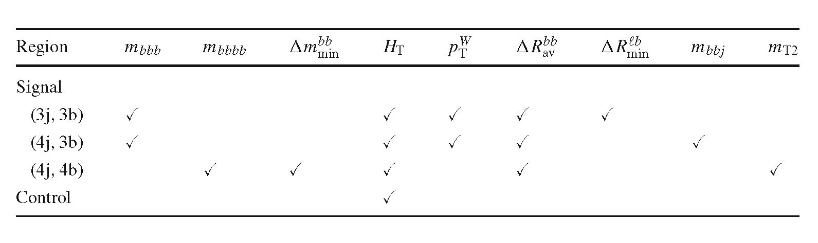
Eur. Phys. J. C (2016) 76:605
Page 5 of 31 605
- Signal and background discrimination
In order to improve the sensitivity of the search, several
kinematic variables are identified to distinguish between
signal and background, and are combined into a boosted
decision tree (BDT) multivariate discriminant [91] that uses
the AdaBoost algorithm [92]. The BDT is trained to dis-
criminate between signal events with an a-boson mass of
60 GeV and tt events. As described below, the variables cho-
sen as input for the BDT do not depend strongly on the
value of ma and provide excellent separation between sig-
nal and background, so training each mass hypothesis sepa-
rately with these variables would only slightly improve the
sensitivity of the search. The training is performed sepa-
rately for each of the channels (3j, 3b), (4j, 3b) and (4j, 4b)
since the signal and background kinematics differ between
them.
Signal events are characterised by the presence of a reso-
nance resulting from the Higgs boson decay H ^ 2a ^ 4b.
Two variables are used to reconstruct particles from the sig-
nal decay chain. The first is the reconstructed invariant mass
of the b-tagged jets, mbbb or mbbbb, defined for events with
three or four b-tagged jets respectively, which peaks around
the Higgs boson mass for signal events. In the case of three
b-tagged jets, the peak is due to events where two b-quarks
are merged in a single jet or one of the b-quarks is very soft
in an asymmetric decay and has a small impact on the kine-
matics. The second discriminating variable for events with
four b-tagged jets is the minimum difference between the
invariant masses of bb pairs (Ammbin). For signal events, two
pairs of b-quarks originate from a pair of a-bosons, so for the
correct jet pairing, mbb & ma, and the difference between
the invariant masses of the bb pairs is smaller for signal than
for tt background events.
Additional kinematic variables exhibit differences betwe-
en signal and background. The HT variable, defined as the
scalar sum of pT for all jets in the event, is a measure of the
total hadronic energy in the event, which is typically larger
for tt than for WH events. The transverse momentum of the
W boson, pW, constructed from the vector sum of the E™ss
and the lepton pT, is slightly higher for signal WH events,
where the W boson recoils against the Higgs boson, than for
background tt events. Another variable used is the average
angular separation between all pairs of b-tagged jets, referred
to as ARbb. For background tt events, the b-tagged jets orig-
inate from the decays of the two top quarks and tend to be
spatially more separated than for the signal. A related vari-
able is the minimum A R separation between any b-tagged
jet and the lepton, ARmbin. In tt background events, the lep-
ton is typically closer to a b-tagged jet than in signal events,
since the lepton and the nearest b-tagged jet often originate
from the same top-quark decay. In the case of the signal, the
Higgs boson and hence the b-jets recoil against the W boson,
which the lepton comes from.
Finally, two variables are used to identify particles from
the dominant tt background decay chain. The first variable is
used in the (4j, 3b) channel to distinguish between tt events
with two b-tagged jets from the top-quark decays and tt
events with a third b-tagged jet from a mis-identified charm
or light jet from the hadronically decaying W boson. The
invariant mass of two b-tagged jets, selected as the pair with
the smallest AR separation, and the non-b-tagged jet, mbbj,
reconstructs the hadronically decaying top quark, peaking
around the top-quark mass for these background events. The
second variable, used in the (4j, 4b) channel, is a variant of
the mT2 observable, defined as the minimum “mother” par-
ticle mass compatible with all the transverse momenta and
mass-shell constraints [93], that identifies events with several
invisible particles. In the case of the tt background events,
in addition to the ET“ss from the neutrino from a leptonic W
boson decay, invisible particles may arise from a t-lepton
decay or from a lost jet from a W boson. In these cases, the
mT2 has an endpoint at the top-quark mass, which is not the
case for the signal.
Table 1 indicates which variables are used to train each of
the three BDT discriminants for the (3j, 3b), (4j, 3b), and (4j,
4b) categories. Figures 1,2 and 3 show the expected distribu-
tions of the kinematical variables obtained after using the sta-
tistical procedure and the systematic uncertainties described
in Sects. 5.2 and 6, respectively. These variables are used
in the BDT discriminants for signal and background for all
events that satisfy the event selection criteria, and are shown
in Figs. 1, 2 and 3 inclusively in number of jets and b-tagged
jets. The distributions are dominated by events with the min-
imum number of b-tagged jets. In this comparison, the jets
in each event are ordered by value of the b-tagging discrim-
Table 1 List of variables used
in the three signal regions as
inputs to the BDT multivariate
discriminant and used in the five
control regions. The variables
are described in the text
1 Springer
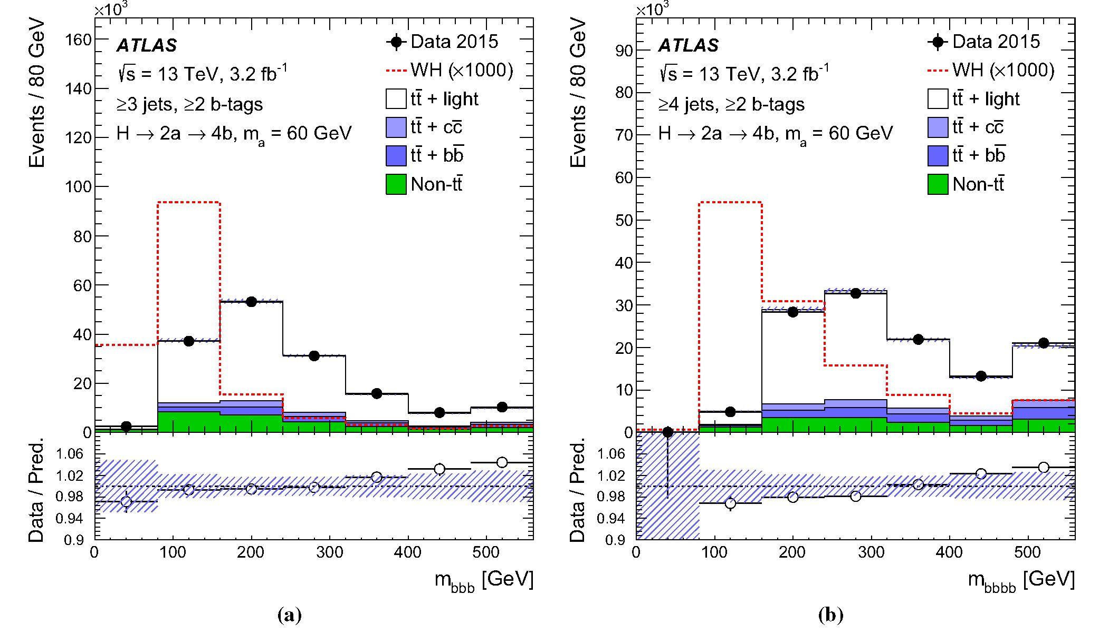
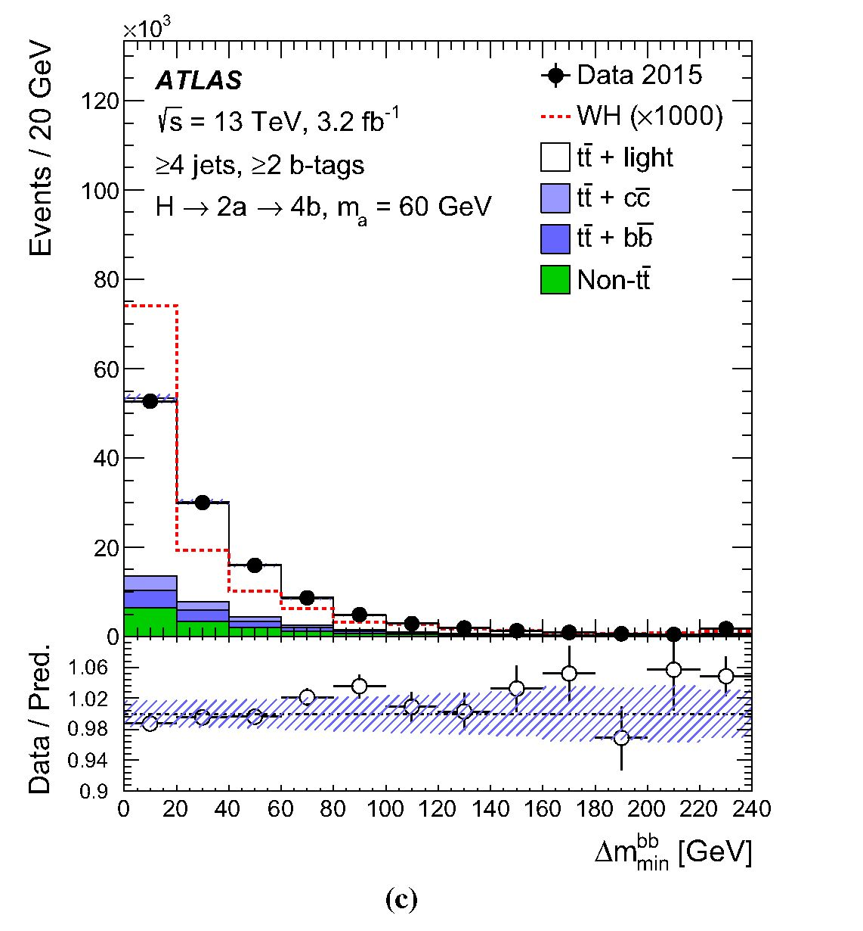
605 Page 6 of 31
Eur. Phys. J. C (2016) 76:605
Fig. 1 Comparison of data with the SM background predictions for
the distributions of a mbbb, b mbbbb and c Am^n in the sample that is
inclusive in number of jets and b-tagged jets. Distributions for the sig-
nal model (WH, H ^ 2a ^ 4b), with ma = 60GeV, normalised
to the SM pp ^ WH cross section, assuming BR(H ^ aa) x
BR(a ^ bb)2 = 1 and scaled by a factor of 1000, are overlaid. The
hashed area represents the total uncertainty in the background. Com-
parisons use events with >3 jets, except when at least four jets are
necessary to define the variable, in which case events with >4 jets are
used. The last bin contains the overflow. Markers are not drawn if they
are outside the y-axis range
1 Springer
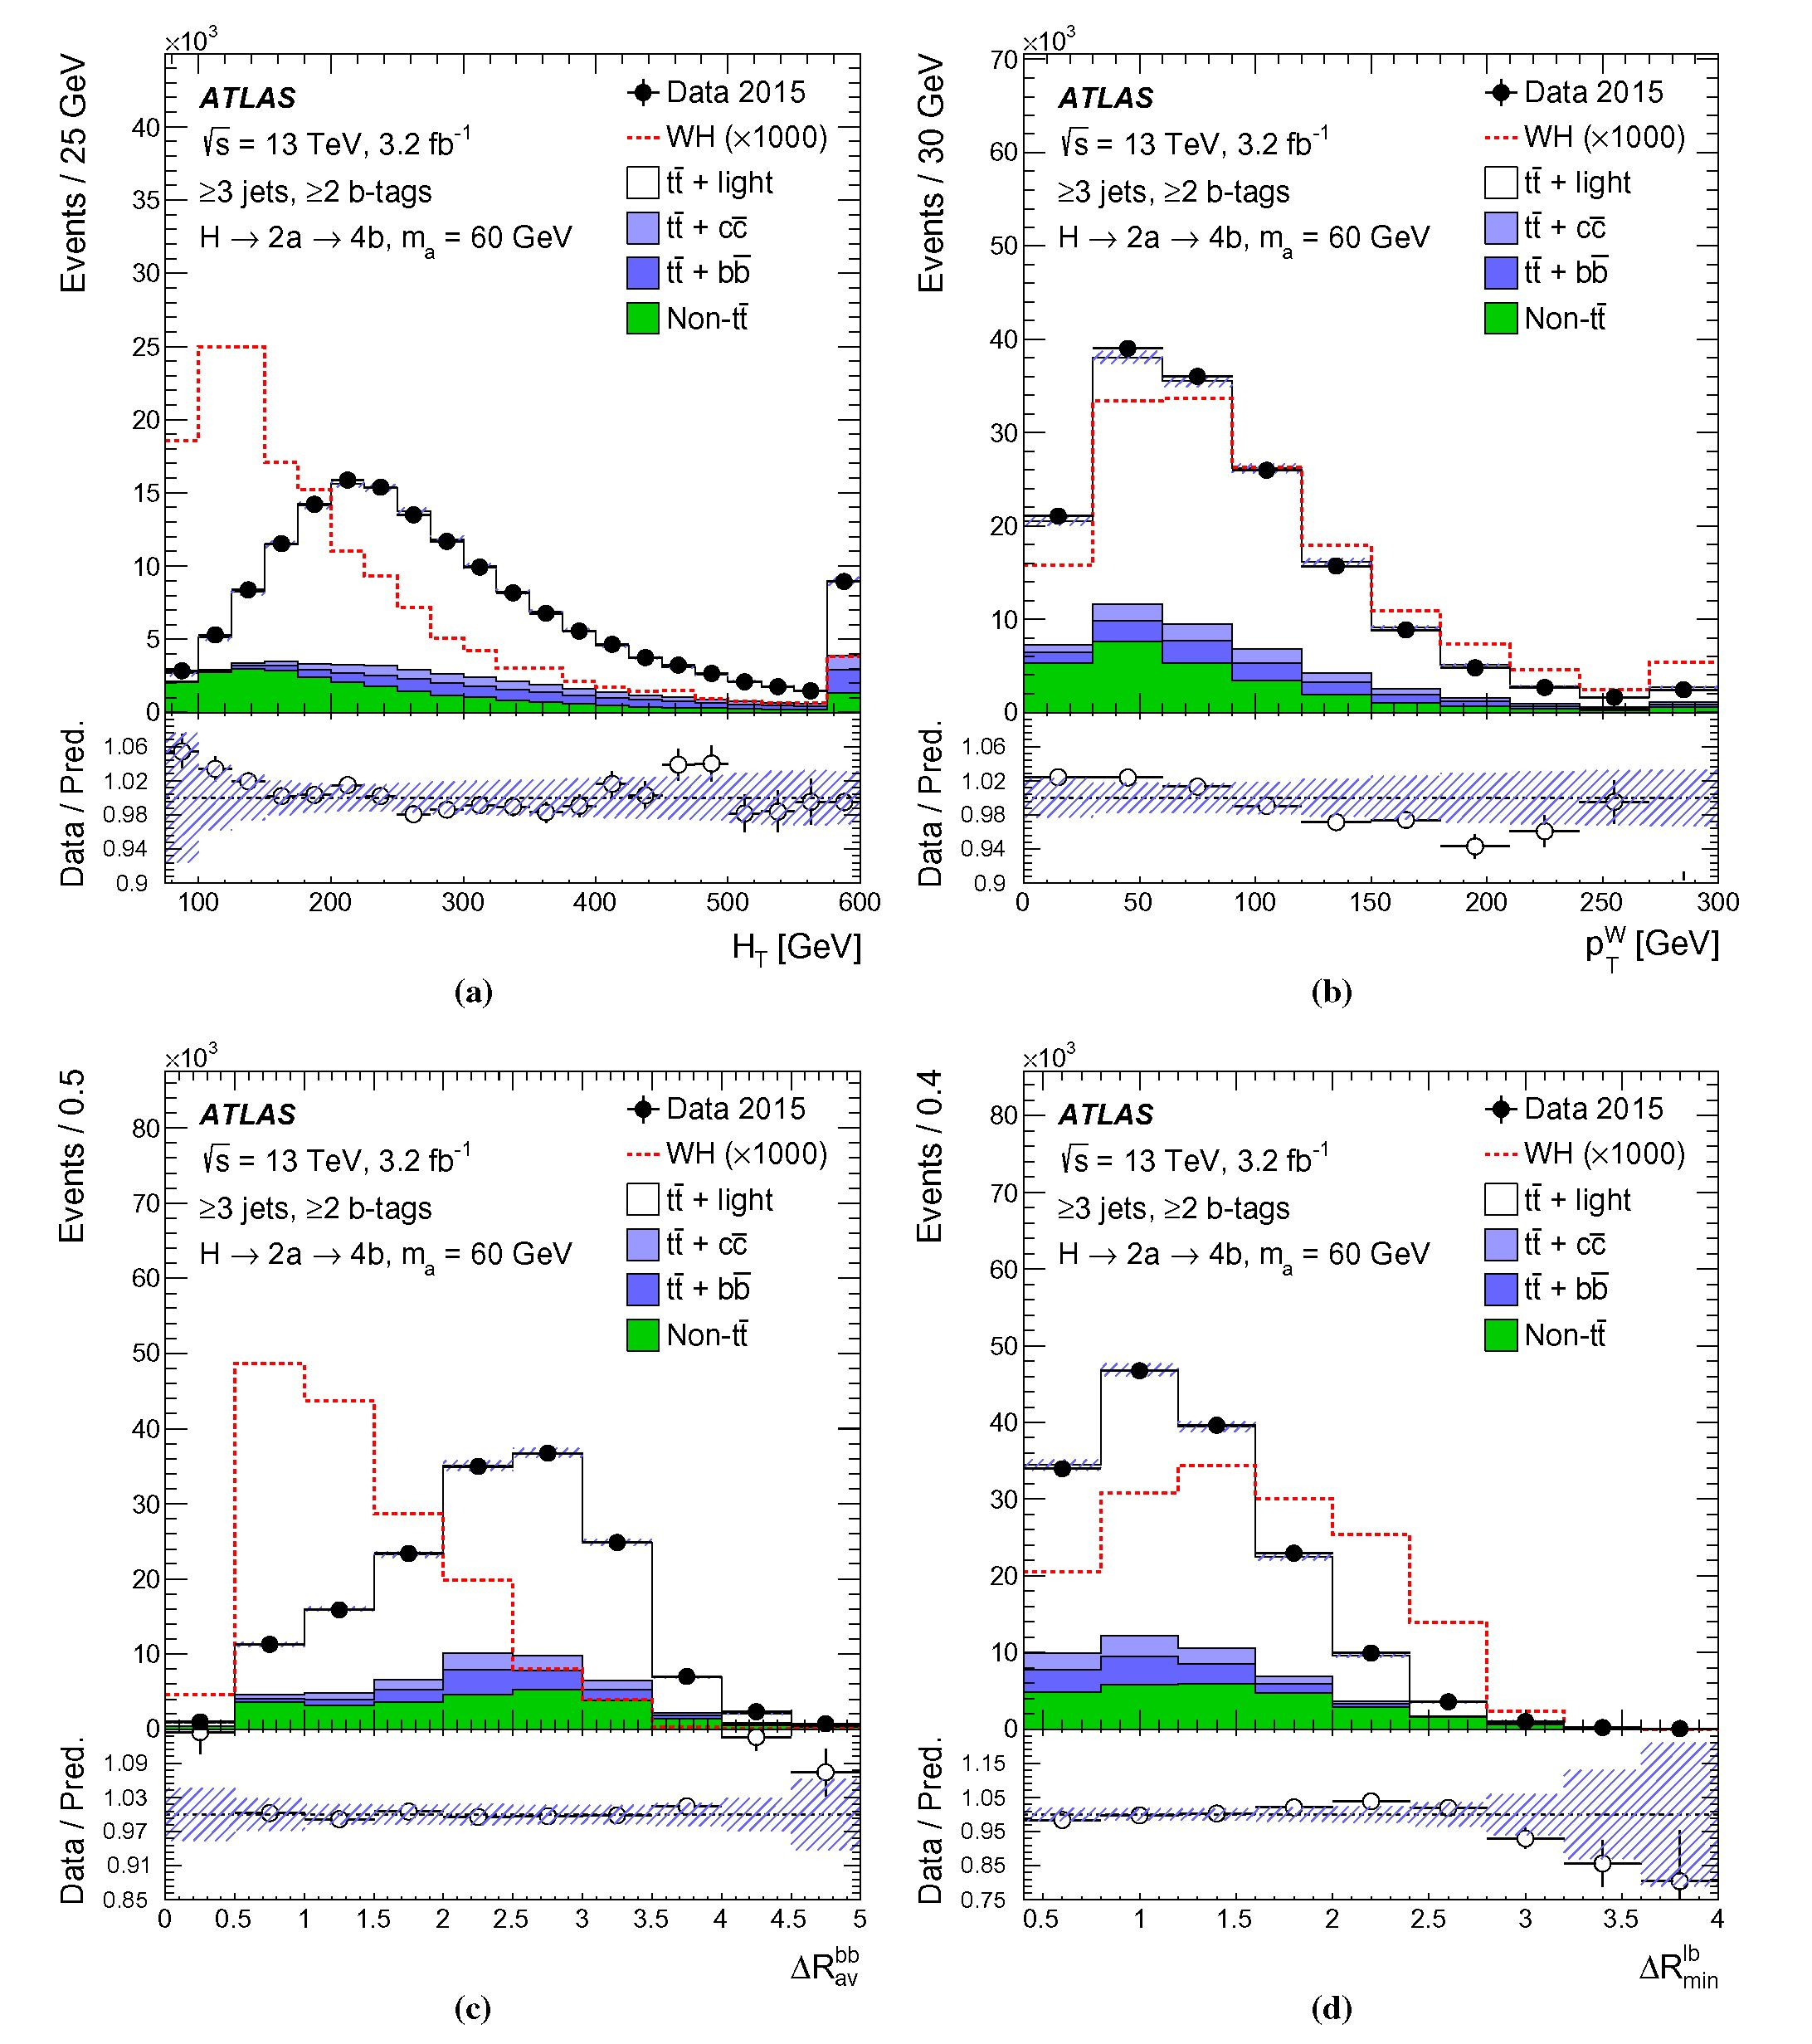
Eur. Phys. J. C (2016) 76:605
Page 7 of 31 605
Fig. 2 Comparison of data with the SM background predictions for the
distributions of a HT, b pW, c A and d A Rfen in the sample that is
inclusive in number of jets and fe-taggedjets. Distributions for the signal
model (WH, H ^ 2a ^ 4fe), with ma = 60 GeV, normalised to the
SM pp ^ WH cross section, assuming BR(H ^ aa) x BR(a ^
fefe)2 = 1 and scaled by a factor of 1000, are overlaid. The hashed area
represents the total uncertainty in the background. The last bin contains
the overflow
1 Springer
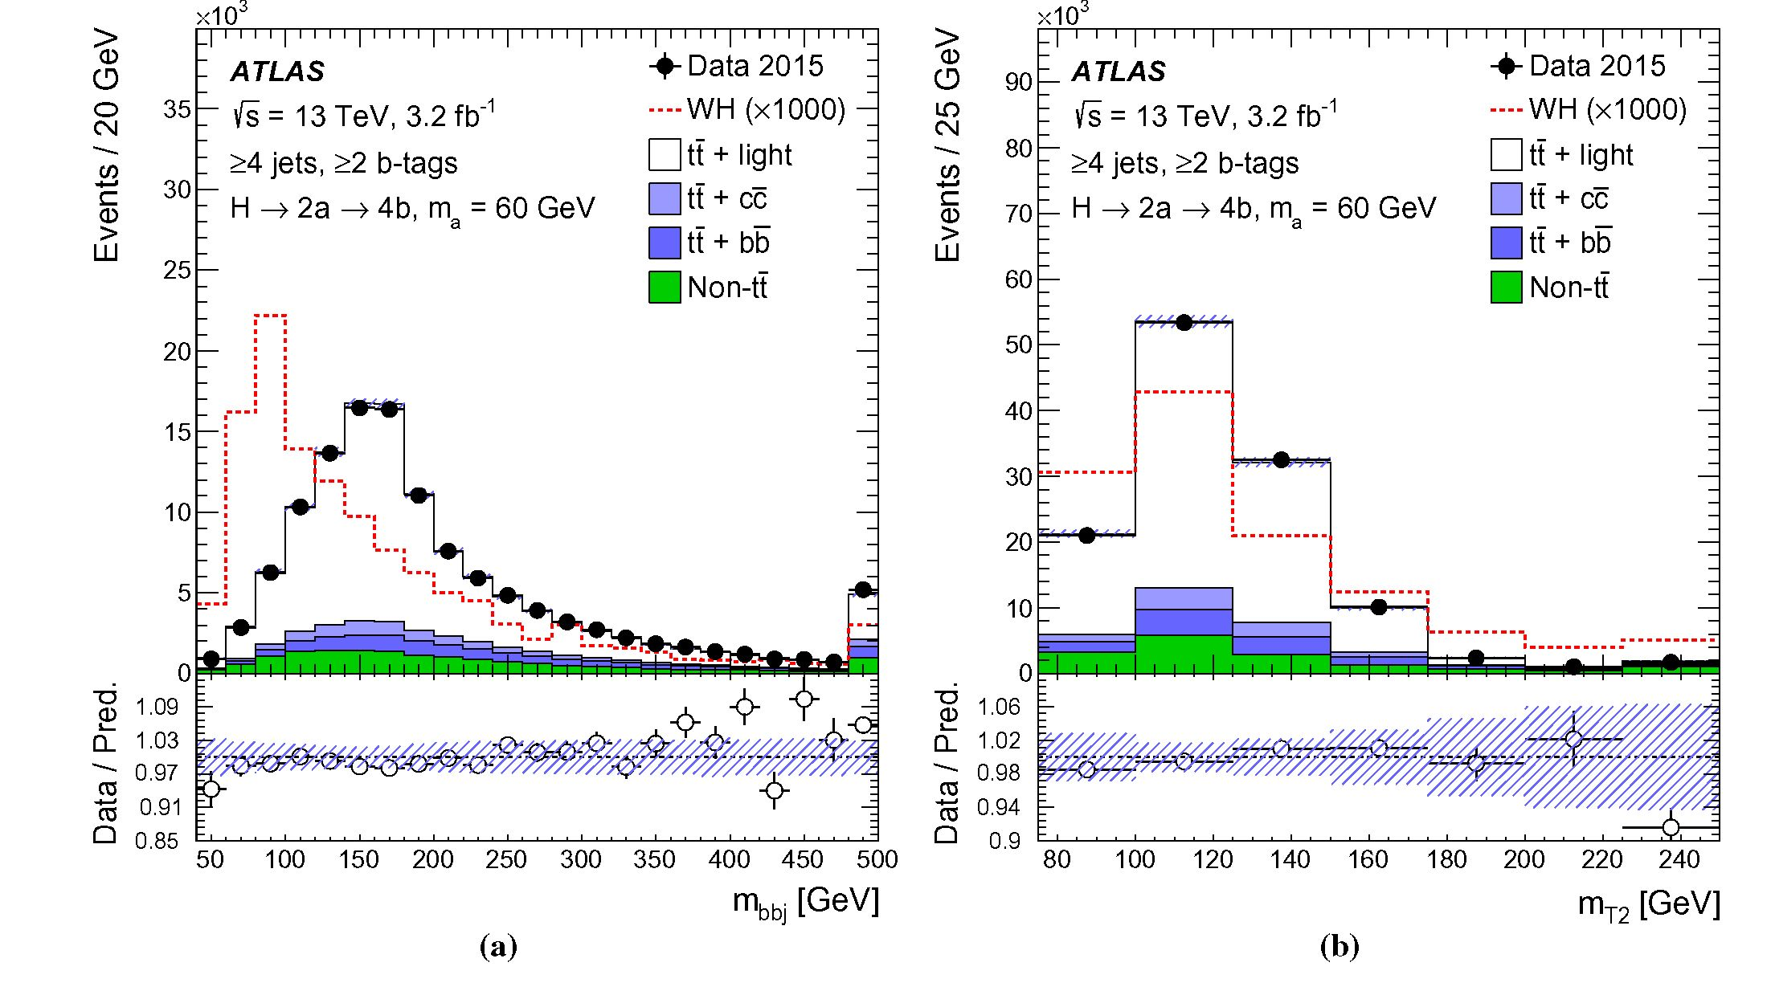
605 Page 8 of 31
Eur. Phys. J. C (2016) 76:605
Fig. 3 Comparison of data with the SM background predictions for
the distributions of a mftftj and b mT2 in the sample that is inclusive
in number of jets and ft-tagged jets. Distributions for the signal model
(WH, H ^ 2a ^ 4ft), with ma = 60 GeV, normalised to the SM
inant and those with the highest score are used to calculate
the input variables of the BDT, even if they do not satisfy
the ft-tagging criteria used in this analysis. The distributions
are similar to those obtained in each analysis channel and
indicate that each variable individually has some signal and
background discrimination power. The tail in the mftftftft dis-
tribution for signal events, shown in Fig. 1, is mainly formed
by events with jets mis-associated to the a-boson decay. The
tail is greatly reduced in the signal regions with the tighter
requirement on the number of ft-tagged jets. Figure 4 shows
the BDT discriminant for signal and background events that
satisfy the event selection criteria inclusively in number of
jets and ft-tagged jets. These distributions are used to val-
idate the BDT modelling in background-enriched samples
with kinematic properties that are similar to those in the sig-
nal regions.
- Fitting procedure
The distributions of the final discriminants in the eight analy-
sis channels considered are combined to test the presence of a
signal. The BDT discriminant, described in Sect. 5.1, is used
for the channels enriched with signal, (3j, 3b), (4j, 3b) and
(4j, 4b), while the HT distribution is used in the five control
channels. The statistical analysis is based on a binned likeli-
hood function constructed as a product of Poisson probability
terms over all bins considered in the search.
The likelihood function, L, depends on the parameter of
interest, the signal-strength p., defined as:
p = a(WH) x BR(H ^ aa) x BR(a ^ ftft)2, (1)
where o(WH) is the production cross section for pp ^
WH.
Systematic uncertainties in the signal and background pre-
dictions (see Sect. 6) are accounted for in the likelihood func-
tion as a set of nuisance parameters, 0. These parameters are
implemented as Gaussian priors in the case of shape uncer-
tainties and log-normal priors for uncertainties affecting the
normalisation, with width parameters corresponding to the
size of the respective uncertainties. Statistical uncertainties
in the background estimates in each bin of the discriminant
distributions are also taken into account via dedicated nui-
sance parameters in the fit.
The background-only hypothesis is tested by fitting the
background predictions to the observed data, setting p = 0
1 Springer
pp ^ WH cross section, assuming BR(H ^ aa) x BR(a ^ ftft)2 =
1 and scaled by a factor of 1000, are overlaid. The hashed area repre-
sents the total uncertainty in the background. The last bin contains the
overflow
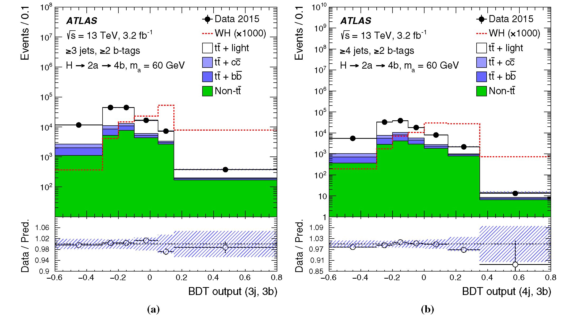
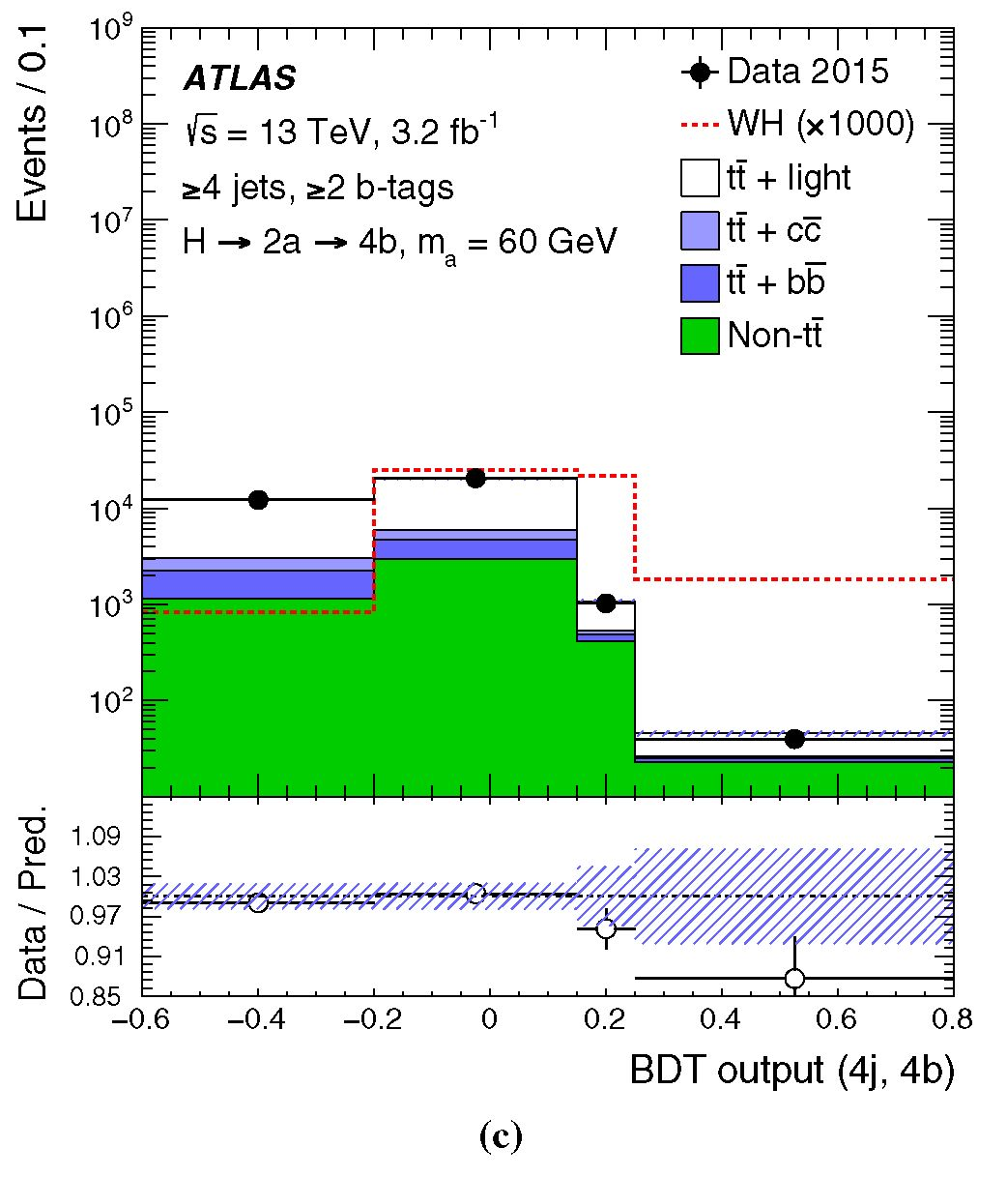
Eur. Phys. J. C (2016) 76:605
Page 9 of 31 605
Fig. 4 Comparison of data with the SM background predictions for
the distributions of a BDT (3j, 3b), b BDT (4j, 3b), and c BDT (4j,
4b) in the sample that is inclusive in number of jets and fe-tagged jets.
Distributions for the signal model (WH, H ^ 2a ^ 4fe), with ma =
60GeV, normalised to the SM pp ^ WH cross section, assuming
BR(H ^ aa) x BR(a ^ fefe)2 = 1 and scaled by a factor of 1000,
are overlaid. The hashed area represents the total uncertainty in the
background. Comparisons use events with >3 jets, except when at least
four jets are necessary to define the BDT discriminant, in which case
events with >4 jets are used. The BDT output is determined in the
range [—1, 1]. The first and last bin contain the underflow and overflow,
respectively
1 Springer
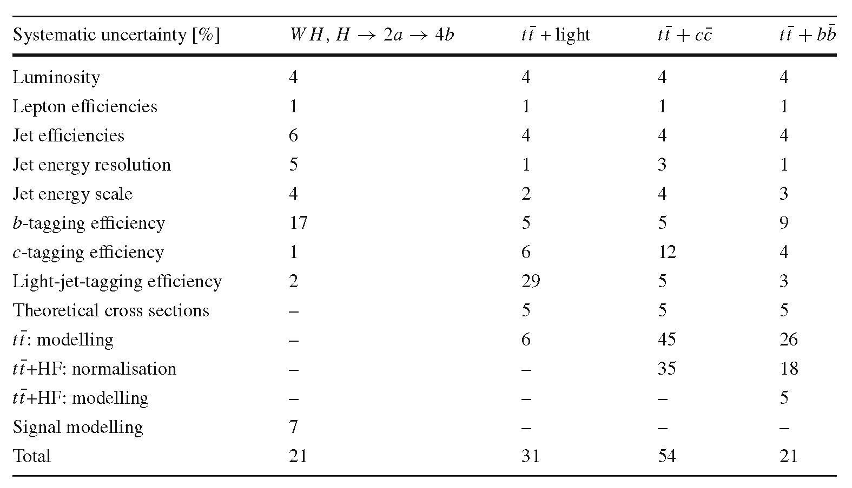
605 Page 10 of 31
Eur. Phys. J. C (2016) 76:605
Table 2 Summary of the
impact of the considered
systematic uncertainties (in %)
on the normalisation of the
signal (ma =60 GeV) and the
main backgrounds for the (4j,
4b) channel after the fit. The
total uncertainty can differ from
the sum in quadrature of
individual sources due to
correlations between them
and maximising the likelihood over 0. The best-fit p is
obtained by performing a binned likelihood fit to the data
under the signal-plus-background hypothesis, i.e. maximis-
ing the likelihood function L(p, 0) over p and 0. The nui-
sance parameters 0 allow variations of the predicted signal
and background according to the corresponding systematic
uncertainties, and their fitted values correspond to the devia-
tions from the nominal predictions that globally provide the
best fit to the data. This procedure allows a reduction of the
impact of systematic uncertainties on the search sensitivity
by taking advantage of the highly populated background-
dominated channels included in the likelihood fit.
6 Systematic uncertainties
Several sources of systematic uncertainty are considered
that affect the normalisation or the shape of the signal and
background contributions to the final discriminant distri-
butions. Each source of systematic uncertainty is consid-
ered to be uncorrelated with other sources, but correlated
across processes and channels where appropriate. This sec-
tion describes the sources of systematic uncertainty consid-
ered in this search.
Luminosity and pile-up The uncertainty in the integrated
luminosity is 5%, affecting the overall normalisation of all
processes estimated from the simulation. It is derived, fol-
lowing a methodology similar to that detailed in Ref. [94],
from a calibration of the luminosity scale using x-y beam-
separation scans performed in August 2015. The uncertainty
associated with the modelling of pile-up arises mainly from
differences between the expected and observed fraction of
the visible pp cross section.
Reconstructed objects Uncertainties associated with lep-
tons arise from the reconstruction, identification and trigger
efficiencies, as well as lepton momentum scales and resolu-
tions. These efficiencies are measured using tag-and-probe
techniques on Z ^ l+l~ data and simulated events. The
small differences found are corrected in the simulation. Neg-
ligible uncertainties arise from the corrections applied to
adjust the lepton momentum scales and resolutions in simu-
lation to match those in data. The combined effect of all these
uncertainties results in an overall normalisation uncertainty
in the signal and background of less than 1%.
Uncertainties associated with jets arise from the efficiency
of jet reconstruction and identification, as well as the jet
energy scale and resolution. The largest contribution comes
from the jet energy scale uncertainty, which depends on jet pT
and n. It affects the normalisation of signal and backgrounds
by approximately 5% in the most sensitive search channels.
Uncertainties associated with energy scales and resolutions
of leptons and jets are propagated to E^1™. An uncertainty in
the contribution from charged-particle tracks is also included
in the £T“ss uncertainty [51]. Additional uncertainties origi-
nating from the modelling of the underlying event are negli-
gibly small.
Several uncertainties are associated with the identifica-
tion of the jet flavour, in particular the modelling of the b-,
c-, and light-jet-tagging efficiencies in the simulation, which
are corrected to match the efficiencies measured in data [47-
49]. These uncertainties are derived from studies performed
with data at */s = 8TeV and are extrapolated to 13TeV.
They depend on the jet pT and the light-jet-tagging addition-
ally depends on the jet n. The sources of systematic uncer-
tainty in the tagging efficiencies are taken as uncorrelated
between b-jets, c-jets, and light-jets. They have their largest
impact in the (4j, 4b) channel, resulting in 4% uncertainty in
the tt background normalisation associated with the uncer-
tainty in the b-jet-tagging scale factors, 8% uncertainty in
the bb background normalisation associated with the uncer-
1 Springer
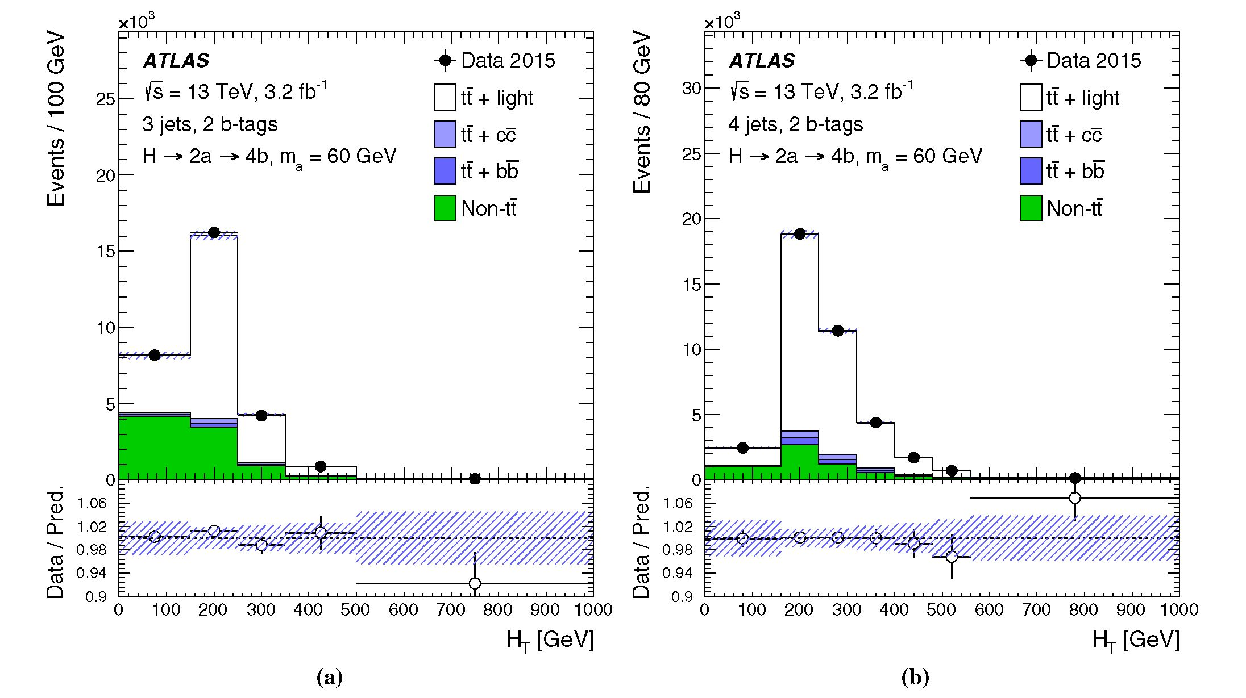
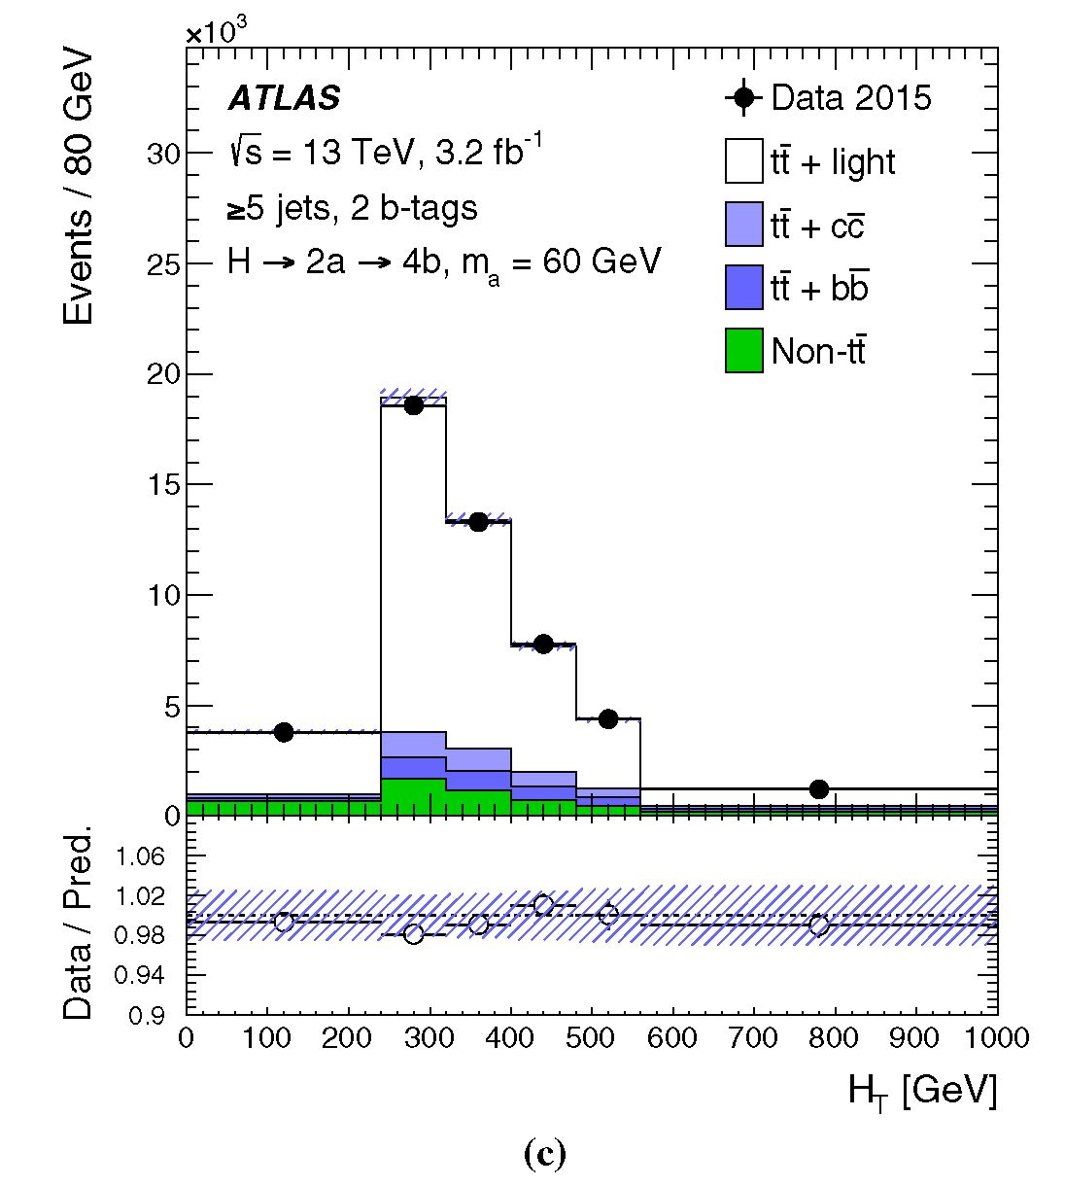
Eur. Phys. J. C (2016) 76:605
Page 11 of 31 605
12n
Fig. 5 Comparison between the data and prediction for the distribu-
tion of the HT variable used in the control regions with two b-tagged
jets. These distributions are after the fit is performed on data under
the background-only hypothesis. The hashed area represents the total
uncertainty in the background. The last bin contains the overflow
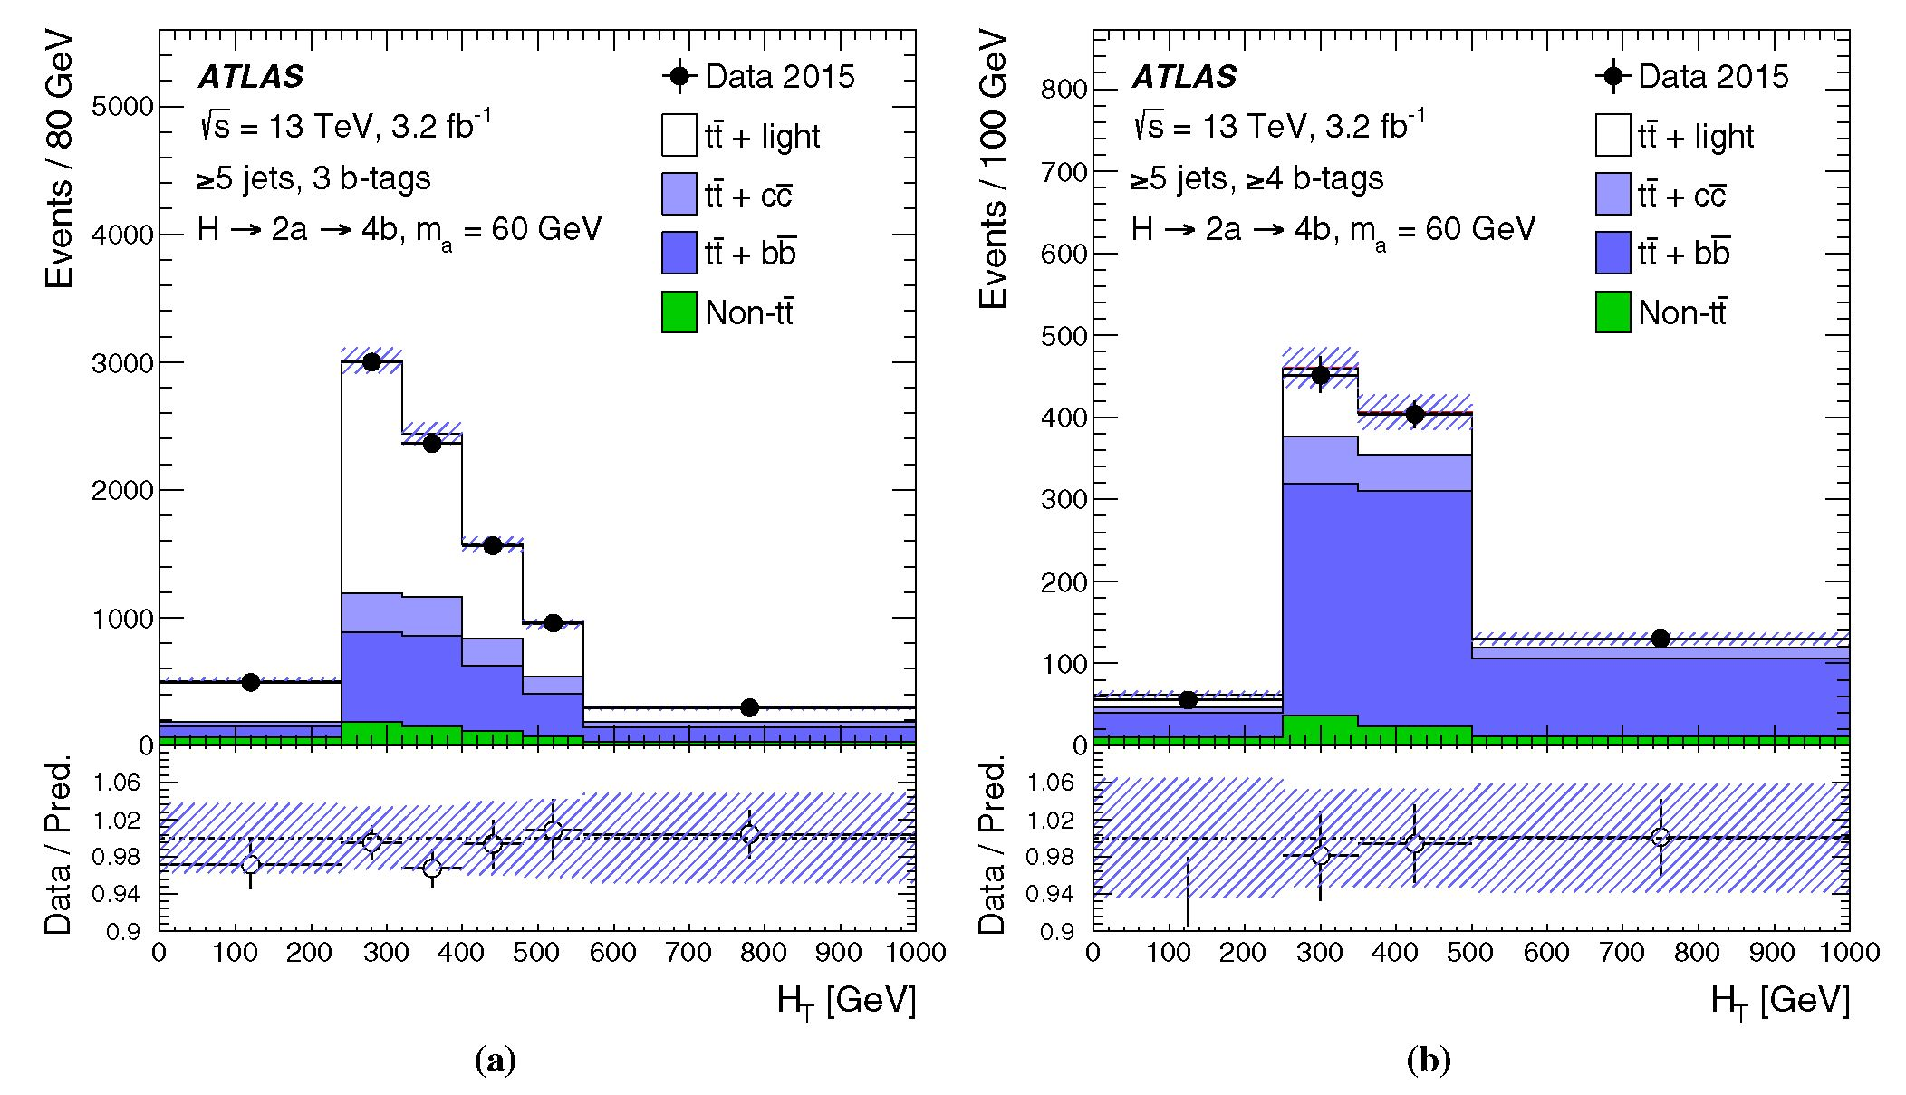
605 Page 12 of 31
Eur. Phys. J. C (2016) 76:605
Fig. 6 Comparison between the data and prediction for the distribution of the Ht variable used in the control regions with three and four fe-tagged
jets. These distributions are after the fit is performed on data under the background-only hypothesis. The last bin contains the overflow
tainty in the c-jet-tagging scale factors, and 45% uncertainty
in the normalisation of the ff+light background normalisa-
tion associated with the uncertainty in the light-jet-tagging
scale factors.
Background modelling: Several sources of systematic
uncertainty affecting the modelling of ff+jets are considered.
An uncertainty of approximately 6% is assumed for the ft
production cross section [72], including contributions from
variations of the factorisation and renormalisation scales, and
uncertainties arising from the PDFs, aS, and the top-quark
mass.
A 50% uncertainty is assigned to the normalisation of the
ft, background. This uncertainty is derived from a comparison
of the ft, production cross sections predicted by Powheg-
Box+Pythia and by Sherpa+OpenLoops at NLO (see
Sect. 4) [33]. An additional 50% uncertainty is assigned to
the component of the ff background that contains exactly one
fe-hadron not originating from a top-quark decay matched to
a particle jet. The same systematic uncertainty of 50% is
applied to the normalisation of the fefe background in the
absence of an NLO prediction for this process. The uncer-
tainties in the ft, components and fefe are treated as uncorre-
lated.
Systematic uncertainties affecting the shape of the ft back-
ground account for the choice of generator, the choice of
parton shower and hadronisation models, and the effects
of initial- and final-state radiation. The uncertainties are
derived from comparisons between the nominal simulation
and alternative samples produced with Powheg- Box or
MADGRAPH5_aMC@NLO interfaced to Pythia or Her-
wig++ (see Sect. 4) and are treated as uncorrelated across
ff+jets backgrounds. Additional uncertainties are evaluated
to account for the use of Sherpa+OpenLoops NLO to
model the ft, background. In particular, uncertainties are
assessed for the PDFs, as well as the choice of shower
recoil model and scale. An additional uncertainty accounts
for limited knowledge of the component of the ft, background
originating from multiple parton interactions, which is not
included in the NLO prediction. These systematic uncer-
tainties are estimated following the methods described in
Ref. [33].
The uncertainties in the predictions for the total cross
sections for the other background processes are applied as
normalisation uncertainties and are: 5% for each of the
W/Z +jets and diboson processes, +5%/-4% for single-
top-quark production, 15% for ff + y/W/Z and +9%/-
12% for ffH [79-81,95-99]. An additional uncertainty of
24% is added in quadrature for each additional jet to account
for the extrapolation to higher jet multiplicities, based on
a comparison among different algorithms for merging LO
matrix-element and parton shower simulations [100]. An
uncertainty is applied to the modelling of the single-top-
12n
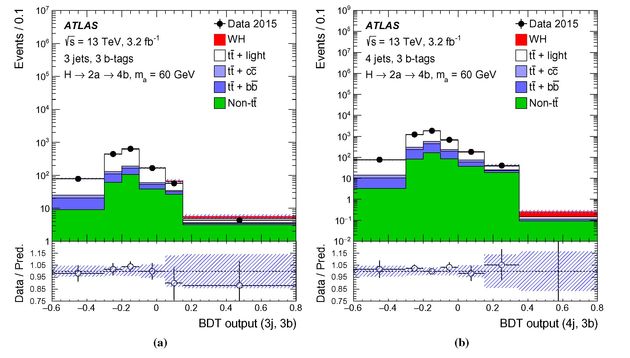
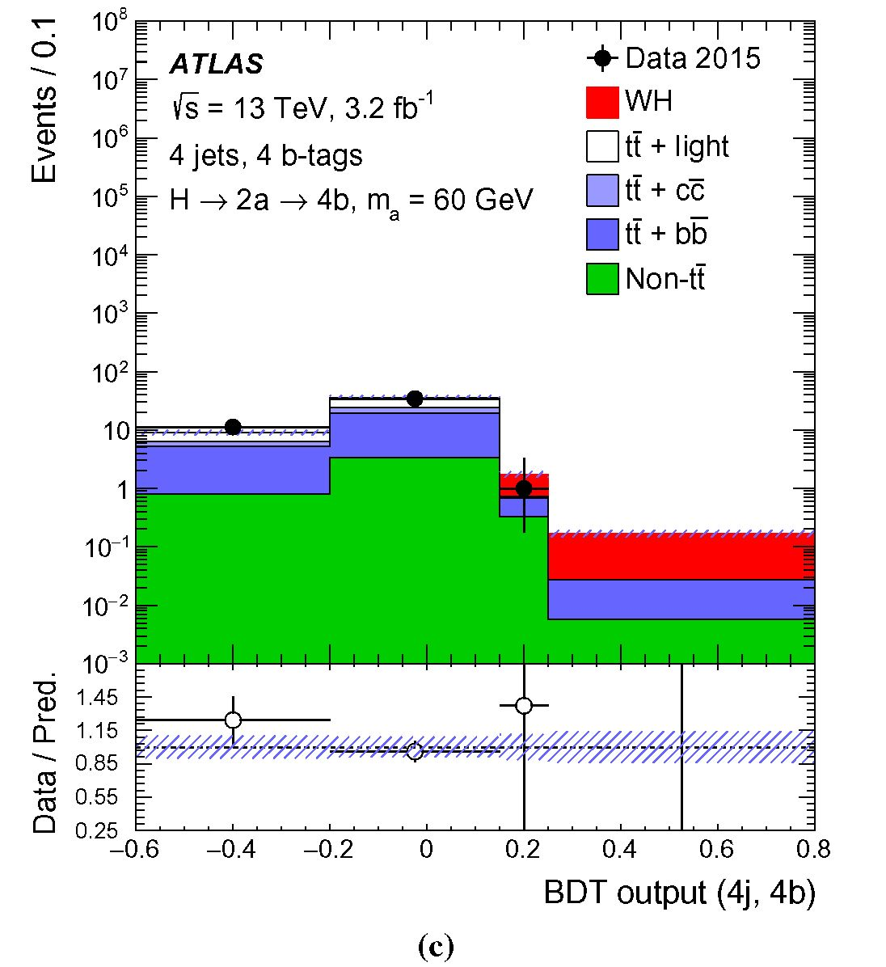
Eur. Phys. J. C (2016) 76:605
Page 13 of 31 605
Fig. 7 Comparison between the data and prediction for the distribution
of the BDT discriminant used in the signal regions. These distributions
are after the fit is performed on data under the background-only hypoth-
esis. The hashed area represents the total uncertainty in the background.
The distributions for the signal model (WH, H ^ 2a ^ 4fe), with
12n
ma = 60GeV, are normalised to the SM pp ^ WH cross section,
assuming BR(H ^ aa) x BR(a ^ fefe)2 = 1. The BDT output
is determined in the range [—1, 1]. The first and last bin contain the
underflow and overflow, respectively. Markers are not drawn if they are
outside the y-axis range
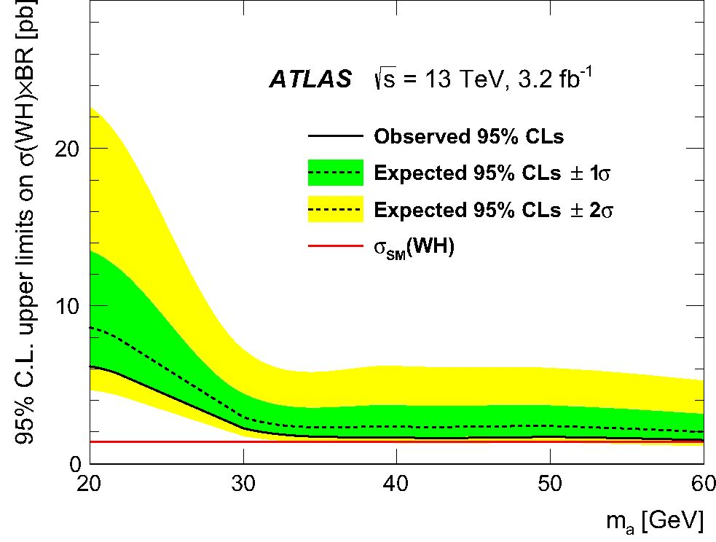
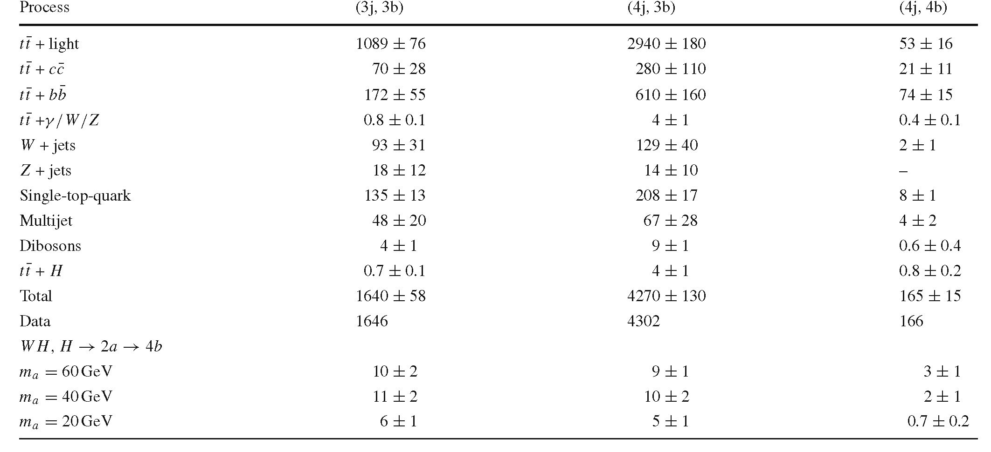
605 Page 14 of 31
Eur. Phys. J. C (2016) 76:605
Table 3 Expected event yields of the SM background processes in
the three signal regions after performing the fit with the background-
only hypothesis. The observed data and the number of expected signal
events are also indicated. The signal yields are quoted for some repre-
sentative values of ma and assume the SM pp ^ WH cross section,
aSM(WH) = 1.37 pb [57], and BR(H ^ aa) x BR(a ^ ftft)2 = 1.
The uncertainties include statistical and systematic components (sys-
tematic uncertainties are discussed in Sect. 6). The total uncertainty can
differ from the sum in quadrature of individual sources due to correla-
tions between them
quark background to account for the choice of scheme to
handle the overlaps between the tt and Wt final states. Small
uncertainties arising from scale variations, which change the
amount of initial-state radiation and thus the event kinemat-
ics, are also considered.
Uncertainties in the estimate of the multijet background
come from the limited number of events in the data sam-
ple without the isolation requirement and from uncertainties
in the measured non-prompt and prompt lepton efficiencies.
The normalisation uncertainty assigned to this background
is 60%, as derived by comparing the multijet background
prediction to data in control regions obtained by inverting
the requirements on the and on mW. An uncertainty in
the shape of the predicted background distribution covers the
difference between the prediction obtained by reducing the
required number of ft-tagged jets and the prediction at high
ft-tagged-jet multiplicity (see Sect. 4).
Signal modelling Several sources of systematic uncertainty
affect the theoretical modelling of the signal acceptance.
Uncertainties originate from the choice of PDFs, the factor-
ization and renormalization scales, and the parton shower,
hadronisation and underlying event models.
As described in Sect. 5.2, a binned maximum-likelihood
fit is performed on the distributions of the final discriminant
in the eight channels considered. The fit constrains system-
atic uncertainties from several sources thanks to the large
number of events in the analysis channels considered and
Fig. 8 Upper limit at 95% CL on o(WH) x BR, where BR =
BR(H ^ aa) x BR(a ^ ftft)2, versus ma. The observed (CLs) val-
ues (solid ftlack line) are compared to the expected (median) (CLs)
values under the background-only hypothesis (dotted ftlack line). The
surrounding shaded ftands correspond to the 68 and 95% CL intervals
around the expected (CLs) values, denoted by ±1a and ±2a, respec-
tively. The solid red line indicates the SM pp ^ WH cross section,
assuming BR(H ^ aa) x BR(a ^ ftft)2 = 1. Markers are not drawn
if they are outside the y-axis range
the variations in the background composition across chan-
nels. The channels with two ft-tagged jets constrain the main
uncertainties affecting the tf+light background prediction,
while the channels with >5 jets and >3 ft-tagged jets are
12n
Eur. Phys. J. C (2016) 76:605
Page 15 of 31 605
sensitive to the dominant uncertainties affecting the tf+HF
background prediction.
After performing the fit, the leading sources of systematic
uncertainty are the modelling of the tf+jets background and
b-, c- and light-jet-tagging efficiencies. Table 2 summarises
the systematic uncertainties by indicating their impact on
the normalisation of the signal and the main backgrounds in
the (4j, 4b) channel. The uncertainties for the other signal
channels (3j, 3b) and (4j, 3b) are reduced to about 7% for
the tf+light contribution, mainly due to the reduced depen-
dence on the light-jet-tagging efficiency, and to about 12%
for the signal, primarily because of the reduced b-tagging
efficiency uncertainty due to the lower b-tagged-jet multi-
plicity requirement.
- Results
The best fit of the background predictions to data in the
binned maximum-likelihood fit is shown in Figures 5, 6 and
7. Table 3 shows the resulting yields and uncertainties for
the signal regions after the fit. The SM background yields
obtained after performing the fit are in agreement with the
results from a fit using only the HT distributions in the control
regions.
In the absence of a significant excess of data above
the background prediction, upper limits are calculated for
p, defined in Eq. (1). The modified frequentist method
(CLs) [101] and asymptotic formulae [102] are used. Figure 8
shows the upper limits obtained at 95% CL. The mass hypoth-
esis ma is tested in steps of 10 GeV between 20 and 60 GeV.
The observed (expected) 95% CL upper limits on p range
from 6.2 (8.6) pb, assuming ma = 20GeV, to 1.5 (2.0) pb,
assuming ma = 60GeV. Assuming the SM pp ^ WH
cross section, it is not possible to set limits on the branching
fraction with the amount of data used. The reduced sensitivity
for the light a-boson hypothesis is due to a lower acceptance
caused by overlapping b-jets. The event yields indicated in
Table 3 correspond to the sum of all BDT bins, while the fit
is most sensitive in the highest BDT bins, where the data are
slightly below the prediction, and hence the observed limit
is slightly lower than the expected one.
- Conclusion
This paper presents a dedicated search for exotic decays
of the Higgs boson to a pair of new spin-zero particles,
H ^ aa, where the new a-boson decays to b-quarks.
The search focuses on the process pp ^ WH where the
Higgs boson is produced in association with a W boson.
The analysis uses the pp collision dataset at */s = 13TeV
recorded by the ATLAS detector at the LHC in 2015, cor-
responding to an integrated luminosity of 3.2 ± 0.2fb-1.
The search for H ^ 2a ^ 4b is performed in the mass
range 20GeV < ma < 60GeV. The analysis uses sev-
eral kinematic variables combined in a multivariate discrim-
inant in signal regions and uses control regions to reduce the
uncertainties in the backgrounds. No significant excess of
data is observed relative to the SM predictions. Upper lim-
its are derived for the product of the production cross sec-
tion for pp ^ WH times the branching ratio for the decay
H ^ 2a ^ 4b. The upper limit ranges from 6.2 pb for an
a-boson mass ma = 20 GeV to 1.5 pb for ma = 60 GeV.
Acknowledgements We thank CERN for the very successful opera-
tion of the LHC, as well as the support staff from our institutions with-
out whom ATLAS could not be operated efficiently. We acknowledge
the support of ANPCyT, Argentina; YerPhI, Armenia; ARC, Australia;
BMWFW and FWF, Austria; ANAS, Azerbaijan; SSTC, Belarus; CNPq
and FAPESP, Brazil; NSERC, NRC and CFI, Canada; CERN; CONI-
CYT, Chile; CAS, MOST and NSFC, China; COLCIENCIAS, Colom-
bia; MSMT CR, MPO CR and VSC CR, Czech Republic; DNRF and
DNSRC, Denmark; IN2P3-CNRS, CEA-DSM/IRFU, France; GNSF,
Georgia; BMBF, HGF, and MPG, Germany; GSRT, Greece; RGC, Hong
Kong SAR, China; ISF, I-CORE and Benoziyo Center, Israel; INFN,
Italy; MEXT and JSPS, Japan; CNRST, Morocco; FOM and NWO,
Netherlands; RCN, Norway; MNiSW and NCN, Poland; FCT, Portu-
gal; MNE/IFA, Romania; MES of Russia and NRC KI, Russian Fed-
eration; JINR; MESTD, Serbia; MSSR, Slovakia; ARRS and MIZS,
Slovenia; DST/NRF, South Africa; MINECO, Spain; SRC and Wal-
lenberg Foundation, Sweden; SERI, SNSF and Cantons of Bern and
Geneva, Switzerland; MOST, Taiwan; TAEK, Turkey; STFC, United
Kingdom; DOE and NSF, United States of America. In addition, indi-
vidual groups and members have received support from BCKDF, the
Canada Council, CANARIE, CRC, Compute Canada, FQRNT, and the
Ontario Innovation Trust, Canada; EPLANET, ERC, FP7, Horizon 2020
and Marie Skłodowska-Curie Actions, European Union; Investisse-
ments d’Avenir Labex and Idex, ANR, Region Auvergne and Fondation
Partager le Savoir, France; DFG and AvH Foundation, Germany; Her-
akleitos, Thales and Aristeia programmes co-financed by EU-ESF and
the Greek NSRF; BSF, GIF and Minerva, Israel; BRF, Norway; Gen-
eralitat de Catalunya, Generalitat Valenciana, Spain; the Royal Society
and Leverhulme Trust, United Kingdom. The crucial computing sup-
port from all WLCG partners is acknowledged gratefully, in particular
from CERN, the ATLAS Tier-1 facilities at TRIUMF (Canada), NDGF
(Denmark, Norway, Sweden), CC-IN2P3 (France), KIT/GridKA (Ger-
many), INFN-CNAF (Italy), NL-T1 (Netherlands), PIC (Spain), ASGC
(Taiwan), RAL (UK) and BNL (USA), the Tier-2 facilities worldwide
and large non-WLCG resource providers. Major contributors of com-
puting resources are listed in Ref. [103].
Open Access This article is distributed under the terms of the Creative
Commons Attribution 4.0 International License (http://creativecomm
ons.org/licenses/by/4.0/), which permits unrestricted use, distribution,
and reproduction in any medium, provided you give appropriate credit
to the original author(s) and the source, provide a link to the Creative
Commons license, and indicate if changes were made.
Funded by SCOAP3.
References
- ATLAS Collaboration, Observation of a new particle in the search
for the Standard Model Higgs boson with the ATLAS detector at
12n
605 Page 16 of 31
Eur. Phys. J. C (2016) 76:605
the LHC. Phys. Lett. B 716 (2012). doi:10.1016/j.physletb.2012.
08.020. arXiv:1207.7214 [hep-ex]
- CMS Collaboration, Observation of a new boson at a mass of 125
GeV with the CMS experiment at the LHC. Phys. Lett. B 716,
30 (2012). doi:10.1016/j.physletb.2012.08.021. arXiv:1207.7235
[hep-ex]
- ATLAS Collaboration, Measurements of the Higgs boson pro-
duction and decay rates and coupling strengths using pp colli-
sion data at -/s = 7 and 8 TeV in the ATLAS experiment. Eur.
Phys. J. C 76, 6 (2016). doi:10.1140/epjc/s10052-015-3769-y.
arXiv:1507.04548 [hep-ex]
- CMS Collaboration, Precise determination of the mass of the
Higgs boson and tests of compatibility of its couplings with
the standard model predictions using proton collisions at 7
and 8 TeV. Eur. Phys. J. C 75, 212 (2015). doi:10.1140/epjc/
s10052-015-3351-7. arXiv:1412.8662 [hep-ex]
- ATLAS and CMS Collaborations Measurements of the Higgs
boson production and decay rates and constraints on its couplings
from a combined ATLAS and CMS analysis of the LHC pp colli-
sion data at VS = 7 and 8 TeV (2016). arXiv:1606.02266 [hep-ex]
- D. Curtin et al., Exotic decays of the 125 GeV Higgs boson. Phys.
Rev. D 90, 075004 (2014). doi:10.1103/PhysRevD.90.075004.
arXiv:1312.4992 [hep-ph]
- B.A. Dobrescu, K.T. Matchev, Light axion within the next-to-
minimal supersymmetric standard model. JHEP 09, 031 (2000).
doi:10.1088/1126-6708/2000/09/031. arXiv:hep-ph/0008192
- U. Ellwanger et al., Towards a no lose theorem for NMSSM Higgs
discovery at the LHC (2003). arXiv:hep-ph/0305109
- R. Dermisek, J.F. Gunion, Escaping the large fine tuning and little
hierarchy problems in the next to minimal supersymmetric model
andh > aa decays. Phys. Rev. Lett. 95,041801 (2005). doi:10.
1103/PhysRevLett.95.041801. arXiv:hep-ph/0502105
- S. Chang et al., Nonstandard higgs boson decays. Ann. Rev. Nucl.
Part. Sci. 58,75-98 (2008). doi:10.1146/annurev.nucl.58.110707.
171200. arXiv:0801.4554 [hep-ph]
- D.E. Morrissey, A. Pierce, Modified higgs boson phenomenol-
ogy from gauge or gaugino mediation in the NMSSM. Phys.
Rev. D 78, 075029 (2008). doi:10.1103/PhysRevD.78.075029.
arXiv:0807.2259 [hep-ph]
- V. Silveira, A. Zee, Scalar phantoms. Phys. Lett. B 161, 136
(1985). doi: 10.1016/0370-2693(85)90624-0
- M. Pospelov, A. Ritz, M.B. Voloshin, Secluded WIMP dark mat-
ter. Phys. Lett. B 662,53-61 (2008). doi:10.1016/j.physletb.2008.
02.052. arXiv:0711.4866 [hep-ph]
- P. Draper et al., Dark light higgs. Phys. Rev. Lett. 106, 121805
(2011). doi: 10.1103/PhysRevLett.106.121805. arXiv:1009.3963
[hep-ph]
- S. Ipek, D. McKeen, A.E. Nelson, A renormalizable model for
the galactic center gamma ray excess from dark matter annihila-
tion. Phys. Rev. D 90,055021 (2014). doi:10.1103/PhysRevD.90.
055021. arXiv:1404.3716 [hep-ph]
- A. Martin, J. Shelton, J. Unwin, Fitting the galactic cen-
ter gamma-ray excess with cascade annihilations. Phys.
Rev. D 90, 103513 (2014). doi:10.1103/PhysRevD.90.103513.
arXiv:1405.0272 [hep-ph]
- S. Profumo, M.J. Ramsey-Musolf, G. Shaughnessy, Singlet
higgs phenomenology and the electroweak phase transition.
JHEP 08, 010 (2007). doi:10.1088/1126-6708/2007/08/010.
arXiv:0705.2425 [hep-ph]
- N. Blinov et al., Electroweak baryogenesis from exotic elec-
troweak symmetry breaking. Phys. Rev. D 92, 035012 (2015).
doi: 10.1103/PhysRevD.92.035012. arXiv:1504.05195 [hep-ph]
- G. Burdman et al., Folded supersymmetry and the LEP para-
dox. JHEP 02,009 (2007). doi:10.1088/1126-6708/2007/02/009.
arXiv:hep-ph/0609152
- N. Craig et al., Naturalness in the dark at the LHC. JHEP 07, 105
(2015). doi:10.1007/JHEP07(2015)105. arXiv:1501.05310 [hep-
ph]
- D. Curtin, C.B. Verhaaren, Discovering uncolored naturalness
in exotic higgs decays. JHEP 12, 072 (2015). doi:10.1007/
JHEP12(2015)072. arXiv:1506.06141 [hep-ph]
- M. Ajello et al., Fermi-LAT observations of high-energy y-
ray emission toward the galactic center. Astrophys. J. 819,
44 (2016). doi:10.3847/0004-637X/819/1/44. arXiv:1511.02938
[astro-ph.HE]
- C. Boehm et al., Extended gamma-ray emission from Coy dark
matter. JCAP 1405, 009 (2014). doi:10.1088/1475-7516/2014/
05/009. arXiv:1401.6458 [hep-ph]
- V. Abazov et al., Search for NMSSM Higgs bosons in the
h ^ aa ^ pppp, ppT t channels using p anti-p collisions
at VS = 1.96 TeV. Phys. Rev. Lett. 103, 061801 (2009). doi:10.
1103/PhysRevLett.103.061801. arXiv:0905.3381 [hep-ex]
- ATLAS Collaboration, Search for Higgs bosons decaying to aa
in the ppTT final state in pp collisions at -/s = 8 TeV with
the ATLAS experiment. Phys. Rev. D 92, 052002 (2015). doi:10.
1103/PhysRevD.92.052002. arXiv:1505.01609 [hep-ex]
- CMS Collaboration, A search for pair production of new light
bosons decaying into muons. Phys. Lett. B 752, 146-168 (2016).
doi:10.1016/j.physletb.2015.10.067. arXiv:1506.00424 [hep-ex]
- ATLAS Collaboration, Search for long-lived neutral particles
decaying into lepton jets in proton-proton collisions at Vs = 8
TeV withthe ATLAS detector. JHEP 11,088 (2014). doi:10.1007/
JHEP11(2014)088. arXiv:1409.0746 [hep-ex]
- CMS Collaboration, Search for long-lived particles that decay
into final states containing two electrons or two muons in proton-
proton collisions at Vs = 8 TeV. Phys. Rev. D 91,052012 (2015).
doi:10.1103/PhysRevD.91.052012. arXiv:1411.6977 [hep-ex]
- ATLAS Collaboration, Search for long-lived, weakly interacting
particles that decay to displaced hadronic jets in proton-proton
collisions at Vs = 8 TeV with the ATLAS detector. Phys.
Rev. D 92, 012010 (2015). doi:10.1103/PhysRevD.92.012010.
arXiv:1504.03634 [hep-ex]
- ATLAS Collaboration, Search for pair-produced long-lived neu-
tral particles decaying in the ATLAS hadronic calorimeter in
pp collisions at Vs = 8 TeV. Phys. Lett. B 743, 15 (2015).
arXiv:1510.04020 [hep-ex]
- CMS Collaboration, Search for long-lived neutral particles decay-
ing to quark-antiquark pairs in proton-proton collisions at Vs =
8 TeV. Phys. Rev. D 91, 012007 (2015). doi:10.1103/PhysRevD.
91.012007. arXiv:1411.6530 [hep-ex]
- LHCb Collaboration, Search for long-lived particles decaying
to jet pairs. Eur. Phys. J. C 75, 152 (2015). doi:10.1140/epjc/
s10052-015-3344-6. arXiv:1412.3021 [hep-ex]
- ATLAS Collaboration, Search for the Standard Model Higgs
boson produced in association with top quarks and decaying into
bb in pp collisions at Vs = 8 TeV with the ATLAS detector. Eur.
Phys. J. C 75,349 (2015). doi:10.1140/epjc/s10052-015-3543-1.
arXiv:1503.05066 [hep-ex]
- ATLAS Collaboration, Search for production of vector-like quark
pairs and of four top quarks in the lepton-plus-jets final state in pp
collisions at Vs = 8 TeV with the ATLAS detector. JHEP 08, 105
(2015). doi:10.1007/JHEP08(2015)105. arXiv:1505.04306 [hep-
ex]
- ATLAS Collaboration, Search for flavour-changing neutral cur-
rent top quark decays t ^ Hq in pp collisions at -fs = 8 TeV
with the ATLAS detector. JHEP 12, 061 (2015). doi:10.1007/
JHEP12(2015)061. arXiv:1509.06047 [hep-ex]
- ATLAS Collaboration, Search for charged Higgs bosons in the
H± ^ tb decay channel in pp collisions at Vs = 8 TeV
using the ATLAS detector. JHEP 03, 127 (2016). doi:10.1007/
JHEP03(2016)127. arXiv:1512.03704 [hep-ex]
12n
Eur. Phys. J. C (2016) 76:605
Page 17 of 31 605
- ATLAS Collaboration, The ATLAS experiment at the CERN
Large Hadron Collider. JINST 3, S08003 (2008). doi:10.1088/
1748-0221/3/08/S08003
- ATLAS Collaboration, ATLAS insertable b-layer technical design
report. ATLAS-TDR-19 (2010). http://cdsweb.cern.ch/record/
1291633
- ATLAS Collaboration, 2015 start-up trigger menu and initial per-
formance assessment of the ATLAS trigger using Run-2 data,
ATL-DAQ-PUB-2016-001 (2016). http://cdsweb.cern.ch/record/
2136007
- ATLAS Collaboration, Electron reconstruction and identifica-
tion efficiency measurements with the ATLAS detector using the
2011 LHC proton-proton collision data. Eur. Phys. J. C 74, 2941
(2014). doi:10.1140/epjc/s10052-014-2941-0. arXiv:1404.2240
[hep-ex]
- ATLAS Collaboration, Electron efficiency measurements with
the ATLAS detector using the 2012 LHC proton-proton colli-
sion data. ATLAS-CONF-2014-032 (2014). http://cdsweb.cern.
ch/record/1706245
- ATLAS Collaboration, Muon reconstruction performance of
the ATLAS detector in proton-proton collision data at -fs =
13 TeV. Eur. Phys. J. C 76, 292 (2016). doi:10.1140/epjc/
s10052-016-4120-y. arXiv:1603.05598 [hep-ex]
- ATLAS Collaboration, Topological cell clustering in the ATLAS
calorimeters and its performance in LHC Run 1 (2016).
arXiv:1603.02934 [hep-ex]
- M. Cacciari, G.P. Salam, Dispelling the N3 myth for the kt jet-
finder. Phys. Lett. B 641, 57 (2006). doi:10.1016/j.physletb.2006.
08.037. arXiv:0512210 [hep-ph]
- M. Cacciari, G.P. Salam, G. Soyez, The anti-kt jet clustering algo-
rithm. JHEP 04, 063 (2008). doi:10.1088/1126-6708/2008/04/
- arXiv:0802.1189 [hep-ph]
- ATLAS Collaboration, Performance of pile-up mitigation tech-
niques for jets in pp collisions with the ATLAS detector. Nucl.
Instrum. Meth. A 824, 367 (2016). doi:10.1016/j.nima.2015.10.
039. arXiv:1510.03823 [hep-ex]
- ATLAS Collaboration, Expected performance of the ATLAS b-
tagging algorithms in Run-2. ATL-PHYS-PUB-2015-022 (2015).
http://cdsweb.cern.ch/record/2037697
- ATLAS Collaboration, Performance of fe-jet identification in the
ATLAS experiment. JINST 11, P04008 (2016). doi:10.1088/
1748-0221/11/04/P04008. arXiv:1512.01094 [hep-ex]
- ATLAS Collaboration, Commissioning of the ATLAS fe-tagging
algorithms using tt events in early Run-2 data. ATLAS-PHYS-
PUB-2015-039 (2015). http://cdsweb.cern.ch/record/2047871
- ATLAS Collaboration, Performance of missing transverse
momentum reconstruction in proton-proton collisions at 7 TeV
with ATLAS. Eur. Phys. J. C 72, 1844 (2012). doi:10.1140/epjc/
s10052-011-1844-6. arXiv:1108.5602 [hep-ex]
- ATLAS Collaboration, Performance of missing transverse
momentum reconstruction for the ATLAS detector in the first
proton-proton collisions at at ftrs= 13 TeV. ATL-PHYS-PUB-
- 027 (2015). http://cdsweb.cern.ch/record/2037904
- S. Frixione, P. Nason, G. Ridolfi, A positive-weight next-
to-leading-order monte carlo for heavy flavour hadroproduc-
tion. JHEP 09,126 (2007). doi:10.1088/1126-6708/2007/09/126.
arXiv:0707.3088 [hep-ph]
- P. Nason, A new method for combining NLO QCD with shower
Monte Carlo algorithms. JHEP 11, 040 (2004). doi:10.1088/
1126-6708/2004/11/040. arXiv:hep-ph/0409146 [hep-ph]
- S. Frixione, P. Nason, C. Oleari, Matching NLO QCD compu-
tations with parton shower simulations: the POWHEG method.
JHEP 11, 070 (2007). doi:10.1088/1126-6708/2007/11/070.
arXiv:0709.2092 [hep-ph]
- S. Alioli et al., A general framework for implementing NLO
calculations in shower Monte Carlo programs: the POWHEG
BOX. JHEP 06, 043 (2010). doi:10.1007/JHEP06(2010)043.
arXiv:1002.2581 [hep-ph]
- H.-L. Lai et al., New parton distributions for collider physics.
Phys. Rev. D 82 , 074024 (2010). doi:10.1103/PhysRevD.82.
074024. arXiv:1007.2241 [hep-ph]
- J.R. Andersen et al., Handbook of LHC Higgs cross sections: 3.
Higgs properties, ed. by S Heinemeyer et al. (2013) doi:10.5170/
CERN-2013-004. arXiv:1307.1347 [hep-ph]
- T. Sjostrand, S. Mrenna, P. Skands, A. Brief, Introduction to Pythia
8.1. Comput. Phys. Commun. 178, 852(2008). doi:10.1016/j.cpc.
2008.01.036. arXiv:0710.3820 [hep-ph]
- ATLAS Collaboration, ATLAS Run 1 Pythia8 tunes. ATL-PHYS-
PUB-2014-021 (2014). http://cdsweb.cern.ch/record/1966419
- ATLAS Collaboration, Comparison of Monte Carlo generator
predictions to ATLAS measurements of top pair production at
V = 7Tev. ATL-PHYS-PUB-2015-002 (2015). http://cdsweb.
cern.ch/record/1981319
- T. Sjostrand, S. Mrenna, P.Z. Skands, PYTHIA 6.4 physics and
manual. JHEP 05, 026 (2006). doi:10.1088/1126-6708/2006/05/
- arXiv:hep-ph/0603175 [hep-ph]
- P.Z. Skands, Tuning Monte Carlo generators: the perugia tunes.
Phys. Rev. D 82 , 074018 (2010). doi:10.1103/PhysRevD.82.
074018. arXiv:1005.3457 [hep-ph]
- M. Bahr et al., Herwig++ physics and manual. Eur. Phys. J. C 58
(2008). doi:10.1140/epjc/s10052-008-0798-9. arXiv:0803.0883
[hep-ph]
- J. Alwall et al., The automated computation of tree-level and next-
to-leading order differential cross sections, and their matching to
parton shower simulations. JHEP 07, 079 (2014). doi:10.1007/
JHEP07(2014)079. arXiv:1405.0301 [hep-ph]
- ATLAS Collaboration, Comparison of Monte Carlo generator pre-
dictions from Powheg and Sherpa to ATLAS measurements of
top pair production at 7 Tev. ATL-PHYS-PUB-2015-011 (2015).
http://cdsweb.cern.ch/record/2020602
- M. Cacciari et al., Top-pair production at hadron colliders
with next-to-next-to-leading logarithmic soft-gluon resummation.
Phys. Lett. B 710, 612 (2012). doi:10.1016/j.physletb.2012.03.
- arXiv:1111.5869 [hep-ph]
- M. Beneke et al., Hadronic top-quark pair production with NNLL
threshold resummation. Nucl. Phys. B 855, 695-741 (2012).
doi:10.1016/j.nuclphysb.2011.10.021. arXiv:1109.1536 [hep-ph]
- P. Barnreuther, M. Czakon, A. Mitov, Percent-level-precision
physics at the tevatron: next-to-next-to-leading order QCD correc-
tions to qq ^ tt+X. Phys. Rev. Lett. 109,132001 (2012). doi:10.
1103/PhysRevLett.109.132001. arXiv:1204.5201 [hep-ph]
- M. Czakon, A. Mitov, NNLO corrections to top-pair production at
hadron colliders: the all-fermionic scattering channels. JHEP 12,
054 (2012). doi:10.1007/JHEP12(2012)054. arXiv:1207.0236
[hep-ph]
- M. Czakon, A. Mitov, NNLO corrections to top pair production at
hadron colliders: the quark-gluon reaction. JHEP 01, 080 (2013).
doi:10.1007/JHEP01(2013)080. arXiv:1210.6832 [hep-ph]
- M. Czakon, P. Fiedler, A. Mitov, Total top-quark pair-production
cross section at hadron colliders through O(a^s). Phys. Rev.
Lett. 110,252004 (2013). doi:10.1103/PhysRevLett.110.252004.
arXiv:1303.6254 [hep-ph]
- M. Czakon, A. Mitov, Top++: a program for the calcula-
tion of the top-pair cross-section at hadron colliders. Comput.
Phys. Commun. 185, 2930 (2014). doi:10.1016/j.cpc.2014.06.
- arXiv:1112.5675 [hep-ph]
- T. Gleisberg et al., Event generation with SHERPA 1.1.
JHEP 02 , 007 (2009). doi:10.1088/1126-6708/2009/02/007.
arXiv:0811.4622 [hep-ph]
- F. Cascioli, P. Maierhofer, S. Pozzorini, Scattering amplitudes
with open loops. Phys. Rev. Lett. 108, 111601 (2012). doi:10.
1103/PhysRevLett.108.111601. arXiv:1111.5206 [hep-ph]
12n
605 Page 18 of 31
Eur. Phys. J. C (2016) 76:605
- S. Alioli et al., NLO single-top production matched with shower in
POWHEG: s- and t-channel contributions. JHEP 09, 111 (2009).
doi: 10.1007/JHEP02(2010)011. doi:10.1088/1126-6708/2009/
09/111. (Erratum: JHEP 02, 011). arXiv:0907.4076 [hep-ph]
- E. Re, Single-top Wt-channel production matched with parton
showers using the POWHEG method. Eur. Phys. J. C 71, 1547
(2011). doi:10.1140/epjc/s10052-011-1547-z. arXiv:1009.2450
[hep-ph]
- S. Frixione et al., Single-top production in MC@NLO.
JHEP 03 , 092 (2006). doi:10.1088/1126-6708/2006/03/092.
arXiv:hep-ph/0512250
- R. Frederix, E. Re, P. Torrielli, Single-top t-channel hadroproduc-
tion in the four-flavour scheme with POWHEG and aMC@NLO.
JHEP 09, 130 (2012). doi:10.1007/JHEP09(2012)130.
arXiv:1207.5391 [hep-ph]
- N. Kidonakis, Next-to-next-to-leading-order collinear and soft
gluon corrections for t-channel single top quark production. Phys.
Rev. D 83, 091503 (2011). doi:10.1103/PhysRevD.83.091503.
arXiv:1103.2792 [hep-ph]
- N. Kidonakis, Two-loop soft anomalous dimensions for sin-
gle top quark associated production with a W- or H-. Phys.
Rev. D 82, 054018 (2010). doi:10.1103/PhysRevD.82.054018.
arXiv:1005.4451 [hep-ph]
- N. Kidonakis, NNLL resummation for s-channel single top
quark production. Phys. Rev. D 81, 054028 (2010). doi:10.1103/
PhysRevD.81.054028. arXiv:1001.5034 [hep-ph]
- M.H. Seymour, A. Siodmok, Constraining MPI models using aeff
and recent tevatron and LHC underlying event data. JHEP 10, 113
(2013). doi:10.1007/JHEP10(2013)113. arXiv:1307.5015 [hep-
ph]
- T. Gleisberg, S. Hoche, Comix, a new matrix element genera-
tor. JHEP 12, 039 (2008). doi:10.1088/1126-6708/2008/12/039.
arXiv:0808.3674 [hep-ph]
- C. Anastasiou et al., High precision QCD at hadron colliders:
electroweak gauge boson rapidity distributions at NNLO. Phys.
Rev. D 69, 094008 (2004). doi:10.1103/PhysRevD.69.094008.
arXiv:hep-ph/0312266
- D.J. Lange, The EvtGen particle decay simulation package.
Nucl. Instrum. Meth. A 462, 152-155 (2001). doi:10.1016/
S0168-9002(01)00089-4
- ATLAS Collaboration, The ATLAS simulation infrastruc-
ture. Eur. Phys. J. C 70, 823 (2010). doi:10.1140/epjc/
s10052-010-1429-9. arXiv:1005.4568 [physics.ins-det]
- S. Agostinelli et al., GEANT4: a simulation toolkit. Nucl. Instr.
Meth. A 506, 250 (2003). doi:10.1016/S0168-9002(03)01368-8
- ATLAS Collaboration, The simulation principle and perfor-
mance of the ATLAS fast calorimeter simulation FastCaloSim.
ATLAS-PHYS-PUB-2010-013 (2010). http://cdsweb.cern.ch/
record/1300517
- ATLAS Collaboration, Measurement of the top quark-pair pro-
duction cross section with ATLAS in pp collisions at .Js =
7 TeV. Eur. Phys. J. C 71, 1577 (2011). doi:10.1140/epjc/
s10052-011-1577-6. arXiv:1012.1792 [hep-ex]
- ATLAS Collaboration, Estimation of non-prompt and fake lepton
backgrounds in final states with top quarks produced in proton-
proton collisions at -/s = 8 TeV with the ATLAS detector.
ATLAS-CONF-2014-058 (2014). http://cdsweb.cern.ch/record/
1951336
- F. Pedregosa et al., Scikit-learn: machine learning in python. J.
Mach. Learn. Res. 12, 2825-2830 (2011)
- Y. Freund, R.E. Schapire, A decision-theoretic generalization of
on-line learning and an application to boosting. J. Comput. Syst.
Sci. 55, 119 (1997). doi:10.1006/jcss.1997.1504
- M. Burns et al., Using subsystem MT2 for complete mass deter-
minations in decay chains with missing energy at hadron collid-
ers. JHEP 03, 143 (2009). doi:10.1088/1126-6708/2009/03/143.
arXiv:0810.5576 [hep-ph]
- ATLAS Collaboration, Improved luminosity determination in
pp collisions at ^f(s) = 7 TeV using the ATLAS detector at
the LHC. Eur. Phys. J. C 73, 2518 (2013). doi:10.1140/epjc/
s10052-013-2518-3. arXiv:1302.4393 [hep-ex]
- J.M. Campbell, R.K. Ellis, An update on vector boson pair produc-
tion at hadron colliders. Phys. Rev. D 60, 113006 (1999). doi:10.
1103/PhysRevD.60.113006. arXiv:hep-ph/9905386
- J.M. Campbell, R.K. Ellis, t/W± production and decay at
NLO. JHEP 07, 052 (2012). doi:10.1007/JHEP07(2012)052.
arXiv:1204.5678 [hep-ph]
- M.V. Garzelli et al., ttW± and ttZ hadroproduction at NLO
accuracy in QCD with Parton shower and hadronization
effects. JHEP 11, 056 (2012). doi:10.1007/JHEP11(2012)056.
arXiv:1208.2665 [hep-ph]
- S. Dittmaier et al., Handbook of LHC Higgs cross sections:
1. inclusive observables (2011). doi:10.5170/CERN-2011-002.
arXiv:1101.0593 [hep-ph]
- ATLAS Collaboration, Modelling of the ttH and ttV (V =
W, Z) processes for prs = 13 TeV ATLAS analyses. ATL-PHYS-
PUB-2016-005 (2016). http://cdsweb.cern.ch/record/2120826
- J. Alwall et al., Comparative study of various algorithms for the
merging of parton showers and matrix elements in hadronic col-
lisions. Eur. Phys. J. C 53, 473-500 (2008). doi:10.1140/epjc/
s10052-007-0490-5. arXiv:0706.2569 [hep-ph]
- A.L. Read, Presentation of search results: the CL(s) technique. J.
Phys. G 28, 2693 (2002). doi:10.1088/0954-3899/28/10/313
- G. Cowan et al., Asymptotic formulae for likelihood-based
tests of new physics. Eur. Phys. J. C 71, 1554 (2011).
(Erratum: Eur. Phys. J. C 73, 2501 (2013)). doi:10.1140/
epjc/s10052-011-1554-0. doi:10.1140/epjc/s10052-013-2501-z.
arXiv:1007.1727 [physics.data-an]
- ATLAS Collaboration, ATLAS computing acknowledgements
- 2017, ATL-GEN-PUB-2016-002 (2016). https://cds.cern.
ch/record/2202407
12n
Eur. Phys. J. C (2016) 76:605
Page 19 of 31 605
ATLAS Collaboration
M. Aaboud136d, G. Aad87, B. Abbott114, J. Abdallah65, O. Abdinov12, B. Abeloos118, R. Aben108, O. S. AbouZeid138
N. L. Abraham152, H. Abramowicz156, H. Abreu155, R. Abreu117, Y. Abulaiti149a,149b, B. S. Acharya168a,168b,a
L. Adamczyk40a, D. L. Adams27, J. Adelman109, S. Adomeit101, T. Adye132, A. A. Affolder76, T. Agatonovic-Jovin14,
J. Agricola56, J. A. Aguilar-Saavedra127a,127f, S. P. Ahlen24, F. Ahmadov67,b, G. Aielli134a,134b, H. Akerstedt149a,149b
T. P. A. Akesson83, A. V. Akimov97, G. L. Alberghi22a,22b, J. Albert173, S. Albrand57, M. J. Alconada Verzini73
M. Aleksa32, I. N. Aleksandrov67, C. Alexa28b, G. Alexander156, T. Alexopoulos10, M. Alhroob114, B. Ali129
M. Aliev75a,75b, G. Alimonti93a, J. Alison33, S. P. Alkire37, B. M. M. Allbrooke152, B. W. Allen117, P. P. Allport19
A. Aloisio105a,105b, A. Alonso38,F. Alonso73, C. Alpigiani139,M. Alstaty87,B. Alvarez Gonzalez32, D. Alvarez Piqueras171
M. G. Alviggi105a,105b, B. T. Amadio16, K. Amako68, Y. Amaral Coutinho26a, C. Amelung25, D. Amidei91
S. P. Amor Dos Santos127a,127c, A. Amorim127a,127b, S. Amoroso32, G. Amundsen25, C. Anastopoulos142, L. S. Ancu51
N. Andari19, T. Andeen11, C. F. Anders60b, G. Anders32, J. K. Anders76, K. J. Anderson33, A. Andreazza93a,93b
V. Andrei60a, S. Angelidakis9, I. Angelozzi108, P. Anger46, A. Angerami37, F. Anghinolfi32, A. V. Anisenkov110,c
N. Anjos13, A. Annovi125a,125b, C. Antel60a, M. Antonelli49, A. Antonov99^, F. Anulli133a, M. Aoki68, L. Aperio Bella19
- Arabidze92, Y. Arai68, J. P. Araque127a, A. T. H. Arce47, F. A. Arduh73, J-F. Arguin96, S. Argyropoulos65, M. Arik20a
A. J. Armbruster146, L. J. Armitage78, O. Arnaez32, H. Arnold50, M. Arratia30, O. Arslan23, A. Artamonov98, G. Artoni121
S. Artz85, S. Asai158, N. Asbah44, A. Ashkenazi156, B. Asman149a,149b, L. Asquith152, K. Assamagan27, R. Astalos147a
M. Atkinson170, N. B. Atlay144, K. Augsten129, G. Avolio32, B. Axen16, M. K. Ayoub118, G. Azuelos964, M. A. Baak32
- E. Baas60a, M. J. Baca19, H. Bachacou137, K. Bachas75a,75b, M. Backes151, M. Backhaus32, P. Bagiacchi133a,133b
P. Bagnaia133a,133b, Y. Bai35a, J. T. Baines132, O. K. Baker180, E. M. Baldin110,c, P. Balek176, T. Balestri151, F. Balli137
W. K. Balunas123, E. Banas41, Sw. Banerjee177,e, A. A. E. Bannoura179, L. Barak32, E. L. Barberio90, D. Barberis52a,52b
M. Barbero87, T. Barillari102, M-S Barisits32, T. Barklow146, N. Barlow30, S. L. Barnes86, B. M. Barnett132, R. M. Barnett16
Z. Barnovska-Blenessy5, A. Baroncelli135a, G. Barone25, A. J. Barr121, L. Barranco Navarro171, F. Barreiro84
J. Barreiro Guimaraes da Costa35a, R. Bartoldus146, A. E. Barton74, P. Bartos147a, A. Basalaev124, A. Bassalat118,f
R. L. Bates55, S. J. Batista162, J. R. Batley30, M. Battaglia138, M. Bauce133a,133b, F. Bauer137, H. S. Bawa146,g
J. B. Beacham112,M. D. Beattie74, T. Beau82, P. H. Beauchemin166,P. Bechtle23,H. P. Beck18,h, K. Becker121, M. Becker85
M. Beckingham174, C. Becot111, A. J. Beddall20d, A. Beddall20b, V. A. Bednyakov67, M. Bedognetti108, C. P. Bee151
L. J. Beemster108, T. A. Beermann32, M. Begel27, J. K. Behr44, C. Belanger-Champagne89, A. S. Bell80, G. Bella156
L. Bellagamba22a, A. Bellerive31, M. Bellomo88, K. Belotskiy99, O. Beltramello32, N. L. Belyaev99, O. Benary156^
- Benchekroun136a, M. Bender101, K. Bendtz149a,149b, N. Benekos10, Y. Benhammou156, E. Benhar Noccioli180
J. Benitez65, D. P. Benjamin47, J. R. Bensinger25, S. Bentvelsen108, L. Beresford121, M. Beretta49, D. Berge108
- Bergeaas Kuutmann169, N. Berger5, J. Beringer16, S. Berlendis57, N. R. Bernard88, C. Bernius111, F. U. Bernlochner23
T. Berry79, P. Berta130, C. Bertella85, G. Bertoli149a,149b, F. Bertolucci125a,125b, I. A. Bertram74, C. Bertsche44
D. Bertsche114, G. J. Besjes38, O. Bessidskaia Bylund149a,149b, M. Bessner44, N. Besson137, C. Betancourt50, A. Bethani57
S. Bethke102, A. J. Bevan78, R. M. Bianchi126, L. Bianchini25, M. Bianco32, O. Biebel101, D. Biedermann17, R. Bielski86
N. V. Biesuz125a,125b, M. Biglietti135a, J. Bilbao De Mendizabal51, T. R. V. Billoud96, H. Bilokon49, M. Bindi56
S. Binet118, A. Bingul20b, C. Bini133a,133b, S. Biondi22a,22b, T. Bisanz56, D. M. Bjergaard47, C. W. Black153, J. E. Black146
K. M. Black24, D. Blackburn139, R. E. Blair6, J. -B. Blanchard137, T. Blazek147a, I. Bloch44, C. Blocker25, W. Blum85^
U. Blumenschein56, S. Blunier34a, G. J. Bobbink108, V. S. Bobrovnikov110,c, S. S. Bocchetta83, A. Bocci47, C. Bock101
M. Boehler50, D. Boerner179, J. A. Bogaerts32, D. Bogavac14, A. G. Bogdanchikov110, C. Bohm149a, V. Boisvert79
P. Bokan14,T. Bold40a, A. S. Boldyrev168a,168c, M. Bomben82,M. Bona78,M. Boonekamp137,A. Borisov131, G. Borissov74
J. Bortfeldt32, D. Bortoletto121, V. Bortolotto62a,62b,62c, K. Bos108, D. Boscherini22a, M. Bosman13, J. D. Bossio Sola29
J. Boudreau126, J. Bouffard2, E. V. Bouhova-Thacker74, D. Boumediene36, C. Bourdarios118, S. K. Boutle55, A. Boveia32
J. Boyd32, I. R. Boyko67, J. Bracinik19, A. Brandt8, G. Brandt56, O. Brandt60a, U. Bratzler159, B. Brau88, J. E. Brau117
- M. Braun179^, W. D. Breaden Madden55, K. Brendlinger123, A. J. Brennan90, L. Brenner108, R. Brenner169
S. Bressler176, T. M. Bristow48, D. Britton55, D. Britzger44, F. M. Brochu30, I. Brock23, R. Brock92, G. Brooijmans37
T. Brooks79, W. K. Brooks34b, J. Brosamer16, E. Brost109, J. H Broughton19, P. A. Bruckman de Renstrom41
- Bruncko147b, R. Bruneliere50, A. Bruni22a, G. Bruni22a, L. S. Bruni108, BH Brunt30, M. Bruschi22a, N. Bruscino23
P. Bryant33, L. Bryngemark83, T. Buanes15, Q. Buat145, P. Buchholz144, A. G. Buckley55, I. A. Budagov67, F. Buehrer50
M. K. Bugge120, O. Bulekov99, D. Bullock8, H. Burckhart32, S. Burdin76, C. D. Burgard50, B. Burghgrave109, K. Burka41
S. Burke132, I. Burmeister45, J. T. P. Burr121, E. Busato36, D. Buscher50, V. Buscher85, P. Bussey55, J. M. Butler24
- M. Buttar55, J. M. Butterworth80, P. Butti108, W. Buttinger27, A. Buzatu55, A. R. Buzykaev110,c, S. Cabrera Urban171
12n
605 Page 20 of 31
Eur. Phys. J. C (2016) 76:605
- Caforio129, V. M. Cairo39a,39b, O. Cakir4a, N. Calace51, P. Calafiura16, A. Calandri87, G. Calderini82, P. Calfayan101
- Callea39a,39b, L. P. Caloba26a, S. Calvente Lopez84, D. Calvet36, S. Calvet36, T. P. Calvet87, R. Camacho Toro33
S. Camarda32, P. Camarri134a,134b, D. Cameron120, R. Caminal Armadans170, C. Camincher57, S. Campana32
M. Campanelli80, A. Camplani93a,93b, A. Campoverde144, V. Canale105a,105b, A. Canepa164a, M. Cano Bret141
J. Cantero115, T. Cao42, M. D. M. Capeans Garrido32, I. Caprini28b, M. Caprini28b, M. Capua39a,39b, R. Caputo85
R. M. Carbone37, R. Cardarelli134a, F. Cardillo50, I. Carli130, T. Carli32, G. Carlino105a, L. Carminati93a,93b, S. Caron107
- Carquin34b, G. D. Carrillo-Montoya32, J. R. Carter30, J. Carvalho127a,127c, D. Casadei19, M. P. Casado13,i
M. Casolino13, D. W. Casper167, E. Castaneda-Miranda148a, R. Castelijn108, A. Castelli108, V. Castillo Gimenez171
N. F. Castro127a,j, A. Catinaccio32, J. R. Catmore120, A. Cattai32, J. Caudron23, V. Cavaliere170, E. Cavallaro13
D. Cavalli93a, M. Cavalli-Sforza13, V. Cavasinni125a,125b, F. Ceradini135a,135b, L. Cerda Alberich171, B. C. Cerio47
A. S. Cerqueira26b, A. Cerri152, L. Cerrito134a,134b, F. Cerutti16, M. Cerv32, A. Cervelli18, S. A. Cetin20c, A. Chafaq136a
D. Chakraborty109, S. K. Chan58, Y. L. Chan62a, P. Chang170, J. D. Chapman30, D. G. Charlton19, A. Chatterjee51
- C. Chau162, C. A. Chavez Barajas152, S. Che112, S. Cheatham74, A. Chegwidden92, S. Chekanov6, S. V. Chekulaev164a
- A. Chelkov67,k, M. A. Chelstowska91, C. Chen66, H. Chen27, K. Chen151, S. Chen35b, S. Chen158, X. Chen35c
Y. Chen69, H. C. Cheng91, H. J Cheng35a, Y. Cheng33, A. Cheplakov67, E. Cheremushkina131, R. Cherkaoui El Moursli136e
V. Chernyatin27,ł, E. Cheu7, L. Chevalier137, V. Chiarella49, G. Chiarelli125a,125b, G. Chiodini75a, A. S. Chisholm19
A. Chitan28b, M. V. Chizhov67, K. Choi63, A. R. Chomont36, S. Chouridou9, B. K. B. Chow101, V. Christodoulou80
- Chromek-Burckhart32, J. Chudoba128, A. J. Chuinard89, J. J. Chwastowski41, L. Chytka116, G. Ciapetti133a,133b
A. K. Ciftci4a, D. Cinca45, V. Cindro77, I. A. Cioara23, C. Ciocca22a,22b, A. Ciocio16, F. Cirotto105a,105b, Z. H. Citron176
M. Citterio93a, M. Ciubancan28b, A. Clark51, B. L. Clark58, M. R. Clark37, P. J. Clark48, R. N. Clarke16
- Clement149a,149b, Y. Coadou87, M. Cobal168a,168c, A. Coccaro51, J. Cochran66, L. Colasurdo107, B. Cole37
A. P. Colijn108, J. Collot57, T. Colombo32, G. Compostella102, P. Conde Muino127a,127b, E. Coniavitis50, S. H. Connell148b
I. A. Connelly79, V. Consorti50, S. Constantinescu28b, G. Conti32, F. Conventi105a,l, M. Cooke16, B. D. Cooper80
A. M. Cooper-Sarkar121, K. J. R. Cormier162, T. Cornelissen179, M. Corradi133a,133b, F. Corriveau89,m, A. Corso-Radu167
- Cortes-Gonzalez32, G. Cortiana102, G. Costa93a, M. J. Costa171, D. Costanzo142, G. Cottin30, G. Cowan79
- E. Cox86, K. Cranmer111, S. J. Crawley55, G. Cree31, S. Crepe-Renaudin57, F. Crescioli82, W. A. Cribbs149a,149b
M. Crispin Ortuzar121, M. Cristinziani23, V. Croft107, G. Crosetti39a,39b, A. Cueto84, T. Cuhadar Donszelmann142
J. Cummings180, M. Curatolo49, J. Cuth85, H. Czirr144, P. Czodrowski3, G. D’amen22a,22b, S. D’Auria55, M. D’Onofrio76
M. J. Da Cunha Sargedas De Sousa127a,127b, C. Da Via86, W. Dabrowski40a, T. Dado147a, T. Dai91, O. Dale15, F. Dallaire96
- Dallapiccola88, M. Dam38, J. R. Dandoy33, N. P. Dang50, A. C. Daniells19, N. S. Dann86, M. Danninger172
M. Dano Hoffmann137, V. Dao50, G. Darbo52a, S. Darmora8, J. Dassoulas3, A. Dattagupta117, W. Davey23
- David173, T. Davidek130, M. Davies156, P. Davison80, E. Dawe90, I. Dawson142, R. K. Daya-Ishmukhametova88
K. De8, R. de Asmundis105a, A. De Benedetti114, S. De Castro22a,22b, S.DeCecco82, N. De Groot107, P. deJong108
- De la Torre84, F. De Lorenzi66, A. De Maria56, D. De Pedis133a, A. De Salvo133a, U. De Sanctis152, A. De Santo152
J. B. De Vivie De Regie118, W. J. Dearnaley74, R. Debbe27, C. Debenedetti138, D. V. Dedovich67, N. Dehghanian3
- Deigaard108, M. Del Gaudio39a,39b, J. Del Peso84, T. Del Prete125a,125b, D. Delgove118, F. Deliot137, C. M. Delitzsch51
A. Dell’Acqua32, L. Dell’Asta24, M. Dell’Orso125a,125b, M. Della Pietra105a,\ D. della Volpe51, M. Delmastro5
P. A. Delsart57, D. A. DeMarco162, S. Demers180, M. Demichev67, A. Demilly82, S. P. Denisov131, D. Denysiuk137
- Derendarz41, J. E. Derkaoui136d, F. Derue82, P. Dervan76, K. Desch23, C. Deterre44, K. Dette45, P. O. Deviveiros32
A. Dewhurst132, S. Dhaliwal25, A. Di Ciaccio134a,134b, L. Di Ciaccio5, W. K. Di Clemente123, C. Di Donato133a,133b
A. Di Girolamo32, B. Di Girolamo32, B. Di Micco135a,135b, R. Di Nardo32, A. Di Simone50, R. Di Sipio162
- Di Valentino31, C. Diaconu87, M. Diamond162, F. A. Dias48, M. A. Diaz34a, E. B. Diehl91, J. Dietrich17, S.Diglio87
- Dimitrievska14, J. Dingfelder23, P. Dita28b, S. Dita28b, F. Dittus32, F. Djama87, T. Djobava53b, J. I. Djuvsland60a
M. A. B. do Vale26c, D. Dobos32, M. Dobre28b, C. Doglioni83, J. Dolejsi130, Z. Dolezal130, M. Donadelli26d
S. Donati125a,125b, P. Dondero122a,122b, J. Donini36, J. Dopke132, A. Doria105a, M. T. Dova73, A. T. Doyle55, E. Drechsler56
M. Dris10, Y. Du140, J. Duarte-Campderros156, E. Duchovni176, G. Duckeck101, O. A. Ducu96,n, D. Duda108, A. Dudarev32
- Chr. Dudder85, E. M. Duffield16, L. Duflot118, M. Duhrssen32, M. Dumancic176, M. Dunford60a, H. Duran Yildiz4a
M. Duren54, A. Durglishvili53b, D. Duschinger46, B. Dutta44, M. Dyndal44, C. Eckardt44, K. M. Ecker102, R. C. Edgar91
N. C. Edwards48, T. Eifert32, G. Eigen15, K. Einsweiler16, T. Ekelof169, M. El Kacimi136c, V. Ellajosyula87, M. Ellert169
S. Elles5, F. Ellinghaus179, A. A. Elliot173, N. Ellis32, J. Elmsheuser27, M. Elsing32, D. Emeliyanov132, Y. Enari158
O. C. Endner85, J. S. Ennis174, J. Erdmann45, A. Ereditato18, G. Ernis179, J. Ernst2, M. Ernst27, S. Errede170, E. Ertel85
M. Escalier118, H. Esch45, C. Escobar126, B. Esposito49, A. I. Etienvre137, E. Etzion156, H. Evans63, A. Ezhilov124
- Fabbri22a,22b, L. Fabbri22a,22b, G. Facini33, R. M. Fakhrutdinov131, S. Falciano133a, R. J. Falla80, J. Faltova32
12n
Eur. Phys. J. C (2016) 76:605
Page 21 of 31 605
Y. Fang35a, M. Fanti93a,93b, A. Farbin8, A. Farilla135a, C. Farina126, E. M. Farina122a,122b, T. Farooque13, S. Farrell16
S. M. Farrington174, P. Farthouat32, F. Fassi136e, P. Fassnacht32, D. Fassouliotis9, M. Faucci Giannelli79, A. Favareto52a,52b
W. J. Fawcett121, L. Fayard118, O. L. Fedin124^, W. Fedorko172, S. Feigl120, L. Feligioni87, C. Feng140, E. J. Feng32
- Feng91, A. B. Fenyuk131, L. Feremenga8, P. Fernandez Martinez171, S. Fernandez Perez13, J. Ferrando55, A. Ferrari169
P. Ferrari108, R. Ferrari122a, D. E. Ferreira de Lima60b, A. Ferrer171, D. Ferrere51, C. Ferretti91, A. Ferretto Parodi52a,52b
- Fiedler85, A. Filipcic77, M. Filipuzzi44, F. Filthaut107, M. Fincke-Keeler173, K. D. Finelli153, M. C. N. Fiolhais127a,127c
L. Fiorini171,A. Firan42, A. Fischer2,C. Fischer13, J. Fischer179, W. C. Fisher92,N. Flaschel44,I. Fleck144,P. Fleischmann91
- T. Fletcher142, R. R. M. Fletcher123, T. Flick179, A. Floderus83, L. R. Flores Castillo62a, M. J. Flowerdew102
- T. Forcolin86, A. Formica137, A. Forti86, A. G. Foster19, D. Fournier118, H. Fox74, S. Fracchia13, P. Francavilla82
M. Franchini22a,22b, D. Francis32, L. Franconi120, M. Franklin58, M. Frate167, M. Fraternali122a,122b, D. Freeborn80
S. M. Fressard-Batraneanu32, F. Friedrich46, D. Froidevaux32, J. A. Frost121, C. Fukunaga159, E. Fullana Torregrosa85
T. Fusayasu103, J. Fuster171, C. Gabaldon57, O. Gabizon179, A. Gabrielli22a,22b, A. Gabrielli16, G. P. Gach40a
S. Gadatsch32, S. Gadomski51, G. Gagliardi52a,52b, L. G. Gagnon96, P. Gagnon63, C. Galea107, B. Galhardo127a,127c
- J. Gallas121, B. J. Gallop132, P. Gallus129, G. Galster38, K. K. Gan112, J. Gao59, Y. Gao48, Y. S. Gao146,g
- M. Garay Walls48, C. Garcia171, J. E. Garcia Navarro171, M. Garcia-Sciveres16, R. W. Gardner33, N. Garelli146
V. Garonne120, A. Gascon Bravo44, K. Gasnikova44, C. Gatti49, A. Gaudiello52a,52b, G. Gaudio122a, L. Gauthier96
- L. Gavrilenko97, C. Gay172, G. Gaycken23, E. N. Gazis10, Z. Gecse172, C. N. P. Gee132, Ch. Geich-Gimbel23
M. Geisen85, M. P. Geisler60a, C. Gemme52a, M. H. Genest57, C. Geng59,p, S. Gentile133a,133b, C. Gentsos157
S. George79, D. Gerbaudo13, A. Gershon156, S. Ghasemi144, H. Ghazlane136b, M. Ghneimat23, B. Giacobbe22a
S. Giagu133a,133b, P. Giannetti125a,125b, B. Gibbard27, S. M. Gibson79, M. Gignac172, M. Gilchriese16, T. P. S. Gillam30
- Gillberg31, G. Gilles179, D. M. Gingrich3 ,d, N. Giokaris9, M. P. Giordani168a,168c, F. M. Giorgi22a, F. M. Giorgi17
P. F. Giraud137, P. Giromini58, D. Giugni93a, F. Giuli121, C. Giuliani102, M. Giulini60b, B. K. Gjelsten120, S. Gkaitatzis157
- Gkialas157, E. L. Gkougkousis118, L. K. Gladilin100, C. Glasman84, J. Glatzer50, P. C. F. Glaysher48, A. Glazov44
M. Goblirsch-Kolb25, J. Godlewski41, S. Goldfarb90, T. Golling51, D. Golubkov131, A. Gomes127a,127b,127d, R. Gonęalo127a
J. Goncalves Pinto Firmino Da Costa137, G. Gonella50, L. Gonella19, A. Gongadze67, S. Gonzalez de la Hoz171
- Gonzalez Parra13, S. Gonzalez-Sevilla51, L. Goossens32, P. A. Gorbounov98, H. A. Gordon27, I. Gorelov106, B. Gorini32
- Gorini75a,75b, A. Gorisek77, E. Gornicki41, A. T. Goshaw47, C. Gossling45, M. I. Gostkin67, C. R. Goudet118
- Goujdami136c, A. G. Goussiou139,N. Govender148b,q,E. Gozani155,L. Graber56,I. Grabowska-Bold40a, P. O. J. Gradin57
P. Grafstrom22a,22b, J. Gramling51, E. Gramstad120, S. Grancagnolo17, V. Gratchev124, P. M. Gravila28e, H. M. Gray32
- Graziani135a, Z. D. Greenwood81,r, C. Grefe23, K. Gregersen80, I. M. Gregor44, P. Grenier146, K. Grevtsov5, J. Griffiths8
- A. Grillo138, K. Grimm74, S. Grinstein13,s, Ph. Gris36, J.-F. Grivaz118, S. Groh85, J. P. Grohs46, E. Gross176
J. Grosse-Knetter56, G. C. Grossi81, Z. J. Grout80, L. Guan91, W. Guan177, J. Guenther64, F. Guescini51, D. Guest167
O. Gueta156, E. Guido52a,52b, T. Guillemin5, S. Guindon2, U. Gul55, C. Gumpert32, J. Guo141, Y. Guo59,p, R. Gupta42
S. Gupta121, G. Gustavino133a,133b, P. Gutierrez114, N. G. Gutierrez Ortiz80, C. Gutschow46, C. Guyot137, C. Gwenlan121
- B. Gwilliam76, A. Haas111, C. Haber16, H. K. Hadavand8, N. Haddad136e, A. Hadef87, S. Hagebock23, Z. Hajduk41
- Hakobyan181,*, M. Haleem44, J. Haley115, G. Halladjian92, G. D. Hallewell87, K. Hamacher179, P. Hamal116
K. Hamano173, A. Hamilton148a, G. N. Hamity142, P. G. Hamnett44, L. Han59, K. Hanagaki68,t, K. Hanawa158, M. Hance138
- Haney123, P. Hanke60a, R. Hanna137, J. B. Hansen38, J. D. Hansen38, M. C. Hansen23, P. H. Hansen38, K. Hara165
- S. Hard177, T. Harenberg179, F. Hariri118, S. Harkusha94, R. D. Harrington48, P. F. Harrison174, F. Hartjes108
N. M. Hartmann101, M. Hasegawa69, Y. Hasegawa143, A. Hasib114, S. Hassani137, S. Haug18, R. Hauser92, L. Hauswald46
M. Havranek128, C. M. Hawkes19, R. J. Hawkings32, D. Hayakawa160, D. Hayden92, C. P. Hays121, J. M. Hays78
- S. Hayward76, S. J. Haywood132, S. J. Head19, T. Heck85, V. Hedberg83, L. Heelan8, S. Heim123, T. Heim16
- Heinemann16, J. J. Heinrich101, L. Heinrich111, C. Heinz54, J. Hejbal128, L. Helary32, S. Hellman149a,149b, C. Helsens32
J. Henderson121, R. C. W. Henderson74, Y. Heng177, S. Henkelmann172, A. M. Henriques Correia32, S. Henrot-Versille118
- H. Herbert17, V. Herget178, Y. Hernandez Jimenez171, G. Herten50, R. Hertenberger101, L. Hervas32, G. G. Hesketh80
N. P. Hessey108, J. W. Hetherly42, R. Hickling78, E. Higón-Rodriguez171, E. Hill173, J. C. Hill30, K. H. Hiller44
S. J. Hillier19, I. Hinchliffe16, E. Hines123, R. R. Hinman16, M. Hirose50, D. Hirschbuehl179, J. Hobbs151, N. Hod164a
M. C. Hodgkinson142, P. Hodgson142, A. Hoecker32, M. R. Hoeferkamp106, F. Hoenig101, D. Hohn23, T. R. Holmes16
M. Homann45, T. M. Hong126, B. H. Hooberman170, W. H. Hopkins117, Y. Horii104, A. J. Horton145, J-Y. Hostachy57
S. Hou154, A. Hoummada136a, J. Howarth44, M. Hrabovsky116, I. Hristova17, J. Hrivnac118, T. Hryn’ova5, A. Hrynevich95
- Hsu148c, P. J. Hsu154,u, S. -C. Hsu139, D. Hu37, Q. Hu59, S. Hu141, Y. Huang44, Z. Hubacek129, F. Hubaut87
- Huegging23, T. B. Huffman121, E. W. Hughes37, G. Hughes74, M. Huhtinen32, P. Huo151, N. Huseynov67,b, J. Huston92
J. Huth58, G. Iacobucci51, G. Iakovidis27, I. Ibragimov144, L. Iconomidou-Fayard118, E. Ideal180, Z. Idrissi136e
12n
605 Page 22 of 31
Eur. Phys. J. C (2016) 76:605
P. Iengo32, O. Igonkina108,v, T. Iizawa175, Y. Ikegami68, M. Ikeno68, Y. Ilchenko11,w, D. Iliadis157, N. Ilic146
T. Ince102, G. Introzzi122a,122b, P. Ioannou9,\ M. Iodice135a, K. Iordanidou37, V. Ippolito58, N. Ishijima119, M. Ishino158
M. Ishitsuka160, R. Ishmukhametov112, C. Issever121, S. Istin20a, F. Ito165, J. M. Iturbe Ponce86, R. Iuppa163a,163b
W. Iwanski64, H. Iwasaki68, J. M. Izen43, V. Izzo105a, S. Jabbar3, B. Jackson123, P. Jackson1, V. Jain2, K. B. Jakobi85
K. Jakobs50, S. Jakobsen32, T. Jakoubek128, D. O. Jamin115, D. K. Jana81, E. Jansen80, R. Jansky64, J. Janssen23
M. Janus56, G. Jarlskog83, N. Javadov67,b, T. Javiirek50, F. Jeanneau137, L. Jeanty16, G.-Y. Jeng153, D. Jennens90
P. Jenni50,x, C. Jeske174, S. Jezequel5, H. Ji177, J. Jia151, H. Jiang66, Y. Jiang59, S. Jiggins80, J. Jimenez Pena171
S. Jin35a, A. Jinaru28b, O. Jinnouchi160, H. Jivan148c, P. Johansson142, K. A. Johns7, W. J. Johnson139, K. Jon-And149a,149b
- Jones174, R. W. L. Jones74, S. Jones7, T. J. Jones76, J. Jongmanns60a, P. M. Jorge127a,127b, J. Jovicevic164a, X. Ju177
A. Juste Rozas13,s, M. K. Kohler176, A. Kaczmarska41, M. Kado118, H. Kagan112, M. Kagan146, S. J. Kahn87, T. Kaji175
- Kajomovitz47, C. W. Kalderon121, A. Kaluza85, S. Kama42, A. Kamenshchikov131, N. Kanaya158, S. Kaneti30
L. Kanjir77, V. A. Kantserov99, J. Kanzaki68, B. Kaplan111, L. S. Kaplan177, A. Kapliy33, D. Kar148c, K. Karakostas10
- Karamaoun3, N. Karastathis10, M. J. Kareem56, E. Karentzos10, M. Karnevskiy85, S. N. Karpov67, Z. M. Karpova67
K. Karthik111, V. Kartvelishvili74, A. N. Karyukhin131, K. Kasahara165, L. Kashif177, R. D. Kass112, A. Kastanas15
Y. Kataoka158, C. Kato158, A. Katre51, J. Katzy44, K. Kawade104, K. Kawagoe72, T. Kawamoto158, G. Kawamura56
V. F. Kazanin110,c, R. Keeler173, R. Kehoe42, J. S. Keller44, J. J. Kempster79, H. Keoshkerian162, O. Kepka128
- P. Kersevan77, S. Kersten179, R. A. Keyes89, M. Khader170, F. Khalil-zada12, A. Khanov115, A. G. Kharlamov110,c
T. J. Khoo51, V. Khovanskiy98, E. Khramov67, J. Khubua53b,y, S. Kido69, C. R. Kilby79, H. Y. Kim8, S. H. Kim165
Y. K. Kim33, N. Kimura157, O. M. Kind17, B. T. King76, M. King171, J. Kirk132, A. E. Kiryunin102, T. Kishimoto158
- Kisielewska40a, F. Kiss50, K. Kiuchi165, O. Kivernyk137, E. Kladiva147b, M. H. Klein37, M. Klein76, U. Klein76
K. Kleinknecht85, P. Klimek109, A. Klimentov27, R. Klingenberg45, J. A. Klinger142, T. Klioutchnikova32, E. -E. Kluge60a
P. Kluit108, S. Kluth102, J. Knapik41, E. Kneringer64, E. B. F. G. Knoops87, A. Knue55, A. Kobayashi158, D. Kobayashi160
T. Kobayashi158, M. Kobel46, M. Kocian146, P. Kodys130, N. M. Koehler102, T. Koffas31, E. Koffeman108, T. Koi146
- Kolanoski17, M. Kolb60b, I. Koletsou5, A. A. Komar97,*, Y. Komori158, T. Kondo68, N. Kondrashova44, K. Koneke50
A. C. Konig107, T. Kono68,z, R. Konoplich111,aa, N. Konstantinidis80, R. Kopeliansky63, S. Koperny40a, L. Kopke85
A. K. Kopp50, K. Korcyl41, K. Kordas157, A. Korn80, A. A. Korol110,c, I. Korolkov13, E. V. Korolkova142, O. Kortner102
S. Kortner102, T. Kosek130, V. V. Kostyukhin23, A. Kotwal47, A. Kourkoumeli-Charalampidi122a,122b, C. Kourkoumelis9
V. Kouskoura27, A. B. Kowalewska41, R. Kowalewski173, T. Z. Kowalski40a, C. Kozakai158, W. Kozanecki137
A. S. Kozhin131, V. A. Kramarenko100, G. Kramberger77, D. Krasnopevtsev99, M. W. Krasny82, A. Krasznahorkay32
A. Kravchenko27, M. Kretz60c, J. Kretzschmar76, K. Kreutzfeldt54, P. Krieger162, K. Krizka33, K. Kroeninger45
- Kroha102, J. Kroll123, J. Kroseberg23, J. Krstic14, U. Kruchonak67, H. Kruger23, N. Krumnack66, A. Kruse177
M. C. Kruse47, M. Kruskal24, T. Kubota90, H. Kucuk80, S. Kuday4b, J. T. Kuechler179, S. Kuehn50, A. Kugel60c, F. Kuger178
- Kuhl138, T. Kuhl44, V. Kukhtin67, R. Kukla137, Y. Kulchitsky94, S. Kuleshov34b, M. Kuna133a,133b, T. Kunigo70
- Kupco128, H. Kurashige69, Y. A. Kurochkin94, V. Kus128, E. S. Kuwertz173, M. Kuze160, J. Kvita116, T. Kwan173
- Kyriazopoulos142, A. La Rosa102, J. L. La Rosa Navarro26d, L. La Rotonda39a,39b, C. Lacasta171, F. Lacava133a,133b
J. Lacey31, H. Lacker17, D. Lacour82, V. R. Lacuesta171, E. Ladygin67, R. Lafaye5, B. Laforge82, T. Lagouri180, S. Lai56
S.Lammers63, W. Lampl7, E. Lanęon137, U. Landgraf50, M. P. J. Landon78, M. C. Lanfermann51, V. S. Lang60a
J. C. Lange13, A. J. Lankford167, F. Lanni27, K. Lantzsch23, A. Lanza122a, S. Laplace82, C. Lapoire32, J. F. Laporte137
T. Lari93a, F. Lasagni Manghi22a,22b, M. Lassnig32, P. Laurelli49, W. Lavrijsen16, A. T. Law138, P. Laycock76, T. Lazovich58
M. Lazzaroni93a,93b, B. Le90, O. LeDortz82, E. Le Guirriec87, E. P. Le Quilleuc137, M. LeBlanc173, T. LeCompte6
- Ledroit-Guillon57, C. A. Lee27, S. C. Lee154, L. Lee1, B. Lefebvre89, G. Lefebvre82, M. Lefebvre173, F. Legger101
- Leggett16, A. Lehan76, G. Lehmann Miotto32, X. Lei7, W. A. Leight31, A. G. Leister180, M. A. L. Leite26d
R. Leitner130, D. Lellouch176, B. Lemmer56, K. J. C. Leney80, T. Lenz23, B. Lenzi32, R. Leone7, S. Leone125a,125b
- Leonidopoulos48, S. Leontsinis10, G. Lerner152, C. Leroy96, A. A. J. Lesage137, C. G. Lester30, M. Levchenko124
J . Leveque5, D . Levin91,L . J . Levinson176, M . Levy19, D . Lewis78, A . M . Leyko23,M . Leyton43, B . Li59,p, C . Li59, H . Li151
- L. Li33, L. Li47, L. Li141, Q. Li35a, S. Li47, X. Li86, Y. Li144, Z. Liang35a, B. Liberti134a, A. Liblong162, P. Lichard32
K. Lie170, J. Liebal23, W. Liebig15, A. Limosani153, S. C. Lin154,ab, T. H. Lin85, B. E. Lindquist151, A. E. Lionti51
- Lipeles123, A. Lipniacka15, M. Lisovyi60b, T. M. Liss170, A. Lister172, A. M. Litke138, B. Liu154,ac, D. Liu154
- Liu91, H. Liu27, J. Liu87, J. B. Liu59, K. Liu87, L. Liu170, M. Liu47, M. Liu59, Y. L. Liu59, Y. Liu59, M. Livan122a,122b
- Lleres57, J. Llorente Merino35a, S. L. Lloyd78, F. Lo Sterzo154, E. M. Lobodzinska44, P. Loch7, W. S. Lockman138
- K. Loebinger86, A. E. Loevschall-Jensen38, K. M. Loew25, A. Loginov180^, T. Lohse17, K. Lohwasser44
M. Lokajicek128, B. A. Long24, J. D. Long170, R. E. Long74, L. Longo75a,75b, K. A. Looper112, L. Lopes127a
- Lopez Mateos58, B. Lopez Paredes142, I. Lopez Paz13, A. Lopez Solis82, J. Lorenz101, N. Lorenzo Martinez63
12n
Eur. Phys. J. C (2016) 76:605
Page 23 of 31 605
M. Losada21, P.J. Losel101, X. Lou35a, A. Lounis118, J. Love6, P. A. Love74, H. Lu62a, N. Lu91, H. J. Lubatti139
- Luci133a,133b, A. Lucotte57, C. Luedtke50, F. Luehring63, W. Lukas64, L. Luminari133a, O. Lundberg149a,149b
- Lund-Jensen150, P. M. Luzi82, D. Lynn27, R. Lysak128, E. Lytken83, V. Lyubushkin67, H. Ma27, L. L. Ma140, Y. Ma140
- Maccarrone49, A. Macchiolo102, C. M. Macdonald142, B. Macek77, J. Machado Miguens123,127b, D. Madaffari87
R. Madar36, H. J. Maddocks169, W. F. Mader46, A. Madsen44, J. Maeda69, S. Maeland15, T. Maeno27, A. Maevskiy100
- Magradze56, J. Mahlstedt108, C. Maiani118, C. Maidantchik26a, A. A. Maier102, T. Maier101, A. Maio127a,127b,127d
S. Majewski117, Y. Makida68, N. Makovec118, B. Malaescu82, Pa. Malecki41, V. P. Maleev124, F. Malek57, U. Mallik65
- Malon6, C. Malone146, S. Maltezos10, S. Malyukov32, J. Mamuzic171, G. Mancini49, B. Mandelli32, L. Mandelli93a
- Mandic77, J. Maneira127a,127b, L. Manhaes de Andrade Filho26b, J. Manjarres Ramos164b, A. Mann101, A. Manousos32
- Mansoulie137, J. D. Mansour35a, R. Mantifel89, M. Mantoani56, S. Manzoni93a,93b, L. Mapelli32, G. Marceca29
L. March51, G. Marchiori82, M. Marcisovsky128, M. Marjanovic14, D. E. Marley91, F. Marroquim26a, S. P. Marsden86
Z. Marshall16, S. Marti-Garcia171, B. Martin92, T. A. Martin174, V. J. Martin48, B. Martin dit Latour15, M. Martinez13,s
V. I. Martinez Outschoorn170, S. Martin-Haugh132, V. S. Martoiu28b, A. C. Martyniuk80, M. Marx139, A. Marzin32
L. Masetti85, T. Mashimo158, R. Mashinistov97, J. Masik86, A. L. Maslennikov110,c, I. Massa22a,22b, L. Massa22a,22b
P. Mastrandrea5, A. Mastroberardino39a,39b, T. Masubuchi158, P. Mattig179, J. Mattmann85, J. Maurer28b, S. J. Maxfield76
- A. Maximov110,c, R. Mazini154, S. M. Mazza93a,93b, N. C. Mc Fadden106, G. Mc Goldrick162, S. P. Mc Kee91
A. McCarn91, R. L. McCarthy151, T. G. McCarthy102, L. I. McClymont80, E. F. McDonald90, J. A. Mcfayden80
- Mchedlidze56, S. J. McMahon132, R. A. McPherson173,m, M. Medinnis44, S. Meehan139, S. Mehlhase101, A. Mehta76
K. Meier60a, C. Meineck101, B.Meirose43, D. Melini171, B. R. Mellado Garcia148c, M. Melo147a, F. Meloni18
- Mengarelli22a,22b, S. Menke102, E. Meoni166, S. Mergelmeyer17, P. Mermod51, L. Merola105a,105b, C. Meroni93a
- S. Merritt33, A. Messina133a,133b, J. Metcalfe6, A. S. Mete167, C. Meyer85, C. Meyer123, J-P. Meyer137, J. Meyer108
- Meyer Zu Theenhausen60a, F. Miano152, R. P. Middleton132, S. Miglioranzi52a,52b, L. Mijovic48, G. Mikenberg176
M. Mikestikova128, M. Mikuz77, M. Milesi90, A. Milic64, D. W. Miller33, C. Mills48, A. Milov176, D. A. Milstead149a,149b
- A. Minaenko131, Y. Minami158, I. A. Minashvili67, A. I. Mincer111, B. Mindur40a, M. Mineev67, Y. Ming177
L. M. Mir13, K. P. Mistry123, T. Mitani175, J. Mitrevski101, V. A. Mitsou171, A. Miucci18, P. S. Miyagawa142
J. U. Mjornmark83, T. Moa149a,149b, K. Mochizuki96, S. Mohapatra37, S. Molander149a,149b, R. Moles-Valls23
R. Monden70, M. C. Mondragon92, K. Monig44, J. Monk38, E. Monnier87, A. Montalbano151, J. Montejo Berlingen32
- Monticelli73, S. Monzani93a,93b, R. W. Moore3, N. Morange118, D. Moreno21, M. Moreno Llacer56, P. Morettini52a
S. Morgenstern32, D. Mori145, T. Mori158, M. Morii58, M. Morinaga158, V. Morisbak120, S. Moritz85, A. K. Morley153
- Mornacchi32, J. D. Morris78, S. S. Mortensen38, L. Morvaj151, M. Mosidze53b, J. Moss146,ad, K. Motohashi160
R. Mount146, E. Mountricha27, S. V. Mouraviev97,*, E. J. W. Moyse88, S. Muanza87, R. D. Mudd19, F. Mueller102
J. Mueller126, R. S. P. Mueller101, T. Mueller30, D. Muenstermann74, P. Mullen55, G. A. Mullier18, F. J. Munoz Sanchez86
J. A. Murillo Quijada19, W. J. Murray132,174, H. Musheghyan56, M. Muskinja77, A. G. Myagkov131,ae, M. Myska129
- P. Nachman146, O. Nackenhorst51, K. Nagai121, R. Nagai68,z, K. Nagano68, Y. Nagasaka61, K. Nagata165, M. Nagel50
- Nagy87, A. M. Nairz32, Y. Nakahama104, K. Nakamura68, T. Nakamura158, I. Nakano113, H. Namasivayam43
R. F. Naranjo Garcia44, R. Narayan11, D. I. Narrias Villar60a, I. Naryshkin124, T. Naumann44, G. Navarro21
R. Nayyar7, H. A. Neal91, P. Yu. Nechaeva97, T. J. Neep86, A. Negri122a,122b, M. Negrini22a, S. Nektarijevic107
- Nellist118, A. Nelson167, S. Nemecek128, P. Nemethy111, A. A. Nepomuceno26a, M. Nessi32,af, M. S. Neubauer170
M. Neumann179, R. M. Neves111, P. Nevski27, P. R. Newman19, D. H. Nguyen6, T. Nguyen Manh96, R. B. Nickerson121
R. Nicolaidou137, J. Nielsen138, A. Nikiforov17, V. Nikolaenko131,ae, I. Nikolic-Audit82, K. Nikolopoulos19
J. K. Nilsen120, P. Nilsson27, Y. Ninomiya158, A. Nisati133a, R. Nisius102, T. Nobe158, M. Nomachi119, I. Nomidis31
T. Nooney78, S. Norberg114, M. Nordberg32, N. Norjoharuddeen121, O. Novgorodova46, S. Nowak102, M. Nozaki68
L. Nozka116, K. Ntekas10, E. Nurse80, F. Nuti90, F. O’grady7, D. C. O’Neil145, A. A. O’Rourke44, V. O’Shea55
- G. Oakham31,d, H. Oberlack102, T. Obermann23, J. Ocariz82, A. Ochi69, I. Ochoa37, J. P. Ochoa-Ricoux34a, S. Oda72
S. Odaka68, H. Ogren63, A. Oh86, S. H. Oh47, C. C. Ohm16, H. Ohman169, H. Oide32, H. Okawa165, Y. Okumura158
T. Okuyama68, A. Olariu28b, L. F. Oleiro Seabra127a, S. A. Olivares Pino48, D. Oliveira Damazio27, A. Olszewski41
J. Olszowska41, A. Onofre127a,127e, K. Onogi104, P. U. E. Onyisi11,w, M. J. Oreglia33, Y. Oren156, D. Orestano135a,135b
N. Orlando62b, R. S. Orr162, B. Osculati52a,52b,\ R. Ospanov86, G. Otero y Garzon29, H. Otono72, M. Ouchrif136d
F. Ould-Saada120, A. Ouraou137, K. P. Oussoren108, Q. Ouyang35a, M. Owen55, R. E. Owen19, V. E. Ozcan20a, N. Ozturk8
K. Pachal145, A. Pacheco Pages13, L. Pacheco Rodriguez137, C. Padilla Aranda13, M. Pagacova50, S. Pagan Griso16
- Paige27, P. Pais88, K. Pajchel120, G. Palacino164b, S. Palazzo39a,39b, S. Palestini32, M. Palka40b, D. Pallin36
- St. Panagiotopoulou10, C. E. Pandini82, J. G. Panduro Vazquez79, P. Pani149a,149b, S. Panitkin27, D. Pantea28b
L. Paolozzi51, Th. D. Papadopoulou10, K. Papageorgiou157, A. Paramonov6, D. Paredes Hernandez180, A. J. Parker74
12n
605 Page 24 of 31
Eur. Phys. J. C (2016) 76:605
M. A. Parker30, K. A. Parker142, F. Parodi52a,52b, J. A. Parsons37, U. Parzefall50, V. R. Pascuzzi162, E. Pasqualucci133a
S. Passaggio52a, Fr. Pastore79, G. Pasztor31,ag, S. Pataraia179, J. R. Pater86, T. Pauly32, J. Pearce173, B. Pearson114
L. E. Pedersen38, M. Pedersen120, S. Pedraza Lopez171, R. Pedro127a,127b, S. V. Peleganchuk110,c, O. Penc128
- Peng35a, H. Peng59, J. Penwell63, B. S. Peralva26b, M. M. Perego137, D. V. Perepelitsa27, E. Perez Codina164a
L. Perini93a,93b, H. Pernegger32, S. Perrella105a,105b, R. Peschke44, V. D. Peshekhonov67, K. Peters44, R. F. Y. Peters86
- A. Petersen32, T. C. Petersen38, E. Petit57, A. Petridis1, C. Petridou157, P. Petroff118, E. Petrolo133a, M. Petrov121
- Petrucci135a,135b, N. E. Pettersson88, A. Peyaud137, R. Pezoa34b, P. W. Phillips132, G. Piacquadio146,ah, E. Pianori174
A. Picazio88, E. Piccaro78, M. Piccinini22a,22b, M. A. Pickering121, R. Piegaia29, J. E. Pilcher33, A. D. Pilkington86
A. W. J. Pin86, M. Pinamonti168a,168c,ai, J. L. Pinfold3, A. Pingel38, S. Pires82, H. Pirumov44, M. Pitt176, L. Plazak147a
M. -A. Pleier27, V. Pleskot85, E. Plotnikova67, P. Plucinski92, D. Pluth66, R. Poettgen149a,149b, L. Poggioli118, D. Pohl23
- Polesello122a, A. Poley44, A. Policicchio39a,39b, R. Polifka162, A. Polini22a, C. S. Pollard55, V. Polychronakos27
K. Pommes32, L. Pontecorvo133a, B. G. Pope92, G. A. Popeneciu28c, A. Poppleton32, S. Pospisil129, K. Potamianos16
- N. Potrap67, C. J. Potter30, C. T. Potter117, G. Poulard32, J. Poveda32, V. Pozdnyakov67, M. E. Pozo Astigarraga32
P. Pralavorio87, A. Pranko16, S. Prell66, D. Price86, L. E. Price6, M. Primavera75a, S. Prince89, K. Prokofiev62c
- Prokoshin34b, S. Protopopescu27, J. Proudfoot6, M. Przybycien40a, D. Puddu135a,135b, M. Purohit27,aj, P. Puzo118
J. Qian91, G. Qin55, Y. Qin86, A. Quadt56, W. B. Quayle168a,168b, M. Queitsch-Maitland86, D. Quilty55, S. Raddum120
V. Radeka27, V. Radescu121, S. K. Radhakrishnan151, P. Radloff117, P. Rados90, F. Ragusa93a,93b, G. Rahal182
J. A. Raine86, S. Rajagopalan27, M. Rammensee32, C. Rangel-Smith169, M. G. Ratti93a,93b, F. Rauscher101
S. Rave85, T. Ravenscroft55, I. Ravinovich176, M. Raymond32, A. L. Read120, N. P. Readioff76, M. Reale75a,75b
- M. Rebuzzi122a,122b, A. Redelbach178, G. Redlinger27, R. Reece138, K. Reeves43, L. Rehnisch17, J. Reichert123
- Reisin29, C. Rembser32, H. Ren35a, M. Rescigno133a, S. Resconi93a, O. L. Rezanova110,c, P. Reznicek130
R. Rezvani96, R. Richter102, S. Richter80, E. Richter-Was40b, O. Ricken23, M. Ridel82, P. Rieck17, C. J. Riegel179
J. Rieger56, O. Rifki114, M. Rijssenbeek151, A. Rimoldi122a,122b, M. Rimoldi18, L. Rinaldi22a, B. Ristic51, E. Ritsch32
- Riu13, F. Rizatdinova115, E. Rizvi78, C. Rizzi13, S. H. Robertson89,m, A. Robichaud-Veronneau89, D. Robinson30
J. E. M. Robinson44, A. Robson55, C. Roda125a,125b, Y. Rodina87,ak, A. Rodriguez Perez13, D. Rodriguez Rodriguez171
S. Roe32, C. S. Rogan58, O. R0hne120, A. Romaniouk99, M. Romano22a,22b, S. M. Romano Saez36, E. Romero Adam171
N. Rompotis139, M. Ronzani50, L. Roos82, E. Ros171, S. Rosati133a, K. Rosbach50, P. Rose138, O. Rosenthal144
N. -A. Rosien56, V. Rossetti149a,149b, E. Rossi105a,105b, L. P. Rossi52a, J. H. N. Rosten30, R. Rosten139, M. Rotaru28b
- Roth176, J. Rothberg139, D. Rousseau118, C. R. Royon137, A. Rozanov87, Y. Rozen155, X. Ruan148c, F. Rubbo146
M. S. Rudolph162, F. Ruhr50, A. Ruiz-Martinez31, Z. Rurikova50, N. A. Rusakovich67, A. Ruschke101, H. L. Russell139
J. P. Rutherfoord7, N. Ruthmann32, Y. F. Ryabov124, M. Rybar170, G. Rybkin118, S. Ryu6, A. Ryzhov131, G. F. Rzehorz56
A. F. Saavedra153, G. Sabato108, S. Sacerdoti29, H. F-W. Sadrozinski138, R. Sadykov67, F. Safai Tehrani133a, P. Saha109
M. Sahinsoy60a, M. Saimpert137, T. Saito158, H. Sakamoto158, Y. Sakurai175, G. Salamanna135a,135b, A. Salamon134a,134b
J. E. Salazar Loyola34b, D. Salek108, P. H. Sales De Bruin139, D. Salihagic102, A. Salnikov146, J. Salt171, D. Salvatore39a,39b
- Salvatore152, A. Salvucci62a, A. Salzburger32, D. Sammel50, D. Sampsonidis157, J. Sanchez171, V. Sanchez Martinez171
- Sanchez Pineda105a,105b, H. Sandaker120, R. L. Sandbach78, H. G. Sander85, M. Sandhoff179, C. Sandoval21
R. Sandstroem102, D. P. C. Sankey132, M. Sannino52a,52b, A. Sansoni49, C. Santoni36, R. Santonico134a,134b, H. Santos127a
- Santoyo Castillo152, K. Sapp126, A. Sapronov67, J. G. Saraiva127a,127d, B. Sarrazin23, O. Sasaki68, Y. Sasaki158
K. Sato165, G. Sauvage5,\ E. Sauvan5, G. Savage79, P. Savard162,d, N. Savic102, C. Sawyer132, L. Sawyer81,r, J. Saxon33
- Sbarra22a, A. Sbrizzi22a,22b, T. Scanlon80, D. A. Scannicchio167, M. Scarcella153, V. Scarfone39a,39b, J. Schaarschmidt176
P. Schacht102, B. M. Schachtner101, D. Schaefer32, L. Schaefer123, R. Schaefer44, J. Schaeffer85, S. Schaepe23
S. Schaetzel60b, U. Schafer85, A. C. Schaffer118, D. Schaile101, R. D. Schamberger151, V. Scharf60a, V. A. Schegelsky124
- Scheirich130, M. Schernau167, C. Schiavi52a,52b, S. Schier138, C. Schillo50, M. Schioppa39a,39b, S. Schlenker32
K. R. Schmidt-Sommerfeld102, K. Schmieden32, C. Schmitt85, S. Schmitt44, S. Schmitz85, B. Schneider164a, U. Schnoor50
L. Schoeffel137, A. Schoening60b, B. D. Schoenrock92, E. Schopf23, M. Schott85, J. Schovancova8, S. Schramm51
M. Schreyer178, N. Schuh85, A. Schulte85, M. J. Schultens23, H. -C. Schultz-Coulon60a, H. Schulz17, M. Schumacher50
- A. Schumm138, Ph. Schune137, A. Schwartzman146, T. A. Schwarz91, H. Schweiger86, Ph. Schwemling137
R. Schwienhorst92, J. Schwindling137, T. Schwindt23, G. Sciolla25, F. Scuri125a,125b, F. Scutti90, J. Searcy91, P. Seema23
S. C. Seidel106, A. Seiden138, F. Seifert129, J. M. Seixas26a, G. Sekhniaidze105a, K. Sekhon91, S. J. Sekula42
- M. Seliverstov124,ł, N. Semprini-Cesari22a,22b, C. Serfon120, L. Serin118, L. Serkin168a,168b, M. Sessa135a,135b
R. Seuster173, H. Severini114, T. Sfiligoj77, F. Sforza32, A. Sfyrla51, E. Shabalina56, N. W. Shaikh149a,149b, L. Y. Shan35a
R. Shang170, J. T. Shank24, M. Shapiro16, P. B. Shatalov98, K. Shaw168a,168b, S. M. Shaw86, A. Shcherbakova149a,149b
- Y. Shehu152, P. Sherwood80, L. Shi154,al, S. Shimizu69, C. O. Shimmin167, M. Shimojima103, M. Shiyakova67,am
12n
Eur. Phys. J. C (2016) 76:605
Page 25 of 31 605
A. Shmeleva97, D. Shoaleh Saadi96, M. J. Shochet33, S. Shojaii93a,93b, S. Shrestha112, E. Shulga99, M. A. Shupe7
P. Sicho128, A. M. Sickles170, P. E. Sidebo150,O. Sidiropoulou178, D. Sidorov115, A. Sidoti22a,22b,F. Siegert46,Dj. Sijacki14
J. Silva127a,127d, S. B. Silverstein149a, V. Simak129, Lj. Simic14, S. Simion118, E. Simioni85, B. Simmons80, D. Simon36
M. Simon85, P. Sinervo162, N. B. Sinev117, M. Sioli22a,22b, G. Siragusa178, S. Yu. Sivoklokov100, J. Sjolin149a,149b
M. B. Skinner74, H. P. Skottowe58, P. Skubic114, M. Slater19, T. Slavicek129, M. Slawinska108, K. Sliwa166, R. Slovak130
V. Smakhtin176, B. H. Smart5, L. Smestad15, J. Smiesko147a, S. Yu. Smirnov99, Y. Smirnov99, L. N. Smirnova100,an
- Smirnova83, M. N. K. Smith37, R. W. Smith37, M. Smizanska74, K. Smolek129, A. A. Snesarev97, S. Snyder27
R. Sobie173,m, F. Socher46, A. Soffer156, D. A. Soh154, G. Sokhrannyi77, C. A. Solans Sanchez32, M. Solar129
- Yu. Soldatov99,U. Soldevila171, A. A. Solodkov131, A. Soloshenko67, O. V. Solovyanov131, V. Solovyev124, P. Sommer50
- Son166, H. Y. Song59,ao, A. Sood16, A. Sopczak129, V. Sopko129, V. Sorin13, D. Sosa60b, C. L. Sotiropoulou125a,125b
R. Soualah168a,168c, A. M. Soukharev110,c, D. South44, B. C. Sowden79, S. Spagnolo75a,75b, M. Spalla125a,125b
M. Spangenberg174, F. Spano79, D. Sperlich17, F. Spettel102, R. Spighi22a, G. Spigo32, L. A. Spiller90, M. Spousta130
R. D. St. Denis55 *, A. Stabile93a, R. Stamen60a, S. Stamm17, E. Stanecka41, R. W. Stanek6, C. Stanescu135a
M. Stanescu-Bellu44, M. M. Stanitzki44, S. Stapnes120, E. A. Starchenko131, G. H. Stark33, J. Stark57, P. Staroba128
P. Starovoitov60a, S. Starz32, R. Staszewski41, P. Steinberg27, B. Stelzer145, H. J. Stelzer32, O. Stelzer-Chilton164a
- Stenzel54, G. A. Stewart55, J. A. Stillings23, M. C. Stockton89, M. Stoebe89, G. Stoicea28b, P. Stolte56, S. Stonjek102
- R. Stradling8, A. Straessner46, M. E. Stramaglia18, J. Strandberg150, S. Strandberg149a,149b, A. Strandlie120
M. Strauss114, P. Strizenec147b, R. Strohmer178, D. M. Strom117, R. Stroynowski42, A. Strubig107, S. A. Stucci27
- Stugu15, N. A. Styles44, D. Su146, J. Su126, S. Suchek60a, Y. Sugaya119, M. Suk129, V. V. Sulin97, S. Sultansoy4c
T. Sumida70, S. Sun58, X. Sun35a, J. E. Sundermann50, K. Suruliz152, G. Susinno39a,39b, M. R. Sutton152, S. Suzuki68
M. Svatos128, M. Swiatlowski33, I. Sykora147a, T. Sykora130, D. Ta50, C. Taccini135a,135b, K. Tackmann44, J. Taenzer162
A. Taffard167, R. Tafirout164a, N. Taiblum156, H. Takai27, R. Takashima71, T. Takeshita143, Y. Takubo68, M. Talby87
A. A. Talyshev110,c, K. G. Tan90, J. Tanaka158, M. Tanaka160, R. Tanaka118, S. Tanaka68, B. B. Tannenwald112
S. Tapia Araya34b, S. Tapprogge85, S. Tarem155, G. F. Tartarelli93a, P. Tas130, M. Tasevsky128, T. Tashiro70, E. Tassi39a,39b
- Tavares Delgado127a,127b, Y. Tayalati136e, A. C. Taylor106, G. N. Taylor90, P. T. E. Taylor90, W. Taylor164b
- A. Teischinger32, P. Teixeira-Dias79, K. K. Temming50, D. Temple145, H. Ten Kate32, P. K. Teng154, J. J. Teoh119
- Tepel179, S. Terada68, K. Terashi158, J. Terron84, S. Terzo13, M. Testa49, R. J. Teuscher162,m, T. Theveneaux-Pelzer87
J. P. Thomas19, J. Thomas-Wilsker79, E. N. Thompson37, P. D. Thompson19, A. S. Thompson55, L. A. Thomsen180
- Thomson123, M. Thomson30, M. J. Tibbetts16, R. E. Ticse Torres87, V. O. Tikhomirov97,ap, Yu. A. Tikhonov110,c
S. Timoshenko99, P. Tipton180, S. Tisserant87, K. Todome160, T. Todorov5^, S. Todorova-Nova130, J. Tojo72
S. Tokar147a, K. Tokushuku68, E. Tolley58, L. Tomlinson86, M. Tomoto104, L. Tompkins146,aq, K. Toms106, B. Tong58
- Torrence117, H. Torres145, E. Torró Pastor139, J. Toth87,ar, F. Touchard87, D. R. Tovey142, T. Trefzger178, A. Tricoli27
- M. Trigger164a, S. Trincaz-Duvoid82, M. F. Tripiana13, W. Trischuk162, B. Trocme57, A. Trofymov44, C. Troncon93a
M. Trottier-McDonald16, M. Trovatelli173, L. Truong168a,168c, M. Trzebinski41, A. Trzupek41, J. C-L. Tseng121
P. V. Tsiareshka94, G. Tsipolitis10, N. Tsirintanis9, S. Tsiskaridze13, V. Tsiskaridze50, E. G. Tskhadadze53a, K. M. Tsui62a
- 1. Tsukerman98, V. Tsulaia16, S. Tsuno68, D. Tsybychev151, Y. Tu62b, A. Tudorache28b, V. Tudorache28b, A. N. Tuna58
S. A. Tupputi22a,22b, S. Turchikhin67, D. Turecek129, D. Turgeman176, R. Turra93a,93b, A. J. Turvey42, P. M. Tuts37
M. Tyndel132, G. Ucchielli22a,22b, I. Ueda158, M. Ughetto149a,149b, F. Ukegawa165, G. Unal32, A. Undrus27, G. Unel167
- C. Ungaro90, Y. Unno68, C. Unverdorben101, J. Urban147b, P. Urquijo90, P. Urrejola85, G. Usai8, A. Usanova64
L. Vacavant87, V. Vacek129, B. Vachon89, C. Valderanis101, E. Valdes Santurio149a,149b, N. Valencic108, S. Valentinetti22a,22b
- Valero171, L. Valery13, S. Valkar130, J. A. Valls Ferrer171, W. Van Den Wollenberg108, P. C. Van Der Deijl108
- van der Graaf108, N. van Eldik155, P. van Gemmeren6, J. Van Nieuwkoop145, I. van Vulpen108, M. C. van Woerden32
M. Vanadia133a,133b, W. Vandelli32, R. Vanguri123, A. Vaniachine161, P. Vankov108, G. Vardanyan181, R. Vari133a
- W. Varnes7, T. Varol42, D. Varouchas82, A. Vartapetian8, K. E. Varvell153, J. G. Vasquez180, F. Vazeille36
T. Vazquez Schroeder89, J. Veatch56, V. Veeraraghavan7, L. M. Veloce162, F. Veloso127a,127c, S. Veneziano133a
- Ventura75a,75b, M. Venturi173, N. Venturi162, A. Venturini25, V. Vercesi122a, M. Verducci133a,133b, W. Verkerke108
J. C. Vermeulen108, A. Vest46,as, M. C. Vetterli145,d, O. Viazlo83, I. Vichou170,*, T. Vickey142, O. E. Vickey Boeriu142
- H. A. Viehhauser121, S. Viel16, L. Vigani121, M. Villa22a,22b, M. Villaplana Perez93a,93b, E. Vilucchi49, M. G. Vincter31
V. B. Vinogradov67, C. Vittori22a,22b, I. Vivarelli152, S. Vlachos10, M. Vlasak129, M. Vogel179, P. Vokac129, G. Volpi125a,125b
M. Volpi90, H. von der Schmitt102, E. von Toerne23, V. Vorobel130, K. Vorobev99, M. Vos171, R. Voss32, J. H. Vossebeld76
N. Vranjes14, M. Vranjes Milosavljevic14, V. Vrba128, M. Vreeswijk108, R. Vuillermet32, I. Vukotic33, Z. Vykydal129
P. Wagner23, W. Wagner179, H. Wahlberg73, S. Wahrmund46, J. Wakabayashi104, J. Walder74, R. Walker101
W. Walkowiak144, V. Wallangen149a,149b, C. Wang35b, C. Wang87,140, F. Wang177, H. Wang16, H. Wang42, J. Wang44
12n
605 Page 26 of 31
Eur. Phys. J. C (2016) 76 :605
J. Wang153, K. Wang89, R. Wang6, S. M. Wang154, T. Wang23, T. Wang37, W. Wang59, X. Wang180, C. Wanotayaroj117,
- Warburton89, C. P. Ward30, D. R. Wardrope80, A. Washbrook48, P. M. Watkins19, A. T. Watson19, M. F. Watson19,
- Watts139, S. Watts86, B. M. Waugh80, S. Webb85, M. S. Weber18, S. W. Weber178, J. S. Webster6, A. R. Weidberg121,
- Weinert63, J. Weingarten56, C. Weiser50, H. Weits108, P. S. Wells32, T. Wenaus27, T. Wengler32, S. Wenig32, N. Wermes23,
M. Werner50, M. D. Werner66, P. Werner32, M. Wessels60a, J. Wetter166, K. Whalen117, N. L. Whallon139, A. M. Wharton74,
- White8, M. J. White1, R. White34b, D. Whiteson167, F. J. Wickens132, W. Wiedenmann177, M. Wielers132,
P. Wienemann23, C. Wiglesworth38, L. A. M. Wiik-Fuchs23, A. Wildauer102, F. Wilk86, H. G. Wilkens32, H. H. Williams123,
S. Williams108, C. Willis92, S. Willocq88, J. A. Wilson19, I. Wingerter-Seez5, F. Winklmeier117, O. J. Winston152,
- T. Winter23, M. Wittgen146, J. Wittkowski101, T. M. H. Wolf108, M. W. Wolter41, H. Wolters127a,127c, S. D. Worm132,
- K. Wosiek41, J. Wotschack32, M. J. Woudstra86, K. W. Wozniak41, M. Wu57, M. Wu33, S. L. Wu177, X. Wu51,
Y. Wu91, T. R. Wyatt86, B. M. Wynne48, S. Xella38, D. Xu35a, L. Xu27, B. Yabsley153, S. Yacoob148a, D. Yamaguchi160,
Y. Yamaguchi119, A. Yamamoto68, S. Yamamoto158, T. Yamanaka158,K. Yamauchi104, Y. Yamazaki69,Z. Yan24,H. Yang141,
- Yang177, Y. Yang154, Z. Yang15, W-M. Yao16, Y. C. Yap82, Y. Yasu68, E. Yatsenko5, K. H. Yau Wong23, J. Ye42, S. Ye27,
- Yeletskikh67, A. L. Yen58, E. Yildirim85, K. Yorita175, R. Yoshida6, K. Yoshihara123, C. Young146, C. J. S. Young32,
S. Youssef24, D. R. Yu16, J. Yu8, J. M. Yu91, J. Yu66, L. Yuan69, S. P. Y. Yuen23, I. Yusuff30,at, B. Zabinski41, R. Zaidan65,
A. M. Zaitsev131,ae, N. Zakharchuk44, J. Zalieckas15, A. Zaman151, S. Zambito58, L. Zanello133a,133b, D. Zanzi90,
- Zeitnitz179, M. Zeman129, A. Zemla40a, J. C. Zeng170, Q. Zeng146, K. Zengel25, O. Zenin131, T. Zenis147a, D. Zerwas118,
- Zhang91, F. Zhang177, G. Zhang59,ao, H. Zhang35b, J. Zhang6, L. Zhang50, R. Zhang23, R. Zhang59,au, X. Zhang140,
Z. Zhang118, X. Zhao42, Y. Zhao140, Z. Zhao59, A. Zhemchugov67, J. Zhong121, B. Zhou91, C. Zhou47, L. Zhou37,
L. Zhou42, M. Zhou151, N. Zhou35c, C. G. Zhu140, H. Zhu35a, J. Zhu91, Y. Zhu59, X. Zhuang35a, K. Zhukov97, A. Zibell178,
- Zieminska63, N. I. Zimine67, C. Zimmermann85, S. Zimmermann50, Z. Zinonos56, M. Zinser85, M. Ziolkowski144,
L. Zivkovic14, G. Zobernig177, A. Zoccoli22a,22b, M. zur Nedden17, L. Zwalinski32
- Department of Physics, University of Adelaide, Adelaide, Australia
- Physics Department, SUNY Albany, Albany, NY, USA
- Department of Physics, University of Alberta, Edmonton, AB, Canada
- (a)Department of Physics, Ankara University, Ankara, Turkey; (b)Istanbul Aydin University, Istanbul, Turkey; (c)Division
of Physics, TOBB University of Economics and Technology, Ankara, Turkey
- LAPP, CNRS/IN2P3 and Universite Savoie Mont Blanc, Annecy-le-Vieux, France
- High Energy Physics Division, Argonne National Laboratory, Argonne, IL, USA
- Department of Physics, University of Arizona, Tucson, AZ, USA
- Department of Physics, The University of Texas at Arlington, Arlington, TX, USA
- Physics Department, University of Athens, Athens, Greece
- Physics Department, National Technical University of Athens, Zografou, Greece
- Department of Physics, The University of Texas at Austin, Austin, TX, USA
- Institute of Physics, Azerbaijan Academy of Sciences, Baku, Azerbaijan
- Institut de Ffsica d’Altes Energies (IFAE), The Barcelona Institute of Science and Technology, Barcelona, Spain
- Institute of Physics, University of Belgrade, Belgrade, Serbia
- Department for Physics and Technology, University of Bergen, Bergen, Norway
- Physics Division, Lawrence Berkeley National Laboratory, University of California, Berkeley, CA, USA
- Department of Physics, Humboldt University, Berlin, Germany
- Albert Einstein Center for Fundamental Physics and Laboratory for High Energy Physics, University of Bern, Bern,
Switzerland
- School of Physics and Astronomy, University of Birmingham, Birmingham, UK
- (a)Department of Physics, Bogazici University, Istanbul, Turkey; (b)Department of Physics Engineering, Gaziantep
University, Gaziantep, Turkey; (c)Faculty of Engineering and Natural Sciences, Istanbul Bilgi University, Istanbul,
Turkey; (d)Faculty of Engineering and Natural Sciences, Bahcesehir University, Istanbul, Turkey
- Centro de Investigaciones, Universidad Antonio Narino, Bogota, Colombia
- (a)INFN Sezione di Bologna, Bologna, Italy; (b)Dipartimento di Fisica e Astronomia, Universita di Bologna, Bologna,
Italy
- Physikalisches Institut, University of Bonn, Bonn, Germany
- Department of Physics, Boston University, Boston, MA, USA
- Department of Physics, Brandeis University, Waltham, MA, USA
12n
Eur. Phys. J. C (2016) 76:605
Page 27 of 31 605
- (a)Universidade Federal do Rio De Janeiro COPPE/EE/IF, Rio de Janeiro, Brazil; (b)Electrical Circuits Department,
Federal University of Juiz de Fora (UFJF), Juiz de Fora, Brazil; (c)Federal University of Sao Joao del Rei (UFSJ), Sao
Joao del Rei, Brazil; (d)Instituto de Fisica, Universidade de Sao Paulo, Sao Paulo, Brazil
- Physics Department, Brookhaven National Laboratory, Upton, NY, USA
- (a)Transilvania University of Brasov, Brasov, Romania; (b)National Institute of Physics and Nuclear Engineering,
Bucharest, Romania; (c)Physics Department, National Institute for Research and Development of Isotopic and Molecular
Technologies, Cluj Napoca, Romania; (d)University Politehnica Bucharest, Bucharest, Romania; (e)West University in
Timisoara, Timisoara, Romania
- Departamento de Fisica, Universidad de Buenos Aires, Buenos Aires, Argentina
- Cavendish Laboratory, University of Cambridge, Cambridge, UK
- Department of Physics, Carleton University, Ottawa, ON, Canada
- CERN, Geneva, Switzerland
- Enrico Fermi Institute, University of Chicago, Chicago, IL, USA
- (a)Departamento de Fisica, Pontificia Universidad Católica de Chile, Santiago, Chile;(b)Departamento de Fisica,
Universidad Tecnica Federico Santa Marfa, Valparaiso, Chile
- (a)Institute of High Energy Physics, Chinese Academy of Sciences, Beijing, China; (b)Department of Physics, Nanjing
University, Jiangsu, China; (c)Physics Department, Tsinghua University, Beijing 100084, China
- Laboratoire de Physique Corpusculaire, Clermont Universite and Universite Blaise Pascal and CNRS/IN2P3,
Clermont-Ferrand, France
- Nevis Laboratory, Columbia University, Irvington, NY, USA
- Niels Bohr Institute, University of Copenhagen, Kobenhavn, Denmark
- (a)INFN Gruppo Collegato di Cosenza, Laboratori Nazionali di Frascati, Rende, Italy; (b)Dipartimento di Fisica,
Universita della Calabria, Rende, Italy
- (a)Faculty of Physics and Applied Computer Science, AGH University of Science and Technology, Kraków, Poland
; (b)Marian Smoluchowski Institute of Physics, Jagiellonian University, Kraków, Poland
- Institute of Nuclear Physics , Polish Academy of Sciences, Kraków, Poland
- Physics Department, Southern Methodist University, Dallas, TX, USA
- Physics Department, University of Texas at Dallas, Richardson, TX, USA
- DESY, Hamburg and Zeuthen, Germany
- Lehrstuhl fur Experimentelle Physik IV, Technische Universitat Dortmund, Dortmund, Germany
- Institut fur Kern-und Teilchenphysik, Technische Universitat Dresden, Dresden, Germany
- Department of Physics, Duke University, Durham, NC, USA
- SUPA-School of Physics and Astronomy, University of Edinburgh, Edinburgh, UK
- INFN Laboratori Nazionali di Frascati, Frascati, Italy
- Fakultat fur Mathematik und Physik, Albert-Ludwigs-Universitat, Freiburg, Germany
- Section de Physique, Universite de Geneve, Geneva, Switzerland
- (a)INFN Sezione di Genova, Genoa, Italy; (b)Dipartimento di Fisica, Universita di Genova, Genoa, Italy
- (a)E. Andronikashvili Institute of Physics, Iv. Javakhishvili Tbilisi State University, Tbilisi, Georgia; (b)High Energy
Physics Institute, Tbilisi State University, Tbilisi, Georgia
- II Physikalisches Institut, Justus-Liebig-Universitat Giessen, Giessen, Germany
- SUPA-School of Physics and Astronomy, University of Glasgow, Glasgow, UK
- II Physikalisches Institut, Georg-August-Universitat, Gottingen, Germany
- Laboratoire de Physique Subatomique et de Cosmologie, Universite Grenoble-Alpes, CNRS/IN2P3, Grenoble, France
- Laboratory for Particle Physics and Cosmology, Harvard University, Cambridge, MA, USA
- Department of Modern Physics, University of Science and Technology of China, Anhui, China
- (a)Kirchhoff-Institut fur Physik, Ruprecht-Karls-Universitat Heidelberg, Heidelberg, Germany; (b)Physikalisches Institut,
Ruprecht-Karls-Universitat Heidelberg, Heidelberg, Germany; (c)ZITI Institut fur technische Informatik,
Ruprecht-Karls-Universitat Heidelberg, Mannheim, Germany
- Faculty of Applied Information Science, Hiroshima Institute of Technology, Hiroshima, Japan
- (a)Department of Physics, The Chinese University of Hong Kong, Shatin, NT, Hong Kong; (b)Department of Physics,
The University of Hong Kong, Pokfulam, Hong Kong; (c)Department of Physics and Institute for Advanced Study, The
Hong Kong University of Science and Technology, Clear Water Bay, Kowloon, Hong Kong, China
- Department of Physics, Indiana University, Bloomington, IN, USA
12n
605 Page 28 of 31
Eur. Phys. J. C (2016) 76:605
- Institut fur Astro- und Teilchenphysik, Leopold-Franzens-Universitat, Innsbruck, Austria
- University of Iowa, Iowa City, IA, USA
- Department of Physics and Astronomy, Iowa State University, Ames, IA, USA
- Joint Institute for Nuclear Research, JINR Dubna, Dubna, Russia
- KEK, High Energy Accelerator Research Organization, Tsukuba, Japan
- Graduate School of Science, Kobe University, Kobe, Japan
- Faculty of Science, Kyoto University, Kyoto, Japan
- Kyoto University of Education, Kyoto, Japan
- Department of Physics, Kyushu University, Fukuoka, Japan
- Instituto de Fisica La Plata, Universidad Nacional de La Plata and CONICET, La Plata, Argentina
- Physics Department, Lancaster University, Lancaster, UK
- (a)INFN Sezione di Lecce, Lecce, Italy;(b)Dipartimento di Matematica e Fisica, Universita del Salento, Lecce, Italy
- Oliver Lodge Laboratory, University of Liverpool, Liverpool, UK
- Department of Physics, Jozef Stefan Institute and University of Ljubljana, Ljubljana, Slovenia
- School of Physics and Astronomy, Queen Mary University of London, London, UK
- Department of Physics, Royal Holloway University of London, Surrey, UK
- Department of Physics and Astronomy, University College London, London, UK
- Louisiana Tech University, Ruston, LA, USA
- Laboratoire de Physique Nucleaire et de Hautes Energies, UPMC and Universite Paris-Diderot and CNRS/IN2P3, Paris,
France
- Fysiska institutionen, Lunds universitet, Lund, Sweden
- Departamento de Fisica Teorica C-15, Universidad Autonoma de Madrid, Madrid, Spain
- Institut fur Physik, Universitat Mainz, Mainz, Germany
- School of Physics and Astronomy, University of Manchester, Manchester, UK
- CPPM, Aix-Marseille Universite and CNRS/IN2P3, Marseille, France
- Department of Physics, University of Massachusetts, Amherst, MA, USA
- Department of Physics, McGill University, Montreal, QC, Canada
- School of Physics, University of Melbourne, Victoria, Australia
- Department of Physics, The University of Michigan, Ann Arbor, MI, USA
- Department of Physics and Astronomy, Michigan State University, East Lansing, MI, USA
- (a)INFN Sezione di Milano, Milan, Italy; (b)Dipartimento di Fisica, Universita di Milano, Milan, Italy
- B.I. Stepanov Institute of Physics, National Academy of Sciences of Belarus, Minsk, Republic of Belarus
- National Scientific and Educational Centre for Particle and High Energy Physics, Minsk, Republic of Belarus
- Group of Particle Physics, University of Montreal, Montreal, QC, Canada
- P.N. Lebedev Physical Institute of the Russian, Academy of Sciences, Moscow, Russia
- Institute for Theoretical and Experimental Physics (ITEP), Moscow, Russia
- National Research Nuclear University MEPhI, Moscow, Russia
- D.V. Skobeltsyn Institute of Nuclear Physics, M.V. Lomonosov Moscow State University, Moscow, Russia
- Fakultat fur Physik, Ludwig-Maximilians-Universitat Munchen, Munich, Germany
- Max-Planck-Institut fur Physik (Werner-Heisenberg-Institut), Munich, Germany
- Nagasaki Institute of Applied Science, Nagasaki, Japan
- Graduate School of Science and Kobayashi-Maskawa Institute, Nagoya University, Nagoya, Japan
- WinFN Sezione di Napoli, Naples, Italy; (b)Dipartimento di Fisica, Universita di Napoli, Naples, Italy
- Department of Physics and Astronomy, University of New Mexico, Albuquerque, NM, USA
- Institute for Mathematics Astrophysics and Particle Physics, Radboud University Nijmegen/Nikhef, Nijmegen, The
Netherlands
- Nikhef National Institute for Subatomic Physics and University of Amsterdam, Amsterdam, The Netherlands
- Department of Physics, Northern Illinois University, DeKalb, IL, USA
- Budker Institute of Nuclear Physics, SB RAS, Novosibirsk, Russia
- Department of Physics, New York University, New York, NY, USA
- Ohio State University, Columbus, OH, USA
- Faculty of Science, Okayama University, Okayama, Japan
- Homer L. Dodge Department of Physics and Astronomy, University of Oklahoma, Norman, OK, USA
12n
Eur. Phys. J. C (2016) 76:605
Page 29 of 31 605
- Department of Physics, Oklahoma State University, Stillwater, OK, USA
- Palacky University, RCPTM, Olomouc, Czech Republic
- Center for High Energy Physics, University of Oregon, Eugene, OR, USA
- LAL, Univ. Paris-Sud, CNRS/IN2P3, Universite Paris-Saclay, Orsay, France
- Graduate School of Science, Osaka University, Osaka, Japan
- Department of Physics, University of Oslo, Oslo, Norway
- Department of Physics, Oxford University, Oxford, UK
- (a)INFN Sezione di Pavia, Pavia, Italy; (b)Dipartimento di Fisica, Universita di Pavia, Pavia, Italy
- Department of Physics, University of Pennsylvania, Philadelphia, PA, USA
- National Research Centre “Kurchatov Institute” B.P. Konstantinov Petersburg Nuclear Physics Institute, St. Petersburg,
Russia
- (a)INFN Sezione di Pisa, Pisa, Italy; (b)Dipartimento di Fisica E. Fermi, Universita di Pisa, Pisa, Italy
- Department of Physics and Astronomy, University of Pittsburgh, Pittsburgh, PA, USA
- (a)Laboratório de Instrumentaęao e Fisica Experimental de Partfculas-LIP, Lisbon, Portugal; (b)Faculdade de Ciencias,
Universidade de Lisboa, Lisbon, Portugal; (c)Department of Physics, University of Coimbra,
Coimbra, Portugal; (d)Centro de Fisica Nuclear da Universidade de Lisboa, Lisbon, Portugal; (e)Departamento de Fisica,
Universidade do Minho, Braga, Portugal;(f^Departamento de Fisica Teorica y del Cosmos and CAFPE, Universidad de
Granada, Granada, Spain; (g)Dep Fisica and CEFITEC of Faculdade de Ciencias e Tecnologia, Universidade Nova de
Lisboa, Caparica, Portugal
- Institute of Physics, Academy of Sciences of the Czech Republic, Prague, Czech Republic
- Czech Technical University in Prague, Prague, Czech Republic
- Faculty of Mathematics and Physics, Charles University in Prague, Prague, Czech Republic
- State Research Center Institute for High Energy Physics Protvino, Protvino, Russia
- Particle Physics Department, Rutherford Appleton Laboratory, Didcot, UK
- (a)INFN Sezione di Roma, Rome, Italy; (b)Dipartimento di Fisica, Sapienza Universita di Roma, Rome, Italy
- (a)INFN Sezione di Roma Tor Vergata, Rome, Italy; (b)Dipartimento di Fisica, Universita di Roma Tor Vergata, Rome,
Italy
- (a)INFN Sezione di Roma Tre, Rome, Italy; (b)Dipartimento di Matematica e Fisica, Universita Roma Tre, Rome, Italy
- (a)Faculte des Sciences Ain Chock, Reseau Universitaire de Physique des Hautes Energies-Universite Hassan II,
Casablanca, Morocco; (b)Centre National de l’Energie des Sciences Techniques Nucleaires, Rabat, Morocco; (c)Faculte
des Sciences Semlalia, Universite Cadi Ayyad, LPHEA-Marrakech, Marrakesh, Morocco; (d)Faculte des Sciences,
Universite Mohamed Premier and LPTPM, Oujda, Morocco; (e)Faculte des, Sciences, Universite Mohammed V, Rabat,
Morocco
- DSM/IRFU (Institut de Recherches sur les Lois Fondamentales de l’Univers), CEA Saclay (Commissariat a l’Energie
Atomique et aux Energies Alternatives), Gif-sur-Yvette, France
- Santa Cruz Institute for Particle Physics, University of California Santa Cruz, Santa Cruz, CA, USA
- Department of Physics, University of Washington, Seattle, WA, USA
- School of Physics, Shandong University, Shandong, China
- Department of Physics and Astronomy (also affiliated with PKU-CHEP), Shanghai Key Laboratory for Particle Physics
and Cosmology, Shanghai Jiao Tong University, Shanghai, China
- Department of Physics and Astronomy, University of Sheffield, Sheffield, UK
- Department of Physics, Shinshu University, Nagano, Japan
- Fachbereich Physik, Universitat Siegen, Siegen, Germany
- Department of Physics, Simon Fraser University, Burnaby, BC, Canada
- SLAC National Accelerator Laboratory, Stanford, CA, USA
- (a)Faculty of Mathematics, Physics and Informatics, Comenius University, Bratislava, Slovakia; (b)Department of
Subnuclear Physics, Institute of Experimental Physics of the Slovak Academy of Sciences, Kosice, Slovak Republic
- (a)Department of Physics, University of Cape Town, Cape Town, South Africa; (b)Department of Physics, University of
Johannesburg, Johannesburg, South Africa; (c)School of Physics, University of the Witwatersrand, Johannesburg, South
Africa
- (a)Department of Physics, Stockholm University, Stockholm, Sweden; (b)The Oskar Klein Centre, Stockholm, Sweden
- Physics Department, Royal Institute of Technology, Stockholm, Sweden
- Departments of Physics and Astronomy and Chemistry, Stony Brook University, Stony Brook, NY, USA
12n
605 Page 30 of 31
Eur. Phys. J. C (2016) 76:605
- Department of Physics and Astronomy, University of Sussex, Brighton, UK
- School of Physics, University of Sydney, Sydney, Australia
- Institute of Physics, Academia Sinica, Taipei, Taiwan
- Department of Physics, Technion: Israel Institute of Technology, Haifa, Israel
- Raymond and Beverly Sackler School of Physics and Astronomy, Tel Aviv University, Tel Aviv, Israel
- Department of Physics, Aristotle University of Thessaloniki, Thessaloniki, Greece
- International Center for Elementary Particle Physics and Department of Physics, The University of Tokyo, Tokyo, Japan
- Graduate School of Science and Technology, Tokyo Metropolitan University, Tokyo, Japan
- Department of Physics, Tokyo Institute of Technology, Tokyo, Japan
- Tomsk State University, Tomsk, Russia, Russia
- Department of Physics, University of Toronto, Toronto, ON, Canada
- (a)INFN-TIFPA, Povo, Italy; (b)University of Trento, Trento, Italy, Italy
- (a)TRIUMF, Vancouver, BC, Canada; (b)Department of Physics and Astronomy, York University, Toronto, ON, Canada
- Faculty of Pure and Applied Sciences, Center for Integrated Research in Fundamental Science and Engineering,
University of Tsukuba, Tsukuba, Japan
- Department of Physics and Astronomy, Tufts University, Medford, MA, USA
- Department of Physics and Astronomy, University of California Irvine, Irvine, CA, USA
- (a)INFN Gruppo Collegato di Udine, Sezione di Trieste, Udine, Italy; (b)ICTP, Trieste, Italy; (c)Dipartimento di Chimica,
Fisica e Ambiente, Universita di Udine, Udine, Italy
- Department of Physics and Astronomy, University of Uppsala, Uppsala, Sweden
- Department of Physics, University of Illinois, Urbana, IL, USA
- Instituto de Fisica Corpuscular (IFIC) and Departamento de Fisica Atomica, Molecular y Nuclear and Departamento de
Ingenierfa Electrónica and Instituto de Microelectrónica de Barcelona (IMB-CNM), University of Valencia and CSIC,
Valencia, Spain
- Department of Physics, University of British Columbia, Vancouver, BC, Canada
- Department of Physics and Astronomy, University of Victoria, Victoria, BC, Canada
- Department of Physics, University of Warwick, Coventry, UK
- Waseda University, Tokyo, Japan
- Department of Particle Physics, The Weizmann Institute of Science, Rehovot, Israel
- Department of Physics, University of Wisconsin, Madison, WI, USA
- Fakultat fur Physik und Astronomie, Julius-Maximilians-Universitat, Wurzburg, Germany
- Fakultat fur Mathematik und Naturwissenschaften, Fachgruppe Physik, Bergische Universitat Wuppertal, Wuppertal,
Germany
- Department of Physics, Yale University, New Haven, CT, USA
- Yerevan Physics Institute, Yerevan, Armenia
- Centre de Calcul de l’Institut National de Physique Nucleaire et de Physique des Particules (IN2P3), Villeurbanne, France
a Also at Department of Physics, King’s College London, London, UK
b Also at Institute of Physics, Azerbaijan Academy of Sciences, Baku, Azerbaijan
c Also at Novosibirsk State University, Novosibirsk, Russia
d Also at TRIUMF, Vancouver, BC, Canada
e Also at Department of Physics & Astronomy, University of Louisville, Louisville, KY, USA
f Also at Physics Department, An-Najah National University, Nablus, Palestine
g Also at Department of Physics, California State University, Fresno, CA, USA
h Also at Department of Physics, University of Fribourg, Fribourg, Switzerland
i Also at Departament de Fisica de la Universitat Autonoma de Barcelona, Barcelona, Spain
j Also at Departamento de Fisica e Astronomia, Faculdade de Ciencias, Universidade do Porto, Portugal
k Also at Tomsk State University, Tomsk, Russia, Russia
l Also at Universita di Napoli Parthenope, Naples, Italy
m Also at Institute of Particle Physics (IPP), Canada
n Also at National Institute of Physics and Nuclear Engineering, Bucharest, Romania
o Also at Department of Physics, St. Petersburg State Polytechnical University, St. Petersburg, Russia
p Also at Department of Physics, The University of Michigan, Ann Arbor, MI, USA
12n
Eur. Phys. J. C (2016) 76:605
Page 31 of 31 605
q Also at Centre for High Performance Computing, CSIR Campus, Rosebank, Cape Town, South Africa
r Also at Louisiana Tech University, Ruston, LA, USA
s Also at Institucio Catalana de Recerca i Estudis Avancats, ICREA, Barcelona, Spain
1 Also at Graduate School of Science, Osaka University, Osaka, Japan
u Also at Department of Physics, National Tsing Hua University, Hsinchu City, Taiwan
v Also at Institute for Mathematics, Astrophysics and Particle Physics, Radboud University Nijmegen/Nikhef, Nijmegen,
The Netherlands
w Also at Department of Physics, The University of Texas at Austin, Austin, TX, USA
x Also at CERN, Geneva, Switzerland
y Also at Georgian Technical University (GTU),Tbilisi, Georgia
z Also at Ochadai Academic Production, Ochanomizu University, Tokyo, Japan
aa Also at Manhattan College, New York, NY, USA
ab Also at Academia Sinica Grid Computing, Institute of Physics, Academia Sinica, Taipei, Taiwan
ac Also at School of Physics, Shandong University, Shandong, China
ad Also at Department of Physics, California State University, Sacramento, CA, USA
ae Also at Moscow Institute of Physics and Technology State University, Dolgoprudny, Russia
af Also at Section de Physique, Universite de Geneve, Geneva, Switzerland
ag Also at Eotvos Lorand University, Budapest, Hungary
ah Also at Departments of Physics and Astronomy and Chemistry, Stony Brook University, Stony Brook, NY, USA
ai Also at International School for Advanced Studies (SISSA), Trieste, Italy
aj Also at Department of Physics and Astronomy, University of South Carolina, Columbia, SC, USA
ak Also at Institut de Fisica d’Altes Energies (IFAE), The Barcelona Institute of Science and Technology, Barcelona, Spain
al Also at School of Physics and Engineering, Sun Yat-sen University, Guangzhou, China
am Also at Institute for Nuclear Research and Nuclear Energy (INRNE) of the Bulgarian Academy of Sciences, Sofia,
Bulgaria
an Also at Faculty of Physics, M.V. Lomonosov Moscow State University, Moscow, Russia
ao Also at Institute of Physics, Academia Sinica, Taipei, Taiwan
ap Also at National Research Nuclear University MEPhI, Moscow, Russia
aq Also at Department of Physics, Stanford University, Stanford, CA, USA
ar Also at Institute for Particle and Nuclear Physics, Wigner Research Centre for Physics, Budapest, Hungary
as Also at Flensburg University of Applied Sciences, Flensburg, Germany
at Also at University of Malaya, Department of Physics, Kuala Lumpur, Malaysia
au Also at CPPM, Aix-Marseille Universite and CNRS/IN2P3, Marseille, France
* Deceased
12n

