


Abstract: (1) Despite many years of research, melanoma still remains a big challenge for modern
medicine. The purpose of this article is to review publicly available clinical trials to find trends
regarding the number of trials, their location, and interventions including the most frequently studied
drugs and their combinations. (2) We surveyed clinical trials registered in the International Clinical
Trials Registry Platform (ICTRP), one of the largest databases on clinical trials. The search was
performed on 30 November 2018 using the term "melanoma". Data have been supplemented with
the information obtained from publicly available data repositories including PubMed, World Health
Organization, National Cancer Institute, Centers for Disease Control and Prevention, European
Cancer Information System, and many others to bring the historical context of this study. (3) Among
the total of 2563 clinical trials included in the analysis, most have been registered in the USA (1487),
which is 58% of the total. The most commonly studied drug in clinical trials was ipilimumab,
described as applied intervention in 251 trials. (4) An increase in the number of melanoma clinical
trials using immunomodulating monoclonal antibody therapies, small molecule-targeted therapies
(inhibitors of BRAF, MEK, CDK4/6), and combination therapies is recognized. This illustrates the
tendency towards precision medicine.
Keywords: melanoma; clinical trials; review; melanoma therapy; melanoma drug

1. Introduction
The number of melanoma clinical tests is increasing every year, especially for patients with
advanced stages of cancer. However, it is difficult to find statistical and geographical data in the
literature showing trends in this area of clinical research. In this study, we aim to analyze melanoma
clinical trials registered in the International Clinical Trials Registry Platform (ICTRP) [1]. The analyzed
data allow us to catalog Food and Drug Administration (FDA) approved melanoma drugs, examine the
number and locations of clinical trials registered each year, and identify interventions most frequently
used in clinical trials.
Invasive melanoma remains the main cause of skin cancer deaths, despite being only about 1%
of all skin cancer cases [2]. Hope for improvement is the dynamic development of new targeted
therapies, immunotherapy, and combined therapies. Unfortunately, the effects of treatment are not
always durable [3]. There is also a large heterogeneity of responses to the treatment used. Therefore,
it is necessary to conduct clinical trials to check the effectiveness of new therapies, drugs combinations,
or different dosages.
- Melanoma Incidence and Mortality Rates
Worldwide, the incidence of cutaneous melanoma has risen dramatically. It is estimated that about
1.7% (232,100 cases) of all newly diagnosed primary malignant tumors as well as 0.7% (55,500 deaths)
J. Clin. Med. 2019, 8, 368; doi:10.3390/jcm8030368
www.mdpi.com/journal/jcm
Review

The Clinical Trial Landscape for Melanoma Therapies

Sonia Wróbel Małgorzata Przybyło 2 and Ewa Stepień *'*
- Department of Medical Physics, Marian Smoluchowski Institute of Physics, Jagiellonian University,
30-348 Krakow, Poland; soniawrobel1@gmail.com
- Institute of Zoology and Biomedical Research, Faculty of Biology, Jagiellonian University,
30-387 Krakow, Poland; malgorzata.przybylo@uj.edu.pl
* Correspondence: e.stepien@uj.edu.pl; Tel.: +48-12-664-47-62
Received: 28 January 2019; Accepted: 12 March 2019; Published: 15 March 2019
J. Clin. Med. 2019, 8, 368
2 of 14
of all cancer deaths are caused by cutaneous melanoma annually [4]. The most cases of melanoma
per 100,000 people are diagnosed in the United States of America and in Europe. According to an
American Cancer Society report, in 2018 in the United States, 91,270 new cases of melanoma (55,150 in
males and 36,120 in females) and 9320 deaths due to melanoma (5990 males and 3330 females) are
estimated [2]. The risk of cancer averages 2.1%, which means that one in 50-60 Americans will develop
melanoma in their lifetime [5]. The US Center for Disease Control and Prevention (CDC) published
that the number of newly diagnosed cases in the US will reach 112,000 annually by 2030 [6]. United
States Cancer Statistics (USCS) lists melanoma of the skin as the top sixth cancer by rates of new cancer
cases [7]. Melanomas rates are reported to be different among various states. In 2015, most new cases
occurred in Utah (40.5 per 100,000 people), Vermont (35.8 new cases per 100,000 people), Minnesota
(31.6 new cases per 100,000 people), and New Hampshire (31.6 new cases per 100,000 people) [7]. Based
on the European Cancer Information System (ECIS), in 2018, estimated incidence of skin melanoma
in European Union 28 countries (EU28) is about 120,505 new cases (60,524 in males and 59,981 in
females) [8]. Including countries belonging to the European Free Trade Association (EFTA), new cases
will be about 126,390 (63,663 in males and 62,727 in females) in total (EU28 + EFTA) [8]. Melanomas
incidence and mortality rates in Europe are very diverse depending on the country. Most new cases
per 100,000 people are estimated in Norway (55.1), Netherlands (45.9), Denmark (45.2), and Sweden
(43.8). The lesser numbers are estimated in Poland (10.3), Cyprus (8.4), Bulgaria (7.1), and Romania
(5.7), respectively [8].
Because of these disturbing statistical data, it is necessary to conduct clinical trials for new
therapeutic methods, especially for advanced stages of melanoma (only 20% five-year relative
survival rate) [9]. In addition to treatment, rapid and effective diagnostics, including the search
for new biomarkers, are also very important [10]. The aim of this article is to analyze publicly
available melanoma clinical trials data to describe trends regarding research timelines, locations,
and studied interventions.

1.2. Risk Factors and Genetic Alterations in Melanoma
Melanoma is considered a multifactorial disease in which both genetic susceptibility and
environmental exposure play important roles. Established environmental risk factors for developing
melanoma are (i) excessive, intermittent exposures to solar ultraviolet radiation and subsequent
sunburns, and (ii) the use of UVA-emitting indoor tanning beds (especially when the use started
before the age of 35 years) [11,12]. Cumulative UV radiation exposure is thought to be responsible
for 60-70% of cutaneous malignant melanoma cases. UVB induces direct DNA damage in the
form of photoproducts, including cyclobutane pyrimidine dimers (CPDs) and 6-4 photoproducts
(6-4 PPs), accumulation of which could lead to DNA strand breaks. UVB also increases infiltration
of macrophages and neutrophils into the skin [13,14] (Figure 1). The inflammatory response created
by these cells promotes angiogenesis as well as melanoma cell survival, invasion, and angiogenesis.
UVA is known to directly induce oxidative stress in melanocytes through the production of free radicals
during the biochemical interaction of UVA with melanin, which causes the damage to DNA, lipids,
and proteins [14].
The most important host risk factors for developing melanoma are (i) the presence and the number
of melanocytic nevi and their appearance and involution throughout the life [15,16], (ii) a family history
of cutaneous melanoma [16], (iii) multiple primary melanomas in a given individual [17], (iv) certain
phenotypic characteristics such as red hair, fair skin, light eyes, sun sensitivity, an inability to tan,
the familial atypical mole/melanoma (FAMM) syndrome [18], and (v) a high socioeconomic status [19].
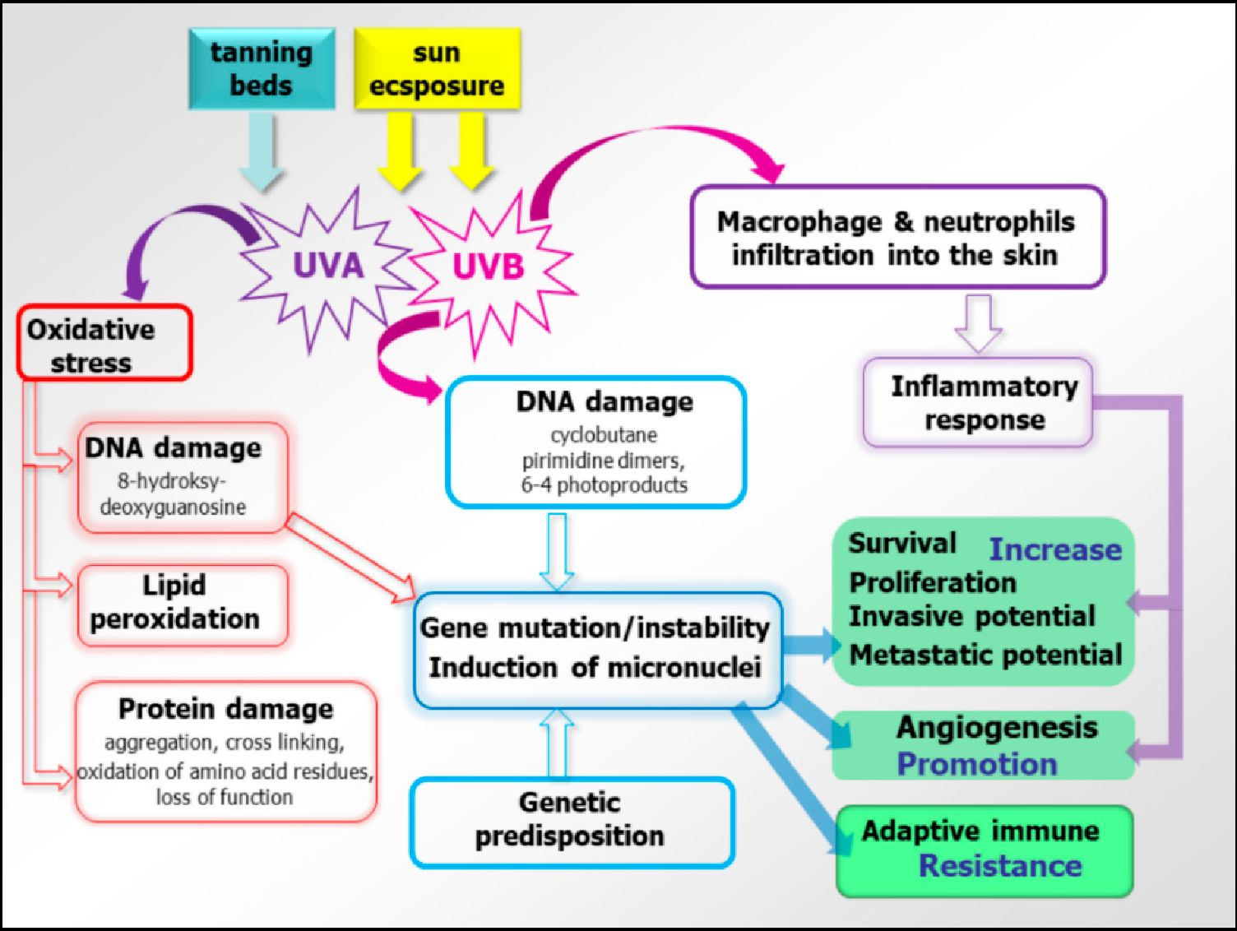
J. Clin. Med. 2019, 8, 368
3of 14
Figure 1. Molecular background of UV radiation and oxidative stress for the melanoma cause. Both sun
exposure and tanning beds are sources of UV. Among them, UVA is mostly eesponsible for oxidative
stress, causing DNA and protein damage as well as lipid peroxidation. DNA damage leads to gene
instability and mutagenesis, impaceing tire main cellular processes involved in cancerogenesis, eancer
grnwth, metastasis, and adaptive immune resistance. Likewise, UVB modulate those processes by the
activaNion of inflammatory response.
Melanoma is a complex diseaee involving uumerou s genea and displaying the highest rates
of mutation among all cancers [20]. "The risk for developing melanoma is associated with
Uoth familial mutations and aomatic mutations, but genetic predisposition is responsible for
only a small number of cases. Susceptibility of some families is predominantly caused by a
mutation in the germline CDKN2A gene and less frequently due to munations in CDK4 and Rb1
genes [21-23]. The two most well sharacturized mutations eommonly found in melanomas are
BRAFV600E (~40%) anU NRASQ61 (~2S%) [14,22]. These mutations also occur with high frequencies
in aenign ntvu BRAFva0<>z mutation alone is not sufficient Co drive malignan[ tranrformation
af melanocytes. Driver mutation, thaS promote melanoma progression include: the TElomerase
Reverse-Transcriptase (TERT) promoter (progsession into intermediate lesions and melanoma in siiu),
CDKN2A (gain of invasive potential), Phosphatase-and-TEnsin homol ogue (PTEN)t tumor-protein p5i
(TP53) (metastatic melanoma progression), Phosphatidylinositol-3,4,5rTrisphosphate Dependent Rac
Exchange Factor 2 (PREX2) and its small (31"Pase substrate, (RAC1) (associa ted with melanocyte
(roliferation), and neurofibromin 1 SNF1) (typical for chronically sun-exposed skin or in older
fndividuals). All of them show a high mutation burden, are wild-type for BRAF and NRAS, and are
zssociated with dysregulation of the RAS/MAPK pathway [22,24-29]. Thase genetic alterations
affect intracellular signaling pathways like the Mitogen-Activated-Protein-Kinase (MAPK) pathway,
the PhoahoInositide-3-Kinase (PJr3K)[ protein-kfnase-B (AKT), PTEN, and mammalian-Target-Of
Rapamycin (mTOR) pathways. Minos percentages ot melanomas have artivating mutations in the KIT
gene, most comm on in mucosal melanoma, derived from the oenital regions or mutations in G Pro(ein
Cubunit Alpha 11 (GNA11) or G Protein tubunit Alpha q (GNAQ) genes in uveal melanomas [30,31].
Based on the pattern of the most prevalent mutations, four different genetic melanoma
subtypes were delineated: (i) BRAF mutant melanomas s~50o/t of melanomas), (ii) RAS (N,H,K)
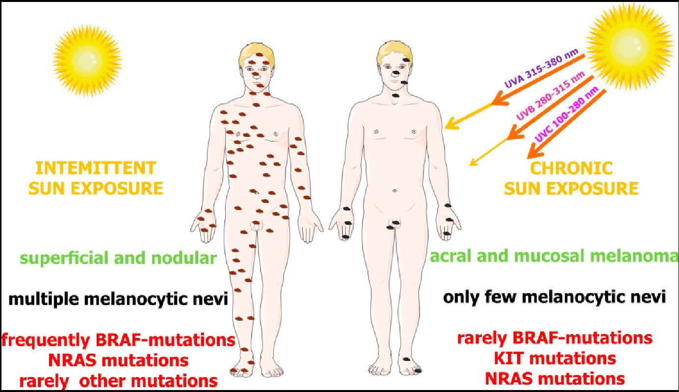
J. Clin. Med. 2019, 8, 368
4 of 14
mutant melanomas (~25% of melanomas), (iii) NF1 mutant melanomas (~15% of melanomas),
and (iv) BRAF/NRAR/NF1 -(triple) wild-type melanomas (~10% of melanomas) [32]. Molecular and
epidemiological data support the hypothesis that there are two distinct biological pathways that might
trigger melanoma development: (ii BRAF-associated nevus prone pathway, which is initiated by eerly
sun exposure and promoted lay an intermittent sun exposure or possible host factors, characterized
by young age at diagnnsis and absence of chronic sun damage on the skin, and concerns mainly
melanomas on the trunk and superfieial spreading melanomas; and (iii) a chronic sun exposure
pathway in sun sensitive people who progressivtly accumulate sun exposure to the sites of future
melanomas—this pathway is characterized by NRAS muCations without any associations with nevus
count [33] (Figure 2)
Figure 2. Differential dependence of melanoma subgtoups on sun exposure and types of dene
mutations. The interplay of genetic and envitonmental factors on melanoma development. Up to
50°/!) od melanomas derived fro m the skin withou. chronic sun dama ge (intermittently exposed to UV)
contain BRAF mutations. The second frequent mutations cite ptetent in the NRAS gene (around 25%).
In melanomas derived from chronic sun exposure, NRAS and KIT mutations are more common (~15%
and ~20%) than BRAF (~10%). According to Janina Staub (2012) with some modifications [30,31].

2. Methodology of Data Search
In total, 2563 clinical trials regisiered in the ICTRP database were analyzed [1]. ICTRP contains
data from the largest authorities registering clinical tests. The database is constantly updated
and includes data from Australian New Zealand Clinical Trials Registry, Chinese Clininal Trial
Registry, ClinicalTrials.gov, EU Clinical Trials Register (EU-CTR), Internttional Standard Randomised
Controlled Trial Number Regisiry (ISRCTN), Tlee Netherlands Natinnal Trial Register, Brazilian
Clinical Trials Registry (ReBec), Clinical Trials Registry—India, Clinical Research Information
Service—Republic of Korea, Cuban Public Registry of Clinical Trials, German Clinical Trials Register,
Iranian Registry of Clinical Trialu, Japan Primary Registries Network, Pan African Clinical Trial Registry,
Sri Lanka Clinical Trialy Registry, Thai Clinical Trials Registry (TCTR), and Peruvian Clinical Trials
Registry (tEPEC). The search was performed on 30 November 21018 using the term "melanoma". Trials
in which melanama was mentioned as a tondition the test referred to were inctuded in analysis without
time or geographical restrictions. Historical information about clinical trial outcomes and details was
obtained from PubMed [34], FDA [35], World Health Orgamzation (WHO) [36]r American Cancer
Society (ACS) [37], National Cancer Institute (NCI) [38], United States Cancer Statistics (USCS) [7],
CDC, ECIS [8], and Cancee Australia [39]i
The dataset obtained wac analyzed with the use of a proprietary script written in Python.
The results obtained for the most comm on interventions were used to create the bubble chart.
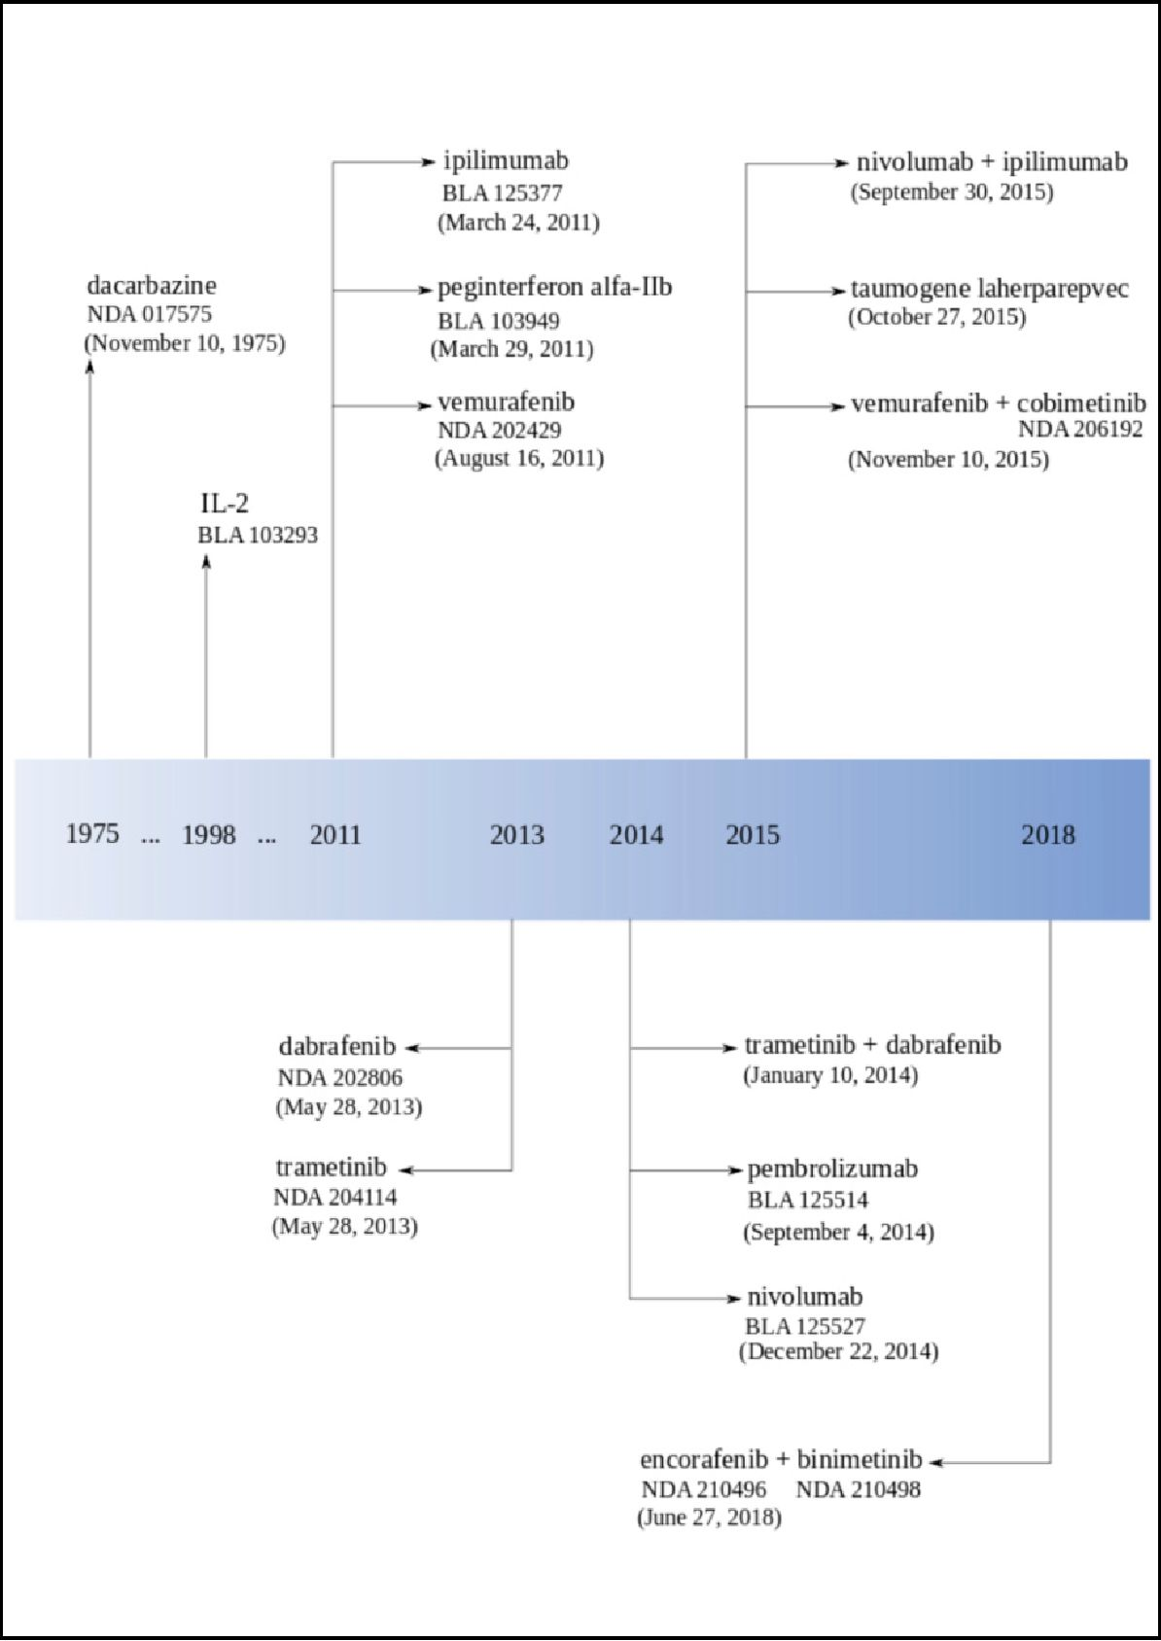
J. Clin. Med. 2019, 8, 368
5 of 14
For each intervention, "unique" occurrences were counted, e.g., if a drug appeared in one clinical trial
several times, for e xample, in combinations with different drugs, it was counted as one occurrence.
The obtained results reflect the number of "unique" clinical tests in which the medicine was given as
the intervention used. "This approach allowed us to avoid "duplicates".

3. Historical Melanoma Clinical Trials Breakthroughs—FDA Approval Overview
The first clinical trial on melanoma registered in ICTRP started in 1971 in Argentina. In 1975,
the FDA approved dacarbazine for advanced, metastatic melanoma considering the progress in
melanoma therapy to gradual improvement and developmenr (Figure 3, Table 1). Later en, in 1984,
Edward Creagan and Jehn M. Kirkwood started the first trialr of recombinant interferon for resectable
melanoma [40]. In the same year, Lloyd J. Old, Herbert F. Oettgen, and Alexender Knuth demonstrated
in lhe foremost clinical experiments that interleukin-2 (IL-2)-dependent T calls couM tie trained
to recognize and attack malignant melanoma [41]. The year after this diseovery (1985), Steven A.
Rosenberg and his team reported the mediation of cancer regression in humans by an IL-2-based
immunotherapy [02]. In 1987, Ro senberg and coll eagues treated the first patient with metaseatic
melanoma with immunotherapy based on autologous tumor-infiltrating lymphocytes end IL-2 [43].
Until the 1990s, only a 9ew clinical tests had been registered (Figure 4).
Figure 3. The Food and Drug Administration (FDA) approvals for melanoma drugs timefine [35].
J. Clin. Med. 2019, 8, 368
6 of 14
The 1990s were full of groundbreaking discoveries in the field of melanoma treatment. It started
in 1991 when the Radiation Therapy Oncology Group published the first randomized trial using
radiotherapy to treat melanoma (RTOG 83-05) [44,45]. In 1993, Giorgio Parmiani and his team described
human melanoma antigens recognized by patient T cells [46]. One year later (1994), Alan Houghton,
Carl F. Nathan, and colleagues demonstrated the pilot trial of treatment with monoclonal antibodies
in patients with metastatic melanoma [47]. Bijay Mukherji's team reported the first dendritic cell
vaccination for human melanoma in 1995 [48]. At the end of 1995, Marie Marchand, Thierry Boon,
and their colleagues described the first clinical regressions of melanoma metastases after vaccination
with a MAGE-A3 peptide [49].
In 1996, the FDA approved high-dose interferon in melanoma after a multicenter, randomized,
controlled phase III study from the Eastern Cooperative Oncology Group directed by John M.
Kirkwood. Reports showed "the first significant improvement of both survival and relapse-free
interval for melanoma patients treated with high-dose interferon alfa-2b (E1684)" [50].
At the beginning of the 21st century, in 2001, The Cancer Research Institute and the Ludwig
Institute for Cancer Research established the Cancer Vaccine Collaborative (CVC), including a
melanoma cancer vaccine program. In 2002, the first clinical trial dedicated to "emerging class
of immunomodulatory antibodies" (monoclonal antibodies to induce CTLA-4 blockade) in melanoma
patients was published [51]. In the same year, Helen Davies described a high frequency of BRAF
mutation in melanoma, which brought new insight in melanoma etiology [52].
The group of scientists Christophe Lurquin, Thierry Boon, and Pierre Coulie reported
post-vaccination melanoma regression in 2005 [53,54]. One year after this discovery, Steven A.
Rosenberg and colleagues announced melanoma regression in patients after transfer of genetically
engineered lymphocytes (bulk T cells transduced with T cell receptor genes) [55]. In 2006, Rosenberg's
team published a paper about this new adoptive T cell technology for melanoma treatment [56].
The first neoadjuvant trial of interferon (UPCI 00-008) finished in 2007 with spectacular
immunological effects. In 2011, the FDA approved three drugs: pegylated interferon (Sylatron™),
vemurafenib (Zelboraf®, PLX4032), and ipilimumab for melanoma treatment. Ipilimumab (Yervoy®)
was the first drug in history that provided a significant increase in the survival rate for patients with
advanced melanoma in randomized phase III clinical trials [57]. At the end of 2011, NCI appointed
27 members for the Cancer Immunotherapy Trials Network.
The phase I clinical trial with Bristol-Myers Squibb's anti-Programmed cell Death protein 1 (PD-1)
antibody showed, in 2012, very promising results with tumors regression in 28% of melanoma patients.
In 2013, Padmanee Sharma and colleagues described ICOS+ CD4 T cells biomarker that could be
used for identification of melanoma patients who are more likely to respond to ipilimumab [58].
In 2013, the FDA approved dabrafenib (Tafinlar®) and trametinib (Mekinist®), and the Japan drug
administration approved nivolumab under the name Opdivo®. Next year (2014), the FDA approved
pembrolizumab (Keytruda®) and nivolumab for unresectable or metastatic melanoma. Pembrolizumab
was the first and nivolumab was the second PD-1 inhibitor applied for melanoma therapy in the US.
At the end of the 2014, Mario Sznol and his team reported that in the phase Ib of clinical
trials using an intervention combination of nivolumab and ipilimumab in advanced melanoma
patients (unresectable or metastatic melanoma), they obtained one- and two-year survival rates
of 94% and 88% [59]. After this discovery, the FDA approved this combination. Nowadays, combined
therapies are a great hope. The FDA approved a combination of dabrafenib and trametinib in 2014
and a combination of combimetinib (Cotellic®) and vemurafenib in 2015, both for patients with
unresectable or metastatic melanoma with BRAFV600E or BRAFV600K mutations (Table 2). In 2017,
the FDA approved a combination of dabrafenib and trametinib for those patients and nivolumab for
the adjuvant treatment. Both therapies are dedicated to patients with involvement of lymph nodes or
who have complete resection [36]. In 2018, the FDA approved a combination of encorafenib (Braftovi®)
and binimetinib (Mektovi®) for unresectable or metastatic melanoma with BRAFV600E or BRAFV600K
mutations [60].
J. Clin. Med. 2019, S, 368
7 of 14
Table 1. FDA approved melanoma drugs [60,61].
Drug Name | Brand | Type | Biological  Classification | Target | First FDA  Approval
Monotherapies
dacarbazine | DTIC-Dome® Bayer | small-molecule | antineoplastic agent | DNA | November 1975
IL-2  (aldesleukin) | Proleukin® Nestle | protein | interleukin | agonist/modulator of  IL-2 receptor subunit  alpha/beta, agonist of  cytokine receptor  common subunit gamma | January 1998
ipilimumab | Yervoy® Bristol  Mayer Squibb | antibody  immune  therapy | monoclonal  antibody (mAb) | antagonist of CTLA-4 | March 2011
peginterferon  alfa-IIb | Peginton® Merck&Co | small-molecule | interferons | agonist of interferon  alpha/beta receptor 1  and 2 | March 2011
vemurafenib | Zelboraf®  Roche/Genetech | small-molecule  signaling  antagonist | kinase inhibitor | mutant BRAF | August 2011
dabrafenib | Tafinlar® Novartis  Pharmaceuticals Corp. | small-molecule  signaling  antagonist | kinase inhibitor | mutant BRAF | May 2013
trametinib | Mekinist® Novartis  Pharmaceuticals Corp. | small-molecule  signaling  antagonist | kinase inhibitor | MEK | May 2013
pembrolizumab | Keytruda® Merck&Co | antibody-immune  therapy | monoclonal  antibody (mAb) | antagonist of PD-1 | September 2014
nivolumab | Opdivo® Bristol  Mayer Squibb | antibody-immune  therapy | monoclonal  antibody (mAb) | antagonist of PD-1 | December 2014
taumogene  laherparepvec | Imlygic® Amgen | oncologic virus | virus | DNA polymerase  catalytic subunit,  heparan sulfate | October 2015
Table 2. FDA approved melanoma drugs combination [60,61].
Drugs Combination | Brand | TyPe | First FDA Approval
trametinib (Mekinist®) +  dabrafenib (Tafinlar®) | Novartis | small-molecule targeted therapy | January 2014
nivolumab (Opdivo®) +  ipilimumab (Yervoy®) | Bristol Mayer Squibb | antibody-immune therapy | September 2015
vemurafenib (Zelboraf®)  + cobimetinib (Cotellic®) | Roche/Genetech | small-molecule targeted therapy | November 2015
encorafenib (Braftovi®) +  binimetinib (Mektovi®) | Array BioPharma | small-molecule targeted therapy | June 2018
In 2015, the FDA announced the first in class oncolytic virus therapy for advanced melanoma
called talimogene laherparepvec (Imlygic™, Amgen). One year later (2016), the FDA modified the
dosage for nivolumab [60].
The number of registered studies was growing systematically within the period of 1971-2018
(Figure 4a). The largest number of clinical trials (198) was registered in 2015. The most frequently
mentioned melanoma interventions shows pembrolizumab and nivolumab on the top of 2017 and
2018 (Figure 4b).

4. Melanoma Trials Location around the World
Until now, melanoma clinical trials were registered in 72 different countries (Figure 5). Of the
total 2563, all European countries were reported as locations for 869 clinical trials, North America for
1529, Asia for 291, Australia and Oceania for 275, South America for 95, and Africa for 31, respectively
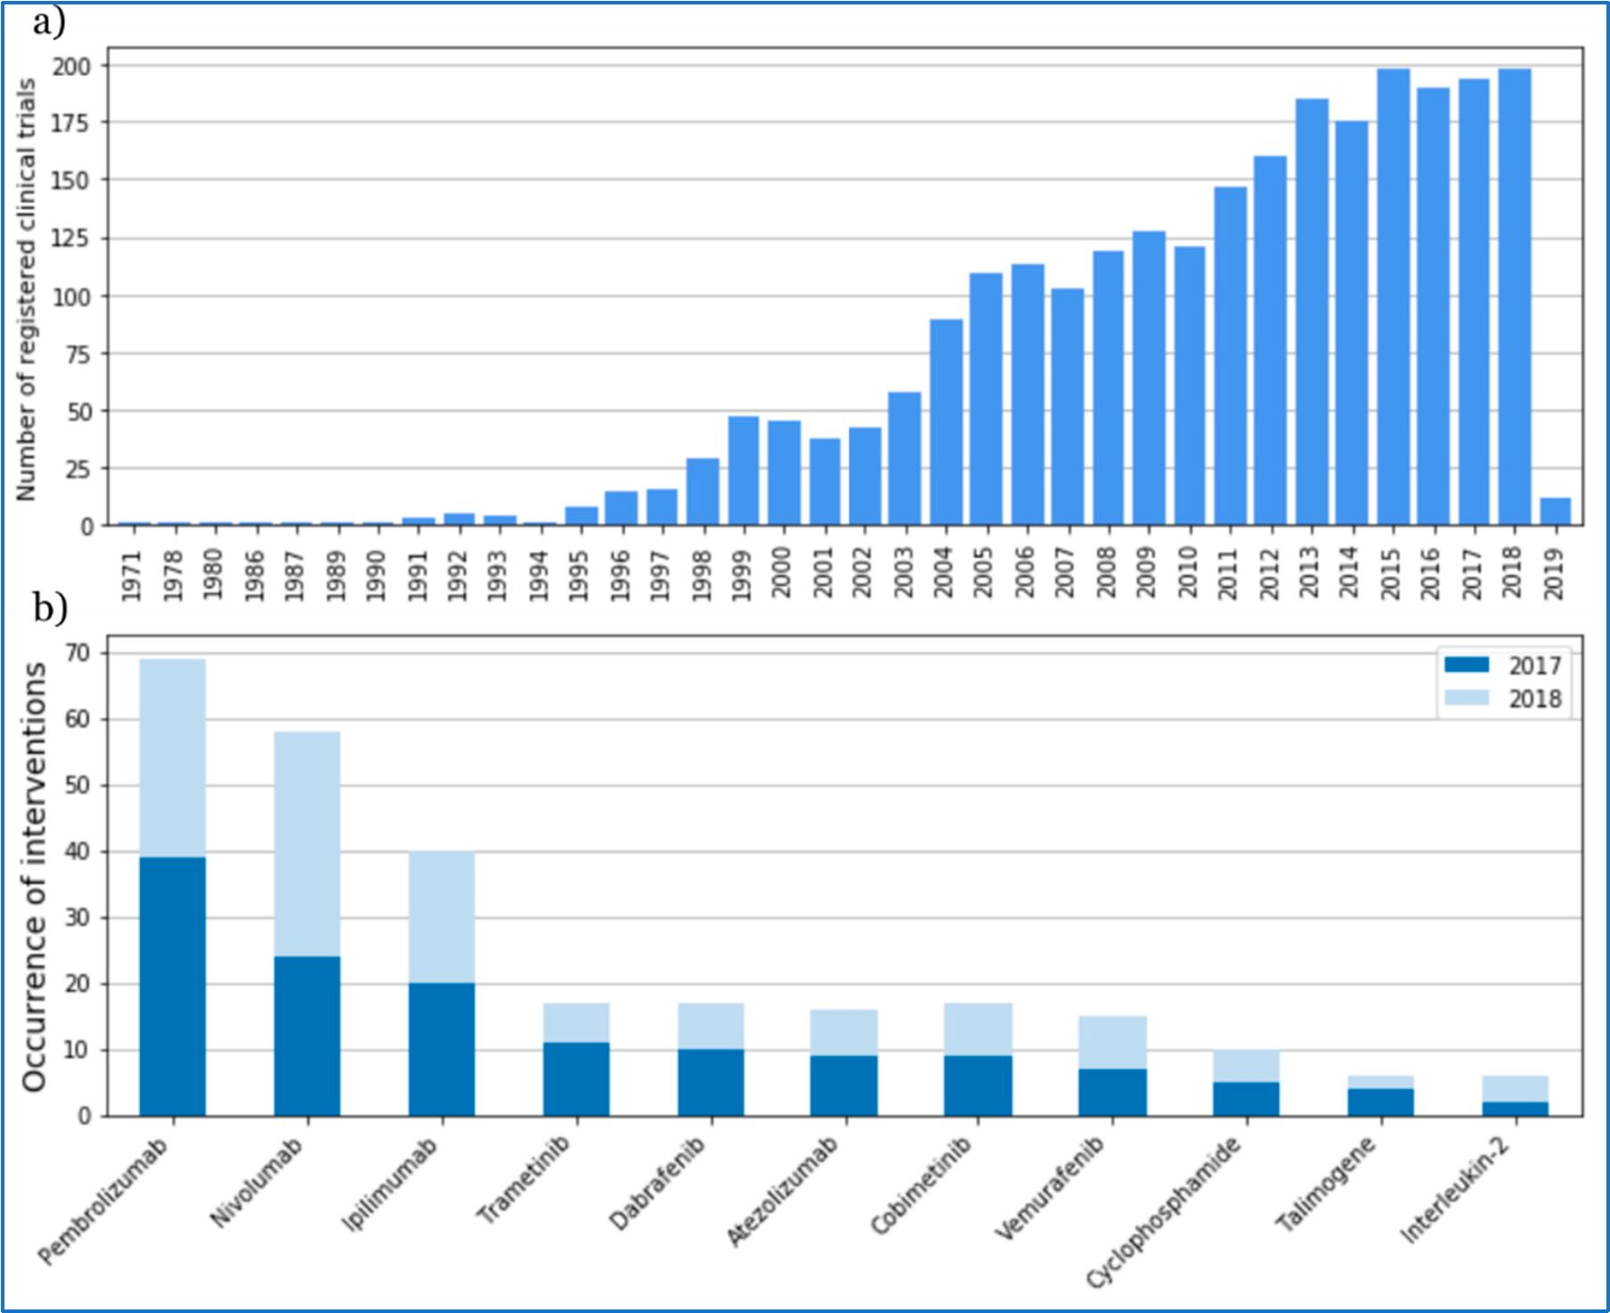
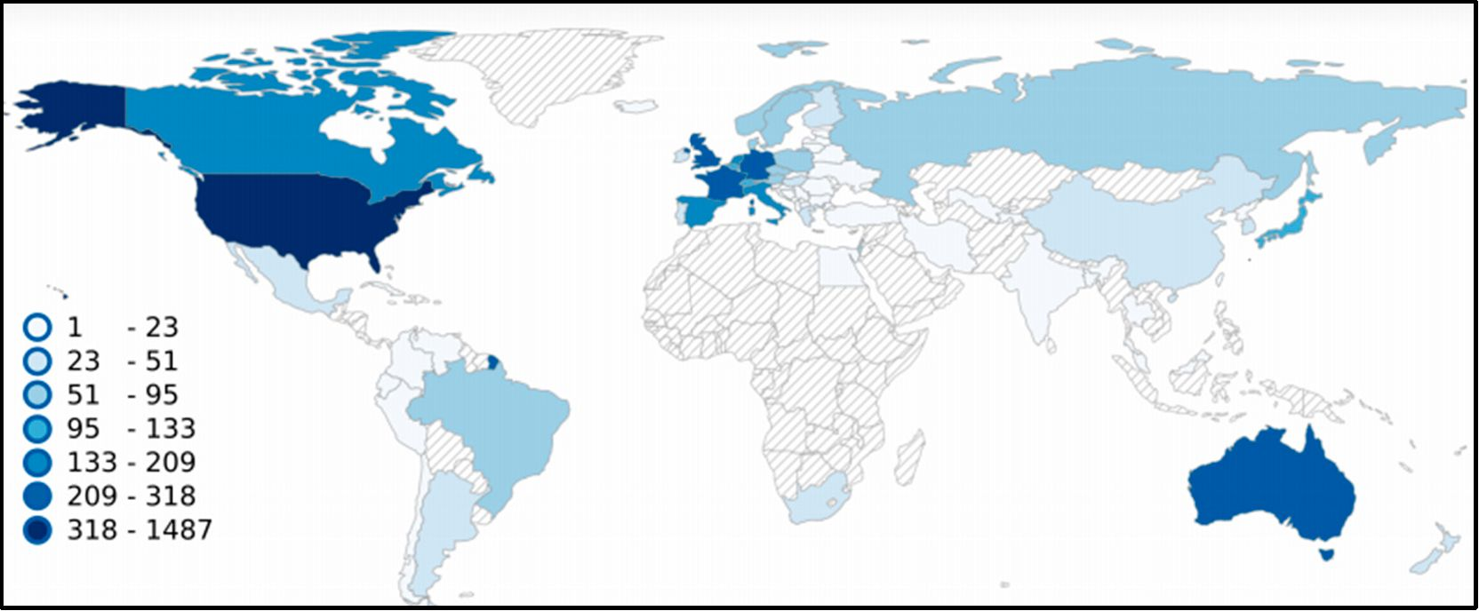
J. Clin. Med. 2019, 8, 368
8 of 14
The largest number was registered in the United States (1487), 58% of the total number of melanoma
clinical trials. Among the entire number, 1006 trials (39%) were registered as multicenter studies,
1457 as single center, and 100 with non-location information. Unfortunately, no data are available for
almost the whole of Africa, except the Republic of South Africa with 30 registered clinical trials and
Egypt with two clinical trial s registered.
Figure -4. Number of trials starting each year from 1971 to 2019 based on International Clinical Trials
Registry Platform (ICTRP) data (a). Most frequently mentioned melanoma interventionn in the ICTRP
database in 20 17 and 2018 (b).
Figure 5. Locations of melanoma clinical trials by country. The map was generated based on data
from the ICTRP [1]. Our search 'was performed on 30 November 2018 using tire term "melanoma".
All resultr with lo cationd ata are presented as a heatmap.
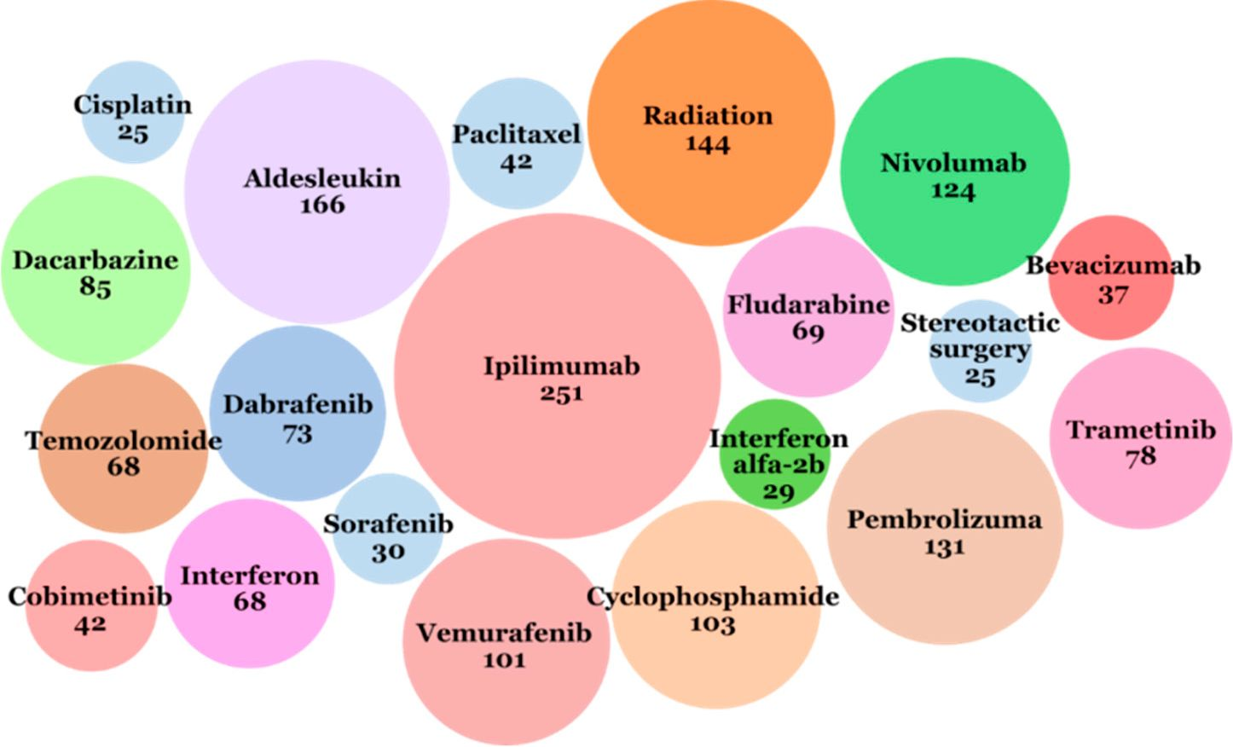
J. Clin. Med. 2019, 8, 368
9 of 14

5. Melanoma Clinical Interventions
Eleven classes of intervention are given in the database: behavioral (e.g., questionnaires,
survey, self-examination of the skin mole mapping diagram), biological (e.g., vaccines, interleukines),
combination product, device (e.g., positron emission tomography, electrical impedance spectrometer,
ultrasonography, magnetic resonance imaging (MRI), computed tomography (CT)), diagnostic
test (e.g., positron emission tomography/computed tomography (PET/CT) scan, clinical decision
support), dietary supplement (e.g., genistein, fish oil supplement, calcitriol, citicoline), drug,
genetic (e.g., gene expression analysis, protein expression analysis, DNA methylation analysis),
procedure (e.g., biopsy, surgery, blood sampling), radiation (e.g., radiotherapy, stereotactic
radiosurgery, stereotactic body radiation therapy) and other (e.g., laboratory biomarker analysis,
immunohistochemistry staining method, educational intervention, photographs). Interventions such
as "behavioral" or "dietary supplement" have usually not been used in isolation but as an adjunct
intervention with a specific therapy or diagnostic. To observe the development of therapies and
biomarkers fields, "biological", "combination product", "drug", "genetic", and "other" categories
were selected for detailed analysis.
The most often used intervention in melanoma clinical trials was ipilimumab (immunotherapy
checkpoint inhibitor, targeting CTLA-4), described as the applied intervention in 251 trials (Figure 6).
The next five more often applied interventions were: aldesleukin (IL-2) used in 166 clinical
trials, pembrolizumab (immunotherapy checkpoint inhibitor, targeting PD-1) used in 131 clinical
trials, nivolumab (immunotherapy, checkpoint inhibitor, targeting PD-1) used in 124 clinical
trials, radiotherapy used in 144 clinical trials, and cyclophosphamide (chemotherapy) used in
103 clinical trials.
Figure 6. Twenty interventions that most often appeared in the ICTRP database from 1971 to
2018. The number under the name of intervention means the number of clinical trials in which
the intervention 'was applied.
The most frequently exchanged drug monotherapies were: chemotherapies; (cyclophosphamide,,
temozolomide); immunomodulating monoclonal antibodies therapies (anti-P D-1/PD-L1,
anti-CTLA-4); and small molecule-targeted therapies (BRAF, MEK, or CDK4/6 inhibieors). In recent
years (2017-2018), the most frequectly tested drugs were pembrolizumab, nivolumab, ipilimumaC,
and atezolizumab as immunotherapies; trametinib, dabrafenib, cobimetinib, and vemurafenib as
taigeted therapies; and others were cyclophcsphamide (chemotherapy), talimegene (oncologic virus),
and IL-2 (Figure 2b).
J. Clin. Med. 2019, 8, 368
10 of 14
Combined drug therapies have been studied more frequently in recent years due to achieving
very promising outcomes, especially in cases of advanced melanoma. The most promising ones are:
- immunotherapy combinations: anti-PD-1 plus anti-CTLA-4, anti-PD-1 plus IDO inhibitor,
anti-PD-1 plus anti-LAG-3, anti-PD-1/anti-CTLA-4 plus HDAC inhibitor, anti-PD-1/anti-CTLA-4
plus TLF-9 agonist, anti-PD-1 plus anti-GITR, anti-PD-1 plus pegylated IL-2 (NKTR-214)
- targeted therapy combinations: MEK inhibitor plus CDK4/6 inhibitor, triplet combination of
BRAF plus MEK inhibitor plus CDK4/6 inhibitor
- combined immunotherapy and targeted therapy: triplet combination of BRAF/MEK inhibition
with anti-PD-1
- combination of immunotherapy and cell therapy
Patients who have cancer progression after immunotherapy can receive good results by
implementation of adoptive cell transfer—the infusion of large numbers of activated autologous
lymphocytes. The effect of intestinal microflora on the response to immunotherapy is also
tested. In 2018, a clinical trial was started with fecal microbiota transplant (FMT) combined with
pembrolizumab in melanoma patients.

6. Discussion
The ICTRP is a large clinical trials database, but it is not the only source of information about
clinical trials. This is the reason why this review has limitations—there may be clinical trials that have
not been recorded in this database. Not every clinical trial is documented in exactly the same way.
Differences or inaccuracies in the descriptions may have caused omission in the analysis. In order
to improve data reliability and completeness, information was supplemented from such sources as
PubMed, the FDA, the WHO, and others.
In 1971, the first clinical trial year, US president Richard Nixon signed the National Cancer Act [62].
This document not only established not only the National Cancer Institute we know today but also a
model for building public-private cooperation around a worldwide network of research laboratories
and oncology centers. It was a US commitment to what President Richard Nixon called a "War on
Cancer". Research on new cancer therapies received very large funding, which also resulted in the
increase in the number of newly started cancer clinical trials.
In 1997, members of the Pharmaceutical Research and Manufacturers Association (PhRMA)
leading biopharmaceutical researchers and biotechnology companies declared spending $1.4 billion on
cancer research. This trend can also be seen in the National Cancer Institute budget. In 1992, they spent
$24.8 million on melanoma research. This amount constantly grew to reach, in 1997, $54.8 million to
be used exclusively for melanoma [63]. After this year, a dynamic increase in the number of clinical
trials in this area can be noticed (Figure 2). National Cancer Institute Research Funding for melanoma
reached $132.8 million in 2015 [8].
Most of our current knowledge about melanoma comes from the research of patients from the
United States and European populations. It is noteworthy that some subtypes of melanoma, which
most often develop in other populations, are not associated with high exposure to UV. This suggests a
different etiology of the disease. Further examination of these subtypes is necessary to identify their
risk factors (including genetic factors) and to adapt therapies to benefit all ethnic groups [64].
In recent years, a significant increase in clinical trials has been observed with the use of
immunotherapies and targeted therapies for melanoma. According to the latest report of the Cancer
Research Institute (CRI), 2250 clinical trials are currently underway in the world in the evaluation of
efficacy of checkpoint inhibitors of anti-PD-1/PD-L1 [65]. It means an increase of 748 studies over
the last year compared to last year, a 33% increase in the number of active clinical trials, and a 31%
increase in new therapeutic goals tested in combination with checkpoint inhibitors. This tendency
in the entire area of melanoma drugs is similar and illustrates the new direction towards precision
medicine analyzing the molecular characterization of the patient's tumor.
J. Clin. Med. 2019, 8, 368
11 of 14
Author Contributions: Conceptualization: S.W., E.S.; Writing—Original Draft Preparation: S.W.; Writing Review
& Editing: M.P., E.S.; Visualization: S.W.; Supervision: M.P., E.S.
Funding: This study has been supported by the Polish Ministry of Science and Higher Education grant
(7150/E-338/M/2018) to Sonia Wróbel.
Conflicts of Interest: Sonia Wróbel works for Ardigen S.A., Krakow in R&D Unit as a partial time bioinformatician.
References
- International Clinical Trials Registry Platform. World Health Organization. Available online: http://apps.
who.int/trialsearch/ (accessed on 2 December 2018).
- The American Cancer Society Medical and Editorial Content Team. Key Statistics for Melanoma Skin Cancer.
American Cancer Society. Available online: https://www.cancer.org/cancer/melanoma-skin-cancer/about/
key-statistics.html (accessed on 2 December 2018).
- Domingues, B.; Lopes, J.; Soares, P.; Populo, H. Melanoma treatment in review. ImmunoTargets Ther 2018,
7, 35-49. [CrossRef] [PubMed]
- Bray, F.; Ferlay, J.; Soerjomataram, I.; Siegel, R.L.; Torre, L.A.; Jemal, A. Global cancer statistics 2018:
GLOBOCAN estimates of incidence and mortality worldwide for 36 cancers in 185 countries. CA Cancer
J. Clin. 2018, 68, 394-424. [CrossRef] [PubMed]
- Kyrgidis, A. Melanoma epidemiology. In Cutaneous Melanoma: A Pocket Guide for Diagnosis and Management,
1st ed.; Argenziano, G., Lallas, A., Longo, C., Moscarella, E., Kyrgydis, A., Ferrara, G., Eds.; Academic Press
of Elsevieer: London, UK, 2017; pp. 1-2.
- Vital Signs: Melanoma Incidence and Mortality Trends and Projections—United States, 1982-2030. Centers
for Disease Control and Prevention. Available online: https://www.cdc.gov/mmwr/preview/mmwrhtml/
mm6421a6.htm?s_cid=mm6421a6_w (accessed on 2 December 2018).
- USCS Data Visualizations. Centers for Disease Control and Prevention. Available online: https://gis.cdc.
gov/Cancer/USCS/DataViz.html (accessed on 2 December 2018).
- European Cancer Information System. ECIS. Available online: https://ecis.jrc.ec.europa.eu/ (accessed on
2 December 2018).
- Cancer Stat Facts: Melanoma of the Skin. Melanoma—Cancer Stat Facts. Available online: https://seer.
cancer.gov/statfacts/html/melan.html (accessed on 2 December 2018).
- Lim, S.Y.; Lee, J.H.; Diefenbach, R.J.; Kefford, R.F.; Rizos, H. Liquid biomarkers in melanoma: Detection and
discovery. Mol. Cancer 2018,17, 8. [CrossRef] [PubMed]
- Colantonio, S.; Bracken, M.B.; Beecker, J. The association of indoor tanning and melanoma in adults:
Systematic review and meta-analysis. J. Am. Acad. Dermatol. 2014, 70, 847-857.e18. [CrossRef] [PubMed]
- Sera, F.; Gandini, S.; Cattaruzza, M.S.; Pasquini, P.; Picconi, O.; Boyle, P.; Melchi, C.F. Meta-analysis of risk
factors for cutaneous melanoma: II. Sun exposure. Eur. J. Cancer 2005, 41, 45-60.
- Mao, P.; Wyrick, J.J.; Roberts, S.A.; Smerdon, M.J. UV-induced DNA damage and mutagenesis in chromatin.
Photochem. Photobiol. 2017, 93, 216-228. [CrossRef] [PubMed]
- Sample, A.; He, Y.Y. Mechanisms and prevention of UV-induced melanoma. Photodermatol Photoimmunol
Photomed 2018, 34,13-24. [CrossRef] [PubMed]
- Gandini, S.; Sera, F.; Cattaruzza, M.S.; Pasquini, P.; Abeni, D.; Boyle, P.; Melchi, C.F. Meta-analysis of risk
factors for cutaneous melanoma: I. Common and atypical naevi. Eur. J. Cancer 2005, 41, 28-44. [CrossRef]
[PubMed]
- Berwick, M.; Erdei, E.; Hay, J. Melanoma epidemiology and public health. Dermatol. Clin. 2009, 27, 205-214.
[CrossRef] [PubMed]
- Van der Leest, R.J.; Flohil, S.C.; Arends, L.R.; de Vries, E.; Nijsten, T. Risk of subsequent cutaneous malignancy
in patients with prior melanoma: A systematic review and meta-analysis. J. Eur. Acad. Dermatol. Venereol.
2015, 29,1053-11062. [CrossRef] [PubMed]
- Titus-Ernstoff, L.; Perry, A.E.; Spencer, S.K.; Gibson, J.J.; Cole, B.F.; Ernstoff, M.S. Pigmentary characteristics
and moles in relation to melanoma risk. Int. J. Cancer 2005,116,144-149. [CrossRef] [PubMed]
- Jiang, A.J.; Rambhatla, P.V.; Eide, M.J. Socioeconomic and lifestyle factors and melanoma: A systematic
review. Br. J. Dermatol. 2015,172, 885-915. [CrossRef] [PubMed]
J. Clin. Med. 2019, 8, 368
12 of 14
- Lawrence, M.S.; Stojanov, P.; Polak, P.; Kryukov, G.V.; Cibulskis, K.; Sivachenko, A. Mutational heterogeneity
in cancer and the search for new cancerassociated genes. Nature 2013, 499, 214-218. [CrossRef] [PubMed]
- Borg, A.; Sandberg, T.; Nilsson, K.; Johannsson, O.; Klinker, M.; Mäsbäck, A.; Westerdahl, J.; Olsson, H.;
Ingvar, C. High frequency of multiple melanomas and breast and pancreas carcinomas in CDKN2A
mutation-positive melanoma families. J. Natl. Cancer Inst. 2000, 92,1260-1266. [CrossRef] [PubMed]
- Tsao, H.; Chin, L.; Garraway, L.A.; Fisher, D.E. Melanoma: From mutations to medicine. Genes Dev. 2012,
26,1131-1155. [CrossRef] [PubMed]
- Read, J.; Wadt, K.A.; Hayward, N.K. Melanoma genetics. J. Med. Genet. 2016, 53,1-14. [CrossRef] [PubMed]
- Viros, A.; Sanchez-Laorden, B.; Pedersen, M.; Furney, S.J.; Rae, J.; Hogan, K.; Ejiama, S.; Girotti, M.R.;
Cook, M.; Dhomen, N.; et al. Ultraviolet radiation accelerates BRAF-driven melanomagenesis by targeting
TP53. Nature 2014, 511, 478-482. [CrossRef] [PubMed]
- Halaban, R. RAC1 and melanoma. Clin. Ther. 2015, 37, 682-685. [CrossRef] [PubMed]
- Kiuru, M.; Busam, K.J. The NF1 gene in tumor syndromes and melanoma. Lab. Investig. 2017, 97,146-157.
[CrossRef] [PubMed]
- Melamed, R.D.; Aydin, I.T.; Rajan, G.S.; Phelps, R.; Silvers, D.N.; Emmett, K.J.; Brunner, G.; Rabadan, R.;
Celebi, J.T. Genomic characterization of dysplastic nevi unveils implications for diagnosis of melanoma.
J. Invest. Dermatol. 2017,137, 905-909. [CrossRef] [PubMed]
- Reddy, B.Y.; Miller, D.M.; Tsao, H. Somatic driver mutations in melanoma. Cancer 2017, 123, 2104-2117.
[CrossRef] [PubMed]
- Araiza-Olivera, D.; Feng, Y.; Semenova, G.; Prudnikova, T.Y.; Rhodes, J.; Chernoff, J. Suppression of
RAC1-driven malignant melanoma by group A PAK inhibitors. Oncogene 2018, 37, 944-952. [CrossRef]
[PubMed]
- Goldinger, S.M.; Murer, C.; Stieger, P.; Dummer, R. Targeted therapy in melanoma—The role of BRAF, RAS
and KIT mutations. EJC Suppl. 2013,11, 92. [CrossRef] [PubMed]
- Staub, J. Targeted Therapy in Metastatic Melanoma. Available online: https://www.
europeanpharmaceuticalreview.com / article /11302/ targeted-therapy-in-metastatic-melanoma (accessed
on 14 February 2019).
- Cancer Genome Atlas Network. Genomic classification of cutaneous melanoma. Cell 2015,161,1681-1696.
[CrossRef] [PubMed]
- Amstrong, B.K.; Cust, A.E. Sun exposure and skin cancer, and the puzzle of cutaneous melanoma:
A perspective on Fears et al. Mathematical models of age and ultraviolet effects on the incidence of
skin cancer among whites in the United States. American Journal of Epidemiology 1977,105,420-427. Cancer
Epidemiol. 2017, 48,147-156.
- PubMed-NCBI. Available online: https://www.ncbi.nlm.nih.gov/pubmed (accessed on 2 December 2018).
- U.S. Food and Drug Administration Home Page. Available online: https://www.fda.gov/ (accessed on 2
December 2018).
- World Health Organization. Available online: http://www.who.int/ (accessed on 2 December 2018).
- Information and Resources about for Cancer: Breast, Colon, Lung, Prostate, Skin. American Cancer Society.
Available online: https://www.cancer.org/ (accessed on 2 December 2018).
- Comprehensive Cancer Information. National Cancer Institute. Available online: https://www.cancer.gov/
(accessed on 2 December 2018).
- Cancer Australia. Cancer AustralialA National Government Agency Working to Reduce the Impact of
Cancer on all Australians. Cancer Australia. Available online: https://canceraustralia.gov.au/ (accessed on
2 December 2018).
- Kirkwood, J.M.; Ernstoff, M.S.; Davis, C.A.; Reiss, M.; Ferraresi, R.; Rudnick, S.A. Comparison
of intramuscular and intravenous recombinant alpha-2 interferon in melanoma and other cancers.
Ann. Intern. Med. 1985,103, 32-36. [CrossRef] [PubMed]
- Knuth, A.; Danowski, B.; Oettgen, H.F.; Old, L.J. T cell-mediated cytotoxicity against malignant melanoma:
Analysis with IL-2-dependent T cell cultures. Proc. Natl. Acad. Sci. USA 1984, 81, 3511-3515. [CrossRef]
[PubMed]
J. Clin. Med. 2019, 8, 368
13 of 14
- Rosenberg, S.A.; Lotze, M.T.; Muul, L.M.; Leitman, S.; Chang, A.E.; Ettinghausen, S.E.; Matory, Y.L.;
Skibber, J.M.; Shiloni, E.; Vetto, J.T.; et al. Observations on the systemic administration of autologous
lymphokine-activated killer cells and recombinant interleukin-2 to patients with metastatic cancer. N. Engl.
J. Med. 1985, 313,1485-1492. [CrossRef] [PubMed]
- Rosenberg, S.A.; Packard, B.S.; Aebersold, P.M.; Solomon, D.; Topalian, S.L.; Toy, S.T.; Simon, P.; Lotze, M.T.;
Yang, J.C.; Seipp, C.A.; et al. Use of tumor-infiltrating lymphocytes and interleukin-2 in the immunotherapy
of patients with metastatic melanoma. A preliminary report. N. Engl. J. Med. 1988, 319,1676-1680. [CrossRef]
[PubMed]
- Overgaard, J.; von der Maase, H.; Overgaard, M. A randomized study comparing two high-dose per fraction
radiation schedules in recurrent or metastatic malignant melanoma. Int. J. Radiat. Oncol. Biol. Phys. 1985,
11, 1837-1839. [CrossRef]
- Sause, W.T.; Cooper, J.S.; Rush, S.; Ago, C.T.; Cosmatos, D.; Coughlin, C.T.; JanJan, N.; Lipsett, J. Fraction
size in external beam radiation therapy in the treatment of melanoma. Int. J. Radiat. Oncol. Biol. Phys. 1991,
20, 429-432. [CrossRef]
- Anichini, A.; Maccalli, C.; Mortarini, R.; Salvi, S.; Mazzocchi, A.; Squarcina, P.; Herlyn, M.; Parmiani, G.
Melanoma cells and normal melanocytes share antigens recognized by HLA-A2-restricted cytotoxic T cell
clones from melanoma patients. J. Exp. Med. 1993,177, 989-998. [CrossRef] [PubMed]
- Minasian, L.M.; Szatrowski, T.P.; Rosenblum, M.; Steffens, T.; Morrison, M.E.; Chapman, P.B.; Williams, L.;
Nathan, C.F.; Houghton, A.N. Hemorrhagic tumor necrosis during a pilot trial of tumor necrosis factor-alpha
and anti-GD3 ganglioside monoclonal antibody in patients with metastatic melanoma. Blood 1994, 83, 56-64.
[PubMed]
- Mukherji, B.; Chakraborty, N.G.; Yamasaki, S.; Okino, T.; Yamase, H.; Sporn, J.R.; Kurtzman, S.K.; Ergin, M.T.;
Ozols, J.; Meehan, J..; et al. Induction of antigen-specific cytolytic T cells in situ in human melanoma by
immunization with synthetic peptide-pulsed autologous antigen presenting cells. Proc. Natl. Acad. Sci. USA
1995, 92, 8078-8082. [CrossRef] [PubMed]
- Marchand, M.; Weynants, P.; Rankin, E.; Arienti, F.; Belli, F.; Parmiani, G.; Cascinelli, N.; Bourlond, A.;
Vanwijck, R.; Humblet, Y.; et al. Tumor regression responses in melanoma patients treated with a peptide
encoded by gene MAGE-3. Int. J. Cancer 1995, 63, 883-885. [CrossRef] [PubMed]
- Kirkwood, J.M.; Strawderman, M.H.; Ernstoff, M.S.; Smith, T.J.; Borden, E.C.; Blum, R.H. Interferon alfa-2b
adjuvant therapy of high-risk resected cutaneous melanoma: The Eastern Cooperative Oncology Group Trial
EST 1684. J. Clin. Oncol. 1996,14, 7-17. [CrossRef] [PubMed]
- Fong, L.; Small, EJ. Anti-cytotoxic T-lymphocyte antigen-4 antibody: The first in an emerging class of
immunomodulatory antibodies for cancer treatment. J. Clin. Oncol. 2008, 26, 5275-5283. [CrossRef]
[PubMed]
- Davies, H.; Bignell, G.R.; Cox, C.; Stephens, P.; Edkins, S.; Clegg, S.; Bottomley, W. Mutations of the BRAF
gene in human cancer. Nature 2002, 417, 949-954. [CrossRef] [PubMed]
- Germeau, C.; Ma, W.; Schiavetti, F.; Lurquin, C.; Henry, E.; Vigneron, N.; Brasseur, F.; Lethe, B.; De Plaen, E.;
Velu, T.; et al. High frequency of anti-tumor T cells in the blood of melanoma patients before and after
vaccination with tumor antigens. J. Exp. Med. 2005,201, 241-248. [CrossRef] [PubMed]
- Lurquin, C.; Lethe, B.; Corbiere, V.; Theate, I.; van Baren, N.; Coulie, P.G.; Boon, T. Contrasting frequencies of
anti-tumor and anti-vaccine T cells in metastases of a melanoma patient vaccinated with a MAGE tumor
antigen. J. Exp. Med. 2005,201, 249-257. [CrossRef] [PubMed]
- Dudley, M.E.; Wunderlich, J.R.; Yang, J.C.; Sherry, R.M.; Topalian, S.L.; Restifo, N.P.; Royal, R.E.; Kammula, U.;
White, D.E.; Mavroukakis, S.A.; et al. Adoptive cell transfer therapy following non-myeloablative but
lymphodepleting chemotherapy for the treatment of patients with refractory metastatic melanoma. J. Clin.
Oncol. 2005, 23, 2346-2357. [CrossRef] [PubMed]
- Morgan, R.A.; Dudley, M.E.; Wunderlich, J.R.; Hughes, M.S.; Yang, J.C.; Sherry, R.M.; Royal, R.E.;
Topalian, S.L.; Kammula, U.S.; Restifo, N.P.; et al. Cancer regression in patients after transfer of genetically
engineered lymphocytes. Science 2006, 314,126-129. [CrossRef] [PubMed]
- Hodi, F.S.; O'Day, S.J.; McDermott, D.F.; Weber, R.W.; Sosman, J.A.; Haanen, J.B.; Gonzalez, R.; Robert, C.;
Schadendorf, D.; Hassel, J.C.; et al. Improved survival with ipilimumab in patients with metastatic melanoma.
N. Engl. J. Med. 2010, 363, 711-723. [CrossRef] [PubMed]

J. Clin. Med. 2019, 8, 368
14 of 14
- Ng Tang, D.; Shen, Y.; Sun, J.; Wen, S.; Wolchok, J.D.; Yuan, J.; Allison, J.P.; Sharma, P. Increased frequency of
ICOS+ CD4 T cells as a pharmacodynamic biomarker for anti-CTLA-4 therapy. Cancer Immunol. Res. 2013,
1, 229-234. [CrossRef] [PubMed]
- Agnew, V. Long-Term Results Encouraging for Combination Immunotherapy for Advanced
Melanoma. YaleNews. Available online: http://news.yale.edu/2014/06/02/long-term-results-encouraging-
combination-immunotherapy-advanced-melanoma (accessed on 2 December 2018).
- Center for Drug Evaluation and Research. Approved Drugs—Hematology/Oncology (Cancer) Approvals &
Safety Notifications. U S Food and Drug Administration. Available online: https://www.fda.gov/Drugs/
InformationOnDrugs/ApprovedDrugs/ucm279174.htm (accessed on 2 December 2018).
- DrugBank. Available online: https://www.drugbank.ca/ (accessed on 2 December 2018).
- National Cancer Act of 1971. National Cancer Institute. Available online: https://www.cancer.gov/about-
nci/legislative/history/national-cancer-act-1971 (accessed on 2 December 2018).
- Research Funding. National Cancer Institute. Available online: https://www.cancer.gov/about-nci/budget/
fact-book/data/research-funding (accessed on 2 December 2018).
- Ossio, R.; Roldan-Marin, R.; Martinez-said, H.; Adams, D.J.; Robles-Espinoza, C.D. Melanoma: A Global
Perspective. Nat. Rev. Cancer 2017,17, 393-394. [CrossRef] [PubMed]
- Tang, J.; Yu, J.X.; Hubbard-Lucey, V.M.; Neftelinov, S.T.; Hodge, J.P.; Lin, Y. Trial watch: The clinical trial
landscape for PD1/PDL1 immune checkpoint inhibitors. Nat. Rev. Drug Discov. 2018,17,854-855. [CrossRef]
[PubMed]
© 2019 by the authors. Licensee MDPI, Basel, Switzerland. This article is an open access
article distributed under the terms and conditions of the Creative Commons Attribution
(CC BY) license (http://creativecommons.org/licenses/by/4.0/).

